

Table of Contents
B2B Catalog Process 1
Introduction: 1
B2B Processing: 5
View Data Files For Import 7
Import Data Files into Rollmaster Catalog 12
Web Services: 14

***CONFIDENTIALITY NOTICE*** This documentation contains confidential information belonging to Textile Management Systems, Inc. and RollMaster Software, which is protected by copyright laws and other privileges. This information is intended for the exclusive use of legally licensed RollMaster Software users. If you are not the intended recipient, you are hereby notified that any disclosure, copying, distribution, or the taking of any action in reliance on the contents of this information is strictly prohibited. If you have received this documentation in error, please immediately notify us by telephone at (800) 777-4107.

B2B Catalog Process

Introduction:
The B2B Catalog Process module contains programs developed for use with the RollMaster B2B electronic data interchange (EDI) functionality with participating flooring industry vendors. The B2B Catalog Process module and functionality requires a subscription. If you are interested in using the catalog import, purchasing, and billing features via B2B, please contact RollMaster Customer Support at support@rmaster.com.
Prior to running the first B2B catalog import, new Product Codes need to be added that are specific to the B2B Catalog—in most cases, with your B2B subscription, these Product Codes will be added to your system by a RollMaster representative. If you need to add any of these, be sure to add them exactly as they appear below. Also, the B2B Product Codes use lower case letters, therefore you should never create any non-B2B Product Codes using lower case letters. New B2B Product Codes will be issued as new B2B Vendors are brought on board. The following is a list of the most current B2B Product Codes as of the publication date of this document:

Code | Description | Factor | Custom Factor Data
a1 | CARPET 12’ | 01
a2 | CARPET 6’ | 03
a3 | CARPET 15’ | 04
a4 | CARPET13’6” | 05
a5 | CARPET 13’2” | 06
a6 | CARPET 12’6” | 13
a7 | CARPET TILE / SY | 02
a8 | AREA RUGS | 08
a9 | CARPET 10’ | 15 | 10,1,3,3
aa | CARPET 12’4” | 15 | 12.333,1 3,3
ab | CARPET 15’4” | 15 | 15.333,1,3,3
ac | CARPET 13’7” | 15 | 13.583,1,3,3
ad | CARPET 15’3” | 15 | 15.25,1,3,3
ae | CARPET 11’6” | 15 | 11.5,1,3,3
af | CARPET 12’8” | 15 | 12.667,1,3,3
ag | CARPET 13’ | 15 | 13,1,3,3
ah | CARPET 13’1” | 15 | 13.0833,1,3,3
ai | CARPET 4’6” | 12
aj | CARPET 4’ | 15 | 4,1,3,3
ak | CARPET 14’ | 15 | 14,1,3,3
al | CARPET 12’10” | 15 | 12.833,1,3,3
am | CARPET 6’6” | 15 | 6.5,1,3,3
an | CARPET 9’ | 15 | 9,1,3,3
ao | CARPET 13’9” | 15 | 13.75,1,3,3
ap | CARPET 13’2” | 15 | 13.167,1,3,3
aq | CARPET 11’ | 15 | 11,1,3,3
ar | CARPET 12’1” | 15 | 12.0833,1,3,3
as | CARPET 6’4” | 15 | 6.333,1,3,3
at | CARPET 6’7” | 15 | 6.583,1,3,3
au | CARPET 12’7” | 15 | 12.883,1,3,3
az | PAD | 08
d1 | CONGOLEUM/SF | 02
d2 | MHK BRND VINYL 12’ | 01
d3 | MHK BRND VINYL 6’ | 03
da | ARMSTRONG 12’ | 01
db | CONGOLEUM 12’ | 01
dc | MANNINGTON 12’ | 01
dd | MANNINGTON 6’ | 03
do | CONGOLEUM 6’ | 03
dn | ARMSTRONG 6’ | 03
ds | ARMSTRONG 6’6” | 15 | 6.5,1,3,3
dt | ARMSTRONG 6’7” | 11
e1 | GENERIC VINYL 4’ | 15 | 4,1,3,3
e2 | GENERIC VINYL 4’5” | 15 | 4.417,1,3,3
e3 | GENERIC VINYL 4’6” | 12
e4 | GENERIC VINYL 4’7” | 15 | 4.583,1,3,3
e9 | GENERIC VINYL 9’ | 15 | 9,1,3,3
ea | GENERIC VINYL 12’ | 01
eb | GENERIC VINYL 13’2” | 06
ec | GENERIC VINYL 16’4” | 15 | 16.333,1,3,3
ed | GENERIC VINYL 13’1” | 15 | 13.083,1,3,3
ee | GENERIC VINYL 16’5” | 15 | 16.417,1,3,3
ef | GENERIC VINYL 6’ | 03
eg | GENERIC VINYL 6’7” | 11
eh | GENERIC VINYL 6’6” | 15 | 6.5,1,3,3
ei | GENERIC VINYL 10’ | 15 | 10,1,3,3
ej | GENERIC VINYL 4’11” | 15 | 4.917,1,3,3
ek | GENERIC VINYL 5’ | 15 | 5,1,3,3
el | GENERIC VINYL 15’6” | 15 | 15.5,1,3,3
em | GENERIC VINYL 4’8.25” | 15 | 4.6875,1,3,3
en | GENERIC VINYL 6’5” | 15 | 6.417,1,3,3
eo | GENERIC VINYL 6’10” | 15 | 6.833,1,3,3
ep | GENERIC VINYL 8’2” | 15 | 8.167,1,3,3
eq | GENERIC VINYL 8’6” | 15 | 8.5,1,3,3
er | GENERIC VINYL 13’6” | 05
f1 | CERAMIC TILE/SF | 02
f2 | CERAMIC TILE/PC | 08
f3 | CERAMIC TILE/SM | 02
f4 | CERAMIC SUPPL7/EA | 08
fa | MARAZZI TILE/SF | 02
fb | MARAZZI TILE/EA | 08
fc | ARMSTRONG TILE/SF | 02
fd | ARMSTRONG TILE/EA | 08
g1 | CONGOLEUM VCT/SF | 02
g2 | CONGOLEUM VCT/EA | 08
g3 | ARMSTRONG VIN/VCT/SF | 02
g4 | ARMSTRONG VIN/VCT/EA | 08
i1 | HARDWOOD/SF | 08
i2 | HARDWOOD TRIM/PC | 08
i3 | HARDWOOD SUPPLY/EA | 08
 | Cannot use i5-i9 - Alpine
ia | BRUCE WOOD/SF | 08
ib | BRUCE TRIM/EA | 08
ic | HARTCO WOOD/SF | 08
id | HARTCO TRIM/EA | 08
ie | MOHAWK HARDWOOD/SF | 08
if | MOHAWK WOOD TRIM/PC | 08
ig | SHAW WOOD/SF | 08
ih | SHAW WOOD TRIM/PC | 08
ii | KAHRS WOOD/SF | 08
ij | KAHRS WOOD TRIM/PC | 08
ik | ROBBINS WOOD/SF | 08
il | ROBBINS WOOD TRIM/PC | 08
iz | HARDWOOD SUPPLIES/EA | 08
l1 | LAMINATE/SF | 08
l2 | LAMINATE TRIM/PC | 08
l3 | LAMINATE SUNDRIES/EA | 08
la | ARMSTRONG LAM/SF | 08
lb | ARMSTRONG TRIM/PC | 08
lc | MOHAWK LAMINATE/SF | 08
ld | MOHAWK LAM TRIM/PC | 08
le | SHAW LAMINATE/SF | 08
lf | SHAW LAM TRIM/PC | 08
lg | WILSONART LAMINATE/SF | 08
lh | WILSONART LAM TRIM/PC | 08
li | QUICK STEP LAMINATE/SF | 08
lj | QUICK STEP LAM TRIM/PC | 08
n1 | VINYL TILE/SF | 02
n2 | VINYL TILE ACCESS/EA | 08
n3 | MANNINGTON VCT/SF | 02
n4 | MANN VCT ACCESS/EA | 08
na | METROFLOOR/SF | 02
nb | METROFLOOR ACCESS/EA | 08
s1 | NATURAL STONE/SF | 08
o1 | COVE BASE/LF | 08
o2 | STAIR TREADS/EA | 08
o3 | VINYL TRIM/REDUCERS/PC | 08
w1 | WALL COVERINGS/SF | 02
w2 | WALL COVERINGS/EA | 08
x1 | ALL-TILE ACCESSORIES/EA | 08
x2 | MOHAWK ACCESSORIES/EA | 08
x3 | SHAW ACCESSORIES/EA | 08
x4 | OVF ACCESSORIES/EA | 08
x5 | HOBOKEN ACC./SF | 02
x6 | WM BIRD ACCESSORIES/EA | 08
x7 | ADLETA ACCESSORIES/EA | 08
x8 | BPI ACCESSORIES/EA | 08
x9 | JJ HAINES ACCESSORIES/EA | 08
xa | T&A SUPPLY ACCESS/EA | 08
xb | BR FUNSTEN ACCESS/EA | 08 | **Halted**
xd | DALTILE ACCESSORIES/EA | 08
xe | DIXIE/FABRICA/MASLND/EA | 08
xf | FLORSTAR ACCESS/EA | 08
xg | EMSER TILE ACCESS/EA | 08
xh | HERREGAN ACCESS/EA | 08
xi | VIRGINIA FLOORING ACC/EA | 08
xj | JAECKLE ACCESSORY/EA | 08
xk | ENGINEERED FLRS ACC/EA | 08
xl | T&L DISTRIBUTING ACC/EA | 08
xm | MSI STONE ACCESS/EA | 08
xn | LOUISVILLE TILE ACCESS/EA | 08
xo | SWIFF-TRAIN ACCESS/EA | 08
xp | J+J INVISION ACCESS/EA | 08
xr | R A SIEGEL ACCESS/EA | 08
xs | KRAUS FLOORING ACC/EA | 08
xt | TOM DUFFY ACCESS/EA | 08 | **Halted**
xu | BEAULIEU SUPPLIES/EA | 08
xv | BUCKWOLD ACCESS/EA | 08
xw | TRI-WEST ACCESSORY/EA | 08
xz | NRF ACCESSORY/EA | 08
y1 | VIRGINIA TILE ACCESS/EA | 08
y2 | KARNDEAN ACCESSORY/EA | 08
y3 | WC TINGLE ACCESSORY/EA | 08
y4 | PHENIX FLOORING ACC/EA | 08
y5 | RADIO DIST ACCESSORY/EA | 08
y6 | INT WHOLE TILE ACCESS/EA | 08
y7 | INTERCERAMIC ACCESS/EA | 08
y8 | FLORIDA TILE ACCESS/EA | 08
y9 | MANNINGTON ACCESS/EA | 08
ya | HANK’S SPECIALTIES ACC/EA | 08
yb | FISHMAN FLOOR ACCESS/EA | 08 | **In Testing**
yc | BISHOP DIST ACCESSORY/EA | 08
yd | UNITED TILE ACCESSORY/EA | 08
ye | READERS WHOLE ACCESS/EA | 08
yg | METROPOLITAN ACCESS/EA | 08
yh | ELIAS WILF ACCESSORY/EA | 08
yi | CAIN/BULTMAN ACCESS/EA | 08
yj | HAPPY FLOORS ACCESS/EA | 08 | **Halted**
yk | UNITED WEAVER ACCESS/EA | 08

Please note: Either before or immediately following the first import, you will need to set up A-J Pricing for each of the B2B Product Codes. You will also want to set up Catalog Price Roundup if applicable to your company.

Also, with regard to B2B PO’s, RollMaster currently converts LF to Rolls based on standard roll length from the Vendor where the PO Line is set to “R” in the R/C switch. For example, a B2B Product with a standard roll length of 75’, will convert to 10 rolls when 750 LF is ordered. To help illustrate this and avoid confusion, a Standard Roll Length field has been added to the B2B PO.

B2B Processing:
When you select the B2B Catalog Process menu option, the system will prompt a B2B Processing screen as follows:

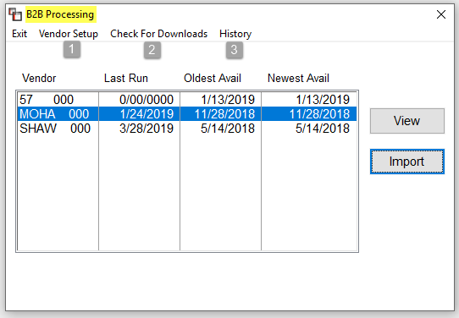
The Vendor Setup (1) option (located at the top left of the B2B Processing screen) will only be available to the System Administrator. Users with permission to view and import can access the import files and view History (3). B2B customers can also force a check for new downloads via the Check For Downloads (2) option. Please Note: the servers will continue to check automatically for new files early in the morning and prompt them in the screen above when new files are available. When you click on the Check For Downloads option, the system will prompt the following B2B Vendor Download box:
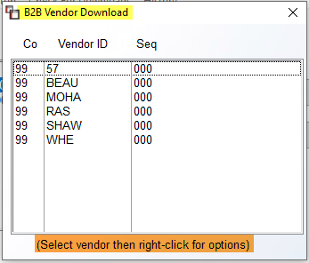
To select a Vendor ID to check for import availability, highlight and then right-click to call up the following options for that vendor: Run Vendor Download and Check Vendor Logs. Select the Run Vendor Download option to start the process. (Please Note: the Check Vendor Logs option is a RollMaster support use feature.)

View Data Files For Import
To select a vendor file to View, from the B2B Processing screen, highlight an available import file, as in the example below:
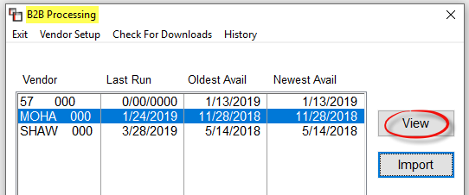
Click the View button to call up the Import Options screen as follows:
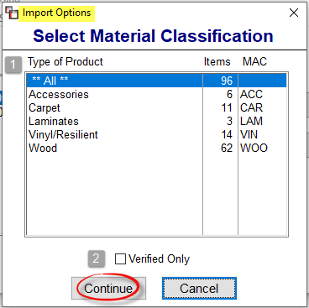
You can select the default **ALL** in the Type Of Product (1) box to see all items, or you can select a specific item such as Carpet to only select those types of items. If you have previously worked with the file and have already verified items to import, you can check the Verified Only (2) box, or leave the box unchecked to see all items. Click the Continue button to proceed. The system will prompt a View Import screen as follows:
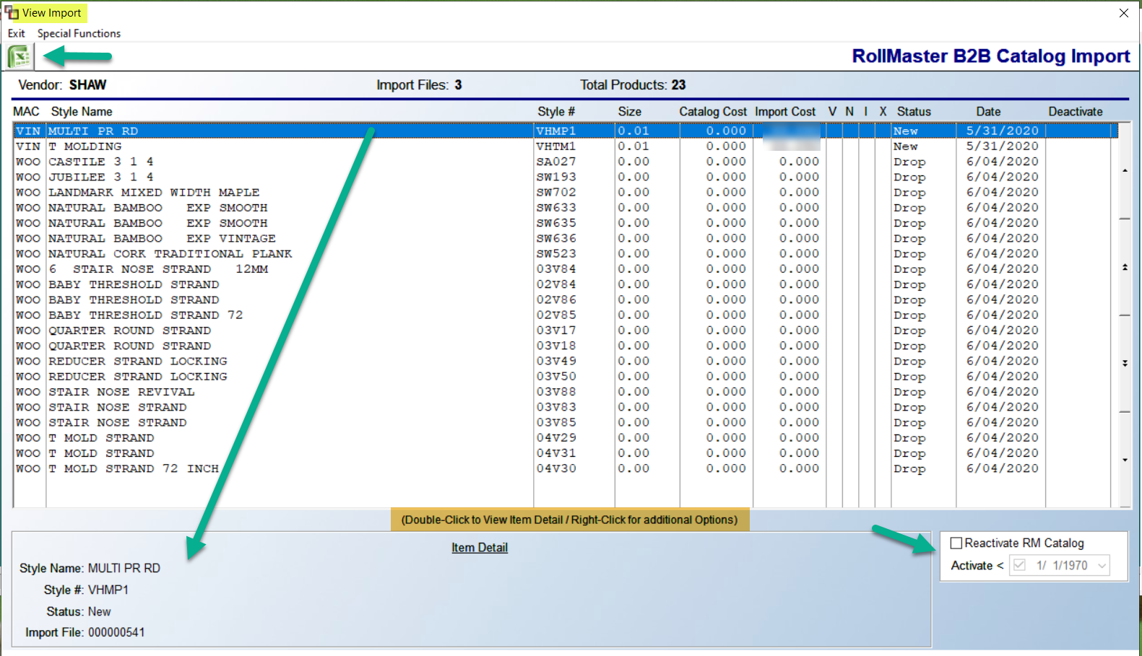
All available items for import will appear in the screen above. Using the Excel icon at the top left, you can export all the pending import data. This includes all colors and all data when drilling into detail, aside from existing catalog. Also, an Excel column titled # Found will display the number of occurrences of existing Catalog Items matching the import item. Returning to the screen above, if you highlight an item, data for that item will prompt in the Item Detail box at the bottom of the screen. The Reactivate RM Catalog box can be checked to allow for reactivation of Inactive styles where effective pricing is included in the import data. If you click to activate you can also set a date for reactivation.
The Special Functions menu, located at the top left of the View Import screen, contains several features to assist with the import process. Those options will appear as follows: Update Catalog with Incoming Name, Mark Invalid MAC Items for Deletion, Deactivate all Items, Activate all Items, and Rebuild Catalog Name. These are all features that should be used prior to importing into your live catalog if applicable. The Update Catalog with Incoming Name option has been added because vendors have been known to change style names for the same product. When this happens, you can use this feature to minimize the impact of that issue. When you select this option, the system will prompt an Incoming Name box as follows:
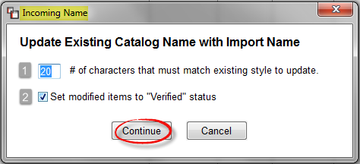
At the # of characters that must match existing style to update (1) box, the default value is 20. You can leave this value or type in a new value of characters to remain the same on matching styles. At the Set modified items to “Verified” status (2) box, the default status will be checked. If you don’t want these styles to be marked as “Verified” in the View Import screen, you can un-check this box. Click the Continue button to proceed.
The Mark Invalid MAC Items for Deletion relates to the MAC column in the View Import screen. This has to do with Vendor Material Classification Codes. Sometimes items come through with an incorrect code and need to be deleted from the import screen because the system will not import them. The Deactivate All Items option will set the Deactivate column in the View Import screen to “Deactivate.” The Activate All Items option will reverse that process.
Returning to the View Import screen, if you double-click on an item, the system will prompt a View Item Detail screen as follows:
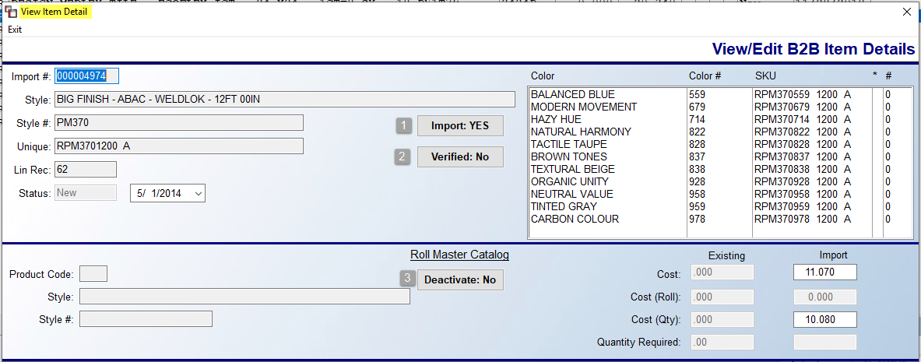
You can toggle the Import (1), Verified (2), and Deactivate (3) buttons to change the status of an item and view the import data of new and existing data for an item. You can also make changes to the Import price column by clicking in those available fields and typing in changes as follows:
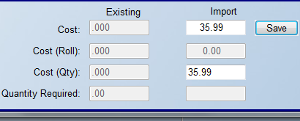
A Save button will appear once you make a change to one of these fields. Be sure to click Save before exiting this screen. Additionally, in the Colors box, if you right-click on a color, the system will prompt the following: View Existing Catalog. If there is a matching color name in the catalog, the system will prompt a Color Detail box as follows:
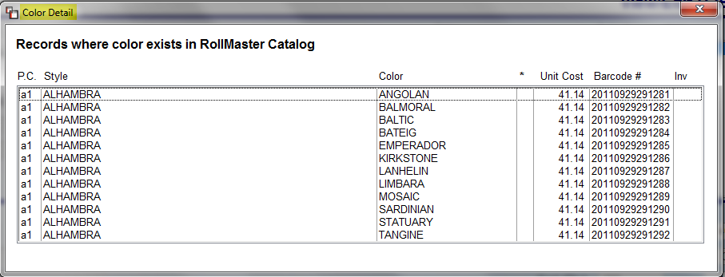
Once again, returning to the View Import screen, if you right-click on an item, you will see the following options: View Detail, Toggle Verified (V), Toggle Do Not Import (X), Toggle Deactivate Item, & Update Catalog with Incoming Name (N). The View Detail option will prompt the View Item Detail screen (explained above) for the selected item. The Toggle Verified (V) option will change the Verified “V” column status for the item: if the status shows “Y” for yes, this option will clear the “Y”; if the status is blank, this option will prompt a “Y” for this item. The Toggle Do Not Import (X) option will do the same for the “X” column. The Toggle Deactivate Item option will change the Deactivate column. And finally, the Update Catalog with Incoming Name (N) option is the same as described above in the Special Functions menu items section. You can use this option to change the “N” column status for a single item.
When the verification/editing process is complete, you will return to the original B2B Processing screen to continue with importing the data into the RollMaster System. Once data has been imported, there are two options available from the History menu to allow you to view changes and imports. Those items appear as follows: Changes made through Maintenance & Import Logs. If you select the Changes made through Maintenance option the system will prompt the following:
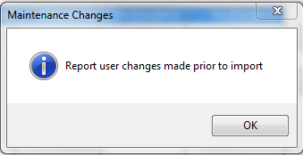
Click OK to continue with printing a report to detail changes made prior to the import. The Import Logs option will prompt an Import History screen as follows:
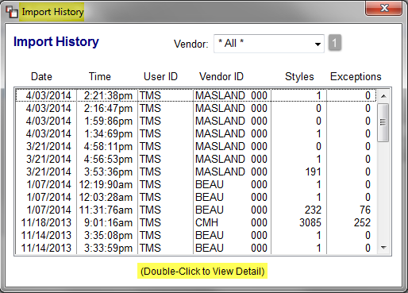
All Import Logs will appear in this screen starting with the latest. You can scroll through the list to find a log file to review, or you can target your search by clicking the down arrow at the Vendor (1) field to search by a specific Vendor. When you have located a file to view, double-click to view detail and the system will first prompt a Filter Log Results box as follows:
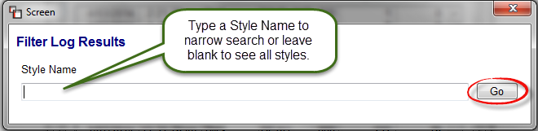
You can type a specific style name to only see the import log for that style, or leave the field blank and click the Go button to see all styles. An example of the Import History Detail screen appears below:
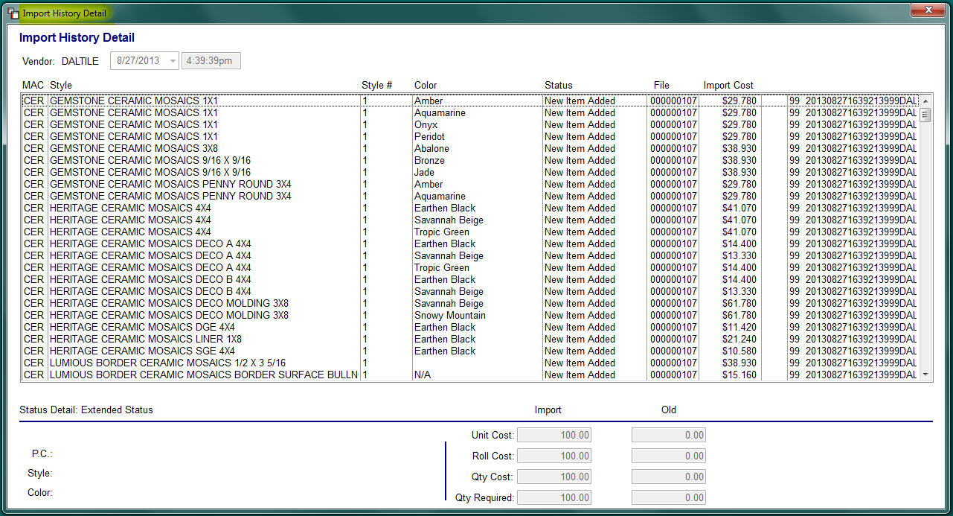
The screen above shows all items imported for that import log matching your sort selection. If you click on an item, the system will display any available historical data at the bottom of the screen, such as Import and Old cost.

Import Data Files into RollMaster Catalog
When you are ready to import a file, return to the B2B Processing screen. Highlight the file to be imported and click the Import button. The system will prompt an Import Options screen, identical to the screen that first prompts when View is selected, as follows:
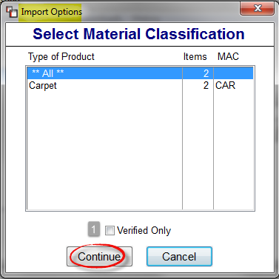
Highlight a file to select. Check the Verified Only (1) box to only import “Verified” items. Click the Continue button to proceed. The system will then prompt a View Import screen, identical to the View Import screen accessed via the View process explained above, as follows:
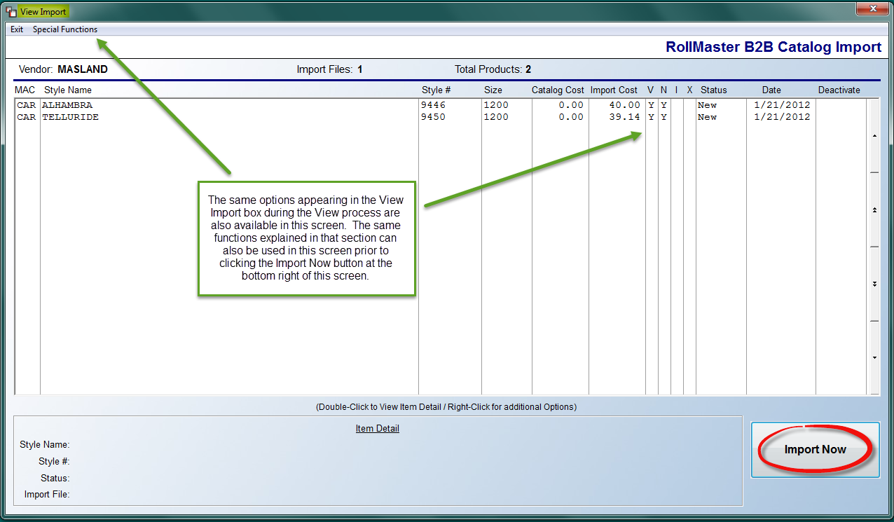
As explained in the box above, you can use the same Special Function options along with the options available when you highlight and right-click on an item prior to running the import—these are explained above in the “View Data Files For Import” section. When you are ready to import a file, click the Import Now button at the bottom right of this screen. The data will immediately update in the RollMaster System and an Import Log will be created for the History option.

Web Services:
The latest Web Services feature of the B2B Technology is now available in RollMaster. There are only a handful of Vendors currently participating, but it is a growing technology. Please review the B2B Vendor List document in the RollMaster Help Desk for updates. It will be up to each Vendor to get this up and running on their end, but the setup side on RollMaster is in place. This technology allows for processes such as Checking Stock, Inventory Inquiry, Related Items, and more. In Catalog Maintenance, under Options, you will see a B2B Services Menu. You will also see this option in the Add or Change a Line Item screen in Order Entry, Quote Entry, and PO Entry. When clicked, this option will display the available Web Services for active Vendors, and allow you to perform any of the available functions.

A RollMaster Trainer will complete the setup for you, or will assist. The B2B Vendor Setup box appears as follows:

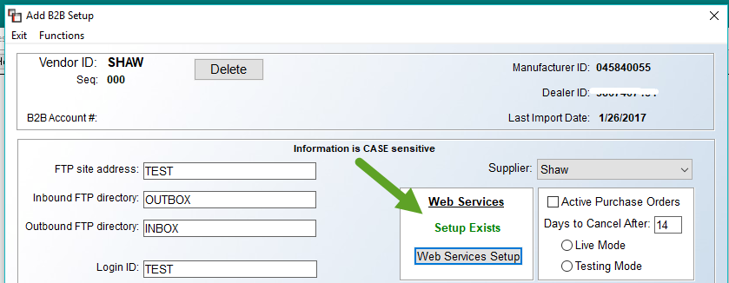

When you click on Web Services Setup, a setup box will prompt as follows:

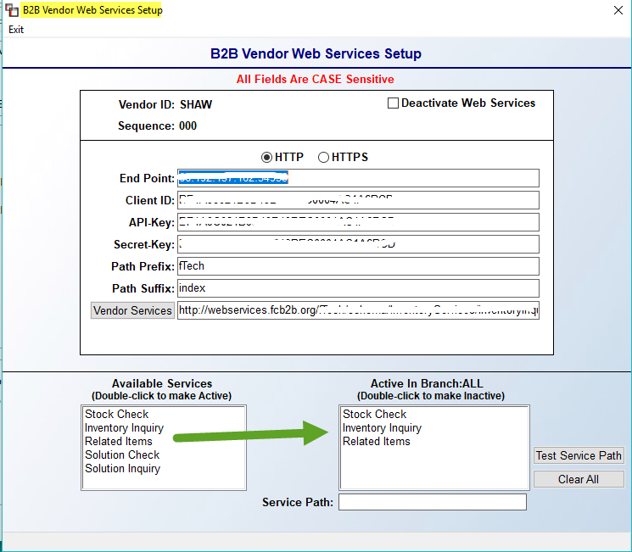

The Available Services box contains all potential Web Services options. Double-click on any to move to the Active In Branch box. These are the options that will prompt from the system when you click on Web Services.

