

Table of Contents
Special Functions 1
Introduction: 1
Vendor Invoice Report: 1
CARE Reporting: 3
RealPage Invoice Export (Formerly OPS): 4
Customer Facing CSV Imports: 5
CCA Global Catalog Import: 8
Vendor Sales: 8
Vendor Café: 8

***CONFIDENTIALITY NOTICE*** This documentation contains confidential information belonging to Textile Management Systems, Inc. and RollMaster Software, which is protected by copyright laws and other privileges. This information is intended for the exclusive use of legally licensed RollMaster Software users. If you are not the intended recipient, you are hereby notified that any disclosure, copying, distribution, or the taking of any action in reliance on the contents of this information is strictly prohibited. If you have received this documentation in error, please immediately notify us by telephone at (800) 777-4107.

Special Functions

Introduction:
The Special Functions menu contains some modules that may only apply to certain RollMaster clients – with the exception of the Vendor Invoice Report – that have contracted with RollMaster to develop special programs based on reporting or integration. This section of the manual will give a general description of each module. This menu will continue to grow as User-developed modules or peripheral software/hardware is added to the system.

Vendor Invoice Report:
This module and report are useful for tracking rebates. As Vendor Invoices are entered in the system through the Accounts Payable Open Item Maintenance module and approved via the Review P.O. History feature, the product purchase data is sent to this module so that reports can be printed to track those purchases. This report can be sorted By Vendor so you can create a report to view all product purchases for a particular Vendor or all Vendors. When you enter the Vendor Invoice Report module, the screen will appear as follows:

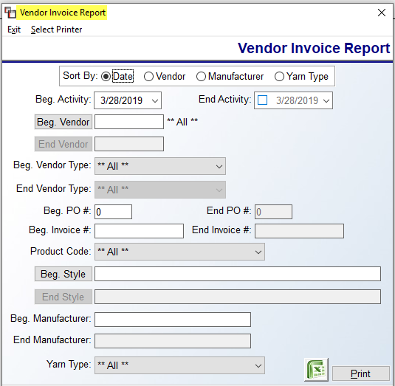

The settings in the screenshot above are the default settings. In order to customize the report, you can select applicable fields. The Activity Date fields allow you to enter a Beginning and Ending Activity Date Range for the report. Whether or not you use any of the other sort options, you should at least set a date range via this option. At the Vendor fields, use this feature to print for a single Vendor or range of Vendors; otherwise leave it unselected to print for ALL Vendors. The Vendor Type fields can only be used if this has been set up in the Vendor Maintenance module for all Vendors. Use the dropdown arrows to make your selections
The P.O. Number fields allow you to view data for a single P.O. or a range of P.O’s. The Invoice Number fields allow you to view data for a single Invoice or a range of Invoices. The Product Code field allows you to select a specific Product Code, and the Style fields allow you to view data for a single Style or range of Styles. The Manufacturer fields allow you to sort this report by Manufacturer. This field is tied directly to the Manufacturer field in the Catalog Maintenance module. The Yarn Type field is tied to the Yarn Type field in the Catalog Maintenance module. You can only select and print for one Yarn Type at a time.
When you have pre-set all options, click on the Print option. This report can also be exported to Excel.

CARE Reporting:
This module only applies to customers who sell carpet in the state of California and must track CARE inventory. This module features two report options. When you enter this module, the screen will appear as follows:

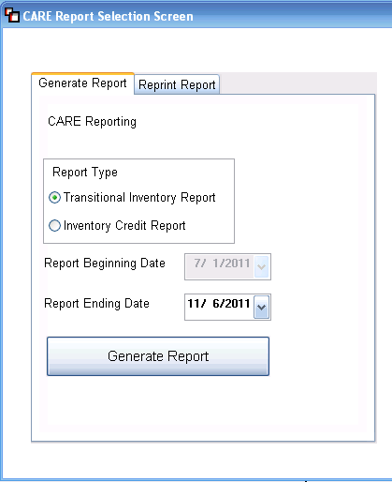

The Transitional Inventory Report is for tracking inventory that was purchased prior to July 1, 2011, but sold after that date. In these cases, the CARE fee assessed for the sold carpet was collected from the consumer, but not paid to the vendor, and should therefore be totaled and remitted to the proper CARE agency. The Inventory Credit Report is used to capture data regarding the amount of CARE fees paid on inventory to CARE vendors, but not collected from consumers for legitimate reasons based on CARE guidelines, such as in the case of carpet sold to be installed on Indian Reservations, or carpet sold to be installed out of state. In these instances, CARE was paid but not collected and this report will total that amount so you can be reimbursed by an applicable CARE reporting agency.

For either report, once a beginning and ending date are entered and you click Generate Report, the system will save the report and move it to the Reprint Report box for historical purposes. You can call up each report at any time in the future and reprint if applicable. The following is an example of a saved report in the Reprint Report screen:

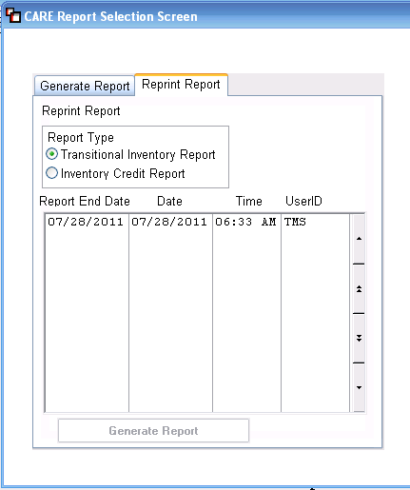

You can switch to either Report Type in this screen and once the applicable report is highlighted, you can click the Generate Report button to print the saved report.

RealPage Invoice Export (Formerly OPS):
For RollMaster Property Management dealers who have customers that use RealPage (Ops) Technology, functionality has been incorporated into the RollMaster System to provide Invoice export data in the format that RealPage requires. Functionality has also been added to designate a RealPage customer and for running the files for export in the required format, as well as with the option to print all or partial Branches. Please Note: any questions on uploading the file on the RealPage portal should be addressed with RealPage. To begin using this functionality, Property Management Customers need to be identified as RealPage clients in each applicable Ship To Code Maintenance box as follows:

Check the RealPage (OPS) box and then click the Save button to complete the Customer side setup. With RealPage Customers designated, the system will capture and save applicable data each time the Invoice Register is printed and cleared in the System. To create the export data, you will enter this module to generate the export. You can do this once or twice a week depending on volume and needs. When you enter this module, the screen will appear as follows:

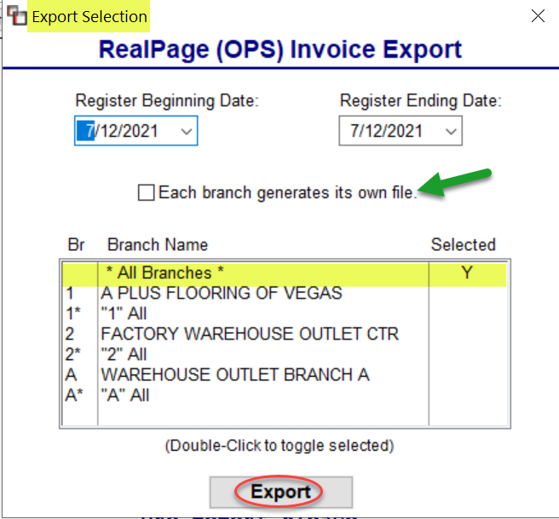

The Register Beginning and Ending Date fields will default to the current date. You can alter these dates to capture all Invoice Register detail since the last export. In the Branch Name box, * All Branches * will be listed at the top and is the default selection. As needed, double-click to select/unselect Branches for the report. Prior to exporting, you can also determine whether to check the Each branch generates its own file box to output separate files by Branch. Click the Export button to proceed. The system will generate the file for uploading into the RealPage website, thus eliminating double-entry. Please Note: this module includes CARE fees in the Tax and Total. CARE only impacts dealers conducting business in the state of California. Additionally, in the Customer Master Listing export to Excel, a column has been added to display a RealPage Account #. The column will appear to the far right of the export data.

Customer Facing CSV Imports:
This module allows customers to import a variety of data into RollMaster using .csv files. Some examples include A/P Open Items, Catalog – Material, including changes to pricing for non-B2B Product Codes, and Sales Tax Codes, including changes to existing Sales Tax Codes, and several other data sets. Once the .csv file has been created and saved, this module can be accessed to perform the import. When you enter this module, the system will prompt a User Imports screen as follows:
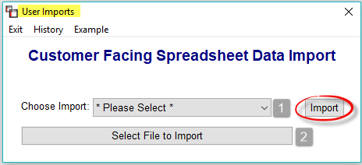
At the Choose Import (1) field, use the drop-down arrow to select an import option. If you are interested in any of the below import items, click on the Example option at the top left of the main screen to access a full list of sample “.csv” files on every import option. If you need further assistance, please contact RollMaster Support. The current list of Import options appears as follows:
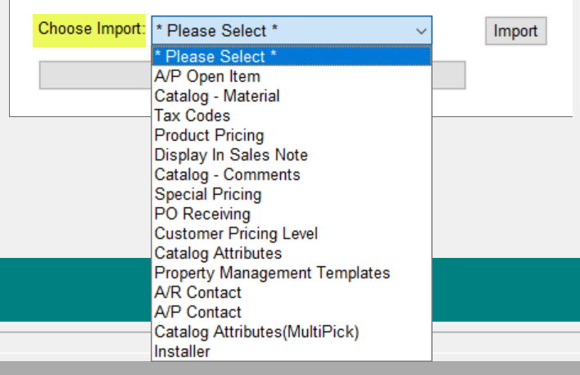

You will then click the Select File to Import (2) button to locate the .csv file on your computer hard drive. Once the file is selected, click the Import button to continue. Some of the options have additional screens that will provide additional functionality prior to import. For example, if the Special Pricing option is selected, following the Import process, the system will then prompt a Special Pricing Spreadsheet Import (CSV) screen as follows:
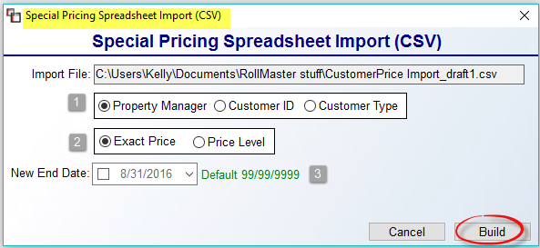
A few fields have been added prior to the import to direct the Special Pricing. At the first field (1), select whether the pricing is by Property Manager, Customer ID, or Customer Type. At the next field (2), select whether it is Exact Price or by Price Level. At the New End Date (3) field, accept the default or click the date box and select a new date for the Special Pricing to expire. Click the Build button to begin the import.

In the A/P Open Item data import option, the screen appears below. The system will recognize negative values and distinguish between an Invoice and a Credit Memo and then denote them as such in the display screen prior to import.

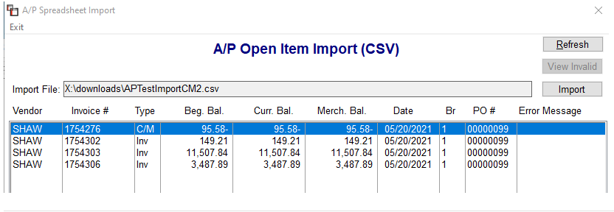

Also, Users will can backdate items to +/- 1 year from the current year. However, a RollMaster Support Agent is able to assist with up to +/- 5 years. The system will check for duplicate items in same file as well as identify the existence of a C/M already in the system, even if it has been deleted.

Please Note: At the top left of the screen, you will note a History option. When you click on this option, the system will prompt the following History screen:
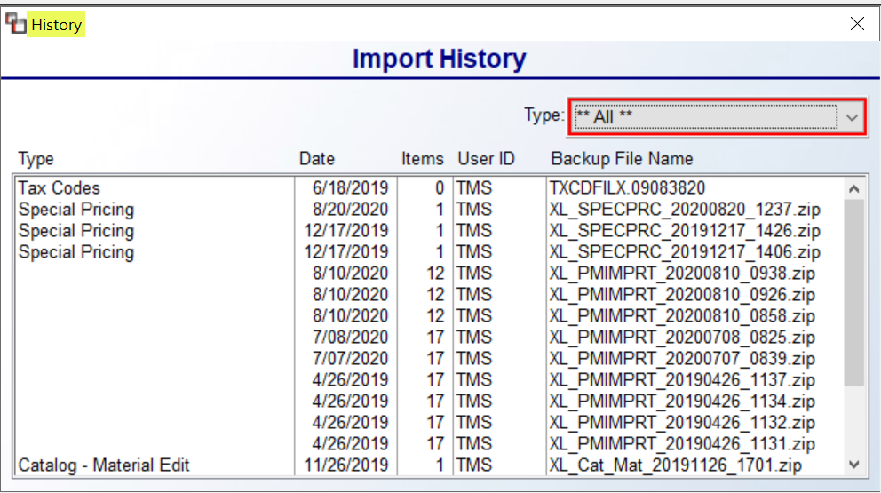
A list of all previously imported files will appear in this screen. Use the Type drop-down box to see all history on a specific import option.

CCA Global Catalog Import:
This module is specifically for Carpet One/CCA Global customers on the RollMaster System. This module will import a full catalog, provided the zip file containing multiple .exe files from CCA Global is up-to-date. For further assistance, please consult with your trainer or contact RollMaster Support at support@rmaster.com.

Vendor Sales:
This module is essentially an Excel report to allow for tracking sales by Vendor, and also works for exporting needed data to Greystar. The exported data includes a column for Invoice Paid Date. In addition to tracking of unpaid items that qualify for rebates, this module also benefits multi-family dealers who need to report quarterly sales to the management companies they do business with and also for multi-family dealers to report to Greystar. RollMaster keeps track of required updates for Greystar so our dealers remain compliant and benefit from the reporting option. When you enter this module, the screen will prompt a Vendor Sales screen as follows:

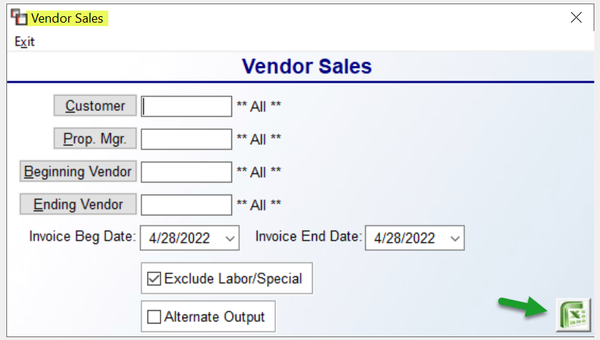

Because Greystar doesn’t require data on Labor and Special Charge lines, a checkbox appears at the bottom of this screen as follows: Exclude Labor/Special. Additionally, the report data can be customized by Customer, Property Manager, and Vendor, as well as for a range of Invoice dates. The data that exports to Excel can be further customized to what you need to provide to each company. Additionally, an alternate Excel export report is available by checking the Alternate Output checkbox prior to exporting. While this was added for a specific customer, it can be used by all RollMaster clients.

Vendor Café:
VENDORCafé is an online Vendor portal with a simple User interface that can dramatically reduce paper invoices and streamline communication with Vendors. It is similar to the Ops Technology for the Property Management/Multi-Family industry. RollMaster has added this feature to allow for exporting Invoices for import into the VENDORCafé portal via this module.

To begin using this functionality, Property Management Customer IDs need to be identified as VENDORCafé clients in each applicable Ship To Code Maintenance screen and a Yardi #/ID entered at the bottom right of the screen. Those fields appear as follows:
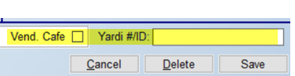

Check the Vend. Café box and enter the Yardi data and then click the Save button to complete the Customer side setup. With VENDORCafé Customers thus designated, RollMaster will capture and save applicable data each time the Invoice Register is printed and cleared. When you enter this module, the screen appears as follows:

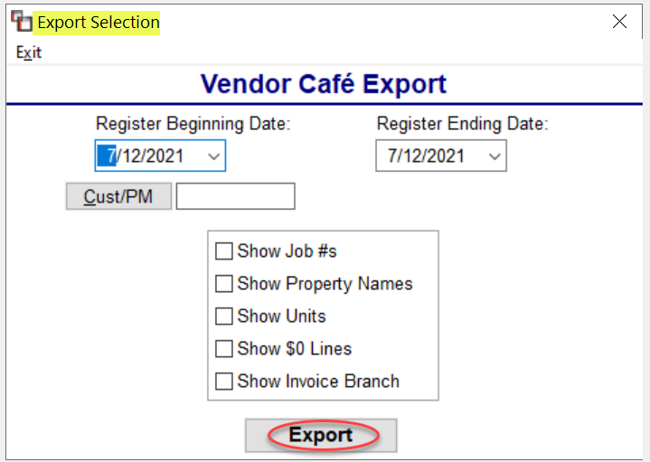

Select an Invoice Register Beginning and Ending Date for the export and then select either a Property Management Customer ID or a Property Manager ID from the Lookup box. If you wish to include any of the data listed in the box above the Export button, you will need to check all that apply. Please Note: if the total of Column I and J is $0.00, the export will not display that line unless the Show $0 Lines box is checked. Click Export to generate the file. Additionally, in the Customer Master Listing export to Excel, a column has been added to display a Yardi Account #. The column will appear to the right of the existing RealPage (formerly Ops) column.

