
A DIVISION OF TEXTILE MANAGEMENT SYSTEMS
800-777-4107
info@rmaster.com

Table of Contents
Management Functions 1
Introduction: 1
Unlock Jobs, Quotes, PO’s, Etc.: 1
Open Jobs Closed in Error: 2
Open Quotes Closed in Error: 3

***CONFIDENTIALITY NOTICE*** This documentation contains confidential information belonging to Textile Management Systems, Inc. and RollMaster Software, which is protected by copyright laws and other privileges. This information is intended for the exclusive use of legally licensed RollMaster Software users. If you are not the intended recipient, you are hereby notified that any disclosure, copying, distribution, or the taking of any action in reliance on the contents of this information is strictly prohibited. If you have received this documentation in error, please immediately notify us by telephone at (800) 777-4107.

Management Functions

Introduction:
The Management Functions menu contains maintenance modules that control management related functions in the system. These are modules that you may or may not want salespeople to be able to access, and are not available from many Custom Menus. For example, once Jobs have been job cost approved, invoiced, and then closed, the only way to re-open any Job is through a module in this menu—Open Jobs Closed in Error. In most cases, you would not want a job to be reopened unless management was aware of the reason(s).

Unlock Jobs, Quotes, PO’s, Etc.:
In the RollMaster System, if a User exits out of a module by shutting down the program, or if something happens to cause the system to shut down unexpectedly, the system may lock the User out of that file upon re-entry. For example, a User can get locked out of a particular Job or Quote. When this happens, the Unlock Jobs, Quotes, PO’s, Etc. module should be used to correct the problem. When you enter this module, the screen will appear as follows:

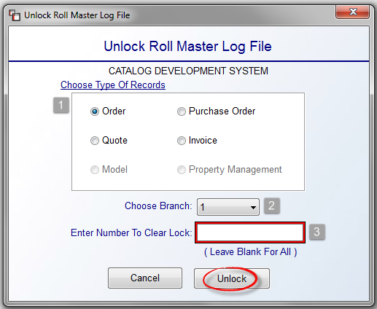

In the Choose Type of Records (1) box, click to select the record type that needs to be unlocked. You can only choose one type at a time. At the Choose Branch (2) field, use the drop-down arrow to switch to another Branch if applicable. At the Enter Number To Clear Lock (3) field, enter the Record Type Number that needs to be unlocked or leave this space blank to clear locks on all of the records in the selected Type. Click the Unlock button to complete the process. Please note: if your User ID matches the one that is locking the Job/Quote, you can clear the lock from the “On-Screen Message” instead of accessing this program from the Home key.

Open Jobs Closed in Error:
This module is used to open a Job that has been closed in the system, either by error or through regular processing. If a problem arises on a closed Job, management will need to access this module to reopen that Job, where applicable. In other words, rather than opening a new Job to order material or process a Work Order for labor for a closed Job, the Job can be reopened and additional material, labor, or repair costs can be added. This will keep the total job cost information together on the same Job. The only exception to this is for Progress Billed Jobs. Those cannot be re-opened by anyone in the System. If that process is attempted, the system will prompt a message as follows: Close Progress Billed Job – Job can’t be re-opened.”

When you enter this module, the screen will appear as follows:

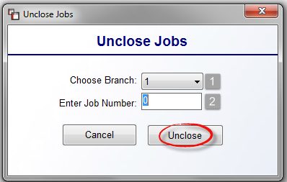

At the Choose Branch (1) field, use the drop-down arrow to switch to another Branch if applicable. At the Enter Job Number (2) field, enter the Job Number that needs to be opened. Click the Unclose button to complete the process.

Open Quotes Closed in Error:
This module will allow you to open a Quote that has been closed in the system either through error or regular system processing. It works identically to the module above. An additional feature, Mass Unclose Quote, has been added to this module and will be explained below. When you enter this module, the screen will appear as follows:
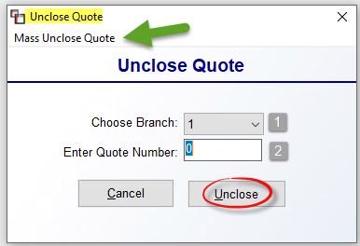

At the Choose Branch (1) field, use the drop-down arrow to switch to another Branch if applicable. At the Enter Quote Number (2) field, enter the Quote Number that needs to be opened. Click the Unclose button to complete the process. As mentioned above, you can perform a Mass Unclose of Quotes by Branch and Close Date. This allows for cleaning up old Quotes that will never be converted to open Jobs in the system, or are duplicates. This feature is located in the Management Functions menu because it’s not something that every User should have the ability to carry out. When you enter this module, at the top left you will see the following: Mass Unclose Quote. When you click on this option, the system will prompt the following Mass Unclose screen:

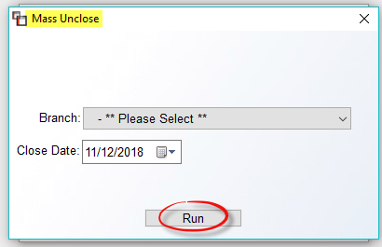

You must select a Branch and a Close Date and then click Run.

