
Table of Contents
Owner Functions 1
Introduction: 1
Overbill / Overhead Job Cost Margin Rpt.: 1
True Job Cost View: 4
Detailed JC View/Print (Owner’s Version): 6
Billed vs Unbilled From JC (Owner’s): 9
Sales Analysis (Owner’s Version): 12
Master Lead Report (upgrade): 28

***CONFIDENTIALITY NOTICE*** This documentation contains confidential information belonging to Textile Management Systems, Inc. and RollMaster Software, which is protected by copyright laws and other privileges. This information is intended for the exclusive use of legally licensed RollMaster Software users. If you are not the intended recipient, you are hereby notified that any disclosure, copying, distribution, or the taking of any action in reliance on the contents of this information is strictly prohibited. If you have received this documentation in error, please immediately notify us by telephone at (800) 777-4107.

Owner Functions

Introduction:
The Owner Functions menu should only be accessible and used by owners and upper management. Within this menu are many job costing modules and reports designed to allow owners/mangers to utilize the Overbill and Overhead options in the system and view actual job cost figures from this menu. The Overbill field appears in the Catalog Maintenance module (for more information on the Overbill functionality see the Inventory Control section of the manual), and the Overhead field appears in the Job Type Maintenance module (for more information on the Overhead functionality see the Sales Processing section of the manual).

Overbill / Overhead Job Cost Margin Rpt.:
This report module works the same as the Job Cost Margin report module accessible from the Job Cost menu. The only difference is that when the Overhead and Overbill features are utilized in the system, an owner/manager must use this report to view true job costs and see any breakout of the actual Overbill and Overhead amounts. An example of this report is shown below (this data can also be exported to Excel):

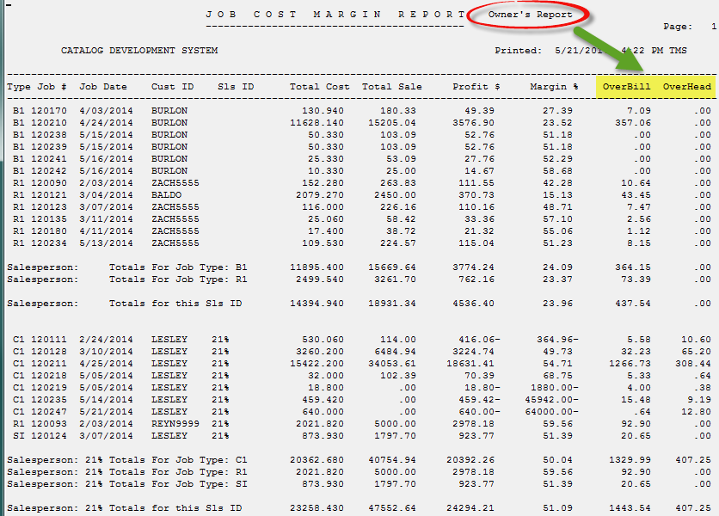

This report will produce “written” sales information by Salesperson and by Branch. Material does not need to be assigned to a Job in order for costs to appear— material costs come from the system catalog. For each Salesperson, the report lists each Job and shows the total of all material, labor, and special charge costs on those Jobs, as well as the total sale, profit, and margin figures. (Please Note: The cost, profit, and margin figures on this report do not reflect the Salesperson’s commission amount.) It also gives a Job Type total for each Salesperson followed by Grand Total figures on cost, sale, profit, and margin. At the end of each Branch section, the report calculates Job Type totals for all Salespeople and then a Grand Total of all sales for the Branch.

At the end of the report, the system calculates and displays Job Type totals for the Company, followed by a Grand Total of all sales for the entire Company. One of the reasons it can be considered a “written” report is because the User can customize the report to show all Jobs entered in the system for the day, for the week, for the month, etc. It will also include Jobs that have been “Closed,” which means that Over the Counter Sales will be reflected in the report without the User having to open those Jobs after invoicing—as with the Open Order Report. This also means that any Jobs that have been canceled in the system will reflect values on this report unless all of the Line Items on those Jobs have been deleted.

When you enter this report module, the OverBill & OverHead Job Cost Margin Rpt screen will appear as follows:

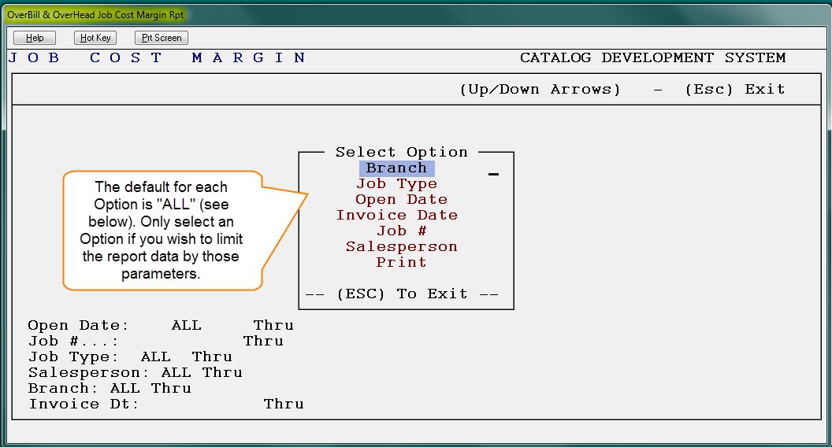

The cursor will be positioned at the Branch option in the Select Option menu. If you do not wish to customize the report, you can arrow down to the Print option and hit enter. However, by selecting an option from the menu, you will have the ability to customize the report. You can program one or more of these options prior to printing the report. The Branch option will allow you to print the report for only one Branch or for a range of Branches. The Job Type option will allow you to print the report for only one Job Type or for a range of Job Types. The Open Date option will allow you to set the Beginning and Ending Dates of the open Jobs you want to include on the report. The Close Date option will allow you to set the Beginning and Ending Dates of the closed Jobs you want to include on the report. The Job # option will allow you to print the report for only one Job or for a range of Jobs. The Salesperson option will allow you to print the report for only one Salesperson or for a range of Salespersons.

When you have programmed your desired options, arrow down to the Print option and hit enter. The system will prompt the following: Do You Want To Print Open And Closed Jobs? (Y,N) N. If you want to include “Closed” Jobs on the report, change the default to “Y” for yes. The system will perform internal procedures and begin printing the report. You can also export this data to Excel.

True Job Cost View:
This module works similarly to the View Job Cost module accessible from the Order Entry module and the Job Cost menu. The differences are as follows: In the Assigned Order Lines box, the Overbill amount collected on each material line will display in the Overbill column. In the Job Cost Totals screen, the total Overhead amount collected on the Job along with the total Overbill amount will display at the bottom right of the screen. (Important Note: If any material lines on a Job do not have inventory assigned—even if a PO for that material has been created in the system—those lines will not display in this module.) When you enter this module, the True Job Cost View screen will appear as follows:

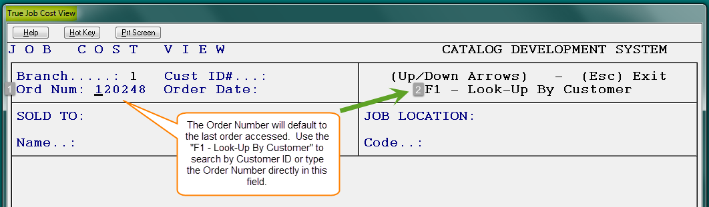

The cursor will be positioned at the Ord Num (1) field; type in the number of the job you would like to view costs on and hit enter or use the “F1 – Look-up By Customer” (2) feature to locate the job you wish to view. The system will bring up an Assigned Order Lines box as follows:

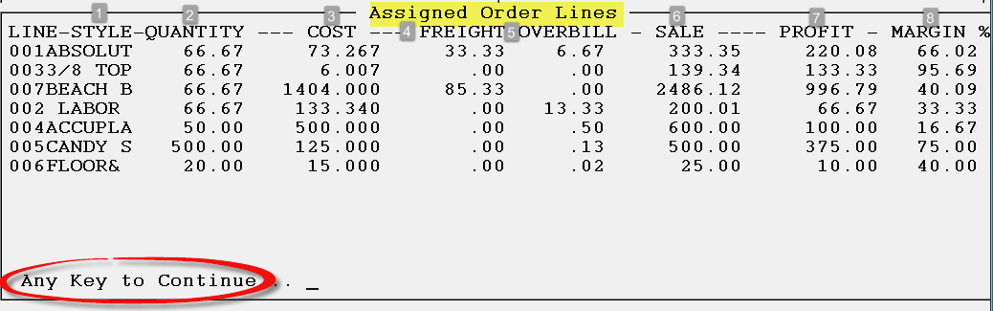
All Material lines with assigned material will appear in this screen. Labor and Special Charge lines will instantly appear. In the STYLE (1) column, only eight characters of the style name will display. The information in the QUANTITY (2) column is pulled from the Working Quantity column in the Enter Line Items screen. The COST (3) and FREIGHT (4) column values are initially pulled from the Inventory Maintenance module. These values are then updated through the Review P.O. History feature when a Vendor Invoice is posted in Accounts Payable Open Item Maintenance. The OVERBILL (5) column displays the total overbill amount accrued on each line. The SALE (6) column displays the total sale price of each line. The PROFIT (7) column displays the total profit to be made on each line based on the current costs and sale price. The MARGIN % (8) column displays the current profit margin. Important Note: If a line has a cost but no sale price, the PROFIT (7) and MARGIN % (8) columns will display negative figures. In this case, you should only be concerned with the bottom line profit and margin % for the total job, which can be viewed in the next screen. To proceed to the next screen, press Any Key to Continue. The Job Cost Totals screen will appear as follows:

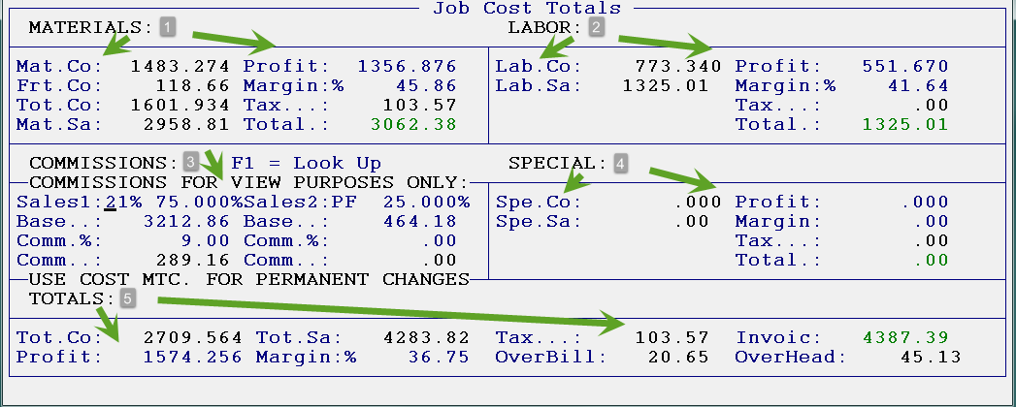

Below, this screen has been divided into five parts (MATERIALS, LABOR, COMMISSIONS, SPECIAL, & TOTALS) in order to explain each in greater detail.

MATERIALS (1) - this section breaks out just the material lines on the Job. It displays the following: the combined cost of all the material; the combined freight cost; what the material was sold for (less tax); the total profit on materials; the profit margin on just the material lines; the total tax charged for material; and finally, the total sale on materials plus tax. Please Note: If tax is charged on the cost of material (Contract Sale), an asterisk will appear in the tax field as illustrated in the following example: Tax..*: 69.30.

LABOR (2) - this section breaks out just the labor lines on the job. It displays the following: the combined cost of all labor; what the labor was sold for; the total profit on labor; the profit margin on labor; the total of any tax charged on labor; and finally, the total sale on labor plus any tax.

COMMISSIONS (3) - this section calculates the salesperson commission based on the information that was entered in the Salesperson Maintenance module. It displays the Salesperson ID, the commission base, the commission percentage, and the total commission to be paid. If a second salesperson is tied to this job, that information will be calculated here as well. This is the only part of the screen that can be accessed. Any changes typed in this screen will be informational only; they will not update Salesperson Commissions. Please Note: The system does not include tax when calculating the commission base.

When the Job Cost Totals screen first prompts, the cursor will be positioned at the “Salesrep1” field. If you need to look up a Salesperson ID, use the F1 key. You can make temporary changes to the salesperson commission information to see how different percentages affect the commission amount and the total job margin, but no changes will save in this screen. The only way to exit this screen is to enter through the Commission section until you get to the following prompt: Continue? (Y,N) Y. If you hit enter again after reaching this prompt, the system will take you back to the Job Cost View screen.

SPECIAL (4) - this section refers to order lines on a job that are neither material nor labor lines; there is never any inventory attached to these lines. Examples include finance charges, delivery charges, adjustments, discounts, etc. These lines are separated out in this section and broken down by total cost, total sale, total profit, total margin percentage, and total tax, if any. Many times these lines will have a cost tied to them but no sale price; in these instances you will get a negative profit and margin percentage which will affect the bottom line figures in the TOTALS (5) section.

TOTALS (5) - this section averages all the cost, sale, tax, profit, and margin percentage totals of each section, and then displays bottom line figures on the job. It also breaks out the total Overbill and Overhead costs that have been collected on the job where applicable.

Detailed JC View/Print (Owner’s Version):
This module works almost identically to the Detailed JC View/Print module located in the Job Cost Menu. The only difference is that this version will break out and display any Overhead and Overbill costs, as well as provide owners/managers with a true picture of job cost on a job-by-job basis. This module provides line-by-line cost, sale, profit and margin information, similar to the View Job Cost module, but does not require material to be assigned to a line. Additionally, the module will print a detailed job cost report on any job in the system, whether open or closed. The job cost data on the report combines data that previously had to be viewed from several different areas of the system, which makes it an incredible tool, especially for large commercial dealers. Everything you need to see as an owner or manager on each job has been combined together on one page of this report. The Budget data displays Actual Costs, the original Budget Amount that was set once the initial lines items were added, and the Difference between the two. You can also see the Salesperson Commission amount, including the Commission Base and the Percentage. That data is followed by all the totals on the job, such as line totals, tax, the total sale, profit and margin, along with any information on the invoice, if one has been created. The end of the report lists each line on the job with the corresponding cost, sale, profit, and margin. On any labor lines where labor has been posted in the system, the Installer ID will also display along with his rate, total paid to date, and any quantity remaining to be paid.

When you enter this module, the system will prompt the following: Please Enter Job Number, or (F1) to Look-Up. Type in the Job Number or use the F1 key to perform a look-up by Customer ID. Once you have selected a job, the system will display all the lines on the job, whether inventory is assigned or not. The Cost Review screen will appear as follows:

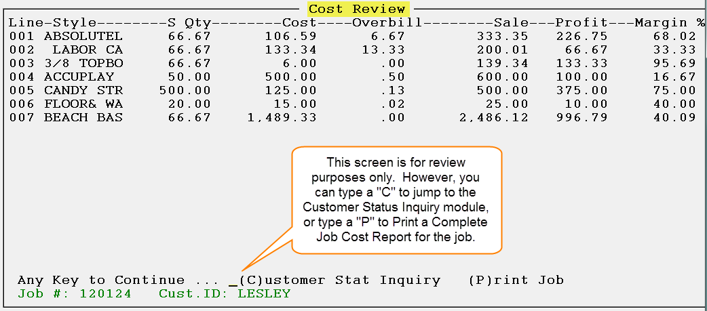

Material does not have to be assigned on a job line in order for it to display in this screen. When material lines are first entered, the costs are read from Catalog Maintenance; material costs are subsequently updated from Purchase Orders, Receiving Inventory, and then bill posting in Accounts Payable. Labor costs are read from the catalog and are then updated in Job Labor Mtc./Installer Payments if applicable. In addition to viewing the Overbill, Sale, Profit, and Margin on each order line, there are two additional functions you can perform from this screen. If you wish to view the customer’s account information, simply type a “C” and the system will pull up the Customer Invoice Credit Lookup Screen from the Customer Status Inquiry module for this customer. If you type a “P” for Print Job, the system will produce a one page Complete Job Cost report, explained at the beginning of this section. Only the first Invoice number and date will display on this report, but the Current Balance is continually updated through the Post Customer Payments module. The following is an example of that report:

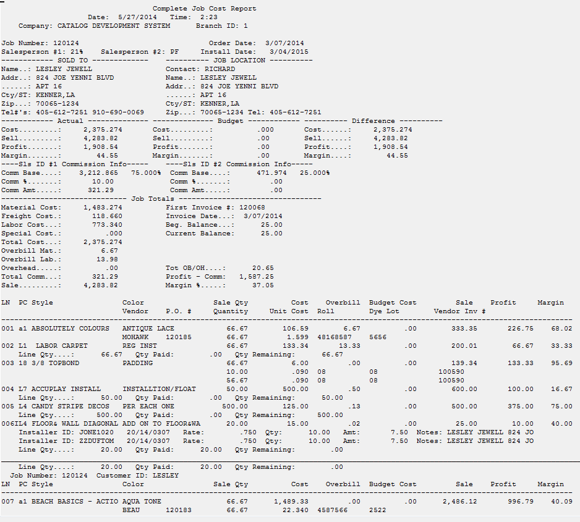

Billed vs Unbilled From JC (Owner’s):
This report module works the same as the report you will find in the Job Cost Reports menu but will be reflective of true costs, meaning no overhead or overbill costs will be reflected in this report. Owners/managers of all flooring businesses should consider printing this report on almost a daily basis to assist with staying on top of open jobs in the system. The report will indicate whether inventory on a job has been received (it will show in the Material Costs To Date column), whether the job has been invoiced but not closed or only partially invoiced (the amount invoiced will show in the Total Billed To Date column), whether the job has been installed (it will show in the Labor Cost To Date column), and the profit and margin on each job (these will display in the Profit and Profit % columns respectively).

Unless there are extenuating circumstances, no residential job should be more than 3-4 weeks old. If there are no remaining costs to complete on a job, the job is more than likely ready to be invoiced and closed. Residential, Property Management, and Builder dealers will not necessarily use the Unbilled column of this report—that was implemented primarily for large commercial dealers to keep track of whether they are over or under billed on long-term projects. The “Material Costs To Date” column of this report gets its cost information from the value of the inventory that has been assigned to a line. The information that appears in this column is the same information that can be seen in the “View Job Cost” or “Cost Maintenance” modules. By the time the vendor invoice is posted in the system, this value may change. The “Labor Costed To Date” values come from the same source for all of the reports—the Installer Payables Report. The “Special Costed To Date” values come from the cost inputted at the time the special charge line was entered in the system—this is also the same for all reports. The “To Be Costed” column values for all reports come from Catalog Maintenance initially, and are updated through the Purchase Order module. This report will export to Excel.
When you enter this report module, the screen will appear as follows:

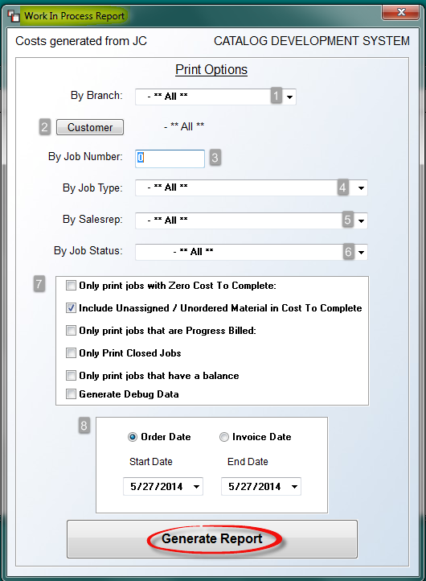

Through the various Print Options, you have the ability to customize this report. If you do not wish to customize the report, you can simply click the Generate Report button to view the data on screen or export to Excel. However, you can narrow the data by programming one or more of these options based on the data you are seeking. At the By Branch (1) option, use the drop down arrow menu to select a specific Branch if applicable. Also, if you have enabled Region Reporting in the Company Control 2 level screen of the System Control Maintenance module, you will also have the option to sort the report by Region. At the Customer (2) field, click the button if you would like to select a specific customer for the report; otherwise leave the default setting for ALL customers. The By Job Number (3) option will allow you to print the report for a specific job. Type the job number in this field, or leave the field set to “0” to include all jobs. At the By Job Type (4) option, use the drop down arrow to select a specific Job Type for the report; otherwise leave the default setting for ALL job types. At the By Salesrep (5) option, use the drop down arrow to select a specific salesperson for the report; otherwise leave the default setting for ALL salespeople. At the By Job Status (6) option, use the drop down arrow to select a specific Job Status for the report; otherwise leave the default setting for ALL.

In the first box of options (7), the only option automatically selected is the following: Include Unassigned / Unordered Material In Costs to Complete. You can uncheck this option to exclude unassigned/unordered material if applicable. The first option, Only print jobs with Zero Cost To Complete, should be checked if you only wish to see jobs that most likely should be closed in the system. The third option, Only Print Jobs That Are Progress Billed, will only be applicable if your company utilizes the Progress Billing feature in the system. If this is the case, then to only see Progress Billed Jobs, select this option. The fourth option, Only Print Closed Jobs, should be checked if you are only interested in looking at Closed Jobs in the system. The fifth option, Only print jobs that have a balance, is useful for designating jobs that may be stalled or have “fallen through the cracks.” The last option, Generate Debug Data, is a RollMaster Support item and should be used in conjunction with a member of the support team.

In the last box (8), you will determine if you want a date range for the report and if you want the system to use the Order Date or Invoice Date. Use the drop down arrows to change the Start Date and End Date calendar fields. When you are ready to generate report data to screen, click the Generate Report button. The system will prompt a Search Results screen as follows:

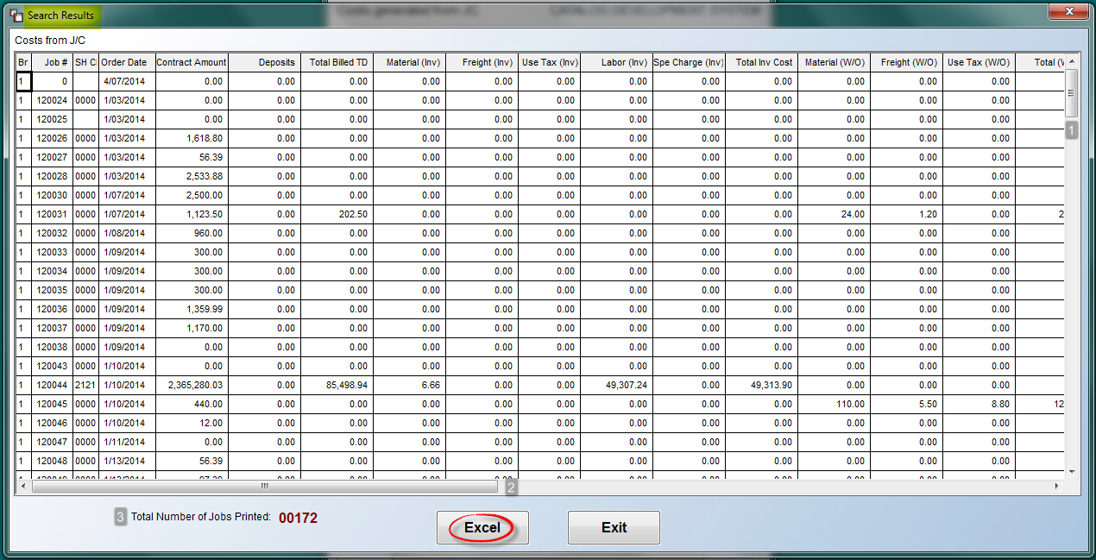
There are several columns on this screen and there will likely be several rows, so you will need to utilize the vertical (1) and horizontal (2) bars to slide the screen and view additional data. At the bottom left, the system will display the Total Number of Jobs Printed (3) to this report. Once you have reviewed the data, you can click the Excel button to export to Excel, or click the Exit button to return to the prior screen.

Sales Analysis (Owner’s Version):
This module is almost identical to the main Sales Analysis program. The only difference is that the Owner’s Version will not include Overhead or Overbill values in the cost fields, so it provides true sales analysis data for owners to view. When you enter this module, the system will prompt a Sales Analysis screen as follows:

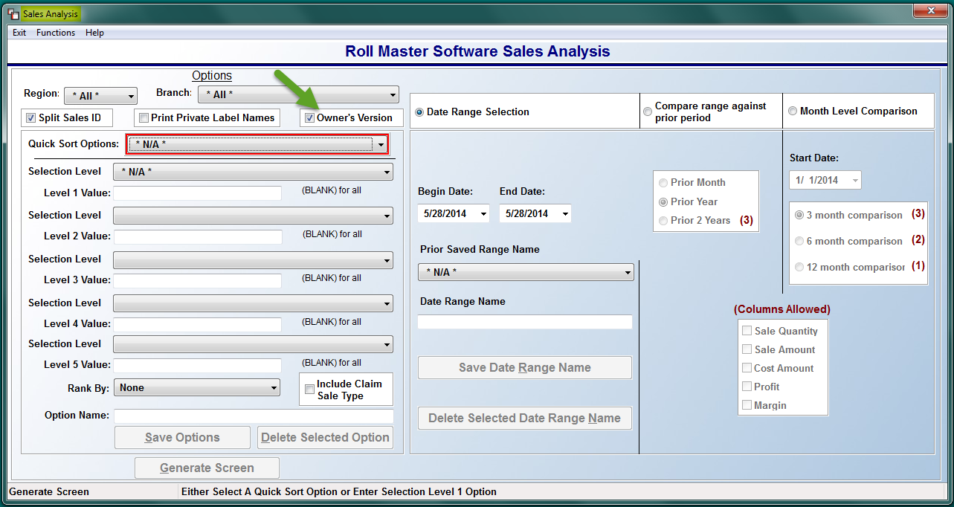

At the top left of the screen below the Branch field, an Owner’s Version field will be displayed and checked, indicating that you are in the Owner’s Version of the Sales Analysis program. If you wish to revert to the regular Sales Analysis program, you can uncheck that box and the program will no longer break out and display Overhead and Overbill costs in the analysis data. In order to access the Sales Analysis (Owner’s Version) in any branch, a user must be set up with a User ID in that branch.

When you first enter the Sales Analysis screen, the cursor will be positioned in the Quick Sort Options field as follows:

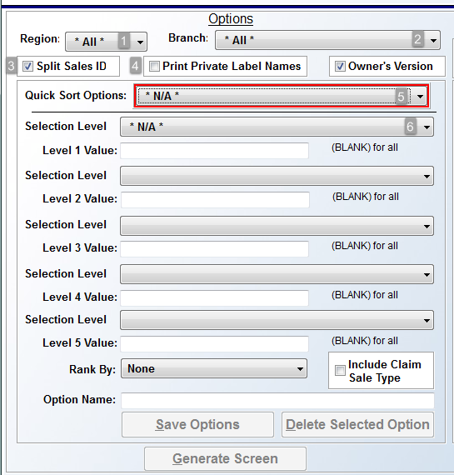

Please note that the Region (1) and Branch (2) fields just above the Quick Sort Options (5) field will default to “All” if Region Reporting is enabled in your system. If you wish to select a specific Region (1) or Branch (2), you should make that change before proceeding by clicking on the drop down menu in those fields. The Split Sales ID (3) option will default to “checked.” This will prompt the analysis to split data between more than one salesperson ID for reporting purposes. If you do not wish to use this feature, you can click the box to uncheck. To the right of the Split Sales ID option, you will see another option as follows: Print Private Label Names (4). This option will default to “unchecked.” If you check the box, the system will use the current Branch’s private label name on the data display.

Although the cursor will be positioned at the Quick Sort Options (5) field, this feature can be bypassed. See “Setup for Quick Sort Options” below for further details on how to complete setup and utilize this option. When not utilizing the Quick Sort Option, you will need to choose each Selection Level by clicking the drop down menu arrow, starting with the Select Option Level 1 (6) field. The system will prompt a list of all sales analysis data options as follows:

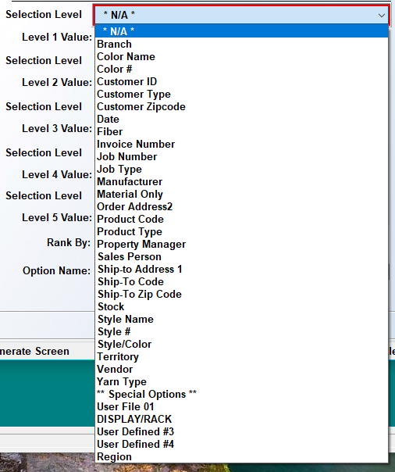

Please Note: If Region Reporting has been enabled in the system, you will see Regions as the very last option in the drop down menu. There are five Selection Levels of analysis criteria that can be viewed on any one report, but you only need to pick one to produce a report. Scroll through the list until the cursor is highlighted on the desired selection and hit enter to bring it into the Selection Level 1 (6) field. The selected item will appear in the Selection Level 1 field as follows:

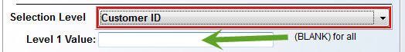

In the Level 1 Value field, you can type a specific value, such as a Customer ID, Color, Manufacturer, etc., or you can leave the Value fields blank to include all values within a selection level, i.e., All Customer IDs, or All Product Codes. You will not get a look-up option in any of these Value fields, so you will need to know that information ahead of time. Once you have completed programming the desired Selection Level fields, you will need to make a selection in the Rank By field. The following options are available from the drop down menu in this field:

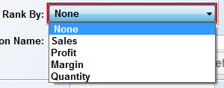

The Rank By options will allow you to sort your analysis report in order of top Sales, highest dollar Profit, highest profit Margin, highest Quantity, or None of these rankings. Make your selection to continue. The Include Claim Sale Type option, in the box to the left of the Rank By field, was added to provide a quick way to include claims sales on the report, when selected. That box appears as follows:

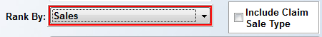

As a reminder, in Job Type Maintenance, you have the option to designate a Job Type Code as a “Claims” code, which means that “Claims” sales are excluded by default from all Sales Analysis reports, unless that specific Job Type Code is a Value in one of the Selection Level fields. You should check this box prior to generating the report to include “Claims” sales in the analysis data.

Setup for Quick Sort Options:
Before continuing with generating a report, consider creating a Quick Sort Option.
This feature was designed to allow Users to pre-set specific sales analysis reports, such as By Sales Rep, Customer, and Product. Those three options together, or any combination of options, can be set up as Quick Sort Options in the drop down menu, and will appear each time the User ID accesses this program. Once a series of Selection Levels has been selected (explained above), you can place the cursor at the Option Name field and type any name for the option as follows:

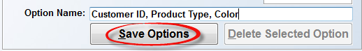

Click on the Save Options button to save it as a Quick Sort Option. If you choose to use the Quick Sort Options feature, once one or more of those options has been set up under a User ID, when you click on the drop down arrow in that field, the system will display a list of those options as follows:

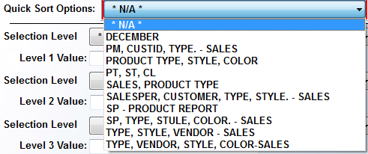

When you click on an option from the drop down list, the system will fill in the Selection Levels in the screen below as follows:

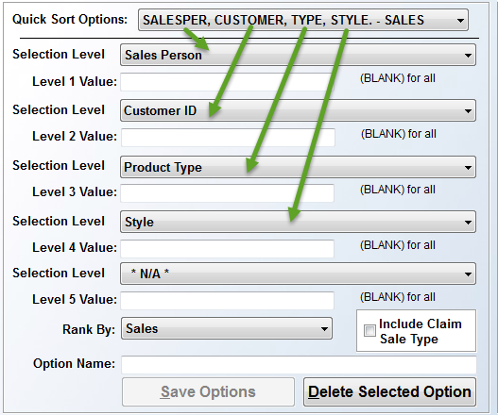

In the example above, the Quick Sort Option included Sales Person, followed by Customer ID, Product Type, and then Style. The Level Values were all pre-set to (BLANK) for all. The last Selection Level is blank because it was not programmed as part of the Quick Sort Option that was selected. However, you can create a Quick Sort Option encompassing all five levels if applicable. If you decide to make any changes to the fields above, you can click the Save Options button to make those options available in the future as another Quick Sort Option. The Rank By option will also be a part of the Quick Sort Options selection. When you are creating a new Quick Sort Option, be sure to set the Rank By as explained above. You can also use the Delete Selected Option button to delete a previously saved Quick Sort Option. To do this, you need to select the Quick Sort Option you wish to delete, and then click the Delete Selection Option button, located below the Option Name field. This will only apply to the options programmed for the current User ID.

Before you click on the Generate Screen button to view the system generated report data, you may wish to consider further customizing the report using the options on the right side of the screen. The first option appears along the top right as follows:

The default will be on the Date Range Selection option, allowing you to set or select a pre-set date range period. Because so many RollMaster customers have asked to see their data as a comparison to prior periods of time, two additional options have been added as follows: Compare range against prior period and Month Level Comparison. These two levels will be explained following the Date Range Selection option explanation. Below the Date Range Selection option, you will see a set of date range fields as follows:

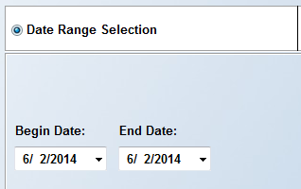

The Begin Date and End Date will default to the current date. Click on the drop down arrow keys in the Begin Date field to select an earlier beginning date. You can do the same for the End Date as well, if applicable. You can also click in these fields and type a date rather than scrolling through the calendar.

Once a beginning and ending date have been selected, you then have the option of saving date ranges by User ID, similar to the Quick Sort Options explained above. Once you set the date range, you will type a reference name in the Date Range Name field. It is important to note here that Date fields in this screen are “intelligent,” meaning that the day and month are static, but the year is dynamic. Therefore, if you wish to create and save Quarterly Date Ranges as a Date Range Name, the system will always use Current Year Data for each year. As another example, you can create a Date Range Name titled “Last Fiscal Year.” Using the example of 2014 as the current year, the date ranges to save would be Begin Date: 01/01/2013 and End Date: 12/31/2013. Once this is saved, the system will treat 2014 (current year as of the publishing of this documentation) data as the current year data until January of 2015, at which point the 2014 data will automatically be considered “Last Year.” The system will automatically do the same in 2015 and 2016, etc. An example of this setup appears below:

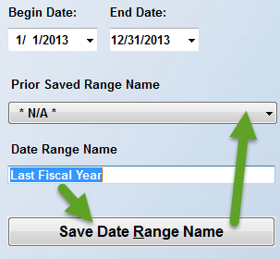

Once you click on the Save Date Range Name button, the Date Range Name will be added to the Prior Saved Range Name drop down menu. Thereafter, when you log in with your current User ID, you can click on the down arrow menu in the Prior Saved Range Name field to recall the “Last Fiscal Year” Date Range Name at any time. You can add multiple Date Range Names. To remove a saved Date Range Name from the Prior Saved Range Name drop down menu, select the desired item from the list. You will then have access to the Delete Selected Date Range Name button. Click the button to remove from the menu. Please Note: You are not required to create any saved date ranges, but these fields were designed to save you time when you need to print a variety of crucial report data for the same timeframes.
To the right of the Date Range Selection box, you will see an option to Compare range against prior period. The comparison options were added because many RollMaster clients found value in tracking trends in their salespeople, products, and customers, and these options provide a quicker and easier method for creating these type of reports. When you click on the Compare range against prior period option, the box below will highlight available options as follows:

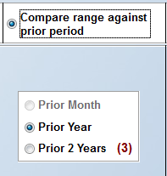

The system will default to the Prior Year option, which will generate a report including Prior Year data for the date range selected, if any exists. The other option is Prior 2 Years, which will allow you to compare data based on the past two years, if any exists, but will only allow you to view up to 3 columns of comparison data. When you click on the Prior 2 Years option, the (Columns Allowed) box (below and to the right of the Prior Year box) will prompt available column options as follows:

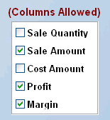

The default column options are Sale Amount, Profit, and Margin, however, you don’t have to use all three columns. For example, you may just wish to see “Sale Amount” on the report, in which case you can uncheck Profit and Margin. You can select any combination of up to three total options when you click the Prior 2 Years option. Please Note: the Prior Year option will display all of the columns listed in the (Columns Allowed) box. Although the system defaults to all five options selected, you can uncheck any, as long as you leave at least one checked. An example of the above scenario appears below when you click the Generate Screen button:

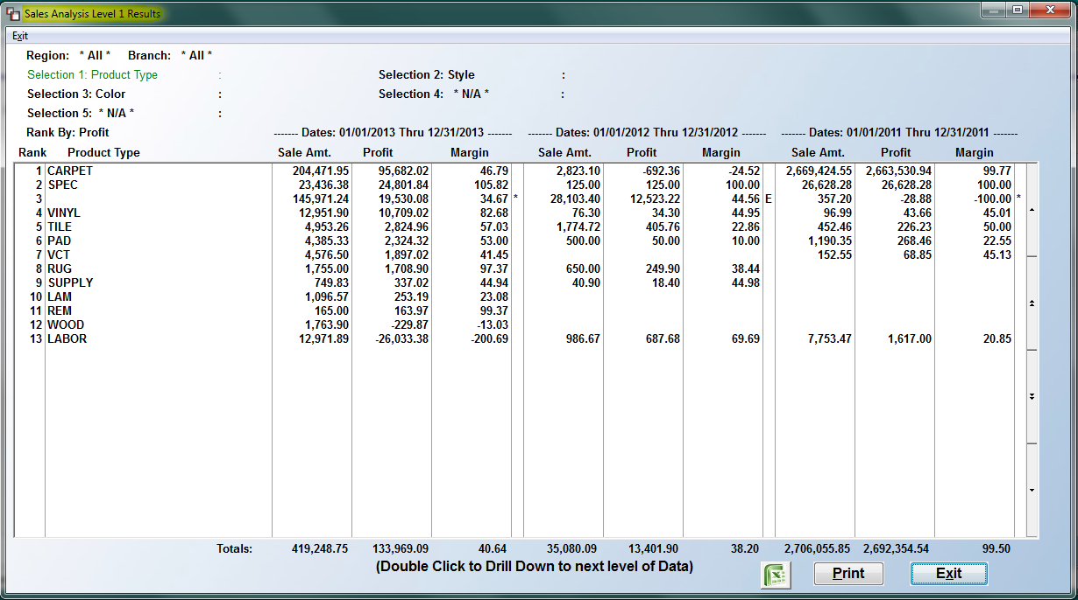

Please Note: The Sales Analysis Level 1 Results screen above will be explained in detail following the Month Level Comparison option below.

The third time period comparison option appears as follows: Month Level Comparison. When you click on this option, the fields below this option will become available as follows:

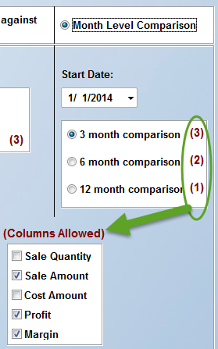

The default settings in this screen will be as they appear in the screen shot above. At the Start Date field, the first day of the current year will prompt, but you can change that date where applicable. The 3 month comparison report will allow you to view three columns of data for each of the co-current three-month period. You can select which three columns to view in the (Columns Allowed) box, just as you can with the “2 Year Prior” option, explained above. When you increase the number of months, the system will allow you to view fewer columns, but you can generate as many reports as you need by changing the data for each report. As you increase from 3 to 6 months, the system will automatically drop the Profit option in the (Columns Allowed) box, however you can switch out options if desired. You will first need to un-select an option and then the system will allow you to choose another for a total of two. As you increase from 6 to 12 months, the system will select only the Sale Amount default, but again, you can make a change by first un-selecting that option and selecting another.

Once you have made your selections in all applicable boxes of this screen, you can click the Generate Screen button at the bottom left of the main screen. The system will process your selections and then prompt the results in a Sales Analysis Level 1 Results screen as follows:

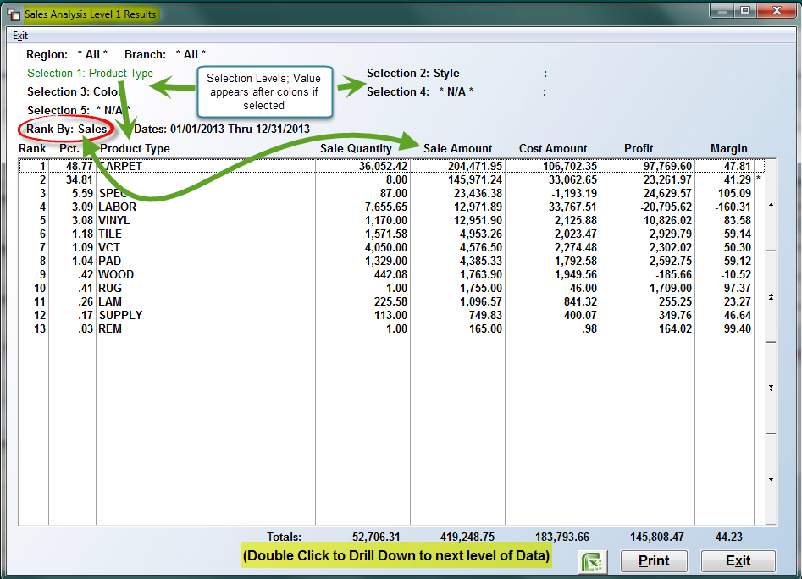
Please Note: When you generate data using the Date Range Selection option, the system will display a Percentage (Pct.) column in the Results screen--as in the example above--provided you select a Rank By option other than “None” or “Margin.” At the top left of this screen, the system will display all of the Selection Level choices from the main screen. The first screen to prompt will display the data for the first Selection 1 Level programmed. As each Selection Level displays in the screen above, it will be noted in green text at the top of this screen. The green text will update and display on the next level as you Double Click to Drill Down to next level of Data. To use the “drill down” feature, position the cursor in the row of the item for which you want to see the next level of data and double-click on the screen. For example, using the data in the screen shot above, if you position the cursor over the “CARPET” item and double-click, the system will display the programmed Selection 2 Level of data for “Style” as follows:

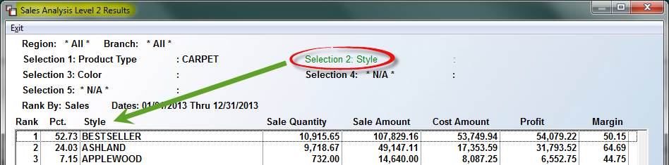

You can then double-click on the style “BESTSELLER” to view the programmed Selection 3 Level of data for “Color” as follows:

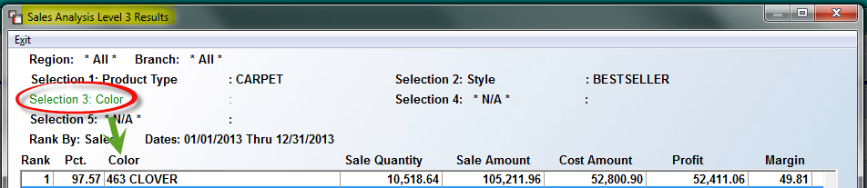

To return to the first screen, click the Exit button at the bottom right of any of the Results screens and the system will start you back at the Selection 1 Level so you can drill down on another item. If you click Exit from the original report screen—back at the Selection 1 Level—the system will return you to the main Sales Analysis screen. From there, you can make any desired changes and hit the Generate Report button to look at additional analysis, or exit the program. To print or export any of the report data to Excel, you must first hit the Generate Screen button, and then you will see those options at the bottom left of the Results screen as follows:

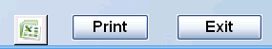

When exporting to Excel, a checkbox will appear the first time Excel is selected, to allow the user to create a “Flat File” for all data and all levels selected to export. When the box is checked, the system will read all the level “0” records and create an Excel file with the following: Selection 1 – Selection 1 Value; Selection 2 – Selection 2 Value, etc., up to the five possible data Selection Levels. Once the data is exported, the user will have the ability to work with the raw data for use in graphs, charts, etc. Also, the Excel export functionality has been updated to allow multiple flat files to be created without the user needing to exit the module and come back in each time. When the Excel icon button is clicked the first time through, the system will prompt the following Sales Analysis Options box:
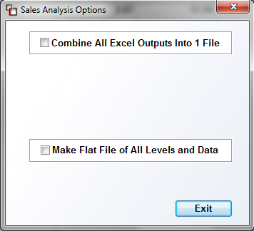
Once you make a selection in this box, it will remain the option until you exit the program and re-enter. The Combine All Excel Outputs option allows you to continue to generate various reports to Excel, with each one being added to a single file, instead of each output being separate. The Make Flat File of All Levels and Data option generates a report of all data to be output into the file. The file can then be used for Excel pivot tables and other analysis.
If you prefer to print to paper, when you click the Print option, the system will prompt the following Sales Analysis Options box:

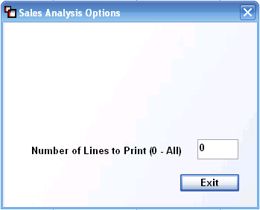

You can print a limited number of lines on each report rather than printing the entire report. If any number besides “0” is entered at this prompt, the report will print only that number of lines. The same option applies to Branch or Region reporting. No totals will appear where a number of lines has been selected. Please Note: Any jobs billed via the Progress Billing Invoicing module will display an “E” for Estimated in the far right corner of the Sales Analysis Level Results screens. This will indicate that cost and margin data is estimated and will not be finalized until the last invoice is processed on the job.

Special Note: If you select Region and/or Branch as your Selection 1 and/or 2, whether you are printing to paper or exporting to Excel, you will see additional options. Once you click to drill down on the Sales Analysis Level Results screen past the first Selection 1 and/or 2 screens, the system will prompt the following (in addition to the “Number of Lines to Print” option):
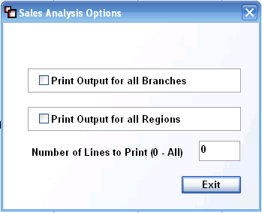

In the example above, the Selection 1 Level is “Region” and the Selection 2 Level is “Branch,” therefore, from the Selection 3 Level screen, which in this example is “Customer ID,” the system will prompt these options. If you select one, the other will automatically be disabled. These prompts will only appear in a scenario where Region or Branch sort options have been selected and you have drilled down to the second, third or fourth Sales Analysis Level Results screens.
Important Note: Some of the lengthier sales analysis comparison reports may not display the Print option. This is because the data is too lengthy for standard print settings and paper size and can only be fully viewed in the Excel format. This will be true for the 6 and 12 month data options. The Excel option will give you all the data, regardless of the number of months selected. If 12 months are selected, you will be able to see all five variables [the five variables are Sale Quantity, Sale Amount, Cost Amount, Profit and Margin] for all 12 months in your Excel document.

A couple of additional features of the Sales Analysis program can be accessed from the Functions drop down menu at the top left of the main Sales Analysis screen. When you click on the Functions menu, the following options will appear as follows:

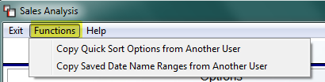

To save a considerable amount of time building your Quick Sort Options and Saved Date Name Ranges for each User ID, these two features were added so you can quickly copy current User ID saved options to another. To copy from another user, you must know the User ID and you must be logged into the system under the User ID to which you want to copy the saved data. When you click on either option, the system will display “User ID Copy box as follows:

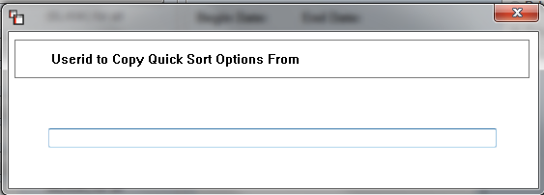

Type the User ID that contains the pre-built options and then hit enter. The system will copy the information over and then display a verification message as follows:

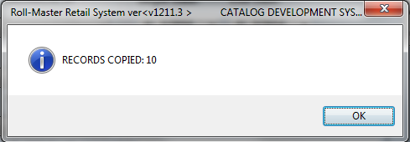

Click the OK button to continue. The new saved records will then be ready for use by the current User ID.

Master Lead Report (upgrade):
If your company has subscribed to the Lead Processing add-on module, you will then see the Master Lead Report in the Owner Functions Menu. This report provides detailed lead data on Written and/or Invoiced sales converted from the Lead Processing module. When you enter this report module, the system will prompt a Master Lead Report screen as follows:

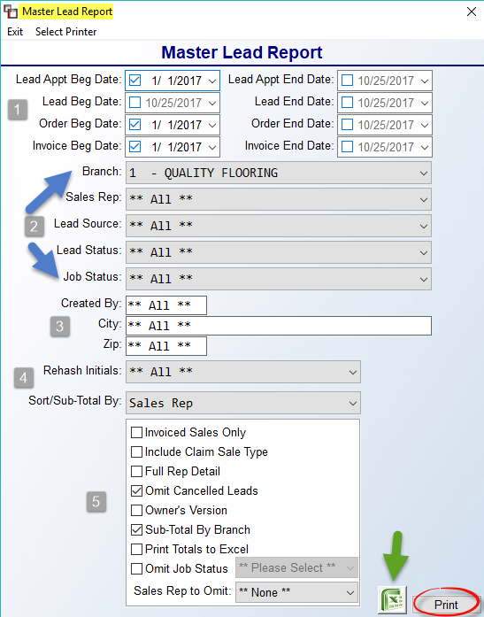

The settings in the screenshot above are the default settings for the report, however any of the fields can be accessed to customize the report. The Lead Appt Beg & End Date (1) fields pull from the Appt. Day/Time field in the Lead Maintenance screen, whereas the Lead Beg & End Date pulls from the Date Created field. The Order Beg & End Date fields and the Invoice Beg & End Date fields allow you to alter the report by these date ranges, or include all dates. Moving to the next section (2), at the Branch field, you can use the drop down arrow to select **All** Branches, or a different Branch. At the Sales Rep field, use the drop down arrow to select a specific Salesperson. The Lead Source (Territory Code) field will include all sources, but can be set to a specific source. The Lead Status field will allow you to print the report based on where Leads are in the conversion process, if desired. The Job Status field allows you to narrow the report by a Job Status Code.

The next three fields (3) are freehand, which means you need to type in exactly what you want to sort by. The Created By field is tied to the User ID of the person who entered the lead, not necessarily the Salesperson. The City and Zip fields will narrow the report by an actual City and/or Zip. At the Rehash Initials (4) field, use the drop down arrow to select a specific person assigned to try and re-vive a Lead that has not been converted. The Sort/Sub-Total By field determines how the lead data should be grouped and displayed. The default is Sales Rep, but some other choices include Branch, Lead Source, etc.

The bottom section includes (5) options to further customize the data on the report. The Invoiced Sales Only box, when checked, will exclude “Written” sales data. The Include Claim Sale Type, when checked, will add back in any Claims sales that were originally generated from a Lead. The Full Rep Detail box, when checked, will print one page per Salesperson and include one line of data per Lead. The Omit Cancelled Leads box will default to checked, but can be unchecked to include these Leads on the report. The Owner’s Version box will need to be checked in order to see true costs. The Sub-Total by Branch box will need to be unchecked if you don’t want to see the totals for each Branch listed on the report. The Print Totals to Excel box will need to be checked if you are exporting the report data and you wish to include totals. The Omit Job Status box can be checked to exclude a specific Job Status Code and includes a drop down menu for ease of selection. And finally, the Sales Rep to Omit option with a drop down menu will only allow selection of one Sales Rep. An example would be to omit a “House Account.”

On the printed report, you will see a column for Volume, which is a sales dollar amount based on what was selected: Written/Invoice/Both; # of Leads in the date range selected; # of Sales (converted Leads) in the date range selected; the RPL (Return Per Lead), which is the volume divided by total Leads; the Closing %, which is number of Sales divided by number of Leads; the Average Sale; and the Estimated Margin, which is derived from the Lead Baseline Margin % set up in the Branch Control 2 screen.

Once all fields have been set, click the Print button to print to paper, or click the Excel icon to export the data.

