
A DIVISION OF TEXTILE MANAGEMENT SYSTEMS
800-777-4107
info@rmaster.com

Table of Contents
Sales Analysis 1
Introduction: 1
Sales Analysis Program: 1
Quick Sort Options 5
Date Range Selection 7
Compare Range Against Prior Period 9
Month Level Comparison 11
Generate Screen 12
Estimated Progress Billing 15
Sales Analysis Options 16
Functions Menu 17

***CONFIDENTIALITY NOTICE*** This documentation contains confidential information belonging to Textile Management Systems, Inc. and RollMaster Software, which is protected by copyright laws and other privileges. This information is intended for the exclusive use of legally licensed RollMaster Software users. If you are not the intended recipient, you are hereby notified that any disclosure, copying, distribution, or the taking of any action in reliance on the contents of this information is strictly prohibited. If you have received this documentation in error, please immediately notify us by telephone at (800) 777-4107.

Sales Analysis

Introduction:
This module is designed to provide extensive tools for the management of Sales Analysis information within the RollMaster System. Please be aware that no information will report to this module until a Job is invoiced in the system. Thereafter, the User will be able to print sales reports on a range of items including Product Types, Yarn Types, Customer IDs, Vendors, etc. The information produced from the Sales Analysis module will prove invaluable to the User and can significantly improve the profitability and long-term success of a floor covering operation. Please Note: in order to have access to Sales Analysis for a specific Branch, the User must be set up in that Branch. Also, when a specific Branch is selected for Sales Analysis, the analysis data will display the Branch ID and Branch Name.

Sales Analysis Program:
This module is fast, simple to use, and very flexible. You will have the option to analyze up to five different analysis criteria at once. For example, you can get analysis for one or all Salespersons, for one particular Customer, on all Styles, and for all Colors, in a specific Ship To code. That is just one possible Sales Analysis scenario. If you are utilizing Region Reporting, you will have a total of 21 different analysis criteria for “All Regions” for which you can get Sales Analysis data, thereby creating potentially hundreds of different reports. If you are not using Region Reporting, you will have a total of 20 different analysis criteria for “All Branches.” You also can “Rank” the data by Sales, Profit, Margin, or Quantity, and use several Date Range options for short or long-term analysis. Please Note: If Region Reporting is enabled and you opt to select a specific Branch, the “Region” option will not be available for that report.
When you enter this module, the system will prompt a Sales Analysis screen as follows:

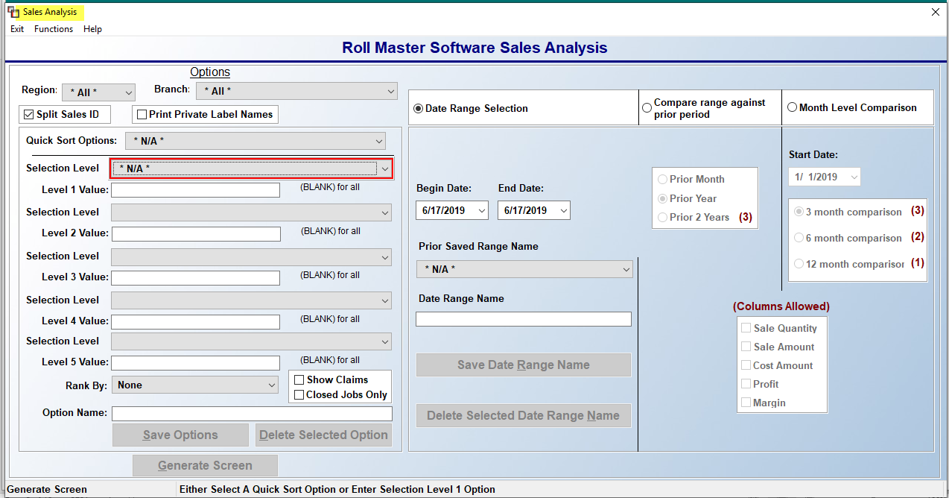

When you first enter the Sales Analysis screen, the cursor will be positioned in the Quick Sort Options (5) field as follows:

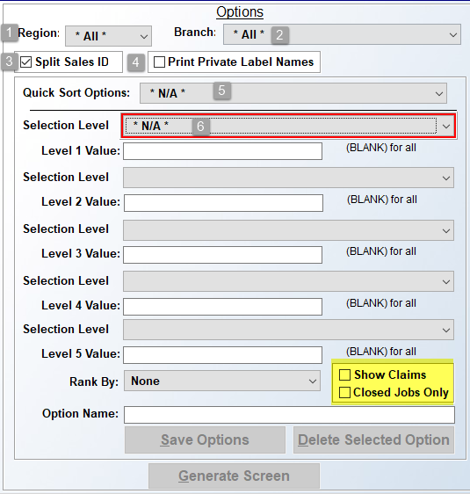

Please note that the Region (1) and Branch (2) fields just above the Quick Sort Options (5) field will default to “All” if Region Reporting is enabled in your system. If you wish to select a specific Region (1) or Branch (2), you should make that change before proceeding by clicking on the drop-down menu in those fields. The Split Sales ID (3) option will default to “checked.” This will prompt the analysis to split data between more than one Sales ID for reporting purposes. If you do not wish to use this feature, you can click the box to uncheck. To the right of the Split Sales ID option, you will see another option as follows: Print Private Label Names (4). This option will default to “unchecked.” If you check the box, the system will use the current Branch’s Private Label Name on the data display, unless Customer ID has been selected. If Customer ID is selected and Style and Style/Color selections are made under the Customer ID selection, and this box is checked, any Customer Private Label Names will prompt over the Branch Private Label Name.

Even though the cursor will be positioned at the Quick Sort Options (5) field, this feature can be bypassed. See the Quick Sort Options section below for further details on how to complete setup and utilize this option. When not utilizing the Quick Sort Option, you will need to choose each Selection Level by clicking the drop-down menu arrow, starting with the Select Option Level 1 (6) field. The system will prompt a list of all sales analysis data options as follows:
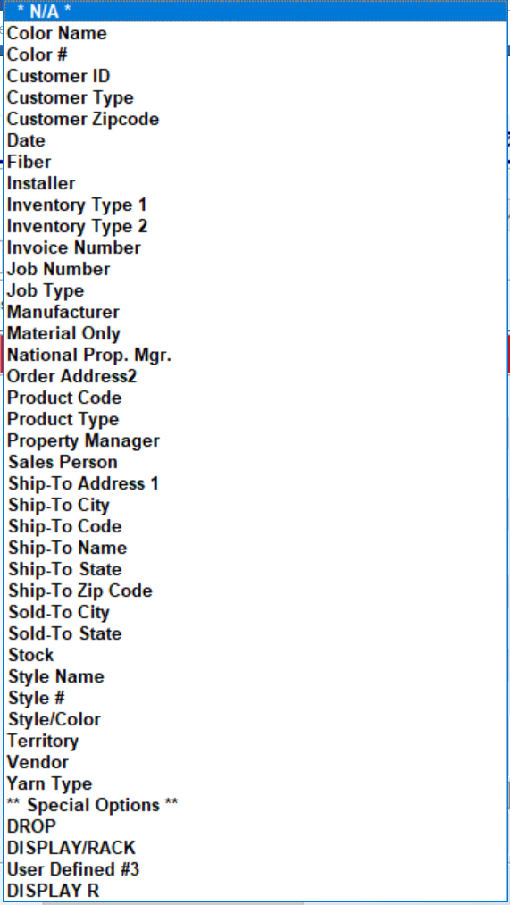
Please Note: If Region Reporting has been enabled in the system, you will see Region as the very last option in the drop-down menu. There are five Selection Levels of analysis criteria that can be viewed on any one report, but you only need to pick one to produce a report. Scroll through the list until the cursor is highlighted on the desired selection and hit enter to bring it into the Selection Level 1 (6) field. The selected item will appear in the Selection Level 1 field as follows:

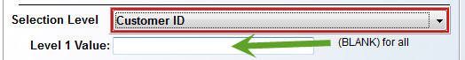

In the Level 1 Value field, you can type a specific value, such as a Customer ID, Color, Manufacturer, etc., or you can leave the Value fields blank to include all values within a selection level, i.e., all Customer IDs, or all Product Codes. You will not get a look-up option in any of these Value fields, so you will need to know that information ahead of time. Once you have completed programming the desired Selection Level fields, you will need to make a selection in the Rank By field. The following options are available from the drop-down menu in this field:

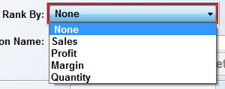

The Rank By options will allow you to sort your analysis report in order of top Sales, highest dollar Profit, highest profit Margin, highest Quantity, or None of these rankings. Make your selection to continue. The Show Claims option, in the box to the left of the Rank By field, was added to provide a quick way to include Claims sales on the report, when selected. As a reminder, in Job Type Maintenance, you have the option to designate a Job Type Code as a “Claims” code, which means that Claims sales are excluded by default from all Sales Analysis reports, unless that specific Job Type Code is a Value in one of the Selection Level fields. You should check this box prior to generating the report to include Claims sales in the analysis data. The Closed Jobs Only, when checked, will only include Closed Jobs on the report.

Quick Sort Options
Before continuing with generating a report, consider creating a Quick Sort Option.
This feature was designed to allow Users to pre-set specific Sales Analysis reports, such as By Sales Rep, Customer, and Product. Those three options together, or any combination of options, can be set up as Quick Sort Options in the drop-down menu, and will appear each time the User ID accesses this program. Once a series of Selection Levels has been selected (explained above), you can place the cursor at the Option Name field and type any name for the option as follows:

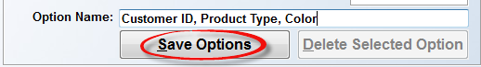

Click on the Save Options button to save it as a Quick Sort Option. If you choose to use the Quick Sort Options feature, once one or more of those options has been set up under a User ID, when you click on the drop-down arrow in that field, the system will display a list of those options as follows:

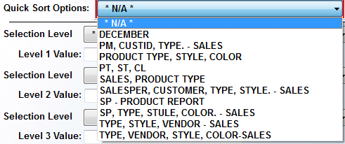

When you click on an option from the drop-down list, the system will fill in the Selection Levels in the screen below as follows:

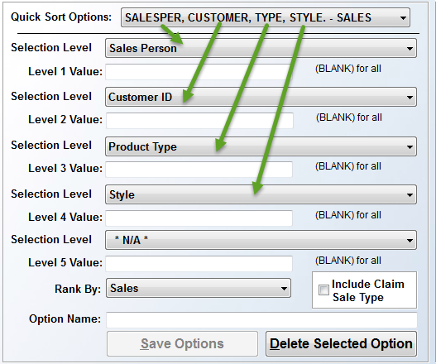

In the example above, the Quick Sort Option included Sales Person, followed by Customer ID, Product Type, and then Style. The Level Values were all pre-set to (BLANK) for all. The last Selection Level is blank because it was not programmed as part of the Quick Sort Option that was selected. However, you can create a Quick Sort Option encompassing all five levels if applicable. If you decide to make any changes to the fields above, you can click the Save Options button to make those options available in the future as another Quick Sort Option. The Rank By option will also be a part of the Quick Sort Options selection. When you are creating a new Quick Sort Option, be sure to set the Rank By as explained above. You can also use the Delete Selected Option button to delete a previously saved Quick Sort Option. To do this, you need to select the Quick Sort Option you wish to delete, and then click the Delete Selection Option button, located below the Option Name field. This will only apply to the options programmed for the current User ID.

Date Range Selection
Before you click on the Generate Screen button to view the system generated report data, you may wish to consider further customizing the report using the options on the right side of the screen. The first option appears along the top right as follows:

The default will be on the Date Range Selection option, allowing you to set or select a pre-set date range period. Because so many RollMaster customers have asked to see their data as a comparison to prior periods of time, two additional options have been added as follows: Compare range against prior period and Month Level Comparison. These two levels will be explained following the Date Range Selection option explanation. Below the Date Range Selection option, you will see a set of date range fields as follows:

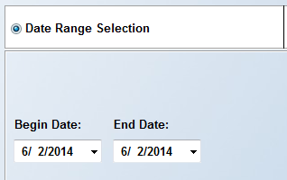

The Begin Date and End Date will default to the current date. Click on the drop-down arrow keys in the Begin Date field to select an earlier beginning date. You can do the same for the End Date as well, if applicable. You can also click in these fields and type a date rather than scrolling through the calendar.

Once a beginning and ending date have been selected, you then have the option of saving date ranges by User ID, similar to the Quick Sort Options explained above. Once you set the date range, you will type a reference name in the Date Range Name field. It is important to note here that Date fields in this screen are “intelligent,” meaning that the day and month are static, but the year is dynamic. Therefore, if you wish to create and save Quarterly Date Ranges as a Date Range Name, the system will always use Current Year Data for each year. As another example, you can create a Date Range Name titled “Last Fiscal Year.” Using the example of 2017 as the current year, the date ranges to save would be Begin Date: 01/01/2016 and End Date: 12/31/2016. Once this is saved, the system will treat 2017 (current year as of the publishing of this documentation) data as the current year data until January of 2018, at which point the 2017 data will automatically be considered “Last Year.” The system will automatically do the same in 2019 and 2020, etc. An example of this setup appears below:

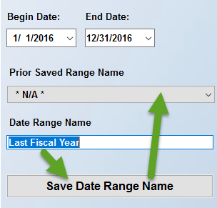

Once you click on the Save Date Range Name button, the Date Range Name will be added to the Prior Saved Range Name drop-down menu. Thereafter, when you log in with your current User ID, you can click on the down arrow menu in the Prior Saved Range Name field to recall the “Last Fiscal Year” Date Range Name at any time. You can add multiple Date Range Names. To remove a saved Date Range Name from the Prior Saved Range Name drop-down menu, select the desired item from the list. You will then have access to the Delete Selected Date Range Name button. Click the button to remove from the menu. Please Note: You are not required to create any saved date ranges, but these fields were designed to save you time when you need to print a variety of crucial report data for the same timeframes.

Compare Range Against Prior Period
To the right of the Date Range Selection box, you will see an option to Compare range against prior period. The comparison options were added because many RollMaster clients found value in tracking trends in their salespeople, products, and customers, and these options provide a quicker and easier method for creating these type of reports. When you click on the Compare range against prior period option, the box below will highlight available options as follows:

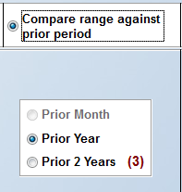

The system will default to the Prior Year option, which will generate a report including Prior Year data for the date range selected, if any exists. The other option is Prior 2 Years, which will allow you to compare data based on the past two years, if any exists, but will only allow you to view up to 3 columns of comparison data. When you click on the Prior 2 Years option, the (Columns Allowed) box (below and to the right of the Prior Year box) will prompt available column options as follows:

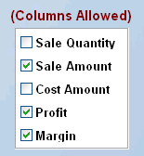

The default column options are Sale Amount, Profit, and Margin, however, you don’t have to use all three columns. For example, you may just wish to see Sale Amount on the report, in which case you can uncheck Profit and Margin. You can select any combination of up to three total options when you click the Prior 2 Years option. Please Note: the Prior Year option will display all of the columns listed in the (Columns Allowed) box. Although the system defaults to all five options selected, you can uncheck any, as long as you leave at least one checked. An example of the above scenario appears below when you click the Generate Screen button:

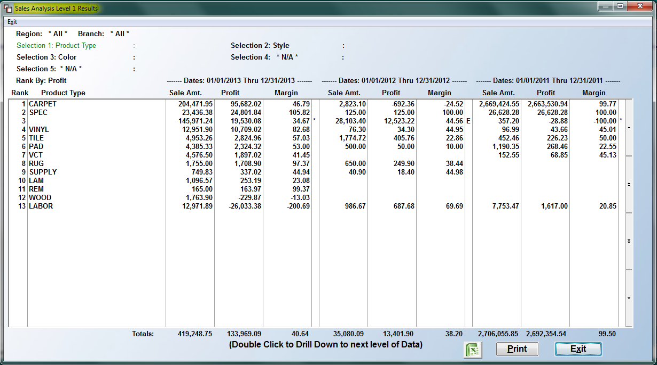

Please Note: The Sales Analysis Level 1 Results screen above will be explained in detail following the Month Level Comparison option below.

Month Level Comparison
The third time period comparison option appears as follows: Month Level Comparison. When you click on this option, the fields below this option will become available as follows:

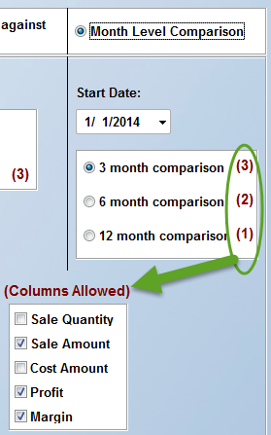

The default settings in this screen will be as they appear in the screen shot above. At the Start Date field, the first day of the current year will prompt, but you can change that date where applicable. The 3 month comparison report will allow you to view three columns of data for each of the co-current three-month period. You can select which three columns to view in the (Columns Allowed) box, just as you can with the 2 Year Prior option, explained above. When you increase the number of months, the system will allow you to view fewer columns, but you can generate as many reports as you need by changing the data for each report. As you increase from 3 to 6 months, the system will automatically drop the Profit option in the (Columns Allowed) box, however, you can switch out options if desired. You will first need to un-select an option and then the system will allow you to choose another for a total of two. As you increase from 6 to 12 months, the system will select only the Sale Amount default, but again, you can make a change by first un-selecting that option and selecting another.

Generate Screen
Once you have made your selections in all applicable boxes of this screen, you can click the Generate Screen button at the bottom left of the main screen. The system will process your selections and then prompt the results in a Sales Analysis Level 1 Results screen as follows:

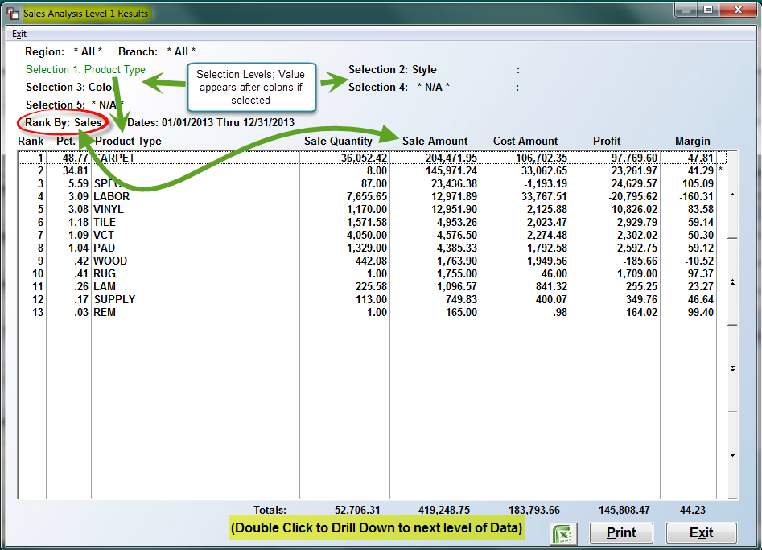

Please Note: When you generate data using the Date Range Selection option, the system will display a Percentage (Pct.) column in the Results screen--as in the example above--provided you select a Rank By option other than None or Margin. Also, where an Invoice Number or Job Number displays in the Results Screens, you can right-click on those numbers to View Job. The system will return you to the current screen after you view the Job.

At the top left of the screen above, the system will display all of the Selection Level choices from the main screen. The first screen to prompt will display the data for the first Selection 1 Level programmed. As each Selection Level displays in the screen above, it will be noted in green text at the top of this screen. The green text will update and display on the next level as you Double Click to Drill Down to next level of Data. To use the “drill down” feature, position the cursor in the row of the item for which you want to see the next level of data and double-click on the screen. For example, using the data in the screen shot above, if you position the cursor over the CARPET item and double-click, the system will display the programmed Selection 2 Level of data for Style as follows:

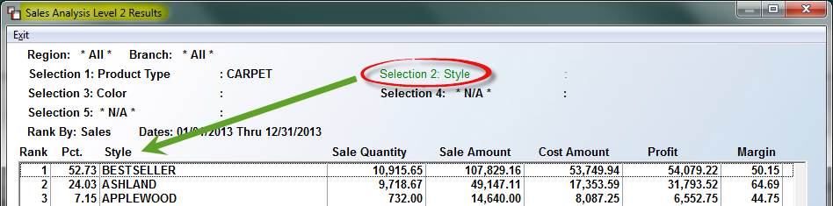

You can then double-click on the style BESTSELLER to view the programmed Selection 3 Level of data for Color as follows:

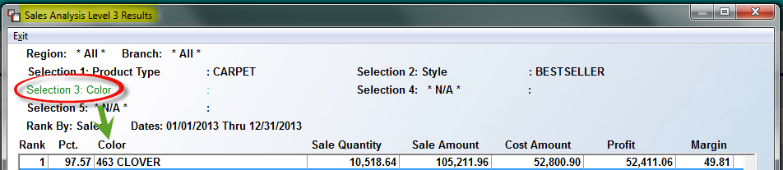

To return to the first screen, click the Exit button at the bottom right of any of the Results screens and the system will start you back at the Selection 1 Level so you can drill down on another item. If you click Exit from the original report screen—back at the Selection 1 Level—the system will return you to the main Sales Analysis screen. From there, you can make any desired changes and hit the Generate Report button to look at additional analysis, or exit the program. To print or export any of the report data to Excel, you must first hit the Generate Screen button, and then you will see those options at the bottom left of the Results screen as follows:

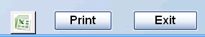

When exporting to Excel, a checkbox will appear the first time Excel is selected, to allow the user to create a “Flat File” for all data and all levels selected to export. When the box is checked, the system will read all the level “0” records and create an Excel file with the following: Selection 1 – Selection 1 Value; Selection 2 – Selection 2 Value, etc., up to the five possible data Selection Levels. Once the data is exported, the user will have the ability to work with the raw data for use in graphs, charts, etc. Also, the Excel export functionality has been updated to allow multiple flat files to be created without the User needing to exit the module and come back in each time. When the Excel icon button is clicked the first time through, the system will prompt the following Sales Analysis Options box:
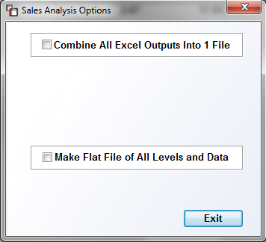
Once you make a selection in this box, it will remain the option until you exit the program and re-enter. The Combine All Excel Outputs option allows you to continue to generate various reports to Excel, with each one being added to a single file, instead of each output being separate. The Make Flat File of All Levels and Data option generates a report of all data to be output into the file. The file can then be used for Excel pivot tables and other analysis.
If you prefer to print to paper, when you click the Print option, the system will prompt the following Sales Analysis Options box:

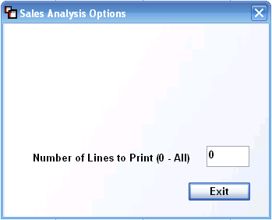

You can print a limited number of lines on each report rather than printing the entire report. If any number besides “0” is entered at this prompt, the report will print only that number of lines. The same option applies to Branch or Region reporting. No totals will appear where a number of lines has been selected.

Estimated Progress Billing
Any jobs billed via the Progress Billing Invoicing module will display an “E” for Estimated in the far right corner of the Sales Analysis Level Results screens as follows:

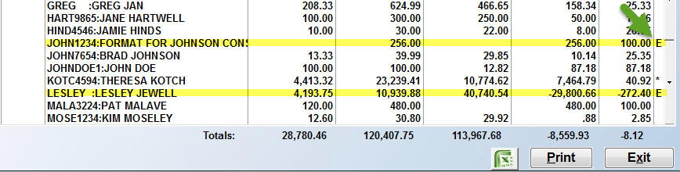

The E indicates that cost and margin data is estimated and will not be finalized until the last Invoice is processed on the job. Estimated Progress Billing data will not be meaningful for Line Item related analysis categories until the final Invoice is processed. These items include Color, Fiber, Manufacturer, Material Only, Product Code, Product Type, Style, Vendor, Yarn Type, and Special Options 1-4.

Sales Analysis Options
If you select Region and/or Branch as your Selection 1 and/or 2, whether you are printing to paper or exporting to Excel, you will see additional options. Once you click to drill down on the Sales Analysis Level Results screen past the first Selection 1 and/or 2 screens, the system will prompt the following (in addition to the “Number of Lines to Print” option):

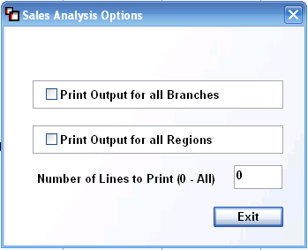

In the example above, the Selection 1 Level is “Region” and the Selection 2 Level is “Branch,” therefore, from the Selection 3 Level screen, which in this example is “Customer ID,” the system will prompt these options. If you select one, the other will automatically be disabled. These prompts will only appear in a scenario where Region or Branch sort options have been selected and you have drilled down to the second, third or fourth Sales Analysis Level Results screens.

Important Note: Some of the lengthier Sales Analysis comparison reports may not display the Print option. This is because the data is too lengthy for standard print settings and paper size and can only be fully viewed in the Excel format. This will be true for the 6 and 12 month data options. The Excel option will give you all the data, regardless of the number of months selected. If 12 months are selected, you will be able to see all five variables [the five variables are Sale Quantity, Sale Amount, Cost Amount, Profit and Margin] for all 12 months in your Excel document.

Functions Menu
A couple of additional features of the Sales Analysis program can be accessed from the Functions drop-down menu at the top left of the main Sales Analysis screen. When you click on the Functions menu, the following options will appear:

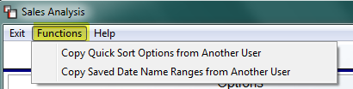

To save a considerable amount of time building your Quick Sort Options and Saved Date Name Ranges for each User ID, these two features were added so you can quickly copy current User ID saved options to another. To copy from another User, you must know the User ID and you must be logged into the system under the User ID to which you want to copy the saved data. When you click on either option, the system will display a “Userid to Copy…” box as follows:

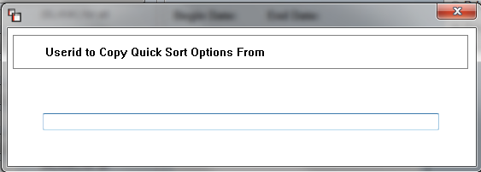

Type the User ID that contains the pre-built options and then hit enter. The system will copy the information over and then display a verification message as follows:

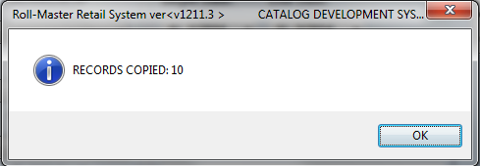

Click the OK button to continue. The new saved records will then be ready for use by the current User ID.

