

Table of Contents

Accounts Payable 1
Introduction: 1
Vendor Maintenance: 1
Vendor Status Inquiry: 14
Open Item Maintenance: 15
Payment Selection: 43
Check History: 51
Hand Check/Void Check Processing: 53
Bank Reconciliation: 58
A/P Recurring Items: 75
Delete “*” Vendors With No Activity: 79
A/P End of Month Processing: 80
Vendor Type Maintenance: 81
A/P Reports -- Menu 1 of 2 84
Introduction: 84
Vendor Listing: 84
Vendor Reference List: 85
Vendor Mailing Labels: 86
Open Items Adjustment Register-Daily Report: 87
Open Item Aging Report: 88
Open Invoice Listing: 89
Open Invoice Listing – BY PERIOD: 91
Invoice History Listing: 91
Items Selected For Payment Listing: 92
Vendor History by G/L Account: 93
Inventory Cost Change Report: 94
Open Item Audit Report: 95
A/P Reports -- Menu 2 of 2 96
Print Checks: 96
Print Electronic Payment Report: 100
Check Register: 101
Check Register History: 103
Print A/P Form 1099: 104
Print Cash Requirements Report: 106

***CONFIDENTIALITY NOTICE*** This documentation contains confidential information belonging to Textile Management Systems, Inc. and RollMaster Software, which is protected by copyright laws and other privileges. This information is intended for the exclusive use of legally licensed RollMaster Software users. If you are not the intended recipient, you are hereby notified that any disclosure, copying, distribution, or the taking of any action in reliance on the contents of this information is strictly prohibited. If you have received this documentation in error, please immediately notify us by telephone at (800) 777-4107.

Accounts Payable

Introduction:
In the Accounts Payable (A/P) menu, you will find all modules relating to the management of Vendor accounts, outstanding payables, check processing, and A/P reports, etc. In the RollMaster System, Invoices/Credit/Debit Memos should be entered in the system as soon as they are received from Vendors. When an Invoice is entered, it is verified against the system Purchase Order to catch Vendor overbilling or correct internal pricing errors. Also, job costs are automatically updated at the same time, along with other integrated areas of the system such as commissions, sales analysis, etc., when cost changes are made. There are also two report menus accessible from the Accounts Payable menu containing useful reports for the accounting and management departments.

Vendor Maintenance:
This is a set-up module that must be completed prior to going “live” on the RollMaster System—thereafter, this module will be used to add new vendors and edit the system vendor database. All Vendors with a balance due at the time the RollMaster System is installed must be entered in this module along with all Installers who are independent contractors. This is necessary so that your “Beginning Payable Balances” can be entered in the system through the A/P Open Item Maintenance module (explained below). When you enter the Vendor Maintenance module, the system will first prompt a Vendor Selection box as follows:
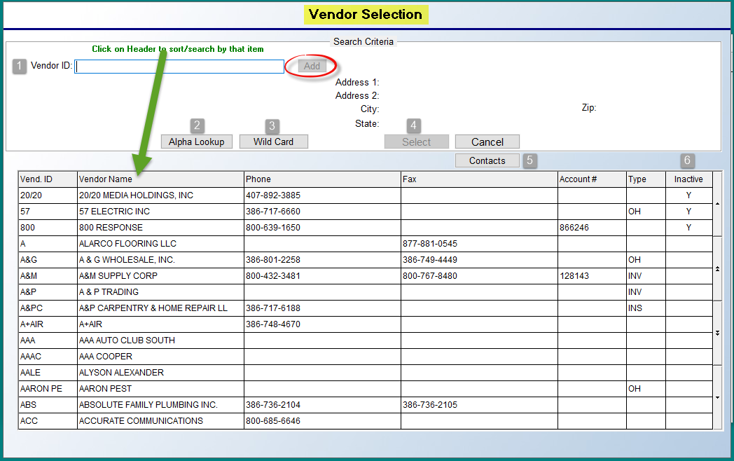
This box will prompt any existing vendors in your system. Please Note: This Vendor Selection box will appear anywhere you are asked to enter a Vendor ID. You can also add Vendors from other modules using this box as described here. See instructions below for adding new vendors. At the Vendor ID -1- field, to search for an existing vendor, begin typing the first couple of letters of the vendor name. As you type, the list of Vendors below will begin sorting to display the first occurrence of those letters in the list. You can also click on any of the Header sections to search by Phone, Fax, etc. When you see the desired Vendor, click on that line to prompt that Vendor in the Vendor ID field. The Select -4- button will then become enabled. Click the Select button to continue to the Vendor Maintenance screen to view/edit the data for that Vendor. Another search mechanism is the Alpha Lookup -2- button. When you click this option, the system will prompt a Vendor Alpha Key Look-Up box as follows:

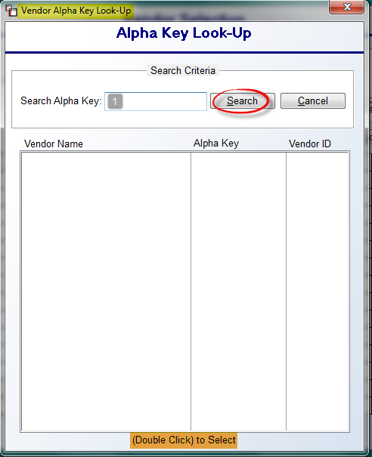

Type the first couple of characters for the Vendor in the Search Alpha Key -1- field, and then click the Search button. The system will display any matches in the screen below by Vendor Name, Alpha Key, and Vendor ID. Double-click the Vendor line item to select. The system will return the cursor to the Vendor Selection box, displaying the selected Vendor in the Vendor ID field. You can then click the Select button in the Vendor Selection box to continue to the Vendor Maintenance screen. Another search method is the Wild Card -3- option. You must first type a couple of searchable characters in the main search field and then click the Wild Card button. The system will display any occurrence of those characters it finds in a Wild Card Vendor Selection screen for you to make a selection.

There are a couple of additional features you need to be aware of in the Vendor Selection box. This includes the Contacts button and the Inactive field. The Contacts -5- button prompts an A/P Vendor Contacts box that displays a listing of important contacts with the current Vendor selected, along with information on how to reach them. This is a Read-Only screen when accessed from the Vendor Selection box. Instructions on adding/editing/deleting Contacts is explained below under the Adding a New Vendor section. The Inactive -6- column that appears to the far right of each Vendor name will display a “Y” if a Vendor has been set to Inactive in the Vendor Maintenance screen. Inactive Vendors will always display in the Vendor Selection box throughout the system, but you will not be able to access those Vendors from any Accounts Payable, Purchase Orders, or Inventory Control programs. They can only be accessed from the Vendor Maintenance module (explained below).

Adding a New Vendor:
When adding a new Vendor, begin typing a Vendor name or code in the Vendor ID field at the top left of the Vendor Selection box. It is recommended that you use characters for Vendor names rather than numbers to make lookup easier. You can use up to eight characters, but keep the ID as simple as possible so it will be easy to remember and lookup in the various A/P modules. For example: for MOHAWK we suggest MOHAWK; for SHAW we suggest SHAW. Try to avoid using symbols or spaces, as they can create confusion in the lookup process. The Vendor ID’s for Installers need to be typed in exactly as they appear in the Installer Maintenance module or vice versa. (You should review that section of the manual prior to adding subcontractors in the Vendor Maintenance module.)
As you type a name, the system will begin sorting through the list of existing IDs in the box below. Always check first to see if the Vendor ID currently exists before adding a new Vendor. If the system does not find a matching ID, click the Add button to continue. The system will prompt the following:
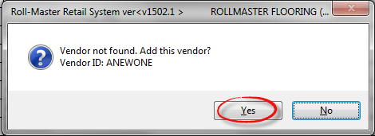
Click the Yes button to continue adding the Vendor. To edit an existing Vendor, select the Vendor from the list by highlighting the Vendor ID and clicking the Select button at the top of the box or by double-clicking on the ID. The system will display a Vendor Maintenance screen as follows:
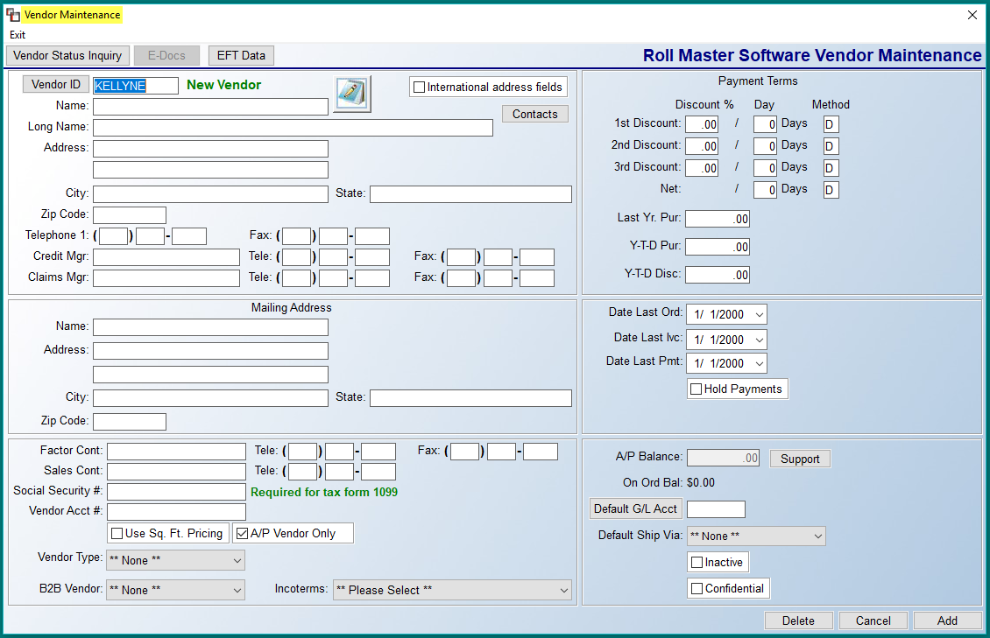

At the very top left of the screen are three buttons that will only apply to existing Vendors in the system, not new Vendors. The first two allow access to other modules. The Vendor Status Inquiry button will take you to that module where you can perform an inquiry for a Vendor, or add/edit Vendor Notes, and then return to this screen. The same goes for the E-Docs button, provided your company subscribes to the E-Docs functionality. These buttons can be used at any time from within this screen after a Vendor has been added and saved. The EFT Data button will only appear where the User Control 6 option, Allowed To Edit Vendor EFT Data, is set to “Y” for yes. This feature will be explained below following steps for adding a new Vendor. Also, for complete instructions on using the Electronic Funds Transfer functionality in RollMaster, you can find an article in our Help Desk, as well as a section in our Accounts Payable manual under Payment Selection. Email support@rmaster.com for additional assistance.

When adding a new Vendor, the top left panel of fields will appear as follows:

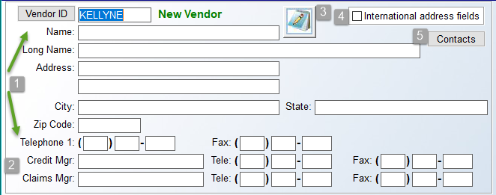

At the Name -1- field, type in the complete Vendor name. For example: SHAW INDUSTRIES, INC. The Long Name field can be used for longer Vendor names. The Address, City/State, and Zip Code fields should be used to capture the physical street address for the Vendor, or the address from which material will ship. This address will appear in the Purchase Orders system. Use the Telephone 1 field to record the main number for the Order Department. This number will also appear in the Purchase Orders system. You can also record a Fax number for the Vendor order department, if applicable. The Credit Manager, Tele, and Fax -2- fields can be used to record the name, telephone, and fax number of the credit manager for this Vendor if applicable. It is not a required field of entry and can be skipped. You should review the Contacts button info below and consider using that feature instead. The same goes for the Claims Mgr fields. The Vendor Notes icon -3- button can be used once a Vendor has been added to the system. The Vendor Notes feature can be found and accessed throughout the Accounts Payable system, and any Notes for a Vendor added from anywhere in the system will appear the same in all applicable modules. You can add up to 99 pages of Vendor Notes in the system for each Vendor. When more than one page of notes has been added, the system will display the most current page first.

If a Vendor is located outside of the U.S., you can click the International address fields -4- box to display international-specific address/phone fields to properly add that info in the system. The Contacts -5- button prompts a feature that has been added to allow you to begin building a database of various Contacts (people with important Roles) for each Vendor. The data does not currently appear on a system report, but programming is moving in that direction. For example, you can enter contact information for the Credit Manager, Marketing Manager, and multiple Sales Associates. Once that data is entered, it can then be viewed via the Vendor Selection box (explained above) from various other places in the system. When you click the Contacts button, the system will prompt an A/P Vendor Contacts screen as follows:

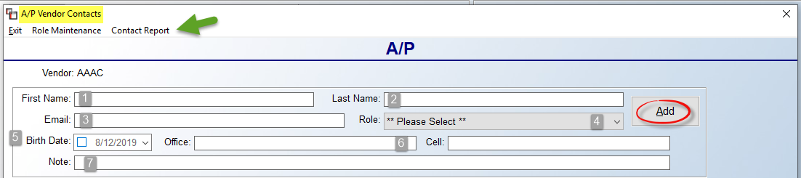

Type the First Name -1-, Last Name -2-, and Email -3- address of the contact, and click the drop-down menu at the Role -4- field to select a Role Code (you can add additional Role Codes via the Role Maintenance option, explained below). Please Note: You can use upper and lower case letters in this feature. If applicable, click the box in the Birth Date -5- field and then select a birth date using the drop down calendar menu. Record both an Office and Cell phone number -6- in the fields provided. And finally, use the Note -7- field to add any additional notes relating to this A/P Contact. Click the Add button to save the Contact. Once a Contact has been added, you can highlight the name in the screen below and then Right-Click to Delete or Edit the data. You can also Double-Click on a Contact to call up the Edit Contact box. Existing Contacts will appear as follows:

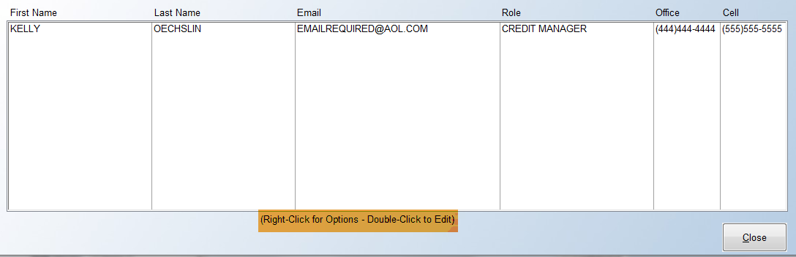

To add a new Role Code, other than the three pre-set Roles, click the Role Maintenance option at the top left of the A/P Vendor Contacts screen. The system will prompt a Role Maintenance selection box as follows:

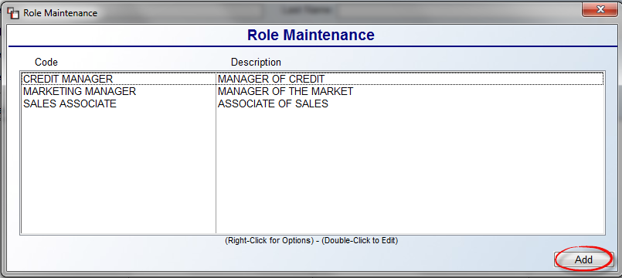

Click the Add button at the bottom right to add a new “Role.” The system will prompt a second Role Maintenance setup box as follows:

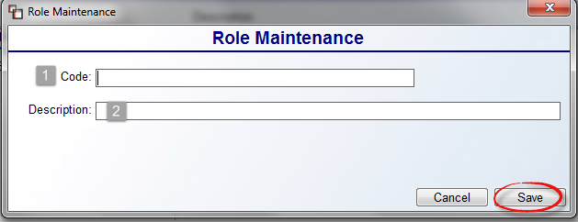

Type a Code -1- and Description -2- for this Role and click the Save button to store the record. You can continue adding “Roles” or return to the A/P Vendor Contacts box to add new contacts. Next to the Role Maintenance option is another option that appears as follows: Contact Report. Once Contacts have been added, you can export a list, including all fields, to Excel for either the current Vendor, or all Vendors by clicking on this option. A A/P Contact Report box will appear as follows:

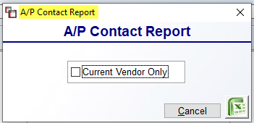

Click in the Current Vendor Only box to only export for the current Vendor.
The next series of fields in the Vendor Maintenance module appear as follows:

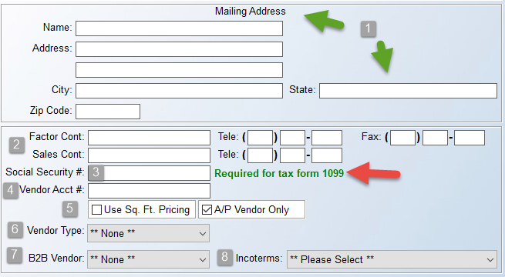

The Mailing Address -1- fields will automatically prompt the address data entered in the fields above. If the billing name and/or mailing address for the Vendor is different, type over that data with the applicable Mailing Address info. For example, many Vendors have a P.O. Box they want payments mailed to, and in some cases, you may pay a Factor instead of the Vendor. Also, the Mailing Address information will prompt in the Vendor Mailing Labels report module and print on system checks. At the Factor Cont -2- fields, if you pay a Factor instead of the Vendor, you can enter the name of a contact person at that business, along with their telephone and fax number. The Sales Cont field is for recording the salesperson’s name and number, but the Contacts feature (explained above) is a better method for recording that data.

The Social Security # -3- field is used primarily for independent contractors, but can be used to record Tax ID #’s for any Vendor in order for the system to keep track of 1099 data. The system prints Form 1099s through the Print A/P Form 1099 report module located in the A/P Reports Menu 2 of 2. Please Note: Programming for IRS Backup Withholding to 1099 has been completed for Phase 1. Setup needs to take place in Installer Maintenance and Vendor Maintenance. Backup Withholding fields/columns have been added to Print Checks and Check History. In Vendor Maintenance, when setup is complete in Installer Maintenance and a valid Social Security # has been added, two new fields will appear to the right of that field as follows:
The IRS Backup Withholding checkbox must first be checked, and then the Withholding Percent field will default to 24%, but is accessible to change if/where applicable. All applicable Accounts Payable modules have been updated to track and display this data, including Payment Selection, Check Print, Check Register/History, View Check History, and Print A/P Form 1099.

In the Vendor Acct # -4- field, type the Vendor’s account number. This field will appear in the Purchase Orders system. At the Use Sq. Ft. Pricing -5- checkbox, only check this option for Vendors that issue pricing by the square foot on roll goods, and where this is not the case for All Vendors. The A/P Vendor Only -5- checkbox determines whether a Vendor can be paid by Credit Card from that module or whether a Vendor can only be paid by a company check. Check this box to remove the option to pay this Vendor by Credit Card. The Vendor Type -6- field is tied to the Vendor Type Maintenance module in the Accounts Payable Menu. Vendor Types must be set up before you can utilize this field. Only create Vendor Types and utilize this field if you would like to separate your Vendor Listing by type and/or if you require specialized 1099 Form printing. This feature was created for customers wanting to provide their insurance companies with a list of Vendors broken down by type such as installer, lessor, vendor, etc. Also, there are various other Accounts Payable modules that will allow you to sort by Vendor Type when searching for or printing data. The B2B Vendor -7- field will only apply to RollMaster users who have subscribed to the B2B Functionality. If this is the case, then for all vendors importing B2B data into your system, you will need to enter to this field and use the drop-down menu to select the corresponding B2B Vendor. This is necessary to properly match imported billing records. The Incoterms -8- field will only be used by customers who import/export with other countries. Incoterms are a set of rules which define the responsibilities of sellers and buyers for the delivery of goods under sales contracts. Shippers worldwide use standard trade definitions (called Incoterms) to spell out who’s responsible for the shipping, insurance, and tariffs on an item; they’re commonly used in international contracts and are protected by International Chamber of Commerce copyright. Incoterms significantly reduce misunderstandings among traders and thereby minimize trade disputes and litigation. If these terms apply to a Vendor, you can set a default here that will flow through to Purchasing and Bill of Lading.

The next set of fields appear at the top right of the Vendor Maintenance screen as follows:
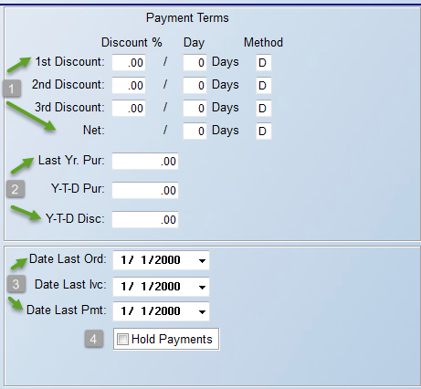

In the Payment Terms -1- section, you have the option of entering three sets of discount terms along with a Net due date in these fields. These fields will be used to determine the discounts available and the due date of Vendor Invoices when they are entered in the system—this information can be easily overridden when an Invoice is added and again when an Invoice is paid. In the 1st Discount / Discount % field, enter the best discount percentage available from this vendor in whole numbers, e.g., “5” for 5%. In the Day column, enter the number of days allowed for this discount, e.g., “15” for 15 days. The Method field will default to “D” for days. Hit enter to accept or change to “P” for Prox., e.g., 2% 10th next month. Follow the same steps for the next six fields to enter your second and third set of terms for this vendor if applicable. If none apply, simply enter through these fields and leave them blank. In the Net / Day field, enter the normal Net Days offered by the Vendor.

The next series of -2- fields will automatically update based on new activity in the system. However, starting out, at the Last Yr. Pur field, you can add that info if you know the total amount of purchases made from a Vendor the previous year. This field will automatically update during A/P EoY processing. The same goes for the Y-T-D Pur field. If you know the total amount of purchases made from a Vendor during the current year, you can type that figure here. This field will automatically update via the Open Item Maintenance module as Invoices are entered in the system, and will be zeroed out during A/P EoY processing. And finally, at the Y-T-D Disc field, if you know the total amount of discounts earned from a Vendor during the current year, you can type that figure here. This field is automatically updated via the Print Checks modules and is zeroed out during A/P EoY processing.

The next three date -3- fields will also automatically update based on new activity in the system. When adding a new Vendor, at the Date Last Ord field, if you know the date you last placed an order with the Vendor, enter it in this field. This field is automatically updated via the Purchase Orders system. At the Date Last Ivc field, if you know the date of the last Invoice for a Vendor, enter that date in this field. This field is automatically updated through the Open Item Maintenance module. And finally, at the Date Last Pmt field, if you know the date of the last payment you made for a Vendor, enter that date in this field. This field is automatically updated via the Print Checks modules.

The Hold Payments -4- field should only be checked if you need to hold ALL payments to a Vendor for some reason. If checked, the system will not allow selection of any Open Items in the Payment Selection module and a “HOLD” status will appear for the Vendor on the Open Invoice Listing report.

The remaining fields in the Vendor Maintenance screen appear at the bottom right as follows:
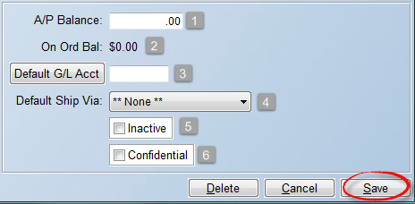

The A/P Balance -1- field is updated through the Open Item Maintenance module. It will reflect the current balance owed to the Vendor. It can be accessed to enter a beginning balance on a Vendor, or make adjustments. The On Order Balance -2- field is updated through the Purchase Orders System. It will reflect the current balance of open P.O.’s to the Vendor. This field is view-only and cannot be accessed from this screen.

At the Default G/L Acct -3- field, you can set a default General Ledger Account number that will automatically pop up in the Open Item Maintenance module when you enter an Invoice for the Vendor. This default can be overridden if you need to make a change for any reason, or if the Vendor relates to more than one G/L Account depending on what is being purchased. To select a G/L Account, click on the Default G/L Acct button to prompt a G/L Account Selection box. The Default Ship Via -4- field allows you to tie assign a Default Ship Via Code that will automatically prompt on PO Lines for the Vendor. If you do not wish to set a default, leave the **None** setting at this field. Click in the Inactive -5- box only if you wish to stop using a Vendor. This will “drop” a Vendor from the active list without losing any history. The final -6- field, Confidential, will only appear in this screen if it has been enabled for a User in the User Control 5 screen. If checked, this Vendor will be considered “Confidential” in the system, and any User not allowed to view “confidential” Vendors will not see these Vendors in the A/P Open Item Maintenance module.

Once all selections have been made, click the Save button to keep the Vendor or save any changes. To eliminate a Vendor from the system entirely and leave no history, you will use the Delete button at the bottom right of the screen. Please Note: If you have used the Vendor ID in the system, you should not Delete the data record from the system. The only information you cannot change once a Vendor has been added in the system is the Vendor ID—the other information can be changed if applicable, and the Inactive option will preserve history if you are no longer doing business with the Vendor.

To set up EFT Data info for a Vendor in order to electronically transfer funds for payment, you will need to click the EFT Data button at the top left of the Vendor Maintenance screen for an existing Vendor. When you click this button, a Vendor EFT Data Maintenance box will appear as follows:
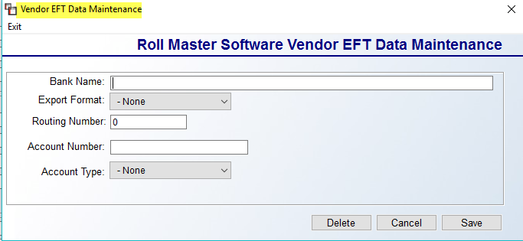
Complete the Banking setup information in the fields provided and click the Save button to keep the data. You will also need to complete some setup in the G/L Account Maintenance/Inquiry module for EFT Banking Account Numbers. Please see the General Ledger section of the manual for those details, or the section below under Payment Selection titled EFT System Setup.

Vendor Status Inquiry:
This module will allow you to view all the open items on a Vendor’s account along with the total amount owed to the Vendor. It will become a very useful module for the accounting department to quickly view Vendor payable information. When you enter this module, you will first see the Vendor Selection Box (described above) to assist with selecting a Vendor. Once a Vendor has been highlighted and selected, the system will display a Vendor Status Inquiry screen for the selected Vendor as follows:

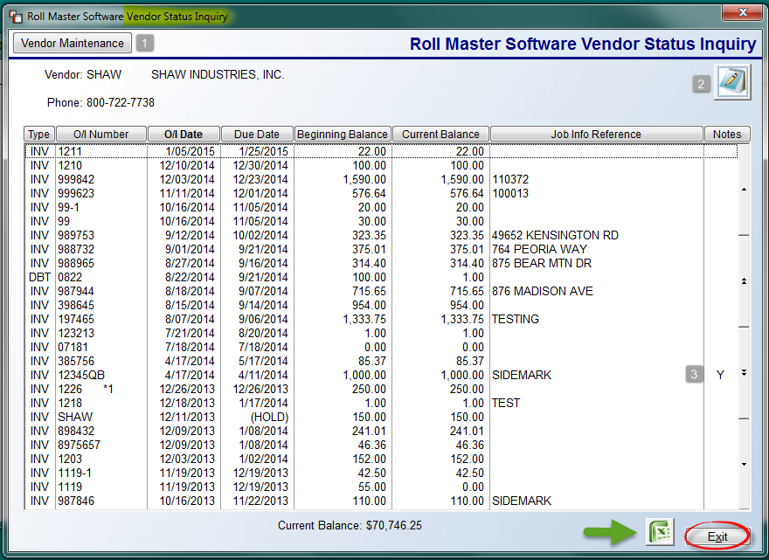

At any point from within this screen, you can click on the Vendor Maintenance -1- button to jump over to the Vendor Maintenance module. When finished, the system will return you to this screen. If you need to add/edit/view Vendor Notes, click the Notes -2- icon at the top right of the screen at any time. The items in the screen listed above are sorted by the newest date to oldest date in the O/I Date field. You can click on any of the Column Headings to change the sort, including clicking on the O/I Date field to reverse the sort. Once the data is sorted, you can right click on any item to call up two options: Invoice Notes and Set/Release Hold (see explanation below). The Invoice Notes will allow you to add Invoice/Open Item-specific notes to any item. A “Y” in the Notes -3- column (displayed above) indicates that Invoice Notes exist on an item.

From within this module, you can place a Hold on an open item in the system that you do not wish to pay because of a claim or dispute with the Vendor. When an open item is on a “Hold” status, the system will not allow it to be pulled up in the Payment Selection module or to print on the Cash Requirements Report. (Please Note: If an item has already been selected for payment, this feature will not prevent a check from being printed. The item should be deleted from the Payment Selection module first.) To place a HOLD on an item, click the Set/Release Hold option. The system will prompt a message that the hold has been placed, and you will then see (HOLD) displayed in the Due Date column for that item as follows:
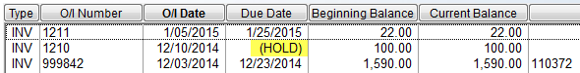
To Release the Hold, right-click and select the option again and the system will prompt a message that the hold has been released and the Due Date will return to the actual date. One final option in this screen is the ability to Print to Excel while in the screen above. Click the Excel icon button at the bottom right to initiate this process. The Exit button will return you to the Vendor Selection screen.

Open Item Maintenance:
The Open Item Maintenance module is a set-up module that must be completed before going “live” on the RollMaster System. Thereafter, this module will be used to enter all Vendor open items (Invoices, Debit Memos, and Credit Memos) in the system, with the exception of B2B open items, as these will automatically import, as explained below. Prior to going live on the system, you must enter all of your beginning payables, item by item. As such, the set-up for this module involves entering all existing Vendor open items received prior to going “live” on the RollMaster System. Entering each open item puts history in the system so that you can keep track of your old as well as your new A/P Balances from the same place.

The Open Item Maintenance module is tied directly to the system General Ledger (G/L). Therefore, any information that is entered through this module will update the General Ledger. (This is not an instant process—after specified daily reports are run, there is a module in the General Ledger Reports menu titled Print Journals/Update General Ledger that needs to be run in order to send information to the General Ledger.) When you enter an open item in this module, the system will automatically send a debit or credit—depending on the item type—to the Accounts Payable G/L Account number. You will need to do the opposing entry (see directions below). For all Beginning A/P Balances, you will take the opposing entry to a Prior Purchases account so that you can check the totals and then perform a reversing entry once all beginning items have been entered. Once all Beginning A/P Balances have been entered, print an Open Invoice Listing and compare that report to your old system to make sure all open items were entered properly and the report total matches your A/P Balance in your old system.

The following documentation covers the use of the Open Item Maintenance module and additional capabilities. If you are a current RollMaster B2B subscriber, there is additional functionality with some initial setup that will be explained in the section below titled “Initial Setup for B2B Subscribers.”

Manually Enter Invoice:
The following instructions detail how you will enter a non-B2B Invoice. When you enter this module, you will first see the Vendor Selection Box (described above) to assist with selecting a Vendor. Once a Vendor has been highlighted and selected, the system will prompt a Select Option menu as follows:

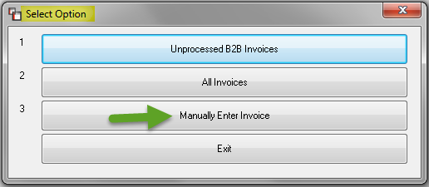

For the purposes of this section, we will go directly to the Manually Enter Invoice option; the other two options will be explained following this section. The system will next prompt an A/P Open Item Final Entry screen as follows:

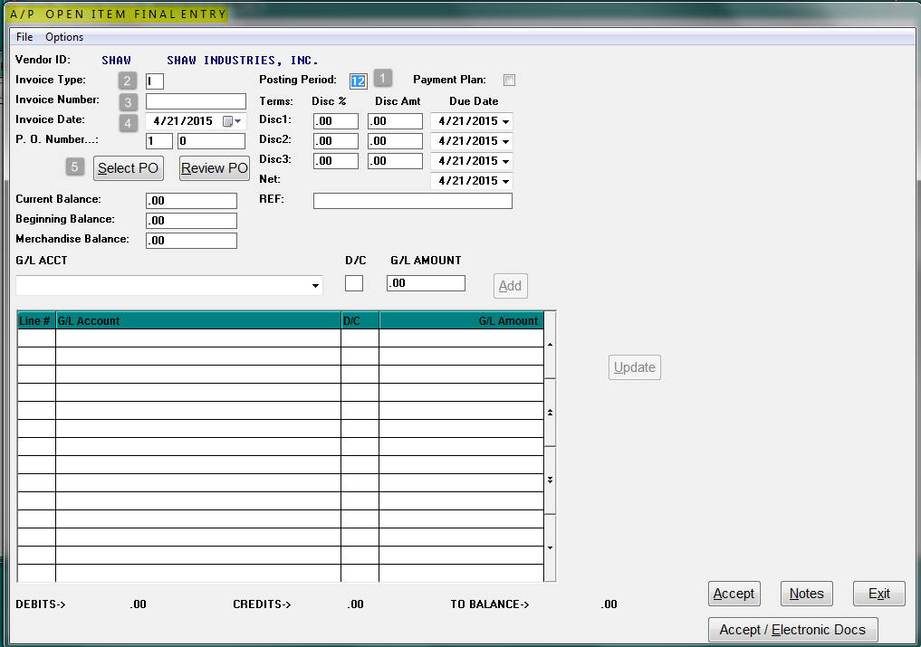

The cursor will first be positioned at the Posting Period -1- field and will default to the current period. You can type in a different period or hit enter to accept. At the Invoice Type -2- field, unless you need to enter a “C” for Credit Memo or a “D” for Debit Memo, you can enter or tab through this field, leaving the default setting of “I” for Invoice. At the Invoice Number -3- field, type in the number associated with the open item in this field. The Invoice Date -4- field will default to the current date; use the drop down arrow to access a calendar to select the actual date of the open item. At the P.O. Number -5- fields, the first box will display the current Branch ID. You can access this field to make a Branch ID change, if applicable. If a system PO is not associated with this open item, type “99” in the P.O. Number field to bypass this next process. When you enter an Invoice for material or products that are tied to a PO, you will need to enter a system PO Number. This can be accomplished by typing the number directly in the field, or by clicking on the Select PO button to perform a lookup. If you perform a lookup, the system will prompt the following A/P Select Branch box as follows:

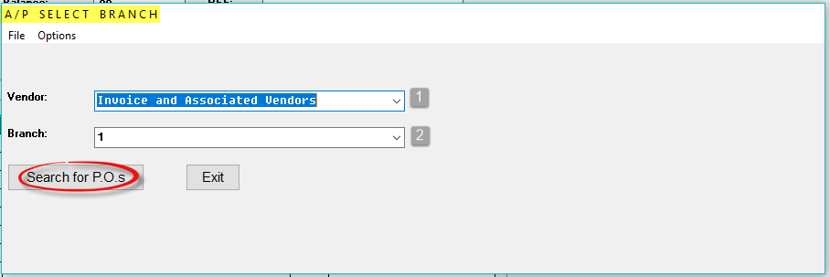

At the Vendor -1- field, leave the default Invoice and Associated Vendors or you can use the drop-down arrow to select Pick all Vendors. At the Branch -2- field, use the drop down arrow to select another Branch or ***All Branches***. The system will then look for POs that exist in multiple Branches and you will have the option to review all. Click the Search for P.O.s button to continue. A list of system POs will appear in the A/P Select Purchase Order box as follows:

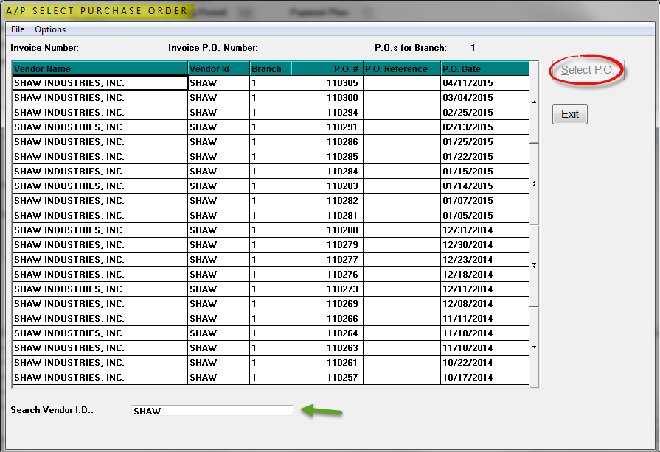

To select a PO from this screen, click in that row to highlight the line. The Select P.O. button will then become available and you can click to continue. At the Search Vendor I.D. field, if you selected ***All Branches*** in the previous screen, you can type another Vendor ID in this field to jump to those POs. Once you select a PO, the system will return you to the A/P Open Item Final Entry screen and the selected PO # will display in that field. You will also note that the Review PO button is highlighted and blinking. Click that button to continue. An Invoice Type Selection Screen box will prompt as follows:

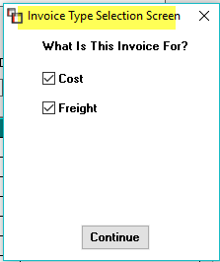

The selections you make in this screen will allow you to allocate freight costs across multiple PO Lines without accessing each line individually. The default setting that allows you to see the Allocation feature is for both Cost and Freight to be checked, or for only Freight to be checked. If just Cost is checked, the feature will not display. If the Allocation feature is in play, when you click the Continue button, the A/P Review PO History screen will appear as follows:

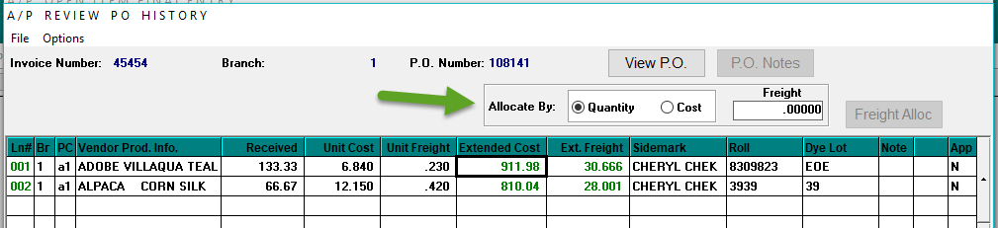

Note the Allocate By and Freight fields, along with a Freight Alloc button at the top right of the screen. You will first determine whether the cost will be allocated by Quantity or Cost, then type in the total Freight cost prior to clicking the Freight Alloc button to update the Ext. Freight column for each PO Line. With this feature, the Receiving Report By ProdType (A/P Not Inv), located within the Purchase Orders module, will clear material and freight separately when freight bills are approved separate from the material invoice.

If the Allocation feature is not in play, the system will prompt an A/P Review PO History screen without the Allocate By fields as follows:

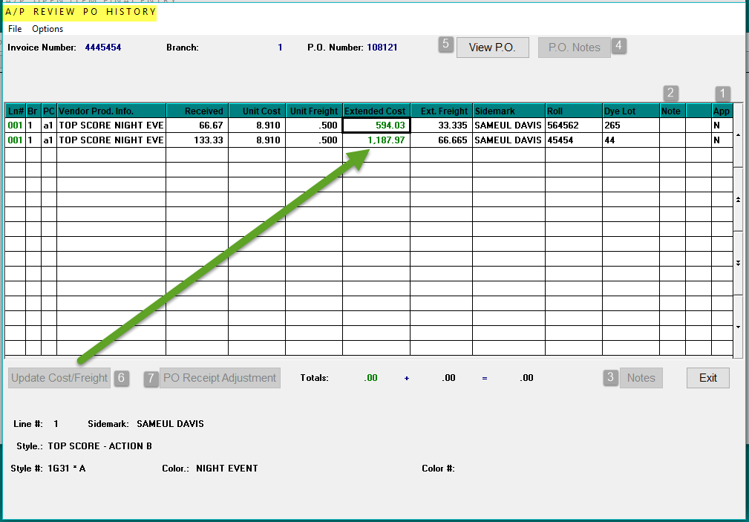

This screen will prompt all the lines on the PO where material has been “received” into the system. One of the most important steps during this process is to check the Extended Cost and Ext. Freight columns on each PO Line to make sure they match the Invoice. If these two amounts are correct, you can click in the App (for “Approved”) -1- column to toggle the “N” for Not Approved to “Y” for Approved. As each line is Approved, the Totals fields at the bottom of the screen will keep a running total of those lines. The Note -2- column will indicate whether any PO Line Notes exist by displaying an “*” in that column. You can click in that column field to display the P.O. Line Notes screen or you can click the Notes -3- button at the bottom right to prompt the same screen. The P.O. Notes -4- button at the top right will only be available where P.O. Notes currently exist. If this is the case, you should review those notes prior to making adjustments in this screen. The View P.O. -5- button will prompt the Purchase Order Maintenance screen for the selected PO.

To make cost or freight changes in the screen above, click on the line in either the Ln# or Extended Cost fields. At this point, you can either manually type in the corrected amounts in the cost fields, or you can make changes via the Update Cost/Freight -6- button at the bottom left of the screen. When you click this button, the system will prompt an A/P Cost Adjustment Entry box as follows:

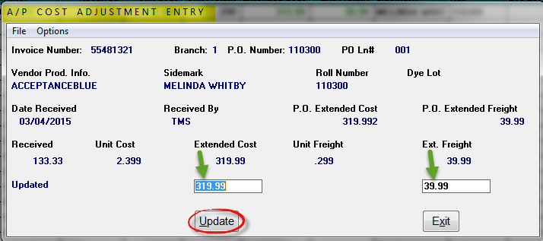

The cursor will be positioned in the Extended Cost field. Type in the new extended cost, if applicable, and then tab over to or click in the Ext. Freight field to enter a new total freight amount, if applicable, and only if you did not utilize the Allocation feature explained above. If any changes are made, be sure to click the Update button to save your changes. Once you click the Update button, the PO Line in the previous screen will automatically toggle to “Y” in the Approved column. One additional feature in the A/P Review PO History screen, is the ability to adjust the receipt quantity on a PO Line. This is the same feature that can be accessed in the Purchase Order Receipts Adjustment feature located in the Purchase Orders system. With the cursor positioned on the applicable PO Line, the PO Receipt Adjustment -7- button will become available. When you click on that button, the system will prompt the following Adjusted Quantity Received box as follows:

Type in the actual amount received to update the PO Line and then hit enter to return to the Review PO History screen. The Options menu in the top left of this screen will prompt the same options as explained above in the A/P Select Branch screen.

Special Note: this next section applies ONLY to customers who sell carpet in the state of California and must track CARE inventory. During the Review PO History process, if you activated the Branch Control 1 CARE option, a CARE message will pop up as you enter through each carpet PO Line item. This will allow you to make changes on a case-by-case basis as to whether the inventory needs to be CARE processed, as in the case of retailers who do a mix of business in the state of California and other states. However, in most systems, you will not see the prompt and the CARE flag will automatically default to “Y” for yes in the Review PO History screen. The Flag can be changed to “N” for no by clicking in that field, such as in the case of carpet being shipped out of the state for sale, and is not, therefore, CARE applicable, but this should only happen if the change is approved under the CARE guidelines.

Once all applicable PO Lines have been approved for an Invoice, click the Exit button to return to the Open Item Final Entry screen. The cursor will be positioned in the Current Balance field as follows:

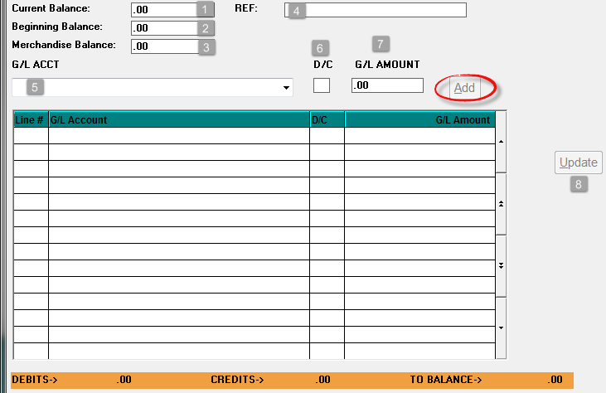

The Current Balance -1- field should reflect the total amount of the Invoice, before any terms discounts, and inclusive of freight, tax, etc. The Beginning Balance -2- field will default to the Current Balance field amount, and should stay that amount. Only on material Invoices, where freight has been broken out on the PO Line, will the Merchandise Balance -3- field default to only the material amount that has been approved during the Review P.O. process, explained above. Otherwise, this field should be identical to the prior two. In the REF -4- field, you can add a reference for this Invoice if applicable. Provided a Default G/L Account has been set up for the current Vendor ID, the system will default the Merchandise Balance value in the G/L ACCT -5- field.

The cursor will be positioned at the G/L Amount -7- field. If the default information is correct, click Add to continue, or you can override this field with the correct data. The system is automatically taking care of the Accounts Payable side entry so that you only need to distribute to the inventory or expense account to create a balanced entry. You can access any of these fields to make applicable changes to the default prompts. If you need to distribute amounts to any other G/L Account numbers, you can type the account number in the field above or use the down arrow to scroll through a list of existing accounts. Once an account is selected, the cursor will move to the D/C -6- field and default to the most logical option, which you can change if applicable. If you tab or hit enter through this field, the system will place the cursor in the G/L Amount -7- field and the balance of the amount to be distributed will default. You can enter to accept or type in another amount if further distribution is required. Click on the Add button to continue. At the very bottom of the screen, the system will keep track of the total Debit and Credit values. Once the G/L Debit & Credit entries are in balance, the Accept button at the bottom right of the main screen will then become available. The Update -8- button can be used to edit an existing G/L Entry line. Click in the Ln# column of the line that needs to be edited and the Update button will become available. Click the button to prompt an A/P Update Entry box as follows:

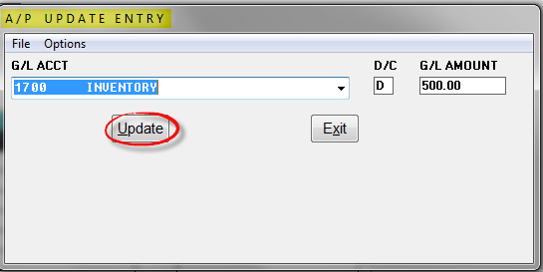

You can change the G/L ACCT, D/C, and/or G/L AMOUNT field from this prompt. Click the Update button to save any changes and return to the previous screen.

In the Terms section, any programmed terms will automatically calculate based on default settings for the Vendor ID and the Current Balance entered for the Invoice as follows:

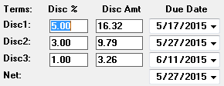

You only need to access these fields if changes need to be made. The Payment Plan checkbox option, located just above the Terms section, can be used for Invoices where a Vendor has allowed a long-term payment plan on an Invoice, over and above your normal terms. In this scenario, you will book the Invoice one time using this feature rather than having to book several Invoices with different due dates. To begin this process, enter the Invoice with the normal Date and Invoice Number, being sure to tie the PO to the Invoice and then enter the total amount of the Invoice in the Current Balance, Beginning Balance, and Merchandise Amount fields. When you get to the Terms fields, check the box next to Payment Plan. When this box is checked, six new payment fields with due dates will prompt to the right of the Payment Plan checkbox as follows:

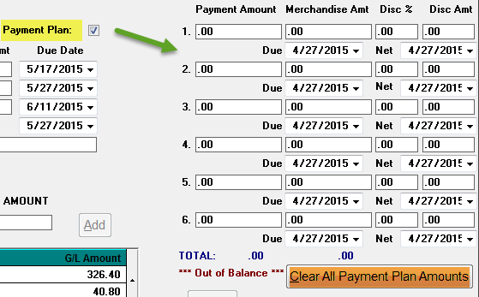

Program these fields per the agreed payment plan terms with the Vendor, using up to six dues dates. Before you move on from these fields, you need to make sure the total of all the Payment Amount fields equals the Current Balance field. Calculate each Payment Amount by dividing the Invoice total by the number of payments. If terms apply to each of the payments, you will need to set those up as well, making sure that the Payment Amount field is inclusive of freight and the Merchandise Amount is minus any freight for terms discount calculations. The ***Out of Balance*** message will prompt until the total of the Payment Amount fields equals the Current Balance field. The Clear All Payment Plan Amounts button will reset any programmed fields in this feature and allow you to begin again. Also, the system automatically prevents any negative amounts from saving in the fields above for Invoices.

The final section of options appears at the bottom right of the screen as follows:
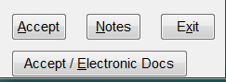

The Accept button will save the open item as entered and prompt a couple more options before returning the cursor to a blank A/P Open Item Final Entry screen. Prior to clicking the Accept button, and at any time during the entry of an open item, you can click the Notes button to access a Vendor Notes screen as follows:

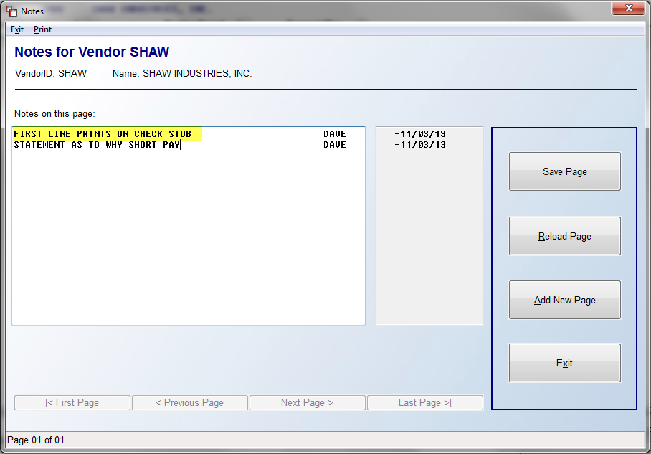

To add a note to the printed check stub, type the info on the first line in the screen above, such as the reason why you are short paying an Invoice. This note will also display on the Payment Selection Report and the Cash Requirements Report. The Vendor Notes screen is also available when you “Inquire” about an existing open item (explained below). Also, when Notes are added to an open item, the system will display a “Y” in the Notes column of the Vendor Status Inquiry module. You can add up to 99 pages of notes in this screen. Once you fill up the first page of notes, you will then see options to jump from the Previous Page to the Next Page, however, you cannot jump to a new page until you enter all lines on the existing page. This also applies to the Notes option in the Check History, Check History PO Version, and Vendor Status Inquiry modules.

The Accept / Electronic Documents button will display for those folks using the RollMaster Electronic Documents module. Use this feature if you wish to add a document to this open item file. Otherwise, this button and the Accept button will work the same. When you click either, the system will first prompt the following:

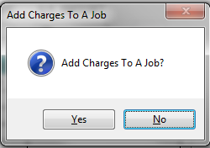

This feature was added in the event a small expense is incurred on a job that was not included in the original work order. An example may be that an installer needed a tool or additional supplies to complete the job and has billed you separately, or in the case of a special freight bill. This feature will send the entire cost of the Invoice to the job as a Special Charge--you will not be able to add it as inventoried cost from this feature. If you need to add a sell price to the job, you will need to add it through the Order Entry module. If any costs on the open item were tied to a system PO, you cannot use this feature or you will be sending a double cost to the job. To add a charge to a job, click “Yes” at this prompt. The system will then prompt the following:

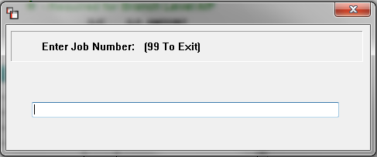

Type in the job number and hit enter. The system will then prompt the following:

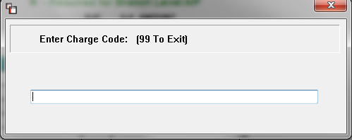

If you hit enter at this prompt, the system will pull up a list of non-inventoried Product Codes. Arrow down to the Product Code that applies and hit enter. The system will then prompt the following:
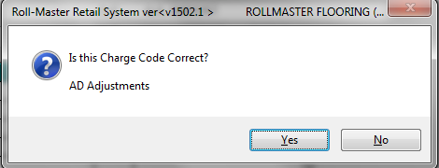

Click “Yes” if this is correct or “No” to select another Product Code. When you have finished with the above feature, the system will then bring up the following prompt--provided the feature has been enabled in the System Control 1 screen of the System Control Maintenance module (see System Maintenance to enable/disable):

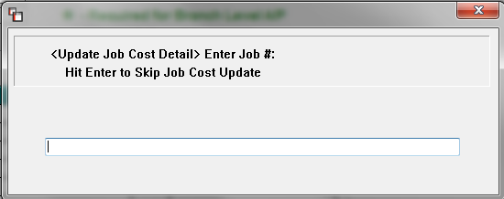

This feature is primarily for special order or commercial dealers rather than stocking dealers, as the total amount of the Invoice will be sent to the applicable Job Cost modules. If the open item contains costs for more than one job or does not relate to a specific job in the system, you should use the “Hit Enter to Skip Job Cost Update” option. When you use this feature, the system will send job cost information to two modules in the Job Cost menu. Those are Costs By Source View/Print and Billed vs. Unbilled – Costs From A/P. See the Job Cost manual section for details on those modules. To complete this feature, type the job number in this prompt and hit enter.

Once you’ve entered through the last prompt, the system will perform internal procedures and prompt the following:
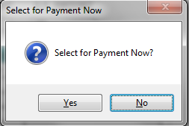

If you need to print a check right away, click “Yes” at this prompt. The system will skip the Payment Selection process so you can go right to the Print Check module. More often than not, you will click “No” at this prompt and age the payable based on the terms entered. Important Note: If at any time during the entry process you click the Exit button prior to clicking the Accept button, your work will not be saved, including any cost/freight changes that may have been made in the A/P Review P/O History screen. The program will remain in the A/P Open Item Final Entry screen, rather than exiting.

Setup for B2B Subscribers:
There is some initial setup required to utilize the B2B section of the Open Item Maintenance module. When you first enter the Unprocessed B2B Items menu option, the system will initially prompt you to perform B2B Service Charge Setup as in the example below:
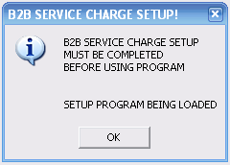

This setup must be completed prior to processing a B2B Invoice so you must click OK to continue. The system will then prompt an Invoicing Setup Maintenance screen as follows:

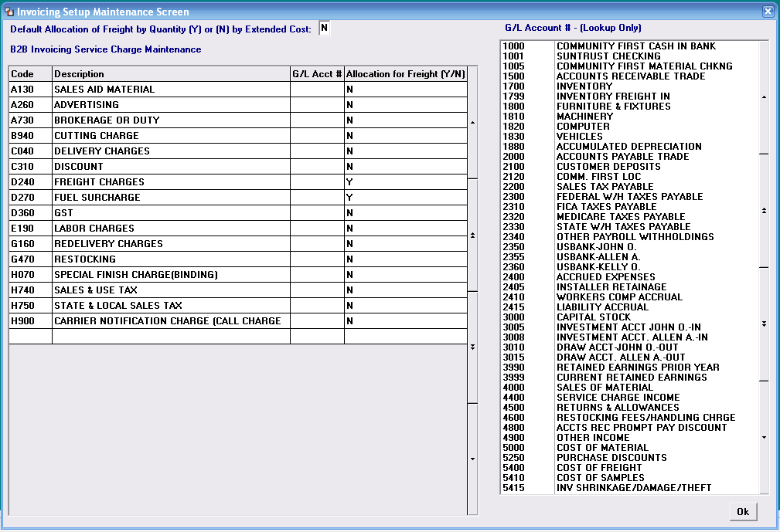

At the top of the screen you will note the following prompt: Default Allocation of Freight by Quantity (Y) or (N) by Extended Cost. If you type a “Y” at this prompt, the system will allocate freight on inventory lines by quantity. If you type an “N” at this prompt, the system will allocate freight on each line based on the costs of the material, allocating more freight to more expensive items. This is simply a default setting as any freight charges can be accessed and changed prior to approving costs. The next step to complete is to assign a RollMaster G/L Account Number (listed in the box on the right side of this screen) to each of the B2B Invoicing Service Charge Maintenance items located on the left hand side of the screen. The codes on the left are possible charges that can appear on a B2B imported Invoice and thus they need to be matched up to an existing RollMaster account in this screen for seamless posting. Using the Lookup box on the right as a “View Only” tool, you will scroll through your RollMaster list of accounts until you find one you need. If you click the single up or down arrow, the screen will move one account; if you click the double up or down arrows, the screen will move an entire page. When you are ready to type in a G/L Account on the left, you will use the mouse to click each box in the G/L Acct # column and then manually type the applicable account. The system will not accept a G/L Account # that is not currently setup in your system. A completed screen will look much like the following:

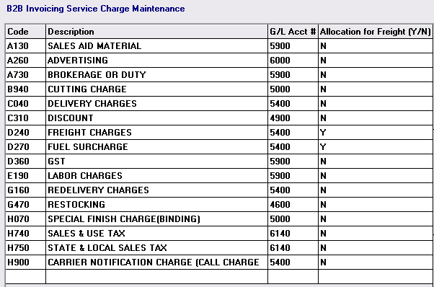

When you have finished adding your G/L Account Numbers, click OK at the bottom right of the screen. The system will place you at a Vendor ID selection box as follows:

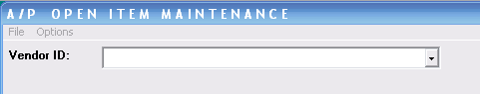

From here, you can hit the Esc key to exit the program; click on the File menu to drop down an Exit option--which does the same thing as hitting the Esc key; click on the Options menu to return to the Invoicing Setup Maintenance box you were just in; or use the drop down arrow to select a Vendor ID.

Unprocessed B2B Invoices:
For RollMaster clients enrolled in B2B Functionality, this menu item will be used to process all electronically generated billing items from participating Vendors. You can select this option from the menu after selecting a Vendor, or from the Vendor Selection box, you can click the “B2B Unprocessed” button that appears below the Vendor ID field as follows:
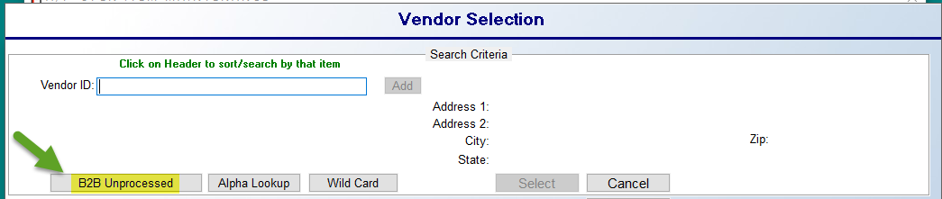
This B2B Unprocessed option will bring up a box that lists only B2B Vendors with unprocessed B2B Invoices along with the Number of Invoices for each Vendor as follows:
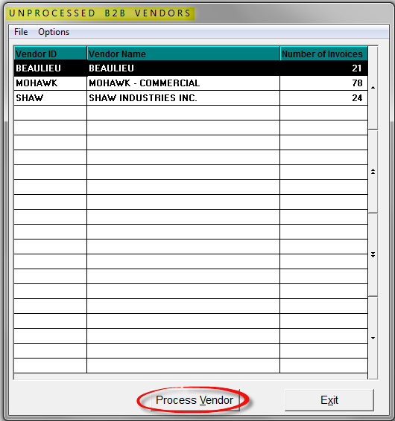

If you click on and highlight a Vendor in this list, the Process Vendor button at the bottom of this screen will become available. When you click on that button, the system will display a list of B2B Invoices for that Vendor in an A/P B2B Invoices screen as follows:

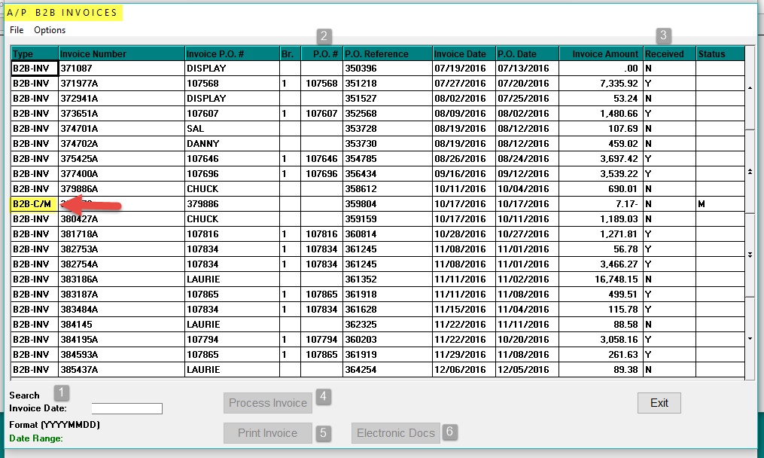

When you first enter this screen, the system will automatically sort by the Invoice Number column; however, you can re-sort and search by any of the other available data by clicking on the header of most of the other columns. If you click on another column heading, notice that the Search -1- option will automatically change to that heading and the data will automatically shuffle within the screen. For example, if you click on the Br. (Branch) column, the system will re-sort to display any items with a blank column first and then group all remaining items by Branch ID. Prior to a B2B Invoice displaying in this screen, the system has automatically matched it up to the system generated PO. As long as the B2B Invoice finds a matching open PO in the system, it will be matched automatically. If a P.O. # -2- field is blank, you can manually attach a system PO. Also, all the data you see in these columns is being pulled directly from the electronic Invoice sent by the mill, but you still have the ability to make manual changes where applicable. Those procedures will be explained below. Please Note the B2B-C/M item highlighted above. This denotes a Credit Memo and must be processed manually. Additionally, any Invoice that doesn’t meet standards or has negative values that flag it, will not automatically process. You will have one shot to send an email to RollMaster from this screen to report the issue. Thereafter you will need to contact support directly.

The Received -3- column will display either a “Y” meaning the material has been received on the PO or an “N” meaning the material has not been received. B2B Invoices will appear in this screen as soon as the material ships out from the Vendor, but you can view the data and print out those Invoices prior to the material arriving at your warehouse. However, you must wait until the material is received before you can process a B2B Invoice because of the “Review P.O. History” functionality (explained above in the Manually Enter Invoice section). The Print Invoice -5- button, when clicked, will prompt you to first “Select a Printer” so you can decide whether to print a hard copy or use the Print to Screen feature. The system will then return the cursor to the screen above so you can continue to print or begin processing an Invoice.

To begin processing an Invoice, click on the applicable line and then click the Process Invoice -4- button. The system will prompt an A/P B2B Invoice Lines screen as follows:

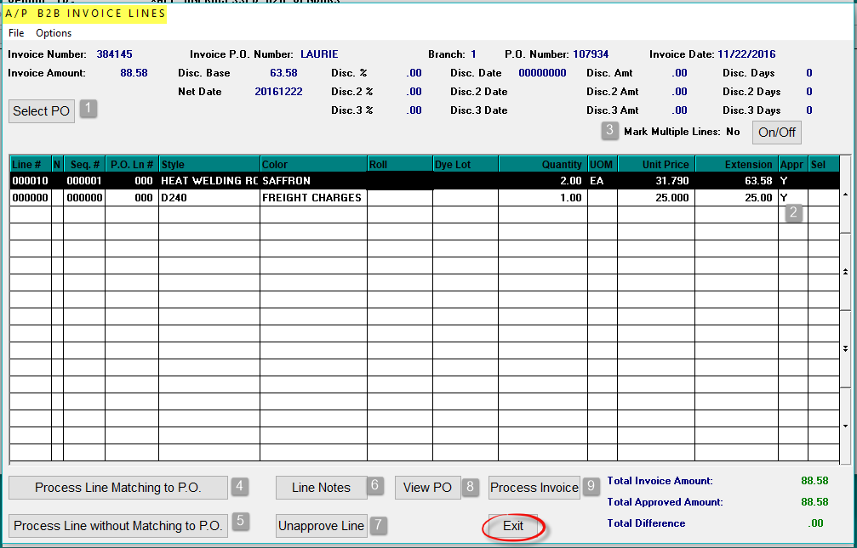

If a PO is not automatically matched, you can use the Select PO -1- button at the top left to make a selection. Next, in the Appr (Approved) -2- column, if that column does not contain an “M” for Match, it means that during the electronic matching of the system PO Line # to the B2B Invoice, the process found some discrepancy and therefore could not 100% match the PO Line to the Invoice. In many cases, this field will already be set to “M” because the process was successful in matching up cost and quantity information. Any Freight Charges and/or Fuel Surcharge lines are automatically matched up and approved so you will only need to access those lines if a change needs to be made. The Mark Multiple Lines -3- option should remain set to “No” unless there is more than one Invoice line that needs to match up to one PO Line/Receipt. You will note the occurrence of this situation by either viewing the B2B Invoice prior to processing or noting that the same number in the P.O. Line # column appears on more than one line in this screen. Change this option to “Yes” by clicking the On/Off button and you will be able to match two or more B2B Invoice lines to one PO Line during the Process Line Matching to P.O. process (explained below).

On any line needing to be approved, you will click on that line to highlight the line and the Process Line Matching to P.O. -3- button will become available (see full explanation in the next paragraph). The Process Line without Matching to P.O. -4- button should only be used where no system PO exists. The Line Notes -6- option will also become available. These are internal notes that will only appear in this screen and on the B2B Invoice form. The Unapprove Line -7- button can be used if you need to revert a line back to unapproved status to make additional changes. The View PO -8- button will prompt the selected PO in the Purchase Order Maintenance screen.

To begin processing a B2B Invoice line, select a line and click on the Process Line Matching to P.O. -3- button. The system will display an A/P B2B Invoice Line Approval screen as follows:

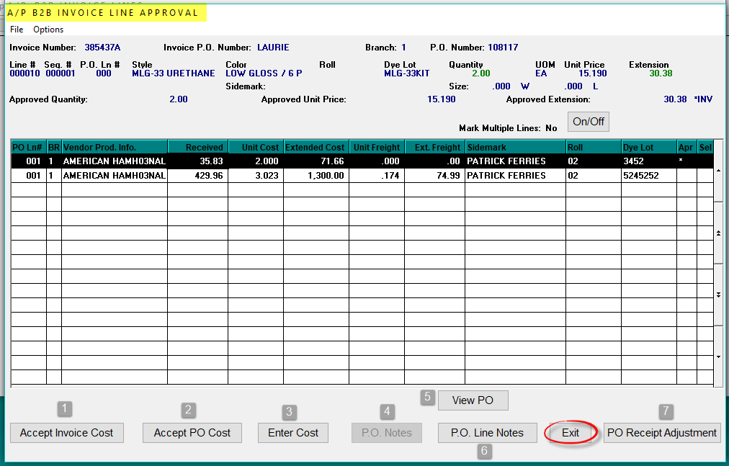

When you click on a PO Line in this screen, the options at the bottom of the screen will become available. The P.O. Notes -4- and P.O. Line Notes -6- button options prompt the same Notes that can be accessed from the Purchase Orders system and A/P Review P.O. History. You can use those options to review any applicable notes or add to those notes. The View PO -5- button works the same as described above in the previous screen. The PO Receipt Adjustment -7- button option will allow you to make receipt adjustments where applicable to inventory receipts that are not fully tied to a job line. That option works the same as the Purchase Order Receipt Adjustments option in the Purchase Orders system and the same restrictions and instructions apply to this option.

In the example above, there are two quantity receipts associated with the same PO Line and both need to be marked and approved. In this instance, you will need to use the Mark Multiple Lines feature that is in this screen. If you click the On/Off button to set this feature to “Yes” you will then be able to match these lines to the one Invoice line in the previous screen. Continuing with this example, you will then click on each line in the Select column at the far right to highlight and set that column to “Y.” Once the lines are selected, if you do not need to make any manual cost changes, you will either click on the Accept Invoice Cost -1- option to use the Invoice cost as the approved cost or select the Accept PO Cost -2- option to use the PO cost as the approved cost for these lines. You can then Exit back to the previous screen to continue.

If you need to make any manual cost changes you will click on the Enter Cost -3- button option. The system will display a B2B Invoice Line Cost Entry screen as follows:

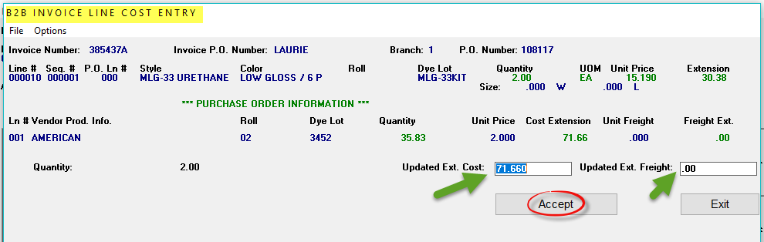

Within this screen, you can click on either the Updated Ext. Cost or Updated Ext. Freight fields to enter a total extended material cost or a total extended freight cost. To save any cost changes you will need to click the Accept button. Click the Exit button to return to the previous screen. At the bottom right of that screen, the system will display the total amount that has been approved and any balance remaining to be approved. For non-material lines, the system will prompt the following: Do you want to approve another amount? If the cost is correct, click “No” or hit enter to continue. If you do need to make a cost change, click “Yes” and the system will prompt an Enter Approved Amount box displaying the current cost. Type in the new cost and hit enter. The Appr column for that line will now display “Y” which means that cost has been approved. Continue with any remaining lines that apply to the current B2B Invoice until all either display “M” for Match or “Y” for approved cost. You should now be ready to click the Process Invoice option to continue posting the Invoice in the RollMaster System. When you click that option, an A/P Open Item Inquiry screen will appear as follows:

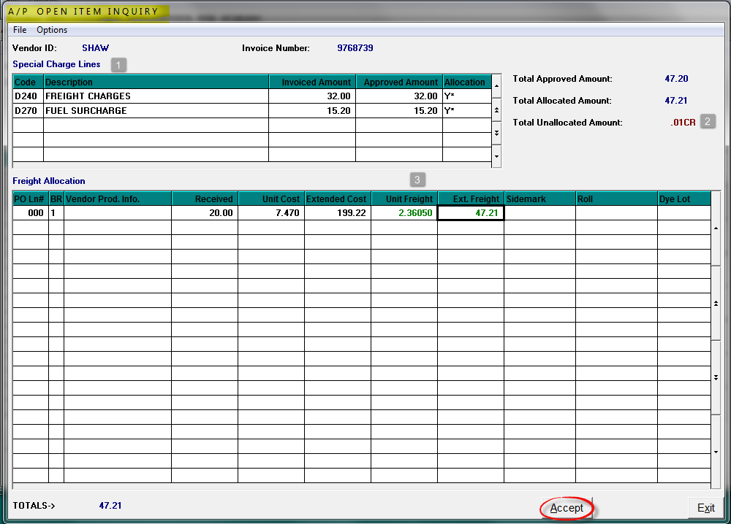

In this screen, the system will display the freight allocation information in the Special Charge Lines -1- section just prior to the Invoice being posted. Based on the default Freight Allocation setting in the Invoicing Setup Maintenance screen (explained above) the system will distribute Freight and Fuel Surcharge amounts to each applicable material line as close to the Total Approved Amount as possible. If the difference is slight, you can click the Accept button to continue and the Total Unallocated Amount -2- will be sent to the designated G/L Account that was established in the Setup screen. If you need to adjust the Unit Freight -3- to alter this amount, you can do so from this screen. If there is a positive amount in the Total Unallocated Amount field, when you hit the Accept button, the system will prompt the following: Approved Totals doesn’t match PO Lines, Continue? To continue, click “Yes.” The system will then prompt the A/P Open Item Final Entry screen with all the details that have previously been approved as follows:

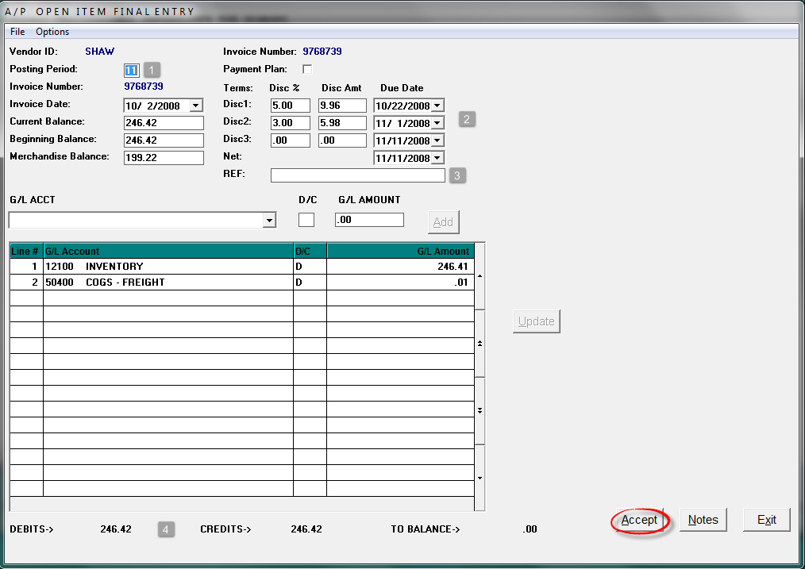

You can enter through this screen to make changes to the Posting Period -1- and Reference -3- fields, but for the most part, if the Debits and Credits -4- match at the bottom of the screen, you are ready to hit the Accept button to finish posting this open item in the system. Caution: if you hit the Exit button prior to hitting the Accept button, the open item will not post and the data will not be saved. If the B2B Invoice has terms that differ from the default Terms -2- settings for the Vendor, the system will prompt the following message when you first enter this screen:

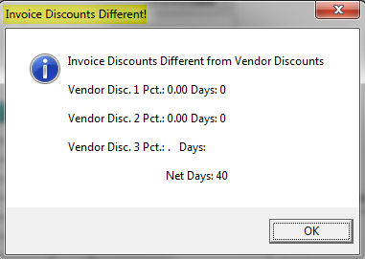
Click OK to continue and make changes where applicable. As B2B Invoices are processed, they can be reviewed in the “All Invoices” screen of this module (explained below), and they will appear on all applicable A/P Reports, as well as prompt during payment processing per the usual RollMaster System procedures. At the end of the accounting day, if you have added or deleted items in this module, you will need to print an Open Items Adjustment Register—located in the A/P Reports Menu 1 of 2—to double-check your entries. This report also serves as a record for all payables that were entered for the day.

All Invoices:
This feature will give you access to every type of A/P open item by Vendor that has been entered in your RollMaster System, including all B2B generated items, whether they have been processed or not. There is a lot of functionality within this feature, so be sure you read through this section in its entirety so you can benefit from all the available options. Once you select a Vendor ID, click on the All Invoices option in the Select Option menu. The system will first prompt a Date Selection Screen with a Date Range drop-down selection box as follows:
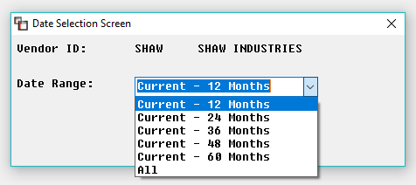
The default is Current – 12 Months, but you can select additional ranges based on the data you are trying to locate to speed up the process. The system will then prompt an A/P All Invoices screen as follows:

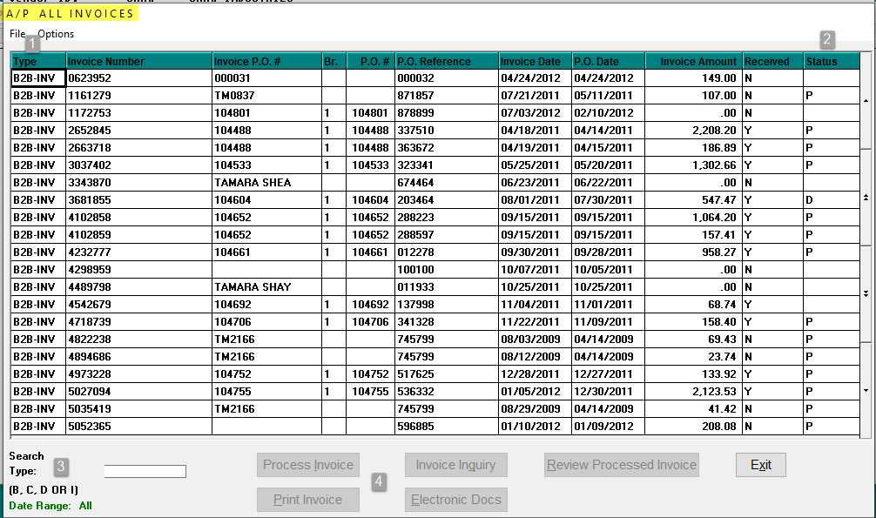

In the Type -1- column, the system will display either “Invoice” for a manually entered Invoice, “Credit” for a manually entered Credit Memo, “Debit” for a manually added Debit Memo, or “B2B” for all B2B generated open items. Please Note: only B2B generated open items will display data in the Invoice P.O.#, Br., P.O. Reference, P.O. and Date columns of this screen. This is because of the electronic data that is generated during the B2B process that doesn’t happen when open items are added manually. At the bottom left of this screen is a Search -3- field. As you click on the column headings at the top of the screen, you will notice that the search criteria at the bottom left will change to match the column headings and the data in the screen will automatically re-sort according to the column heading that has been selected. For example, if you click in the Type heading, the screen will automatically re-sort to display all the B2B open items first (or Credits if there are no B2B items) and the Search field at the bottom will change to “Type” so that you can enter a specific open item type to search. As you move across the top of the screen clicking each column heading, you will notice that the data re-sorts and the Search field changes to match that search criteria. Additionally, you can move up and down in this screen by clicking on the up and down arrows on the right side of the screen.

The Status -2- column will also display notations as follows: an “X” denotes that the B2B and non-B2B open item has been entered and has a balance; on B2B Invoices only, if the Status column is blank, it denotes the Invoice has not been processed; a “P” denotes the Invoice has been paid; and a “D” denotes the open item has been deleted. An “E” denotes E-Docs exist and you will typically see this as “P E” for Paid E-Docs Exist. The option buttons -4- along the bottom of the screen will become available based on the open item you select and the status of that open item. On any non-B2B item, you will only have access to the Invoice Inquiry and Electronic Docs options. Also on any B2B items, you will only be able to use the Invoice Inquiry option on items where the Received column = “Y,” indicating the merchandise for the item has been received in the system, and where the Status column = “X,” indicating the open item has been processed and is in the system as an approved payable. When you click on a line to highlight an open item and then click the Invoice Inquiry button, the system will display an A/P Open Item Inquiry screen as follows:

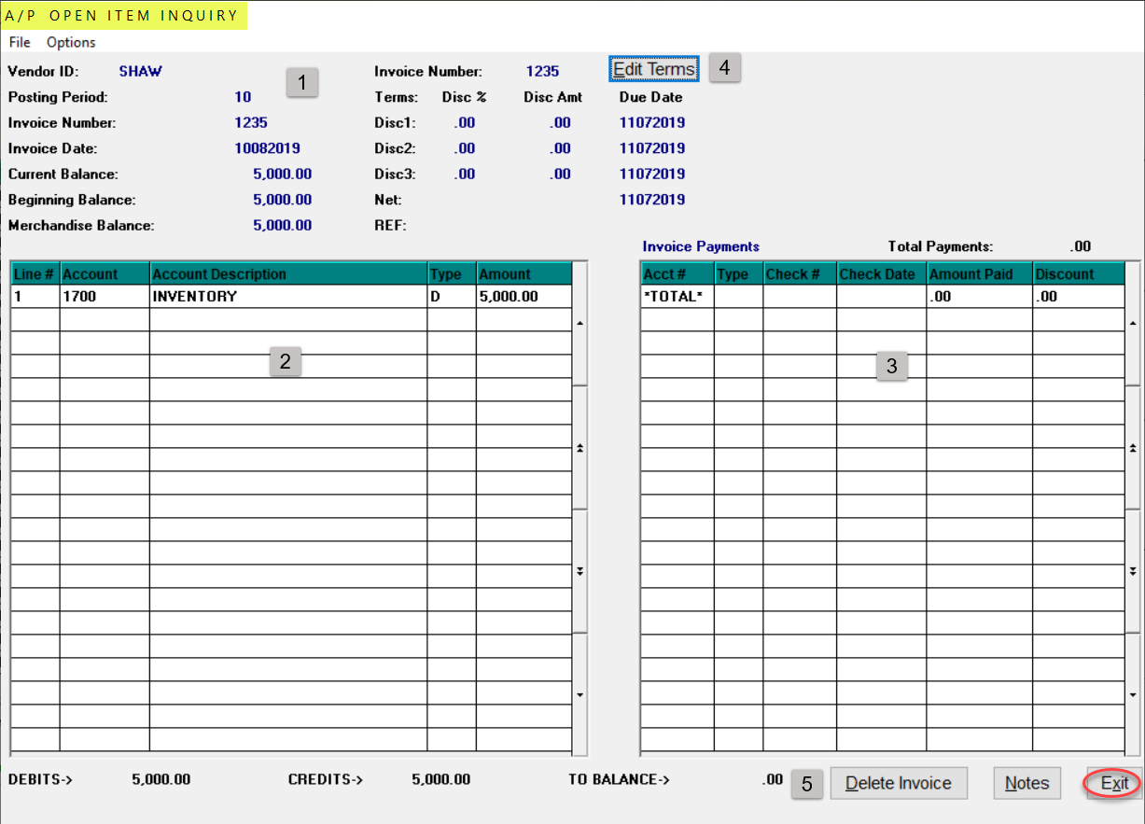

The top portion of the screen -1- will display the details of the open item, the bottom left -2- will display the G/L distribution data for the open item, and the bottom right -3- will display payment data. The Edit Terms -4- button applies to any existing unpaid Invoice. When you click on this button, a Terms Update box will appear as follows:

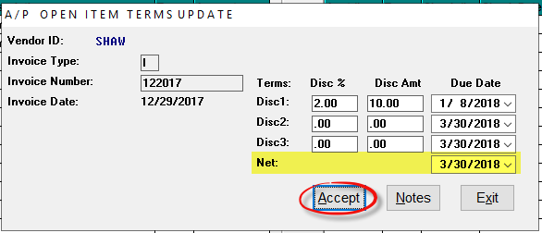

From this box, you can enter in and change any of the Terms fields. When a new Date is entered, tab through until the Accept button is highlighted and be sure to click it to save the change. As a part of this automated process, the system will write an Invoice Note with a comment that states **TERMS UPDATED** along with the User ID and Time Stamp on the comment. When you exit out of the Invoice Inquiry screen and enter back, you will see an “*” in the Notes button for that Invoice. This note will always appear on the 2nd line of this screen unless Notes already exist, and then it will appear on the next available blank line.

At the very bottom right corner A/P Open Item Inquiry screen, you will see a couple of additional -5- options. The Notes button will display an “*” if internal or external notes exist. You can add Notes from this screen as well. The Delete Invoice option will only work for open items that have not been paid. When you click the Delete Invoice button, a prompt will appear as follows:

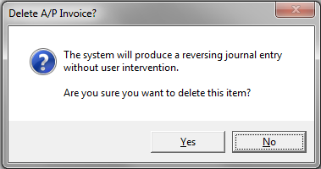

Click the “Yes” button to delete the open item or click the “No” button to cancel the process. If you click “Yes,” the system will then prompt the following:

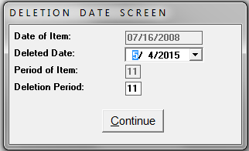

The Date of Item field will reflect the actual date the item was entered in the system. The Deleted Date field will default to the current date, but you can use the drop-down arrow to select a different date if applicable. The Period of Item field will reflect the actual posting period the item was originally entered in; you cannot access this field. You can, however, change the Deletion Period field if applicable; this field will default to the current Period. Only users allowed to change Posting Periods will have access to this screen. Click the Continue button to complete this process. The system will return the cursor to the A/P All Invoices display screen.

Special Note: If you delete an Invoice number and then re-add that same Invoice number, the system will allow you to do that by automatically creating a unique file record. When you type in an Invoice number that the system recognizes as having been deleted for the selected vendor, the system will prompt the following: Item has been Deleted. When you click ‘OK’ at this prompt, the system will then prompt the following: Do you want to reuse this invoice number? If you select “Yes” at this prompt, the system will then prompt the following:

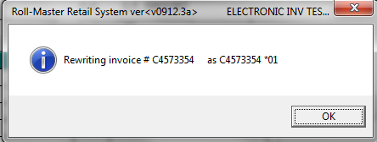

The system will not display the *01 in your look-up screens or reports, but it will be used by the system to identify it is a unique item.

The Print Invoice option in the A/P All Invoices screen will only be available on all B2B open items. It was added to allow you to print a paper copy of the B2B generated Invoice detail from the Vendor. If you click on this option, the system will prompt a Select Printer menu box. Make your printer selection and the Invoice will print. If you select Print to (S)creen, you will be able to view the Invoice detail without printing to paper.

The Process Invoice button option will jump you to the Unprocessed B2B Invoices feature (explained above). This option will only be available when you click on B2B items where the Status column is blank. Although this option will be available on items where the Received column = “N,” it should only be used where material has been received in the system to allow for matching of costs to a system PO. The remaining option, Review Processed Invoice, will only be available on B2B items where the Status column = “X.” When you click on this button option, the system will prompt the A/P B2B Invoice Lines screen for you to review the data on the open item. This display is essentially the same as the Invoice Inquiry screen, but because of the B2B functionality, the system captures the detail of each line. You can read or add Notes from this screen specific to the B2B item or click the Exit button to return to the previous screen.

Payment Selection:
This module is used to select items for payment in the Check Print programs. There are many options for payment selection within this module to allow for easy selection of single items or only items due based on discount dates, etc. When you enter this module, the A/P Payment Selection screen will appear as follows:

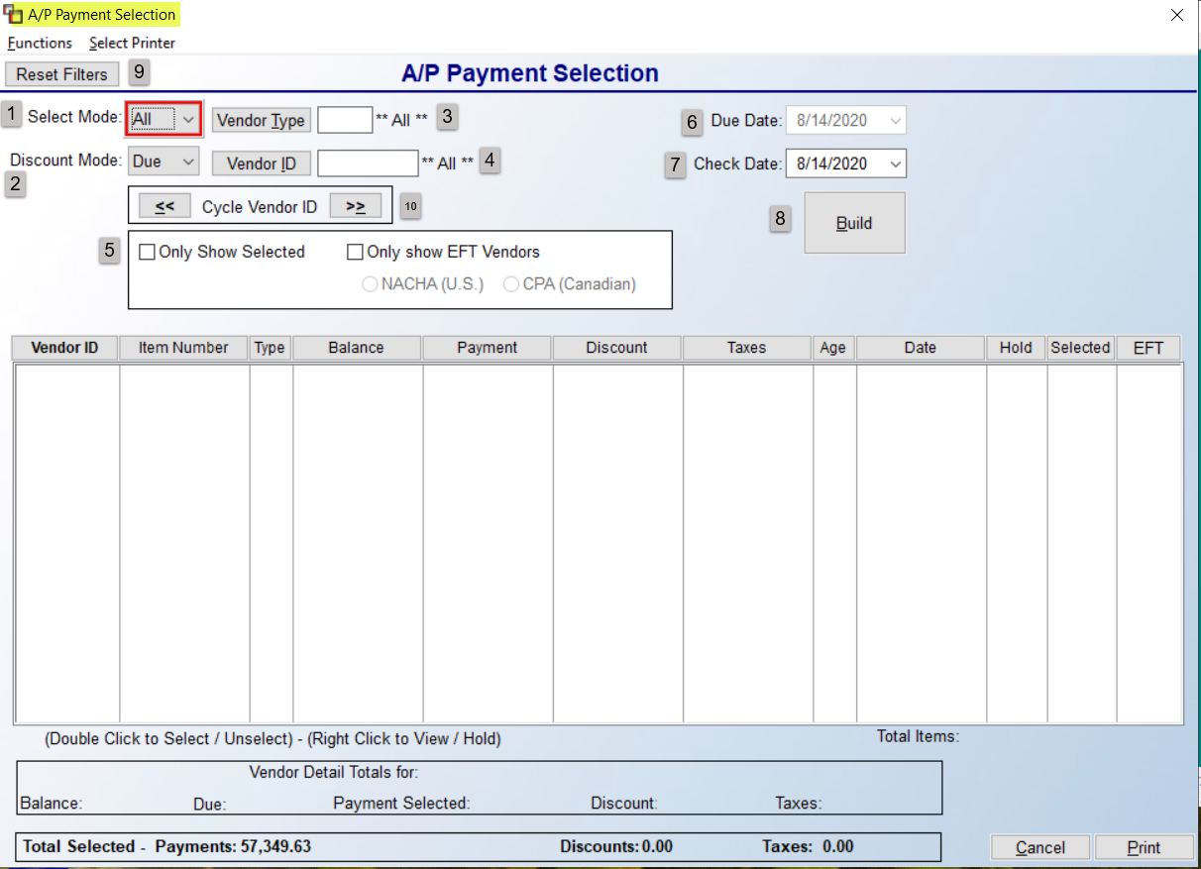
At the Select Mode -1- field, you will make a selection from the drop-down menu based on how you wish to view the open items in the screen below. When you click on the down arrow, all options will appear as follows:

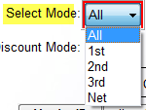

To see all open items for selected Vendors, regardless of any programmed due dates, leave the default All setting. If you select this option, the Due Date -6- field will not be available. To display and select items based on the 1st Due Date, select “1st” from the drop down menu; to select items by the 2nd Due Date, select “2nd;” to select items by the 3rd Due Date, select “3rd;” to select items by the Net Due Date, select “Net.” The Discount Mode -2- drop-down contains the terms you want displayed in the Discount column in the selection screen below. With the exception of “Due,” this drop-down list mirrors the Select Mode drop-down list explained above. Leave the default “Due” setting to display earned discounts based on the Check Date -7- field. Please Note: you will still have the option to override the terms amount that appears in the Discount column prior to selecting an item.

The Vendor Type -3- field defaults to **All**, but if you have established Vendor Types in the Vendor Maintenance module, you can click the button to make a specific selection to only see those types of vendors for Payment Selection purposes. The same goes for the Vendor ID -4- field; select a specific Vendor if you are only printing checks for that Vendor; otherwise, leave the default setting of **All**. This will allow you to then use the Cycle Vendor ID -10- arrows, explained below. The Only Show Selected -5- checkbox should be checked if you have previously selected items for payment and only wish to view those in the display screen below. The Only show EFT Vendors checkbox should only be checked if you completed setup and are currently processing for EFT Vendors. The Due Date -6- field will be available if the Select Mode -1- field does not equal “ALL.” If this is not the case, type the Date through which you want to select open items based on the Select Mode field setting. For example, if you selected 1st in that field, at the Due Date field, if you enter the current date, you will see all items that show a 1st Discount Due Date through the current date. If you pay a week ahead and want to earn that 1st discount, add 7 days to the current date and enter that as the Due Date. Items with a 1st Discount Due Date after the date entered will not appear in the display screen below. The same goes for the 2nd, 3rd, and Net Select Mode settings.

The Check Date -7- field will default to the current date. This field should reflect the date you will be printing the checks. This field does not affect how items are selected, but it does affect the discount calculation. In other words, the Due Date field determines which invoices are displayed, the Check Date determines which discounts are available to take within the dates selected. This primarily works with “Due” as the Discount Mode. Once the previous eight fields have been set, you can perform one of two options to prompt open items in the display screen (see screenshot below). The first option is to click the Build -8- button to display all applicable open items in the display screen in alphabetical order by Vendor ID. The other option is to click the Cycle Vendor ID -10- arrows to view each Vendor individually in alphabetical order. Please Note: prior to clicking the Build button or the Cycle Vendor ID arrow buttons, if you need to change any of the sort fields, you can click the Reset Filters -9- button to clear any settings and reset the defaults in all the fields. Open items meeting the sort parameters will appear in the display screen as follows:

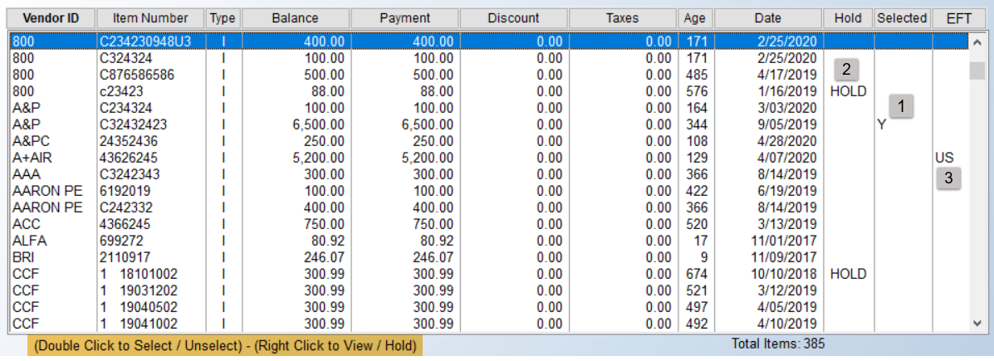

You can sort the open items further by clicking in the Column headings along the top of the display screen. The default display for multiple Vendors is alphabetical by Vendor ID and then by Item Number. If only one Vendor is displayed, the open items will display in order of Item Number. The Selected -1- column will display a “Y” if an open item has been selected for payment. A single open item can be selected by double-clicking on a highlighted line to prompt a Select Payment box as follows:

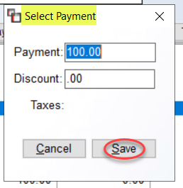

From this box, you can adjust the Payment amount and Discount amount when applicable. Click the Save button to continue. If you click on an open item and then right click, the system will prompt the following options:

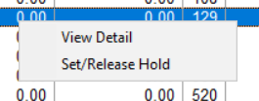

The Set/Release Hold option will place a Hold on an item or Release a Hold. If a hold is placed on an open item, you will see the word “HOLD” in the HOLD -2- column of the display screen. The View Detail option will prompt a detail screen as follows:
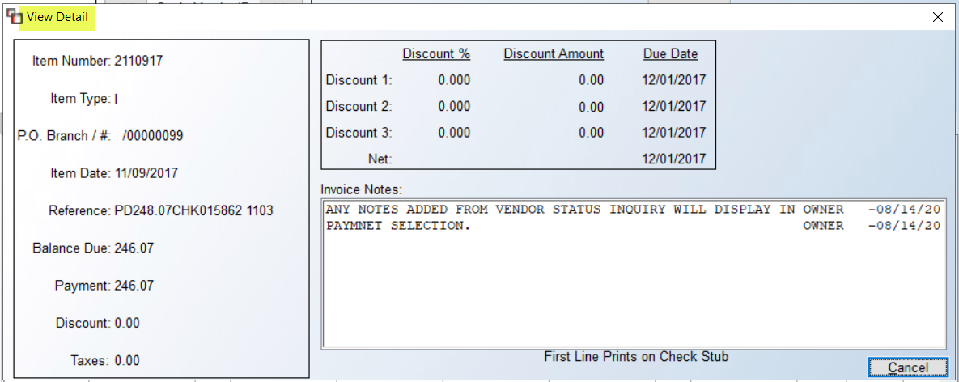
This is a view-only screen. Changes will need to be made from Open Item Maintenance. The EFT -3- column will display either US or CPA, denoting either a U.S. EFT Vendor payment or a Canadian EFT Vendor payment.
As you select items for payment, the system will keep track of payments selected data at the bottom of the screen as follows:

As open items are selected for payment, the Vendor Detail Totals box will keep track of the total Balance -1- of all open items on the account in the current display screen, along with the total of the open items that are currently Due, the Payment Selected amount, and the total Discount amount of the open items that have been selected for payment. Below the Vendor Detail Totals box, the system will display a Total Selected – Payments -2- amount for all Vendors and a running Discounts total. Once all items are selected for payment, you can click the Print button at the bottom right of the screen to print the Items Selected for Payment Listing report. This report also appears in the A/P Reports Menu 1 of 2. The report lists everything currently selected for payment that will prompt in the Print Checks program, along with the number of checks that will print, the total discount selected, and the net total of all checks. If any open items appear on this report that you do not wish to print a check for, you will need to enter back into the Payment Selection module and unselect those items. If the system encounters a negative check condition, it will display that information rather than print the report. To fix a negative check condition, you will need to enter back through the Payment Selection module and correct.

Functions Menu
At the top left of the screen is a Functions menu. When you click that menu option, the system will display the following options:
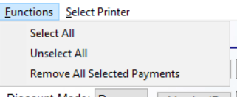
When you have items displayed in the box below for a Vendor, you can use the Select All option to instantly select all items currently visible in the display screen. The Unselect All option will instantly unselect any currently visible selected items in the display screen. The Remove All Selected Payments option will prompt the system to unselect every open item currently selected for every Vendor. When you click that option, the system will first prompt the following:
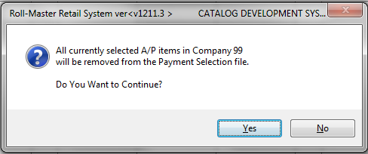
If you wish to proceed, click the Yes button.

Electronic Funds Transfer in RollMaster
The RollMaster System allows for Electronic Funds Transfers (EFT) to Vendors. Some setup must first be completed in System Maintenance, General Ledger and Accounts Payable. See next section below for setup details, followed by a section on how to process EFT Transfers. Please Note: A minimum of 2 hours of support is required to assist with setup and ongoing assistance. Also, you must confirm with your bank that they have a portal for customers to upload EFT files. Additionally, you must first run a TEST of the EFT data to your bank, so you should start this process by setting up only one Vendor to make sure any bugs are worked out before running live EFT Data Transfers. Please note: for Canadian clients, our system produces a file for CPA500 ACH payments.

EFT System Setup
If User Controls are enabled in your system, the first step is to determine which Users should have access to setting up EFT banking data for Vendors. In the User Control 6 screen, an EFT enabling control appears as follows: Allowed To Edit Vendor EFT Data. If set to “Y” for yes, this control grants access to an EFT Data button in Vendor Maintenance.

The next step is to complete setup of Vendor EFT Data in the Vendor Maintenance module. Users with permission will see an EFT Data button at the top of the Vendor Maintenance screen for each Vendor. When you click this button, a Vendor EFT Data Maintenance box will appear as follows:
Complete the banking setup information in the fields provided. The Bank Name is not required, but recommended in the event your Vendor ever changes banks to assist in needed updates. The Routing Number and Account Number will be provided to you by the Vendor—these fields must be identical to the bank’s data. The Routing Number should be 9 digits. The Export Format should be NACHA for U.S. and CPA for Canada. The Account Type must be correct in order for the bank to accept any transfers. Click the Save button to keep your data.

The final setup will be completed in the G/L Account Maintenance/Inquiry module. In that screen, you will see an EFT Data button at the top right that appears as follows:

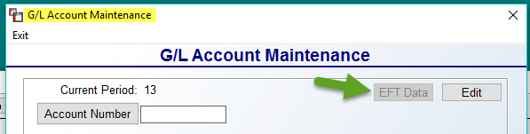

Here you will need to identify any G/L Accounts used for EFT payments via this module. When you enter an Account Number that is also identified as a Bank Account, the EFT Data button will become available. When you click on that button, a General Ledger EFT Data Maintenance box will appear as follows:

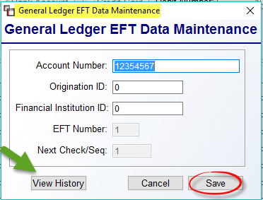

The Account Number is your bank account number. The Origination ID and Financial Institution ID field data should come from your bank’s ACH Department. Leave the EFT Number and Next Check/Seq fields with the default settings. Be sure to click Save to keep the data. For existing Account Numbers with history, you can view that history via the box above by clicking the View History button.

Running EFT transfers
Once setup is complete, the first thing you need to do is access the Payment Selection module to perform a trial run to only test the EFT set up. Click the Only Show EFT Vendors box to proceed. Select a couple of Open Items for an EFT Vendor that has been setup based on instructions above. Again, this is only to test. The next step is to access the Print Checks module—be sure to select a PDF Printer for testing purposes. Select the EFT Export radio button, and then make sure the GL Account field is set to an EFT Bank Account. The screen should look much like the following:

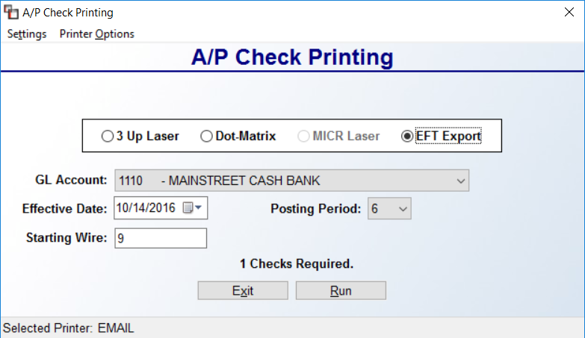

The Starting Wire # is the EFT equivalent of a check # and will automatically advance with each EFT Transfer. When live, the Effective Date may be advanced to a future date, but can never be less than the default date of the following day. Click Run to start the TEST. This will generate two pages: one is similar to a check stub for each Vendor payment and the other is a text file that is for uploading to the bank. Save the bank file with a name that includes the run date. The Vendor file will display like the system laser checks in the stub/check/stub format. This can be given to Installers to act as a pay stub if any are set up on EFT.

At the Did Check Print OK? prompt, click NO for the test only! Send the test file to your bank. (Most banks will provide you with ACH test information needed for their ACH Dept.) Please Note: When live, the text file must be sent to the bank right after the EFT Transfer to ensure it goes through and because of the requirement of the Effective Date being at least one day after the current date. You may be able to do this online. Contact your bank’s ACH Dept directly regarding questions on any information they need from your business.

Once the bank verifies proper setup, you will be able to run live data. You can now finish setting up your remaining EFT Vendors. You need to do separate runs for EFT Transfers. Standard check printing should be done completely separate.

For live EFT Transfers:
- After clicking the Run button you will get the standard “Printing Complete” followed by the question asking if the checks printed correctly. If you Did Not get both files, they did not print correctly and you should answer NO, otherwise select YES.
- After saving the text file, it must be uploaded to the bank to complete the transaction. If for some reason you did not save the file, a copy is also saved locally in the acuthin folder.

Check History:
This module will allow you to view all checks that have been printed in the system by Vendor, by Invoice number, by Check number, and by PO number. This module is useful for quickly determining whether a specific item has been paid. When you enter this module, an A/P View Check History screen will appear as follows:

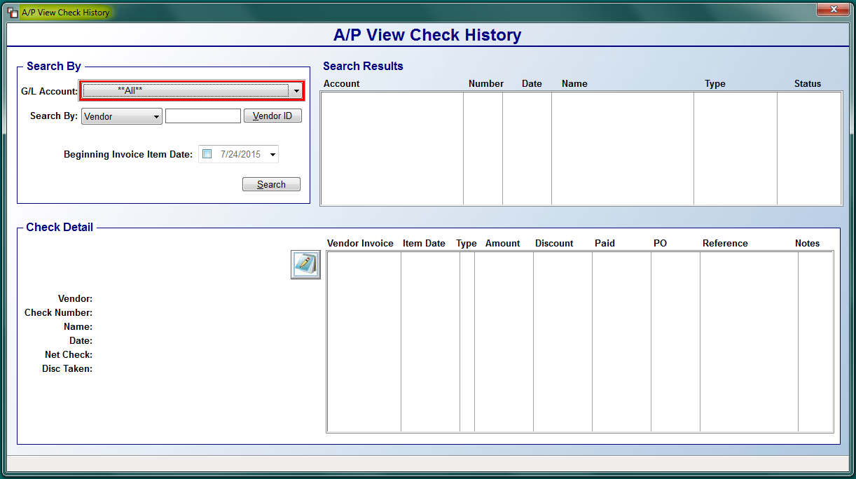

To begin searching, make selections in the Search By box at the top right, as follows:

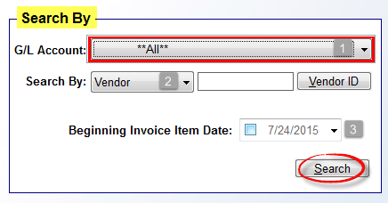

At the G/L Account -1- field, start by selecting a specific G/L Account using the drop down arrow. These will only be accounts designated as Bank Accounts or Credit Card Accounts in the system G/L. You can leave the default **All** selection if you need to search more than one account. At the Search By -2- field, the default search option is Vendor. If you click the drop down arrow, you can select by additional search options as follows: Invoice Number, Check Number, and PO Number. If you leave the default Vendor search option, you will need to use the Vendor ID button to select a specific vendor. The Beginning Invoice Item Date -3- field will not be active unless you click the check box to activate. You can then select a date applicable to the item for which you are searching. Once all applicable fields are complete, click the Search button to continue.
In the Search Results box, the system will display all items matching the Search options you selected as follows:

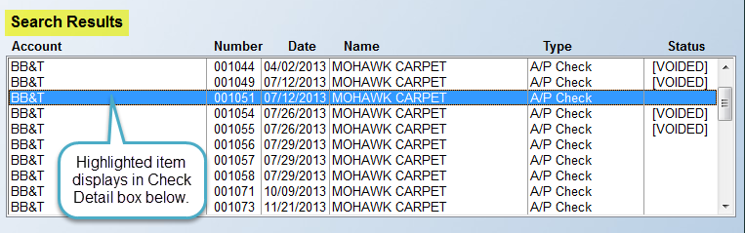

If you highlight a line in the box above, the system will display the detail in the Check Detail box below as follows:

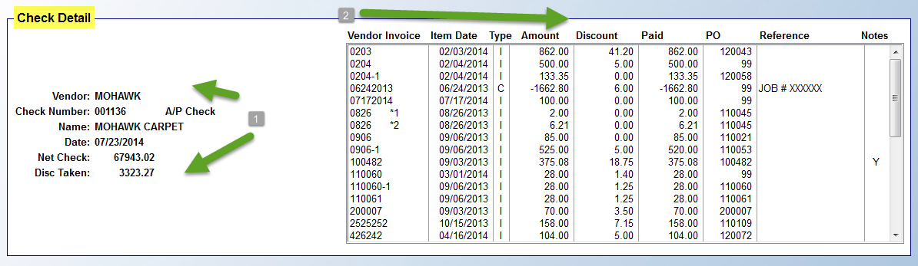

The left side of the box -1- displays the Vendor ID, Check Number, Vendor Name, Check Date, Net Check, and any Discount Taken. The right side of the box -2- displays all the items, including credit or debit memos, included in the single check or payment. If any Notes exist on an item, you will see a “Y” in that column. If you highlight that line, the system will prompt a Notes icon to the left of the Vendor Invoice column. When you have finished looking up history in this module, click the red X at the top right of the screen or hit the Esc key to return to the A/P Menu.

Hand Check/Void Check Processing:
This module allows you to process hand written checks in the system and also to void both hand written and system printed checks. The Hand Check feature should only be used for “quick” checks that need to be processed before the next scheduled check print. Please Note: the system will allow you to pay more than one Invoice per Hand Check, and Invoices can be added ahead of time through Open Item Maintenance or in this module “on the fly.” When you process a Hand Check or Void a check, the system will automatically update the Cash Disbursements and Accounts Payable G/L Accounts. Also, if a check has been printed and cleared through the Bank Reconciliation module, the system will not allow that check to be voided through this module.

When you enter this module, the system will first prompt a Vendor Selection screen as follows:

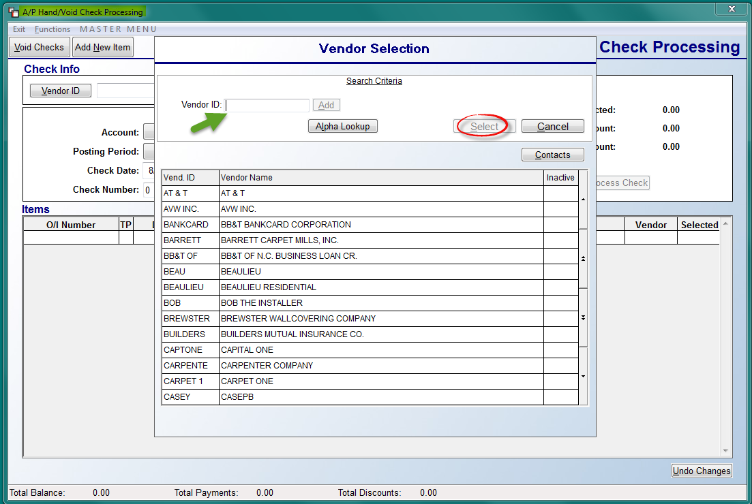

Make a Vendor selection and click the Select button to continue. The system will prompt the Vendor ID, along with any existing Open Items in the Items box as follows:

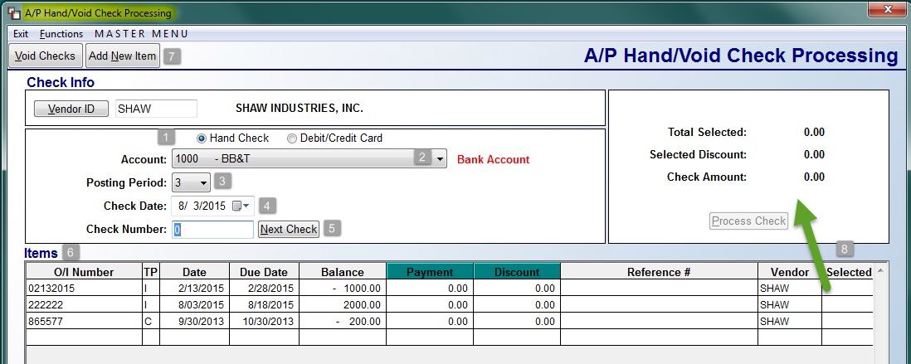

The system will default to the Hand Check -1- selection, but you can click the Debit/Credit Card option to switch to that payment type. The Account -2- field will default to your main Bank Account. Use the down arrow key to select an alternate Bank Account. The Posting Period -3- field will default to the current Period. You can change the Period, when applicable, via the down arrow key. At the Check Date -4- field, you can leave the current date default, or use the down arrow key to select an alternate date. The Check Number -5- field will default to “0”. You can click the Next Check button to prompt the next available check number in the system for the current Bank Account, or you can type a number in this field.

The Items -6- box will display any current Open Items on the Vendor’s account that are ready for payment. These Items will not automatically be selected when you access this screen, but you do have the option to select them for Hand Check processing by clicking in the Selected -8- column next to the item, including any credits. To add an item for payment, click the Add New Item -7- button at the top left of the screen. Please Note: The Functions menu contains the same options as the buttons at the top left as follows: Add New Item & Void Checks. When you click the Add New Item button or select it from the Functions menu, the system will first prompt an Add New Item screen as follows:

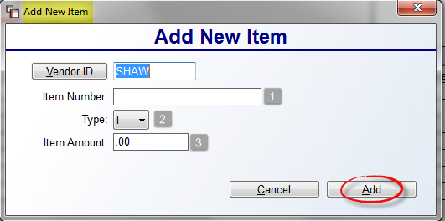

The Vendor ID field will prompt the current Vendor selected in the previous screen. At the Item Number -1- field, type in the applicable number of the item you are creating. At the Type -2- field, leave the default “I” for Invoice, or use the down arrow to select “D” for Debit Memo or “C” for Credit Memo. Type in the amount of the item in the Item Amount -3- field, and then click the Add button to continue. If you click Add before typing an Item Number, the system will prompt you with a warning, forcing you to enter a number. The system will then jump you to the A/P Open Items Maintenance screen for you to add the item “on the fly.” When you have completed that process, the system will return you to this screen and prompt the new item in the Items box, automatically selecting the item, as follows:

Prior to selecting an Item, you can click in the Payment and Discount columns to make changes, such as adding or removing a discount, or making a partial payment. An Edit Payment box will prompt as follows:

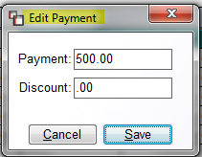

If you make changes in this box, be sure to click the Save button to keep those changes. As Items are clicked in the Selected column to reflect “Y” for yes, the box above will total the amounts selected as follows:

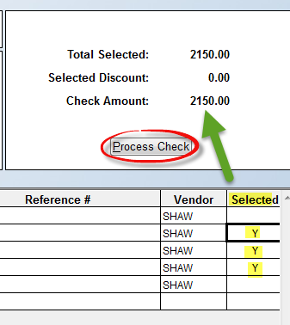

The Undo Changes button at the bottom right of the screen will clear any changes in this screen since first entering, basically reverting everything, aside from any new items added, back to the defaults. Once all items for the Hand Check have been selected, click the Process Checks button to continue. A Check Processed box will prompt at follows:

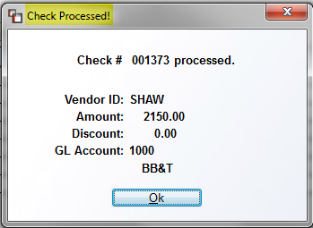

Click the Ok button to continue. The system will revert back to a blank screen. You can hit the Exit menu item at the top left if processing is complete, or click the Vendor ID button to process another Hand Check. Note: don’t forget to print a Check Register following activity in this module.

Void Checks
To use the Void Checks option, make a Vendor selection to begin. The system will prompt a Void Check Processing screen as follows:

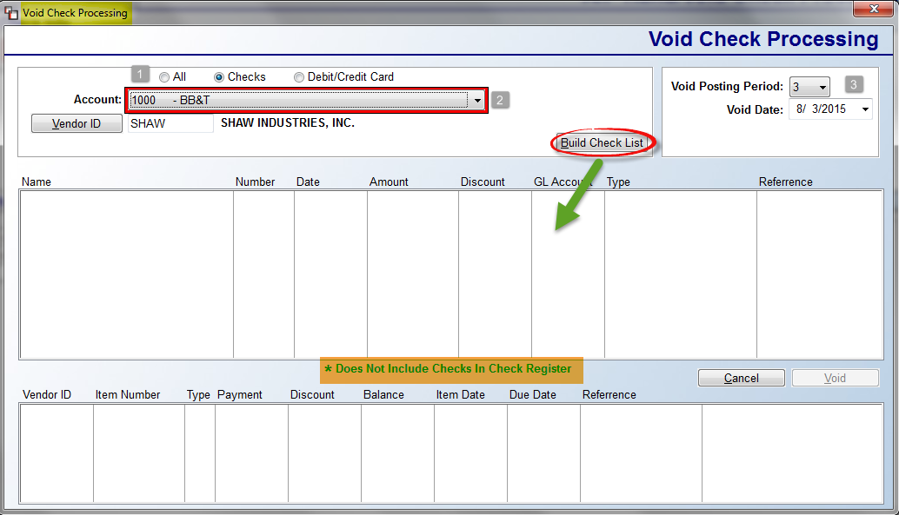

The system will default to the Checks -1- selection, but you can click the All or Debit/Credit Card option to switch when applicable. The Account -2- field will default to your main Bank Account. Use the down arrow key to select an alternate Bank Account. The Void Posting Period -3- field will default to the current Period. You can change the Period, when applicable, via the down arrow key. At the Void Date -3- field, you can leave the current date default, or use the down arrow key to select an alternate date. Please note the message in the display screen that appears as follows: Does Note Include Checks in Check Register. Print and clear the Check Register to Void a check that was just processed and not yet cleared on that report. To continue, click the Build Check List button to display a list of available checks/payments for voiding as follows:

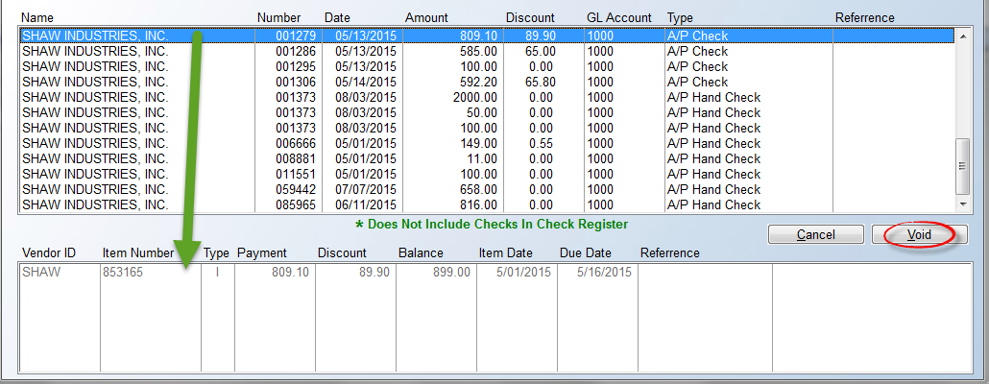

Scroll through and highlight the item to be voided. The data will display in the box below. When you have selected the correct item, click the Void button to continue. The system will prompt a Void Check # box as follows:

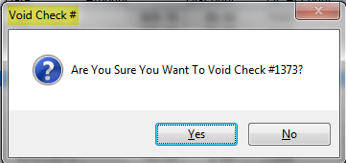

Click Yes to void the selected item, or No to return to the previous screen. When you click “Yes,” the system will prompt a message confirming the data has been processed. If more than one open item exists on a payment, this message will prompt for each one.

Bank Reconciliation:
This module is used to reconcile all bank accounts in the RollMaster System. When you enter this module, the screen will appear as follows:
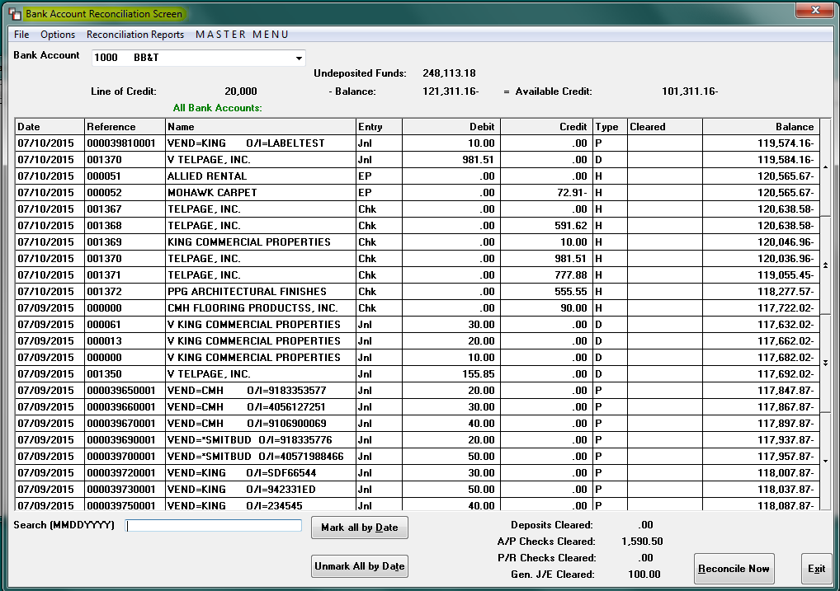

If a Line of Credit is set up on an account, that data will appear at the top of the screen, as in the example above. If not, the top of the screen will appear as follows:

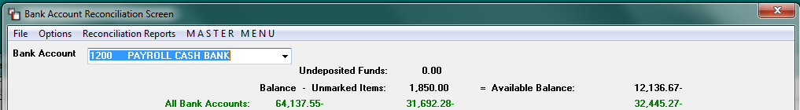

When you first enter this module, the screen will default to your main Bank Account and will display the newest entries at the top by Date. Deposits will sort within a date range by Payment Type Code, Branch, and then Sequence. This will group all the different payment types together so that a list of Visa charges for the day will be together, followed by the next Payment Type Code, etc. To change Bank Accounts, use the drop down arrow in the field to make a selection. Next to the Bank Account field are display fields that cannot be accessed, but will give you important information. The Undeposited Funds field will display the total of deposits/payments that have not been cleared via the Customer Payment Register module, although all deposits/payments will display in the grid below as soon as they are posted in the system. The Balance – Unmarked Items field displays the General Ledger value of the Bank Account selected, plus or minus any transactions made to the bank account whether or not the G/L has been updated. The Available Balance field displays the sum of the previous balance, less any unmarked transactions that have not cleared the bank. Any “Undeposited” funds will not be included in this total.

The list of items you will see in this screen are as follows: Deposits/Payments that have been cleared off the Customer Payment Register (if a deposit/payment has not been cleared it will be totaled and included in the Undeposited Funds value at the top of this screen), A/P checks, Payroll checks, Electronic Payments, Credit Card payments, and any Journal Entries created from this module. The Reference column field denotes different information based on the type of entry. Journal Entries will display the General Ledger sequence number assigned by the system when the entry was created. For A/P checks, Payroll checks, and Electronic Payments, the Reference column will display the six-digit check number. If the item is a Deposit or Payment, that column will display the Branch ID, Payment Type Code, and Sequence #. The Name column will display Vendor Names for A/P Checks and Description information for Journal Entries. The Entry column denotes the type of item such as “Jnl” for Journal Entry, “Chk” for Check, “EP” for Electronic Payment, or “Dep” for Deposit/Payment.

Please Note: from the A/R Customer Account Maintenance module, if an entry impacts a Bank Account, the system will create a journal entry in the Bank Rec. with a type “R; the A/P Open Item Maintenance module will also write a journal entry if a Bank Account is impacted and will display a type “P”; and finally, if a G/L Journal Posting entry impacts a Bank Account, the system will write an entry to the Bank Rec. with a type of “G.”

The Debit and Credit columns display how each entry impacted the Bank Account. The Type column will display various codes for different types of transactions as follows:

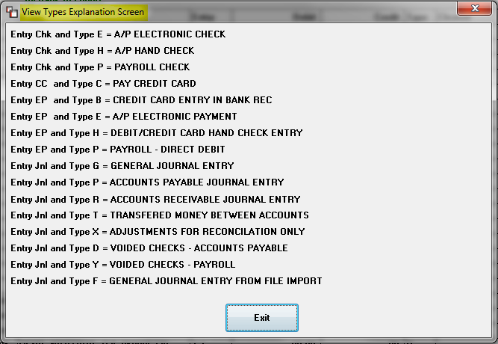

This screen can be called up at any time within the Bank Rec. module via the Options menu at the top left of the screen, under “View Types Explanation.” The Cleared column will display an “R” if the entry has been reconciled, a “Y” if marked as “Cleared” or the field will be blank if the entry has not been marked as “Cleared.” Please Note: with regard to voided checks, you will not see the original check along with a negative entry, instead the entire check will disappear. You can scroll up and down within this screen by clicking on the arrows on the right-hand side.

Heading and sort changes:
At the top left of the screen, if you click on the box for the Date heading field, the system will change the date order to display the oldest items at the top of the screen. If you click a second time, it will revert back to newest to oldest. Also, at the very bottom of the screen you will see the following: Search (MMDDYYYY). If you type a date in this field, the system will find the first item it encounters with that date. You can sort by other column headings by first clicking on the heading and then typing the search data in the “Search” field, which changes based on the heading you selected. For example, to search by a name, click on the “Name” column header and the Search field will display “Search Name” instead of “Search (MMDDYYYY).” Another option is to click on the Reference header column to sort that information in ascending order. Additionally, if you click this column heading, you can use the “Search” field to locate a specific Check Number. If there are any preceding zeros in the Check Number, you will need to enter those in the Search field. Another Reference item is a Deposit search. For this you will need to type a combination of the Branch ID, Payment Type Code, and Sequence #, using a “/” in between. You will need to type up to two-digits for the Branch ID, up to four digits for the Payment Type Code, and then the two-digit Sequence #. The sequence “00” represents the first deposit of that type on that date. The sequence “01” would be the second deposit of that type that day. Here is an example: 1 /AMEX/00.

If you click on the Entry heading column, the system will sort all Checks together, followed by Deposits/Payments, and then Journal Entries. You can also type a “D” in the Search field to jump to the first Deposit, a “C” for the first check, and a “J” for the first Journal Entry. If you click on either the Debit or Credit column headings, the system will sort all of the amounts in descending order regardless of whether they are debits or credits. Click again and it will sort in ascending order. Additionally, you can enter an Amount in the Search field to jump to the first occurrence of that Amount. One final column heading sort option is to click on the Cleared column heading. The system will display all Not Cleared items first, then all Reconciled items, followed by any Cleared items. If you type a “Y” in the Search field, the system will find the first record marked as Cleared. Also, the Checks, Deposits and Journal Entries marked with a “Y” will be showing in the four fields at the bottom of the screen as follows: 1) Deposits Cleared, 2) A/P Checks Cleared, 3) P/R Checks Cleared, and 4) Gen. J/E Cleared.

In the Cleared column, if the field is blank, you can click on the field to change the status to “Y,” which indicates the item has cleared the bank. As soon as you hit enter at the Cleared column for an item, the system will prompt the current date next to the “Y” for yes indicator, and the Date will default to the current date, which displays until the reconciliation process is completed. (See Options menu explanation below to change the default date for items cleared). You can also click on an item with a “Y” status and revert the item back to “Not Cleared.” When this happens, the system will first prompt the following: Are You Sure? You will need to type a “Y” for yes to unclear the item. As you “Clear” and “Un-Clear” items, the balance of the fields at the bottom right will increase and decrease. This can be done up until the point that an item has a status of “R” for Reconciled.

Two additional options appear at the bottom of the screen as follows: Mark All By Date and Unmark All By Date. To Mark (as Cleared) all items on or before a particular date, click the Mark All By Date option to display the following: Mark All Records with dates on or before. The system will default to the current date; if you would like to change the date, you can click on the down arrow to prompt a calendar to select a different date. Once a date is entered and accepted, the system will change the status of all Un-cleared items within the date range as Cleared with a “Y” in the Cleared column. Similarly, you can instantly “Unmark” any Cleared items the same way via the “Unmark All By Date” button. The Reconcile Now button should not be used until you have completed clearing all items and making any additional entries to reconcile.

Options Menu Item Explanations:
Along the top of the Bank Rec. screen are Menu Items that will allow you to access additional information and programs while still in the Bank Rec. screen. Moving from left to right, if you click on the File button, you will see an option to Exit this menu. You can also use the Esc key to exit this screen, or click on the “X” at the top right. If you click on the Options menu, a drop-down menu will display several options as follows:

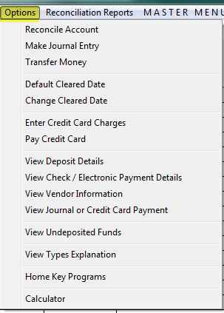

The Reconcile Account feature will be used when you have marked all Cleared items, made any additional applicable entries not already entered in the system, and are ready to begin the Reconciliation process. This feature will be explained in detail below following the explanation of the other items in the Options menu. The Make Journal Entry option will prompt a journal entry screen as follows:

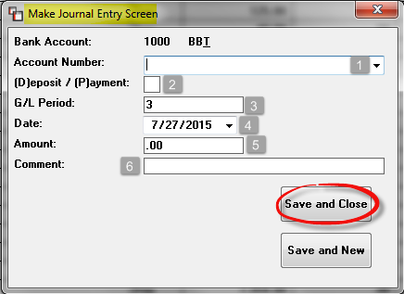

At the Account Number -1- field, click the down arrow to select from a list of G/L Accounts. The Account selected will be impacted along with the Bank Account displaying at the top of the screen. The (D)eposit / (P)ayment -2- field is looking for a “D” for Deposit or “P” for Payment. Deposits will be added to the bank account and Payments will be subtracted. Note: If you enter a minus sign in the Amount -5- field, the system will perform the reverse of what was just explained. You can only select one G/L Account in this module, so if you need to make an entry impacting more than one G/L Account you will need to use the Journal Posting module. If you need to make an entry from the Journal Posting module, you will need to update the General Ledger prior to completing a Bank Reconciliation. The G/L Period -3- field will default to the current posting period. You can type in a different period if applicable. The Date -4- field will default to the current date, but you can use the drop-down calendar to select another date where applicable. Type in a dollar figure in the Amount -5- field and add a Comment -6- if needed. The final step is to click on the Save and Close button. Or, if you need to make another entry, click on the Save and New button to stay in this screen. To exit without saving the entry, hit the Esc key or click on the “X” at the top right. All Journal Entries will automatically be marked as Cleared, but you can easily unmark any of these entries prior to reconciling by clicking on the “Y” in the Cleared column.

The Transfer Money feature is used to move money from one bank account or line of credit account to another. When you click on this feature, a box will appear as follows:
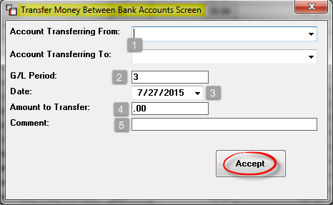

At the Account Transferring From -1- field, click on the down arrow to display a list of Bank Accounts and select the Account from which you will be moving money. In the Account Transferring To -1- field, click the down arrow to select the Account to which you will be transferring the money. The G/L Period -2- field will default to the current posting period. Type in a different period if applicable. The Date -3- field will default to the current date, but you can click on the drop-down arrow to select another date if applicable. At the Amount to Transfer -4- field, type in the dollar amount of the money transfer. At the Comment -5- field, you can type out a brief explanation for the money transfer. Click the Accept button to save the transfer. To exit without saving, click on the “X” at the top right of the screen or hit the Esc key. Once saved, in the Bank Rec. screen the system will display a “T” in the Type column and “Jnl” in the Entry column for money transfers.

By selecting the Default Cleared Date option from the Options menu, you can change the Default Cleared Date for all records you are about to mark as Cleared. When you select this option, a Set Default Cleared Date box will prompt as follows:

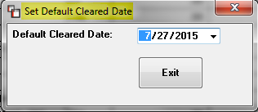

The date will default to the current date. Use the drop-down arrow to prompt a calendar to select another date. By clicking on the new date in the calendar and then clicking the Exit button, all new records that you mark as Cleared will reflect the default date now selected. You can also change the Cleared date on any selected item via the Change Cleared Date option. Position the cursor in another column in the row for the item you want to change and then select the Change Cleared Date option from the menu. (Be careful not to position the cursor in the row beneath the item as this will instantly unselect that item.) The system will prompt the following:

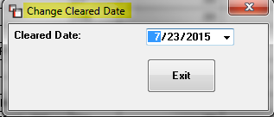

Use the drop-down arrow to prompt the calendar and select the proper date. Click the Exit button and the system will change the Cleared Date to the date you selected. Please Note: after you change the date, the program will restart the browse from that record.

The Enter Credit Card Charges option will allow you to enter and then distribute expenses for credit card bills. Please Note: this option, along with the Pay Credit Card option (explained below), was designed for online bill paying. If you are going to write a check to the credit card company, you should stick to normal check printing procedures. Before you can use this option, you must first identify all applicable Credit Card G/L Accounts as Credit Cards via the General Ledger Account Maintenance/ Inquiry module. You can also set Credit Card Limit and Interest Rate data so that the Credit Card Balance and Available Balance data can be viewed in this module when a Credit Card Account is selected from the Bank Account field. Also, any Vendors you would like to set up for payment through this option should have the following field in the Vendor Maintenance module set to “N” for no: A/P Vendor Only. Once all set up is complete, select this option from the menu and an Enter Credit Card Charges screen will display as follows:
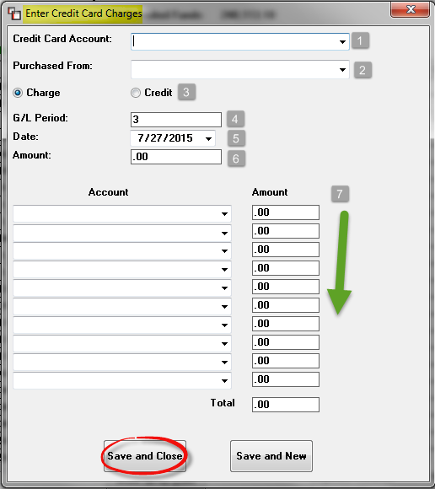

At the Credit Card Account -1- field, click on the down arrow to select a Credit Card G/L Account—again, only G/L Accounts that have been designated as Credit Cards in Account Maintenance will display here. In the Purchased From -2- field, a list of Vendors not designated as A/P Vendor Only will display. If your Credit Card company has not been added, you can select <ADD NEW VENDOR> from the top of the list. This will allow you to quickly add a Vendor—these will not appear in the Vendor Maintenance module—via an Enter New Vendor box as follows:

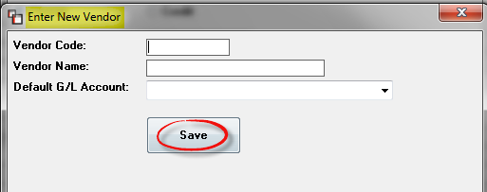

You will generate the information in the Vendor Code and Vendor Name fields, but in the Default G/L Account field, click the down arrow to display a list of existing G/L Accounts to assign a default. Once this has been done, the system will return you to the Enter Credit Card Charges screen.

In the next -3- section, you will choose whether this is a “Charge” or “Credit” to this card. The G/L Period -4- field and the Date -5- field will default to the current period and date. Accept the defaults or select a new Period or Date if applicable. At the Amount -6- field, type in the total credit or charge for this transaction. As soon as you enter an amount, in the first line of the fields below, the system will display the default G/L Account you previously selected in the Add New Vendor screen along with the total Amount entered in the field above, on the first Account -7- line. If this is the only entry that needs to be made, you can click the Save and Close or Save and New button to complete the process. Otherwise, change the Amount on the first line and continue to select Accounts and amounts until the full charge or payment has been distributed. This process does not pay the bill, but allows you to enter all the financial distribution information for the credit card in preparation for making the payment to the credit card company. You will not see any listing in the Bank Rec. screen for the credit card charges, but you will see the financial data on your Cash Disbursements and A/P Journals for the entries made.

The Pay Credit Card option can be used once credit card charges have been added and distributed in the Enter Credit Card Charges option. Before you click on this option, be sure the applicable Credit Card G/L Account has been selected in the Bank Account field of the main screen. When you click this option, a Pay Credit Card screen will display as follows:

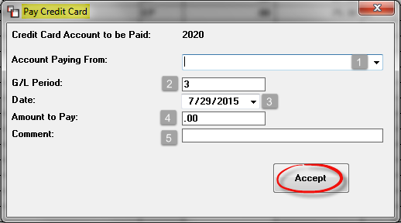

The Credit Card Account to be Paid field will display the Credit Card G/L Account number you selected in the Bank Account field. At the Account Paying From -1- field, click on the down arrow button to display a list of Bank Accounts from which the payment is to be made. Accept the default G/L Period -2- and Date -3- prompts, or click on those fields to make changes if applicable. In the Amount to Pay -4- field type in the amount of the payment and in the Comment -5- field, you can add a note applicable to the payment. Once you click the Accept button, the process will be complete and you will be able to view the payment in the Bank Rec. main screen. You will also be able to see all history of Credit Card payments by selecting the Credit Card G/L Account in the Bank Account field.

The View Deposit Details option will allow you to view all details of a deposit entry. Note: the cursor must be positioned on a Deposit entry of the main Bank Rec. screen when you click on this option. When this option is selected, the system will display a Deposit Screen with the deposit details as follows:

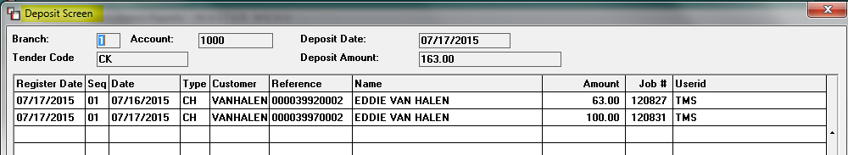

For any Deposits not Marked as Cleared, additional functionality will allow you to click on any line in the screen above to prompt a Change Deposit Screen as follows:

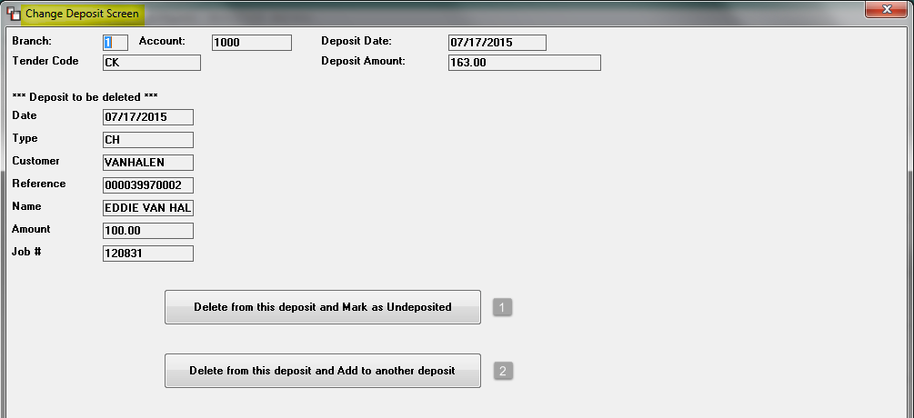

There are two options from this screen and both appear at the bottom. The first -1- option is Delete from this deposit and Mark as Undeposited. Use this option to delete the selected deposit amount from the Deposit and return the entry to the Customer Payment Register. When this option is used, the Undeposited Funds field will automatically change to reflect the deletion. The second -2- option is Delete from this deposit and Add to another deposit. If you click this option, the system will prompt a Deposit Selection Screen. From this screen you can click in the Select This Deposit column to select the Deposit to add the amount. If you select Move deposit to selected deposit button which adds the selected Deposit entry from the previous screen to the selected Deposit, it will change the amounts on both Deposits before displaying the screen again. You can also use the Exit and cancel moving deposit button to cancel the Deposit move. Please Note: this feature will only let you add to a Deposit from the same Branch.

With the cursor positioned in any field on an “EP” or “Chk” item in the main screen, you can click on the Options menu and select View Check/Electronic Payment Details to see all applicable details of the check or electronic payment. For either item type, the system will prompt a Check Screen as follows:

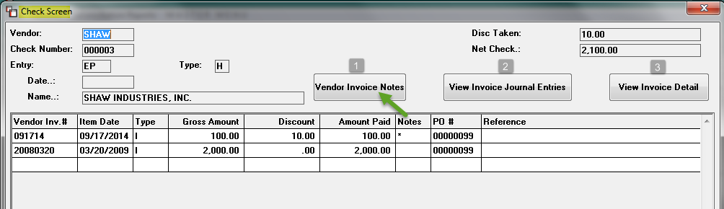

From this screen, if an “*” appears in the Notes column on a line, you can click the Vendor Invoice Notes -1- button to view those Notes. Be sure the cursor is positioned on the line before you click any of the buttons. The View Invoice Journal Entries -2- button will prompt the Entries made in Open Item Maintenance for an item. You can also click the View Invoice Detail -3- button to view Inventory Data for material Invoices, and/or the Purchase Order Data on items tied to a system PO.

With the cursor positioned on a Vendor ID in the Name column, you can select the View Vendor Information feature from the Options menu to display the Vendor Maintenance screen for that Vendor. This is a display only screen. You can, however, click on the Vendor Notes button to prompt existing Notes for the selected Vendor.

With the cursor positioned on a Journal Entry or Credit Card Payment item, you can select the View Journal or Credit Card Payment option to display a View Journal Detail Screen as follows:

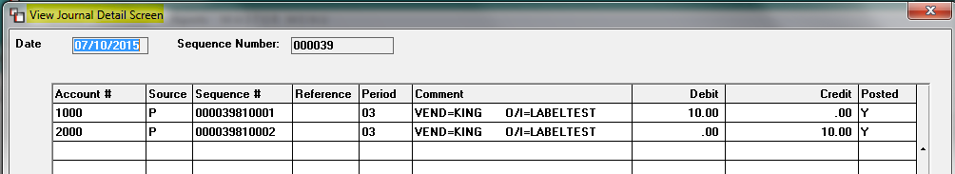

This is a display only screen. Hit the Esc key to return to the main screen.

For the Bank Account selected in the main screen, you can select the View Undeposited Funds option to display a listing of all Undeposited funds as follows:

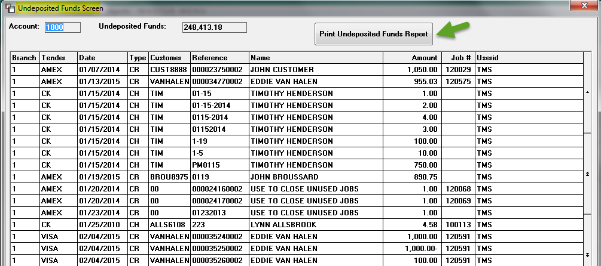

This is a display only screen also, but you can click on the Print Undeposited Funds Report button to print a listing of all Deposits appearing in this screen.

The View Types Explanation option displays a list of abbreviations found in the Entry and Type columns as a handy reference. When you select this option, the system will display a View Types Explanation Screen as follows:

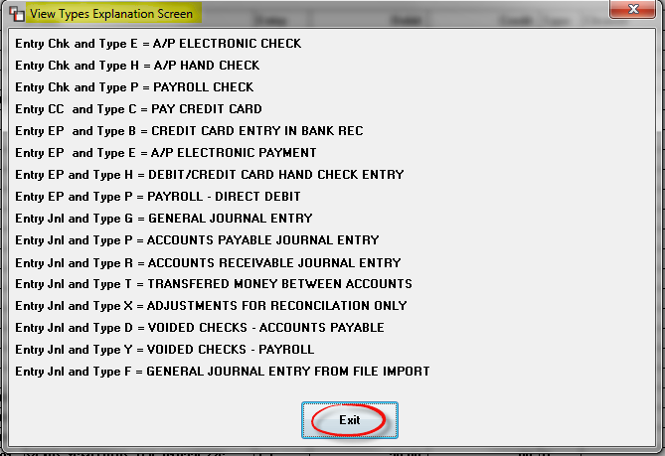

Click the Exit button to return to the main screen.

The final options appear as follows: Home Key Programs and Calculator. The first will prompt the Home Key menu of programs and the Calculator will prompt an on-screen calculator.

Reconciliation Reports:
The next drop-down menu to the right of the Options menu appears as follows: Reconciliation Reports. The report options available from here appear as follows:

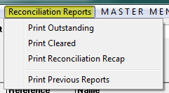

The Print Outstanding, Print Cleared, and Print Previous Reports items can be printed at any time; if there are no Previous Reports available, the system will prompt you that no reports are available. Also, the Print Outstanding and Print Cleared reports will export to Excel. Within each of those reports, you can select which items you wish to appear via a Report Option box as follows:

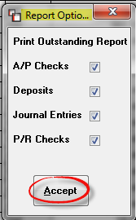

You can click on the Accept button to print all items, or click on the arrow to remove any items you don’t want on the report. The Print Reconciliation Recap report will only print data once you have begun the reconciliation process. Ideally, you will want to print a complete report just prior to finalizing a Bank Reconciliation. During the Bank Reconciliation process (explained below) you will also be prompted to print these reports, but they can be printed at any time via this drop-down menu.

The Master Menu option allows you to access any system module without leaving the Bank Rec. screen.

Bank Reconciliation Procedures:
When you are ready to begin a Bank Reconciliation, you will first begin by clicking in the Cleared column for all items that are cleared on your bank statement, making sure each has a “Y” in that column to indicate it has cleared the bank. You can click on an item with a “Y” status and revert the item back to Not Cleared at any time. As you Clear and Un-Clear items, the balance of the fields at the bottom right will increase and decrease. This process can continue on any item up until the point that it displays a status of “R” for Reconciled. Two other options to be aware of appear at the bottom as follows: Mark All By Date and Unmark All By Date. To Mark (as Cleared) all items on or before a particular date, click the Mark All By Date option to display the following: Mark All Records with dates on or before. The system will default to the current date; if you would like to change the date you can click on the down arrow to pop up a calendar to select a different date. Once a date is entered and accepted, the system will change the status of all Un-cleared items within the date range to Cleared. Similarly, you can instantly Unmark any Cleared items the same way via the Unmark All By Date option.

When all items for a Bank Rec. have been marked as Cleared and you are ready to finalize the Bank Rec. process, click on the Reconcile Account option from the Options drop-down menu. The system will prompt a Reconcile Screen as follows:

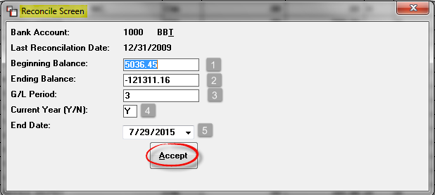

Important Note: When using lines of credits and credit cards in the Bank Reconciliation module, make sure the Ending Balance is entered with a (-) minus sign. These account types are listed in the system as Liability accounts and should reflect a Credit balance on your Financial Statements.

In the Beginning Balance -1- field, the system will automatically prompt the ending balance from the last completed Bank Reconciliation. However, this field can be overridden if applicable. The Ending Balance -2- field will default to the Available Balance field from the main screen, but should reflect the ending balance from your current bank statement. At the G/L Period -3- field, type in the applicable period for this Bank Reconciliation if different from the default period. At the Current Year -4- field, the default is “Y” for yes, meaning that the data will post to the Current Year reflected in the system General Ledger. In a situation where your Accounting year is January through December, but only the first six periods (January through June) of the current year are closed and you are about to move into a new Accounting year, your January and subsequent months will be considered Next Year in the system until you finish closing all the remaining periods of the Current Year and do a physical End of Year close in the system. In this case you would need to change the default to “N” to post to the Next Year.

At the End Date -4- field, enter the date, using the calendar via the down arrow, to select the last date you would like to see any items displayed during the Bank Rec. Prior to hitting the Accept button, you can exit this screen at any time by hitting the Esc key or by clicking on the “X” in the upper right hand corner. If you hit the Accept button, the Bank Rec. screen will re-display with items and values based on the information you just entered. The Total Cleared and Difference fields will display values at the bottom right of the screen to let you know if the Bank Rec. info is correct. You can only complete the reconciliation if the Difference field is 0.00. You will not be able to click the Reconcile Now button until the difference is 0.00. If you attempt to use the Reconcile Now button prior to successfully completing the reconciliation, you will receive a prompt indicating why you cannot proceed.

When the Difference field is 0.00 and you are ready to complete the reconciliation, you will then click the Reconcile Now button to complete the process. All items that were marked as cleared will then be reconciled and an “R” will appear in the Cleared column next to those items. Also, the system will prompt a Reconcile Account Report Options menu. You can check or uncheck the reports that you want printed. If you don’t print any reports at this time, they will be archived and available for printing later once the reconciliation is successfully completed. Once you hit the Accept button from the reports menu, the system will prompt the following: Reconciliation Final Confirmation. Are you sure you want to mark all cleared items as reconciled? To complete the process, click “Yes” to proceed.

A/P Recurring Items:
This module will allow you to set up recurring payables and quickly process those items every month. Only set up items in this module that are due on a recurring basis for the same amount. When you enter this module, the system will prompt an A/P Recurring Items screen as follows:
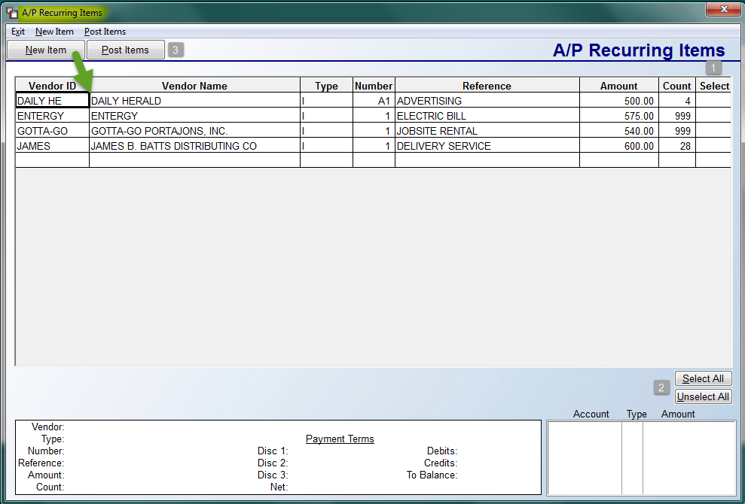

Any existing Recurring Items will automatically appear in the screen in order of Vendor ID, as in the example above. To select an item for recurring payment, click in the Select -1- column for that item. You can also click the Select All -2- button at the bottom right of the screen to select all items instantly. The Unselect All button will instantly unselect any selected items. Once items are selected, you will click the Post Items -3- button to continue the process. The explanation for this process appears below, following instructions for adding a new item.

To add a new recurring item, click the New Item button at the top left, or select that menu option from the top left of the screen. The system will first prompt a Vendor Selection box for you to select a Vendor ID. The system will then prompt an Add Recurring Item box as follows:

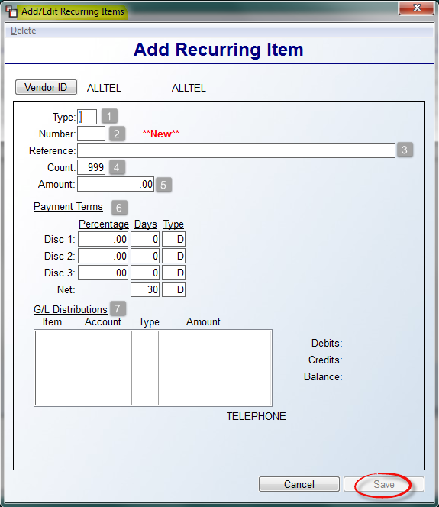

At the Type -1- field, use “I” for an Invoice or a “C” for a recurring Credit Memo. At the Number -2- field, create a 4-digit alphanumeric item number (Please Note: each time you Post a Recurring Item, the system will automatically add a date stamp to the end of this 4-digit number to create a unique item number as follows “15080401-two for the year, two for the month, two for the day, and two to number each item in a day. You can use letters or numbers, i.e., RENT, AUTO, etc.) At the Reference -3- field, type a brief reference for this Recurring Item. The Count -4- field will default to 999 for unlimited postings. If you know the total number of times you will post this item, override this field with that number. At the Amount -5- field, type in the amount of the Recurring Item—this is the amount you will post each time you Post this Recurring Item. In the Payment Terms -6- fields, setup any terms that would apply to this Recurring Item; leave blank if terms do not apply. The next step is to set up the G/L Distributions -7- box. To start, click in the Item column of the G/L Distributions box to prompt the following:

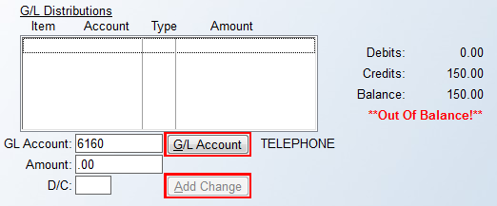

An Account Number will default in the G/L Account field if one has previously been entered in the Vendor Maintenance screen for this Vendor. If not, click the G/L Account button to perform a look-up for the applicable Account Number. At the Amount field, type in the amount of this distribution. Note: you can create multiple distributions in this screen provided the Debits and Credits equal at the end. At the D/C field, indicate a Debit with a “D” and a Credit with a “C.” Click the Add Change button to continue. Once you entry is in balance, click the Save button. The system will return you to the main A/P Recurring Items screen and the new item will appear alphabetically in the items list.

To post a Recurring Item, start by selecting an item or items in the main screen by clicking in the Select column next to that item or using the Select All button. Next, click the Post Items button or select the Post Items menu option at the top left of the main screen. An Are You Sure? box will appear as follows:

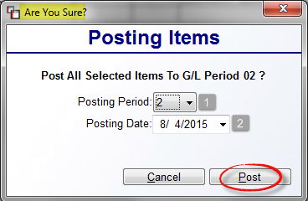

The Posting Period -1- field will default to the earliest open Period in the system G/L, not the Default Posting Period in Company Control. Hit enter to accept the current open Period, or use the down arrow to select another open Period. At the Posting Date -2- field, the system will prompt the current date; use the down arrow to select a different date.
When the data is correct, click the Post button to complete the process. Back in the main screen, if the Count column displays anything other than “999,” you will note the count value decrease by one for all items posted. The item(s) will also appear on all A/P Reports, including the Open Item Adjustment Register. You can also view items in the Vendor Status Inquiry module.

If you need to Delete a Posted Recurring Item, you will handle it just as you would when deleting an Open Item entered through A/P Open Item Maintenance. Be sure to look up the complete Item Number through the Vendor Status Inquiry module first.

Delete “*” Vendors With No Activity:
The Delete “*” Vendors With No Activity module works in tandem with the Credit/Refund procedures in the Order Entry/Maintenance module. When a check is selected as the method of refund during credit/refund processing, the system will automatically create a new Vendor using the Customer’s ID and placing an “*” at the beginning. For example, SMIT1234 becomes *SMIT123 in the Vendor Maintenance module. Once the check has been paid, you can delete this “Vendor” by running this module—you may want to consider doing this on a monthly or quarterly basis. Please Note: You do not have to delete these refund Vendors, but if you process a large volume of refunds by check, your Vendor Listing could become bogged down with “*” vendors. When you enter this module, the screen will appear as follows:

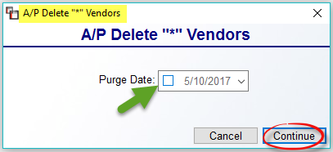
If you would like to make a Date selection that will only purge “*” Vendors with zero balances or no A/P Items after that specified date, click in the Purge Date box and use the calendar option to make a Date selection. Click the Continue button to proceed with this process. The system will prompt the following message box:
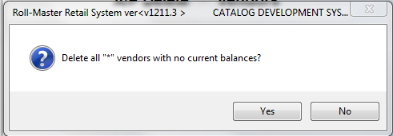
Click the Yes button to continue with deletion of the “*” refund Vendors with a zero current balance. When the process has completed, the system will prompt the following confirmation message:
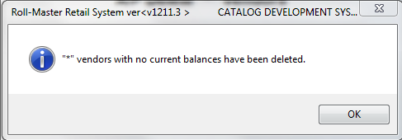

Click the OK button and the system will place the cursor back at the A/P Delete “*” Vendors screen above. Click the “X” at the top right corner to exit or hit the Esc key. Note: These “*” Vendors will still be visible from the Check History module after deletion.

A/P End of Month Processing:
The A/P End of Month Processing should be run at the end of every month and also at the end of a calendar year. At the end of the month, it purges cleared open items from the Vendor Status Inquiry module. At the end of the year, it moves the value in the Y-T-D Pur field in the Vendor Maintenance module to the Last Yr. Pur. field, and clears the Y-T-D Disc. field. When you enter this module, the screen will appear as follows:
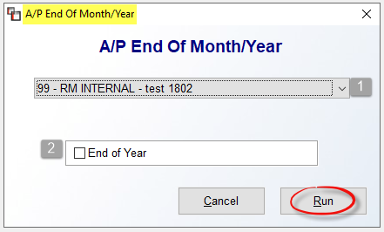
The cursor will be positioned at the Company ID -1- field. Use the drop-down arrow to select a different company or accept the default. At the End of Year -2- field, only click the box in this field if this is also the end of your calendar year. Please Note: Before running the end-of-year program, you should first run the end-of-month for December. You should also run the Print A/P Form 1099 report located in the A/P Reports Menu 2 of 2 to get a 1099 form for all subcontractors before you run the end-of-year program. Click the Run button to continue with End of Month or Year Processing.

Vendor Type Maintenance:
The Vendor Type Maintenance module allows you to create specific Vendor Types to separate your Vendor Listing into categories such as installer, lessor, vendor, etc., for insurance reporting purposes. It also allows you to designate a 1099 Payment Type to allow for splitting out and totaling different types of payments on the system 1099 printed forms. There are also several A/P modules that can be sorted by this Vendor Type. Those modules are as follows: Payment Selection, Vendor Listing, Open Item Aging Report, Open Invoice Listing and (As Of), Invoice History Listing, Vendor History by G/L Account Number, and the Cash Requirement Report. When you enter this module, the screen will appear as follows:
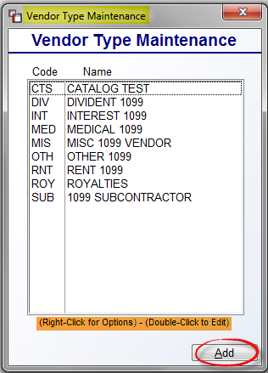
All existing Vendor Types will automatically appear in this screen. To add a new Vendor Type, click the Add button at the bottom right of the screen. A Vendor Type Maintenance screen will appear as follows:
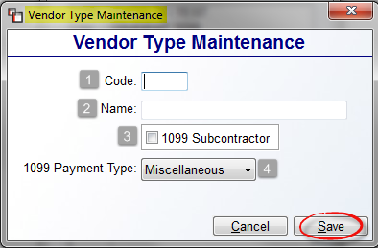
At the Code -1- field, type a 1-3 character code for the new Vendor Type. At the Name -2- field, type the full name description associated with this Vendor Type. If the Vendor Type will require a 1099, click the 1099 Subcontractor -3- box to select that option. You will then need to select a 1099 Payment Type -4- from the drop-down box to complete the setup. The NEC option in the drop-down menu stands for Non-employee Compensation. When you have finished, click the Save button to continue.
Once a Vendor Type has been saved, from the main Vendor Type Maintenance box, you can Edit existing Vendor Types by double-clicking on a selected type or by using the right-click button on the mouse to select the Edit Vendor Type option. The option to Delete a Vendor Type will only be available by using the right-click button on the mouse to select the Delete Vendor Type option. Please Note: If any relevant sales history exists in your system for a Vendor Type Code, you should not delete that code.

Once all Vendor Types have been created, you can then add a Vendor Type to each Vendor in the Vendor Maintenance module. The Vendor Type field is located at the bottom left under the Use Sq. Ft. Pricing field. Once all applicable Vendors have been assigned a Vendor Type, you can then print the Vendor Listing by Vendor Type.

A/P Reports -- Menu 1 of 2

Introduction:
There are two report menus for Accounts Payable—A/P Reports Menu 1 of 2 & A/P Reports Menu 2 of 2. Within both menus there are several reports relating to Vendors and Accounts Payable balances that will prove extremely beneficial to the accounting department. These report menus can only be accessed from the Accounts Payable menu. This next section will explain each report and how that report can be beneficial to the RollMaster user.

Vendor Listing:
This report prints a detailed listing of vendor information, displaying most of the data entered in the Vendor Maintenance module. You can print this report for one Vendor, a range of Vendors, or for all Vendors. If you print for all Vendors, it could be a very lengthy report depending on the number entered in the system, but there are additional options for customizing that can shorten the report and display only the data you need. When you enter this module, the screen will appear as follows:
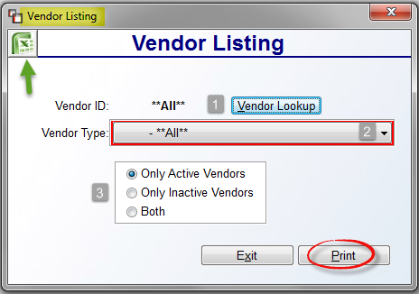
The Vendor ID -1- field will default to **All**. Use the Vendor Lookup button to select a specific vendor if applicable. The Vendor Type -2- field will also default to **All**. Use the drop-down arrow to select a specific Vendor Type if applicable. This program will also default to print Only Active Vendors -3-. You can opt to print Only Inactive Vendors or Both, depending on your needs. When you have made your selections, click the Print button to continue. You can also choose to export the data by clicking on the Excel icon at the top left. Both the printed copy and Excel export will denote Active/Inactive Vendors.
The Excel export has a column for Active/Inactive. The printed report will display data in the Header based on report selection as follows:

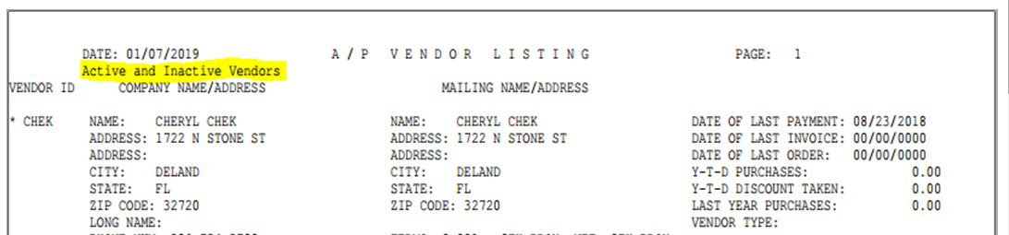

Next to Inactive Vendors, the report will also display an “*” next to the Vendor Name as follows:

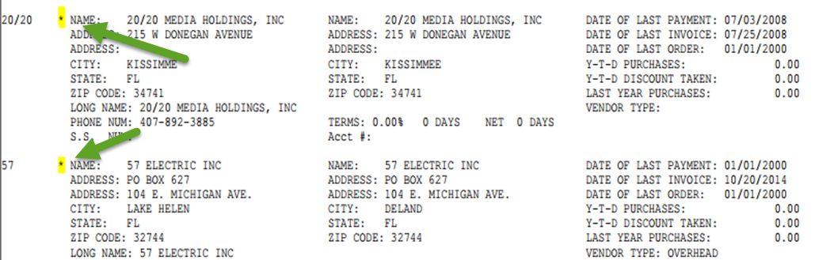

Vendor Reference List:
The Vendor Reference List is a much simpler report than the Vendor Listing. It lists only the Vendor ID and the Vendor Name. There are no customization options for sorting this report. When you enter this module, the screen will appear as follows:

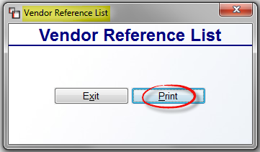

Click the Print button to continue. The Exit button will return you to the A/P Reports Menu 1 of 2 without printing.

Vendor Mailing Labels:
The Vendor Mailing Labels report module will print mailing address labels for all Vendors entered in the system, with a few options for customizing. When you enter this module, the screen will appear as follows:
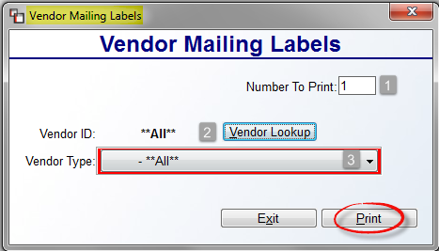

At the Number To Print -1- field, accept the default or type in the number of labels to print for each selected Vendor. The Vendor ID -2- field will default to **All**. Use the Vendor Lookup button to select a specific Vendor if applicable. The Vendor Type -3- field will also default to **All**. Use the drop-down arrow to select a specific Vendor Type if applicable. Click the Print button to begin printing labels.

Open Items Adjustment Register-Daily Report:
This report module prints an audit of all activity in the Open Item Maintenance module, as well as any Recurring Items posted since the last time the report was cleared. It is considered a daily report, only on days where activity has been performed, because it must be run and cleared in preparation for the next day’s activity. The end of the report will give you the net effect on the Accounts Payable G/L Account for the day.

When you enter this report module, the system will prompt an A/P Open Item Adjustment Register box as follows:

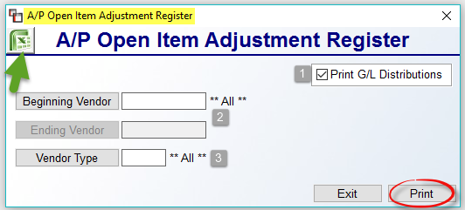
The Print G/L Distributions -1- box defaults to checked. If you leave it checked, for every Item on the report, the system will display each G/L Journal Distribution. This is a good way to double-check that all the entries for the day are correct. The Beginning & Ending Vendor -2- fields will default to **All**, however, if you would prefer to print and clear for a specific Vendor, or range of Vendors, you can use these fields to narrow the selection. The Vendor Type -3- field will allow you to print for a specific Vendor Type. This field is only applicable where you have previously set up Vendor Types in the Vendor Maintenance module. To learn more about Vendor Types, please see the Vendor Maintenance section of this documentation. To export the data to Excel, click the icon at the top left of the screen. Otherwise, click the Print button to continue. Whether printing or exporting, the system will prompt the following:

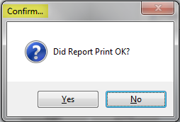

The data will not clear out of the module until you click the Yes button in the Confirm box.
If you click No because you need to regenerate the data, the system will place you back at the first screen to reprint the report. When you click Yes from the Confirm box, the system will prompt an additional: Are You Sure? Click Yes again to clear the report. Please Note: Items that have been deleted will display the Deleted Date on the report, not the original Open Item Date.

Open Item Aging Report:
This report will print a list of all Open Items in the system by age for each Vendor. It will then give a grand total of all Open Items at the end of the report. This report can be printed in either Detail or a Summary format. When you enter this report module, the system will prompt an A/P Open Item Aging Report screen as follows:

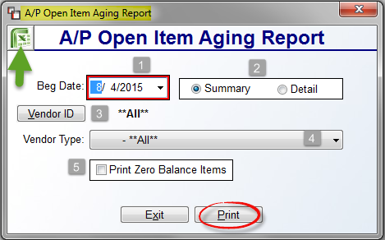

At the Beg Date -1- field, the system will default to the current date. However, you can use the drop-down arrow to select a prior date for aging. The default report display -2- option is Summary. This will print one line for total due per Vendor. The Detail option will print a detailed list of all Open Items on each Vendor’s account. At the Vendor ID -3- field, the default is **All** for all Vendors. Use the Vendor ID button to select a specific Vendor for the report where applicable. At the Vendor Type -4- field, again, the default is **All** for all Vendor Types. This field is only applicable where you have previously set up Vendor Types in the Vendor Maintenance module. Use the drop-down arrow to print for a specific Vendor Type. To learn more about Vendor Types, please see the Vendor Maintenance section of this documentation. The final -5- option, Print Zero Balance Items, should only be checked if you wish to include zero balance items on the report. Once all selections are completed, click the Excel icon at the top left to export the data, or click the Print button.

Open Invoice Listing:
This report module prints a list of every Invoice by Vendor and gives detailed information on each. The Invoices are subtotaled for every Vendor and a grand total of all Invoices displays at the end of the report. The report also shows discount information and gives a total of all discounts at the end of the report. If you have placed a Vendor on “HOLD” status, this report will indicate that info next to the Vendor data. Additionally, you can customize this report to list only Invoices due within a certain date range. When you enter this report module, the system will prompt an A/P Open Invoice Listing screen as follows:

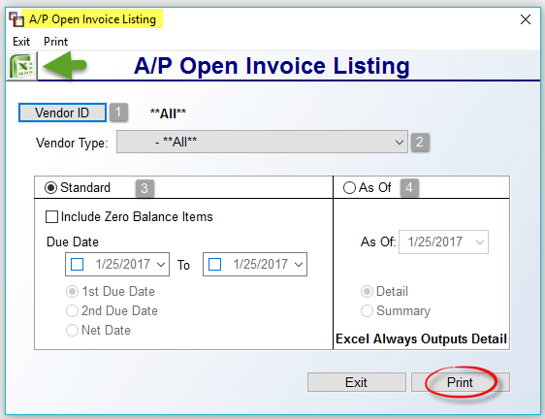

At the Vendor ID -1- field, the default is **All** for all Vendors. Use the Vendor ID button to select a specific Vendor for the report where applicable. At the Vendor Type -2- field, again, the default is **All** for all Vendor Types. This field is only applicable where you have previously set up Vendor Types in the Vendor Maintenance module. Use the drop-down arrow to print for a specific Vendor Type. To learn more about Vendor Types, please see the Vendor Maintenance section of this documentation. The Standard -3- print option will allow you to enter a range of due dates using Terms Discount dates. You can also check the Include Zero Balance Items if you wish to include those items on the report. To print all Invoices, click the Print option or click the Excel icon to export the data. However, if you wish to print Invoices based on a range of Due Dates, you will need to click in the Due Date boxes and use the drop-down arrows to select a date range. To display Invoices by the 1st Discount Due Date, leave the default setting. To select by the 2nd Due Date, click next to that option. To select by the Net Date, click next to that option.

The As Of -4- print option works much like the Open Item Aging Report. When you click this option, you will need to select an As Of date and then determine whether you want full Detail or Summary data on the printed report. The Excel export will only work with Detail selected, hence the note at the bottom of the As Of box. If the Printer is set to Excel and Summary is selected, the system will prompt the following: No Data.

Open Invoice Listing – BY PERIOD:
The module will actually print a listing of all Invoices entered in the system by G/L Period regardless of whether they are still open. You can print for a particular Period and for a particular Vendor or print for all. When you enter this report module, the system will prompt an A/P Open Invoice Listing By Period screen as follows:

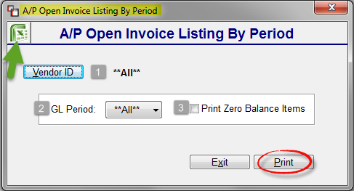

At the Vendor ID -1- field, the default is **All** for all Vendors. Use the Vendor ID button to select a specific Vendor for the report where applicable. At the GL Period -2- field, again, the default is **All** for all Periods. Use the drop-down arrow to select a specific Period. You can also check the Print Zero Balance Items -3- option to include those items on the report. When you have made your selections, click the Excel icon to export the data, or click the Print option to print the report.

Invoice History Listing:
The Invoice History Listing will print a list of all Invoices for a Vendor within a specific date range, regardless of whether they have been cleared from the Vendor’s open account. When you enter this module, the screen will appear as follows:

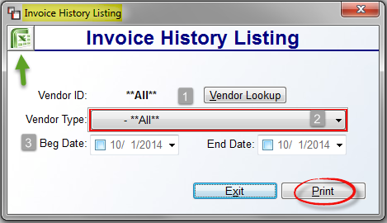

The Vendor ID -1- field will default to **All**. Use the Vendor Lookup button to select a specific Vendor if applicable. The Vendor Type -2- field will also default to **All**. Use the drop-down arrow to select a specific Vendor Type if applicable. At the Beginning and Ending Date -3- fields, select an applicable date range using the drop-down arrows. When you have made your selections, click the Print button to continue. You can also choose to export the data by clicking on the Excel icon at the top left. This report will first sort by Vendor ID, and then by Open Item Date.

Items Selected For Payment Listing:
This report module works in conjunction with the Payment Selection module. It should be printed prior to printing checks to make sure that you are ready to print a check for all items on the report. If a Vendor Note was added to an item through the Open Item Maintenance module, the first line of that note will appear on this report under the applicable item. Before printing, the system will run a check to make sure no negative totals have been selected that would create a negative check. If it finds any, it will print that information rather than printing the report. You will need to fix any negative check conditions through the Payment Selection module before proceeding to the Print Checks module. Also, if you need to add or delete an item from this report, return to the Payment Selection module to make changes and then reprint this report. The report also displays the total number of checks that will be used during the check print. Once checks have been printed, the system will clear this report. When you enter this report module, the screen will appear as follows:

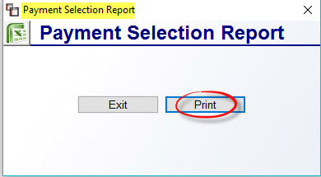

Click the Print button to print the report.

Vendor History by G/L Account:
This report will allow you to view Vendor activity broken down by G/L Account Number and also provide additional data for each entry such as Posting Period, G/L Sequence, Invoice number, Check number, Checking Account, Paid Date and the Debit or Credit amount. When you enter this report module, the system will prompt a Vendor History By G/L Account screen as follows:

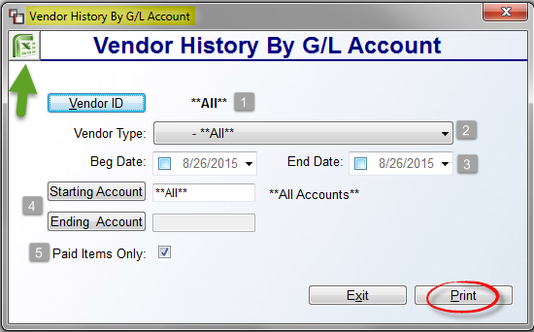

At the Vendor ID -1- field, the default is **All** for all Vendors. Use the Vendor ID button to select a specific Vendor for the report where applicable. At the Vendor Type -2- field, again, the default is **All** for all Vendor Types. This field is only applicable where you have previously set up Vendor Types in the Vendor Maintenance module. Use the drop-down arrow to print for a specific Vendor Type. To learn more about Vendor Types, please see the Vendor Maintenance section of this documentation. At the Beg & End Date -3- fields, click in each box to access the drop-down calendar to set a date range for this report. The Starting and Ending Account -4- fields will default to **All**. To print for only one G/L Account or a range of G/L Accounts, use the Starting and Ending Account buttons to make G/L Account Number selections. The Paid Items Only -5-option will be checked by default. To include unpaid items (items not in the A/P Check Register History file), uncheck this option. Those items will appear on the report with a “000000” Check number. When all selections have been made, click the Excel icon to export the data or click the Print button to print the report.

Inventory Cost Change Report:
When any cost changes are made to material and/or freight in the Review P.O. History feature of the Open Item Maintenance module, this report will display all individual material and freight unit price changes, along with the User ID of the person who made the change. When you enter this report module, the screen will appear as follows:

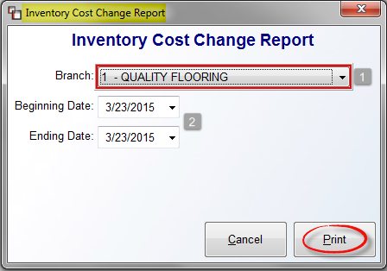

Prior to printing, make your Branch -1- selection, if different from the default, and then select the applicable Beginning and Ending Dates -2-. Click the Print button to complete the process. The detail of this report can also be exported to Excel.

Open Item Audit Report:
The Open Item Audit Report details the total cost changes that were made to material and freight in the Review P.O. History feature of the Open Item Maintenance module. It includes the Journal Entry that will be sent to your financials along with the detail for each General Ledger Account impacted by the change. When you enter this report module, the screen will appear as follows:

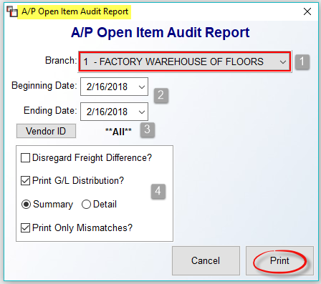

The selections above are the default settings for the report. Prior to printing, you can make any applicable changes to customize the report. At the Branch -1- field, use the drop down menu to select a Branch other than the default. At the Beginning & Ending Date -2- fields, the system will default to the current date. Use the drop down arrows to select a different date or date range. At the Vendor ID -3- field, to print this report for a specific Vendor, click the button to make a selection. The next box -4- contains a few additional options to customize the output of the report. The Disregard Freight Difference option was added because freight charges are not always billed on the mill Invoice. When this is the case, select this option to disregard the freight difference without causing an error on the report since the total job costs and the Vendor Invoice won’t match up when freight is billed separately. The Print G/L Distribution option, when checked, includes the detail of the distributions to the General Ledger. The Summary/Detail option defaults to Summary. Click Detail to see all the detail for the date range entered. Where Summary is selected, the system will auto check Only Print Mismatches. To see only the items that are mismatched and need to be corrected, leave this option selected. Click the Print button once all report options have been selected.

A/P Reports -- Menu 2 of 2

Print Checks:
This Print Checks module is used for printing checks to laser, dot matrix, or MICR printers. All items that appear on the Items Selected For Payment Listing will print when you run this module. Before printing checks, the system will search for a negative check condition. If it finds any, it will prompt the following upon entering this module:

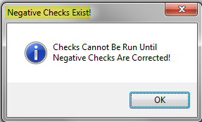

When you click OK at this prompt, the system will return you to the A/P Reports menu. Print the Items Selected For Payment Listing to identify the negative check Vendor and then enter back into the Payment Selection module to correct the negative check condition. You can print a zero check, but you cannot print anything less than zero.

When you enter this report module, the system will prompt an A/P Check Printing screen as follows:

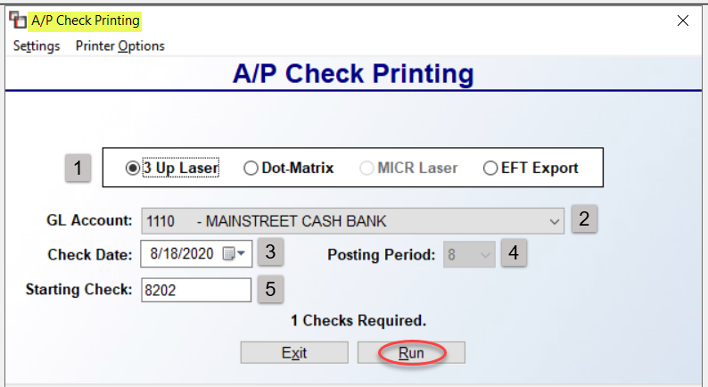

The check type -1- field determines the type of checks you will be printing. When making a change, be sure the correct printer has been selected via the Printer Options menu at the top left. You can also set a default for this -1- field via the Defaults Check Settings option accessed via the Settings menu. Two additional options appear in the Settings menu as follows: A/P MICR Bank Account Maintenance and Test MICR Font. Both of these options relate ONLY to the MICR Laser check printing type and will be explained at the end of this section, but must be completed prior to running an MICR Laser check. The EFT Export option is for running Electronic Funds Transfers. Please see section below for how to complete that process.

The G/L Account -2- field will default to the main Bank Account. Use the drop-down arrow to make an alternate Bank Account selection. The Check Date -3- field will default to the current date. You can change this date using the drop-down arrow. At the Posting Period -4- field, leave the default period or make a change if applicable. The Starting Check -1- field will default to the next available check number for the selected Bank Account. If this needs to be changed, you can type a new number in this field. When you have made your selections, click the Run button to begin printing checks. The system will prompt the following when printing has begun:

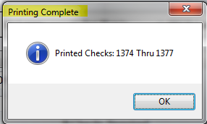

Click OK to continue. The system will then prompt the following:

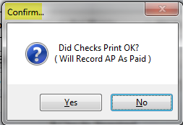

This is a very important prompt. Before responding to this prompt, look over each check to make sure all were printed correctly. If everything looks good, click Yes at this prompt. The system will then prompt the following: Are You Sure? Click Yes to continue. If the checks were jumbled or did not print correctly, you need to click No at the prompt above. The system will reset so you can reprint the check run. Run the program again making sure the Starting Check number matches the next available check number in the printer. After every check run in the system is complete, you need to print a Check Register (see explanation below) to complete the process.

A/P MICR Bank Account Mtc & Test MICR Font:
If you will be using a Magnetic Ink Cartridge Printer to print your checks onto blank check stock, you will need to first set up each Bank Account in this setting option. When you click on this option, the screen will prompt an A/P MICR Bank Account Maintenance screen as follows:

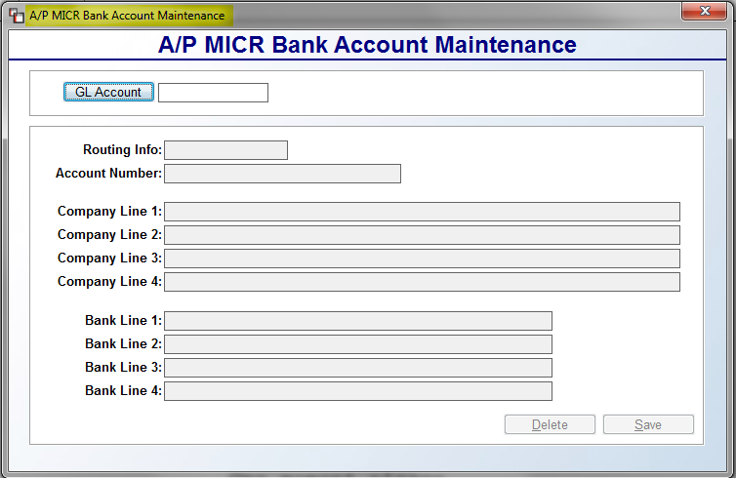

Select the applicable G/L Account and then complete the Routing and Account Number info for the Bank. Use the Company Line 1-4 and Bank Line 1-4 fields to add company and bank info to the blank MICR check stock for printing purposes. Be sure to click Save to keep your setup. Be sure to run the Test MICR Report on each MICR Bank Account prior to printing for the first time.

Running EFT transfers
Once setup is complete, the first thing you need to do is access the Payment Selection module to perform a trial run to only test the EFT set up. Click the Only Show EFT Vendors box to proceed. Select a couple of Open Items for an EFT Vendor that has been setup based on instructions above. Again, this is only to test. The next step is to access the Print Checks module—be sure to select a PDF Printer for testing purposes. Select the EFT Export radio button, and then make sure the GL Account field is set to an EFT Bank Account. The screen should look much like the following:

The Starting Wire # is the EFT equivalent of a check # and will automatically advance with each EFT Transfer. When live, the Effective Date may be advanced to a future date, but can never be less than the default date of the following day. Click Run to start the TEST. This will generate two pages: one is similar to a check stub for each Vendor payment and the other is a text file that is for uploading to the bank. Save the bank file with a name that includes the run date. The Vendor file will display like the system laser checks in the stub/check/stub format. This can be given to Installers to act as a pay stub if any are set up on EFT.

At the Did Check Print OK? prompt, click NO for the test only! Send the test file to your bank. (Most banks will provide you with ACH test information needed for their ACH Dept.) Please Note: When live, the text file must be sent to the bank right after the EFT Transfer to ensure it goes through and because of the requirement of the Effective Date being at least one day after the current date. You may be able to do this online. Contact your bank’s ACH Dept directly regarding questions on any information they need from your business.

Once the bank verifies proper setup, you will be able to run live data. You can now finish setting up your remaining EFT Vendors. You need to do separate runs for EFT Transfers. Standard check printing should be done completely separate.

For live EFT Transfers:
- After clicking the Run button you will get the standard “Printing Complete” followed by the question asking if the checks printed correctly. If you Did Not get both files, they did not print correctly and you should answer NO, otherwise select YES.
- After saving the text file, it must be uploaded to the bank to complete the transaction. If for some reason you did not save the file, a copy is also saved locally in the acuthin folder.

Print Electronic Payment Report:
This report is for processing Electronic Payments to Vendors. During this process, no actual Check is printed, but a report is printed listing the Invoices paid. To use this feature and report, you can first select the Invoices/Credit Memos you wish to pay electronically in the Payment Selection module, or you can make item selections directly from this screen. If no items have been selected, the system will prompt the following: No Items Selected for this Vendor. Would You Like To Select Items Now? Once items for the Vendor are selected, you will return to the screen below to continue processing.

You will process an Electronic Payment for one Vendor at a time. This module works almost identical to the Print Checks module. When you enter this module, the system will prompt an A/P Electronic Payment Print screen as follows:

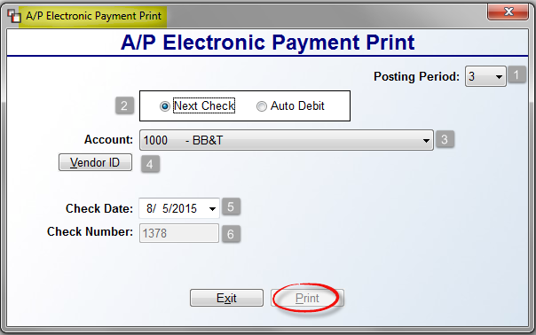

At the Posting Period -1- field, leave the default Posting Period, or use the drop-down arrow to select another Period. The payment type -2- field determines the type of payment you will be making: Electronic Check or Automatic Debit from the Bank Account selected. The Next Check option will assign the next available check number to the Electronic Payment for tracking purposes, but you can change the number in the Check Number field below. The Auto Debit option will create a unique number for reporting and tracking purposes. Also, if Auto Debit is selected, the fields below will change to Debit Date and Debit Number.

At the Account -3- field, the system will default to the main Bank Account. Use the drop-down arrow to make an alternate Bank Account selection. At the Vendor ID -4- field, use the Vendor ID button to select a specific Vendor for this payment. The Check/Debit Date -5- field will default to the current date. You can change this date using the drop-down arrow. The Check/Debit Number -6- field will default to the next available number for the selected Bank Account. When you have made your selections, click the Print option to print the report and complete the process. Once all Electronic Payments have been processed, print the Check Register just as you would after a normal check run. You will see an “E” next to the Check/Debit number to denote all Electronic Payments. Please Note: you should manually write Void/Electronic Payment on any paper Checks “burned” during this process so they are not used for any other check printing procedures—DO NOT Void the check in the system!

Check Register:
This report module prints a Register of all Checks printed through the Print Checks module, the Print Electronic Payment Report module as well as any checks processed through the Hand Check/Void Check Processing module. It should be run after any batch of checks/payments are processed in the system—if you are making payments from multiple Bank Accounts, you can print the Register one time after all payments have been processed. If you need to Void a Check/Payment and the Check Register for that run has not been printed, you will need to first print and clear the Check Register, otherwise you will not be able to complete the Void process. You will then print the Check Register again following the Void process.

When you enter this report module, the system will prompt an A/P Check Register screen as follows:

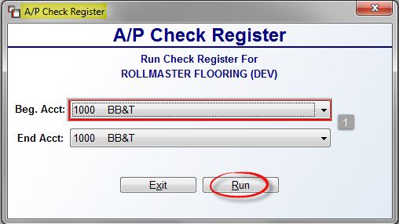

At the Beg. Acct -1- field, the system will default to the main Bank Account. Use the drop down arrow to make an alternate Bank Account selection. If only one Bank Account was used, leave the End Acct field the same as the Beg. Acct field. If multiple Bank Accounts were impacted, use the drop down arrow to select a range of Bank Accounts. Next, click the Run button to continue clearing the report. The report will print and the system will the prompt the following Confirm box:

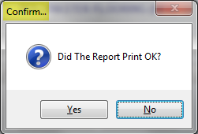

If you did not get a readable copy, click No at this prompt, and then reprint the report. If the report looks good, click Yes. The system will then prompt the following:

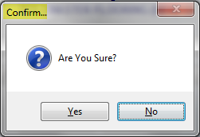

If you are sure the report printed okay, click Yes at this prompt. Once the report is cleared, you will need to access the Check Register History module to see any data cleared on the Check Register via this module.

Check Register History:
This report module prints a history of any Check Register that has been cleared in the Check Register module. It can be printed by Register Date or Check Date. When you enter this report module, the system will prompt a A/P Check Register History screen as follows:
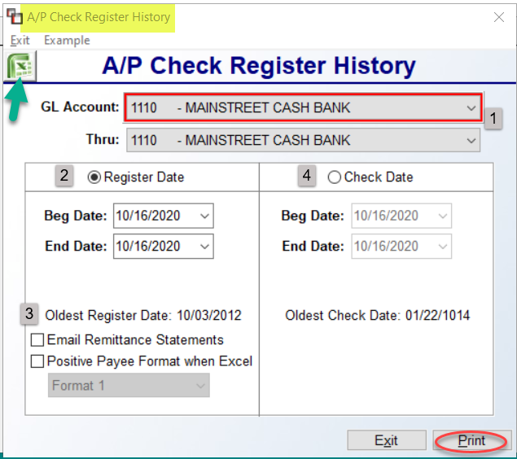

The GL Account & Thru -1- fields will default to the main cash disbursements account number in the system. If checks were printed out of a different account, use the down arrow to select another GL Account before proceeding. If you need history on a register for more than one GL Account, you can select a different account at the Thru field. This screen will default to the Register Date -2- box. To print by date of check, click next to the Check Date -4- field to switch. In either box, you will need to select a Beginning and Ending Date for the item in history. In both boxes, the system will display the dates of the oldest Register and Check in the system. The Email Remittance Statements -3- option has been added to this screen where previously it was only available in Check History for EFT Statements. This works the same as with Check History, where a valid Vendor or A/P Contact Email has been set up and the Register is for EFT Remittance.

The Positive Payee Format when Excel -3- option was added for use with banks that do “positive pay.” You can click this prior to exporting to Excel and then upload/email the file to the bank, which only honors checks in that file for security purposes. Please note: formats per bank may vary, which is why multiple Format options are available from the drop-down list. Once you have made your selections, you can click the Excel icon at the top right to export the data to Excel, or click the Print button to continue.

Print A/P Form 1099:
This report module will produce a Form 1099 for all Vendors that have a Social Security number entered in that field in the Vendor Maintenance module. The system will prompt only amounts paid to a 1099 Vendor in a year and will not include any outstanding Invoices that have been posted in A/P Open Item Maintenance but not actually paid to the Vendor on a system check, as the data is pulled from check history. Additionally, there are print options to use Electronic 1099s or print Total Display on screen. The 1099 data can be called up again by utilizing the Report Year feature and entering a Beginning and Ending Date so you can print and re-print the 1099 data at any time. With regard to Installer Retained Amounts on the 1099, the system will treat the retained amount as taxable income only at the time it is paid back to the installer, most likely at the time he or she no longer performs work for your company.

When you enter this report module, the system will place the cursor at a Print A/P 1099 Form screen as follows:

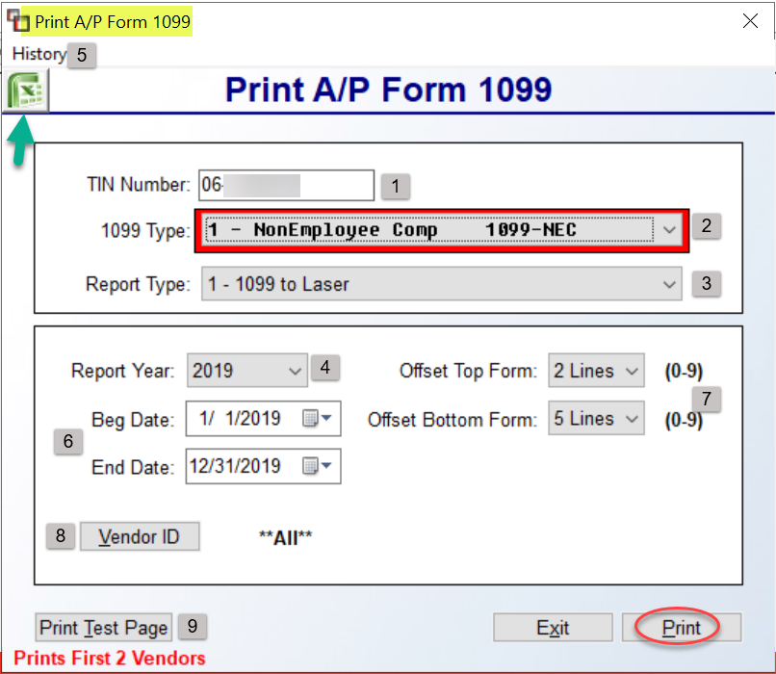

When this module is used for the first time, the TIN Number -1- field will be blank. You will need to type in your Tax ID Number the first time and when you either Print Test Page or Print the first form, the system will prompt you to save the number. Also, if a change is made to this field, a similar message will prompt alerting you to save the change or cancel. At the 1099 Type -2- field, use the down arrow key to select an applicable type of form for your current run. The Report Type -3- field is also a drop-down menu, from which to select the type of printer/form to use. Please Note: see below for instructions on generating and downloading Electronic 1099s. The Report Year -4- field will default to the last closed year in the system. Use the drop-down arrow to select a different year. The History -5- option at the top left contains history for previous year Electronic 1099 Data. The Beg & End Date -6- fields will default to the last closed year’s first and last day. You should change these fields if you selected a different Report Year. The Offset -7- fields help with lining up the printed data on the forms. Use the drop-down arrows in each to make adjustments to the default settings. The Vendor ID -8- field will default to **ALL** Vendors, but will only pull the Vendors matching the 1099 Type selection. Only use the Vendor ID button to select a specific Vendor.

Once you have made your selections, if you will be printing to forms, it’s important that you use the Print Test Page -9- button to make sure everything lines up on the form so you can make adjustments if needed. When ready, either click the Excel icon to export the data, or click the Print button to continue. If you selected Total Display in the Report Type field, the system will display any applicable totals on screen in a Count Display box. Any other Report Types will begin printing at this point.

Electronic 1099s have been configured for generating and downloading. The format fits all specifications as detailed in Publication 1220 from the IRS. You will need your 5-digit Transmitter Control Code (TCC) assigned to your business by the IRS. From the Print A/P Form 1099 screen, at the Report Type field, use the drop-down arrow to select Electronic 1099s from the menu. You will then be prompted for your TCC #. The system will then check for the existence of an original file. If it doesn’t find one, it will generate. If it detects one, the system will prompt the following:
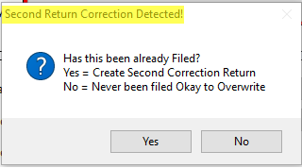
You can choose to create a second corrected return by clicking “Yes,” or click “No” to override the existing file. Once saved, you will receive an option to Download the file. As mentioned above, previously saved files are accessible via the History -5- option at the top left of the main screen.

Print Cash Requirements Report:
This report module prints a list of all Payables in the system and when they are due according to a range of days entered in the System Maintenance module during initial setup, e.g., 7, 14, 21. It will include the amount of cash required to pay the current bills. If a Vendor Note was added to an Item through the A/P Open Item Maintenance module, the first line of that Note will appear on this report. This report can be printed prior to entering the Payment Selection module, enabling you to quickly identify which Items need to be paid; however, the Open Invoice Listing has additional functionality that may prove more useful.

When you enter this report module, the system will prompt an A/P Cash Requirements Report screen as follows:

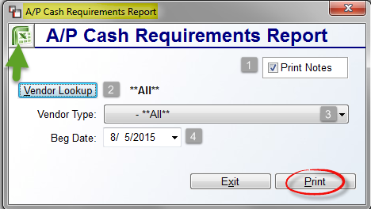

The Print Notes -1- box will be checked when you enter this module. You can uncheck if you prefer not so see any Notes. At the Vendor Lookup -2- field, the default is **All** for all Vendors. Use the Vendor Lookup button to select a specific Vendor for the report where applicable. At the Vendor Type -3- field, again, the default is **All** for all Vendor Types. This field is only applicable where you have previously set up Vendor Types in the Vendor Maintenance module. Use the drop down arrow to print for a specific Vendor Type. To learn more about Vendor Types, please see the Vendor Maintenance section of this documentation. At the Beg Date -4- field, they system will default to the current date. Use the down arrow button to select an alternate beginning date for the report.
When all selections have been made, click the Excel icon to export the data or click the Print button to print the report.

Please Note: On the Print Cash Requirements Report, the CURRENT-7 DAYS column displays items that are currently due; however, it will also include items that are past due as well as those that are due within seven days of the report date.

