

Table of Contents

Accounts Receivable 1
Introduction: 1
Customer Maintenance: 1
Options At Top of Screen: 15
Adding a Ship To Code: 22
Credit Hold Feature: 30
Customer Account Maintenance: 34
Purge Cleared Account Activity: 39
Post Customer Payments—Text Version: 40
Post Customer Payments—Grahpical Version: 50
Customer Status Inquiry: 54
Customer Deposit Inquiry: 58
Customer Payment History: 58
Invoice History Inquiry: 61
Account History Inquiry: 62
Service Charge Processing: 63
End of Month Processing: 65
Closed Deposit Purge: 66
Sales Tax Code Maintenance: 67
Sales Tax Automatic Update—Annual Subscription: 71
Approve/Select Jobs: 73
A/R Reports Menu 1 of 2 76
Introduction: 76
Customer Master Listing: 76
Customer Reference Listing: 77
Customer Mailing Labels (3up): 78
Open Items Adjustment Register – Daily Report: 80
Customer Payment Register (Daily Report): 81
Customer Payment Register (History): 84
Payment Distribution Report – Daily Report: 86
Customer Profitability Report: 87
Past Due Report: 87
Over Credit Limit Report: 88
Service Charge Ledger: 89
Print Statements: 89
Jobs Not Approved Report: 91
A/R Reports Menu 2 of 2 93
A/R Detail List: 93
A/R Detail List (by Lien Date): 93
A/R Agings: 94
Customer Deposit Agings: 97
Contact Activity Notes Report: 98

***CONFIDENTIALITY NOTICE*** This documentation contains confidential information belonging to Textile Management Systems, Inc. and RollMaster Software, which is protected by copyright laws and other privileges. This information is intended for the exclusive use of legally licensed RollMaster Software users. If you are not the intended recipient, you are hereby notified that any disclosure, copying, distribution, or the taking of any action in reliance on the contents of this information is strictly prohibited. If you have received this documentation in error, please immediately notify us by telephone at (800) 777-4107.

Accounts Receivable

Introduction:
In the Accounts Receivable (A/R) menu, you will find all modules relating to the management of customer accounts, receipt of customer payments (not deposits on jobs), customer billing, A/R reports, etc. In the RollMaster System, when a job is invoiced with a balance due, the system will automatically generate a Receivable for that Customer. Then, through the modules and reports found in this section, the User will be able to keep track of the Receivable until the outstanding balance is paid in full. Additionally, there are many more modules related to Customer account management that can be found within this menu.

Customer Maintenance:
This is a set-up module that must be completed prior to going “live” on the RollMaster System. Thereafter, this module will be used to edit the system customer database and to add any customers that are not added through the Quotation or Order Entry modules. All customers with a balance due at the time you go “Live” on the RollMaster System must be added in this module. This is necessary so that Beginning Receivable Balances can be entered in the system through the Customer Account Maintenance module. Once this process is complete, all new customers will mostly be added from the Quotation or Order Entry modules as quotes and jobs are being entered in the system (see Quotation/Proposal Maintenance and Order Entry/Maintenance in the Sales Processing Documentation for further details).

When you enter the Customer Maintenance module, the system will first prompt a Customer Selection box as follows:

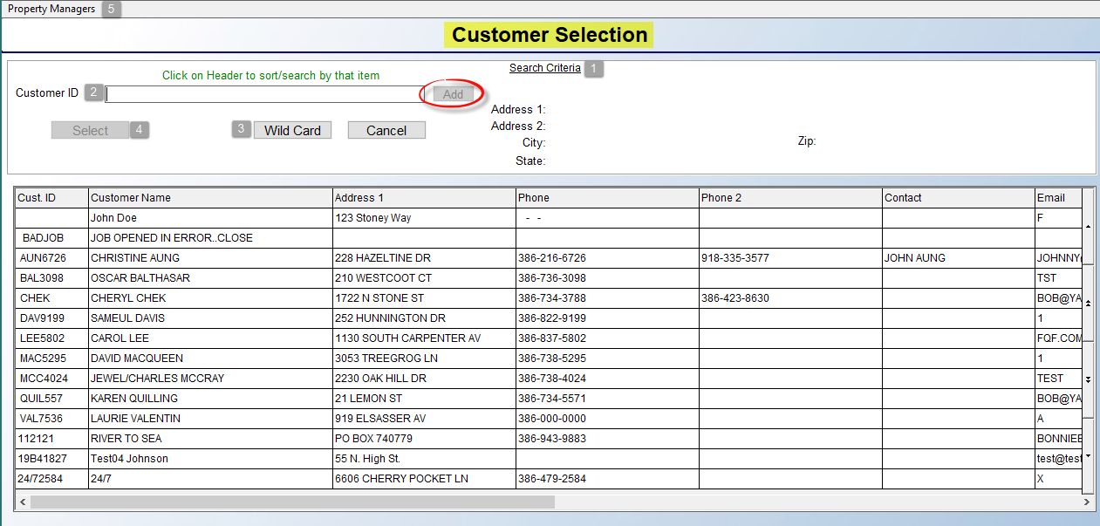

All existing customers will appear in the Customer Selection box in alphanumeric order. The functionality in this screen will allow you to sort by any of the column headings as you are conducting a search, such as by Phone number, rather than only by the first couple of letters of the ID. As you click on any of the column headings, you will note that the Search Criteria (1) box at the top of the screen will switch to that heading. For example, if you click the Email column heading, the “Customer ID” search (2) field will now display “Email” and you can begin typing the first couple of letters of an email address to start sorting the data in the screen below by those characters. You can also scroll through the list by using the up and down arrow slides along the right side, or you can still type the first couple of letters of the Customer ID to perform an alpha lookup by last name. The Wild Card (3) button offers an additional search method. You will first select a column heading to search by and then type a couple of characters in the search field prior to clicking the Wild Card button. Once you have located the applicable customer, click on that line to highlight. The system will then populate the Address 1, Address 2, City/St, and Zip fields for that customer in the top right of the Customer Selection screen. Click the Select (4) button at the top of the screen to access that Customer ID.

An option to search by Property Managers (5) appears at the top left of the Customer Selection box. When you click on that option, the system will prompt a Customer Property Manager Selection box as follows:
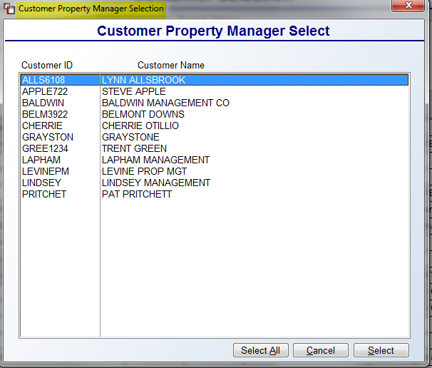

Highlight the applicable Property Manager in the screen above and click the Select button to continue.

You can also add a new Customer from this screen by typing a new ID in the Customer ID field (1) and then clicking the Add button. Please Note: if a User is not allowed to add Customers to the system, the Add button field will not display. To Add or create a new Customer ID, you can use up to eight characters. RollMaster recommends using the first four letters of the customer’s last name followed by the last four digits of the customer’s phone number when creating a new ID. For example: John Smith at 615-777-4107 would have an ID as follows: SMIT4107. It is best not to use symbols or spaces in the ID. For a business, use the first four letters of the business name followed by the last four digits of the telephone number, i.e. Broderick Builders with phone number 615-791-0204 should appear as follows: BROD0204. This method is beneficial for the following reasons: it keeps the ID format the same for all customers whether retail, commercial, or builder; it forces the salesperson to always ask the customer for their phone number; it is easier for the A/R department to locate customers because the phone number is most always on the check; and the setup is extremely beneficial for commercial dealers, whose customers may be large with many different branches or departments that have many different billing addresses. For example: the University of New Mexico has departments and annexes all over the state. The phone number is the only way to identify each particular billing department since the name is the same for all departments.

When creating a new ID, begin typing the first four letters in the Customer ID field. As you type, the system will begin sorting the data in the Customer Selection box, prompting any matching names. This will allow you to check to make sure the ID does not already exist. If the system does not find a match, continue typing the last four digits of the phone number. Once the 8-character ID is entered and there is no match in the selection box, click on the Add button to the right of the Customer ID field to continue. The system will prompt the following:
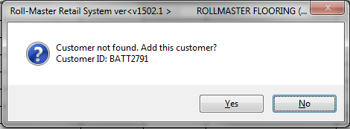

To add, click the Yes button. The system will then prompt a Customer Maintenance screen as follows:

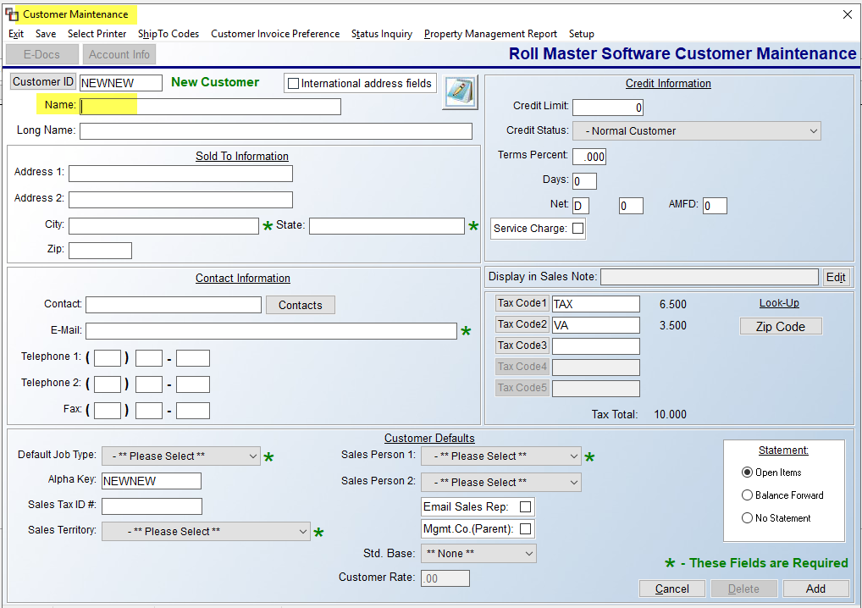

The Customer ID will automatically default to the new ID you created and the cursor will be positioned at the Name (1) field as follows:

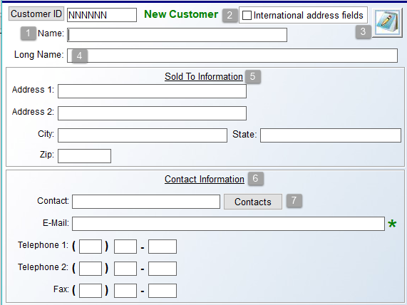

Type the customer’s first and last name; omit titles such as “Mr.”, “Mrs.” and “Dr.”, etc. Use the Long Name (4) field for longer names. If the Customer resides in a foreign country, click the International address fields (2) checkbox to display a Country field and expand the Contact, Telephone and Fax fields. In the Sold To Information (5) fields, type the complete address, including Zip code. These fields automatically read into a system database for A/R mailing labels. In the Contact Information (6) fields, if the customer is a business, type in a main contact name, followed by that person’s E-Mail address. Additional Contacts and E-Mail addresses can be added via the Contacts (7) button, explained below. Type the customer’s main number in the Telephone 1 field, and use the Telephone 2 field for work or cell, if applicable. Both numbers will appear in the Order Entry and Quotation screens. Add a Fax # also, if applicable. The Notes (3) icon is for viewing/recording Customer Address Notes, but will not be accessible until the Customer has been added to the system. This option will allow you to record internal notes on a Customer such as collections information and problems on the Job. These Notes can also be accessed from the Customer Status Inquiry and the Customer Deposit Inquiry modules in the Accounts Receivable menu.

As mentioned above, the Contacts (7) button will allow you to build a database of additional Contacts with E-Mail addresses and other pertinent data. For example, you can record Roles, or Job Titles, for the Sales Manager, Marketing Manager, multiple Sales Associates, etc. Prior to using this feature, you will need to create Role Codes (see below) to assign to additional contacts. When you click the Contacts button, the system will prompt an A/R Customer Contacts box as follows:

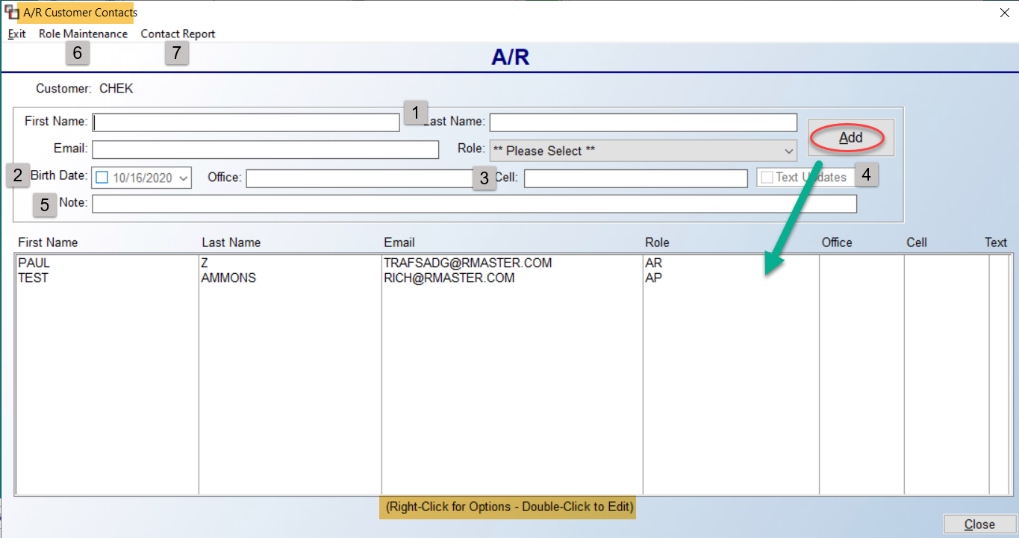

To create new Role Codes, click the Role Maintenance (6) menu option at the top left of the screen above. The system will first prompt a Role Maintenance selection box as follows:
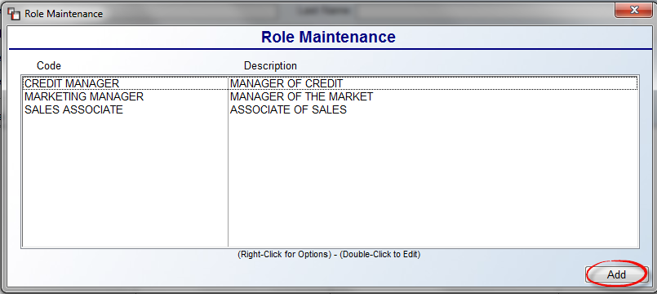

Any existing Roll Codes will prompt in the screen above. Please Note: You can use upper and lower case letters within this feature. To create a new code, click the Add button at the bottom right. The system will prompt a Role Maintenance box as follows:
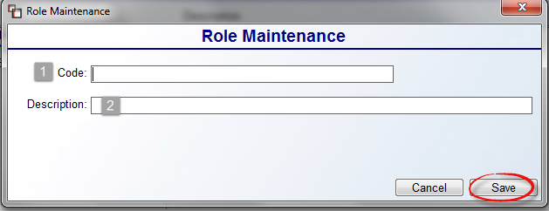

Type a Code (1) and Description (2) for this Role and click the Save button to store the record. You can continue adding Role Codes or return to the A/R Customer Contacts box to add new Contacts as explained below.

In the A/R Customer Contacts screen, type the First Name (1), Last Name, and Email address of the Contact, and click the drop-down menu at the Role field to select a Role Code. If applicable, click the box in the Birth Date (2) field and select a birth date using the drop-down calendar menu. Use the Office (3) and Cell fields to record phone numbers. The Text Updates (4) checkbox works in conjunction with the RM Text Alert integration. If setup is complete and Contacts are the preferred Text Source info, this Contact will receive a Text when automatic appointment reminders are sent to this Customer. For more info on the RM Text Alert integration, please email info@rmaster.com. And finally, use the Note (5) field to add any additional notes relating to this A/R Contact. Please Note: You can also edit the Contact once added to access additional Notes options. Click the Add button to save the new Contact. All A/R Contact Email addresses will export to Excel when printing the Customer Master Listing. Also, the system will separate each email address by a “;” for ease of import into other databases.

The last option (7) in this screen appears next to the Role Maintenance option at the top left as follows: Contact Report. This option will export a list of existing Contacts--including all fields for each Contact--for all Customers to Excel, or you can opt to print for just the Current Customer Only by clicking that checkbox prior to running the export. From the list of existing Contacts in the main screen, you can right-click or double-click on a Contact to Edit or Delete. The Edit Contact screen appears as follows:
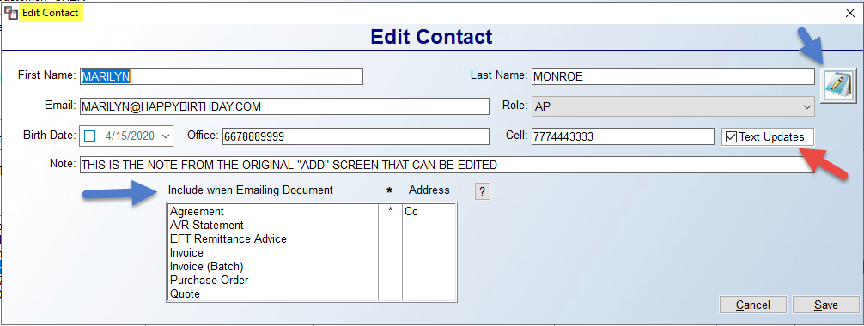

You can edit all the fields in this screen, plus you have a few additional features. The Include when Emailing Document section allows for the Contact to be included on Emails containing any selected Documents. The “*” indicates a Document has been selected. In the Address column, right-click to select one of the following options: Add at ‘To’ Level, Add at ‘Cc’ Level, and Add at ‘Bcc’ Level. The Notes icon will prompt an expanded Contact Activity Notes screen as follows:

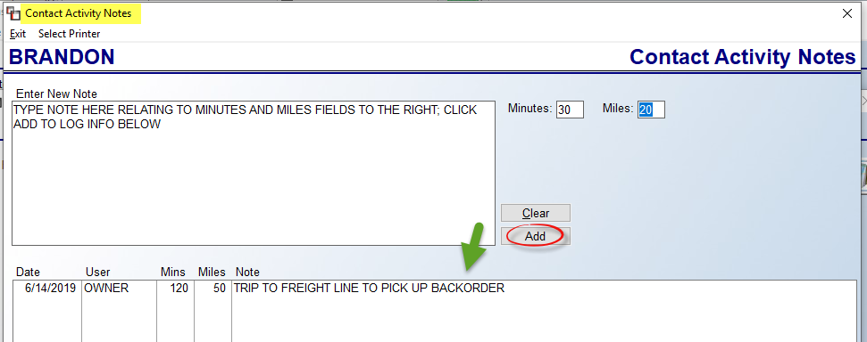

The Minutes and Miles fields can be used to record data along with a Note about the activity that corresponds to the time and mileage. This data will appear on the Contact Activity Notes report.

Returning to the main Customer Maintenance screen, the next series of Credit Information fields will be explained in the order they appear in the screen below:

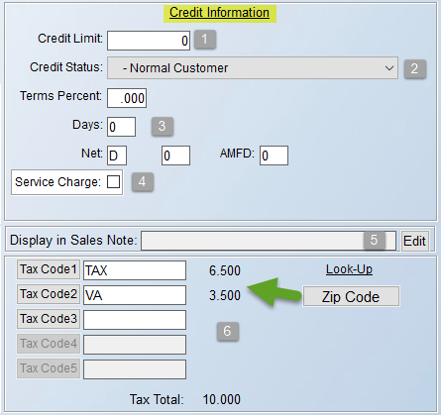

The Credit Limit (1) field is primarily informational, but it does tie into an optional feature titled “Credit Hold Control” that is enabled via the Company Control 2 level of the System Control Maintenance module. If you issue credit limits to any of your Customers, enter that value here. If the control is enabled, when the Customer has exceeded their credit limit, this field will flash in the Order Entry screen. Also, a list of the Customer’s current receivables will appear on the Over Credit Limit Report (accessible from the A/R Reports Menu 1 of 2). If you do not issue credit limits, it is best to leave this field blank—this is especially true for C.O.D. balance customers. Leave the Credit Limit field blank in order for the C.O.D. balance to appear on the system Work Order and C.O.D. Report. A complete section on the optional Credit Hold Control feature can be found at the end of this section.

At the Credit Status drop-down menu (2) field, the available selections allow you to control sales to a Customer based on their Credit Status with you. The default setting is Normal Customer, and with this option selected, no Credit Status features will be activated for the customer. The next option, N – No Sales, will prevent any sales from being processed for the customer. Additionally, the Credit Limit field in Order Entry will prompt the following: No Sales For This Customer! The next option, C – Cash, Certified Check Only, will prompt the following at the Credit Limit field: Cash or Certified Check Only! The next option, Y – +0.00 Credit Limit – C.O.D., triggers a C.O.D. amount to appear on the system Work Order and the C.O.D. Report. Additionally, the Credit Limit field will prompt the following: C.O.D. Customer! The next option appears as follows: W – CBD Only Print W/O – Inv with Dep(osit) or Valid App(roval). With this option selected, the system will require that payment is made in full through the Deposit option on the Job before a Work Order or Invoice can be processed. However, a User that has permission to override Credit Status can approve a Job for processing on a job-by-job basis. For more information on overriding the Credit Status on a Job by User, see the User Control 2 level options in the System Control Maintenance manual section. The final option appears as follows: A – Credit Alert. When this status is selected, it will not prevent processing of a Job or Quote, but it will automatically display a red tinted background on the Job and prompt an alert as follows:
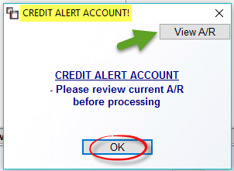
The View A/R button will prompt the Customer Status Inquiry screen for the Customer so the account can be reviewed before processing the Order/Quote.
The Terms Percent/Days/Net (3) fields should be used only if you issue terms to your customers. If so, you can record the Percentage, Days, Net/Proximo data here, and the information will automatically calculate on the system generated Invoices. AMFD stands for Additional Mail Float Days, allowing you to add additional float days for figuring Past Due items on an account. Users with permission will be able to add additional days at this level where applicable. The Service Charge (4) field only applies to customers with terms so that a Service Charge can be accessed on Past Due Invoices. To activate, check the box in this field. The system will then prompt you for a Percent amount to charge as well as the number of Days past due an Invoice can be before a Service Charge is assessed. Please Note: you can instantly change the Service Charge percentage for all customers selected to assess a Service Charge. If you access these fields for a customer and make a change to the Percent field, the following message will prompt: Service Charge Percentage Changed. Do you want to update for all customers in this company (Y/N)? If you type a “Y” for yes, the system will automatically change all customers within the current company.

The Display in Sales Note (5) field allows for adding “Sales Notes” that can be viewed in Quote and Order Entry. To add Sales Notes, click the Edit button to prompt a Display In Sales Note Maintenance box as follows:
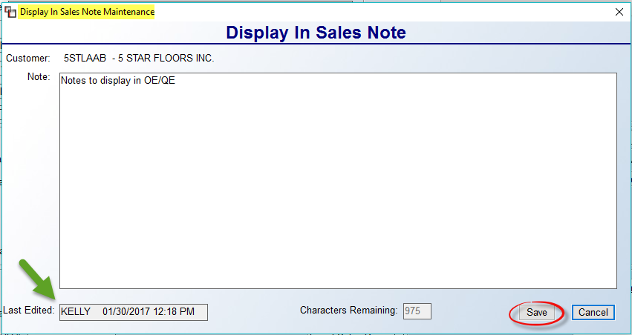
Type notes in the box above that are relevant for Salespeople or Order Processing staff. Click the Save button to keep your notes. The system will also keep track of the person making the most recent changes via the Last Edited box in the bottom left corner. When Sales Notes exist for a Customer, upon entering either a Job or Quote for that Customer, the system will prompt the screen above. Further, a Sales Note button has been added to the top of the Order and Quote Maintenance screens.

Tax Codes:
The Tax Code 1 (6) field will automatically prompt the Default Tax Code for this Branch. If you need to change the Tax Code you can click the Tax Code 1 button to prompt a Tax Code Selection box and perform a lookup. The system will not allow you to leave this field blank. Please Note: New Tax Codes must be set up prior to use through the Sales Tax Code Maintenance module accessible from the Accounts Receivable menu.
If you need to change the Tax Code and you have subscribed to the RollMaster Sales Tax Automatic Update, you will see a Zip Code Lookup button option to the right of the Tax Code 1 field. When you click the Zip Code button, the system will prompt the following:
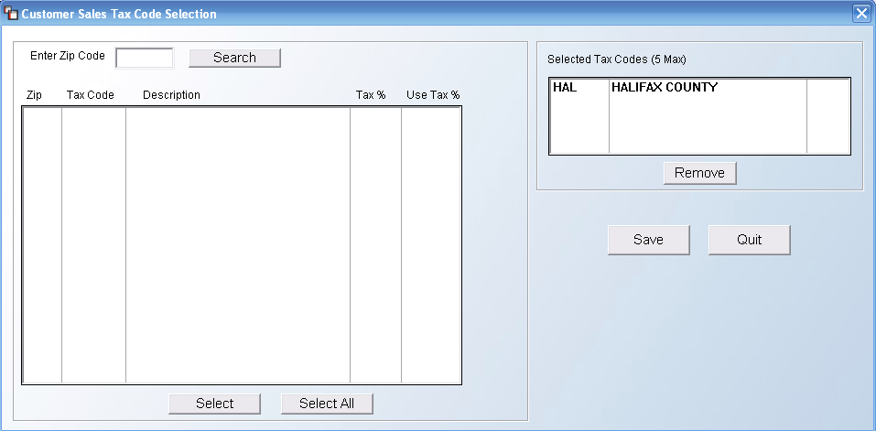

At the Enter Zip Code field, type in a zip or postal code to search for all applicable Tax Codes and then click the Search button. The system will perform a quick search and display its findings in the box below as follows:

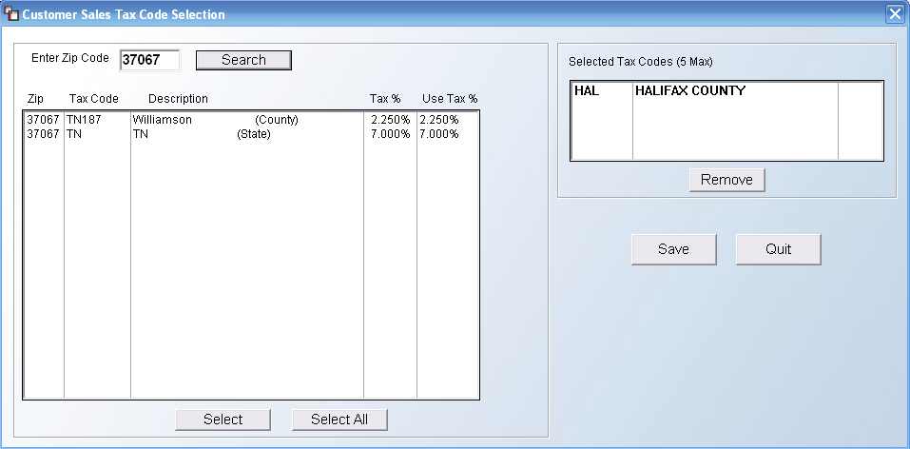

You can highlight and then click Select on the codes that apply, or hit the Select All button to include All Tax Codes for this customer. If a Tax Code needs to be removed, you can highlight it in the Selected Tax Codes box at the top right and then click the Remove button. When all changes have been made, be sure to click the Save button before you click the Quit button to return to the Customer Maintenance screen.

In the Tax Code 2 thru 5 fields, if applicable and if you are not using the Sales Tax Automatic Update Service, these fields are for additional Tax Codes that will be added on top of the Tax Code 1 percentage. For example, if a city tax is charged in addition to a state tax, but only in certain areas of your territory, a second Tax Code will need to be added on all applicable jobs—you will need to select that Code in the next available Tax Code field using the Tax Code 2-5 buttons if you need to perform a lookup. The Tax Rate will display next to each Tax Code field and a Total Rate automatically updates and displays at the bottom of this section.

The fields in the Customer Defaults section will be explained in the order they appear in the Customer Maintenance screen. They appear as follows:

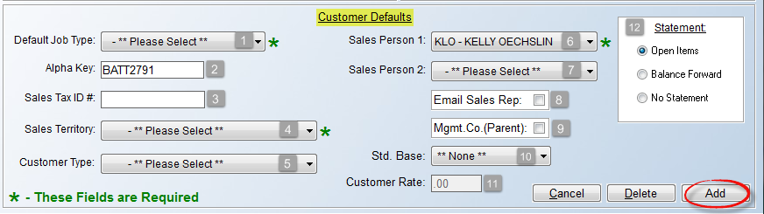

As noted in the green type at the bottom left, the Default Job Type (1) field is required, meaning a selection must be made. This field defaults a prompt in the Job Type field in the Order Entry/Maintenance module. There should be an existing list of Job Types pre setup. Use the drop-down arrow to select the Job Type that is primarily applicable for this customer. This field can be overridden on a Quote or Order when applicable. Based on your Default Job Type selection, you will see (Sales) or (Contract) display to the right of this field. This indicates how tax is assessed on the job, either on the cost or sale. See the Job Type Maintenance section of this documentation for additional information.

The Alpha Key (2) field will default to the Customer ID created upon entering this screen. This field is being phased out with the search options in the Customer Selection box, so you can leave the default. The Sales Tax ID # (3) field can be used to record a Tax Exempt Certificate ID number where applicable. The Sales Territory (4) field, also a required field, contains a list of pre setup codes for marketing purposes. See the Territory Code Maintenance section of this documentation for additional information. Use the drop-down arrow to make a selection. A Customer Type (5) field selection can be made if you will be using the Special Pricing Mtc. (Date Range Pricing) module found in the Inventory Control menu. It is used so that special pricing can be updated by the type of customer rather than by each individual customer. In order to use this feature, you must first create at least one Customer Type in the system, although this field can be skipped and left blank if this feature does not apply to a customer. If you intend to use Customer Types, you must first create those via the Customer Type Maintenance option accessed at the top of the Customer Maintenance screen (explained below). If you don’t see this field, you will need to access the User Control 1 screen and update a prompt under Add Customers as follows: User allowed to change customer type.

The Sales Person 1 (6) field will default to the Salesrep ID attached to the User ID creating the Order. If the User is set up as a Salesperson. If not, you can use the down arrow to make a selection. Please Note: there is a User Control feature that will prevent salespeople from changing the salesperson of record on a job. In addition, with User Control features enabled, the system will override the Salesperson ID attached to a Customer with the ID of the User (provided they are set up as a Salesperson in the User Control 1 screen) who is logged into the system at the time a job is first entered. For more information on User Controls, see the System Control Maintenance manual section. The Sales Person 2 (7) field can be used to attach a second salesperson to a Customer. If this doesn’t apply, skip this field.

Check the Email Sales Rep (8) box if your system has been configured to tie into your default Email program, such as Outlook or Gmail. This will allow for notifying salespeople via email when orders are processed in the system. This field pulls from the Salesperson Maintenance module provided the salesperson’s Email address was properly added in that module. Also, each Ship To Code (see below) can have a different Sales Person ID and Email assigned. The Mgmt. Co. (Parent) (9) box should only be checked when identifying the customer accounts that are the “parent” or “umbrella” Property Management/Builder companies in the system. Among other features, with this box checked, the Property Management Report (accessed from the top of the Customer Maintenance screen) will display a list of all Properties—set up as individual Customers in the system—that are owned/managed by this Customer ID. Select this field only for those true Parent companies where you need to link up all the apartment complexes, condominiums and/or builder neighborhoods to be able to generate combined reports and sales analysis, but the individual address remains its own Customer ID.

The Std. Base (10) field and Customer Rate (11) box work together to allow setting a Salesperson Commission default for this Customer. You will first select a base from the drop-down field, and then enter a percentage rate in the box below. This will likely not apply to all customers, if any, depending on how you pay salespeople. The Statement (12) box contains options for printing Customer Statements, if applicable, for this Customer. If Open Items is selected, the Statement will show all open Invoices. If Balance Forward is selected, the Statement will show a lump sum total of previous Invoices, along with any new Invoices for the period, similar to a credit card statement. And finally, if No Statement is selected, no Statement will print out for this Customer.

Once all applicable fields have been accessed, you can click the Add button at the bottom right of the screen to add the customer to the system. Please Note: If a User is not allowed to add Customers, this button will not display. The Cancel button will clear the screen of any new data prior to clicking the Add or Save button (once a Customer has been added to the system). The Delete button can only be used once a Customer has been successfully added. This option will permanently delete the Customer from the system’s database. If you have used the Customer ID in the system, you should not Delete the data record from the system. The only information you cannot change once a customer has been added in the system is the Customer ID—the other information can be changed if applicable.

Options At Top of Screen:
Prior to saving or exiting the screen, there are additional options at the very top of the screen that appear as follows:

The Exit option will return you to the Accounts Receivable menu. The Save option works the same as the Save button at the bottom right. The ShipTo Codes option is a feature that allows you to add multiple shipping addresses to a customer’s account. (See section below for full explanation of Ship To Codes). This feature is used primarily with builder/commercial/property management clients. Essentially, a Ship To Code is used to create job site address and tax code information for your builder, commercial, and property management customers, but can also apply to rental property jobs or any situation where the “Bill To” and “Ship To” are different addresses and require different Tax Codes. The Customer Invoice Preference allows you to set default Invoice print preferences for the customer. You can also set these for each Ship To Code, if applicable. When you click this option, a Customer Invoice Preferences screen will appear as follows:

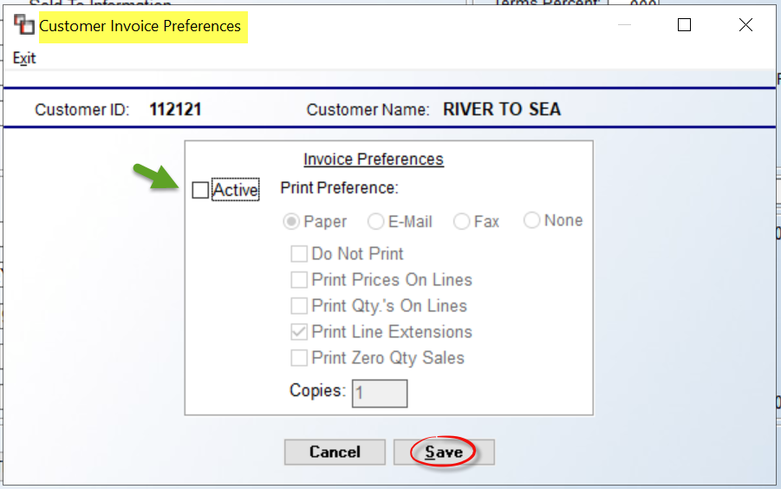

To set preferences, click the Active button to access the default settings. Be sure to click Save when complete. These can be overridden during the Invoice printing process. Please see section on Invoice in the Sales Processing manual for a full explanation of these print preferences.

The Status Inquiry option prompts the Customer Status Inquiry module screen (explained below) for the selected customer. You can only access this option on existing Customers in the system.

The Property Management Report option will print a report of all the properties—set up as individual Customers—in the system that are owned/managed by the Customer you have accessed. When you click this option, the system will prompt a report screen as follows:

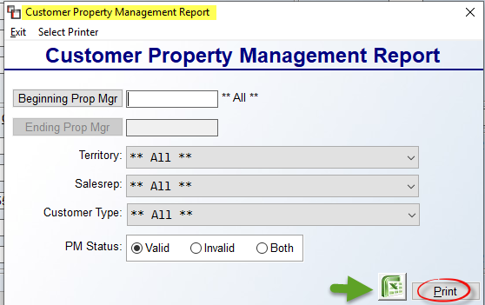

At the Beginning Prop Mgr field, you can leave it blank to include all Property Managers, or you can click the button to prompt a look up to make an individual selection. If you are printing for an individual Property Manager, or range of Property Managers, you will need to access the Ending Prop Mgr field to make a selection. At the Territory field, only use the down arrow to make a selection if you do not wish to print All Territories. At the Salesrep field, you can leave that setting to **All** Salesreps, or use the down arrow to make a selection. Similarly, at the Customer Type field, leave the default setting or use the down arrow to make a specific Customer Type selection for the report. The PM Status box allows for including or only printing Invalid Property Managers. These are records that were once set up as Property Managers, but no longer. You can export the data to Excel by clicking that icon, or click the Print button to send to paper. The Excel data will include the Sales ID of the Ship To Address, the Unit Count on Ship To, and the last Invoice Date. All of the Customer IDs and related Ship To addresses will appear below each Property Management/Builder Company ID on the report. This printout was designed to help clients with several Property Management/Builder customers see a list of all properties and addresses in one easy report.

The Setup menu contains a few additional setup options in Customer Maintenance. When you access that menu, it will appear as follows:

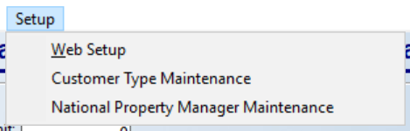

The Web Setup option will only be available for RollMaster clients using the Web Portal program, and only Users with permission to create Web Portal logins will have access to this option. For those who do have permission, when you click on this option, a Customer Web Login Setup box will appear as follows:

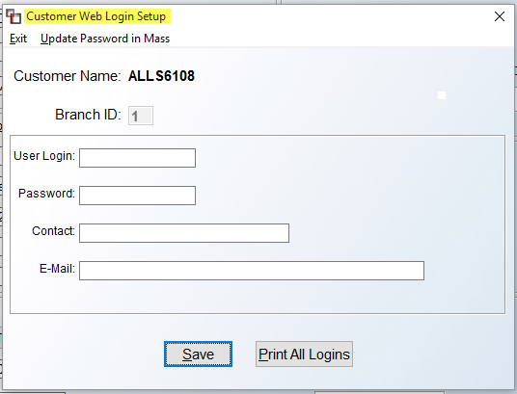

The Web Login Setup should be completed for each property that will be logging into the Web Portal system to place online orders. RollMaster recommends using the Customer ID as the User Login and a universal password for everyone--such as the owner of your flooring company’s name--as the Password. You can then type out their entire name in the Contact field and then enter their Email address in the remaining fields. Please note that this username and password is kept internally for accessing your customer’s web portal. You will actually go to their web portal and use this to log in and then create an Admin user for them to begin using the Web Portal.
At the top left, to the right of the Exit option, another option appears as follows: Update Password in Mass. When you click on this option, the system will prompt the following:
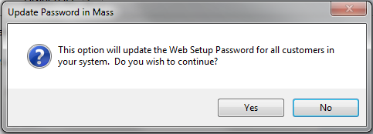

If you wish to update the Web Setup password for all Customers, click the Yes button to continue. The system will prompt you to enter a New Password. Type in the password and hit enter to save. Please Note: only one Login record can be set up for each Customer ID, but the Login data can be updated at any time, or deleted altogether by clicking on the Delete button that appears to the right of the User Login field of an existing Customer Web Login Setup screen. Click the Print All Logins button to print a list of existing Web Login Setup IDs.

The Customer Type Maintenance option was created—and is tied to the Special Pricing Mtc. (Date Range Pricing) module of the Inventory Control menu—so special pricing can be updated by a customer group or type, rather than by each individual customer. In order to use this option, you must first create at least one Customer Type via this option, although not all Customers are required to have a Customer Type setting. When you select this option, the system will prompt a Customer Type Maintenance screen as follows:
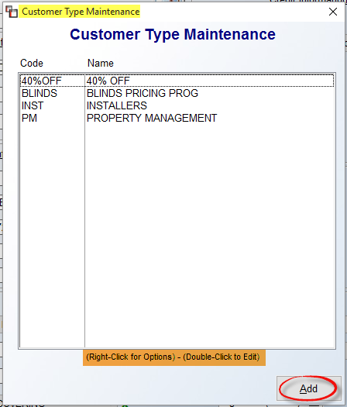

Any existing Customer Type Codes will prompt in the screen above. You can highlight and then right-click or double-click on an existing code to prompt one of two options: Edit Customer Type or Delete Customer Type. To add, click the Add button to prompt a second Customer Type Maintenance screen as follows:

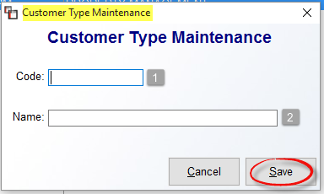

At the Code (1) field, type a new code, up to 8 alphanumeric digits. At the Name (2) field, type a longer description for the Code. Click the Save button to add.

The National Property Manager Maintenance option is used to create National Property Managers (NPM), which is the highest level in the hierarchy of Property Management customers in the system. The first is Property Management Customer (property), followed by Property Manager (over several properties but answer to one NPM) and finally National Property Manager. When you access this option, a National Property Manager Maintenance screen will appear as follows:

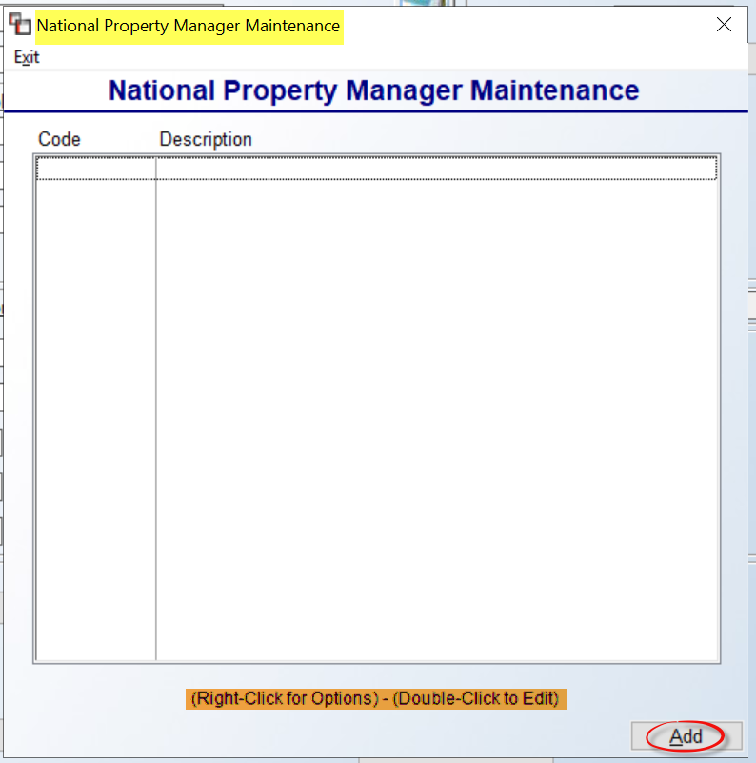

Once NPM’s have been added to the system, you will see them in the screen above. Click the Add button to create a new NPM. That screen will appear as follows:

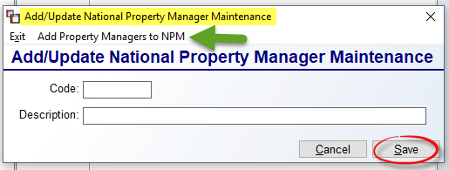

At the Code field, type up to an 8-digit alphanumeric code for the National Property Manager. You can then type a longer Description in the field below. Click Save to keep the new NPM. Once added, in the prior screen, highlight and right click or double-click to call up an existing National Property Manager so you can then utilize the Add Property Mangers to NPM option which appears in the screen above. That screen will appear as follows:

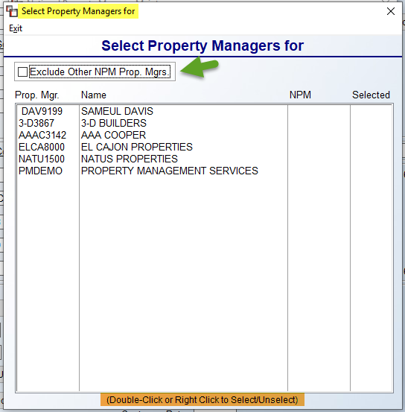

All current Property Management Companies in the system will appear in the screen above. You will need to highlight and double-click or right click to Select or Unselect Property Management Companies that report to the selected National Property Manager. Property Management Companies can only report to one NPM. The Exclude Other NPM Prop. Mgrs. option will clear any Property Management Companies from the screen not tied to the existing NPM. With this setup complete, the Customer Master Listing export to Excel will display an NPM column. Also, the A/R Aging Report (Standard) will sort by Property Management Company/NPM. And finally, Sales Analysis will generate for either all Property Management Companies under an NPM, or all PM Customers included under an NPM.

E-Docs and Account Info Options at top left:
The E-Docs button will only be visible for those customers subscribed to the RollMaster Electronic Document Storage feature, and only enabled once a Customer has been successfully added to the system. This will allow you to attach documents to this customer’s record. The Account Info button prompts an Account Balance/Sales Information screen as follows:

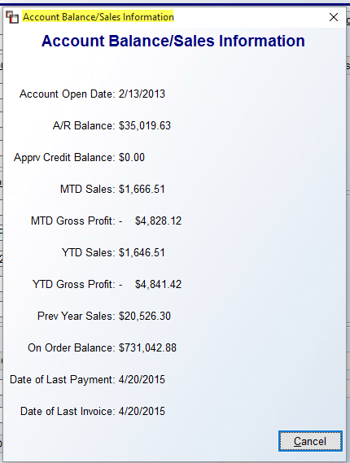

The screen above displays valuable at-a-glance accounting information on such things as the Customer’s A/R Balance, Approved Credit Balance (this works in conjunction with the Credit Hold feature in the system), various Gross Sales and Profit data, Date of Last Payment, etc. This screen is automatically updated through various system procedures.

Adding a Ship To Code:
When you click the Ship To option, the system will prompt a Customer Ship To Selection box as follows:

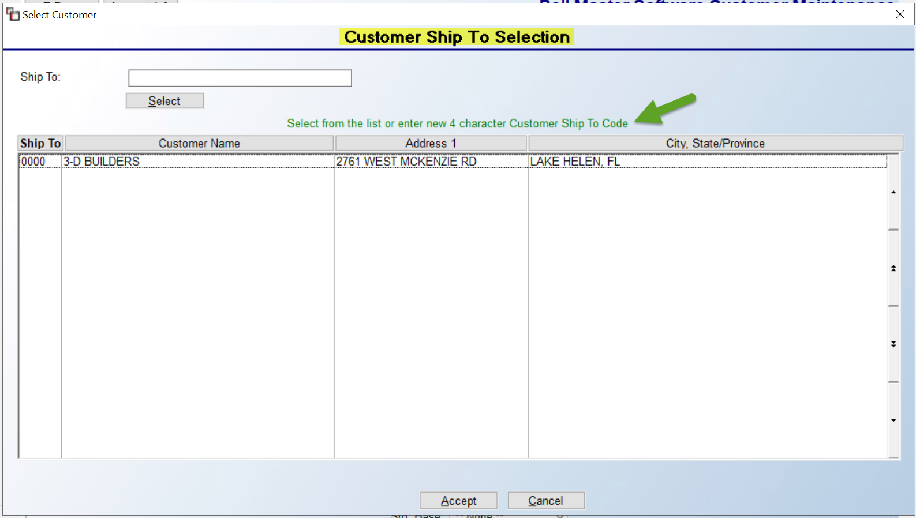

A “0000” default Ship To Code is automatically created by the system for the main Customer ID address and will prompt in the screen above. You can select/edit an existing Ship To address by double-clicking on a line or by highlighting the line and then clicking the Accept button at the bottom of the screen. You can also type a Code above the Select button at the top left and then click Select. If there are several Ship To Codes for a customer, you can sort the screen by clicking at the top of any of the columns to sort the data by those options. A Ship To Code is typically a four-digit alphanumeric code. Some examples appear as follows: L210 for Lot 210, SHER for Sherwood Apartments, or use the numbers from the street address. To add a Code, begin typing a new Ship To Code in the screen above. If not recognized, the system will prompt an Add button to the right of that field. When you click Add, the system will prompt the following:

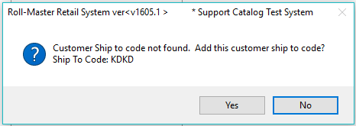

Click the Yes button to continue. The system will prompt a Ship-To Code Maintenance screen as follows:

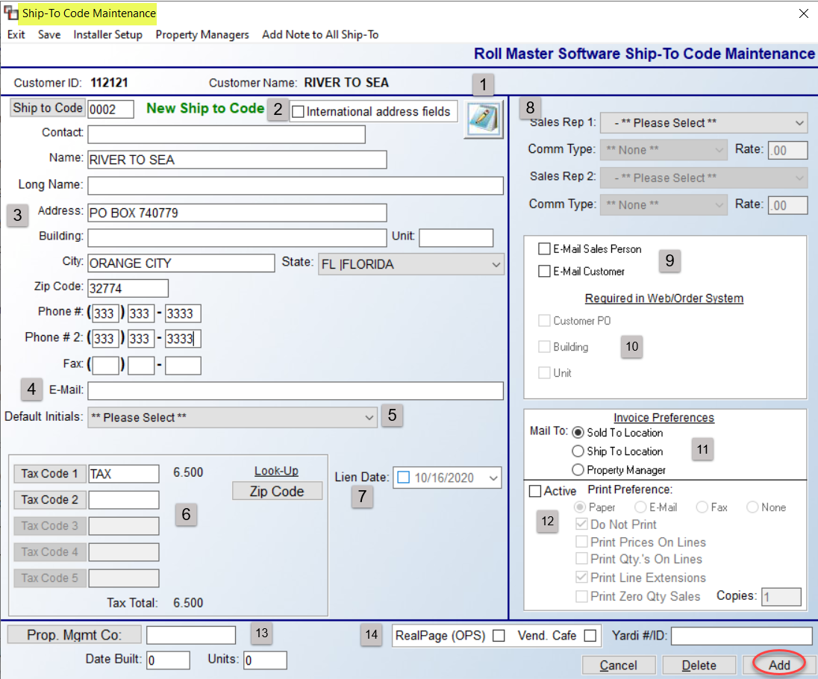

The Notes (1) icon will prompt the Ship To Notes screen. Only check the International address fields (2) box if the Ship To is in a foreign country. The address info from the main screen will default in the address (3) fields. Type over it with any new Contact, Name, Address, etc., for this Ship To Code, including any Phone, Fax, and Email (4) address information. At the Default Initials (5) field, if initials are selected here, they will default in the Initials field on jobs with the same Ship To Code. This was added for RollMaster clients delivering materials, so the trucks could be assigned initials and tracked on the Open Order Report. The Default Initials field appears on the Customer Master Listing, and can be imported.

The Tax Code (6) fields are included in the Ship To screen because there will be jobs where you need to override the tax code status of the “Sold To” customer. For example, if the Ship To Code address is tax exempt, you can enter your exempt tax code in the first field and make this address tax exempt. Another example is if you need to add an additional or different tax to the Job. You will need to enter all tax codes that apply to this address in this screen. The default Tax Codes for each new Ship to Code will pull from the “0000” Tax Code on each Customer. The Lien Date (7) field, when checked, allows for a date to be selected by hitting the drop-down arrow. When activated, this Lien Date will appear on the Customer Master Listing export to Excel when exporting with Ship To Codes, to allow for a way to track Lien Dates by Job Location rather than by the Invoice.

At the Sales Rep (8) fields, use these to override Salesperson and Commission data by Ship To Code. You can select an ID or IDs different from the one(s) entered on the main Customer ID screen, as well as set up different Standard Base Commission—this will not work for Sliding Scale. When you program commissions on the Ship To Code, this will trump settings in Customer Maintenance and Salesperson Maintenance. Also, the commission will be split if set up for two Sales Reps. At the E-Mail Sales Person (9) field, check here if you would like the Salesperson to be copied when an email relating to this Ship To address is sent. You can also check the E-Mail Customer field if you want to send an email to the address in the E-Mail field in the main Customer Maintenance screen when an email is sent relating to this Ship To Code.

At the Required in Web/Order System (10) fields, only those clients using the Web Portal Program will need to access these prompts, although it can be turned on for non-Web Portal customers. These prompts can only be accessed by Users with permission. If a User has permission, they are then allowed to determine whether any of the three fields are considered required fields of entry when a Web Order is placed for this Ship To address. If any of these options have been checked, the Web Portal program will display a red asterisk next to these fields, and your client will not be able to leave these fields blank when placing a Web Order. The Invoice Preferences (11) fields control the default of where the Invoices will be mailed for each Ship To address, whether that be the “Sold To” location, “Ship To” location or the Property Manager, if one has been assigned in the field below.

The Print Preference (12) fields are an extension of the previous section. To use these pre-sets, click the Active field to enable. You can then pre-set how you would like your client to receive a copy of their Invoice, either via Paper, Email, Fax, or None. When the Print Preference is Active, the selection will display in the Invoice Selection Screen in green text next to the Copies field at the bottom as follows:

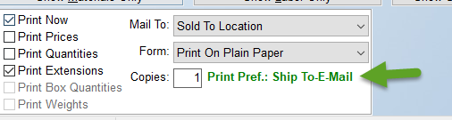

The next series of fields below the Print Preference option fields will allow you to set additional override default settings in the Invoice print screen for this Ship To Code. At the very bottom left of the screen are additional (13) fields for Property Management Ship To Codes. At the Property Management Co field, if this “Ship To” address needs to be tracked on the Property Management Report for a parent Property Management/ Builder Company, you will need to add the Customer ID of the Parent Company in this field to complete the setup for that report. Click the button to prompt a list of all existing Customer IDs designated as Property Management Companies. This feature also allows you to make the Property Management Company address the billing address. However, before you can do that you must use the Property Managers option that appears at the top left of the Ship-To Code Maintenance screen to add any Property Management companies prior to assigning one in this field. (See explanation below.)
The Date Built and Units fields are 4-digit fields used to record the year the property was built and the number of units. The data entered in these fields will print out on the Customer Master Listing, as well as export to Excel. The Date Built field will also print on the Work Order, which was added because of federal lead-based paint laws.

The RealPage (OPS) and Vendor Café fields, if checked, will activate the Ship To Code to appear on the RealPage (OPS) Invoice Export and/or the Vendor Café Export data files when the Ship To Code appears on an Invoice that is cleared on the Invoice Register. For Vendor Café Customers, you will need to also add your Yardi ID in that field for this to work. The RealPage (OPS) Invoice Export and Vendor Café modules are located in the Special Functions menu.

At the top left of the Ship-To Code Maintenance screen are three additional options as follows: Installer Setup, Property Managers, and Add Note to All Ship-To. The Installer Setup option will only be available to Users with permission. This feature allows you to compile a list of installers that can perform work for this Ship To Code and then allows you to rank installers in order of most preferred to least preferred. It also allows you to mark any installers as “Excluded” from performing any work at this address. With permission set, when you click this option, an Installer Ship To List box will appear as follows:

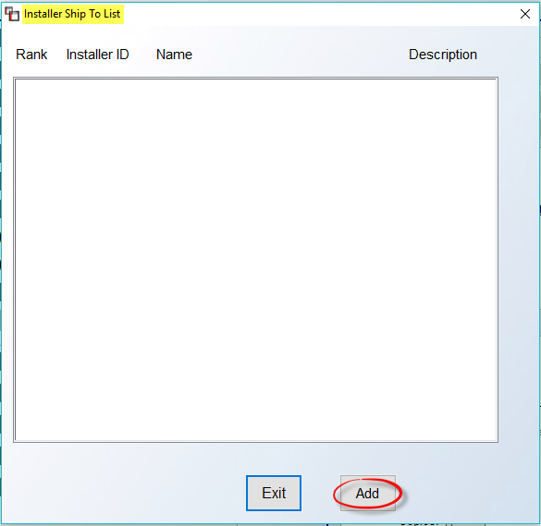

Click on the Add button to begin. The system will prompt an Add Installer to Ship To List box as follows:

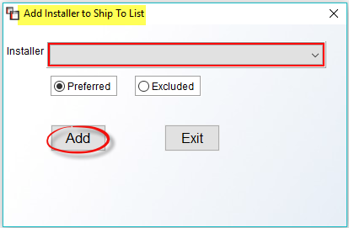

At the Installer field, click on the down arrow button to display a list of existing Installers in your system. Click on a name to select. For each selection, the default will be set to Preferred. If this is not the case, you can click on the Excluded option before clicking on the Add button to finish this process. Once you have added an Installer, the system will return you to the previous screen and the newly selected Installer will appear in that screen. To add more Installers, repeat these steps until all have been selected. Once you return to the previous screen, the system will display the Installers in the order they were selected as follows:

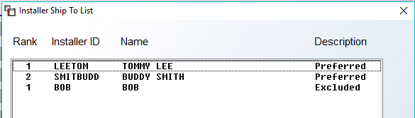

If the displayed order is your preference, you can exit this screen. However, if you would like to change the order, you can click on the Installer you would like to move up or down in ranking and the system will display up or down arrows to the right of the screen as follows:
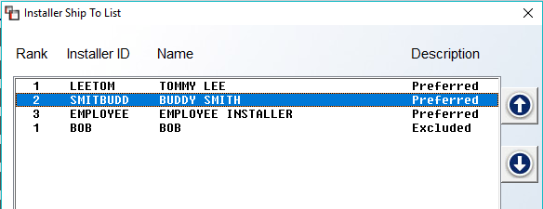

This setup can be initiated from this screen, however this feature is also available in other areas of the system for ongoing maintenance.

Use the Property Managers option if this Ship To Code needs to be tracked on the Property Management Report for a “Parent” Property Management company or “Parent” Builder company. When you select this option, a Property Managers or Builders screen will appear as follows:

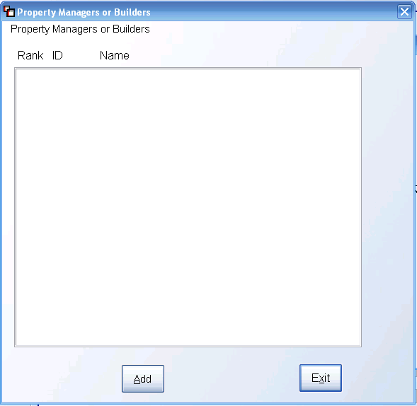

To begin adding Property Managers, click the Add button. The system will then prompt the following:

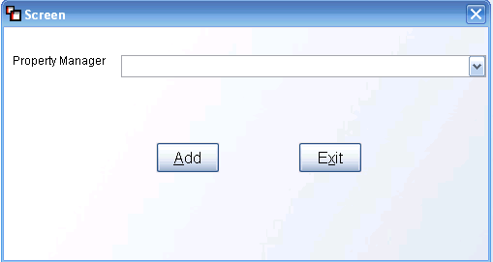

Click the down arrow button to the right of the Property Manager field to display a list of existing Property Managers or Builders that have been designated as such in the system prior to this step via the Customer Maintenance module. Click on the applicable name and then click the Add button in this screen to complete the process. If applicable, you can add multiple Property Managers or Builders to any Ship To Code via this feature. Once a list has been created, you can then use the Rank column in the first screen to prioritize the list. When you click in the Rank column, an up or down arrow button will appear to the right of the list and you can click the arrow until you have organized the list in the proper order. Once a Property Manager or Builder list has been compiled, you will also see a Delete option in the first screen to allow you to delete entries.

The Add Note to All Ship-To option allows for adding Customer Address Notes to all Ship To Codes. When you click on that option, a Note screen will prompt as follows:
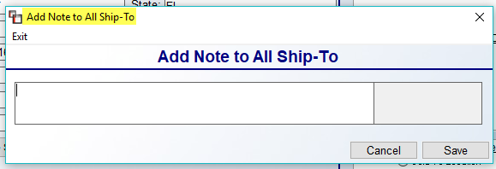
You can add up to three lines of notes in this screen. When you click Save, the Notes will copy to the Customer Address Notes feature for all Ship To Codes that exist for the Customer.
When all selections/options have been completed for a Ship To Code, be sure to click the Add button at the bottom right of the screen to keep. Also, once a Ship To Code has been successfully added, you can use the Delete button to remove the Code from the system, but please do so with caution. If history exists for the Code, RollMaster recommends keeping the Code for Sales Analysis and historical data purposes.

Credit Hold Feature:
Within the RollMaster System are optional settings that will allow you to implement Credit Hold and Past Due Credit Limit control features. If you do not wish to utilize these features, do not turn these features on in the System Control Maintenance module. If you would like to utilize these features, this section will explain how to turn on the features and how to implement them in the system. Please Note: If you turn on these features, all open Jobs will immediately be affected, so please read through this documentation thoroughly to understand how these features will impact the system.

System Maintenance (How To Turn On Credit Hold Features):
In the Company Control 2 level of the System Control Maintenance module, there are two controls that are both tied to the Credit Hold program. They are as follows: Credit Control to Disallow W/O and Mail Float Days, <for Credit>. The first option is a two-part control. If you type a “Y” for yes in the first field, that will actually turn on the Credit Hold program. With the Credit Hold program turned on, all Jobs are immediately affected and the system will not allow the processing of a Work Order or Invoice on Jobs where the Customer is over their Credit Limit or has past due Invoices. (Please Note: there are two User Control features that will allow certain Users to override the Approval status on a Job-by-Job basis.) If you turn on the first field, but don’t want your C.O.D. Customers with a zero credit limit to be affected, you must type a “Y” in the second field. The second field in the Credit Control feature will allow processing of Work Orders and Invoices on C.O.D. Customer jobs, but only if they do not have past due Invoices on their account. The Mail Float Days control will allow you to add some days to the Credit Hold cutoff time on unpaid Invoices. For example, if your customer is set to Net 30 in Customer Maintenance, and you want to float the customer another 3 days beyond the Net 30, you will type a “3” in this field.

In the User Control 2 Level screen of the System Control Maintenance module, there are three controls tied to the Credit Hold program. They are as follows: Allowed to Approve CBD Status Customer, Allowed to Approve Jobs Over Credit Limit, and User: halt/allow processing for all jobs. The first option controls whether a User can approve CBD (Cash Before Delivery) Jobs for processing Work Orders and Invoices. If they can override Approval status on CBD Jobs, then set this control to “Y” for yes; if they can’t, then set this control to “N” for no. The second control determines whether a User can approve a Job for credit that is over the Credit Limit allowed for the Customer. With this control set to “Y” for yes, the User will be able to change the Credit Status on a Job from “N” to “Y” either from the Job or in the Approve/Select Jobs module accessible from the Accounts Receivable menu. This control does not allow them to use or change the “X” or “A” Credit Hold status. The third option gives Master Credit Override permission to the User if it is set to “Y” for yes. This means that if a User with this permission changes the Credit Hold status on a job to “X” to disable processing, that Job cannot be processed unless that User determines the Job can be processed and then changes the status from an “X” to a “Y” or “A.” An “A” status means a Job can be processed where past due Invoices exist on a Customer’s account. Only a User with this option set to “Y” for yes can approve Jobs for Customers with past due Invoices.

Sales Processing (How Credit Hold Features Impact Open Jobs):
There is an Approved field in the Order Entry/Maintenance module to the right of the Customer PO field that is tied to the Credit Hold program and displays only if this feature has been turned on. If it is turned on, the system will not allow a Work Order or Invoice to be processed on a Job where the Customer is over their Credit Limit or has past due Invoices on their account. If one of these conditions exists, there is a User Control option that will allow key employees to override the Approval status but no other Users will be allowed to approve these Jobs. A User with Credit Override permissions will be able to enter to the Approved field and change a status of “N” for no to “Y” for yes, which will allow a Work Order or Invoice to be created. If the Approved status is “X”, that means a User with Master Override permissions has determined that the Approved status cannot be changed by anyone else. An “X” status cannot be changed from the Order Entry module, it must be done from the Approve/Select Jobs module in the Accounts Receivable menu. If the Approved field is set to “Y” for yes, but the Customer has past due Invoices, the system will still not allow processing of the Job. When you try to print a Work Order or Invoice, the system will halt the process and prompt the User that Past Due Invoices exist for this Customer. The system will then automatically change the Approved Status to “N” for no so it will appear on the Jobs Not Approved Report found in the Accounts Receivable Reports Menu 1 of 2. The status on the Customer must then be changed to an “A” for Approved for Past Due Invoices and it can only be done from the Approve/Select Jobs module by a User with that permission.

Accounts Receivable (How To Manage the Credit Hold Program):
In the Customer Maintenance module, in the Account Balance/Sales Information screen, available by clicking the Account Info button at the top left, the system will display a running total on credit approved Invoices and open Jobs in the Approved Credit Balance field.

In the Customer Status Inquiry module, if an Invoice or a portion of an Invoice has been marked as Disputed through the Lien Date/Dispute feature, the system will not consider that amount as part of a Customer’s Credit Limit or as past due for Credit Hold Approval purposes.

A module titled Approve/Select Jobs can be found in the Accounts Receivable menu and works in conjunction with the Credit Hold program. If the Credit Hold program has been turned on, you can use the Approve/Select Jobs module to manage Credit Approvals on a job-by-job basis for each Customer. When you enter this module, the screen will appear as follows:

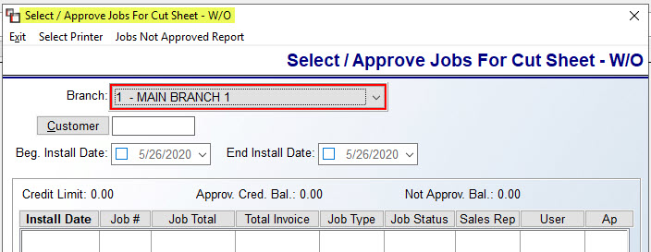

The Jobs Not Approved Report can be printed from within this module. The option appears at the top left. At the Branch field, use the drop-down box to select an alternate Branch ID if applicable. At the Customer field, click the button to make a selection, or type in the Customer ID. In the Install Date fields, you can change the dates to view only those Jobs scheduled to be installed during a particular time frame or make no selection to view all Jobs in the system for the Customer. The Credit Limit (CrLmt) field will display the current Credit Limit on the Customer’s account. The Approved Credit Balance (Apprv Cred Bal) field will display the balance for all Jobs currently approved for credit. The Not Approved Balance (Not Apprv Bal) field will display the total of the Jobs that have not been approved for credit. Once you have entered an Install Date range, the system will pull up all applicable Jobs on the screen as follows:

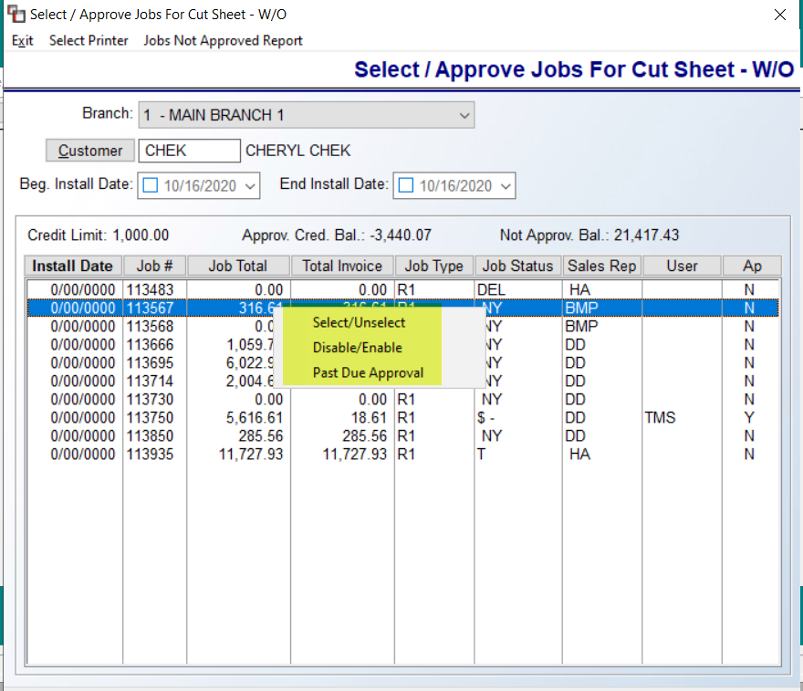

If a User has permission to override the Credit Status on a Job, they can right-click on a highlighted line and use the Select/Unselect option to change the Approval status and that will automatically update the Job accordingly. If an “X” appears in the Ap column, no one can override the Credit Status to allow processing of the Job unless they have Master Override permission which is granted in the User Control 2 screen. If this is the case, the User will see both the Disable/Enable option as displayed above. This is the final determination for that Job and the system will not allow a Work Order or Invoice to be processed for that job. The Past Due Approval option allows a User with that permission to approve Jobs where the Customer has past due Invoices. In this case, a Job may be approved for credit based on the Credit Limit, but if there are past due Invoices on the account, the system will still not allow processing of the Job. The “X” and “A” status can only be changed from within this module, not from Order Entry.

A report titled Jobs Not Approved Report can be found in the A/R Reports Menu 1 of 2 and it can be accessed from the module above. It works in conjunction with the Credit Hold program. All Jobs that are not approved for credit will appear on this report. This report can be customized by the following sort criteria: Branch, Job Type, Open Date, Install Date, Salesperson, and Customer ID. If a Job appears on this report, the Credit Approval status on that Job can be managed from the Approve/Select Jobs module located in the Accounts Receivable menu. When you enter this module, a Jobs Not Approved screen will appear as follows:
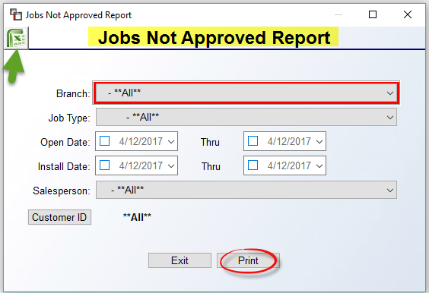
The screen above displays the default settings. If no changes are made, the report will include all Jobs not approved. If you need to customize the report, make those changes in the fields above. When ready, you can click the Excel icon to export to the data, or click the Print button for paper output. It will total all sales for each Customer and at the end of the report it will total all sales for every Job listed.
Important Note: The Credit Hold program will not register any Invoices added through the Customer Account Maintenance module for determining Credit Hold Status on a Customer’s account. In the case of a bad check where an Invoice has to be re-setup through Customer Account Maintenance, the Credit Manager should then review the account and disable any Jobs manually.

Customer Account Maintenance:
This is a set-up module that must be completed before going “live” on the RollMaster System. Thereafter, this module will be used to make adjustments to customer accounts that cannot be made through regular system Invoicing or Credit Memo Processing. Examples include adding on or taking off customer service charges, writing off bad debts, etc. The RollMaster System creates receivables through the Invoicing process; however, you must get your current receivables in the system before you go “live” on the system. As such, the set-up for this module involves entering all existing Customer Invoices/Credits with a balance that were processed prior to going “live” on the RollMaster System. Entering each Invoice or Credit puts history in the system so that you can keep track of your old as well as your new A/R balances from the same system. Please Note: Any jobs that are open at the time you go “live” on the RollMaster System should be entered through the Quotation or Order Entry modules, depending on their status, and processed accordingly.

The Customer Account Maintenance module is tied directly to the system General Ledger (G/L). Any information that is entered through this module will update the General Ledger. (This is not an instant process—after specified daily reports are run, there is a module in the General Ledger Reports menu titled Print Journals/Update General Ledger that needs to be run in order to send information to the General Ledger.) When you enter an Open Item (Invoice, Credit Memo, prior payment, etc.) in this module, the system will automatically send a debit or credit—depending on the item type—to the Accounts Receivable G/L account number. You will need to do the opposing entry (see directions below). For all Beginning A/R Balances, you will take the opposing entry to an account titled “Prior Sales/Rev to A/R.” Once all Beginning A/R Balances have been entered, print an A/R Detail List and compare to your old system to make sure they were entered properly and the report total matches your A/R Account Balance in your old system. You will then perform a journal entry to reverse the accounting data out of your A/R and Prior Sales accounts to net the balance back to zero in preparation for entering your Beginning G/L Balances. This last process will clean up your financials but leave the detail of your old A/R in the system for further processing.

When you enter this module, the system will first prompt a Function selection screen as follows:
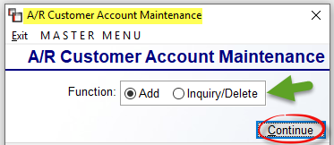

The default setting for the Function screen is Add. To make an Inquiry or Delete an item, click on that option and then hit Continue. That will prompt a lookup screen as follows:

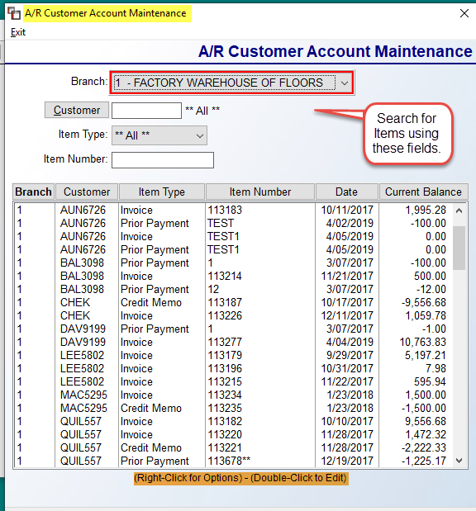

Each of the column headers is sortable if you click on it. You can scroll through the list of items, or use the Customer, Item Type, and/or Item Number fields to narrow the search. Once an Item is located in the screen, highlight and Right Click to Edit or Delete or Double-Click to Edit. The system will prompt an Add/Update Customer Account box as follows:

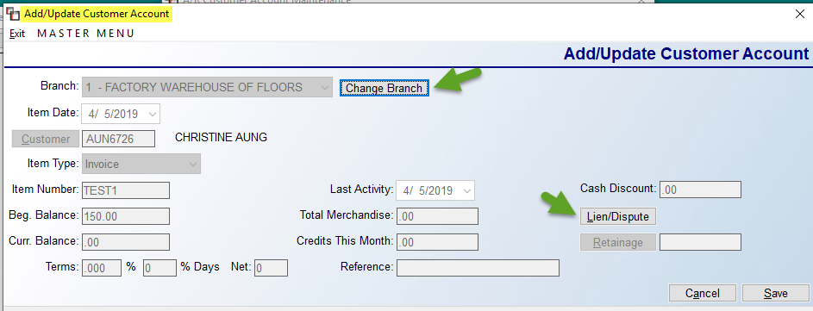

There is limited functionality in this screen, other than to Change Branch, or modify Lien/Dispute, and Retainage.
To add an Open Item, click on the Add option in the Function screen and click Continue. The system will prompt a main Add/Update Customer Account screen as follows:

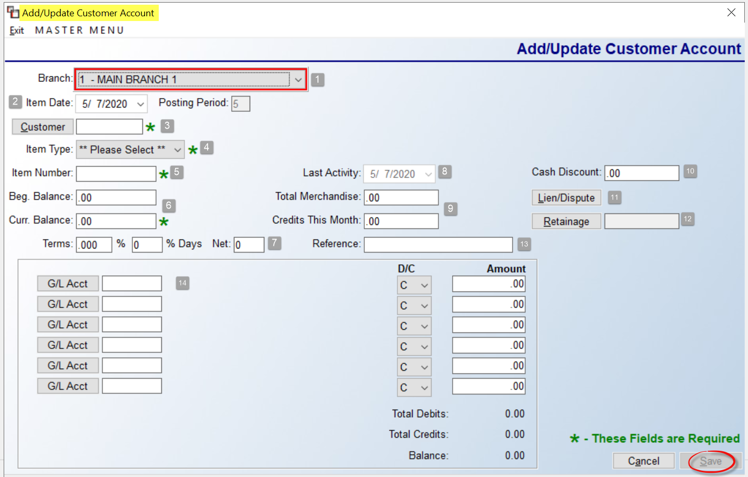

At the Branch (1) field, use the drop-down arrow to select another Branch if applicable. The Item Date (2) field will default to the current date, but you can alter if applicable. The Posting Period field is display only. At the Customer (3) field, ether type the Customer ID or click the button to prompt the Customer Selection box, just like the one explained above in Customer Maintenance to make a selection. At the Item Type (4) field, there are five options available from the drop-down box. Select the one that corresponds to the Item you are entering in the system. See below for explanation of Item Types:

Invoice (the system will debit or increase A/R for the amount of the invoice)
Credit Memo (the system will credit or decrease A/R for the amount of the credit memo)
Service Charge (the system will debit or increase A/R for the amount of the service charge)

The Item Number (5) field is used to record a number or alphanumeric description for the item you are adding. The Beg. Balance and Cur. Balance (6) fields are generally the same amount. Make sure the Current Balance reflects the current amount of the item you are adding. When you are adding Invoices or Service Charges, the amount must be a positive number. When you are adding Credit Memos, the amount must be a negative number. The Terms (7) fields are used only if you are adding an Invoice. If you offer terms to your customer that apply to the Invoice you are adding, enter the discount percentage and the number of days the customer has to take the discount. If terms are pre-programmed in the Customer Maintenance module, that information will automatically default here. If no terms apply, you can skip these fields.

The Last Activity (8) field will default to the date entered in the Item Date field. If there has been activity on this item since the original date, you can record that date in this field; otherwise, leave the default date. The Total Merchandise (9) field is used to calculate Cash Discount amounts. If no discounts apply, enter through this field. If discounts do apply, enter the total merchandise amount of the item that should be used for calculating the discount amount. The Credits This Month field is generally not used. However, it can be used to record any payments that have already been applied to an item during the month you are adding it, or for beginning balances for reference purposes.

As mentioned above, the Cash Discount (10) field is used only if you are adding an Invoice. If you are giving terms on the Invoice you are adding, the system will figure the discount amount based on the percentage entered in the Terms field and the value entered in the Total Merchandise field. That amount will then prompt in the Post Customer Payments module when you go to post a payment for this Invoice. If no discount applies, skip this field. The Lien Date (11) field is also only used if you are adding an Invoice. If applicable, enter the earliest date on which you can file a lien against the customer if the Invoice is not paid. The Lien Date will display in the Customer Status Inquiry module, and you can also print an Aging Report by Lien Date. If you do not file liens, skip this field. The Retainage (12) field is used to record an amount that is being retained on an Invoice, if applicable. There is an A/R Aging Report (Retainage) to keep track of these invoices, and this amount can be edited as needed in the Inquiry/Delete option when you first enter this module.

And finally, the Reference (13) field can be used to type in a reference memo that applies to the item you are adding. This field reads over into the Customer Status Inquiry module. For your Beginning A/R Balances, you may want to make a note in this field to indicate that the item is a part of your Beginning Balances. If no reference memo applies, you can skip this field.

G/L Account Fields:
As explained in the beginning of this section, when you add an Open Item in this module, the system automatically sends the value of it to the General Ledger for your Accounts Receivable asset account. In the G/L Account (14) fields, you will post the opposing entry(ies). There are multiple fields in the event you need to distribute a value to more than one General Ledger Account. Start by using the G/L Acct button in the first field to prompt a G/L Account Selection screen. You can also type the number if you know it. The D/C (Debit/Credit) column will default to either “D” or “C” depending on the Item Type you are adding (see explanation for Item Type above). If applicable, you can override the default if more than one entry is being made, but ultimately your debits must equal your credits in order to save. In the Amount column, the system will default to the value that was entered in the Current Balance field, unless a value was entered in the Total Merchandise field. You can override this amount if you need to distribute to more than one G/L account, or hit enter to accept. You cannot enter a negative number in this column—use the “D” or “C” entry in the previous column to distribute correctly. The total of the postings must equal the value entered in the Current Balance field before you can exit this screen. Click the Save button when complete.

At the end of the accounting day, if you have added or deleted items in this module you will need to print an Open Items Adjustment Register—located in the Accounts Receivable Reports Menu 1 of 2—to double-check your entries and to complete the system’s internal procedures.

Purge Cleared Account Activity:
When an Invoice is paid in full, or a Credit Memo or prior payment is applied to an open item, those items will still show in the Customer Status Inquiry module and print out on the Detail Listing reports even though they have a zero balance. This module will remove those items and send them to the A/R History modules. You should be aware that the same thing will happen when you run the A/R End of Month Processing module, so unless you are clearing a high volume of open items during the month, you may not need to use this module. When you enter this module, the screen will appear as follows:

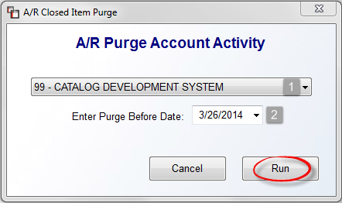

The cursor will be positioned at the Company ID (1) field. Use the drop-down arrow to select a different company or accept the default. At the Enter Purge Before Date (2) field, use the drop-down arrow to select another date or accept the current date. Click the Run button when you are ready to purge A/R account activity.

Post Customer Payments—Text Version:
You will use this module to post customer payments to outstanding receivables in the system and to apply any credits (Credit Memo, Prior Payment, Journal Entry) to a customer’s balance. It can also be used to post monies received other than receivables and to transfer money between bank accounts in the system—see explanation for these items below. It is important that you understand when to use this module as opposed to entering a Deposit in the Quotation or Order Entry modules. Only when a job has been invoiced and a receivable is created in the system should you access this module to post a payment. As long as a job has not been invoiced, you should continue to take payments through the Deposits option in the Order Entry module—that option is designed to keep track of multiple payments on each job if applicable. When you enter this module, the screen will appear as follows:

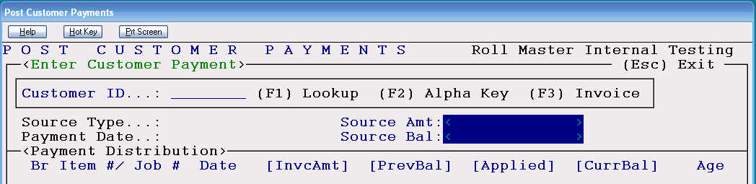

The cursor will be positioned in the Customer ID field. At this point you have a few lookup options for locating the applicable customer. You can hit the F1 key to get an alphabetical Lookup of Customer IDs in the system and make a selection from that box. You can also type the first couple of letters of the customer’s last name or the first couple of letter’s of the company name if it is a business in the Customer ID field and hit enter and the system will pull up the first occurrence of those letters in the Lookup box. The F2 Alpha Key option will allow you to search for the customer alphabetically by the information that was entered in the Alpha Key field in the Customer Maintenance module. The F3 Invoice key option will allow you to search for a customer by the Invoice number. When you hit the F3 key, an Enter Invoice Number prompt will appear as follows:

Type in the applicable Invoice Number and the system will prompt the following screen displaying the Invoice Number, Customer ID, Beginning Balance and Current Balance of the invoice as follows:

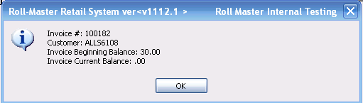

If this is the correct customer and invoice, click the OK button to proceed, otherwise you will need to hit the Esc key to start again. When you click the OK button, the system will place the cursor in the Period field. However, when using the (F3) Invoice feature, you will have a couple of additional options in this screen. The first option occurs after the “Modify Distribution” prompt (explained below). If you select “Y” for yes at this prompt, rather than prompt you to sort by Invoice or Job Number, the system will display the invoice at the top of the display screen and all other invoices will be listed below that invoice in invoice number order.

The second option allows you to review only the payment(s) that paid the invoice. At the “Receive New Payment” prompt (explained below), accept the “N” for no default and hit enter. The system will display only the payment(s) that paid this specific invoice on this customer’s account, rather than displaying multiple payments currently open on the customer’s account. This is especially helpful for builder and property management clients. In the example below, using the process described above, the system is only displaying the payments that were applied to the invoice number entered during the (F3) search as follows:

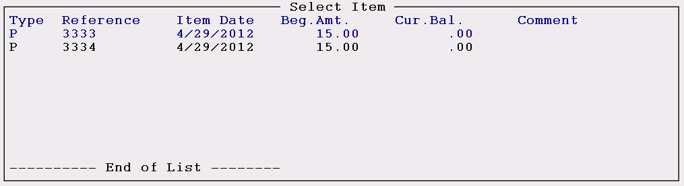

If the (F3) search had not been used, the system would have displayed all payment types on the customer’s account as follows:

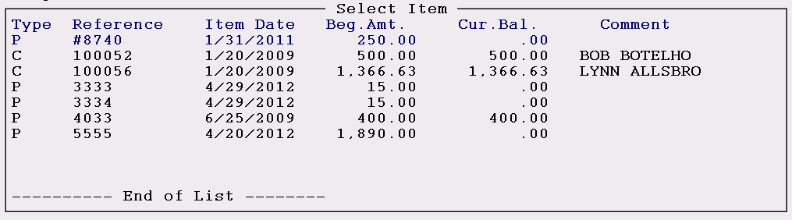

Using this same scenario, if the invoice has not been paid in full, the system will then display any payments that have been applied along with any other payments with a remaining balance for the customer selected. You can then choose a credit or unapplied payment to apply to the invoice.

Once a Customer ID has been typed or selected, the system will place the cursor at the Posting Period field. This field will display the current Default Posting Period set up in your system; hit enter to accept or type in the period for which this activity belongs.

At the Item Reference field, if you are posting a new payment, type in a reference for that payment as follows: if it is a check, type the check number; if it is a credit card, type the first letter of the type of credit card followed by an authorization code to create a unique reference for this payment. An example is V235543 for a Visa payment with the authorization code from the charge receipt. Hit enter when you have finished and the system will prompt the following: Payment Does Not Exist. Receive New Payment? (Y,N) N. To proceed with posting, type a “Y” for yes at this prompt and the system will accept the payment. If you have made a mistake, hit enter and the system will place the cursor back at the Item Reference field. Please Note: Once a payment has been accepted, if you exit the program without applying the payment to an invoice, the system will keep the payment on file and it can be called up again by hitting enter at the Item Reference field and selecting it from a look up screen.

When you enter the Source Type field, the system will automatically bring up a Payment Type Look-Up box. These payment types will be the same as those that were set up in the Payment Type Code Maintenance module in the Sales Processing menu and are branch specific. (If you have multiple branches, make sure you are in the correct branch when posting cash receipts.) Arrow up or down to highlight the appropriate Payment Type, hit enter to select, and the system will fill in the Payment Type description. At the Payment Date field, the system will default to the current date. You can override this date with a different date or hit enter to accept. If you type in a new date, be sure to use two numbers for the month, two for the day, and four for the year. Once you hit enter, the cursor will move to the Source Amount field. Type in the total amount of the payment and hit enter. (Please Note: the A/R Balance field above the Source Amount field will automatically decrease as soon as you hit enter to accept the amount you typed in.) The system will then prompt the following: Sort by Invoice Number/Job Number (I/J): I. The default is “I” for Invoice but you can type a “J” for Job Number if you would prefer to sort the list of items on the screen that way. Regardless of which sort option you select, the system will still display both the Invoice Number and Job Number in the display screen. The system will then bring up a list of all open items on the customer’s account as follows:

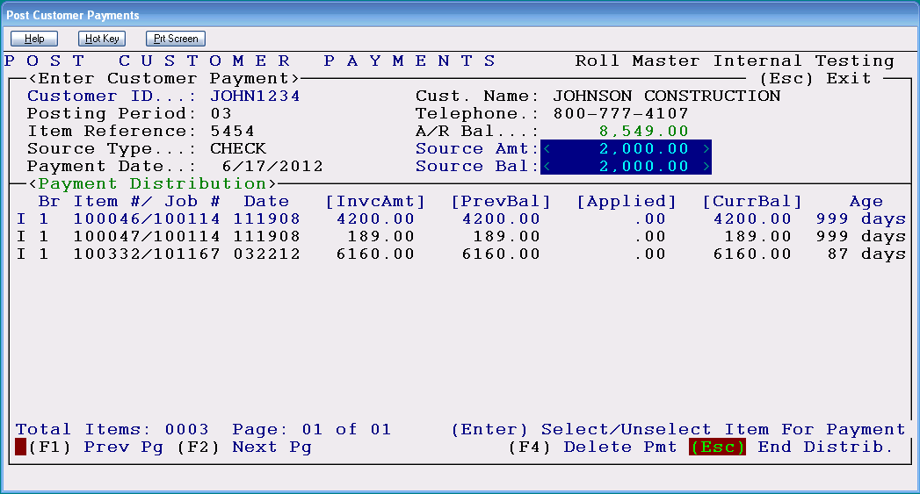

If there is more than one open item in the Payment Distribution screen, you will be able to arrow up and down within the screen to select the applicable item. Once you make a selection, the system will pull up the following Apply/Unapply Payment to Invoice box on screen:

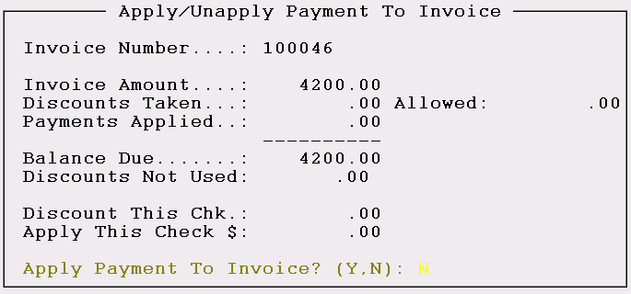

The cursor will be positioned at the Apply Payment To Invoice? prompt. If you hit enter at the prompt, the system will place you back at the Payment Distribution screen and you can select another item if applicable. If this is the correct item, type a “Y” at the Apply Payment prompt and the system will place the cursor in the Discount This Chk. field. If a discount applies to this invoice or if the customer has underpaid the invoice by an amount you are never going to collect from them, type that amount in this field. Please Note: If a customer overpays an invoice by an amount too small to bother returning, you can enter a negative amount in this field and the system will update the customer’s account balance accordingly. For this to work, be sure the Source Amount field contains the total amount of the customer’s payment and not the invoice amount.

Once you have entered through the “Discount This Chk.” field, the system will place the cursor in the “Apply This Check $:” field. If the payment amount is less than the item you are paying, the system will default to the total amount of the payment; however, if the payment amount is more, the system will default to the total amount of the open item you have selected. If everything is correct, hit enter to proceed. The system will prompt the following: Apply Payment, Are you sure? (Y,N): N. If you have made a mistake, hit enter to cancel the procedure and the system will place the cursor back in the Payment Distribution screen. If everything is correct, type a “Y” for yes and the system will update the information on the screen accordingly. If the payment amount covers more than one invoice, once you have applied the applicable portion to the first invoice, the system will place the cursor back in the Payment Distribution screen. Scroll to the next item and hit enter to select and repeat the above procedure. When the Source Balance field is zero, you can hit the “Esc” key to end the distribution and the system will place the cursor at the Item Reference field. When the cursor is back at the Item Reference field, you can add/select another payment to apply to this customer’s account, arrow up to the Customer ID field and enter another ID, or hit the Esc key again to exit the module.

If a payment needs to be deleted once it has been added, you can use the F4 Delete Pmt option located at the bottom right of the screen. This option should only be used to correct data entry mistakes, as in the case of the wrong check number used or the wrong customer selected to apply the payment, etc. When you hit the F4 key, the system will prompt the following:

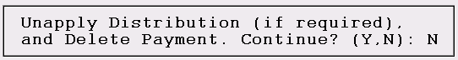

Type a “Y” for yes at this prompt to “unapply” any payment(s) to an invoice and delete the payment from the customer’s account. A Deletion Date Screen will then appear as follows:

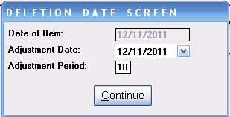

The “Date of Item” field will reflect the actual date the item was entered in the system. Please Note: you cannot access this field. In the “Adjustment Date” field, you can use the drop-down arrow to locate a date different form the default date when applicable. You can also override the default posting period in the “Adjustment Period” field if that change is also applicable. Only users allowed to change Posting Periods will have access to this screen. Click the Continue button to complete the process. If you are adding or deleting a discount to a payment, the following Discount Date Screen will appear as follows:

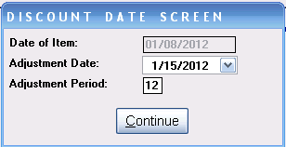

Just as with the Deletion Date Screen above, you can access both the Adjustment Date and Adjustment Period fields to override the defaults if applicable. Again, only users allowed to change Posting Periods will have access to this screen. Click the Continue button when the data is complete.

Another feature in this module is the ability to apply a portion of one payment to more than one customer’s account--as is usually the case with Property Management customers. When a check is to be applied to invoices on more than one account, you will start by posting the payment to the first account as you normally would, making sure to enter the entire check amount in the Source Amount field. You will then apply the applicable portion of the check to all the invoices to be paid for this Customer ID. When this has been completed and a balance still remains on the payment amount, hit the Esc key to end the Payment Distribution for this customer. A box will then pop up asking the following question: Apply rest of this payment to another customer (Y/N): N. If the balance of the payment is actually an overpayment and you wish to keep the balance unapplied on this customer’s account, hit enter at this prompt. However, if you wish to apply the balance of the payment to another Customer ID, type a “Y” at this prompt. The system will then prompt you to print a receipt for the current customer. Once you enter through that prompt, the system will place the cursor back at the Customer ID field. Type in the next Customer ID to apply a portion of the payment to and hit enter. The system will prompt the following: Is this correct (Y/N): Y; hit enter if correct. The source amount will change to the balance left on the check, but the check number, check date and posting period will carry over from the previous Customer ID. You can then select the invoices to pay on the next customer’s account and continue with the payment distribution. You can continue following these procedures until all invoices for each Customer ID have been paid.

On the Customer Payment Register, each amount applied to a customer will display separately but the same Reference (check number) will display on each record. The Payment Distribution Report will show each invoice that was paid using that check on each affected customer’s account. If during the routine you inadvertently enter a Customer ID that you do not wish to apply a payment to, you can simply hit the Esc key to get back to the Customer ID field. The system will, however, create a zero payment record for that customer and you will see that on the Customer Payment Register and on the customer’s account until you purge cleared items or run your end of month processing. If you exit the Post Customer Payments program before applying the full amount of the check, the system will leave the unapplied balance on the last account to which you applied a payment. If you need to delete the payment, you will have to delete each payment off of every account to which you applied partial payment. In other words, if you applied a portion of a check to 10 different accounts, you would need to go back into each of those accounts to “F4 delete payment and unapply distribution.”

If you are using a Credit Memo or Journal Entry to apply to an open item, at the Item Reference field, you can hit enter to get a look up of existing items and select the appropriate Credit Memo or Journal Entry from that screen. You should not try and type the credit memo number in the Item Reference field--always hit enter to get a lookup and select the Credit Memo from that list. You can then follow the same steps outlined above to apply the Credit Memo or Journal Entry to clear an open item on the customer’s account. This procedure will be used to clear service charges and to finish return procedures in the system. To clear small account balances to your A/R Cash Discount account, you can enter a zero amount in the Source Balance field (it doesn’t matter which payment type you select) and apply that zero payment to the item you wish to clear. At the “Discount This Check” prompt, type in the amount of the balance you wish to clear and accept the payment. The system will automatically clear the amount from the item. Customer “Writeoff’s” to accounts other than A/R Discount will need to be done through the Customer Account Maintenance module.

Correcting Payment Posting Errors:
If you incorrectly post a payment to an open item or incorrectly post a payment amount, you can easily reverse the process in this module. If you have posted a payment to the wrong open item, highlight that item in the Payment Distribution screen and hit the (F4) Delete Pmt. key. The following message will prompt: Unapply Distribution (if required), and Delete Payment. Continue? (Y,N): N. To unapply and delete the payment, type a “Y” at this prompt. The system will unapply the payment, delete it from the Item Reference Lookup box, clear the Payment Distribution screen, and place the cursor at a blank Item Reference field. The balance of the item you incorrectly cleared will return to what it was prior to that payment being posted. Also, the applicable bank account and your Accounts Receivable account will automatically be updated accordingly. The Customer Payment Register will reflect the payment coming out of the system, and the Payment History module will be cleared of the entry as if it never existed. This procedure will work up until the point that you perform your end-of-month processing. If you add a payment in this module incorrectly but do not apply it to an invoice, once the cursor is in the Payment Distribution section of the screen, you can hit the F4 key and type a “Y” at the Unapply Distribution prompt. The payment will be deleted in the same way described above.

Other Uses for Post Customer Payments:
In addition to posting customer payments, other checks can also be posted through this module. For example, if you have received an insurance reimbursement, a co-op advertising check, a mill spiff check, etc., those can be posted through this module. At the Customer ID field, simply type NONE and hit enter. The system will place the cursor at a “Comment” field. Type a short applicable comment for future reference and hit enter. The cursor will then jump to a G/L Account field. Type in the account number (or hit enter to get a lookup) to which you want to apply the credit and hit enter. At the Payment Type Lookup box, select a payment type code tied to your cash receipts account—this procedure will send a debit to that account.

This same procedure will allow you to transfer money between bank accounts or between lines of credit and bank accounts. In order to do this, you must set up a Payment Type Code in the system (see the Payment Type Code Maintenance module in the Sales Processing menu) for the bank account that will receive the debit. At the G/L Account field, enter the bank account that needs to be credited (the one you are taking the money out of) and then select the payment type code for the bank account you will be debiting (the one the money is being deposited into) and the journal entry will be complete. In the Bank Reconciliation program, for the bank account the money was taken out of, the system will send a negative entry to Deposits/Credits (Outstanding); for the bank account the money was deposited into, the system will send a positive entry to Deposits/Credits (Outstanding). The Customer Payment Register will also display both entries. The negative entry will display a pay type as TRNSFR for transfer.

Post Customer Payments Refund Procedures:
Please Note: These procedures will only apply to situations where you were unable to process an automated system refund from the Quotation or Order Entry modules.

If you are typing or hand writing a check, perform the following steps:
- In the A/R Customer Account Maintenance module, add an Invoice for the amount of the refund—this amount should currently be reflected as a credit balance on the customer’s account. It is recommended that you type in the customer name in the Reference field of the Customer Account Maintenance module for future reference. During this process, the system will automatically debit your General Ledger account number for Accounts Receivable; you should take the credit to your General Ledger account number for Accounts Payable.
- In the A/R Post Customer Payments module, apply the credit balance on the customer’s account to the Invoice you added in step 1. This will clear the customer’s account of the credit balance.
- When hand writing or typing a check, the system will allow you to add a Vendor and an Invoice “on the fly,” which means you can go straight to the Hand Check/Void Check Processing module at this point. At the Vendor field, you can add your customer as a vendor or set up a general use vendor titled REFUND. If you create a new Vendor ID in the Vendor field, the system will ask if you are adding a new Vendor. If you respond with a “Y” at that prompt, the system will pull up the Vendor Maintenance screen for you to complete. When you have finished, the system will return you to the Hand Check/Void Check Processing module. Type in the check number, the check date and the amount of the check and type a “Y” at the Header OK prompt.
- At the O/I Number field, create an invoice number for the refund and hit enter. The system will prompt that the number is not on file and ask if you want to add. Type a “Y” at the prompt and the system will bring up the A/P Open Item Maintenance module and place the cursor at the Period field. Finish entering the open item in the amount of the refund due. It is recommended that you type in the customer name in the Reference field—this information will show in the Check History module. During this process, the system will automatically credit Accounts Payable. Take the debit to your General Ledger account number for Accounts Payable also—this is an offsetting entry. At the “Select for Payment Now” prompt, type an “N” for no because you are writing a hand check. The system will then place you back at the Hand Check/Void Check Processing module. The cursor will be flashing in the Payment column; hit enter to proceed. Enter through the Discount column and type a “Y” in the OK column. If all the information is correct, type a “Y” at the DATA OK prompt. This process will automatically debit your General Ledger account number for Accounts Payable and credit your General Ledger account number for Cash Receipts. Be sure to print the Check Register when you have finished processing Hand Checks.
If you are printing a system check, perform the following steps:
- Follow steps 1 & 2 above to clear the customer’s account of the credit balance.
- In the A/P Vendor Maintenance module, set up your customer as a vendor. You can also set up a general use vendor titled REFUND and change out the Mailing Address (Remit To) information to reflect each refund customer’s name and address. The Mailing Address information is what actually prints out on the system generated checks and this information can be changed for each subsequent refund that needs to be processed. This will prevent your Vendor ID look-up screen from becoming cluttered with refund customers.
- In the A/P Open Item Maintenance module, add an Invoice for your Customer or REFUND vendor (whatever you set up in step 3) in the amount of the refund due. It is recommended that you type in the customer name in the Reference field—this information will show in the Check History module. The system will automatically credit your General Ledger account number for Accounts Payable. Take the debit to your General Ledger account number for Accounts Payable also—this is an offsetting entry. At the “Select for Payment Now” prompt, type a “Y” for yes. This will allow you to skip the Payment Selection process so you can go directly to the Print Checks module.
- Load checks on your printer and print the check. If the check printed successfully, type a “Y” at the “Did Checks Print OK” prompt. This will automatically debit your General Ledger account number for Accounts Payable and credit your General Ledger account number for Cash Receipts. Print the Check Register when you have finished processing checks.

If you are processing a credit card refund, perform the following steps:
- In the A/R Customer Account Maintenance module, add an Invoice for the amount of the refund—this amount should currently be reflected as a credit balance on the customer’s account. It is recommended that you type in the customer name in the Reference field of the Customer Account Maintenance module for future reference. During this process, the system will automatically debit your General Ledger account number for Accounts Receivable. You should take the credit to your General Ledger account number for Cash Receipts provided the credit card payment was originally made through the Post Customer Payments module. If the credit card payment was originally taken as a deposit, the credit should be taken to the General Ledger account number that is attached to the credit card (Payment Type Code) in the Payment Type Code Maintenance module.

- In the A/R Post Customer Payments module, apply the credit balance on the customer’s account to the Invoice you added in step 1. This will clear the account of the credit balance.

At this point, you can run the credit through on your electronic credit card processing machine or follow whatever procedures your store utilizes for processing a credit to the credit card company.

Post Customer Payments—Grahpical Version:
The Post Customer Payments module is now graphical. If you don’t yet have this version, you can request the update through our Support Department. When you enter the graphical version, though the screens look dramatically different, the functionality remains essentially the same. When you enter this module, the screen will now appear as follows:
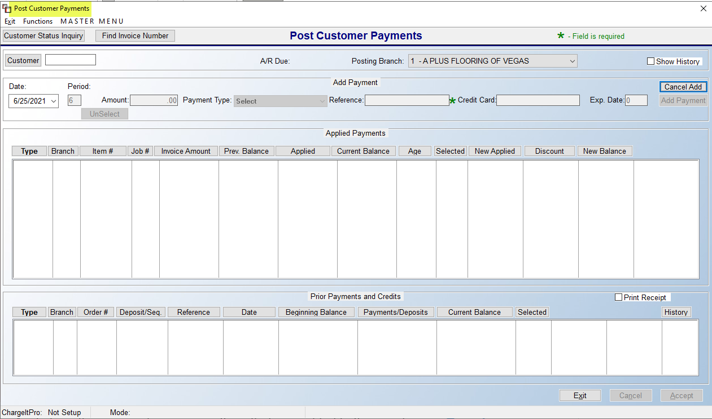
Aside from the screen change, something that was added to the very top is a Branch selection field, titled Posting Branch. Accounts Receivable is Company oriented, not Branch, but you do have the option to change Branches from within this module. An example to change Branches may be that a payment specifically came into the cash drawer of another Branch. The Show History checkbox in the top right corner is also new. Once a Customer has been selected, you can click this option to show historical data. This data is not retro to the text version, but will capture history moving forward in the modern screen.

Another couple of additions at the top left is the ability to access the Customer Status Inquiry module while in this new version, and the ability to Find Invoice Number if you have that info, but not the exact Customer ID. The Functions menu at the very top left has two options as follows: Find Invoice Number and Add Customer (None) Payment. The Find Invoice Number option here is the same as accessed from the Find Invoice Number button. The Add Customer (None) Payment replaces the need to type “NONE” in the Customer field of the text version to post monies that are not tied to a specific Customer/Invoice. An example could be a rebate from a Vendor or some other revenue not tied to a Job in the system. When you click on this option, a box will prompt as follows:

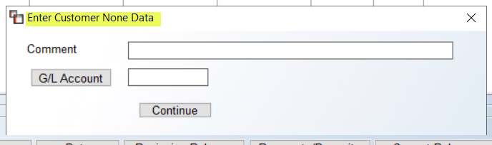

Use the Comment field to describe the non-customer payment and then make a G/L Account selection. Click the Continue button to finish the process.

As with the text version, you will begin by making a Customer selection, but you now have the option of using the Customer Selection screen to look up customers. Once a Customer is selected, their A/R Due amount will populate to the left of the Posting Branch field and any Prior Payments or Credits existing will display in the screen at the bottom. Unless the Date needs to change, the next step is to type the payment amount in the Amount field. The Payment Type is a now a drop-down box from which you will use to make that selection. You can type your Reference for the payment as you normally would, such as check number of cc auth number. The Credit Card and Exp Date fields are for use with ChargeItPro/Gravity. At this point, you can click Cancel Add to restart or reset the payment info if applicable. If not, then enter or tab to the Add Payment button.

Once you click the Add Payment button, the new payment will display in the Prior Payments and Credits box with a “Y” in the Selected column. If you will not take a discount, you can highlight the applicable Invoice in the box above and double-click to apply the payment. If you need to apply a discount or write off a few pennies, then you will highlight and right-click to display Apply. This will prompt a somewhat familiar box as follows:
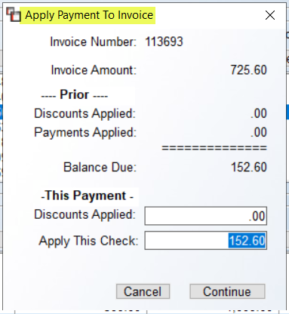
Use the Discounts Applied field to take a Discount and hit Continue to apply the payment. You can post a payment without a taking a discount this way as well, it’s just now an extra step. If you right-click on an Invoice with an applied payment, you will see two options as follows: Modify and Unselect. The Modify option will prompt the box above so you can make changes to the Discounts Applied field and the Unselect option will remove the payment from the Invoice.

If a balance remains on the payment, you can select another Invoice until the full balance has been applied. When completed, click the Accept button at the bottom right. The system will prompt a confirmation of the payment application as follows:

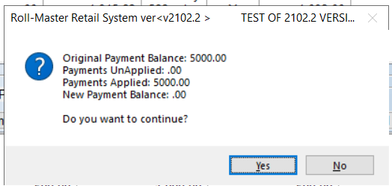

You can click Yes to finalize, or No to go back and make any changes. If you need to print a receipt, prior to hitting Accept, you can click the Print Receipt check box. If you need to go back after the payment has been applied, you can enter back and select the payment, and a Reprint Receipt button will prompt next to the Print Receipt check box. The Delete Payment button, when a payment is selected, will unapply any amount already applied to an Invoice(s) and delete the payment in one step.

One additional feature that carried over with the modern version is the ability to apply funds from one payment to more than one Customer, as can be the case with multifamily customers. To do this, once a payment has been added and while a balance exists, you will see a Move to Another Customer button to the left of the Delete Payment button. When you click this button, the system will prompt a box as follows:

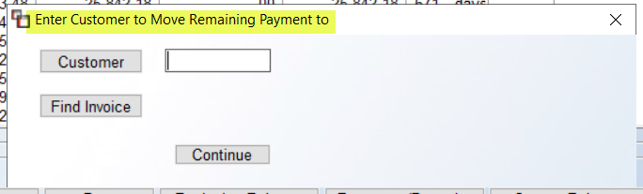

You can search by Customer or by Invoice Number and then hit the Continue button. You can use this feature until the full balance is applied or a remaining balance is left unapplied on a customer account.

Customer Status Inquiry:
This module will allow you to view a Customer’s credit information as well as all the Open Items on their account, including Deposits, and also allow you to add Notes to individual Invoices. It is very useful module for the accounting department to quickly view Customer account information. Any Customer Notes added in the Customer Maintenance or Customer Deposit Inquiry modules can be pulled up from this module. When you first enter this module, the system will prompt the Customer Selection box. Highlight the desired Customer ID and click the Select button to continue. A Customer Invoice Credit Lookup Screen will appear as follows:

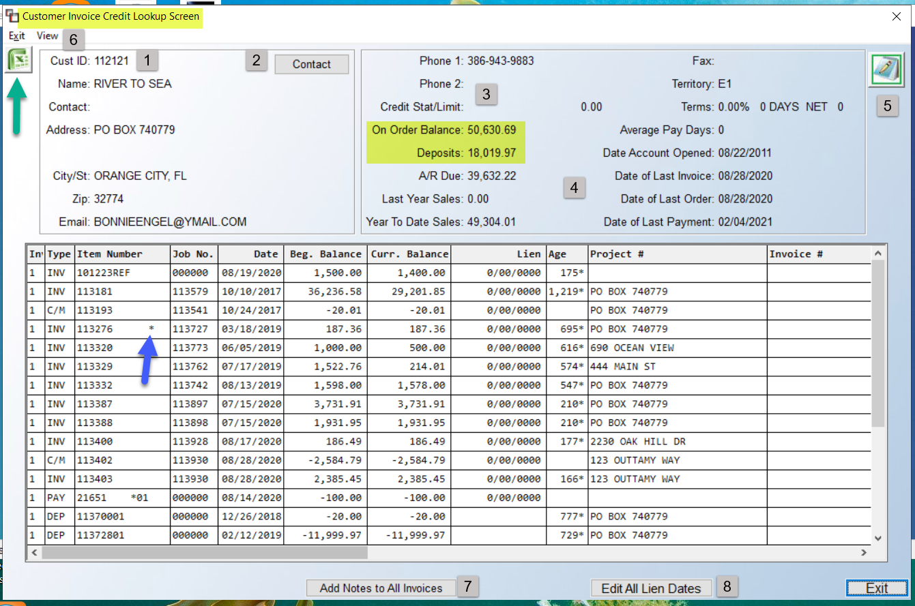

At the top left of the screen, you will see an Excel icon. All the data you see within this screen can be exported to Excel. In the box (1) closest to the Excel icon, the Customer’s name, address, email, etc., entered in the Customer Maintenance module will display. The Contact (2) button also pulls data entered in Customer Maintenance, along with the fields at the top of the box (3) to the right of the Contacts button. The fields (4) just below provide crucial account data, including the On Order Balance and the Deposits total, providing a quick picture of what the Customer truly owes at a glance by subtracting the Deposits total from the On Order Balance. The Average Pay Days field is tied to a Company Control 4 level option that will allow you to select how many months of history to use in order to determine this figure. See System Maintenance manual for setup details. That control appears as follows: A/R Avg Pay Days Month.

The Notes (5) icon will prompt the Ship To Notes feature where you can view and add new Notes. All of the items listed in the main screen are individual items on the Customer’s account, the total of which create the account data at the top of the screen. Most columns are self-explanatory. Click on the header for each column to sort the display by that column’s data. An “*” next to an Item Number denotes Invoice Notes exist. The Beg. Balance column displays the beginning amount of the Open Item when it was first added or created in the system. The Curr Balance column displays the current amount of the Open Item. The Lien column displays a lien date for the item provided a date was entered through either the Customer Account Maintenance module or the Lien Date/Dispute (explained below) option in this module. The Age column displays the number of days an Invoice has been aging in the system—this column only displays data for Invoices. An asterisk in the Age column denotes that the Invoice is past due. Scroll to the right to see additional columns. The Cust. Ref. column is updated through two different sources. When an Open Item is added through the Customer Account Maintenance module, anything typed in the Reference field displays in this column. Also, when an Invoice is processed in the system, the data that appears in the Name field of the Job Location box displays here. For those clients using ChargeItPro, a View (6) option will appear at the top left of this screen. When clicked, the system will prompt the following: Gravity/ChargeItPro Transactions. When selected, a Gravity/ChargeItPro Transactions screen will prompt with applicable data.

Two additional options appear at the bottom of the screen. The Add Notes to All Invoices (7) button, when clicked, will prompt a Notes box that will appear as follows:

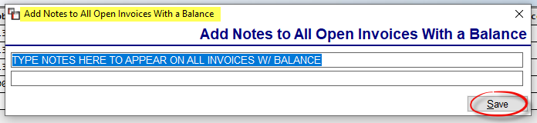

You can type up to two lines of Notes. Click the Save button to have the Notes added to all open Invoices with a balance. You will see an asterisk “*” appear next to each Item Number where these Notes have been added. You can manage these Notes via the Invoice Notes option when you click on an Item Number in the main screen. The Edit All Lien Dates (8) button, if clicked, will prompt an Enter New Lien Date box, and any change made here will impact all Lien Dates. For complete details on Liens/Disputes, see the next section.

When you click on an individual item in the screen, the system will display additional options at the bottom of the screen as follows:

The Print Invoice button will launch the Invoice Reprint program ready to reprint the selected item. The Invoice Notes button will prompt an Invoice Notes screen for notes specific to this Open Item. Where Invoice Notes exist, you will see an asterisk to the right of the Number. Also, you will be able to view these notes under each Invoice on the A/R Aging Report (Retainage) report if you select by Salesperson at the print options. The Add Notes to All Invoices works the same as explained above. The Lien Date/Dispute button will prompt the following:

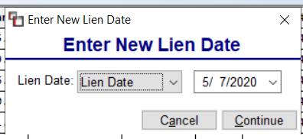

There are many options from the Lien Date drop-down box, and, once programmed, will appear next to the Invoice with the applicable notation on the following reports: A/R Aging Report (Standard), A/R Aging Report (by Salesperson), and the A/R Detail List (by Lien Date). The first is to enter a date the lien would go into effect by selecting a date in the field next to the Lien Date drop-down box. The remaining options for this feature include changing the status from Lien Date to another option as follows: None, Liened, NO2ODA, BONDCL, Progress, Disputed, Legal, Payment Dispute, Final Demand, and Escalation (you may need to exit and re-enter to see these notations display in the main screen). NO2ODA means “Notice to Owner Date.” BONDCL stands for Bond Claimed (applicable for some states). Progress denotes a Progress Bill Invoice (see Progress Billing in Sales Processing for more info). Disputed denotes that all or part of an Invoice has been disputed by the Customer, and this option will also allow you to enter a disputed amount. When you select this option, the system will prompt the following after you click the Continue button:

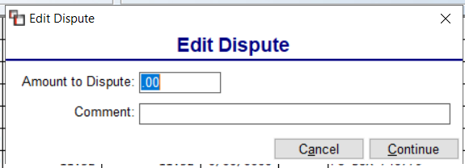

Type the disputed amount in the Amount to Dispute field. You can also type a Comment regarding the dispute and then save your changes before exiting. The portion that is in dispute will not impact the Customer’s credit balance. The additional options are self-explanatory and not all of these options may be used.

The Edit Item Retainge button feature was designed primarily for commercial accounts where the general contractor holds back a retained amount on Invoices until all work is complete. Keeping track of retained amounts can assist with opening lines of credit or borrowing money. If the lender is aware that certain dollars are considered a retained amount rather than old receivable or bad debt, they may be more willing to allow the dealer to borrow money against that amount. The A/R Aging Report (Retainage)—located in the A/R Reports Menu 2 of 2—will display any reatained amounts programmed from this feature. When you click this button, the system will prompt the following:
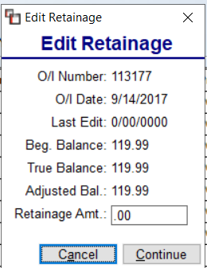

Type the total to be retained in the Retainage Amt field and click Continue to proceed. Any retained amounts will appear in the far-right column of the A/R Aging Report (Retainage) with an “R” to the right of the amount.

Customer Deposit Inquiry:
This module works much the same as the Customer Status Inquiry module except you will only be able to view open Deposits on a Customer’s account. The Credit Status screen looks similar to the one in the Customer Status Inquiry module. When you enter this module, after making a Customer selection, the main screen for this module appears as follows:

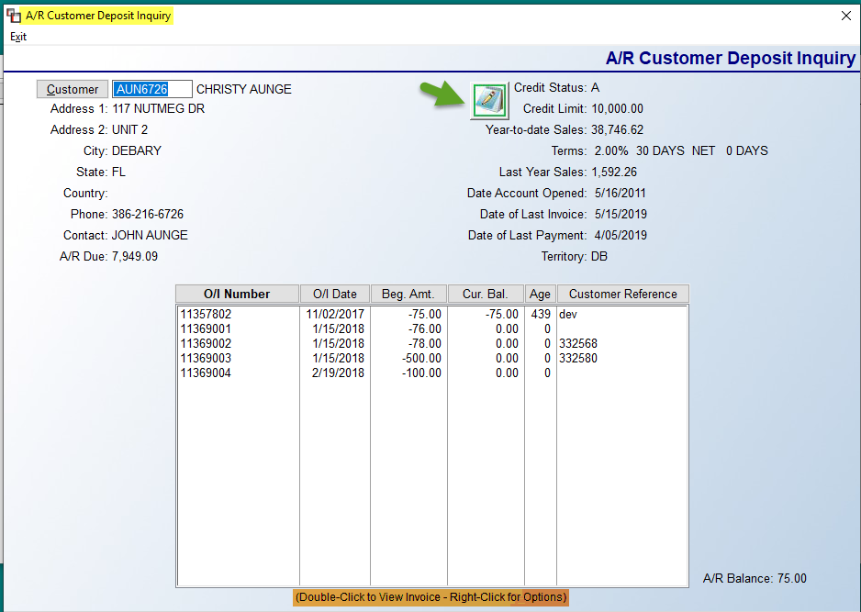

You can access Customer Notes (explained above in the Customer Status Inquiry module section) option from this screen by clicking on the icon. Also, if a Deposit is tied to a system Invoice, you can double-click to View/Print the Invoice. You can also right-click on an item to get the following options: View Job and View Invoice/Credit Memo.

Customer Payment History:
This module is tied to the Post Customer Payments module. A record of all payments posted will display in this screen for each Customer’s account. Use this module to check whether a payment has been received from a Customer, or when the last payment was received. The display shows the payment and the Open Item to which it was applied. When you enter this module, a Customer Payment History screen will appear as follows:

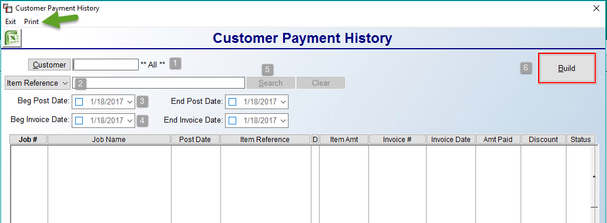

Click the Customer (1) button to select a specific customer or leave the default **ALL** to search through all customer payments. From the Item Reference (2) drop-down menu, you can select to Search (3) by the following criteria: Job #, Job Name, Item Reference, Item Amount, Invoice #, Amount Paid, and Status (I for Invoice or S for Service Charge). The Clear (3) button is used to clear Search criteria for the same Customer so a new selection can be made. Upon making an Item Reference selection, to further narrow the search, you can enter a Beginning and Ending Post Date (4) for the payment and/or a Beginning and Ending Invoice Date (5). The Property Manager (6) drop-down selection box allows for viewing history by a specific Property Manager. The default is **All**, so no change will occur unless a Property Manager is selected. This would be the Property Manager associated with the Job Ship To that is tied to the paid Invoice. When all selections are made, click the Build (7) button.

At the top left, you will see a Print option next to the Exit option. This option will allow you to print an A/R Invoice and Payment Report. This report is designed to provide detail on a Customer’s account including Invoices, Credit Memos, Payments, and how Payments were applied to Invoices. The data on this report is the same as what can be printed on an A/R Statement, but this report will include purged (month end or cleared account activity) and will allow you to set a date range. Currently this report will print for one Customer at a time. You do not need to first select a Customer ID in the Customer Payment History module in order to use this report. The system will prompt an A/R Invoice and Payment Report screen as follows:

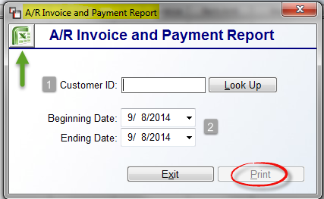

Select a Customer ID (1) using the Look Up button. Use the Beginning and Ending Date (2) fields to set a date range for the data. Click the Print button to print to paper, or click the Excel icon to export the data. A sample of the report appears below.

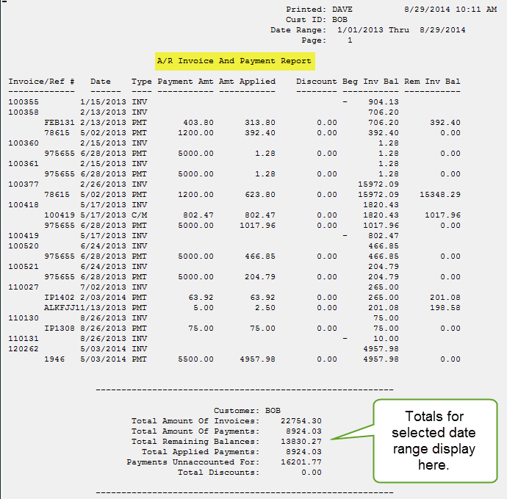

Once a list of items appears in the Customer Payment History screen, you have a few additional options. After the initial search, the items will sort in order of the Item Reference option you selected as follows:

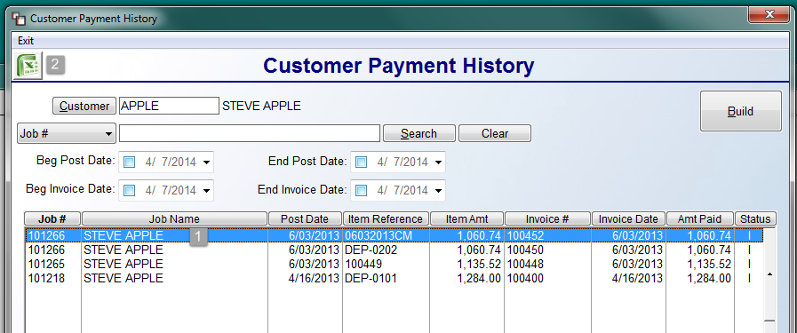

If there are multiple items on the screen, you can click on any of the column heading buttons to change the listing order. You can also right click on a highlighted line (1) to prompt the following: Invoice Reprint. This is the same feature that appears in the Invoice/Credit Memo module and will allow reprinting of Invoices from this screen. And finally, you can click on the Excel (2) icon to export all the data on the screen to Excel. This data will display the Customer Name along with the Customer ID, and the Salesperson 1 & 2. Additional Excel data export items include Payment Type Code and whether payment/deposit was posted in Deposits or via Post Customer Payments.

Invoice History Inquiry:
This module keeps a record by Customer of every Invoice or Credit Memo ever processed in the system that is not currently reflected in the Customer Status Inquiry module. Data moves to this module when cleared items have been purged in the system through the End of Month Processing module or through the Purge Cleared Account Activity module. When you enter this module, after making a Customer selection, the system will prompt a Customer Invoice History screen as follows:

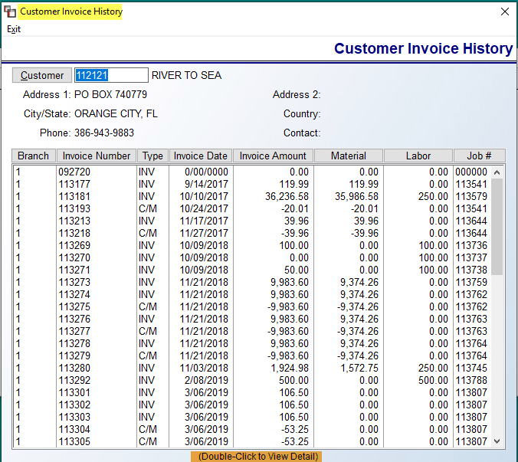

Highlight and double-click on an Item to View Detail and reprint, if applicable. This is the same option that is available in the Customer Status Inquiry module (explained above). Click Exit or hit Esc to return to the Accounts Receivable menu.

Account History Inquiry:
This module keeps track of month-to-date and year-to-date sales and profit information in addition to other credit history information such as the average number of days customers take to pay their bills. It is updated through the End of Month Processing module when you close each month and then perform an End-of-Year closing. It is a useful module for keeping track of credit history information for your repeat customers. When you enter this module, after selecting a Customer, the screen will appear as follows:

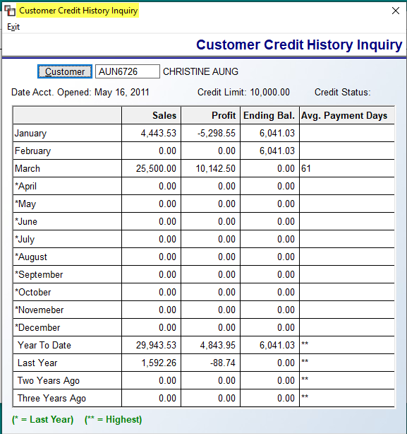

This is strictly a “View” screen—you cannot perform any functions or access any of the fields. Once activity has been generated on an account, these fields will be updated during end-of-month and end-of-year processing. To exit this screen, click Exit or hit the Esc key to return to the Accounts Receivable menu.

Service Charge Processing:
This module is used to automatically calculate and add service charges to past due Invoice amounts. This module is tied to the Service Charge field in the Customer Maintenance module. As explained in the Customer Maintenance section, that field needs to be set to “Y” for yes in order for a Service Charge to automatically be added to a Customer’s account. You should also have entered a percentage amount to charge (e.g., 1.5 percent) and the number of days after the date of invoice a Service Charge should be assessed. Based on that information, the system will determine which Invoices are past due and how much the charge amount should be. When you enter this module, the screen will appear as follows:

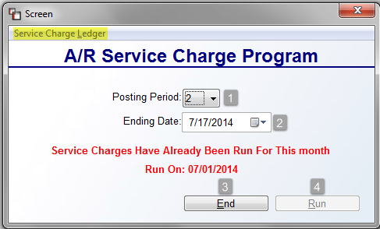

The Posting Period (1) will default to the current open period in the Company General Ledger. The Ending Date (2) field will prompt the current date. Provided this module has not already been processed for the month, you can change the date if applicable. If it has been run, a message will prompt just below the Ending Date field, letting you know Service Charges have already been run and the date they ran. If this is the case, the End (3) button will be available to exit the module. The Run (4) button will only be available if Service Charges have not yet been run. The Service Charge Ledger option at the top left of the screen should be run after Service Charges have been processed. The Service Charge Ledger option will become available as soon as you successfully run service charges for a month. When you click on that option, the system will prompt the following:
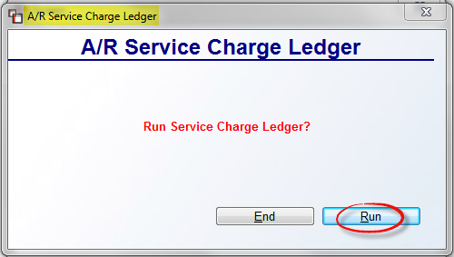

Click the Run button to continue. The system will begin printing and then prompt the following:
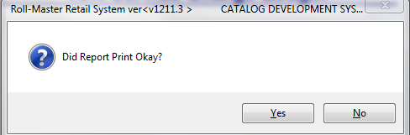

To clear the Service Charge Ledger, make sure the report printed okay and then click the Yes button. To reprint, click the No button and enter back into the program. All Service Charges assessed will appear on the Customer’s account in the Customer Status Inquiry module and on the Customer’s A/R Statement. For all Service Charges the system generates, it will automatically credit the Service Charge Revenue Account and debit the Accounts Receivable Asset Account in the system General Ledger.

End of Month Processing:
This module should be run at the end of every month after all month-end A/R reports have been run and before any new activity is entered in the system for the next month. When you run this module, the system performs internal procedures to clear all month-to-date fields in the A/R modules and purges any cleared Open Items to the applicable History modules. You will access this module to perform end-of-year processing as well—this procedure will clear year-to-date fields and move the information to the previous year fields. When you enter this module, the system will prompt an A/R End of Month/Year screen as follows:

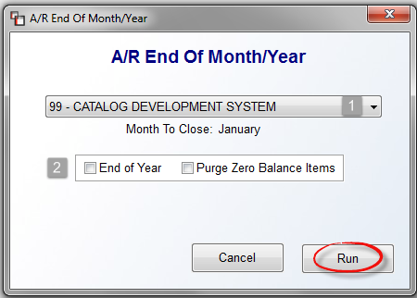

The cursor will be positioned at the Company ID (1) field. Use the drop-down arrow to select a different company or accept the default. Below the Company ID field, the system will prompt the following: Month To Close. Before proceeding, make sure the month is correct. At the End of Year (2) field, only click this box if it is also the end of your calendar year. Click the Purge Zero Balance Items field to clear out any items with no balance during End of Month processing. When you click this box, the system will prompt the following:
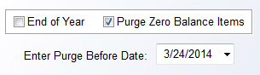

The Enter Purge Before Date will default to the current date. Use the drop-down arrow to select another date if applicable. When you are ready to continue, click the Run button to begin End of Month Processing.

Closed Deposit Purge:
This module will purge any cleared Deposits on all Customer accounts in the system. This module needs to be run once a month, as it is the only way to remove cleared Deposits from the Customer Status Inquiry and Customer Deposit Inquiry modules. When you enter this module, the system will prompt a A/R Closed Deposit Purge screen as follows:
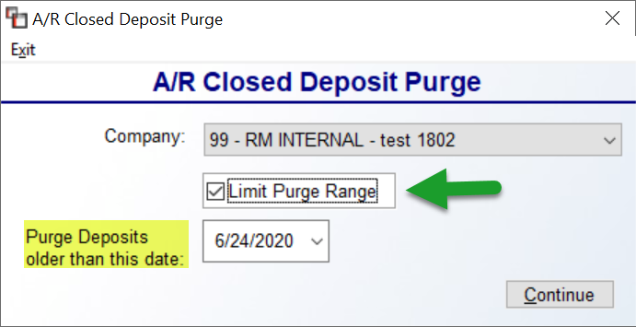

At the Company ID field, use the drop-down arrow if you need to select another company, otherwise accept the default. The Limit Purge Range box, if checked, will display a Date field, as seen in the image above. This will allow you to set a prior date for purging closed Deposits, when applicable. Click the Run button to continue with purging closed Deposits from the Open Item screens and reports.

Sales Tax Code Maintenance:
This is a set-up module that must be completed before any customers are entered in the Customer Maintenance module. Thereafter, this module will be used to add or change Sales Tax Codes, when applicable. Following this section is an explanation of an automated Sales Tax update option that you can add to your system for an additional annual subscription.

Before you can begin using the RollMaster System, you will need to set up a Sales Tax Code for every type of sales tax that you collect and report/pay to your state government. The number of Tax Codes you set up depends on how your state government wishes you to remit those taxes—separated or not separated. (Before you begin, make sure you have a G/L liability account number set up for each classification of sales tax that you collect.) As an example, if you have a state (let’s say Tennessee) tax of 4% and a county (let’s say Williamson) tax of 2% for a total of 6% sales tax that needs to be collected on every sale, does the State want to see a breakdown of the 4% and 2% or does it just want a report on the total 6%? If the State does want a breakdown, you will need to create at least two Sales Tax Codes such as the following: “TN” for Tennessee, and “WL” for Williamson County. If the state does not want the information broken down, then you can create just one Sales Tax Code for the state such as “TN” for Tennessee. One additional Sales Tax Code that you should create is an Exempt tax code. This code should have a zero percentage. Use “EX” or “EXT” as the code. All tax-exempt customers should be set up with this Sales Tax Code.

When you enter this module, the system will prompt a Sales Tax Code Maintenance screen as follows:

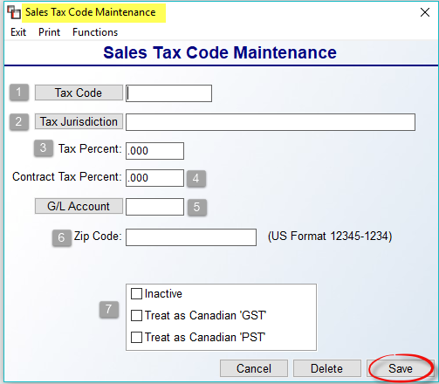

At the Tax Code (1) field, if you click the Tax Code button, the system will prompt a list of existing Sales Tax Codes. To add a new one, create a one to eight-digit alphanumeric code to identify the Sales Tax Code you are adding—it is best to use letters that closely identify the county, city, or state. At the Tax Jurisdiction (2) field, type in a description of the Sales Tax Code, up to 40 characters (e.g., Tennessee State Tax) and hit enter to continue. However, if you click the Tax Jurisdiction button, the system will prompt a “wild card” type search for an existing Tax Jurisdiction (description). When you click the Tax Jurisdiction button, the system will prompt a Tax Code Jurisdiction Look-Up box as follows:
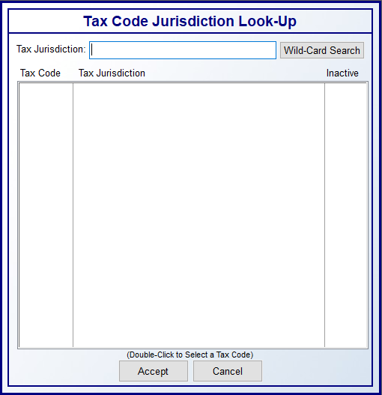
In the blank Tax Jurisdiction field above, you can type a few letters of the tax code you wish to locate and then click the Wild-Card Search button. The system will then display all occurrences of those letters to allow you to scroll and search for the desired Tax Code. You can double-click on the desired Tax Code to load into the maintenance screen, or highlight and then click the Accept button. Please Note: this new Tax Code Jurisdiction Look-Up screen is also available anywhere in the system where you can perform a Tax Code lookup.

At the Tax Percent (3) field, type in the tax percentage amount applicable to the Tax Code. You have up to six characters, which means you can have three to four spaces after the decimal if applicable. For your Exempt Sales Tax Code, leave “.000” in this field. The Contract Tax Percent (4) field can be used if your Use Tax percentage or Contract Tax percentage is different from your regular Sales Tax percentage. The G/L Account (5) field is tied to the system General Ledger. Type in the Sales Tax Liability Account Number that applies to the Sales Tax Code you are adding, or click the G/L Account button to prompt a G/L Account Selection box. This is a required field of entry and the account must be set up in the system before you can type or select that number in this field. (See Account Maintenance/Inquiry in the General Ledger manual for information on setting up G/L accounts.) At the Zip Code (6) field, you will only use this if you have to report by Zip Code and then each Tax Code can have its own zip code for reporting purposes. If this is not applicable, leave this field blank.
You can also set a Tax Code to an Inactive (7) status by checking that box on an existing Tax Code. When the Tax Code Selection box is called up from anywhere in the system, an “Inactive” column will appear as follows:

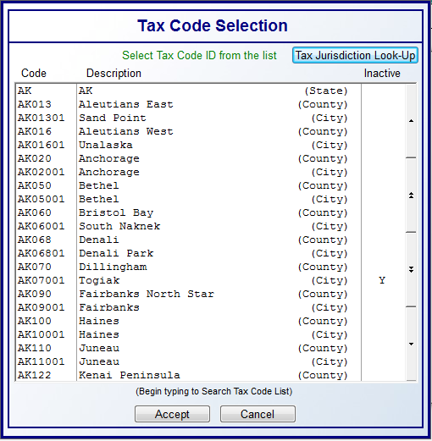

The system will not allow you to select an Inactive Sales Tax Code from the Customer Maintenance module. Two additional options pertain to functionality for Canadian Customers. These two GST and PST checkboxes allow for creating Tax Codes that don’t need to contain the text “GST” and “PST” in the Code name. Also, Canadian customers can now operate in multiple Provinces within the same Company. Because of the importance of proper setup, any Canadian client wishing to switch to this optional method of Tax setup should contact RollMaster at info@rmaster.com for assistance. A second change for Canadian Dealers deals with grouping Tax Codes together in Regions, rather than defaulting from Branch setup. Please Note: It is recommended that a RollMaster Trainer assist with this set up. Please send an email to info@rmaster.com for assistance.

When you have finished adding a Tax Code, be sure to click the Save button prior to exiting the Sales Tax Code Maintenance screen to save any changes. When using either the Delete or Save buttons, the system will keep you in the screen above so you can continue to add, delete, or edit without having to re-enter the module.

Two additional options in this module can be found at the top left of the screen. If you click the Print option, the system will print a list of existing Sales Tax Codes. You can also export this data to Excel. If you click the Functions menu option, the system will prompt the following option: Replace Sales Tax Codes. When you select this option, a box will appear as follows:

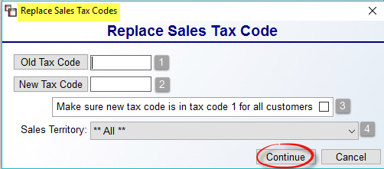

This functionality is designed to allow you to replace an existing Sales Tax Code with a new one on all existing Customer accounts. In the Old Tax Code (1) field, type in the existing old tax code. In the New Tax Code (2) field, type in the new applicable Tax Code. At the Make sure new tax code is in tax code 1 for all customers (3) field, if checked, this will be a blanket change for all Customers, so be sure this is the outcome you are wanting before checking this option and then clicking the Continue button. At the Sales Territory (4) field, the default is set to **All**. To replace Sales Tax Codes for a specific Territory, use the drop-down menu to make that selection prior to clicking the Continue button. Please Note: if you need to delete a tax code entirely, you will need to contact RollMaster Customer Support for assistance.

Tax Rate Changes after going “live” on RollMaster: When a rate change is made on an existing Tax Code, as soon as you enter into a Job or Quote, the system will automatically recalculate the tax data at that time, so even closed Quotes that are reused will also be handled properly. Additionally, the system will also re-check tax rates on Line Items prior to Invoicing, so if a tax rate change is made after a Job is entered, the system will automatically adjust for the change prior to Invoicing. Additionally, if a new tax rate is selected on a “Ship To Code,” the system will automatically recalculate the tax on any existing Line Items so you will not need to re-enter through each line. The tax rate is stored at the point of Invoicing, so that all Job Costs will remain unchanged and any Credit Memos will be handled properly using the tax rate on the job at the time of Invoicing.

Sales Tax Automatic Update—Annual Subscription:
Available from RollMaster Software is a subscription-based automatic Sales Tax percentage update that will alleviate any additional work or preparation with regard to sales tax percentage changes and the addition of new tax jurisdictions. With this new functionality, the RollMaster corporate office is continually gathering and importing sales, use and local taxes for every city, county, state, municipalities (including other taxing jurisdictions i.e. school board, transit, special etc.), as well as any updates, from all 50 states as well as all Canadian Provinces. These changes will integrate seamlessly for all subscribed RollMaster customers without any extra steps on the client-interface side.

In cases where the state, county, and city are clear cut, the integration is automatic and based on the job location zip or postal code entered. And even when the zip or postal code is complex (i.e. has multiple counties, cities or jurisdictions within the zip or postal code), the dealer need only select the appropriate tax combinations from a pop-up offering based on the job location zip or postal code from within the Customer Maintenance screen. To call up this new pop up box, at the Tax Code 1 field, a new option will appear to the right of that field as follows: (F2) Zip Lookup. When you hit the F2 key, the system will prompt the following:

At the Enter Zip Code box, type in a zip or postal code to search for all applicable tax codes and then click the Search button. The system will perform a quick search and display its findings in the box below as follows:

You can highlight and then Select the codes that apply or hit the Select All to include all Tax Codes for this Customer. If a Tax Code needs to be removed, you can highlight it in the Selected Tax Codes box and then click Remove. When all changes have been made, be sure to click the Save button before you click the Quit button to return to the Customer Maintenance screen. For more information on how to subscribe to this annual service, please contact the RollMaster Customer Service department by sending an inquiry to support@rmaster.com.

Approve/Select Jobs:
This module allows you to manage the Credit Approval feature in the RollMaster System. It first needs to be activated before use. If the Credit Approval program has been turned on through the Company Control 2 level of the System Control Maintenance module, you can then use the Approve/Select Jobs module to manage Credit Approval on a job-by-job basis for each Customer. For every Customer that is either over their Credit Limit or past due on an Invoice, the system will not allow processing of a Work Order or Invoice on those Jobs. However, through this module, if a User has Credit Approval control, they can change the Credit Status Approval on a Job through this module. (Please Note: Credit Approved Status can be changed from an “N” to a “Y” in the Job if the User has that control enabled.) When you enter this module, the screen will appear as follows:

The Jobs Not Approved Report can be printed from within this module. The option appears at the top left. At the Branch field, use the drop-down box to select an alternate Branch ID if applicable. At the Customer field, click the button to make a selection, or type in the Customer ID. In the Install Date fields, you can change the dates to view only those Jobs scheduled to be installed during a particular time frame or make no selection to view all Jobs in the system for the Customer. The Credit Limit (CrLmt) field will display the current Credit Limit on the Customer’s account. The Approved Credit Balance (Apprv Cred Bal) field will display the balance for all Jobs currently approved for credit. The Not Approved Balance (Not Apprv Bal) field will display the total of the Jobs that have not been approved for credit. Once you have entered an Install Date range, the system will pull up all applicable Jobs on the screen as follows:

If a User has permission to override the Credit Status on a Job, they can right-click on a highlighted line and use the Select/Unselect option to change the Approval status and that will automatically update the Job accordingly. If an “X” appears in the Ap column, no one can override the Credit Status to allow processing of the Job unless they have Master Override permission which is granted in the User Control 2 screen. If this is the case, the User will see both the Disable/Enable option as displayed above. This is the final determination for that Job and the system will not allow a Work Order or Invoice to be processed for that job. The Past Due Approval option allows a User with that permission to approve Jobs where the Customer has past due Invoices. In this case, a Job may be approved for credit based on the Credit Limit, but if there are past due Invoices on the account, the system will still not allow processing of the Job. The “X” and “A” status can only be changed from within this module, not from Order Entry.

A/R Reports Menu 1 of 2

Introduction:
There are two report menus for Accounts Receivable—A/R Reports Menu 1 of 2 & A/R Reports Menu 2 of 2. Within both menus there are several reports relating to customers and receivable balances that will prove extremely beneficial to the accounting department. These report menus can only be accessed from the Accounts Receivable menu. This next section of the manual will explain each report and how that report can be beneficial to all RollMaster clients.

Customer Master Listing:
The Customer Master Listing is a detailed customer data listing that shows all the information that was entered in the Customer Maintenance module as well as a complete credit history. There are many options to customize this report that can make it a valuable tool for the sales and/or marketing department, such as only printing Customers with no activity after a specific date, and even only printing a listing of Customers entered in the system in a specified date range. In addition to customer data, this report also lists all “ShipTo” codes that have been created for a Customer; therefore, it can be a very lengthy report if you print for several Builder and/or Property Management customers. Also, this report can be exported to Excel, which means that Email addresses are included in the export, allowing you to create mass email listings. Also, when exporting, the Statement default setting on the Customer’s account will export. You will see “O” for Open Items, “B” for Balance Forward, “N” for No Statement, and any other value defaults to Open Items. When you enter this report module, the screen will appear as follows:

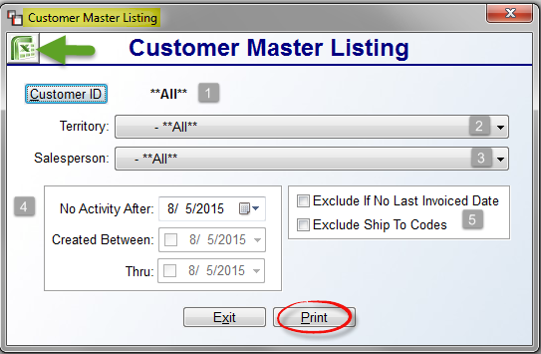
At the Customer ID (1) field, the system will default to **All** Customers. To print for a specific customer, click the Customer ID button to make a selection. At the Territory (2) field, use the drop-down arrow to print for specific Territory, or leave the default for **All** Territories. The Salesperson (3) field will also default to **All**. To print for a specific Salesperson, use the drop-down arrow to make a selection. In the box (4) at the bottom left, the No Activity After option will default to the current date. If you use the drop-down arrow to select a prior date, you can then use the Created Between & Thru date fields to exclude any customers created in the system within that date range. The box (5) to the right has two additional options. The Exclude If No Last Invoiced Date option, when checked, will exclude any Customers where there is no last invoiced date in the data record. The Exclude Ship To Codes, when checked, will exclude all Ship To Codes under each customer, which will make the export process faster. Also, when this option is checked, one additional Excel-only option will display as follows: Include Avg.Pay Days (Excel Only). This is also a very time-consuming export process, so it’s only available where the Exclude Ship To Codes is checked. When you have made your selections, click the Excel icon to export the data, or click the Print button to print to paper or screen.

Customer Reference Listing:
This is a much simpler customer listing report. It shows the Customer ID, the Customer name and address information, the telephone number, the Customer’s Credit Status and Credit Limit, and the Territory Code and Salesperson ID assigned to each Customer. The only option to customize this report is to print by Territory Code. This report can be exported to Excel for added functionality. When you enter this module, the screen will appear as follows:

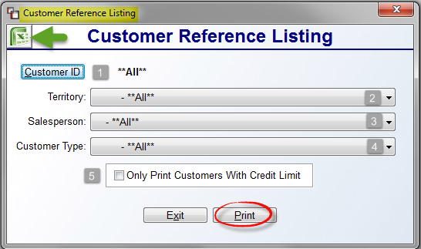

At the Customer ID (1) field, the system will default to **All** Customers. To print for a specific customer, click the Customer ID button to make a selection. At the Territory (2) field, use the drop-down arrow to print for specific Territory, or leave the default for **All** Territories. The Salesperson (3) field will also default to **All**. To print for a specific Salesperson, use the drop-down arrow to make a selection. The Customer Type (4) field is tied to the Customer Type Maintenance option in the Customer Maintenance module. If these have been set up, you can use the drop-down arrow to select a specific Customer Type. The next option (5), Only Print Customers With Credit Limit, when checked, will only include Customers showing a Credit Limit in the Customer Maintenance module. When you have made your selections, click the Excel icon to export the data, or click the Print button to print out.

Customer Mailing Labels (3up):
This module will allow you to print a mailing label for every Customer in the RollMaster System. It can be customized in many ways in order to allow you to perform target mailings. This mailing label report is formatted for 3up laser printer label sheets and can also be exported to Excel-you will need to select the Excel Printer option prior to entering this module. Use 1 inch x 2 5/8 inch laser labels/30 per page. When you enter this module, an A/R Customer Labels screen will appear as follows:

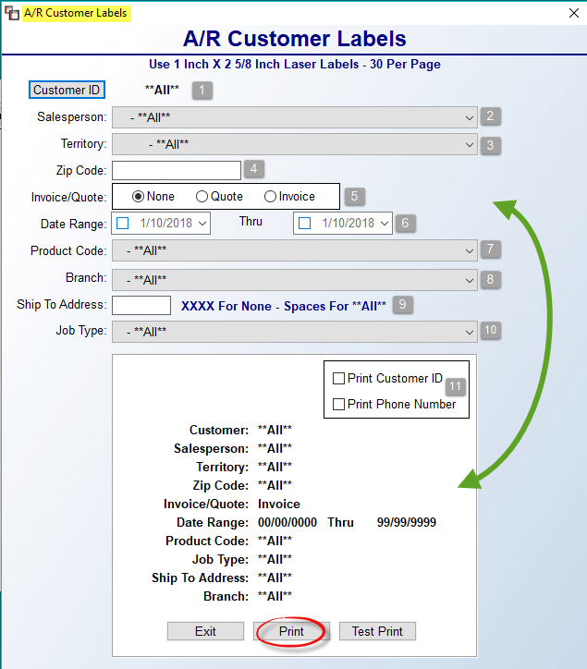

The default settings above will prompt automatically when you first enter this module. If you make no changes, the system will print a label for every Customer. As you make selections in the fields at the top, you will see those defaults change in the white box below. You can make multiple selections to customize the labels. At the Customer ID (1) field, if you only want to print a label for a specific Customer, use the button to perform a look up, otherwise leave the default setting. The Salesperson (2) option will allow you to only print labels for Customers tied to a specific Salesperson. The Territory (3) option will allow you to customize labels by a specific Territory. At the Zip Code (4) field, you can type a single zip code to print labels only for Customers in that Zip Code. The Invoice/Quote (5) option will allow for printing labels based on whether a Quote exists for a Customer, or for all Customers that have been Invoiced in the system. The Date Range (6) fields are tied to the option above and will allow you to set a date range for the Quote or Invoice. The Product Code (7) field will allow for customizing by a specific Product Code. The Branch (8) field will allow you to customize by a specific Branch. At the Ship To Address (9) field, you can leave it blank to include labels for all Ship To Codes for each Customer, type “XXXX” to not print any labels for Ship To Codes, or type in a specific Ship To Code. The Job Type (10) field will allow for printing labels for a specific Job Type.

The checkbox (11) options, Print Customer ID and Print Phone Number, will only appear on the labels if checked. Prior to printing, you have the option to run a Test Print to make sure the labels are lined up properly. When you are ready to begin printing, click the Print button. If you selected the Excel printer, then the system will prompt an Excel file with the data.

Open Items Adjustment Register – Daily Report:
This report module prints an audit of all activity that took place in the Customer Account Maintenance module. It is considered a daily report [this report does not need to be run on days when no activity has been performed in the Customer Account Maintenance module] because any errors that are detected on the report should be corrected prior to updating the General Ledger. When you access this module, the screen will appear as follows:
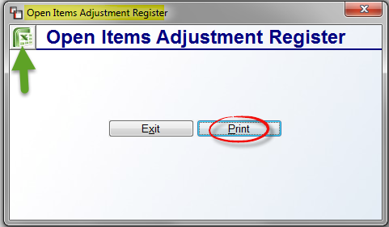

Click the Print button to print to paper, or you can click the Excel icon to export the data. You will then be prompted for a print confirmation as follows:

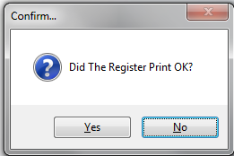

The report will only be cleared when you respond “Yes” at this prompt. Once cleared, the system will prompt this final message when the process is complete:

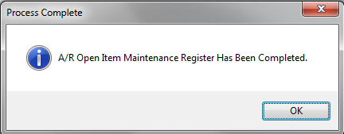

Click the OK button to return to the exit this module.

Customer Payment Register (Daily Report):
This report module displays a listing of all customer payments that were posted in the system through the Post Customer Payments module, via the “Receive Money” feature, or through either of the Deposit options in the Quotation and Order Entry modules by Branch. Quote Deposits will be denoted with a “Q” in the Job # column. It is considered a daily report because you will clear those items that have cleared your bank each day, which will then help you with your bank reconciliations. You can also use the report to find any mistakes made in the system and quickly correct those. This report lists each payment individually and shows the type of payment, the User ID of the person posting the payment, the date of payment, the customer name, the payment reference number, the amount of the payment, the G/L Account the payment was posted to, and gives a G/L sequence number. You can distinguish between payments taken through the Post Customer Payments module as opposed to the Deposits option by the account number in the G/L Account column. Payments taken through the Post Customer Payments module will post to your Cash Receipts G/L Asset Account Number, and payments taken through the Deposit option will post to your Customer Deposits G/L Liability Account Number. Additionally, any payments posted via the Receive Money feature will be noted with an “-R” next to the Job # on the report.
When you enter this report module, the screen will appear as follows:

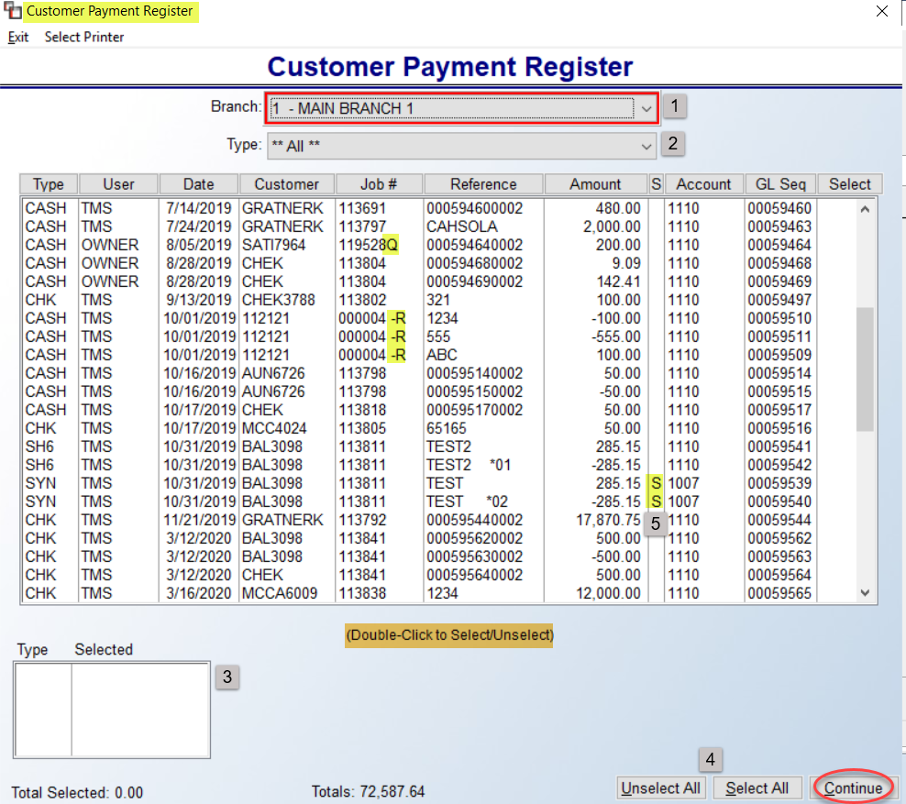

A Select Printer option has been added to the top left of each screen to ensure you select a Graphical printer prior to printing the Customer Payment Register. The Branch (1) field will default to the current Branch, but you can select another Branch from the drop-down menu when applicable. The Type (2) field will default to ** All **. Using the drop-down menu, you can choose to change the view to a single Payment Type. By double-clicking on an item, you can Select/Unselect. The Type/Selected (3) box will display what has been selected, totaled by Type. You can also use the Unselect All and Select All (4) buttons to automatically change the Select column for the items currently displayed. If you have set up Split Deposit functionality, the “S” (5) column will display an “S” for a Split Deposit. See Payment Type Code Maintenance in the Sales Processing manual for how to set up Split Deposit types. For any Split Deposit, if you right-click on the line item, a View Split Detail box will prompt as follows:

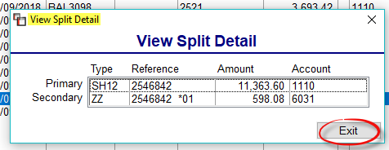

The Secondary line displays a “Finance Fee” amount that will never hit your bank account because the finance company retains a percentage of the amount financed, but it displays as a part of the entire Deposit to be cleared via this Register. The Bank Rec will display the Primary amount only, and the Secondary amount will go to the G/L Account assigned to this type of fee.

Once all Items are selected in the main screen, hit the Continue button to proceed. A View Customer Payment Register Deposit Entries screen will display as follows:

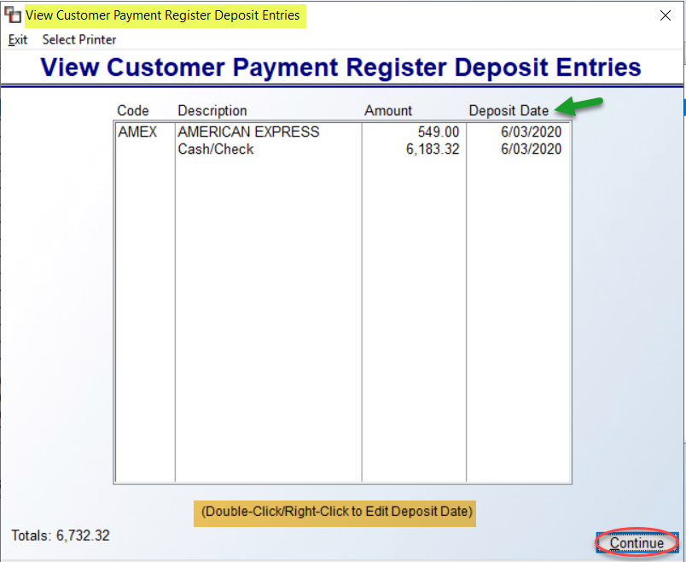
The only option in this screen is to double-click or right-click to edit the Deposit Date. A box will prompt as follows:

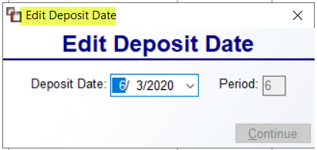

Once you have made your change, click Continue. When you are ready to print the Register, click Continue on the “View” screen to proceed. Once the report begins printing, you will receive the following option to reprint the report as follows:

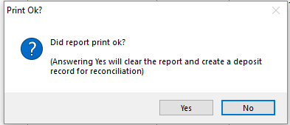

This report can be exported to Excel, so make sure you don’t clear the report until you have all the copies needed for accounting purposes.

Customer Payment Register (History):
Once a regular Customer Payment Register has been printed and cleared in the system, the information can then be re-accessed through this History report module. You can print the History by a past Register, Item, or Deposit Date. When you enter the Customer Payment Register (History) module, the screen will appear as follows:

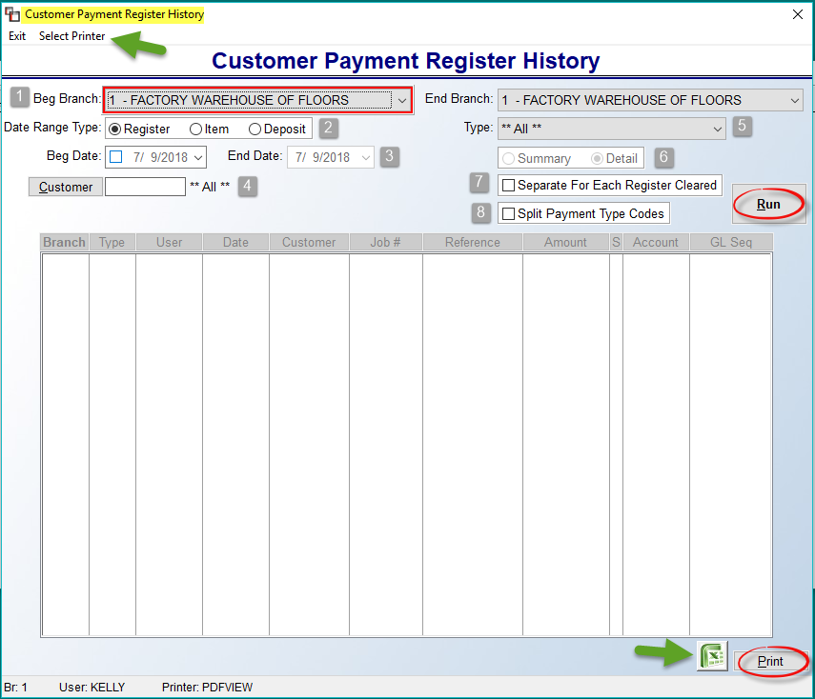

The Select Printer option appears in the screen above to ensure a graphical printer is selected prior to printing the History. However, this report can also be exported to Excel. The default for Beg and End Branch (1) fields will be for the current Branch, however, you can select another Branch or display/print for a range of Branches by adjusting these fields. The Date Range Type (2) field allows for selecting the type of date to use to locate History. The Register option uses the date the Register was cleared. The Item option uses the date the Item was entered in the system, and the Deposit option uses the Deposit Date from the Customer Payment Register. Once a Date Range Type is selected, use the Beg and End Date (3) fields to isolate the historical data to a time period. The Customer (4) field will default to ** All **. Only select a Customer if you are looking for history specific to a Customer. The Type (5) field allows you to search for history for a specific Payment Type. The Summary / Detail (6) option will only be available when more than one Branch is selected. The Separate For Each Register Cleared (7) option will produce one report per Register. The Split Payment Type Codes (8) option can be checked to display Split Deposit data on the report. Once all options have been selected, click the Run button to display historical data in the screen above. At this point, you can make adjustments to the sort/option fields, or continue to Print the report or export to Excel.

Payment Distribution Report – Daily Report:
This report module prints a list of all payments that were posted via the Post Customer Payments module. It also shows to which Invoice/Service Charge the payment was applied. It is considered a daily report because it gives an accounting of the activity in the Post Customer Payments module for the day, and the money posted has a direct impact on your bottom line. If you have multiple Branches, a separate report needs to be printed for each Branch. This report prints each payment individually and shows the Customer ID and name, the payment type and reference information, the amount of the Open Item that was paid, the Open Item number and type, the payment date, the payment amount, any discount that was taken, and the balance of the Open Item after payment.

When you enter this module, the system will prompt an A/R Payment Distribution Register box as follows:
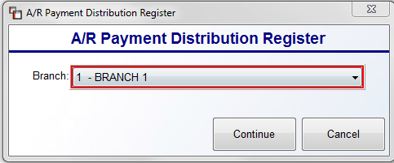

At the Branch field, you can select to print for All Branches by using the drop-down menu to make your Branch selection. Click the Continue button when you have made your selection. The report will begin printing and the system will prompt the following:

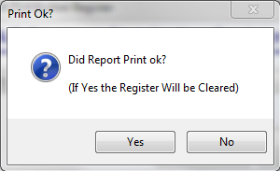

The only reason you should respond with “No” at this prompt is if the report was jumbled in the printer and you do not have a readable copy, as it needs to be cleared every day. If the report printed okay, click the Yes button to clear the register and the system will return the cursor to the Branch selection field.

Customer Profitability Report:
This report module prints a ranking of customers by either total sales, total profit, or total gross margin. It shows this information for the current month and for the year. It is an extremely useful report for the accounting department as well as for the sales department. When you enter this module, an A/R Customer Profitability Report screen will appear as follows:
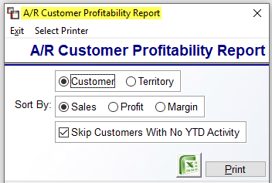

The default settings appear in the screenshot above. In the first box, the Customer option will rank all Customers together. The other option is to rank each Territory group together. In the Sort By box, the default Sales option will rank Customers in order of highest sales to lowest sales. If you select Profit, the report will rank Customers in order of highest total profit earned to lowest total profit earned. If you select Margin, the report will rank Customers in order of highest overall gross margin to lowest gross margin. The Skip Customers With No YTD Activity, when checked, will leave off Customers with no activity for the year. Make any applicable changes and then either click the Excel icon in the top left to export the data, or click the Print button for paper output.

Past Due Report:
The Past Due Report displays a list of past due Invoices based on information that you enter. For example, if you wish to see a list of all Invoices 60 days past due and over, you can set the module options to show only those Invoices. This report will automatically separate Invoices by Territory Code. When you enter this module, a Past Due Report screen will appear as follows:
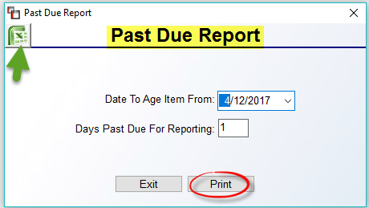
The Date To Age Item From field will default to the current date. You can select another date using the drop-down menu. The Days Past Due For Reporting field will always default to “1.” Type any number of days past due applicable to the data you require. Once you make your selections, click the Excel icon to export the data or click the Print button for paper output.

Over Credit Limit Report:
If your company utilizes and enforces Credit Limits, you can use this report module to print a list of Customers who are over their limit. You can then pull up account information in the Account History Inquiry module to determine if the Credit Limit needs to be increased, or if the over limit amount needs to be collected. This report module is tied to the Credit Limit field in the Customer Maintenance module—you will need to return to that field to increase a Customer’s limit. When you enter this module, the screen will appear as follows:

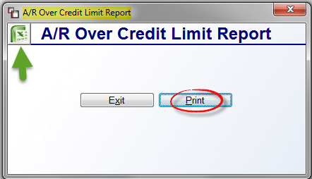

Click the Print button to print the report, or click the Excel icon to export to Excel.

Service Charge Ledger:
This report module has been disabled. The Service Charge Ledger should now be run from within the Service Charge Processing module as explained in that section above.

Print Statements:
This report module prints Statements for Customers with outstanding balances, provided the Statement field in the Customer Maintenance module for those Customers is not set to “N” for no statement. Any Service Charges assessed will also appear on these Statements. If mailing, these statements are designed to be folded and inserted into a #10 left window envelope to display customer mailing address. A custom message can be added via this module, and there are several print options available. When you enter this module, an A/R Statement Print screen will appear as follows:

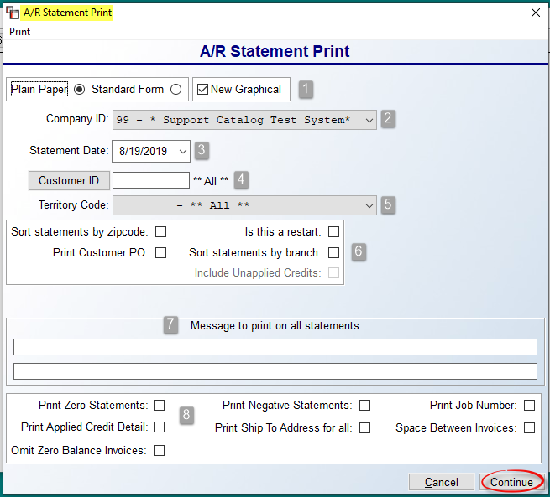

The cursor will be positioned at the Select Form Type (1) box, defaulting to Plain Paper. Leave this default unless you have purchased Standard Forms. For information on these pre-printed forms, please contact the RollMaster Customer Support Team. In addition to Plain Paper and Standard Form, if you have graphical server-side printing available at your location, you can print a Graphical Statement. If you choose a graphical printer upon entering this module, the New Graphical box will be checked by default.

At the Company ID (2) field, leave the default ID, or use the drop-down arrow to select another Company if applicable. The Statement Date (3) field will default to the current date. Use the drop-down calendar to select another date where applicable. The Customer ID (4) field will default to **All** Customers. When applicable, you can use the Customer ID button to select individual Customers. The Territory Code (5) field will also default to **All** Territories. Leave the default or select a specific Territory Code for printing Statements.

The next box (6) contains various print options. Check only those that apply. The Sort statements by zipcode option will group printed Statements together by zip code. The Print Customer PO option will include system PO numbers tied to Invoices appearing on the Statement. The Sort statements by branch option will group printed Statements together by Branch. The Is this a restart option should only be checked if you are re-printing a batch of Statements just printed. This module also has an option to include unapplied credits residing in other Branches, when selecting to print for just one Branch. If you check the Sort statements by branch checkbox, you will have access to one additional checkbox just below as follows: Include Unapplied Credits. This option will allow you to only print for one Branch, but include those items in other Branches on the one Statement.

At the Message to print on all statements (7) section, type a short message to appear on the printed Statements. You can also leave this section blank. Additional print options appear in the box (8) at the bottom of the screen. Check those that apply. The Print Zero Statements should be left unchecked unless you wish to print zero balance Statements. The Print Negative Statements option, if checked, will print Statements for Customers with a credit balance. The Print Job Number option, if checked, will include Job Numbers on the Statement. The Print Applied Credit Detail option, if checked, will show the details of applied credits to a Customer’s account. When checked, the format of the Statement will change slightly to show the details of how Open Items were paid. In addition, only the remaining unapplied credit portion will show on the payment lines, as the applied portion is already matched to Open Items. The Print Ship-To Address for all option, if checked, will include all relevant Ship To Addresses on the printed Statement. The Space Between Invoices option, if checked, will skip a line between listed Invoices. And finally, the Omit Zero Balance Invoices option, if checked, will exclude all zero balance items.

Once all of the options have been selected, click the Continue button to begin printing Statements. You can also click the Cancel button to exit this module without printing.
Please Note: If a Customer has Invoices in more than one Branch, a separate Statement will print for each Branch listing only the Invoices posted in that Branch. Also, any Invoices created in A/R Open Item Maintenance with a Branch ID of “**” will also print on a separate Statement. Lastly, if a customer has an overpayment on their account, it will appear as an “**” Branch item.

Jobs Not Approved Report:
This report works in conjunction with the Credit Approval feature in the system and can only be used if the Credit Approval feature has been enabled in the system through the Company Control 2 level of the System Control Maintenance module. If the feature is enabled, all jobs that are not approved for credit will appear on this report. This report can be customized by the following sort criteria: Branch, Job Type, Open Date, Install Date, Salesperson, and Customer ID. If a Job appears on this report, the Credit Approval status on that Job can be managed from the Approve/Select Jobs module located in the Accounts Receivable menu. When you enter this module, a Jobs Not Approved screen will appear as follows:
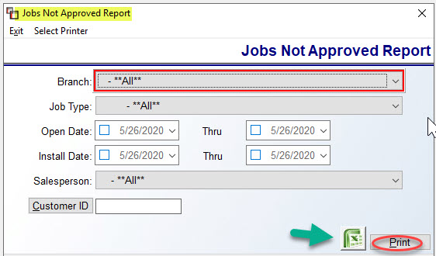
The screen above displays the default settings. If no changes are made, the report will include all Jobs not approved. If you need to customize the report, make those changes in the fields above. When ready, you can click the Excel icon to export to the data, or click the Print button for paper output.

A/R Reports Menu 2 of 2

A/R Detail List:
This report module prints a listing of every open Invoice, Credit Memo, Prior Payment, and Journal Entry by Customer currently entered in the system. It will then print a list of open Deposits by Customer at the end of the first list. The items are subtotaled for every customer and a grand total of all open items in the system appears at the end of the report. When you enter this module, an A/R Detail List screen will appear as follows:
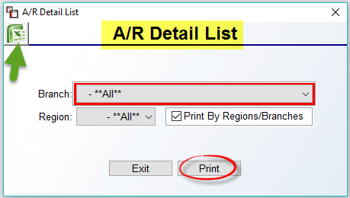
The Region field will only be available where “Region Reporting” has been enabled in the Company Control 2 screen of the System Control Maintenance module. When ready, you can click the Excel icon to export the data, or click the Print button for paper output. . When this data is exported to Excel, an additional column titled “Tender Type” will denote the Payment Type Code of all A/R Post Cash Receipts payments and all Customer Deposits.

A/R Detail List (by Lien Date):
This report module prints a listing of every Open Item—except Deposits—by Lien Date. This report will alert you to any liens that need to be placed. It is a much shorter report than the A/R Detail List as it does not subtotal the Customer’s account. When you enter this module, the screen will appear as follows:

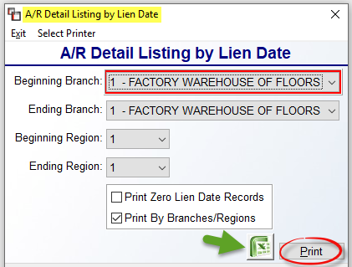

All of the options to print this report work exactly the way they do in the A/R Detail List report explained above, with the exception of the following: Print Zero Lien Date Records. If the Lien Date on an open item equals “0”, this prompt will exclude those items from the print out if you select this option.

A/R Agings:
This module combines four types of Aging Reports: Standard, Salesperson, Retainage, and As Of. The Standard Aging is the default report and very similar in content to the A/R Detail List, except that it does not include Deposits. It will also list any credits in a separate column, but it does not age the credits. The total on this report should be used to check against the balance that is reflected in your Accounts Receivable G/L Account. It is also useful when you enter your Beginning Receivable balances to double-check all items were entered properly and that both the report total and the G/L A/R total match.

The Salesperson Aging report option works essentially the same as the Standard version, except that you can separate the report by Salesperson. You can then pass the paper or Excel report on to each salesperson to assist with collections.

The Retainage Aging report option also works similarly to the Standard except that it will print retainage amounts in the far-right column provided these amounts have been set up in Customer Status Inquiry. This report will also display any “Disputed” amounts and indicate those with a “D” in the far-right column. Disputed amounts are set up via the Lien Date feature in the Customer Status Inquiry module. This report can be used along with financial statements to apply for a line of credit from a bank. If the lender is aware that certain dollars are considered a “retained amount” rather than old receivables, they may be more willing to allow you to borrow money against that amount.

The As Of Aging report option gives you a true “As Of” Receivable balance based on any prior date you enter. Again, this report works similarly to the Standard report (explained above) with a couple of exceptions. When you select this report, the Date you enter at the Aging Date field will be the date the report will age from. Also, next to the Print Zero Balance Items checkbox, the system will prompt the following: Oldest zero balance item. Select a date of the oldest zero balance item you would like to see on this report. The Separate Credit items checkbox will also become available. If you wish to see a separate total for all credits on the report, select this option.

You can export all the Aging Reports to Excel. This will work for both the Detail and Summary print options. The totals on the report will not export, so you will need to add Excel formulas once the data is imported into Excel. Also, if Excel is selected, the Credit Limit amount will appear on both the printed report and the Excel export data. Additionally, the first page of notes added to an Invoice in the Customer Status Inquiry module will export to Excel along with the Customer Email address. The notes will appear in the last column of data and the Email address will line up under the Customer Address. And finally, you have the option to view the Ship To addresses tied to Receivable balances on all of the A/R Aging reports, with the exception of the As Of report. This information will print automatically, provided you select the Detail option when printing/exporting these reports. When you enter this report module, the A/R Aging Reports screen will appear as follows:

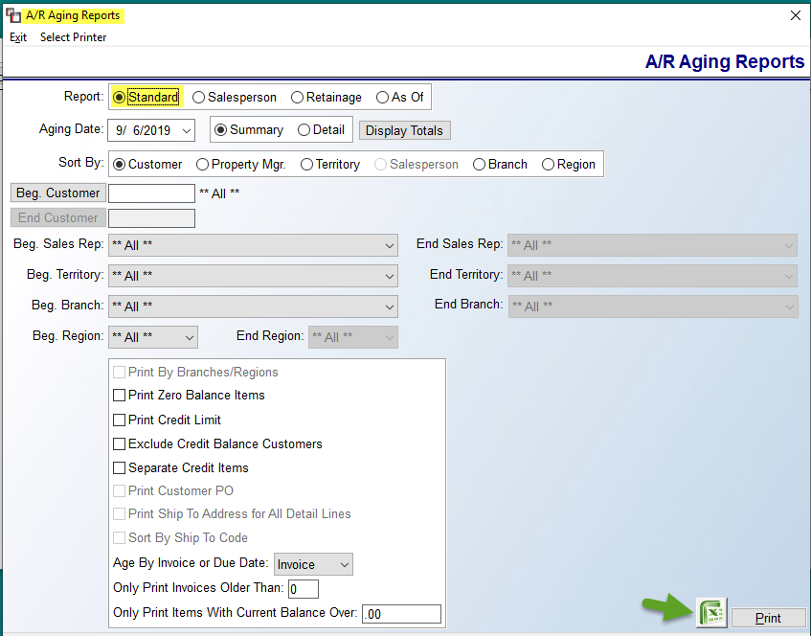

Based on the Report selection, some of the options in this screen will become available, while others will become disabled. The Aging Date will ONLY truly age from the Date selected for the As Of report option. For all other reports, it will be the report date, as it will not go back and reflect “As Of” a prior date. The Summary and Detail options are available for all reports, as is the Display Totals button. That button will generate a Grand Totals box that will prompt in this screen as follows:

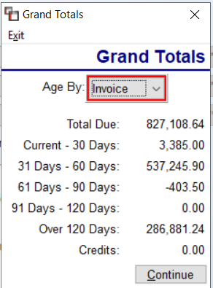
The Sort By options will alter according to the report selection. If Property Managers have been pre-set in the Customer Maintenance module, you can use this option to sort the Standard and As Of reports by Property Manager. Salesperson will only be available for that report option. All of the reports can be sorted by Customer, Sales Rep, Territory, Branch, and Region. You only need to make selections that are applicable to the report data you wish to see.

The box below those items has varying additional options that will enable and disable based on your Report selection. A brief explanation of each follows. The Print by Branches/Regions, if checked, will separate the report by Branches/Regions, based on setup in the system. The Print Zero Balance Items, if checked, will eliminate items on a Customer’s account with a zero balance. The Print Credit Limit checkbox applies to customers with a set credit limit in Customer Maintenance. If this box is checked, that data will display on the report. The Exclude Credit Balance Customers, if checked, will leave off any Customers with a credit balance on their account. As mentioned above in the As Of report description, the Separate Credit items checkbox, if enabled, will display a separate total for all credits on the As Of report. If the Detail option has been selected above, the Print Customer PO option will be available for all reports. Check the box if you want that info to print/export.

The Print Ship To Address for All Detail Lines will also only be enabled for the Detail option. If checked, you will see this data for all lines on the report. As a follow up option, the Sort By Ship To Code, if enabled, will print the data grouped by Ship To Code. The Age By Invoice or Due Date option defaults to Invoice. You can use the drop-down arrow to switch to Due Date, if you prefer, and the report will age by the Net Due Date on the Invoice and you will see the following at the top of the report: AGED AS OF XX/XX/XXX BY DUE DATE. The Only Print Invoices Older Than: 0 option will have no impact unless you enter a number of days at this prompt to exclude anything under a certain number of days. The final option, Only Print Items With Current Balance Over: 00, again will have no impact unless you enter a dollar amount in this field. If so, the system will exclude any balances under this amount.

When all sort and selection data has been set, you are ready to use the Display Totals button, or export to Excel, or Print to paper.

Customer Deposit Agings:
This module combines two types of Deposit Aging reports: A/R Aging Report (Customer Deposits) and A/R Aging Report (Deposits As Of). The former works similarly to the A/R Aging Report (Standard) except that it will print a list of open Deposits in the system. The total of this report should match the value in your Customer Deposit G/L Liability Account. If a zero-balance Deposit appears on a Customer’s account, it will display on this report. When the zero balance is purged from the account, it will no longer appear on this report. The A/R Aging Report (Customer Deposits) report allows you to print a listing of Deposits “As Of” a prior date rather than only seeing current deposits via the first report in this module. Both reports will export to Excel using either Detail or Summary. When you enter this report module, a A/R Deposit Aging Report (Customer Deposits/As Of) screen will appear as follows:

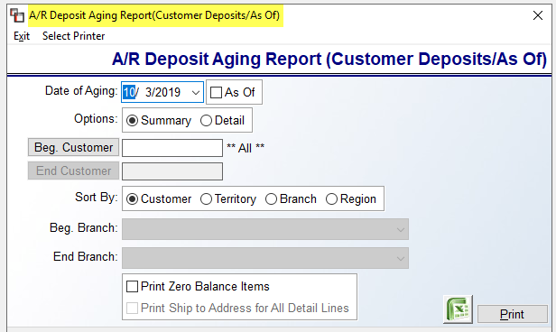

The default report is the Customer Deposit Aging. To switch reports, you can click the As Of checkbox. The options will stay the same. The Print Ship to Address for All Detail Lines option is enabled when Detail is selected in the Options box.

Contact Activity Notes Report:
This report is tied to the Contacts Notes in Customer Maintenance and Vendor Maintenance, as well as the new RMMobileSales App when Customer Notes are added. When you enter this report module, a Contact Activity Notes Report screen will appear as follows:
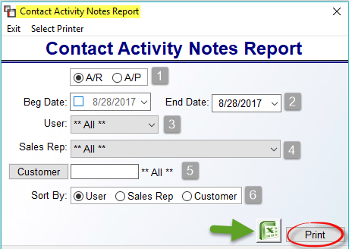
The default settings for this report appear above. You can customize this report by any of the fields above. To switch to Accounts Payable Notes, click next to A/P (1) in that field. The Beg Date & End Date (2) fields will allow you to set a date range or specific date for the report. The User (3) field will allow you to customize by a specific User in the system. The Sales Rep (4) field will allow for selecting a specific Salesperson for the report. The Customer (5) field will prompt the Customer Selection box for you to select a specific Customer. And finally, the Sort By (6) field will allow you to determine how the report contents are sorted, by User, Sales Rep, or Customer. When you have finalized your selections, click the Excel icon to export the data to Excel, or click the Print button to for paper output.

