

Table of Contents

General Ledger - 1 -
Introduction: - 1 -
Date Driven period based accounting: - 1 -
Account Maintenance/Inquiry: - 5 -
Journal Posting: - 10 -
Journal Entry Template: - 14 -
Recurring Journal Entries: - 17 -
Account Detail Inquiry: - 20 -
Report Format Maintenance: - 24 -
End of Month Processing: - 32 -
End of Year Processing: - 33 -
G/L Budget Comparison Report: - 35 -
G/L Budget Comparison Report (Pct.Sales): - 36 -
G/L Budget History Report: - 37 -
G/L Budget Maintenance: - 38 -
G/L Budget Posting: - 40 -
G/L Budget Worksheet: - 41 -
G/L Journal Import (csv): - 42 -

General Ledger Reports - 44 -
Introduction: - 44 -
Print Chart of Accounts: - 44 -
Print Journals/Update General Ledger—Daily Report: - 44 -
Print Account Detail Report: - 46 -
Print Account Summary Report: - 51 -
Print Account History Report: - 52 -
Print Trial Balance: - 53 -
Print Annual Trial Balance: - 54 -
Change in Financial Position: - 55 -
Chart of Account Change in Position: - 56 -
Income/Expense Statement: - 57 -
Balance Sheet: - 59 -
Report Format Listing: - 60 -
General Ledger Report Consolidation (for Multi-Company Financial Statements): - 61 -
Print Invoice Detail Report: - 62 -
Print Journals History Report: - 64 -
Compare GL Inv. Value to PO Receipts: - 64 -

***CONFIDENTIALITY NOTICE*** This documentation contains confidential information belonging to Textile Management Systems, Inc. and RollMaster Software, which is protected by copyright laws and other privileges. This information is intended for the exclusive use of legally licensed RollMaster Software users. If you are not the intended recipient, you are hereby notified that any disclosure, copying, distribution, or the taking of any action in reliance on the contents of this information is strictly prohibited. If you have received this documentation in error, please immediately notify us by telephone at (800) 777-4107.

General Ledger

Introduction:
The General Ledger (G/L) menu contains all modules relating to the management of the system financial statements. As explained in other areas of the RollMaster manuals, there are many functions throughout the RollMaster System that automatically send information to the system G/L during daily processing. This functionality allows the system to produce current financial information quicker and easier. Several reports are also available from this menu that allow for detailed viewing of the data that makes up your financial statements.

Date Driven period based accounting:
This programming was developed to allow for the Date to drive the selection of the General Ledger Accounting Posting Period in the system. Most of the setup will be completed by a RollMaster Trainer prior to customers using the new functionality. Below is a brief synopsis of Account Management that may or may not need to be performed, depending on how clients choose to run their systems. Beyond that, the changes to day-to-day operations, explained at the end of this section, will be minimal. Please Note: these changes do not impact the physical closings of G/L accounting periods. Each General Ledger Period will still need to be closed via the End of Month Processing module in the General Ledger menu, as well as the End of Year Processing module, when ready. A/P, A/R, and Inventory “End of Month/Year” modules DO NOT close G/L Periods.

Account Management:
Once the Enable G/L Driven By Date control has been enabled in the Company Control GL/AP level screen by a RollMaster Trainer, one other User Control 6 control should be enabled for at least one Accounting Professional within the company. That control appears as follows: Allowed To Use G/L Period Mtc. That User (or Users) will then have access to an option in the General Ledger Account Maintenance/Inquiry module that relates to this new functionality. That screen option appears as follows:
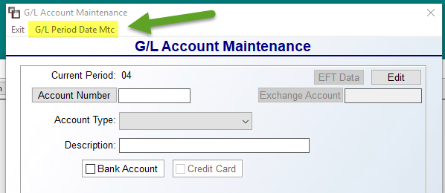
The G/L Period Date Mtc option will prompt the following G/L Period Table Setup screen:
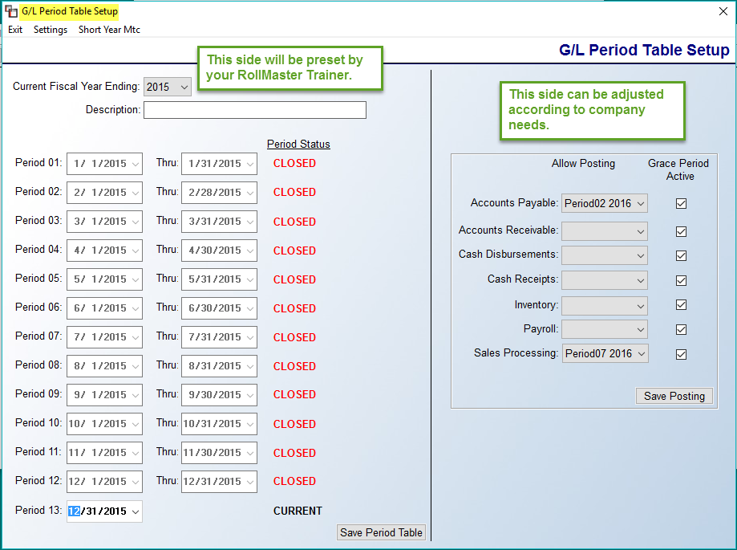
As stated in the illustration above, the left side of the screen will be completed, based on your company’s fiscal year, by your RollMaster Trainer. The right side, however, can be set and adjusted by authorized Users. The Date Driven functionality will still allow you to post to any open period in the system, unless you select a Period/Date under the Allow Posting column above, thereby, preventing G/L postings to any previous open period from any of the listed modules. For example, in the illustration above, even though Period 13 of 2015, and Period 1 of 2016 are still open, by selecting Period 02 2016 next to Accounts Payable, you are “cutting off” any data from A/P to those open periods. The Grace Period Active checkboxes can be enabled or disabled (uncheck) to allow for a number of days beyond the Period Date to still send G/L data. The Allow Posting column fields can be changed anytime if an item truly belongs in a prior open period, or these fields can be adjusted forward at the end of every month. The Inventory option is different, in that it uses the dates for non-G/L (inventory adjustments) as well as the Inventory Purge, which does produce a G/L entry.
At the top left of this screen, you will see two additional items as follows: Settings and Short Year Mtc. The Settings option allows you to set/adjust the Grace Period for the fiscal year. This will primarily be used by customers who choose to leave the entire year open, and then begin to get into a situation at the end of the year, when Period 01 is still open, but data is being processed for the new year. The Grace Period will allow a few additional days of G/L Data accumulation (that will not post to the G/L) to give accounting time to “hard close” those periods. The Short Year Mtc option is not currently available. Please Note: Tax related EOY changes can be complicated and involved, therefore, please notify RollMaster Support to seek guidance once you’re aware of any changes needed.

System Changes To Accounting Functions:
Once the Date Driven Period Based Accounting System functionality is active in your system, you will note that the Period fields are now greyed, or unavailable, based on whether the screens are graphical or text. This means they can only be updated by changing the item Date. Using A/P Open Item Maintenance module as a graphical example, when you enter that screen, the system will skip the Period field and both the Date and Period fields will default to the current date. The Period field will be greyed and will not grant access to the User as follows:
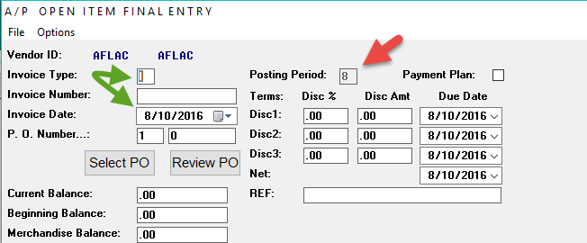
The cursor flow will move from Invoice Type to Invoice Number to Invoice Date. When you change the Invoice Date field, the Posting Period will remain unchanged in the display screen until you enter another available field. For example, if the date above is changed to 7/31/2016, the Posting Period field will continue to display “8” until you click in the P.O. Number field, or click the Accept button, at which time the Posting Period field will automatically change to “7”. If a date is selected that is Invalid or Unavailable, the system will prompt the following:
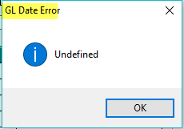
You will not be able to move forward until the date/period issue is corrected.
The accounting modules that have not yet been updated to graphical screens (text programs) will have similar functionality. Using the Customer Account Maintenance module as an example, when the cursor moves to the Posting Period field, the system will not prompt an Item/GL Posting Date box as follows:
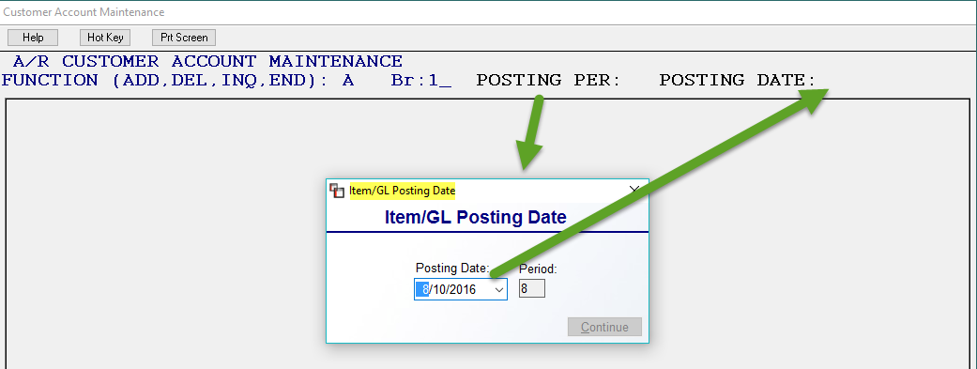
The current date will default in the Posting Date field, and the Period field, while displaying in this box, will not be available. Select the applicable date for the Period, and that date will display as both the Posting Date and the Open Item Date field—one date drives both the G/L and the Aging reports. In order to enable the Continue button, you must first select a date and then click outside of the Posting Date box. The same rules apply for Unavailable and Invalid dates in the text versions as described above. The system will now skip over the Open Item Date field.

Account Maintenance/Inquiry:
Initial set-up of your system Chart of Accounts has been completed for you. You will only utilize this module to add or edit G/L accounts and also to view archived data for closed periods/years for existing accounts numbers. You will also access this module to convert to the Date Driven G/L posting method.

When you enter this module, the screen will appear as follows:

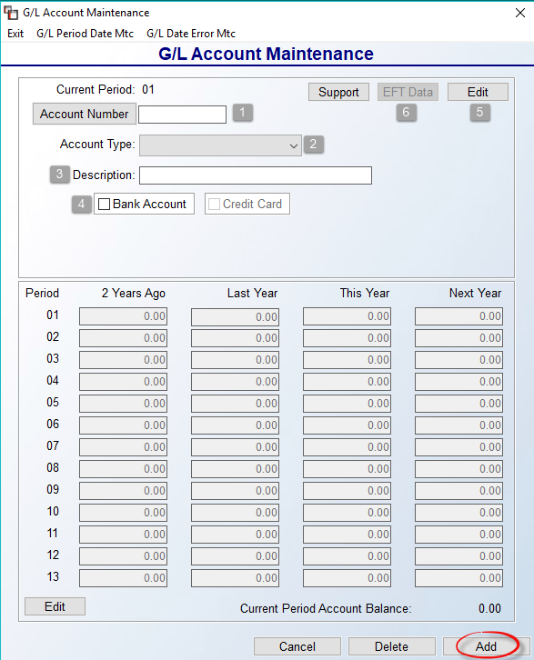

The Current Period field at the top left will display the earliest open period in the system G/L. To add an account, type the new number in the Account Number (1) field. You can use up to eight digits in this field. You can also use a period or hyphen to denote a sub-account. If you are deleting, changing, or inquiring about an account number, you can click on the Account Number button to call up a G/L Account Selection box—see additional details below. At the Account Type (2) field, use the drop-down arrow menu to select the type of account you are adding. There are five possible account types as follows: AS = Asset Account (carries a Debit balance), LI = Liability Account (carries a Credit balance), EQ = Equity account (carries a Credit balance), RV = Revenue or Income Accounts (carries a Credit balance), EX = Expense and Cost of Goods accounts (carries a Debit balance). Please Note: once an account has been added to the system G/L, you cannot change this field. If you need assistance with this, please contact RollMaster support via email at support@rmaster.com.

At the Description (3) field, type the name of this account. This information will appear on the printed Chart of Accounts. Please Note: if the G/L account you are entering is a Bank Account or Credit Card account, or if it needs to be used as a Payment Type Code for posting payments, you will need to check the applicable box next to those options. The system will then display additional fields based on your selection. If you check Bank Account (4), you will see the following additional fields:

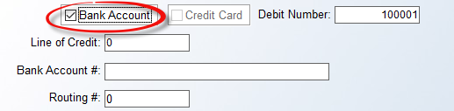

The default Debit Number will be 100001. This number will be automatically assigned and updated sequentially to each Hand Check or Electronic Payment processed in the system. The system will prevent any duplicate numbers. The Line of Credit field is used to record the maximum amount available to draw against, such as “40000.” This amount will display in the Bank Reconciliation module. The Bank Account # and Routing # fields will primarily be used in conjunction with submitting a Positive Payee report to your bank following a check run—please see Check Register History for more details. At this time, Wells Fargo is the only banking institution that requires a Routing #.

Prior to adding a Credit Card Account, you must first make sure the Account Type is set to “Liability.” The system will prompt new field descriptions just below that box as follows:

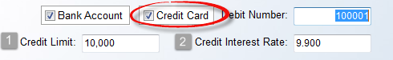

The Credit Limit (1) field should contain the maximum credit available on the credit card. The Credit Interest Rate (2) field is used to record the interest rate for the card and will display in the Bank Reconciliation module, along with the Credit Limit field.

Be sure to click the Add button at the bottom of the screen once the new Account Number has been entered properly. You can continue to add G/L Account numbers in this screen. When you have finished, click the Cancel button or the Exit button at the top left to return to the General Ledger menu.

To edit or view an existing account, click the Account Number button to call up a G/L Account Selection box as follows:

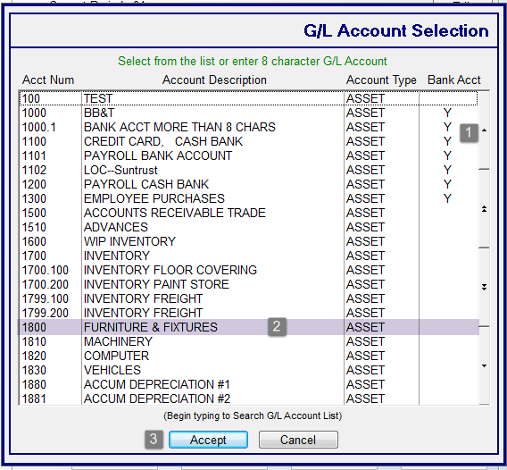

Scroll through the list of existing G/L account numbers using the up and down arrow keys along the right side (1), or begin typing the G/L number directly in this screen to sort the data to display the closest match. Once you have located the G/L Account Number, highlight (2) it and click the Accept (3) button at the bottom of the screen, or double-click on the account. The account number and any financial data will display in the G/L Account Maintenance screen. Click the Edit (5) (in first screen shot above) button to edit the Description, Bank Account or Credit Card fields. All other fields are not accessible.

The EFT Data (6) button at the top right is to be used in conjunction with A/P EFT Vendors. If this does not apply, you can disregard. However, if you plan to set up any Vendors for payment via EFT, you will need to identify any G/L Accounts used for EFT payments via this module. When you enter an Account Number that is also identified as a Bank Account, the EFT Data button will become available. When you click on that button, a General Ledger EFT Data Maintenance box will appear as follows:

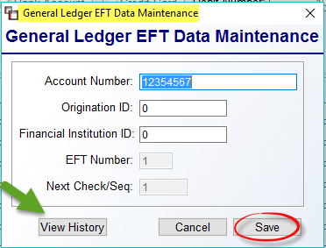

Complete the Account Number, Origination ID, and Financial Institution ID fields and then click Save to keep the data. For existing Accounts, you can view history via the box above by clicking the View History button. The history data will appear as follows:

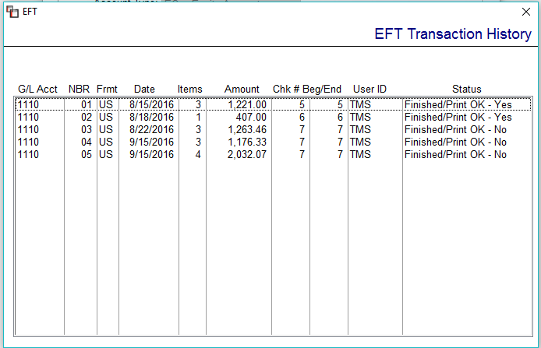

For complete instructions on using the Electronic Funds Transfer functionality in RollMaster, you can find an article in our Help Desk, as well as a section in our Accounts Payable manual under Payment Selection. Email support@rmaster.com for additional assistance.

The remaining fields in the G/L Account Maintenance screen are for display only. If changes are needed to the financial data displayed in any of the “Years” columns for an account, contact RollMaster support for assistance. For information purposes, the first column of numbers (01-13) are accounting periods. The second column is for account balances by period for 2 Years Ago. The third column is for account balances by period for Last Year. The fourth column is for account balances by period for the current year (This Year). And the fifth column is for account balances by period for the Next Year.

To delete an existing account, click on the Account Number button and locate the applicable Account Number. Once the Account Number is displayed in the screen, click the Delete button at the bottom right. The system will then prompt the following: Are you sure you want to delete? Click “Yes” to delete the account. Please Note: the system will not allow you delete an account if there has ever been any non-zero activity recorded, even in prior closed periods/years.

Journal Posting:
Initial set-up of your system beginning G/L balances has been completed for you.
This module will be used primarily to post values to accounts that are not updated during regular system processing. Some examples include depreciation, accruals, and other accounting type entries not automatically generated through the use of the system. You will make both the debit and credit side entries in this module and debits must equal credits before you can exit this module. Please Note: To complete the posting process and update the General Ledger Accounts, the system requires you to run the report module Print Journals/Update General Ledger (explained below). When you enter this module, the screen will appear as follows:

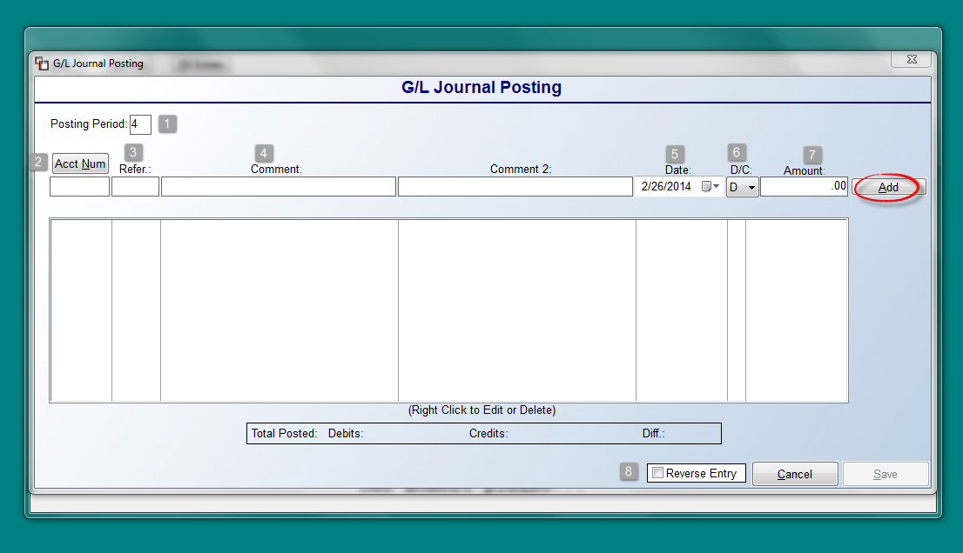

The system will place the cursor in the Posting Period (1) field, which defaults to the earliest period open in the system. You can type in a new Posting Period or accept the current period. At the Acct Num (2) field, you can type in the applicable account number or click the button to call up a G/L Account Selection screen. In the Refer.(ence) (3) field, type a brief reference for this journal posting or your initials. In the Comment (4) and Comment 2 fields, type a descriptive comment/reason for this journal entry. The Date (5) field will default to the current date. To make a change, click on the calendar down arrow to make another date selection. At the D/C (6) field, select a “D” (debit) or a “C” (credit) for the entry. In the Amount (7) field, enter the amount of the journal posting. If all data looks correct, click the Add button. (If “Update Job Cost Detail File?” prompts, see details following the Edit & Delete options below.) The journal entry line will appear in the screen below as follows:

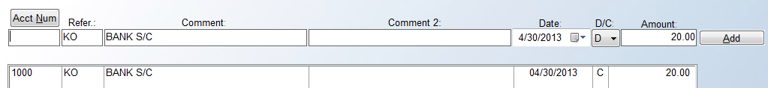

The Refer, Comment, Comment 2, Date, and Amount fields in the top screen will retain the data from the entry that was just added in preparation for you to make the offsetting entry or entries. If you need to edit or delete the journal entry line, right-click on the line to call up the Edit and Delete options. If you select Edit, a new screen will appear as follows:
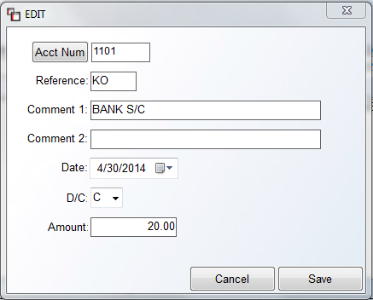

From this screen, you can change any field and then click the Save button to continue.

If you have enabled the Job Cost Detail from A/P control in the System Control 1 screen of the System Control Maintenance module, the system will prompt the following:

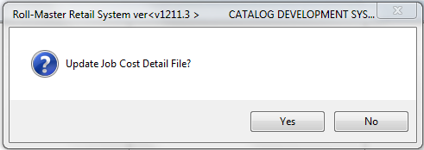

This is the same feature found in the A/P Open Item Maintenance module and works the same way. If the journal entry corresponds to a specific Job in the system, you can use this feature to send job cost information to two modules in the Job Cost menu. They are Costs By Source View/Print and Billed vs. Unbilled – Costs From A/P. See the Job Cost section of the manual for details on those modules. To update Job Cost, click the “Yes” button. Type the job number in the next prompt and hit enter. The system will perform internal procedures and place the cursor back in the Acct Num field.

Once the first journal entry is posted correctly, you are ready to post the offsetting entry or entries. The Total Posted box at the bottom of the screen will keep up with the debit and credit amounts as follows:

If there is a value in the Diff(errence) field, the Save button at the bottom right of the Journal Posting screen will not be available until your Debits equal your Credits and the Diff field is 0.00. Continue to edit, delete, or add journal entries until you have reconciled the difference.

There is also a Reverse Entry (8) (in the main screen shot above) checkbox option in this module to allow for auto reversal of accounting accruals or other items that you want to automatically reverse in the next period. This feature is intended for accruals such as work in progress. In instances like this you want the entry posted in the current month and then automatically reversed out of the following month. Please Note: this process will always default to the next open accounting period. For example, for period 1, the reversal will prompt for period 2, however you can override to a later period where applicable. Once you have added your journal entries, prior to clicking the Save button, check the box next to Reverse Entry and then click Save. The system will prompt the following Reverse Entry Edit screen as follows:

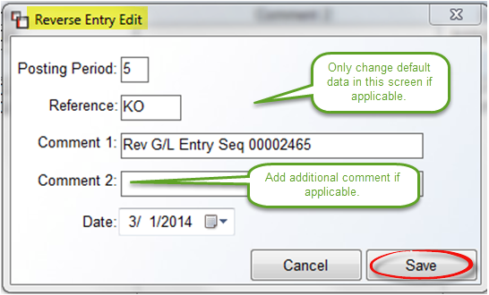

Check the reversing entry data in the screen above for accuracy and make any changes or add any additional notes in the Comment 2 field. Click the Save button to complete the process. Important Note: Unlike the text screens, the new process doesn’t save your work until Save is clicked.

Please Note: At some point after activity has occurred in the Journal Posting module, when you are ready to send your journal entry postings to the General Ledger and see them reflected in company financials, you will need to run the Print Journals/Update General Ledger report module accessed from the General Ledger Reports menu. Any journal entry postings entered in this module will appear on the General Journal report.

Journal Entry Template:
The purpose of this module is to create templates for regular monthly general Journal Postings that are recurring, but need to post with a different amount each time. An example would be for posting payroll entries (provided you are not using the RollMaster Payroll Management program). Another example is for monthly depreciation entries or any entries where it would be easier to access a template and add only the amounts, prior to posting. When you enter this module, a Template Selection box will appear as follows:

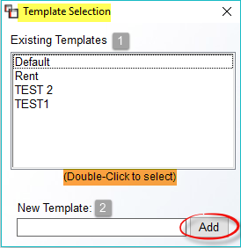

Any existing templates will appear in the Existing Templates (1) box. If you wish to delete a Template, right click on the name to prompt the following: Delete Template. To create a new Template, type a name in the New Template (2) field and then click the Add button. The system will first prompt a blank G/L Journal Entry Template screen as follows:

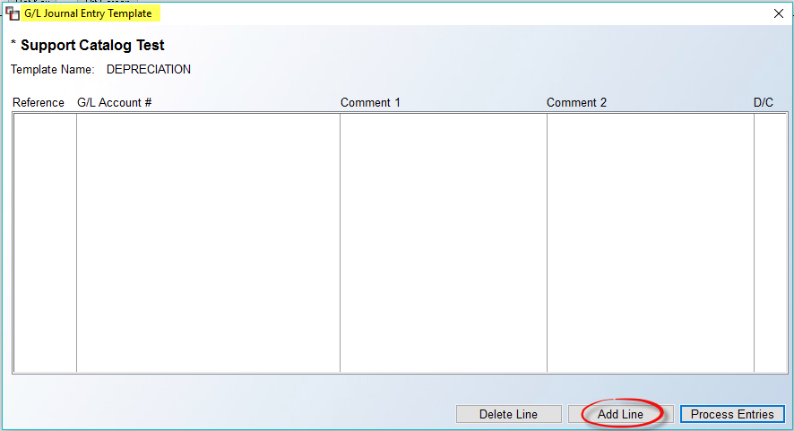

At the bottom of this screen is an Add Line button. Click that button to prompt the Add Line to Template screen as follows:

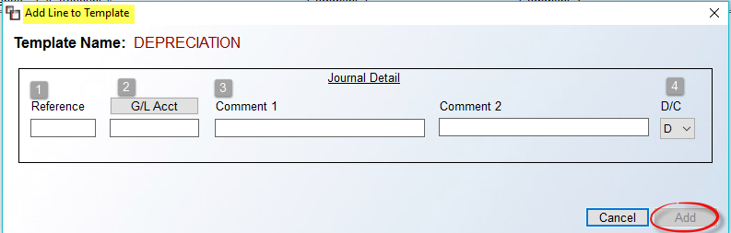

The Journal Detail fields work much like the fields in the Journal Posting module. The Reference (1) field can be used to record initials, “RECJRN,” etc. In the G/L Acct (2) field, use the button to look up the applicable G/L Account for this entry. At the next two fields, add any Comments (3). And finally, at the D/C (1) field, select whether the entry is a Debit or Credit. Once the required fields are completed, click Add to save the line. The system will prompt the following: Record Successfully Added. Hit the Esc key or click the “X” at the top right to return to the G/L Journal Entry Template screen. Continue to add journal entry lines until all necessary Debit and Credit lines are entered for the Template. To delete a line from a Template, in the G/L Journal Entry Template screen, highlight the line you wish to delete. You can then click the Delete Line button to remove the line from the Template.

When you are ready to process entries in a Template, from the G/L Journal Entry Template screen, click the Process Entries button to prompt a Process Journal Entries screen as follows:

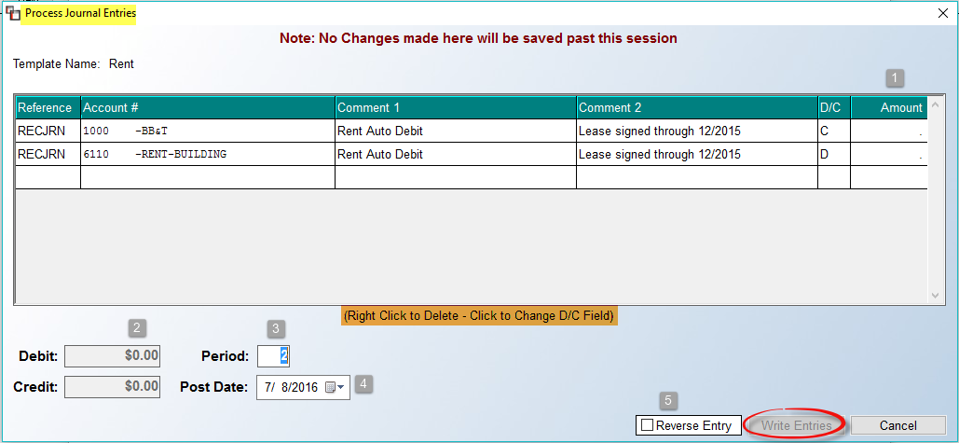

In the Amount (1) field, position the cursor in the first field and type an amount for that line. Continue adding amounts until the Debit (2) and Credit fields at the bottom left of the screen are in balance. You can change the Period (3) field and Post Date (4) field, where applicable. Prior to clicking the Write Entries button, you can right-click on a line to delete the line from the current entry posting—this will more likely be the case with a multiple line Template. You can also click on the D/C field to change those default settings, where applicable, for the current entry. No changes will be saved. All data will revert back to the original Template setup after writing the entry. Once you click the Write Entries button, the system will prompt the following: Journals Successfully Written. As with all journal postings, the data will not be reflected in the financial statements until you run the Print Journals/Update General Ledger report module.

One additional feature is the Reverse Entry (5) feature, similar to the feature of the same name in the Journal Posting module. This option allows for auto reversal of accounting accruals or other items that you want to automatically reverse in the next period. This feature is intended for accruals such as work in progress. In instances like this you want the entry posted in the current month and then automatically reversed out of the following month. Please Note: this process will always default to the next open accounting period. For example, for period 1, the reversal will prompt for period 2, however you can override to a later period where applicable. Once you have added your journal entries, prior to clicking the Save button, check the box next to Reverse Entry and then click Save. The system will prompt the following Reverse Entry Edit screen as follows:

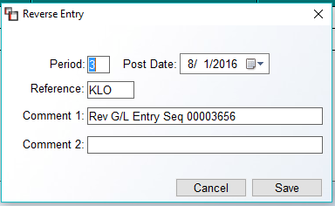

Check the reversing entry data in the screen above for accuracy and make any changes or add any additional notes in the Comment 2 field. Click the Save button to complete the process.

Recurring Journal Entries:
This module will allow you to set up and run recurring journal entries that take place on a regular basis. Recurring journal entries must contain the same value and utilize the same account numbers for each post or you should not use this module. Also, this module should not be used to take the place of any check printing procedures where you need check history in the system. When you enter this module, the screen will appear as follows:

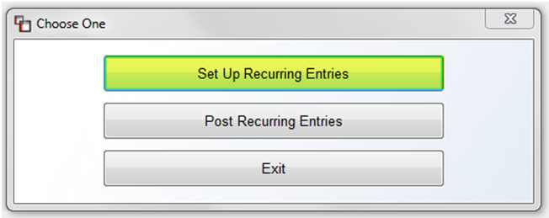

You will select the Set Up Recurring Entries option first to set up your recurring journal entries. When you click on this option, the screen will appear as follows:

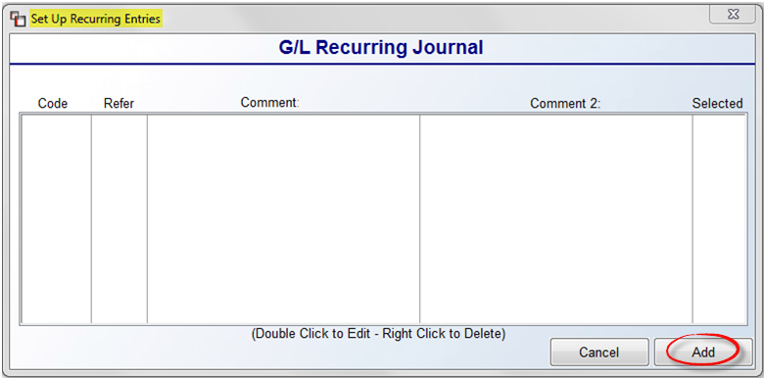

Any existing Recurring Journal items will display in the box above. If you are setting up for the first time, click the Add button at the bottom right to prompt the Add Recurring Journal screen as follows:
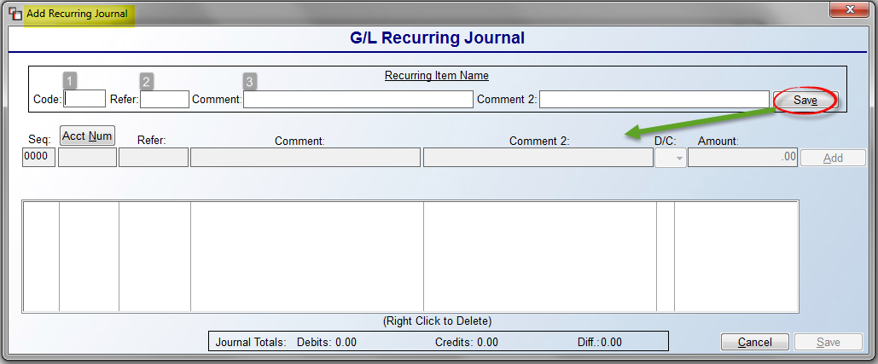

The cursor will be positioned the Code (1) field. You must first create a code (up to 4 characters) describing this code, i.e. FFDE for Furniture & Fixtures Depreciation. The Refer(ence) (2) field is the same as the one in the Journal Posting module. RollMaster recommends typing “RECJRN” here to identify it as a recurring journal entry on the Account Detail Report. In the Comment (3) and Comment 2 fields, describe the recurring journal entry just as you would in the Journal Posting module. Click the Save button when this entry is complete. The data you just entered will then prompt in the fields below as follows:

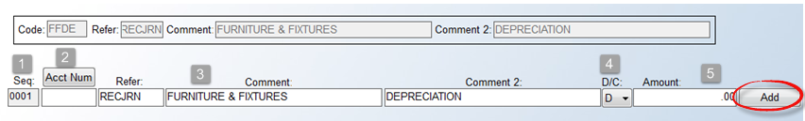

The Seq(uence) (1) field will default to “0001” and the cursor will be positioned in the Acct Num field. Click the Acct Num (2) button to call up a G/L Account Selection box or type in an applicable account number. The Refer(ence), Comment (3), and Comment 2 fields will prompt the data entered in the fields above. You can change the D/C (4) field and then add a value in the Amount (5) field to complete this line. When all data is correct, click the Add button. Continue adding recurring journal entry lines until all lines that make up the recurring entry are entered and your debits equal your credits. Once this is done, click the Save button to save the Recurring Journal entry.

Once you have added at least one Recurring Journal entry, you will see it listed in the Set Up Recurring Entries screen as follows:

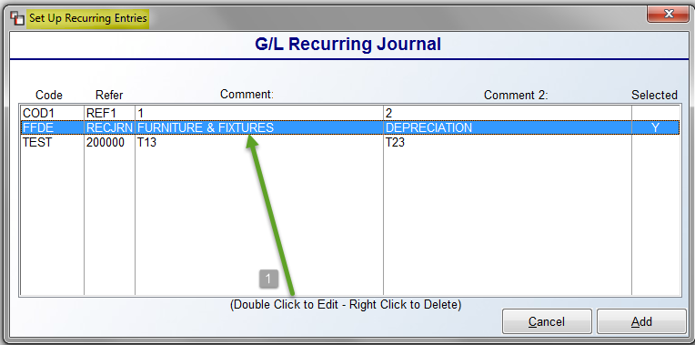

To Edit (1) the header for a Recurring Entry, highlight the line in the screen above and Double Cick to pull up the Add Recurring Journal screen. Please note: you cannot edit the journal entries that make up a Recurring Entry, only the header data you see in the screenshot above. To make changes to an entry, delete it and re-enter with the correct data. To Delete (1) a Recurring Entry, highlight the line in the screen above and Right Click to display the Delete option. Click Delete and the Recurring Entry will be removed from the screen.

When you are ready to process a Recurring Entry, select the Post Recurring Entries option from the “Choose One” menu displayed above. The system will prompt a Post Recurring Entries screen as follows:

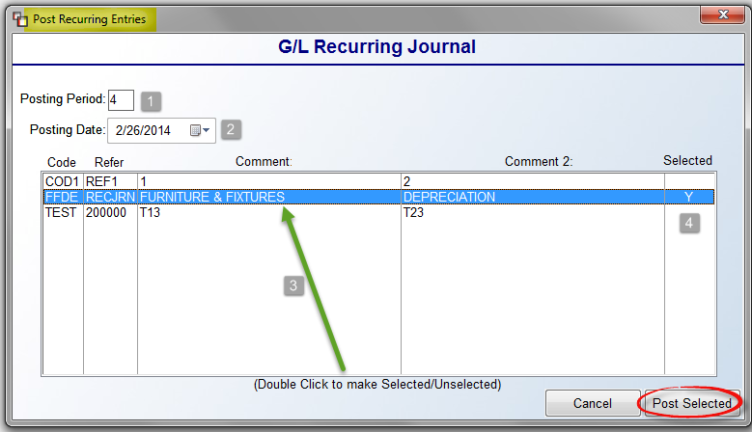
All Recurring Journal Entries previously created in the Set Up Recurring Entries option will display in the screen above. If applicable, adjust the Posting Period (1) and Posting Date (2) fields. You will then highlight and double-click (3) on each line you would like to select for processing. As lines are selected, a “Y” (4) will appear in the Selected column. As a reminder, you can change the Posting Period field and the Posting Date field where applicable prior to clicking the Post Selected button to process. The Recurring Journal entries will appear on the General Journal and will each have their own sequence number. There is no reversing entry option in this module. To reverse a recurring journal entry, make the applicable reversing entries in the Journal Posting module.

Account Detail Inquiry:
This module is used to view activity detail posted to a G/L Account on screen rather than having to print out a report. Detail from all nine journals can be viewed in this module. The detail in this module can also be printed out through the Print Account Detail Report module. Also, an option to Re-Use Journal entry is available from this module. This allows for re-using or copying any existing General Journal Entry. The purpose is to allow for quick and easy picking of accounts and amounts that will be duplicated, as the editing feature would make this option more labor intensive. This applies to entries such as Bank Fees, Depreciation, or any entry created in the Journal Posting module that can be easily copied. Please see end of this section for details on how to access.

To understand a little better about how information flows in the RollMaster system, we’ve included a description of the information contained in each journal. Any process in the system that impacts the General Ledger will be recorded on one of ten G/L Posting Journals. As a reminder, information does not hit the system General Ledger until you run the Print Journals/Update General Ledger report module located in the G/L Reports menu.

1. General Journal (G)- all entries made in the Journal Posting, Recurring Journal Entries, and CSV Import module will appear on this journal. In addition, any journal entries and transfers made via the Bank Reconciliation process will also appear on this journal.

2. Accounts Payable Journal (P)- all entries made in the A/P Open Item Maintenance module will appear on this journal.

3. Cash Disbursements Journal (D)- all checks processed through the Print Checks module or through the Hand Check/Void Check Processing module in the Accounts Payable menu will appear on this journal.

4. Accounts Receivable Journal (R)- all entries made in the A/R Open Items Maintenance module will show up on this journal. All service charges processed through the Service Charge Processing module will appear on this journal.

5. Cash Receipts Journal (C)- all entries made through the Deposit option in Quote/Order Entry or through the Post Customer Payments module in the Accounts Receivable menu will appear on this journal.

6. Sales Journal or Order Processing Journal (O)- when Invoices or Credit Memos are processed in the system, a summary of the debits and credits from each open item by date will appear on this journal.

7. Payroll Journal (Y)- all payroll checks processed through the Payroll System menu will appear on this journal.

8. Job Cost Journal (J)- all adjustments to Job Cost made after a Job has been invoiced will appear on this journal.

9. Inventory Transfer Journal- tracks the financial transfer of inventory from one Branch to another—especially for those customers who use separate inventory G/L Accounts between Branches. In the Refer.(ence) column of this report, the Branch the inventory was transferred from and to will display. In the Comment column, the roll and dye lot number of the inventory will display along with the product and color name.

Please Note: A journal will print for each period if more than one period was impacted during daily processing. For example, if you posted one Invoice to period 7 and another to period 8, the system will print a Sales Journal for period 7 and a Sales Journal for period 8.

When you enter the Account Detail Inquiry module, the screen will appear as follows:

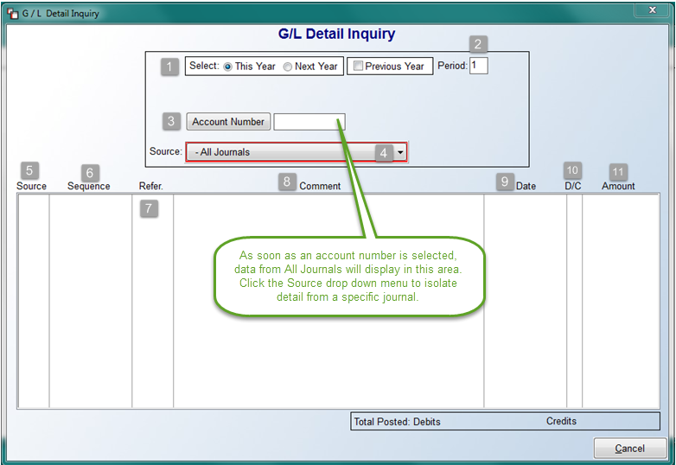

In the Select (1) box fields, the default is for This Year, which is considered the current open year in the system. If you have begun posting into next year, you will need to click on the Next Year option to view detail. A third option is to view data for a Previous Year. When you click on this option, the system will display an FYE (Fiscal Year Ending) drop-down menu as follows:

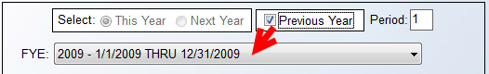

Once you have made your selection, you can change the Period (2), if applicable. You will then click on the Account Number (3) button to call up a G/L Account Selection box. As soon as you select a G/L Account, the system will display detail from All Journals in the grid below. You can sort that detail by utilizing the Source (4) drop-down menu to select from a list of all nine journals in the system. You can continue to switch between journals to isolate detail for the account, where applicable.

The Source (5) column displays the abbreviation of the journal. The Sequence (6) column displays the G/L Sequence number assigned to the posting by the system. The sequence number is used to keep an audit trail of every Journal Posting made in the system. Sequence numbers will appear in the Posting Sequence column of every journal print out. The Refer.(ence) (7) column is tied to various reference fields in the system. For example, if you type in a reference for an entry in the Journal Posting module, it will appear in this column when you view detail from the General Journal. The reference field in the Post Cash Receipts module and in the Deposit option will display here when you view detail from the Cash Receipts Journal, and so on. The Comment (8) column works similarly to the Reference column, although for many of the journals, the system will generate a comment describing the posting, e.g., DEPOSIT FROM, VEND=MASLAND, etc. The Date (9) column reflects the date at the time of the posting—it will not necessarily correspond to the posting period. For example, the date of the invoice, or the date of the check, etc. The D/C (10) column indicates whether the entry was a debit or credit to the account. And finally, the Amount (11) column displays the value of the posting. At the bottom of this screen, the system will total the debits and credits on the screen. When you have finished viewing the detail, you can click the Cancel button to exit the module.

Re-Use Journal:
The Re-Use Journal option can be accessed from two different screens in the RollMaster System. The first appears in this module. Once an existing General Journal Entry has been called up in the screen (Source = G/J), you can right-click on an applicable detail line to prompt the following: Re-Use Journal. When you click on this option, the system will prompt a Re-Use Date box as follows:

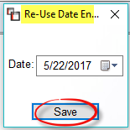

Select an applicable date for the new Journal Entry and click Save to continue. The G/L Journal Posting screen will prompt with the copied lines of the Journal Entry selected. You can Edit and Delete from this screen, if applicable. If all looks good, click the Save button to keep the new entry. The second module with this new option is the Print Account Detail Report. To have access to this option there, you will need to know the G/L General Journal Sequence # of the Journal Entry you wish to re-use. You will also need to set the Report Option field to Print Entries Sequence to prompt the G/L Detail Report screen. Type the applicable number in the G/L Sequence # field, click the Generate button, and the system will then prompt a Re-Use G/L button to the right of that field. Once you click on the Re-Use G/L button, the option works the same as explained above.

Report Format Maintenance:
This module is used to design custom Financial Statements. The RollMaster System automatically prints a Trial Balance report, but cannot print a Balance Sheet, Income & Expense Statement (P&L) or any other customized financial report until they have been formatted through this module. In most cases, your RollMaster trainer will have already worked with you to set up the Balance Sheet and Income & Expense statement. Before adding a new report, it is best to draft these reports on paper line by line, giving each line a sequential number. When you enter this module, the screen will appear as follows:

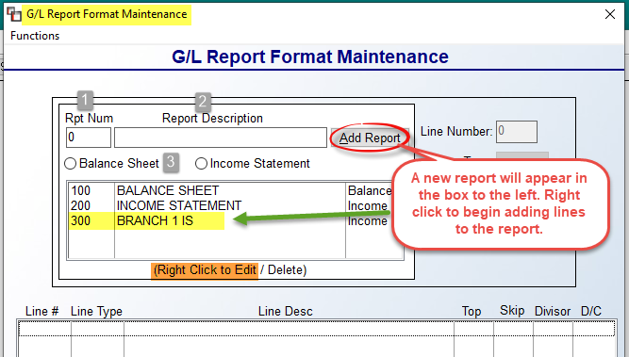

The cursor will be positioned at the Rpt Num (Report Number) (1) field. If you look in the display box below that field, you will see all existing reports listed in order of Report Number. In the example above, there are three reports: 100 BALANCE SHEET, 200 INCOME STATEMENT, and 300 BRANCH 1 IS. To add a new report, type a new number in the Rpt Num (1) field followed by a description of the report in the Report Description (2) field. You will then need to select either (3) Balance Sheet or Income Statement to assign a Report Type. Click the Add Report button to continue. The Report Number, Description, and Report Type will display in the box below those fields as soon as you click the Add Report button. Right-click on the new Report Number to open the report and start building the lines that will make up the report. The screen should now appear as follows:

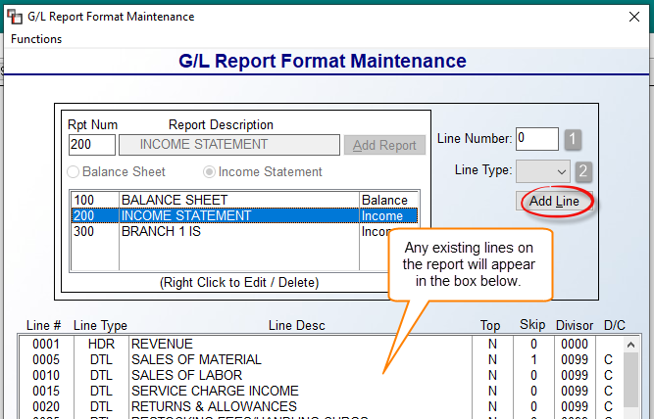

In the Line Number (1) field, type the number for the first line. RollMaster recommends skipping a couple of numbers in between lines in the event you need to add in a line at some future date. At the Line Type (2) field, use the drop-down arrow to access a list of line types to choose from (see next paragraph for Line Type explanations). Click the Add Line button to continue.

The first option in the Line Type (2) drop-down menu is a HDR (Header) line. These lines are used to add a description or title to print on the report, e.g., CURRENT ASSETS or REVENUE, etc. A DTL (Detail) line is used to add your G/L Accounts and will be tied to one or more G/L Account Numbers. Detail lines will display the total value of all accounts tied to the line on the printed report. The TL1 – TL9 (Total line 1 – 9) line types are designed to subtotal all previous Detail lines on the report. You will need to follow these rules to use them properly: each TL line will print the total of all Detail lines since the last subtotal line of equal or greater value (the value being 1-9) and clears subtotals of lesser value, e.g., a TL2 line or higher is used to total the Detail lines included in two previous TL1 lines. However, if you will be using a TL3 line to total a later section of the report and do not wish to include the previous TL2 total, you should use a TL3 or higher line instead after the first series of TL1 lines.

When you select to add a Header line, the system will prompt the following:

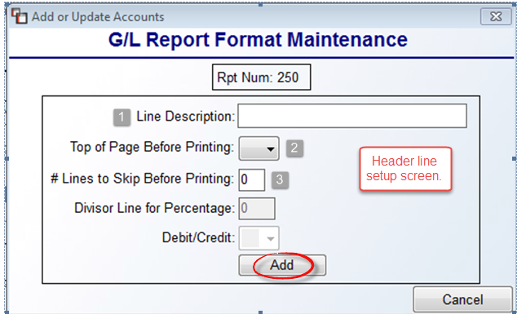

The only fields available for a Header line are the Line Description (1), Top of Page Before Printing (2), and # Lines to Skip Before Printing (3) field. For all Line Description (1) entries, type a description for the line as it should appear on the report. You may want to consider spacing over twice before you type a description for a second Header line and four times before you type a description for a Detail line. This will make the printed report easier to read. At the Top of Page Before Printing (2) field, you have two choices. If the report will be more than one page, use this feature to advance a line—usually a new Header line—to the top of the next page by typing a “Y” for yes. Otherwise, type an “N” for no at this option. At the Number of Lines To Skip Before Printing (3) field, enter the number of blank lines to insert before printing this line. For Detail lines, this will mostly be zero; for Header and Total lines, consider inserting at least one line to separate the line from the previous lines. Click the Add button to save the Header line.

When a Detail Line Type is selected, the system will prompt the following:

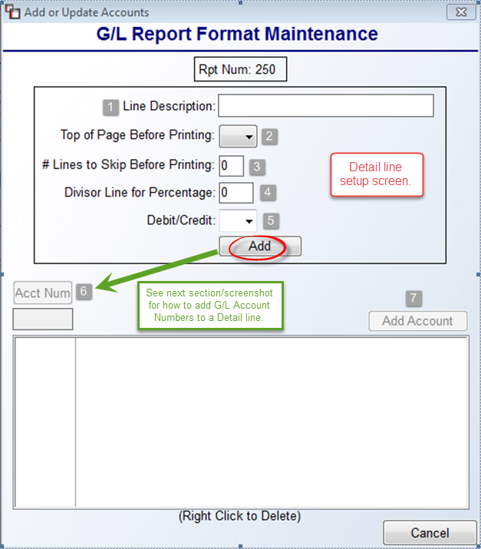

The Detail line type setup screen appears very similar to the Header line screen, but there are a couple more options that need to be considered. Complete the Line Description (1), Top of Page Before Printing (2), and the # Lines to Skip Before Printing (3) fields as explained in the Header line section above. The Divisor Line for Percentage (4) is more applicable for Income Statements rather than Balance Sheets. Use this field if you want to know what percentage of total Sales a line is, or what percentage of Cost of Goods a line is, etc. To use this option, type in the number of the Total line you wish to use as the basis of percentage, e.g., the total Sales or total Cost of Goods line number on the report. The system will divide the current line into that line to yield a percentage on the report. To skip this field, leave it blank. The Debit/Credit (5) field is also used primarily for Income Statements rather than Balance Sheets. Use this option for all Revenue and Expense Detail lines along with Gross and Net Profit Total lines to designate whether they should carry a credit or debit balance. This will ensure the Income Statement prints positive and negative numbers. Once all Revenue accounts have been set to show a credit balance and all Expenses have been set to show a debit balance and the Gross and Net Profit Total lines have been set to show a credit balance, a profit will display as a positive number and a loss will display as a negative number. When you have completed all fields, click the Add button below the Debit/Credit field to proceed. The system will prompt the following:
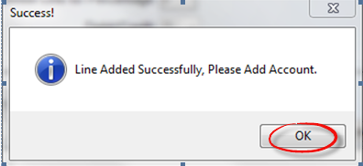

Click the OK button and the cursor will move to the Acct Num (G/L Account Number) (6) field. Click the Acct Num button to call up a G/L Account Selection box or type in the first applicable number for this line. Click the Add Account (7) button to create the line. It will display in the screen below as follows:

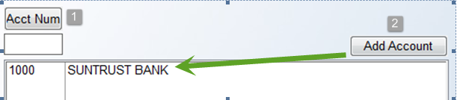

You can continue to add G/L Account Numbers to this Detail line, or if only one account is needed, hit the Esc key to return to the previous screen to add the next line. As lines are added, they will appear in the main screen as follows:

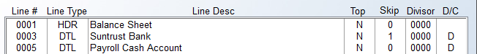

When you select to add a TL1-TL9 Total line, the system will prompt the following:

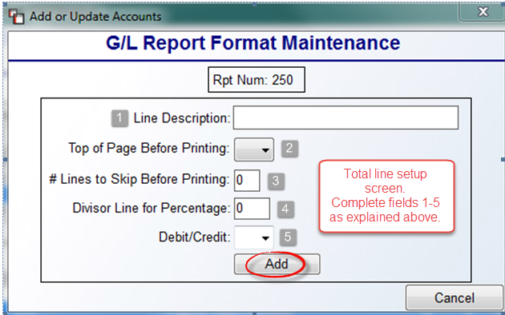

Complete fields 1-5 as explained in the previous sections and then click the Add button to continue. The most difficult task when adding total lines is determing if it needs to be a TL1, TL2, etc. RollMaster customer service can assist with this process.

Once all report lines have been added, there are three options for managing reports located at the bottom of the main screen as follows:

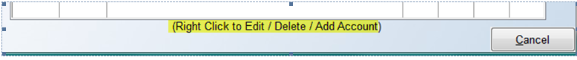

When the cursor is positioned on a report line in the main screen, you can Right Click to Edit the line data, Right Click to Delete the line entirely from the report, or you can add a G/L Account Number to an existing line via the Right Click to Add Account option.

The following is an example of a complete formatted Income Statement in the G/L Report Format Maintenance screen:

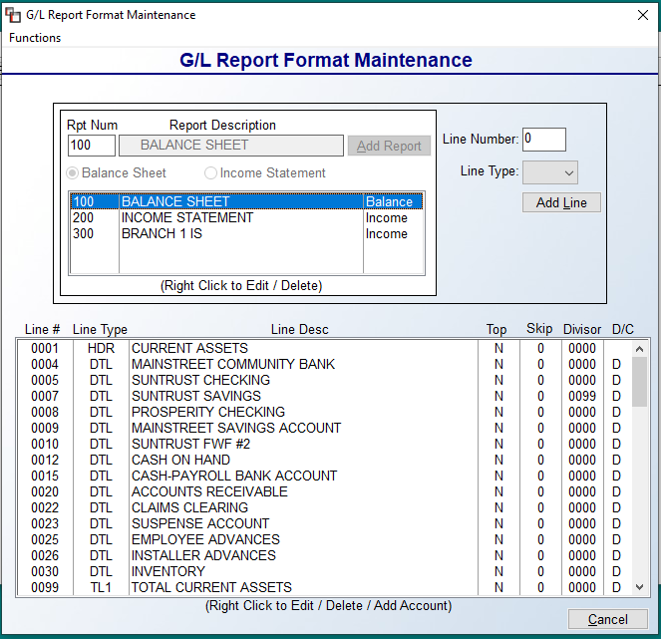

The final two options available in the Report Format Maintenance module can be found under the Functions menu located at the top left of the main screen. When you click on that menu, two options will appear as follows: Verify GL Accounts and Print Report Records. Once you have finished formatting all reports, you should run the Verify GL Accounts option to make sure all General Ledger Account Numbers appear in one of the reports. If the system finds one that has not been used, it will prompt the following:

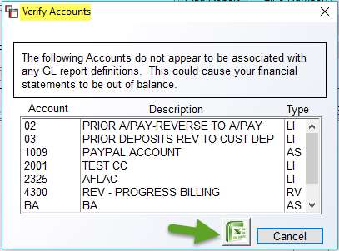

To export a list of accounts, click the Excel icon, or make a note of any accounts that need to be added to one or more of the reports and then click Cancel to return to the main screen. The Print Report Records option will prompt a General Ledger Report Format Listing box as follows:

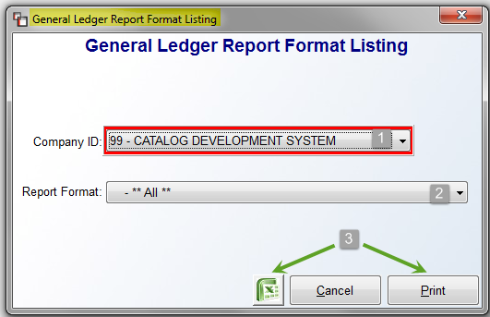

The Company ID (1) will default to the current company. If using multiple companies on RollMaster, switch to another company via this field, when applicable. At the Report Format (2) field, you can keep the **All** default to print the format listing for all reports, or you can use the drop-down arrow to select a specific report. To export the report detail, click the Excel (3) icon. To print to paper, click the Print (3) button. To exit without printing, click the Cancel button.

End of Month Processing:
This module is used to close an accounting period in the system General Ledger and to move Balance Sheet account balances over to the next period. It does not need to be done promptly at the end of every month. In fact, you can leave a period open for 12 months, though RollMaster recommends closing a period within three to four months. If you do not close a period before you enter that period for the next year, you will mix prior year and current year information together. Once you close a period, you cannot reopen it or post any values. The data can continue to be viewed from the Account Detail programs.

Before you close a period, you must be in balance or the system will not allow you to close. You should also run all reports and financial statements for the period. The system is set to handle 13 periods, but you do not need to close the 13th period—the system will do that during end of year processing. When you enter this module, the screen will appear as follows:
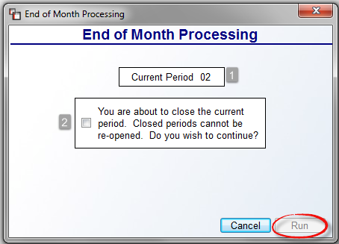

The current open period you are about to close will display in the Current Period (1) field—this is a display-only field. The system forces you to click the box in the “You are about to close the current period…” (2) prompt, forcing you to think twice about whether you are ready to close the period. If you are ready to close the Current Period, click in that box and then click the Run button.

End of Year Processing:
This module is used to close a fiscal year in the system. All twelve periods must be closed before you can proceed with end of year processing. If you are out of balance for the year, the system will not allow you to close until it has been corrected. If you use period 13 in the system, you do not need to close that period—the system will do it in this module. During this process, the system will zero out all income and expense accounts and the net income will be moved to your Current Earnings account. This process will also archive the detail from the General Ledger for the year you are closing for access through the Account Detail Inquiry module as well as the Account Detail and Summary Reports. When you enter this module the screen will appear as follows:

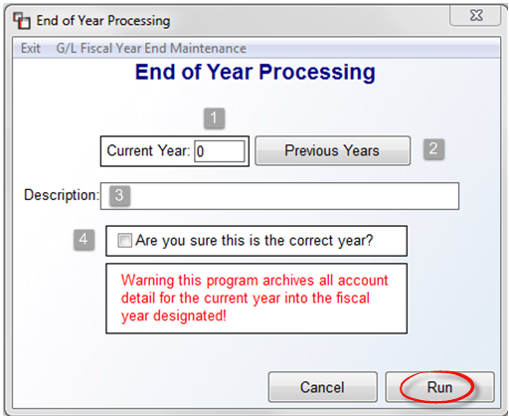

The cursor will be positioned at the Current Year (1) prompt. The system requires you to type in the year you are preparing to close. You can click the Previous Years (2) button to see the history of previous years closed in the system. In the Description (3) field, you can type out the fiscal year data, i.e., 1/1/2013-12/31/2013. Please Note: at the top left of the screen is an option that appears as follows: G/L Fiscal Year End Maintenance. You can use this feature to edit the Descriptions of Previous Years. When you click on this option, the system will prompt a Fiscal Year Ending Maintenance box as follows:

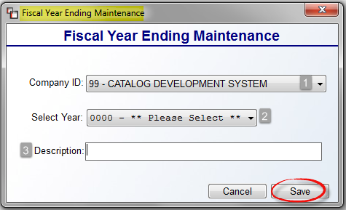

At the Company ID (1) prompt, if applicable, use the drop-down menu to select a different Company. At the Select Year (2) field, use the drop-down menu to select a previous fiscal year for which you would like to edit the description. At the Description (3) field, change or create a new description, i.e., 1/1/2010 – 12/31/2010. Click the Save button to continue. These descriptions will prompt everywhere you access the Previous Year option throughout the General Ledger system.

When you are 100% sure you are ready to close the year, click the box in the Are you sure this is the correct year? (4) field (in the first screenshot above) to proceed. Click the Run button to continue and close the year. Please Note: Once a year is closed it cannot be re-opened and no changes can be made.

G/L Budget Comparison Report:
The following “Budget” programs were developed to set budgets for income and expense accounts. This allows a User to track whether the company is over or under budget on these accounts on a monthly basis. To set budgets for these accounts, you must first start with the G/L Budget Maintenance and G/L Budget Posting modules. These modules are explained in the order they appear in the General Ledger Menu. It is also possible to import G/L Budget Detail by period. This process must be administered by a member of the RollMaster Customer Support Team. Please email support@rmaster.com if you are interested in this feature.
The G/L Budget suite of modules has been expanded to allow for multiple budgets. The addition of a new G/L Budget Name field in all these modules allows for this process, which adds additional functionality for setting “Target” budget goals, with the objective of comparing goals for growth to current numbers. Budget data is importable. Please contact RollMaster Support for additional assistance. G/L Budget Names can be added in the G/L Budget Maintenance module via the following option: G/L Budget Name Mtc.
The G/L Budget Comparison Report module requires you to create a Report Format in the Report Format Maintenance module first, using only the accounts for which you have set a budget. The printed report looks much like an Income Statement. It will display a Current Month column giving Activity, Budget, and Percentage of the budget, along with a Year-to-Date column showing the same information, and a Last Year-To-Date column for comparison purposes. When you enter this module, the screen will appear as follows:
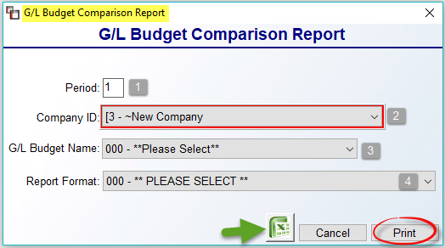

The cursor will be positioned at the Period (1) field. You can type in a different period or leave the default for the current open period in your system. At the Company ID (2) prompt, if applicable, use the drop-down menu to select a different Company. At the G/L Budget Name (3) field, use the drop-down arrow to select the applicable Budget Name. At the Report Format (4) field, use the drop-down menu to select the Report Format previously formatted specifically for this module. To export the data, click the Excel icon. Click the Print button for a paper copy of the report.

G/L Budget Comparison Report (Pct.Sales):
This module also requires you to create a Report Format in the Report Format Maintenance module, although you can use the same one created for the regular Budget Comparison Report. The printed report looks very similar to the report above, but this report will display Percentage of Sales data for the Current and Year-to-Date Activity columns. You can also select to view data for This Year or Next Year. When you enter this module, the screen will appear as follows:

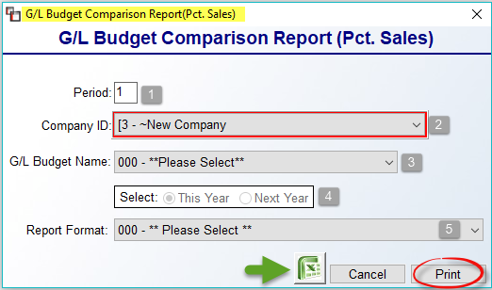

The cursor will be positioned at the Period (1) field. You can type in a different period or leave the default for the current open period in your system. At the Company ID (2) prompt, use the drop-down menu to select a different Company if applicable. At the G/L Budget Name (3) field, use the drop-down arrow to select the applicable Budget Name. In the Select (4) box fields, the default for this report is This Year, but you can click on Next Year if applicable. At the Report Format (5) field, use the drop-down menu to select the special report that was previously formatted specifically for the Budget Comparison modules. To export the data, click the Excel icon. Click the Print button for a paper copy of the report.

G/L Budget History Report:
This module prints a report with budget data for all revenue and expense accounts for Two Years Ago, Last Year, This Year, and Next Year. There is no comparison to actual numbers; it simply shows what was budgeted for those time frames. When you enter this module, the screen will appear as follows:

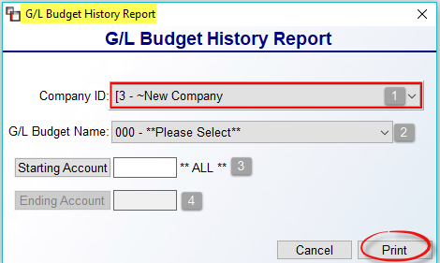

The cursor will be positioned at the Company ID (1) prompt. If applicable, use the drop-down menu to select a different Company. At the G/L Budget Name (2) field, use the drop-down arrow to select the applicable Budget Name. At the Starting Account (3) and Ending Account (4) fields, enter the range of G/L account numbers to include on the report. You can also tab through the Starting Account field until the cursor is positioned at the Print button to include **ALL** account numbers on the report. Click the Print button to print the report.

G/L Budget Maintenance:
This module is used to add revenue and expense accounts for budget monitoring. You will also access this module if you would like to create multiple budgets. The G/L Budget Name Mtc. option at the top left should be used to add each Budget Name to distinguish between budgets when printing from any of the Budget Modules. When you enter this module, the system will prompt a G/L Budget Maintenance screen as follows:
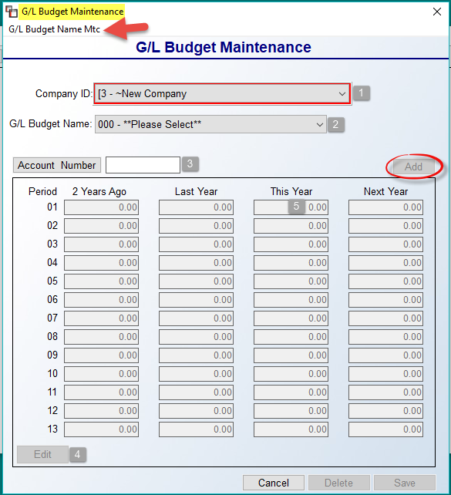

You will need to first create a Budget Name or Names using the G/L Budget Name Mtc. option at the top left. Thereafter, the cursor will be positioned at the Company ID (1) prompt. If applicable, use the drop-down menu to select a different Company. At the G/L Budget Name (2) field, use the drop-down arrow to select the applicable Budget Name. At the Account Number (3) field, click the button to call up a G/L Selection box or type in a revenue or expense account. Once selected, click the Edit (4) button at the bottom left. This will allow you to click the Add button to add the G/L account number to the budget modules. If you only wish to create a budget for next year, you can continue to add account numbers. You can access any of the fields in the 2 Years Ago, Last Year, and This Year columns. Budget data for the Next Year column can be added here, but can also be added via the G/L Budget Posting module, explained below. The G/L Budget Posting module will override any data entered in the Next Year columns in this module. Please Note: all G/L Account Numbers for budget setting must first be entered in this module.

To set a budget for the current year, first click the Edit button and then position the cursor in the Period 1 field of the This Year (5) column and type a budget amount. Again, any of the periods in 2 Years Ago, Last Year, and the This Year columns can be programmed with budget data. Once data has been programmed, click the Add button to save. The system will prompt a message as follows: Budget Account Update Successful. Any changes to an existing account will prompt the following message: Budget Account Already Exists. Do You Want to Update? Click Yes to save your changes.

G/L Budget Posting:
Use this module to set the monthly budget for next year for all the revenue and expense accounts you added in the G/L Budget Maintenance module. Please Note: data can be imported from a .csv file, rather than manually entered via this module. See CSV Import option at top left. When you enter this module, the system will appear as follows:

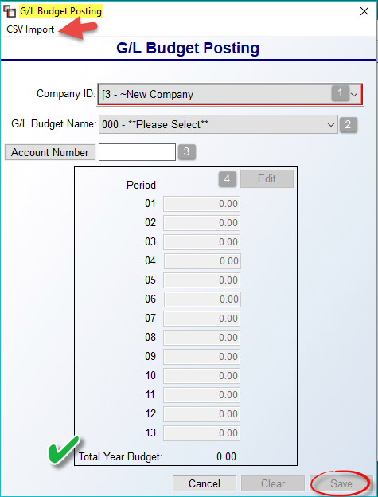

The cursor will be positioned at the Company ID (1) prompt. If applicable, use the drop-down menu to select a different Company. At the G/L Budget Name (2) field, use the drop-down arrow to select the applicable Budget Name. At the Account Number (3) field, click the button to call up a G/L Selection box or type in a revenue or expense account. Once selected, click the Edit (4) button to begin entering budget data. As you type a budget for each financial period for the next year, the system will keep track of the Total Year Budget at the bottom of the screen. You can tab to the next field or use the mouse to move back-and-forth between the fields until you have completed entering the budget for this account. When complete, click the Save button. The system will prompt the following: Budget Account Update Successful. Any changes to an existing account will prompt the following message: Budget Account Already Exists. Do You Want to Update? Click Yes to save your changes. The Cancel button will exit the program and no changes will be saved. The Delete button can be used to remove the account and budget from the Budget Reports.

G/L Budget Worksheet:
This module prints a report with the following information: G/L Account Number, Account Name, Account Type, Last Year’s budget and Actual, This Year’s budget, Percentage of budget increase, and Actual, the Percentage of budget the actual value is, and Next Year’s budget. When you enter this module, the screen will appear as follows:

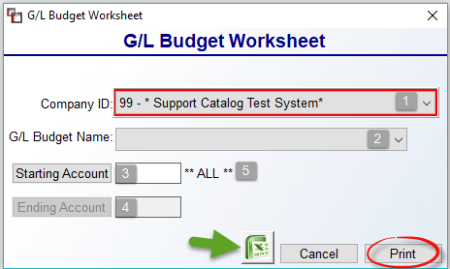

The cursor will be positioned at the Company ID (1) prompt. If applicable, use the drop-down menu to select a different Company. At the G/L Budget Name (2) field, use the drop-down menu to select an applicable Name. At the Starting Account (3) and Ending Account (4) fields, enter the range of G/L Account Numbers to include on the report to customize the report. You can also tab through the Starting Account field until the cursor is positioned at the Print button to include ALL (5) account numbers on the report. To export the data, click the Excel icon. Click the Print button to print the report.

G/L Journal Import (csv):
This module will allow you to import your payroll and other financial data into RollMaster from a csv file. This program will likely be utilized by your RollMaster trainer/support team during initial setup, but thereafter can be used to quickly import payroll data into the system General Ledger, rather than make manual postings via the Journal Posting module, provided you are not using the RollMaster Payroll Processing System. When you enter this module, the screen will appear as follows:

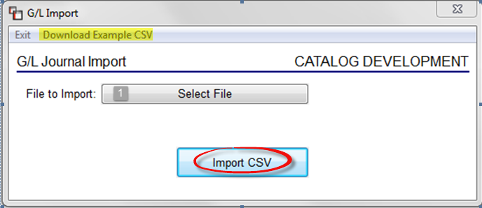

You will first need to create a csv file in Excel prior to the import process. The following is an example of a template format for the file:

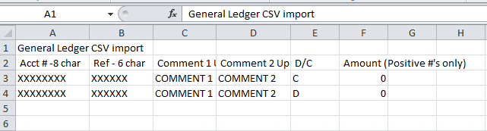

When your file is ready to be imported, click the Select File button at the File to Import (1) field. The system will prompt you to select the file from your computer to upload to the server. A new screen will then prompt displaying the data about to be imported. At this point, you can change the date and period. The Import G/L screen displays only valid lines to be imported. Any invalid accounts or improperly formatted fields (such as fields with text vs. numbers) will be excluded from the display/balance calculations. When this happens, the contents of any record determined “invalid” during the import process can be printed out so that they can be fixed and the data re-imported. If all items are in balance, the system will allow you to complete the process by clicking the Import CSV button.

Please Note: at the top left of this box is an option to Download Example CSV. This will prompt the system to download the Excel csv file template for you to use to build your import data. A csv file is not like an Excel file; it does not read commas, apostrophes, or quotation marks. Also, if your G/L Account Numbers utilize “dot” extensions like “4000.100,” the csv file will drop the ending zeroes and make it “4000.1” unless a text qualifier (the apostrophe) is inserted in front of items with leading or trailing zero’s’ (after a period). Example: ‘0400.100.

General Ledger Reports

Introduction:
This menu contains many reports to assist in managing the system General Ledger account number data. It also contains the report modules for printing valuable financial statements for your company. A thorough understanding of these reports is necessary to maximize the effectiveness of the system accounting program. Each report will be explained in the order it appears in the menu.

Print Chart of Accounts:
Once you have added General Ledger accounts through the Account Maintenance/ Inquiry module, this report module will print a list of those accounts. The report lists the account number, account description, and account type. When you enter this report module, the screen will appear as follows:

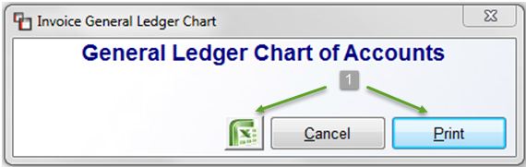

To export to Excel, click the green Excel icon (1). To print to paper or screen, click the Print (1) button. To exit without printing, click the Cancel button.

Print Journals/Update General Ledger—Daily Report:
This is an extremely important report module. At the end of the day, after all daily processing and reports are completed, run this report module to send all activity to the system General Ledger. This includes any entries made in the Journal Posting module and any recurring entries or journal postings and transfers made from the Bank Reconciliation module. When you are updating all Journals at once, no other processing should be done in the system or you will risk losing data to the G/L. The report module will print nine possible Journals depending on the type of activity that took place during the day. For example, if any Invoices or Credit Memos were processed, this module will produce a Sales Journal recapping that information. For a detailed list of Journals, please review the Account Detail Inquiry section above.

Please Note: A Journal will print for each period if more than one period was impacted during daily processing. For example, if you posted one Invoice to period 7 and another to period 8, the system will print a Sales Journal for period 7 and a separate one for period 8.

When the Journals have printed, you need to inspect each thoroughly to make sure they are all in balance. If any are out of balance, you need to correct the problem as soon as possible. When printing the Journals, you can update all Journals at once or just one Journal. For example, if you make a general journal posting and wish to see that reflected in your financials immediately without updating all Journals, you can select to update just the General Journal to see those changes. When you enter this module, the screen will appear as follows:

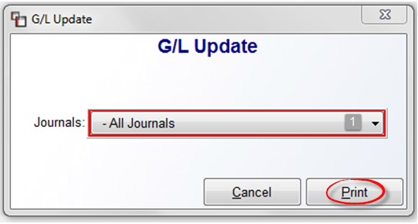
The cursor will be positioned at the Journals (1) field and the default will be to print All Journals—meaning all Journals with activity since that last time the G/L was updated. Use the drop-down arrow to select a specific Journal to print, when applicable. To exit without printing, click the Cancel button. When you have made your selection, click the Print button to continue. The Journals will begin printing and the system will prompt the following:

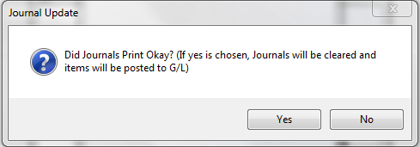

Prior to clicking the Yes button, look over all the printed Journals. If any of the Journals were jumbled in the printer or if you notice any incorrect our out-of-balance information on one or more of the Journals, you need to click the No button. You will then need to correct any issues and start the print process again. Once the journals are in good fiscal condition, click the Yes button at the prompt. AGAIN: No information will report to the system General Ledger until you respond with a Yes at this prompt.

Print Account Detail Report:
This report module prints information similar to what you can view in the Print Account Detail Inquiry module (explained above). You can print this report for a range of periods and a range of accounts rather than just one period and one account at a time, as with the Account Detail Inquiry module. You can also pull detail by a Date Range within a period as well as print entries by Sequence Numbers. The report displays the account beginning balance, a list of the total debits and credits to the account from each journal, and the ending balance of the account. You can also produce a Recap Report, which is useful for quickly identifying an out of balance condition in your financials. When you enter this report module, the screen will appears as follows:

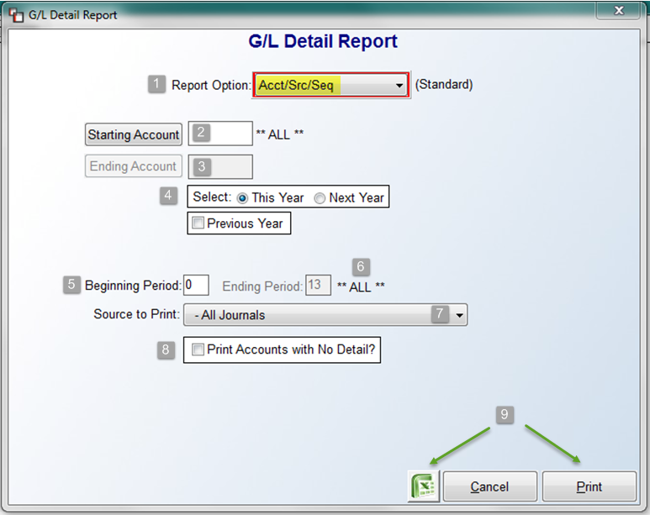

The cursor will be positioned at the Report Option (1) field and default to Acct/Src/Seq (Standard). There are three sort options available in this module. Based on the selection, the screen below will change to accommodate these different scenarios. The first option, which is the default option, prints a report that displays data by a period or range of periods and will not factor any date information. At the Starting (2) and Ending Account (3) fields, you can tab through these fields if you want **ALL** accounts to print, or you can click on each button to select a single account or a range of accounts. At the Select (4) box fields, decide the applicable Year for this report. If you click next to Previous Year, the system will prompt a FYE field with a drop-down arrow for you to select a previous year. At the Beginning (5) and Ending Period (6) fields, you can tab through to select **ALL** periods, or type a Beginning Period to enter a single period or range of periods. The Source to Print (7) field defaults to All Journals. If you want to select a specific journal, click the drop-down arrow to make your selection. At the Print Accounts with No Detail? (8) option, click to exclude any accounts that don’t contain detail. Once you have made your print selections, click the Excel icon (9) to export the data, or click the Print (9) button to print to paper or screen. To exit without printing, click the Cancel button.

The second Acct/Date/Period report option includes all of the options explained above, but will also allow you to set a date range. The Acct/Date/Period option screen will appear as follows:

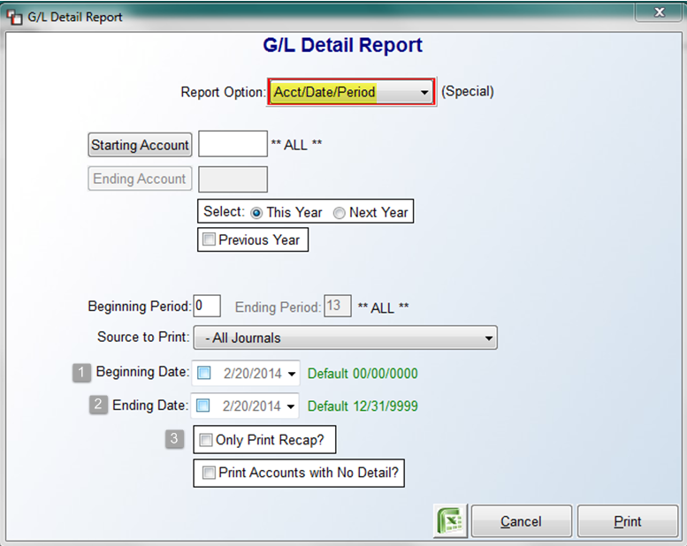

If you tab through the Beginning (1) and Ending Date (2) fields, the system will default to all dates. If you wish to set a date range or select a single date, click in those boxes to make your selection using the drop-down calendar menu. You will also have the following option: Only Print Recap? (3) This will alter the report to give a “recap” of each account, rather than include each entry that makes up the total. This report option is most helpful in extracting data where financial information has been posted to the wrong period. In the date range fields, if you tab through to include all dates, all the data will prompt like it does in the standard version; however, dates will be the first sort parameter, then source, and then it will total for the journal. Therefore, if you use this feature for your Cash account, the system will total each date’s entries and total by date for the Cash Receipts Journal. This will help enormously for bank reconciliations. All cash entries on that one date would appear together and total for that date.

Another beneficial scenario is as follows: if you key in a current period, say 12, and then key in a beginning date of 12/01/2015 and an ending date of 12/31/2015, the system will print only those entries within that date range. It will also indicate that the account is out of balance, which means the detail printed isn’t all that is in that account for that period. If there is a message saying no detail for this account, it means that there is detail in that account, but not in that date range. This is beneficial in the event you forgot to change posting periods and you need to isolate the entries in that period that need to be reversed out and moved to another period. Once you begin using this feature, you may discover even more uses for extracting data.

The third option, Print Entries Sequence, allows you to sort by a single G/L sequence number. The Print Entries Sequence screen will appear as follows:

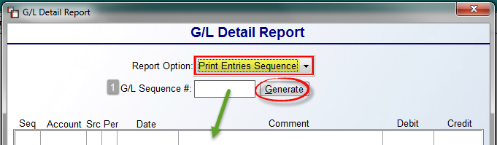

This option is helpful for resolving issues such as if you entered an A/P bill but didn’t remember where the other parts of the entry went in the G/L. The sequence number is in a format of xxxxxx-001, xxxxxx-002, etc. If you type the first six digits in the G/L Sequence # (1) field, then click the Generate button, the system will find and display all the -001, -002, etc. entries so you can see the entire entry with all accounts impacted. The Print Entries Sequence screen with detail will appear as follows:

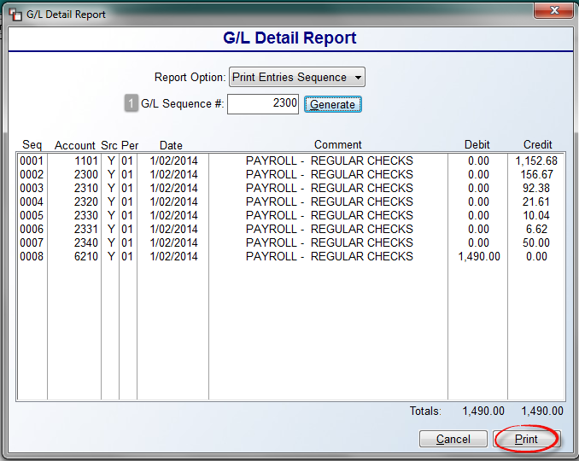

Once you type in an applicable G/L Sequence # (1), the data below that field will display all the entries associated with that sequence, as in the example above. You can then print the detail by clicking the Print button at the bottom right of the screen. To exit without printing, click the Cancel button.

Re-Use Journal:
The Re-Use Journal option can be accessed from two different screens in the RollMaster System. The first appears in the Account Detail Inquiry module, explained above, and the second one in this module. In this moducle, in order to have access to this option, you will need to know the G/L General Journal Sequence # of the Journal Entry you wish to re-use. You will also need to set the Report Option field to Print Entries Sequence to prompt the G/L Detail Report screen. Type the applicable number in the G/L Sequence # field, click the Generate button, and the system will then prompt a Re-Use G/L button to the right of that field. Once an existing General Journal Entry has been called up in the screen (Source = G/J), you can right-click on an applicable detail line to prompt the following: Re-Use Journal. When you click on this option, the system will prompt a Re-Use Date box as follows:

Select an applicable date for the new Journal Entry and click Save to continue. The G/L Journal Posting screen will prompt with the copied lines of the Journal Entry selected. You can Edit and Delete from this screen, if applicable. If all looks good, click the Save button to keep the new entry.

Print Account Summary Report:
This report is similar to the Print Account Detail Report explained above, but it only displays totals. It does not include the debit and credit detail and it will only print for one period at a time. This report lists the account beginning balance, followed by a total of all debits and credits from each journal, and then the ending balance for the account. This report can be used to make sure there are no out of balance conditions or to look for mistakes. For example, if you see an account on this report that typically posts to the A/R Journal posted to the A/P Journal, you can go back and run the Print Account Detail Report for that account and make a correction where applicable. When you enter this report module, the screen will appear as follows:

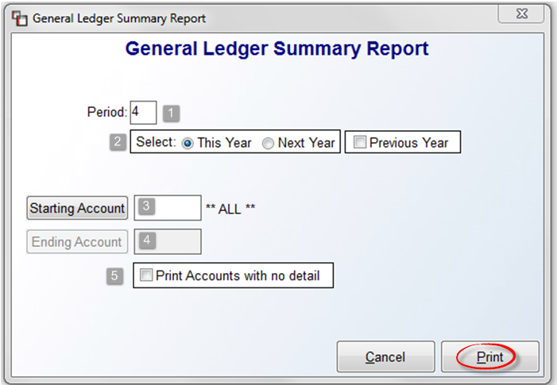

The cursor will be positioned at the Period (1) field and will default to the current open period in the system. Type a different period if applicable. The default for the Select (2) box fields is This Year. You can click Next Year, or click the Previous Year option and the system will display an FYE drop-down menu so you can select a prior year. At the Starting (3) and Ending Account (4) fields, you can tab through these fields if you want **ALL** accounts to print, or you can click on each button to select a single account or a range of accounts. If you click the Print Accounts with no detail (5) option, the report will exclude any accounts with zero detail. Click the Print button to print to paper or screen. To exit without printing, click the Cancel button.

Print Account History Report:
This report prints the information that you see in the Account Maintenance/Inquiry module. For each account, it will print a period ending balance for 2 Years Ago, Last Year, This Year, and Next Year. This report is helpful if you think someone posted something to next year that belongs in the current year. If that is the case, rather than scanning through the Account Maintenance/Inquiry module, you can print this report while you are doing something else and then scan through the Next Year column of the report to quickly catch any mistakes. When you enter this report module, the screen will appear as follows:

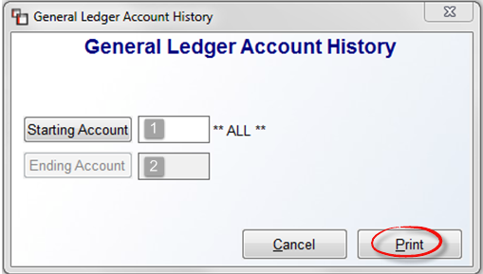

At the Starting (1) and Ending Account (2) fields, you can click on each button to select a single account or a range of accounts, or leave the **ALL** default to include all accounts and click the Print button to print to paper or screen. To exit without printing, click the Cancel button.

Print Trial Balance:
This report prints a standard Trial Balance. It does not need to be formatted in the system like the other financial reports. The report includes a list of all G/L Account Numbers, descriptions, and the current balance of each account in either a debit or credit column followed by a total of all debits and credits. Use this report to see if a period is in balance prior to running a Balance Sheet. When you enter this report module, the screen will appear as follows:

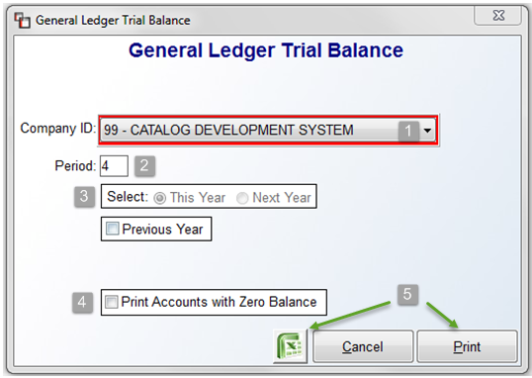
The cursor will be positioned at the Company ID (1) prompt. If applicable, use the drop-down menu to select a different Company. The Period (2) field will default to the current open period in the system. You can type an earlier period for the year if applicable. The fields in the Select (3) box will not be available if the current period is selected. However, if you type an earlier period in that field, you can then access these fields, though you cannot select Next Year if that period is still open in the current year. If you wish to access archived data, click the Previous Year option and the system will display an FYE drop-down menu so you can select a prior year. If you click the Print Accounts with Zero Balance (4) option, the report will exclude any accounts with zero detail. Click the Excel icon (5) to export the data, or click the Print (5) button to print to paper or screen. To exit without printing, click the Cancel button.

Print Annual Trial Balance:
This report was designed to export several periods to an Excel file so the data can be viewed in separate columns for analysis. Paper output yields multiple pages wide and tall. (Please Note: Excel exported reports will not total at the end of each column, so you will need to use Excel functionality to create formulas in columns needing totals.) When you enter this report module, the screen will appear as follows:

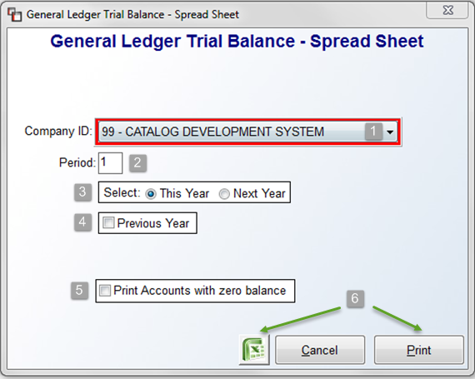

The cursor will be positioned at the Company ID (1) prompt. If applicable, use the drop-down menu to select a different Company. The Period (2) field will default to the first period of the current year in order to include all periods on the export/report. Type a different period if applicable. The default for the Select (3) box fields is This Year. You can click Next Year if that period is not open in the current year, or click the Previous Year (4) option and the system will display an FYE drop-down menu so you can select a prior year. If you click the Print Accounts with zero Balance (5) option, the report will exclude any accounts with zero detail. Click the Excel icon (6) to export to the data, or click the Print (6) button to print to paper or screen. To exit without printing, click the Cancel button.

Change in Financial Position:
You must first format your financial statements in the Report Format Maintenance module prior to using this module. For each account, it will show the beginning balance for the period, activity for the period, and the ending balance for the period. You can use your Balance Sheet report format in this module or format a special report with all account numbers included. You can print this report for closed periods, current periods, and future periods. When you enter this report module, the screen will appear as follows:

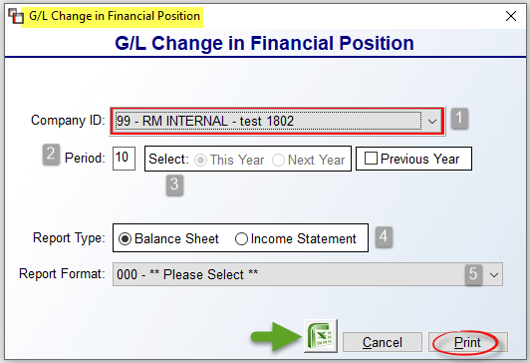

The cursor will be positioned at the Company ID (1) prompt. If applicable, use the drop-down menu to select a different Company. The Period (2) field will default to the current open period in the system G/L. You can type an earlier period for the year if applicable. At the Select (3) box fields, if the default period is selected, these fields will not be available. However, if you type an earlier period in that field, you can then access these fields, though you cannot select Next Year if that period is still open in the current year. If you wish to access archived data, click the Previous Year option and the system will display an FYE drop-down menu so you can select a prior year. The Report Type (4) field defaults to Balance Sheet. Wherever this option appears, you can select the most applicable type to avoid choosing the wrong Report Format in the next field. At the Report Format (5) field, use the drop-down arrow to select the applicable report to use. Click the Excel icon to export the data, or click the Print button to print to paper or screen. To exit without printing, click the Cancel button.

Chart of Account Change in Position:
This report does not need to be formatted—it prints detail for every account that has been entered in the system through the Account Maintenance/Inquiry module. For each account, it will show the account number, account description, account type, the beginning balance in the account for the current period, the activity for the account in the current period in debit and credit column format, followed by the ending balance for the account in the current period. At the end of the report, you will be able to see if the period is in balance. When you enter this report module, the screen will appear as follows:

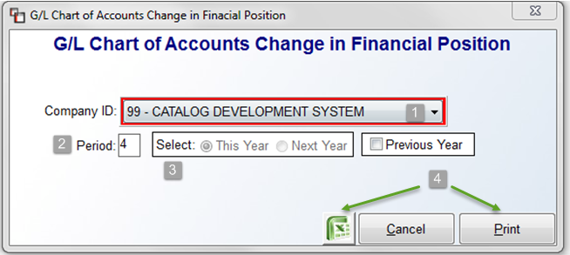

The cursor will be positioned at the Company ID (1) prompt. If applicable, use the drop-down menu to select a different Company. The Period (2) field will default to the current open period in the system. You can type an earlier period for the year if applicable. At the Select (3) box, if the default period is selected, these fields will not be available. However, if you type an earlier period in that field, you can then access these fields, though you cannot select Next Year if that period is still open in the current year. If you wish to access archived data, click the Previous Year option and the system will display an FYE drop-down menu so you can select a prior year. Click the Excel icon (4) to export the data, or click the Print (4) button to print to paper or screen. To exit without printing, click the Cancel button.

Income/Expense Statement:
This report must be formatted in the Report Format Maintenance module prior to printing. It will produce an Income & Expense Statement, also referred to as a Profit & Loss Statement, in the format most people are used to seeing. It is a comparative report that can be printed for any period or year, open or closed, in the system General Ledger. For each account, it will show the balance for the current month, the balance year-to-date, what the balance was this month last year, and what the year-to-date balance was last year. It will also show the increase or decrease for the period or for a range of periods. You can format both a detailed Income & Expense Statement and a consolidated one to print through this report module. When you enter this report module, the screen will appear as follows:

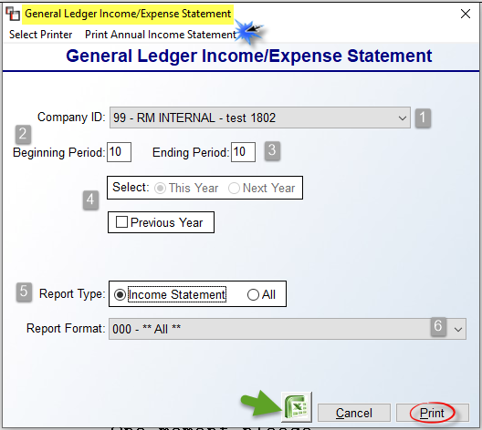

The cursor will be positioned at the Company ID (1) prompt. If applicable, use the drop-down menu to select a different Company. The Beginning (2) and Ending Period (3) fields will default to the current open period in the system G/L. To print for a range of periods, type the applicable period in the Ending Period field. At the Select (4) box fields, if the default period is selected, these fields will not be available. However, if you type an earlier period in the Beginning Period field, you can then access these fields, though you cannot select Next Year if that period is still open in the current year. If you wish to access archived data, click the Previous Year option and the system will display an FYE drop-down menu so you can select a prior year. The Report Type (5) field will default to Income Statement. Switch to All to see a list of all available Report Formats in the next field. At the Report Format (6) field, use the drop-down arrow to select the applicable report to use. Click the Excel icon to export the data, or click the Print button to print to paper or screen. To exit without printing, click the Cancel button.

One additional report feature appears at the top left of the screen as follows: Print Annual Income Statement. This report currently only exports to Excel because of the landscape format required to compare multiple periods in column format. This report looks and works very similarly to the Annual Trial Balance. When you enter this report module, the screen will appear as follows:

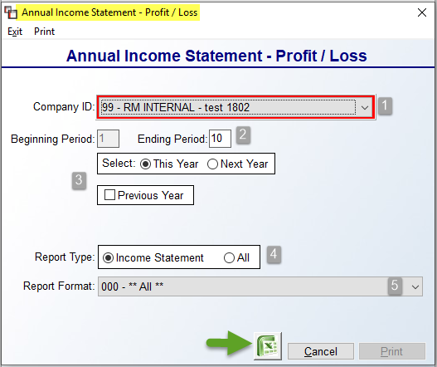

The cursor will be positioned at the Company ID (1) prompt. If applicable, use the drop-down menu to select a different Company. One big difference from the regular report is that the Beginning Period (2) field will be hard coded to Period 1. The Ending Period field will default to the current default Posting Period. You can adjust the Ending Period when applicable. The default for the Select (3) box is This Year. You can click Next Year if that period is not open in the current year, or click the Previous Year option and the system will display an FYE drop-down menu so you can select a prior year. The Report Type (4) field will default to Income Statement. Switch to All to see a list of all available Report Formats in the next field. At the Report Format (5) field, even though the report is not yet printing to paper, you must select an option at this field that contains Income & Expense accounts to display in Excel. Next, click the Excel icon to export the data. To exit without exporting, click the Cancel button. The exported data will display a column for each Period included and then a Total column as the last column.

Balance Sheet:
This report must be formatted in the Report Format Maintenance module prior to printing. It will produce a Balance Sheet in the format most people are used to seeing. In one column, it will list all asset accounts with the current balance and place each total line to the right of the column. The assets will be followed by a list of all liability and equity accounts with totals. You can format both a detailed Balance Sheet and a consolidated one to print through this report module. When you enter this report module, the screen will appear as follows:

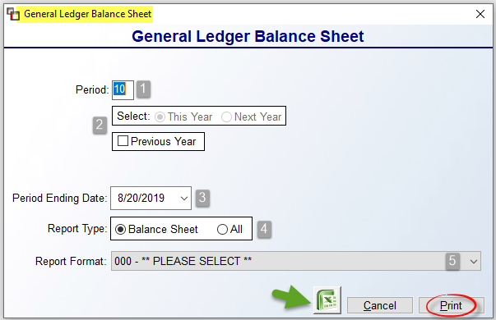

The cursor will be positioned at the Period (1) field and will default to the current open period in the system G/L. You can type an earlier period for the year if applicable. At the Select (2) box, if the default period is selected, these fields will not be available. However, if you type an earlier period in that field, you can then access these fields, though you cannot select Next Year if that period is still open in the current year. If you wish to access archived data, click the Previous Year option and the system will display an FYE drop-down menu so you can select a prior year. The Period Ending Date (3) will default to the current date. You can use the drop-down arrow to select another date. The Report Type (4) field will default to Balance Sheet. Switch to All to see a list of all available Report Formats in the next field. At the Report Format (5) field, use the drop-down arrow to select the applicable report to use. Click the Excel icon to export the data, or click the Print button to print to paper or screen. To exit without printing, click the Cancel button.

Report Format Listing:
This report module will print a hard copy of the formatting entries made in the Report Format Maintenance module. It lists each line in a report format that has been added through the Report Format Maintenance module. It will show the line number, the line type, the line description, entries for the Top of Page Before Printing field, Number of Lines to Skip Before Printing field, and Divisor Line for Percentage for each line of the report, and the G/L account numbers that have been assigned to the line. When you enter this report module, the screen will appear as follows:

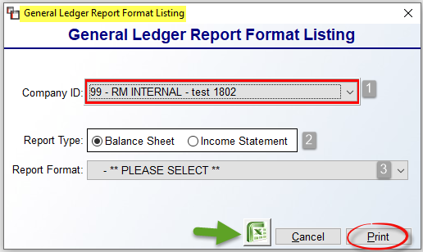

The Company ID (1) will default to the current Company. If using multiple companies on RollMaster, switch to another Company via this field, if applicable. The Report Type (2) field will default to Balance Sheet. Switch to Income Statement to see a list of only those type of reports in the next field. At the Report Format (3) field, use the drop-down arrow to select a specific report. To export the report detail, click the Excel icon. To print to paper, click the Print button. To exit without printing, click the Cancel button.

General Ledger Report Consolidation (for Multi-Company Financial Statements):
This module allows for multi-Company operations to consolidate their Balance Sheets and Income Statements. The only limitations to this option are that each Company has to be on the same fiscal year and same period as all the rest, and if one Company has closed the previous year, they must all close the previous year before consolidated financial statements can be printed. Your RollMaster Trainer will typically perform all the necessary set up for this report.

Once the setup has been completed, the General Ledger Report Consolidation module will allow you to first set-up which Company financial statements will be merged and then merge the values. When you enter this module, you will have a choice of whether to Perform Consolidation or Set Up Consolidations. The first time through, you must enter the Set Up Consolidations option. Thereafter, the only time you need to enter that option is to remove a Company from the consolidation or add a Company to the consolidation. In the Set Up Consolidations screen, the cursor will be positioned at the Master Company prompt. You can type the number of the Master Company your trainer created or you can look it up by typing a “?” in that field and hitting enter. Once you have entered through the Master Company field, the system will prompt a Subsidiary Company field. Again, you can type in one of your Company numbers or type a “?” to get a look up of existing companies in the system. Once you have selected a Company, the system will bring up an Option prompt. At this prompt, you can type an “A” to Add the company to the consolidation or type a “C” to Cancel the process. The system will then place the cursor back at the Subsidiary Company prompt. Select the next Company and continue the process until all companies have been added. When you have finished, you can hit the Esc key twice to exit this screen. To remove a Subsidiary Company, enter back into this screen, select the Company you wish to remove from the consolidation and type a “D” to Delete it from the process.

You will need to enter into the Perform Consolidation screen after you exit the Set Up Consolidations screen to merge all G/L Account Numbers in all companies into one Chart of Accounts within the Master Company. Thereafter, you will use this screen to merge the value of all account numbers in all companies prior to printing consolidated financial statements. If you use the same set of account numbers for each Company, they will simply combine together into one in the Master Company. In the Perform Consolidations screen, the cursor will be positioned at the Master Company prompt. You can type the number of your Master Company or hit enter to bring it up through a look-up process. The system will then prompt the following: Perform consolidation? (Y)es, (N)o. Type a “Y” to perform the consolidation. By performing this step, you have instantly set all Account Numbers up in the Master Company and they can be viewed through the Account Status/Inquiry module. Before you can print out consolidated financial statements, you must first format them in the Master Company through the Report Format Maintenance module. They can then be printed through the Income/Expense Statement and Balance Sheet report modules in the G/L Reports Menu.

Print Invoice Detail Report:
This report is designed to show the detail of the entries from the Sales Journals by Invoice. The report shows ledger balances based on Invoice numbers and verifies what is hitting a certain G/L account. For example, if you see an account on your Sales Journal that shouldn’t be used, or you have a Sales Journal that is out of balance and you need to know how to find the source of the data or out of balance entry, this report will give you that information. This report will pinpoint the job and even the line that created the entry. You can then take the appropriate steps to make any necessary adjustments. When you enter this report module, the screen will appear as follows:

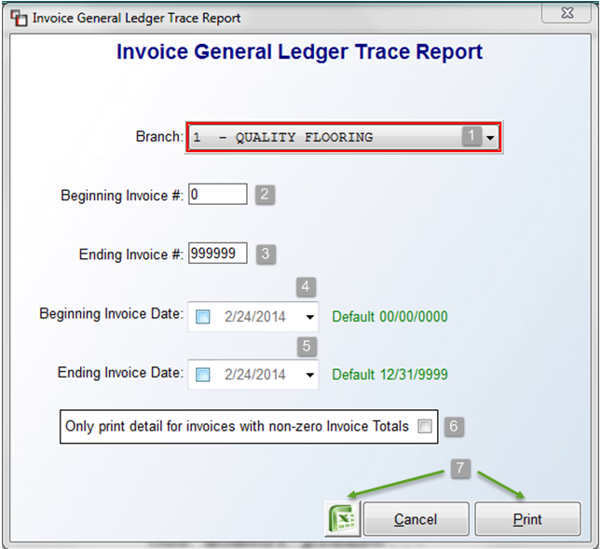

The cursor will be positioned in the Branch (1) field and default to the current branch. Use the drop-down arrow to select **ALL** Branches or another specific branch if applicable. At the Beginning Invoice # (2) field, type in the first Invoice number applicable to this print and hit enter. At the Ending Invoice # (3) field, type in the last Invoice number applicable and hit enter—if you are only wanting to see the detail on one Invoice, enter the same Invoice number in both fields. At the Beginning Invoice Date (4) and Ending Invoice Date (5) fields, use the drop-down arrows to select specific dates in these fields or leave the default settings to capture all dates. And finally, in the “Only print detail for invoices with non-zero Invoice Totals?” (6) box, click to select this option and the system will weed through any invoice detail that is correct and pinpoint any problem invoices. You can then click on the Excel icon (7) to export the data to excel or click the Print (7) button to print to paper or screen. If the system does not find any applicable invoices to print based on the sort criteria selected for a report, the system will alert you to that fact by prompting the following: No Non-Zero Invoice Totals Found in range selected! You can then return to this program to try another sort option. To exit without printing, click the Cancel button.

Print Journals History Report:
This report will allow you to re-print a cleared Journal by date range and/or by a G/L sequence number range. When you enter this report module, the screen will appear as follows:
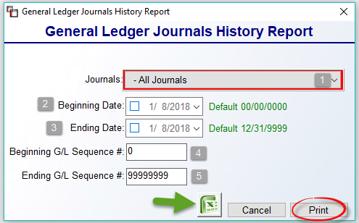

The cursor will be positioned at the Journals (1) field and default to –All Journals. Use the drop-down arrow to select a specific journal if applicable. At the Beginning (2) and Ending Date (3) fields, use the drop-down arrow menus to select a specific date or date range or leave the default for all dates. At the Beginning (4) and Ending G/L Sequence # (5) fields, type in a specific G/L sequence number or a range of sequence numbers, or accept the default for all sequence #’s. You can then click the Excel icon to export the data, or click the Print button to print to paper or screen.

Compare GL Inv. Value to PO Receipts:
This report will display the differences between the General Ledger Inventory value and P.O. Receipts and Non-Receipts. If any differences appear, you can determine how you would like to make adjustments where applicable. When you enter this report module, the screen will appear as follows:

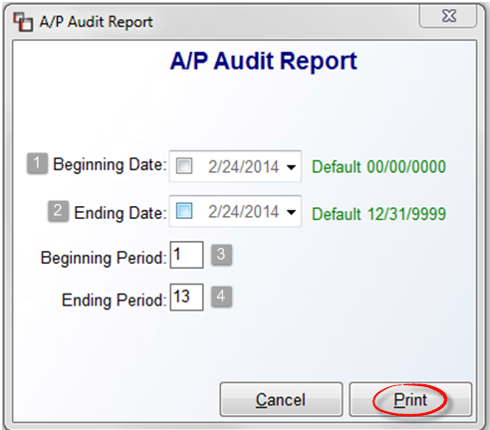

At the Beginning (1) and Ending Date (2) fields, enter a specific date or date range for this report, or accept the default of all dates. At the Beginning (3) and Ending Period (4) fields, type in the applicable period or range of periods for the report, or leave the default for all periods. Click the Cancel button to exit without printing. When you click the Print button, the system will first prompt a results box as follows:

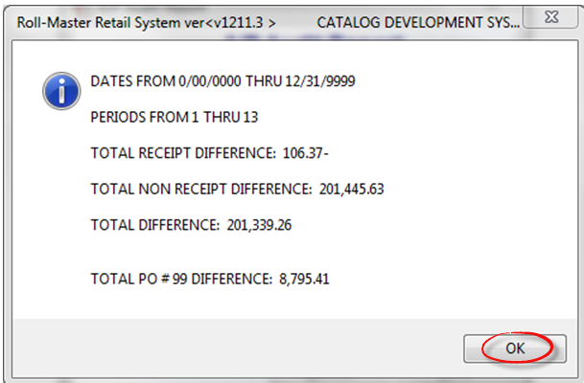

When you click on the OK button, the system will print an audit report of the variances including the PO #, Roll #, Dye lot, Qty, Cost, Freight, etc., information for the record. This report data can be exported to Excel; be sure to first select Excel in the Select Printer box when you enter this module.

