

Table of Contents
Installation System 1
Introduction: 1
Job Labor Maint. / Installer Payments: 1
Installer Payables System: 10
Installer Payroll Register: 17
Installer Maintenance: 17
Installer Rate Maintenance: 26
Installer Payable Report: 30
Installer Listing Report: 31
Work Order / Pick Ticket Printing: 32
Installer Work Order Printing: 43
Inventory Cut Sheet: 43
Installation Schedule: 49
Installation Schedule (Short Version): 59
Installer Payables History: 59
Installer Payroll Register History: 61
Installer Hourly Report: 62

***CONFIDENTIALITY NOTICE*** This documentation contains confidential information belonging to Textile Management Systems, Inc. and RollMaster Software, which is protected by copyright laws and other privileges. This information is intended for the exclusive use of legally licensed RollMaster Software users. If you are not the intended recipient, you are hereby notified that any disclosure, copying, distribution, or the taking of any action in reliance on the contents of this information is strictly prohibited. If you have received this documentation in error, please immediately notify us by telephone at (800) 777-4107.

Installation System

Introduction:
The modules within the Installation System menu are designed to help retailers manage their installation departments by keeping track of installer payables and creating a permanent record of the Installers on each Job. There are also tools for keeping track of retainage amounts, workers compensation, liability insurance and other such deductions. Additional functionality such as Work Orders, Cut Sheets, and Installation Scheduling can also be found in this menu section. Prior to using this section, you must first complete setup of your installers in the Installer Maintenance module. That section is explained in the order it appears in the Installation System menu.

Job Labor Maint. / Installer Payments:
This module will allow you to assign Installers to Labor Lines and update Installer pay rate information based upon the Installer’s submitted bill; or in the case of employees, the actual hours worked on a job, in preparation for running Installer payroll. Job costs are updated when changes to Job Labor Lines are made in this module. When you enter this module, a Job Labor Maintenance screen will appear as follows:
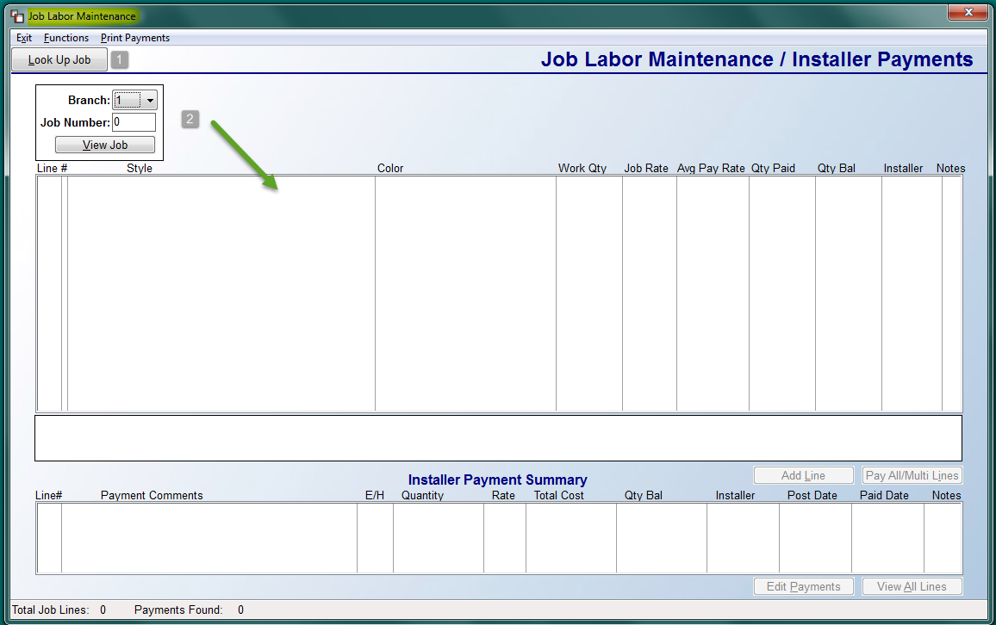

You can locate a job with Labor Lines to pay in one of two ways. The first is via the Look Up Job (1) button at the top left. This button will call up the Order Entry job selection screen allowing you to use all the available search features to locate the applicable Job. If you know the Job Number (2), you can type it directly in that field and then hit the View Job (2) button to load any existing Labor Lines to the box below. The Branch (2) field will allow you to process payments for another Branch without leaving this module. The system will prompt a message when you log into another Branch. Once a job is selected, the Labor Lines will display in the box below as follows:
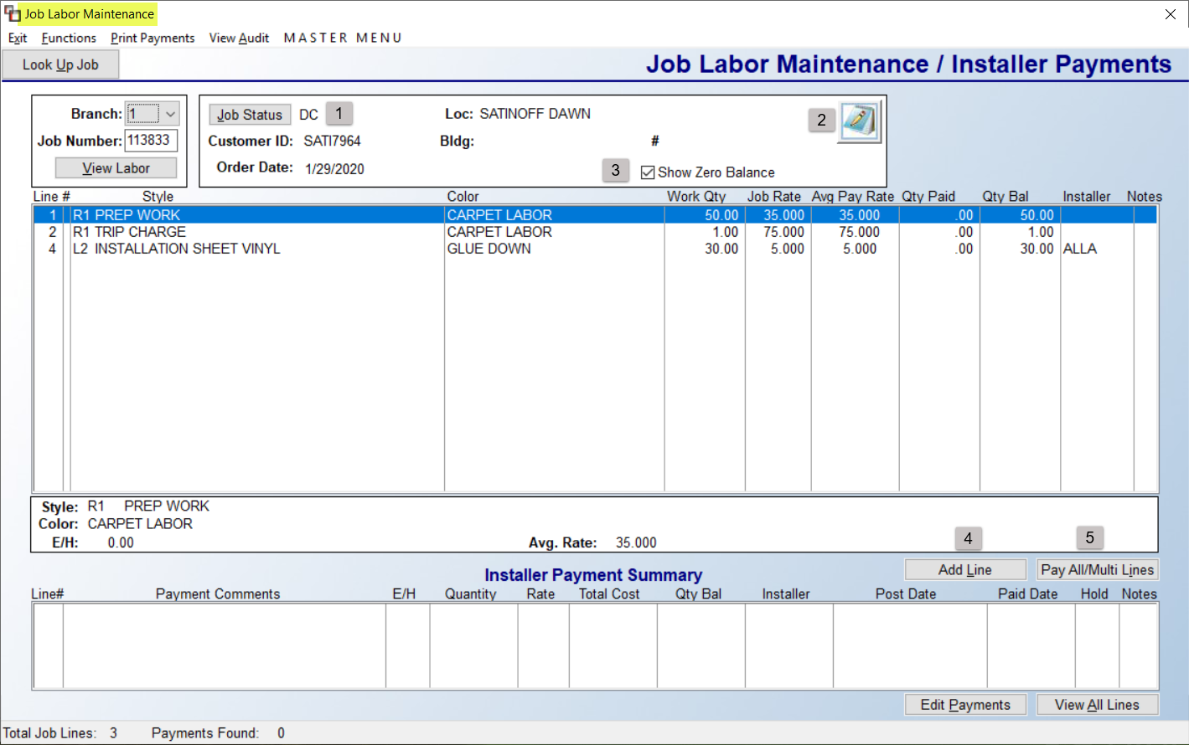

Once a Job is selected, the details of the Job will display in the box to the right of the Job Number field, and all the Labor Lines will display in the box below. The Job Status (1) button can be updated from this screen where applicable. The Notes (2) icon will give you access to Job Number Notes. The Show Zero Balance (3) box will be checked as a default setting. To hide any lines with a zero Qty Balance to pay, you can uncheck the box. The Add Line (4) button will allow you to add a line from this screen. It will prompt the Catalog Product Selection screen. The Pay All/Multi Lines (5) button can be used when all lines are ready for payment posting, or for paying multiple lines. If you will be paying only a couple of the lines, you can right-click on any line to access the Add Payment option for just that line (explained below). When you click the Pay All/Multi Lines (5) button, an Installer Payments screen will prompt as follows:
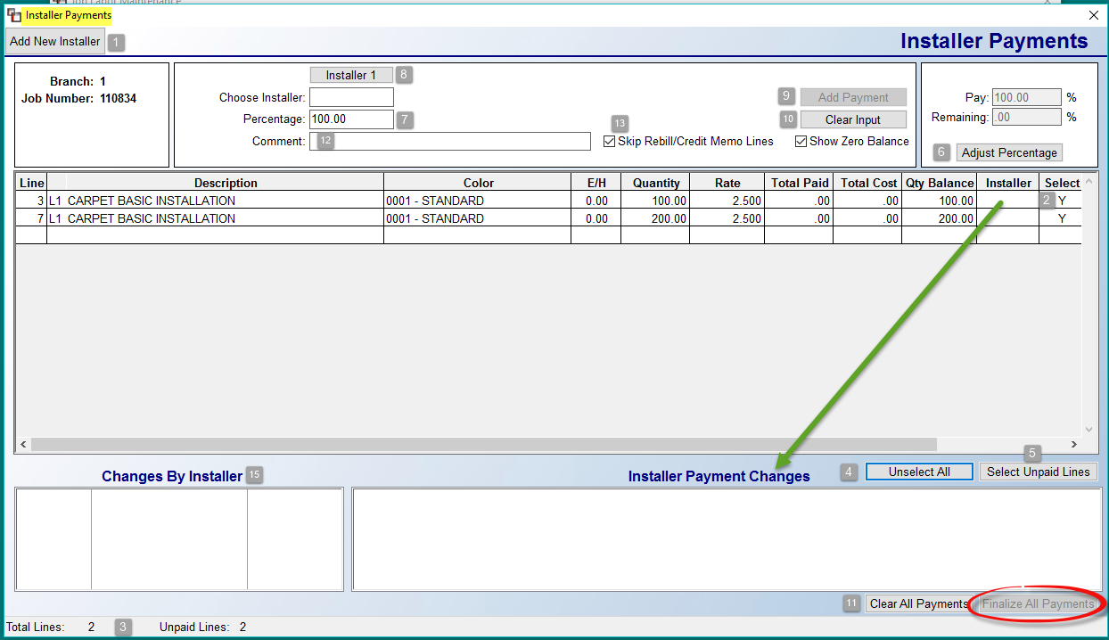

The Add New Installer (1) button, located at the top left of the screen, prompts the Installer Maintenance module, allowing you to add an Installer “on the fly” prior to adding a payment. All lines will currently show “Y” in the Select (2) column when you first enter this screen. At the bottom left of the screen, the Total Lines (3) and Unpaid Lines (3) fields will update automatically as changes are made. If you need to unselect and pay only some of the lines, use the Unselect All (4) button to instantly unselect. The Select Unpaid Lines (5) will instantly select any lines where the Select column is blank. The Adjust Percentage (6) button and fields, where applicable, is used to adjust the total percentage of what you want to pay on lines selected. If more than one line is selected, you can set a percentage to pay a portion of what is selected. If one item is selected, you can adjust the total percentage of what is to be paid on that one line.

If an Installer was assigned from the Order Entry screen, their ID will prompt in the Installer column. Please Note: if an Installer is assigned at the Line Level, and there are no other Installer records for Multi-Date Installations, the Installer that appears at Line Level will apply for all. To assign/change an Installer on selected lines, click the Installer 1(8) button. The system will prompt an Installer Selection box. Make your selection and the system will update the Choose Installer field with the Installer ID selected. At the Percentage (7) field, if this is the only Installer to be paid for the selected lines, leave the default of 100%. However, if you wish to pay two or more Installers for a percentage of the work, adjust the percentage down, say to 50% to split between two Installers, and the system will prompt an Installer 2 button as follows:

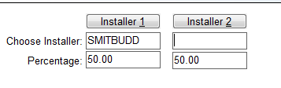
You can split the percentage on up to five Installers. If you make any mistakes, use the Clear Input (10) button to clear that data and start again. When the data is correct, and 100% of the total quantity has been assigned to one or more installers, click the Add Payment (9) button to save the data. The system will then prompt a Confirm box as follows:
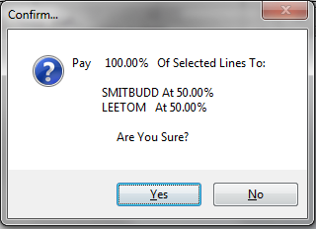

Click Yes to continue. The system will then display the payment data in the Installer Payment Changes and Changes by Installer boxes as follows:

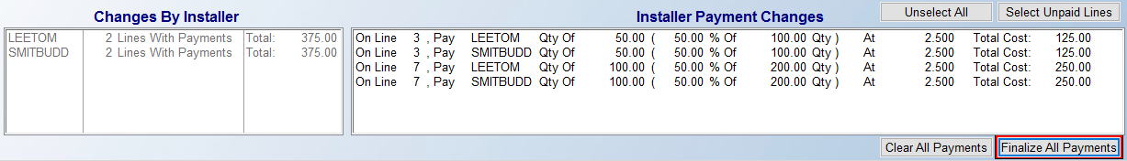

The data will not be finalized until you click the Finalize All Payments button. If you exit this screen prior to clicking that button, the system will prompt the following:

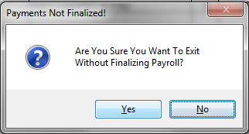

If you click Yes, none of your data will be saved. If you click No, you can then return to the screen and use the Finalize All Payments button to save the payment data. The Comment (12) field will be blank unless the Company Control 3 option “Prompt Ship To in Installer Pay” is set to “Y” for yes. If so, then the Customer Name and Ship To Addr 1 & 2 will automatically prompt here. The Skip Rebill/Credit Memo Lines (13) box will be checked automatically. You can uncheck where applicable.

When you return to the Job Labor Maintenance screen, the Installer Payment data will now display in the Installer Payment Summary box as follows:

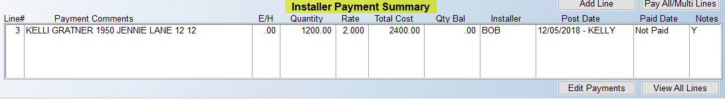

The Post Date column will reflect the date the labor bill was posted in this module, along with the User ID of the person who added the Payment. The Paid Date column will display “Not Paid” until the Installer is paid via the Installer Payables module, at which time it will display the Paid Date. When all payments have been added, at the top left of the Job Labor Maintenance screen is an option to Print Payments. Click this option to see all line items where payments have been added in preparation for using the Installer Payables module. When you click this button, you will also get the following prompt: Do you wish to print comment lines? If you select “Yes” at this prompt, any Work Order comment lines will print along with the payment information.

Once you have finalized payments, you can still use the Edit feature and Delete the payment, prior to updating the line as paid via the Installer Payables module. The Edit & Delete option can be accessed from the Installer Payments screen. Right-click on a line to display the Edit Payments option. The system will prompt an Add/Edit Payments screen as follows:

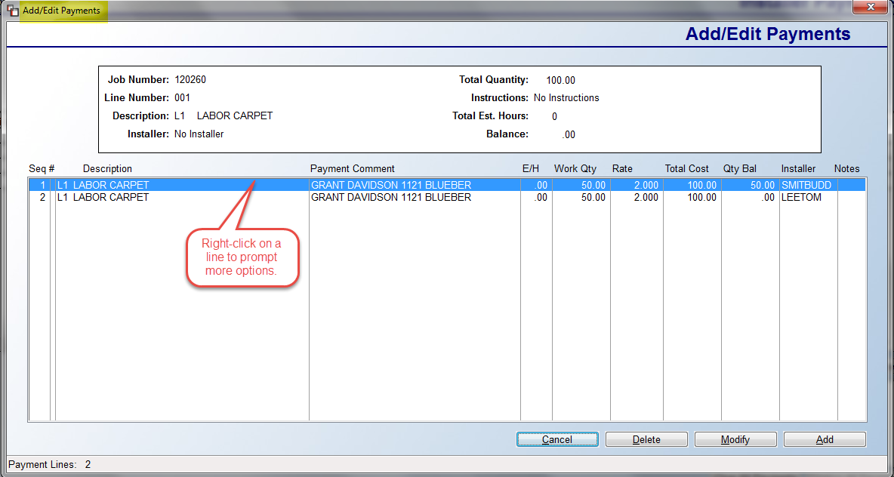

From this screen, you can use the buttons along the bottom or right-click on a line to Add Payments, Modify or Edit Payments, and Delete Payments. The second Add/Edit Payment screen appears as follows:

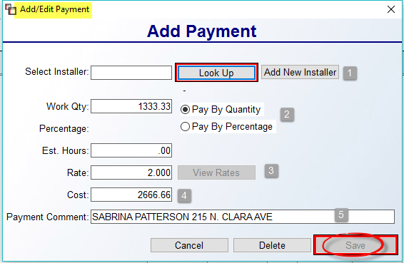

Whether you select Add, Edit, or Modify, this Add/Edit Payment box will prompt. If a payment exists, you can edit the Select Installer (1), Work Qty (2), Est. Hours, Rate (3) , Cost (4), and Payment Comment (5) fields. When adding, you can access these same fields. The Delete option will delete the payment, not the line. If you make any changes to this screen, be sure to click the Save button.

From the Job Labor Maintenance screen, prior to using the Pay All/Multi Lines button feature, you can right-click on an existing line to prompt additional options as follows:

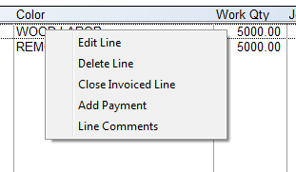

The Edit Line option will prompt an Add/Edit Line box as follows:

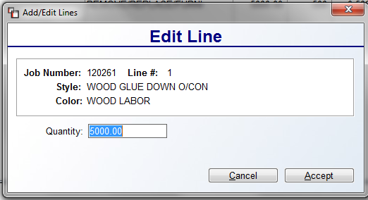

If an Installer bill reflects a lower quantity than was entered in the Job, you can adjust the Quantity to pay before you edit the line and add a payment by changing the Quantity screen in the field above. Click the Accept button to save and continue. The Delete Line option will only be available where no payments have been added. This option will remove the line entirely from this screen and from the Job. The Closed Invoiced Line option will only be available if a User has permission to perform this function. If there is a Quantity Balance remaining on a Labor Line after all payments have been posted, you can use this option to zero the remaining balance. This action converts the cost to profit on the Job. This feature may not apply to every flooring business. It should only be used where you have labor costs that will not be paid to an Installer, whether subcontractor or employee. The Add Payment option will allow you to add a payment to just the highlighted line. It will prompt the Add/Edit Payment screen explained above. The Line Comments option will prompt the Order Entry Line Comments Screen for you to view or Add Labor Line comments.

Hourly Installers:
If you are paying an hourly Installer on a Labor Line, you cannot use the Pay All/Multi Lines button feature. Instead, you will need to right-click on each line and select the Add Payment option. From the Add/Edit Payment box, you will next need to select an Installer that has been set up with a Pay Type as Hourly. The system will then prompt the Add Installer Payments box as follows:

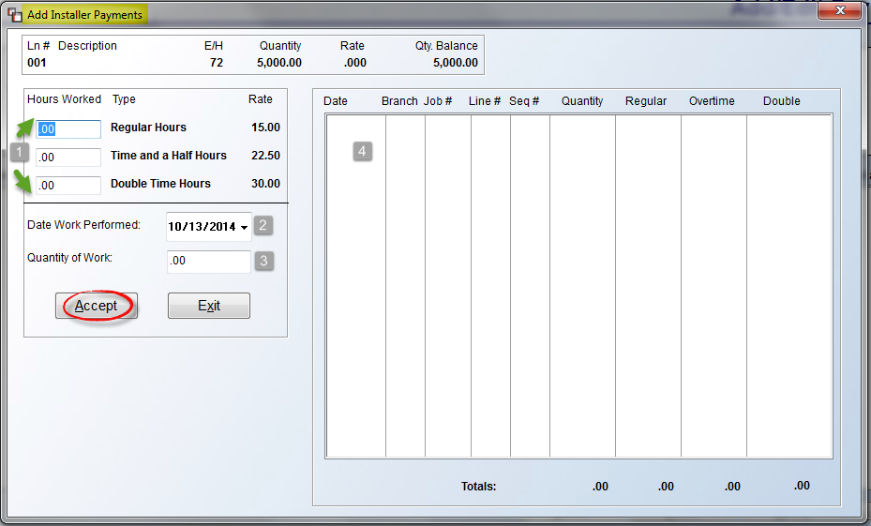

The cursor will be positioned at the Regular Hours (1) field of the Hours Worked section. Enter the number of regular hours you are paying the Installer in this field for this Job Line for this pay period. If you need to pay any overtime, you can enter those hours in the next two fields (1) if applicable. The Date Worked Performed (2) field will default to the current date; override to an earlier date where applicable. This field is important, as it is tied to the Installer Hourly Report module that requires a work Date Range to print. At the Quantity of Work field (3), enter the amount of yardage or footage completed. Please note: This is not a required field of entry. In the screen to the right (4), a list will display of all unpaid records for the selected Installer, with totals for Regular, Overtime, and Double-time hours. Be sure to click the Accept button to save the data.

Installer Payables System:
When you are ready to process Installer payroll, you will use the options contained in this module to begin that process. When you enter this module, the Installer Payables screen will appear as follows:

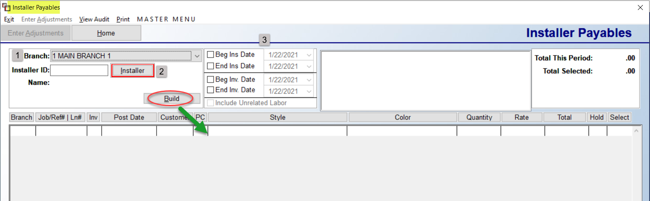

The Branch (1) field will default to the current Branch. You can switch to another Branch at this prompt, or select All Branches if the Installer has performed work in more than one Branch and you wish to process all payments together. If you select “All”, the Payables Report will total each Branch before displaying deductions at the end of the report. At the Installer ID field, use the Installer (2) button to prompt an Installer Selection box to select an Installer. In the Date box (3), you can program beginning and ending Installation and Invoice dates, if applicable, to further narrow the search results. Next, click the Build button to display all open items for the selected Installer as follows:

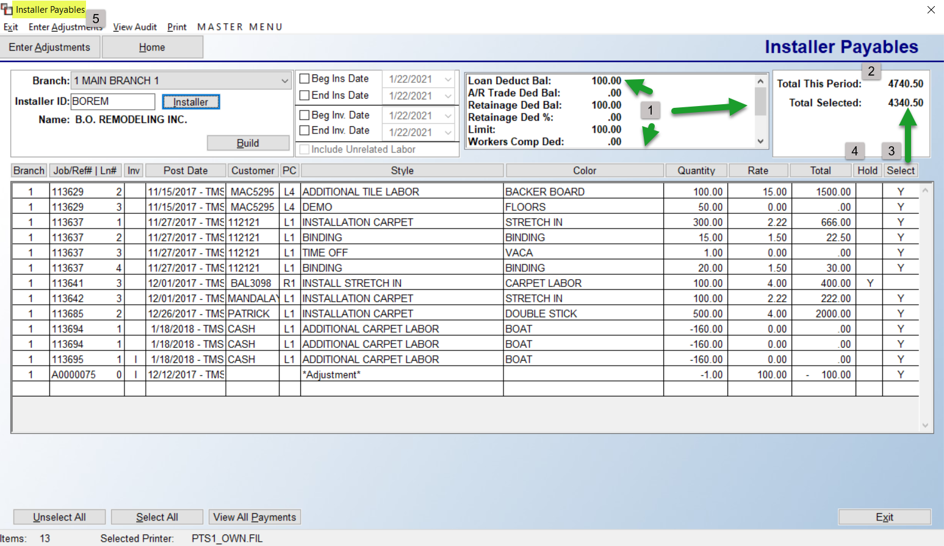

Once an Installer is selected, you will see account details display in the box to the right (1) of the ID, such as Loan Deduction Balance, any A/R due, Retainage balance, etc. These fields are display only and will be updated during the Print Payables Report process (explained below). In the box to the top right, the system will display Total This Period (2), which is the total of all Labor Lines that appear in the screen below, and Total Selected (3), which is the total of any lines that have been selected for payment. If no lines have been selected, this field will be .00. The Hold (4) column can be used to place a hold or release a hold on any Installer Payment. In order to use this feature, it must be enabled for all applicable Users in the User Control 7 screen of the System Control Maintenance module. Only a User with permission can place an item on hold or release it. To perform this function, right-click on the line to prompt a Set/Release Hold option as follows:
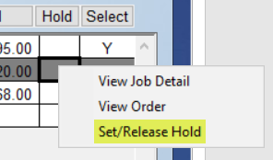

When an item is placed on Hold, the column will display a “Y” in that line. To release the hold, you will repeat this process and the “Y” will disappear, allowing selection of the line for payment. The other two options, View Job Detail and View Order, are explained below following the Enter Adjustments explanation.

The Enter Adjustments (5) button and menu option at the top left will both prompt an Enter Adjustments box as follows:

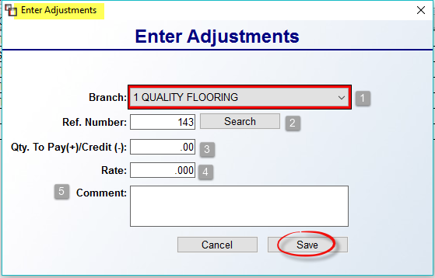

As a reminder, this feature will allow you to adjust an Installer’s paycheck without impacting job cost. The only adjustments that should be entered in this module are those that do not affect costs on a Job in the system, or any deductions not already addressed in the system. Examples include entering additional pay that relates to a Job that is not entered in the system—as in the case of Jobs that were installed prior to going “live” with the RollMaster System—and special bonuses or holiday pay that do not apply to a particular Job in the system. An adjustment can be positive or negative, you just need to make sure you are using the other deduction features properly when determining if the Enter Adjustments box is the correct place for the entry. The Branch (1) field will default to the current Branch, but you can switch to another Branch where applicable. At the Ref. Number field (2), the system will prompt the next available record number. This number can be overridden if applicable provided the number doesn’t currently exist. The Search button will find the next available reference number if a change was made and you wish to return to the next available record. The Qty. To Pay(+)/Credit (-) (3) field is typically a “1.00” or “-1.00” and the Rate (4) field is the total amount to pay or credit. In the Comment (5) field, type an explanation for the adjustment. Click the Save button to keep the changes and continue. Adjustments can be entered before or after pay lines have been selected, but must be entered prior to printing the Payables Report.

Two additional features available in this module appear when you right-click on a line as follows: View Job Detail and View Order. The first gives the ability to view the details of the Job for each line displaying. When selected, the system will prompt a Job Detail screen as follows:

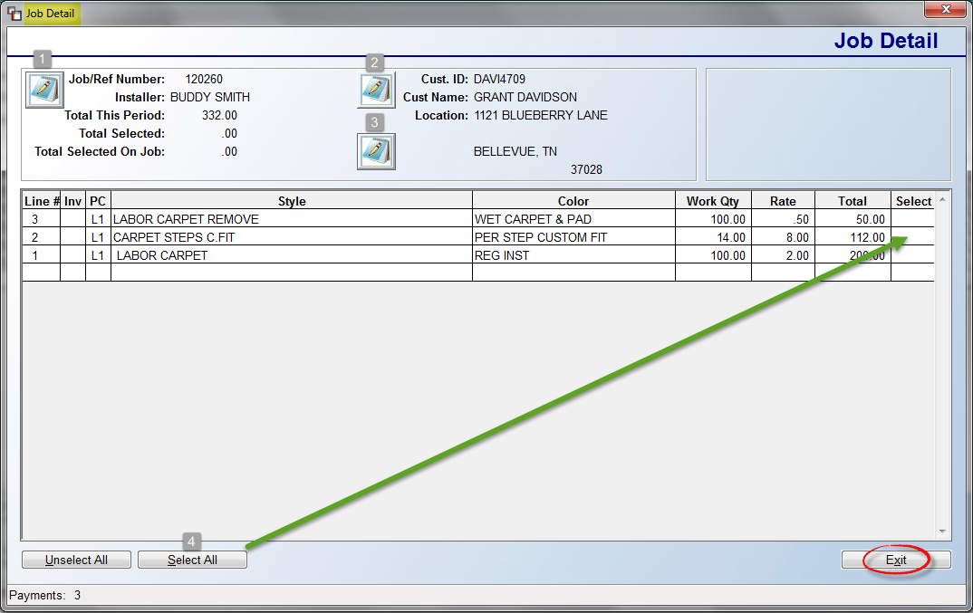

All Labor Lines for the selected Job will appear in the screen above. You also have access to viewing/editing Job Number Notes (1), Customer Notes (2), and Job Location Notes (3). You can select lines to pay from this screen in one of two ways. You can click in the Select column on each line you wish to pay, or use the Select All (4) button to select all lines for payment. The Unselect All button will unselect any selected lines. Click the Exit button to return to the previous screen. Any lines you select in the Job Detail screen will stay selected in the Installer Payables screen. Please Note: You don’t have to select lines from this screen, it is simply an option. The second option, View Order, will prompt the Order Entry screen tied to the labor item currently selected. When you are done viewing the Order, the system will return you to the Installer Payables screen.

When selecting Labor Lines from the main Installer Payables screen, you can select lines as described in the Job Detail screen above, or use the View All Payments button to prompt a larger view of the Labor Lines and then use the Select All or click in the Select column method to complete the process. Once all applicable lines are selected, you are ready to print the Payables Report. This report can be exported to Excel. The Print options can be accessed by clicking on the Print option at the top left of the screen to display a menu as follows:

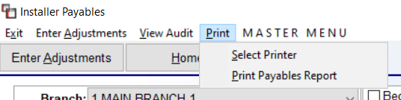:

The Select Printer option will allow you to select a specific printer. The Print Payables Report will start the payment process by prompting a Deductions box as follows:

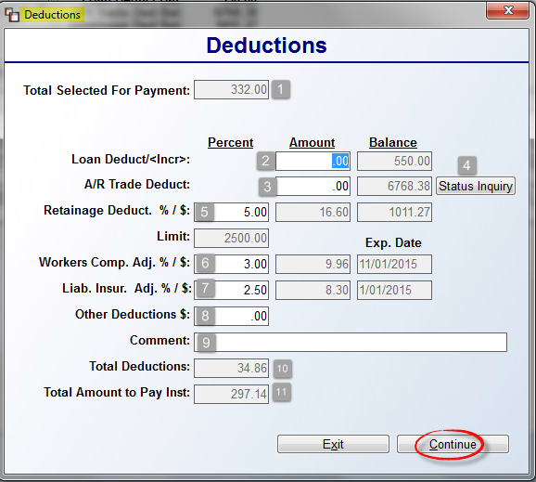

Much of the setup for this box comes from the Installer Maintenance module and changes can be made in that module as well. The Total Selected For Payment (1) is the total of all the selected lines. The Balance column of the Loan Deduct/<Incr> (2) field keeps track of any current outstanding loan owed by the selected Installer. Type a dollar amount to deduct from the Installer’s pay to apply towards the loan balance. The Increase feature in this field will allow you to add to or create a new Loan Balance provided you type a minus sign “-“ in front of the amount as follows: “-100.00.” In the A/R Trade Deduct (3) field, the system will keep track of an Installer’s outstanding receivable balance provided the Customer ID for the Installer matches the Installer ID. As Installer Jobs are invoiced from the Order Entry module, the A/R balance will accrue and display in the Balance column of this field. In the Amount column, enter a deduction that will be applied to the A/R balance once this screen is complete (see explanation below). You can deduct any amount you wish up to the total balance showing, provided the Total Selected For Payment amount will cover the total. The Status Inquiry (4) button will prompt the Customer Status Inquiry screen for this Installer so you can preview outstanding Invoices.

The Retainage Deduct. % / $ (5) field will default to the % that has previously been set up in the Installer Maintenance module for the selected Installer. If a User has permission, the percentage can be changed; otherwise the system will calculate a retained amount to be deducted from the Installers check, provided the Limit has not already been met. The Limit amount that was pre-set in the Installer Maintenance module displays just below this field. If you need to pay back a retained amount, enter a negative figure in the Amount column of the Retainage Deduct %/$ field. This amount will increase the Total Amount to Pay Inst (11) field.

Please Note: Do NOT send a zero amount to A/P. You have to pay them at least $.01, otherwise the 1099 will not calculate the Retainage as earnings. 1099's are based on paid money, not accrued money. If there is no check or a zero check, the amount of the Retainage will not be included on the 1099. As an alternative, you can add an Open Item in A/P for a penny and then pay that with the zero balance Retainage item. As long as you select both for payment with an actual payment on the check of .01, the Retainage amount will update the 1099. The Installer will likely not mind being off a penny. You can also print the penny check and sit on it until all the 1099's are done, then go back next year and Void the check and delete the .01 Open Item. You will need to Void the check by back-dating to the previous year (year check was printed).

The Workers Comp. Adj. % / $ (6) field works similarly to the previous field and changes can be made as previously explained. The same goes for the Liab. Insur. Adj. % / $ (7) field. If the Exp. Date column of either of the two previous fields displays a date earlier than the current date, the system will prevent any deductions from being taken. You will need to update the Expiration Date fields in the Installer Maintenance module. In the Other Deductions $ (8) field, if there are any other amounts that need to be deducted, such as Child Support or a Garnishment, you can enter that amount in this field but you will need to be prepared to make a manual G/L entry for this amount during the A/P posting process. The Comment (9) field can be used to make a note regarding Other Deductions.

Based on the entries made to this screen, the system will calculate and display the total of those amounts in the Total Deductions (10) field. Before you proceed, be sure the total of deductions does not exceed the Total Amount to Pay Inst field (11), as the system will not allow you to print a negative check. Click the Continue button when you are ready to proceed. If you Exit prior to clicking Continue, no changes will occur and you can start the Print Payables Report over. Once you click Continue, the system will first prompt the following: Do You Want To Print Product Information? By clicking Yes, the system will add additional detail to the Installer Payable Report. The next prompt appears as follows: Number Of Copies. The default is “1” but you can print additional copies. The system will then prompt the following: Update Items as Paid. When you select “Yes”, if an A/R Trade deduction applies to this installer for this payroll run, the system will prompt the following: Entering A/R Post Receipts Now. If you click the Ok button, the system will “jump” to the Post Customer Payments module and the selected Installer ID will prompt in the Customer ID field. You can hit the Esc key if you do not wish to continue with this process, but if you do wish to clear the receivable during this process you can continue through the fields in this screen making sure you use the Payment Type Code for clearing Installer payments that you set up prior to using this feature. As soon as you exit the Post Customer Payments module, the system will return you to the Installer Payables module and prompt the following: Entering A/P Open Item Now. Again, just as with clearing the receivable, you can escape out of this process and the payable can be posted at a later date. However, to take full advantage of the system features, RollMaster recommends training your personnel to post the payable from this module.

One final feature in this module appears at the top left of the screen as follows: View Audit. This is similar to the View Audit option in Order Entry and Quotes. When you click on this option, an Installer Payments Audit Review screen will appear as follows:

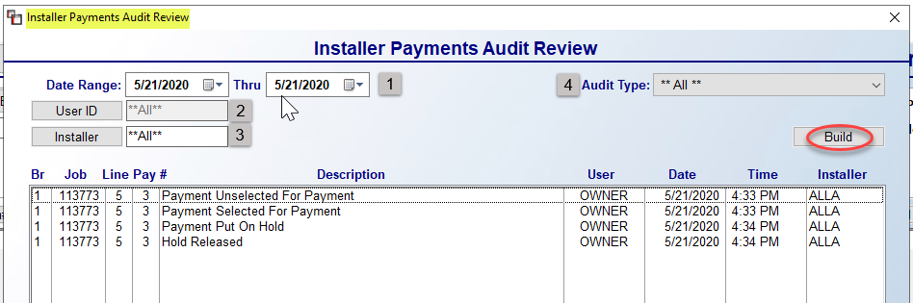

The screen will initially display all defaults on the current day. At the Date Range (1) field, you can select a different day or range of dates. You can also narrow by User ID (2), and Installer ID (3). And if you need to only see a specific Audit Type (4), you can use the drop-down box in that field to make a selection. Click the Build button to see the results of your selections in the main screen.

Installer Payroll Register:
This report compiles all of the Installer Payables Report totals together to show a total of the Installer payables for the payroll period. This report should be run only after all of the Installer Payables Reports have been run and cleared. A helpful feature to this report is that you can categorize your Installers and get a report for each category. To do this you must utilize the “Reg Type” (Code for Payment Register) field in the Installer Maintenance module. This is a single character field for which you can create a code to get separate figures on such things as employees vs. subcontractors, or installation companies vs. independent subs, or vinyl installers vs. carpet installers, etc.

When you enter this module, an Installer Payroll Register screen will appear as follows:

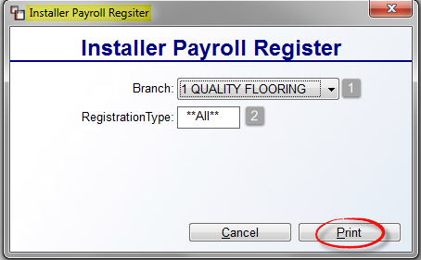

The Branch (1) field will default to the current Branch. Use the drop-down arrow to select ALL Branches to print the register for all Branches, if applicable. At the Registration Type (2) field, if you are utilizing the “Reg Type” field in the Installer Maintenance module, type an applicable code in this field or leave it set to **ALL** to print all types. Click the Print button to continue. The system will then prompt the following: Did Installer Payroll Register Print OK? Click “Yes” if the report printed, so the data will clear and move to the Installer Payroll Register History module (explained below).

Installer Maintenance:
This is a set-up module that must be completed prior to going “live” on the RollMaster System—thereafter, this module will be used to add new Installers and edit the Installer database. Before you can begin using modules in the Installation System menu, all of your Installers need to be added to the system through this module. (Very Important: Installers who are subcontractors also need to be added as Vendors—using the exact same ID code—in the Vendor Maintenance module accessible from the Accounts Payable menu.) Compile a complete listing of all your Installers including their full name, address, telephone number, and Social Security number or Tax ID (needed for the Vendor Maintenance program). As part of the Vendor Maintenance setup, you will also need to access the Vendor Type Maintenance module to create a Vendor Type Code for all 1099 subcontractors. Vendor Type Codes can be up to three alphanumeric digits so we suggest using “SUB” with a description of “1099 Subcontractor.” In the Vendor Maintenance module, you will need to add your newly created Vendor Type Code at the “Vendor Type” field at the bottom left of this screen for every Installer that is a 1099 subcontractor for your company. With these setup items complete, your 1099 tax form processing will become much easier at the end of the year.

Also, when you are posting your payables for 1099 Vendors, the Merchandise field in Open Item Maintenance module will appear as “Taxable Amount” and that will be the total for 1099 reporting. One additional area of setup involves adding a new Payment Type Code in the system via the Payment Type Code Maintenance module in the Sales Processing menu. This setup will need to be done only if you sell supplies and/or material to your 1099 Subcontractors through the system. Paying down A/R balances on your Installers is a part of the automated process in the Installers Payables System module. We suggest using the following Payment Type Code: INST with a description of Installer A/R. For the G/L Account, we suggest using an Expense Account such as Installer A/R Clearing, much like you use a Claims Clearing account for claims processing.

When you enter the Installer Maintenance module, the system will first prompt an Installer Maintenance lookup box as follows:

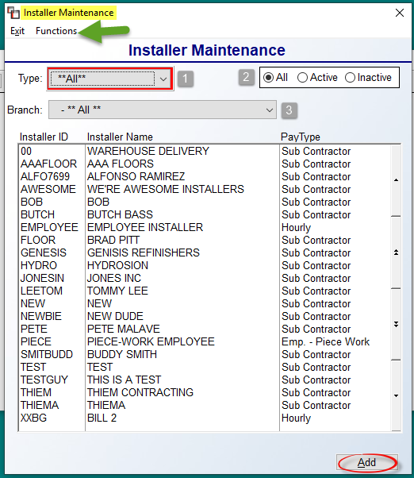

Any existing Installers will automatically prompt in the screen above. This screen be sorted by (Pay) Type (1) of Installer and by whether they are Active or Inactive (2). You can also sort by Branch (3). If no Installers have been added, this screen will be blank. Before you begin adding Installers, you will need to add key G/L Account Numbers (these need to have been added to your chart of accounts prior to being used here) to this module via the Installer G/L Maintenance option located in the Functions menu at the top left of the screen above. Only Users with permission will be allowed access to these fields. Prior to completing this setup, consider whether you would like to track these G/L’s by Branch, by Company or a combination. The Installer G/L Defaults box will appear as follows:
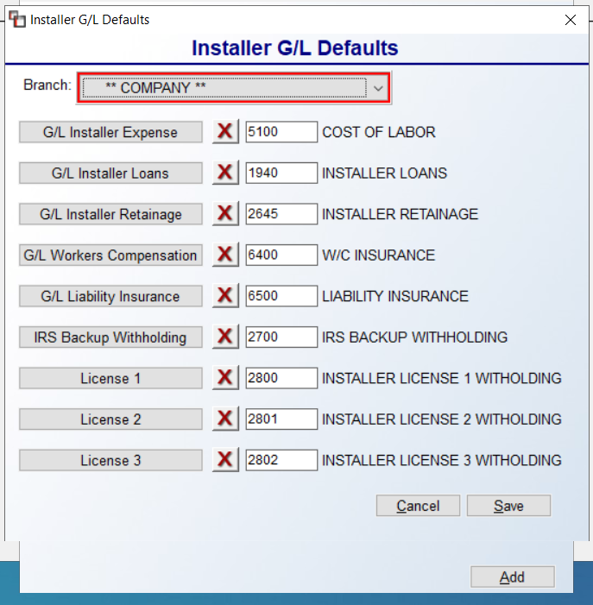

If you would like these accounts to be tracked the same for the entire Company, select the ** COMPANY ** option from the drop-down menu at the Branch field. If these accounts will be different by Branch, you will need to complete this setup for each Branch. Click each G/L button to prompt a G/L Lookup box and make your selection for each G/L Account. Be sure to click the Save button to keep any changes. The next section will describe how to Add a new Installer, followed by an explanation of options available for existing Installers.

To Add an Installer, click the Add button at the bottom right of the first Installer Maintenance screen to prompt the following screen:

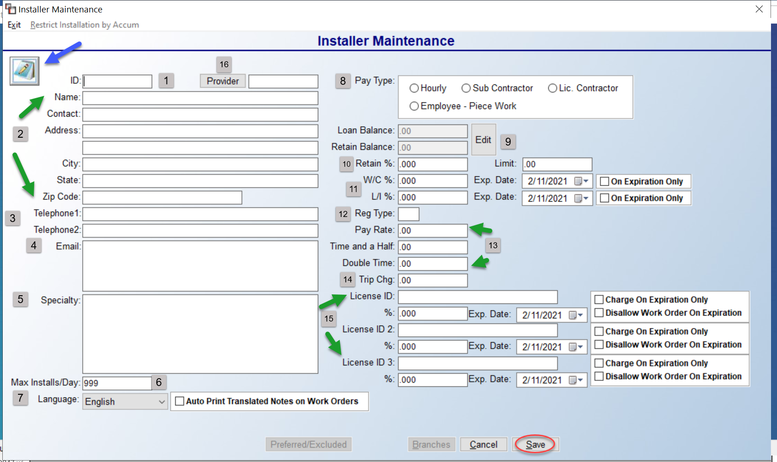

An Installer Notes icon/feature appears at the top left of this screen. This will be specific to each Installer ID and can be accessed at any time after an Installer has been added to record internal notes. At the ID (1) field, create an ID for the Installer, up to 8 alphanumeric characters, based on the method discussed with your RollMaster Trainer. In the next few (2) fields, type in the Installer’s Name or Business Name, a Contact if applicable, Address info, and Telephone (3) number(s). The Email (4) field can hold up to 100 characters for multiple Email addresses, but this field is display only at this time, and does not currently tie into any other part of the system. The Specialty (5) field is informational for you to record whether the Installer primarily works with carpet or vinyl, etc. This field holds up to 200 characters.

The Max(imum) Installs/Day (6) field was added to assist with preventing an Installer from being overbooked on a given day in the RM Install Calendar app. The default setting is “999,” which is essentially unlimited, or no change. To prevent overbooking, set this field to “1” or “2” or a higher number depending on the Installer’s capabilities or typical labor work performed, or based on whether this Installer ID runs multiple crews. The Language (7) field will only be active if the Language Translation feature has been enabled in your system via a Company Control 4 screen option in the System Control Maintenance module. Using the drop-down menu, select the default language for the Installer. To the right of that field, you will also see a checkbox as follows: Auto Print Translated Notes on Work Order. When checked, where this Installer is selected on a Work Order, Notes in his selected Language will appear, even if another Language is selected in the Work Order print screen. This allows for multiple translated notes on a Work Order for each applicable Installer.

In the Pay Type (8) box, make a selection that best defines the Installer from a payroll standpoint. The Lic.(ensed) Contractor option was added for subcontractors where you want the system to exclude Labor Overbill charges from all paid Labor Lines assigned to these Installers. The Employee – Piece Work option allows an employee who is an Installer to be assigned to piece work in the Installer Payables system, without the system running through the “Post to A/P” routine when the work is updated as paid. This feature will also allow you to skip the A/R Trade Deduction process.

At the Loan Balance and Retain Balance (9) fields, only Users with permission will have access to these fields for set up and to make any changes. Please Note: the system will not allow deletion of an Installer with amounts in either of these fields. These two fields keep track of any loans or retained amounts that apply to a 1099 Subcontractor. As you are adding Installers, if any Subcontractors have outstanding loans or accumulated retained amounts, you can enter a starting balance in these fields. As mentioned above, a User Control 4 permission must be enabled for a User to use these fields. That control appears as follows: Allowed to modify Installer Deduc. /Rpt. If this control is set to “Y” for yes, the User will have full access to making adjustments/changes. Please be aware that if any adjustments are made in this screen other than entering beginning balances, the report that keeps track of these fields in the Print Payables Report will not be accurate. If a User has this permission, by clicking the Edit button, the system will enable these fields. Type in the outstanding Loan Balance in this field and hit enter to get to the Retain Balance field. Type any retained amount that has been accumulated on this subcontractor and hit enter.

The Retain % and Limit (10) fields allow you to set a standard percentage deduction amounts for Installer retainage and then also set a Limit so that once that figure has been retained, the system will no longer withhold any retainage. The W.C. % (11) and Exp. Date (for Worker’s Compensation percentage) and L.I. Ins% (11) and Exp. Date for (Liability Insurance percentage) fields will allow you to program a default percentage to be deducted from each Installer’s check as well as enter an expiration date for when these policies will expire. Please note: these percentages can be overridden in the Installer Payables module at the time you are processing Installer checks, if applicable. To enter a default, simply type a percentage in whole numbers in each applicable field, i.e., 2 for 2 percent. That percentage will automatically default in Installer Payables and will calculate the percentage amount to be deducted from the Installer’s check based on the amount to be paid to the Installer. To the right of these two fields, you will also see checkboxes as follows: On Expiration Only. When either or both of these are checked, and if accurate expiration dates have been entered, the system will begin deducting these percentages from an Installer’s check when the date has expired. Otherwise it will remain manual to deduct upon expiration.

The Reg(ular) Type (Code for Payment Register) (12) field is tied to the Installer Payroll Register module. You can create a single digit code to produce a breakdown of different installation categories on the Installer Payroll Register. Suggested categories include subs vs. employees, installation companies vs. independent subs, or you can break down the different types of installation, or not at all—this is strictly an option.
The Pay Rate (13) field is used primarily for employees rather than subcontractors and will only work in the Job Labor Maint. / Installer Payments module if no catalog items are built under the Labor Product Codes. You will need to add a Labor Product Code for every possible rate with the exception of Time and a Half (13) and Double Time, which can be added directly in those fields, and then selected in the Job Labor Mtc./Installer Payments module (explained above). The Trip Charge (14) field is informational for you to record what the Installer charges to go back on a job, make a special trip, or charge for a trip outside of an acceptable travel area.

The License ID (15) fields are for recording that info for Installers who are licensed.
If a License ID is entered in any of the three fields, along with a Percentage amount to collect and an Expiration Date of the license, the User can then determine whether they select to Charge on Expiration Only, so the amount will begin to be deducted from the Installer’s paycheck upon expiration of the license, and/or Disallow Work Order on Expiration, preventing a Work Order or Batch Work Order from printing upon expiration—the system will display the following message: Bad Installer Info. Also, the Install Date fields/tabs in Order Entry, the Installation Schedule, the text Work Order and Graphical Work Order will not allow assigning an Installer with an expired license with the above option checked. Additionally, the G/L functionality in the A/P Open Item Maintenance module has been adjusted for these fields. Further, the RM Install Calendar app will not allow assigning of an Installer where the license is expired and the option checked. These fields will also appear in the Installer Payables System when you print the Installer Payables report, as well as in the Installer Payables History module when exporting to Excel. The fields will not display in the History screen because of space limitations, but they will factor into the total calculations. And finally, these fields can be imported in the Installer import and they appear on the Installer Listing Report to Excel.
With all this functionality, if you do not wish to utilize these fields, they can be left blank for no change in the system.

Back at the very top left of the Installer Maintenance screen, a Provider (16) field has been added to allow for setting up Provider/Installer or Crew relationships in the system for billing/payment purposes. Before this option can be utilized, you will first need to make sure the Provider (Licensed Contractor in charge of one or more install crews) is set up with an Installer ID to use in this field. The default for all existing Installers will be their own ID, which means no change will take place in the system unless a different Provider is selected. Once the setup is complete, during the Installer Payables process, even though an Installer is tied to a Job Labor Line, the system will automatically flip to the Provider ID to process the payment. The Installer Payables Report will display the Installer ID in the last eight digits of the Memo line for reference purposes. Also, this relationship flows through to the RM Web Install Calendar, allowing a Provider to log in and see all jobs scheduled for their crews, whereas the individual Installer can still log in and only see Jobs assigned to him or her. Invoices can still be submitted, as new User Web Dashboard controls in the System Control Maintenance module have been added to control which Users can submit and/or see cost.

Once all applicable fields are completed, click the Save button to create the Installer ID and keep the information you just typed. When adding a new Installer and saving, the current Branch is automatically selected as Active and a pop-up message appears asking if you want to add to other Branches. If “Yes” is selected, the Branches selection screen will prompt (explained below). Once an Installer is saved, there are a few more options that can then be accessed from this screen. The first appears at the top left of the screen as follows: Restrict Installation by Accum. This feature is dependent upon having Accumulator Codes set up in your system. It allows for deactivating an Installer from being scheduled based on Accumulator Codes. When this option is selected, the system will prompt a Restrict Installation by Accum box as follows:

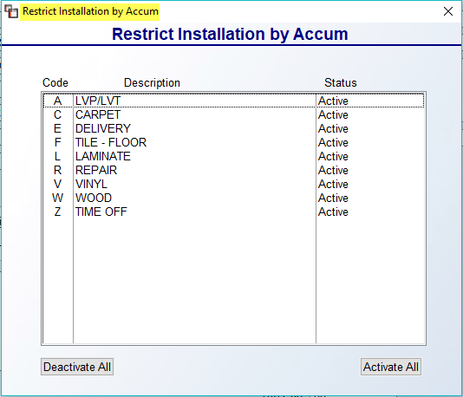

All Accumulators Codes will be Active by default. You can double-click on individual Codes to Deactivate, or click the Deactivate All button. The Activate All will reset all Codes to Active.

Another couple of options available once an Installer has been successfully added to the system appear along the bottom of the screen as follows:

The Logo button is for use with the RM Web Install Calendar efficiency tool. From here, an Installer’s logo can be added for the Invoices they are able to submit through the program. This is a simple fixed upload of a jpg file, with no Branch settings and no alignment. The next option is the Preferred/Excluded Installers button. This option can also be accessed in the first screen by highlighting and right-clicking on an existing Installer. If this Installer appears as a Preferred or Excluded Installer on a Customer Ship To Code, this button will be available to click and view details of that setup. That screen will appear as follows:

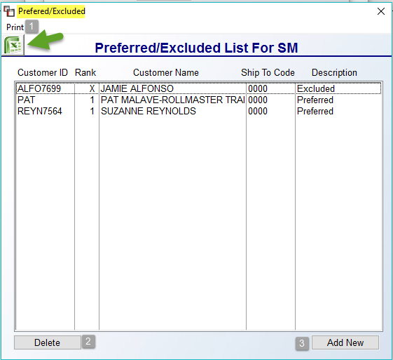

This feature allows for Printing (1) a current list of Customers/Ship To addresses that are currently set up under the Installer’s account. New Customers/Ship To addresses can also be Added (3) from this feature, as well as Deleting (2) existing. The Excel icon will allow for exporting existing setup data displayed in this screen.

The third option is the E-Docs button for RollMaster clients with that added functionality. Where an asterisk appears, an E-Doc exists pertaining to this Installer. You can view existing E-Docs, or add new attachments, such as copies of licenses, Worker’s Comp certificates, etc., from this screen by clicking this option. The Branches button allows for making Installers Active or Inactive in existing Branches. When you click this option, the system will prompt an Installer Active in Branch screen as follows:
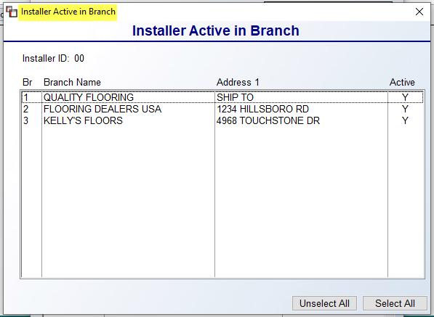

From this screen you can determine in which Branches an Installer ID will appear. You can double-click on any Branch Name to change the Active status for that Branch, or use the Unselect All and Select All buttons at the bottom of the screen to make changes to all Branches.

From the main Installer Maintenance screen displaying the list of all existing Installers, you can Edit the data on an existing Installer ID by double-clicking the ID or by right-clicking on an Installer ID to prompt the following menu options: Edit Installer, Delete Installer, Branches and Preferred/ Excluded Installers. The Edit Installer option will prompt the existing Installer Maintenance box data for the selected Installer, explained above. The Delete Installer option should be used with care, and will only work where there is no longer any balance due to an Installer or any value showing in his or her Loan Balance or Retain Balance fields. Ideally, if there is any current or historical data in the system associated with the ID, consider using the Installer Active in Branch feature to hide the ID in some or all Branches rather than delete entirely. The Branches and Preferred/Excluded Installers are the same options explained above, but can also be accessed here.

Installer Rate Maintenance:
This module can be used to program different rates for each Installer on each Labor Catalog Item. Once programmed, these rates will automatically default in the Order Entry, Quote Entry, and Job Labor Maint. / Installer Payments modules when an Installer is selected. When you enter this module, an Installer Rate Maintenance screen will appear as follows:

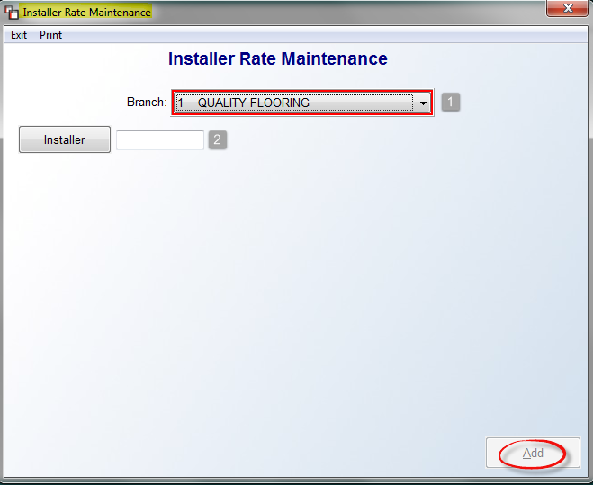

The Branch (1) field will default to the current Branch. Use the down arrow to select another Branch or All Branches, if applicable. The Installer (2) button will prompt an Installer Selection box for the selected Branch, displaying only those Installers set up in the selected Branch. Once an Installer is selected, click the Add button. The system will prompt the Catalog Item Selection screen as follows:

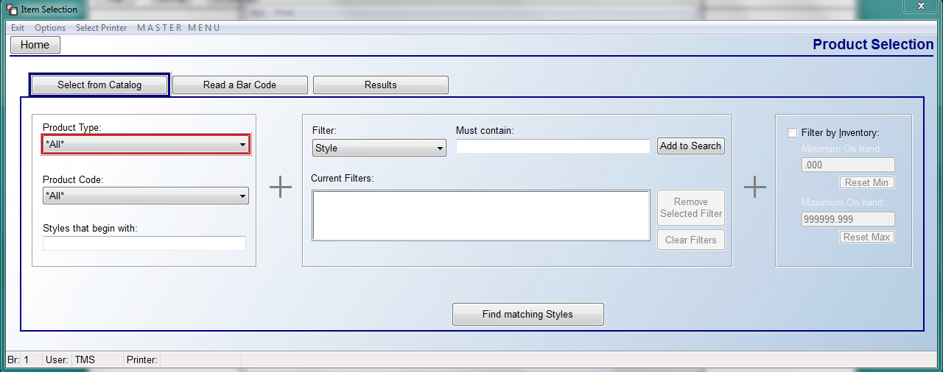

Start by making a Product Type and/or Product Code selection from those drop-down menus. Please Note: the system will only prompt Labor related Product Types and Codes in the screen above. Once you have found an applicable Labor Catalog Item via the Find matching Styles button search, click the Select Style and Color button at the bottom right of the Item Selection screen to continue. (The Select Style and All Colors button is not applicable to this feature.) The system will then display the Installer Rate Maintenance screen as follows:

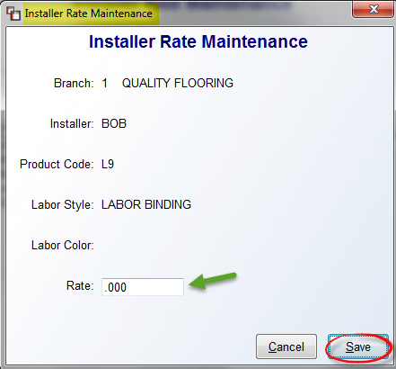
In the Rate field, type the selected Installer’s rate for this Labor item and then click the Save button to continue. The new rate will now appear for the Installer in the screen above and will prompt in the Job Labor Maint. / Installer Payments module when the Installer is assigned to this Labor Catalog Item. All programmed rates will appear in the Installer Rate Maintenance box as follows:

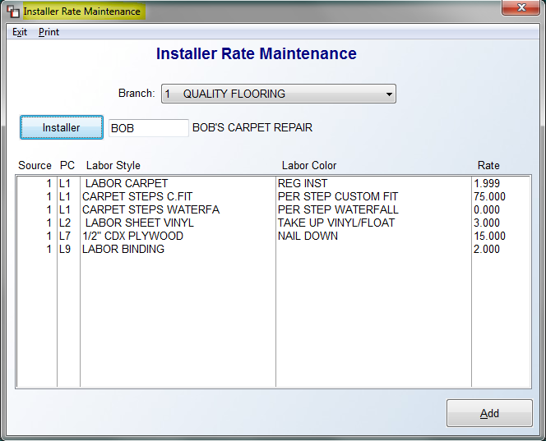

You can edit an existing rate by double-clicking on a line to bring up the Installer Rate Maintenance box and updating the Rate field. Click the Save button to save your change and continue. From either screen, a Print option appears at the top left. This option will allow you to print all rates programmed or a customized list of rates for an Installer. When you click this option, a Print Installer Rates box will prompt as follows:

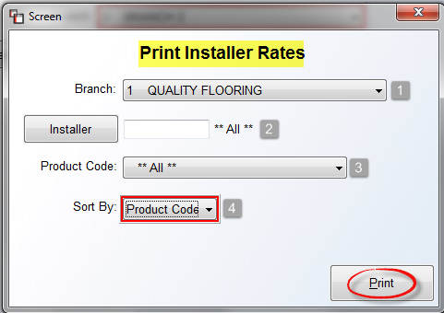

Select the applicable Branch (1) and Installer (2), as explained in the Installer Rate Maintenance screen above, or leave the **All** default to print for all Installers. At the Product Code (3) field, select a specific Product Code using the drop-down menu, or leave the default to include All Product Codes. The final option is a Sort By (4) field. You can leave the default sort of Product Code, or use the drop-down menu to select Installer as the Sort By option. Once you have finalized your selections, click the Print button to continue.

Installer Payable Report:
This module will print a report of all Installer Payables currently selected through the Job Labor Maint. / Installer Payments module. This report should be printed and used prior to processing Installer payroll through the Installer Payables System to double-check that everything is correct before printing the individual Installer Payables Reports through that module. This report displays a total for each Installer along with a Report Total at the end. When you enter this module, the system will prompt an Installer Payable Report screen as follows:

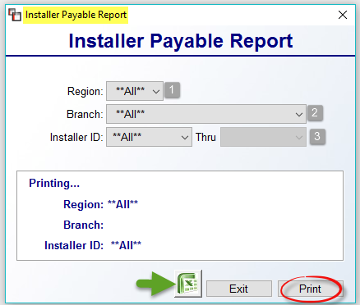

If Region Reporting has been enabled in your system, you will see a Region (1) field. To switch to a specific Region, use the drop-down arrow to make a selection. At the Branch (2) field, leave the default for All Branches, or use the drop-down arrow to select a specific Branch. At the Installer ID (3) fields, the default is All Installers. Use the drop-down arrow(s) to select a specific Installer or range of Installers. Your selections will display in the “Printing…” box as you make them. When you are ready to print the report, click the Print button. You can also export the date to Excel.

Installer Listing Report:
This module will generate a report displaying current set up information on any or all of your Installers. When you enter this module, an Installer Listing Report screen will appear as follows:

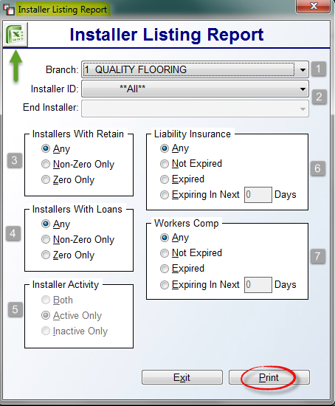

The Branch (1) field will default to the current Branch. Use the drop arrow to select ALL Branches or another Branch. At the Installer ID (2) and End Installer (2) fields, you can leave the default for **ALL**, or you can use the drop-down arrow to select a specific Installer ID in both fields, or to set up to print a range of Installers by selecting a beginning and ending Installer ID. In the Installers With Retain (3) box, make your selection with regard to Installer Retainage data or leave the default of Any. In the Installers With Loans (4) box, make your selection with regard to Installer Loans or leave the default of Any. In the Installer Activity (5) box, you can only make a change here if the Branch (1) field is set to **ALL**; you can then make an alternate selection in this box. At the Liability Insurance (6) box, the report can be set to show Any setup, Not Expired only setup, Expired only setup or setup scheduled to Expiring in the next XXXXXX days. The same goes for the Workers Comp (7) box. Click the Print button to print the report. You can also export the data to Excel by clicking the Excel icon at the top left of the screen prior to exiting.

Work Order / Pick Ticket Printing:
As you learned in the Order Entry/Maintenance module, printing Work Orders can be performed from inside or outside of a Job. In the RollMaster System the Work Order is a printed document that serves to communicate material and labor information to the warehouse personnel and to the Installers and it also updates valuable inventory information. This module has been designed to give the User lots of flexibility when using this function. For instance, you can print several customized Work Orders for the same Job if different Installers are doing the work, or you can ship partial quantities on Work Orders for multi-phase jobs. Important Note: The following explanation is for systems where the Inventory Cut Sheet feature is not being used. When you enter this module the screen will appear as follows:

When you enter this module, a Work Order Maintenance screen will prompt as follows:

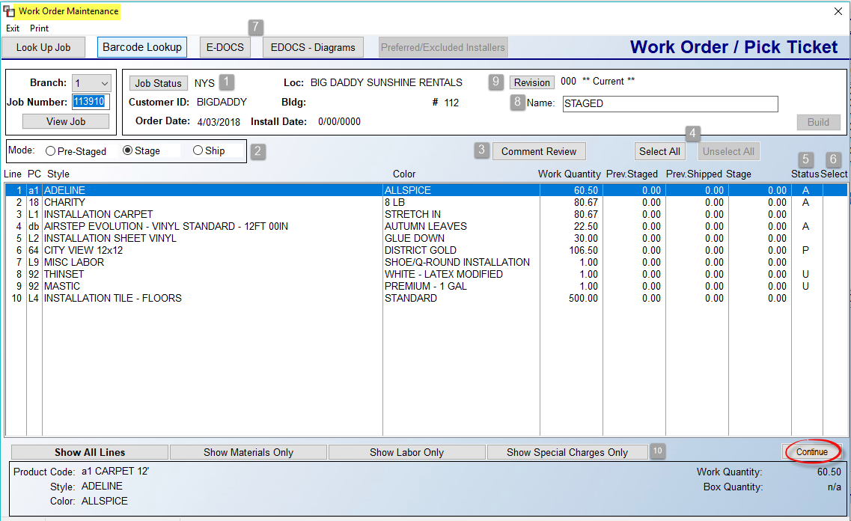

In this first section, we will cover the basics of this program, and further down in the documentation, we will get into more advanced processes, such as creating multi-stage Work Orders and Revisions. All the lines on the Job will appear in the screen above, regardless of line Status (5). To print a copy of the Work Order with all lines as they appear in the screen above, prior to selecting any lines, click Continue. The system will prompt the following: No Lines Selected. Do You Want to Print Work Order Only? Click Yes. A Pick Ticket Print Preview screen will prompt. Click the Print Now button to continue.

Screen Explanation:
The Job Status (1) field on the Job can be updated from this screen--you will be prompted to Save any changes. The Mode (2) box will default to Stage. This means you are getting the job ready, or in the pre-shipping stage. This Mode is used prior to material leaving the warehouse and allows for printing the Work Order document without shipping material. The Ship Mode will update inventory as having been cut and gone from the warehouse. The Pre-Staged mode, essentially a Pick Ticket, allows you to print material lines on the Work Order without assigning material. This is used for “job grouping” material in the warehouse, and can be used in conjunction with the Wireless Handheld Barcode scanner to instantly assign.

The Comment Review (3) button will prompt the Order Entry Comment Review Screen and works exactly the same when accessed from this screen. The Select All and Unselect All (4) buttons can be used to instantly select or unselect all lines. The Status (5) column keeps track of the current status of material lines. An “A” means Assigned, a “U” means Unassigned, a “P” means a Purchase Order is tied to that line, a “W” means the line has been shipped on a Work Order, an “M” means material is coming from multiple sources, such as inventory and Purchase Order, an “I” means the line is Invoiced, and a “C” means the material has been Cut, for those using the Cut Sheet functionality. The Select (6) column will display a “Y” for lines selected to Print on the Work Order. You also have access to the E-DOCS (7) functionality from this screen as well as in the Comment Review screen. The Name (8) field can be used to create distinct names for each Work Order, especially where you will be using Multi-Stage Work Order processing. The Revision (9) button (used more for multi-stage jobs) will prompt a list of each Work Order created, allowing you to update and print a Staged Work Order when that material and labor are ready to be shipped out of the warehouse, or for re-printing a Work Order. If you will only print a single Work Order, it is not necessary to create a unique name. You can also rename completed Work Orders that have not been cancelled or closed or where any lines have not been partially shipped.

Additional features can be accessed by right-clicking on each line. The options will vary based on the Status of a line and for the type of line. The following options are available in the Stage Mode for Assigned material lines:

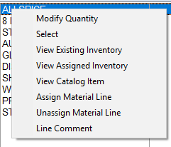

When shipped, you will see the option to Return to Stock. If a material line in Stage Mode is Unassigned, the same options will prompt, but the Modify Quantity and Select options will not be available. Labor Lines in the Stage Mode will display the following options:

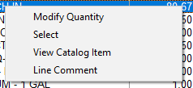

When in Ship Mode, you will see an option to Assign Installer. One additional feature to point out in the main screen is the buttons (10) along the bottom of the screen. On Jobs with multiple lines, you can click through each to narrow the view to Show Material Only, Show Labor Only, or Show Special Charges Only.

If you will be printing a single Work Order for a Job, once each material line shows an “A” Status, switch the Mode option to Ship status. The system will then prompt a Ship Selection Screen as follows:

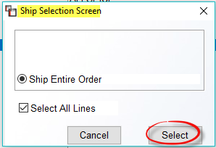

If all lines are shipping, leave the Select All Lines box checked and then click Select. The system will auto-select the lines and you can then click Continue. The system will then prompt a Work Order Print Preview Screen as follows:

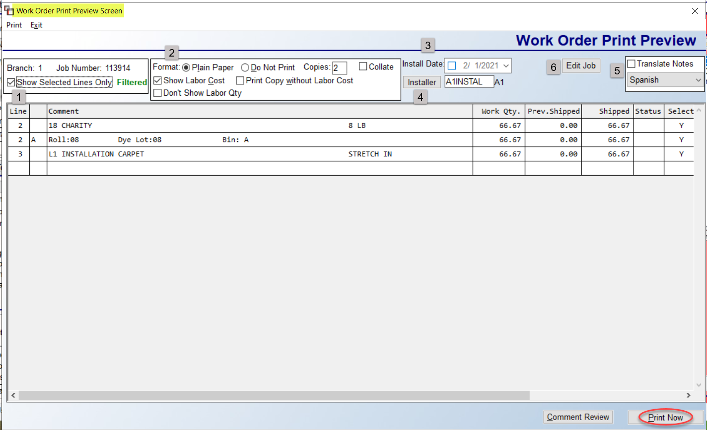

If everything is good to print, unless you want/need to update the Install Date (3) and add/change the Installer (4), you can click the Print Now button to print the Work Order. The Show Selected Lines Only (1) option will be checked by default. The Format (2) box will default to Plain Paper and you can adjust the number of Copies. If you have previously printed Staged Work Orders and simply wish to update material and labor as having left the warehouse, you can click the Do Not Print option so the system updates without generating a hard copy of the report. The Show Labor Cost option will be checked by default, but can be unchecked to not show Labor Cost. The Print Copy without Labor Cost is another option to leave off Labor Costs. And the Don’t Show Labor Qty, when checked, will encrypt the Labor Qty on the printed doc. The Translate Notes (5) feature, when checked, will copy existing Work Order Comment Lines, Customer Address Notes, and Installer Work Order Instruction Sheet data and print in both English and the language selected in the drop-down menu on the printed document. This feature also appears on all Print options of the graphical Work Order as well as the Graphical Batch Work Order Processing option. The Edit Job (6) button will prompt the current Job.

When ready, click the Print Now button to print the Work Order and ship the material. Upon printing, the system will prompt a Revision Created box showing the Revision number. Click OK to continue. The printed Graphical Work Order will look much like the following (with your company logo at top):

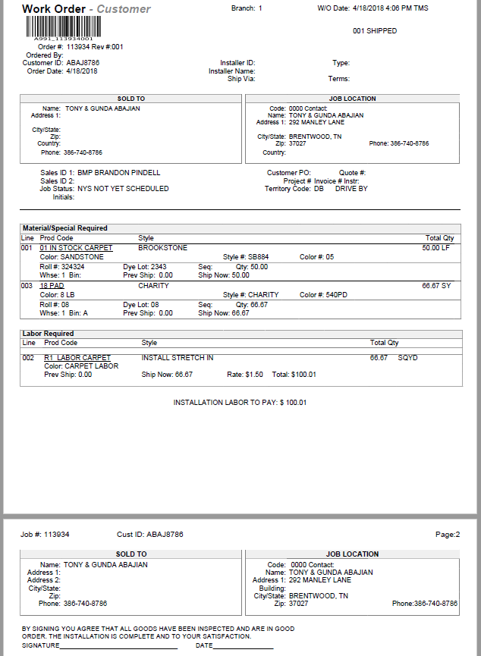

If there is an issue with the Work Order after printing, back in the main Work Order Maintenance screen, click the Revision button to prompt a list of Work Order Revisions as follows:
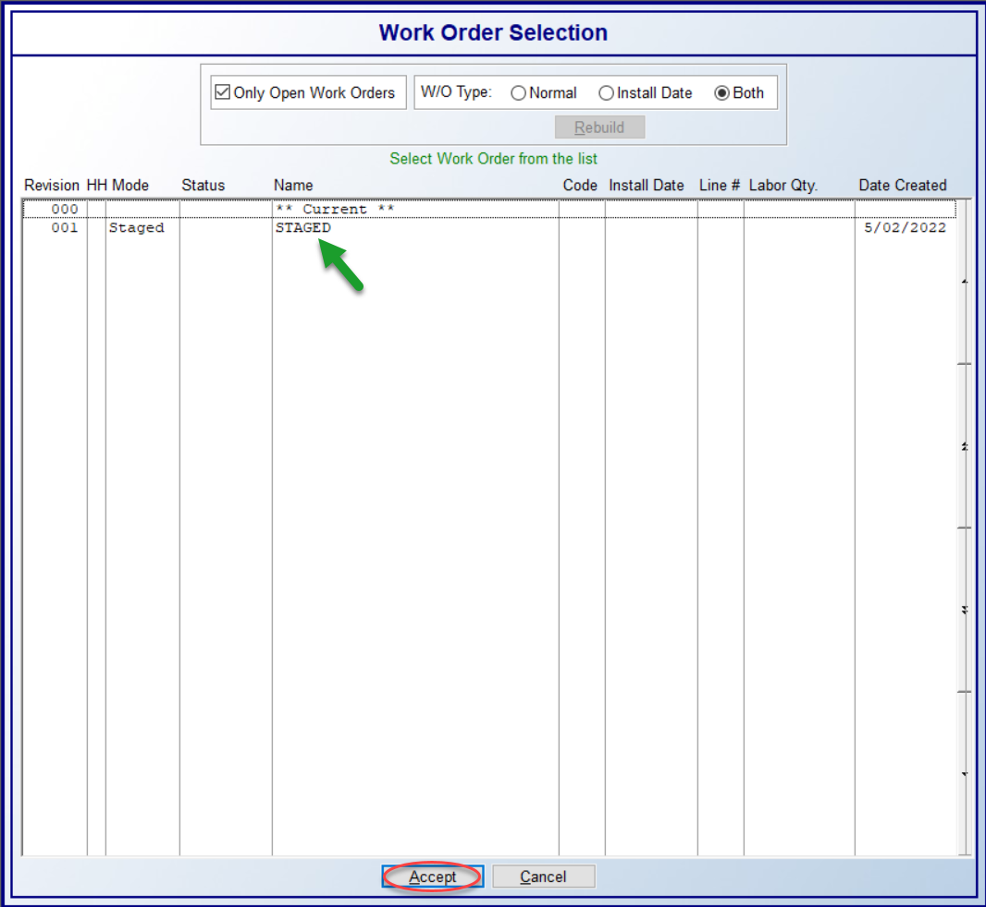
This box also pops up immediately after printing the Work Order. The Only Open Work Orders option will be checked by default. Because you can cancel a Work Order and create multiple Staged and Shipped Work Orders, the system saves all versions and you can uncheck that box to view closed Work Orders. In the W/O Type box, the default is Both. Work Orders created via the Multi-Install functionality (explained below) will be considered Install Date Work Orders. All others are considered Normal. This screen functions as a history for previously shipped, staged, cancelled staged, and cancelled shipment Work Orders for each Job. You can pull up any previous Work Order at any time.

To access a Work Order from this screen, click on the Work Order then click Accept. For Shipped Works Orders, the system will pull up the Work Order in the main screen and display a Cancel All button next to the Mode box, along with a Select All Lines checkbox as follows:

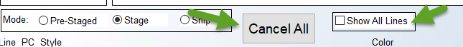

If you click the Cancel All button, the system will reset all lines so you can ship again, but the Revision will exist as a Cancelled / Closed Work Order. Please Note: this should only happen on Shipped Work Orders that need to be re-printed, but where material does not need to be returned to stock. That step will be covered in the next section. The Show All Lines checkbox allows for displaying all lines from the Job, even if they weren’t Staged or Shipped on the Work Order selected.

In both the Stage and Ship Mode, the printed documents are tied to the Terms & Disclaimer Document Maintenance module. This means you can add applicable documents to print for either mode, or print the same for both, or neither. Additionally,
when creating a Staged or Shipped Revision from a *Current W/O, you can Select and Modify quantities of both Unassigned and Purchased Inventory. You will see an “*” instead of a “Y” when selected and the document will print just like the Pre-Staged document, displaying the following: Unassigned Inventory. Additional selection displays will appear as follows: “N” for Not in Branch – Need to transfer; and if not transferred, a “P” will allow staging/shipping and display Item in Transit. The following is an example:

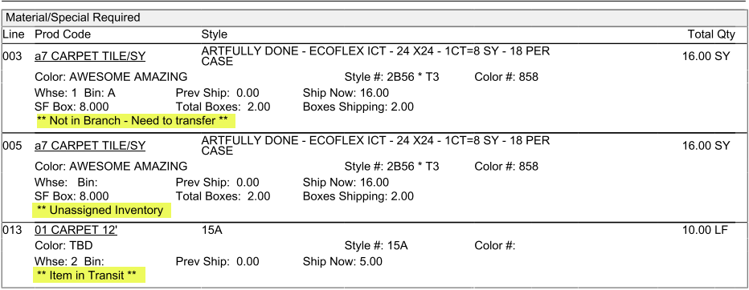

Return To Stock / Irregular Returns:
Once you have material items that have been shipped on a Work Order, you can return those items back to stock, just as you can in the text program. Very Important: Returns must be processed from the Work Order they were shipped out on. Also, Shipped materials must be returned PRIOR to being Unassigned with the Graphical Version.

Returns only applies to items that need to be returned to the warehouse and have been cut and some or all quantities are being returned for later re-selection. To initiate the process, use the Revision button to prompt the Work Order Selection screen and select the applicable Work Order. You will then right-click on the line of an item being returned to prompt the Return to Stock option. The system will prompt a Return Material Screen as follows:

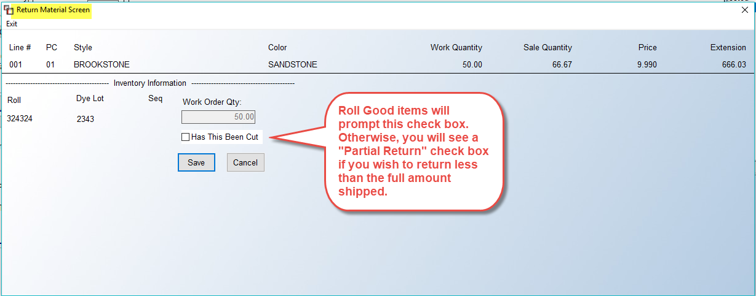

On non-Roll items, if the Partial Return box is checked, a Return Amount field will prompt as follows:
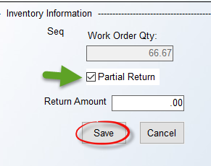
Enter the amount to put back into inventory and then click Save. You can then re-select on another Work Order, or Unassign from the Job and place back in stock.

On Roll items, the system will prompt a Has This Been Cut check box. If the entire amount in the Work Order Qty box is coming back, you can just click Save. However, when checked, you have the option to return each applicable cut, or process an Irregular Return. The system will prompt a Return Material box as follows:

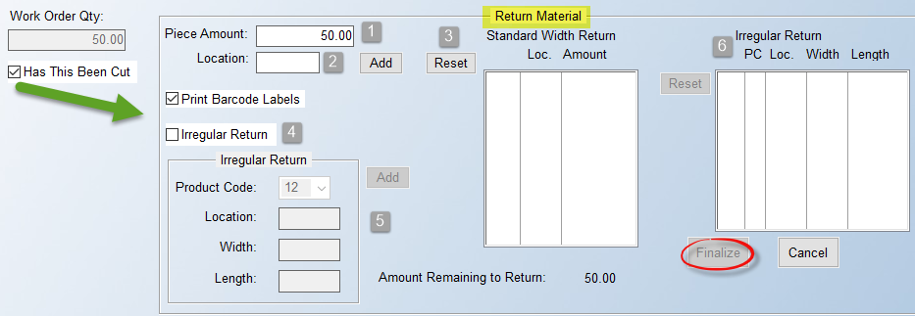

In the Piece Amount (1) field, type in the first cut amount being returned, along with the Location (2) (required field) in the warehouse, and click Add. That piece will prompt in the Standard Width Return box, and the Amount Remaining to Return will update accordingly. Type in the next cut, and so forth. If you need to re-enter the data, click the Reset (3) button to clear the existing cuts. When all cuts are entered, click the Finalize button to return to inventory. For Irregular Returns (4), click that check box. In the box (5) below, select the Product Code for the Irregular Return, and enter the Location, Width, and Length, followed by the Add button. You will then see the item(s) prompt in the Irregular Return (6) list box. Use the Reset button next to that box to clear the contents and start again if needed. When complete, click the Finalize button to move the item(s) to inventory. When you hit the Finalize button, the system will prompt a Finalize Return box with a summary of what you entered as follows:
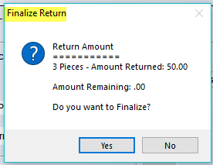

You will need to click Yes to save your changes. If you click No, the system will return you to the Return Material screen. Please Note: When a new inventory item is created from this process, the system will write a line to the Memo field on the inventory record with the Branch ID, W/O #, Job #, and Job Line #.

Multi-Stage Work Orders:
This section covers how the new graphical Work Order works in conjunction with the scheduling of Multi-Install Dates in Order Entry. All of the setup must be complete for scheduling Multi-Install Dates prior to using the Multi-Stage Work Order functionality. The process starts with the scheduling of multiple installation dates in Order Entry. Please refer to the documentation on Multi-Install Dates for details, as this section strictly covers the Graphical Work Order Multi-Stage process. As each Install Date is scheduled, the system will generate a “Stage Mode” Work Order accessible from the Revisions button/screen. It will look much like the following:

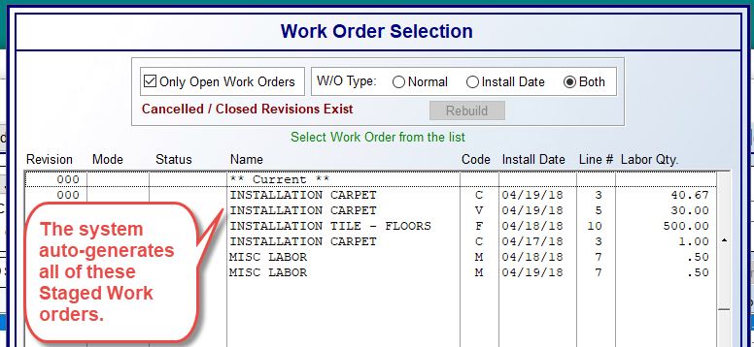

You can then select each Revision and Modify and Ship all or some lines as needed, making any needed changes based on the way the graphical Work Order functions, as explained above. You can pull up each Revision and re-name as you see fit. When you create a new Shipped Work Order Revision, the Pre-Staged Version above will auto-close, but can be called back up at any time by un-checking the Only Open Work Orders check box.

Please Note: If the Company Control 1 option in the System Control Maintenance module, W/O Print – Show Installer Pay?, is set to “Y” for yes, a check box for Show Labor Cost will display with the default setting as checked, and another check box will appear next to that one as follows: Print Copy without Labor Cost. If both options are checked, the print program will create two copies: one with Labor Cost and one without. Additionally, if the Show Labor Cost box is unchecked, the second Print Copy option will disappear. And finally, when utilizing the Re-Print option, the system will not display the Print Copy without Labor Cost check box, even if the Company Control 1 option mentioned above is set to “Y.”

Additional Features tied to other areas of the system:
With regard to shipping Private Labeled material on the graphical Work Order, if the Company Control 2 option in the System Control Maintenance module, Use Private Labeling by Customer, is set to “Y” for yes and a Private Label item appears on the Work Order, the printed document will display “-customer” instead of “-warehouse” at the Header level. See below:

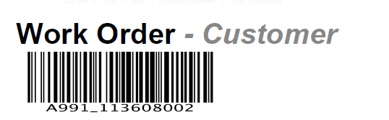

Additionally, in systems where Multi-bin functionality is enabled, an update was made to display the locations of inventory on the printed document when the inventory has not been assigned. Also, you can print Cut Tags (Barcode) from a Staged Work Order for each line. You will right-click to get to the Assigned Inventory screen, and then right-click on the Inventory to access the following option: Print Cut Tag (Barcode).

Installer Work Order Printing:
This module will only work with the Cut Sheet feature enabled in the System Control Maintenance module. When enabled, this Work Order should be printed once all cuts have been made on a Job via the Inventory Cut Sheet, module explained below. Prior to any cuts made, the Print Pick Ticket module can be used to ship supplies and non-roll good items on a job.

Inventory Cut Sheet:
If you do not have a RollMaster interface compatible cutting machine, you can still use this module to facilitate manual cuts made to each roll. In order to use this module, the Cut Sheet feature must first be enabled in the System Control Maintenance module (see Company Control 2 screen for feature and options). When you enter this module, a Cut Sheet Selection screen will appear as follows:

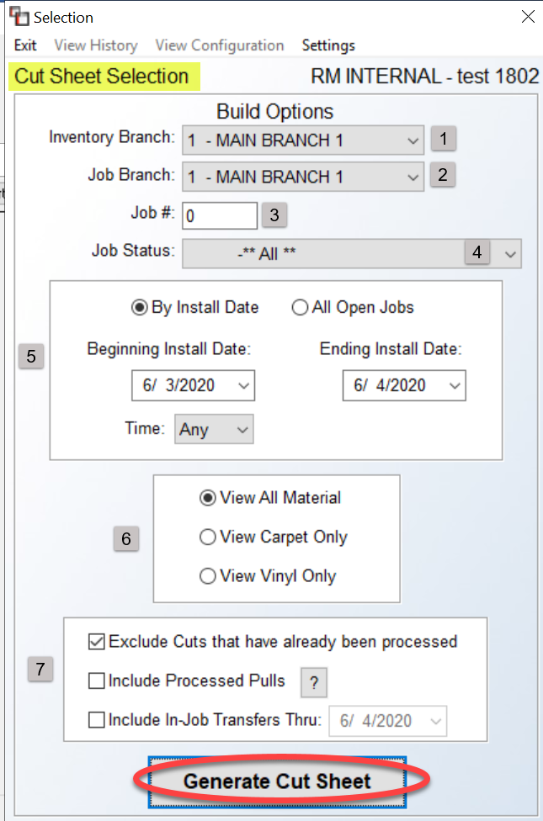

The fields in this first screen will help narrow down the items that need to be cut, or pulled, prior to performing the next step, which is to click the Generate Cut Sheet button to view items on the screen. The Settings option at the top of the screen will only be available to Users with a full Custom Menu set up in the User Control 1 screen. When you click this option, the system will display all of the Company Control 2 and Branch Control 1 cut sheet feature options as they are currently set. That box appears as follows:

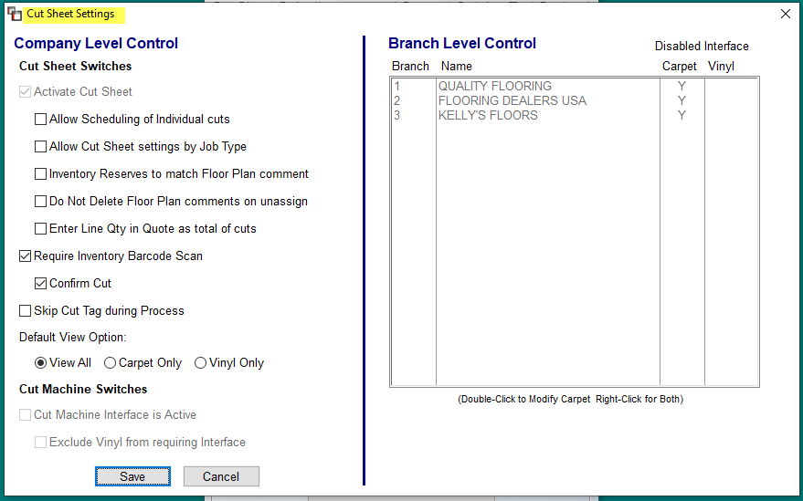

The Require Inventory Barcode Scan, Confirm Cut, Skip Cut Tag during Process, Default View Option, and Cut Machine Switches all need to be checked in this Cut Sheet Settings box in order to activate. They are not default settings that can be set in the Company Control 2 option. There is a Branch Control 1 option, Disable Cut Machine Interface, that is a two-part control for setting default options relating to Carpet and Vinyl in the Cut Sheet Settings box above. The first response is for Carpet, and the second for Vinyl, so that one or the other, or both can be activated by Branch.

Returning to the Cut Sheet Selection screen, the cursor will be positioned at the Inventory Branch (1) field and default to the current Branch. If this is the Branch containing the inventory to be cut, move on to the Job Branch field. Otherwise, use the drop-down arrow to select the applicable Branch. At the Job Branch (2) field, you can accept the default current Branch for cuts, use the drop-down arrow to select another Branch, or hit enter to proceed as normal for the current Branch, or you can select the **ALL** option to see items to be cut in all Branches. If Region Reporting is enabled in your system (see Company Control 2 option Region Reporting for more details), the system will then prompt a Region field. You can process cuts for one Region at a time or you can select All Regions. (Please Note: You must select All Branches first before you can select cuts for a particular Region or All Regions.) At the Job # (3) field, you can enter a specific Job #, and only items to be cut for that Job will display. The Job Status (4) field will only be available if activated from the Company Control 2 switch to Activate Inventory Cut Sheet. If so, you can use the drop-down arrow to select an applicable Job Status.

In the Install Date (5) box, the Install Date fields will default to the current date plus a day. Use the drop-down arrows to change to a specific date or a range of dates. (These fields integrate with the Order Entry installation fields.) As an alternative, you can click the All Open Jobs option, and in conjunction with the Job Status field above, you can use this search method instead. The next series of fields, defaulting to View All Material (6), will allow you to isolate carpet rolls from vinyl rolls and vice versa, or see all roll goods. In the final box, the system will automatically check the following option: Exclude Cuts that have already been processed (7). You can uncheck to see processed cuts in the next screen. The second option, Include Processed Pulls, when checked, will display items where the assigned quantity matches the roll quantity, meaning no cut needs to take place, but the item can be pulled by the warehouse in preparation for shipping to a job. The final option, Include In-Job Transfers Thru: works in conjunction with the In-Job Transfer feature. You can only use this option if you are utilizing In-Job Transfers. When all selections have been made, click the Generate Cut Sheet button to continue. The system will prompt a Results screen as follows:

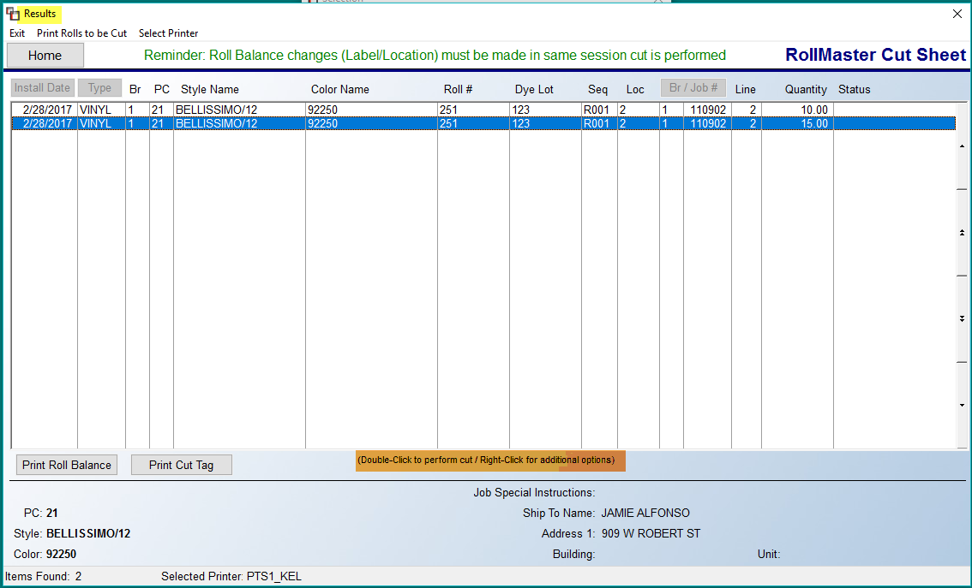

The sort in this screen is by roll number, so that all cuts needed from a particular roll, regardless of the Job, will be grouped together. Also, when a reserve amount matches the roll length of an item assigned to it or the entire roll is to be used on a Job, a “P” will display to the right of that item. There are several options available for each item appearing in this screen, accessed by right-clicking on the item. Those options appear as follows:
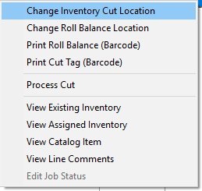

Before you begin processing any cuts, you first need to click the Print Rolls to be Cut option at the top left of this screen. The system will then prompt the following:

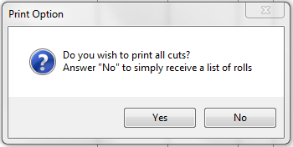

Click Yes to print all cuts or click No to print a list of rolls appearing on the Results screen.
This report lists all the rolls needed to be cut based on the Install Date you entered and should be given to your warehouse personnel so they can pull these rolls. (Please Note: You do not need to print the cuts on this report, only the rolls that need to be cut.) On the report, you will see an Estimated Roll Balance in the far right column. This is to give the warehouse person a visual of the size roll needed to be pulled so they can locate it quicker. If you have the cutting machine interface, you will place the first roll on the cutting machine before processing the cut. Place the cursor on the first cut to be made double-click or right-click and select Process Cut. An asterisk will appear to the right of the line denoting that the roll has been cut. If you are making a manual cut, the system will automatically be updated that the cut has been made and the Pointer Record in Inventory Maintenance will be updated accordingly. (Please Note: Each cut line will display in this screen for this Install Date until the job line has been invoiced through Order Entry.) Continue making your cuts for each roll until all jobs are ready to be shipped out of the warehouse. As cuts are being made, if you have the large 4x6 Bar-code label printer and the Bar-Code equipment, labels will begin printing for each of the cuts. You need to make sure your system is set up for this printer. You can do this by going to a menu, typing 88 and enter, typing BARCODE and enter, and then typing a 3 for the Printer Type. Each label will show the customer, job number, style, color, first and second address line of the Ship To address, and size of the cut.

When you have made the last cut off a roll, the Change Roll Balance Location option will allow you to change the bin location for that roll balance in the system if applicable; type in the new location when the box pops up. The Print Roll Balance option will only work in conjunction with the larger 4x6 Bar-code printer. You also need to have the RollMaster Bar-code software in order for this to work. (You do not need to have the bar-code palm pilot; that is only needed for performing physical inventories.) If you do have the proper software and printer, the system will print a new label for the roll balance displaying the new size after all the cuts.

Important Note: After making your cuts, you should also print a Pick Ticket. The Pick Ticket will only be an option in the system when the Cut Sheet feature has been enabled in the system. The Pick Ticket will also be an option in Order Entry and Property Management instead of the “Work Order” option. In the Installation System menu, you will see a menu item titled Work Order / Pick Ticket Printing. A Pick Ticket should be printed on each job for a list of all other items that need to be pulled and ready for the installer. The Pick Ticket does not display any Labor Lines. (Please Note: You cannot select roll goods that have not been cut on the Pick Ticket.) Material that is being cut will display a “C” to denote that it has gone to the cutting machine or is manually being cut. You cannot partial ship roll goods that have a “C” on a Pick Ticket, but you can partial ship non-roll goods. The Pick Ticket doesn’t save any information as far as what has previously been shipped. Please see the section titled “Installer Work Order” for that information. You should print the Pick Ticket only to see other items needed to complete the installation on selected jobs. It will not let you select any roll item that has not been cut through the Inventory Cut Sheet module. Once roll goods have been shipped on the Installer Work Order, that amount will show as “Staged” on the Pick Ticket. The Work Order Instruction Sheet will not print on the Pick Ticket, it will only print on the Installer Work Order with the Cut Sheet program enabled.

Also, from the Order Entry module, when an installation date is selected, the system will prompt the following:
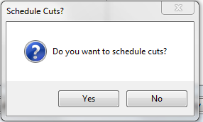

If you click “Yes” at this prompt, the system will prompt a Scheduling of Cuts Screen as follows:

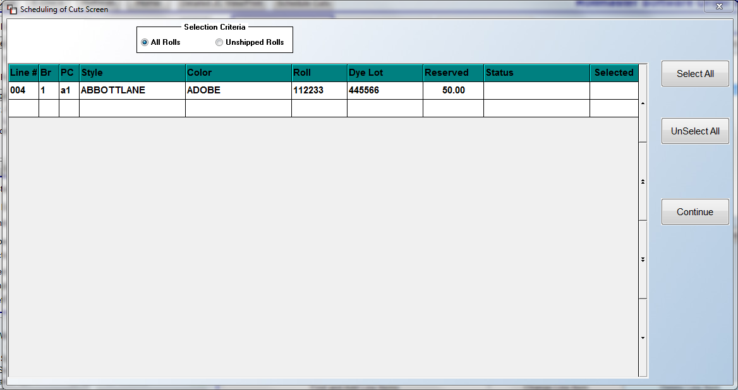

This screen will display all roll good reserved cuts so a User can select what they want cut on the Install Date selected.

Installation Schedule:
This module is tied to the Order Entry/Maintenance module. As a reminder, there are fields in the Order Entry module that update this module. The Install Date and Time will read into this module as well as the Initials of the person who set the Install Date. When a Job is first entered in the system, the Install Date may not be known at that time. Therefore, if this module is to be utilized effectively, the individual entering the Job should leave that field blank until a date can be set. Also, because installation dates and times can and do change frequently, special care needs to be taken with the Install Date fields in order to keep this module accurately updated for proper use. In addition to keeping track of labor totals for a given day, week, month, etc., this module will also allow you to assign Installers to Labor Lines, based on User permission, and update Job Status and installation information on Jobs, without leaving the program. A Refresh button will allow you to update the module with new Install Dates that have been added while you’ve been working in the module.

In order to maximize use of this program, you must first set up and add special codes, called Accumulator Codes, to your “principal” labor catalog items. For example, a typical residential remodel job may have three or more Labor Lines on a Job, just for carpet installation. However, only one of the carpet labor lines should be considered your “principal” labor catalog item. That is the line that tells the program the total yardage to be installed. The other labor lines, such as rip up, stairs, haul away, etc., should not be considered “principal” labor items in the system or the result will be an over-estimation of the total labor required for a given day. More than one “principal” Labor Line on a Job is fine, but it must relate to another installation service, such as tile or hardwood, or a different carpet installation.

The first step is to create your Accumulator Codes. You will find the setup in Product Code Maintenance as one of the items under the Functions menu as follows: Accumulator Code Maintenance. Please note: if any Accumulator Codes were previously set up under the manual field of the non-graphical Product Code Maintenance module, they will prompt in this maintenance screen. If so, you will need to enter a Description for those codes via the Edit option. When you click on the Accumulator Code Maintenance option, the system will prompt an Accumulator Code Maintenance screen as follows:
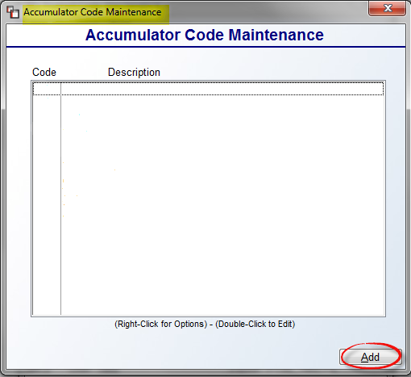

To add an Accumulator Code, click the Add button. The system will prompt the following:

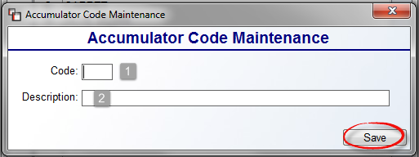

At the Code (1) field, type a one character code to represent a labor item. At the Description (2) field type a longer description for the Code. Click the Save button to save your new code and return to the previous screen. You can add/edit text in the Description field at any time. You can remove any unwanted codes by using the Delete Accumulator Code option. An example of a suggested list of Accumulator Codes appears as follows:

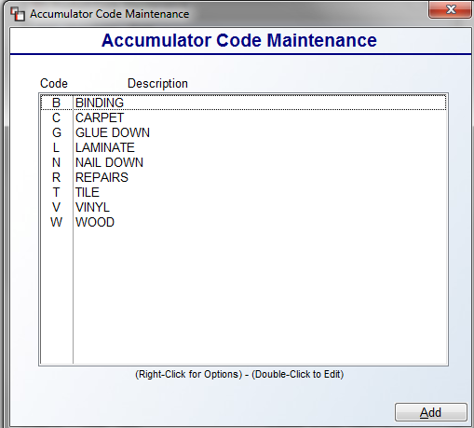

Once Accumulator Codes have been added/edited, the next step is to access the Labor Catalog via the Catalog Maintenance module and add these Accumulator Codes to each applicable “principal” installation labor item. An example appears below:

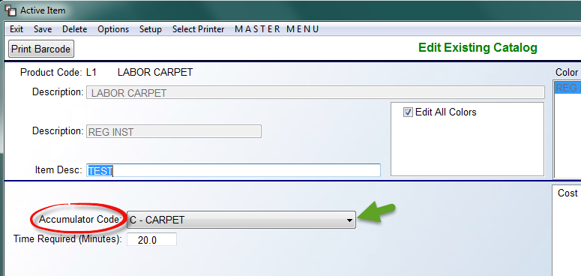

At the Accumulator Code field, use the drop-down arrow to select from a list of existing codes and make a selection. Once this setup portion is complete, there is one more setup item to complete. A User Control 5 option determines who is allowed to assign Installers in the Installation Schedule module, and also controls who can assign Installers on the Work Order. That control appears as follows: Allowed to Assign Installer. To enable this control, set it to “Y” for yes.

Once the above setup is complete, you are ready to begin using the program. When you enter this module, the cursor will be positioned at the Select Filter button and a default filter will display as follows:

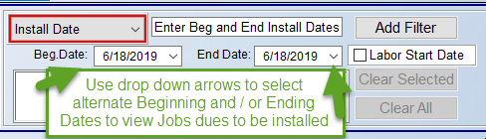

The Beg. Date and End Date fields will default to the current date. Use the drop-down arrow menus in the date fields to select a different Install Date or range of Install Dates. The Labor Start Date checkbox, when checked, allows the system to only look at the Beginning Install Date on any scheduled Jobs. This is so that multi-day or extra/fluff days added to the schedule will not factor into the lookup. Fluff days refer to days in the schedule added to tile, hardwood, etc., installs because the Installer usually has to return to grout, install trim or shoe mold, etc. Please Note: Jobs with Accumulator Install Dates are filtered by the earliest Install Date record in range on a Job. Next, click the Add Filter button to prompt the new date range and display the Installation Schedule screen as follows:

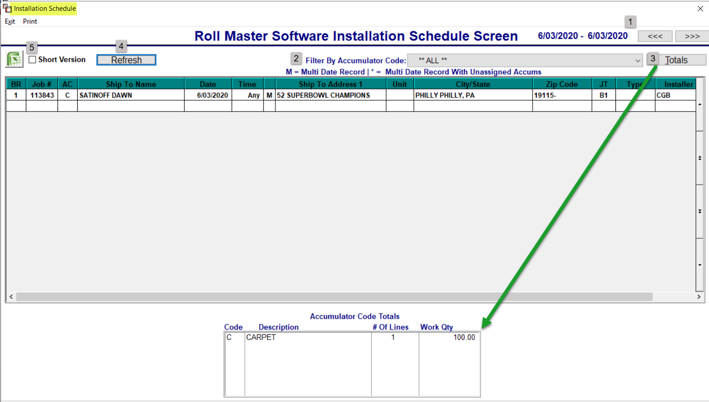

All Jobs with the Install Date(s) selected in the previous screen will appear in the screen above. The arrows (1) at the top right allow you to click forward or backward based on the date range selected. If you are looking at a single date, the system will move up or back a single day, if a week is selected, it will move a week at a time, etc. You can also filter the Jobs by selecting a specific code using the drop-down menu in the Filter By Accumulator Code (2) at the top of the screen. Based on your selection, the jobs will sort by that code and you will see Totals (3) for each code in the Accumulator Code Totals box at the bottom of the screen. If you click to highlight a specific Job, clicking the Totals button will return the view to the Accumulator Code Totals box. If you select a different Accumulator Code, you will need to click the Refresh (4) button to update the screen. You can also click the Refresh button to update the screen with any new installation data that has been added in the system for the selected date range since entering this module. Another option is to click in the box next to Short Version (5) to switch to that version prior to printing or exporting. Be sure to click the Refresh button after clicking the Short Version box.

Additionally, you can sort the jobs in the Installation Schedule screen by clicking on any of the Column Headers to sort by that data. The default sort is by the Date / Time column; click on that column header to reverse the Date / Time sort. When you highlight a specific job, the screen at the very bottom will prompt job-specific data as follows:

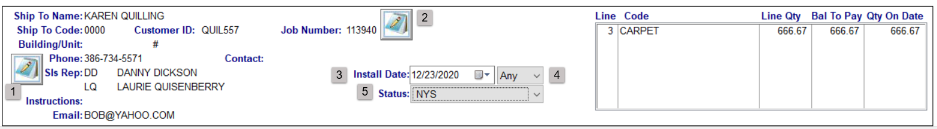

In the screen above, you can add/edit Job Location Notes (1) using the icon at the far left, add/edit Job Number Notes (2) using the icon in the middle of the screen, and make changes to the Install Date (3), Time (4), and Status (5) fields using the drop-down menus in those fields. If any changes are made to this section, the system will prompt you to click the Refresh button at the top of the screen.

When a line is highlighted, if you right-click on the line, the following options are available, based on User permissions:

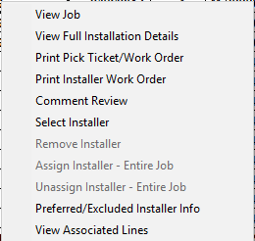

Most of these items you will already be familiar with from using them in other areas of the system. One new feature is View Full Installation Details. When you select this option, the system will display the following:

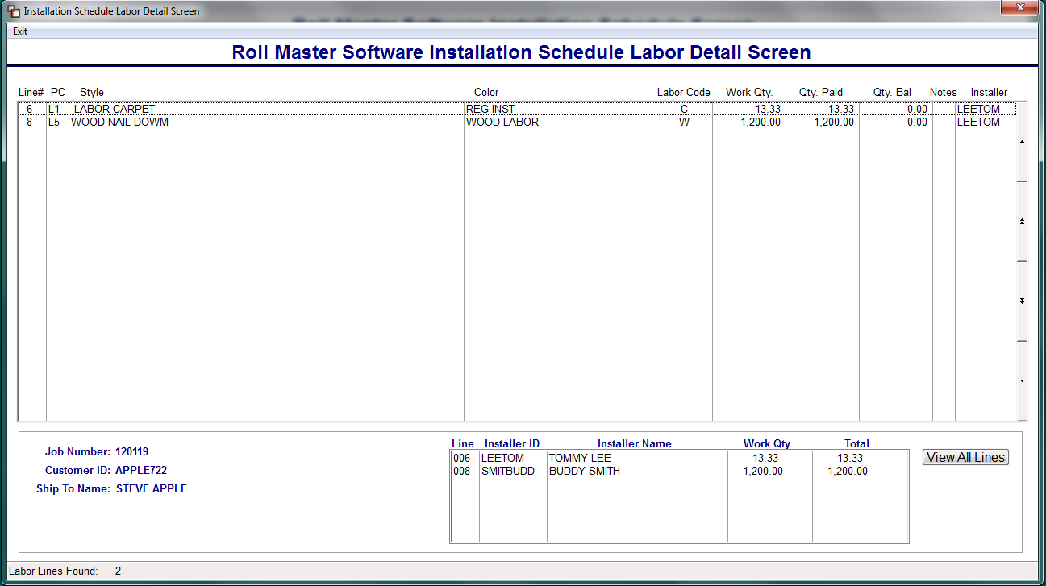

The Installer column is updated via the Select Installer option mentioned above. If an Installer ID appears in the box at the bottom of the screen, that indicates the Labor Lines have been scheduled for payment in the Job Labor Mtc./Installer Payments module. You can right-click on any of the Labor Lines in the screen above to prompt the following options, based on User permissions: View Catalog, View Job, Print Pick Ticket/Work Order, Print Installer Work Order, Line Comments, Select Installer, and Remove Installer. The Select Installer option is User controlled. When enabled, a User can select an Installer ID for the entire Job by using this option in the Installation Schedule screen, or assign different Installer IDs to each line by selecting this option in the screen above. Assigned Installer IDs will appear on the system Work Order and flow through to the Installer Payables module. When assigning an Installer, the system will check the Preferred/Excluded Installer list against the Customer/Ship To and pop up a warning where an Excluded Installer has been selected.

When you have finished filtering and sorting data and making any applicable changes in this module, you can either print the Installation Schedule Report by clicking the Print menu option at the top left of the first screen, or export the data to Excel by clicking the Excel Icon. When you click the Excel icon, the system will prompt the following:

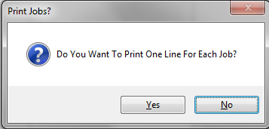

The default is No, so hit enter to continue or click the Yes button to export all lines. When you select to Print Installation Schedule Report from the Print option, the system will prompt the following:
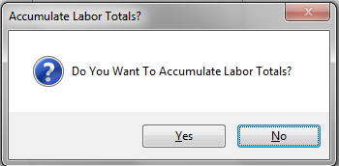

The default is No, so hit enter to continue or click the Yes button to accumulate labor totals on the report. If you select Yes, the system will then prompt the following:

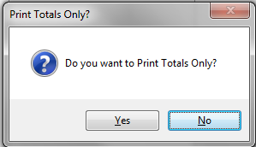

The default is No, so hit enter to continue or click the Yes button to only print accumulator totals on the report.

If you click the Short Version box prior to printing or exporting to Excel, the system will switch to the Short Version report data. Currently, the only difference between the Installation Schedule and the Installation Schedule (Short Version) is that the Short Version checkbox will be automatically selected when you access the program via the Installation Schedule (Short Version) menu option.

Also under the Print option, several additional Installation reports are available that require the use of the Foxit Reader app. With that app installed, you can click on the Print option to access a print option as follows: Additional Reporting Options. When you click on that option, the system will prompt an Installation Schedule Reports screen as follows:

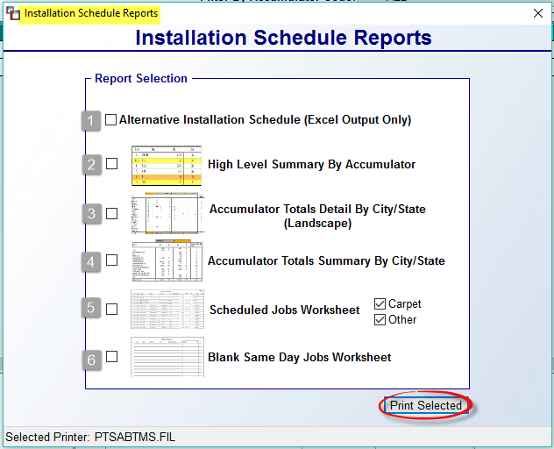

There are six different report options available. Options 1 and 5 have more broad use application across several types of dealers, but the others are more applicable to dealers scheduling 20 or more installs per day. Option 1 is Excel only and generates a scaled-down version of the regular Print Installation Schedule Report. Option 5 prints a consolidated list of every Job going out that day. It is nicely formatted and contains clear and pertinent data. With both Carpet and Other checked, you will get one page for Carpet and then everything else on a separate page/pages.

Option 2 generates a summary of the number of Jobs and totals by Accumulator Code. Option 3 generates detailed Accumulator Totals and breaks down by City and State. Option 4 generates summary totals by City/State.
Option 6 generates a blank formatted Worksheet for last minute “write in” Jobs.

Click the Print Selected button once you’ve made your report selections.
Order Entry Screen Access:
As explained above, this program can be accessed from three modules: Installation Schedule, Installation Schedule (Short Version), and from the Order Entry/Maintenance module. When you enter the Order Entry/Maintenance module, the system will prompt the Sales Processing module screen and you will now see a View Installation Schedule button at the top left of the screen, next to the Print Job Report button as follows:

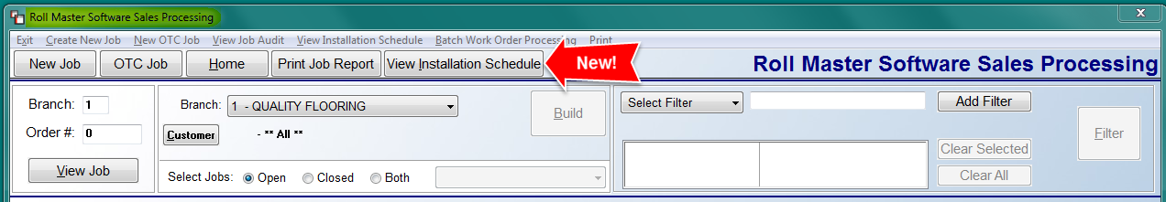

Prior to clicking the View Installation Schedule button, you must use the Select Filter option and choose “Install Date” to begin as follows:

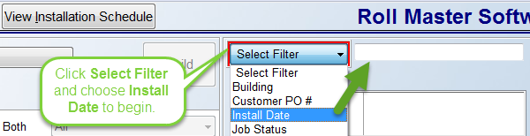

The system will then prompt a default filter as follows: Enter Beg and End Install Dates, as in the screenshot below:

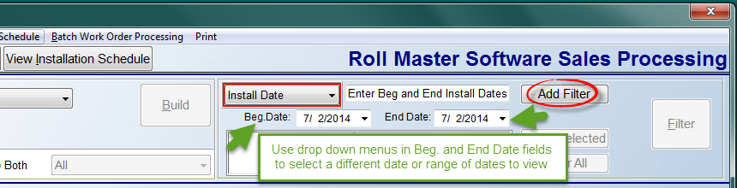

The Beg. Date and End Date fields will default to the current date. Use the drop-down arrow menus in the date fields to select a different Install Date or range of Install Dates. Next, click the Add Filter button to prompt the new date range in the box below. You will then need to click the Filter button to sort the list of jobs in the box below to match the Filter criteria. Now you are ready to click the View Installation Schedule button to call up the Installation Schedule screen (explained above).

Installation Schedule (Short Version):
There only difference between this module and the one explained above is that the report in the module above lists every labor line on a job while the Short Version report only lists the first labor line. The same screen as explained above will prompt when you enter this module, but the Short Version checkbox will be automatically selected when you access the program via this menu option.

Installer Payables History:
Once Installers are paid through the Installer Payables System module, history is available for viewing and printing in this report module. When you enter this module, the system will prompt an Installer Payables History screen as follows:

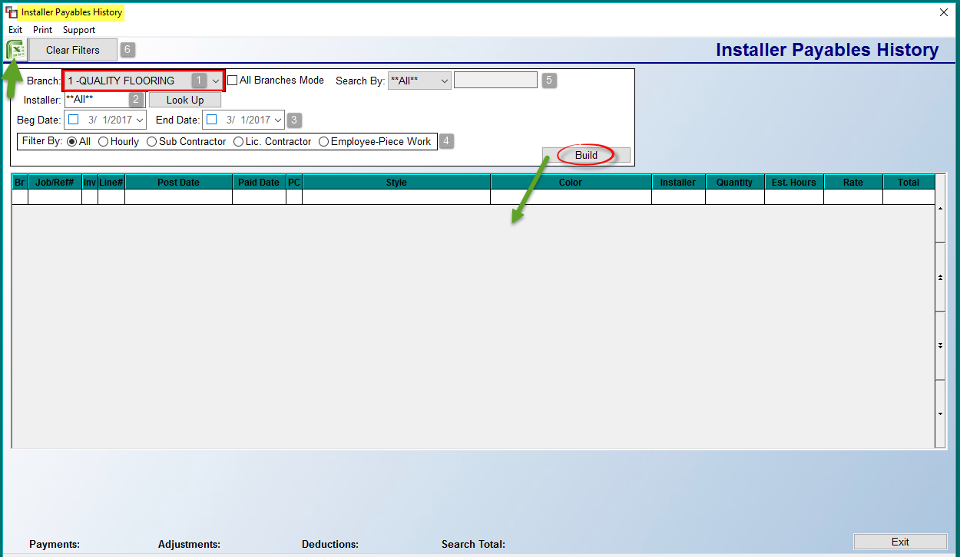

The Branch (1) field will default to the current Branch. Use the drop-down arrow to select a different Branch, or to select the ALL Branches Mode. You will then need to select an Installer (2) using the Look Up button next to that field, or choose the ALL option to view/print data for multiple Installers, particularly when using the Filter By and Search By options. At the Beg & End Date (3) fields, select a beginning and ending Installer payroll date for the data you wish to view or print. The Filter By (4) box will only be available if ALL Installers have been selected. You can then sort the data by the type of Installer. At the Search By (5) field, if applicable, you can select to search by Customer or Job #. A Look Up Customer button will pop up to the right of that box when the Search By Customer option is selected. Once you have made your selections, click the Build button to display all matching paid Labor Lines in the screen below. In the box to the right of the Build button, the system will display your current Filter Options. If you click on a Labor Line, the system will then display additional job detail in the screen at the very bottom of the screen as follows:

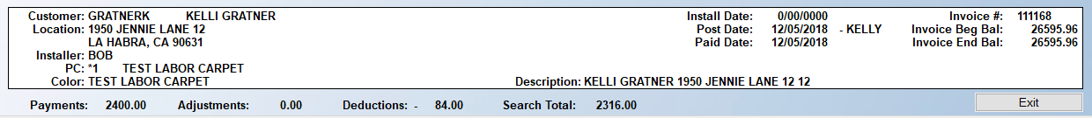

Additionally, at the very bottom of the screen, the system will total all Payments, Adjustments, and Deductions for the Labor Lines in the screen above and calculate a Search Total. If you need to create a new search, click on the Clear Filters (6) button at the top left of the screen. Once data appears, you can sort the various columns by clicking on the column headings. Once you have located data, you can export by clicking the Excel icon at the top left of the screen, or click on the Print option. The Excel feature will export a list of paid items along with any deductions, and provide full details, including all the data that creates the totals on this report. The Print option will prompt the following: Select Printer, Print Payables Report, and Print Deductions Report. The Print Payables Report will print a list of paid labor items for the Installer(s) based on the date range you have previously entered. When you select this option, the system will prompt the following:

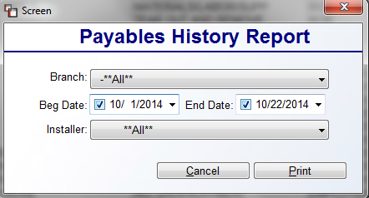

The selections in this screen are based on settings in the main screen. However, you can make changes prior to clicking the Print button. The Print Deductions Report prints a list of selected installer payroll deductions. When you select this option, the system will prompt the following:
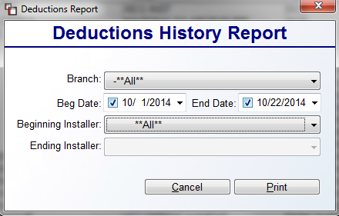

Again, the selections are based on settings in the main screen, but you can make changes prior to clicking the Print button. The system will then prompt the following: Print Loans Taken/Retainage Used Line? If you wish to see this data on the report, click “Yes.”

Installer Payroll Register History:
Once the Installer Payroll Register has been printed and cleared, that history can be accessed through this module. When you enter this module, an Installer Payroll Register History screen will appear as follows:

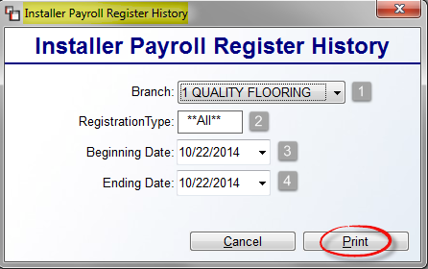

The Branch (1) field will default to the current Branch. Use the drop-down arrow to select “ALL” if applicable. At the Registration Type (2) field, if you are utilizing the “Reg Type” field in the Installer Maintenance module, type an applicable code in this field or leave it set to ALL. Use the Beginning Date (3) and Ending Date (4) fields to set a specific date or date range for the report. Click the Print button to continue.

Installer Hourly Report:
This report module is tied to the Hourly Installer box that appears in the Job Labor Maint. / Installer Payments module. It allows you to produce customizable reports on your Installers paid through the hourly installer posting module. When you enter this report module, an Hourly Installer Report screen will appear as follows:

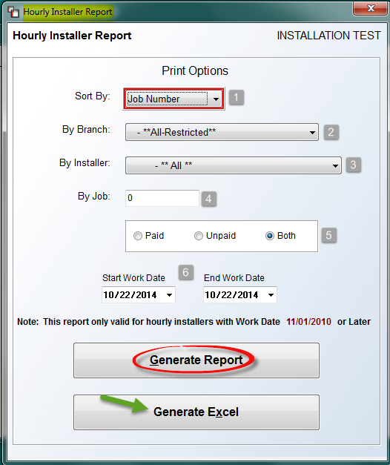

At the Sort By (1) field, you can select the default Job Number or switch to Installer. The By Branch (2) field defaults to **All**; use the drop-down arrow to select a specific Branch. The By Installer (3) field also defaults to **All**; use the drop-down arrow to select a specific Installer. In the By Job (4) field, type a specific Job # if applicable. The next section (5) will allow you to select to see only Paid Labor Lines, Unpaid, or Both. Use the Start Work Date and End Work Date (6) fields to set a specific date or date range. Once you have chosen your print options, you can click the Generate Report button prior to printing to paper to view data on screen, or you can skip that step and select the Generate Excel button to export the data to Excel. If you do select the Generate Report option first, you can still generate an Excel import after viewing the printed report as the system will return you to this screen once the report has printed.

