
A DIVISION OF TEXTILE MANAGEMENT SYSTEMS
800-777-4107
info@rmaster.com

Table of Contents

Job Cost 1
Introduction: 1
Cost Maintenance: 1
Budget Maintenance: 4
Detailed JC View/Print: 5
View Job Cost: 6
Costs By Source View / Print: 7
Job Cost Reports 9
Introduction: 9
Job Cost Margin: 9
Job Cost Detail: 11
Job Cost Detail (By Salesperson): 11
Job Analysis Summary: 11
Work In Process & 13
Billed vs Unbilled Reports 13
Introduction: 13
Work in Process – Costs From JC: 13
Work in Process – By Invoice Date: 17
Billed vs Unbilled – Costs From A/P: 17
Billed vs Unbilled – A/P w/Paid Inventory: 18
Work in Progress – Labor: 18
Job Analysis – By Invoice Date: 19
Outstanding Costs vs Cust Inv / Recd Inv. 19
Budget Vs Actual: 21
Master Lead Report (Upgrade): 22

***CONFIDENTIALITY NOTICE*** This documentation contains confidential information belonging to Textile Management Systems, Inc. and RollMaster Software, which is protected by copyright laws and other privileges. This information is intended for the exclusive use of legally licensed RollMaster Software users. If you are not the intended recipient, you are hereby notified that any disclosure, copying, distribution, or the taking of any action in reliance on the contents of this information is strictly prohibited. If you have received this documentation in error, please immediately notify us by telephone at (800) 777-4107.

Job Cost

Introduction:
One of the toughest and most time-consuming, but extremely necessary, jobs a flooring business owner faces is managing job cost. Fortunately, the RollMaster System has simplified this procedure, featuring a module for instant job cost reporting, Job Cost Margin, allowing you to track projected profit margin well in advance of a completed job. From within the Order Entry module you can “View Job Cost,” but you have additional Job Cost functionality from this menu. Plus, RollMaster continues to automatically update Job Cost after a job is closed, via the Installer Payables and Accounts Payable systems. That data will continue to be tracked and be available through modules and reports located in this menu, and will be noted in this documentation.

Cost Maintenance:
Once a Job has been entered in the system and all material lines have been assigned, you can view Job Cost information from this module. You should be aware that job costing is updated through the following modules: Purchase Order Maintenance, Receive Inventory, Job Labor Mtc./Installer Payments, and Open Item Maintenance in the Accounts Payable menu. This means that Job Costs are updated when orders are placed with Vendors, when material is received into the warehouse, when labor payments are posted, and again when Vendor Invoices are booked in the system. As costs are updated via these modules, you will be able to view the most current Job Cost data from this module. Prior to invoicing, commission changes can be made via this module provided the Salesperson is not set up on a Scale Base commission and provided the commission has not already been selected for payment. When you enter this module the screen will appear as follows:

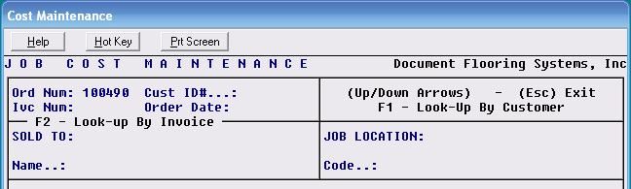

The system will place the cursor at the Order Number field; type in the number of the Job you wish to pull up and hit enter; you can also look up jobs through the F1 – Look-Up By Customer option. The system will fill in the Customer ID and place the cursor at the Invoice Number field. If the Job has been invoiced, the system will automatically prompt the Invoice Number. If there is more than one Invoice on a Job, you will need to type in the Invoice Number you wish to access if it is other than the one showing. Please Note: The system will only display Job Cost data for one Invoice at a time in this module. If the Job has not been invoiced, the system will place the cursor at a blank Invoice Number field. If this is the case hit enter to proceed. Once you hit enter the system will bring up all the order lines from the Job as follows:

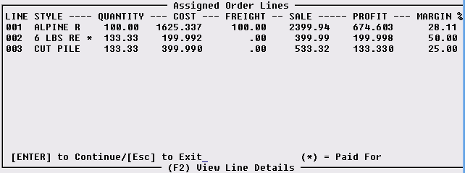

In the screen shot above Lines 001 through 003 are being pulled from the Enter Line Items screen of the Order Entry module for the Job selected. Only those material lines that have material assigned to them will display. In the STYLE column, only eight characters of the style name will display. The information in the QUANTITY column is pulled from the Work Qty column in the Enter Line Items screen. The COST and FREIGHT column values are pulled from the Inventory Maintenance module. These values can be updated through the Purchase Order Mtc. module via Receive Inventory, through the Job Labor Mtc./Installer Payments module, and via the Review P.O. History feature when a Vendor Invoice is posted in the A/P Open Item Maintenance module. The SALE column displays the total sale price of each line on the job. The PROFIT column displays the total profit to be made on each line based on the current costs and sale price. The MARGIN % column displays the current profit margin. Important Note: If you enter lines with a cost but no sale price, the Profit and Margin % columns will display negative figures. In this case, the User should only be concerned with the bottom line profit and margin % on the total job.

When you enter this screen, the system will display the following at the bottom left: [ENTER] to Continue/[Esc] to Exit. If you see a costing error in the screen above, you cannot make any changes in that screen. All costs should be updated via P.O. Maintenance, Receive Inventory, Job Labor Mtc., or the Review P.O. History feature in A/P Open Item Mtc. The “(*) = Paid For” message means that if an asterisk appears to the right of the Style column on a line, that material/labor has been paid for in the system and an approved cost figure should be showing. If you hit enter after viewing this screen or hit the F2 key for “View Line Details,” the following screen will appear:

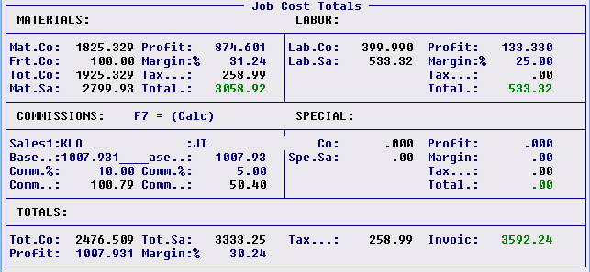

Below we have divided this screen explanation into five parts (MATERIALS, LABOR, COMMISSIONS, SPECIAL, & TOTALS) to cover each in detail.

MATERIALS- this section breaks out just the material lines on the Job. It displays the following information: the combined cost of all the material; the combined freight cost; what the material was sold for (less tax); what the total profit on materials is; the profit margin on just the material lines; the total tax charged for material; and finally, the total sale on materials plus tax. Please Note: If tax is charged on the cost of material (Contract Sale), an asterisk will appear in the Tax field as such: Tax..*: 166.32, and the following message will appear at the bottom of the screen: Tax is included in Material Sale. The total tax amount will be reflected in the total cost calculation at the bottom of the screen.

LABOR- this section breaks out just the labor lines on the Job. It displays the following information: the combined cost of all labor; what the labor was sold for; what the total profit on labor is; the profit margin on labor, the total of any tax charged on labor; and finally, the total sale on labor plus any tax.

COMMISSIONS- this section calculates the salesperson commission based on the information that was entered into the Salesperson Maintenance module. It displays the Salesperson ID, the commission base, the commission percentage, and the total commission to be paid. Please Note: The system does not include tax when calculating the commission base. If a second Salesperson is tied to this Job, that information will be calculated here as well. This is the only part of the screen that can be accessed and changed. It should be noted, however, that the Salesperson ID can only be changed prior to invoicing. After invoicing, you should not add an ID, change an ID, or delete an ID. Also, if the commission on a Job has been selected for payment or already paid, the system will prompt the following: Salesperson 1 already selected for payment cannot update job cost. If the commission item is only selected and has not been updated as paid, you can Unselect through Salesperson Payables module and then make changes. Also, you cannot add a second Salesperson ID in this screen for processing of Salesperson Payables data after invoicing. If a Job has been invoiced in the system and should have included a second Sales ID, you should process a credit on the job and re-bill after adding the second Sales ID.

When the Job Cost Totals screen first comes up, the cursor will flash on the Salesrep1 field. If you need to look up a Salesperson ID, use the F1 key—do not change, add, or delete an ID after a job has been invoiced. You can make permanent changes to the commission information from this screen, either before or after invoicing. The only way to exit the Job Cost Totals screen is to enter through this section until you get the following prompt: Continue? (Y,N) Y. If you hit enter at this prompt, the system will take you back to the first Job Cost Maintenance screen.

SPECIAL- this section refers to order lines on a Job that are neither material nor labor lines; there is never any inventory attached to these lines. Examples include finance charges, delivery charges, adjustments, discounts, etc. These lines are separated out in this section and displayed by total cost, total sale, total profit, total margin percentage, and tax, if any. Many times these lines will have a cost tied to them but no sale price; in these instances, you will get a negative profit and margin percentage, which will affect the bottom line figures in the TOTALS section.

TOTALS- this section averages the cost, sale, tax, profit, and margin percentage totals of each section and displays bottom line figures on the job.

When you have finished with the Job Cost Totals screen, you will have to enter through the Commissions section and enter Yes at the Continue? prompt to get back to the original Job Cost Maintenance screen.

Budget Maintenance:
This module is tied to the Set Budget option found in the Select Option menu of the Enter Line Items screen. (The Set Budget feature is explained in the Sales Processing section of this manual.) If your company is not using the Set Budget option, then you will not need to access this module. Once the Set Budget feature is activated on a Job, the system will read those order lines over into this module. If the customer changes the order and you wish to reset the budget for those lines that are affected, from this module you can pull up the Job with the original budget and make adjustments. Any changes that are made in this module will automatically update the Budget Vs. Actual report located in the Job Cost Reports menu.

The Budget Maintenance module works exactly like the Cost Maintenance module in terms of changing the cost, freight, and salesperson commission information—the screens look and work identically. Please Note: this module will display unassigned material lines if those lines were entered at the time the Set Budget feature was activated. Also, Use Tax will be added to the total cost figures at the bottom of the Job Cost Totals screen. This module will not display data on closed Jobs.

Detailed JC View/Print:
This module will provide line-by-line cost, sale, profit and margin information, similar to the View Job Cost module, but does not require material to be assigned, just entered as a line item on the Job. Additionally, the module will print a detailed job cost report on any Job in the system, whether open or closed. The job cost data on the report combines data that previously had to be viewed from several different areas of the system, which makes it an incredible tool, especially for large commercial dealers. Everything you need to see as an owner or manager on each Job has been combined together on one page of this report. The Budget is displayed showing the Actual Costs, the Budget as it was set in the beginning and then the Difference between the two. You can also see the salesperson commission amount, including the commission base and the percentage. That information is followed by all the totals on the job, such as line totals, tax, the total sale, profit and margin, and then information on the Invoice if one has been created. The end of the report lists each line on the Job with the corresponding cost, sale, profit and margin. On any labor lines where labor has been posted in the system, the Installer ID will also display along with his rate, total paid to date, and any quantity remaining to be paid. If you wish to see Unit Costs on this report, you will need to set the System Control 2 menu option “Work in Progress – Print Vendor” option to “Y” for yes.

When you enter this module, the system will prompt the following: Please Enter Job Number, or (F1) to Look-Up. Type in the Job Number or use the F1 key to perform a look-up by Customer ID. Once you have selected a Job, the system will display all the lines on the Job, whether inventory is assigned or not. The screen will appear as follows:

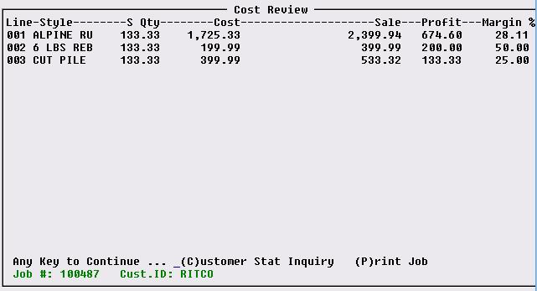

Material does not have to be assigned on a line in order for it to display in this screen. This module costs material, labor and special charges the same way the Billed vs. Unbilled – Costs From JC report does—see the details of the report explained below. When material lines are first entered, the costs come from the catalog; they are subsequently updated from purchase orders, receiving inventory, and then bill posting in Accounts Payable. Labor costs come from the catalog and are then updated in Job Labor Mtc./Installer Payments if any changes apply. In addition to viewing the Sale, Profit, and Margin on each order line, there are two additional functions you can perform from this screen. If you wish to view the Customer’s account information, simply type a “C” and the system will pull up the Customer Account Status Inquiry screen for this Customer. If you type a “P” for Print Job, the system will produce a one page report as explained at the beginning of this section. Only the first Invoice number and date will display on this report but the Current Balance is continually updated through Post Cash Receipts. Where you see a “-p” at the end of an Invoice number, that indicates the Invoice has been paid through A/P. For Accumulator items, such as Pad and other supplies, since multiple Invoices are tied to the inventory record, in place of the Invoice number, the printed report will display “ACCUM.”

View Job Cost:
This module can be accessed from the Order Entry/Maintenance module and is used primarily in Order Entry as a tool to double check costs as the Job is being completed. This module is explained in the Sales Processing section of this manual—it is essentially identical to the Cost Maintenance module except that you cannot make any permanent changes to commission costs from this module. Another difference is that if you create more than one Invoice on a Job, you can view the entire Job Cost in this screen rather than one Invoice at a time in Cost Maintenance.

Costs By Source View / Print:
This module was developed for stores that primarily sell special order goods and are not a large stocking dealer. This report will not show costs until a Vendor Invoice is entered in the system through the A/P Open Item Maintenance module. In order to use this module, the option to enable it must be turned on in the System Control Maintenance module. If the control is not enabled, when you enter the screen, the following message will appear: System Control Option: “J/C Detail Questions in A/P”, Not Enabled. If this is the case, you will need to refer to the System Maintenance section of the manual for instructions on enabling this option.

Before using this feature, you need to be aware of the following: First, any material assigned to a Job that is a part of your Beginning Inventory will not come up in this module. And second, if a Vendor Invoice contains costs for more than one Job, you can only tie the Invoice to one Job. However, you can break the Invoice down by Job and enter a portion at a time so that only those costs relating to each Job are sent to this module.

Once costs have been updated in the system through the Review P.O. History feature, the Costs By Source View/Print module will allow you to view those costs on the screen job by job. You can then print various reports detailing the breakdown of that information. These reports can be printed by customer, by date, by job number, by job type, and by salesperson.

If this feature is enabled, when you enter this module the following screen will appear:

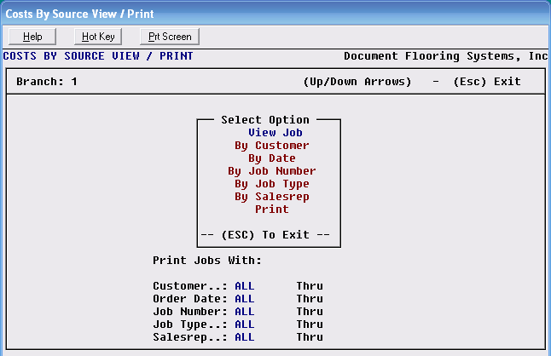

To view the costs of a job on screen, hit enter at the View Job option. Enter the Job Number you wish to look at and hit enter again. The following screen will appear:

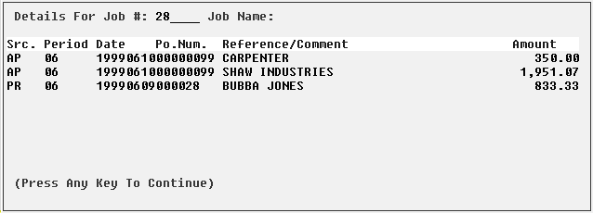

The Source (Src.) column displays where the cost information came from. In this example, AP stands for the Accounts Payable Open Item Maintenance module, and PR stands for the Installation System Installer Payroll Register. The Period column displays which accounting period the costs were entered in. The Date column displays the date the costs were entered into the system—the first four digits are the year, the next two are the month, and the last two are the day. The Po.Num. column displays the purchase order number tied to these costs. (The 99 indicates that the option to tie the Vendor Invoice to the original PO was skipped in the A/P Open Item Maintenance module.) The Reference/Comment column displays the Vendor name. The Amount column displays the cost for each line.

To print a report, you can set print parameters by selecting any of the “By” options. You will then arrow down to the Print option and hit enter.

Job Cost Reports

Introduction:
This menu offers several reports relating to Job Cost that are very helpful from an accounting and sales management perspective. It can only be accessed from the Job Cost menu. This next section of the manual will explain each report and how that report can be beneficial to the flooring business owner.

Job Cost Margin:
The Job Cost Margin report was developed to produce “written” sales information by Salesperson and by Branch. Material does not need to be assigned in a Job in order for costs to appear— material costs come from the system catalog. For each Salesperson, the report lists each job and shows the total of all material, labor, and special charge costs on those jobs, as well as the total sale, profit and margin figures for those jobs. (Please Note: The cost, profit, and margin figures on this report do not reflect the salesperson’s commission amount.) It also gives a Job Type total for each Salesperson followed by grand total figures on cost, sale, profit and margin. At the end of each Branch section, the report calculates Job Type totals for all Salespeople and then a grand total of all sales for the Branch. The end of the report calculates Job Type totals for the company, followed by a grand total of all sales for the entire company. One of the reasons it can be considered a “written” report is because the User can customize the report to show all Jobs entered in the system for the day, for the week, for the month, etc. It will also include Jobs that have been closed, which means that Over the Counter Sales jobs will be reflected in the report without the User having to open those jobs after invoicing—as with the Open Order Report. This also means that any Jobs that have been canceled in the system will reflect values on this report unless all of the order lines on those jobs have been deleted. The data on this report can also be exported to Excel.

When you enter this report module, the system will place the cursor in the following Select/Option menu:
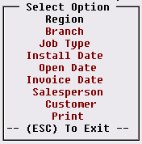

Through this Select Option menu, you have the ability to customize the Job Cost Margin report. If you do not wish to customize the report, you can simply arrow down to the Print option and hit enter. You can set one or more of these options at your discretion. The Branch option will allow you to print the report for only one Branch or for a range of Branches. The Job Type option will allow you to print the report for only one Job Type or for a range of Job Types. The Install Date option will allow you to see Jobs based on a single Install Date or for a longer period. The Open Date option will allow you to set the Beginning and Ending order dates of the Open Jobs you want to include on the report—this is the option to use for a “Written” report for the day. The Close Date option will allow you to set the Beginning and Ending order dates of the Closed Jobs you want to include on the report. The Invoice Date option will allow you to select a list of Jobs by the date of the Invoice, rather than the date the Job was opened or installed. The Salesperson option will allow you to print the report for only one Salesperson or for a range of Salespersons. The Customer option will allow you to print the report for only one Customer or for a range of Customers.

When you have programmed your options, arrow down to the Print option and hit enter. The system will prompt the following: Do You Want To Print Open And Closed Jobs? (Y,N) N. If you want to include closed Jobs on the report, change the default to “Y” for yes. The system will then prompt the following: Do You Want To Print (D)etail Lines, Or The (S)ummary Section Only?: D. If you only wish to see a summary of all Job Types for each Salesperson selected, type an “S” at this prompt; otherwise, hit enter to see the detail. If you select Detail, the system will prompt the following: Do You Want to Only Print Jobs below a set gross margin (Y,N): N. The default is set to “N” for no, so if you don’t wish to use this feature, simply hit enter. However, if you would like to see all Jobs (based on your previously selected sort criteria) below a certain gross profit percentage, type a “Y” for yes at this prompt. The system will then prompt the following: Set Gross Margin. At this prompt you will type in a whole number such as “30” for 30%. The report will then sort through and only print Jobs with a profit margin percentage below that number. Please Note: Credit Memos will be included in this sort as they appear as negative profit margins on the report. Also, if you have enabled Region Reporting in the Company Control 2 level screen of the System Control Maintenance module, you will have the option to sort the report by Region. In the Select Option menu, there will be an option titled Region. If you select this option, the system will prompt the following: Enter Beg. Region (F1) = All. At this prompt you can type in a beginning Region ID or hit the F1 key to include all Regions. If you type in a Region ID, the system will then prompt the following: Enter End Region. If you wish to print for only one Region, type in the same ID as in the above field; if you wish to print for a range of Regions, type in the ending Region ID in this field and then continue with printing the report.

Job Cost Detail:
This report will print by order date and displays a one line summation of all the costs on a Job, including commission, along with the total sale, the profit total, and the bottom line profit margin. Material must be assigned on a Job in order for material costs to appear on this report. Jobs that have been canceled in the system will reflect values on this report unless all of the order lines on those jobs have been deleted—even though material has been unassigned, the report will still display figures in the sales commission, total cost, total sale, profit, and margin columns if order lines are not deleted. To print this report for another Branch, you must switch to that Branch and then print this report.

When you enter this report module, the system will prompt you to enter a Beginning and Ending order date to include on the report. The report will begin printing and the system will place you back in the Job Cost Reports menu.

Job Cost Detail (By Salesperson):
This report is almost identical to the one above except that the information will be grouped by Salesperson ID. The other differences are that instead of the Job Name, the report displays the Job Address, and this report does not display sales commissions. When you enter this report module, the system will prompt you to enter a Beginning and Ending order date to include on the report. When the report begins printing, the system will place you back in the Job Cost Reports menu.

Job Analysis Summary:
This report prints by Order Date and by Salesperson. It displays the Job Address rather than the Job Name, and displays only the Order Total, the Invoice amount—if the Job has been invoiced— and the total profit on each Job. Jobs that have been canceled in the system will reflect values on this report unless all of the order lines on those jobs have been deleted—even though material has been unassigned, the report will still display figures in the order total and total profit columns if order lines are not deleted. To print this report for another Branch, you must switch to that Branch and then print this report. When you enter this report module, the system will prompt you to enter a Beginning and Ending order date to include on the report. The report will begin printing and the system will place you back in the Job Cost Reports menu.

Work In Process &

Billed vs Unbilled Reports

Introduction:
The Work in Process & Billed vs Unbilled series of reports were developed primarily for large commercial dealers utilizing the Progress Billing feature. However, owners/ managers of all types of retail business should read through the section on Work in Process – Costs From JC to find out how that report can assist with keeping your system clean and up to date. (For information on Progress Billing, please refer to the Sales Processing manual.) There is more than one report listed because each is tied to a different costing source in the system. This was done in order to accommodate the needs of a variety of Users. The general purpose of these reports is to help the User keep track of cost and revenue information for financial statement purposes. In other words, the reports show if too much profit is being taken when you don’t yet have costs in the system that correspond with the profit and vice versa. They also show how much actual cost has been accumulated to date and how much is as yet estimated. At the end of each report, for those dealers using the Under Billed Sale amount to calculate a percentage of the cost, the report will display that calculation (cost). These reports are generally run prior to printing a monthly financial statement so that adjustments can be made in the General Ledger to reflect a more accurate Profit & Loss Statement (adjustments must be reversed out once the statement is printed for the month).

Jobs that have been canceled in the system will reflect values on this report unless all of the order lines on those jobs have been deleted—always be sure to delete order lines on canceled jobs. To print any of these reports for another Branch, you must switch to that Branch and then print the applicable report.

Important: The Work in Process & Billed vs Unbilled series of reports are designed to print landscape instead of portrait. They must be printed on a laser printer. Two of the reports will export to Excel as noted below.

Work in Process – Costs From JC:
Owners/managers of all flooring businesses should consider printing this report on almost a daily basis to assist with staying on top of open Jobs in the system. The report will indicate whether inventory on a Job has been received (it will show in the Material Costs To Date column), whether the Job has been invoiced but not closed or only partially invoiced (the amount invoiced will show in the Total Billed To Date column), whether the Job has been installed (it will show in the Labor Cost To Date column), and the profit and margin on each Job (these will display in the Profit and Profit % columns respectively). Unless there are extenuating circumstances, no residential Job should be more than 3-4 weeks old. If there are no remaining costs to complete on a Job, the Job is more than likely ready to be invoiced and closed. Residential, Property Management, and Builder dealers will not necessarily use the Over/Under Billed column of this report—that was implemented primarily for large commercial dealers to keep track of whether they are over or under billed on long-term projects. Also specific to commercial dealers, the Excel export data will include the Project Name from the Projects module.

The Material Costs To Date column of this report gets its cost information from the value of the inventory that has been assigned to a line. The information that appears in this column is the same information that can be seen in the View Job Cost or Cost Maintenance modules. By the time the Vendor Invoice is posted in the system, this value may change. This report can be printed by Customer, by Order Date, by Job Number, by Job Type, or by Salesperson. The Labor Costed To Date values come from the same source for all of the reports: the Installer Payables Report. The Special Costed To Date values come from the cost inputted at the time a Special Charge line was entered in the system—this is also the same for all reports. The To Be Costed column values for all reports come from the system catalog originally, and are updated through the Purchase Orders module. The data generated in this report can be exported to Excel but the columns will not automatically total—you will need to use Excel formula functionality to create totals.
When you enter this report module, the system will place the cursor in the following Select/Option menu:
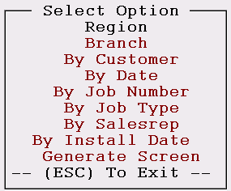

Through this menu, you have the ability to customize this report. If you do not wish to customize the report, you can simply arrow down to the Print option and hit enter. You can set one or more of these options at your discretion. By selecting the Branch option, the system will place the cursor at a Beginning Branch prompt. You then have the option of entering a Beginning Branch ID or hitting the (F1) key to print for All Branches. If you enter a Beginning Branch ID, the system will then prompt you to enter an Ending Branch ID, so you can print for only one Branch or a range of Branches. Also, if you have enabled Region Reporting in the Company Control 2 level screen of the System Control Maintenance module, you will also have the option to sort the report by Region. This option works the same as described above.

The By Customer option will allow you to print the report for only one Customer or for a range of Customers. The By Date option will allow you to print the report for only one day or for a range of days. The By Job Number option will allow you to print the report for only one Job or for a range of Jobs. The By Job Type option will allow you to print the report for only one Job Type or for a range of Job Types. The By Salesrep option will allow you to print the report for only one Salesperson or for a range of Salespersons. The By Install Date option will allow you to print the report for only one Install Date or a range of Install Dates.

When you have programmed your options, arrow down to the Generate Screen option and hit enter. The system will prompt the following question: Enter Job Status To Print: (F1) to Lookup. If you would like to customize by a Job Status Code, type that Code in this field or hit the F1 key for a lookup. Otherwise, enter through this prompt to include all Job Status Codes. The next prompt will appear as follows: Print Only Jobs With Zero Cost To Complete? (Y,N): N. Hit enter to include Jobs that still have outstanding costs, or type a “Y” to print only Jobs with zero costs to complete. The next question will be the following: Include Unassigned / Unordered Material In Costs to Complete? (Y,N): Y. Hit enter to include unassigned/unordered material, or type an “N” to exclude. The next question will be the following: Only Print Jobs That Are Progress Billed (Y,N): N. If your company utilizes the Progress Billing feature in the system, and you want to only see Progress Billed Jobs, change this prompt to “Y” for yes; otherwise, hit enter to proceed. The last question will appear as follows: Do You Want to Only Print Jobs below a set gross margin (Y,N): N. The default is set to “N” for no so if you don’t wish to use this feature, simply hit enter. However, if you would like to see all Jobs below a certain gross profit percentage, type a “Y” for yes at this prompt. The system will then prompt the following: Set Gross Margin. You will need to type in a whole number such as “30” for 30%. The report will then sort through and only print Jobs with a profit margin percentage below that number. Please Note: Credit Memos will be included in this sort as they appear as negative profit margins on the report. When you have entered through the last question, the report will generate a detail screen as follows:
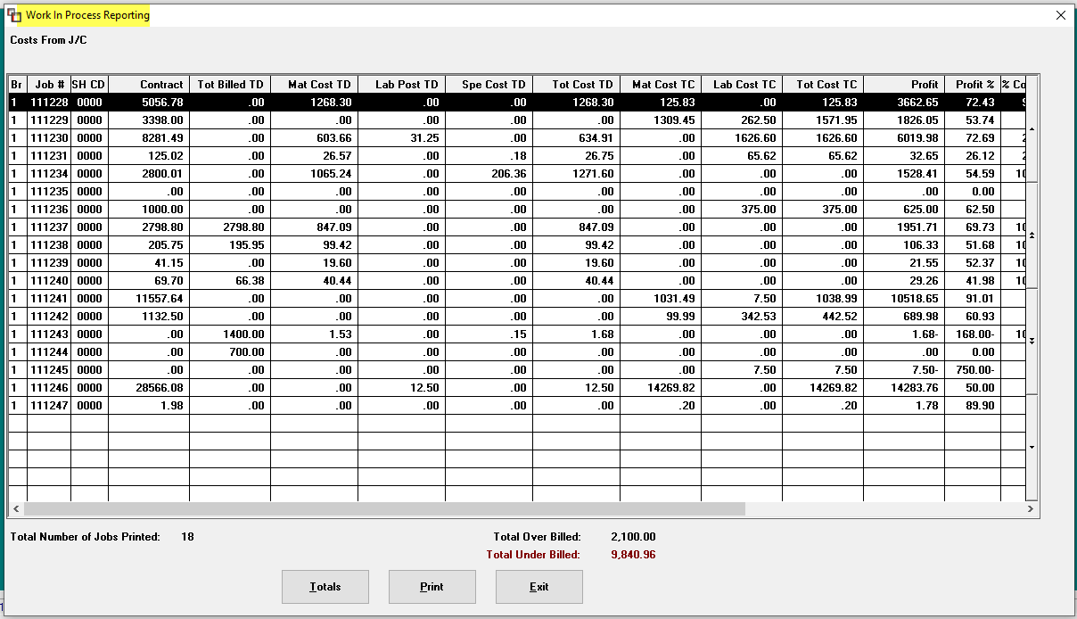

From this screen, you can click on a line to prompt an additional screen that will display each line on the job as follows:

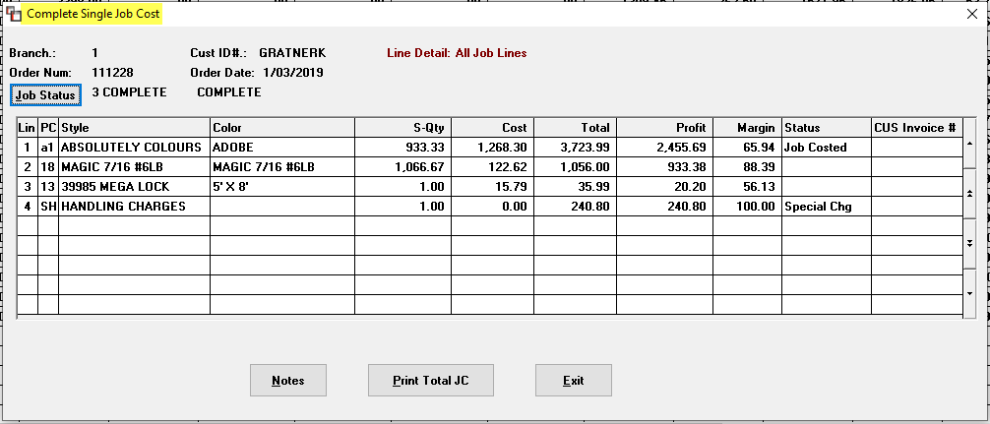

From this screen you can click on the Notes button to see any notes tied to the Job, or you can click on the Print Total JC button to print out a complete Job Cost report for the job. You can click the Job Status button to prompt a Job Status Code box and change the current Code if applicable. The Exit button will return you to the previous screen. Back in the first screen, if you click on the Totals button, the system will display a Report Totals box as follows:

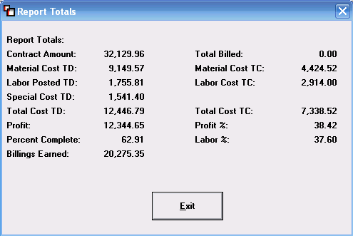

This screen displays the combined totals of all the jobs included on the Work In Process Reporting screen. Click the Exit button to return to that screen. By clicking the Print button in the initial screen, the system will print out the information you see in that screen. You can also click the Exit button to return to the Job Cost Reports menu.

Work in Process – By Invoice Date:
This module works almost identical to the Work in Process – Costs From JC module explained above, but will only show invoiced lines from a Job; it will not show Work in Process values. The Material Costs To Date column gets costs from the inventory record just as with the report above. The same options and questions that were explained above will operate in the same way in this module. This report can be exported to Excel.

Billed vs Unbilled – Costs From A/P:
The Material Costs To Date column of this report receives cost information only when the Vendor Invoice is posted in the system through the A/P Open Item Maintenance module. If you prefer to see costs only when they have been verified through the Accounts Payable department, then utilize this report or the one below. When you add or edit a Special Charge order line in the Order Entry module, the system will prompt an option to make the cost “Actual” or “Estimate.” When a line is set to Actual, it appears on this report as a Cost-to-Date, and when it is set to Estimate, it appears on this report as a Cost-to-Complete.

Just as with the Cost By Source View / Print module, this report will not work unless it is enabled in the System Control Maintenance module. If the control is not enabled, when you enter into the screen, the following message will appear: System Control Option: “J/C Detail Questions in A/P”, Not Enabled. If this is the case, you will need to refer to the System Maintenance section of this manual for instructions on enabling this option in the System Control Maintenance module.

This report module works the exact same way as the Billed vs Unbilled – Costs From JC report module explained above. Please see that module explanation above for instructions on printing this report.

Billed vs Unbilled – A/P w/Paid Inventory:
As with the report above, this report is also updated when the Vendor Invoice is posted in the system through the A/P Open Item Maintenance module. When an open PO is tied to a Vendor Invoice, the system brings up the “Review P. O. History” option. At that time, the Material Costs To Date column in this report is updated. Until then, the value stays in the To Be Costed column. Use this report if you do not use the Billed vs Unbilled – Costs From A/P report. This report module works the same way as the Billed vs Unbilled – Costs From JC report module explained above. Please see that module explanation above for instructions on printing this report. This report can be exported to Excel.

Work in Progress – Labor:
This report will give you Labor Costs To Date for all Jobs or a range of Jobs based on sort criteria options in the Select Option box. If labor on a Job has been paid through the Installer Payables module, the costs will be considered Labor Costs To Date, if they have not been paid, then they will be considered Labor Costs To Complete. This report will display only Jobs with un-invoiced Labor Lines and will show the amount paid and to be paid so that journal entries can be made for work in progress labor on your financials. You will be able to customize this report using the same options that were explained above in the Billed vs Unbilled – Costs From JC module. This report can be exported to Excel.

Job Analysis – By Invoice Date:
This report was adapted from the Billed vs. Unbilled – Costs From JC report. It shows most of the same information, but does not have the Billings Earned or Over/Under Billed columns. It is also a landscape formatted report and must be printed on a laser printer. An added feature to this report is that it will sort by Salesperson and by Job Type. Jobs that have been canceled in the system will reflect values on this report unless all of the order lines on those Jobs have been deleted—be sure to delete all order lines on canceled jobs. To print this report for another Branch, you must switch to that Branch and then print this report.

When you enter this report module, the system will prompt you to enter a Beginning and Ending order date to include on the report. It will also prompt you to enter a Job Type Code, or you can hit enter to include all Job Types in the report. The last prompt is for a Salesperson ID. You can type an ID or hit enter to include all Salespeople in the report.
When you have entered through the last prompt, the system will bring up the following question: Print Only Jobs With Zero Cost To Complete? (Y,N): N. Hit enter to include Jobs that still have outstanding costs, or type a “Y” to print only Jobs with zero costs to complete. The next question appear as follows: Include Unassigned / Unordered Material In Costs to Complete? (Y,N): Y. Hit enter to include unassigned/unordered material, or type an “N” to exclude. The final question will appear as follows: Print Only Jobs That Have Been Closed (Y,N): Y. This question was added so that you can customize the report to display only completed (closed) Jobs, or both in process (open) and completed Jobs. Hit enter to print only closed Jobs, or type an “N” to include both open and closed Jobs.

When you have entered through the last question, the report will begin printing and the system will place you back in the Job Cost Reports menu. This report can also be exported to Excel.

Outstanding Costs vs Cust Inv / Recd Inv.
This report module contains two different reports, though they both compare outstanding costs to another value in the system. The two reports are Outstanding Costs vs Customer Inventory and Outstanding Costs vs Received Inventory. The default setting is for Custom Inventory, so when you enter this module, the screen will appear as follows:

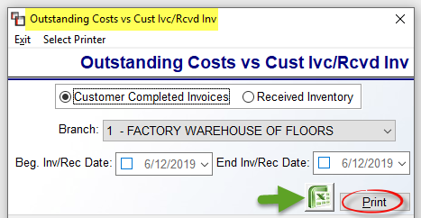

This report gives a total value of Labor that needs to be paid on Jobs that have been invoiced in the system. It can be a handy tool for keeping track of outstanding Labor on completed and invoiced Jobs. It will only list Jobs where Labor still needs to be paid. Along with the Job # and Customer ID, the report lists the value of the outstanding Labor. (The Inventory Value column on the report is not a working column.) To print this report for another Branch, you must switch to that Branch and then print this report. The Date fields are only enabled for the Received Inventory report option. You can print this report to paper or export to Excel.

The Received Inventory report option lists all the inventory in the system that does not have a Vendor Invoice number attached to the inventory record. In other words, the inventory has been received but no A/P Invoice has yet been entered in the system, or was entered and not tied to this inventory. It was designed for retailers wanting to know the total dollar value of their inventory for which they have not yet received an Invoice. In order for this report to be accurate, the accounting department must perform the “Review P. O. History” option for every Vendor Invoice that is posted in the system. Also, if this report is to be utilized effectively, all Beginning Inventory records will need to have a Vendor Invoice number added. If one is not known, you can type 99999 or something similar in the Vendor Invoice field of those records to denote that the inventory existed prior to going online with the RollMaster System. This report will allow you to enter a Beginning & Ending Inventory Receipt Date and the date range selected will appear at the top of the report. Also, the Date, Time and User ID will display on the printed report.

This should be a monthly report to back up your Financial Statements. You could go so far as to make an adjusting entry to your Inventory G/L account for the overstated value, print your Financial Statements, and then make a reversing entry to put the value back to where it was. To print this report for another Branch, you must switch to that Branch and then print this report. You can print this report to paper or export to Excel.

Budget Vs Actual:
This report is tied to the Set Budget feature found in the Order Entry/Maintenance module. When a Job is first entered into the system, you can set the Budget once all order lines have been entered. Then, any time after that, you can print this report to get a comparison of how the estimated total costs have changed. Any changes made through the Budget Maintenance module will automatically update this report. You can print the report by Job Number, by the Date it was closed, and by Job Type. The report displays the original budget that was set on the Job, the actual budget by the time the Job was completed, and then the difference between the beginning and ending budgets. This report can be used as a tool to encourage salespeople to identify all the costs on a job up front so less money is lost on the back end.

When you enter this report module, the system will place the cursor at a Branch field. It will default to the Branch you are in when you entered this module. If you wish to print the report for a different Branch, simply type that Branch ID. Once you have selected a Branch, the system will prompt a Select Option menu as follows:

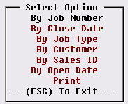

Through this menu, you have the ability to customize the Budget Vs. Actual report. If you do not wish to customize the report, you can simply arrow down to the Print option and hit enter. You can set one or more of the following options at your discretion. The By Job Number option will allow you to print the report for only one Job or for a range of Jobs. The By Close Date option will allow you to print the report for a specific Close Date (the day the job was closed) or for a range of Close Dates. The By Job Type option will allow you to print the report for only one Job Type or for a range of Job Types. The By Customer option will allow you to print the report for a specific Customer or a range of Customers. The By Sales ID option will allow you to print the report for only one Salesperson or a range of Salespersons. The By Open Date option will allow you to print the report for a specific Open Date (the day the job was opened) or for a range of Open Dates.

When you have programmed your options, arrow down to the Print option and hit enter. The system will prompt the following: Do you wish to continue..:(Y,N) _. Type a “Y” at this prompt to continue. Once you have selected to Print, a new prompt will appear as follows: Do you wish to Print Open Jobs Also? The default is “N” for no, so to include Open Jobs, type a “Y” for yes at this prompt. The next prompt will appear as follows: Include Jobs Without a Budget: N. The default is “N” for no, so to include Jobs that don’t have a Budget set, you will need to type a “Y” for yes as this prompt. The system will perform internal procedures and place the cursor back in the Select Option menu. Hit the Esc key to return to the Job Cost Reports menu.

Master Lead Report (For Leads Processing):
If your company has subscribed to the Lead Processing Efficiency Tool module, you will then see the Master Lead Report in the Job Cost Reports Menu. This report provides detailed lead data on Written and/or Invoiced sales converted from the Lead Processing module. When you enter this report module, the system will prompt a Master Lead Report screen as follows:

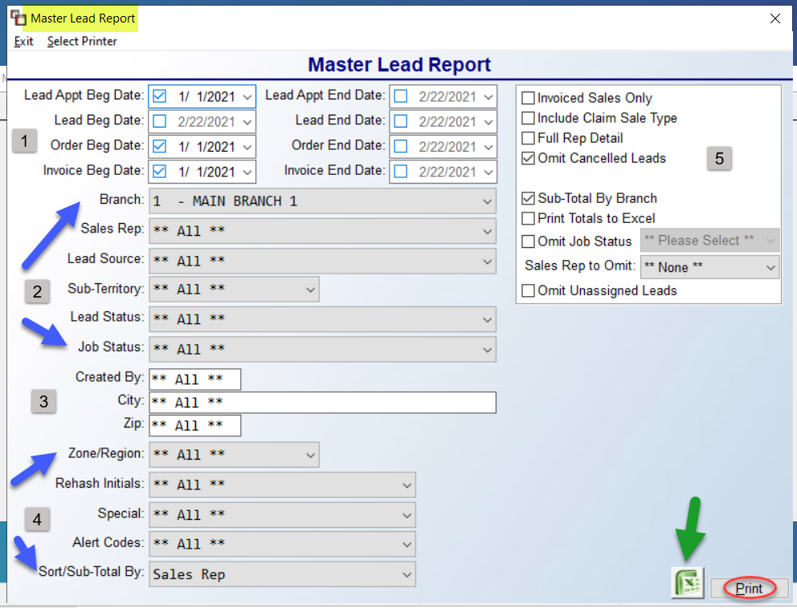

The settings in the screenshot above are the default settings for the report, however any of the fields can be accessed to customize the report. The Lead Appt Beg & End Date (1) fields pull from the Appt. Day/Time field in the Lead Maintenance screen, whereas the Lead Beg & End Date pulls from the Date Created field. The Order Beg & End Date fields and the Invoice Beg & End Date fields allow you to alter the report by these date ranges, or include all dates. Moving to the next section (2), at the Branch field, you can use the drop-down arrow to select **All** Branches, or a different Branch. At the Sales Rep field, use the drop-down arrow to select a specific Salesperson. The Lead Source (Territory Code) field will include all sources, but can be set to a specific source. The Lead Status field will allow you to print the report based on where Leads are in the conversion process, if desired. The Job Status field allows you to narrow the report by a Job Status Code.

The next three fields (3) are freehand, which means you need to type in exactly what you want to sort by. The Created By field is tied to the User ID of the person who entered the lead, not necessarily the Salesperson. The City and Zip fields will narrow the report by an actual City and/or Zip. Moving on to the next (4) section, the Zone/Region field will allow you select a specific Zone/Region from the drop-down, provided this has been set up in the Lead Module. At the Rehash Initials field, use the drop-down arrow to select a specific person assigned to try and re-vive a Lead that has not been converted. The Special field will allow sorting by any customer specials that have been set up in the Lead Module. The Alert Codes field is tied to any Alert Codes added in the Lead Module. And finally, the Sort/Sub-Total By field determines how the lead data should be grouped and displayed. The default is Sales Rep, but some other choices include Branch, Lead Source/Sub-Territory, etc.

The last section at the top right includes (5) options to further customize the data on the report. The Invoiced Sales Only box, when checked, will exclude “Written” sales data. The Include Claim Sale Type, when checked, will add back in any Claims sales that were originally generated from a Lead. The Full Rep Detail box, when checked, will print one page per Salesperson and include one line of data per Lead. The Omit Cancelled Leads box will default to checked, but can be unchecked to include these Leads on the report. The Sub-Total by Branch box will need to be unchecked if you don’t want to see the totals for each Branch listed on the report. The Print Totals to Excel box will need to be checked if you are exporting the report data and you wish to include totals. The Omit Job Status box can be checked to exclude a specific Job Status Code and includes a drop-down menu for ease of selection. The Sales Rep to Omit option with a drop-down menu will only allow selection of one Sales Rep. An example would be to omit a “House Account.” And finally, the Omit Unassigned Leads option will be unchecked by default. To leave Unassigned Leads off the report, you will need to check this box.

On the printed report, you will see a column for Volume, which is a sales dollar amount based on what was selected: Written/Invoice/Both; # of Leads in the date range selected; # of Sales (converted Leads) in the date range selected; the RPL (Return Per Lead), which is the volume divided by total Leads; the Closing %, which is number of Sales divided by number of Leads; the Average Sale; and the Estimated Margin, which is derived from the Lead Baseline Margin % set up in the Branch Control 2 screen.

Once all fields have been set, click the Print button to print to paper, or click the Excel icon to export the data.

