
Table of Contents
Inventory Control 1
Introduction: 1
Product Code Maintenance: 1
Catalog Maintenance: 23
Inventory Maintenance: 63
Catalog Price Roundup: 89
Catalog (A-J) Pricing Maintenance/Print: 92
Special Price Mtc. (Date Range Pricing): 100
Private Label Mtc. (By Customer): 116
Yarn Type Maintenance: 117
Inventory Purge: 119
Special Catalog Mtc. (By Product Code): 122
Inventory Reports 128
Introduction: 128
Customer Price Lists: 128
Catalog Listing: 130
Inventory Listing: 132
Inventory Valuation: 134
Inventory Valuation (Freight Split): 139
Inventory Valuation (As Of): 141
Inventory Audit: 143
Inventory Transit Report: 145
Inventory Daily Branch Transit Report: 147
Inventory Transfer Requests: 148
Inventory Reserved Report (by Vendor): 152
Safety Stock Evaluation Report: 153
Inventory Usage Report: 155
Yardage Report: 158

***CONFIDENTIALITY NOTICE*** This documentation contains confidential information belonging to Textile Management Systems, Inc. and RollMaster Software, which is protected by copyright laws and other privileges. This information is intended for the exclusive use of legally licensed RollMaster Software users. If you are not the intended recipient, you are hereby notified that any disclosure, copying, distribution, or the taking of any action in reliance on the contents of this information is strictly prohibited. If you have received this documentation in error, please immediately notify us by telephone at (800) 777-4107.

Inventory Control

Introduction:
The various modules located within the Inventory Control menu will help the User to create and maintain the system catalog as well as manage inventory. Before orders can be entered in the system, the User should be familiar with this menu and have completed all the set-up modules. The major steps in preparing for system startup include building the non-B2B imported catalog items, adding all existing inventory, and completing the maintenance for pricing, including A-J Levels and Margin percentages.

Product Code Maintenance:
This is one of the set-up modules that must be completed before inputting orders—it will most likely be pre-built by a RollMaster Trainer prior to system training. Once the set-up is complete, you may need to return to this module to add a Product Code for a new type of product line that is added to your store. (This would be a completely different type of product that does not fall under any existing product category.)

Product Codes are considered your catalog subheads, so most of these will already be covered in your initial system setup or be included in the B2B Product Codes for catalog importing. For instance, all of your 12’ wide non-B2B carpet styles will be under one Product Code; all of your non-B2B padding will be under another Product Code; all of your 12’ wide vinyl will be under another Product Code, etc. You cannot add any catalog items or inventory until these Product Codes have been created.

When you enter this module, the Product Code Maintenance screen will appear as follows:

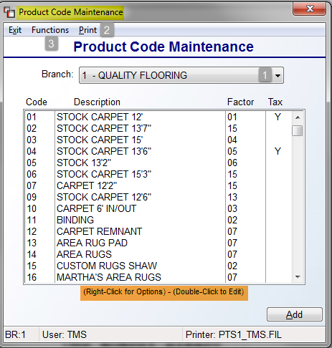

Existing Product Codes, as in the example above, will display automatically. The Branch (1) field will default to the current Branch. If you have multiple Branches, you will perform this setup for each Branch. You can select a different Branch by using the drop-down arrow in the Branch field. All existing Branches will display and you can click on a different Branch to access Product Codes in that Branch. Please Note: An option to Copy Code to another Branch can be accessed by highlighting and then right-clicking on an existing Product Code in the box above. When you select this option, the system will prompt a Branch Selection screen as follows:
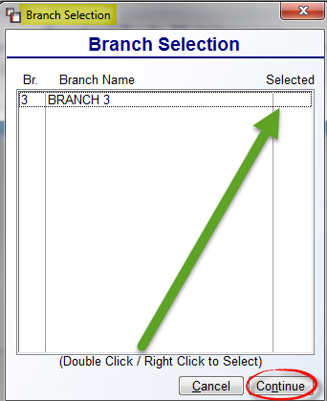
This screen will only display Branches where the selected Product Code does not currently exist. To copy to another Branch, highlight and then double-click to select. You can also right-click to prompt two options as follows: Select and Unselect. Once a “Y” is displayed in the Selected column for that Branch, you can click the Continue button to copy. The system will then prompt a Select G/L screen as follows:

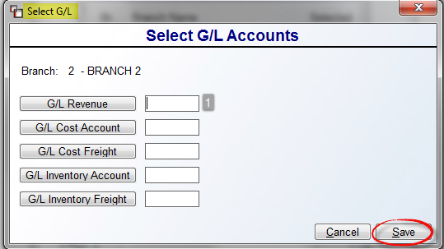

The cursor will be positioned at the G/L Revenue (1) field. Click the G/L Revenue lookup button to call up a G/L Lookup screen, or type the G/L Account number in this field. Complete this step for all G/L fields and the click the Save button to complete the process.

Returning to the Product Code Maintenance box displayed above, you can also edit existing codes by double-clicking on a selected Product Code or by using the right-click button to select the Edit Product Code option. The Delete Product Code option will only be available for selection on Product Codes where there are no catalog items. From the Print (2) option at the top left of the screen, you can print a list of existing Product Codes. A drop-down list will display the following two options: Print Product Code Report and Select Printer. Select Excel from the Select Printer option to export the Print Product Code Report.
Several maintenance features are available from the Product Code Maintenance module and accessible via the Functions (3) menu located at the top left of the Product Code Maintenance screen. When you click this menu, the system will prompt a list of options as follows:
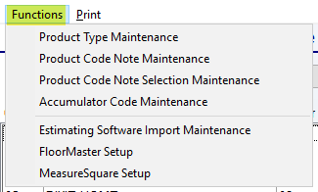

Please Note: The Estimating Software Import Maintenance, FloorMaster Setup, and MeasureSquare Setup options are all related to Add On Estimating products and will be used by RollMaster Personnel to complete setup. The remaining options will be explained in the order they appear in the Functions menu above. The Product Type Maintenance option allows you to create a list of Product Types for use on each Product Code to maintain consistency for the various reports that can be customized by Product Type. In some cases, your RollMaster Trainer will have already set some or all of these up for you. When you select this option, the system will prompt a Product Type Maintenance screen as follows:

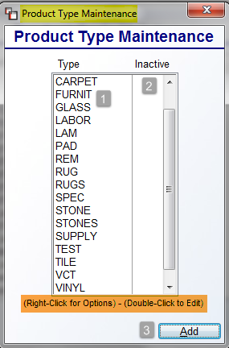

Existing Product Types (1), as in the example above, will display automatically. The Inactive (2) column will display a “Y” if the Product Type has been set to Inactive—explained below. If you right-click on an existing Product Type, the system will display the following two options: Edit Product Type and Delete Product Type. Please Note: Once you are live in the system, if any relevant sales history exists for a Product Type Code, you should not delete that code. If you click on Edit Product Type, the system will display a Product Type Maintenance box as follows:

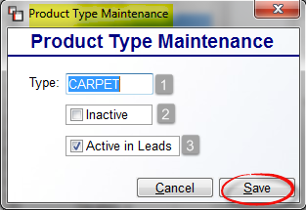

The only three functions you can perform in this screen are to change the Type (1) field, click the Inactive (2) box to make the Product Type inactive in the system, or unclick the Active in Leads (3) box to prevent a Product Type from being viewed in the Lead System Maintenance module. Click the Save button to keep your changes. In the main Product Type screen, you also have an option to create new Product Types by clicking the Add (3) button. The same screen above will prompt for you to create a new Type (1) for use in the Product Code Maintenance screen. It is important to note that with this feature, the system will not allow deletion of a Product Type that is currently in use on a Product Code. As a reminder, the Inactive (2) flag will hide a Product Type in the lookup screen unless that code already appears on the Product Code prior to the switch to Inactive.
The next two options in the Functions menu are set up modules for the Required Notes feature in the Quote & Order Entry modules. This setup allows for prompting questions that require a salesperson response, such as grout line width, subfloor type, etc. Please talk with your RollMaster Trainer or email an inquiry to support@rmaster.com for further assistance with how best to use this feature. The Product Code Note Maintenance screen will appear as follows:
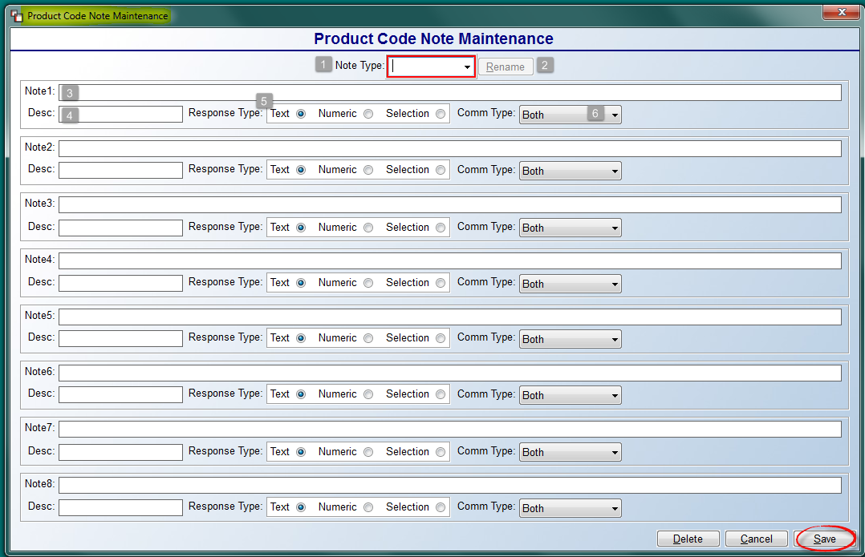
At the Note Type (1) field, type the name of a Required Note category you wish to create, i.e., Tile. You must complete at least the first Note 1 box section to Save the Note Type. Once a Note Type (1) has been saved, you can exit and reenter to make additions/changes. You can also make changes to the Note Type (1) name and click the Rename (2) button to save the edit. At the Note (3) field, type the exact question or requirement for your Salespeople to complete. The Description (4) field should be a shortened version of the Note field; it will appear in the Line Comment screen along with the Salesperson’s responses to the required questions. The Response Type (5) radial button field determines how the Salespeople should respond: Text requires a typed response; Numeric requires a numbered response; and Selection requires a response that has been pre-setup in the Product Code Note Selection Maintenance screen. See explanation directly below. The final step is to select the Comment Type (6) from the drop-down menu—these are the same Comment Types that appear in the Line Comment feature that determine where the Required Notes will print.

When you enter the Product Code Note Selection Maintenance module, the screen will appear as follows:
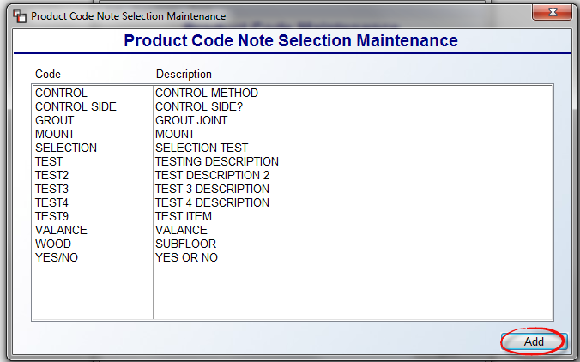

The screenshot above contains several existing Selection Code options. To create a new one, click the Add button at the bottom right. The system will prompt PC Notes Selection Add/Update screen as follows:

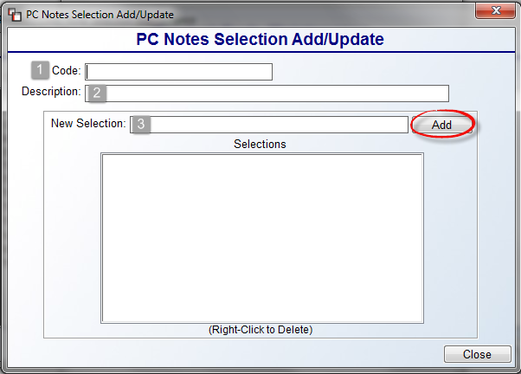
The Code (1) should be a shortened version of the type of selection; you will see this Code in a drop-down menu when Selection is checked as a Response Type. The Description (2) is a longer description of the Selection Code. The New Selection (3) is where you will type any applicable selection for the Salesperson to make. Some examples include “Yes” and “No” selections for a yes/no question; existing subfloor selections such as Luan, concrete, etc.; grout size selections such as 1/4, 1/2, etc. Click the Add button to save each New Selection. With this setup complete, in the Product Code Maintenance setup box, you will see a Notes Required check box as follows:
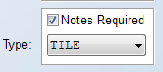

With this box checked, you can use the drop-down Type menu to select a Note Type. Thereafter, when this Product Code is selected in the Quote and Order Entry modules, the system will pop up a Required Information box for salespeople to complete as soon as a Sale Quantity is entered as follows:

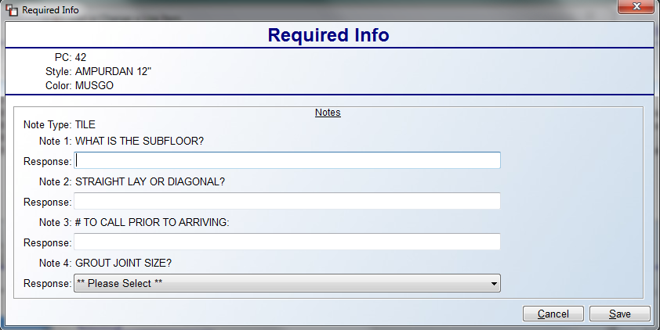

At this point, you can skip this next section for later setup and jump to the “Adding Product Codes” section to continue with adding Product Codes.

Accumulator Codes
The next to the last item under the Functions menu is as follows: Accumulator Code Maintenance. Please Note: this Accumulator Code Maintenance program has also been added as a module in the Sales Processing Setup Programs Menu and works the same as described here. This maintenance program is tied to the graphical Installation Schedule module, wherein Accumulator Codes are instrumental. Accumulator Codes are used to identify the principle installation Labor Lines on a Job, allowing the system to compute total yardage or footage scheduled for a given time period. For example, a Job may have 4 Labor Lines consisting of 100 yards of installation, 100 yards of rip/up, 100 yards of disposal, and 12 steps. The Accumulator Code should only be tied to the 100 yards of installation, so the system only counts 100 total yards, not 312, which would be inaccurate from a scheduling standpoint.
When you click on this option, the system will prompt an Accumulator Code Maintenance screen as follows:
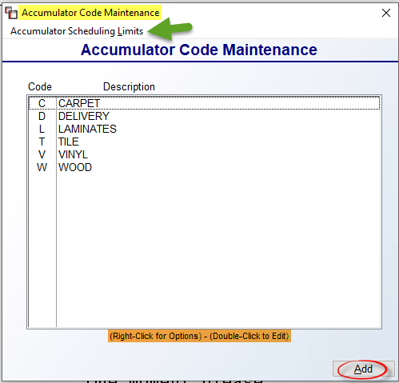

The items in the above screen are typical installation descriptions. The Accumulator Scheduling Limits option will be explained below at the very end of the Accumulator Code Maintenance section. To add a new Accumulator Code, click the Add button. The system will prompt the following:

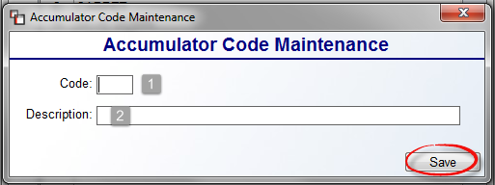

At the Code (1) field, type a one character code to represent a labor item. At the Description (2) field type a longer description for the Code. Click the Save button to save your new code and return to the previous screen. When you double-click on a highlighted Code, the system will prompt the following:
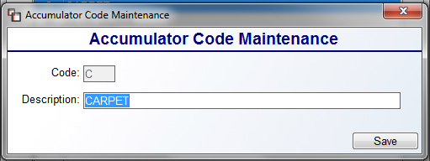
You can add/edit text in the Description field at any time. Click the Save button to save your changes and exit the screen above. In the main screen, if you right-click on any existing Codes, you can call up the Accumulator Code Maintenance screen above, or you can remove any unwanted codes by using the Delete Accumulator Code option. Once your Codes have been added, the next step is to access items in your Labor Catalog via the Catalog Maintenance module and add these Codes to each applicable “main” installation Labor Item. An example appears below:

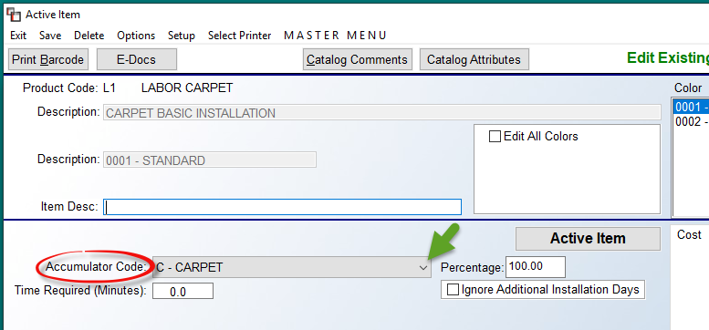

At the Accumulator Code field, use the drop-down arrow to select an applicable Code. Continue until all main Labor Items have been assigned an Accumulator Code. Also, on each Labor Catalog Item, to assist with not over-scheduling, there is a Percentage field next to the Accumulator Code field that appears as follows:

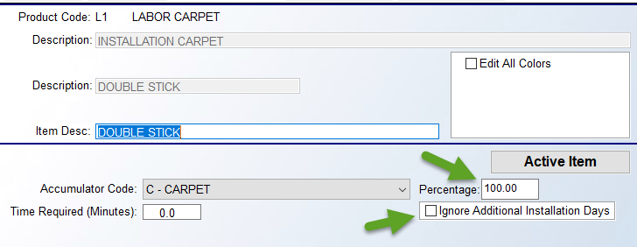

Consider this field a percentage value of the duration of an installation. A percentage of 100% would be a normal or average setting for a typical type of install. Any increase in percentage would indicate that extra time is needed for the Labor Item, and a lower percentage would indicate less time is needed. For example, typical stretch-in carpet would be set at 100%. Patterned carpet installation would then need to be at about 125% or higher, and rip up could be set to 50% or lower. Just below the Percentage field, you will see a checkbox as follows: Ignore Additional Installation Days. When checked, the system will ignore any setup requiring this particular item to need additional days to install.

Another change you will note in the RollMaster System after this setup is completed, is in the Install Dates tab when scheduling installation. It will take into account the Capacity Limits set (explained below), Percentage field, and the Ignore Additional Installation Days checkbox to calculate a suggested number of days required to install when scheduling. When you click the Add button to schedule a Labor item, the Add New Install Dates box will still prompt, but you will now see a Total Days Required message, as in the screenshot below:

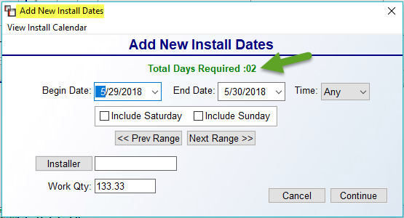

Scheduling Capacity Limits
The system allows for setting Installation Scheduling Capacity Limits on Accumulator Codes in the Catalog Maintenance module. This feature is designed for setting “Hard Limits” that cannot be exceeded when scheduling installation for a particular day. It also allows for blocking installation dates entirely, as in the event of holidays, and will allow key Users to raise or lower capacity limits for a particular day. The setup starts with accessing a Company Control 4 screen option that appears as follows: Company Accum Totals (R, B, C). This control determines at what level capacity is met for each type of installation: Region, Branch, or Company. There is also a User Control 6 screen option that allows key Users to override these limits. That control option appears as follows: Allowed To Override Installation Limits. Set to “Y” to enable this ability.

Once the Company and User Control items are set, you will move on to the Accumulator Scheduling Limits option available from the Accumulator Code Maintenance screen. When you click on this option, an Installation Scheduling Limits By Accum screen will appear as follows:

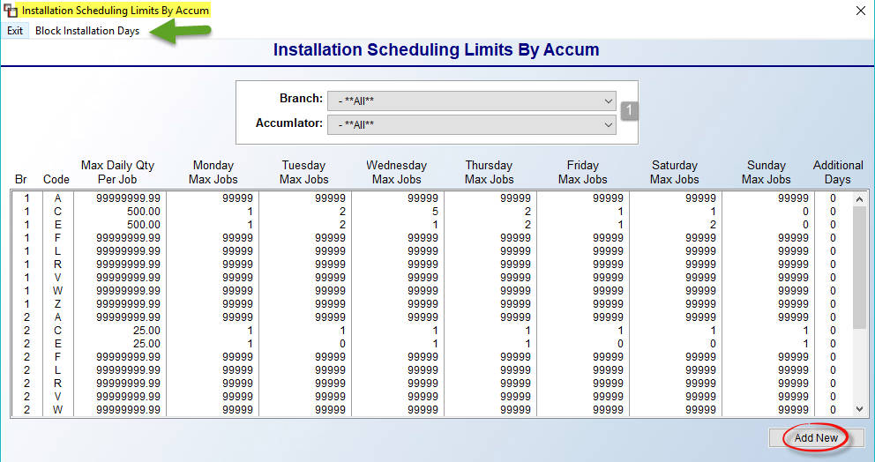

Prior to any Limits being scheduled, the default for all Codes is all “9’s” in each field. This is so that no limits can be met until they are intentionally set by the installation scheduling department. To Add or Edit Limits, click the Add New button at the bottom right, or you can highlight and right-click on an existing line. If accessing from a line, the system will prompt the exact Branch and Code to edit, whereas the Add New button will prompt a screen allowing you to select the Branch (1) and Code (2) as follows:

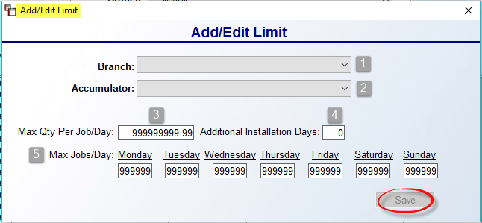
At the Max Qty Per Job/Day (3) field, type in the total feet or yards that can be installed per Job for the Day. For example, 200 yards of carpet or 500 feet of tile. The Additional Installation Days (4) field should be used for Accumulator Codes that typically require an extra day to complete, such as tile. For each day of the week in the Max Jobs/Day (5) section, type in a max number of Jobs that can be scheduled in a Day based on the Accumulator Code selected. For example, 5 carpet jobs, or 2 tile jobs. This will be individual to each company based on the number of crews you run on a given day. To block an entire Day, enter “0” in that field.
The feature to Block Install Dates can also be found in the Installation Scheduling Limits By Accum screen. At the top left, you will see that option as follows: Block Installation Days. When you click on this option, a Block Installation Days screen will appear as follows:
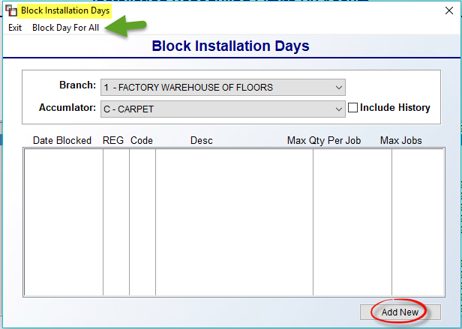

This screen will display any current blocked days. You can use the Block Day For All option at the top left to block an entire day for all Accumulator Codes. That screen appears as follows:

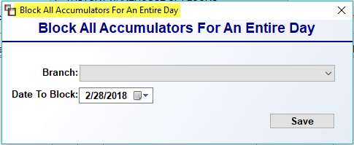

Select the Branch and the Date To Block and click Save to continue. To block only certain Accumulator Codes, or to revise the Qty Per Job or Max Jobs for a Day, click the Add New button to prompt the following screen:

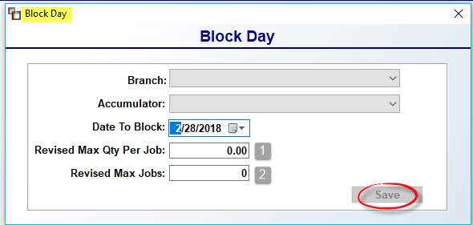

Make your Branch, Accumulator, and Date To Block selections in the screen above. To leave the day blocked for the selection, click Save, leaving the remaining two fields set at “0.” To Revise the fields, enter an applicable Qty (1) and Max Jobs (2) prior to clicking Save.

Adding Product Codes
To create a new Product Code, click the Add button at the bottom right of the first Product Code Maintenance screen. The system will prompt the following:
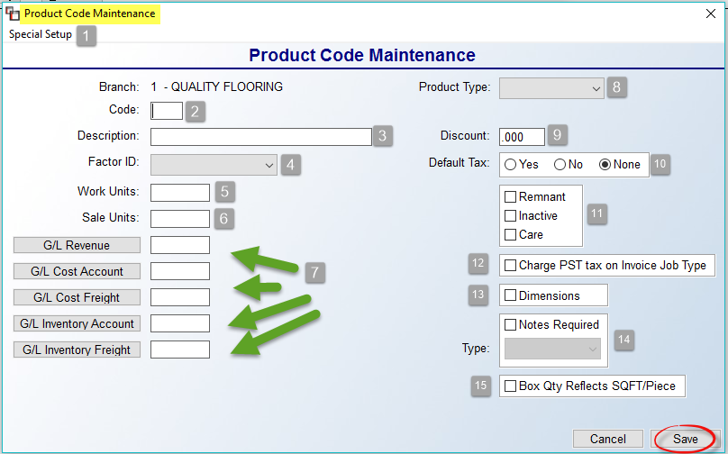

The Special Setup (1) menu at the top left of the screen contains two options as follows: Dimensions Maintenance and Overbill Percentage Setup. The Dimensions Maintenance option is tied to the Dimensions (13) field in the screen above and will be explained below within that section of the documentation. The Overbill Percentage Setup option is only relevant to customers using the optional Build Order Module. If you’re interested in learning more about the BOM, please email info@rmaster.com.

At the Code (2) field, type in a two-digit alphanumeric code. At the Description (3) field, type out a description for the code. The Factor ID (4) field has a drop-down menu containing various factors that determine how each item is purchased, sold, or inventoried. The Factor ID establishes various information such as whether linear feet needs to be converted to square yards, whether or not a roll or dye lot number needs to be entered on inventory, whether the item is a material or labor Product Code, etc. When you click the down arrow, a drop-down list will appear as follows:

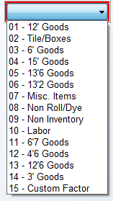

Each of the “Goods” Factor IDs correspond to a width of a roll good item. For example, all Product Codes for roll good items in 12’ widths will have a Factor ID of 01; a 15’ carpet Product Code should have a Factor ID of 04; a 12’ vinyl Product Code should have a Factor ID of 01, etc. The “02 - Tile/Boxes” Factor ID should be used for hard surface goods where you need to keep track of dye lot or run numbers. The “08 - Non Roll/Dye” Factor ID should be used for supplies, sundry items, items sold by the piece, hard surface items that do not require dye lot or run numbers, etc. RollMaster also recommends using the 08 Factor ID for carpet pad, because it allows inventory receipts to be accumulated together and then cost averaged for job cost purposes—see Accumulating/Cost Averaging Inventory Items below for additional info. This practice eliminates multiple inventory records for items that are received frequently such as pad and other supplies. Also, pad should be entered into the system in square yard or square foot quantities and sold by the square yard, or square foot—no conversion is necessary for pad. If a roll of pad contains 300 yards, it will be ordered, inventoried, and sold by each yard, or by the foot if you sell roll goods by the square foot.

The “09 - Non Inventory” Factor ID should be used on all special charge Product Codes where a cost and/or a sell needs to be added to a job, but the charge is not tied to inventory or labor, such as with adjustments, discounts, and finance charges, etc. The “10 - Labor” Factor ID should be used on all labor Product Codes. The “15 - Custom Factor” ID should be used only if you carry a product with a width other than what is currently listed in the drop-down menu. For example, if you sell a 13’ product, enter the Factor ID of 15; this will prompt a Custom Factor box to pop up below the G/L fields as follows:
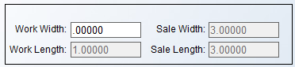

In the Work Width field, enter the new width “13.” The Work Length, Sale Width, and Sale Length fields will always prompt the same data and cannot be accessed. If the Work Width contains inches, you need to convert inches to decimals when entering that figure, i.e. 6 feet 6 inches should be entered as 6.5. And finally, the “07 - Misc Items” Factor ID is rarely used. Consider using this Factor ID on Product Codes where you do not wish to accumulate and cost average inventory as with the 08 Factor ID.

Returning to the main Product Code Maintenance screen above, the Work Units (5) field displays in the Purchase Order and Receive Inventory screens in the system, as well as on various reports. Whatever unit of measure designation is most commonly used when ordering a product from a supplier should be entered here. For example, on roll goods the work unit is linear feet, or LF. There are only four characters available for display so you will need to abbreviate, i.e. LNFT, SQFT, EACH or LF, SF, EA, etc. The Sale Units (6) field will also print out on various reports. Whatever unit of measure designation is most commonly used when pricing material to a customer and when paying installers should be entered here. As with the Work Units, you only have four characters available to display so you will need to abbreviate.

All of the G/L fields (7) have a G/L Account Selection screen available, so you don’t have to know the exact G/L Account Number prior to setting up the Product Code. When you click on any of the G/L (7) buttons, the system will prompt a G/L Account Selection screen as follows:
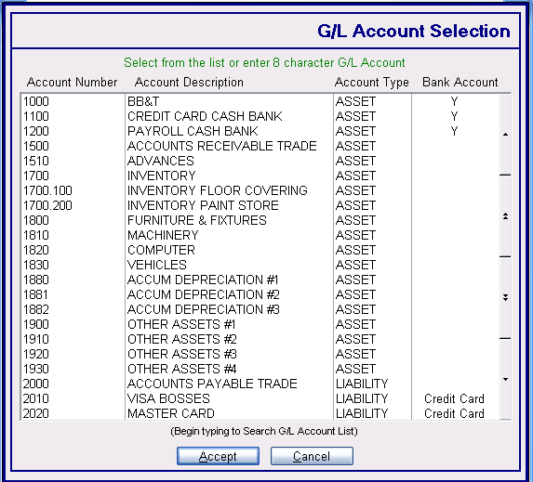

Highlight the applicable G/L Account and then click the Accept button to continue. The following bulleted items explain each G/L (7) button:

- G/L Revenue - enter the applicable sales revenue account number that corresponds to the Product Code you are creating. For example, if you have a separate revenue account for material, labor, and freight, and you are setting up a Product Code for 12’ carpet, enter your material revenue account number in this field. For labor Product Codes, enter your labor revenue account number.

- G/L Cost Account - enter the applicable Cost of Goods expense account in this field. (Please Note: The labor Cost of Goods expense account is updated when you enter an installer invoice into the Open Item Maintenance module in the Accounts Payable menu. Special charge Product Codes impact job cost only and have no direct impact on the system G/L.)

- G/L Cost Freight - enter the applicable Cost of Freight expense account for each material Product Code.

- G/L Inventory Account - enter the applicable Inventory Asset account in this field for each material Product Code.

- G/L Inventory Freight - if you wish to keep track of your inventory freight in a separate asset account, you need to make sure the account is added to your General Ledger and then enter that account here so the system can keep track of your freight asset value separate from your material asset value.

Moving over to the top right of the Product Code Maintenance setup screen, the Product Type (8) field is tied to several reports, including Sales Analysis in the system. Setup for this drop-down menu field was explained at the beginning of this section, under Functions, and should be set up prior to adding Product Codes. Product Types also tie into the Work Order Instruction Sheet to enable customization—see that module explanation for more details. A Product Type must be selected for each material and labor Product Code.

The Discount (8) field will only display if the Company Control 3 option, Activate Invoice Discounts by PC, has been set to “Y” for yes. If this field is available, you can enter a discount percentage that will be applied during the invoicing process for all items under the displayed Product Code.

The Default Tax (10) field allows you to set the default for the Tax prompt in the Quote and Order Entry modules. Set it to “Yes” or “No” to control how the tax question prompts for catalog items within this Product Code. If this field is set to None, this system will read this field as blank and defaults will remain unchanged. You can lock this field by enabling an option in the User Control 3 screen that prevents a User from overriding this default. That option appears as follows: Allowed to change tax default.

The Remnant (11) field determines whether remnants can be sent to this Product Code. For most Product Codes, this will remain unchecked. However, for those few Product Codes designated for selling remnants, check this box and then review the Remnant feature instructions in the Inventory Maintenance section of this documentation. The
Inactive (11) field should only be checked to “hide” a Product Code that is no longer being used in the system, but contains sales analysis history. Deleting a Product Code with sales history will impact your Sales Analysis data.

The CARE (11) field only applies to customers who sell carpet in the state of California and must track CARE inventory. This field should be set to “Y” for yes on all broadloom and modular carpet Product Codes. Where this field has been set to “Y” for yes, the system automatically knows what amount to assess on each applicable CARE job. Important Note: Synthetic grass products do not fall under the CARE guidelines and should not be sold under a CARE enabled Product Code. Additionally, for Remnant Product Codes, the CARE field should also be set to “Y” for yes, and any non-carpet remnant items, such as vinyl, should not be mixed in under these Product Codes.

The Charge PST tax on Invoice Job Type (12) relates to Canadian tax laws and should only be checked on Product Codes where PST tax applies and can be charged based on Job Type. The Dimensions (13) field is designed for selling stock blinds that are “cut to fit” for a customer, though it is not limited to just blinds. When setting up this feature (partially explained above), two options specific to selling “cut to fit” blinds are to first create a “BLINDS” Product Type to add to any Product Code you create for selling blinds. Also, if you charge customers for cutting blinds to size, you can create a Special Charge Product Code for this charge, different from any other Special Charge Product Code. Use the following example for setup:

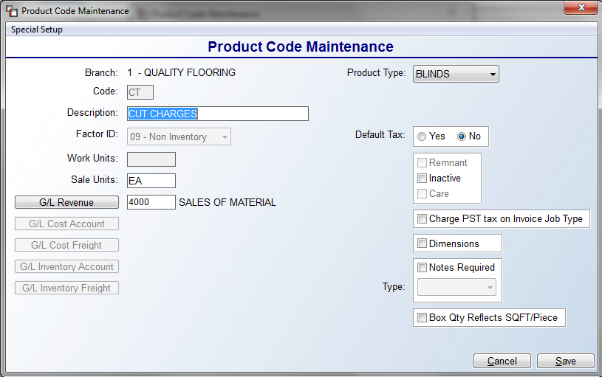

Once a Product Code has been created, add at least one Cut Charge Catalog Item for this charge. An example of a Cut Charge Catalog item appears below:

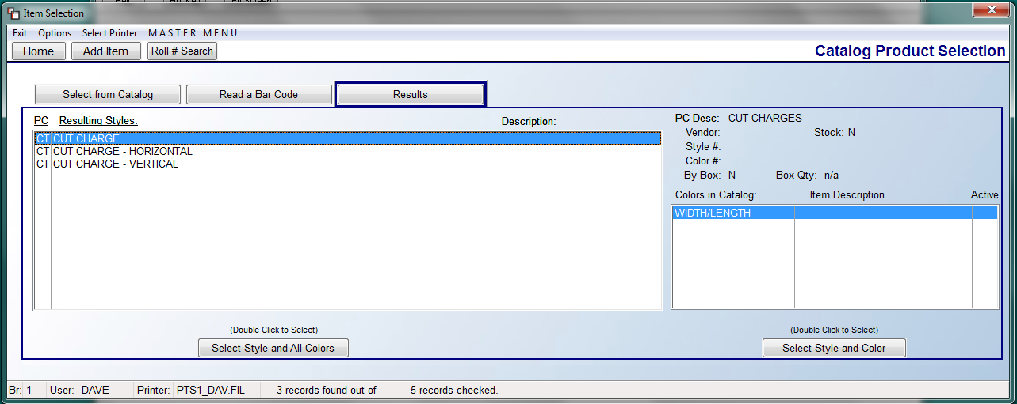

In addition to this optional setup, in any of the “cut to fit” blinds catalog items, you will find additional setup that needs to be completed. In the Edit Existing Catalog screen, just below the Consignment and Programmed check boxes, there are two size fields that appear as follows:
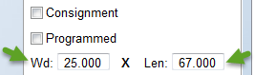

In the Width (Wd) field, type the stocking width of the blind. In the Length (Len) field, type the stocking length of the blind. This will ensure the programmed cuts cannot be higher than what appears in these fields and also allows the system to determine the maximum cut sizes allowed.

Once this setup is complete, you are ready to continue with the Dimensions (12) feature. (Please Note: after the initial setup has been completed, you will perform any edits via the Special Setup menu at the top left of the Product Code Maintenance screen, via the Dimensions Maintenance option.) When you check the Dimensions box the first time, the system will prompt a Dimensions Maintenance box as follows:

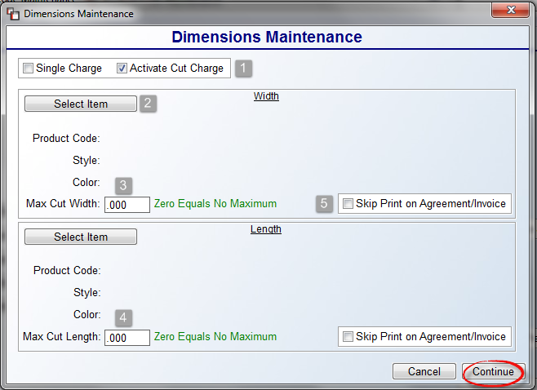

To control the maximum width and length cuts allowed and to set up charges for cuts, you will need to program the fields above for each applicable blind Product Code. In the first box, the Activate Cut Charge (1) box will be checked by default. If your company doesn’t charge for this service, you can un-check this box. If you charge for cuts, but only charge a single fee regardless of whether it is a width or length cut, you should also click the Single Charge (1) box. The two Select Item (2) buttons will prompt you to select a Cut Charge Catalog item (covered above). If you checked the Single Charge box, you will only use the first Select Item button at the top of the screen to program one Cut Charge item. Otherwise, you can select a Cut Charge for Width at the top and for Length at the bottom. At the Max Cut Width (2) field, type the maximum number of inches that can be cut from the width of the blind selected. At the Max Cut Length (4) field, type the maximum number of inches that can be cut from the length of the blind selected. These will also generate Comment Lines for the Work Order and Customer Copy. At the Skip Print on Agreement/Invoice boxes, you can set the default for how this prompts in the Quote and Order Entry modules. If this box is checked, the Cut Charge lines will not print on the Sales Agreement or Customer Receipt; instead, the charges will be reflected in the sale amount of the material line item, but only if the quantity of blinds and related cuts are equal.

As explained above, the Notes Required (14) and Type fields are used to set up required notes for Salespeople to answer required information when entering Quotes and Orders. With this box checked, you can use the drop-down Type menu to select an existing Note Type. See the Product Code Note Maintenance section above for further details. The last available field in the Product Code Maintenance screen appears at the bottom right as follows: Box Qty reflects SQFT/Piece (15). This controls the verbiage for the Sold by Box feature. When this box is checked, in Catalog Maintenance, instead of displaying “Catalog Item Sold By Box,” the system will display “Catalog Item Sold By Piece.” The quantity will also display as follows: SQFT/Piece. This change will flow through to the Quote, Order Entry, Purchasing, Work Order, etc. areas of the system.

Only for Product Codes with a Factor ID of 09 or 10, one additional feature will appear at the bottom right of the screen as follows: Exclude From Cost Review Sale Changes. With this box checked, in the Cost Review feature of Quote and Order Entry, this provides the ability to exclude the Sale Qty of a Labor or Special Charge Line Item from the recalculation of Total Sales on the Quote or Job. A use case for this is a Warranty on Installation, where you wouldn’t want the Sale Qty Price of what you are selling to change from what was originally entered. This does not apply to adjusting the cost or margin.

When you have finished adding all your Product Codes, you can begin entering non-B2B catalog items. If you have multiple locations, you will need to set up Product Codes in each Branch. If any of the Branches will be sharing a catalog, the Product Codes need to be set up identically except for the G/L account numbers. (The G/L account numbers will only be different if you are using separate revenue and expense account numbers for each Branch to create separate Income Statements.)

Accumulating/Cost Averaging Inventory Factors:
If you use a Factor ID of 02 or 08, the system will allow you to group inventory receipts together. During the Receive Inventory process, an item with an 02 Factor will default to a Roll # of “02” which you will need to accept for this to work. During this process, if the dye lot you enter in Receive Inventory matches an existing dye lot under that style with a matching “02” Roll #, the system will prompt you to add the inventory to the existing record. For the 08 Factor, which can be used for items such as pad, it will prompt a Roll # of “08” and a dye lot of “08” so all you have to do is hit enter through those prompts when receiving. The next time you order the same material, it will add the new inventory with the “08” Roll # and the “08” dye lot to the existing inventory record, eliminating a long list of partial inventory records-you will only have one record with the total inventory amount.

Important Note: When you use this feature, the value of the new inventory record will be averaged so that if a previous receipt was less expensive than a current receipt, the two will average together to create a new valuation for job costing purposes. When inventory is merged, the PO # from the last item merged will appear in the Inventory Maintenance screen. Also, when using the Review P.O. History feature in A/P, the last Invoice approved will generate the Invoice # for that inventory record. If you need to find the actual Invoice # for a PO you can look that up in P.O. History Inquiry, and the PO Number can be found through the Job Line Review feature. If cost or freight is changed during the Review P.O. History process, those changes will be averaged into the new value of the inventory. For items with a Factor ID of 02, the inventory records will only be combined where the dye lots match. This would include items such as ceramic, VCT, hardwood, etc. The 08 Factor should be used for items such as laminate, adhesive, metal, tack strip, supplies, etc. If you are ordering items with a factor of 08 for larger Jobs where you are receiving special pricing for just that Job, you should change the Roll & Dye lot numbers when the inventory is received so that the special pricing goes to that Job and the value is not averaged in with existing inventory.

The system will allow anyone with access to this module to enter into the Factor ID field for Product Codes with an 02, 07, or 08 existing Factor ID and will permit changes, but only if the change is to a Factor ID of 02, 07, or 08. For example, if you need to change an 07 Factor ID to an 08, the system will permit this, but it would not allow changing to roll goods, special charges or labor Factor IDs.

Catalog Maintenance:
Once you have added Product Codes and before you can begin entering inventory or creating POs, you must create catalog items in this module. If you are importing a B2B catalog, you will only need to enter any non-B2B imported inventory items in this module to get started. You do not need to enter every product in every color that your store carries before you begin using the RollMaster System, but you should enter all of your top sellers and you must create a catalog item for each inventory item your store has in stock, unless that will be handled through the B2B import.
When you enter the Catalog Maintenance module, the screen will appear as follows:
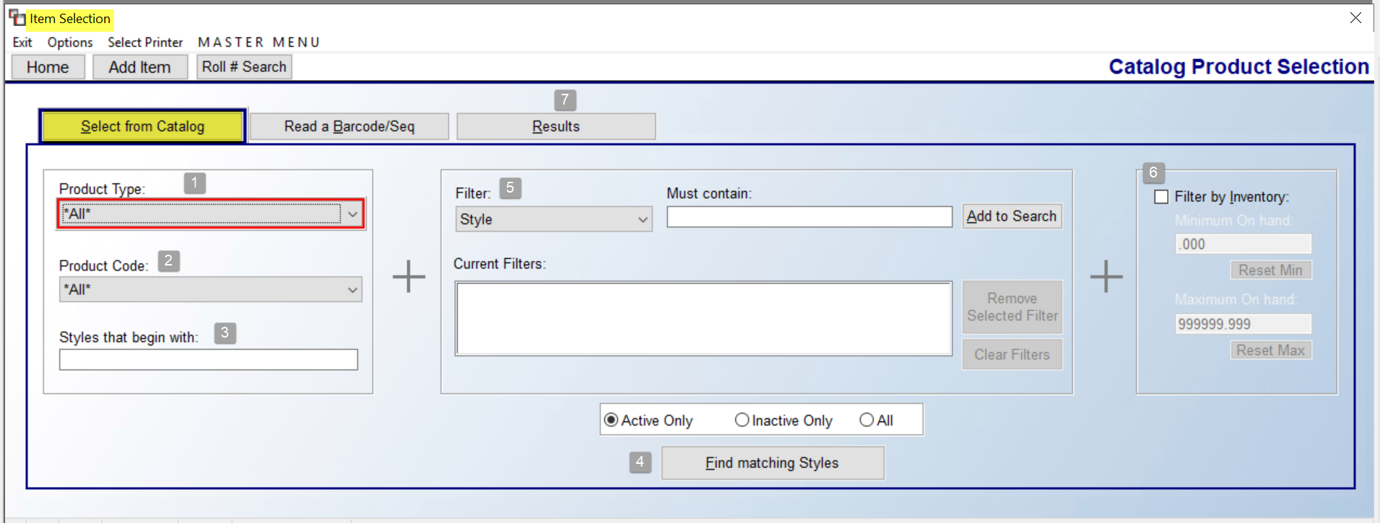
The screen above is designed to allow you to search for an existing catalog item and is identical to the Select Catalog Item box in the Order Entry and Quote Entry modules to maintain consistency in the system. You can narrow your search by making Product Type (1) and Product Code (2) selections and/or by entering the first couple of letters of a style in the Styles that begin with (3) box prior to clicking the Find matching Styles (4) button at the bottom of the screen. You can also utilize the Filter (5) box features as well as the Filter by Inventory (6) option at the far right of the screen once you add existing inventory, to further customize your search. Again, all of these features work the same as they do in the Order Entry and Quote Entry modules. Please Note: When using the Filter (5) search feature, if you select Color or Color # to sort your search, the system will only display matching color items in the Results (7) tab, rather than list all the colors under a catalog item, as it does when searching by Style Name.
Special Note: the graphical catalog item selection program has been enhanced so that if a Product Style/Code has not been selected and a couple of characters have been typed in the Styles that begin with field, such as ABC, the system will use the order of those letters to begin the search through the entire catalog rather than just the presence of those letters. In this case, it would only prompt items as follows: ABCA, ABCB, etc., so that the list does not include superfluous items that only contain those letters not in that order. This will be most helpful for B2B clients searching through extensive tile and wood catalogs. For example, typing DECO would return DECO 12x12, DECO 18x18, and DECORUM, but not any word that simply contains one or more of those letters as it was doing prior to this release.

Adding Catalog Items
To add a new catalog item, click the Add Item button at the top left of the Item Selection screen that appears as follows:

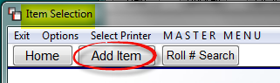

The system will prompt an Add box as follows:

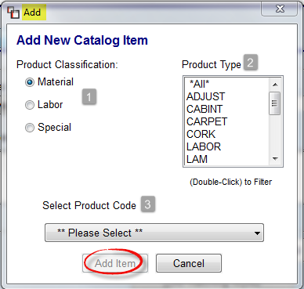

You will first need to make a Product Classification (1) selection from the three available choices at the top left of this box. The default classification is Material, but you can switch to the Labor or Special classifications when applicable. At the Product Type (2) box, select an existing type from the list to narrow the Product Code search by double-clicking on a Type in the box to filter the Select Product Code (3) drop-down menu selection. If you wish to see all Product Codes, leave the default **All** selection in place. The next option, Select Product Code (3), should be completed last and will display options based on your prior selections. Click the down arrow to prompt a list of applicable Product Codes. Make a selection by clicking on an existing Product Code in the list. The Add Item button will become available once a Product Code is selected and you can click on that option to continue. Please Note: this next section covers Material product classification only; Labor and Special items will be addressed following this section.
The Add New Catalog Item screen will appear as follows:
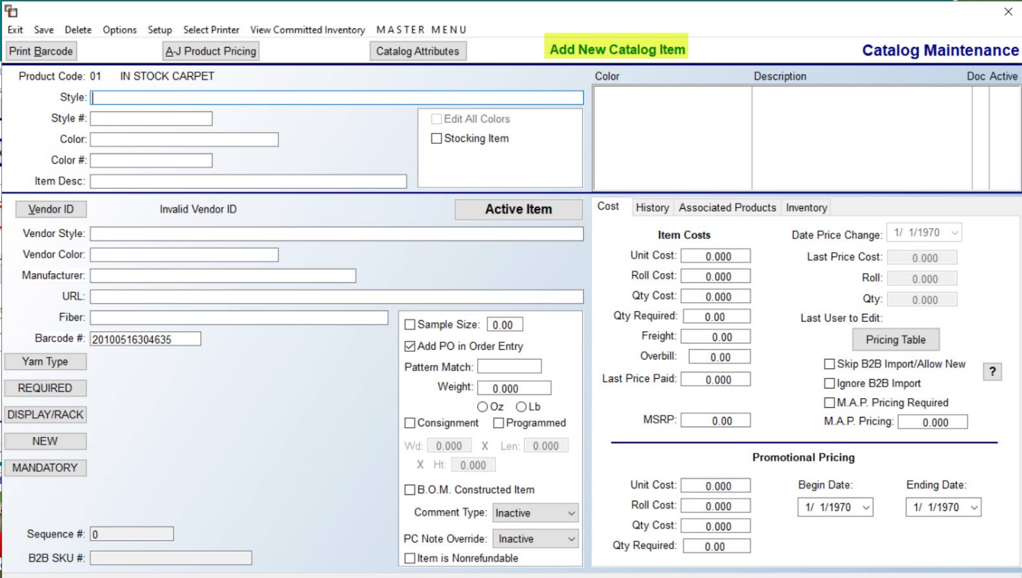

Whether adding a new catalog item or editing an existing catalog item, you will see the same screen above. The first series of fields that need to be completed for new items are located at the upper left corner of the screen as follows:

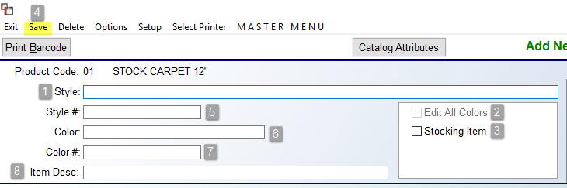

In the Style (1) field, type a complete style name up to 80 characters. In many places throughout the RollMaster System and on many printed reports, only the first 20 characters will display, but the entire field of 80 characters is searchable. There are system options for handling Private Label names for catalog items, however, if an item needs to be listed in your catalog by the Private Label name, you can type that name in this field.

Important Note: When entering catalog items that are available in different quantities such as 1 quart vs. 1 gallon, the quantity amount needs to appear in the Style field. In addition, some rubber cove base products have different costs for different colors. For these products, you need to alter the Style field to distinguish between the different pricing levels. When a change is made to a catalog record, the system will make the same change(s) to all records within that style making pricing updates quicker, therefore to avoid inadvertently updating catalog items that are similar in description but priced differently because of color or some other variation, you need to distinguish between them in the Style field.

When adding a new item, the Edit All Colors (2) option will not be enabled. The Edit All Colors (2) option will only be enabled on existing catalog items. When making changes to existing items that will impact all colors, be sure to click the Edit All Colors (2) option prior to clicking the Save (4) option at the top left of this screen. Please note: Not all fields will be available for editing when Edit All Colors is selected. The Stocking Item (3) option will be available for new items, and should be checked if this item will be stocked in your warehouse. Key inventory reports can be printed for “stock only” items. Also, for items such as wood, tile, vct, etc., two additional fields will appear just below the Stocking Item field as follows:
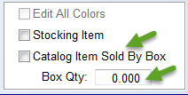

If an item is purchased and sold by the square foot, but must be in quantities that are full boxes (no split cartons), you can check the Catalog Item Sold By Box field and the system will force selling, purchasing, and receiving by the Box Qty amount you enter in that field. If you purchase by the box, but sell by the piece, you can leave the Catalog Item Sold By Box option unchecked, but still enter the square foot per box quantity in the Box Qty field, and the system will display this information during purchasing and receiving, but it will not force a full box quantity sell in the Quote and Order Entry modules. Also, any quantity listed here will also display in the Results tab of this module, to the left of the View Available Inventory button, when selecting a catalog item. When editing an existing item, where an item is set to Catalog Item Sold By Box and where there is existing inventory, the following message will prompt if a change is made and the inventory no longer matches a valid box quantity:

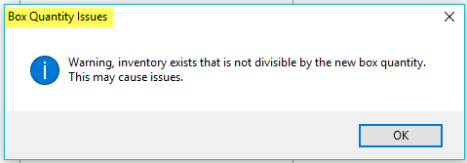

This is only a warning that pops up after you click Save. You will need to make the adjustment back if the warning needs to be heeded.

At the Style # (5) field, type the style number, up to 15 alphanumeric characters. You can search for an item by this field, so entering the number correctly is important. The Color (6) field is used to record the color name; where a color name is not applicable, the field can be used to record additional identifying data. For Private Label items, use the Color associated with the Private Label name. The Color # (7) field is also 15 alphanumeric characters. Type the color number for the color being added. The Item Desc. (8) field is a multi-use field that will appear in the Results Tab during catalog look-up. Use this field for additional information on the product that will be helpful to a Salesperson in identifying the right product. For example, you could enter construction data such as TEXTURE or PATTERNED OLEFIN. You could also enter pattern match data such as PATTERN MATCH 15”. For hard surface products, you can enter packaging information such as 23.6 SF/CTN. For adhesives you can enter spread rates, etc. This field can be edited whenever applicable.

The next series of fields to be completed appear as follows:

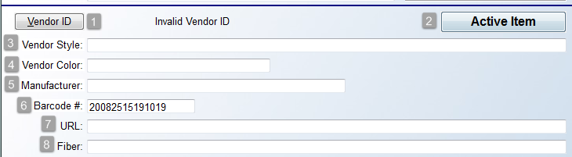

The Vendor ID (1) button will prompt a Vendor Selection box as follows:

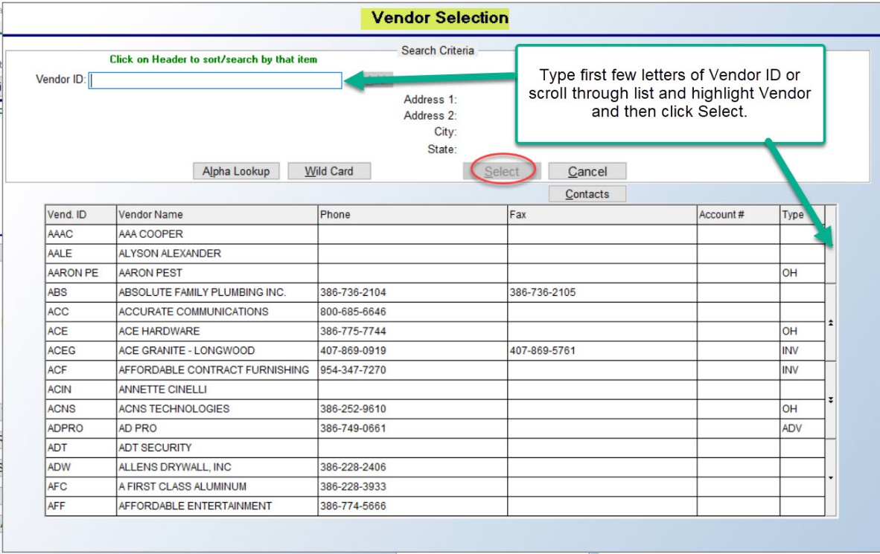

At the Vendor ID field, you can type the first few letters of the Vendor name to begin sorting the list below. You can also use the up and down arrows along the right side to scroll through the list to search for a Vendor. Highlight the line containing the applicable Vendor ID and click the Select button to return to the Add New Catalog Item screen. The Active Item (2) button, to the right of the Vendor ID button, defaults to Active for all new items. When an item or a color within an item is dropped, you can click this button to set the item to an Inactive Item. This will preserve any history and keep your sales analysis data clean.

The Vendor Style (3) and Vendor Color (4) fields will automatically default to the data entered in the Style and Color fields above. If the product is a Private Label, type over the Private Label style name and color entered in the fields above with the actual Vendor name for the product. These two fields will display on the Purchase Order for ordering purposes. At the Manufacturer (5) field, enter the manufacturer’s name up to 30 characters. This field ties to the Sales Analysis module, and provides analysis for the Manufacturer versus the Vendor. The Barcode # (6) field will automatically prompt a system generated number. Regardless of whether you use the RollMaster Bar-coding system, enter through this field and allow it to default to the system generated number. Customers using the RollMaster Bar-coding system can edit this Barcode # field, if applicable. The URL (7) field is tied to B2B imported products. This is not yet a working field, but soon, where applicable, it will display a web link to additional product specification information for a style. The Fiber (8) field should be used to record data different from Yarn Type. It reports to the Sales Analysis module, so be consistent with this field to yield meaningful data. The next series of buttons/fields appear as follows:

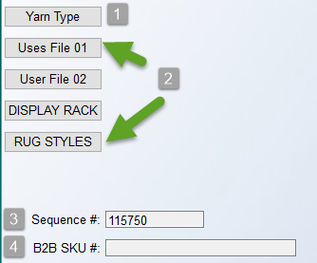

The Yarn Type (1) button prompts a list of yarn types that should already have been created in the Yarn Type Maintenance module (see explanation further down in this manual). The Yarn Type field reports to the Sales Analysis module as well as the Yardage Report module. In order to ensure the system generates meaningful data, selections for this field should be consistent.

The four consecutive User File (2) buttons just below the Yarn Type button are user-definable for additional categories that also report to the Sales Analysis module. They have been added to allow for further customization and sorting of Catalog Items. These can be changed from the default names by clicking the Setup menu at the top left of the screen to access an edit screen and then you can build applicable selections within those user-defined categories. See “Setup” menu section below for further details.

The Sequence # (3) field contains a system-generated number for each individual Style and Color. This number can be used to speed up the search for 08 inventory items in the Roll # Search feature. This field is importable and appears on several Inventory Reports. The B2B Sku # (4) field will automatically populate on all B2B Imported items. When adding a catalog item, you have access to this field if the item has a SKU #, but if the item is ever available for import, it will create a new record under one of the pre-set B2B Product Codes.

The next series of fields appears as follows:

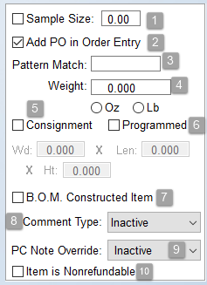

The Sample Size (1) field should only be checked for items found in your showroom. When checked, you will have access to the size box where you can type the size of the sample for this product, i.e., 27”, 18”, etc. This field is not required, but there are catalog and inventory reports tied to this field. The Add PO in Order Entry (2) field will default to the checked position. This field controls whether a Purchase Order can be created from the Order Entry module. For stocking items such as pad and glue, you may wish to only allow the purchasing department to create a PO for these type items, in which case you can uncheck this box. The Pattern Match (3) field is for programming pattern match data that will prompt automatically in Order Entry, Quote Entry, Property Management, and Purchase Orders to ensure enough material is ordered to match the pattern. Please Note: the system will not copy Pattern Match (3) data to other colors--you will need to add this data to each color separately. This is primarily because sheet vinyl can have a variety of pattern matches by color within the same style, and the same can be true for other flooring products.

The Weight (4) field is designed to allow you to record weight in ounces or pounds if you wish to keep track of that data in the system. The Consignment (5) field is for Area Rugs that you carry on consignment. Check the box for this field if it is a Consignment item. This field is currently a display only field but will be used in future programming. The next field, Programmed (6), is also for Area Rugs. If the rug is a programmed rug, meaning it is available in a variety of sizes on a continual basis, check the box at this field. Again, this is currently a display only field but will also be used in future programming. The Width, Length and Height fields are only updated via B2B Item import. Not all Vendors are sending this data at this time. They are informational only.

The B.O.M. Constructed Item (7) field relates to Build Order Maintenance module items, which is a supplemental RollMaster module available only by subscription. The B.O.M. functionality essentially allows you to build “kits” or “packaged” products within RollMaster, such as custom mini-blinds or installation kits, to sell as “1” item, versus selling it in several pieces. For additional information, please inquire at info@rmaster.com.

The Comment Type (8) field can be used to set a default Line Comment type in Quote and Order Entry for catalog item lines and special charge lines. Use the drop-down arrow to select a default Comment Type. Once selected, the system will automatically prompt the Update Comment Line screen upon exiting the Add or Change a Line Item screen after entering a line item the first time through. If you are not yet familiar with the Order Entry process, you can leave this field set to the default Inactive status and return to this field once you determine how you would like to utilize this feature.

The PC Note Override (9) checkbox feature is tied to the Required Notes feature set up in the Product Code Maintenance module, explained above, and used in Order Entry. When checked, you can select a Notes option that will override what is currently set up on the Product Code, where applicable. The Item is Nonrefundable (10) checkbox feature is not yet working. It will be activated in a future update.

The right side of the Add Catalog Item Screen displays items and functionality that allow access to more options from within this screen. Most of these items will relate to existing catalog items and will not be applicable when adding new catalog items; therefore in the next section, the content will mostly cover fields that relate to adding a new item.

When adding a new catalog item, the right side of the screen will appear as follows:

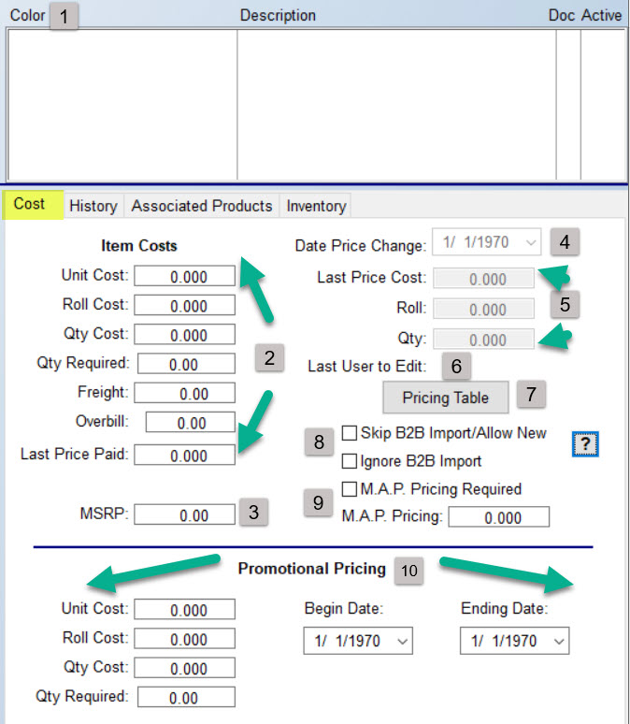

The Color/Description/Doc/Active (1) columns will automatically update as new colors are added to a style, or they will instantly populate with all available colors during the B2B Import process. If a color is dropped, clicking next to that color in the Active column will “hide” the color in Quote, Order Entry, Inventory Maintenance, and Purchase Orders--this is an automated process for B2B customers. The Doc column is tied to the Edocs functionality and will indicate if an electronic document is tied to a specific color in the system.

Below the Color section, you will see a series of tab screen options. The Cost tab screen will always be the default screen when in the Catalog Item screen. The Item Costs (2) fields are for all applicable cost information for this item and should be completed before proceeding. Please Note: if you tab through the Add New Catalog Item screen, the system will take you through the Item Costs (1) fields and then back over to the Sample Size, Add PO in Order Entry, etc. fields. If you use the mouse to access fields, you can enter data in any order, but the system will not allow you to save the item unless key fields such as Style, Color, Vendor ID, etc. have been completed. A popup box will alert you to this if you click Save without having completed these key fields. In the Unit Cost field, enter the cut or regular price per unit of the product (do not include freight in this field). In the Roll Cost field, enter the roll or quantity discount price of the product. If the cut and roll price are the same, enter the cut price again in this field (do not include freight in this field). The Qty Cost and Qty Required fields are for roll goods. These two fields should display the minimum size of a roll (Qty Required) and the yardage cost for roll buys (Qty Cost). For hard surface goods, these two fields can be used to display the number of square feet per pallet on an item and the pallet price. During the B2B Import process, these fields will automatically be updated and will reflect a landed cost. Also, depending on the Vendor, the Qty Required field on B2B imported hard surface items may reflect how many units or SF per carton. For non-B2B customers or for non-B2B imported items, these fields can be manually completed. The data entered into these two fields will appear in the (F1) Roll/Cost Comparison feature in the Purchase Orders module, along with the other cost fields.

In the Freight field, enter the average or estimated freight price per unit for this product. The total freight price on a Job for this product can be verified and changed through either the Purchasing, Receiving or A/P Review P.O. History features before or after closing out the Job. For this reason, you only need to enter an estimated freight cost in this field. The Overbill field was developed for owners/managers to add an additional unit cost to a stocking product that is not a part of the material cost or the freight cost. The catalog item must be designated as a Stocking Item in order to see these costs reflected in Quote and Order Entry. Also, only Users with permission to see or adjust Overbill will have access to this field. The Overbill amount will not increase inventory value, it is simply for job cost purposes. In order for the cost to be factored into the A-J Level Pricing (explained below), make sure that the “Include OverBill In (A-J) Pricing” option in the Company Control level settings is set to “Y” for yes. (See the System Administration Manual for more details.)

This Overbill value will be sent to the Job as a cost when a PO is created or when stock inventory is assigned. For Job Cost purposes, the Overbill amount will be factored into the total cost of the material and will reduce the base used to determine Salesperson commissions (provided commissions are based on Margin and not Total job). This amount will not be reflected in the Review P.O. History feature in the Accounts Payable Open Item Maintenance module. In the Owner Functions menu, the Overbill / Overhead Job Cost Margin Report will display true job cost information and will break out the total Overbill amount collected on each job. Please Note: The Owner Functions menu will be the only place in the system to view true job cost once you use either the Overbill or Overhead Percentage options (available in Job Type Maintenance).

The Last Price Paid field is automatically updated through the Purchase Orders module. It will reflect the last unit price paid for this product on a system PO. The MSRP (3) field is strictly informational in this screen at this time. In the Date Price Change (4) field, as new B2B pricing downloads are imported into RollMaster, the system will keep track of the date of price changes for each product. For non-B2B imported items, if a price is changed manually, the system will also update this field. The next three fields, Last Price Cost, Roll, Qty (5), will keep track of pricing prior to the last price change so that when a price is changed, you have a record of the old pricing. These fields will automatically be updated either during the B2B Import process and or when pricing is changed manually. In the Last User ID to Edit (6) field, the last User ID of the person that made any changes to this catalog item will display.

The Pricing Table (7) button will prompt an A-J Level Pricing Table as follows (A-J may be replaced with custom names via Level Name Mtc option explained below):

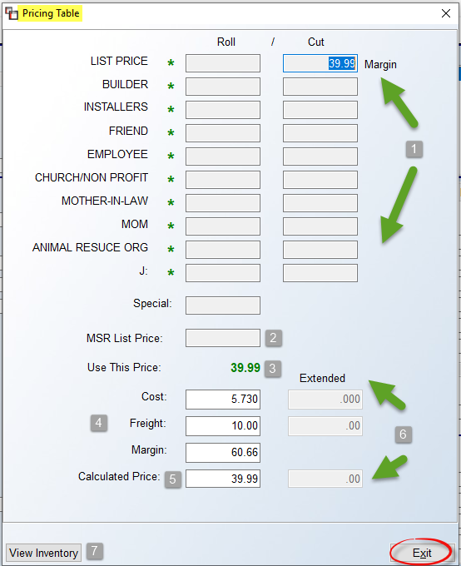

This Pricing Table is also available in the Quote, Order Entry, and Property Management modules and serves multiple purposes. Please Note: access to this Pricing Table will also be controlled by User/Branch setup. If a User is not set up in a Branch, they will not have access to the Pricing Table in that Branch. Data will only appear if you have programmed pricing in the Catalog (A-J) Pricing Maintenance/Print module (explained below) and where costs have been entered on a catalog item. When this screen first prompts, the cursor will be positioned in one of the Roll/Cut (1) column fields based on the preference setting in the System Control 1 Level screen of the System Control Maintenance module with regard to Default A-J and Default Roll/Cut. Please note the appearance of green asterisks next to each field that contains programmed pricing. In the example above, all levels have been programmed, giving Salespeople a range of pricing from which to select. You can tab through these fields to prompt each level price. A User Control 2 level setting determines if a Salesperson can sell below any A-J programmed pricing.

The Special field will only display pricing on any item that has been programmed for All Customers via the Special Price Mtc. module. The MSR List Price (2) field is not currently a working field. The Use This Price (3) field will display the current selection in the A-J Level fields above. The Cost, Freight, and Margin (4) fields display data entered for the item. You can make changes to each of these fields to adjust the Calculated Price (5) field and override the margin calculated price. This will come into play on the selling side of the system. The Extended (6) fields will display totals on the selling side of the system. And finally, the View Inventory (7) button will prompt an Inventory Review screen defaulting to the From Inventory tab as follows:

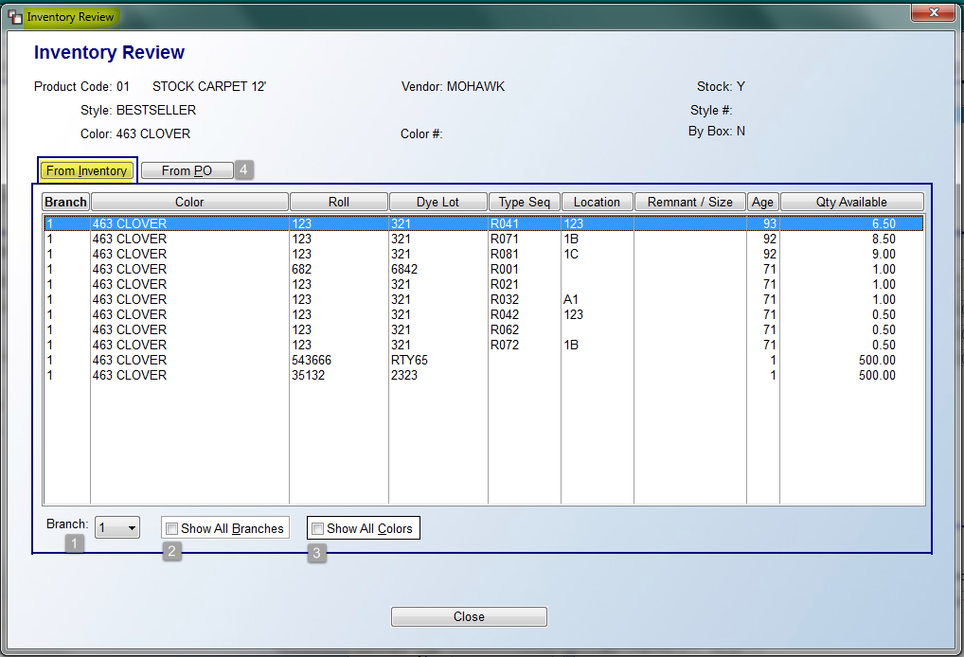

If inventory exists on this item, you will see all inventory records in the From Inventory tab screen above. You will not be able to select any inventory as this is a “view only” screen. However, you do have additional options for locating inventory available at the bottom left of the screen. At the Branch (1) field, use the down arrow to select another Branch to see what inventory may reside in that location. At the Show All Branches (2) field, you can click that box to display all inventory available in all locations. At the Show All Colors (3) field, you can click that box to see all colors with available inventory for the style selected. Again, this is for lookup purposes only. The other option available in the Inventory Review screen is the From PO tab (4) screen. When you click on this tab, the system will prompt a list of any open POs in the system for this material as follows:

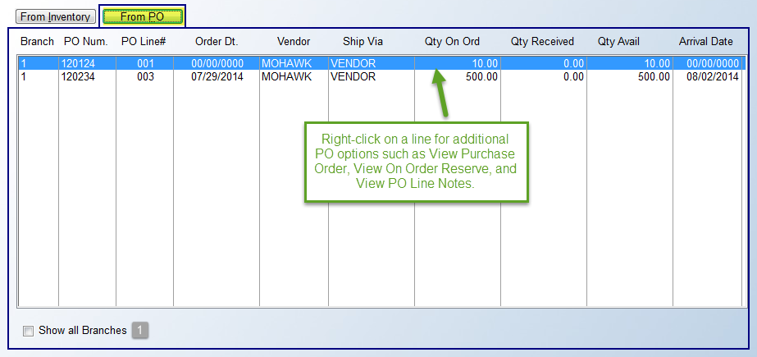

In the screen above, if the Order Date and Arrival Date columns display all zeros, it means the PO has not yet been ordered. Also, the Qty Available column will indicate if any of the material coming in is available for a Job or if more will need to be ordered. At the Show all Branches (4) field, you can click to see Purchase Order detail that exists in other locations for this item. If you right-click on a line, the system will prompt three additional options: View Purchase Order, View On Order Reserve (to see where incoming inventory will be assigned), and View PO Line Notes.

The Skip B2B Import/Allow New (8) checkbox should be used if an item is set to Inactive and you want the B2B Import to not see this item so it will create and update a new B2B Item. The Ignore B2B Import (8) option, if checked, will disregard any pricing updates sent via B2B. This should be used on items such as regular stocking or best buys where you receive special pricing and don’t want a B2B pricing import to potentially make any changes. The (?) option, when clicked, will display a reminder of what these two fields actually do when you are in a Catalog Item, as follows:

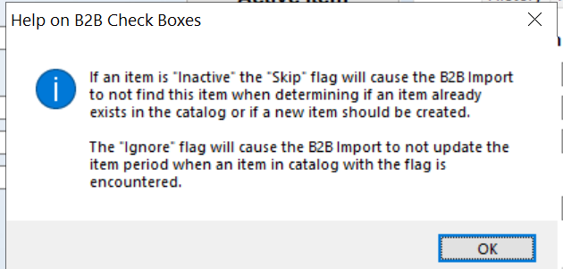

The M.A.P. (Manufacturer Advertised Price) Pricing Required, and M.A.P. Pricing (9) fields/checkbox are tied to Ecommerce functionality and should only be used if an integrated program, such as WooCommerce, is pulling catalog data into an online website via RollMaster’s API. These two fields would then allow you to set a minimum advertised price so you don’t inadvertently advertise a price below what the manufacturer allows.

Moving down to the bottom of the Cost tab screen, you will see several fields for use with Promotional Pricing from a Vendor. They appear as follows:

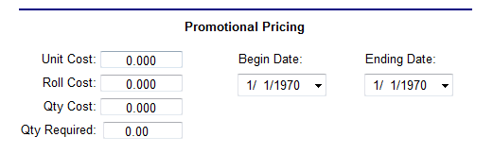

During the B2B Import Process, if a Vendor offers promotional pricing on a style, that data will import into these fields. (These fields can also be accessed manually for any non-B2B imported items.) You will see the Beginning and Ending Dates for the promotion, and all the applicable pricing for the promotion. These fields currently tie into the Purchase Orders module, so you can access this information when ordering via the (F3) Promo Pricing feature. The system will prompt a box alerting you that Promotional Pricing Exists and an asterisk will appear to the right of the price in the Gross Cost field if promotional pricing exists. For non-B2B customers, you can manually type promotional data into Catalog Maintenance and the Purchase Orders prompts will work the same way. Very Important: Because the Promotional Pricing features are only available from Purchase Orders, we do not recommend that you place any orders from the Order Entry Purchase Order screen. Simply create the Open PO in Order Entry and then complete all ordering from the Purchase Orders module.
The History tab, next to the Cost tab will appear as follows for newly added items:
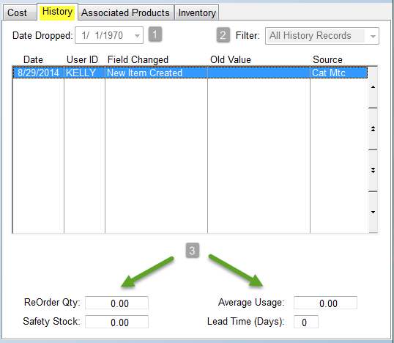
As ordering, receiving, invoicing, etc. processes are completed in the system for an item, you can view that data here as well as sort the data in the main screen via the Filter (2) option. This includes all the types of Catalog field edit records you would like to view for an item, including when an Item is made Inactive or Active. The Date Dropped (1) field is updated during the B2B Import Process. At the bottom of this screen, you will see four additional fields that can be programmed for a catalog item. The ReOrder Qty (3) field is used to record a recommended reorder quantity for a product. Any figure entered here will tie into the Safety Stock Evaluation Report (accessible from the Inventory Reports menu) to help keep track of standard reorder amounts. The Safety Stock (3) field is used to record the level at which additional stock needs to be ordered. Any figure entered here will also tie into the Safety Stock Evaluation Report to keep track of the level at which new stock should be ordered. The Average Usage (3) field is a manual field. It is not updated from purchasing, but can be used to display manually entered usage data based on purchasing history. The Lead Time (Days) (3) field is based on information updated in the Purchase Orders module. This field will display the number of days it takes to receive this product into your warehouse once it has been ordered.
The Associated Products tab will be explained in its own section below.
The Inventory tab for newly entered items does not contain any setup fields and does not need to be accessed. However, once you begin ordering and receiving inventory into the system, the screen will appear as follows:

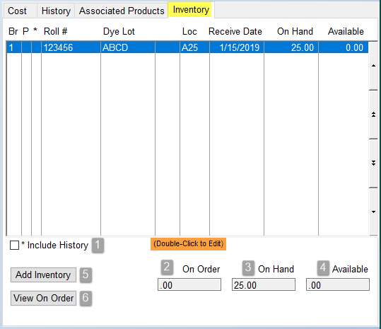

The screen above displays all existing inventory for the currently selected item in the system. The “P” column, when populated with a “P” indicates an item is in transit from another Branch. The “*” column will contain an “*” for inventory that has been moved to history via the Inventory Purge process and will display those records when the Include History (1) box below is checked. In the column to the right of the Dye Lot column, if you see “C01”, “C02”, etc., it indicates that the inventory item has been cut off the main roll. Also, where you see an “R01”, “R02”, etc., in that column, it indicates the roll was returned to the system through the Credit Memo program or F5 Return to Order option.

The On Order (2) field displays the total inventory that has been ordered on a system PO, but has not yet been received into the system. The On Hand (3) field displays the total physical inventory amount sitting in all the locations referenced above. The Available (4) field displays what portion of that inventory, if any, is available for use on new orders. The Add Inventory (5) button will call up the Edit Inventory Item screen in the Inventory Maintenance module (explained in the next section below), allowing you to add inventory for this item—this is primarily used for beginning inventory items. All new inventory will be ordered and received via the Purchase Order module. The system will return you to this screen upon exiting that module. You can also double-click on an existing inventory record to view/edit/adjust an inventory record in the Edit Inventory Item screen. The View On Order (6) button will display all POs in the system containing the currently selected catalog item.

Editing/Additional Options for Existing Catalog Items:
At the top right of the Catalog Maintenance screen, under the Options menu, you will see the following list of available options:

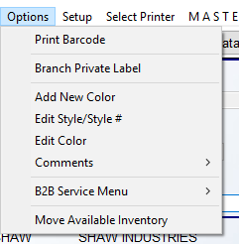

The Print Barcode option will print a barcode label for the item currently displayed. It is designed to work in conjunction with the RollMaster Barcode Software & Equipment, which are an addition to the RollMaster System. When this option is selected, if a Private Label name exists, the system will prompt a message asking if you want to use the Private Label name instead.

The Branch Private Label option will prompt the following Branch Private Label Maintenance box:
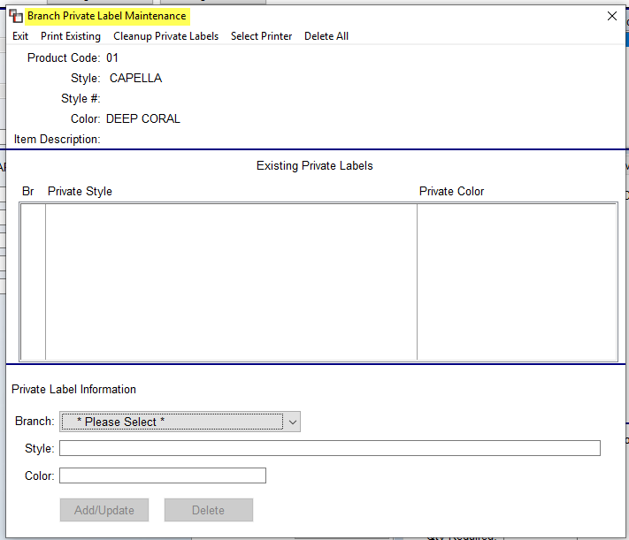
This option works in both Edit All Color mode and single style and color mode. If Edit All Color mode is enabled when this feature is in use, a box will first prompt as follows:

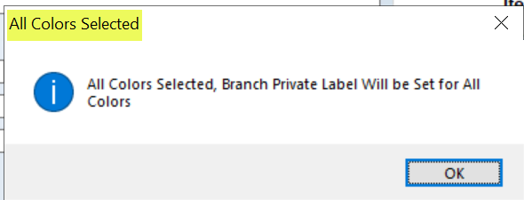

You will then only need to edit the Style field. In the Branch Private Label Maintenance screenshot above (displaying single style and color mode), the top part will display any Existing Private Label items for the selected Catalog Item. If you wish to add a new Private Label style, you can complete that by using the fields at the bottom of the screen. You will first need to make a Branch selection from the drop-down menu. You can then type a Style and Color name for the new Private Label item. Be sure to click the Add/Update button to save the data. If you click on an existing item in the Existing Private Labels box, you can then edit and Update the changes or Delete the Private Label item. Along the top left are additional options available in this screen. You can Print Existing Branch Private Label items, Delete All Branch Private Label items appearing in this screen, and use the Cleanup Private Labels option to delete any “orphaned” Private Label Names associated with a Catalog Item that no longer exists.

Adding Colors
Before using the Add New Colors option, first call up an existing catalog item with an existing color name and make sure the Edit All Colors box is unchecked. Click the Options menu and choose Add New Color from the drop-down menu. The system will prompt an Add Color box as follows:
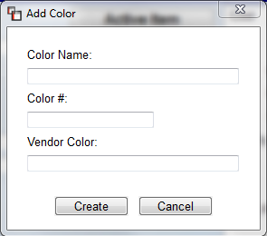
Type a new Color Name and Color # in the fields shown above. As soon as you type a Color Name and exit that field, the system will automatically drop that name in the Vendor Color field. However, you can override and change this name if applicable. Click the Create button when you have entered all data for the new color. If Associated Products have been added for the copied Style/Color, the system will then prompt the following:

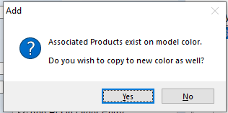

Once this prompt has been answered, the system will add the new Color and re-prompt the Add Color box to allow you to continue adding colors, or you can click Cancel to exit this process. Existing Colors for a Style will appear to the right of the Style Name as follows:
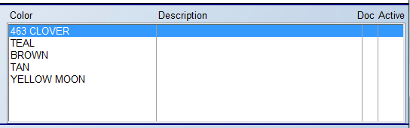
If you highlight and right-click on a Color name (be sure the Edit All Colors box is unchecked), you will see the Add New Color option here as well. Additionally, there is an option to Add B2B Sku #. For any item without an existing B2B Sku #, the system will allow you to add one from this option so that the B2B Import Process will begin updating pricing info on manually added items. An ADD B2B SKU # box will prompt and you will type the number directly into that box. Once you hit enter from that box, the system will prompt the new number in the B2B SKU # field at the bottom left of the Edit Existing Catalog screen. Click the Save button prior to exiting this screen to save all changes.

The Edit Style/Style # option will allow you to change the name and or number of an existing Style. When you make either of these two changes to existing items with history in the system, you need to be aware of the following: during the invoicing process, the system will read the order line as the style name and number appearing at the time the Line Item was added; however, if a Credit Memo is created on the line, the inventory will go back into the system under the new name and number and the same goes for changing a color name. Sales Analysis will display the Style name, number and color as it was at the time of invoicing. Prior to making this option selection, you will need to click on the Edit All Colors box; the system will prompt you to do this if you click the option first. An Edit Style box will appear as follows:

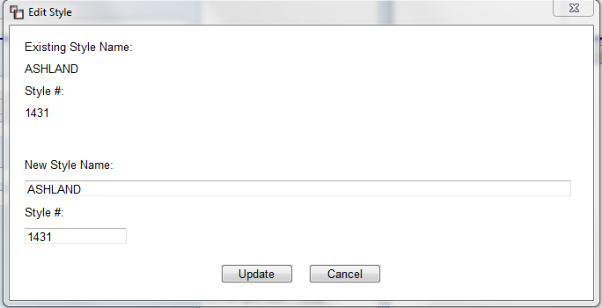

You can type another name in the New Style Name field and you can also change the Style # field if applicable. Once you have made your changes, click the Update button to save.

The Edit Color option allows you to edit an existing Color name--you will need to unclick the Edit All Colors box first, if currently checked. The Edit Color box will appear as follows:
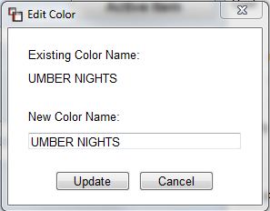

In the New Color Name field, type the new color name as you would like it to appear and then click the Update button to save. You can perform this function, as well as the editing of Style Name and # data, explained above, as frequently as you would like.

The Comments option works in conjunction with the Catalog Comments feature, explained below. This option allows you to export any Catalog Comments to Excel only, they will not print to paper or PDF, so be sure to select the Print to Excel print option prior to exporting. Also, there must be existing Catalog Comments for one or more colors of a Style in order to view anything on the export. When you click on this option, you will see two additional options as follows: Export Single Color and Export All Colors.

The B2B Service Menu option is available to all RollMaster B2B Subscribers. With the addition of Web Services, this option was added to give you access to the following items for the selected Style: Stock Check, Inventory Inquiry, and Related Items.

The Move Available Inventory option allows for moving inventory between Styles, Colors and/or Product Codes. A similar option is available in the Inventory Maintenance module in the Edit Inventory Item screen under the Options menu, where it appears as Move Inventory (Available) and is used for moving a single roll (see Inventory Maintenance section below for full details). Only Available inventory will be moved. If any inventory is currently assigned, it will stay with the current record. All Cost, Freight, Overbill, Vendor Invoice #, etc. information will transfer with the moved inventory. Additionally, a Pointer Record will be written for both the old and new inventory record, and an Audit Detail record will also be created. This is handy for B2B conversion, among other uses. From this option, you can move all Available rolls/inventory within a Single Color (Edit All Colors is unchecked) to a new Catalog Item or Product Code. The Move Available Inventory box appears as follows:

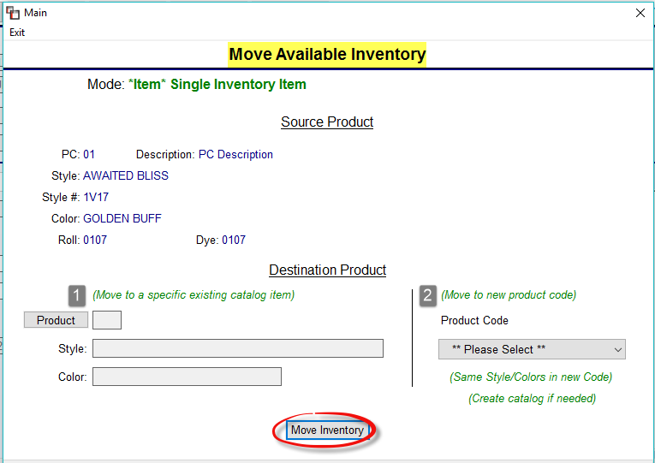

To Move to a specific existing catalog item (1), use the fields in that section to identify a specific Catalog Item to move the inventory. This is the preferred scenario for B2B conversion as the inventory should be moved to an existing B2B Catalog Item with a B2B Sku so the system will match to that item for future updates. If the B2B Catalog Item has not been imported, contact your Vendor Rep to have it added to your import and then go back and move the Inventory once the item has been imported. If the item is dropped, you can decide if you want to move the inventory using the option below, or leave where it is until the inventory is gone and then drop the Catalog item.

To Move to new product code (2), use the drop-down menu to select an existing Product Code. If the Catalog Item or Color does not exist under that Product Code, the system will automatically create the Catalog Item. Click the Move Inventory button to move the inventory.

Another scenario involves moving a Style and All Colors to a new Product Code. You need to first check the Edit All Colors box for this to work. The screen will now appear as follows:
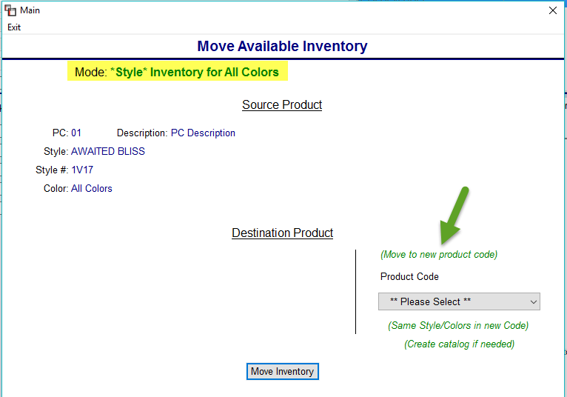

Click the Move Inventory box to complete the process.

Additional Options in Edit Existing Catalog Screen
These remaining options will be explained in this section:
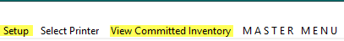

When you click on Setup, a drop-down menu will appear as follows:
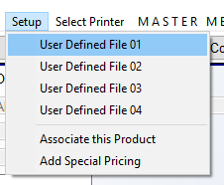

The first four fields are tied to the User Defined fields, just under the Yarn Type field, mentioned above. To edit, click on one of the User Defined File options to display a User Defined File Setup and Maintenance box as follows:

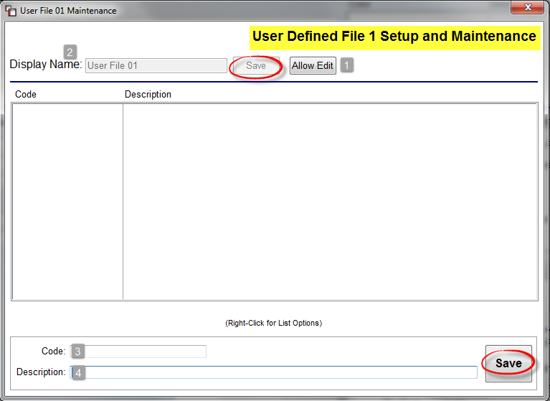

To create a customized button, click the Allow Edit (1) button to change the default User File button name to one of your choosing. The system will place the cursor in the Display Name (2) field. Type a new name for the button and click Save. The Code and Description columns are populated via the Code (3) and Description (4) fields at the bottom of the screen. The Code field will be a shorter version of the Description field. Click the Save button, and the new data will appear in the box above. Once Codes are saved, you can right-click on an existing item to bring up an option to Delete Selected Item, or you can highlight the item and make edits in the Code and Description fields. Once the setup is complete, from the main Add New Catalog Item screen, you can click on each customized User Defined button to make selections that are applicable to the Catalog Item. One example is a Display Name of “Rug Styles” with Codes for Classic, Contemporary, Geometric, etc.

The Associate this Product option will prompt a Mass Association box. Simple and Mass Association is explained in detail below under Associated Products. This option is a short cut to the Mass Association feature and should only be used once the section below has been reviewed. The Add Special Pricing option is another short cut option that will call up the Special Price Mtc. (Date Range Pricing) Add Special Price screen for quicker access to this feature. Again, please review that section of this manual to better understand this feature before utilizing this shortcut. If special pricing exists, that data will prompt in this screen and you do have the ability to use the Delete button in that screen to remove any special pricing.

The View Committed Inventory option, also available from Order Entry, allows for viewing “committed” inventory for a Catalog Item throughout the system. It was designed to work for items such as pad, which may not be assigned until the job is ready to ship, but will work on any material. In the instance of pad, you may know how much inventory you have and how much of that is assigned, but you wouldn’t know the total amount of all the job lines waiting to be assigned. When you click on this option the system will prompt a Committed Inventory box as follows:

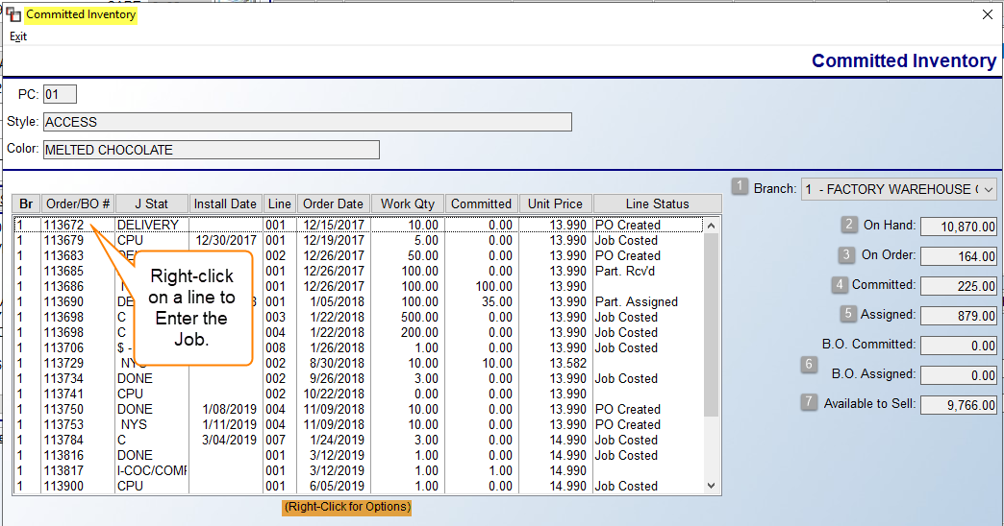

The Branch (1) field will default to the current Branch and only display lines/quantities for that Branch, however, you can use the drop-down arrow to select another Branch, or All Branches. The On Hand (2) field displays the total of all inventory existing in the system, regardless of status. The On Order (3) field displays the total of inventory ordered on a system PO. The Committed (4) field displays totals for just lines that have a blank status (not assigned to any material or PO) for the selected Catalog Item. The Assigned (5) field displays totals for only lines with a Job Costed status. The B.O Committed and B.O. Assigned (6) fields display committed and assigned totals for just lines entered in the Build Order Processing module, which will only apply to those customers using that upgrade module. And finally, the Available to Sell (7) field displays the total available inventory minus what is assigned and minus what is “committed,” based on Branch selection, therefore, it is not uncommon to see a negative number sometimes if you are in an oversell situation on a product. Pad is a great example of an item repeatedly in oversell status. If you right-click on a line in the screen above, the system will prompt the following: Enter Job. This will allow you to access the Job from this screen. The Install Date column pulls from the Job, and where multiple install dates exist, it will display the first Install Date. Please note: The Inventory Usage Report has a checkbox to include a Committed Inventory calculation, which will only work when exporting to Excel. That checkbox appears just below the Stocking print options.

Buttons Under Options/Setup Menus
The buttons just under the Options/Setup menus, along the top left of the screen, can be used at any time. They appear as follows:

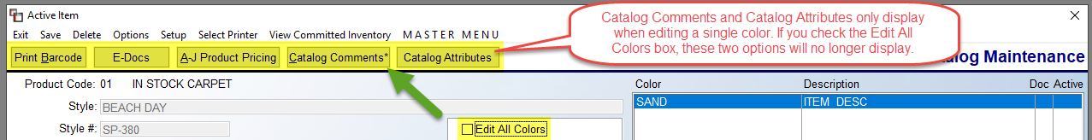

The Print Barcode button will apply only to those RollMaster Customers using the Barcode Software & Equipment. The same goes for the E-Docs button. Separate documentation is available for both features. These are add-on subscription products and you can request more info by emailing info@rmaster.com.

The A-J Product Pricing button will prompt a Catalog Price List box for this Style, and allows you to view and edit that data from here. Please see the Catalog (A-J) Pricing Maintenance/Print section of this documentation for additional information. The Catalog Comments button will only prompt when editing a single color (Edit All Colors box must be unchecked). These are essentially Line Comments, similar to the ones that appear in Quote/Order Entry, that have been added to Catalog Items. Once added, these Comments will appear in Quote/Order Entry as Line Comments when a Catalog Item is selected. An “*” in that button denotes Catalog Comments exist for the current Style/Color. Please Note: Catalog-Comments can be imported via an Excel spreadsheet through the Customer Facing CSV Imports module located in the Special Functions module. When you click this option, a Catalog Comment Review box will appear as follows:

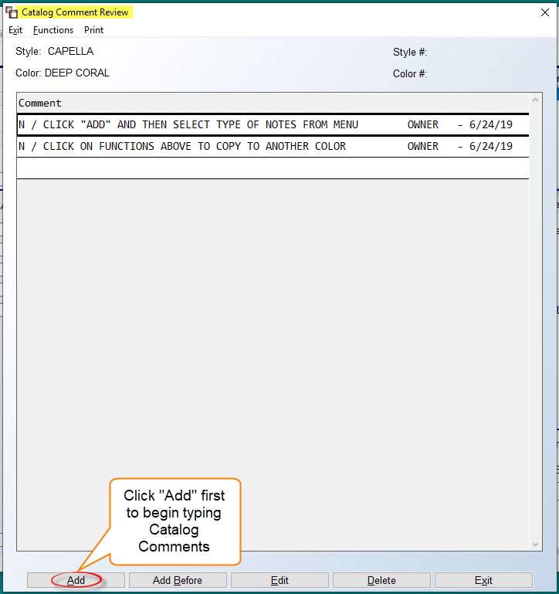

This feature allows you to add Comments specific to a Catalog Item and then determine where they will appear in the system, much like the Line Comment feature in Order Entry. Click the Add button to prompt a Select Option menu to determine where these comments will appear, i.e., Work Order, Customer Copies, etc. Select None to keep them internal. Once Catalog Comments have been added, you can copy to other catalog colors for this Style via the option that appears in the Functions menu at the top left. That option appears as follows: Copy Comments to other Colors.

The Catalog Attributes button/functionality has been added to the Catalog Maintenance module to work in conjunction with e-Commerce APIs, such as WooCommerce. Not all RollMaster clients will utilize this feature, so this section is to make you aware and allow you to follow up at info@rmaster.com if you believe you would be interested in finding out more. Catalog Attributes are essentially all the data points associated with a catalog item. For example--and especially helpful on a website selling flooring such as hardwood--data on wear layer, edge profile, country of origin, species, etc., can be loaded into RollMaster for uploading to a website. Although helpful, the amount of work involved in setting this up for several catalog items would be labor intensive for non-e-Commerce clients, so it will generally only make sense for a company interested in pursuing e-Commerce. There is a customer facing import/export feature to allow for easier data entry. It can be downloaded from the Catalog Attributes Export screen, accessible from the options tab at the top left of the screen below. When copying Colors, where Catalog Attributes exist, you will be prompted to copy Attributes as well. If Catalog Attributes exist, they can be viewed from the Associated Products (explained below) tab screen. Once setup is complete, a typical Catalog Attribute screen will appear as follows:
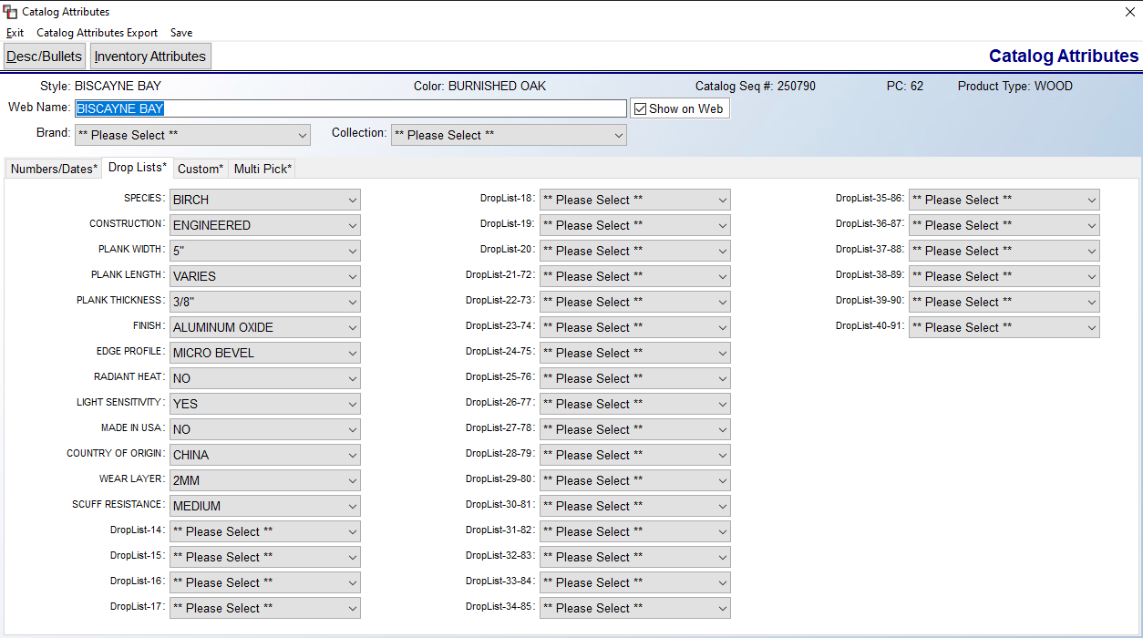

Please Note: If a User is not allowed to Edit Catalog, they will not be able to save changes to Attributes. Also, an asterisk on any of the Tab or Button options in the screen above indicates data exists in those screens. To customize/edit these selection and drop-down fields, you will need to navigate to Product Code Maintenance> Functions> Product Type Maintenance>Catalog Attributes>Selection Maintenance and Brand Maintenance.

Adding Labor/Special Charge Items
When adding a Labor Catalog Item, the Add New Catalog Item screen will appear as follows:

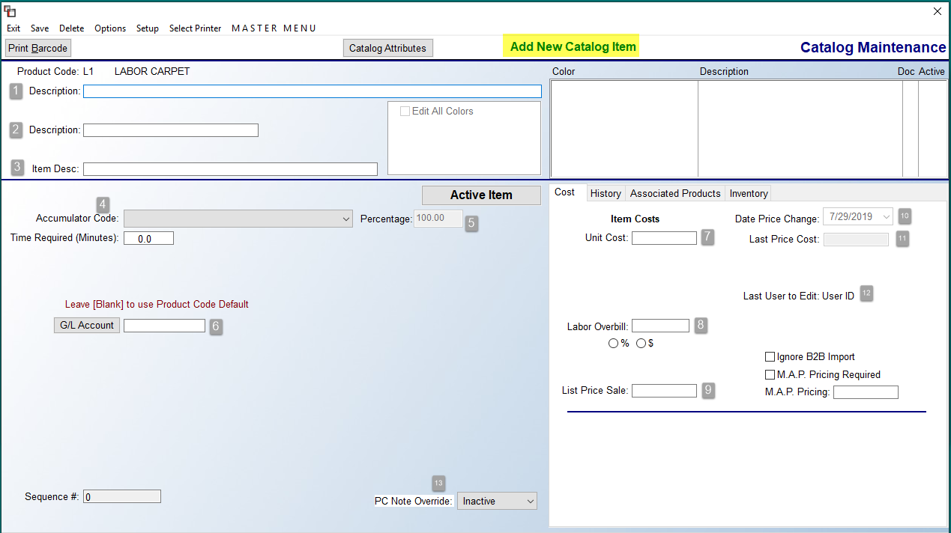
Labor and Special Charge catalog items are added a little different from material catalog items. Since no inventory is attached to these lines, the screen is much simpler. In the first Description (1) field, enter a labor description such as CUT-PILE CARPET. In the second Description (2) field, narrow the labor description further based on cost, such as BUILDER WORK. These two fields can be seen when performing a catalog lookup throughout the system. The Item Desc. field (3) can be left blank or used to add any additional descriptive data to assist Salespeople when selecting labor items. Please Note: Labor that is performed during more than one type of installation, such as floor prep or moving furniture, can be handled two different ways. You can either build these items under each applicable Labor Product Code. For example, Floor Prep will need to be added as a Labor Catalog Item under the Tile Labor, Vinyl Labor, Wood Labor, Carpet Labor, etc., Product Codes. You can also opt to create one specific Product Code for these extras. The following illustrates how setup relates to catalog lookup:

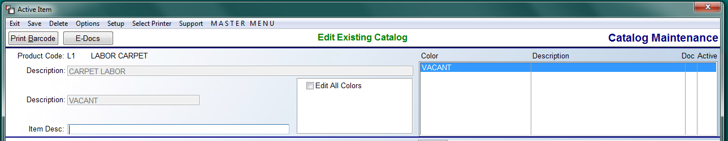

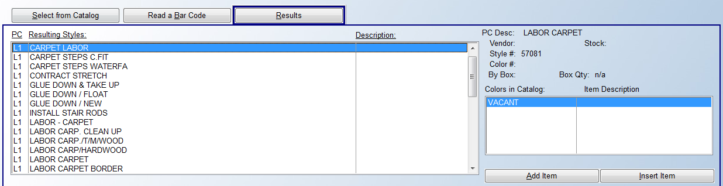

The first screenshot displays the Catalog Maintenance screen while adding a Labor Catalog Item. The second screenshot displays how that item displays in the Labor Catalog when adding a line to a Quote, Order, or Property Management/Builder Template.

Returning to the Add New Catalog Item screen, at the Accumulator Code field (4), use the drop-down arrow to select the applicable code, using the instructions presented above in the Product Code Maintenance section. As a recap, only select an Accumulator Code for your main installation items, such as “Carpet Install—Cut Pile” or “Vinyl Install—Glue Down.” This is an important field as it ties into the system Installation Schedule. Consult your RollMaster Trainer or our Support Department for further assistance. The Time Required (Minutes) field is to be used only for labor being paid by the hour.

The Percentage (5) field represents a percentage value of the duration of an installation. A percentage of 100% would be a normal or average setting for a typical type of install. Any increase in percentage would indicate that extra time is needed for the labor item, and a lower percentage would indicate less time is needed. For example, typical stretch-in carpet would be set at 100%. Patterned carpet installation would then need to be at about 125% or higher, and rip up could be set to 50% or lower. Once a new Labor Item is saved, just below the Percentage field, you will see a checkbox as follows: Ignore Additional Installation Days (see below). When checked, the system will ignore any setup requiring this particular item to need additional days to install. This is used in conjunction with install Capacity Limits, covered in the Product Code Maintenance section above.

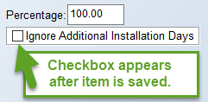

At the G/L Account (6) field, this field should be left blank so the system will default to the G/L Account Number attached to the Product Code. You can add a different G/L Account Number for rare items that are the exception to this rule. At the Unit Cost (7) field, enter the standard cost per unit for the labor—costs can be updated on Jobs based on the Installer selected. In the Labor Overbill (8) field, if you wish to add an Overbill cost to a Labor Catalog Item, you can do that by selecting either the “%” or “$” options and entering the corresponding percentage or dollar amount. If this Overbill will apply to all items under a Product Code, leave the “Edit All Colors” box checked. If it applies or is different for each item, uncheck that box. Please Note: This field will override the Company Control option to add an Overbill percentage to all labor items.

At the List Price Sale (9) field, enter the standard sale price per unit of this labor; you can override the sale field in Quote and Order Entry when applicable. The Date Price Change (10), Last Price Cost (11), and Last User To Edit (12) fields are all updated during system use. The PC Note Override (13) field works the same for Labor and Special Charge items as it does for Material Catalog Items, explained above. Click Save at the top left of the screen prior to exiting to save the Labor Item or any edits.

Special Charge Catalog Items have a screen almost identical to Labor Catalog Items. Disregard any fields, such as Accumulator Code, that are labor-specific when completing these items. Examples of Special Charge items include Freight charges, Restocking Fees, Contract Adjustments, Discounts, etc.

Associated Products – Simple Association:
The Associated Products tab, located inside Catalog and Inventory Maintenance, allows commonly used product groupings, such as carpet and pad, to be linked together to ease and assist with Quote, Order, and Property Management Template building. B2B Products will download into your system “pre-associated;” however, manual associations can be added at any time using the process outlined below. When activated in a Branch, will use Private Label Names. There is also a Mass Association tool, described below, that will allow, for example, carpet padding and carpet labor to be associated across all carpet SKUs. Overall, Associated Products should greatly speed up Quote and Order Entry and Property Management Template building, while at the same time increasing accuracy.

To begin this process, click on the Associated Products tab in the Edit Existing Catalog screen for an active style. That screen will appear as follows:

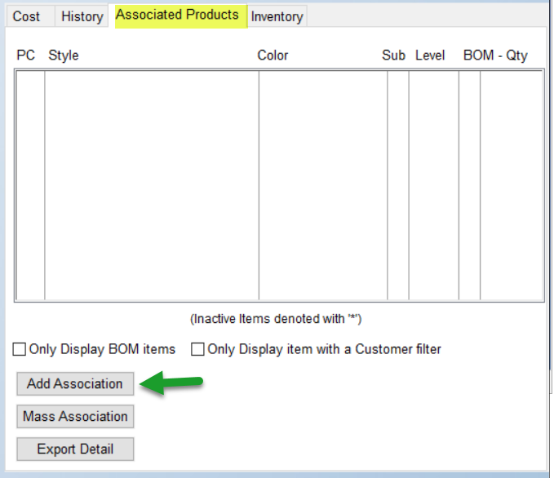

The Export Detail button was added for items checked as B.O.M Constructed Item. When clicked, this button will export all Associated Products and B.O.M. Items for the selected catalog item. Please Note: The Edit All Colors field must be unchecked in order to access the Add Association button above. The two checkboxes above the Add Association button are for use once Associations have been added. If you are using the Build Order Maintenance module (B.O.M), you can check that box to only see those items with a BOM association. The Only Display item with a Customer filter, if checked, will display any associated items tied to a Customer Level, explained below.

To add a simple association, click the Add Association button at the bottom left of the screen. The system will then prompt a Product Association box as follows:

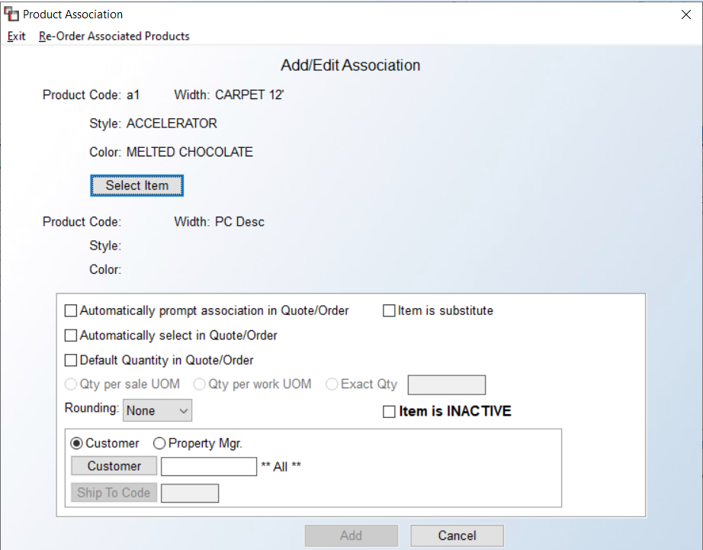

Click the Select Item button to choose a product to associate with the main product (e.g., 3/8 TOPBOND carpet padding can be associated with style: ACCELERATOR, color: MELTED CHOCOLATE). The options in the white area above will determine how that association is handled when a linked product is added to a Quote or Order. If no options are selected, after adding the main product to a Quote/Order, an Association Products Exist message will appear in the Add/Change Line Item screen and a button to View Associations will also display (when clicked, the Add Associated Products screen prompts):
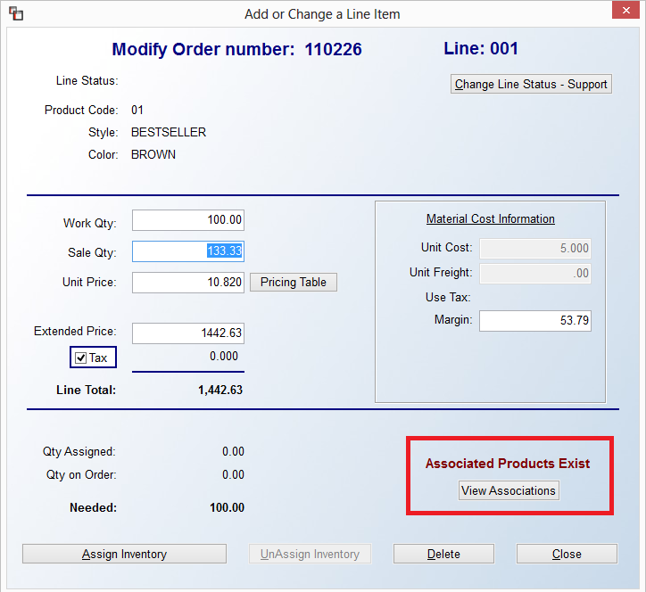
If the Automatically Prompt Association in Quote/Order option has been selected in the Product Association screen for an item, the Associated Products Exists/View Associations message/button will prompt in the Add/Change Line Item screen. After the screen is closed, the Add Associated Products screen will appear listing all items associated with the main item as follows:
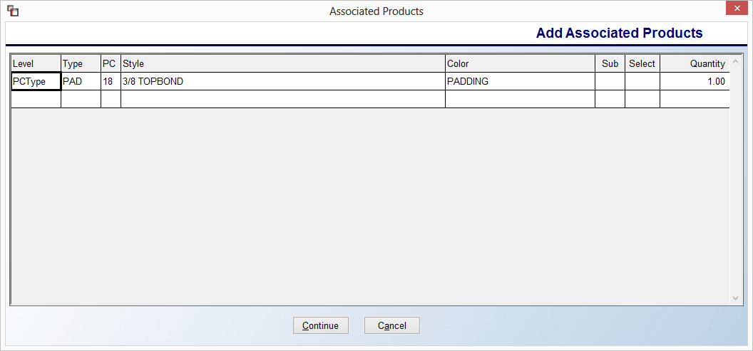

If the Automatically Select in Quote/Order option was also selected, the Associated Products Exists/View Associations message/button, along with the Add Associatied Products screen will prompt, and the item will be automatically selected (Y in the Select column) to be written as a line on the Quote/Order, with a Sale Quantity of 1 as follows:

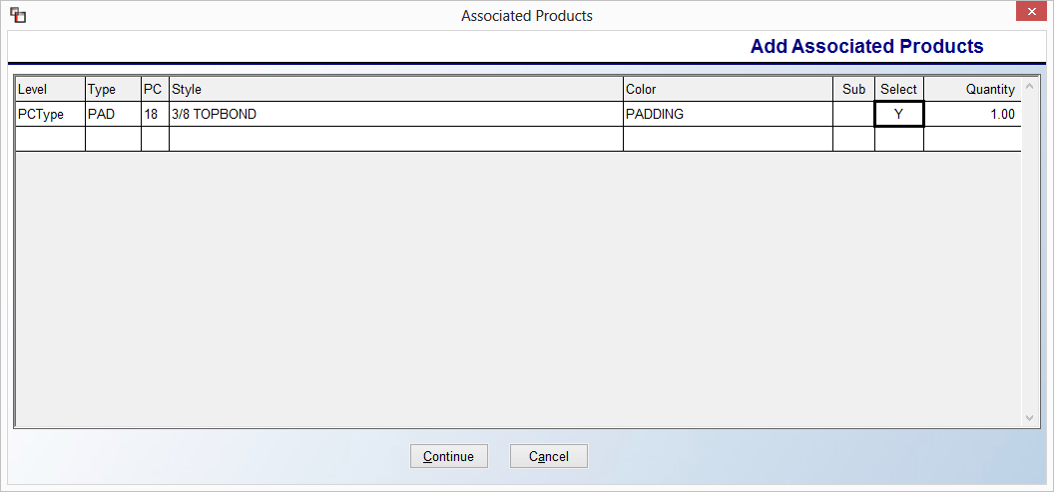

Additionally, if the first two options described above have been selected and the Default Quantity in Quote/Order has also been selected, in addition to the scenario above, the Mass Associated product’s Sale or Work Quantity will be correlated to the main item’s Quantity depending on how Qty per Sale UOM (Unit of Measure), Qty per work UOM, or Exact Quantity has been established. For example, if we associated carpet pad with 1.00 as Qty per Sale UOM, the system will automatically write the carpet line, as well as the pad line, with the same Sale Quantity amount as follows:

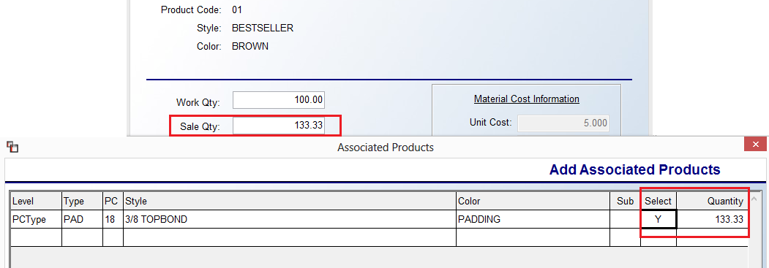

When the Add Associated Products screen (illustrated above) is displayed, the Quantity column can be edited during Quote/Order Entry by clicking in the field. Type in the applicable Quantity amount and click Continue. All of the selected items and corresponding quantities will then be written onto your order.

Additional setup options in the Product Association box include the following: Rounding, Item is a Substitute, and Item is INACTIVE. The Rounding option works with the UOM options and defaults to None. The other two options are Up and Nearest. If the Item is a Substitute option is selected, the system will flag the Sub column in the Add Associated Products screen, indicating that the item is a substitute for a main product when needed (e.g., LIGHT GOLD end cap may be a substitute for GOLD end cap). If the Item is INACTIVE option is selected, the system will render the association inactive, so that it will no longer appear in the Add Associated Products screen.

The area at the very bottom allows for programming Associated Products by Customer Levels. The first level is by Customer ID, the second is Customer Ship To Code, which requires a Customer ID also, and then the third is Property Manager (On Ship To). This one is independent of Customer ID and Ship To Code.

Associated Products - Mass Association:
Mass Association allows for the association of one product across all products that meet at least one of the following criteria: Vendor, Product Type, or Product Code. Mass Associations can be setup in the Catalog/Inventory Maintenance modules within the Associated Products tab:
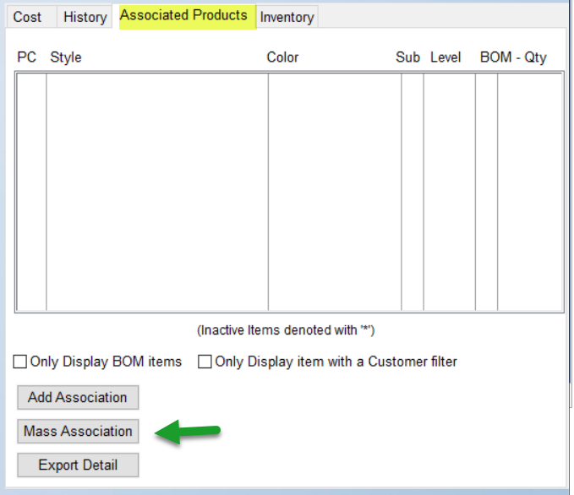

After clicking the Mass Association button, if any current associations exist, a View Associations screen will appear as follows:

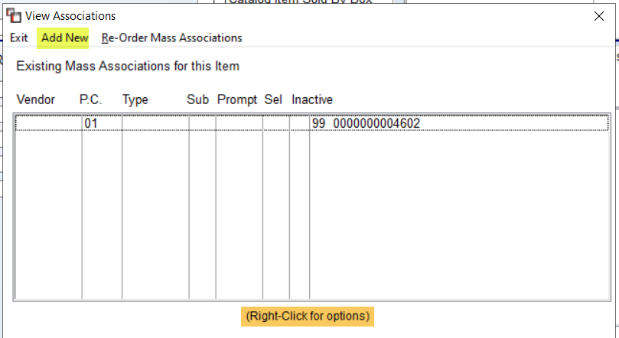

Within this screen, you can review, edit, or delete existing Mass Associations or add new associations. To add Mass Associations, click the Add New button. The system will prompt a Mass Association screen as follows:

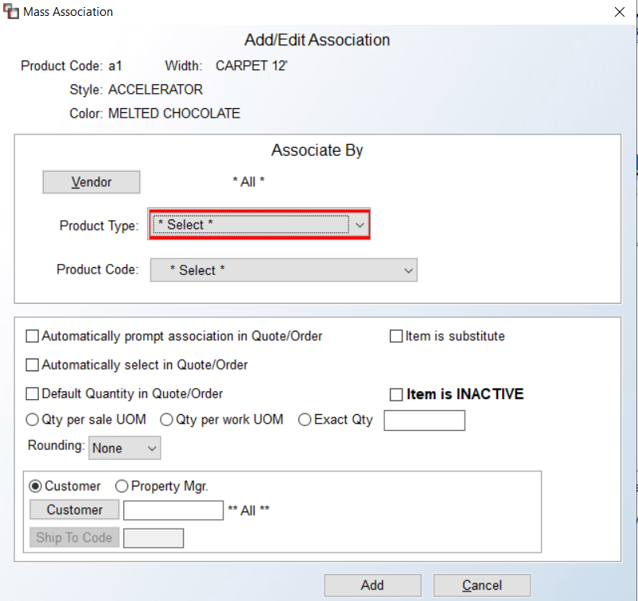
At the top of the screen, the system displays the item that will be Mass Associated (e.g., 3/8 TOPBOND CARPET PADDING). Below that, in the middle portion of the screen, the Associate By criteria can be selected (i.e., Vendor, Product Type, and/or Product Code). In this example, the carpet pad is being associated across all items that have a Product Type of Carpet. To further narrow the criteria, a specific Vendor and/or Product Code can also be selected. At the bottom of the screen, you will see the same options as explained above in the Simple Association section above.
As another example, you can “Mass Associate” CARPET LABOR across all CARPET Product Types, as exemplified in the illustration below:
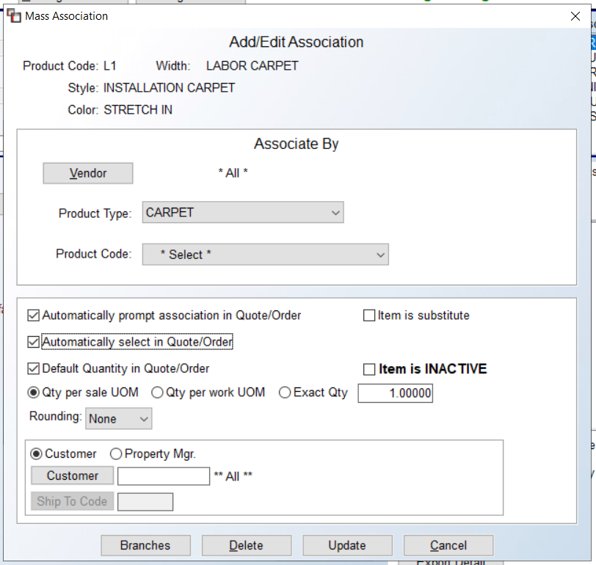
Using the example above, while in Quote/Order Entry, the following Mass Association setup will appear as follows:
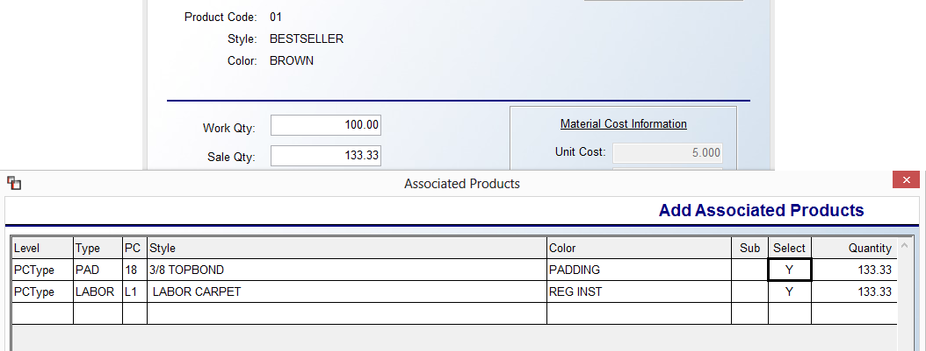
The data above will then appear as follows in either the Quote or Order Entry Line Items screen:
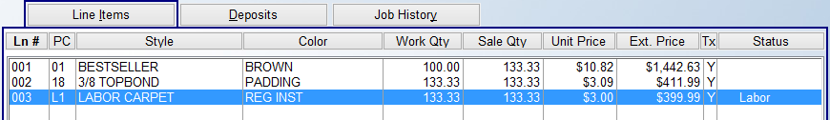

The last half of the screen works the same as described above in the Add Association section. When you click the Add button, if the system Catalog is shared among all Branches, the system will next prompt if the system Catalog is shared among all Branches, the program supports Branch Level setup. A Mass Association Active Branches box will prompt, allowing for selecting a specific Branch or more than one Branch for the Mass Association to appear. If no Branches are selected, the Association will display in All Branches automatically. That screen appears as follows:

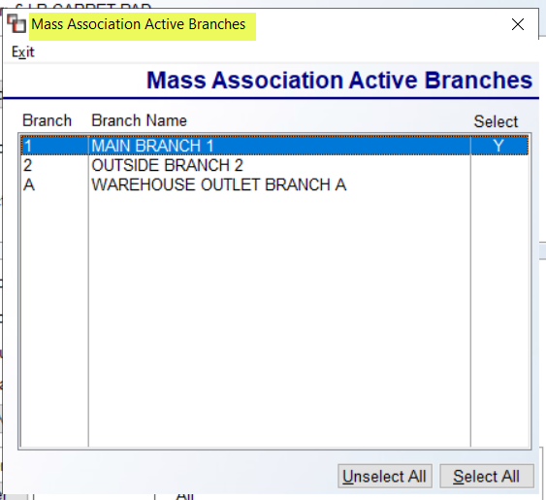

Inventory Maintenance:
Because the RollMaster System has an entire Purchase Order module for ordering and receiving material goods, the Inventory Maintenance module should only be used for entering your beginning inventory levels, and thereafter for inventory adjustments, location changes, and inventory transfers. Please Note: using the Purchase Order Receipts Adjustment feature is the preferred method for making receipt adjustments properly on inventory entered into the system via the Purchase Order module. Before you use this module, you must create (or import via B2B) a catalog item for all existing inventory that you will be entering in the system. For example, if you have a pallet of Hartco pre-finished Provincial Strip, color Natural, you must first create a catalog item for Provincial Strip, color Natural.

When you enter the Inventory Maintenance module, the screen will appear as follows:

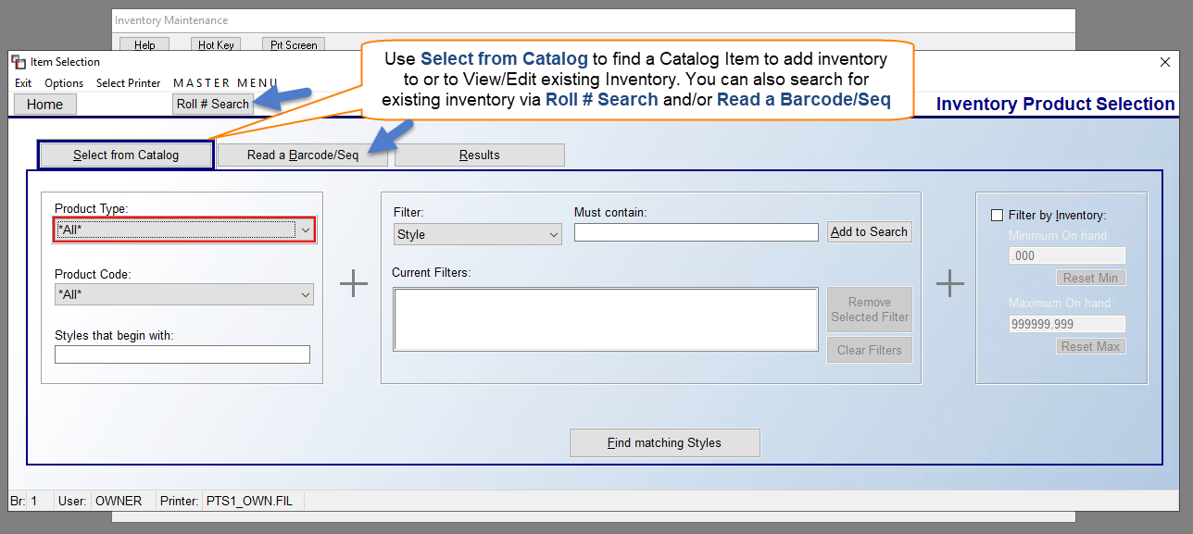

The Item Selection screen above looks almost identical to the Catalog Maintenance screen, explained above. Follow the same steps for locating an item for which you will be adding or adjusting inventory as outlined in the section above for selecting a Catalog Item to edit. The Read a Barcode/Seq tab screen will appear as follows:

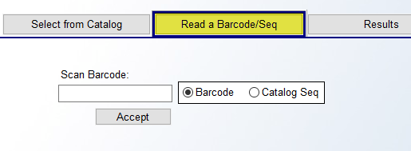
Using a Barcode scanner (provided this is installed on your system) you can scan a Barcode to pull up an existing Inventor Item. Or, by toggling to the Catalog Seq option, you can type a Sequence # in the field to the left to search by that criteria. This option is available anywhere you can access the Catalog Product Selection box.

Adding Beginning Inventory:
Once you have located the catalog item for which you want to add inventory, click the Select Style and Color button to pull up the Active Item screen for that item. The Edit Existing Catalog Item screen will prompt for that item with the Inventory tab as the default window at the bottom right as follows:
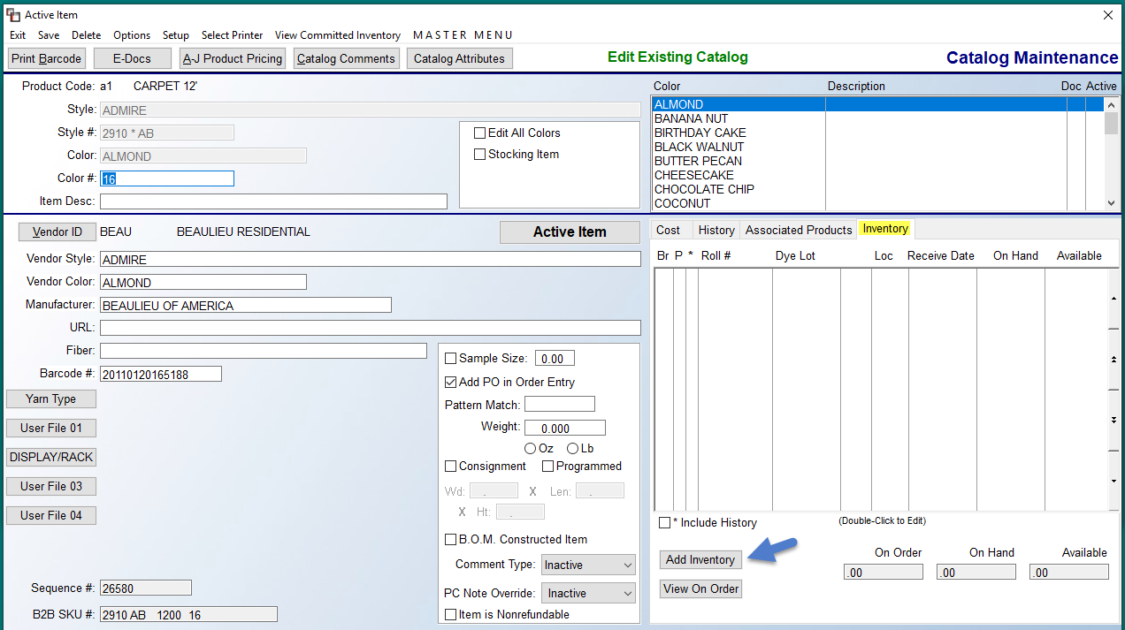

To add inventory, click the Add Inventory button at the bottom right of the screen above. The system will then prompt an Edit Inventory Item screen as follows:

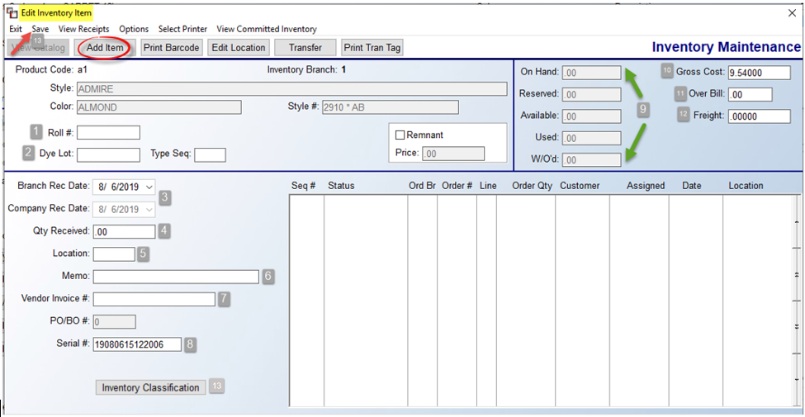

The Style and Color data at the top left of the Edit Inventory Item screen will pertain to the current item selected. The fields that need to be completed to add beginning inventory will be explained in the numbered order of the screenshot above. At the Roll # (1) field, type the applicable roll number for all roll goods aside from pad, which will default to an “08” Roll # and Dye Lot. (See Accumulating/Cost Averaging Inventory Records in Product Code section above for additional information.) For hard surface goods, use “02” as Roll # if you intend to merge inventory with the same dye lot or run number. If you don’t wish to merge inventory, create a unique Roll # in this field for non-roll goods. At the Dye Lot (2) field, type the applicable dye lot number for roll goods and hard surface items. For all other items, the system should prompt an identification number if setup was completed correctly. The Type Seq. field, to the right of the Dye Lot field, is updated during inventory transfers between Branches to keep track of partial inventory shipped to other locations. Leave this field blank when entering beginning inventory.

The Branch Rec Date and Company Rec Date (3) fields will default to the current date as the receipt date for both fields. You can override the Branch Rec Date field back to the original receipt date if you wish to age your inventory on beginning inventory. The Company Rec Date field will always be the original date the inventory was received into the system. The Branch Rec Date field changes when an inventory record is transferred, cut, adjusted, etc. Please Note: there is a User Control 4 option to Use Alt Inventory Receipt Date which, if it is set to “Y” for yes, will utilize the Company Rec Date for Barcode Label Printing, Order Entry and Build Order Assign Inventory by Age, Outstanding Costs vs Received Inventory, Inventory Purge, Inventory Listing, Inventory Valuation, and the Inventory Valuation (As Of). If the Control is set to “N” for no, the system will automatically use the Branch Rec Date. You will see both dates in the Edit Inventory Item screen, which can only be updated by RollMaster Support personnel, should there ever be a need. Also, if the Branch Rec Date is different, you will see a brief notation in green type next to the Company Rec Date field, for items such as Inventory Transfer, Work Order Return, etc.

Currently, 08/02 Accumulated Items are updated each time there is a transfer, receipt, etc. This is referred to as the Branch Aging or Branch Receipt Date. In several Inventory Reports, unless the Company is not set to share Catalog between Branches, you will see radial buttons for Branch Rec Date and Company Rec Date. Based on the selection, the system will treat all accumulated records for a catalog item across Branches the same and share a common receive date/age on the following reports: Inventory Listing, Inventory Valuation, Inventory Valuation – (freight split), and Inventory Valuation (As Of).

At the Qty Received (4) field, type the quantity of the inventory item in linear feet for roll goods (except padding). If you have more than one roll of the same style and color, enter each roll separately to keep your inventory counts accurate. Padding should be entered as total square yards or square feet depending on how you sell your roll goods in the system. Hard surface goods should be entered in square feet totals making sure to keep dye lot or run numbers separated where applicable. Items sold by the piece should be entered according to how they will be sold in the system. For example, if you sell stock trim pieces in full pieces, rather than by the linear foot, you should enter the total number of pieces, but if you do sell by the linear foot, than you need to enter the total linear feet on hand.

At the Location (5) field, type the bin number or other designation used in your warehouse for inventory placement. The system will keep track of inventory location changes, making your inventory audits easier. Also, reports can be printed by this information, and other system features tie into this field. The Memo (6) field can be used for “side mark” data if known. This field updates from the Purchase Order module as inventory is received. The Vendor Invoice # (7) field is updated from the A/P Open Item Maintenance module as Invoices are entered in the system. For beginning balances, you can record the info if you know it or at least enter a number such as 99999 or even BB for Beginning Balance, to signify that it is a beginning inventory record. This field is tied to key reports in the Job Cost system requiring data to be entered in this field to designate paid inventory. The P.O. Number field is display only. When material is ordered and received in the system, this field will display the corresponding Purchase Order number. The system will automatically assign a Serial # (8) in this field to every inventory record that is entered in the system. This is an internal numbering system and should not be altered.

Moving over to the top right of the screen, there are a series of fields (9) that are updated by the system during regular processing. Once inventory is added or received, the On Hand (9) field displays the quantity of the inventory that physically resides within your entire company. Once inventory is in the system, this field can be accessed to make inventory adjustments, but should only be done in the event of shrinkage or theft, not because of receiving errors. Receiving errors should be handled via the P.O. Receipts Adjustments option in the Purchase Orders module. The Reserved (9) field is updated when inventory is assigned through the Quote and/or Order Entry modules. It will display the amount of On Hand inventory that is currently reserved against a Job or Quote. Inventory that is reserved cannot be adjusted unless it is first unassigned from the Job or Quote. The Available (9) field displays the quantity of inventory that is On Hand less the amount that has been Reserved against open Jobs or Quotes. The Used (9) field displays the quantity of inventory that has been sold, meaning the Job the inventory was assigned to is invoiced in the system. The W/O’d (Work Ordered) (9) field keeps track of the portion of the inventory that has been shipped out on a system Work Order, and has presumably left the warehouse. It will still be considered On Hand until invoiced, but this field will help during physical inventories because it will alert you to what has been shipped to a job site and no longer sitting in the warehouse. During audits, what you physically count in the warehouse should be added to this number to compare to what the system says is On Hand to help account for discrepancies.

The Gross Cost (10) field will automatically default to the catalog unit cost for the selected item. If the beginning inventory was originally purchased at a different unit price, override the default with the correct unit price. The Job Cost system will use this price rather than the catalog item price when costing this material. When receiving inventory against a system Purchase Order, cost changes should only be made through the Purchase Orders and A/P Open Items Maintenance modules. The Over Bill (11) field will allow you tie an Overbill amount to a specific piece of stocking inventory that will override any Overbill value that has been entered in the Catalog Maintenance module. This means that the catalog item must be set up as a Stocking Item for this to factor into Job Cost in Quote and Order Entry. This feature must first be enabled in the Company Control 2 level screen of the System Control Maintenance module. That control appears as follows: Material Overbill By Inventory. This prompt needs to be set to “Y” for yes in order for the system to use the value entered in this Over Bill (11) field for job costing on Jobs where the inventory is assigned. Regardless of whether this control is enabled, the Over Bill field will default to what is currently showing in the Catalog. The Freight (12) field will automatically default to the Catalog unit freight cost. If you know the actual freight cost per unit of the inventory you are adding, override this field with that information. Moving forward, freight cost changes should only be made through the Purchase Orders and A/P Open Items Maintenance modules. The Inventory Classification (13) button is only applicable to existing inventory. It allows for tracking the salesperson and/or customer for which the inventory was ordered so aging inventory can better be scrutinized. It is most useful for dealers in the Builder, Multifamily and/or Distribution markets. It is explained fully below.

For items sold by the Box or Piece, you will see that data display in boxes next to each field on the left and the informational Box Qty or UOM field below the Freight field—see below. Also, if the On Hand inventory quantity is changed, the system will also update each of the Boxes/Pieces info accordingly. If the change is cancelled, the fields will be reset.
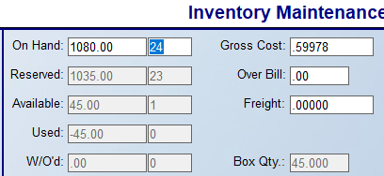

Once you have finished with the cost fields, click the Save (13) button at the top left of the screen to add the inventory to the system. The system will then prompt an Update screen as follows:
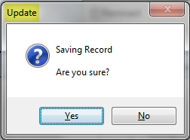

Click the Yes button to proceed. The system will then prompt the following: Do you wish to enter a comment for this change. If you select Yes, the system will then prompt an Enter/Select Adjustment Comment box as follows:

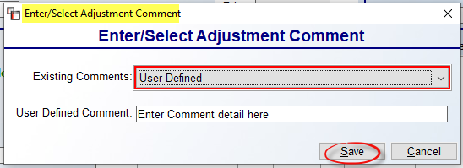

The Existing Comments field allows for selection of pre-built Comments by clicking on the down arrow. The default of User Defined will allow you to type a custom comment in the User Defined Comment box. Click Save when complete. The system will then prompt an Inventory Updated message. Click OK and the system will place the cursor back at the Location field. Note: On the Inventory Audit report to Excel, the Adjustment Description column will automatically prompt the following: **New Roll Added Thru Inventory Mtc.**

Existing Inventory Features:
Several additional features are available from both the Inventory tab in the Edit Existing Catalog screen, and from menus and options in the Edit Inventory Item screen on existing inventory records. In the Inventory tab, on any existing inventory record, you can right-click to prompt a list of options as follows:

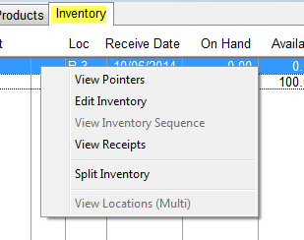

The View Pointers option will prompt an Inventory Pointer View screen as follows:

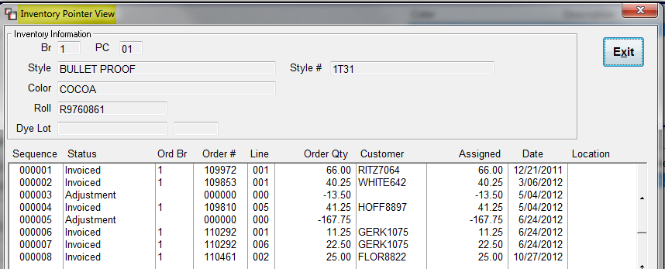

The list above contains all of the Pointer Records for an inventory item. Pointer Records indicate how inventory has been used in the system, i.e., to which Jobs inventory is assigned/invoiced, and any adjustments to inventory. Whether you view Pointer Records from the screen above or via the Edit Inventory Item screen, when you right-click on a Pointer Record, the system will prompt two options as follows: View Audit Detail and View Job Info. The View Audit Detail option only applies to inventory records that display Adjusted or Barcode in the Status column after May 2015. For those records, the system will prompt an Audit Detail box as follows:

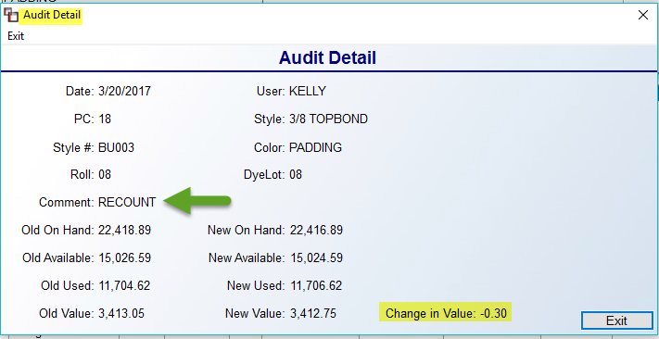

The detail will include the User who made the adjustment, a Comment as to why the adjustment was made, the Old and New data, and the Change in Value from the adjustment. Click the Exit button to return to the previous screen. The View Job Info option allows you to see details, such as Job Status and Install Date, of Jobs where material is Assigned, and if applicable, access the Job to Unassign the material for use on a Job that is shipping sooner. This option is also available on lines with a Status of Invoiced. When you click on this feature, the system will prompt a Job Info box as follows:

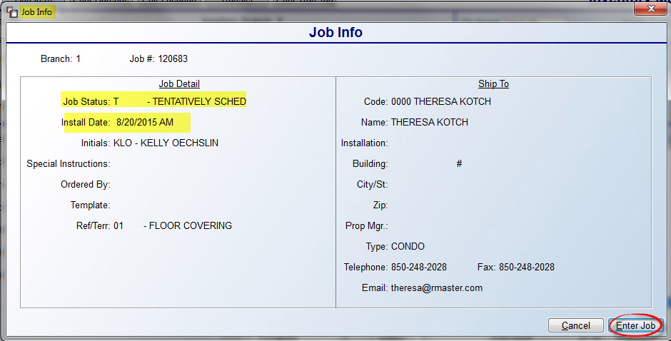

From this screen, you can click the Enter Job button to “jump” to the Order Entry Maintenance module for the Job selected. From there, you can Unassign the material and then return to this screen and the system will update the Job and Pointer Record and the inventory can then be Assigned to another Job.

Returning to the Existing Inventory Features explanations, the Edit Inventory option will prompt the Edit Inventory Item screen for that particular inventory item. You can also double-click on an item to perform this same function. The View Inventory Sequence option is a support-only feature. The View Receipts option will prompt only on inventory record items that are marked as “Accumulator Items” in the Product Code. This option is also available from the Edit Inventory Item screen and will be explained below. The Split Inventory option is also explained below, following the Transferring Inventory section. The View Locations (Multi) is available now by turning on a multi-bin switch, but the switch must be activated, and there is required training and procedural changes that must first take place. This feature essentially allows tracking of inventory from multiple bin locations.

At the bottom left of the Inventory tab screen is a View On Order button. This option will prompt an Inventory Review screen (explained above in Catalog Maintenance) and default to the From PO tab screen. All features work the same when accessing the Inventory Review screen from the View On Order button. One additional feature from this screen is a Show All Colors checkbox option located next to the Show All Branches checkbox.

In the Edit Inventory Item screen, most features can be accessed from the top left of the screen as follows:

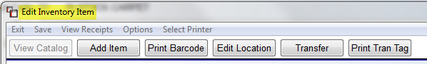

The Exit option will return you to the previous screen. The Save option will allow you to keep any changes made in this screen, as well as add a comment regarding the changes, and edit the date of the change. The View Receipts option will prompt only on inventory record items that are marked as “Accumulator Items” in the Product Code. Where this is the case, you will right-click on that option to display a View Accumulated Items Receipt box as follows:

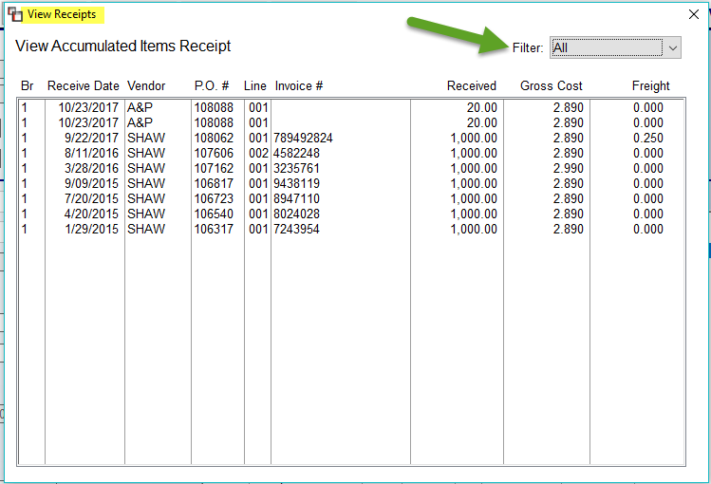

The screen above displays a history of items received and “accumulated” under one combined inventory record. The Filter field allows for sorting the display by the way the accumulated Inventory records were received into the Branch. The options include Build Order, Inventory Transfer, and Purchase Order.

As a reminder, when you use this feature, the value of the new inventory record will be averaged so that if a previous receipt was less expensive than a current receipt, the two will average together to create a new valuation for job costing purposes. When inventory is merged, the PO # from the last item merged will appear in the Inventory Maintenance screen. Also, when using the Review P.O. History feature in A/P, the last Invoice approved will generate the Invoice # for that Inventory record. If you need to find the actual Invoice # for a PO, you should see that data in the screen above or you can look it up in P.O. History Inquiry. The PO Number can also be found through the Job Line Review feature. If cost or freight is changed during the Review P.O. History process, those changes will be averaged into the new value of the inventory. For items with a Factor ID of 02, the inventory records will only be combined where the Dye Lots match. This would include items such as ceramic, VCT, hardwood, etc. The 08 Factor should be used for items such as pad, laminate, adhesive, metal, tack strip, supplies, etc. Special Note: If you are ordering items with a Factor of 08 for larger jobs where you are receiving special pricing for just that Job, you should change the Roll & Dye Lot numbers when the inventory is received so costs stay true on the Job and the value is not averaged in with existing inventory.

Returning to the explanation of the features at the top left of the screen, the Options item will prompt a list of features as follows:
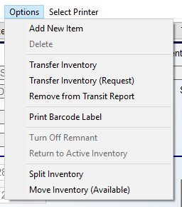

The Add New Item option will clear all fields in the screen below so you can add a new inventory record for the current catalog item. The Delete option will only be available for inventory that has been added directly to this module, such as your beginning inventory balances, and will not be available once the inventory is assigned to a Quote or Job, thereby creating a “Pointer Record” in the system. The Transfer Inventory option will be explained in detail below in the Transferring Inventory Between Branches section. The Transfer Inventory (Request) will add a “Request” to the Inventory Transfer Requests report located in the Inventory Control Reports menu. This can be used to request inventory where a User does not have authority to perform transfer functions. The Remove from Transit Report option works the same as the Receive Transit button explained below in the Transferring Inventory Between Branches section—please read through that section for complete details.

The Print Barcode Label option is only applicable when an existing inventory record is displayed. It will print a new Barcode Label. The Turn Off Remnant option will only apply to Remnant inventory. It will be explained below in the Remnant Feature Explanation section. The Return to Active Inventory option will move an inventory record out of History status from a previous Inventory Purge. The Split Inventory feature allows you to split roll good inventory and move it to another Product Code. For example, you can split 12’ to 6’, 13’2” to 6’7”, 15’ to 7’6”, and 6’ to 3’ roll goods. This will work between any two Product Codes provided the splits are moved to a Product Code that is ½ the width of the original Product Code width. Please Note: this may involve creating Product Codes with a Custom Factor to handle widths not currently available. The Split Inventory screen appears as follows:

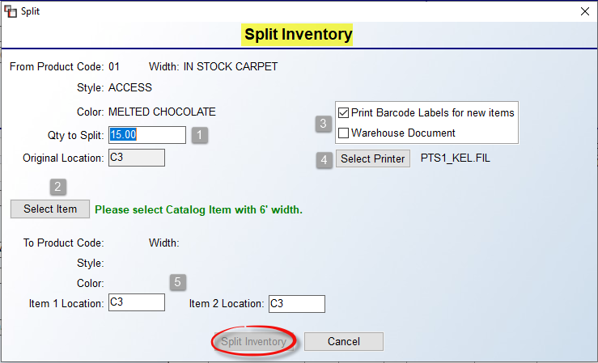

The Qty to Split (1) field will default to the current inventory quantity. Click the Select Item (2) button to select a Product Code with the correct Factor for conversion, as well as the corresponding Style and Color. The Print (3) section will default to Print Barcode Labels for new items and you can also switch to the Warehouse Document option to print a document for the split. The Select Printer (4) option will allow for toggling between printer types. The final option (5) is to change the location of the two new split items in those two fields. This process will create two inventory items with the same lineal feet. Also, where inventory is split, you will see “SPLIT” in the Comment section of the Inventory Audit report. This feature can also be found in the Catalog Maintenance screen under the Inventory tab when you right-click on an existing inventory record.

The Move Inventory (Available) allows you to move a single roll to a different Catalog Item, Color, or to an entirely new Product Code. If written to a new Product Code, the system will automatically create the Catalog Item during the inventory move process. The Move Available Inventory box appears as follows:

To Move to a specific existing catalog item (1), use the fields in that section to identify a specific Catalog Item to move the inventory. To Move to new product code (2), use the drop-down menu to select an existing Product Code. If the Catalog Item or Color does not exist under that Product Code, the system will automatically create the Catalog Item. Click the Move Inventory button to move the inventory.

Additional options in the Edit Inventory Item Screen:
Moving to the second row of features, beginning again at the far left of the screen, the View Catalog button will prompt the Edit Existing Catalog screen for the current catalog item. The Add Item button will clear all fields in the screen below so you can add a new inventory record for the current catalog item. The Print Barcode button is only applicable when an existing inventory record is displayed and will produce a new Barcode Label. The Edit Location button will allow you to enter a new location for the inventory record. The Transfer button will prompt an Inventory Transfer box. Please see Transferring Inventory Between Branches below for complete details on this option. The final option at the top left of the screen, Print Tran(sfer) Tag button, will prompt a Transfer Reprint box to allow you to select and reprint an existing Transfer Slip on inventory currently in transit between Branches.

Moving to the bottom left of the Edit Inventory Item screen, this next section will explain the Inventory Classification button, including setup. This option was added to allow for tracking the reason inventory was brought in and to help inform aging inventory, including tagging salespeople and customers who requested the inventory. This feature should have interest for Property Management, Builder work, and/or Distribution, where you may have Salesrep’s or Customers wanting a particular product, and six months later you look at aging inventory and need or want to know why it was ordered. Setup takes place in a couple of places, but then flows from Catalog to PO Line to Inventory. The first setup area is in User Control 7. A new control appears as follows: Allowed to Edit Inventory Classification. Set to “Y” for yes to allow the User to make edits to this feature. The second area of setup is creating user-defined Inventory Type 1 and Type 2 descriptions. This is done in Product Code Maintenance>
Functions> Product Type Maintenance>Catalog Attributes>Selection Maintenance. When you scroll all the way down to the list on the left side of the Selection Maintenance screen, you will see the Inv Type 1 and Inv Type 2 fields as follows:

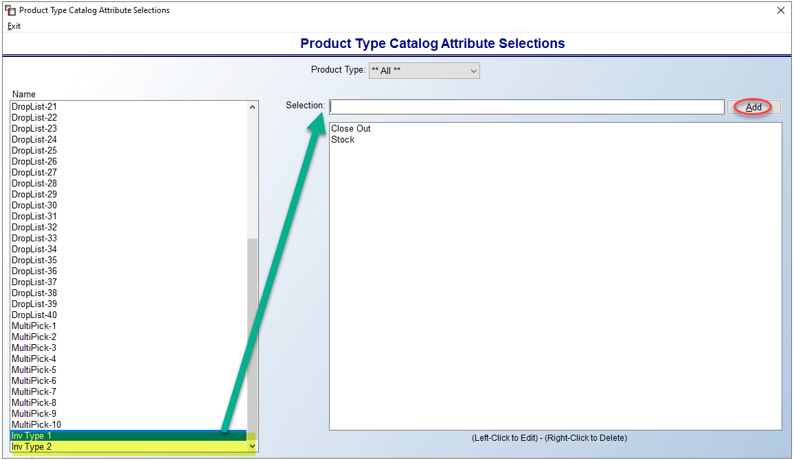

Highlight the item and type your desired option in the Selection field and then click Add. Continue until all have been added. You can now move to the main setup step.

The final area of setup is in Catalog Maintenance under the Catalog Attributes feature/screen. You will see a new option as follows:

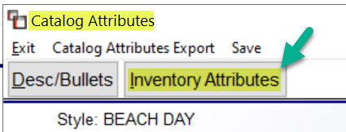

When you click on this button, an Inventory Attributes screen will appear as follows:

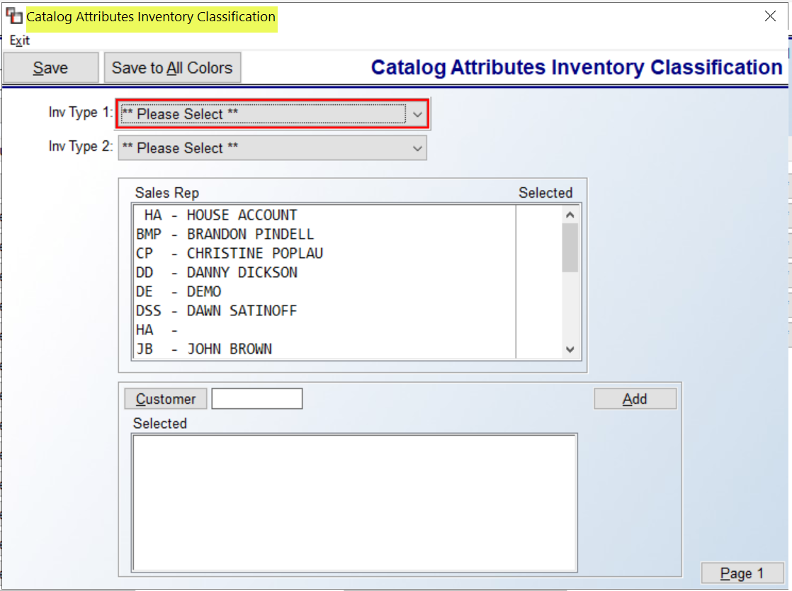

The Inv Type 1 and Type 2 fields are user-defined as explained above. Make an applicable selection for this product to continue. You can then select one or more Sales Reps, depending on who is requesting the material to be brought in and then one or more Customers requesting the material, if applicable. The setup in Catalog Attributes above is the default, but the data can be changed in Purchasing and Inventory, once received. In the Add or Change Purchase Order Screen, an Inventory Classification button will appear at the bottom left of the screen, just under the Sales ID field. Changes can be made at this stage if needed, based on whether another Customer is requesting, or to change out Salesrep and Customer, etc. And finally, after the material has been received, in the Edit Inventory Item screen, this same button appears at the bottom left just above the Inv Sequence # field. The reason you may access here is if it wasn’t set up originally, so now you can access here and apply these classifications. Other areas of the system that report this information is Sales Analysis, where you will see Inventory Type 1 and Type 2 in the drop-down field for reporting, as well as on the Catalog Listing when Export Print (Excel Only) is checked, and also on the Inventory Valuation Report export to Excel.

Transferring Inventory Between Branches:
The Transfer Inventory feature allows you to transfer an inventory record or part of an inventory record from one Branch to another within the same company. The RollMaster System will only permit you to initiate and process transfers where inventory is available and within Region parameters, if that feature is being utilized in your system. If a Pointer Record exists on an inventory item and has been fully or partially shipped on a Work Order, the system will not allow the inventory to be transferred.

To initiate an inventory transfer or request inventory, click on the Transfer Inventory option, or the Transfer button, to prompt an Inventory Transfer box as follows:
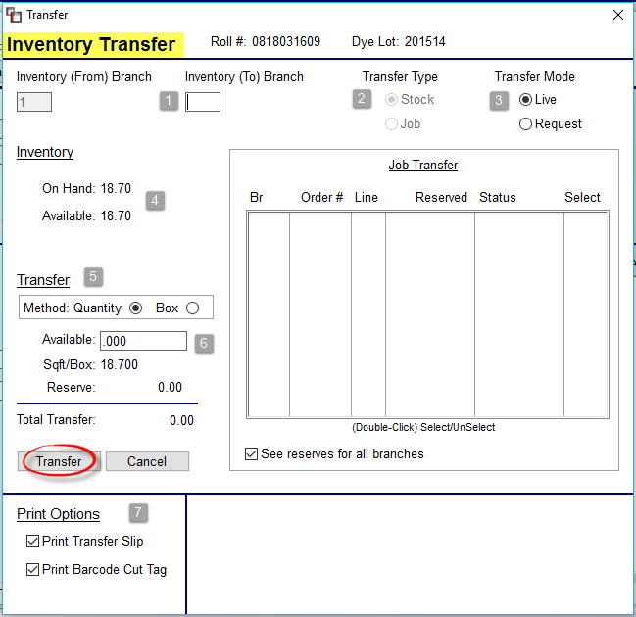
At the Inventory (To) Branch (1) field, type the Branch ID of the Branch to which the inventory is being transferred. This can be for an entire stock record or partial. A “Stock” Transfer Type (1) moves available inventory from one Branch to another. A “Job” Transfer Type moves assigned inventory to the Job Branch, and gives the option of moving additional available inventory to that Branch. When a Job or Jobs appear in the Job Transfer box in the middle of the screen, it means those Jobs have requested some or all of the inventory, as in the following example:

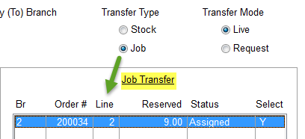

In order to select a Job in the Job Transfer box, the Job option must be selected at the Transfer Type field. You can then double-click on a job line to Select for inventory transfer to the applicable Branch. The See reserves for all branches option will default to “enabled” for all Branches. To see only the current “To” Branch reserves, click the box to turn off “All Branches.” The Transfer Mode (3) section determines whether the transfer is considered “real” or Live, or a Request for inventory to be transferred. If the inventory will be physically transferred to the “To” Branch, select Live in this section.

The Inventory (4) section displays the current On Hand and Available quantities for the inventory item. Assigned inventory will be part of the On Hand total. Any portion of the inventory item not currently assigned will display as part of the Available quantity. You can use this information to determine if you will transfer more than the requested material amount prior to completing the transfer. To do this, at the Available (6) field in the Transfer section, type in the applicable amount up to the total available quantity. Stock Transfer Types can be for the entire Available amount or a portion of the Available amount. You can also transfer portions of an inventory record to multiple Branches, provided the material is Available at the time of transfer.

For Catalog Item Sold By Box enabled items, the Method (5) section allows you to select whether to transfer by Quantity or by the Box. Either way, the system will enforce Box Qty settings. Prior to clicking the Transfer button, be sure your Print Options (7) are properly selected.

When you click the Transfer button, the system will then prompt the following:

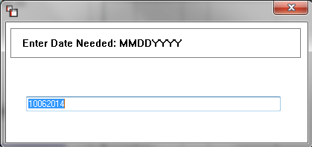

The date will prompt the current date. You can override this where applicable. A Select Printer box will prompt to allow you to print the Inventory Transfer Slip to one printer and then switch to a Barcode Label printer if applicable for the Barcode Label. The inventory item will now be considered “In Transit.”

Once an inventory item has been transferred, in the Inventory tab screen, you will see a “P” in the “P” column for that inventory record. The “P” indicates the inventory is in transit from one Branch to another. An example appears as follows:

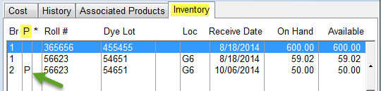

Please note: when transferring an 02 or 08 Factor Item, where the Roll # & Dye Lot fields match an existing inventory in the receiving Branch, the system will combine those inventory records and average the cost. The Inventory Transit Report (located in the Inventory Reports menu) keeps track of all the inventory that is considered “In Transit.” When inventory that has been transferred arrives at the new Branch, in order to receive it into the system you need to enter back into the Inventory Maintenance module, locate the inventory record, making sure the inventory record line displays a “P” to the right of the line, and double-click on that item to edit. The Edit Inventory Item screen will now display a Receive Transit button and an “Item In Transit” message as follows:

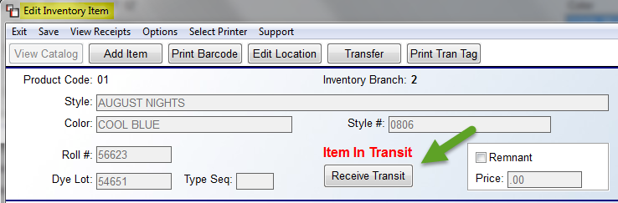

If the inventory has physically arrived in the receiving Branch, click the Receive Transit button and the system will prompt a Receive Transfer box as follows:

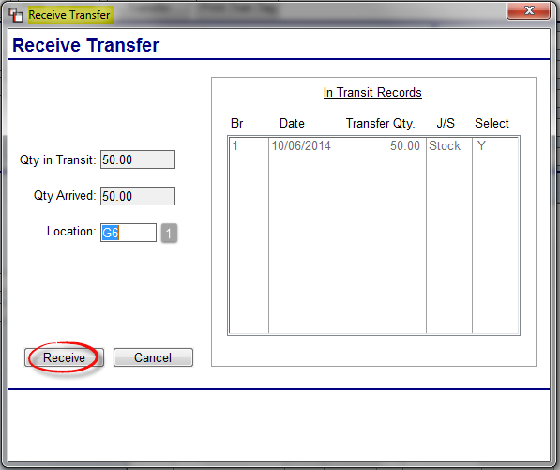

The Location (1) field will prompt the old location from the transferring Branch. Type in a new Location at the receiving Branch for the inventory item and then click the Receive button. The transfer is now complete.

There are two reports in the Sales Processing Reports Menu 2 that will help with the facilitating of inventory that needs to be transferred from one Branch to another. As inventory is assigned in the system from other Branches, that information will appear on both reports. One report will display the inventory that is needed from other Branches and the other will display inventory needing to be transferred out to other Branches. Those two reports are as follows: Inventory Required From Other Branches and Inventory Required For Other Branches. Please see the Sales Processing Reports section of this manual for more information on those reports.

Please Note: If you have different Inventory G/L Account Numbers for each Branch, the value of the inventory that is being transferred will automatically transfer to the receiving Branch when the transfer is complete. Also, the system will create an Inventory Transfer Journal to track the financial transfer. This will automatically print out when you run the Print Journals/Update General Ledger module. In the “Refer.” column of this report, the Branch the inventory was transferred “from” and “to” will display, and in the Comment column, the Roll # and Dye Lot number of the inventory will display along with the Style Color name.

Locating Existing Inventory
To locate an existing inventory record, you can utilize the Select from Catalog tab screen tools (see screen shot below), just as you do when searching for catalog items in Order, Quote Entry, and Catalog Maintenance.

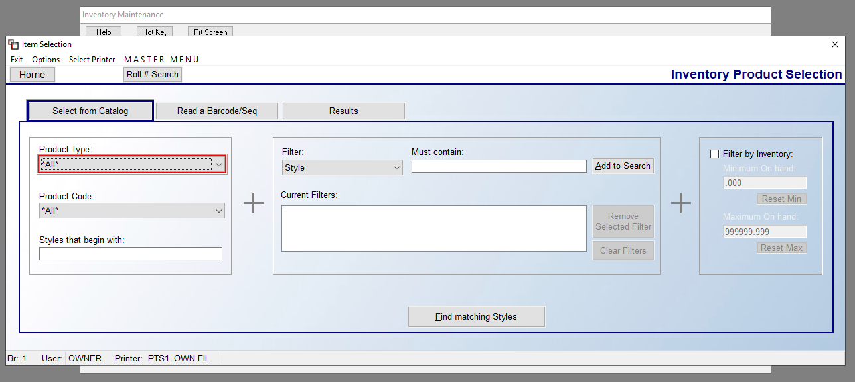

You can also click the Read a Barcode/Seq tab—provided you have this feature installed on your system—to scan and locate a particular inventory record. And finally, you can perform a manual roll number search by clicking the Roll # Search button at the top left of the screen above. This process will prompt a Roll Number Look-Up screen as follows:

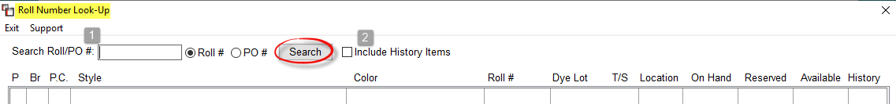

Prior to beginning your search, you can click the Include History Items (2) option to include rolls purged to history in your search. At the Search Roll/PO # (1) field, the default setting is by Roll #. In this case, you will type a roll number or a portion of a roll number in the field at the top left and then click the Search button to continue. By clicking the PO # option, you will then be able to enter an existing PO # to perform a search. The system will prompt any matching data as follows:

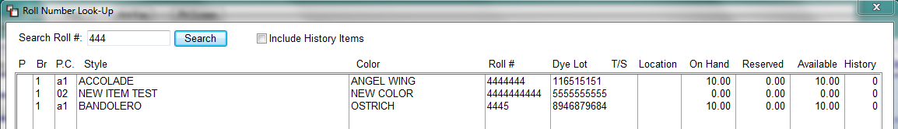

If the item you are searching for is listed in the box above, double-click on the Style name to bring up the Edit Inventory Item screen (explained above). If you right-click on an item in the screen above, the system will prompt the following two options: Select Item & View Pointers. The View Pointers will prompt an Inventory Pointer View screen (explained above). The Select Item option will bring up the Edit Inventory Item screen.
Also, from the Inventory Product Selection screen, you will see an Options drop-down menu at the top left of the screen. Currently, there is one feature that appears as follows: Print Existing Branch Private Labels. This report will print a list of all existing Private Label Styles for the current Branch.

One final note, when performing a Roll # Search on “08” accumulated items (start by entering 08 in the Search Roll # field), the system will prompt an Enter Catalog Sequence box for you to enter the Sequence # in order to isolate the search to a particular catalog item, such as a specific carpet pad. The Catalog Sequence Number is a system generated number and appears above the B2B SKU # field in the Edit Existing Catalog screen of the Catalog Maintenance module. You can hit enter at a blank field to skip this feature.

Remnant Feature Explanation:
The Remnant feature should only be used on items that you consider a remnant, meaning it is inventoried and sold as is, much like an area rug. For all other inventory records, this feature should remain inactive. The remainder of this section details how to use the Remnant features in the system. Please Note: you cannot create a remnant out of inventory that has any portion assigned on a Job. Also, once a remnant is assigned on a Job, you cannot make changes to the remnant in Inventory Maintenance unless you first unassign the remnant from the Job.

Important Note: If you wish to assign a special Salesperson Commission percentage to remnant sales, you must first turn the commission option of this feature on in the Company Control 2 level screen of the System Control Maintenance module. The control appears as “Remnant Commission” and must be set to “Y” for yes. Secondly, a commission percentage should be entered in the next field of that control. If you do not want remnant sales to impact a Salesperson’s regular commission on a Job, you need to enable this control. If this control is not used, the commission will be negatively impacted by the lower margin or loss on the remnant. The remainder of this section is written based on this control being enabled. Additionally, if a User is not allowed to sell below the A-J Level Pricing, the system will check to see if the price entered is below what is allowed and adjust the price back to the stored price; otherwise, it will keep the new price entered if it equals or exceeds the stored remnant price.

To create a remnant from existing inventory, click the Remnant box for that item in the Edit Inventory Item screen. The system will prompt the following:

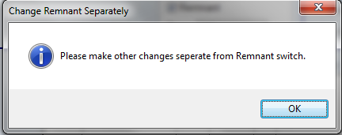

This is a reminder to complete other necessary steps to complete the process. Click the OK button and the system will return you to the Edit Inventory Item screen. Tab to or click in the Price field of the Remnant box. Type the sale price you would like to prompt when this remnant is assigned in Quote or Order Entry. Continue to tab through this screen to update the Location field and Memo field where applicable. If the Vendor Invoice field is blank at the time the remnant is moved to a Remnant Product Code, the system will automatically write an entry of “Remnant” in this field so the inventory will not display on any Inventory Not Paid reports. Click the Save button at the top left of this screen to continue with conversion. When you click “Yes” at the Are You Sure box, the system will prompt the following:

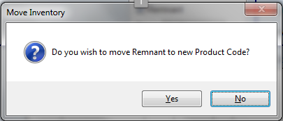

If you select “Yes,” the system will then prompt the following: Enter New Product Code. If you are moving an existing roll good item with a Width Factor ID (01, 02, 03, etc.) to a Product Code with an Each Factor ID (02, 08 or 07) the system will automate the process of converting it to a remnant. Please Note: the Product Code you are moving the remnant to must first be designated as a “receiver” Product Code via checking the Remnant box in Product Code Maintenance. When the move is successful, the system will prompt the following: Available Remnant Moved. Click OK and the system will prompt the following: Inventory Updated. Click OK again to complete the process. Exit out of the existing Edit Inventory Item screen and locate the new remnant under the new Product Code. The remnant item will appear as follows:

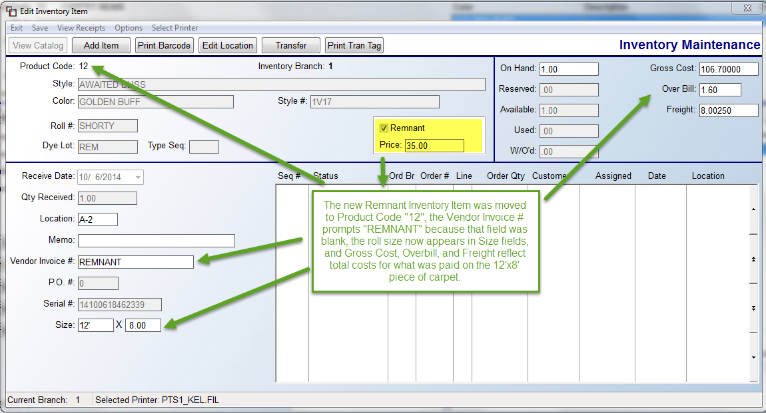

Once an item is designated as a remnant and moved to a designated Remnant Product Code, the system will change the Quantity Received to “1”, multiply the length times the width and multiply that with the existing unit costs to determine the Cost, Overbill, and Freight totals, and then display the width and length in the Size field. The width will come from the existing Width Factor ID and the length will come from the On Hand field when the conversion takes place.

In the Quote and Order Entry modules, when a remnant item is selected, the system will write an F6 Comment Line to display the width and length of the remnant for the customer. Please Note: when you move remnants from a Product Code with a Factor Width, you will still see the original inventory record with a 0.00 On Hand quantity. It will need to be purged through the Inventory Purge module to remove from the screen. One additional note on moving remnants from one Product Code to another has to do with the Inventory G/L Account. If the Inventory G/L Account of the new Product Code is different from the existing Product Code, the system will make an automatic adjustment to credit the old account and debit the new account.

Before you begin creating and selling remnants, you should understand how job costing and salesperson commissions will be impacted. If you are losing money on a remnant, the job costing will reflect that on the overall job and bottom line profit and profit margin. However, the salesperson’s commission will not be negatively impacted as long as you have enabled the Remnant Commission control in Company Control 2. The Commission Base will be calculated on all material and labor line items, with the exception of any Remnant Line Items. The Commission % will display as the regular commission set up in Salesperson Maintenance, but the Commission Amount will actually reflect regular commission plus the remnant sales commission (remnant commission will be paid on the gross sale of the remnant). Where there are remnant commission sales, the system will display an “R” to the right of the Commission Total as follows:
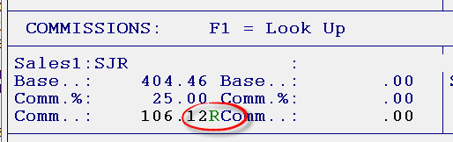

Also, after you enter through the Commissions box, where remnant commission exists, the system will prompt the following:

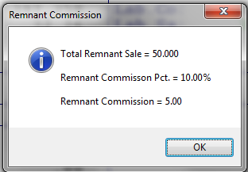

The last area to be impacted by the Remnant feature is the Salesperson Payables module. When you print the Commission Report, it will display any remnant sales and indicate that the commission has been *INCLUDED* in the total commission paid on the job.

Adjusting Inventory Records:
Once an inventory record has been added or received through the Purchase Order module, you should only make consumption error adjustments through this module. Consumption errors include material used up through cutting errors or shrinkage, end-of-roll adjustments, and theft. Receiving errors should be adjusted via the Purchase Order Receipt Adjustments feature. To make an adjustment, select the inventory record and enter it into the Edit Inventory Item screen. At the On Hand field, adjust the quantity to the amount that physically resides in the warehouse. The system will prompt a red “X” next to the On Hand field. If you need to cancel before saving, click “X” to reset the amount. To proceed, click the Save button. The system will prompt the following:

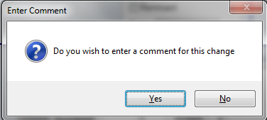

It is always a good idea to record a comment about why the adjustment is being made. This comment will appear on the Inventory Audit report, along with a record of the adjustment and the value change in the inventory record. Changes to the Cost field will also prompt the Enter Comment box above and appear on the Inventory Audit report. If you click Yes in the box above, the system will prompt an Enter Adjustment Comment box as follows:

The Existing Comments field allows for selecting pre-built Comments by clicking the down arrow. The default of User Defined will allow you to type a custom comment in the User Defined Comment box. Click Save when complete. The system will then prompt an Adjustment Date box. Enter to accept the current date or override to an earlier date if applicable. Once the change has been saved, you will see a Pointer Record for the adjustment in the Edit Inventory Item screen and in the View Pointer Records screen. Any changes affecting financial data should be posted directly to the General Ledger.

Catalog Price Roundup:
This module will allow you to round up the A-J programmed pricing to the nearest “9” or “99” or any cent figure you would prefer. You should first program your A-J level pricing in the Catalog (A-J) Pricing Maintenance/Print module (explained below) before completing this module. When you use A-J Margin pricing, the system will display that pricing exactly as it is figured, i.e., 5.89 divided by .4 = 14.73. If you use this Roundup module, you can program the system to round up the 14.73 to 14.79 or 14.99. Any exact pricing programmed in the A-J Pricing module will also roundup if it is not already entered that way. This module only needs to be programmed once for each Product Code to update all Branches.

When you enter the Catalog Price Roundup module, the screen will appear as follows:

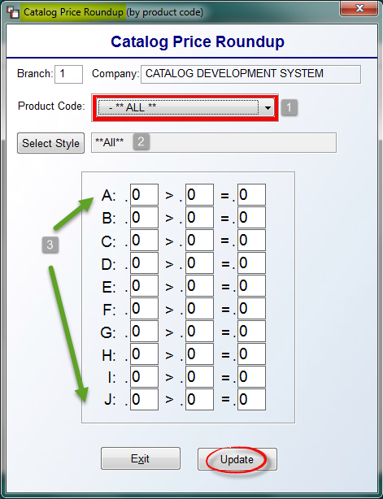
The cursor will be positioned at the Product Code (1) field and the default will be **ALL**. Use the drop-down arrow to select a specific Product Code if applicable. If a specific Product Code is entered, you can program the Roundup feature for a specific Style, or for All Styles under that Product Code. The Select Style (2) field will also default to **ALL**. Only if you need to program a unique Roundup scenario for a specific Style should you click the Select Style button to choose a Style. In the A-J (3) fields, you can click in each field to enter/change data or tab through each field starting at the A Level. From one to ten different Roundup levels can be programmed using the following guidelines: A full range of cents must be programmed, from .00 to .99. The second field in the A level line must be .99, and the first field of the lowest range programmed must be .00. In other words, if pricing is to round up to the nearest “9”, all 10 levels would need to be programmed and the A level would read “.90 > .99 = .99” and the J level would read “.00 > .09 = .09.” To program all pricing to roundup to the nearest “99”, only the A level line needs to be programmed. It should read “.00 > .99 = .99.” To roundup to the nearest “49” or “99,” program the A & B levels to read as follows: A.) .50 > .99 = .99 & B.) .00 > .49 = .49. The following is an example of a Roundup Table programmed to round to the nearest “9”:
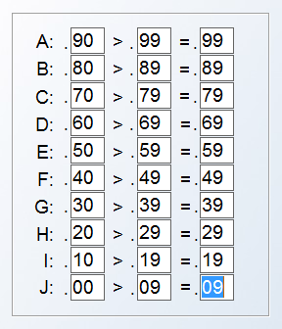
Click the Add or Update button to save new programming or any changes. Depending on the size of the catalog being updated, this may take a few seconds. The system will prompt a Record Updated message when complete. Click OK and the system will place you back at the Inventory Control menu. You will need to enter back into this module to continue programming.
Once all applicable Roundup Tables have been programmed, the new pricing can be viewed in many areas of the system. (Please Note: If Margins or Exact Pricing through the Catalog (A-J) Pricing Maintenance/Print module have not been programmed, these new Roundup prices will not be accurate.) In the Catalog and Inventory Maintenance modules, the A-J Level prices will automatically reflect the new pricing once the Roundup Table(s) is programmed. In the Order Entry, Quote Entry*, and Property Management modules, the Price column will reflect the new rounded pricing if the System Control 1 option is set to default to one of the A-J Level prices. Also, the A-J Level Pricing Table in Quote and Order Entry will display the new A-J Level rounded pricing. And finally, the price list in the Catalog (A-J) Pricing Maintenance/Print module will reflect the new pricing change.
*If the Enter Cost in Quote Entry option has been enabled in System Control 1, the Roundup feature will not be applicable in the Quote Entry module.

Catalog (A-J) Pricing Maintenance/Print:
This module will allow you to program pricing levels in the system either by profit margin or by exact pricing. Once programmed, you will then be able to print out a list of those programmed prices. The price list(s) that can be printed from this module can be exported to Excel, however, if a User can see costs, there is a User Control option that will control whether they can also print out costs to the Excel export. Please Note: access to this module will also be controlled by User/Branch setup. If a User is not set up in a Branch, they will not have access to that Branches pricing data. Also, as noted in the Catalog Maintenance module section, the A-J Level pricing that is programmed here appears in Catalog Maintenance in Quote and Order Entry via the Pricing Table option. There is also a Catalog Item price lookup that can be called up from anywhere in the system by hitting the Home key or the “Ctrl” and “P” key simultaneously.
When you enter this module, the system will prompt a Catalog Price List Maintenance screen as follows (the screenshot below displays existing Margin pricing):
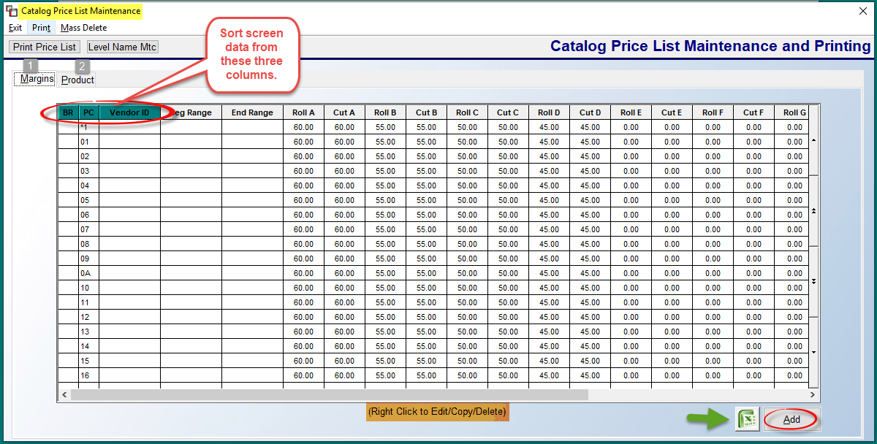
The default view is the Margins (1) pricing screen. If you click on the Product (2) tab, you will be able to view/use the Product exact pricing option. The Product option will allow you to enter an exact range of pricing for one product at a time and is only recommended for items such as supplies or padding that you will generally sell at the same price all the time. Any pricing programmed through the Product pricing screen will override Margin pricing in the Quote and Order Entry modules. This is important to keep in mind because any mill increases will require you to return to this module and update all the pricing levels, whereas with the Margin option, the increase will automatically update when the new price is entered in the Catalog Maintenance module or imported via B2B. The view in both screens can be sorted by the first three column headings as follows: Br for Branch, PC for Product Code, and Vendor ID. This is because you can program pricing specific to a Branch, a Product Code, or a Vendor ID where applicable. The Product screen has an additional column sort option for Style.
To add new margin pricing, from the Margins tab screen, click the Add button at the bottom right. The system will prompt the following:
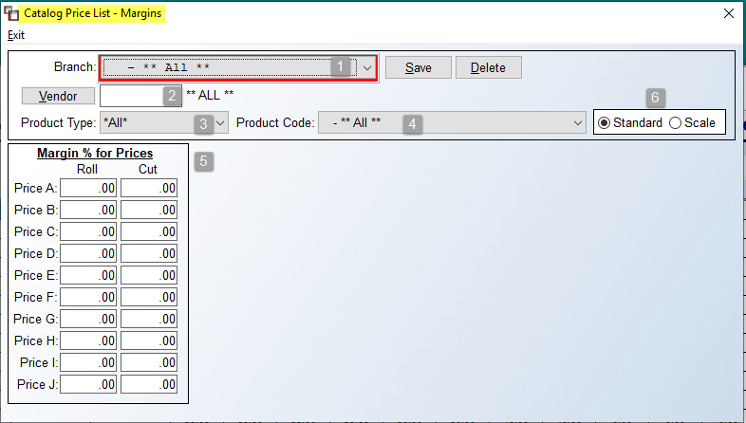
At the Branch (1) field, you can program for ALL Branches, or the current Branch, but you will need to change Branches to enter pricing data specific to another Branch. The Vendor (2), Product Type (3), and Product Code (4) fields can be used to create Margin pricing specific to each of those fields and will override any “ALL” pricing that exists. It is recommended to first program for All Vendors, All Product Types, and All Product Codes, and then selectively program for any Vendors, Product Types, or Product Codes that require different margins. At the Margin % for Prices (5) fields, start with the highest margin preferred and enter it in both the Roll and Cut columns for the Price A fields. Gradually reduce the margin and continue entering down through to the Price J level if applicable--you do not have to program margins for all levels. Be sure to click the Save button at the top right to save your changes.

There is an additional option to the right of the Product Code field that appears as follows: Standard / Scale (6). The default mode is Standard. However, the Scale option is available to program higher margins for lower cost items within a Product Code. To access Scale Margin pricing, click the radial button next to Scale (6) to display the following Scale Margins screen:
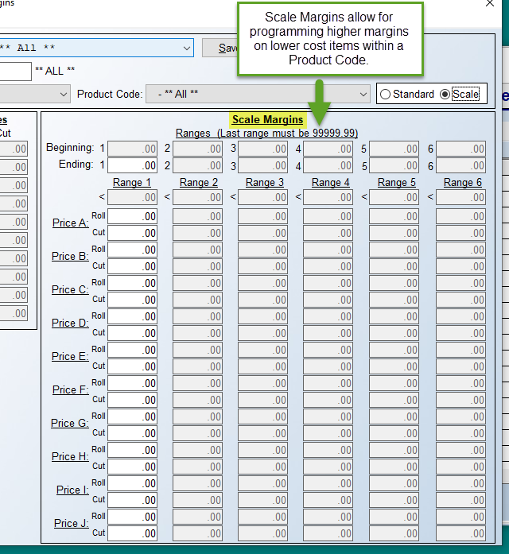

The cursor will be positioned in the Ending: 1 field. Enter the lowest cost that will apply for the Range 1 column below. For example, you may wish to enter a range of margins for items that cost between $0.00 and $5.00. Once you type a cost in the first field, hit enter and the system will calculate the Beginning: 2 field and place the cursor in the Ending: 2 field (you will not have access to the Beginning: 1 field, as that must stay .00). Program all the Ending fields up to the last range of 99999.99, and the system will automatically calculate all the Beginning fields. You can program up to six different price ranges. At whichever level you choose to end, the last Ending field must contain the following: 99999.99. Once the Beginning and Ending cost range fields are complete, you will then set up corresponding margins for each programmed cost range in the fields below. The following is an example of a programmed Scale Margin table:

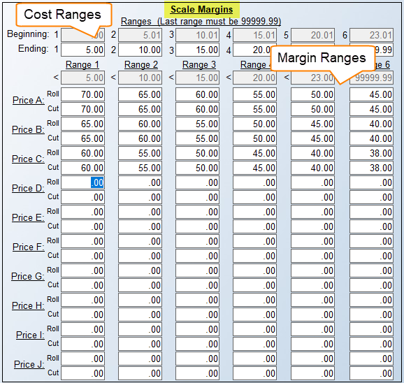

When you have programmed the last column or if you exit before completing this screen, please be sure to Save your changes. Please Note: If you have previously set margins in the first screen, the Scale Margin screen, when saved, will override anything pre-set on that screen so you will not need to delete that data.

Once margins have been programmed, if you Double Click To Edit an existing Margin pricing line in the main screen, the system will prompt the Catalog Price List – Margins box as follows:
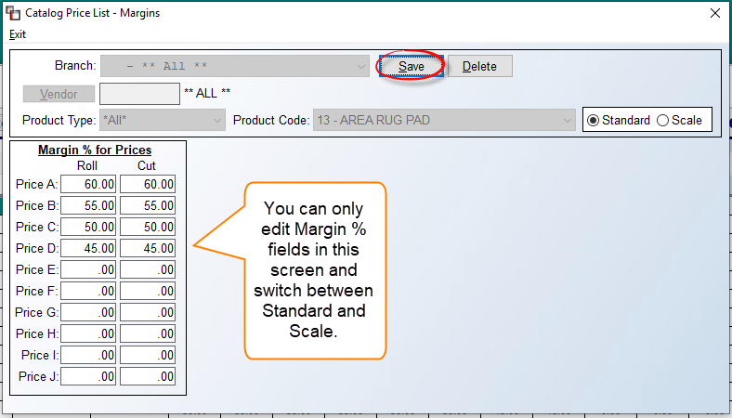
In the Edit mode, you will not be able to access the Branch, Vendor, or Product Code fields to make changes. However, you can make changes to the Margin % for Prices A-J column fields. The Standard / Scale box will default to Standard unless Scale Margins have been programmed. Be sure to click the Save button to save any changes prior to exiting this screen. You can also Delete the current data and re-enter if you need to make a change to any of the other fields.
The Product tab screen will appear as follows:
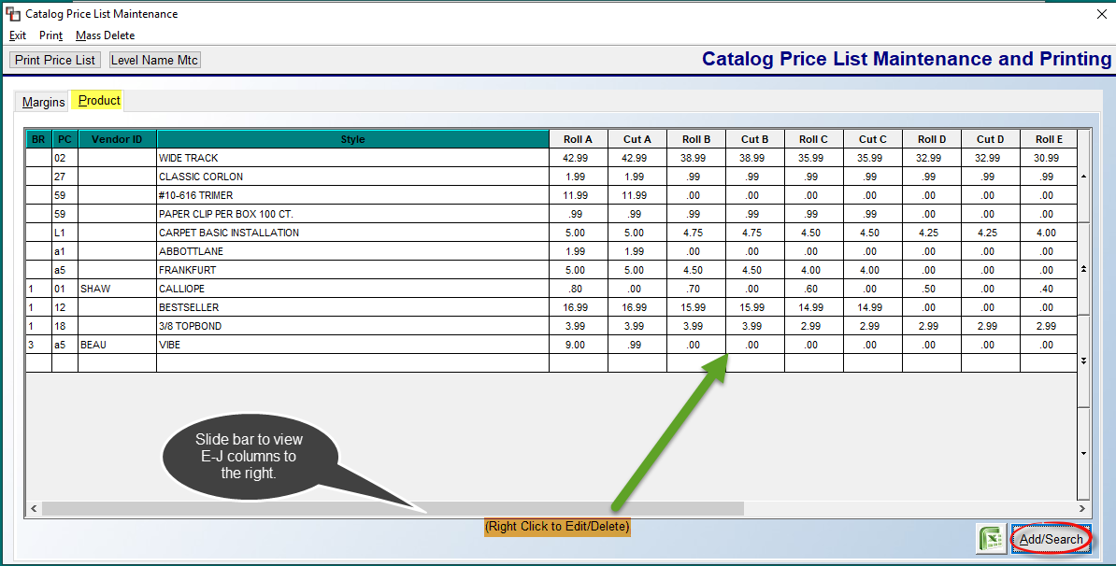
As with the Margins tab screen, you can sort the data on this screen by the first four column headings. To add exact product pricing data, click the Add/Search button at the bottom right of the Product tab screen. The system will prompt a Catalog Price List – Product box as follows:
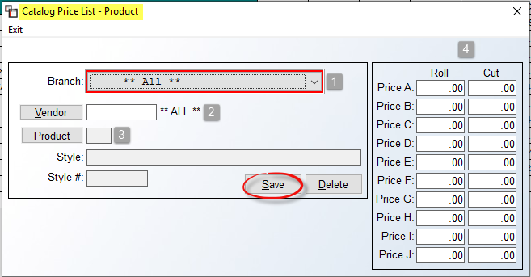
The Branch (1) and Vendor (2) fields will default to **All**. You can select a specific Branch or Vendor or leave the default setting. Click the Product (3) button to select a Style and Style # to program. This button will prompt the Catalog Product Selection lookup screen. Once a Style is selected, at the Roll / Cut columns (4), you will type an exact price, Roll and Cut, for each applicable pricing level. You do not need to program all levels. Be sure to click the Save button prior to exiting. If you wish to Delete programmed pricing, you cannot simply zero out the pricing on all levels, you must use the Delete button to permanently remove the record.
From the main Product screen, the Add/Search button will also allow you to “search” for existing Product pricing. From a blank Catalog Price List – Product screen, you can enter twice to get to the Product button, or click on the Product button to call up the Catalog Product Selection. Locate and select the catalog item, and the system will display any existing pricing for that item if any exists. You can also double-click or right-click on an existing line in the Product screen to edit. The edit screen will appear as follows:
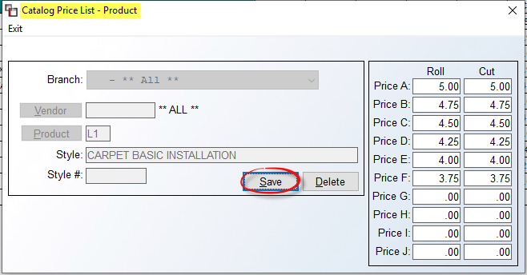
You can only change the Price A-J fields in the Roll and Cut columns. If the Branch or Vendor fields need to change, you will need to Delete the pricing and reenter.
From the top left of the main Catalog Price List Maintenance screen, you will see a couple of print options as follows:

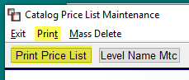
The Print Price List button will prompt a Print Price List screen as follows:
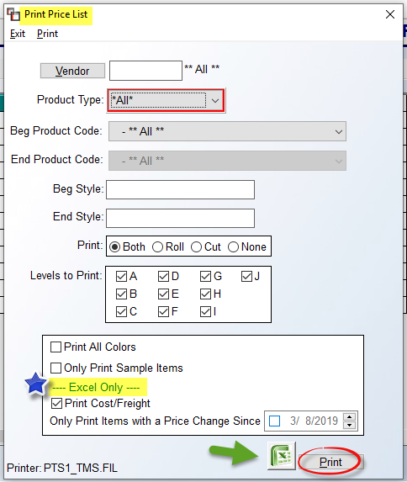
The default settings will print all programmed pricing unless you make any applicable changes prior to clicking the Print button at the bottom right of the screen. Please note the Blue Star toward the bottom of the screenshot above--two additional options appear here that only apply to an Excel export. The Print Cost/Freight option defaults to “checked.” You can uncheck when applicable. The Only Print Items with a Price Change Since option, when checked, will allow you to customize the data by a Price Change date. If an item is set to Inactive in the Catalog Maintenance module, it will not print on a price list.
When you click the Print menu just above the Print Price List button, the system will prompt the following options:
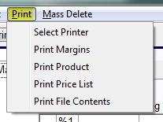

The Print Margins option prints all the data that appears in the Margin screen. The Print Product option prints all the data that appears in the Product screen. The Print Price List works the same as the Print Price List button explained above. The Print File Contents option prints a list of all Product Codes or Styles that have been programmed under either the Product or Margins screens.

The Mass Delete option, located to the right of the Print option, allows you to mass delete any programmed pricing for a specific Vendor. When you click on Mass Delete, the system will prompt the following: Delete Margin Pricelist by Vendor. Select a Vendor and the program will clear all the prices for that Vendor. This relates to pricing setup by Vendor within this module, not pricing based on the Vendor in Catalog Maintenance.

The final option in this module is the Level Name Mtc button at the top left. This option allows for assigning custom names to some or all of the Pricing Levels. When you click this option, a Level Name Maintenance box will prompt as follows:

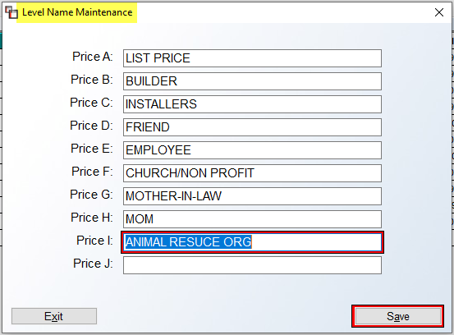

Special Price Mtc. (Date Range Pricing):
This module offers several features for programming Special Pricing on products and/or labor for particular Customers, such as builders or property management companies, or for specific Customer Types, or even All Customers. You can also program default A-J Level pricing by Customer, among several other features. If you are using the Property Management / Builders Template module, you can set up Special Pricing in this module for all of your Templates that will make price changes much easier to manage. At the end of this section, we have included a Pricing Hierarchy Reference List to illustrate the lowest priority pricing level to the highest.

Any Special Pricing entered in this module will default in the Price column of the Quotation and Order Entry modules for the duration of the sale date programmed in this module. At the end of the promotion, the system will default back to regular system pricing. When you enter this module, a Special Price Mtc. screen will appear as follows:

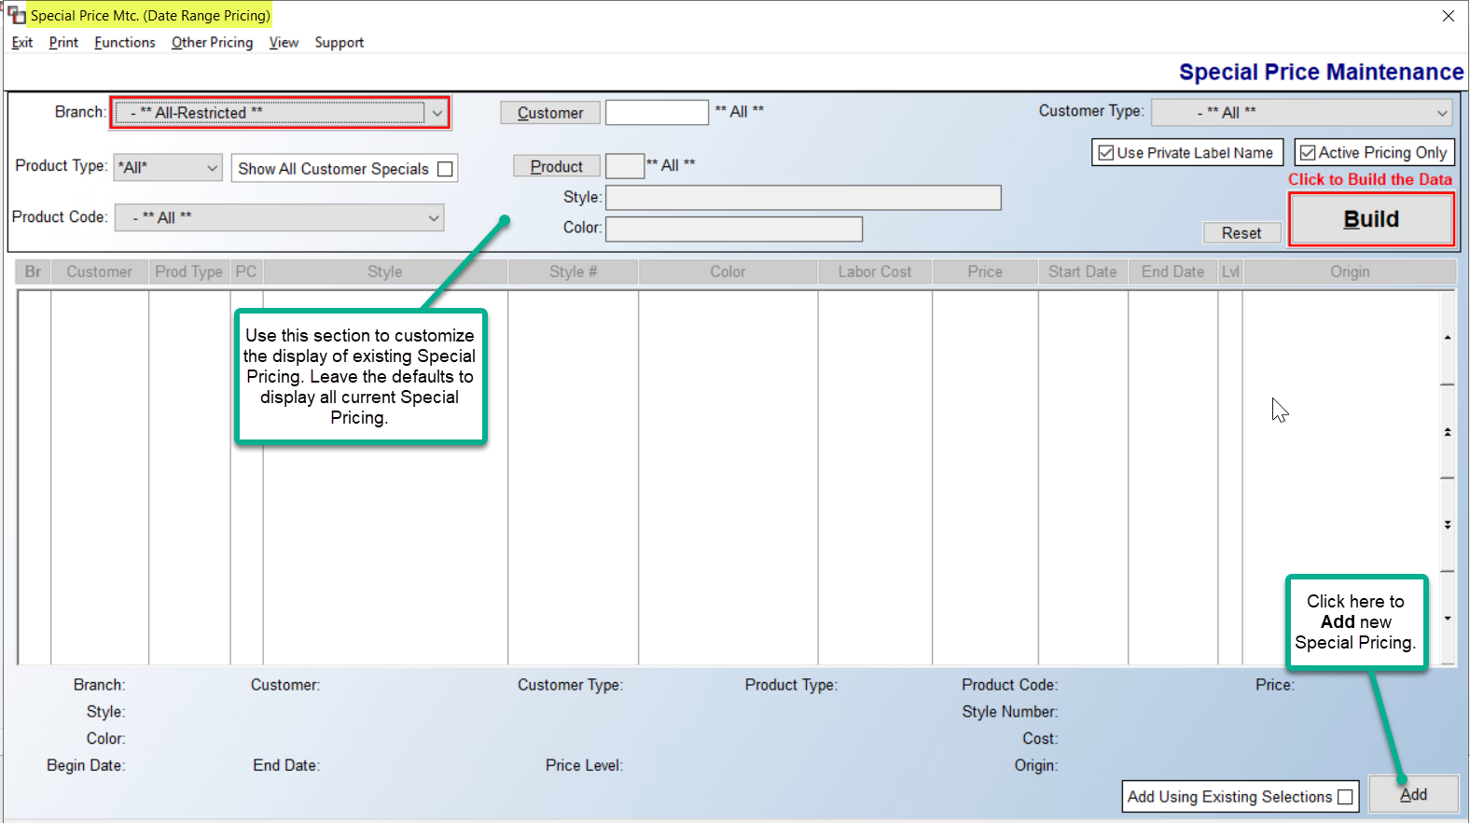

There are many features and options within the screen above that will be explained in this next section. This first topic will cover how to add Special Pricing.

Adding Special Pricing:
When you click the Add button, located at the bottom right of the main Special Price Mtc. screen, the system will prompt an Add Special Price box as follows:

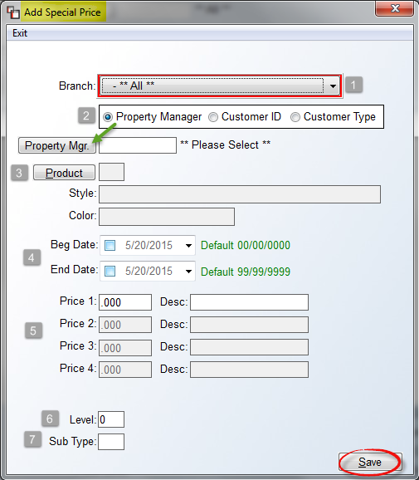
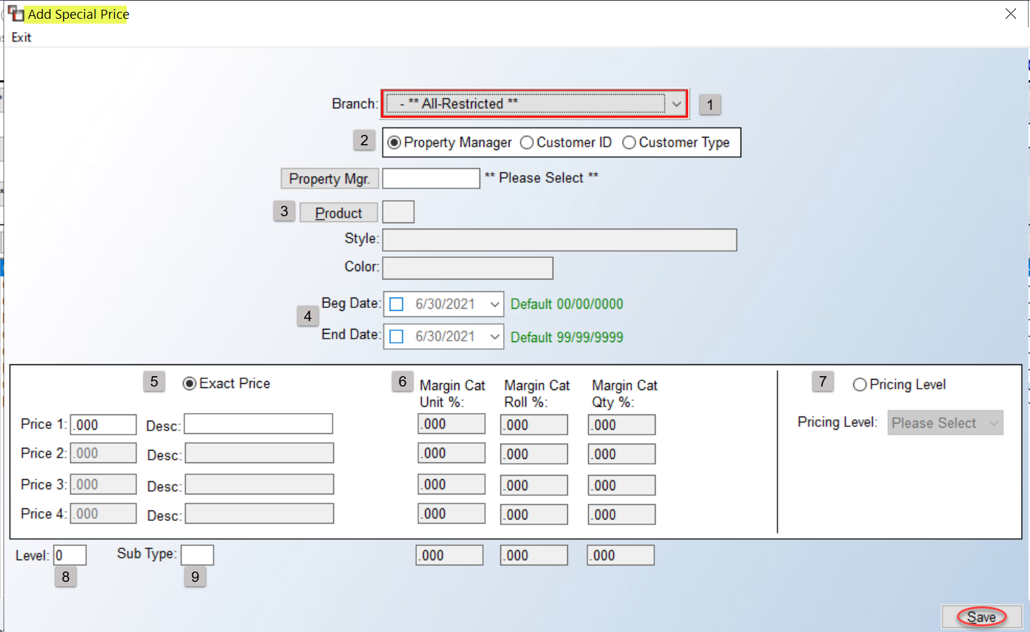

At the Branch (1) field, the system will default to ** All-Restricted **, forcing you to select a Branch, using the down arrow button. The next box (2) presents a few different options for programming Customer pricing. The default is by Property Manager. This option requires setup in both the Company Control 3 level screen of the System Control Maintenance module, and in the Customer Maintenance module prior to use. The CC3 control appears as follows: Special Pricing for Property Mgr. This control must be set to “Y” to access the Property Manager option in this module. In the Customer Maintenance module, Property Managers must first be identified via the Property Management/ Parent Company fields for all applicable Customers. With setup complete, changes for multiple locations can occur instantly. Please Note: Customer ID pricing for Property Managers should not be programmed if you will be using Property Manager pricing. This selection field will default to ** Please Select **. To program pricing for a specific Property Manager, click the Property Mgr. button to prompt a Customer Property Manager Selection box to display a list of Property Managers.

The next option is to program by Customer ID. If this option is selected, the system will change the button option to a customer lookup function as follows:

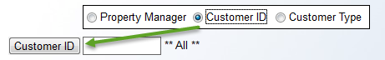

Click the Customer ID button to perform a lookup to select a specific Customer. If the default of ** All ** is used, the Special Pricing programmed will apply to all Customers within the system. The final option in the selection box (2) is by Customer Type. To use this option, Customer Types must first be setup and then assigned to applicable Customers from within the A/R Customer Maintenance module. This option will then allow you to enter Special Pricing for all Customers grouped together within a Customer Type, rather than programming for an individual or all Customers. When you click the Customer Type option, the system will prompt a Customer Type drop-down menu as follows:
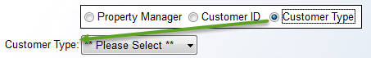

Use the drop-down menu to make a Customer Type selection. Once you have completed the Customer selection portion, you will need to program the Product (3) fields by clicking the Product button to prompt the Product Selection screen. Make a Product and Color or All Colors selection from the catalog to continue. At the Beg. and End Date (4) fields, enter a date range for the Special Pricing. The next series of fields are for programming pricing levels. For Property Manager pricing, only program the Price 1 field under the Exact Pricing (5) column—the other fields will not be available. For Customer ID and Customer Type pricing, you can program up to four levels by clicking the Multi Level checkbox that appears to the right of the Margin (6) display fields, but these are primarily used for quantity breaks. You can also enter a brief description for each level. Once a price is entered in the Price 1 field, based on costs programmed for Unit, Roll, and Qty, these fields will display the calculated Margin %. It the User can see costs, each cost level will display along the very bottom, provided these fields are all populated in the Catalog.

Rather than program an Exact Price or Pricing you can also click on the Pricing Level (7) column to default to the A-J pricing levels in the system and a Pricing Table button will prompt for you to access that information while you are making your selection. These pricing levels will appear in the Order Entry and Quote Entry modules when entering applicable Line Items. Be sure to click the Save button once all applicable fields have been programmed in this screen.

The Level (8) and Sub Type (9) fields work together to provide an additional feature for creating special pricing groupings or levels of products for individual Customers so that you can quickly update the pricing for all those items grouped together. These fields are used exclusively in the non-custom home builder business. This is also an optional feature, meaning these fields can be left blank. To use these fields, please read this section for setup instructions and examples. Please Note: this feature will only work with a specific Customer ID selected. Initial setup is completed in this screen, and then any pricing updates will be handled from the Update Pricing by Level/Sub Type option accessed via the Other Pricing menu in the main screen of this module. The Level field is a numeric field and the Sub Type field is an alphanumeric field. The Level field determines levels of pricing for multiple products, such as 1-5; while the Sub Type defines the type of product, such as “CA” for carpet, “WO” for wood, etc. Using a builder client as an example, you can select a few different carpet styles (Sub Type = CA) and set them all at the same price for all colors (Level = 1). You can then enter a different series of carpet styles (Sub Type still = CA) at a lower price (Level = 2), and so on. If you sell hard surface to a builder and have standard products and pricing you offer, you can create different Sub Types for those products and different Levels for pricing.

Update Pricing by Level/Sub Type:
Once the above Level/Sub Type programming is complete, the best part of the feature is being able to update pricing on all of these Levels quickly via the Update Pricing by Level/Sub Type option. This option can be accessed via the Other Pricing menu at the top left of the main screen. When you select this option, the box will appear similar to the Add Special Price box. Complete the top five fields as they are currently programmed, using the available lookup options as needed. The Edit Pricing by Level screen will then appear much like the following:

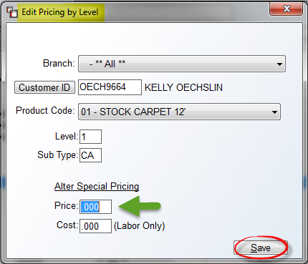

At the Price field, type in the new price you would like to apply to the selected Level and Sub Type. Click the Save button and all products/colors within that Product Code/Level/Sub Type will instantly be changed to reflect the new Price. Use the Cost field only where a Labor item pricing is being edited. Once the records are changed, the system will prompt a “[XX} Records have been updated” message.

Labor Items:
You can also program Special Pricing on any Labor Catalog Item as well as enter a special Cost for Labor items. When a Labor Catalog Item is selected, the system will prompt the same Add Special Price box explained above. When a Labor Catalog Item is selected in the Product field, the system will then prompt a Cost field at the bottom of the screen as follows:

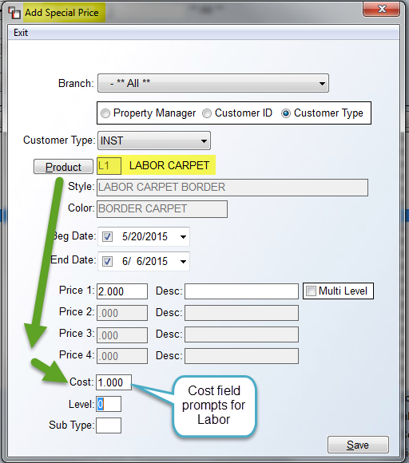

The Cost field does not have to be utilized, and if you leave the Cost field set to “0.00,” the following box will pop up:

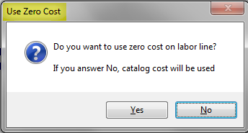

If you truly wish to use zero cost on a Labor Catalog Item you will need to click “Yes” in this box; otherwise you can click “No” to prompt the Catalog cost.

Look Up Special Pricing:
From the main Special Price Mtc. (Date Range Pricing) screen, the fields in the top portion of the screen will allow you to lookup existing Special Pricing and view in the screen below. Those fields appear as follows:

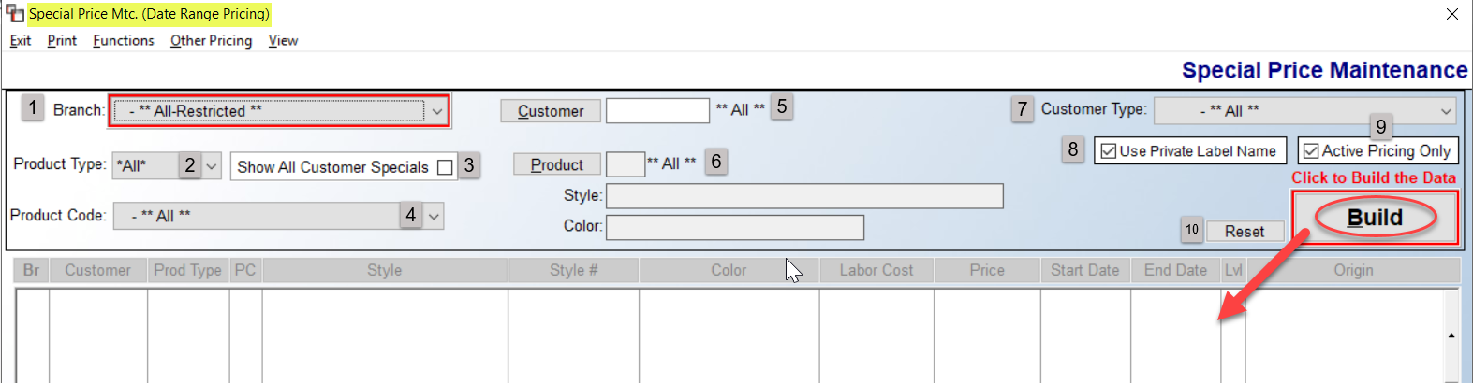

If you leave all the defaults as they are and click the Build button, the system will load all existing/current Special Pricing in the display screen below. Once items appear in that display screen, you can sort them by clicking on any of the column headings, such as Br, Customer, Prod Type, etc. The Origin column at the far right displays the customer level at which the pricing is programmed, such as All Customers, Customer Type, Property Manager, etc. To further sort the data in the display screen, you can make specific selections in the fields at the top. Please Note: Once you make selections in any of these fields, be sure to click the Build button to update the data in the display screen below. At the Branch (1) field, to see pricing for a specific Branch, use the drop-down arrow to make a Branch selection. You can do the same at the Product Type (2), Product Code (4), and Customer Type (7) fields. Use the Customer (5) button to select a specific Customer ID. You can make one selection or multiple field selections in this section. At the Show All Customer Specials (3) box, when checked, all pricing that is not programmed for “All Customers” will not appear in the display screen below when the Build button is clicked. Use the Product (6) button to make a specific Catalog Item selection. The Use Private Label Name (8) defaults to checked and applies to items that have been Private Labelled. In order to see the Vendor Name, you will need to uncheck this box. The Active Pricing Only (9) checkbox also defaults to checked, meaning no expired pricing will display while this box is checked. To include expired pricing, uncheck this box and click the Build button. The Reset (10) button will restore the default settings in all the fields explained above.

One additional feature in this screen appears at the bottom right as follows:

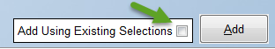

The Add Using Existing Selections feature works in conjunction with the search selection fields at the top of the screen. If you need to add additional pricing based on the search criteria currently selected, you can click the box in this feature and then click the Add button to prompt the Add Special Price box with those fields pre-selected.

Edit/Delete/View Audit Special Pricing:
Once there are Special Pricing items listed in the display screen, you can highlight and right-click on an item to display the following three options: Edit, Delete, and View Audit. An example is as follows:

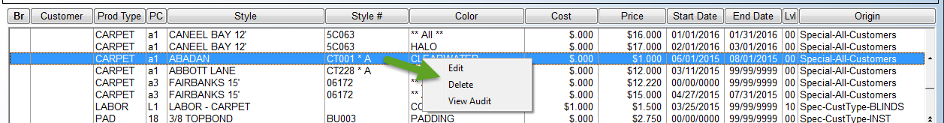

The Delete option, when clicked, will prompt a Delete box with the following question: Are You Sure? If you click Yes in this box, the system will immediately remove the Special Pricing line that is highlighted. The Edit option will prompt the Add Special Price box with the details of the selected line as follows:

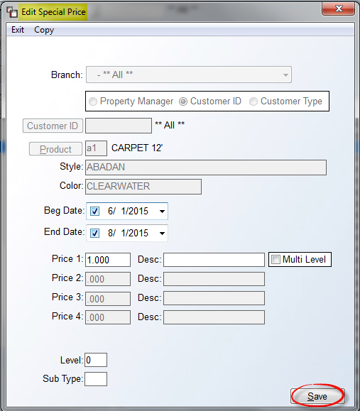

You can make any needed changes in this box and then click the Save button to save the changes. The View Audit feature can also be accessed by clicking the View menu option at the top left of the main screen as follows:

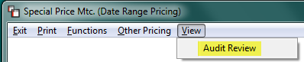

When you click on this feature, the system will prompt an Audit Review screen as follows:

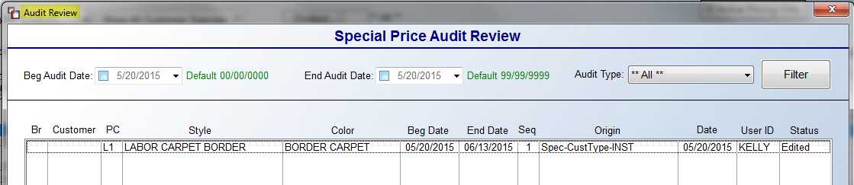

The default view will include all changes to a special pricing item since it was added. You can sort the view by the Date an item was changed, or you can display by Audit Type, which includes Added, Edited, and Deleted. The Filter button should be clicked if you make a Date or Audit Type selection to update the display screen.

Print Special Pricing:
Once Special Pricing has been programmed, you can print customized pricing reports via the Print Existing option available from the Print menu located at the top left of the Special Price Mtc. screen as follows:

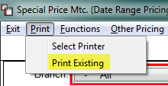

When you click on the Print Existing option, the system will prompt a Print Options box as follows:
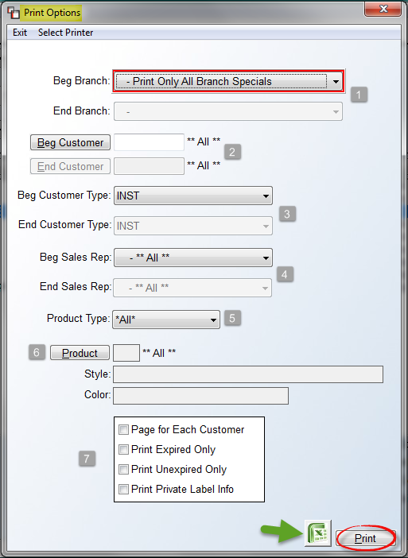
At the Beg & End Branch (1) fields, the default is Print Only All Branch Specials. This default should be used only to print Special Pricing programmed for All Branches. To print for a specific Branch or range of Branches, use the drop-down arrows to make your selections. At the Beg & End Customer (2) fields, if you wish to print for a specific Customer or range of Customers, use the look up buttons to make your selections. Otherwise, leave the default setting of **All** Customers. The Beg & End Customer Type (3) and Beg & End Sales Rep (4) fields work the same, aside from employing a drop-down menu. Leave the default of **All** or program specific options for the report. At the Product Code (5) field, use the drop-down arrow to select a specific Product Code. At the Product (6) fields, use the Product button to make a specific style and color selection, or leave the default **All** Products.

In the next section (7), there are a few additional options for the printed report. Click the Page for Each Customer option to start each customer’s Special Pricing on a separate page of the report. The Print Expired Only option will include only expired pricing, whereas the Print Unexpired Only option will include only current, or “unexpired” pricing. The Print Private Label Info option will include any programmed Private Label names on the printed report. When you have made all print option selections, you can either click the Excel icon to export the data or click the Print button to print out the report. If graphical printers are enabled, this step will create a PDF file.

Update Ending Date:
Once Special Pricing has been programmed, you can mass update a new ending date for Special Pricing by all customer options. Please Note: you can also update the Ending Date column in the main display screen on any displayed item, but if you need to do this for several items, this option will be more efficient. The Update Ending Date option is available from the Functions menu located at the top left of the Special Price Mtc. screen as follows:

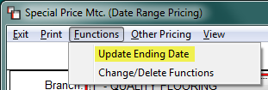

When you click on the Update Ending Date option, the system will prompt an Edit Special Pricing Ending Date box as follows:

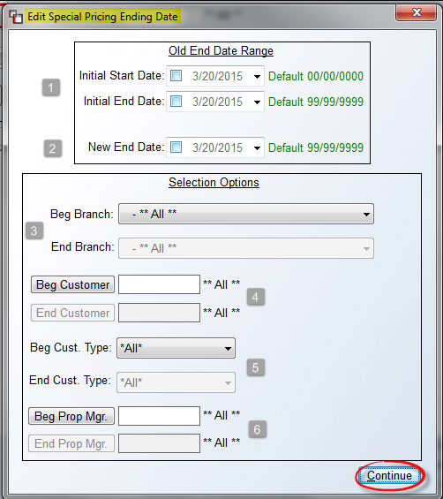

At the Initial Start Date & End Date (1) fields, use the drop-down arrows to enter the Old Date Range you wish to update. At the New End Date (2) field, use the drop-down arrow to select a new ending date. You will then use the Selection Options box to program the applicable Branch(es) (3), Customer(s) (4), Customer Type(s) (5), and/or Property Manager(s) (6). Once all applicable fields are programmed, click the Continue button to complete the update. The system will prompt a message with the number of records updated. You will then need to click the Build button to see any changes reflected in the display screen.

Change/Delete Functions:
The Change/Delete Functions option should be used to mass Change or Delete programmed Special Pricing vs. deleting or changing items one at a time in the display screen. The Change/Delete Functions option is available from the Functions menu located at the top left of the Special Price Mtc. screen as follows:

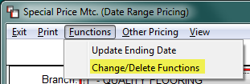

When you click on the Change/Delete Functions option, the system will prompt a Change or Delete by Product & Customer box as follows:

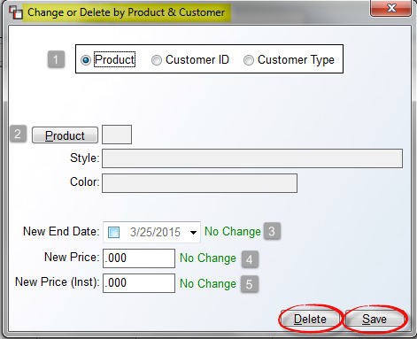

At the first (1) field, select the method of change or deletion, i.e., by Product, Customer ID, or Customer Type. If you select Customer ID or Customer Type, the system will prompt a drop-down selection box for you to apply to ** ALL ** or make a specific ID or Type selection. At the Product (2) field, regardless of the method selected in the field above, you will need to make a Product selection to continue. If you are using the Delete Option, you can click the Delete button after making a Product selection. Where applicable, the system will prompt overlapping Dates for the Delete option for you to approve each one. For the Change Option, continue on to any applicable fields at the bottom of the screen. At the New End Date (3) field, the system will default to the current date. Click in this box and use the drop-down calendar to select a new end date, if applicable. At the New Price (4) field, type a new price for this change, if applicable. The New Price (Inst) (5) field is not a working field and will be removed in a future update.

Manage Customer ID/Type Pricing Level:
This option will allow you to tie an A-J Margin or Special Pricing Level to an existing Customer ID or Customer Type in the system. When complete, the system will prompt that level of pricing whenever a Quote or Order for the Customer or Customer Type is entered. When you selectin this option, the screen will appear as follows:

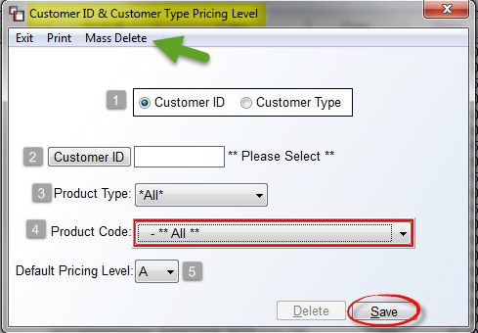

At the first (1) field, the system defaults to Customer ID and a Customer ID lookup button and field will prompt in the next (2) field. If you select Customer Type in the first (1) field, the system will then prompt a Customer Type drop-down menu in the (2) field below. At the Product Type (3) field, to program a Default Pricing Level by a specific Product Type, use the drop-down arrow to make a selection; otherwise leave the default setting for *All* Product Types. At the Product Code (4) field, use the drop-down menu to select a specific Product Code, or leave the default setting for **All** Product Codes. At the Default Pricing Level (5) field, use the drop-down menu to select Levels B through J or “S” for Special Pricing. Click the Save button to keep your programmed data. Please Note: It is not necessary to program this for every Customer ID or Customer Type in the system. If no Default Pricing Level is programmed for a customer, the system will continue to prompt the Default Pricing Level that has been set up in the System Control 1 screen of the System Control Maintenance module. Also, Customer ID Level Pricing will override any **All** Customer and/or Customer Type Level Pricing.

The Print option at the top left of the screen above will print a list of all programmed Customer Pricing Levels. The Mass Delete option will allow you to delete all current programmed pricing for a Customer ID, **All** Customers, or Customer Type. When you click on this option, the system will prompt a Special Pricing Maintenance Mass Delete box as follows:

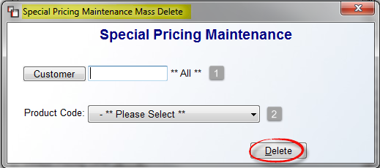

At the Customer (1) field, leave the default **All** setting, or click the Customer button to select a specific Customer ID. For Customer Type, select that option in the previous screen prior to clicking the Mass Delete option. At the Product Code (2) field, use the drop-down menu to select a Product Code. Click the Delete button to proceed. The system will then prompt the following: All Customer Price Levels with this product code will be deleted. Continue? Click “Yes” to complete the process.

Pricing Hierarchy Reference List:
- A-J Margin Pricing carries the lowest priority.
- A-J Product Pricing overrides Margin Pricing.
- Customer Type Pricing Level overrides both Margin and Product Pricing.
- Customer ID Pricing Level overrides the above, but should not be used if Date Range Pricing by Management Company is set up.
- Date Range Pricing by Customer Type overrides all above.
- Date Range Pricing by Management Company overrides all above.
- Date Range Pricing by Customer ID will override everything.

Private Label Mtc. (By Customer):
This module was added primarily for builder and property management dealers who wish to Private Label styles to their Customers. When a style is Private Labeled through this module, it will appear on screen as it is in the catalog, but on each report that the Customer sees, it will display the Private Label name. The reports affected include the Quotation/Proposal, Sales Agreement, Customer Receipt, Work Order, and Invoice. Before you can use this module, you must enable a control in the Company Control 2 level screen of the System Control Maintenance module. That control appears as follows: Use Private Labeling By Customer. You must set this control to “Y” for yes to use this module.

When you enter this module, the system will prompt a Private Label Maintenance screen as follows:
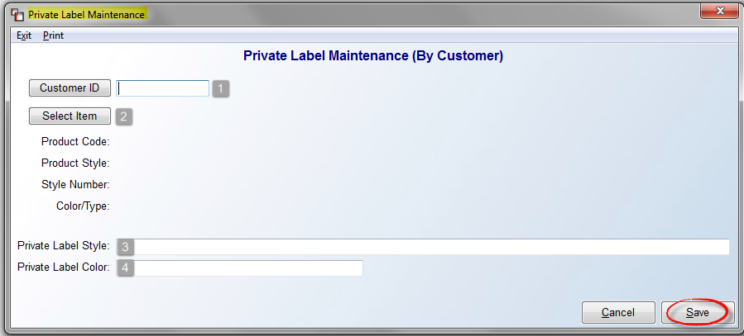
At the Customer ID (1) field, click the Customer ID button to prompt a Customer Selection box to make your selection. The Select Item (2) button will call up the Catalog Item Selection box from which you can locate the product you wish to Private Label for this customer. Once that selection has been made, you will then type the Private Label Style (3) and Private Label Color (4) in the two remaining fields at the bottom of the screen. If everything looks good, click the Save button to continue. The system will prompt the following:
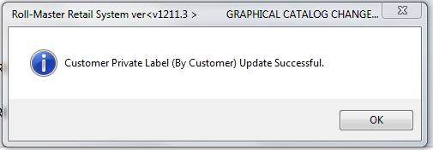
Click the OK button to return to the Customer ID field. You can then create a new Private Label entry or exit the module. You can also print all existing items from this screen by clicking the Print menu at the top left of the screen. If you need to Delete a Private Label style, enter the original data in the screen above and the system will then prompt a Delete button at the bottom right of the screen as follows:

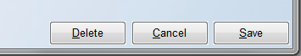

Yarn Type Maintenance:
This module will allow you to create codes that distinguish between the different yarn types or carpet fibers. This module is tied to the Yarn Type field in the Catalog Maintenance module. The data captured from this field will generate a Sales Analysis report, as well as a Yardage Report, based on the yarn types created in this module. You can also create codes for hard surface products if you would like this information to appear on a Sales Analysis report. When you enter this module, the system will prompt a Yarn Type Maintenance screen as follows:
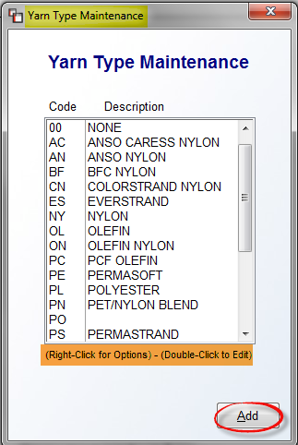
Any Yarn Type Codes created by your RollMaster trainer will appear in this screen. If you right-click on an existing Yarn Type Code, the system will prompt two options as follows: Edit Yarn Type and Delete Yarn Type. If you select Edit Yarn Type, the system will display a Yarn Type Maintenance box as follows:
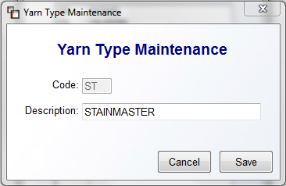
You can make changes in the Description field in this screen if applicable. If you do make changes, be sure to click Save prior to exiting. A second way to edit an existing Yarn Type Code is to double-click on the Code and the system will prompt the same Yarn Type Maintenance box displayed above.
To add a new Yarn Type Code, from the first screen, click the Add button at the bottom right of the screen. A blank Yarn Type Maintenance screen will appear as follows:
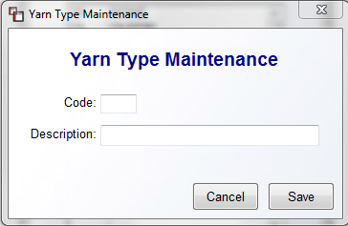
At the Code field, type a two-character code for the new Yarn Type. At the Description field, type a longer description for this Yarn Type. When you have finished, click the Save button to continue or click the Cancel button to start again.

Inventory Purge:
This module clears zero and small balance inventory records from the Inventory Look-up screen and sends the information to the History Tab of the Inventory Maintenance module. The purpose is to keep current information only in the Inventory Maintenance module and prevent the look-up screen from appearing cluttered, while also keeping your inventory as up-to-date as possible. When you perform a purge, the system will also check for a valid Product Code on an item before moving it to history. When items are purged, the system will automatically create Inventory Transfer Journal entries. In the comment field, the description will display the Branch, Product Code, and Purge. Please note that if Product Codes have different accounts for cost and freight, the system will create an entry for each. If the accounts are the same, the system will create an entry for cost of goods sold and inventory. The system will use the current date for the journal date and the current period when creating the entries.

When you enter this module, the system will prompt an Inventory Purge screen as follows:

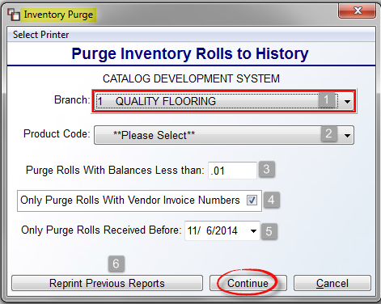

The cursor will be positioned at the Branch (1) field. Use the drop-down arrow menu to select another Branch or ALL BRANCHES, if applicable. At the Product Code (2) field, select a Product Code from the drop-down menu or you can select “ALL” to purge in all Product Codes. The Purge Rolls With Balances Less than (3) field will default to what has been set up in the System Control 1 screen, and will most likely be “.01.” When applicable, you can change the size based on your current inventory purge requirements. For non-roll good inventory items, the system will work the same—any inventory record that is below the quantity entered in this field will be purged if it meets the requirements of the remaining prompts. Please Note: if you select “ALL” Product Codes, the system will only allow you to enter “.99” or less in this field. At the Only Purge Rolls With Vendor Invoice Numbers (4) field, the default setting is enabled, meaning this will be a requirement to purge an inventory record. In other words, the system will not purge rolls where the Vendor Invoice Number has not been added to the inventory record through the Review P.O. History option in the Accounts Payable Open Item Maintenance module, or manually on beginning inventory records. The Only Purge Rolls Received Before (5) field will default to the current date. This date can be changed to any previous date where applicable.

To begin the purge, click the Continue button. The system will first prompt the following: Are You Sure? Click “Yes” to continue. A report documenting each inventory record purged will print out and the system will prompt the following: Purge Complete. Click OK at this prompt and the system will return you to the Inventory Purge screen. Once a report has been printed, you can click the Reprint Previous Reports (6) button to recall that report and also see a list of all previous reports. When you click the Reprint Previous Reports button, the system will prompt a listing of previous reports as follows:
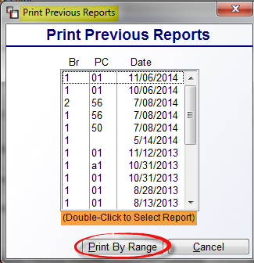
Scroll through the list of reports to find the applicable report and then highlight and double-click to select. The Print By Range button will prompt a Print Previous Reports by Range screen as follows:

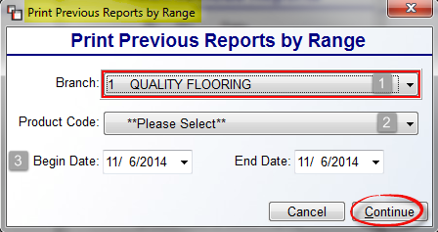

Prior to printing this report, you can change branches in the Branch (1) field or switch to ALL BRANCHES. You will then need to select a Product Code (2) or ALL to include all Product Codes. In the Begin and End Date (3) fields, enter the range of dates applicable to the report data you need and then click the Continue button to print.

Special Catalog Mtc. (By Product Code):
This program contains options for quickly changing some of the pricing fields in the Catalog Maintenance module such as the Overbill and Freight fields and has a couple of additional features you may find useful from time-to-time. Please Note: Changes made here will not roll forward to new catalog items. A reminder prompts at the bottom of this module—see screenshot below. When you enter this module a Catalog Setup menu will appear as follows:

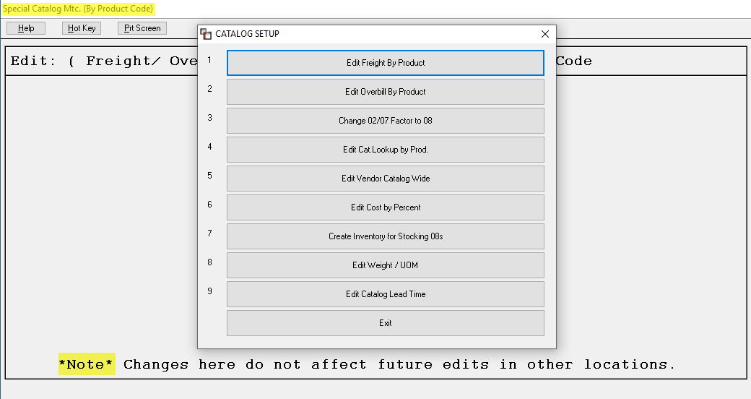

To edit the Freight field by Product Code or Product Type, and then by Vendor, select the Edit Freight By Product menu option. The system will prompt an Enter Product Code box (you will not get a lookup box from this prompt). Type in a Product Code and hit enter or leave the Product Code field blank and hit enter. The system will prompt an Enter Product Type box. You will need to type in a Product Type in this box to continue. The system will then prompt a Vendor box (no lookup box will prompt). You can leave this prompt blank to include all Vendors or type a specific Vendor ID. The system will then prompt the following:

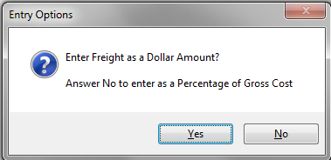

If you click Yes at this prompt, you can enter a dollar amount such as “.50” for fifty cents and the system will then run through all applicable Catalog Items in the previously entered Product Code or Product Type and adjust the Freight field. If you select No at this prompt, the system will prompt you to enter a Percentage of Gross Cost amount. You will need to type a whole number such as “10” for 10 percent. Once an option is selected, the system will perform internal procedures and return to the Catalog Setup box. Important Note: This will only update catalog costs, it will not change existing inventory item values. Also, the system will not allow a dollar amount to be added to any Labor Product Code. If you enter a Labor Product Code to add a percentage, the system will prompt the following:
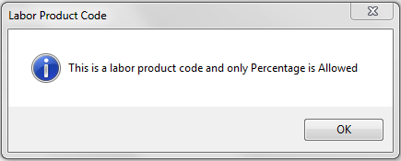
Click the OK button to continue and the system will place the cursor at the Enter Overbill Percent field for you to add a percentage amount.
To edit an Overbill amount, select the Edit Overbill by Product option and follow the same directions described above for editing the Freight field. Please Note: while this will update the Overbill field in Catalog Maintenance, only items designated as Stocking Items will send the updated Overbill amount to the Quote and Order Entry modules for Job Cost purposes.
The third menu option appears as follows: Change 02/07 Factor to 08. If you wish to change the Factor ID on any of your 02 or 07 Product Codes for the purpose of consolidating and averaging inventory (and more specifically for Bar-code customers), you can use this feature to accomplish that task. Please Note: you should only use this for inventory items where you do not want to track roll number, dyelot, and/or shade information. When you hit enter on this option, a message will appear as follows:

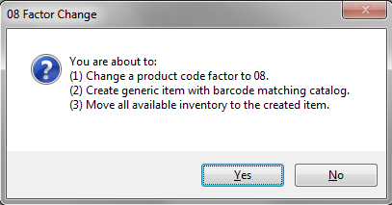

If you click Yes, the system will prompt the following: Enter Product Code. Please Note: this program will only accept Product Codes with an existing Factor ID of either 02 or 07. Once you have typed a Product Code and hit enter, the system will prompt the following: Factor has been changed to 08. You will then see the following Fix Results:

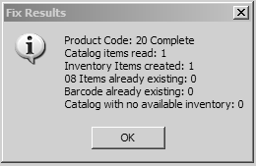

During this process, the system will perform the following functions: change the Factor ID on the Product Code to 08; all available inventory under this Product Code will be merged into one record with a Roll Number of 08 and a Dyelot of 08; any inventory that was Reserved on a Job or Quote will remain in the existing inventory record; and the View Pointer Record will show the Available quantity referenced as merged into the 08, 08 record. Please Note: this fix will not merge any Inventory Records that haven’t been previously approved from the A/P Open Item Maintenance module. If you need any further assistance with this process, please email Customer Service at support@rmaster.com.

The fourth option in the Catalog Setup menu appears as follows: Edit Cat. Lookup by Prod. This feature was added to allow a user to “Drop” all catalog items within a Product Code that are not tied to any inventory. This feature assists in the transition for a client switching to the B2B catalog and functionality or simply because many styles have become obsolete within a Product Code. This will work across multi-companies as well.

The fifth menu option appears as follows: Edit Vendor Catalog Wide. This feature will allow you to change the Vendor ID on all catalog items at once. When you hit enter on this feature, the system will prompt the following: Enter Old Vendor ID. Type in the existing Vendor ID you would like changed and hit enter. The system will then prompt the following: Enter New Vendor ID. Type in the new Vendor ID, making sure it is an active Vendor ID in A/P Vendor Maintenance, and hit enter. The system will then cycle through your entire catalog replacing the old ID with the new ID. When it has finished, it will prompt you with the number of records that have been changed.

The sixth menu option appears as follows: Edit Cost by Percent. When you click on this option, an Edit Cost by Percent box will appear as follows:

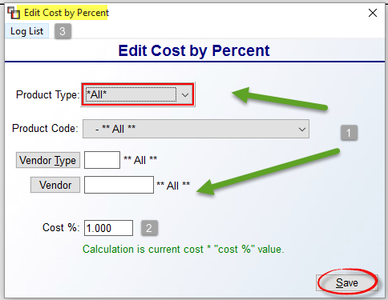

In the Product Type, Product Code, Vendor Type, and Vendor (1) fields, select any applicable combinations to customize the list of catalog items impacted by this percent change. At the Cost % (2) field, choose an integer to multiply all costs, i.e., 1.11 will effectively raise costs by 11%, and .90 would effectively lower costs by 10%. Once programmed, click the Save button to activate the percent change. The system will then read through the catalog and update costs accordingly. The system will also write a history record within each catalog record, displaying the User ID, what was changed, and that the change came from this program. The Log List (3) option at the top right will display a list of percent changes performed in this feature. When you click on that option, a Log List box will display as follows:

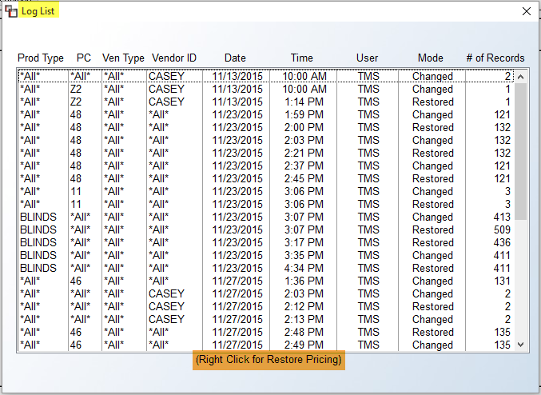

If you highlight and right-click on a “Changed” item in the list, you will see the following option: Restore Pricing. This will revert the pricing back to what it was before the percent change was enacted. The system will also write a new history record for the Restored pricing.

The seventh option appears as follows: Create Inventory for Stocking 08s. This feature was added specifically for RollMaster Bar-coding Software customers. It must be used in conjunction with a trainer, so please disregard unless instructed to do something with this feature. It essentially allows for adding inventory and then adjusting with the handheld scanner.

The eighth option appears as follows: Edit Weight / UOM. This option allows you to update the Catalog Weight and UOM (Lb. or Oz) that is used on Bill of Ladings and displayed on screens now, so that shipping weight/quotes can be generated. When you enter this option, an Update Weight/UOM screen will appear as follows:
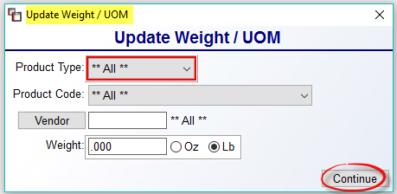

In the screen above, you can use the Product Type, Product Code, and/or Vendor fields to update only specific Catalog Items. You will then need to enter a Weight amount in the last field. Click the Continue button to start the update process.

The ninth and final option appear as follows: Edit Catalog Lead Time. This option allows you to update the Lead Time (Days) field in the Edit Catalog Item screen found at the bottom of the History tab screen, which is the amount of time added to the Ship Date on POs for estimated arrival times. When you enter this option, an Edit Catalog Lead Time screen will appear as follows:

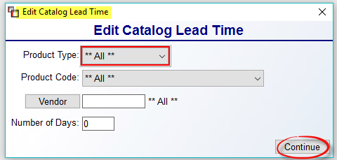

Use the Product Type, Product Code, and/or Vendor fields to make more specific selections for updating Lead Times and then enter the Number of Days in the last field. Click the Continue button to update the data in the system.

Inventory Reports

Introduction:
This menu offers several inventory-related reports that are helpful for keeping track of inventory quantities, locations, and values. The various reports allow you to manage this aspect of the business more effectively. In addition, physical inventories should become less burdensome and mistakes easier to catch. This next section of the manual will explain each report and how it can be beneficial to running a flooring business.

Customer Price Lists:
This report works in tandem with the Special Pricing Mtc. module located in the Inventory Control menu. It will only print data if you have programmed Special Pricing in the system. When you enter the Customer Price Lists report module, the screen will appear as follows:

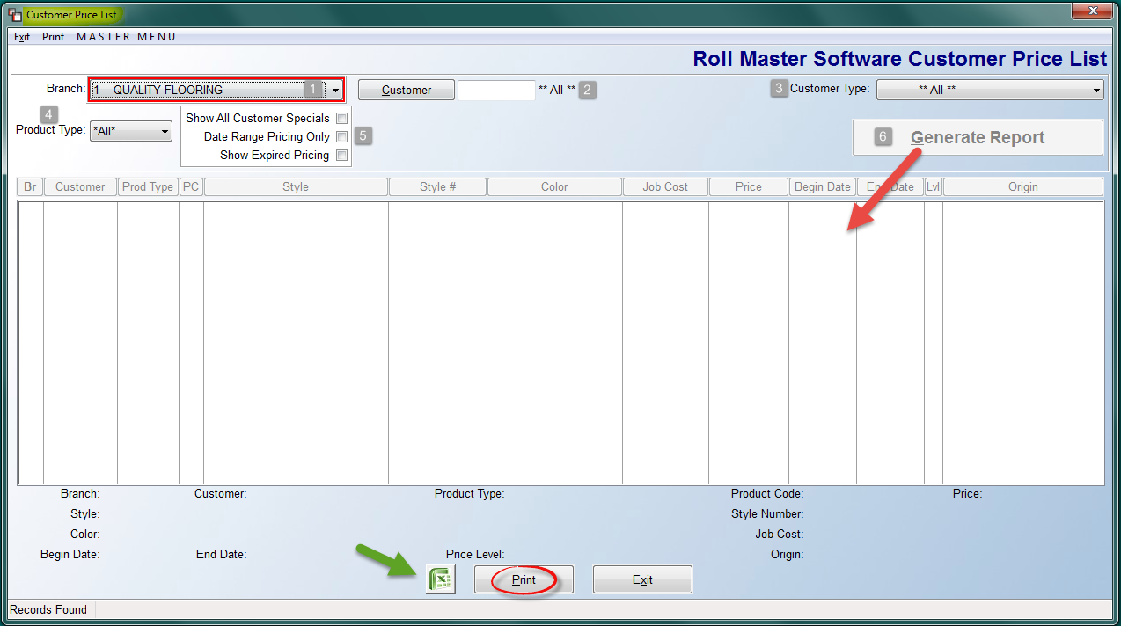

From the screen above, you will need to make at least one applicable selection prior to printing, exporting, or displaying data on screen. At the Branch field (1), you can switch to another Branch, or stay in the current Branch. At the Customer field (2), the default setting is for **All** Customers with Special Pricing. If you would like to print for a specific Customer, start by clicking the Customer (2) button to bring up a Customer Selection screen as follows:

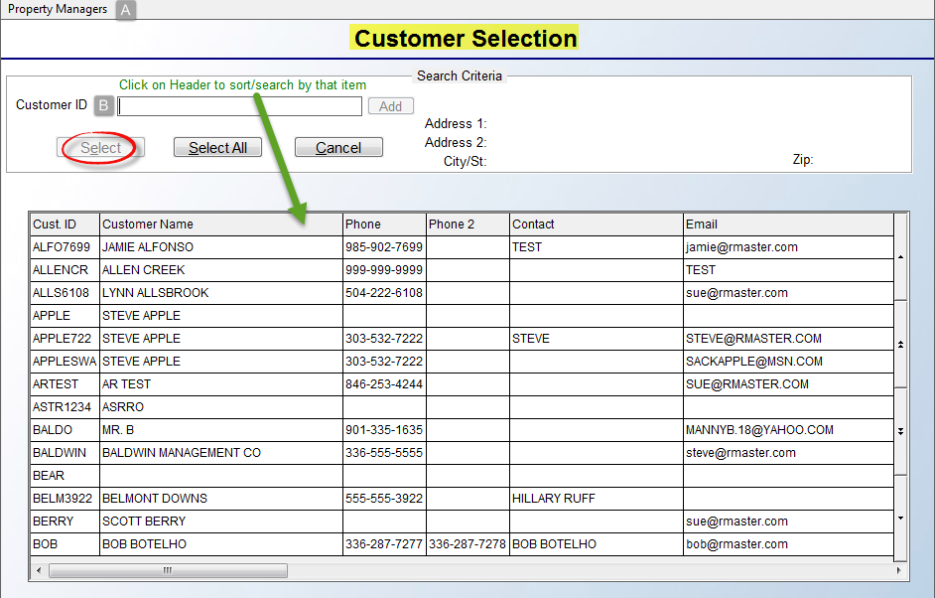
In the screen above, there are a couple of options for locating a specific customer. If you have set up Property Managers (A) in Customer Maintenance, you can click that option to confine the search to Property Managers. At the Customer ID (B) field, type the first couple of letters of the Customer ID, or click on the Header boxes above each column to help sort the list. You can also use the up and down arrows along the right side to scroll through the list. Once you have located the applicable Customer, click on that line to highlight the Customer and then click the Select button at the top of the screen. Once you have made your selection, the system will return you to the first screen.
Back in the original screen, you can further sort the report data by selecting a Customer Type (3) from the drop-down menu if you have programmed Special Pricing by Customer Type. It is advisable to make at least a Product Type (4) selection prior to generating a report. The final sort options appear below the Branch field as follows: Show All Customer Specials (5), Date Range Pricing Only, and Show Expired Pricing. Once you have made your selections, the system will highlight the Generate Report (6) button. Click to display data in the screen below as follows:
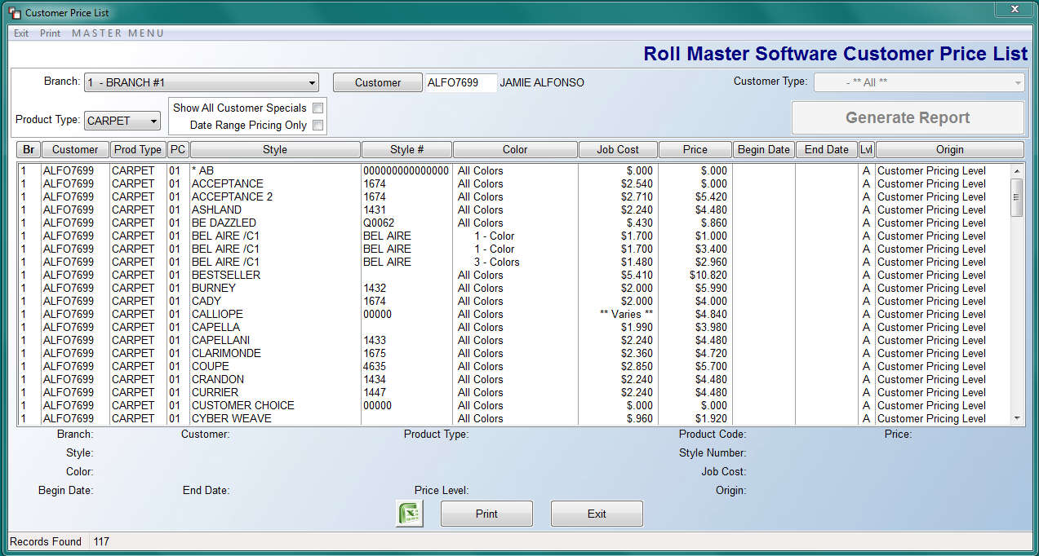

Once the data is generated, you can view and exit the program without printing, or you can choose to export to Excel or Print a copy to paper. Please Note: there is a User Control 5 option that controls whether a User can print data from this module. See System Maintenance for more details. If the User cannot print, the Excel and Print buttons will not be visible in this screen.

Catalog Listing:
This report will print out a listing of all catalog items entered in the system. You can customize this report by selecting one or more of the available options. This report essentially consolidates the fields in the Catalog Maintenance module and prints that information for each product. When exporting to Excel, the data will match the current Catalog Material Import spreadsheet. This is important for customers who export areas of the catalog, make adjustments, and then reimport catalog items from the Special Functions module. When you enter the Catalog Listing report module, the screen will appear as follows:

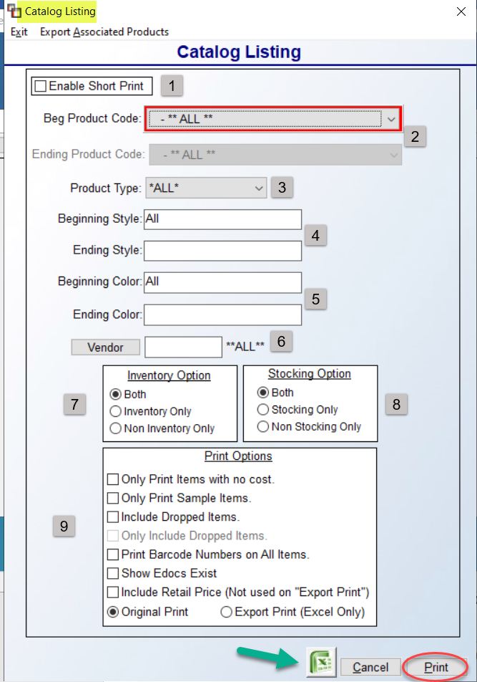
The screen above allows you to make selections to customize the data on the report or export. You will need to make your selections prior to hitting the Print or Excel buttons. The Enable Short Print (1) option at the top left has taken the place of the Catalog Listing – Short option in the Inventory Reports menu. By clicking this box, you will see one line per catalog item instead of three as with the regular report.
In the Beg and Ending Product Code fields (2), you can select a specific Product Code, or enter a range of Product Codes, i.e., Material Product Codes. At the Product Type (3) field, use the drop-down arrow to select a specific type. At the Beginning and Ending Style (4) and Beginning and Ending Color (5) fields, again, you can program for a specific style and color, or a range, or just one style with all colors, etc. Use the Vendor (6) button if you wish to print for a specific Vendor. In the Inventory Option (7) box, accept the default Both option, or you can print Inventory Only items or Non Inventory Only items. The same applies in the Stocking Option (8) box.
The Print Options (9) box provides a few additional options to consider. The Only Print Items with no cost option was added to print items that don’t have pricing so they can be updated with accurate pricing. The Only Print Sample Items option is tied to the Sample / Size field in the Catalog Maintenance module. If you are using this field and only wish to see those styles that you have samples for in your showroom, click this option. The Include dropped items option should be checked to include Inactive styles on the report. The next option will only be available if you selected the previous option. The Only Include Dropped Items, when checked, will print only Inactive styles, and no Active styles. The next option, Print Barcode Numbers on All Items, should be checked to include this data on the report or export. The next option in this section, Show Edocs Exist, can be checked to include a notification of which styles have Edocs, but will only work on the Excel export. The final option, Include Retail Price (Not used on “Export Print”, should only be checked if you are printing the report, and even then, only if you require that detail, as adding data this will significantly slow the printing of the report. The Original Print option will default. If you want all the data available on the Excel export, select the Export Print (Excel Only) option.

When you have selected all of your customized sort options, click either the Excel or Print buttons to continue. You can also click the Cancel button to exit the module. If you have programmed the Catalog Roundup module (explained above), the “A-J Level Retail Price” display fields on this report will reflect that programming. If User Controls are in place and a User is not allowed to see cost, no costs will appear on this printed report and those Users will not be able to see the Vendor ID or Private Label data from the catalog. All User Controls can be found in the System Control Maintenance module.

Inventory Listing:
This report will print a list of inventory considered “On Hand” in the system in every Branch. It will list the Roll or Identification number, the Dye Lot number, the Location in the warehouse, if applicable, the Quantity On Hand, the Quantity On Hand less W/O (what has been shipped on a Work Order), the Branch the inventory is located in, and the Quantity Available for use. (“Available” means the inventory is not currently assigned to a Job in the system.) This is a handy report for completing a physical inventory. You can customize the report by pre-selecting various options, explained below. When you enter the Inventory Listing report module, the screen will appear as follows:
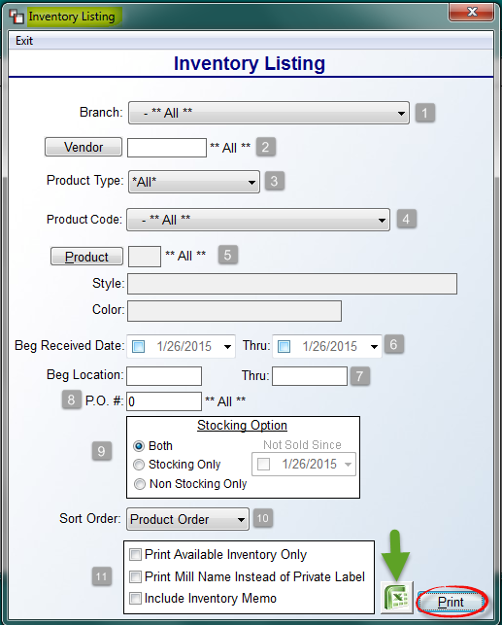

At the Branch (1) field, leave the default of ** All ** Branches, or use the drop-down menu to select a specific Branch. At the Vendor (2) field, leave the default to include **All** Vendors, or click the Vendor button to select a specific Vendor. At the Product Type (3) field, either leave the default of **All** Product Types, or use the drop-down menu to select a specific Product Type. At the Product Code (4) field, again, either leave the default of ** All ** Product Codes, or use the drop-down menu to select a specific Product Code. At the Product (5) field, you can select a specific Style and Color by clicking the Product button; otherwise, leave the default setting for ** All ** Products. At the Beg Received Date (6) fields, you should only click in the date boxes if you wish to program the report for a specific Receipt Date or range of Receipt Dates. The Beg Location (7) boxes should only be used to narrow the report to include inventory in specific bin locations in the warehouse. At the P.O.# (8) field, only type in a P.O. Number if you wish to narrow the report to include only inventory received on that PO.

The Stocking Option (9) box pertains to items you have designated in the catalog as Stock. If this is the case, then by clicking the Stocking Only option, the report will only include Stock items and the reverse will work for Non Stocking Only. On the Stocking Only option, if you click the Not Sold Since box, you can also select a date to see Stock items that have not sold since that date. The Sort Order (10) drop-down menu will default to Product Order, meaning the report will print in order of Style name. The other options in this field are to print in Location Order or Roll # Order. The last section (11) contains three additional options for customizing the report. Check any that apply. Once all selections have been made, click the Excel icon to export the data, or click the Print button to print to paper.

Inventory Valuation:
This report will print a listing of each inventory record in the system with a corresponding value. The report prints by Product Code and lists each roll or inventory record individually under the style name. In addition to the roll or identification number and the dye lot number, the system shows how much of the inventory record is on hand, how much is still available, the unit cost, the total cost of the inventory record, and the age of the inventory record. At the end of each product listing, the report gives a total of all inventory on hand for that product, a total of all available inventory for that product, and a total value of the inventory for that product. At the end, the report totals the value of all available inventory, the value of all reserved or assigned inventory, and a grand total of all inventory on hand. Also, this report will indicate if an inventory item is tied to an Inactive Catalog Item by placing an “*” to the right of the On Hand quantity on the printed report. An Inactive column appears on the Excel export data next to the On Hand column and will display “INACTIVE.”

When you enter the Inventory Valuation report module, the system will display a Report Selection screen as follows:

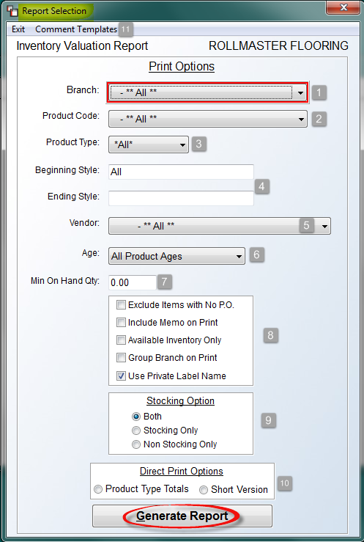

The default settings in the screenshot above will produce a report with all existing inventroy in the system if you click the Generate Report button without making any changes. However, the Print Options are designed to allow you to customize the report based on a variety of scenarios. At the Branch (1) field, click the down arrow to select a specific Branch. At the Product Code (2) field, click the down arrow to select a specific Product Code. To print the report by a specific Product Type (3), click the down arrow at this field. At the Beginning and Ending Style fields (4), you will need to type a specific Style Name without the benefit of a Look-up screen in order to print for just one Style or a range of Styles. The Vendor (5) button will prompt a Vendor Lookup if you need to customize by Vendor ID. At the Age (6) field, the drop-down menu options include an Age of 0-180 days, 181-365 days, and 366 days and Older. The Min On Hand Qty (7) field can be set to any number above 0.00, if you wish to exclude small roll balances; however, if you print for all styles, adding a number to this field could adversely impact your valuation.

The next box of options (8) can be checked or left unchecked based on your needs. The Exclude Items with No P.O. option, if checked, will leave off any records that are not tied to a system PO or contain a PO # in the inventory record. The Include Memo on Print option will include the Memo field on the report where data exists. The Available Inventory Only option should be checked if you do not wish to display inventory that is assigned to a job. The Group Branch on Print option will group together data by Branch, if you are printing for All Branches. The Use Private Label Name option defaults to checked, so you will need to uncheck it if you do not want to see Private Label names on the printed report.

At the Stocking Option box (9), the default is Both. You can change to either of the other two options to customize the report. At the Direct Print Options (10) box, if you click Product Type Totals, the report will bypass the screen display and print the total of each Product Type directly to paper. The Short Version option will switch the program to the Inventory Valuation – Short report format (see explanation in next section below). The Comment Template (11) option at the top left of the screen will prompt an Adjustment Comment Maintenance box as follows:

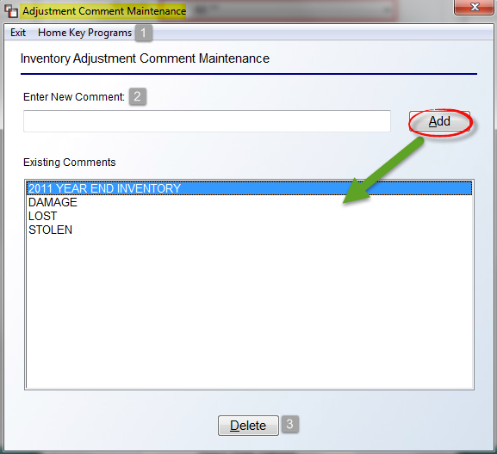

This option was added to allow you to create standard comments for adjusting small inventory balances in this module from the Generate Report screen. In this box, you can click the Home Key Programs (1) option to pull up the Home Key Menu. Any Existing Comments will appear in the screen above. To add a new comment, type the comment in the Enter New Comment field and then click the Add button. Once a comment has been added, you can highlight the comment and click the Delete (3) button to remove it from the program.

Once you have made your selections in the Report Selection screen above, click the Generate Report button to prompt the data in the Inventory Valuation Results screen as follows:

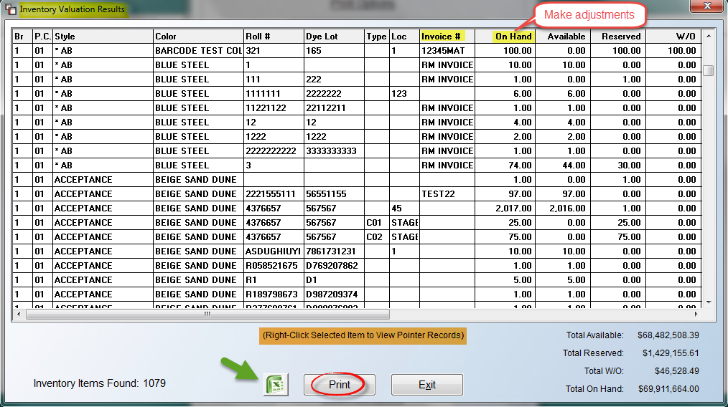

From this screen, the system will total the results of your selections at the bottom right of the screen. You can also export the data to Excel or click the Print button to print to paper. Additionally, there are a few columns you can click in and make adjustments. These include: Invoice #, On Hand, Unit Cost, and Freight. When you make an adjustment, the system will prompt an Update Inventory box as follows:

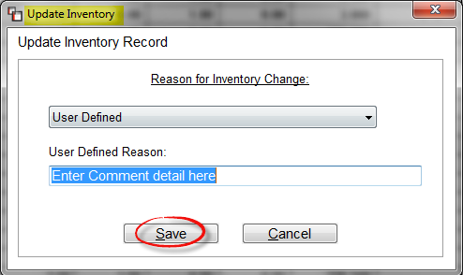

You can click the down arrow to select an existing Adjustment Comment, or you can type a new comment in the User Defined Reason field. Click the Save button to continue. The system will prompt an Enter Adjustment Date field with the current date as the default. You can override this date or hit enter to continue. Returning to the Inventory Valuation Results screen, you can right-click with your mouse on any item to view the Pointer Record detail in the Inventory Pointer View screen as follows:

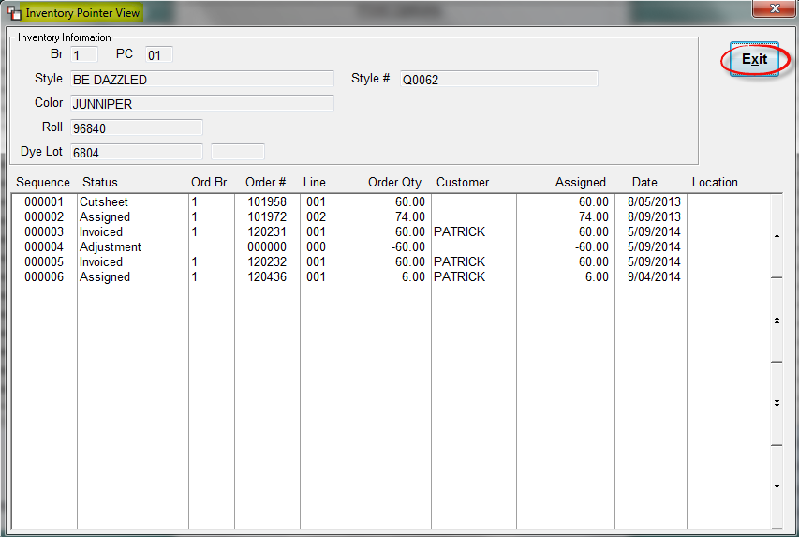

Click the Exit button to return to the previous screen. You can then export the data to Excel or click the Print button to print to paper.

Inventory Valuation (Freight Split):
This report is similar to the Inventory Valuation report, but will display a freight value of your inventory in a separate column as well as a total freight value, rather than include it as part of the total material value. You can customize the report by pre-selecting various options, explained below. When you enter the Inventory Valuation (Freight Split) report module, the screen will appear as follows:

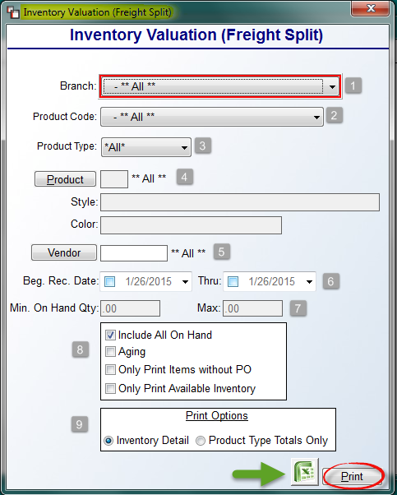

At the Branch (1) field, you can leave the default of ** All ** Branches, or you can use the drop-down menu to select a specific Branch. At the Product Code (2) field, you can leave the default of ** All ** Product Codes, or you can use the drop-down menu to select a specific Product Code. The Product Type (3) field works the same as the previous two. At the Product (4) field, you can select a specific Style and Color by clicking the Product button; otherwise, leave the default setting for ** All ** Products. At the Vendor (5) field, you can leave the default to include **All** Vendors, or click the Vendor button to select a specific Vendor. At the Beg. Rec. Date (6) fields, you should only click in the date boxes if you wish to program the report for a specific Receipt Date or range of Receipt Dates.

If you uncheck the Include All On Hand (8) option, the Min./Max On Hand Qty (7) boxes will become available for use in customizing the report. In the next section (8), you can click one or more of these options to further customize the report data. The default selection is Include All On Hand. The Aging option will break the report down in Age Ranges of 1-180 with summary subtotals by Product Code and Date Range. This will repeat for 181-366 days, and 366 Days and Over. The Only Print Items without a P.O. option should be checked if you would like the report to only include inventory items that do not have a P.O. Number tied to the record. The Only Print Available Inventory option should be checked if you would like the report to only list items with available inventory. The Print Options (9) box allows you to choose how to display the report data. The default, Inventory Detail, will list all items and generate totals at the end of the report. The Product Type Totals Only option will total data by Product Type for each Branch, and then total up all Branches, and Regions if activated. Once you have made your Print Option selection, you will then click the Excel icon to export the data, or click the Print button to print to paper.

Inventory Valuation (As Of):
This report was designed to give you an “As Of” value rather than a current value of inventory. The report will generate data going back to any previous date since you started entering inventory in the system and give you an Inventory Value as of the date you entered. “As Of” reports attempt to recreate your inventory value as of a given date in the past. Since some companies backdate Customer Invoices and A/P during the month end closing process, the accuracy of this information is only as good as the dates used.
This report works very similarly to the Inventory Valuation (Freight Split) report, in that you can customize the report by pre-selecting various options, explained below. When you enter the Inventory Valuation (As Of) report module, the screen will appear as follows:

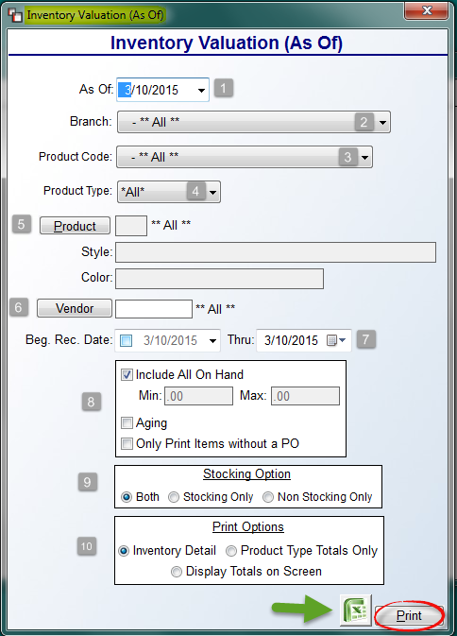

At the As Of (1) field, the system will default to the current date. Use the drop-down arrow to select a prior date for the report. At the Branch (2) field, you can leave the default of ** All ** Branches, or you can use the drop-down menu to select a specific Branch. At the Product Code (3) field, you can leave the default of ** All ** Product Codes, or you can use the drop-down menu to select a specific Product Code. The Product Type (4) field works the same as the previous two. At the Product (5) field, you can select a specific Style and Color by clicking the Product button; otherwise, leave the default setting for ** All ** Products. At the Vendor (6) field, you can leave the default to include **All** Vendors, or click the Vendor button to select a specific Vendor. At the Beg. Rec. Date (7) fields, you should only click in the date boxes if you wish to program the report for a specific Receipt Date or range of Receipt Dates.
If you uncheck the Include All On Hand (8) option, the Min./Max On Hand Qty boxes will become available for use in customizing the report. The Aging option will break the report down in Age Ranges of 1-180 with summary subtotals by Product Code and Date Range. This will repeat for 181-366 days, and 366 Days and Over. The Only Print Items without a P.O. option should be checked if you would like the report to only include inventory items that do not have a P.O. Number tied to the record. At the Stocking Option box (9), the default is Both. You can change to either of the other two options to customize the report.

The Print Options (10) box allows you to choose how to display the report data. The default, Inventory Detail, will list all items and generate totals at the end of the report. The Product Type Totals Only option will total data by Product Type for each Branch, and then total up all Branches, and Regions if activated. Once you have made your Print Option selection, you will then click the Excel icon to export the data, or click the Print button to print to paper.

Inventory Audit:
Any additions, deletions, or changes made in the Inventory Maintenance module or from the Inventory Valuation report module will display on this report. For example, if you make a change to the Unit Cost of an Inventory Record, the old Cost and new Cost will appear on this report. Or, if an Inventory Record is deleted, the report will display the Quantity and Value of that record, etc., along with any Comment added. When you enter the Inventory Audit report module, the screen will appear as follows:

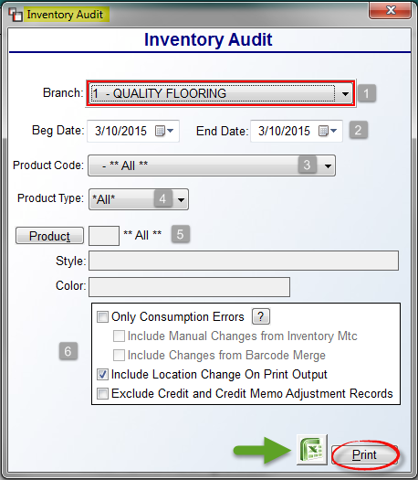

At the Branch (1) field, the system will default to the current Branch. Accept the default, or use the drop-down arrow to select ** All ** Branches, where applicable. At the Beg & End Date (2) fields, the system will default to the current date. Click the drop-down arrows in each Date box if you wish to program the report for a different Date or range of Dates.
At the Product Code (3) field, leave the default of ** All ** Product Codes, or use the drop-down menu to select a specific Product Code. At the Product Type (4) field, leave the default of ** All ** Product Types, or use the drop-down menu to select a specific Product Type. At the Product (5) field, you can select a specific Style and Color by clicking the Product button; otherwise, leave the default setting for ** All ** Products. In the final box (6) in the screen above, you will find additional options for customizing the report. The system will default to the settings in that box above. The “?” symbol, when clicked, will prompt the following:

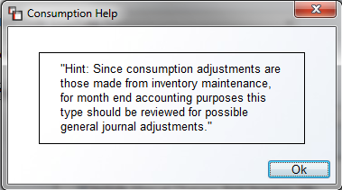

The Print Only Consumption Errors? option should be checked if you wish to only see consumption errors on the printed report. When this box is checked, the system will automatically uncheck the Include Location Change On Print Output option. For the Include Location change on printout? option, to not see changes in location, uncheck this box. The final option, Exclude Credit Memo Adjustment Records, when checked, will exclude credit memo adjustment records from the report. If you have multiple Branches and choose to include credit memo adjustment records, the system will display the following: “Total Credit Memo Adjustments” and “Branch XX Credit Memo Adjustment” lines for each of the Branches that returned merchandise. Please note that the “Branch Old Value” column already includes these entries. Once all selections have been made, click the Excel icon to export the data, or click the Print button to print to paper.

Inventory Transit Report:
This report works in conjunction with the Inventory Transfer feature for multiple location companies. It displays every inventory record that is in transit between Branches or that has been transferred between Branches or Regions if applicable. When you enter this report module, the system will prompt an Inventory Transit Report screen as follows:

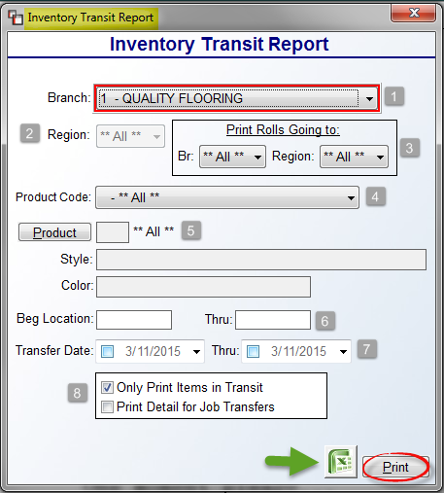

At the Branch (1) field, the system will default to the current Branch. To see inventory in transit for all Branches, use the drop-down menu to select ** All ** Branches. The Region (2) field will only apply where Regions have been created in the system. If they have, you can select a specific Region or leave the default to include **All** Regions. At the Print Rolls Going to: (1) box, either leave the default of **All** to see inventory going to ** All ** locations, or use the drop-down menus to select a specific Branch and/or Region. At the Product Code (4) field, again, either leave the default of ** All ** Product Codes, or use the drop-down menu to select a specific Product Code. At the Product (5) field, you can select a specific Style and Color by clicking the Product button; otherwise, leave the default setting for ** All ** Products. The Beg Location (6) boxes should only be used to narrow the report to look for “in transit” inventory in specific bin locations in the warehouse. At the Transfer Date (7) fields, you should only click in the date boxes if you wish to program the report for a specific Transfer Date or range of Transfer Dates. In the next box (8), the default checked setting will apply for the Only Print Items in Transit option. To include inventory that has already been transferred, and that meets the criteria selected in the previous options, you can uncheck this option. The Print Detail for Job Transfers option, when checked, will display important job details on inventory currently assigned to Jobs in the system. This detail can assist the receiving warehouse staff with key data such as: Job #, Line #, Customer, Salesperson ID, and Reserved Amount. Also, if more than one Job is tied to an inventory transfer record, the report will display the following: Multiple records exist. When you have made your selections, click the Excel icon to export that data, or click the Print button to print to paper.

Inventory Daily Branch Transit Report:
This report module allows you to print one report for all Transfers with a signature line for each Transfer item to be signed by the sender and receiver as opposed to printing individual Transfer Slips that need to be signed individually. This report consolidates all the Transfer data for one Branch or All Branches. When you enter this report module, the system will prompt the following:

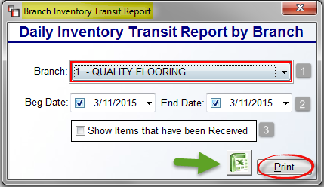

At the Branch (1) field, the system will default to the current Branch. Accept the default, or use the drop-down arrow to select ** All ** Branches, where applicable. At the Beg & End Date (2) fields, the system will default to the current date. If you wish to see only the current day’s transfers, hit enter to accept. You can also click the drop-down arrows in each Date box if you wish to program the report for a different Date or range of Dates.
In the next box (3), click the Show Items that have been Received option to include those items on the report for the date or range of dates selected. When you have made your selections, click the Excel icon to export that data, or click the Print button to print to paper.

Please note: if using Server-Side Printing (SSP), the Inventory Daily Branch Transit Report will display Barcodes at the Line Level. See example below:

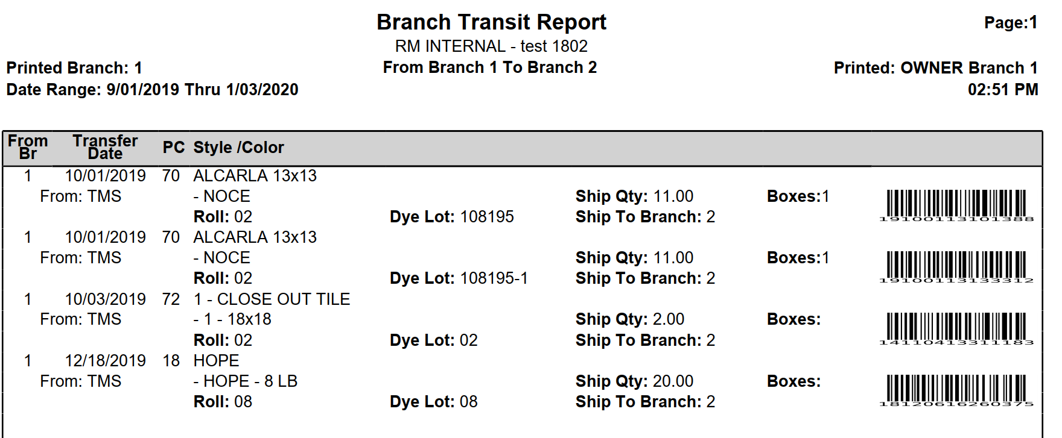

Inventory Transfer Requests:
This report module will keep track of requested inventory transfers, allowing you to both view them on screen when you enter this module and print a report. When you enter this report module, a Branch Selection screen will appear as follows:

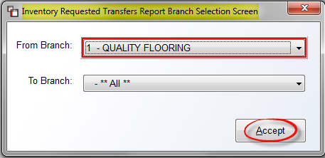

From this box, select the From Branch and To Branch warehouses. The From Branch field will default to the current Branch and the To Branch will default to **All**. Click the Accept button to continue. The system will then prompt an Inventory Requested Transfers Screen as follows:

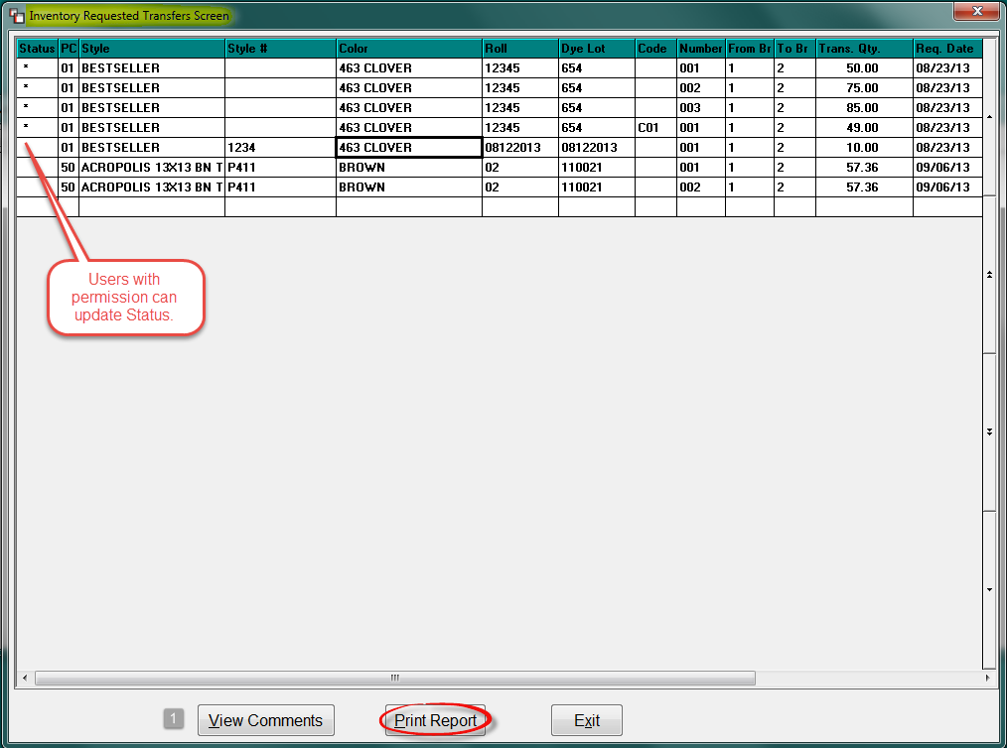

Users with permission can change the Status column for transferred inventory in this screen by clicking in that column next to a transfer line. If you highlight and then right-click on a line, the system will prompt the following options:

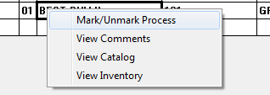

Also, when a line is highlighted, the View Comments (1) button will become available. This option prompts an Inventory Transfer Request Comment Screen as follows:

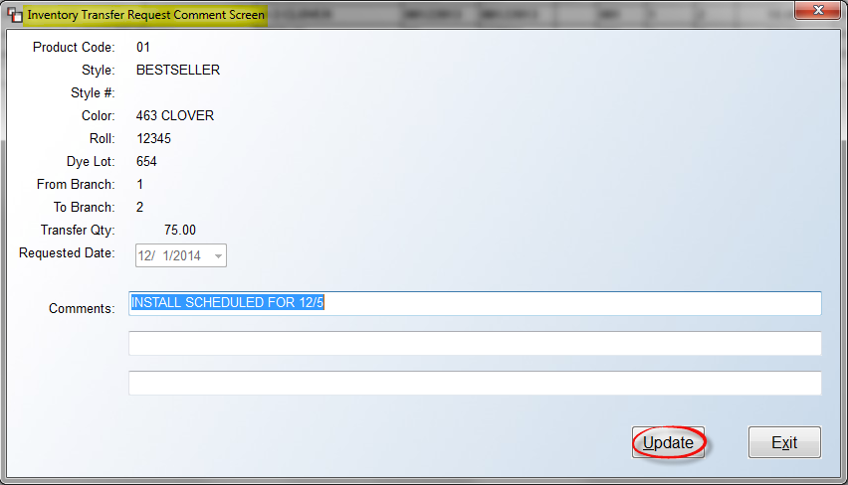

You can make applicable changes and additions in any of the three comment lines in the screen above. Click the Update button to save changes before clicking the Exit button to continue. If Comments exist or are added to an item, an “*” will appear in the Status column in the main screen. When you are ready to print, click the Print Report button from the main screen. The system will prompt you to select a Printer, and place the cursor at a Branch field. Accept the current Branch default or change to another Branch where applicable. The system will then prompt a Select Option menu box as follows:

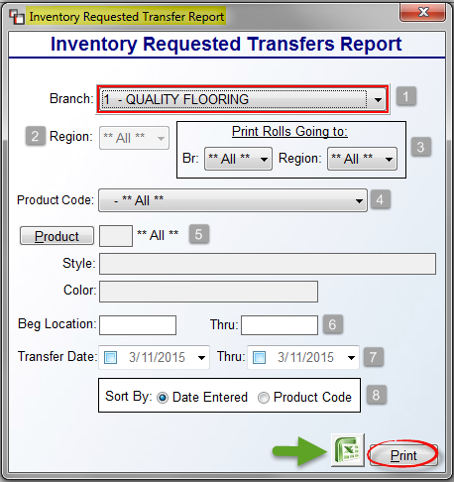
At the Branch (1) field, the system will default to the current Branch. You can leave the default or use the drop-down menu to select ** All ** Branches or another Branch. The Region (2) field will only apply where Regions have been created in the system. If they have, you can select a specific Region or leave the default to include **All** Regions. At the Print Rolls Going to: (3) box, either leave the default of **All** or use the drop-down menus to select a specific Branch and/or Region. At the Product Code (4) field, again, either leave the default of ** All ** Product Codes, or use the drop-down menu to select a specific Product Code. At the Product (5) field, you can select a specific Style and Color by clicking the Product button; otherwise, leave the default setting for ** All ** Products. The Beg Location (6) boxes should only be used to narrow the report to look for inventory in specific bin locations in the warehouse. At the Transfer Date (7) fields, you should only click in the date boxes if you wish to program the report for a specific Transfer Date or range of Transfer Dates. In the Sort By: (8) box, the default for this prompt is “Date Entered.” If you wish to print by Product Code instead, click next to that option. Please Note: for historical purposes, the program will store the Date, Time and User ID in the deleted fields of the file when the transfer is marked as processed. When you have made your selections, click the Excel icon to export that data, or click the Print button to print to paper. Please Note: the program is using the Catalog Style/Color name rather than using what is on the Inventory item.

Inventory Reserved Report (by Vendor):
The Inventory Reserved Report (by Vendor) prints a listing of all inventory with a Job or Quote reserve in the system, sorted by Vendor. When you enter this module, an Inventory Reserve Report (By Vendor) screen will appear as follows:

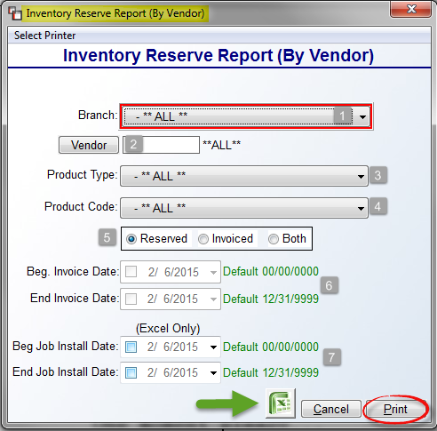

At the Branch (1) field, you can use the drop-down arrow to select a specific Branch if applicable. The same applies for the Vendor (2) and Product Type (3) fields. You can also sort by Product Code (4). Also, this program can handle pointer records that have been Invoiced, not just Reserved, therefore, a selection field (5) for Reserved, Invoiced, or Both allows you to customize that data. If either Invoiced or Both are selected, the Invoice Date (6) fields will become available for you to enter a date range. The Beg & End Job Install Date (7) fields are only applicable for exporting data to Excel. By clicking in these fields and entering a specific date or range of dates, you can build a spreadsheet based on Install Dates entered on the job. The export data will include a column displaying Job Install Date. The printed report displays a W/O’d column denoting inventory that has been shipped on a system Work Order. A capital “W” to the right of the column will indicate all material was shipped, and a lower case “w’ will indicate partial shipment. When you have made your selections, click the Excel icon to export that data, or click the Print button to print to paper.

Safety Stock Evaluation Report:
This report works in conjunction with the Reorder Quantity and Safety Stock fields in the History Tab of the Catalog Maintenance screen. If you enter a Safety Stock level in the Catalog Maintenance module for a catalog item, that information will display on this report along with any Reorder Quantity value entered. Additionally, it will display any current inventory On Hand, Reserved, total Available and any On Order for each Branch. If a Safety Stock value has not been programmed on a Catalog Item, it will not appear on this report. The information on this report will allow you to accurately manage your stock inventory. When you enter this module a Safety Stock Evaluation screen will appear as follows:
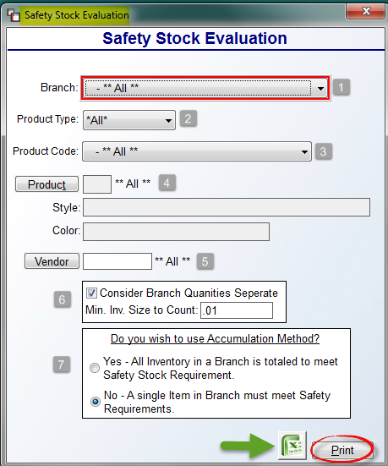

Using the options in the screen above, you can customize the report to include only the inventory that meets the parameters you have selected. You can also select multiple options. At the Branch (1) field, leave the default of ** All ** Branches, or use the drop-down menu to select a specific Branch. At the Product Type (2) field, either leave the default of **All** Product Types, or use the drop-down menu to select a specific Product Type. At the Product Code (3) field, again, either leave the default of ** All ** Product Codes, or use the drop-down menu to select a specific Product Code. At the Product (4) field, you can select a specific Style and Color by clicking the Product button; otherwise, leave the default setting for ** All ** Products. At the Vendor (5) field, leave the default to include **All** Vendors, or click the Vendor button to select a specific Vendor. The next box (6) will default to the settings in the screenshot above. If you uncheck the first box, the system will combine Branch quantities to determine Safety Stock requirements. The second box is preset to the lowest size or amount possible so the system will include all inventory in the count; however, you can eliminate smaller inventory balances by increasing this value.

The two options in the last box (7) concern whether the report should combine inventory records within a Branch (Accumulation Method) to meet the Safety Stock requirement level, or if the report should consider inventory records individually to determine if any one record meets the Safety Stock requirement level. The default setting is to count individual records. To combine, or accumulate, all inventory of the same Style together, check the first option prior to printing the report. When you have made your selections, click the Excel icon to export that data, or click the Print button to print to paper.

Inventory Usage Report:
This report is designed to show you how many periods/months of stock you have remaining at the current selling rate. In order for material to show up on this report, it must first be marked as “Stock” in the Catalog Maintenance module. When you first enter this module, the screen will appear as follows:

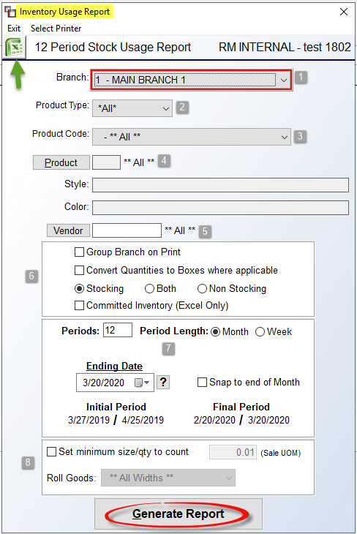

Prior to generating the report, you can customize the report by making different selections in the Print Options section at the top. For example, you can select another Branch (1) or All Branches, select a specific Product Type (2), and/or Product Code (3), select a specific Product (4), or select a specific Vendor (5). You can utilize all, some, or none of these options, depending on the information you would like to see. If you select All Branches at the top of this screen, then you can check the Group Branch on Print (6) option to group items by Branch on the printed report, if applicable. If your hard surface material items are set to Box Quantities in the Catalog Maintenance module, you can check the Convert Quantities to Boxes where applicable option to see that data listed in boxes on the report. Stocking catalog items will be the default to include on this report, but you can switch to Both or Non Stocking prior to printing where applicable. And finally, the Committed Inventory (Excel Only), which only works when exporting to Excel, will include that data when this box is checked.

In the next section (7), you can adjust the “rolling” month or week period if applicable. The Inventory Usage Report can generate data for any timeframe, however, anything over 12 periods, will only be available as an Excel export because of the number of columns. The Periods field defaults to 12 in the Period Length data box. Keep the default of 12 or type in another applicable number to decrease or extend the report data. When you first enter this report module, the system will default to the current date as the Ending Date as follows:
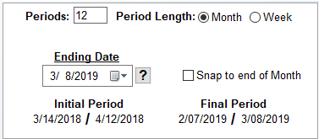

The system defaults to a 30-day period when determining the Initial Period, and also defaults to the Month option. In the example above, the Final Period will be the last 30 days, and the Initial Period is exactly twelve 30-day periods prior. Other than the Periods field, the first option in this screen is to switch to a Period Length of a Week, and then the periods will revert to 7-day periods prior, as in the example below:

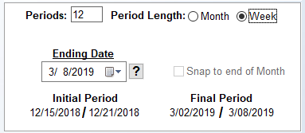

Under the Ending Date, you can change to any prior date and the system will then re-calculate the Initial and Final Periods based on whether Month or Week is selected. The final option in this section appears as follows: Snap to end of Month. This feature will only apply when Month is selected as the Period Length. When you click this feature, the system will revert from twelve 30-day periods, to the actual twelve prior monthly periods, meaning it will factor in the last day of each month, whether it be the 31st or the 28th as in February. The “?” to the right of the Ending Date field will display a reminder of this feature as follows:

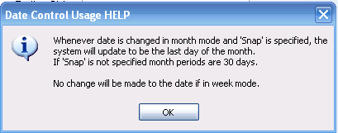

The final option (8) in this screen appears at the very bottom as follows:

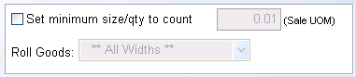

This feature will allow you to Set a minimum size/qty to count when looking at the inventory records. The default is anything over “0.01.” To utilize this feature, you will need to click the box next to Set minimum size/qty to count in order to enable the other two fields. You can then increase the Unit of Measure (UOM) to whatever applicable size you require. In the Roll Goods section, you can leave the default to All Widths, or click the down arrow to see a list of available widths. When you have made your selections, you can click the Excel icon to export the data, or you can click the Generate Report button to print the data. The printed or exported data will display sales for each period side-by-side, with an average per period, and an average lot size or roll size if rolled goods. When exporting Multi-Branch detail to Excel, the first series of columns will reflect Company totals and the column headings will denote that, and then each Branch’s data will appear in subsequent columns. If printing for Company, the report exports the same and groups all data together. If printing for a single Branch, all the data will be specific to that Branch, as it’s always been.

Yardage Report:
This report was originally designed to print sales information for Yarn Types, though it can be used to generate sales information for any product with a Yarn Type code in Catalog Maintenance. When you enter this module, the screen will appear as follows:

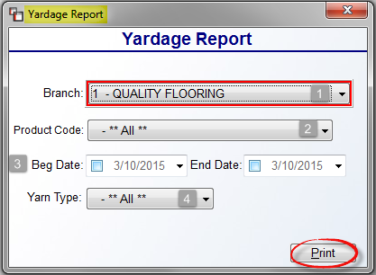

At the Branch (1) field, the system will default to the current Branch. Accept the default, or use the drop-down arrow to select ** All ** Branches, where applicable. At the Product Code (2) field, leave the default of ** All ** Product Codes, or use the drop-down menu to select a specific Product Code. At the Beg & End Date (3) fields, the system will default to the current date. Click the drop-down arrows in each Date box if you wish to program the report for a different Date or range of Dates. At the Yarn Type (4) field, leave the default of ** All ** Yarn Types, or use the drop-down menu to select a specific Yarn Type. Click the Print button to begin printing the report.

