
Table of Contents
Sales Processing Part II 1
Lead Processing: 1
Property Management / Builders Templates: 14
Initial Setup: 15
Creating Templates: 23
Editing Templates: 26
Property Management / Quick Orders: 36
Web Order Maintenance: 41
Projects: 45
Salesperson Payables System: 49
Clear Inventory Holds On Quotes: 58
Sales Processing Setup Programs 58
Salesperson Maintenance: 58
Salesperson Draw Maintenance: 67
Job Type Maintenance: 69
Job Status Code Maintenance: 74
Payment Type Code Maintenance: 77
Territory Code Maintenance: 85
Initials Maintenance: 87
Time Maintenance: 89
Accumulator Code Maintenance: 91
Sales Processing Reports 1 of 2 97
Introduction: 97
Invoice / Credit Memo: 97
Progress Billing Invoicing: 98
Invoice Register (Daily Report): 102
Invoice Register – History: 103
Open Job Report: 105
Work In Process (Progress Billing): 106
Quotation Listing: 106
Salesperson/Open Job Listing: 107
Open Order Report: 109
Open Order Tax Report: 111
Credit/Return Report: 111
Sales Processing Reports 2 of 2 112
Sales Tax Reporting Details & Sales Tax History: 112
Sales Tax Collected: 113
Inventory Required From/For Other Branches: 114
Estimated C.O.D. Amt. Report: 116
Salesperson Payables History: 119
Salesperson Draw Commission Schedule: 120
Salesperson Draw Commission Detail: 120
Contact Activity Notes Report: 120

***CONFIDENTIALITY NOTICE*** This documentation contains confidential information belonging to Textile Management Systems, Inc. and RollMaster Software, which is protected by copyright laws and other privileges. This information is intended for the exclusive use of legally licensed RollMaster Software users. If you are not the intended recipient, you are hereby notified that any disclosure, copying, distribution, or the taking of any action in reliance on the contents of this information is strictly prohibited. If you have received this documentation in error, please immediately notify us by telephone at (800) 777-4107.

Sales Processing Part II

Lead Processing:
Customers with a subscription to this Efficiency Tool module will see a Lead Processing menu option in the Sales Processing Menu for all Users with permission/menus to access this program. It appears just below Quotation/Proposal Maintenance in the menu. This program was initially developed for “Shop-At-Home” operations, but added functionality makes it appealing to any business with retail or property management customers. It’s designed so that sales appointments can be scheduled and tracked without having to add a Customer to the live database prior to creating a Quote or Order. If an appointment results in an estimate or sale, the customer information created in this module will transfer over to the live Customer Maintenance, Quote, and/or Order Entry modules. It also has an integration with MeasureSquare, RM Text Alert, Zillow, and Google Maps. There is an option in Quote Entry, from within a Quote, to Copy Quote to a Lead. This can be found in the Copy menu at the top left of that screen. Additionally, from the RM Mobile App, there is access to a Leads Calendar. Please see the very end of this documentation for Web Dashboard Controls that need to be set for each User with regard to the RM Mobile App.
Please note: there are three User Control options, located in the System Control Maintenance module, that need to be setup prior to using this module. They appear in both the User Control 1 and User Control 5 screens. In the User Control 1 screen, under the control Is This User a Sales Person?, an additional box of controls prompts when you set this control to “Y” for yes. First, look for the following control: Only Allow Leads for This User. If set to “Y” for yes, the User will only be allowed to view their own Leads. Next look for this control: Allow View of Lead Phone and Email. This control determines whether the User can see the Phone and Email data for a Lead.

In the User Control 5 screen, look for the following control toward the bottom of the screen: Lead Options. When the cursor is positioned in this field, the system prompts a Lead Options box as follows:

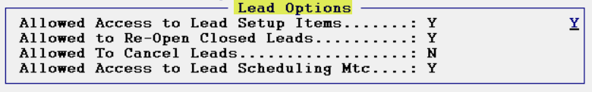

The first option, Allowed Access to Lead Setup Items, determines which Users will have access to the Functions menu in the Lead Processing module. The Functions menu allows access to six important setup options as follows: Room Maintenance, Material Type Maintenance, Special Maintenance, Time Maintenance, Alert Maintenance, and Zone/Region Maintenance. Please see below for more details on how these options work. If you do not want a User to have access to these options, make sure this control is set to “N” for no. The Allowed to Re-Open Closed Leads option, when enabled, allows a User to open a closed Lead. The Allowed to Cancel Leads option controls whether a User can view and access the Cancelled checkbox in the Lead Maintenance screen. It will be initially disabled for all Users; therefore, it will only need to be enabled for those Users who will be allowed to cancel Leads. The Allowed Access to Lead Scheduling Mtc option should only be enabled for two reasons: a.) your company has activated and is using this feature (see end of Lead Processing section for complete details) and b.) if this User will be allowed access to Lead Scheduling if it is activated in your system.
When you first enter this module, the screen will appear as follows:
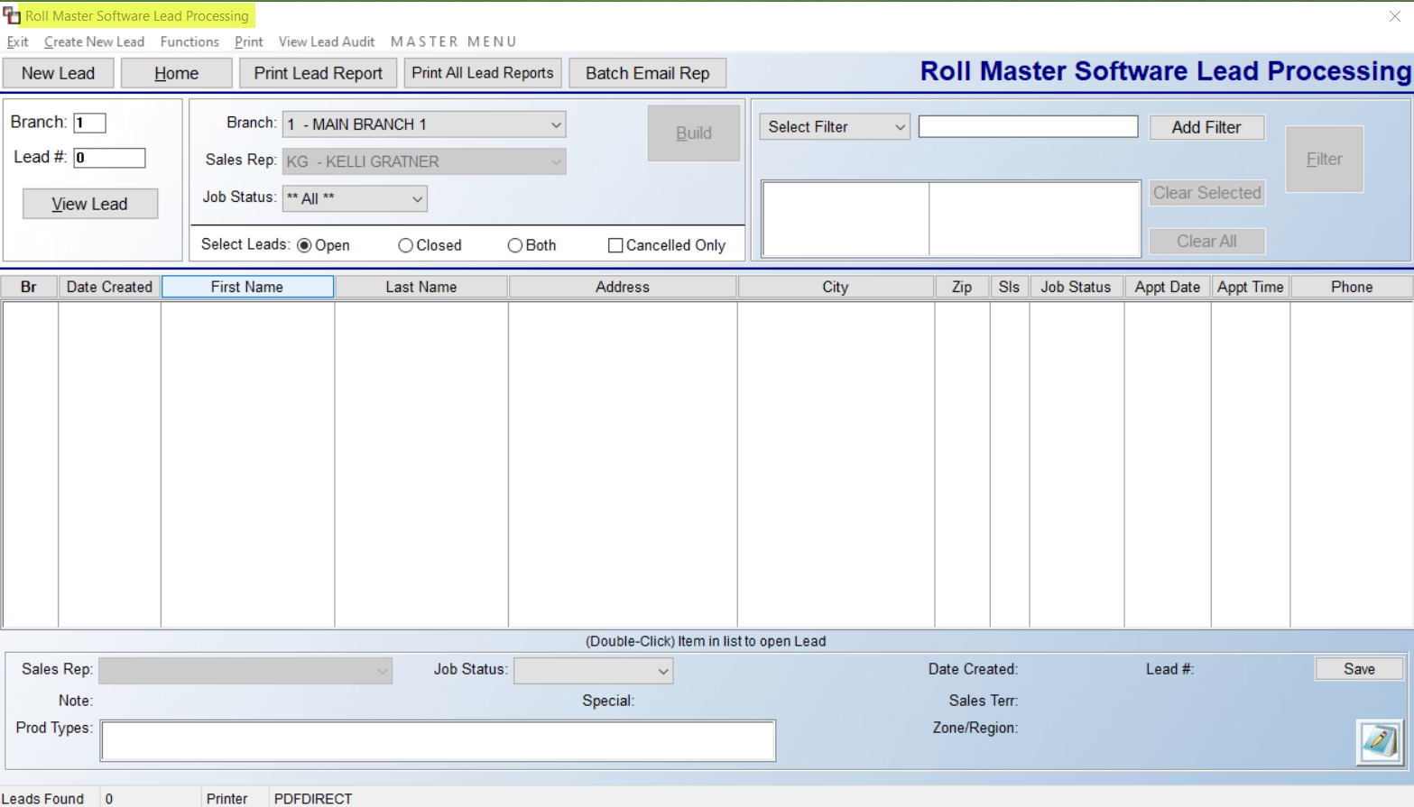
This screen works much like the Quote and Order Entry screens in terms of all existing Leads showing in the middle screen for the selected Sales Rep, along with the functionality to sort and filter the displayed data via the options at the top of the screen. In the Br column above, an “O” indicates a Lead has been converted to an Order.
Prior to creating a new Lead, if you are using this module for the first time, you need to complete setup items via the Functions option at the top left of the screen above. Please note: only Users with permission will be able to access the Functions menu. When you click on this option, you will see the several options as follows:

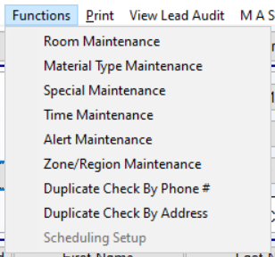

The first six options are setup options that should be completed prior to creating the first Lead. The Room Maintenance option will allow you to add/edit/delete room name descriptions to indicate which areas will be measured and eventually quoted on each lead. Examples include Basement, Kitchen, Den, etc., or you can add items such as 2 Bth, 2 Bdrm, etc. The Material Type Maintenance option is similar to RollMaster’s Product Type Maintenance. These should be Types such as Carpet, Vinyl, Tile, etc. The Special Maintenance option allows you to set up appointment specials such as percentage discounts off purchases or other special offers. Examples include 20% OFF, FREE PAD, etc. The Time Maintenance option allows you to set up pre-determined appointment times for Users to select from when scheduling new appointments. Examples include 10:00 AM, 2:00 PM, etc. Lead Appointment Scheduling will be covered in greater detail below, as it requires a bit more setup, but provides a broader use of this feature.

The Alert Maintenance option is for Managers and Owners to use to create descriptions for problem leads or why a Lead didn’t close. For example, Non-Qualified Lead. Salespeople are not able to see this field in the Lead Processing screen. The Zone/Region Maintenance screen is for setting up locations within a Branch, such as Downtown, North Side, etc. This will be used more for the Lead Appointment Scheduling feature. The Duplicate Check By Phone # can be used after Leads have been entered. It allows for checking Leads that may be redundant or could be combined. The same goes for the Duplicate Check By Address. These options prompt items containing some or all of the same data. The final option, Scheduling Setup, is accessible when the Lead Appointment Scheduling option has been enabled, and is covered in detail at the end of this main documentation.

In addition to the Functions menu, there are two reports available in this screen. The Print Lead Report will generate a text printout of the current lead data displayed in the Lead Maintenance screen at the time the report is printed. You can also export this data to Excel. The Print Lead Report option is also available from the Lead Processing screen. This option will produce a printout of exactly what you see displayed in the box in the middle of the screen. If you have used any Sort or Filter criteria to alter the items in that list, the Print Lead Report option will only print the data currently displayed. The Print All Leads Report will generate both a listing of what is displayed in the screen along with the detail for each of the leads displaying. You will also see a Batch Email Rep button, which requires you to first Filter by Appointment Date or Sales Rep, and then allows you to send Batch Emails to the Sales Rep addresses on file.

If you right-click on a Lead in the main screen, you will see an option to Copy Lead. If you select the Copy Lead option, the system will prompt the following:

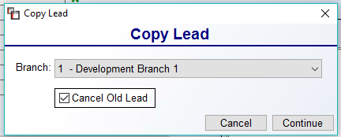

Use the drop-down menu to select another Branch. The Cancel Old Lead option will default to checked. If you wish to leave the original Lead open in the current Branch, uncheck this box and then click the Continue button. The system will then prompt the following:
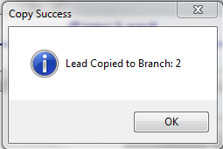

The Copied Lead can then be accessed in Branch 2. When a Lead is highlighted in the main screen, the Sales Rep and Job Status fields at the bottom will display any existing data for that Lead and you can access and change these fields as shown below. The Notes icon at the bottom right is for Lead Notes and will attach to the Lead that is currently highlighted when this button is selected. Be sure to click the Save button to keep any changes.
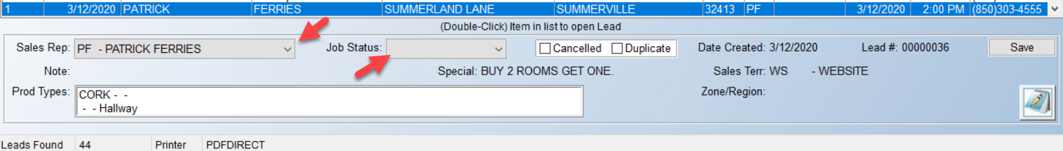
To create a new lead, click the New Lead button at the top left of the main screen or click on the Create New Lead option next to the Exit option. The system will prompt a Lead Maintenance screen as follows:
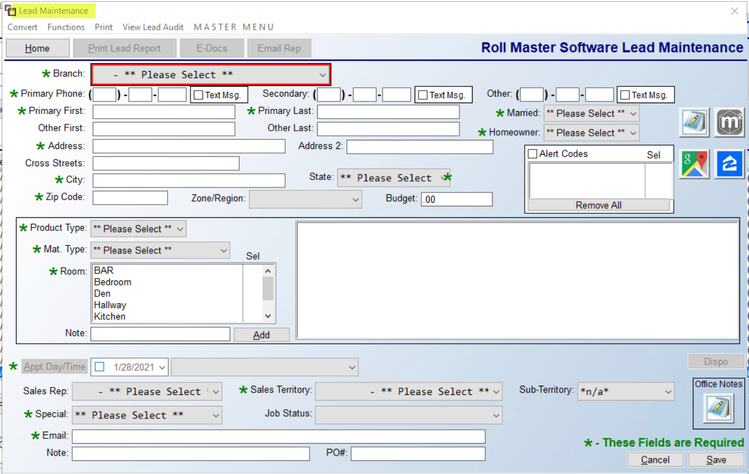

Begin by first selecting the applicable Branch, and then completing the phone, address, and data fields with as much detail as you have at the time of creation. Please Note: all the fields with a green asterisk “*” must be completed prior to clicking the Save button. Within the address section, a field has been added for Cross Streets to help locate the residence. The Zone/Region drop-down field requires advance setup, but allows for setting up Zones and/or Regions for which you can assign your Sales Reps. Also, the system forces the State field to be two characters, and the Zip to be five, if it is set to US. The Budget field can be used to record an amount the Lead has previously mentioned as the amount they are looking to spend.

When entering Phone and Address data, the system will search for duplicates. Where it finds duplicates, it will prompt a Duplicate box as follows:

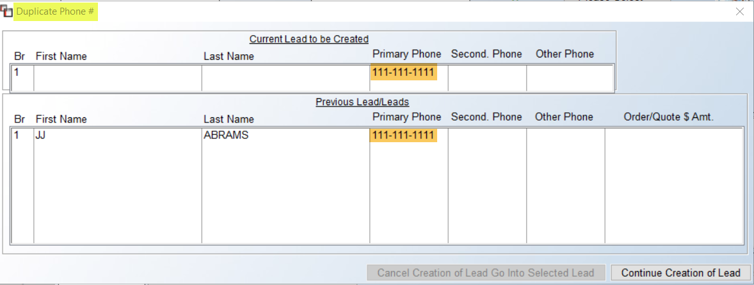

To continue with the Lead creation, click the Continue Creation of Lead button at the bottom right of the screen. Otherwise, you can click on an existing item, and if no dollar amount is listed in the column to the far right, you can select that Lead from the list and then click on the Cancel Creation of Lead Go Into Selected Lead button. When this option is selected, the system will reset the Job Status and Appt. Day/Time fields. The same process will occur for any Address data duplications.

In the far-right upper corner, the Cancelled and Duplicate check boxes can be used by Owners/Managers to update the status of a Lead that falls under one of these criteria. These boxes are not visible to reps. Below that is a cluster of four interactive icons. The Notes icon will become active once you save the initial lead data in this screen. Thereafter, you can double-click to enter notes pertaining to this specific Lead appointment. If Notes exist for a Lead, the icon will display a bright green box around the image. Next to the Notes icon is for RM MeasureSquare, if activated in your system. The data from this module will export to your MeasureSquare application. Below the Notes icon is a Google Maps button to use for making sure the address is valid. The button next to it is to access Zillow to review home appearance and value. Another integration feature with a RollMaster Efficiency Tool is the Text Msg check boxes next to the phone # fields that sends data to the RM Text Alert integration. If checked, it allows for texting with the Lead from that application. The Alert Codes checkbox is also only visible to non-sales reps. Users set up as a “Salesperson” in RollMaster will not even see the Alert Codes option. Also, as mentioned above, these Codes must first be setup in the Alert Code Maintenance option in the Functions menu.

The Product Type section in the middle of the screen allows the User to select all the types of products that will be considered during the appointment. The items displayed in the drop-down box are pulling from the Product Type Maintenance module. Please review that section to complete applicable setup prior to going live with the Lead System. You will then make a Material Type selection, select a Room by double-clicking on an item in the list, add a Note pertaining to this item, and then click Add to have it display in the box to the right as follows:

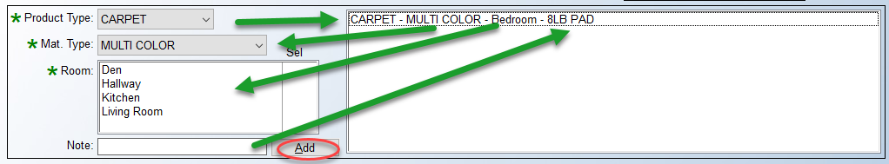

If you highlight and right-click on the description line you created, you have the option to Edit or Delete the line. Add as many lines as apply to this Lead. Below this box, are additional items to consider. In order to schedule an appointment, you must click the box next to Appt.Day/Time and then use the drop-down calendar menu to first select a day, and then use the drop-down menu to the right of that field to select a time (times should previously be set up via the Time Maintenance option under the Functions option in the main screen). The Sales Rep and Sales Territory fields pull directly from the main system—use the drop-down arrows to select applicable data. The Special field is tied to the Special Maintenance function explained above. The Job Status field will display only items that have been pre-setup to display in this module. Please be sure to access the Job Status Maintenance module to complete setup prior to using this module. The Sub-Territory field is new and will be a part of future programming. The Email address field is not required but you can add one in this screen if you have one for the Lead. The Note field can be used to add information such as “Gate Code is xxx,” “Call First,” or “Customer has dogs,” etc. The PO# field is not required, but will carry over to Quote or Order, just as most of the fields described above will. Click the Save button to keep your changes.

The system will then populate the Created By and Date Created fields at the very bottom of the screen with the current User Id and Date. These fields are currently only updated during the initial Save and will not be updated when changes are made. When a Lead is converted to a Quote or Job, the system will display the Quote and/or Order # in a field to the right of the Date Created field. Additionally, the system will default the Customer to Credit Status of “Y”, making them C.O.D. A User with permission will need to update that field if applicable. Also, the system will ask if the User would like to leave the Lead Open when converting to a Quote or Order. An example of a completed Lead Maintenance screen appears as follows:

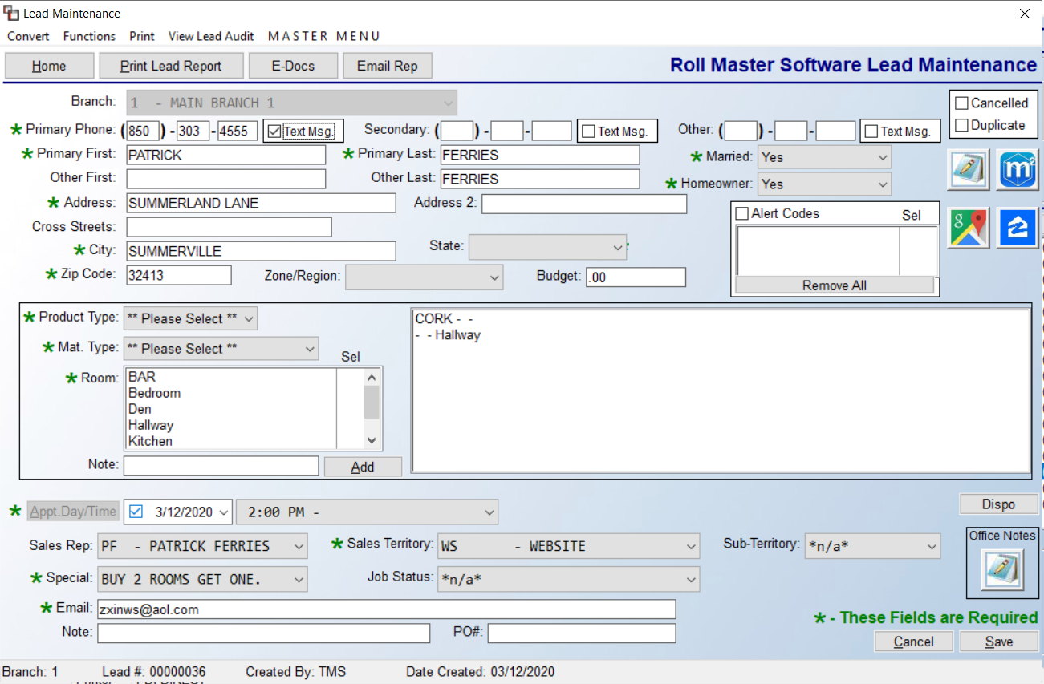
The Office Notes at the bottom right are only visible to non-sales reps. These can be used for internal Leads Notes. The Dispo button above the Office Notes should be used as a mechanism for Salespeople to store notes on Leads they weren’t able to close. By adding detailed notes, it’s then possible for another Salesperson to access them to follow up and try again to close the sale. When you click on the Dispo button, a Sales Notes screen appears as follows:

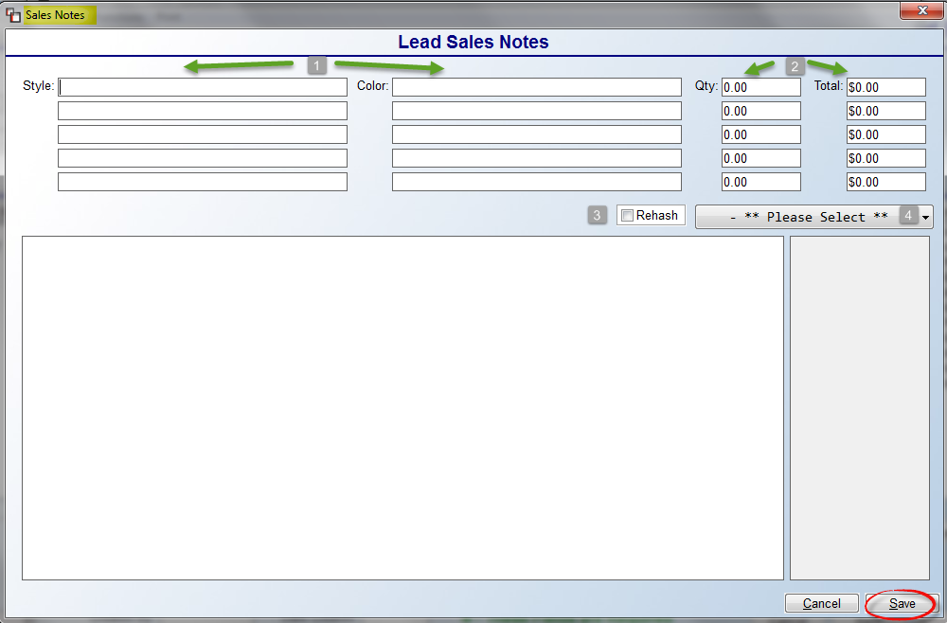

In the Style and Color (1) fields, make note of material quoted during the Lead Appointment. The Qty and Total (2) fields can be used to record quantity and total price data that was presented at the Lead Appointment. These fields are all freehand text and do not integrate with or update any other fields in the system. However, if you export the Print Lead Report from the main screen to Excel, the data will include any values in the first two fields of the Total column in sequential columns titled Dispo 1 and Dispo 2. The Rehash (3) checkbox should be checked after a Salesperson has tried to “re-hash” the lead and turn into a sale. Use the Drop-down (4) menu to record the Salesperson attempting to Rehash the lead—only Users set up via the Initials Maintenance module will appear here based on set up in each Branch. This drop-down menu does not pull from the Salesperson Maintenance list. The large note field is used for additional freehand notes regarding the Lead Appointment and/or the “rehash” phone call. Be sure to click the Save button each time changes are made and after the initial entry of Notes.

The Functions menu in the Lead Processing screen contains different options than the one in the main screen. When you click on this menu, the options will appear as follows:
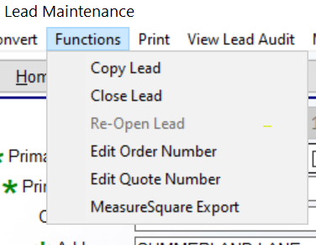

The Copy Lead option, if enabled, works the same as described in the main screen above. It allows for copying a Lead to another Branch. The Close Lead option, if enabled, allows the User to Close the Lead. The Re-Open Lead, if enabled, allows for opening a Closed Lead. The Edit Order Number and Edit Quote Number options, if enabled, allow for editing the Lead to reflect an existing Order or Quote Number where a Lead was not converted, but an Order or Quote added directly, thereby tying them together. The MeasureSquare Export, if enabled, sends the Lead data to the RM MeasureSquare app, and requires activation of that Efficiency Tool. Separate video and documentation is available for that process.

To the right of the Functions menu is a Print menu containing a single item as follows: Availability Report. This report will export to Excel and works in conjunction with the Lead Appointment Scheduling feature. The data on this report can be sorted by Date, Branch and Zone/Region. It will display applicable Sales Reps, Time Slots, and who is Available for each, provided proper setup has been completed. Next to the Print menu, you will see a View Lead Audit option. This works similarly to the View Audit option in Quote and Order Entry, but has Audit Types specific to the Lead Processing module. When you click on this option, a Lead Audit screen will appear as follows:

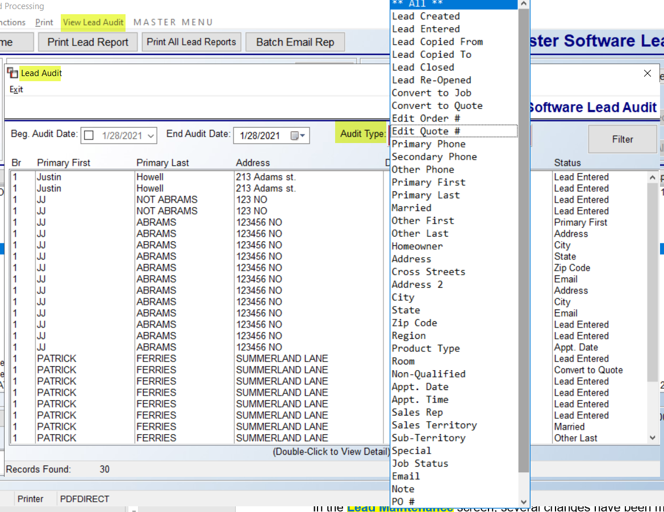

A list of Audit Types appears in the screenshot above. Once activity begins on a new Lead, the system will start tracking these Types by User and Date. The Audit Type selection box allows for sorting the display screen by a specific action.

When a Lead is ready to be converted to a Quote or Order, select the Lead from the main screen and pull up the Lead Maintenance screen. At the top left of this screen you will see Convert as an option. When you click on this option, the system will display two options as follows: Convert to Job and Convert to Quote. Either selection will prompt a Customer Selection box. As you begin typing an ID, the system will search the existing database for markers to determine if the Customer already exists. It will search the Customer Name, Phone Number, and Email fields for matches. You can select an existing Customer ID if you find a match, or continue to add a new ID. Once the new ID is added, the system will transfer all existing customer data from the Lead Maintenance screen into the Customer Maintenance screen. Enter through to complete all other pertinent data and save the new Customer. The system will return the cursor to the Customer Selection box. Click the Select button to continue. The system will then prompt an Edit Ship To Address box. Update any pertinent Ship To data and click the Save button to continue. The system will then open a new Job or Quote based on the Convert option you selected. The cursor will be positioned at the Job Status field in the Order or Quote Detail box. Make your selection at this required field to continue processing as you normally would.

When a Lead is converted to a Quote or Order, the system will automatically close the Lead in the Lead Processing module. If you ever need to utilize that data again, you can locate the closed Lead and use the Copy Lead function to re-use the information. Please note: a Quote or Job Number Note will be written with the Lead number when converted from a Lead. Upon exiting the Quote or Order generated from the Lead System module, the system will return the cursor to the Lead Processing module and prompt the following:

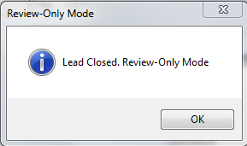
Click OK at this prompt. You will then need to exit the closed Lead to return to the Lead Processing main screen. From here you can create or edit another Lead or exit the module.

Lead Appointment Scheduling:
This functionality requires a bit of additional setup prior to use. With proper setup, this feature allows for scheduling Lead Appointments based on a Salesperson’s schedule and availability, so that a Manager or Scheduler can control the appointments.

In the Branch Control 2 screen of the System Control Maintenance module, you will see the following: Activate Lead Appt Scheduling. With this control set to “Y” for yes, the system will activate Lead Appointment scheduling. Also, please make sure that the User Control 5 Lead Option, Allowed Access to Lead Scheduling Mtc—which is explained at the very beginning of this documentation—has been enabled for each User who will need access to Lead Appointment Scheduling.

Once the system setup is completed, you will need to access the Leads Processing module to perform some additional setup. There is a Zone/Region field for use in assigning names to the various sections of your business service area. These can be preset from the Functions menu under Zone/Region Maintenance. When a Lead is assigned to one of these Zones or Regions, you can schedule your reps based on which of these areas they have been set to operate within. You should also then complete the Time Maintenance option to create Time Slots for scheduling appointments, such as 6:00 AM Early Morning, 10:00 Am Morning, etc. The final setup area can also be found in the Functions menu as follows: Schedule Setup. All other setup should be completed prior to accessing this option. That screen appears as follows:

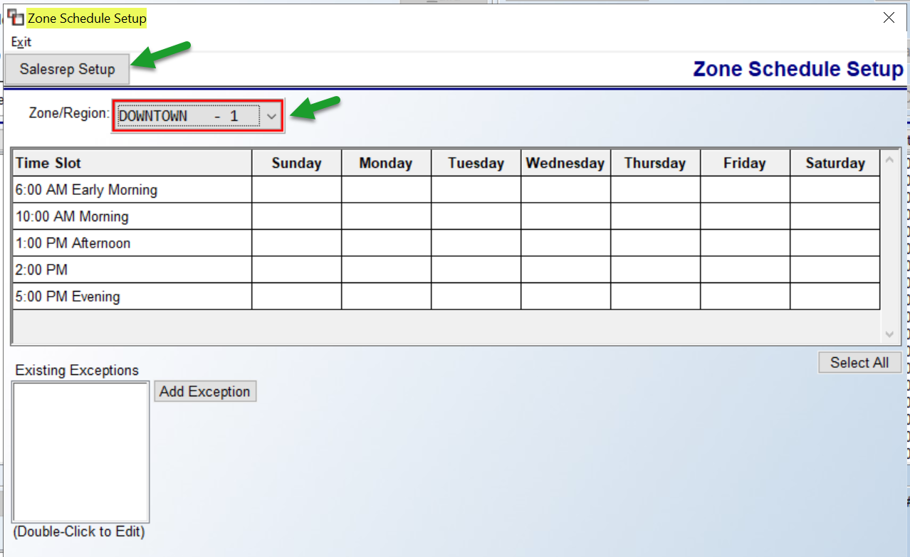

In the Salesrep Setup option you will Add all Salespeople available for Schedule Setup and determine what their availability is for each Zone/Region. You can also use the screen above for a default availability screen, and once that is set, the system will take into account all available reps for a date/time/zone and display that during the live scheduling process.

When setup is complete, when you save a new Lead, or click in the Appt Day/Time field, a Schedule Lead screen will appear as follows:

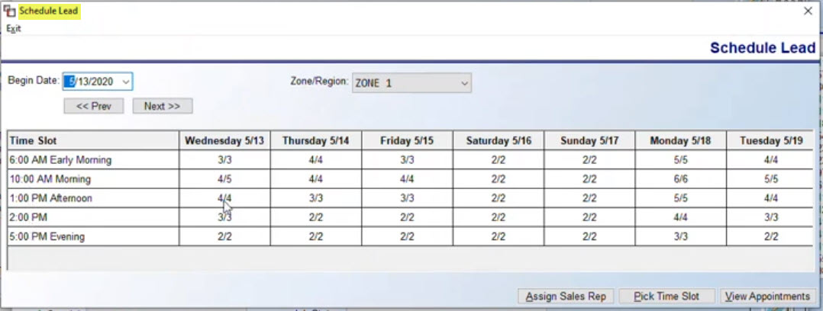

In this screen, you can see available appointment slots so you can then Assign Sales Rep, Pick Time Slot, and then View Appointments.

RM Mobile App Setup for Leads Calendar:
If your company is also using the RM Mobile App, in order for a Mobile User to access the Leads Calendar integration with the RM Mobile App, in the User Web Dashboard screen, located in the System Control Maintenance module, the three highlighted areas need to be set for each User:

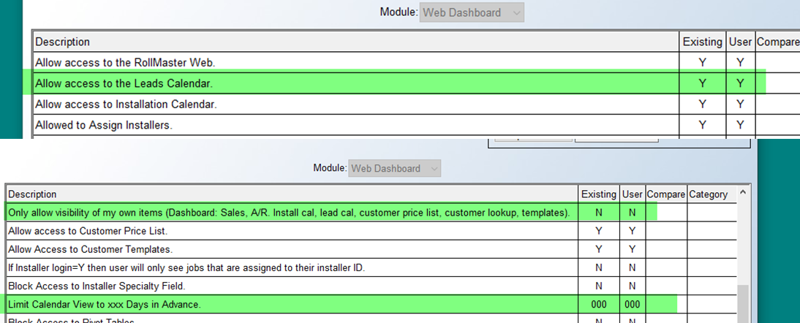

Property Management / Builders Templates:
This module is very instrumental to those RollMaster customers who do business with Property Management/Multi-Family companies and track home builders. Additionally, those customers who are using the PM Web Portal program will use this module extensively to generate online Templates for Web Order Processing. To use this module most effectively, there is setup that needs to be performed in other areas of the system and will be explained at the beginning of this section to ensure proper use of this module.

Initial Setup:
The first area of setup is in the System Maintenance menu under the System Control Maintenance module. Under the User Control menus, there are three User Control screens that need to be accessed to complete the setup in this section. The first is in the User Control 4 screen. The last control in that screen will appear as follows: Allowed to change property mgmt. templates. This control determines two areas of PM/Bldr (Property Management/Builder) processing. The first is which Users can make changes to the Templates that have been or will be set up in this module. The second is the ability to see and use the Web Setup and Web Name features (explained below) that will only apply to those customers with the PM Web Portal system. Set this control to “Y” for yes to allow a User the ability to change any existing Templates and to use the Web Order features. The next control appears in the User Control 5 screen as follows: Update excluded/preferred installer list. One of the innovations made to the system for Web Order processing is the ability to assign a list of installers to a PM/Bldr Customer and then determine whether they are a preferred or excluded installer for that Customer. It also allows the User the ability to rank the list of preferred installers. Set this control to “Y” for yes for those Users allowed to make these decisions.

The final controls apply only to Web Order processing and they are found under the User Web Portal Control screen as follows: Allowed to setup web portal users, Show Pending Web Orders on menu status, and Update required on web property mgmt. The first control determines who can see the Web Setup option in the Customer Maintenance module. This option allows completion of the setup of Customers for the online Web Portal. Only set this control to “Y” for yes for those Users who understand all the functionality of the Web Order system and for those responsible for implementation and continued processing of orders placed via the web. The next control, Show Pending Web Orders on menu status, determines whether a User, while logged into RollMaster, can receive an alert on the screen when Web Orders are placed online and received into the Web Order Maintenance module. That alert will appear as a flashing message at the very bottom left of the RollMaster screen as follows: $$$New Web Order$$$. Set this control to “Y” for yes for a User to see this alert. The final control, Update required on web property mgmt, determines whether a User can access and change a field in the Ship To box of the Customer Maintenance module that controls whether some key fields are considered “required fields of entry” for Web Orders on a customer-by-customer basis. Those fields are as follows: Customer PO, Building, and Unit. Set this control to “Y” for yes if the User has permission to set these fields for Web Order Customers.

Before you leave the System Maintenance menu, you will want to complete one additional area of setup pertaining to Web Order Email messages generated by Web Order processing. This setup can be completed in a module that appears in the System Maintenance menu as follows: Web Portal Email Message Maintenance. You can type up to 18 lines of data that will be added to every Email that follows the standard job information. Please note that this message is sent automatically after both a Web Order and an Order created from the Property Management module is created so it should be generic enough to be used for both. An example of a Web Order Email message appears as follows:
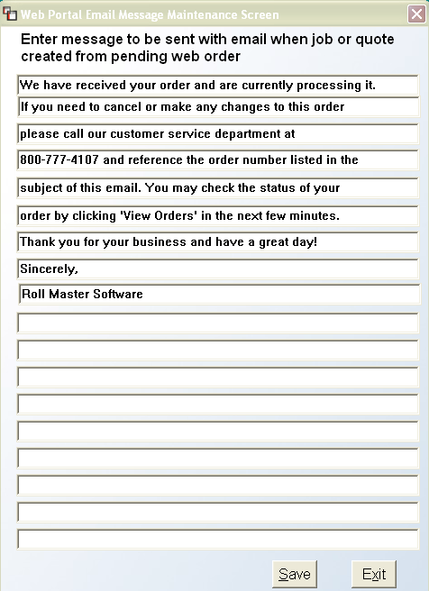

This menu option will only appear under the following custom menus: MENU.FIL, MENUNO.FIL, and MENUB2BT.FIL.

The next area of system setup is in the Customer Maintenance module. There are several fields in this module that apply to PM/Bldr Templates and that tie into the online Web Portal program. The first of those appears in the main screen of each Customer below the Customer Type field as follows: Prop. Mgmt. Co. This field was added to identify the Customers that are the “parent” or “umbrella” property management companies in the system. With this field set to “Y” for yes, a Property Management Report is available to display a list of all the properties—set up as individual customers—in the system that are owned/managed by the main Property Management Customer. Only set this field to “Y” for yes for those type Customers. You will find the report function listed along the top of the Customer Maintenance screen as follows: Property Management Report. An example of the Property Management Report appears as follows:

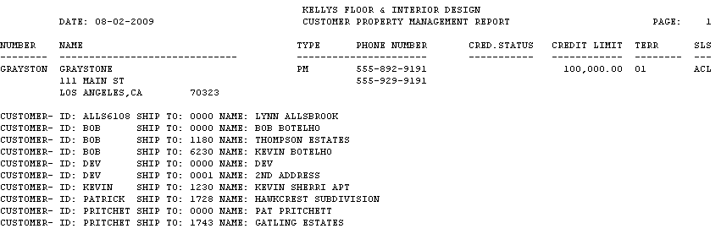

All of the Customer IDs and related Ship To addresses will appear below each Property Management Company on the report. This printout was designed to help clients with several Property Management Customers see a listing of all properties and addresses in one easy report.

There is another level of hierarchy available that is designated as a National Property Manager. If this level is set up, all existing Property Management Customers and subsequent properties, can be added and tracked under this top level. Begin this setup by entering the Customer Maintenance screen for any existing PM Customer. When you click on the Setup menu, you will see a new option there as follows: National Property Manager Maintenance. The system will prompt a maintenance screen as follows:

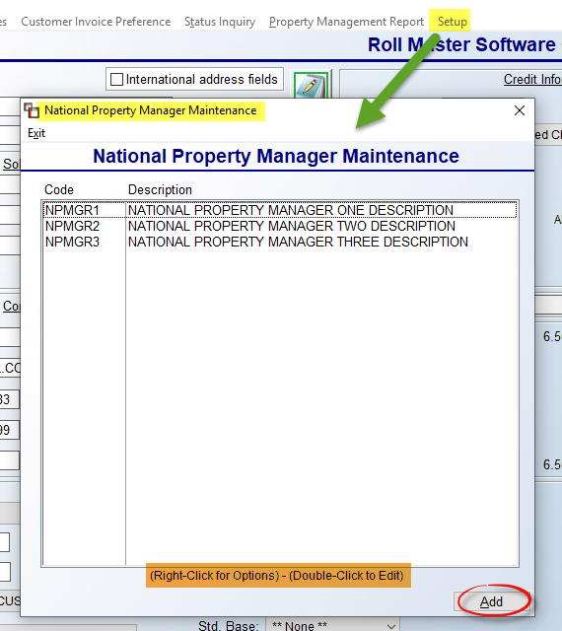

Any existing National Property Managers (NPM) will appear in the screen above. Click the Add button to create a new NPM. That screen will appear as follows:

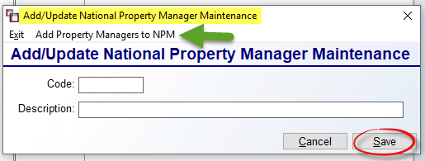

At the Code field, type up to an 8-digit alphanumeric code for the new NPM. You can then type a longer Description in the field below. Click Save to keep the new NPM. Once added, in the prior screen, highlight and right click or double-click to call up an existing National Property Manager so you can then utilize the Add Property Mangers to NPM option which appears in the screen above. That screen will appear as follows:

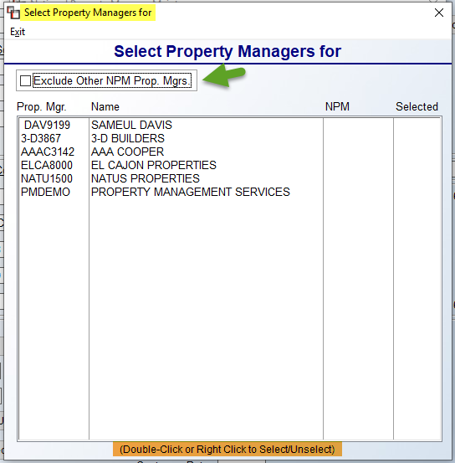

All current Property Management Companies in the system will appear in the screen above. You will need to highlight and double-click or right click to Select or Unselect Property Management Companies that report to the selected National Property Manager. Property Management Companies can only report to one NPM. The Exclude Other NPM Prop. Mgrs. option will clear any Property Management Companies from the screen not tied to the existing NPM. With this setup complete, the Customer Master Listing export to Excel will display an NPM column. Also, the A/R Aging Report (Standard) will sort by Property Management Company/NPM. And finally, Sales Analysis will generate for either all Property Management Companies under an NPM, or all PM Customers included under an NPM.

The next applicable setup fields in Customer Maintenance appear under the Ship To Codes option. At the middle and bottom of the Ship To Code Maintenance screen, are applicable fields for this setup. The first appear as follows: Sales Person and Email Sales Rep. Enter a Salesrep ID in the first field to tie them to this Ship To Code, and use the next field for the Salesrep ID who also should receive copies of Web Order emails and Email Acknowledgements. Please note: this feature requires an email be added in the Salesperson Maintenance module for each applicable salesperson. The next related field appears as follows: Email Cust. If you type a “Y” at this field and then enter a valid email address in the next field, copies of any Web Order or Email Acknowledgements will go to this address as well. The third appears as follows: P/M Co. If this Ship To address needs to be tracked on the Property Management Report for a parent Property Management company, you will need to add the Customer ID of the parent company in this field to complete the setup for that report. This also allows you to make the Property Management company address the billing address. However, before you can do that, you must use the Property Managers option–displayed at the top of the Ship To screen—to add any Property Management companies prior to assigning one in this field. When you select this option, a Property Managers screen will appear as follows:

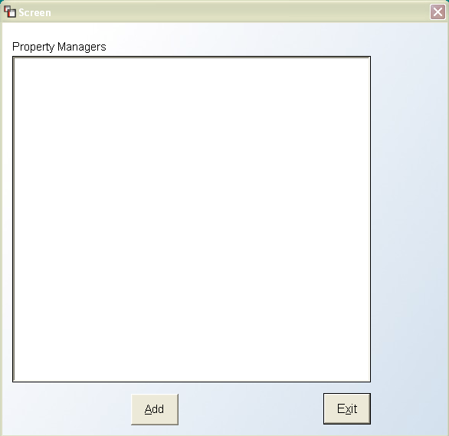

To begin adding Property Managers click the Add button. The system will then prompt the following:
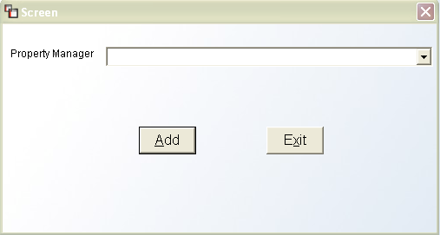

Click on the down arrow button at the Property Manager field to display a list of existing Property Managers (these have been designated as such in the system prior to this step via the main Customer Maintenance screen). Click on the applicable name and then click the Add button in this screen to complete the process. If applicable, you can add multiple Property Managers to any Ship To code via this feature.

The next applicable field appears as follows: Mail To: (S)old To or S(H)ip To. This prompt has been added in preparation for Batch Invoicing in RollMaster and is not yet working. However, it can be accessed and set in preparation for the future programming. It will control the default of where the Invoices will be mailed for each Ship To address, whether that be the Sold To address, Ship To address, or the parent Property Management company. If a Property Manager has been assigned to this Ship To Code, you will see a third option available at this field as follows: or (P)roperty Manager. The final applicable field appears at the very bottom of the screen as follows: Required on Web Property Management System (Y/N). This field controls the three prompts at the very bottom of the screen and can only be accessed by Users with permission. If a User has permission to access this field, they can then determine whether any of the three fields below are considered required fields of entry when a Web Order is placed for this Ship To address. For example, if a Customer PO is required to process a Web Order, this field should be set to “Y” for yes so the cursor can move to the Customer PO: field, which should also be set to “Y” for yes. The same goes for the Building field and the Unit field. If none of these are required for Web Order placement, you can leave the main field set to “N” for no. If any of these options have been set to “Y” for yes, the Web Portal program will display a red asterisk next to these fields and your client will not be able to leave these fields blank when placing a Web Order.

Another relevant option is available in each Ship To setup screen and appears at the very top as follows: Installer Setup. This is a User-based permission option as well. If a User has permission to access this option, when you click on it, an Installer Ship To List box will appear as follows:

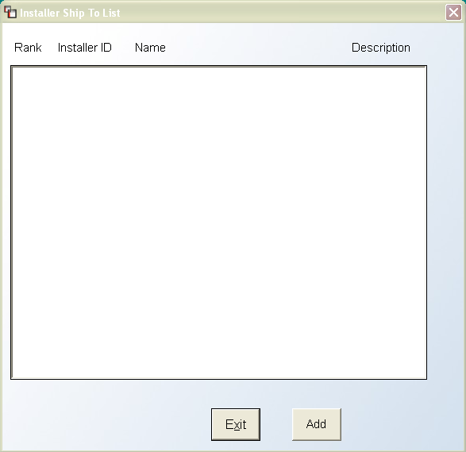

This option allows you to compile a list of Installers that are allowed to do work for this Ship To address and you can then rank them in order of most preferred to least preferred. It even allows you to mark any installers as “Excluded” from performing any work at this property or for this builder. Click the Add button to begin. The system will prompt another box as follows:
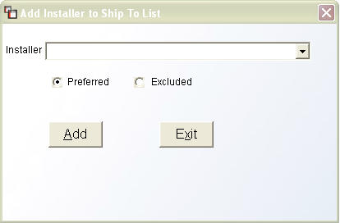

At the Installer field, click on the down arrow button to display a list of existing Installers in your system. Click on the desired Installer name to select. For each Installer you select, the default will be set to Preferred. If this is not the case, you can click on the Excluded option before clicking on the Add button to finish this process. Once you have added an Installer, the system will return you to the previous screen and the newly selected Installer will appear in that screen. To add more Installers, repeat these steps until all applicable Installers have been selected. Once you return to the previous screen, the system will display the Installers in the order they were selected as follows:

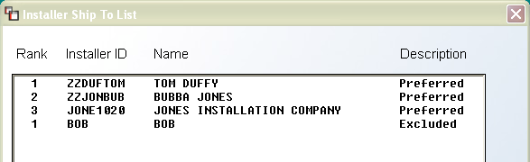

If this is the order of preference, you can exit this screen. However, if you would like to change the order, you can click on an Installer you would like to move up or down in ranking and the system will display up or down arrows to the right of the screen as follows:

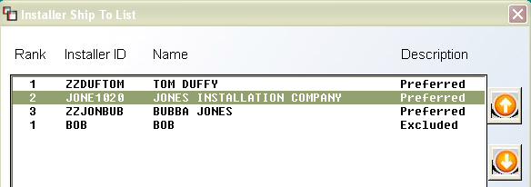
This setup can be initiated from this screen, however this option is also available in other areas of the system for ongoing maintenance.

Creating Templates:
Before you can begin processing Orders from this module, you will first need to create a series of Templates in this module. This next section will cover all the setup required for creating the Templates that can be instantly converted to Quotes, Orders, or will be uploaded to the Web Portal system. Also, there are a couple of print options available in this module that will be useful as Templates are created.

When you enter this module, the Customer Selection screen will prompt first for you to select a specific Customer, or click the Select All button to see Templates for all Customers. The Property Management screen will appear as follows:

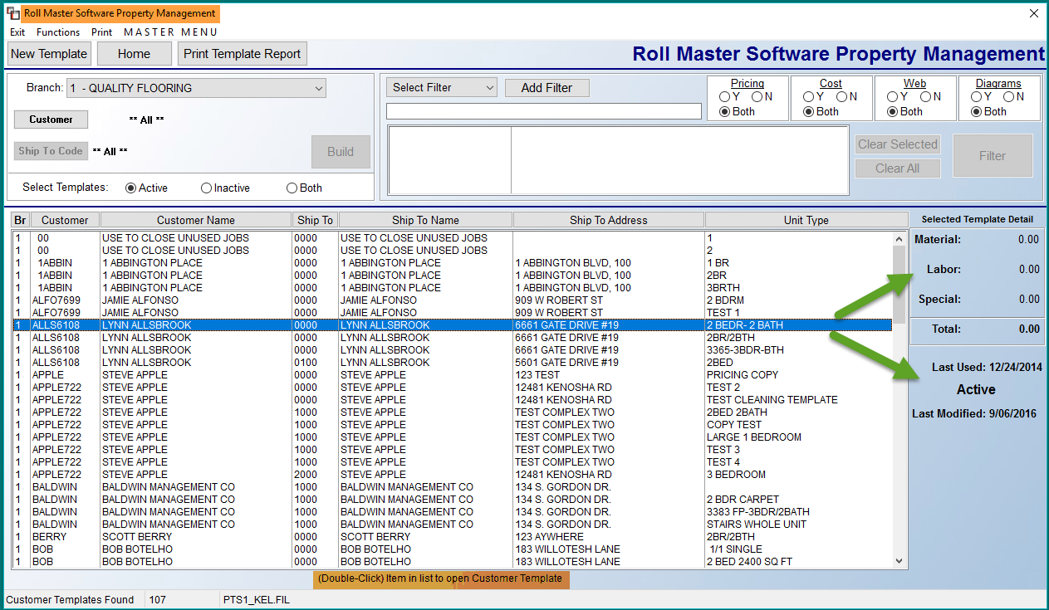

All existing Templates will appear in the screen above. You can scroll through the list to find a template or use the features at the top of the screen to sort through the existing data. The Branch field will allow you to change Branches and access Templates in another Branch, or select “All” to display all Templates in all Branches. If you make a selection in the sort fields, you will need to click the Build button to change the template data that appears in the screen below the sort fields. The Customer button will prompt a Customer Selection box for you to select an existing Customer to view only that Customer’s existing Templates. You can further narrow the search by clicking on the Ship To Code button to prompt a Customer Ship To Selection box. If you make a selection from this screen and then click the Build button, the system will display only those Templates matching the selected Ship To. In the Select Template box, you can toggle between Active, Inactive, and Both. On each Template, you will see an Active button that can be switched to Inactive and back again as needed, controlling this feature.

The Select Filter feature works the same as in Order Entry and Quote Entry, and will allow you to further refine your search by building one or more Filters to locate an existing Template. Click the drop-down menu to select a Filter item, click the Add Filter button, and then type in the value for the Filter such as a phone number, style name, etc., based on the selection. When you have made your selections, click the Add Filter button to start the process based on the Filters you added. One Filter worth mentioning allows for sorting by the Date a Template was last used, called the Last Used Date. When this Filter is selected, you will also see an additional checkbox to the right of the Date fields as follows: Never Used. If you click this box, you can then search Templates that have never been used. Once results are filtered, in the Functions menu, you can then utilize an option to inactivate the Templates in the results screen as follows: Inactivate Displayed Templates.

Four additional sort criteria appear to the right of the Add Filter button as follows:

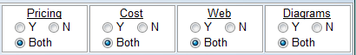

These sort options only need to be used if you would like to see Templates specifically based on these options. The Pricing option sorts by whether or not unit pricing exists in a Template; the Cost option sorts by whether or not costs have been entered in a Template; the Web option sorts by whether or not Web Portal Templates should display; and the Diagrams option sorts by whether or not Edocs exist for a Template. If you make a change to any of these four boxes, be sure to click the Filter button to reflect that change in the Template Selection box. At the bottom right of the full screen, just below the Selected Template Detail section, is a field as follows: Last Used. When you highlight a Template in the screen to the left, the system will display the date it was last edited or used. The Last Modified field will display the date a Template was last changed.
At the top left of the Property Management screen, you will see a few Menu and Button options as follows:
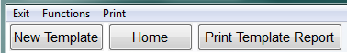
The Exit option will return you to the Sales Processing menu. The Functions menu contains one item as follows: Export Template Detail to Excel. If you click this option, the system will export the lines for currently displayed Templates to Excel, therefore, you should filter and sort to get just the detail you wish to export prior to using this item. The Print option will allow you to select another printer from the one selected when you entered the module. The New Template button will initiate the process of adding a brand new Template to the system. This process works much the same as adding a new Order or Quote to the system. The Home button will call up the Home Key menu. And finally, the Print Template Report option will print a listing of all existing Templates currently in the system. This report will also export to Excel.

Editing Templates:
To edit an existing template, double-click on the Template in the selection box and the system will display a Property Manager Maintenance screen as follows:
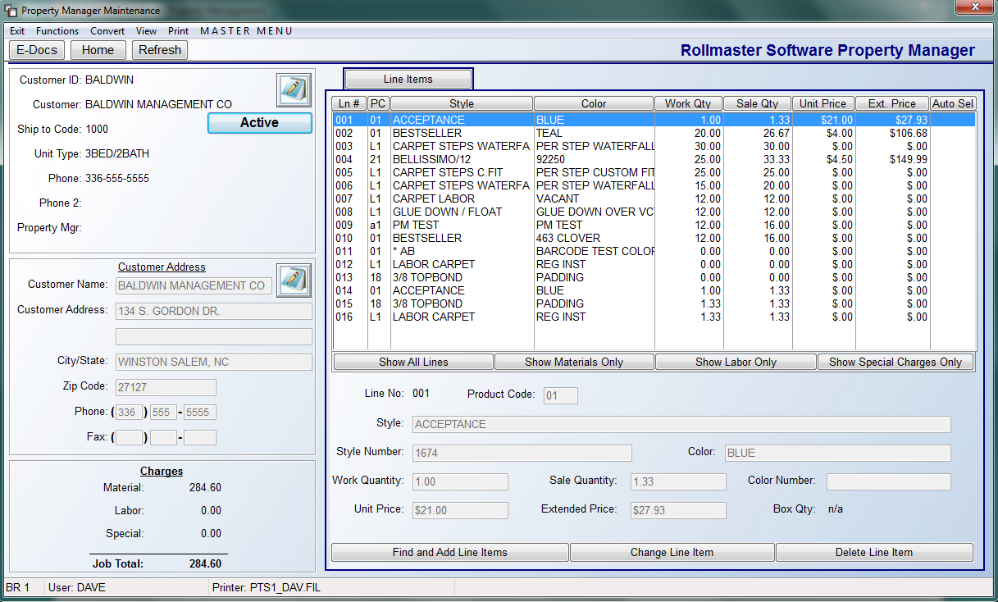
Along the left side, the system will display the existing Customer ID and Address data that has been set up in the system. You can add/edit Customer Notes and Customer Address Notes by clicking on the either of the Notes icons in each section. An Active/Inactive toggle button appears just under the Customer Notes icon. This is tied to the Select Template box in the main screen that allows you to view only Active templates, Inactive templates, or Both. If you click the Active button, it will change to Inactive and vice versa.
The Line Items tab screen works very similarly to the Order and Quote Entry modules in terms of adding, changing, and deleting line items. When you have made the initial entry for a new line or would like to change or delete a line, the Add or Change a Line Item box will appear as follows:
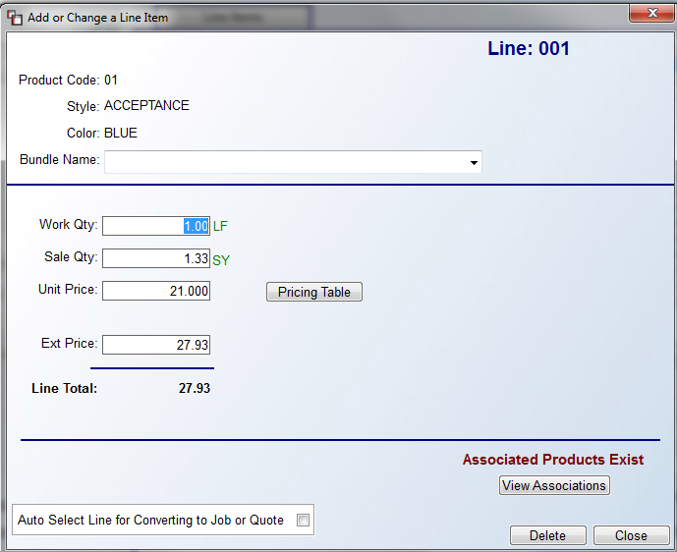
These fields will be familiar to you with the exception of the following: Bundle Name, Auto Select Line for Converting to Job or Quote, and Associated Products Exist/View Associations. The ability to bundle together material, labor, and special charge lines together on printed sales documents has been added to the system. Please review the Branch Control section of the System Maintenance manual for complete details on how to activate and use this feature. With regard to the Auto Select Line for Converting to Job or Quote option, by clicking this box, you are telling the system that this line will be automatically selected whenever this Template is converted to a Job or Quote. You will then see a “Y” in the “Auto Sel” column next to this line in the main Line Item screen. You can edit this option at any time. The Associated Products Exists/View Associations feature is new to the graphical update. It has been explained in detail in the Catalog Maintenance section of the Inventory Control manual.
With regard to Labor Catalog Items, the default cost will pull from the existing catalog, unless the checkbox titled Use Custom Cost is selected allowing access to the Labor Cost Information fields. If the default cost is used, upon conversion to a Quote or Job, the system will then update to any programmed Date Range Pricing, if applicable. In the event of an “ad hoc” (non-catalog) labor line, any cost can be entered and will be carried over to the Quote or Order.
On any existing line in the Line Items box, you will see three options when you right click on the line as follows: View Existing Inventory, View Catalog Item, and Line Comments. These options work the same as in the Order Entry and Quote Entry modules; they are listed here to bring attention to the fact that the options are accessible in Property Management as well. One exception is the addition of a Delete All button in the Property Management version of the Line Comments and Comment Review features.
Once all the lines for a Template have been added, you will be ready to convert the Template to a Quote or Order and/or perform additional functions that you will find accessible in the menu and button options at the top left of the Template Entry screen. Those options appear as follows:

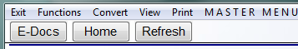

This next section will explain the Menu options from left to right, followed by an explanation of the Button options located just below. The Exit option will return you to the main Property Management screen. The Functions option is a drop-down menu featuring the following options: Delete Template, Copy to Template, Copy Line to Other Templates, and Web Setup. The Delete option will permanently remove the existing Template from the system. When you select that option, the system will first prompt the following:
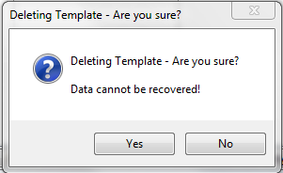

This prompt ensures that you fully intend to delete the Template and didn’t just hit the option by mistake. Click “No” to keep the Template and return to the previous screen; click “Yes” to permanently delete the Template. When you click the Copy to Template option, the system will prompt the following Copy Template to New Customer box:

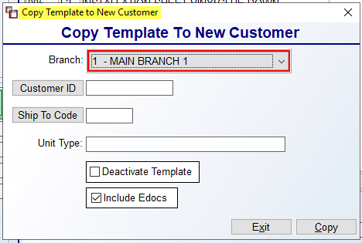

The fields in this screen will allow you to determine to which Branch to copy the new Template, the Customer ID to assign to the copied Template, along with the Ship To Code, and Unit Type for the new Template. The Deactivate Template checkbox, when checked, will deactivate the source Template once copied. If your company subscribes to the E-Docs application, you will see an option to include any existing E-docs with the copied Template. When all of these fields have been completed, click the Copy button to create the new Template. The system will prompt the following: Property Has Been Copied. You will then be able to pull up that Template and perform any maintenance or functions needed. Please Note: it may be necessary to exit the Property Management module and enter back in to see the copied Template in the main lookup screen.

Important Note: if you attempt to copy a Template to a Branch that does not contain matching Product Codes for some or all of the order lines, the system will prompt a warning as follows: XXX Lines won't be copied over because the following product codes don't exist in the copied to branch xx xx xx xx xx xx. The system will then ask if you want to continue with the copy.

The Copy Line to Other Templates option will allow you to copy a new line to all Templates matching the current Customer and Ship To Code address. When you click on this option, the system will prompt the following Copy Line to Other Templates box as follows:
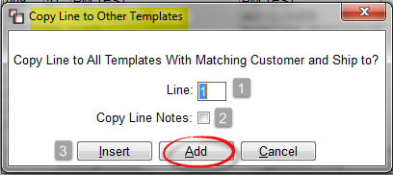
At the Line (1) field, type the Line # you would like to copy to another Template. The Copy Line Notes (2) option, when checked, will copy any existing Comment Lines over with the template line. The Insert (3) button will allow you to add the line to all applicable Templates at the specified line you enter when you click this button, or the first available spot if specified line doesn’t exist. You can skip the Insert button and click Add, and the system will add the line to the first available line on all applicable Templates. The system will force a re-write of all relevant catalog fields saved on the line record, including Style Name, Style #, Color Name, and Color #. This allows for all changes made to a material line within a Template to be copied selectively or universally.
The Web Setup option is for Web Portal clients and will allow those customers to access the Property Management Web Setup Screen as follows:

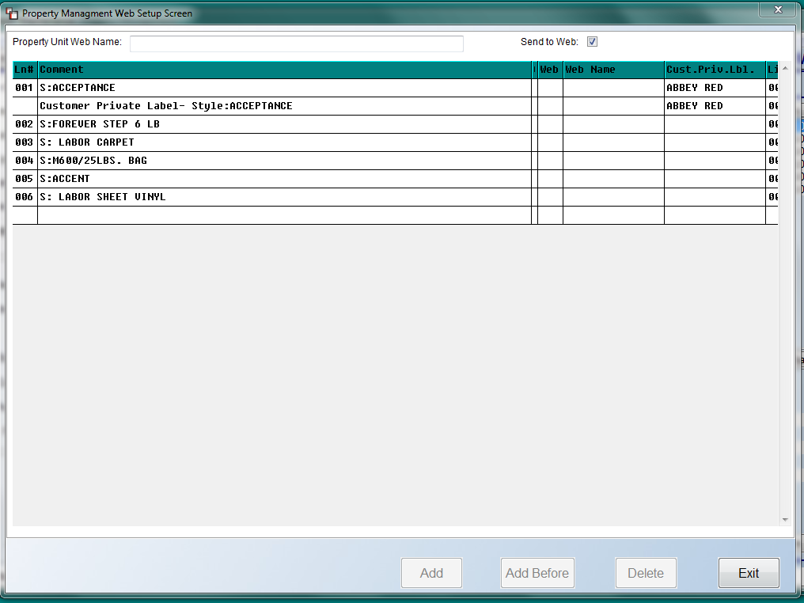

In the Property Unit Web Name field at the top left of the screen, type in the name as you would like it to display in the Web Portal system for your client. Web Portal clients should be familiar with this screen and the options available for web setup. Click the Exit button to return to the previous screen.

The Convert menu option will prompt the following two options: Convert to Job and Convert to Quote. Please Note: a password can be added to the system for the Convert option. Contact support@rmaster.com for the program name to password protect and for further assistance. When you are ready to convert a Template to a Quote or an Order, you will use one of these options to initiate the process. The process is essentially the same for either option. When you select Convert to Job, the system will display a Convert to Job screen as follows:

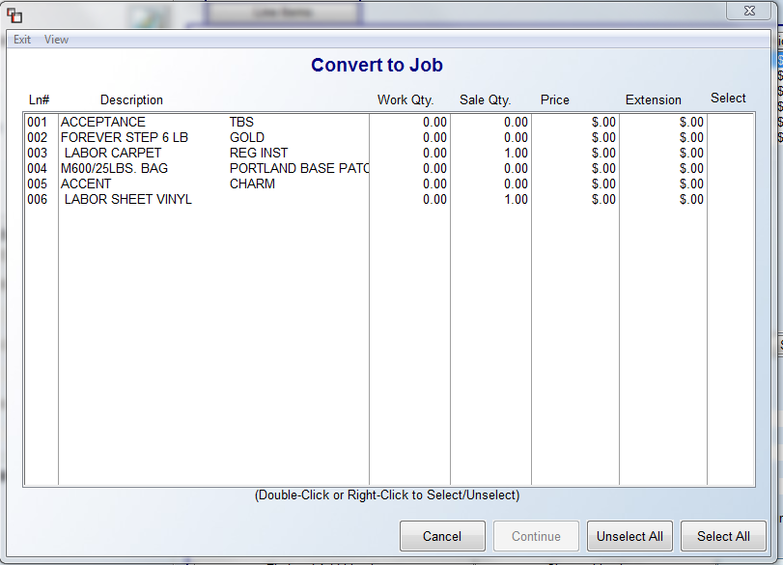

To select lines individually, double-click or right-click on a line to select and unselect as needed. To Select All or Unselect All lines, use the buttons at to bottom right of the screen. Once you have selected the applicable lines, the Continue button will become available and you will click that button to continue with the conversion. The system will then display an Enter Job Information box as follows:

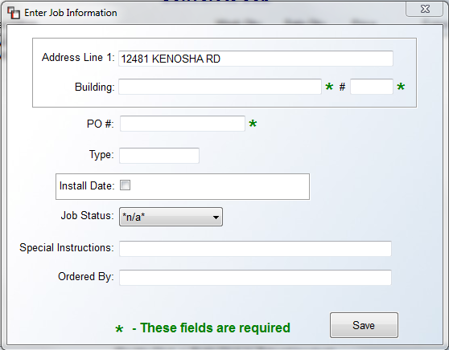
Complete this screen based on the actual job or quote requirements, making sure you at least complete the fields denoted with a green asterisk. Any data entered in the Special Instructions and Ordered By fields will flow through to the Job or Quote. When you have finished, click the Save button to continue. If you have setup your default email client and acknowledgement data, the system will prompt an Email Acknowledgment to go out to the applicable people. The system will then prompt either the order entry or quote entry screen containing the new template information for you to continue processing. Please Note: the “required” fields are maintained in the Customer Maintenance Ship To Code screen. When you have finished entering through the fields above, the system will return you to the Template screen.

When converting a Template to an existing Quote, if the Customer ID doesn’t match, you will only receive a soft stop instead of a hard stop. This is to allow for creating more complex templates for things like a shower install, so that they can then be used on multiple estimates. Additionally, in conjunction with the Credit Hold Feature in RollMaster, when converting a Template to a Job or Quote, if the Customer is on Credit Hold, a message will prompt as follows: Customer on Credit Hold. Limited Processing Allowed. The same rules for processing a Job or Quote for a Customer on Credit Hold will now apply.

The View menu option contains two options as follows: Comment Review and Bundle View. The first option will call up a Property Management Comment Review Screen and works the same as the Comment Review feature found in Quote and Order Entry. The Bundle View option prompts the Bundle View screen explained in the Order Entry section of the manual. The Print option will allow you to select a different printer if applicable. The MASTER MENU option will prompt the Master Menu to allow you to jump to any module in the system to perform a function and then return to this screen. The E-Docs button will call up the Electronic Documents functionality. The Home button will prompt the Home Key Menu. And finally, the Refresh button can be used to update changes made if you are not seeing them in the screen.
One additional feature in this module has to do with changes to line items. The system will allow you to copy changes to line items from one Template to another. If you make a Product/Style or Color change on a line, the system will allow you to copy that change to other Templates in the system. When you enter through a line that has been changed, the system will prompt an Update Property Management Template box as follows:

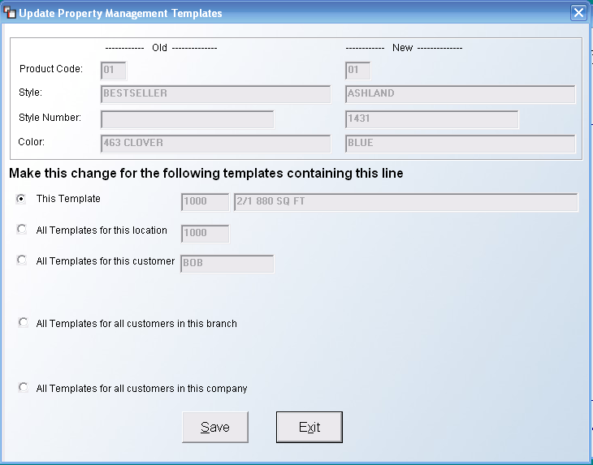

At the top of this box, the system will display the Old and New data, and then you can click the most applicable option under the Make this change for the following properties section for the Templates that need to be changed. Only one option can be selected, so make sure you click the option that will make the most changes possible. Once you have selected an option, click the Save button to continue. If you click the Exit button prior to clicking the Save button, no changes will take place. Also, when changing template lines where Special Pricing exists, a Copy Special Pricing Screen will prompt as follows:

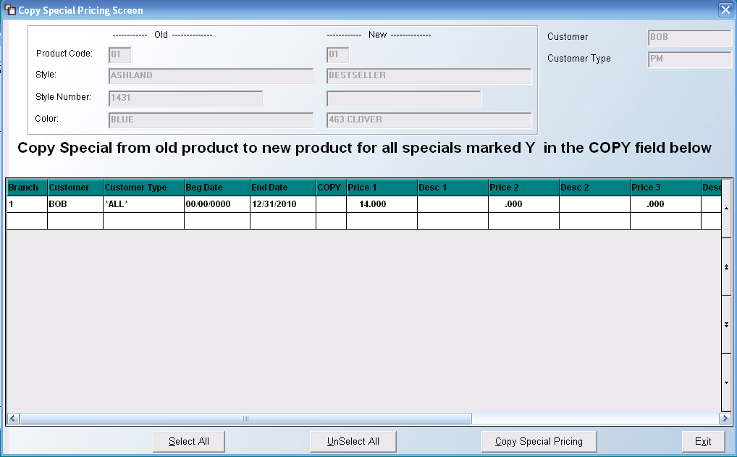

The top of the screen will display the Old style information, the New style information, the Customer ID and a Customer Type, if applicable, or if the Customer has been set up as a Property Manager, the Customer Type field will display a “PM.” From this screen, if a “Y” appears in the Copy column on any line item, when you click on the Copy Special Pricing button, the system will copy the Special Pricing over to the new style. Special Note: If a User does not have access to viewing or accessing Special Pricing because of their Custom Menu, instead of the Copy Special option, the system will prompt the following: Special Pricing May Exist for this Product! Please check with Administrator. The menus that display this message are as follows: MENUVIEW.FIL, MENUSLSR.FIL, MENUSLSC.FIL, MENUWH.FIL, MENUPROD.FIL, MENUPRO2.FIL, and MENUMANB.FIL.
And finally, the Delete Line Item option allows for more universal changes to Templates in the system based on Location, Customer, Branch, and Company. When you click the Delete Line Item button, the system will prompt a Delete Item From Property Management Templates box as follows:
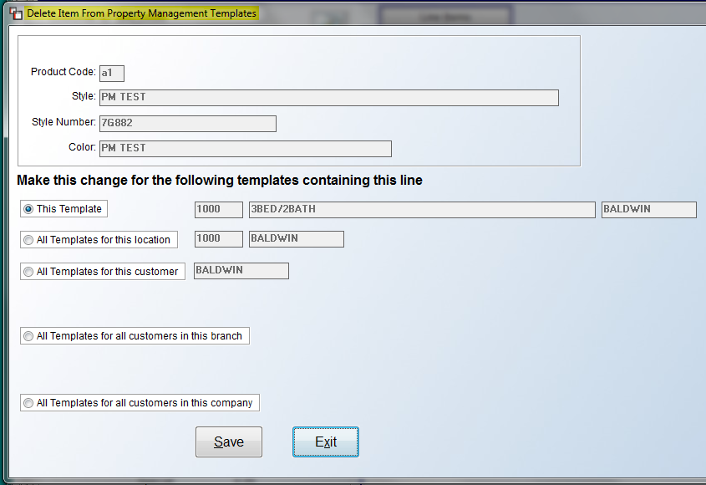
The default setting is to delete Only This Line. However, where applicable, you can select to Delete the line from this Template, from all Templates, for the Location displayed, for the Customer displayed, for the current Branch, and even for the Company. Be sure to click the Save button to keep your selection.

Property Management / Quick Orders:
Property Management / Quick Orders is a streamlined version of the Property Management/Builders Template full version that is designed to quickly process one or more orders on existing Templates for existing PM Customers. In addition to streamlining, the ability to move back-and-forth within the Template, rather than in the existing linear order process, is an added bonus that Users who process several orders in a day will certainly appreciate.

In conjunction with this new Quick Order programming, a change was made to the Customer Selection box that pops up upon entry—this change is also reflected everywhere the Customer Selection box is found within RollMaster. In the top left corner, the Property Managers option has been updated to allow for filtering of Customer Properties under each listed Property Manager. When you click on this option, the updated screen will appear as follows:

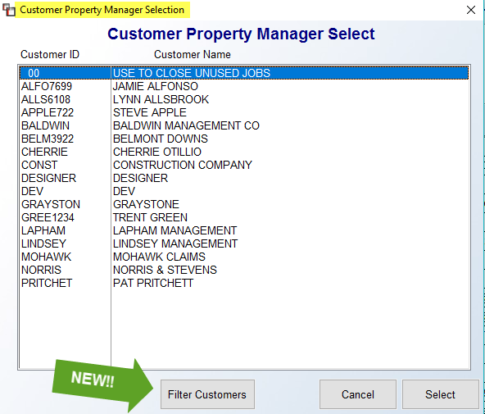

Highlight the Property Manager of the property you are placing the order for, click the Filter Customers button, and the system will display all associated properties in a Customer Selection Screen as follows:

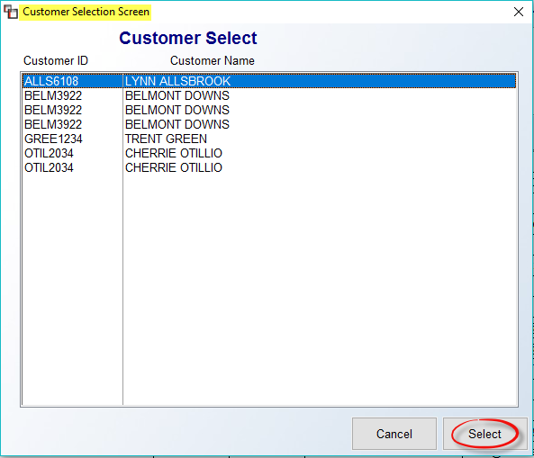

Highlight the applicable property and click the Select button to continue. The Template Selection screen will automatically prompt next--you will need double-click on a Template in the list to select. Once a selection is made, a Convert Template screen will appear as follows:

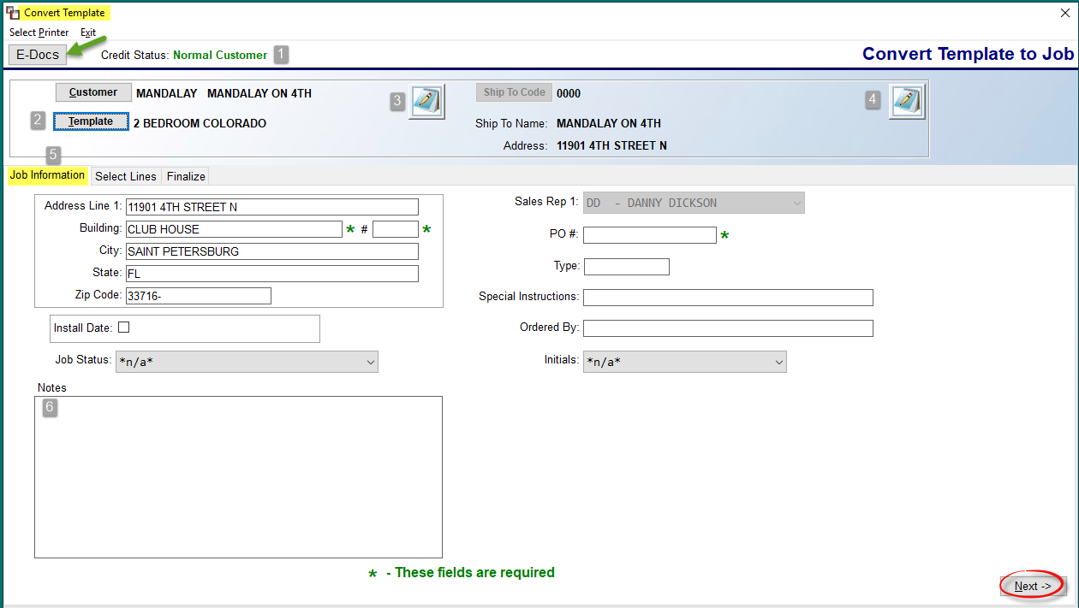

Before proceeding, note the Credit Status (1) field at the top left. If a negative credit status condition exists, this field will display that data in red text to alert the User to halt processing until credit is reestablished. The E-docs button is also available from this screen and appears at the top left. The Template (2) button would allow you to switch to a different Template if applicable. You can click on the Notes (3) icon in the Customer box to add Customer Notes and the other Notes (4) icon is for Customer Address Notes. The default screen upon entry is the Job Information (5) tab screen. You can click over to the Select Lines tab screen right away--in the event you’re on the phone with a customer and needing to jump around this screen or the Select Lines screen--or you can remain here until all Job Information data has been inputted. All of the fields in the Job Information screen are editable, but only the fields with a green “*” are required. The Notes (6) box is tied to Job Notes and will stay with this Order as it moves through the order process.

To begin selecting lines for the Order, click on the Select Lines tab or click the Next button at the bottom right corner of the Job Information screen. Please Note: If lines are set to “Auto Select,” they will prompt as Selected in this module as well. The Select Lines screen will appear as follows:

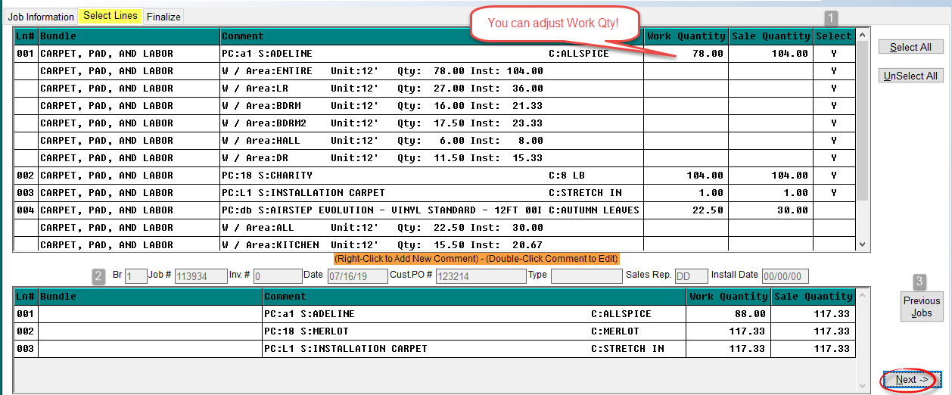

All the Lines and Comment Lines from the selected Template will appear in the top portion of the Select Lines screen. As with the regular program, you can click in the Select (1) column to select Lines individually or unselect. Another great feature of this program is the ability to select individual Comment Lines for each Line. The regular program automatically selects all Comment Lines when a Line is selected. You can also adjust the Work Quantity column, which is currently not allowed in the regular program. Also note the Select All and UnSelect All buttons at the top right to use when applicable. You can right-click on a Line # to add a new Comment Line and double-click on a Comment Line to edit. Any edits to Comment Lines will only impact this Order. The system will not go back and change the original Template. The right-click option also prompts two additional functions: Select All Lines in Bundle and Unselect All Lines in Bundle. The Bundle Name will appear in the Bundle column next to the Ln# column.

In the bottom portion of this screen, you will see the last order placed for the unit (2). The job data displayed is the last order placed for this Template. This is beneficial for a couple of reasons. First, you can check to make sure you are not placing a duplicate order. Second, you can see if there are any errors, or if the material amount being ordered is more or less than previous. It’s a great tool for preventing mistakes. The Previous Jobs (3) button will prompt a list of every order placed for the unit, allowing you to quickly sort through and select any previous order for review.

Once all Lines and Comment Lines for the order have been selected, click the Next button or click on the Finalize tab to access a summary screen as follows:

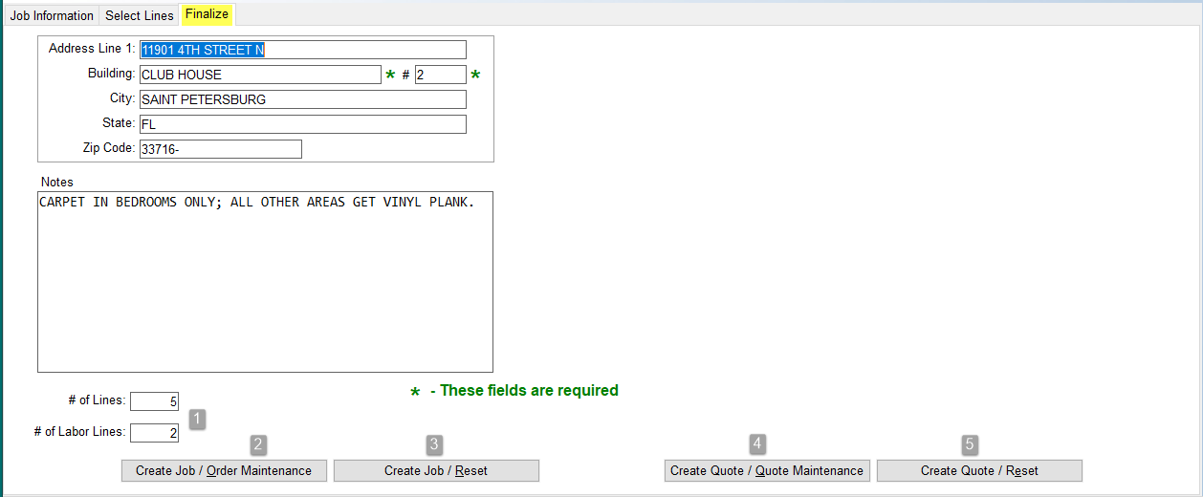

The Job Information entered in the first tab will display at the top left of this screen. It can be updated in the screen above, or you can click back to the Job Information tab screen at any time to make changes. At the bottom left, material and labor line totals (1) will appear. Prior to completing the order, you can click back to the Select Lines tab screen to make additional adjustments. The Create Job/Order Maintenance (2) button will finalize the order and place you in the Order Entry/Maintenance module. The Create Job/Reset (3) button will send the order to Order Entry for later processing and place the cursor back at the Job Information tab screen so you can continue to process orders. This is beneficial to Property Management businesses that may take orders for several units, allowing them to create all orders and then complete the processing in Order Entry later. Many companies have personnel that only generate the orders for the units, and other personnel to take over the Order Entry side of the job processing. The Create Quote / Quote Maintenance (4) and Create Quote / Reset (5) buttons work similarly, but send to Quote Entry.
When you click on one of the Create Job buttons above to Finalize, the system will prompt a Job Created box and display the Job #. This will be followed by an Email Acknowledgement box for you to Email, if that functionality has been set up in your system. When you click on one of the Create Quote buttons, the system will prompt an Enter Quote #: Blank for Next Available box, followed by a Quote Created box and the Email Acknowledgement screen.
Important Note: There is a Company Control 4 option to set a default Job Status for these Property Management Quick Order jobs. It appears as follows: Default P/M Job Status. This control is only for the Property Management/Quick Order module. By setting this control, you can alleviate an additional step during the quick order process.

Web Order Maintenance:
This module will only be used by RollMaster customers who are subscribed to the PM Web Portal program. As Web Orders are placed on the internet by your clients, those Users with proper setup, will be alerted at the bottom left of the RollMaster screen with the following flashing prompt: $$$New Web Order$$$. They can then enter into this module to finish processing the Order in the system. When you enter this module, the screen will appear as follows:

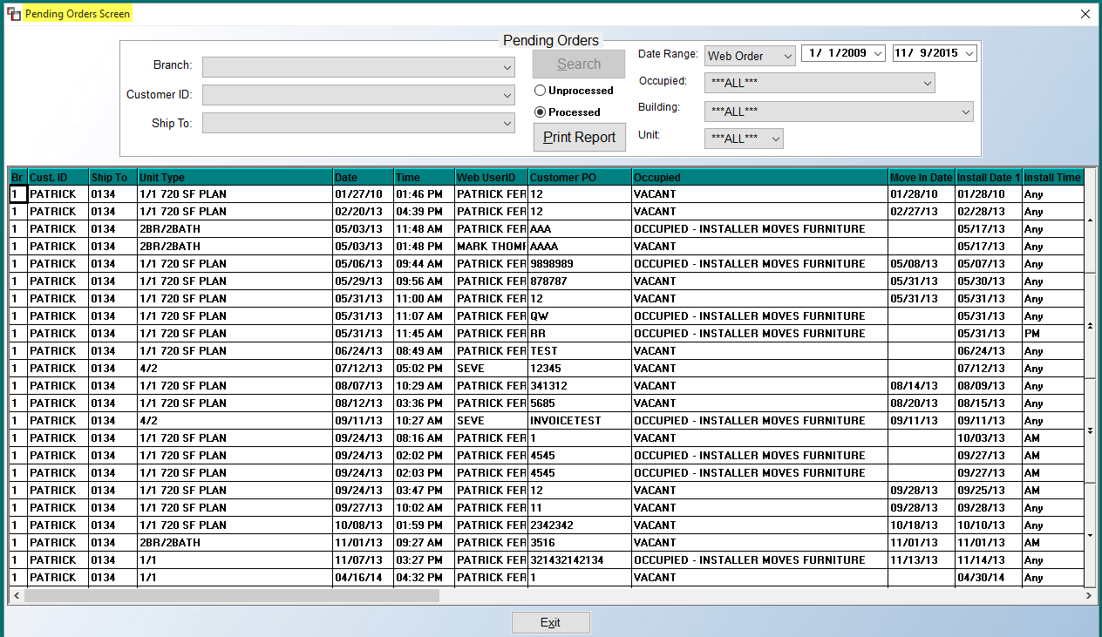

As Web Orders are placed from the Web Portal program, those orders will automatically display in this screen for processing in your RollMaster system. The options at the top of the screen will allow you to sort the displayed data below so you can modify the display by Branch, Customer ID, and Ship To. The Date Range field has an additional option in the drop-down menu for Install Date, which is the date that appears in the Install Date 1 column in the screenshot above. These sort options will be helpful for narrowing down which Jobs and/or Customers need to be processed. This program will maintain historical data that can be displayed by clicking on the Processed option and you can also use the Date Range fields to further isolate your search for either Processed or Unprocessed Web Order jobs. The default for all these fields is “ALL,” so this screen will automatically display all Unprocessed jobs until you begin sorting the data by altering these fields. The Print Report option will print a list of all the Jobs displayed in this screen.

If you click on any field in a line, the system will prompt the following detailed Property Management Pending Order Inquiry screen as follows:

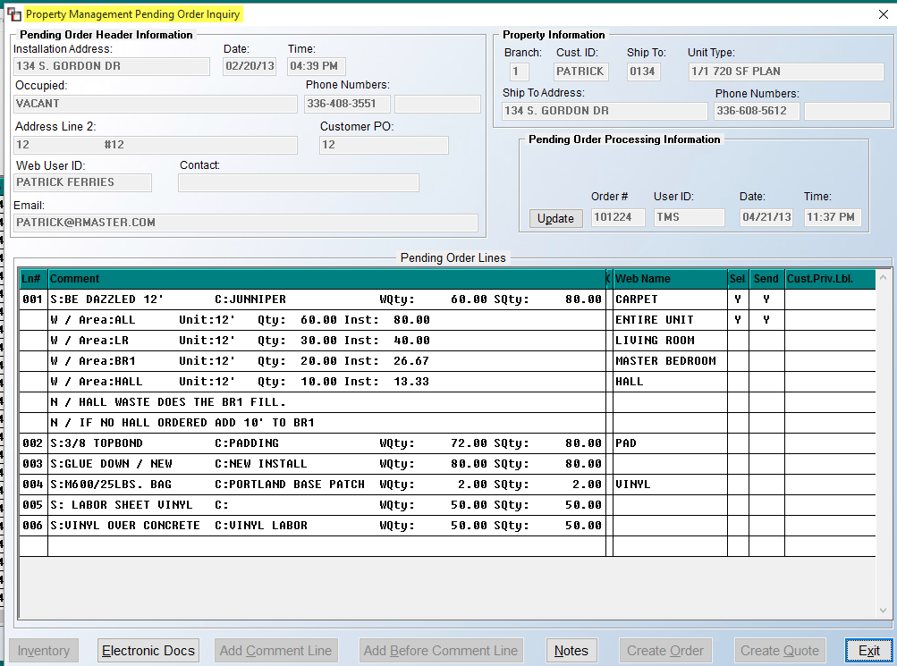

The buttons along the bottom will allow you to accomplish several things prior to creating a Quote or Order in RollMaster. When you first enter this screen, the Electronic Docs button will be available for use and allows you to attach scanned images, signatures, etc. to a Web Order if you have this equipment and functionality available from RollMaster. The Inventory button at the bottom left of the screen will become available if you click on an actual line number in the Ln# column. This option displays On Hand inventory for the material in the line selected as follows:

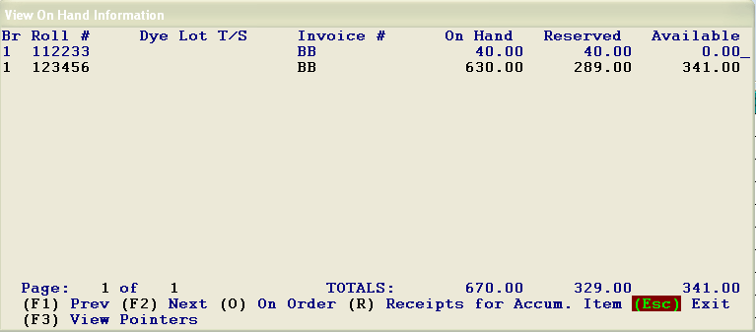

Although you cannot assign inventory from this screen, you will gain a lot of valuable information prior to creating a Quote or Order. Hit the Esc key to exit this screen and continue processing the Web Order. If you click on a material line under the Comment column, the system will display an Update Line Quantity box as follows:

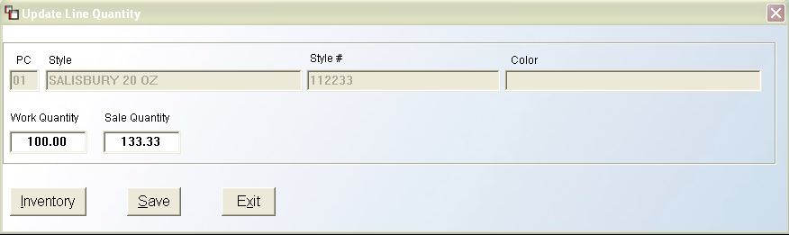

You can adjust the Work Quantity and Sale Quantity fields from this box prior to converting the Web Order to a Quote or Order in the system if applicable. The Inventory button in this screen works the same as just described above. If you make any adjustments to the quantity fields be sure to click the Save button before clicking the Exit button. If you click next to a comment line under the Ln# column, all of the notes options along the bottom will become available. The Add Comment Line will allow you to add additional comment lines under each material line if applicable. This feature works the same as the Line Comments feature available from the Order Entry/Maintenance module. Also, you can click on any existing comment line to change the Type of line it is by clicking directly on that line in this screen. Additionally, you can adjust Floor Plan comment lines by clicking directly on those lines in this screen. If you wish to insert a new comment line higher up in the order, you will need to use the Add Before Comment Line button. Place the cursor in a blank field under the Ln# column next to the line you wish the new comment line to appear before and then click the button.

The Notes button is an important feature as it will display any Install or General notes your customer added from the Web Portal system among other useful functionality. You will also have access to the Preferred/Excluded Installers feature explained above. When you click on the Notes button, the system will display the following Pending Order Notes screen:

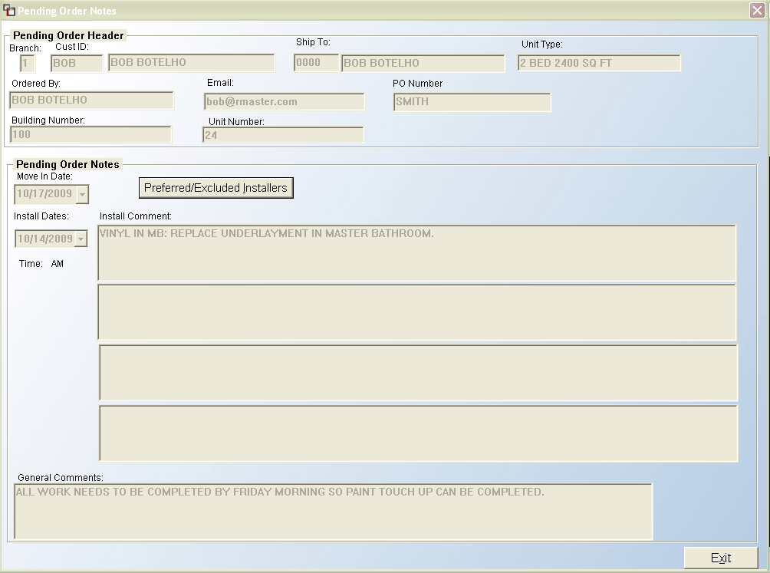

Prior to clicking the Create Quote or Create Order buttons, the final step is to determine which lines you wish to send. The lines with Web Names that were selected from the Web Portal program will automatically be selected. Any additional comments or added comments that need to be sent will need to be selected from this screen. In the Send column, you can change the status to “Y” for yes or change it back to a blank status by clicking directly on that field. Use the up and down arrow slides at the very right of the screen to access additional lines that cannot be viewed from the current screen. When all lines have been selected, you will be ready to create a Quote or an Order in RollMaster.

You only need to create a Quote from this screen if your client requires that a Proposal first be generated and approved before the order can be placed. To place an Order, click on that button and the system will first prompt an Email message that will notify the client and the salesperson, provided that setup has been completed as explained above. The system will create the order and then display the following:

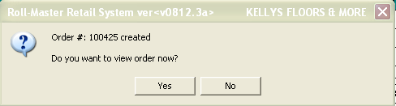

If you click the Yes button, the system will place you in the Order Entry/Maintenance module in that Job. If you click the No button, you can continue in Web Order Maintenance and access the Job at a later time. If you did click the Yes button, the Order screen will display directly on top of the Property Management Pending Order Inquiry screen.

Projects:
This module is available to all customers, but may only apply to commercial or multi-family focused businesses. This module was designed to allow for grouping together multiple Orders (and Quotes where applicable) for the purpose of tracking costs, margins, sales, change orders, and billing. In order to see this new module, it must first be turned on via a Company Control 4 option in the System Control Maintenance module that appears in that menu as follows: Activate Projects Module. There are also a few new User Control 7 options, also located in the System Control Maintenance module, relating to this module that should be reviewed prior to turning on the feature. When you enter this module, the screen will appear as follows:
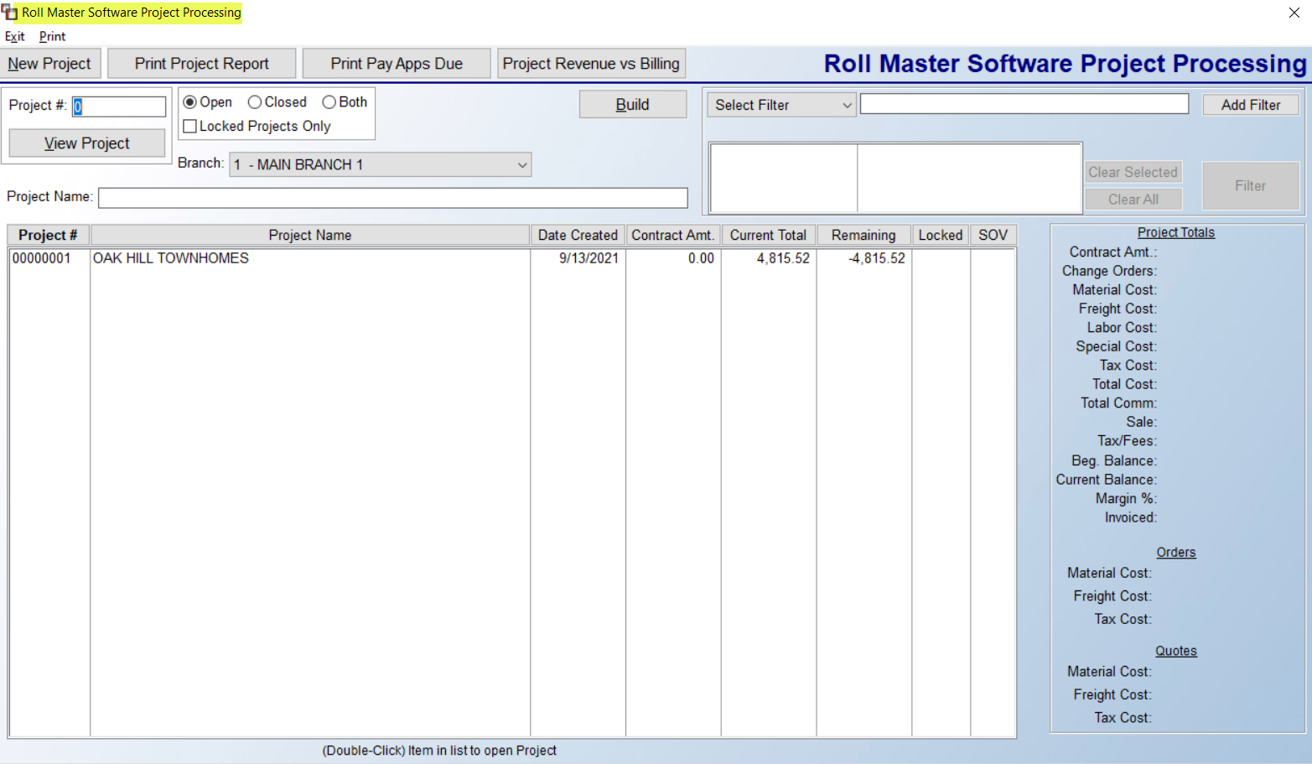

Existing Projects will display in the screen above. When you highlight a Project in this view screen, the Project Totals will display on the right side of the screen for the entire Project. If you right-click on a Project, the system will prompt the following options: View Project, Add Order to Project, and Add Quote to Project—you will also be able to Add an Order or a Quote from inside the Project. To create/add a new Project, click the New Project button at the top left of the screen. The system will prompt the Project Summary tab screen, but you will first need to navigate to the Detail tab screen to add Orders or Quotes to your Project as follows:

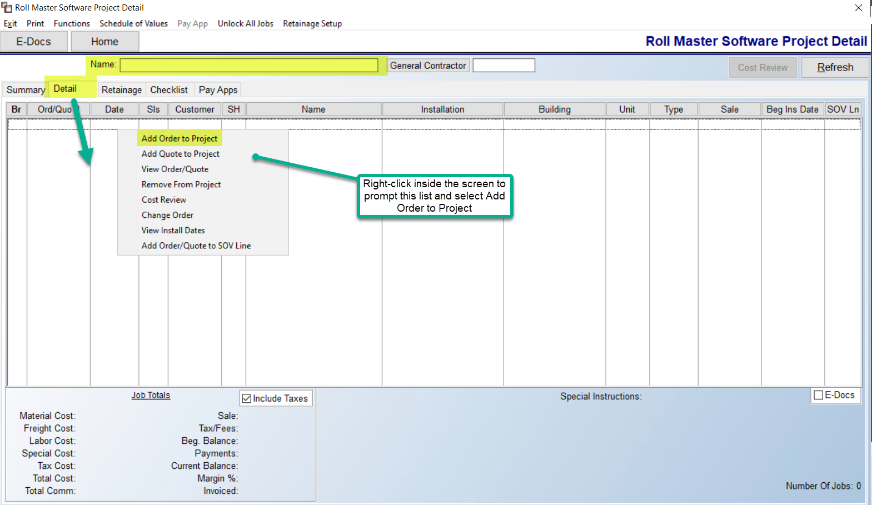

The cursor will be positioned at the Name field. Begin by entering a title or description for the Project. This can be edited at any time. The General Contractor field can be left blank, primarily because the Customer on each job or quote tied to a project is the same. However, you can run reports by this field, meaning you can run reports across all Projects for a particular GC, or you may have other jobs listed because of installer chargebacks or vendor claims, and you would not want those tied to the GC. The General Contractor button and field is tied to the Customer ID lookup.

When you right-click in the screen above, the menu you see displayed in the image above will appear. Click the Add Order to Project to begin building a Project. The system will prompt the Sales Processing screen for you to locate an applicable Order for the Project. Double-click on an Order to select. Please Note: If an Order is tied to another Project, a message will prompt to that effect and you will not be able to select. If any Quotes have been created that will be included in the Project, those can be added in the same manner via the Add Quote to Project option. The View Order/Quote option will prompt the Order or Quote so you can make edits and then return to the Projects module. The Remove From Project option will allow you to untie an existing Order or Quote from the Project. The Cost Review option will prompt the Cost Review screen and include data for all existing Orders. Please Note: if a User is not allowed to see Costs or is not allowed to use the Retail Cost Review feature via the User Control 3 option, they will not have access to the Cost Review feature in this screen. The Change Order option can be used to identify a Job or Quote that should be designated as a Change Order on the Project. If you highlight the applicable Job or Quote and click on this option, a “Y” will appear in the Change column of the screen above. The View Install Dates option will prompt the Install Dates tab screen of the Order you have selected. You can make changes and return to the Projects module. And finally, the Add Order/Quote to SOV Line option will allow you to add the selected Order or Quote to an existing SOV Line. A box with a current list of SOV Lines will prompt and you can double-click to select.

Once you’ve created a Project, you can move to the Summary tab screen to enter initial Project amounts to begin tracking the project. That screen appears as follows:

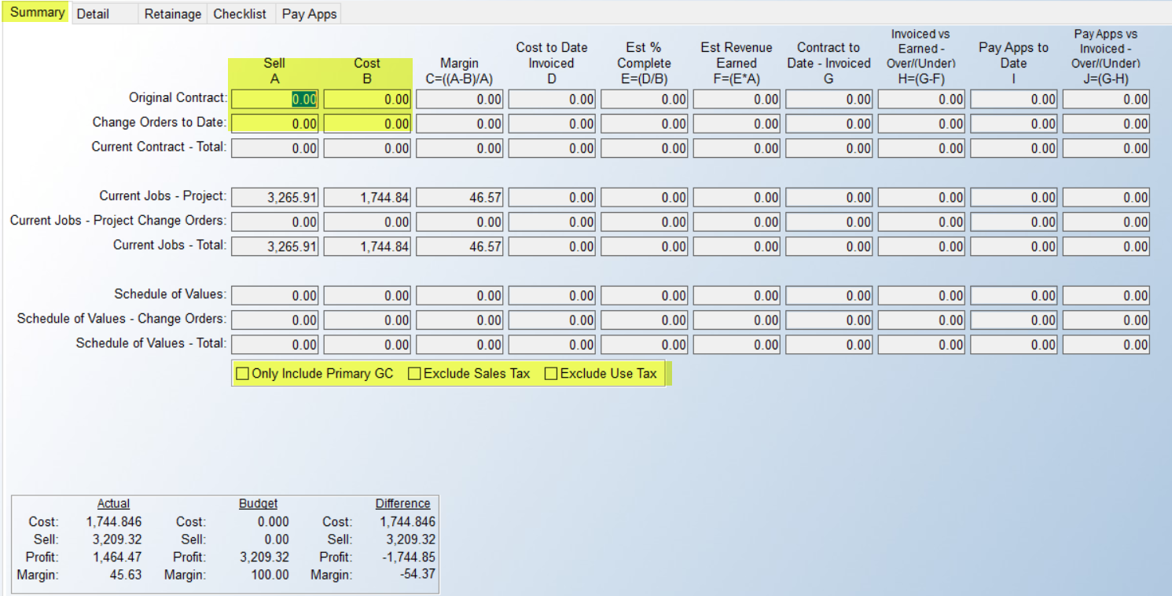

All of the editable fields in the screen above are highlighted. In the Original Contract A and B fields, enter the contracted Sell and Cost figures for the entire Project. These fields can be updated if the info has not been finalized. The remainder of this screen details the accounting side of the project and updates based on completion of work, revenue earned, and invoicing. Below is an example of a Project in progress for example purposes:

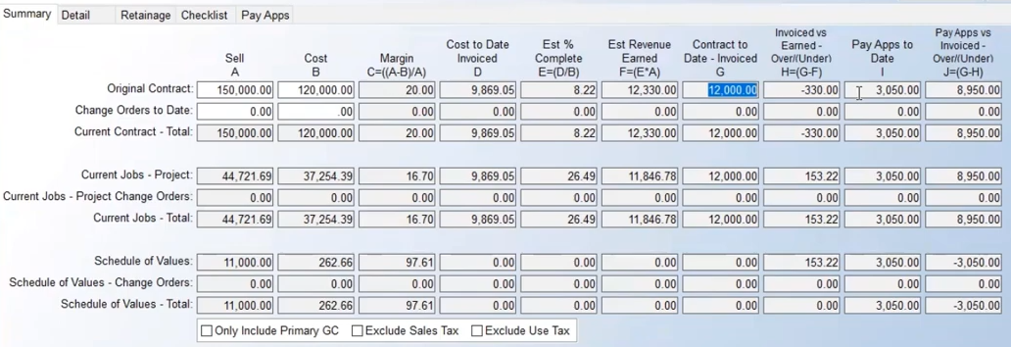

As you Invoice in RollMaster, the system will recognize any revenue and/or cost on what is invoiced and report to this screen. Please Note: It is up to you whether you put your revenue on the principal material lines, or on a Special Charge line for billing (Pay App) only purposes. Across the top of the columns in the screen above, you will see letters, i.e., A, B, C, etc. If a formula is involved in the column calculation, that will also display at the top, along with a brief description. Column D, Cost to Date Invoiced, is coming from any RollMaster Invoices processed on any of the Orders associated with the Project where costs exist. They may or may not have had revenue associated with them, but they had material or labor costs. The Est % Complete, Column E, is taking Column D and dividing it by Column B, which is estimated at this point because final costs are not in. This amount then informs the Column F, Est Revenue Earned, by dividing Column A by Column E. Column G, Contract to Date – Invoiced, displays the total revenue invoiced out on the Project to date. That total then provides Invoiced vs Earned – Over/(Under) amount for Column H, which is the difference between Column G and Column F. A negative amount reflects the Project is under billed, or you are behind on billing, by that amount. A positive amount reflects over billing, which means you have billed revenue you have not yet earned. It’s not uncommon for this column to be over or under during the length of the Project, but extreme values should be addressed.

Another reason to pay attention to these numbers is for making Journal Entries at the end of the month to “true up” your revenue recognized to revenue earned. However, you wouldn’t do this on a single Project level, you will want to use the Project Revenue vs Billing report accessible from the main Project Processing screen. This will give you a total over/under figure for the company, which is the total amount that should be journalized. Similarly, the last two columns will track Pay Apps to Date less Contract to Date and determine if you are over or under on submitting Pay Apps. That covers the columns, so next we’ll explain the purpose of the three groups of rows. When you first land a project, you may not necessarily set up all your phases of the job, for example if this is a long-term multifamily project where completion may not happen for several months or more. In this case, you will still want to put your original contract amounts in first row, but in the middle section, you will want to know what’s happening with just the current building or current phase. Eventually, these will even out as the project concludes, but you may encounter Change Orders that need to be entered, so you can adjust the first two columns in the first two rows as needed. The final three rows are for tracking Schedule of Values, as it progresses.

The Retainage Setup option allows up to three setup items per Project. These must be setup prior to submitting any SOVs. When you click on that option and select a Retainage Setup item, the system will display the following:

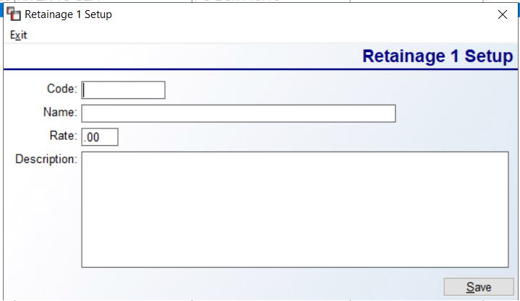

You will create a Code, Name, Rate and Description for each. These need to be setup for each Project according to what was contracted initially.

The Print menu at the top left of the screen will prompt the following options: Print Job Summary, Print Line Summary (Excel Only), and Print Line Detail (Excel Only). The first report displays one row per Job, the next displays one row per Line Item, and the last somewhat mirrors Detailed Job Cost View/Print. In addition to displaying one row per Line Item, it will also display additional rows for Inventory Reserves and Labor Payments.

The Function menu, to the right of the Print menu, will prompt the following options: Close Project, Open Project, Lock/Unlock Project. There are User Control 7 options (explained below) that determine which Users will have access to these options. The Close and Open options impact the entire Project and will typically only be used to Close upon completion of the entire Project, and Open only if necessary. Neither of these options impacts billing or sales analysis in any way. The Lock/Unlock feature allows a User to Lock the entire Project and prevent anyone from adding or removing Orders/Quotes, or making changes to the Original Contract fields in the Summary tab screen. The E-Docs button at the top left can be used to attach documents relating to the entire Project. Please Note: It will not display any E-Docs on individual Quotes or Orders tied to the Project.

Schedule of Values and Pay Apps:
These are both optional to use, but once you understand the functionality, you may decide to take advantage. Some people may prefer to use Excel to track their Schedule of Values (SOV), which is fine, but this module does allow for importing and exporting SOV Lines (importing only works up until a submitted Pay Apps exists). When you click on the Schedule of Values option, the system will prompt the following:

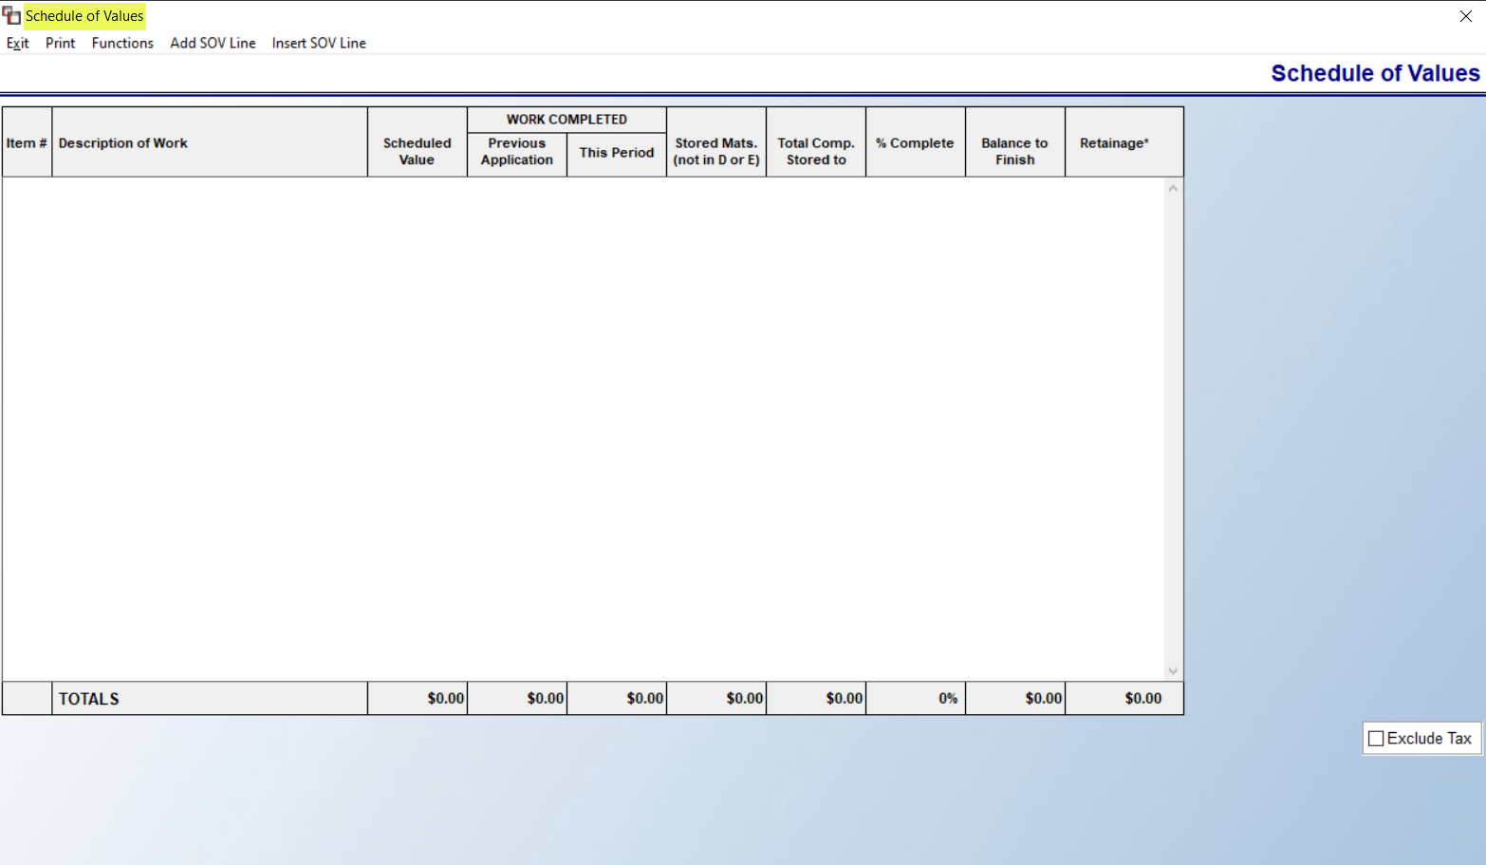

The Functions menu at the top of the Schedule of Values screen contains three options as follows: Export SOV, Import SOV, and Pay Apps (this option is explained below). To manually add, click Add SOV Line and the system will prompt that screen as follows:
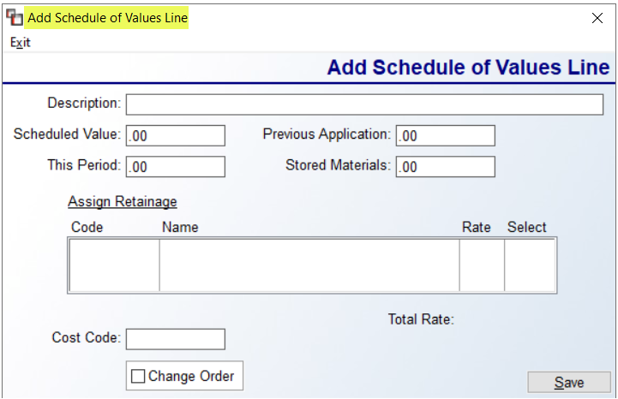

Begin by adding a Description of the work, the Scheduled Value of that work, and any Retainage that has been set up (explained below.) Then click Save. The system will automatically track the other columns in the main screen. Once the SOV Lines have been added and the Project is moving forward, at some point you may wish to schedule Pay Apps. This is commonly referred to as a G703, and if the contractor requires this, you will not submit Invoices for payment, but rather scheduled Pay Apps. When you select that option, a Pay Apps screen will appear as follows:

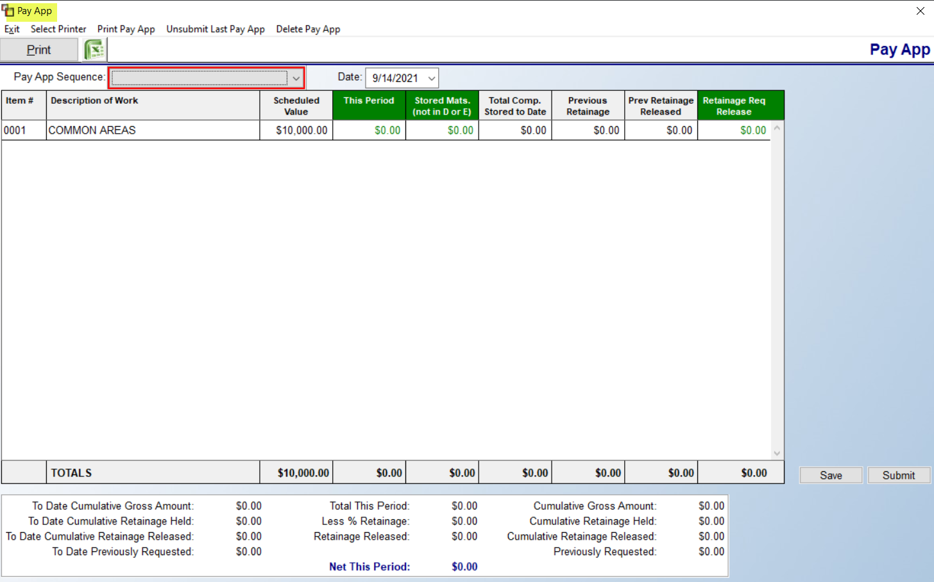
In the Pay App Sequence field, any existing Pay Apps can be accessed via that drop-down. When it’s a new month, the Save button at the bottom right will display New. If you click that button, or click in the This Period column of an existing SOV Line, the system will prompt a box as follows:

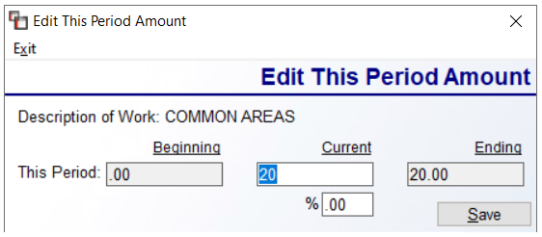

Based on what you’re allowed to submit, you can enter an amount in the Current field, or you can type a percentage in the field below. Click Save to continue. When you are ready to send a Pay App, you will hit the Submit button. Moving forward, you will access via the Pay App Sequence field. The Unsubmit Last Pay App option will reverse that process and allow you to make changes to resubmit, but this can only be done on the last Pay App submitted. You will use the Excel export icon to create the data you will need to submit to the contractor in their required format. One reason to use this feature is so you have a running list these you can view as Receivable Items (not tied to the system G/L) on the Project. From the main screen of the Project, when you click on the Pay Apps tab, it will display a running list of Pay Apps that have been submitted as follows:

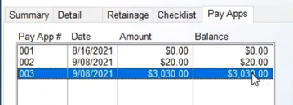

In order to use these successfully, you will need to track payments received and apply payments received in the Pay Apps screen, in addition to Post Customer Payments in A/R. In the Pay Apps screen, select the Pay App Sequence from the drop-down field, and then place the cursor in the Paid Amount field at the bottom right to enter the amount. You can repeat this for each Pay App Sequence as needed. You may need to exit out of the Project to refresh the display screen to reflect the amounts applied. The Print Pay Apps Due report, accessible from the main Project Processing screen, looks similar to the A/R Aging Reports, but is helpful in tracking Pay Apps across all Projects.

In the Order and Quote Entry modules, when Projects is enabled, a Project tab will appear next to the Job Detail tab and will display the Project name, basic data, and includes a button to View Project as follows:

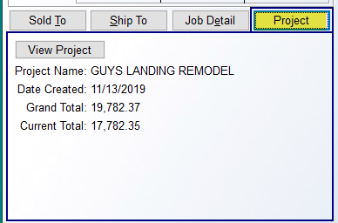

Salesperson Payables System:
This module keeps track of Salesperson commissions and gives you some analysis tools with which to manage the sales department. When you are ready to pay commissions, this module will print a Payables Report showing a breakdown of the commissions to be paid. The commission information from a Job will only appear in this module when it has been invoiced in the system. The module also keeps track of whether a Job has been paid or not, so commissions can be paid only on Jobs where the Customer has paid in full, if applicable to your company policy. This module can display information for one Salesperson at a time or can be viewed for all Salespeople in a Branch or all Salespeople in all Branches. When you enter this module, a menu screen will appear as follows:
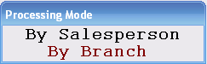

If you would like to process payables for one Salesperson at a time, select the By Salesperson option. If you would like to process payables for all Salespeople within a Branch, or across all Branches, at once, select the By Branch option. The system will place you at a Branch field, defaulting to the current Branch. To process for just that Branch, hit enter to continue and all display screens and reports will include all Salespeople within that Branch. You can also process another Branch separately by typing in that Branch ID. If you wish to process all Branches at once, space out any Branch ID and leave the field blank. All display screens and reports will then include all Salespeople in all Branches. Whether you selected an individual Salesperson or the entire Branch or all Branches, the system will prompt a Select Option menu as follows:

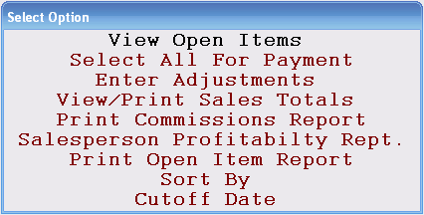

The View Open Items option will display a screen containing all the open items for the Salesperson or Salespeople you have selected. Within this option, you will select the Jobs for which commission is to be paid. When you hit enter at this option, a View Open Items screen will appear as follows:

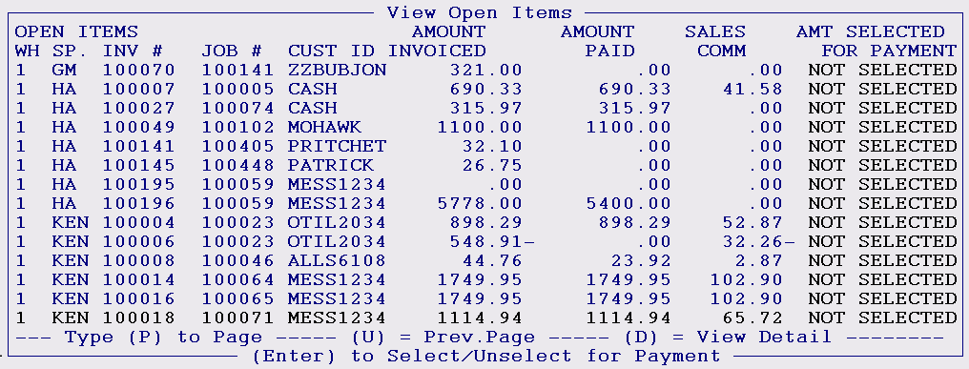

From left to right, this screen will display the corresponding Branch ID (WH) for the sale, the Salesperson ID (SP) corresponding to the sale, the Open Item (INV #) number, the Job number, and the Customer ID on the Open Item. The Amount Invoiced column displays the total amount of the Open Item. The Amount Paid column keeps track of how much the Customer has paid towards the Open Item to date. The Sales Commissions column displays the total commission amount to be paid for that Open Item. The Amount Selected For Payment column displays whether or not a commission has been selected for payment, and if so, how much is to be paid. Even though the invoicing process in the system sends the commission information to this module, prior to printing the Salesperson commission report and updating the items as paid, you can still make changes to non-sliding scale commissions on a job through the Cost Maintenance module in the Job Cost menu. When a change is made to the commission base or percentage from anywhere in the system, an “*” will appear in the screen above to denote an adjustment has been made and those amounts have changed. The Adjusted amount will display along with Commission Base in the View Detail option from this screen and in the Salesperson Payables History module. Also, the Commission Report in this module and the History module will display an “*” on the printed report.

To select an item for payment, use the up and down arrow keys to highlight the line you wish to select, and then hit the enter key. The system will then prompt the following: Select This Item? (Y,N):_. Type a “Y” for yes and the following box will appear:

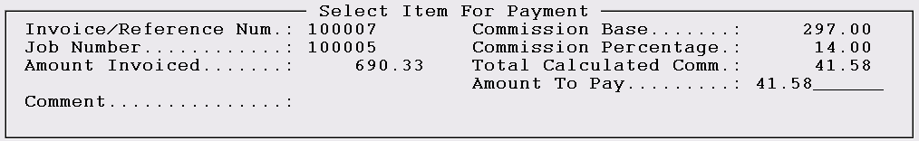

This box shows a little more detail about the Job and will allow you to adjust the amount of commission to pay. To adjust the commission amount, at the Amount To Pay field, type in the commission amount you wish to pay and hit enter. (Caution: if you want the change to be reflected in job cost, you should make the adjustment through the Cost Maintenance module in the Job Cost menu and before selecting the item for payment.) At the next field, you can add a Comment if applicable, and then hit enter to exit the Select Item for Payment box. Items that have been selected for payment will be denoted with an arrow to the right of the line and the commission amount will fill in under the Amount Selected For Payment column in the View Open Items screen. The function at the bottom right of this screen, D = View Detail, will bring up the same information as in the Select Item For Payment box, but you cannot make any changes through that function. When you have finished selecting items for payment, hit the Esc key to return to the Select Option menu.

The second option in the Select Option menu is Select All For Payment. If all the items in the View Open Items screen are ready for processing and no changes need to be made, this option will quickly select all the items for further processing. Important Note: When you use the Select All For Payment option, the system will automatically select Credit Memos that meet the Date Range criteria. When you hit enter on this option, the system will prompt the following:

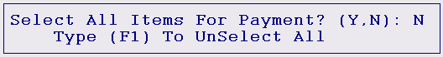

To select all items for payment, regardless of whether they have been paid in full, type a “Y” for yes at this prompt. To unselect all items, hit the F1 key. To select only items that have been paid in full, hit enter at this prompt. The system will then prompt the following:

Type a “Y” at this prompt if you want the system to automatically select only those items that have been paid in full. You can then enter back into the View Open Items menu to see all the items that have been selected. An additional feature to not pay commission on items past a certain number of days can be enabled and used in this module. To turn this feature on, access the Company Control 4 level of the System Control Maintenance module and locate the following control: Comm. not paid on aged invoices. Set this control to “Y” for yes, and then type in the number of days past which commission will not be paid on unpaid Invoices. Once this is enabled, if you hit enter at the Select All prompt and then type a “Y” at the Select Only prompt, the system will then prompt the following:

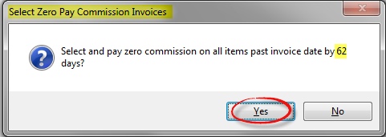
Click Yes in this screen to continue with this process. When you select the Print Commissions Report (explained below), you will see all Invoices that fit the parameters of this feature listed with an Amount Selected of “0.00” and the following in the Comment column: ZERO COMM.- UNPAID AFTER XXX DAYS.

Please Note: If cost changes are made to a Job after invoicing via the Job Labor Maintenance and/or the A/P Open Item Maintenance modules, and the corresponding commission has not been selected for payment, the system will automatically adjust the commission amount. If the commission has been selected but not paid, the system will rewrite the record changing the commission base and percent (if applicable) and also change the amount selected for payment to reflect the adjustment. If the commission has already been paid, the system will create an adjustment line in Salesperson Payables automatically to account for the change in commission. If this is the case, you will see “**” next to the Invoice Number denoting that a change was made from either Job Labor Mtc. or A/P Open Item Mtc. after the item was paid. When selecting one of these adjustment lines for payment, the system will display the Job # and Line # in the Comment field for reference.

The Enter Adjustments option will allow you to make any necessary adjustments to a Salesperson’s commission amount, however, any adjustment you make in this option will not affect job cost. You can also use this option to pay bonuses. When you select this option, the following screen will pop up:

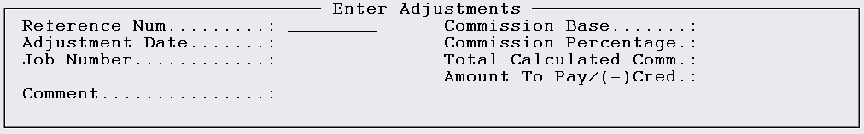

Begin by creating a Reference number for the adjustment. Then enter the Commission Base that applies along with the Commission Percentage to be paid. The system will calculate a commission amount and fill in the information in the next two fields. Please Note: You can create a negative amount by typing a minus sign before or after the amount to take away from the commission total when applicable. The comment line will further help to identify why the adjustment was made. When you complete this screen, the system will prompt the following question: Select This Item For Payment Now? (Y,N). If the adjustment needs to be reflected in the upcoming commission check, type a “Y” for yes; if not, enter “N” for no. and the adjustment will remain in the View Open Items screen until it is selected at some point in the future.

The View/Print Sales Totals option provides helpful sales analysis information for each Salesperson. Again, only invoiced Jobs will be reflected in this option. Changes made in the Cost Maintenance module after invoicing will also be reflected in this option. When you select this option, the following screen will appear:

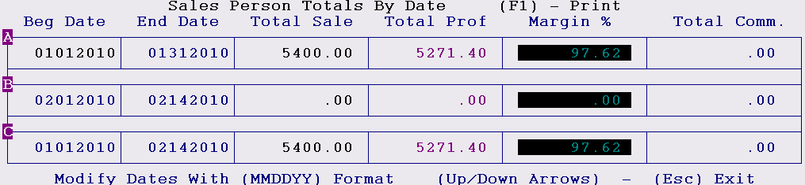

There are three date parameters fields you can use to view different date ranges. This example shows a previous month, current month, and year-to-date comparison. You can enter any date parameters you wish to get instant sale, profit, margin %, and commission totals. Any Credit Memos will be reflected in these totals. The F1 key will print out the information on the screen.

When you have completed selecting items for payment and are ready to run a Commission Report, arrow down to the Print Commissions Report option and hit enter. The following box will pop up:

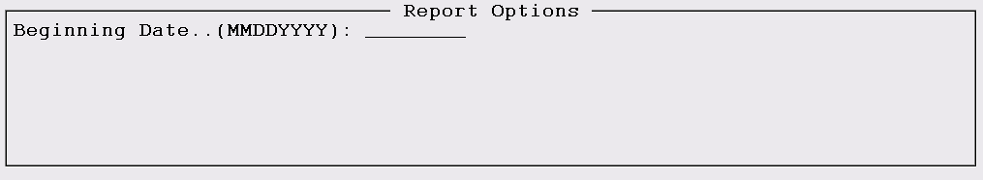

The Beginning Date field will allow you to enter a beginning date for the report. If you enter a date in this field, the system will not display any Open Items that were created prior to this date. You do not have to use this field—it is only there if you wish to customize the report with a Beginning Date. When you enter through the first field, a second field will prompt as follows: Print Selected/Unselected /Both: S (S/U/B). At this option, you can select to see only those items that have been selected for payment, only those that have not been selected for payment, or both. Once you make your selection by typing the applicable letter in this prompt, the system will prompt the following:

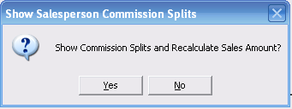

This feature was added for those RollMaster clients using split commission in the system. If you would like to see the Commission Splits on the report, select “Yes” at this prompt. If not, hit enter to continue. The system will then prompt the following:

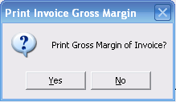

The Gross Margin is the margin on the Job before Commissions are calculated. The default is set to “No” so you can hit enter to continue or click on “Yes” if you would like to include the Gross Margin of each Invoice on the Commission Report. The system will then prompt the following: Print Each Line Item. If you type a “Y” for yes at this field, the system will display each line item from each Open Item on the report. When you have entered through this last field, the system will then prompt the following: Continue? If you need to make changes to your previous selections, type an “N” for no at this prompt and you can begin again. If you are ready to proceed, type a “Y” for yes and the system will then prompt the following: Number of Copies: 1. Hit enter for only one copy of the report or type another number at this prompt to produce multiple reports. Once you have entered through this box, the system will prompt the following:

If you are ready to run commission checks, type a “Y” for yes at this prompt. This will delete the items from the View Open Items screen. Regardless of how you respond to this prompt, the system will print out a Salesperson Commissions Report. If you are using the Draw Against Commission functionality, the system will prompt you to update that information in the system. You will then see the following prompt:

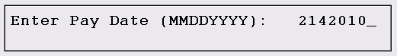

This prompt will default to the current date but you can override if you need to change the date to the intended payroll date. Type in a new date in this field or hit enter to accept the default date. The system will then prompt the following: Is Pay Date Correct? To make a change type an “N” for no and the system will return the cursor to the pay date field; otherwise hit enter to continue.

The Salesperson Profitability Report option can be used at any time to produce additional reporting on salesperson profitability. When you select this report option, the system will prompt a Select Print Option box and the cursor will be positioned at the following prompt: Do You Want To Print (S)ummary or (D)etail Report. The Summary report will give you one line totals for Sales, Profit, Gross Margin, and Total Commissions. The Detail report will list each Job that makes up those totals. (Please Note: This report is displaying gross margin based on net profit after commissions. Sales Analysis displays gross margin based on net profit before commission.) Type an “S” at this prompt for Summary or a “D” for Detail. The system will then prompt the following: Enter Branch or (F1) for all branches, and the cursor will be positioned in a Branch field. Hit enter to select the current Branch, type another Branch ID, or hit the F1 key to select for all Branches. The system will then prompt you to enter a Beginning and Ending Salesperson ID. If you only wish to print this report for one Salesperson, type those initials in both fields; if you wish to print the report for a range of Salespeople, type a beginning and then an ending ID. The system will then prompt the following: Date Selection (S-Salesperson Paid Date / I-Invoice Date): S. The Salesperson Payables system is storing the Salesperson Paid date along with the Invoice Date, therefore, you can print this report by either option. This prompt is defaulting to “S” for Salesperson Paid Date; hit enter to accept or type an “I” to print by a range of Invoice Dates. The system will then prompt you for a Beginning and Ending Date for the report; in each field, you will need to type two digits for the month, two for the day, and four for the year. In the final prompt, you can type a specific job number or hit enter to include all Jobs. The screen should now appear as follows:

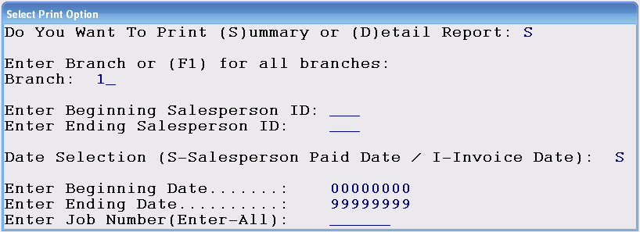

The report will begin printing once you have entered through the last field. On the printout, if you selected to print by Invoice Date, the listing will include all Jobs where Invoices have been processed (not necessarily Invoices paid) in the date range for that Salesperson, regardless of whether the commission has been selected and paid or not. If you selected to print by Salesperson Paid Date, you will only see paid commissions for the date range entered.

The Print Open Item Report displays all the items currently in the View Open Items screen. If you would like to look at the items before deciding what to pay, print this report. You can also export this data to Excel. The export will include a Remnant column, but only as long as the Print Each Line Item option is set to “Y” for yes and the inventory assigned to the line is flagged as a Remnant. This report can be sorted through the Cutoff Date and Beginning Date explained below. The Sort By option will allow you to sort the View Open Items screen, the Commissions Report and the Open Item Report by Job Number rather than Invoice Number. When you select this option, a box will pop up prompting you to select Invoice Number or Job Number. The default option is the Invoice Number option, so the only reason to select this option is if you would like to sort by Job Number. The reason for this sort is so that multiple Invoices for the same Job can be lined up together to see whether the Job has been paid in full rather than searching through the list. The last option is the Cutoff Date option, which will allow you to enter a date that will act as a cutoff for displaying Invoices past this date. For example, if you enter a date of 05312006, the system will not display any commission data invoiced after that date. Once a Cutoff Date has been set, the View Open Items, Commissions Report, and Open Item Report options will use this date to determine which items will display.

The Salesperson Payables module and reports has some functionality for tracking commissions on jobs that have been Progress Billed. Those changes appear as follows: the Salesperson Payables module will display a “P” before the Invoice number on the Progress Billed final Invoice; you can enter a job number when making commission pay adjustments; Salesperson Payables History has been updated to display a “P” before the Invoice number on Progress Billed final Invoices; the Salesperson Profitability Report was modified to include a report option to run by a specific job number; the Invoice file now tracks the current date, time, Invoice Register date, User Id and device (if you would like to view this data, go to Sales Processing reports, Invoice/Credit Memo and hit F2 Reprint. Put in the Invoice number and this information displays at the bottom left side of the screen.).

If you wish to pay your Salespeople as subcontractors, much like an installation subcontractor, with some setup, the Salesperson Payables System module will interface with A/P Open Item Maintenance so that 1099 payments to Salespeople can be posted without requiring you to exit the module. If you are interested in using this feature, contact RollMaster Support to have a G/L Account for Salesperson Expense entered in the Branch Maintenance screen. Once this is complete, in the Salesperson Maintenance module, you will now see applicable fields that need to be completed at the bottom left of the screen as follows:

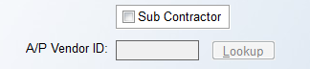

Please note: You do not need to create a "matching" A/P Vendor ID, since there are only 3 characters for the Salesperson ID, but you WILL need to set up a Vendor ID specific to each Salesperson for this process to work, making sure you add the Salesperson's SS# in the Vendor Maintenance screen. When the Sub Contractor box is checked, you will select the applicable A/P Vendor ID for the Salesrep. With setup complete, during the Salesperson Payables process, when commissions are marked as “Paid,” the system will prompt the A/P Open Item Maintenance screen and fill in available data. Once the data is entered and saved, the system will return you to the Salesperson Payables module to process the next one.

Clear Inventory Holds On Quotes:
This module is tied to the Company Control 1 option, Allow Inventory Holds On Quote. If this option has been enabled, and holds have been placed on inventory in the Quotation module, this module should then be accessed on a daily basis to clear Holds that have expired, thereby returning material back to available stock. When you have finished running this module, the system will print a listing of any material that has been taken off the “Hold” status. When you enter this module, a Clear Expired Quote Inventory Holds screen will appear as follows:
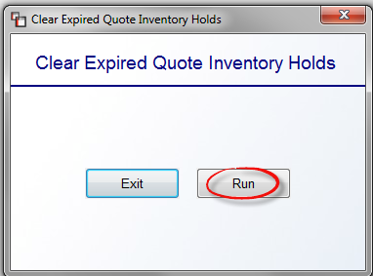
Click the Run button to start the process. The system will search for expired Quote holds, clear them, and then produce a report on any cleared inventory holds.

Sales Processing Setup Programs

Salesperson Maintenance:
Every individual who sells products and services in your store, regardless of whether they receive a Commission, needs to have a Salesperson ID setup in the RollMaster System in each Branch where they will process sales. All Salesperson IDs and related Commission and salesperson data is set up from within this module. When you enter this module, the system will prompt a Sales Person Maintenance selection screen as follows:

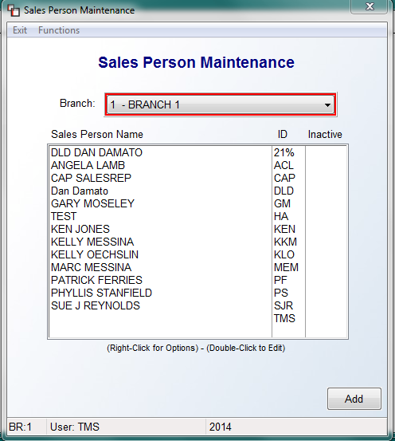

All Salesperson IDs that currently exist in the system will automatically appear in this screen. The Branch field will default to the current Branch. You can switch Branches by clicking on the down arrow button and making a selection from the drop-down menu. A list of all current Salespeople for the Branch will display in the Sales Person Name box along with their corresponding ID. The Inactive column will display a “Y” next to any Salesperson that has been set to Inactive in the individual Sales Person Maintenance screen. To add a new Salesperson, click the Add button at the bottom right of this screen. An individual Sales Person Maintenance screen will appear as follows:

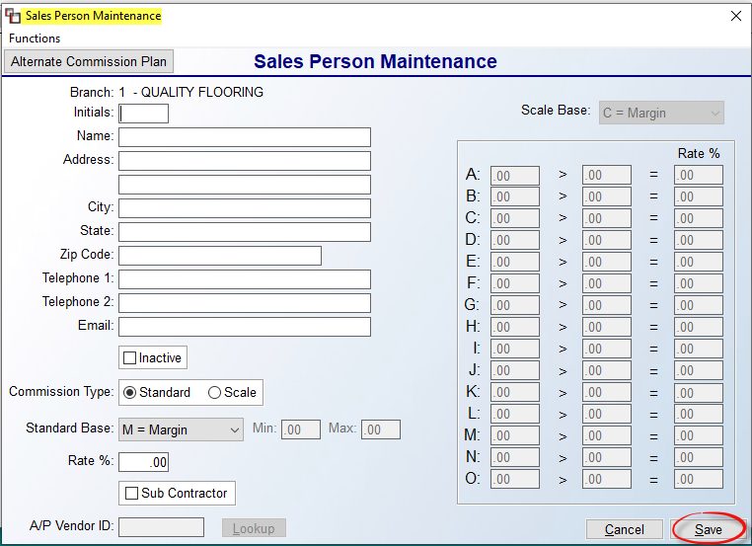

At the Initials field, type up to three alphanumeric (using letters and/or numbers) characters to create a new unique ID. Type in the Salesperson’s name, address and telephone number in the next few fields. The Email field should reflect an accurate email address for the Salesperson in order for the system to properly alert this person when certain processes occur in the system. The Inactive field is not applicable for new Salespeople, but should be checked down the road if the Salesperson no longer works for the company. When checked, the ID will no longer display in any Salesperson Lookup screens with the exception of this module, Salesperson Payables, Salesperson Payables History, and Sales Analysis. The remainder of this screen is for setting up commission rate information. Please Note: The system will allow you to override these settings, when applicable, for any Standard Commission Salesperson on a job-by-job basis through the Cost Maintenance module.

At the Commission Type field, you have two options. The Standard Base option will allow you to access the next two fields, and the Scale Base option will place the cursor at the Scale Base field (explained below). The options for the Standard Base field are as follows: M for Margin, T for Total, L for Total Less Labor, P for Margin Less Labor, G for Gross Profit, and X for Enter Base/Com. If the Salesperson receives a percentage of the profit, select M. If the Salesperson receives a percentage of the total job, select T. If the Salesperson receives a percentage of the total job excluding any labor, select L. If the Salesperson receives a percentage of the profit excluding any labor, select P. The “G” for Gross Profit option is based on the Gross Profit of the Invoice. If you select this option, you will see a Min and Max fields display to the right. Determine the Minimum and Maximum Gross Profit spread you will pay commission on and enter that in the Min and Max fields. Using 15 and 40 as an example, if an Invoice has a GP of 15%, the salesperson will receive 15% of the Gross Profit, and so on up to 40%. Anything above 40% Gross Profit, will still earn 40%. Anything below 15% will earn 0. The final option, X-Enter Base/Com, is rarely used, but allows for manually entering the Commission Base and the Commission Amount, allowing the system to then calculate the Commission Percentage. The Percentage field will allow up to 5 digits after the decimal point. These entries must be made in Cost Maintenance just prior to Invoicing, or they can be made during Item Selection in Salesperson Payables. You may want to discuss with your trainer prior to use.

In the Rate % field, enter the standard percentage amount, in whole numbers, that applies to the Salesperson. For example, if the Salesperson receives a percentage of the profit margin, say 20 percent, enter “20” in this field. In the case of a Salesperson or other employee who sells but is paid a salary instead of a commission, simply enter “0” in the Rate % field. The Sub Contractor checkbox field and the A/P Vendor ID field are only for businesses that pay their Salespeople as 1099 subcontractors. If this is the case, click the checkbox and perform a Vendor Lookup of the ID set up for this Salesperson. If this does not apply, leave these fields blank.

Click the Save button to keep the data and continue adding another Salesperson. (It is important to note that the options that exclude labor will not work properly if you enter an installed price on a material line and then a zero sale price on the labor lines. This is because all the profit will then be figured in the material total and the system has no way to distinguish between labor profit and material profit when it is lumped together on a material line.)

The Scale Base option, which is basically a Sliding Scale Commission Rate, can be used to program a range of commission percentages to pay based on the total profit margin on each job. (Once the system calculates a commission rate based on the sliding scale information you input, you will not be able to make any adjustments via the Cost Maintenance module. You can, however, switch the Commission Type in that screen to Standard Base and then make a change.)

At the Scale Base field, use the drop-down arrow to select how you wish the commission to be figured, using the same guidelines explained above, but using the associated letters in this field, C for Margin, O for Percentage, N for percentage of the Total Less Labor, or R for percentage of the Margin Less Labor. In the A-O fields, you can program up to 15 different commission percentages. However many you choose to program, you have to program a range from 0-999.99. Also, there is a Company Control 2 prompt in the System Control Maintenance module that, when enabled, will eliminate the need to program negative sliding scale commission levels for the Credit Memo program (see Sliding Scale (Auto. Neg. Comm.) option explained in the System Control Maintenance section of the documentation). If you enable this option after Scale Base fields have been completed, make sure you delete any existing negative sliding scale commission levels that have previously been set up. On Invoices with negative margins, with the above option enabled, the system will find the positive margin range in the Sliding Scale you have programmed and use that commission percentage. If one or more Invoices appears on a Job and a Credit Memo is processed, the commission calculation will use the commission percentage of the total Invoice the Credit Memo lines were originally invoiced on and calculate a negative commission for those lines. If you wish to enforce a different negative commission scale, then you will need to set that up in this screen rather than use the option described above.

The following is an example of a sliding scale using a Margin scale base as opposed to a Total scale base (margin ranges and commission percentages shown are purely for example and should not be considered industry standard):

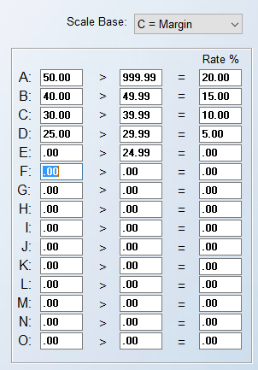

As you will note from the example above, line A should be used to program the highest margin range for which you will pay the highest commission percentage. Regardless of the figure you type in the first field, you must type 999.99 in the second field of line A. Also, the second field of each subsequent line must be no more than one tenth of a percentage point lower than the first field in the previous line, e.g., 49.99 if the previous line figure is 50.00, etc. In other words, there can be no gaps between the margin figures from one line to the next. Finally, you must type .00 in the first field of the lowest margin line—see line E in the example above. Although the example above uses five lines, you can set up a sliding scale using less than five lines or as many as 15—you just need to make sure you program a range from 0 to 999.99. Be sure to click the Save button at the bottom right of the screen to save the data before exiting.

If you wish to edit the data on an existing Salesperson, from the main Sales Person Maintenance screen, highlight the Salesperson from the list and either double-click on the name to bring up the existing data for that sales person, or you can hit the right-click button on the mouse to display two options, one of which is Edit Sales Person. Once you make any applicable changes, be sure to click the Save button before exiting the screen. The other option available when you right-click on a name is Delete Sales Person. You should ONLY to do this if a Salesperson has no history in the system, otherwise your Sales Analysis reports will be impacted—the data will continue to display, but the ID will be unknown. The preferable method would be to set the sales person to Inactive.
From within this module, you also have the ability to Copy a Salesperson to another Branch. To perform this function, once a Salesperson has been added, enter into the individual Sales Person Maintenance screen for that ID. At the top left of the screen, you will see a Functions menu. When you click on that menu option, the system will display the following: Copy Sales Person to Another Branch. When you select this option, the system will prompt a Branch Selection box as follows:
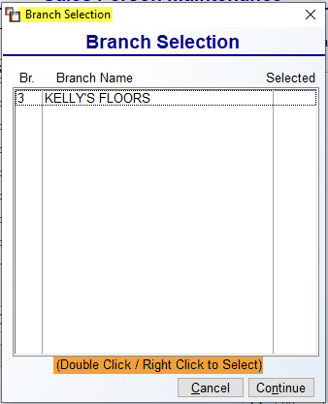
Double click on each applicable Branch to Select, or right-click to do the same. Click the Continue button to complete the process. A second option appears in the Functions menu as follows: Copy Sales Person Commission. This option allows for copying of one Salesperson’s commission set up to all Salespeople within a selected Branch. Make sure you are in the Sales Person Maintenance Screen for the commission setup you wish to copy to ALL Salespeople within a Branch. When you select this option, the system will first prompt a Branch selection box and default to the current Branch. Accept the default or select another Branch and click the Copy button.

A final option available from the Functions menu--and also has button access just below the Functions menu--appears as follows: Alternate Commission Plan. This was added for situations where a Salesperson may sell commercial and residential jobs, and their pay structure may be different for each. In this case, rather than have two different Sales IDs to dilute analysis and reporting, this feature allows for tracking alternate plans--up to 20--under the same Salesperson. When you click this option, a box will prompt for you to click Add to access the Alternate Commission Plans box as follows:

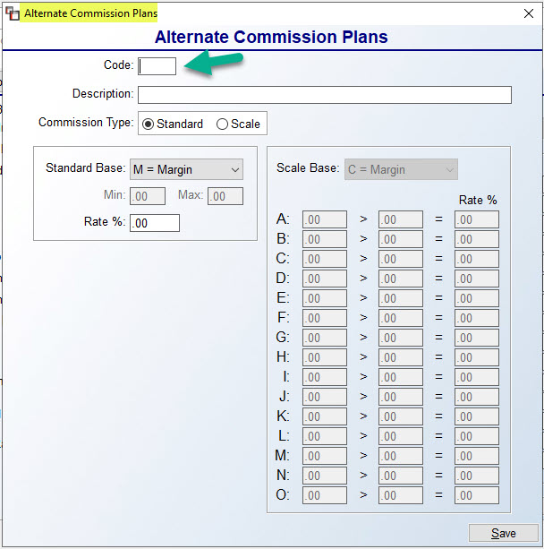

Create a Code for each Plan. You can even create a different Code for Standard and Scale for a Salesperson. Once a Code/Plan has been created, if needed, it can be set to Inactive via a checkbox that appears to the right of the Commission Type box as follows:

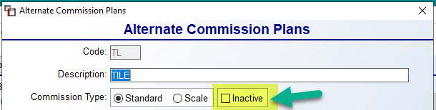

These Codes will be assigned in the Sales Reps field on the Quote/Job, but the tracking will all stay under the main Salesperson. The drop-down menu will display all Alternate Plans as follows:

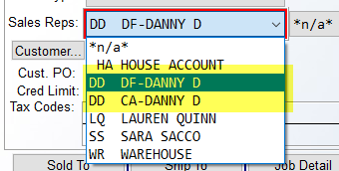

The “DF” and “CA” after the Sales ID denotes the two different Codes. When Alternate Commission Plans exist for a Salesperson, a Plan Name field will display next to the Initials field in the Salesperson Maintenance screen. The first Plan in the list box will display here. Also, you can set these Alternate Commission Plans as defaults in Customer Maintenance. When Alternate Commission Plans exist in the system, the Excel export data on the Print Job Report, will include this info.

One additional feature to this Alternate Commission Plan setup is completely optional and appears in the Job Type Maintenance module. If you use a recurring or standard Code for several Salespeople, you can add the Code to the Job Type Maintenance module, thereby defaulting that Code for the Sales ID selected based on Job Type. That field appears as follows:

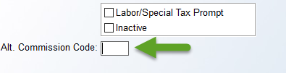

Returning to the main Salesperson Maintenance module functionality, there is one additional option available that allows for changing the Salesperson ID on all Customer records in the system at once. This is helpful for updating the system with new information when a Salesperson leaves the company and is replaced by a new Salesperson, especially with Builder or Property Management clients. When you first enter the Salesperson Maintenance module, at the top left you will see another Functions menu. When you click on that option, the system will display the following: Change Sales Rep. on All Customers. When you click this option, the system will prompt a Sales Rep Change Screen as follows:

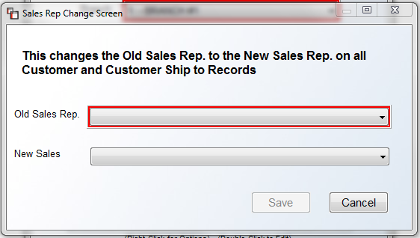
Make sure you have added the new Salesperson ID prior to starting this process. When you are ready, use the drop-down menu to select an ID from the Old Sales Rep field, and then select the new ID from the New Sales field. Once both IDs are displayed in the box above, click the Save button to complete the process.

Salesperson Draw Maintenance:
This module will allow you to set up a true Draw Against Commission when calculating salesperson commissions on a salesperson-by-salesperson basis and the module will keep track of all Draws paid and all Draw Balances accrued. The only pre-requisite for using this module pertains to multi-branch companies. In this case any salesperson being set up with a Draw must have the exact same Salesperson ID throughout all branches. Also, in order for this option to appear in the Sales Processing Menu you must enable this feature in the Company Control 2 screen of the System Control Maintenance module. It will appear as follows: Salesperson Commission Draw Paid. Make sure this control is set to “Y” for yes to use this feature. With this control set to “Y”, you will now be able to complete the setup for any true Draw Against Commission salespersons. When you enter this module the system will prompt you to enter the Initials (Salesperson ID) of a salesperson you wish to setup on this Draw program. Once you enter a recognized ID, the system will display the following Edit Salesperson Data screen:

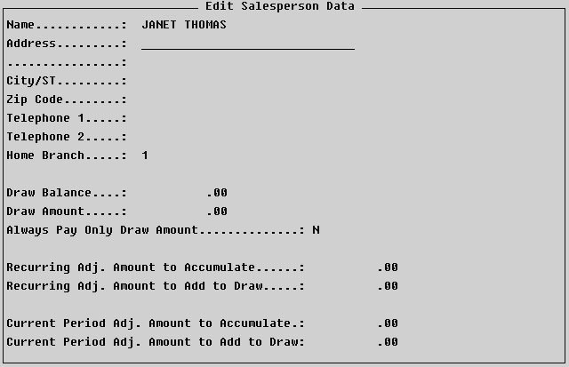

It is not required but you can fill in the Address, City/ST, Zip Code and Telephone 1 & 2 fields for each salesperson. The Home Branch should be set to the Branch in which you will be mainly processing payables for this salesperson. In the Draw Balance field, the system will keep track of the total amount of Draw’s paid for the current pay period. Please Note: if you ever wish to adjust the Draw Balance amount, while the cursor is on the Draw Amount field below, hit the F5 key to gain access to the Draw Balance field, making sure it is a negative number once the change is made or 0.00. In the Draw Amount field type the amount of the Draw you will be paying prior to processing an actual commission report. For example, if a salesperson will receive a $500 per week Draw, enter ‘500.00” in this field. At the Always Pay Only Draw Amount field if you will only ever pay the Draw and never process a commission less paid Draws report, set this field to “Y” for yes. Otherwise leave it set to “N” for no. At the Recurring Adj. Amount to Accumulate field, if applicable, you can add an amount here for items such as Phone Expense that will added to the Draw Amount each time the Draw is paid but will accumulate so the amount can be paid back along with the total Draws when the actual Commission check is printed. At the Recurring Adj. Amount to Add to Draw field you can add an amount for another purpose that will be added to the Draw each time it is paid but will not accumulate to be paid back. If neither of these fields applies simply leave them blank.

At the Current Period Adj. Amount to Accumulate field you can set up a one time amount to be added to the Draw but will accumulate so the amount can be paid back along with the total Draws when the actual Commission check is printed. At the Current Period Adj. Amount to Add to Draw field you can add a one time amount to be added to the Draw such as a Quarterly Bonus that will not be accumulated to be paid back. You will need to edit these amounts every time you process a Draw Commission Report; if these fields do not apply, simply leave them set at 0.00. Once this screen has been completed for each applicable salesperson you will be ready to process Draws. Once you have selected all items to be paid to each salesperson there are a couple of reports that will give you reporting details on the Draw information and can then be sent to your payroll department for check processing. In order to see these reports you must be in the All Branch mode in the Salesperson Payables module and then enter into the Print Commissions Report option. Follow the prompts for this option as you normally would but at the Update Items As Paid prompt make sure this prompt is set to “N” for no and then you will receive the following prompt: Print Preliminary Salesperson Draw Commission Schedule, Print Preliminary Salesperson Draw Commission Detail. In order to see both of these reports leave the default set to “Y” for yes and enter through this screen.

The Schedule report will display one line for every salesperson showing the Commission Base, Earned Commission, Adjustments, Previous Overdraw Balance, Current Period Draw, Overdraw Balance, Draw Adjustment, and Commission to Pay—this is the report that can be given to the payroll department. The Detail report will print one report for each Draw salesperson displaying a line for each commission item selected to be paid and then it will display a total of the Sale Amount, Gross Profit dollar amount, Gross Profit percentage, and Commission Earned. Following that the report displays Total Adjustments, Previous Overdraw Balance, Current Period Draw, Overdraw Balance and Commission to be Paid. If the Preliminary reports look good or once any adjustments have been made, you must then enter back through the Print Commissions Report option and make sure to type a “Y” at the Update Items As Paid prompt to clear out for the next pay period. You will then receive finalized Draw Schedule and Draw Details reports along with the Commissions Reports. Once you have processed paid items you can reprint the Salesperson Draw Commission Schedule and Salesperson Draw Commission Detail reports by payroll date accessible from the Sales Processing Reports Menu 2 of 2.

Job Type Maintenance:
The use of Job Type Codes in the system provides very valuable Sales Analysis information. It is a required field of entry on every Job, and used primarily to track the different markets your store services, i.e. Residential, Builder, etc. These Job Types can be general or detailed, however most new setups will have a suggested list pre-set in their systems upon start up. Below we have included a sample listing of Job Type Codes to use as a reference. When you enter this module, a Job Type Maintenance screen will appear as follows:
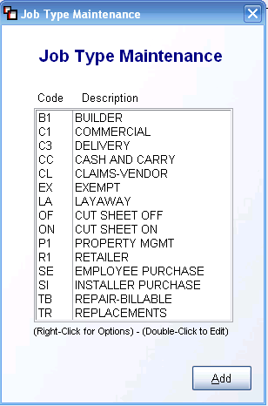
All existing Job Types Codes in your system will automatically appear in this screen. The Code column displays the current two-digit Job Type Codes, while the Description column displays the description for each code listed. If you click on a Code to highlight that line, you can then right-click the mouse to see two options as follows: Edit Job Type and Delete Job Type Code. You can also double-click on an existing Job Type Code to edit. Please Note: If any relevant sales history exists in your system for a Job Type Code, you should not delete that code. To add a new one, click the Add button at the bottom right of the screen. A new screen will appear as follows:
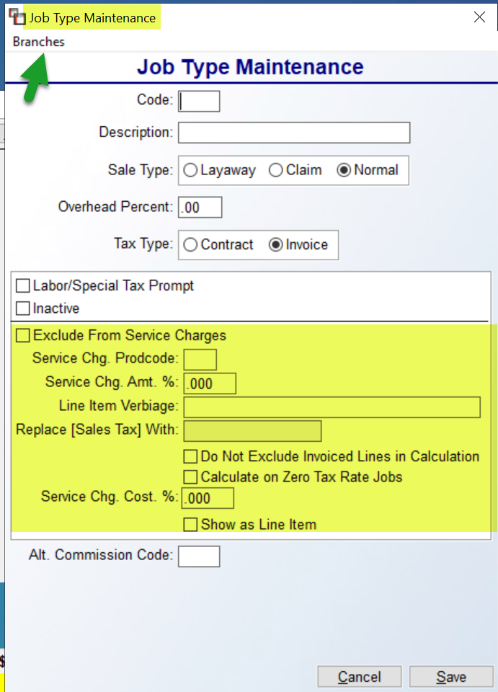
At the Code field, type a 2-character alpha-numeric code for the Job Type. In the Description field, type a more descriptive explanation to help other Users distinguish between Job Types. The Sales Type section will default to Normal. This Sale Type will not create any change in the system, and will be the type used for most Job Types. The Claim option, when selected, will effectively remove Mill or Installer Claims jobs from your Invoice Register, Job Cost Margin, and Work in Process – By Invoice Date reports, as well as from the Sales Analysis and Sales Analysis (Owner’s Version) modules. Many customers have requested that the system not include claims in their regular sales information, though they still need the data on their financials and in receivables. If Claim is selected in this field, the system will handle any Order with this Job Type in the manner described above. On the Invoice Register and Invoice Register History, those orders will not be included in the total and the report will display the following at the bottom of the register: * - Claims not included in Total. The register will then display a Claims count and total. For historical purposes, any Jobs that have previously printed on an Invoice Register that have this Sale Type will be reported as a Claim. As for Sales Analysis changes, Claims Jobs will automatically be excluded. However, if you would like to see analysis on Claims Jobs only, in one of the Report Selection options, you can select Job Type and then type the specific Job Type code for Claims Jobs to only see those Jobs. The Layaway option was developed for large commercial dealers and should not be used without consulting RollMaster Customer Support.

The Overhead Percent field was added so that a percentage amount in whole numbers can be added to the total costs on each Job. This field can be used to capture overhead costs on each Job. It is tied to Job Type Codes because many times overhead can be higher on certain types of jobs than others. It can also be used to inflate costs by a small percentage so owners are not hit so hard on the bottom line when problems arise on a Job. This added cost will not be broken out in the normal Job Cost screens, it will only be added to the total cost on the Job (before any Overbill value), which will then be reflected in the base used to determine salesperson commissions (provided commissions are being programmed on Margin and not Total job). In other words, the commission base will be reduced by the total Overhead Percentage amount and the bottom-line profit and margin totals on the Job will be adjusted accordingly. The Overhead Percentage amount will not inflate your inventory value, it will not show up in the Purchase Order or Receive Inventory modules, and it will not be reflected in the Review P.O. History option in the Accounts Payable Open Item Maintenance module. It is simply a tool for owners/managers to recoup some overhead costs. In the Owner Functions menu, the Overbill/Overhead Job Cost Margin Report will display true job cost information and break out the total Overhead Percentage amount collected on each Job. If you do not wish to use this feature, leave this field blank.

Next, click the applicable Tax Type option for the code. This option sets a default for the way tax should be calculated on different types of jobs. This field was added here so that it can be preset and Salespeople will not be allowed to change the Tax Type unless they change the Job Type Code. The options for this field are Contract for Use Tax or Invoice for Sales Tax. The Contract option will apply the tax percentage to the cost of material and the Customer never sees this figure; the Invoice option will apply Sales Tax to the total of the Job, less labor if applicable, and the Customer sees the tax amount.

The Labor/Special Tax Prompt, when checked, will set the default Tax prompt for Labor and Special Charge lines to “Y” for yes based on Job Type. Leave this field unchecked if the Tax prompt on these job lines for the Job Type should default to “N” for no. The Inactive box should only be checked to hide this Job Type from lookup screens within the system. Rather than delete a Job Type with history for Sales Analysis purposes, it is best to set them to Inactive.

The highlighted section in the screenshot above are fields that appear in the Company Control 1 screen of the System Control Maintenance module under an option titled Enable Service Charge. They also appear in the Branch Control 2 level screen with the same name, as they can be set up by Branch, which overrides Company. By including them here, they can now be set up by individual Job Types. If you wish to set them up on this level, you don’t need to set them up on a Company or Branch level, but you do need to turn on the Enable Service Charge control in Company Control 1. If you do have this set up on a Company or Branch level, you can use the Exclude From Service Charge checkbox to prevent a particular Job Type from having this calculation performed.

If you are unfamiliar with this feature, here is how it works: This option was designed to help flooring dealers recoup the miscellaneous costs associated with flooring installation such as freight, supplies, waste, warehousing, and other miscellaneous expenses, so it can also help with job costing items like RealPage, Vendor Café, Recycling, and various other things, like fuel surcharges. It will calculate on material cost only, unless you set it otherwise using the last two fields in the screen above. You will first enter a Product Code for this Special Charge, which should be set up ahead of time. You will then enter an amount for the Service Charge as a percentage. For the Invoice Verbiage, type how you would like this to appear. You can also use the next field to replace the term Sales Tax with something else. The next option allows for including any lines that have been previously invoiced to the Service Charge calculation. The next option determines whether a Service Charge can be calculated on jobs with zero tax rate. To cost a Service Charge amount to the job for job costing and commission purposes, enter that percentage in the next field. The next field determines if Service Charges will apply only to Contract (Use Tax), Invoice (Sales Tax), or Both. At the next option, if you wish to show this line as a separate Line Item, type a “Y” for yes. And the final two options determine whether you wish to include Labor and Special Charge lines in the calculation. These will default to “N” for no, so only change them if you want to include them.

And finally, the Alt. Commission Code field is tied to the Alternate Commission Plan feature located in the Salesperson Maintenance module and should only be accessed if that setup is complete and being used in the system. Otherwise, leave this field blank.

The Branches option in the top left corner of the Job Type Maintenance screen allows for editing Job Types across Branches. When you click on that option, the system will prompt a Job Type Active in Branch box as follows:
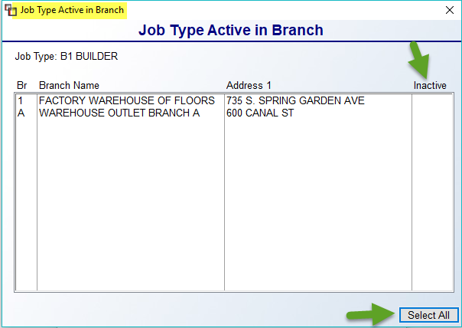
The default setting is for all Job Types to be active in all Branches. In this screen, you can click in the Inactive column next to a Branch to set the Job Type as Inactive in that Branch. Or you can click the Select All button at the bottom right to make the Job Type Inactive in all Branches.
When you have finished entering the data for a new Job Type, click the Save button before exiting to keep your changes. If you do not wish to save or wish to start over, click the Cancel button.

In systems where the Inventory Cut Sheet module has been enabled and where the option “Do you want to Allow Cut Sheet settings by Job Type” has been set to “Y” for yes in the Company Control 2 screen, you will see those options appear at the bottom of the Job Type Maintenance screen as follows:

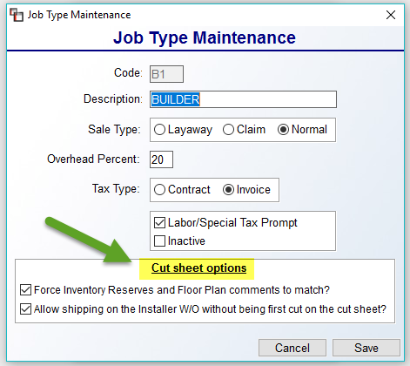

Please Note: This option will most likely be utilized for dealers specializing in Property Management and Builder work.

Job Status Code Maintenance:
This module was added so that Job Status Codes could be added and edited in the system. The codes created in this module are tied to the Job Status field in the Job Detail box in the Quote Entry, Order Entry, and Lead Processing module screens, and is a required field of entry. These codes are defined by each RollMaster client, but should essentially be used to track the status of a Job from the time it is first created in the system until the time it has been completed. The Open Order Report can be sorted by Job Status Codes, which allows you to product a report based on the status of each job in the system. When you enter this module, a Job Status Code Maintenance screen will appear as follows:
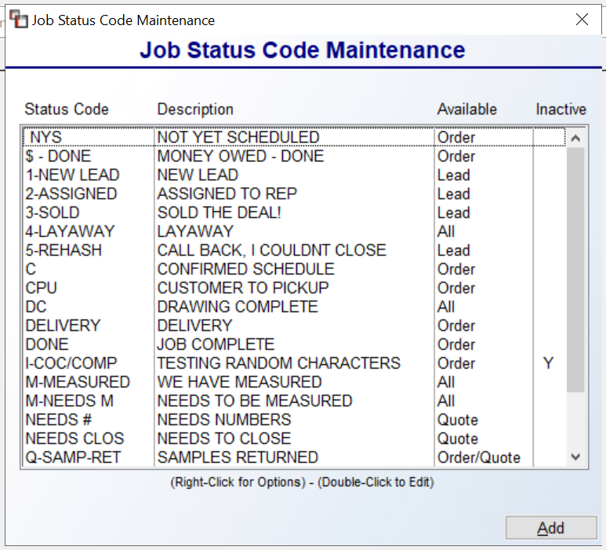

All Job Status Codes that currently exist in the system will automatically appear in the screen above. The Status Code column displays the current Codes, the Description column displays a longer description for each code listed, the Available column displays whether the code will appear in the Order Entry, Quote Entry, or Lead Processing modules, or in a combination of those modules, and the Inactive column displays a “Y” if any have been inactivated. To change where a Job Status Code will appear, or where it is “Available,” use the Edit Status Code option (explained below). The default for all new codes will be ALL. You will use the same Edit Status Code process to set a Code as Inactive. To create a new Code, click the Add button at the bottom right of the first screen. A blank Job Status Code Maintenance screen will appear as follows:

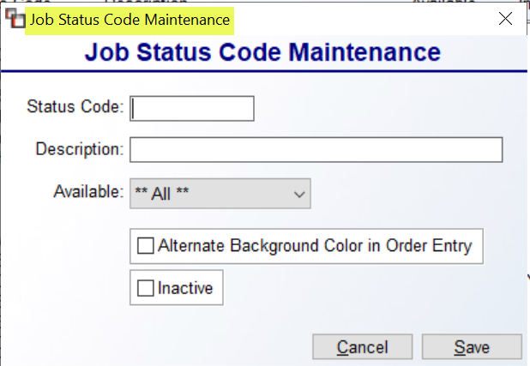

Complete this screen by typing a new--up to 8-character--Status Code, followed by a longer Description. Please Note: You may wish to consider numbering these Codes so they appear in a logical Job flow order in the drop-down menus. At the Available field, use the drop-down menu to select where to see this Job Status Code: Order, Quote, Lead, or a combination. The default is **All** to allow for viewing the Job Status in all available modules. The Alternate Background Color in Order Entry option, when checked, will prompt a red tinted background in Order Entry for Jobs with this Job Status Code. The Inactive checkbox should only be checked in the event you wish to remove the Job Status Code from all modules but preserve any sales analysis data. Be sure to click Save when the new Code is complete.

If you click on an existing Code to highlight that line, you can then right-click to access two options as follows: Edit Status Code and Delete Status Code. Please Note: If any relevant sales history exists in your system for a Job Status Code, you should not delete that Code. If you click on Edit, the system will display the existing Code as follows:

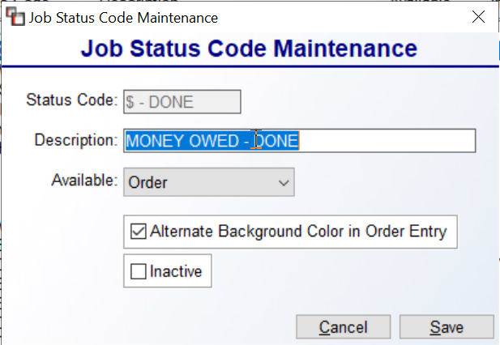

In this screen, you can edit the Description field and you can change the Available options to determine in which modules this code will appear. You can also check or uncheck the Alternate Background Color in Order Entry checkbox and check or uncheck the Inactive checkbox. Click Cancel if you do not wish to save your changes or click Save to keep your changes. The system will then return you to the previous screen. If you double-click a Code, the system will jump straight to the Edit screen.

Payment Type Code Maintenance:
In order to record deposits/payments in Quote and Order Entry or Post Customer Payments in the Accounts Receivable menu, you will need to set up Payment Type Codes in each Branch. The accounting department should be involved with this process, as setting up Payment Type Codes involves entering General Ledger Account Numbers, and it is crucial that they be setup correctly. When you enter this module, the screen will prompt a Payment Type Code Maintenance screen as follows:

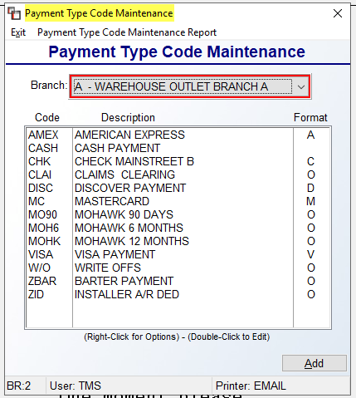

All Payment Type Codes currently added to your system will automatically appear in the screen above. The Branch field will default to the current Branch. You can switch Branches by clicking on the down arrow button and making a selection from the drop-down menu. To add a new Payment Type Code, click the Add button at the bottom right of this screen. A second screen will appear as follows:

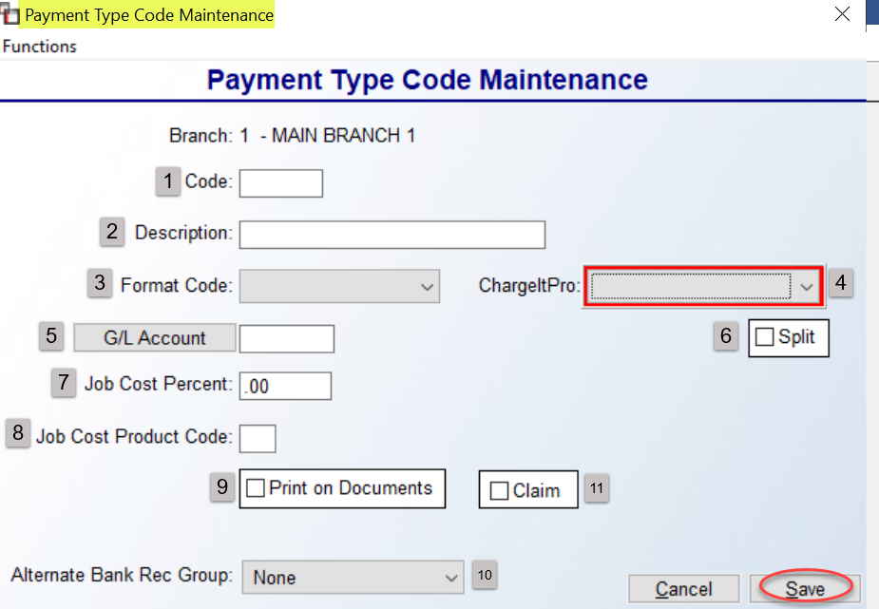

In the Code (1) field, type a new code (up to 4 characters, e.g., VISA, CHK, CASH, MC, AMEX, DISC, SHAW, etc.). At the Description (2) field, type a longer description to assist Users with identifying the correct Code. You must assign a Format Code (3) to each code for internal system purposes. Use the drop-down arrow in that field to access a list. If your company is using the Gravity (formerly ChargeItPro) Integration/Equipment, with RollMaster Trainer assistance, you will use the drop-down arrow in this field (4) to select an option that best matches the Format Code you selected as part of that setup. The G/L Account (5) button will prompt a G/L Account Selection box displaying only existing G/L Accounts designated as a Bank Account or Credit Card in the system as follows:

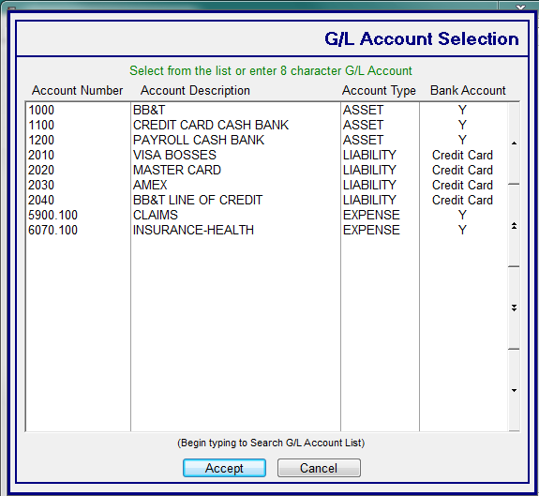

Select the desired G/L Account from the list and click Accept to continue. Please Note: The system will not allow you to click the Cancel button without first selecting a G/L Account from the list. If you need to make a change, you will need to make a selection, and then click the Cancel button in the Add Payment Type Code screen. Once you have selected the correct account, the new G/L Account will display to the right of the button and can be changed in the future with the assistance of the RollMaster Support Team.

At the Split (6) checkbox, RollMaster allows for splitting finance Payment Codes so that the Bank Reconciliation properly shows the amount being deposited into the Bank Account and the split portion being charged as a Fee. (This is not active with the Gravity Integration upgrade.) There is a User Control 6 option to determine who can override the Deposit Split %. That control appears as follows: Allowed To Override Deposit Split %. First, you will need to add, unless you already have a Payment Code for which this feature would apply, a Payment Code for the main Financing payment, such as SHAW 12MO DEFERRED. You will also need to add the Secondary Payment Type Code to send the split, such as ZZ (to send to the bottom of the lookup) for the Financing Fee. Be sure you know to which G/L Account you want to send this Fee to and make sure it is set up as a Bank Account before completing this next step. Please Note: This works independently of Job Cost, as you may wish to cost a lower percentage to the Job. Once the new Codes have been added, start with the new “ZZ” Payment Type Code. When you check the Split option, a new box will prompt for additional setup as follows:

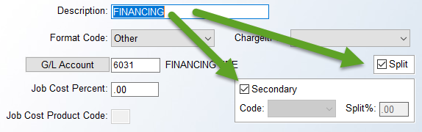

You will only need to click in the Secondary box for this setup. Be sure to click Save prior to exiting. Next, enter into the Shaw, etc. Payment Type Code(s) and click the Split checkbox in that Code as well. Leave the Secondary option unchecked in this Code. Use the drop-down arrow to select the new “ZZ” Payment Type Code you just added. In the Split % field, type in the fee percentage you are charged for offering this finance option. This is the amount that will show as split/separate in the Bank Reconciliation module and that you can show as split on the Customer Payment Register. The completed setup should appear as follows:

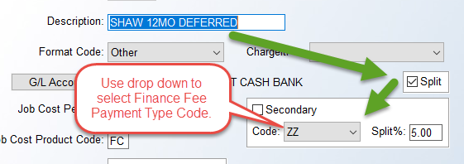

On the Job, the system will write a two-line Deposit entry as follows:

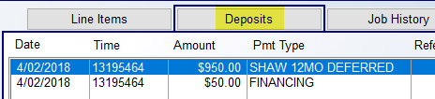

Moving on with the remaining options in the Payment Type Code Maintenance screen, the Job Cost Percent (7) and Job Cost Product Code (8) fields were added to help recoup financing/credit card processing costs. These fields require some setup before use and can be left blank if you don’t intend to use this feature. Please refer to the section below on Financing for complete details on setup and how to use these fields. The Print on Documents (9) checkbox was added primarily for the ChargeItPro Credit Card Processing integration because CIP does not produce a traditional CC receipt. However, with this box checked, whether you have CIP or not, a payment summary for this Payment Code will appear at the bottom of any Customer documents, such as the Sales Agreement, Receipt, Invoice, etc. This will only include money taken via the Deposits feature in Quote and Order Entry, not via Post Customer Payments.

The Alternate Bank Rec Group (10) field, also accessible for non-CIP customers, can be used to “join” Payment Types together so they total together in the Bank Rec module for easier reconciliation. The drop-down menu contains a list of pre-defined “Groups” that should cover all scenarios. In most cases, Visa, Master Card, and Discover will be grouped together under a generic “Credit Card” Group, leaving American Express to Group by itself as American Express. However, every company is different, so this field can be used to create a myriad of combinations. Please Note: the system will not allow
you add a Payment Type Code to an Alternate Group if the G/L Account doesn’t match the existing Payment Type Codes in that Group for the current Branch. In other words, it will not allow more than one G/L Account within a Group.

An alternative feature for finalizing Claims processing has been added to the system and setup starts in the Payment Type Code Maintenance module. The Claim (11) checkbox that appears to the right of the Print on Documents checkbox must be checked in order for this process to initiate. Additionally, as this sets up a process that prompts the User to enter an A/P Credit to the Vendor, the G/L Code on the Payment Type should also be changed to Sales/Sales Allowances. This will require you to temporarily activate the Sales G/L Account as a Bank Account so it can be used in this module, but you can turn that off as soon as the new or edited Payment Type Code is set up. This portion of the process will reverse the revenue recognized when the Claim is invoiced. To control who can use this feature there is a User Control 7 option in the System Control Maintenance module as follows: Allowed to Post Deposit/AP Claims. Only enable this control for those Users allowed to process Claims in the manner. (Not all customers will wish to utilize this feature, so be sure you make an informed decision before proceeding.)

Once the setup is complete, using the Deposit feature in Order Entry, you can add a deposit amount to a Job with the Claims Payment Type Code. The system will prompt the following: Would you like to Enter AP Credit now for $XXXX? Select “Yes” to proceed. The system will then prompt a message as follows: Entering A/P Open Item Now. Click OK to proceed. The A/P OPEN ITEM FINAL ENTRY screen will prompt as follows:

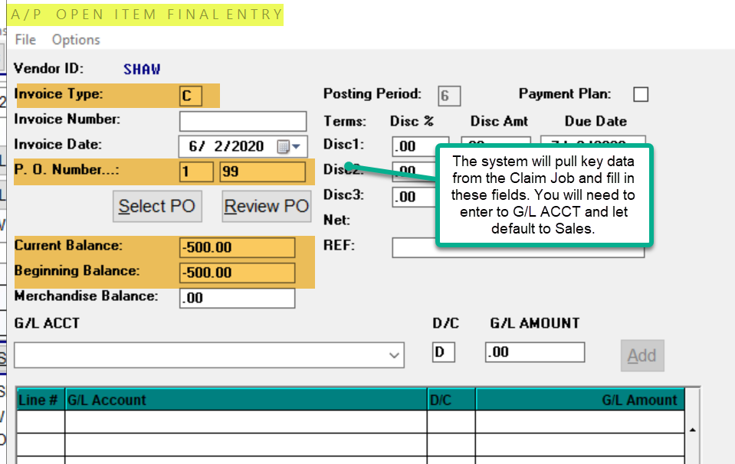

You will need to create an Invoice Number. Use your Cost of Materials as the G/L ACCT to reverse the expense of the replacement material recognized when the Claim Job is Invoiced. As mentioned above, the Payment Type Code Deposit reverses the Revenue when the Claim Job is Invoiced. Additionally, for proper revenue and expense recognition, this process should be performed in the same accounting period(month) that the Claim Job is Invoiced. You will receive a message to that effect when you Accept this Invoice as follows:

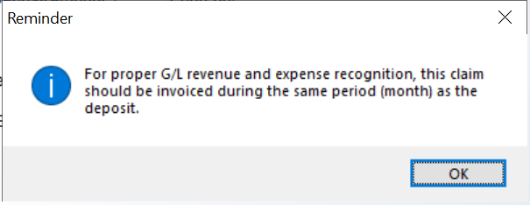

Please note: you can make adjustments to Claims Deposits, just as you can with actual Deposits, and the system will handle those adjustments.

Once you have completed adding a Payment Type Code, click the Save button to continue. If you wish to edit the data on an existing Payment Type Code, from the main Payment Type Code Maintenance screen, highlight the Code from the list and either double-click on the Code to bring up the existing data for that payment type, or you can hit the right-click button on the mouse to display two options, one of which is Edit Payment Type Code. Once you make any applicable changes, be sure to click the Save button before exiting the screen. The other option when you right-click on a code is Delete Payment Type Code. Before you attempt to delete a Code that has been used in the system, or before you change G/L Account numbers on an existing Code, please email the RollMaster Support Team at support@rmaster.com for assistance.

One additional feature in this module is the ability to copy/update an existing Payment Type Code to another Branch. Once a Code has been saved, you can click on the Functions menu at the top left of the Payment Type Code Maintenance screen and the system will display the following: Copy Payment Type Code to Another Branch. If you highlight and click on that option, the system will prompt a Branch Copy box as follows:

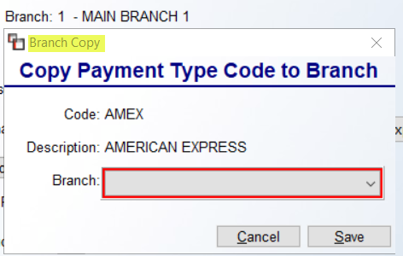

Click the down arrow in the Branch field to display a list of current Branches in the system. Select the applicable Branch ID and then click the Save button to complete the process. Also, if any changes are made to an existing Payment Type Code, those changes can be copied to all other applicable Branches using this same feature. Once your Codes have been added, you will have the ability to export a list of the Codes to Excel with details for easy reference. This option is located at the top left of the main screen as follows: Payment Type Code Maintenance Report. When you click that option, the system will prompt the following:

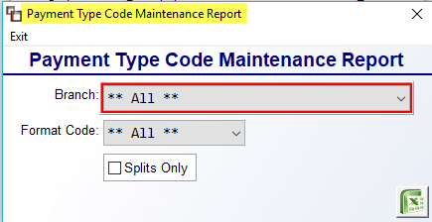

You can export by Branch, Format Code, and/or Splits Only, or leave the defaults to include all Codes.

Financing Feature:
If you would like to use the Financed option or would like the ability to send costs to the job for credit card processing, you will first need to enable the Company Control 2 option Job Cost for Payment Type Codes. With this control enabled and proper set up completed, you will be able to add financing charges to your credit card Payment Type Codes for job costing purposes that will also impact Salesperson Commissions. It will also allow you to create Special Financing Codes—such as “6 Months Same As Cash”—that can be added as line items to add financing costs on a job. In order to use Financed as a Format Code, you will first need to set up a Product Code with a Factor ID of 09-for example “Financing Expense.” (Please Note: this percentage will only be used for job costing and commission purposes, and will not impact your financial records.) Once the Product Code has been set up, you can then set up Special Financing Charge Payment Type Codes via this module. (As a suggestion: if you wish to keep all of your Finance Payment Type Codes grouped together in the lookup box, you may want to consider using “0001”, “0002”, etc. or even “Z001”, “Z002” to keep them at the end of the lookup box list. Another suggestion is to use the 4-digit code already used by the Finance Company.)

Once you enter a Code and Description, you will need to select Financed as the Format Code (3). At the Job Cost Percent (6) field, type in the percentage associated with this special financing in whole numbers, i.e. “3” for 3%. In the Job Cost Product Code (7) field, type in the new Product Code you created for Financing Expense. You can only use up to three Financed Lines per Job. Once everything has been setup, you will use the Deposit option to enter a Financed Amount on the Job—this will write a line displaying the Financing Expense and display the amount financed in the Price field—though you will have to hit enter on the line to view it on screen. In the Cost field, the system will display the amount that will be factored into job cost for the financing expense. This line item will print out on the Sales Agreement and Invoice (if you choose to display line items) showing the Amount Financed but it will not display a cost. The Work Order will display the Financed Amount above the C.O.D. Amount field so the installer will know not to collect a balance. This line item will also display in the Job Costs screens with the corresponding financing expense.

If you enter an Amount to be Financed in excess of the total on the job, the system will display a message box prompting Amount Financed Correct? and will also display the current Job Balance and the Amount Financed. If correct, select “Yes;” otherwise, select “No” and the system will allow you to re-enter an amount. Also, if you later add an item to the Job and the finance amount changes, you can simply re-enter through the Deposit screen and override the previous entry by following the prompts. The system will then re-write a new Special Charge Financing Expense line and make it the last line on the Job.

When the Job is complete, you will invoice the Job, which will set up a Receivable for the Customer and when you receive payment from the Finance Company, you can apply it to the Customer’s balance in A/R Post Customer Payments. If you need to cancel a Financed Job, you need to delete the Deposit and that will clear the data on the Special Charge Financing Expense line on the job. Please Note: These Finance Payment Type Codes will not appear in the lookup box from the Receive Money feature and they will not appear on the Customer Payment Register or the Payment Distribution Report, as they do not send any value to the G/L Account.

You can also add costs to a job based on credit card usage. To set this up, you will need to have the Company Control 2 option enabled as explained above. You can then enter into the Payment Type Code Maintenance setup box for each of your credit cards, and type a percentage cost for the credit card in the Job Cost Percentage field. You will then enter an applicable Product Code in the Job Cost Product Code field. You can use the same Product Code as suggested above for Financing Expense or create a new one for this purpose. Once this has been set up in the system, when you select a credit card payment type—either in Order or Quote entry—the system will write a Special Charge Line with a cost and no sale and you will be able to view the cost in the Job Cost screens. This line will not print on the Sales Agreement, Invoice or Work Order. It is only for job costing purposes and commission calculations, and will not impact your financial records. If you take a second Deposit using a credit card, the system will write a second line to the Job with those additional costs. If you delete or make changes to a Deposit amount, the system will automatically adjust the Special Charge Line item.

Territory Code Maintenance:
The use of Territory Codes in the system provides valuable additional market research information by Customer. Territory Codes are user defined (meaning you decide what they are to be), but we have included some examples to assist you in developing your own. There are many reports in the system that print by Territory Code, such as Aging reports, Customer Listings, Mailing Labels, and Sales Analysis by Territory Group. As such, Territory Codes have served many purposes among RollMaster clients. The Territory Code option was originally designed to track which territories or regions of your demographic area your customers reside; however, because of additional Branch reporting programming, Territory Codes have evolved into other uses, such as tracking advertising leads, categorizing customers for mailings, and tracking Property Management/Builder/ Developer sales.

During the process of adding a new Customer in the system, that screen will require you to enter a Territory Code in the Sales Territory field. Because of this, at least one Code needs to be set up ahead of time. When you enter this module, the system will prompt a Territory Code Maintenance Screen as follows:

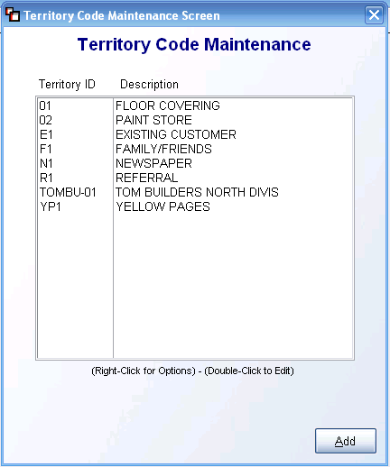

All Territory Codes that currently exist in the system will automatically appear in this screen. The Territory ID column displays the Territory Code, while the Description column displays the description for each code. If you click on a code to highlight that line, you can then right-click the mouse to see two possible options as follows: Edit Territory Code and Delete Territory Code. You can also double-click on an existing code to edit. Please Note: If any relevant sales history exists in your system for a Territory Code, you should not delete that code. To add a new Territory Code, click the Add button at the bottom right of the screen. A new screen will appear as follows:

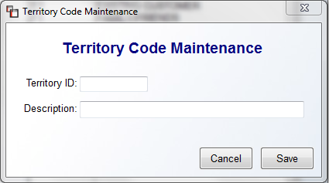

In the Territory ID field, type in a new up to 8-character alpha-numeric ID. Use the Description field to type a broader description for the ID. When you have finished adding a new ID, click the Save button to continue. If you click the Cancel button first, your data will not be saved.

Initials Maintenance:
This module will allow you to create Initials Records to assign to the Initials field in the Order Entry and Quote Entry screens. The Initials field contains a drop-down menu to look up these records and assign a name when an Install Date is added. A User Control 3 option has been added to prevent a User from adding Initials Records in the system. Also, a Company Control 2 option has been added to allow you to require that Initials be entered on an Order or Quote when an Install Date is added or changed. With this control enabled, a User will not be able to skip assigning an Initials Record in that field. Both of these controls can be found in the System Control Maintenance module in the System Maintenance menu. When you enter this module, an Initials Maintenance screen will appear as follows:

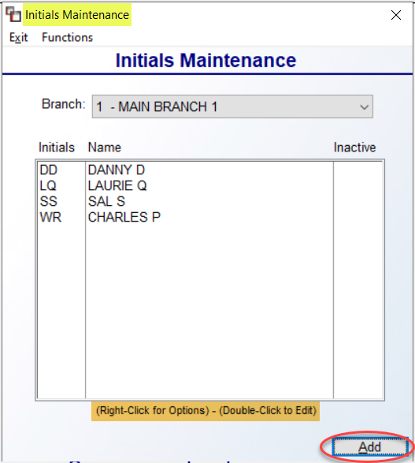

Any existing Initials Records will automatically appear in the screen above. The Branch field will default to the current Branch. Please Note: Initials Records must be entered in each Branch. Use the drop-down menu to select another Branch. If you click on an existing Initials Record/Name to highlight that line, you can then right-click the mouse to see two possible options as follows: Edit Initials and Delete Initials. If you click on Edit, the system will display an Initials Maintenance box as follows:

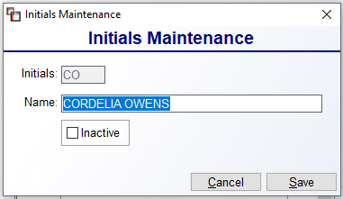

You can make changes in the Name field of this screen if applicable. You can also set Initials to Inactive, by checking that box. If Initials have been used on Jobs, it is best to set to Inactive rather than Delete. If you do make changes, be sure to click Save prior to exiting. A second way to edit existing Initials Records is to double-click on the item in the first screen. The system will prompt the same Initials Maintenance box displayed above. To add a new set of Initials, from the first screen, click the Add button at the bottom right of the screen. A blank Initials Maintenance screen will appear as follows:

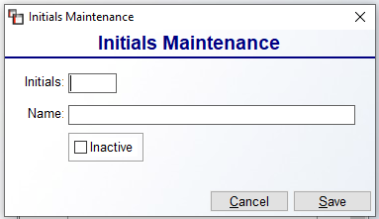

At the Initials field, type up to a three-character set of initials for the new name to be added. At the Name field, type the full name of the person for this setup. When you have finished, click the Save button to continue or click the Cancel button to start again. Once Initials have been added to one Branch, you can copy all Initials to another Branch if applicable. From the main screen, this option can be found under the Functions menu at the top left as follows: Copy All Initials to Another Branch. This will prompt a Branch selection screen for you to select All Branches or a single Branch.

Time Maintenance:
This module was added to add/edit “time” parameters in the Time drop-down menu field that appears when setting an Install Date on a Job. These “Time” codes will appear in the Installation Schedule module, as well as on the Job. In most cases these will already be created in the system by your RollMaster Trainer, but this module can be accessed at any time to re-sort the order of the drop-down menu or add new Time descriptions. When you enter this module, the screen will appear as follows:

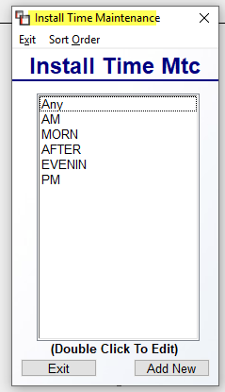

The Add New button will prompt an Edit Time box as follows:

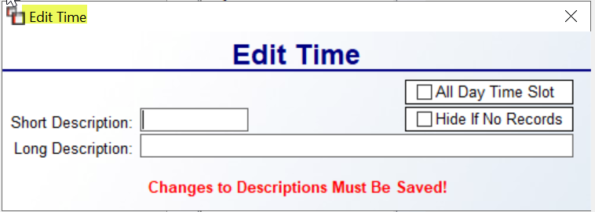

The Short Description is what will display in the drop-down menu in the Job Detail box on the Job and in the Time column of the Installation Schedule and the Add New Install Dates box. The Long Description is for a longer description area and does not currently display or print out. The All Day Time Slot option works in conjunction with the Company Control 4 option that appears as follows: Prevent Double Booking Installer. This control forces use of the Install Date tab screen and will not allow booking an Installer where there is a time conflict. The “Hide If No Records” option can be used on existing records to remove from live display boxes described above. You will need to double-click on an existing record to Edit. Once you begin typing in the Short Description field, a Save button will appear at the bottom right of the box above. Be sure to click Save to keep new records.

Accumulator Code Maintenance:
This maintenance program is tied to the graphical Installation Schedule module, wherein Accumulator Codes are instrumental. Accumulator Codes are used to identify the principle installation Labor Lines on a Job, allowing the system to compute total yardage or footage scheduled for a given time period. For example, a Job may have four Labor Lines consisting of 100 yards of installation, 100 yards of rip/up, 100 yards of disposal, and 12 steps. The Accumulator Code should only be tied to the 100 yards of installation, so the system only counts 100 total yards, not 312, which would be inaccurate from a scheduling standpoint.
When you click on this option, the system will prompt an Accumulator Code Maintenance screen as follows:
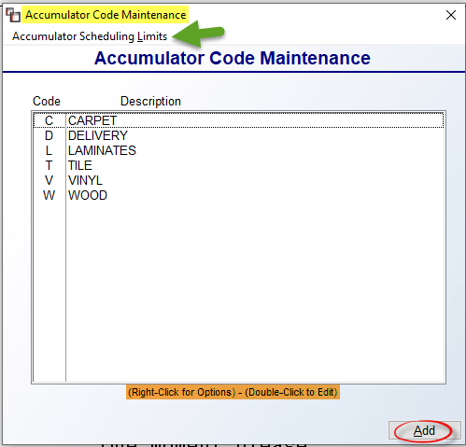

The items in the above screen are typical installation descriptions. The Accumulator Scheduling Limits option will be explained below at the very end of the Accumulator Code Maintenance section. To add a new Accumulator Code, click the Add button. The system will prompt the following:

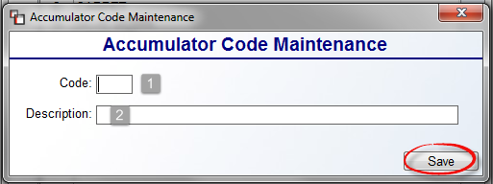

At the Code (1) field, type a one character code to represent a labor item. At the Description (2) field type a longer description for the Code. Click the Save button to save your new code and return to the previous screen. When you double-click on a highlighted Code, the system will prompt the following:
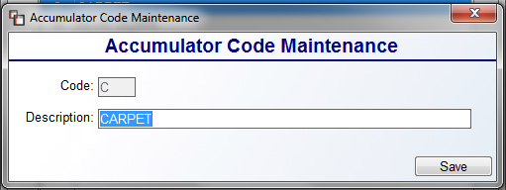
You can add/edit text in the Description field at any time. Click the Save button to save your changes and exit the screen above. In the main screen, if you right-click on any existing Codes, you can call up the Accumulator Code Maintenance screen above, or you can remove any unwanted codes by using the Delete Accumulator Code option. Once your Codes have been added, the next step is to access items in your Labor Catalog via the Catalog Maintenance module and add these Codes to each applicable “main” installation Labor Item. An example appears below:

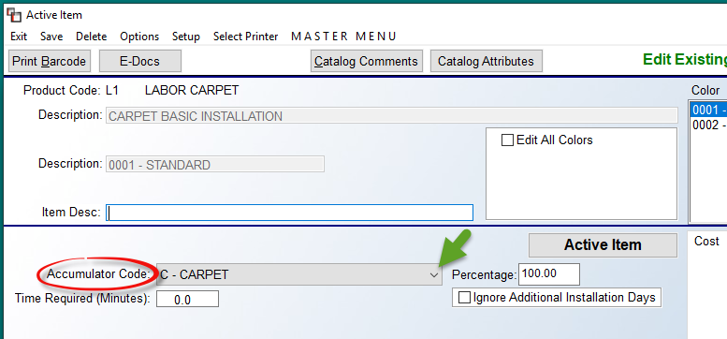

At the Accumulator Code field, use the drop-down arrow to select an applicable Code. Continue until all main Labor Items have been assigned an Accumulator Code. Also, on each Labor Catalog Item, to assist with not over-scheduling, there is a Percentage field next to the Accumulator Code field that appears as follows:

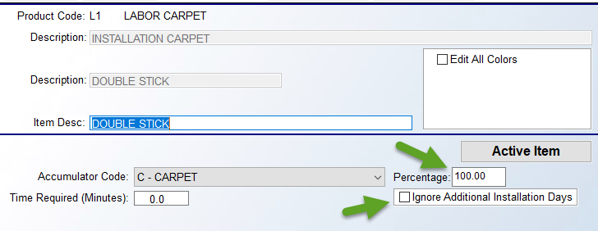

Consider this field a percentage value of the duration of an installation. A percentage of 100% would be a normal or average setting for a typical type of install. Any increase in percentage would indicate that extra time is needed for the Labor Item, and a lower percentage would indicate less time is needed. For example, typical stretch-in carpet would be set at 100%. Patterned carpet installation would then need to be at about 125% or higher, and rip up could be set to 50% or lower. Just below the Percentage field, you will see a checkbox as follows: Ignore Additional Installation Days. When checked, the system will ignore any setup requiring this particular item to need additional days to install.

Another change you will note in the RollMaster System after this setup is completed, is in the Install Dates tab when scheduling installation. It will take into account the Capacity Limits set (explained below), Percentage field, and the Ignore Additional Installation Days checkbox to calculate a suggested number of days required to install when scheduling. When you click the Add button to schedule a Labor item, the Add New Install Dates box will still prompt, but you will now see a Total Days Required message, as in the screenshot below:

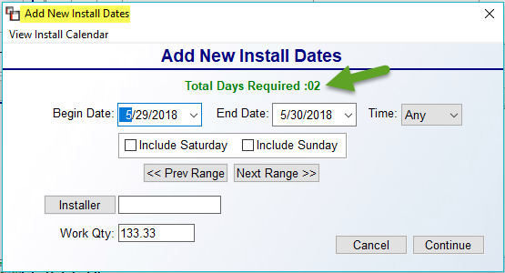

Scheduling Capacity Limits
The system allows for setting Installation Scheduling Capacity Limits on Accumulator Codes in the Catalog Maintenance module. This feature is designed for setting “Hard Limits” that cannot be exceeded when scheduling installation for a particular day. It also allows for blocking installation dates entirely, as in the event of holidays, and will allow key Users to raise or lower capacity limits for a particular day. The setup starts with accessing a Company Control 4 screen option that appears as follows: Company Accum Totals (R, B, C). This control determines at what level capacity is met for each type of installation: Region, Branch, or Company. There is also a User Control 6 screen option that allows key Users to override these limits. That control option appears as follows: Allowed To Override Installation Limits. Set to “Y” to enable this ability.

Once the Company and User Control items are set, you will move on to the Accumulator Scheduling Limits option available from the Accumulator Code Maintenance screen. When you click on this option, an Installation Scheduling Limits By Accum screen will appear as follows:

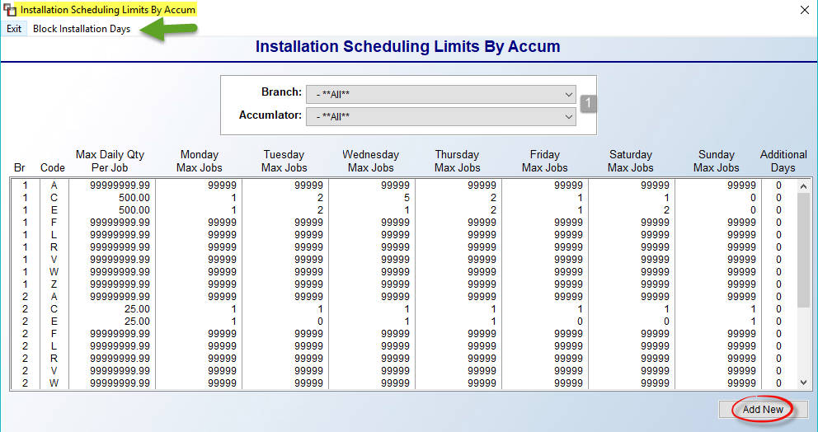

Prior to any Limits being scheduled, the default for all Codes is all “9’s” in each field. This is so that no limits can be met until they are intentionally set by the installation scheduling department. To Add or Edit Limits, click the Add New button at the bottom right, or you can highlight and right-click on an existing line. If accessing from a line, the system will prompt the exact Branch and Code to edit, whereas the Add New button will prompt a screen allowing you to select the Branch (1) and Code (2) as follows:

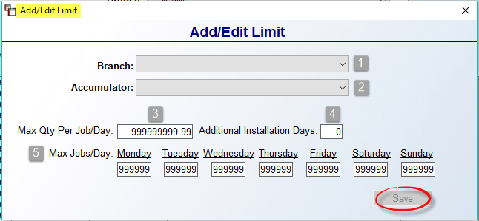
At the Max Qty Per Job/Day (3) field, type in the total feet or yards that can be installed per Job for the Day. For example, 200 yards of carpet or 500 feet of tile. The Additional Installation Days (4) field should be used for Accumulator Codes that typically require an extra day to complete, such as tile. For each day of the week in the Max Jobs/Day (5) section, type in a max number of Jobs that can be scheduled in a Day based on the Accumulator Code selected. For example, 5 carpet jobs, or 2 tile jobs. This will be individual to each company based on the number of crews you run on a given day. To block an entire Day, enter “0” in that field.
The feature to Block Install Dates can also be found in the Installation Scheduling Limits By Accum screen. At the top left, you will see that option as follows: Block Installation Days. When you click on this option, a Block Installation Days screen will appear as follows:
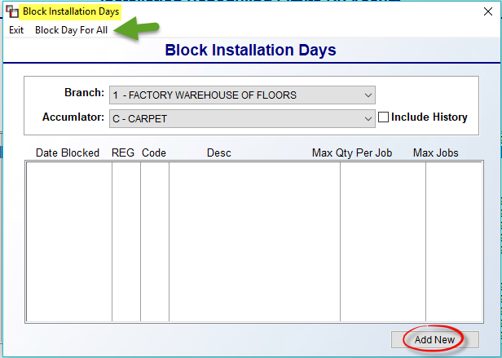

This screen will display any current blocked days. You can use the Block Day For All option at the top left to block an entire day for all Accumulator Codes. That screen appears as follows:

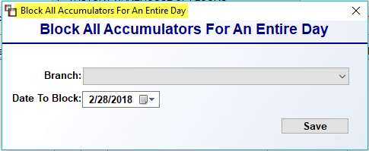

Select the Branch and the Date To Block and click Save to continue. To block only certain Accumulator Codes, or to revise the Qty Per Job or Max Jobs for a Day, click the Add New button to prompt the following screen:

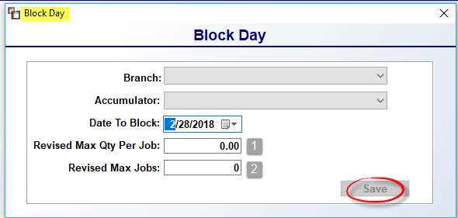

Make your Branch, Accumulator, and Date To Block selections in the screen above. To leave the day blocked for the selection, click Save, leaving the remaining two fields set at “0.” To Revise the fields, enter an applicable Qty (1) and Max Jobs (2) prior to clicking Save.

Sales Processing Reports 1 of 2

Introduction:
There are two report menus for Sales Processing—Sales Processing Reports Menu 1 of 2 & Sales Processing Reports Menu 2 of 2. Within both menus, there are several reports relating to Sales Processing that are very helpful from a management perspective. These report menus can only be accessed from the Sales Processing menu. This next section of the manual will explain each report and how that report can be beneficial to the RollMaster customer. Examples of many of these reports can be found in the Retail Report Sampling booklet.

Invoice / Credit Memo:
Both the Invoice processing/printing and Credit Memo procedures have been explained in earlier sections of this manual. Since you can perform these functions from Order Entry, we will not go into a full explanation here. However, this is a good option to come to if you need to Reprint an Invoice or Credit Memo, or if you would like to Invoice from outside the Job. Use the Reprint button in the upper left corner of the screen or click the Function menu to select Reprint. The screens look exactly the same as the screens that were explained in the earlier sections of this manual—see Invoice and/or Credit Memo in the Order Entry section of this documentation. When you enter this module, the top of the Invoice Selection Screen will appear as follows:

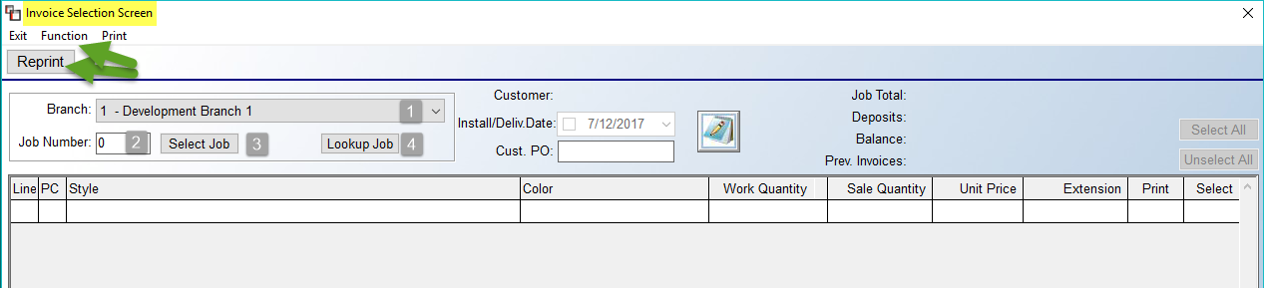

At the Job Number (2) field, you will need to type a Job Number and then click the Select Job (3) button. The Branch (1) field will default to the current Branch. You can also use the drop-down arrow in the Branch (1) field to select another Branch where applicable. Additionally, you can click the Lookup Job (4) button to prompt the RollMaster Software Sales Processing screen to make your selection, which is the easiest way to access if you don’t know the Job Number.

For multi-Branch operations, when using the Select Job option to locate a Job to invoice, if the Branch changes, you will see a prompt notifying you of the Branch change. The system also checks that the User ID and controls set up for the Branch selected are enabled. The display at the bottom will prompt the new Branch. When the Invoice process is complete, another message will prompt asking if you wish to return to the Login Branch, or original Branch.

Progress Billing Invoicing:
This is a different type of invoicing used primarily for large commercial jobs. The idea behind this option is that large commercial jobs can take many months to complete and there are times when you wish to bill the client for partial payment prior to the completion of the job. Once you begin Progress Billing a job, you have to bill the entire job through Progress Billing. In a recent update new functionality has been added and some set up needs to be completed prior to beginning any Progress Billing. In the Branch Control level of the System Control Maintenance module, you need to enable and set up the following controls: Progress Billing – Use Est. Cost. …COGS – Progress Billing …Work In Process. (Please see the System Administration Manual for complete setup instructions). With these controls in place, the system will keep track of your COG (Cost of Goods) and Work In Process entries on your financials as you perform your Progress Billings rather than someone in accounting having to make a manual entry at the end of the month. If you do only Progress Billing within a Branch, you can use the existing COG Expense Account in the first field option after typing a “Y” for yes at the control prompt. If you generate Progress Billings in the Branch but also do regular Invoicing, you should create a new G/L account for COG-Progress Billing. This will only work for one account so you will not be able to break out Progress Billing COG data by Product Type. You will also need to add a new Asset G/L account for Work In Process or Progress if you don’t already have one and add that account in the second field under this new control. With these accounts entered, as you generate Progress Billings, your estimated costs will be sent to this new cost (expense) account and the revenue will go to the Work In Process Asset account. This will continue until you perform your final 0.00 Invoice from the job. At that time the system will reverse any non-material costs such as Labor, out of your new COG - Progress Billing account and make entries to clear the Work In Process Asset account along with the regular entries the system normally makes. You will also now be able to view estimated cost and margin data based on each Progress Billing Invoice via the Sales Analysis – Est. Progress Billing module located in the Sales Analysis menu.

RollMaster recommends that you set up a separate branch for Progress Billing unless all you do is progress billing. The reason for this is that the Product Codes should be set up differently so that you can expense material as you purchase rather than as you sell since that won’t happen until the very last Progress Billing Invoice. In the Progress Billing Branch, make the following changes: Initialize System Sequence Numbers so Invoice numbers, Job numbers, etc. are different in this branch; in Product Code Maintenance, use a Revenue account and then duplicate the cost account in the last two G/L fields so that no cost hits the G/L when the final Invoice is created-then be sure to expense material for Progress Billed jobs in Accounts Payable Open Item Maintenance; use Work in Process – Costs From JC report for this branch to manipulate financial statements on a monthly basis. Please call Textile Management Systems at 800-777-4107 if you need more information on the special set up for Progress Billing.

Before you can begin Progress Billing, you need to open a job through Order Entry. Progress Billing has no relation to the Status of the lines in order entry; you can bill anything at any time. When you are ready to begin Progress Billing, make a note of the job number and enter into this module. When you pull up the first screen it will look exactly like the invoicing screen. At the Job Number field type in the number for the job and hit enter. The system will automatically fill in the Ship To and Sold To information from the job and a prompt at the bottom of the screen will ask: This Job .. (Y,N) Y. Hit enter to accept Yes. The system will then prompt you for an Invoice Date; hit enter to accept the current date or type in the date you prefer to appear on the Invoice. When you have finished, the following box will pop up:

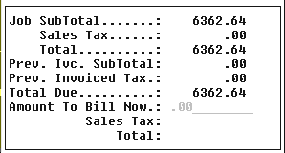

At the Amount To Bill Now field enter the total amount you would like to bill on this Progress Billing Invoice. The system will then prompt the following: Add Sales Tax? (Y,N) Y. If you are billing the customer sales tax on the total sale price of the job, enter to accept Yes. If this is a “Contract” sale and tax is being figured as a cost on the job, type “N” for No. If you entered yes in the Sales Tax field, the system will automatically figure the tax amount for you. (Please Note: the system will not allow you to charge more tax than is showing on the job.) When you have entered through the Total field, the system will prompt the following: Is This Correct? (Y,N). Enter a “Y” to proceed. The system will then prompt the following:

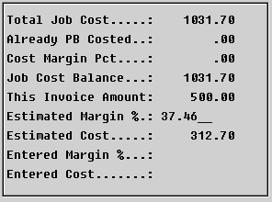

When this box displays, the cursor will be positioned at the Estimated Margin % field and an Estimated Margin will display based on the margins on the job lines at this moment. You can override this margin and if so, then override estimated cost on each Progress Billed Invoice. When the new Progress Billed Invoice is complete, the system will generate commission information based on the estimated profit (see Salesperson Payables section above for additional changes for Progress Billed Invoices.) When you generate the Final 0.00 Invoice from the job, the system will now Credit your Inventory Asset G/L Account and Debit your Work In Process G/L Account. If the amount of actual costs are different from the estimated costs, the system will DR/CR COG-Progress Billing and Work In Process and a commission entry will be created for the difference from previous estimated records. When you have finished with the above box, the system will prompt you for a Current Posting Period. If the Posting Period reflected in the box is correct, hit enter to proceed. The next box is extremely important and will appear as follows:

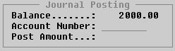

During the Progress Billing process, you are only sending information to Revenue or Sales accounts in the General Ledger. During regular invoicing, because everything is setup ahead of time, the system knows to which General Ledger accounts to send the information. At the Account Number field in the box above, you need to enter the General Ledger Revenue account number you wish to report this sale to; check with your accounting department for verification. You can split the amount and send to different General Ledger accounts if applicable. The system will “are you sure” message when entering a G/L Account Number. After you enter a valid number in the Account Number field, the system will prompt the following:

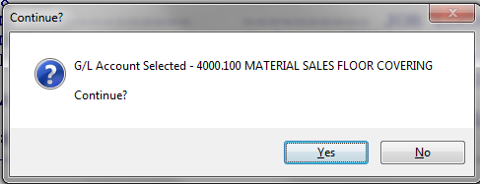

This allows for a second look at whether the correct Account has been entered before proceeding. If the Account is correct, click the Yes button. If another Account Number needs to be entered, click the No button and the system will return the cursor to the Account Number field. Once you complete the Journal Posting box, the system will prompt a Customer Terms box. Enter the terms, if any, you wish to reflect on this Progress Bill Invoice. The next screen will appear as follows:

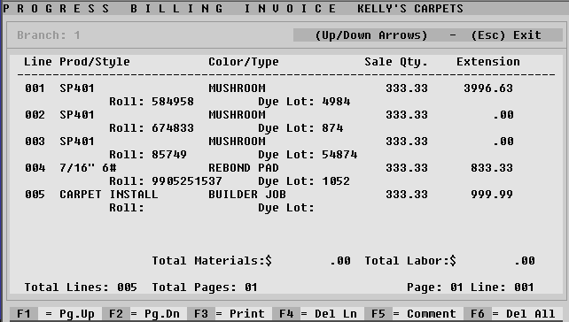

Just like with regular invoicing, this screen will allow you to customize each Progress Bill. Because you are billing an amount that may not be tied to specific order lines, most users will hide all the lines with the F4 or F6 function keys and then use the F5 key to add comment lines. When you are ready to print, hit F3 to continue. Follow the prompts at the bottom right of the screen, just like with regular invoicing, to complete the Progress Billing process. The printout will look just like a regular invoice.

Once you begin the Progress Billing process for a job, you must continue to Progress Bill until the total job as been invoiced. Use the “Work In Process (Progress Billing)” report module to keep track of the amount that has been processed through Progress Billing for a particular job. After the last Progress Bill has been processed for a job, there is one final step to complete. You need to pull the job up in Order Entry or through the “Invoice / Credit Memo” report module and process a regular invoice. (Make sure all material lines on the job have been assigned before you process a regular invoice.) The invoice amount will be zero, but this important step will update all the other accounting and sales analysis functions in the system.

The following are additional changes made to this feature: The Salesperson Profitability report was modified to use the estimated cost entered at Progress Billing time to show the profit on Progress Billed Invoices in the salesperson payables file--on the final bill, it will use the profit on the job minus profits that were estimated and will have a 0.00 sell; the Salesperson Payables system will now allow entry of a commission percentage if the record was created by a Progress Billing estimate (Note: If final Invoicing has been completed, you will not be allowed to change commission percentage or the amount to pay on these records, nor will the system allow any change of records related to that job—if a change needs to be made, you will need to enter manual adjustments with the job number); it is also important to note that prior to the final Invoice, cost changes can be made via A/P Open Item Maintenance and Job Labor Maintenance, but once that final 0.00 Invoice is created the system will no longer allow cost changes. (Please Note: there is a separate Sales Analysis module for viewing Progress Billed Invoices. See that section of the documentation for more information.)

Some additional changes to the system for Progress Billing Invoices are as follows: the Order Entry screen was modified to display a “P” next to the Prev. Inv. Field in the Job Totals box on Progress Billed jobs; the Job History feature was modified to display Progress Billed Invoices and will prompt “Progress Bill” below the Invoice number; and finally, Deposits can be applied to Progress Billed Invoices, but you cannot create a Final Invoice for Progress Billed jobs with a Deposit record.

Invoice Register (Daily Report):
This report should be run daily—if your store has more than one Branch, an Invoice Register should be printed for each. It is an accounting of all Invoices/Credit Memos/ Progress Bills that were processed in the system since the last Invoice Register was printed. It will list the Invoices in numerical order, along with the Job Number, Customer Name, and Salesperson ID. It will then break down the material totals, labor totals, special charge totals and sales tax totals, followed by the total invoice amount, the gross profit on the invoice, and finally the gross margin. The bottom of the report will show an Invoice count along with column totals for the categories mentioned above. If there is an asterisk to the right of the Sales Tax column, this denotes a Contract tax job and it means that tax is being charged on the cost of the material, not the sale. When you print and clear an Invoice Register, the system creates the Sales Journal, which in turn updates the General Ledger in the system. It is a crucial accounting procedure in the RollMaster System. When you enter this module, an Invoice Register screen will appear as follows:
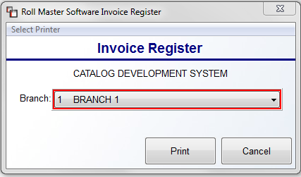
The Branch field defaults to the current Branch. Use the drop-down menu to select another Branch, or you can choose to print for All Branches. Click the Print button when you have made your selection. The report will begin printing and the system will prompt the following:
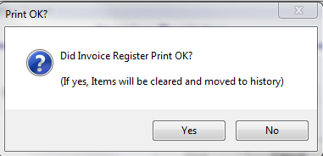

The only reason to click No at this prompt is if the report was jumbled up in the printer and you didn’t get a readable copy. The system will not clear the Register and you will be able to print another copy. If the report printed okay, click the Yes button to clear the Register, and the system will return the cursor to the Branch selection box.

Invoice Register – History:
This print module will give you an Invoice history by Register Date or Item Date. Data becomes available in this module as soon as it is cleared from the Invoice Register. When you enter this module, an Invoice Register History screen will appear as follows:
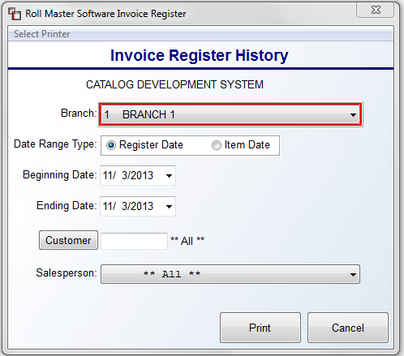
The Branch field defaults to the current Branch. Use the drop-down menu to select another Branch, or you can choose to print for All Branches. You will then select whether to print by Register Date or Item Date at the Date Range Type field. You will then select a Beginning Date and an Ending Date for the type selected. The last two options will allow you to select for one Customer ID or **All** Customers, and then for one Salesperson ID or **All** Salespeople. When you have made your selections to customize the report, click the Print button to print the report. This report can be exported to Excel.

The Excel version has additional columns that you will not see on the printed version. This data includes a modified version of the Sales Rep column which includes the name as well as the ID of the Salesperson. Also the export data includes a column for a second Salesperson. If User IDs are set up, the User ID of the person who processed the Invoice will display in the Invoiced By column, to the right of the Invoice Date column. Two more additions can be found near the end of the export data--you will see Job Date and Install Date columns. Additionally, at the very end, you will see three columns as follows: SalesID 1 Est Commisions, SalesID 2 Est Commissions, and Total Est Commissions. These commission totals are reported at time of invoicing and are not updated if changes are made to Job Cost following invoicing. And finally, a column has been added to track Invoices for Orders converted from Web Orders. This column appears as the very last column as follows: Web Order.

Open Job Report:
This is an extremely valuable sales management tool for keeping track of open jobs in the system. The Open Order Report, explained below, is very similar and a much shorter report, if you don’t wish to see all the detail on this report. The Open Job Report will print out all the detail on an open Job including every order line and any invoicing information. The only qualification in the system for an “Open Job” is that it has not been Closed or canceled. Jobs can be complete and invoiced, but if they are still open in the system, they will show up on this report. The report displays the status of all the lines on a Job, which will inform the sales manager of what needs to be done to complete the Job, or at least point them in the right direction. It also displays the Branch any assigned inventory is located in along with a roll or inventory record number.

When you enter this module, an Open Job Report screen will appear as follows:

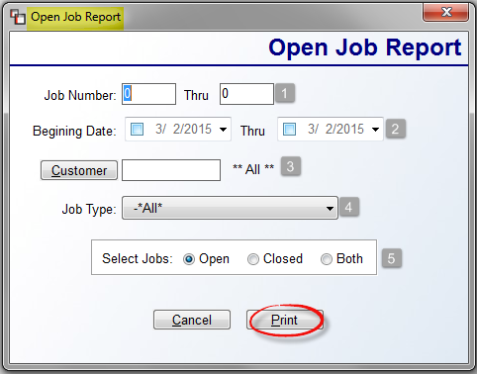

The cursor will be positioned in the Job Number (1) field. To see all open Jobs in the system, you can leave all the default settings and click the Print button. However, if you wish to filter or sort the data to narrow the data that appears on the report, you can access any of the fields to make those selections prior to printing the report. At the Job Number (1) field, you can leave these fields blank, or you can enter a specific Job Number or a range of Job Numbers. At the Beginning Date (2) field, click in the date box to enable printing jobs for a date range, and then use the drop-down arrows to select a beginning and ending date for the report. The Customer (3) field will allow you to print jobs for a specific customer. The Job Type (4) field allows you to print the report for a specific Job Type, such as Builders, or Property Managers. And finally, in the Select Jobs (5) box, you can opt to print only Open jobs, only Closed jobs, or Both. Click the Print button to begin printing the report.

Work In Process (Progress Billing):
This report works in tandem with the Progress Billing module. On this report you will get a breakdown of the amount that has been Progress Billed on each job to date, which will make it easier to know how much still needs to be billed. With the enhancements to Progress Billing Invoicing explained above, you will be able to view the estimated cost and margin percentage (if used) next to each Progress Billed Invoice. You can also view the total cost and percentage below the Job Invoicing History line. These costs are purely from estimating and are not updated through regular job costing update procedures. Additionally, you can now view Progress Billed Invoices on closed jobs.

The program is set up much like the Open Order Report (explained below). When you enter this module, you will get the same Select Option menu with which to set print parameters. The best way to use this report is to know the job number or customer ID on the Progress Billed job ahead of time, and print using that information. Once you set the parameters, arrow down to the Print option and hit enter. The report will show a Job Invoicing History, the total amount that has been Progress Billed thus far, and it will also show the balance remaining to be invoiced.

Quotation Listing:
This report module is a management tool that will give managers a good indication of how many Quotes are not being converted into sales. This report can be printed by Salesperson, so sales managers can go over with each Salesperson why the Quotes have not been closed. The Salesperson can use this report to follow up with Customers. It can be printed by Branch, which means that the report can be printed for all Branches without the User having to change Branches to print this report. It will also display any Deposits taken and total those by Branch and then for the entire Company. Sales tax will not be included on this report.

When you enter this module, a Quotation Listing box will appear as follows:

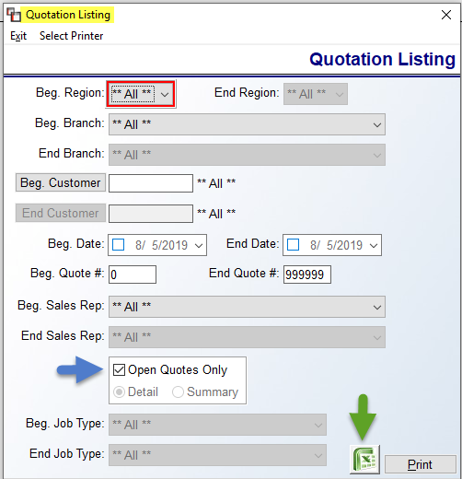

If you wish to see all open Quotes in the system, click on the Print button. However, you can customize the report via any of the listed options where applicable. If you uncheck the Open Quotes Only box, you will then have an option to print by Detail or Summary and the Job Type option will become available.

Salesperson/Open Job Listing:
This module holds a combination of two reports: Salesperson Job Listing and Open Job Listing. The Salesperson Job Listing gives you multiple ways of looking at job data by Salesperson. The Open Job Listing lists all open Jobs according to any sort parameters you select, and will display any Deposits taken on those Jobs. At the end of the report, you will see a total number of open Jobs, a total value of Deposits on all open Jobs, and the total value of all the open Jobs previously listed. Each Job will only take up a couple of lines on the report and you will only see basic information; it does not include data on the various lines or Job type info. When you enter this report module, the screen will appear as follows:
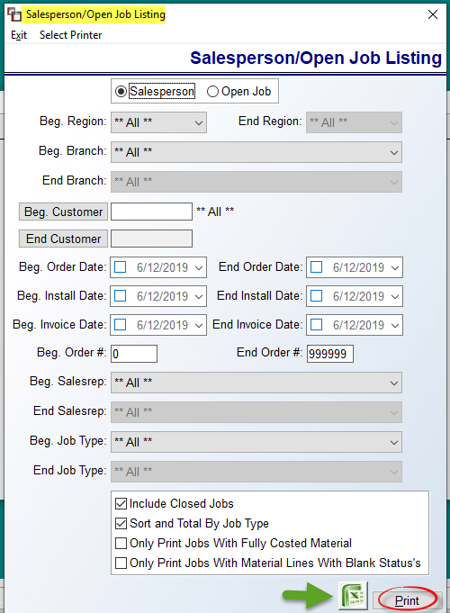
The settings in the screen above are the default settings for the Salesperson Listing option. If you click on the Open Job option, some of the fields will grey out as they don’t apply to that report. Both reports can be exported to Excel. The default settings for all of the available sort options are “ALL,” which means that if you click the Print option without using any of the sort options, you will see all available data. However, if you would like to customize this report, you can access one or more of these options and set specific sort criteria. There are additional questions at the bottom to further customize the data on the report. The first option, Include Closed Jobs, is checked by default, so to exclude any closed Jobs, you will need to uncheck that option. The next option, Sort and Total by Job Type is also checked by default. If you do not wish to see the report sorted by Job Type then uncheck that option. The remaining two options, Only Print Jobs With Fully Costed Material and Only Print Jobs With Material Lines With Blank Status’s, are unchecked by default. These options can be used to help identify Jobs that need to be Invoiced or Installed, and then Jobs that need material ordered or assigned.

Open Order Report:
This report reveals much of the same information as the Open Job Report, but it is much more condensed. It also has some additional Print Options. In addition to several key pieces of information, this report will display the Install Date on each listed Job as well as the Job Line Status in the Status column—the same Status options that appear in the Enter Line Items screen will display here, and if a line has a blank status, the report will display N/A. Additionally, to the far left of the report, in the Job Stat column, the report displays the Ship To Address from the Job and will also display the content of the Special Instructions field if any text has been added to that field in a Job. Please Note: if there are no Order Lines on a Job, the Ship To Address and Special Instructions will not print. And finally, the report will display the total number of Orders for each Branch and, if applicable, each Region included in the report.

When you enter this module, an Open Order Report screen will appear as follows:

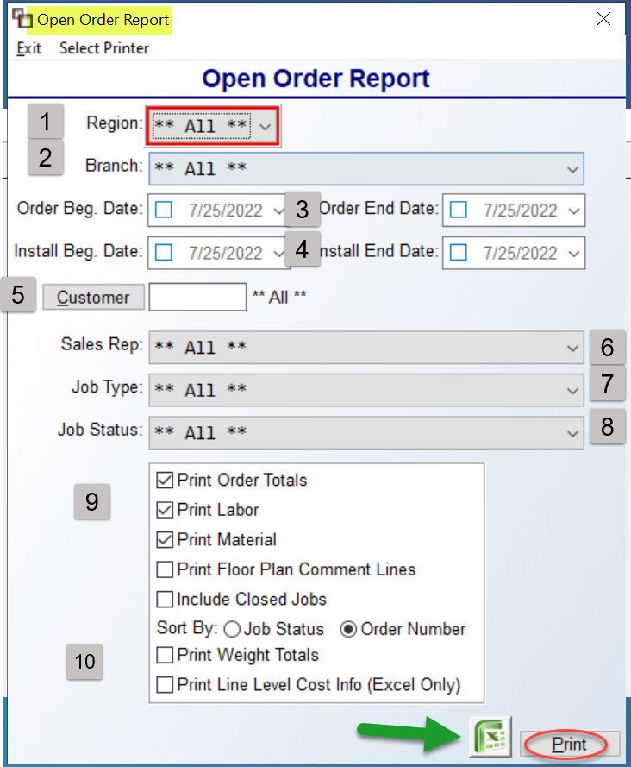

The defaults for all of the sort fields in this screen above are **ALL**, which means that if don’t alter any of the 1-8 fields, the report will print all available data. However, if you would like to customize this report, you can access any of the drop-down or date fields to set specific sort criteria, such as viewing only Open Orders for one specific Sales Rep. The Region (1) field will prompt if Region Reporting has been enabled in the system. Use the drop-down arrow to select a specific Region, if applicable. The same goes for the Branch (2) field. At the Order Beg. & End Date (3) fields, only click in these boxes to select a specific date or set a date range for the report. The same goes for the Install Beg. & End Date (4) fields. If no dates are selected, all dates will be included. Click on the Customer (5) button to select a specific Customer for the report. At the Sales Rep (6), Job Type (7), and Job Status (8) fields, only use the drop-down arrows to make specific selections to narrow the report parameters.

In addition to having several sort fields to customize this report, there are also a couple of additional features to consider prior to printing or exporting the data. Just below the Job Status field are additional Print Option (9) fields. The first appears as follows: Print Order Totals. The default is checked, however, if you would like for the report to not display any order or tax totals, you can uncheck this option. The next two appear as follows: Print Labor & Print Material. The default is set to include both; however, if you would like to limit the print out to only Labor lines or only Material lines, you can make that change here. The Print Floor Plan Comment Lines option can be checked if you wish to include those on the report. The Include Closed Jobs option can be checked to include data from closed Jobs in the system. The Sort By (10) option defaults to Order Number; if you wish to sort by order of Job Status, you should leave the field above set to **ALL**. The Print Weight Totals, if checked, will include data based on the Weight field in the Catalog Maintenance module.

This report can be exported to Excel. Please Note: The Print Line Level Cost Info (Excel Only) checkbox can only be enabled where User can see Costs. This allows for adding Cost and Budget info to the exported data provided the User can see Cost. Several additional columns will appear in the Excel export of the Open Order Report. These columns appear at the end of the data that appears on the printed report, with the exception of the following: Order Line # appears next to Order #. The remaining additional columns are as follows: Tax (Y/N), Tax Amount, Closed (blank if open, “C” if Closed), Invoice Date, Invoice (zero if no Invoice), and Invoice Line. Additionally, a column for PO#, when material is assigned, appears after the last column. It is one field listing all PO’s per line, including PO #, Line #, and any quantity remaining to be received, along with the ETA of arrival. Where there are multiple POs, you will see info on the first PO, followed by the second PO, and so on, separated by a vertical line, referred to as a pipe character. The Customer’s Email Address will also export. The system will first look at the Ship To Code for an email address, and then revert to what is in Customer Maintenance.

Open Order Tax Report:
The purpose of this report is to display tax assessed as Sales tax for “I” Invoiced jobs. On the printed report, if there is an amount in the taxable material column, then the tax displayed is Sales tax. If there is a 0.00 value in the taxable material column and an asterisk at the right end of the line, then no tax is displayed as Use tax being assessed to the job. This report looks and works the same as the Open Order Report but will display additional tax columns on the printed report as follows: Taxable Material, Non-Taxable Material, and Tax Amount. These columns will be broken down for each line on a job appearing on the report and then totaled for each job and at the end of the report the system will display a total in these columns for all jobs by Branch and Region if applicable.

Credit/Return Report:
This report works in tandem with the F3 Credit procedures, which have been explained above in the Order Entry Maintenance section of this manual. This report will print out a list of all Credit Memos created in the system with the corresponding Job Number, original Invoice # and amount, the amount of the credit, the amount refunded, the salesperson, and the customer. It will also print any Notes added during credit processing. It can be sorted by Branch, CM Invoice #, CM Invoice Date, Salesperson, and Payment Type Code. As an example, if you wanted to see a list of credits performed by each Salesperson for a specific time period, you could use this report for that purpose. When you enter this report module, the cursor will be positioned in a Select Option box. Set your print parameters and then arrow down to the Print option and hit enter. The report will begin printing and the system will place the cursor back at the Sales Processing Reports Menu 1 of 2. This report can be exported to Excel.

Sales Processing Reports 2 of 2

Sales Tax Reporting Details & Sales Tax History:
The Sales Tax Reporting Details and Sales Tax History report modules have been combined and modernized into one graphical screen as follows:

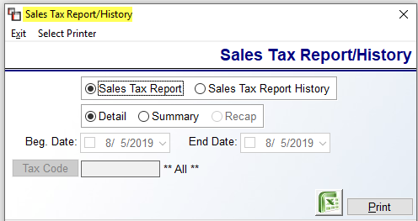

The default report selection will be on Sales Tax Report, and only those options that relate to this report will be enabled, such as Detail and Summary. When the Sales Tax Report History option is selected, you will see the other options enabled as follows:

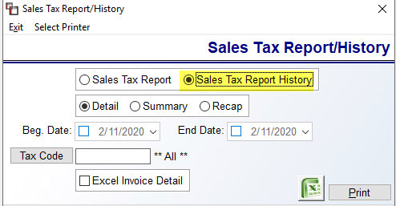

As a reminder, no data will appear on the Sales Tax Report History until that data has first been printed and cleared from the Sales Tax Report.

The Sales Tax Reporting Details or Sales Tax Report is a monthly report that will show all the tax that was invoiced for the month. If your state requires that you pay sales tax based on sold jobs and not on whether the customer has paid for the job in full, this report will give you the information and backup you need. No value is sent to this report until a Job is invoiced in the system. With this report, you have the option of printing a Detailed report or a Summary report. The Detailed report will list each sale and denote whether it was a Contract sale or an Invoice sale. At the bottom of the report you will see a total of all Contract sales, Invoice sales, Tax Exempt sales, and finally a grand total of all tax invoiced and therefore due. The Summary report simply lists all the totals without the job-by-job breakdown, but does list Total Taxable Sales. When the report is cleared, it is sent to the Sales Tax History Report explained below. Please Note: if using the Sales Tax Collected report—see separate documentation—you will not clear this report.

The Sales Tax Report History is updated only from printing and clearing the Sales Tax Reporting Details report. When you clear that report, the information is transferred into this report where it becomes history. If you ever need to pull the history, select this option and set any print options desired. The Tax Code field can be used to isolate a single Tax Code on the history report. This report looks exactly like the one that prints from the Sales Tax Reporting Details module, except that it has a Date column to the right of the Invoice column. It will also display a Job Type and Salesperson ID for each Invoice. This report can be exported to Excel by selecting that checkbox prior to printing. The Excel Invoice Detail checkbox has been added to assist with Sales Tax Audits of PST/GST tax, but can be used by anyone wishing to see the listed data. This export data will include the following: Tax Code, C/I, Invoice, Date, Cust.ID, Job Type, Sls ID, Job Number, Job Line Number, PO Br, PO #, Vendor Name, Vendor Invoice Number, and Material Cost Per Line.

As with all reports that are now exporting, the data in each column will not automatically total; you will need to use Excel formula functionality to create totals. This export includes a column for any Labor tax and for any Special Charge tax that was collected.

Sales Tax Collected:
If your state allows you to pay sales tax after the customer has paid for a Job in full, then use this report. Many states do not, so please be sure to check with your CPA or Tax Advisor for verification. If you use this report, you need to be sure not to clear the information out of the Sales Tax Reporting Details report explained above. You can print this report once a month to find out how much sales tax is owed. When you enter this report module, the screen will appear as followed:

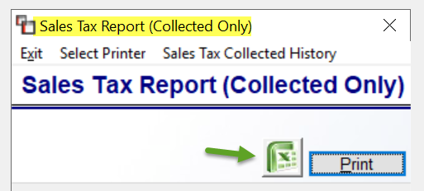
In addition to exporting the data to Excel, or clicking the Print button, you can also access prior cleared files by date, which can be called up and reprinted at a later time in a csv format. That option appears along the top as follows: Sales Tax Collected History. This option will prompt a Sales Tax Collected History box as follows:

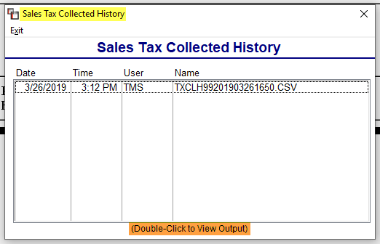

Double-click on a file to view the detail in a csv format.

Inventory Required From/For Other Branches:
These reports work in tandem with the Inventory Transfer feature. They are used to keep track of inventory that needs to be transferred in from other Branches, as well as out to other Branches. When you enter this report module, the screen will appear as follows:

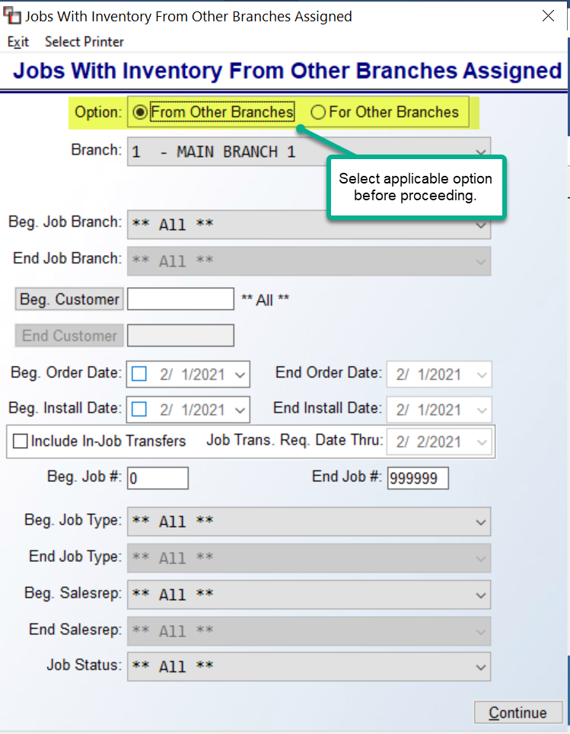

The default report setting is From Other Branches. See explanation further down for For Other Branches. When material is assigned From another Branch’s inventory, it will automatically appear on this report. This report prints for each individual Branch to communicate to the warehouse the inventory that needs to be physically transferred from other Branches to fill orders in the current Branch. This report will print a list of all inventory items needing to be transferred, or you can customize the report to print inventory items by the following criteria: Job Branch, Customer, Order or Install Date, Job Number, Job Type, Salesperson, and Job Status. The Include In-Job Transfers checkbox, when checked, will include those transfer requests initiated from within Jobs. If you do not need to customize the report, you can simply click on the Continue option to print everything on the report.

The For Other Branches option is used to keep track of inventory in the current Branch that needs to be shipped to other Branches for Jobs in progress so it can be prepared for physical transfer. When other Branches assign material from the current Branch’s inventory, it will appear on this report. This report will print a list of all inventory that needs to be transferred out of the current Branch to complete order processing in other Branches. You will make your sort criteria options much the same as explained above. However, when you hit Continue, the system will perform an additional step. This report will first prompt the following:

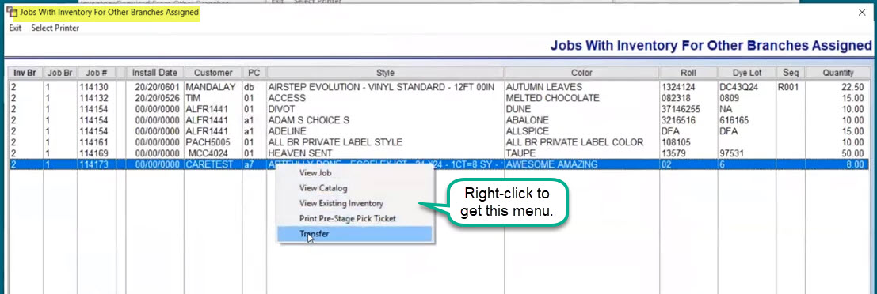

This screen will display the Jobs that meet the criteria selected in the previous screen and allow you to perform some additional functions. You can Print the list and give to warehouse personnel for pulling material, and when ready you can initiate Transfers from this screen, View Jobs, View Catalog, View Existing Inventory, and even Print Pre-Stage Pick Tickets, so material for the entire Job can be pulled. Once an item is transferred, it will fall off the For report screen. This report will page at the start of each Branch. Also, if an Initials Record has been entered in the Order Entry screen indicating that an Install Date has been scheduled, those initials will print on this report next to the Order Date.

Estimated C.O.D. Amt. Report:
This is an estimated C.O.D. report that was developed for use primarily with retail jobs where a deposit is taken when the order is placed and the balance or C.O.D. is due upon installation and prior to invoicing. Jobs where the customer has a credit limit will not appear on this report. (If you do not see the “C.O.D. Customer!” prompt in the Order Entry screen, next to the Credit Limit field, the job will not appear on this report.) Also, a job will not appear on this report until a Work Order has been printed. An installer must be assigned to a job prior to printing this report if you wish to see an installer ID included.

This report is considered “estimated” because it is only updated through the Deposit option in the Order Entry module. Any credits or payments applied to a customer’s account through the A/R Post Customer Payments module will not be reflected in this report, and if a partial Invoice on a job is processed, any deposit that was taken will be removed from this report and it will appear that the full amount of the order is due. However, if a partial Invoice has been processed, the report will place an asterisk to the right of the C.O.D. amount prompting the user to check the customer’s account. Generally, partial invoicing on straight retail jobs does not take place, and credit balances will only be a factor for a small percentage of jobs. As a general rule, if you pull up the job through the Order Entry module, you can look to see if the customer has a credit balance in the A/R Due field of the Job Totals box. However, if the customer has a positive balance due, you will need the accounting department to give you a true C.O.D. amount to collect. When you enter this module, the system will place the cursor in a Select Option box as follows:

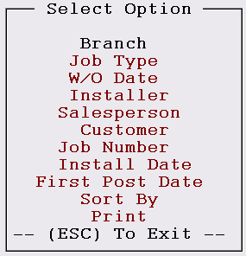

Using the options in the box, you can customize the report to include only those jobs that meet the parameters you have selected—you can set up more than one print option. When you enter this report module, you will note the addition of Region as an Option in the menu if you have enabled Region Reporting in the system, via the Company Control 2 level of the System Control Maintenance module. If enabled, this report will automatically group all Regions together and you will see the Branch ID at the top of each page. If you wish to limit the Regions, you can select this option and type in a Beginning and Ending Region ID to appear on the print out. The Branch option will allow you to print this report for only one branch, a range of branches, or all branches; the Job Type option will allow you to print this report for only one job type, a range of job types, or all job types; the W/O Date will allow you to print this report by a range of Work Order print dates; the Installer option will allow you to print this report for only one installer, a range of installers, or all installers; the Salesperson option will allow you to print this report for only one salesperson, a range of salespersons, or all salespersons; the Customer option will allow you to print this report for only one customer, a range of customers, or all customers; the Job Number option will allow you to print this report for only one job, a range of jobs, or all jobs; the Install Date option will allow you to print this report for one installation date, or a range of installation dates; the First Post Date option is tied to the Job Labor Mtc./Installer Payments module. When you post the first Installer Payment on the job, you can then customize this report by that date. The last option appears as follows: Sort By. When you hit enter on this option the system will prompt a Select Sort Order box as follows:

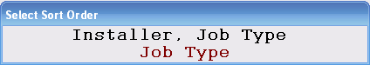

You will notice to the left of the Select Option menu that the Default Sort By is via Installer, Job Type; therefore, if you would rather sort the report by Job Type only, you can arrow down to that option prior to printing the report. Once you set the parameters, arrow down to the Print option and hit enter. The system will then prompt the following: Do You Want Jobs With Zero C.O.D. Amounts (Y,N) N. Hit enter to leave out jobs with no C.O.D. to be collected or type a “Y” at this prompt to include those jobs. Print Financed Jobs? This prompt is defaulting to “No”, so if you wish to include Financed Jobs on the print out, select “Yes” at this prompt. If you only wish to print out Financed Jobs, answer “N” to the Print Only C.O.D. customers prompt and “Y” to the Print Only Financed Jobs prompt. On the print out, you will now see an Initials and Financed Amt column on the report. Please note that if the Financed Amount on a job is $1,000 and the total job is $1,100, the report will print showing $1,000 in the Financed Amt column and $100 in the C.O.D. Amt column. In order for the Installer ID to print on this report, you have to select the option to Print Only C.O.D. customers and a Work Order must be assigned with an installer. If a job is Financed, the Work Order will print a Financed Amount under the C.O.D. Amount Due field.

When you have entered through the Financed options, the system will then prompt the following: Do You Want To Print Open And Closed Jobs? (Y,N) N. Hit enter to print only open jobs, or type a “Y” to include closed jobs. This prompt was added so that closed jobs could be included on the report at the User’s discretion. However, this also means that canceled jobs that still have order lines will also show on this report, which is why it is important to always delete order lines on canceled jobs. At the Eject Page prompt, hit enter and the system will place you back at the Sales Processing Reports menu.

Salesperson Payables History:
This module works similarly to the Salesperson Payables module, but gives you history on all Paid Commission items for all Salespeople in all Branches. When you enter this module, the system will prompt you to select a Processing Mode of either By Salesperson or By Branch. If you wish to view for only one Salesperson at a time, choose the By Salesperson option. If you wish to view for all Salespeople within a Branch or all Salespeople within all Branches, choose the By Branch option. Once you have selected your Processing Mode, the system will then prompt a Select Option box. From this box, you can use the Sort By option to sort data by Invoice Number or Job Number; you can use the Enter Date Range to set a date range for the data you wish to view or print a report for; you can View Paid Items on screen based on the sort criteria you previously entered; you can print a report of all commissions earned for a date range through the Print Commissions Report; or you can print a report of all items where commission has been paid through the Print Paid Item Report. Please Note: When printing Commissions Report, in order to see commission splits, you will see the following prompt: Show Commission Splits and Recalculate Sales Amount? This is the same prompt that prints in the regular Salesperson Payables module.

The next option appears as follows: Inquiry by Job, Invoice or Cust. When this option is selected, the system will prompt the following menu:

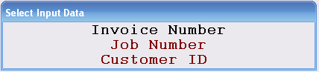

Based on your selection, the system will search the history file for matches for a customized report. You will get a customer lookup box if you select the Customer ID prompt. If you don’t wish to search by a particular Salesperson ID, you can select one Branch or all Branches and the system will search through all Salesperson Payables entries for matches. Also, the Item Paid date has been added to the Detail screen. In the Enter Date Range option, the system will prompt the following: Date Selection (S-Salesperson Paid Date / I-Invoice Date): S. The Salesperson Payables system and this History module are now storing the Salesperson Paid date along with the Invoice Date, therefore, you can now sort your history data by either a range of Salesperson Paid Dates or Invoice Dates. This prompt is defaulting to “S” for Salesperson Paid Date; hit enter to accept or type an “I” to sort by a range of Invoice Dates.

Salesperson Draw Commission Schedule:
This report works in conjunction with the Salesperson Draw Maintenance feature and can only be used where some or all salespeople have been set up to be paid a Draw. Once you have processed paid Draw items, you can reprint the Salesperson Draw Commission Schedule from this menu. Prior to updating paid Draw items, this report should be printed from within the Salesperson Payables module.

Salesperson Draw Commission Detail:
This report works in conjunction with the Salesperson Draw Maintenance feature and can only be used where some or all Salespeople have been set up to be paid a Draw. Once you have processed paid Draw items, you can reprint the Salesperson Draw Commission Detail report from this menu. Prior to updating paid Draw items, this report should be printed from within the Salesperson Payables module.

Contact Activity Notes Report:
This report is updated from three places. The first is from Customer Maintenance, Contacts, Edit Contact, Notes icon to access Contact Activity Notes. The second is from Vendor Maintenance, Contacts, Edit Contact, Notes icon to access Contact Activity Notes. The third is from the RMMobileSales App, an upgrade program for outside sales people to log in from their mobile devices to access live customer data from RollMaster. Owners/Managers can print this report to see updates on outside sales activity as it happens. When you access this report option, the screen will appear as follows:

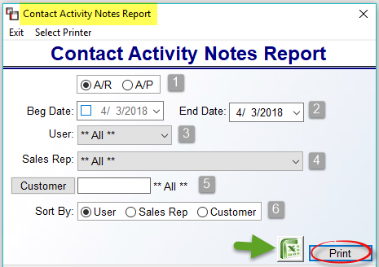

At the A/R A/P radial button option (1), only click A/P if you wish to see Vendor Contact Activity Notes. At the Beg Date and End Date (2) fields, you can narrow the date range by clicking the checkbox and entering a date range. The User (3) field can be accessed to view by a specific User in the RollMaster System. Similarly, the Sales Rep (4) field can be accessed to sort the report data by a specific Sales Rep. At the Customer (5) field, use the lookup button to select a specific Customer ID for the report. At the Sort By (6) field, the default is User, however, you can select to sort by Sales Rep or Customer where applicable. Click the Excel icon to export the report data. The Print option will only work with a graphical printer selected, otherwise that option will trigger an export to Excel. Please Note: All Custom Menus currently displaying Sales Processing Reports Menu 2 of 2 will see this new report.

