
Table of Contents
Sales Processing Part I 1
Introduction: 1
Order Entry/Maintenance: 1
Existing Order Lookup: 2
Creating a New Job: 7
Searching/Adding A New Customer: 7
Continuing Order Entry Process: 20
Line Items Screen: 35
Line Comments: 55
Right-Click Line Item Options: 60
Cut Sheet Feature (If Enabled): 65
Labor & Special Charge Line Items: 69
Line Items Screen Continued: 74
Deposits: 76
Job History: 80
Install Dates: 81
Job Cost, E-Docs, Refresh, Home, Quick Invoice, & Detailed Job Cost View/Print: 81
Options From Order Maintenance Screen: 94
Credit Memo: 98
Work Order/Pick Ticket--Graphical Version (see separate doc below for text work order): 109
Work Order/Pick Ticket--Text Version (See separate doc above for graphical work order): 121
Invoice: 131
Invoice Batch Printing: 139
Print Menu Options: 143
View Menu Options: 146
Options From Sales Processing Screen: 157
View Job Audit: 157
Batch Work Order Processing: 159
Print: 162
OTC Job: 164
Print Job Report: 166
View Installation Schedule: 166
Quotation/Proposal Maintenance: 171
Commercial Quote Entry: 173
Converting a Quote to an Order 177

***CONFIDENTIALITY NOTICE*** This documentation contains confidential information belonging to Textile Management Systems, Inc. and RollMaster Software, which is protected by copyright laws and other privileges. This information is intended for the exclusive use of legally licensed RollMaster Software users. If you are not the intended recipient, you are hereby notified that any disclosure, copying, distribution, or the taking of any action in reliance on the contents of this information is strictly prohibited. If you have received this documentation in error, please immediately notify us by telephone at (800) 777-4107.

Sales Processing Part I

Introduction:
The Sales Processing menu options allow the salesperson/order entry person to quickly and easily input orders into the RollMaster System. It is the very first menu option in the Master Menu because all other business activities hinge on sold Jobs. Every sales processing related function and report is accessible from the Sales Processing menu. Because you can do so much from Order and Quote Entry, those manual sections are quite large and have been combined into one manual: Sales Processing Part I. The documentation for the remaining modules in the Sales Processing Menu can be found in the Sales Processing Part II manual.

Please Note: Contained within the Sales Processing menu are a few setup modules that need to be completed before any orders are entered in the system. They are Salesperson Maintenance, Salesperson Draw Maintenance (this menu option will only be visible if it has been enabled through the System Control Maintenance module and should only be used if applicable for your business), Territory Code Maintenance, Job Type Maintenance, Payment Type Code Maintenance, Job Status Code Maintenance and Initials Maintenance. Please Note: If these modules have already been set up, please continue with the section below titled Order Entry/ Maintenance. Again, documentation covering these setup modules can be found in the Sales Processing Part II Manual.

Order Entry/Maintenance:
To create a new order in the system or to access an existing order, from the Sales Processing main menu, click on the Order Entry/ Maintenance menu option to get started. The system will then prompt a Select Printer box. You will need to click on an option from this menu to continue; however if you need to make a printer change from within the program, you will be able to do so. Once you click on a printer option, the system will prompt a RollMaster Software Sales Processing screen as follows:

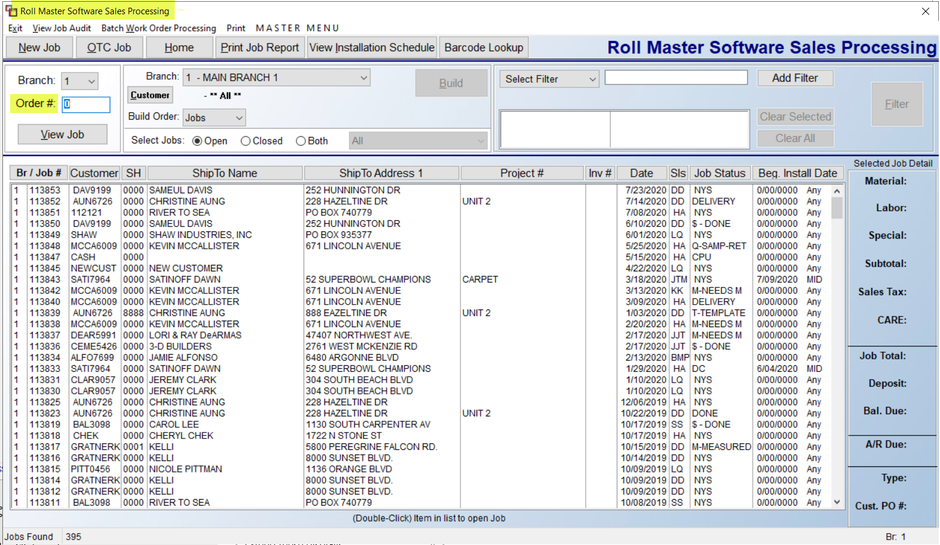

When you first enter this screen, the cursor will be positioned at the Order # field at the top left of the screen. The list of Jobs displayed will automatically sort numerically, oldest to newest, in the Br./Job# column, based on the default settings you see in the screen above. You can click on any of the column headings to change the sort display, including the Install Date (to the far right) to see Jobs with scheduled Install Dates furthest out. More extensive details of this screen will be explained further down in this section following the instructions for Creating a New Job. Also, an explanation of the OTC Job (Over the Counter Sale) can be found at the very end of the Order Entry/Maintenance section.

Existing Order Lookup:
For purposes of this documentation, the words Order and Job are interchangeable. Once several Orders/Jobs have been entered in RollMaster, in order to look up a specific Job, there are several ways to search rather than scrolling through a long list. As noted above, when you first enter the Order Entry/Maintenance module, the screen will appear as follows:

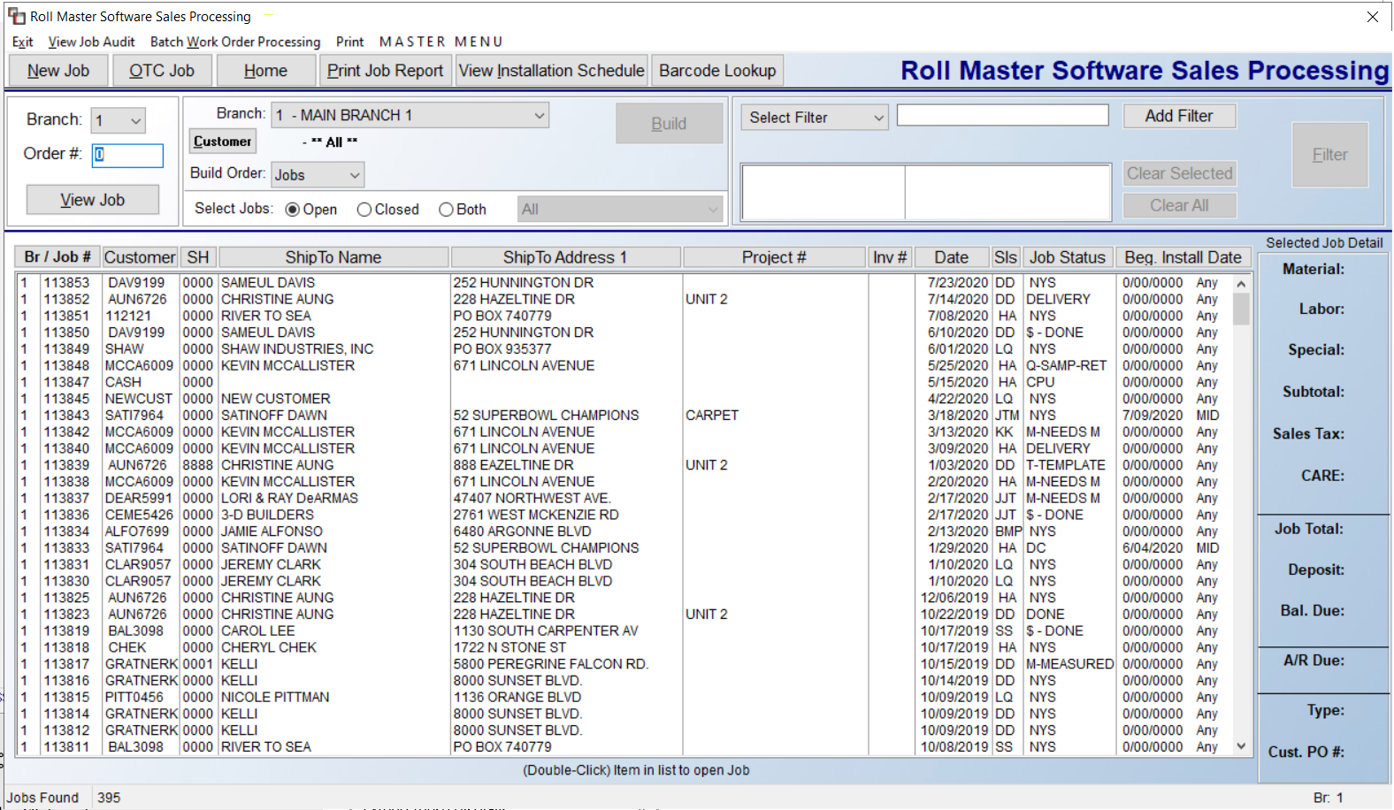

A list of existing Jobs will display in the main screen sorted in order of Branch ID and then newest Job #. At the far right is a Selected Job Detail column. When a Job is highlighted in the display screen, you will see all applicable detail for that Job in these fields. You can scroll through the list of existing Jobs by clicking and sliding the vertical View Ruler located to the right of the listed Jobs. However, there are many quicker ways to locate Jobs using the features at the top of this screen. Those features appear as follows:

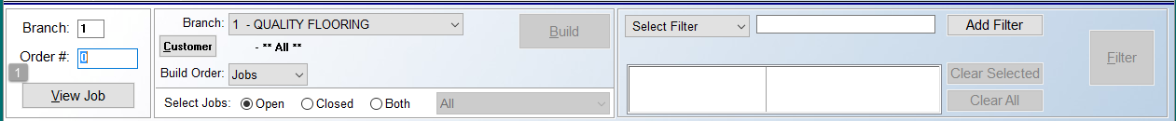

Starting at the far left, you can type in an existing Order # (1), and then click on the View Job button. The system will prompt the Order Maintenance screen for that Job, and you can begin editing. You will need to know the exact Order # to use this feature. In the next section, additional lookup features appear as follows:

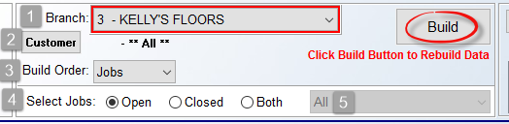

In the Branch (1) field, the system will display the current Branch ID and Name. To change to another Branch, click on the down arrow and select from the list. Once you make one or more selection options in this section, click the Build button to implement the selected change in the list of existing Jobs in the screen below. To look up a Job by the Customer name, click the Customer (2) button to prompt a Customer Selection box (explained above). Locate a Customer ID, click Select, and from the screen above, click the Build button to prompt a list of Jobs for the Customer selected. The only difference between the two Customer Selection screens is the addition of a Select All button when accessed from here. This will allow you to clear the selected ID. To do this, click the Customer button again and then click the Select All button. The display will revert back to **All**; click the Build button once more to rebuild the Job display screen to include **All** Customers. Note the red type in the screenshot above: Click Build Button to Rebuild Data. This is a reminder to re-click the Build button whenever a search option is changed and you wish to display the new data.

The Build Order (3) field allows searching by the Ship To Address 1 & 2 (or Project #) columns. The default setting is Jobs. When you click on the down arrow, you will see the two new search options as follows:

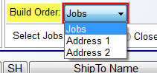

When you select either option, the system will prompt a blank field for you to begin typing some or all of the address data for search purposes. Click the Build button to refresh the screen and display all matching data. At the Select Jobs (4) section, you can search for Open jobs, Closed jobs, or Both. The default will be set to “Open,” so if you need to make a change, you will need to click on a different option and then click the Build button to rebuild the job listing display. An additional feature for the Closed and Both settings is the ability to narrow the closed Jobs search by Year (5). The default for this option is All. To change the search, click on the down arrow to select from the following: Current Year, Last Year, Last 2 Years, Last 3 Years, Last 4 Years, and Last 5 Years. If you make a selection from the drop-down menu other than the default, be sure to click the Build button to rebuild the data in the screen below.

The final Job look up section appears as follows:

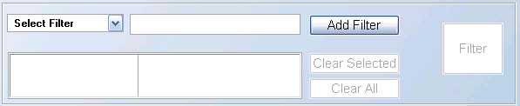

This section will allow you to choose filters for sorting through the list of existing Jobs to find the right one. This section will more likely be used by companies who do a lot of Property Management or Builder work. To use one or more Filters, click on the down arrow in the Select Filter box and a drop-down menu will appear as follows:
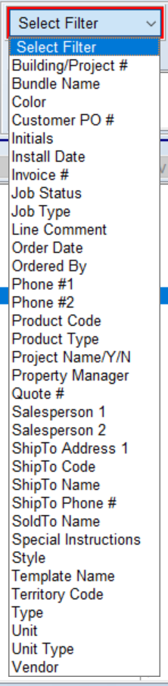

You can use your mouse to click on an option or use the up and down arrow keys and hit enter to choose a Filter from this list. Once a selection is made, it will appear in the Select Filter field and the cursor will be positioned in the field to the right that will now display the following: Enter a value here. In this field, you will type in data applicable to this Filter search, such as a unit number if you selected the Unit Filter. Once this is done, you will need to click the Add Filter button to add the Filter to the box below the Select Filter field. You can then make additional Filter selections to further narrow the search. You will need to click the Add Filter button after each selection, and the list of Filters will display in the box below as follows:

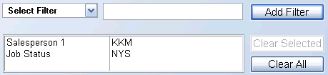

At this point, you can click the Clear All button to remove all the Filters and start again, or you can highlight a filter and then click the Clear Selected button to remove only one Filter. You can add as many Filters as necessary, but once they are selected, the next step is to click the large Filter button on the right to apply the Filters to the display lookup box below. The system will sort through the data and display all Jobs matching the Filter data in the Job listing box below as follows:

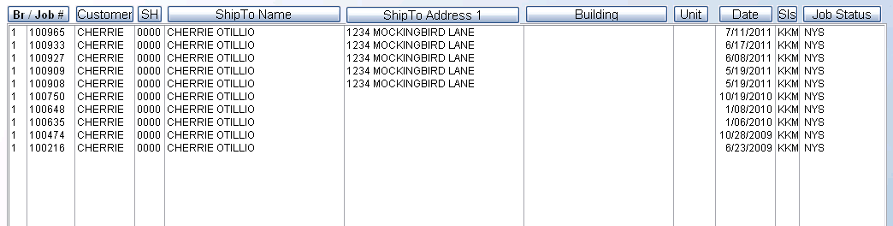

If the Job you are searching for appears in the box above, you can double-click on that Job to enter the Job. If you don’t find the Job you are looking for, you can change the Filter options or revert to one of the other methods for Job lookup. The final option for sorting through the Job listing display is to click on the buttons at the top of each column. If you click on the Customer column, the Job list display will sort alphanumerically by Customer ID, placing any blank ID’s at the top. You can click again and it will reverse the order. You can do this to any of the column heading buttons, however, the other Job search options explained above will likely prove quicker and easier.

Creating a New Job:
To create a new Job, click the New Job button at the top left of this screen. When you are finished in this module, to exit out of this module, you can either click the Exit option, click on the “X” at the top right of this screen, or hit the Esc key on your computer keyboard. When you click on the New Job button, an Order Maintenance screen will appear as follows:

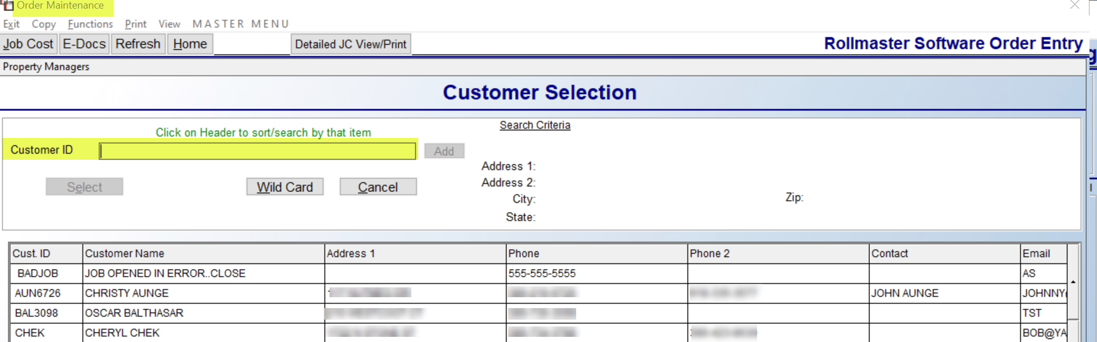

Searching/Adding A New Customer:
The cursor will be positioned at the Customer ID field in the Customer Selection box.
All existing Customers will appear in the Customer Selection box in alphanumeric order. The functionality in this screen will allow you to sort by any of the column headings as you are conducting a search, such as by Phone number, rather than only by the first couple of letters of the ID. As you click on any of the column headings, you will note that the Search Criteria box at the top of the screen will switch to that heading. For example, if you click the Email column heading, the “Customer ID” search field will now display “Email” and you can begin typing the first couple of letters of an email address to start sorting the data in the screen below by those characters. You can also scroll through the list by using the up and down arrow slides along the right side, or you can still type the first couple of letters of the Customer ID to perform an alpha lookup by last name. Once you have located the applicable customer, click on that line to highlight. The system will then populate the Address 1, Address 2, City/St, and Zip fields for that customer in the top right of the Customer Selection screen. Click the Select button at the top of the screen to access that Customer ID.

An option to search by Property Managers appears at the top left of the Customer Selection box. When you click on that option, the system will prompt a Customer Property Manager Selection box as follows:
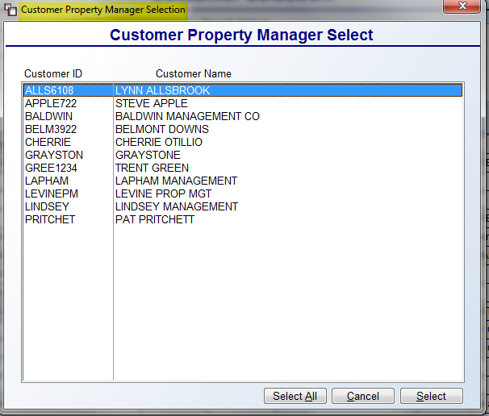

Highlight the applicable Property Manager in the screen above and click the Select button to continue.

You can also add a new Customer from this screen by typing a new ID in the Customer ID field and then clicking the Add button. Please Note: if a User is not allowed to add Customers to the system, the Add button field will not display. To Add or create a new Customer ID, you can use up to eight characters. RollMaster recommends using the first four letters of the customer’s last name followed by the last four digits of the customer’s phone number when creating a new ID. For example: John Smith at 615-777-4107 would have an ID as follows: SMIT4107. It is best not to use symbols or spaces in the ID. For a business, use the first four letters of the business name followed by the last four digits of the telephone number, i.e. Broderick Builders with phone number 615-791-0204 should appear as follows: BROD0204. This method is beneficial for the following reasons: it keeps the ID format the same for all customers whether retail, commercial, or builder; it forces the Salesperson to always ask the Customer for their phone number; it is easier for the A/R department to locate Customers because the phone number is most always on the check; and the setup is extremely beneficial for commercial dealers, whose customers may be large with many different branches or departments that have many different billing addresses. For example: The University of New Mexico has departments and annexes all over the state. The phone number is the only way to identify each particular billing department since the name is the same for all departments.

When creating a new ID, begin typing the first four letters in the Customer ID field. As you type, the system will begin sorting the data in the Customer Selection box, prompting any matching names. This will allow you to check to make sure the ID does not already exist. If the system does not find a match, continue typing the last four digits of the phone number. Once the 8-character ID is entered and there is no match in the selection box, click on the Add button to the right of the Customer ID field to continue. The system will prompt the following:
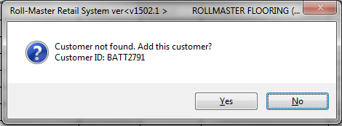

To add, click the Yes button. The system will then prompt a Customer Maintenance screen as follows:

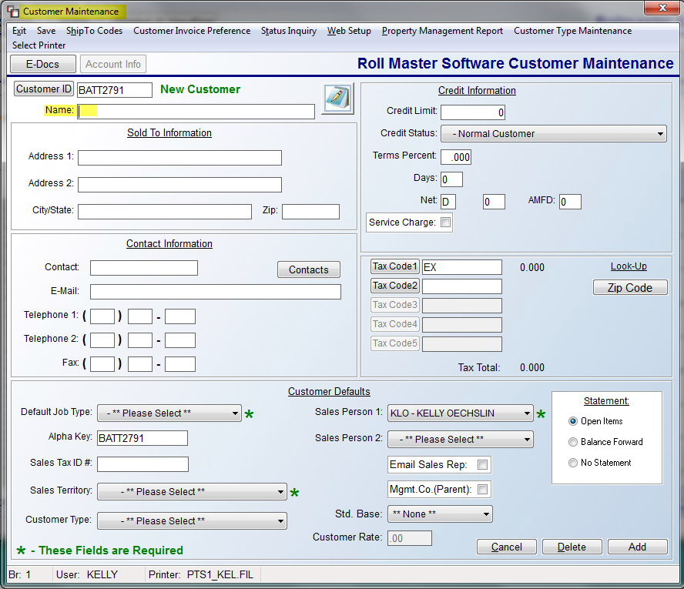
The Customer ID will automatically default to the new ID you created and the cursor will be positioned at the Name (1) field as follows:

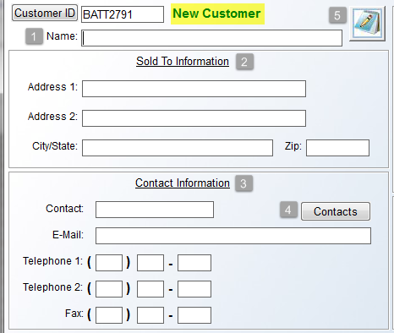

Type the Customer’s first and last name; omit titles such as “Mr.”, “Mrs.” and “Dr.”, etc. In the Sold To Information (2) fields, type the complete address, including Zip code. These fields automatically read into a system database for A/R mailing labels. In the Contact Information (3) fields, if the customer is a business, type in a main contact name, followed by that person’s E-Mail address. Additional Contacts and E-Mail addresses can be added via the Contacts (4) button, explained below. Type the Customer’s main number in the Telephone 1 field, and use the Telephone 2 field for work or cell, if applicable. Both numbers will appear in the Order Entry and Quotation screens. Add a Fax # also, if applicable. The Notes (5) icon is for viewing/recording Customer Address Notes, but will not be accessible until the customer has been added to the system. This option will allow you to record internal notes on a customer such as collections information and problems on the job. These notes can also be accessed from the Customer Status Inquiry and the Customer Deposit Inquiry modules in the Accounts Receivable menu.

As mentioned above, the Contacts (4) button will allow you to build a database of additional Contacts with E-Mail addresses and other pertinent data. For example, you can record Roles, or Job Titles, for the Sales Manager, Marketing Manager, multiple Sales Associates, etc. Prior to using this feature, you will need to create Role Codes to assign to additional contacts. When you click the Contacts button, the system will prompt an A/R Customer Contacts box as follows:
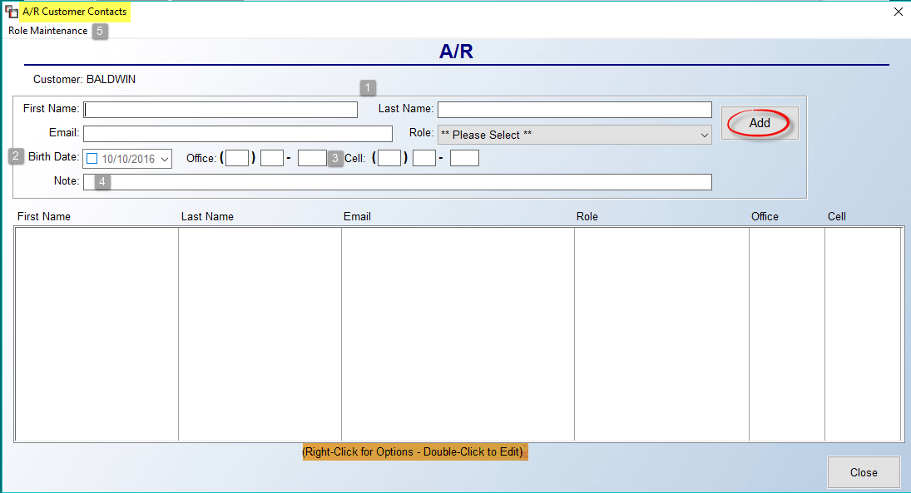

Type the First Name (1), Last Name, and Email address of the Contact, and click the drop-down menu at the Role field to select a Role Code (explained below). If applicable, click the box in the Birth Date (2) field and select a birth date using the drop-down calendar menu. Use the Office (3) and Cell fields to record phone numbers. And finally, use the Note (4) field to add any additional notes relating to this A/R Contact. Click the Add button to save the new Contact. Please Note: all A/R Contact Email addresses will export to Excel when printing the Customer Master Listing. Also, the system will separate each email address by a “;” for ease of import into other databases.

To create new Role Codes, click the Role Maintenance (5) menu option at the top left of the screen above. The system will first prompt a Role Maintenance selection box as follows:
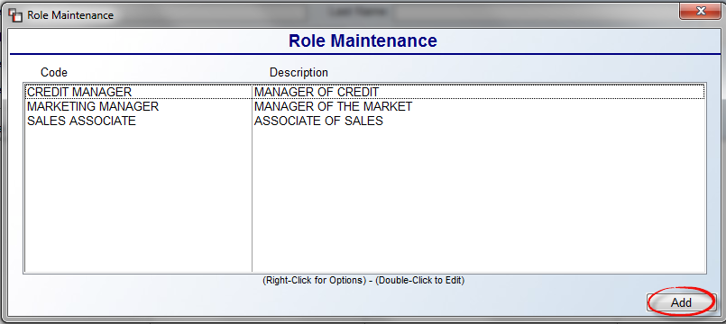

Any existing Roll Codes will prompt in the screen above. To create a new code, click the Add button at the bottom right. The system will prompt a Role Maintenance box as follows:
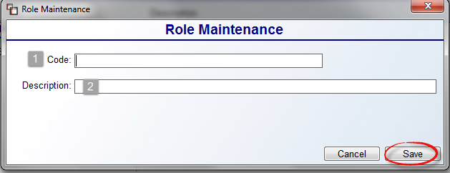

Type a Code (1) and Description (2) for this Role and click the Save button to store the record. You can continue adding Role Codes or return to the A/R Customer Contacts box to add new Contacts as explained above.

The next series of Credit Information fields will be explained in the order they appear in the screen below:

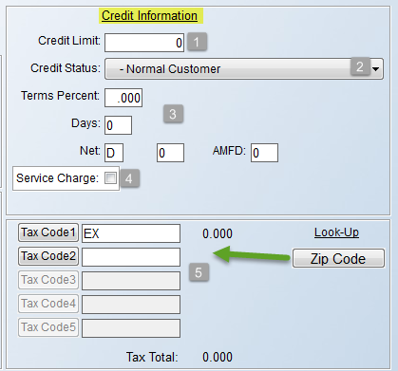

The Credit Limit (1) field is primarily informational, but it does tie into an optional feature titled “Credit Hold Control” that is enabled via the Company Control 2 level of the System Control Maintenance module. If you issue credit limits to any of your customers, enter that value here. If the control is enabled, when the customer has gone over their credit limit, this field will flash in the Order Entry screen and a list of the Customer’s current receivables will appear on the Over Credit Limit Report (accessible from the A/R Reports Menu 1 of 2). If you do not issue credit limits, it is best to leave this field blank—this is especially true for C.O.D. balance customers. Leave the Credit Limit field blank in order for the C.O.D. balance to appear on the system Work Order and C.O.D. Report. . A complete document on the optional Credit Hold Control feature can be found in the Appendices section of this manual.

At the Credit Status drop-down menu (2) field, the available selections allow you to control sales to a customer based on their Credit Status with you. The default setting is Normal Customer, and with this option selected, no Credit Status features will be activated for the customer. The next option, N – No Sales, will prevent any sales from being processed for the customer. Additionally, the Credit Limit field in Order Entry will prompt the following: No Sales For This Customer! The next option, C – Cash, Certified Check Only, will prompt the following at the Credit Limit field: Cash or Certified Check Only! The next option, Y – +0.00 Credit Limit – C.O.D., triggers a C.O.D. amount to appear on the system Work Order and the C.O.D. Report. Additionally, the Credit Limit field will prompt the following: C.O.D. Customer! The final option appears as follows: W – CBD Only Print W/O – Inv with Dep(osit) or Valid App(roval). With this option selected, the system will require that payment is made in full through the Deposit option on the job before a Work Order or Invoice can be processed. However, a User that has permission to override Credit Status can approve a job for processing on a job-by-job basis. For more information on overriding the Credit Status on a job by User, see the User Control 2 level options in the System Control Maintenance manual section.

The Terms Percent/Days/Net (3) fields should be used only if you issue terms to your customers. If so, you can record the Percentage, Days, Net/Proximo data here, and the information will automatically calculate on the system generated Invoices. AMFD stands for Additional Mail Float Days, allowing you to add additional float days for figuring Past Due items on an account. Users with permission will be able to add additional days at this level where applicable. The Service Charge (4) field only applies to customers with terms so that a Service Charge can be accessed on Past Due Invoices. To activate, check the box in this field. The system will then prompt you for a Percent amount to charge as well as the number of Days past due an Invoice can be before a Service Charge is assessed. Please Note: you can instantly change the Service Charge percentage for all customers selected to assess a Service Charge. If you access these fields for a customer and make a change to the Percent field, the following message will prompt: Service Charge Percentage Changed. Do you want to update for all customers in this company (Y/N)? If you type a “Y” for yes, the system will automatically change all customers within the current company.

Tax Codes:
The Tax Code 1 (5) field will automatically prompt the Default Tax Code for this Branch. If you need to change the Tax Code you can click the Tax Code 1 button to prompt a Tax Code Selection box and perform a lookup. The system will not allow you to leave this field blank. Please Note: New Tax Codes must be set up prior to use through the Sales Tax Code Maintenance module accessible from the Accounts Receivable menu.
If you need to change the Tax Code and you have subscribed to the RollMaster Sales Tax Automatic Update, you will see a Zip Code Lookup button option to the right of the Tax Code 1 field. When you click the Zip Code button, the system will prompt the following:
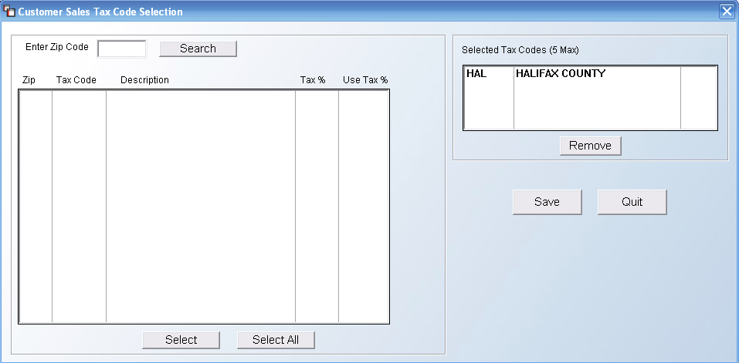

At the Enter Zip Code field, type in a zip or postal code to search for all applicable Tax Codes and then click the Search button. The system will perform a quick search and display its findings in the box below as follows:

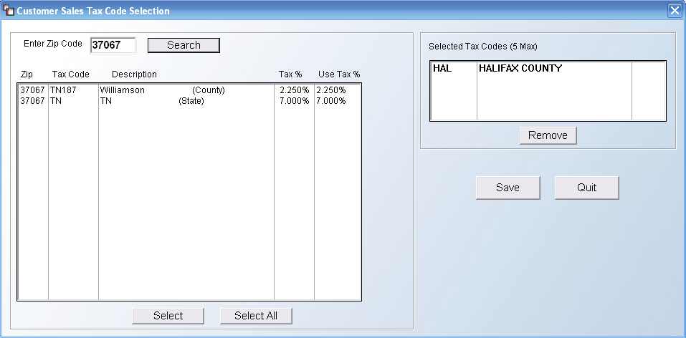

You can highlight and then click Select on the codes that apply, or hit the Select All button to include All Tax Codes for this customer. If a Tax Code needs to be removed, you can highlight it in the Selected Tax Codes box at the top right and then click the Remove button. When all changes have been made, be sure to click the Save button before you click the Quit button to return to the Customer Maintenance screen.

In the Tax Code 2 thru 5 fields, if applicable and if you are not using the Sales Tax Automatic Update Service, these fields are for additional Tax Codes that will be added on top of the Tax Code 1 percentage. For example, if a city tax is charged in addition to a state tax, but only in certain areas of your territory, a second Tax Code will need to be added on all applicable jobs—you will need to select that Code in the next available Tax Code field using the Tax Code 2-5 buttons if you need to perform a lookup. The Tax Rate will display next to each Tax Code field and a Total Rate automatically updates and displays at the bottom of this section.

The fields in the Customer Defaults section will be explained in the order they appear in the Customer Maintenance screen. They appear as follows:

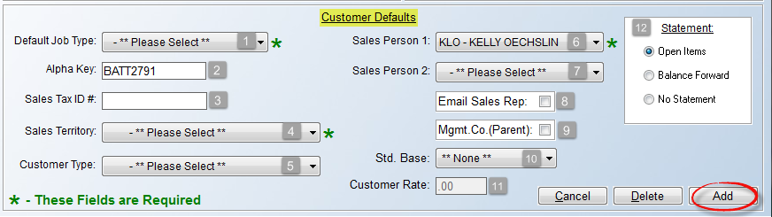

As noted in the green type at the bottom left, the Default Job Type (1) field is required, meaning a selection must be made. This field defaults a prompt in the Job Type field in the Order Entry/Maintenance module. There should be an existing list of Job Types pre setup. Use the drop-down arrow to select the Job Type that is primarily applicable for this customer. This field can be overridden on a Quote or Order when applicable. Based on your Default Job Type selection, you will see (Sales) or (Contract) display to the right of this field. This indicates how tax is assessed on the job, either on the cost or sale. See the Job Type Maintenance section of this documentation for additional information.

The Alpha Key (2) field will default to the Customer ID created upon entering this screen. This field is being phased out with the search options in the Customer Selection box, so you can leave the default. The Sales Tax ID # (3) field can be used to record a Tax Exempt Certificate ID number where applicable. The Sales Territory (4) field, also a required field, contains a list of pre setup codes for marketing purposes. See the Territory Code Maintenance section of this documentation for additional information. Use the drop-down arrow to make a selection. A Customer Type (5) field selection can be made if you will be using the Special Pricing Mtc. (Date Range Pricing) module found in the Inventory Control menu. It is used so that special pricing can be updated by the type of customer rather than by each individual customer. In order to use this feature, you must first create at least one Customer Type in the system, although this field can be skipped and left blank if this feature does not apply to a customer. If you intend to use Customer Types, you must first create those via the Customer Type Maintenance option accessed at the top of the Customer Maintenance screen (explained below).

The Sales Person 1 (6) field will default to the Salesrep ID attached to the User ID creating the Order. If the User is set up as a Salesperson. If not, you can use the down arrow to make a selection. Please Note: there is a User Control feature that will prevent salespeople from changing the salesperson of record on a job. In addition, with User Control features enabled, the system will override the Salesperson ID attached to a Customer with the ID of the User (provided they are set up as a Salesperson in the User Control 1 screen) who is logged into the system at the time a job is first entered. For more information on User Controls, see the System Control Maintenance manual section. The Sales Person 2 (7) field can be used to attach a second salesperson to a Customer. If this doesn’t apply, skip this field.

Check the Email Sales Rep (8) box if your system has been configured to tie into your default Email program, such as Outlook or Gmail. This will allow for notifying salespeople via email when orders are processed in the system. This field pulls from the Salesperson Maintenance module provided the salesperson’s Email address was properly added in that module. Also, each Ship To Code (see below) can have a different Sales Person ID and Email assigned. The Mgmt. Co. (Parent) (9) box should only be checked when identifying the customer accounts that are the “parent” or “umbrella” Property Management/Builder companies in the system. Among other features, with this box checked, the Property Management Report (accessed from the top of the Customer Maintenance screen) will display a list of all Properties—set up as individual Customers in the system—that are owned/managed by this Customer ID. Select this field only for those true Parent companies where you need to link up all the apartment complexes, condominiums and/or builder neighborhoods to be able to generate combined reports and sales analysis, but the individual address remains its own Customer ID.

The Std. Base (10) field and Customer Rate (11) box work together to allow setting a Salesperson Commission default for this Customer. You will first select a base from the drop-down field, and then enter a percentage rate in the box below. This will likely not apply to all customers, if any, depending on how you pay salespeople. The Statement (12) box contains options for printing Customer Statements, if applicable, for this Customer. If Open Items is selected, the Statement will show all open Invoices. If Balance Forward is selected, the Statement will show a lump sum total of previous Invoices, along with any new Invoices for the period, similar to a credit card statement. And finally, if No Statement is selected, no Statement will print out for this Customer.

Once all applicable fields have been accessed, you can click the Add button at the bottom right of the screen to add the customer to the system. The Cancel button will clear the screen of any new data prior to clicking the Add or Save button (once a Customer has been added to the system). The Delete button can only be used once a Customer has been successfully added. This option will permanently delete the Customer from the system’s database. If you have used the Customer ID in the system, you should not Delete the data record from the system. The only information you cannot change once a customer has been added in the system is the Customer ID—the other information can be changed if applicable.

Explanation of Options at top of Customer Maintenance screen:
Prior to saving or exiting the screen, there are additional options at the very top of the screen that appear as follows:

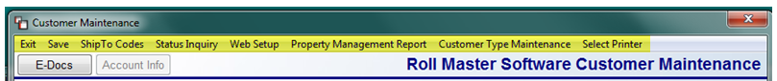

The Exit option will return you to the Customer Selection box. The Save option works the same as the Add button at the bottom right. The ShipTo Codes option is a feature that allows you to add multiple shipping addresses to a customer’s account. This feature cannot be accessed when first adding a Customer. Please see Customer Maintenance in the Accounts Receivable documentation manual for a complete explanation. The Status Inquiry option is not available from Order Entry. You can only access this option on existing Customers from the main Customer Maintenance screen. The Web Setup option will only be available for RollMaster clients using the Web Portal program, and only Users with permission to create Web Portal logins will have access to this option. For those who do have permission, when you click on this option, a Customer Web Login Setup box will appear as follows:

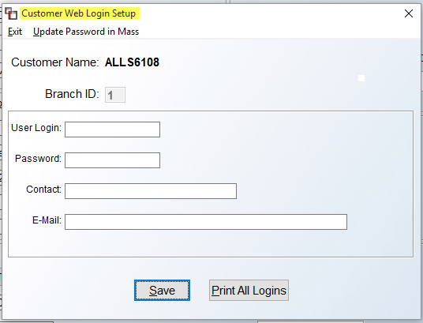
The Web Login Setup should be completed for each property that will be logging into the Web Portal system to place online orders. RollMaster recommends using the Customer ID as the User Login and a universal password for everyone--such as the owner of your flooring company’s name--as the Password. You can then type out their entire name in the Contact field and then enter their Email address in the remaining fields. Please note that this username and password is kept internally for accessing your customer’s web portal. You will actually go to their web portal and use this to log in and then create an Admin user for them to begin using the Web Portal.
At the top left, to the right of the Exit option, another option appears as follows: Update Password in Mass. When you click on this option, the system will prompt the following:
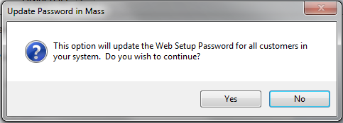

If you wish to update the Web Setup password for all Customers, click the Yes button to continue. The system will prompt you to enter a New Password. Type in the password and hit enter to save. Please Note: only one Login record can be set up for each Customer ID, but the Login data can be updated at any time, or deleted altogether by clicking on the Delete button that appears to the right of the User Login field of an existing Customer Web Login Setup screen. Click the Print All Logins button to print a list of existing Web Login Setup IDs.

The Property Management Report option will print a report of all the properties—set up as individual customers—in the system that are owned/managed by a Customer. It will not be applicable from Order Entry.

The Customer Type Maintenance option was created and tied to the Special Pricing Mtc. (Date Range Pricing) module of the Inventory Control menu so that special pricing can be updated by a customer group or type, rather than by each individual customer. In order to use this option, you must first create at least one Customer Type via this option, although not all Customers are required to have a Customer Type setting. When you select this option, the system will prompt a Customer Type Maintenance screen as follows:
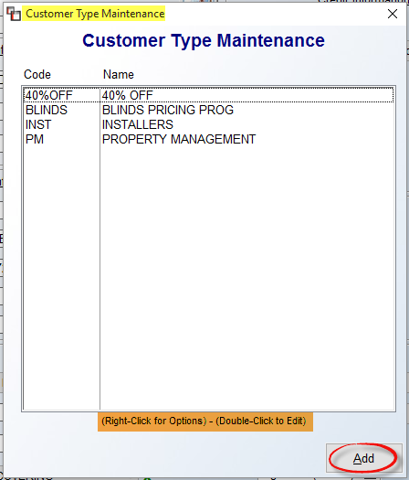

Any existing Customer Type Codes will prompt in the screen above. You can highlight and then right-click or double-click on an existing code to prompt one of two options: Edit Customer Type or Delete Customer Type. To add, click the Add button to prompt a second Customer Type Maintenance screen as follows:

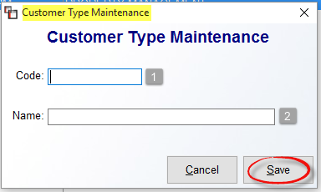

At the Code (1) field, type a new code, up to 8 alphanumeric digits. At the Name (2) field, type a longer description for the Code. Click the Save button to add.

The E-Docs and the Account Info buttons will not be enabled from Order Entry when first adding a Customer. As soon you click the Add button to save the new data the system will return you to the Customer Selection box. Click on the Select button to continue. The system will automatically fill in some of the default information from the Customer Maintenance screen and place the cursor at the Order Date field.

Continuing Order Entry Process:
This next section will break out each of the sections along the left side of the Order Entry screen and explain each field. The first section to be covered appears as follows:

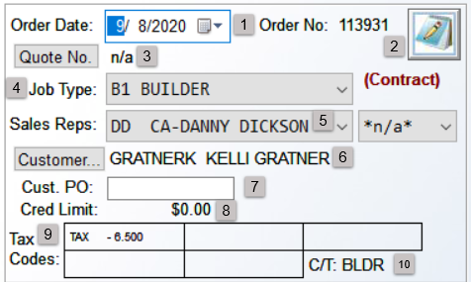

At the Order Date (1) field, you can click on the down arrow button to call up a calendar to choose a different date, or you can hit enter to accept the current date. To the right of that field is the system assigned Order Number, which cannot be changed. To the right of that number, is a graphic of a pad and pencil, or Notes (2) icon. If you click on the graphic, the system will prompt a Job Number Notes screen as follows:

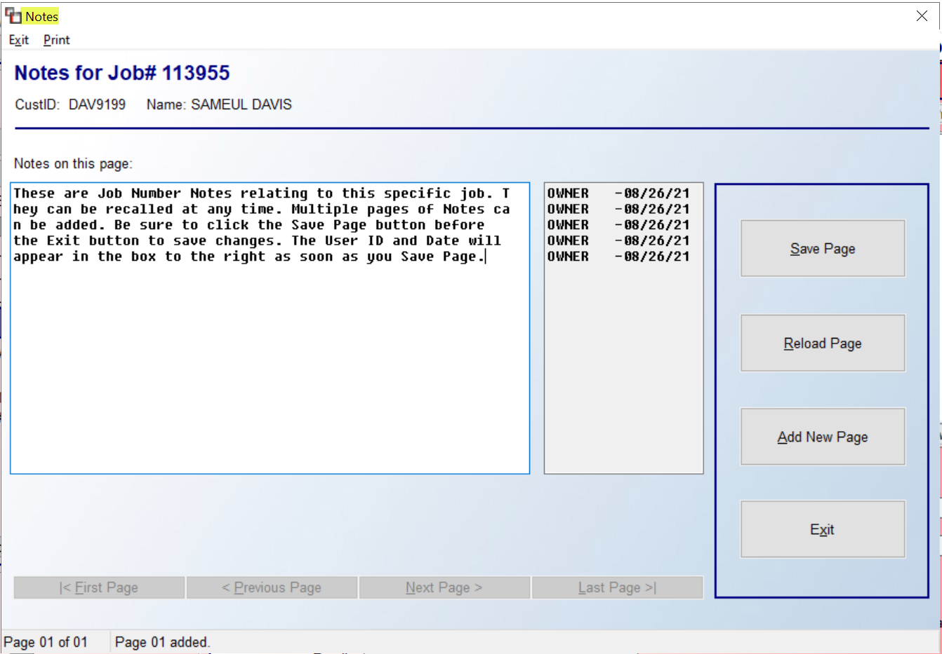

In this screen, you can type in several notes relating to this Job. The Job Notes screen can be called up at any time to either read current notes or add new notes. Once notes have been entered, you will need to click the Save Page button prior to clicking the Exit Without Saving button if you want to save new notes. The scroll buttons along the bottom of the Notes screen will allow you to scroll through multiple pages of notes, once more than one page has been entered. As displayed in the screen shot above, the User ID and the Date of the note will appear to the right of each line, as soon as you click the Save Page button.

Below the Order Date field is the Quote No (3) field. If a Job was generated from the Quotation / Proposal Maintenance module, the Quote number will display in this field. If a Quote was not first created, the field will display “n/a.” From the Order Date field, the cursor will then move to the Job Type (4) field. As explained in the manual section titled Job Type Maintenance, this field is designed to capture sales analysis information. It is a required field of entry used primarily to keep track of the different markets your store services and will automatically prompt the Job Type entered in the Customer Maintenance screen. If you need to change the existing Job Type code, you click on the drop-down arrow and make a new selection. The Job Type also controls how tax is applied to a Job. Based on the Job Type, you will see a prompt to the right of that field indicating the type of tax applicable to this Job. An example appears below:

The (Sales Tax) prompt indicates tax will apply to the sale price of the Job and will appear on customer printouts. The other option is (Contract), which means tax will be calculated on the cost of materials and will not display on any customer printouts. In the Sales Reps (5) section, the default salesperson from the Customer Maintenance screen will automatically prompt here, unless User IDs have been set up in the system. In this case, the Sales Rep ID of the User who is logged into the system at the time the Job is first entered will override any ID entered in the Customer Maintenance screen and override the default in this field. If a User has permission, the Sales Rep can be changed by clicking on the down arrow to call up a list of all Sales Reps. Click on the applicable Sales ID to make a change. At the field to the right, you can add a second Sales Rep ID to an order, if applicable. In some instances, two salespeople will need to be assigned to a Job. This feature can also be used when working with designers. You will first need to set your designers up as Salespeople in the System and then you can enter their ID in the second Sales Rep field. This will help you keep track of the designer’s commission. If a second Sales Rep does not apply, you can leave the field set to “*n/a*.”

The Customer’s (6) name will prompt below the Sales Rep fields. The Customer button on the left will prompt the Customer Selection box when clicked. You can select a new Customer from this box, when applicable, only if a Deposit has not been entered on the Job. When you are first entering a Job, you will not likely need to use this prompt unless a mistake was made. The cursor will next be positioned at the Cust. PO (Customer Purchase Order) (7) field. If your customer has issued a purchase order for this Job, use this field to capture that information. This field will print on the Sales Agreement and you can search for existing Jobs by the Customer PO, look up POs and perform a Batch Invoice Print. This field will also check for duplicates. When the system finds a duplicate Cust. PO for a Customer, the system will prompt a Job Inquiry screen with a list of Jobs showing duplicates. This allows for a Salesperson to double-check whether the Order should be separate or combined with the existing Order.

If a Credit Limit has been set on the Customer’s account, that amount will display in the Cred Limit (8) field. This is a display only field and does not reflect other current Jobs in the System that may be open; however, the system has Credit Control features that will handle issues with Customers going over their Credit Limits. If no Credit Limit applies, this display will show $0.00. The Tax Codes (9) fields will display all Tax Codes that were added from the Customer Maintenance screen. If this Job requires a change in the Tax Codes, you will be able to make those changes in the “Ship To” box, explained below. The final (10) field in this section appears to the right of the last Tax Code display box as follows: C/T:. The C/T stands for Customer Type. This field is display only and requires set up of applicable Customer Type Maintenance codes in the Customer Maintenance module. FYI: access to the Customer Type field in Customer Maintenance is controlled by a prompt in the User Control 1 screen of the System Control Maintenance module, and appears under the Add Customers control as follows: User allowed to change customer type. This needs to be set to Yes in order for a User to see and access this field.

The next section of the Order Entry screen features three different options for making changes to a Job where applicable. That section appears as follows:

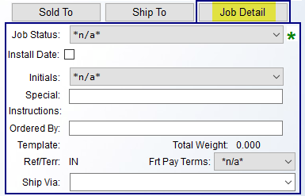

As noted above, the system will default on the Job Detail screen when you are first entering an Order. This is the first box you should access before moving on to the others. The Job Status field is a required field of entry. The field will default to *n/a*, but the system requires you to make a selection in this box prior to exiting a Job. If you don’t make a selection before exiting, the system will alert you to do so. Click the drop-down arrow to make a selection. These status options have been pre-set in the Job Status Maintenance module. The Job Status is tied to key reports in the system and should be changed as the Job progresses by Users with authority to update the Job Status field.

The Install Date box is tied to an Installation Schedule & Report accessible from the Installation System menu. If the installation date is not known at the time the Job is first entered in the system, leave this field un-checked. However, when the installation date or approximate date is known, record that date here by clicking in this box. The system will prompt a Calendar and Time fields for scheduling information. If the installation date changes, the person that makes that decision should return to this field to enter a new date or access the Installation Schedule module to change the date.

If an Install Date is entered, at the Initials prompt, use the drop-down arrow to record the initials of the person setting the installation date. There is an Initials Maintenance module located in the Sales Processing Setup Programs (Menu) that can be used to set up all Users allowed to set installation dates. There is also a User Control option that controls who can add Initials records in the system. Below this field is a Special Instructions field. There is no drop-down menu for this field as it is a User-defined field. This field prints out on the Sales Agreement, Invoice, and Work Order, so you can communicate a quick message to your Customer or to the warehouse/installation department. Some ideas are as follows: entering comments on whether material is in stock or backordered, customer pick-up instructions, etc. You can also leave it blank.

The next couple of fields have to do with the RollMaster Web Portal program. The Ordered By field will automatically populate based on the Web Portal User ID, when the order was placed from the Web Portal program. It can also be manually entered here for non-Web Portal Orders. The Template field is automatically populated on all Jobs created via the Web Portal program, but will also be populated where Templates were selected during the Property Management to Order process. It can be used to track down what Template was selected originally in case of errors or disputes.

If BOL (shipping feature) is turned on in the system and If weight data has been added to applicable Catalog Items, the Total Weight: 0.000 field will display in the Job Detail box, and it will display a total weight of material on the Job. Please Note: this data is an extension of the Work Qty field and will not be impacted by changes a User may manually make to the Sale Qty field on the Job. The Ref/Terr: field will prompt the Territory Code that currently appears in the Customer Maintenance screen for this client. The “Ref” is short for Referral, or in other words, how the client heard about your company. It can also be used for tracking other types of information. The Frt Pay Terms field has a hard-coded drop-down menu. This will primarily be used for RollMaster clients acting as Wholesalers, and can otherwise be ignored. This field and the Ship via field are strictly for use on the Order Entry and Quote side and have nothing to do with Purchasing. The Ship Via drop-down menu field will primarily also be used by clients who offer wholesale products and need to track internal shipping methods. This field is preset via the Bill Of Lading Maintenance module. If your company is interested in using the BOL and shipping features, please contact us at info@rmaster.com.
The tab to the left of the Job Detail tab is the Ship To tab. When you click on this tab, the current Ship To data for the client will appear as follows:

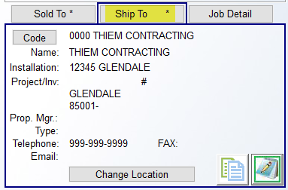

This box should be used to enter a different job location address and/or contact information if it is different from the Sold To address, and can also be used to change the Tax Code information on a Job. If an “*” appears in the Ship To Tab, as in the example above, it indicates that Ship To Notes exist relating to the current Ship To address. Notes can be accessed via the Pad & Pencil Icon at the bottom right of the box. One additional feature of these specific Notes is that in the Ship To Notes screen, on Page 1 only, if you type an “*” before the line of type, these Notes will appear on the printed Work Order. Below is an example:

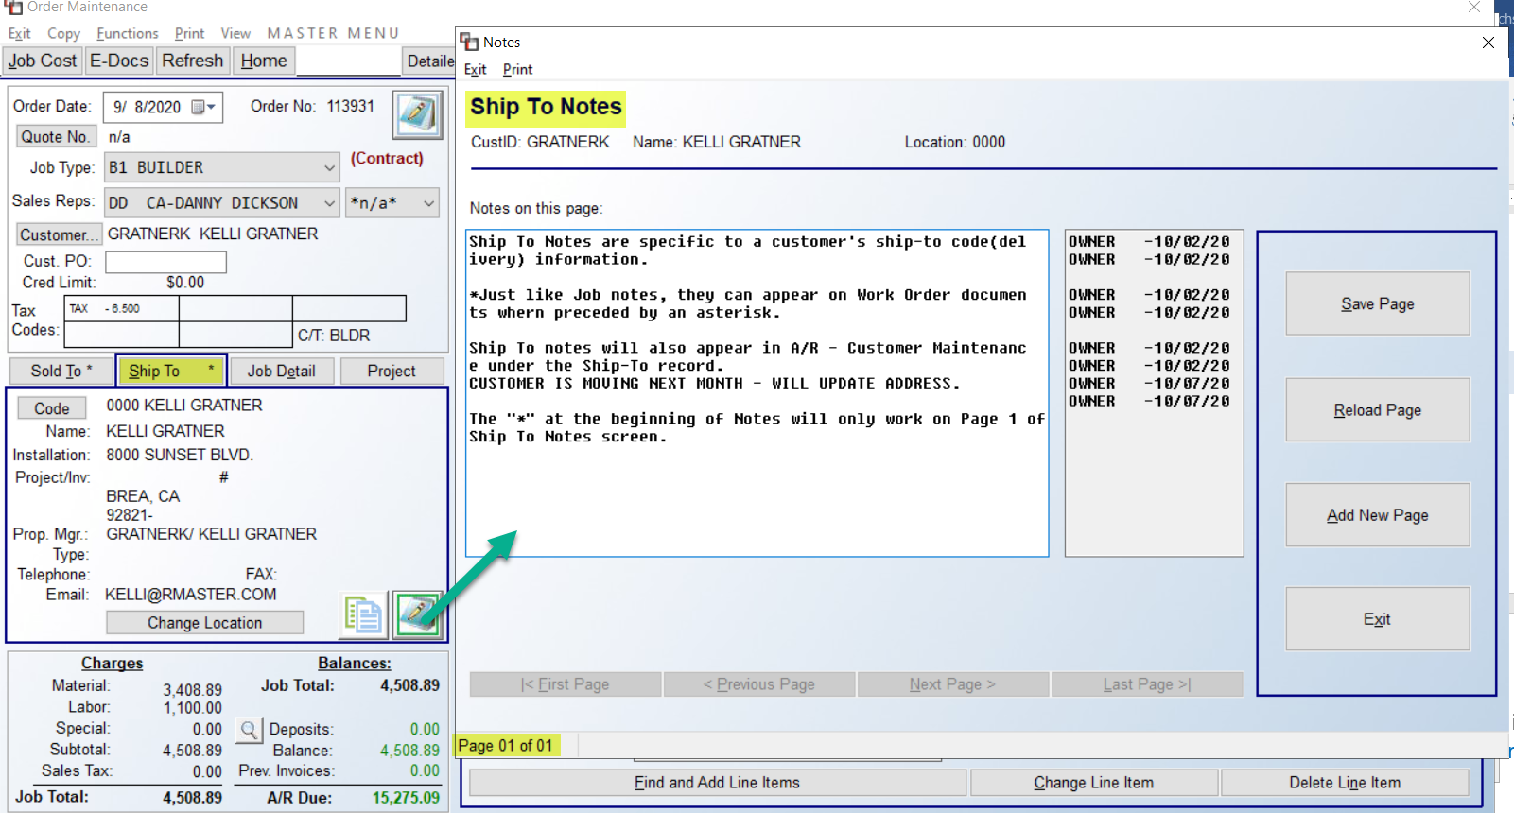

To the left of the Notes icon, is the Copy Icon. When clicked, it will prompt a Copy Text box as follows:

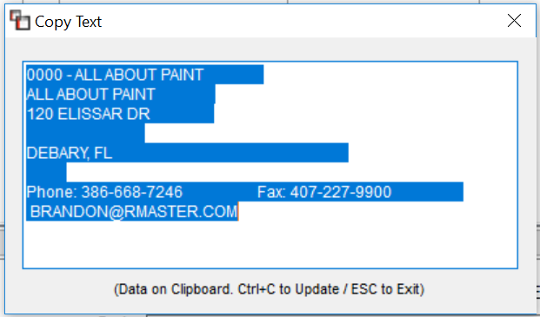

The entire Ship To address will copy to the Clipboard. From here you can copy to an email, calendar, etc. If everything in the Ship To box looks good, you can continue the Order Entry process. However, if you just want to change the location information without creating a permanent Ship To Code, you can click on the Change Location button at the bottom of the screen. A Change Job Location box will appear as follows:

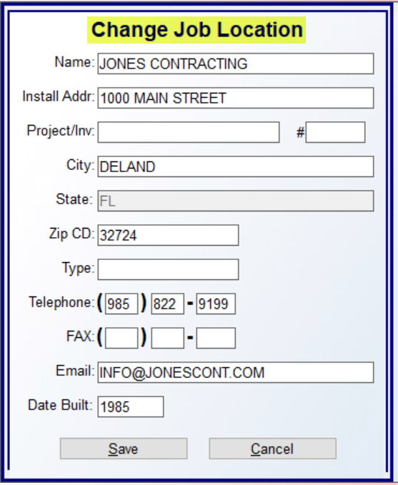

Any field in this screen can be edited. The Type field is related to the Property Management Web Portal program, usually to denote the Product Type on the Job, i.e., carpet only, vinyl only, complete, etc. It can also be used by non-Web Portal customers for the same purpose in this box. The Date Built field allows for tracking the year a condominium or apartment complex, etc., was built or first broke ground. It can also be used to track the build year on homes or commercial buildings. This is strictly informational on the Job. Once you have made changes, click the Save button to continue or click the Cancel button to exit without saving any changes. Any changes in this box will only stay with this Job.

The other function available from the Ship To box is to either look up another existing Ship To Code for this client or create a new Ship To Code. Click the Code button to prompt a Customer Ship To Selection box as follows:

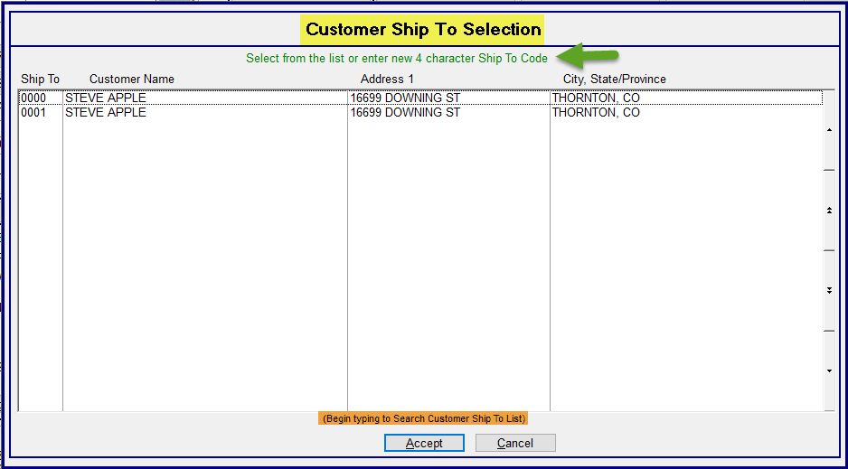

A “0000” default Ship To Code is automatically created by the system for the main Customer ID address and will prompt in the screen above. You can select/edit an existing Ship To address by double-clicking on a line or by highlighting the line and then clicking the Accept button at the bottom of the screen. A Ship To Code is typically a four-digit alphanumeric code. Some examples appear as follows: L210 for Lot 210, SHER for Sherwood Apartments, or use the numbers from the street address. To add a Code, begin typing a new Ship To Code in the screen above and then hit enter. The system will prompt the following:
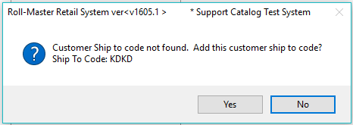

Click the Yes button to continue. The system will prompt a Ship-To Code Maintenance screen as follows:

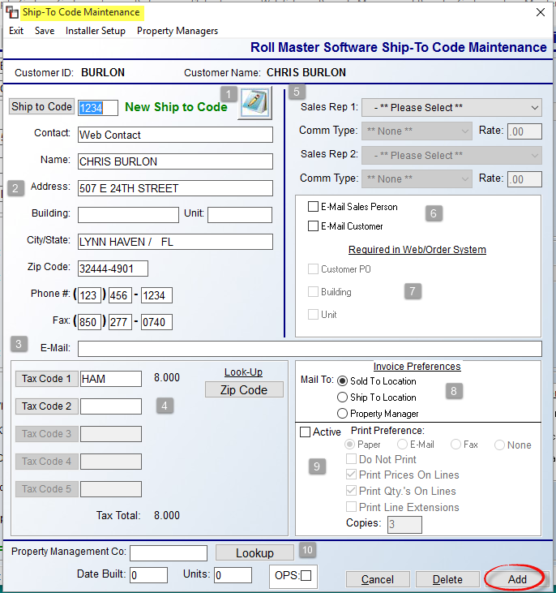

The Notes (1) icon will prompt the Customer Address Notes screen. The address info from the main screen will default in the address (2) fields. Type over it with any new Contact, Name, Address, etc., for this Ship To Code, including any Phone, Fax, and Email (3) address information. The Tax Code (4) fields are included in the Ship To screen because there will be jobs where you need to override the tax code status of the “Sold To” customer. For example, if the Ship To Code address is tax exempt, you can enter your exempt tax code in the first field and make this address tax exempt. Another example is if you need to add an additional or different tax to the job. You will need to enter all tax codes that apply to this address in this screen. The default Tax Codes for each new Ship To Code will pull from the “0000” Tax Code on each Customer.

At the Sales Rep (5) fields, you can select an ID or IDs different from the one entered on the main Customer ID screen if applicable, as well as set up new Commission Types and Rates, where applicable. You can check the E-Mail Sales Person (6) field if you would like the salesperson to be copied when an Email relating to this Ship To address is sent and you can also select the E-Mail Customer field to send an Email to the address in the E-Mail field in the main Customer Maintenance screen when an Email is sent relating to this Ship To Code.

At the Required in Web/Order System (7) fields, only those clients using the Web Portal Program will need to access this field. It controls the three prompts at the very bottom of the screen and can only be accessed by Users with permission. If a User has permission, they are then allowed to determine whether any of the three fields are considered required fields of entry when a Web Order is placed for this Ship To address. If any of these options are checked, the Web Portal program will display a red asterisk next to these fields, and your client will not be able to leave these fields blank when placing a Web Order. The Invoice Preferences (8) fields control the default of where the Invoices will be mailed for each Ship To address, whether that be the “Sold To” location, “Ship To” location or the Property Manager, if one has been assigned in the field below. These fields are especially important for the Batch Invoicing feature in RollMaster.

The Print Preference (9) fields are an extension of the previous section. To use these pre-sets, click the Active field to enable. You can then pre-set how you would like your client to receive a copy of their Invoice, either via Paper, Email, Fax, or None. The next series of fields will override default settings in the Invoice print screen for this Ship To Code. At the very bottom of the screen are additional (10) fields for Property Management Ship To Codes. At the Property Management Co field, if this “Ship To” address needs to be tracked on the Property Management Report for a parent Property Management/Builder Company, you will need to add the Customer ID of the parent company in this field to complete the setup for that report. Use the Lookup button to prompt a list of all existing Customer IDs designated as Property Management Companies. This feature also allows you to make the Property Management Company address the billing address. However, before you can do that you must use the Property Managers option that appears at the top left of the Ship-To Code Maintenance screen to add any Property Management companies prior to assigning one in this field. (See explanation below.)

The Date Built and Units fields are 4-digit fields used to record the date the property was built and the number of units. The data entered in these fields will print out on the Customer Master Listing, as well as export to Excel. The OPS field is not currently available and will default to unchecked. In an upcoming update, it will be tied to the “Invoice Export” functionality.

At the top left of the Ship-To Code Maintenance screen are two additional options as follows: Installer Setup and Property Managers. The Installer Setup option will only be available to Users with permission. This feature allows you to compile a list of installers that can do work for this Ship To Code and then allows you to rank installers in order of most preferred to least preferred. It also allows you to mark any installers as “Excluded” from performing any work at this address. With permission set, when you click this option, an Installer Ship To List box will appear as follows:

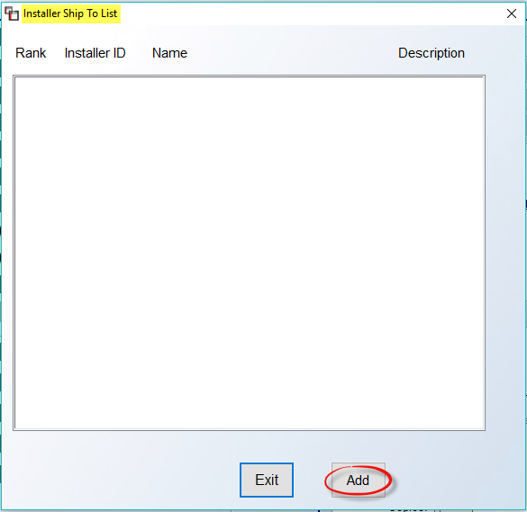

Click on the Add button to begin. The system will prompt an Add Installer to Ship To List box as follows:
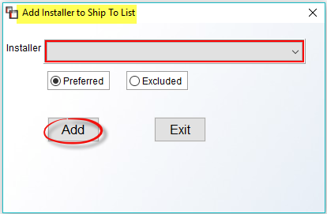

At the Installer field, click on the down arrow button to display a list of existing Installers in your system. Click on a name to select. For each selection, the default will be set to Preferred. If this is not the case, you can click on the Excluded option before clicking on the Add button to finish this process. Once you have added an Installer, the system will return you to the previous screen and the newly selected Installer will appear in that screen. To add more Installers, repeat these steps until all have been selected. Once you return to the previous screen, the system will display the Installers in the order they were selected as follows:

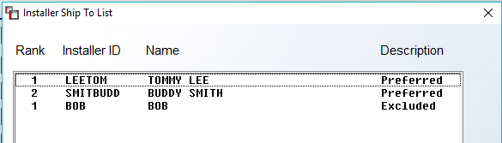

If the displayed order is your preference, you can exit this screen. However, if you would like to change the order, you can click on the Installer you would like to move up or down in ranking and the system will display up or down arrows to the right of the screen as follows:
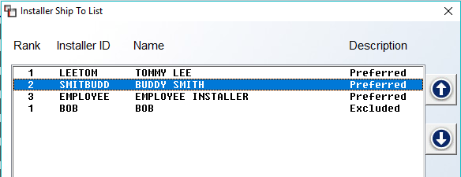

This setup can be initiated from this screen, however this feature is also available in other areas of the system for ongoing maintenance.

Use the Property Managers option if this Ship To Code needs to be tracked on the Property Management Report for a “Parent” Property Management company or “Parent” Builder company. When you select this option, a Property Managers or Builders screen will appear as follows:
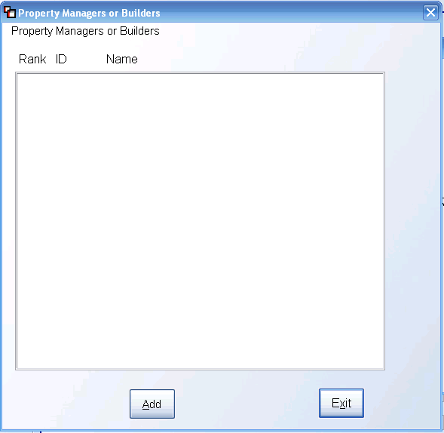

To begin adding Property Managers, click the Add button. The system will then prompt the following:
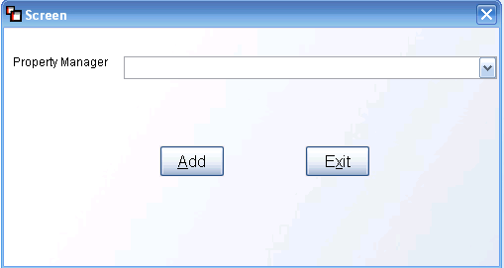

Click the down arrow button to the right of the Property Manager field to display a list of existing Property Managers or Builders that have been designated as such in the system prior to this step via the Customer Maintenance module. Click on the applicable name and then click the Add button in this screen to complete the process. If applicable, you can add multiple Property Managers or Builders to any Ship To Code via this feature. Once a list has been created, you can then use the Rank column in the first screen to prioritize the list. When you click in the Rank column, an up or down arrow button will appear to the right of the list and you can click the arrow until you have organized the list in the proper order. Once a Property Manager or Builder list has been compiled, you will also see a Delete option in the first screen to allow you to delete entries.

When all selections/options have been completed for a Ship To Code, be sure to click the Add button at the bottom right of the screen to keep. Also, once a Ship To Code has been successfully added, you can use the Delete button to remove the Code from the system. However, if history exists for the Code, RollMaster recommends keeping the Code for Sales Analysis and historical data purposes.

The final option is the Sold To screen. When you click on this option, the system will display the current default data from the Customer Maintenance module. The Note icon at the bottom right of this box is for Customer Notes and will stay with this Sold To Customer from job-to-job. The Change Customer Info button should only be used to change the Contact person for the Sold To data. When you click this button, the system will prompt a Change Customer Address box as follows:

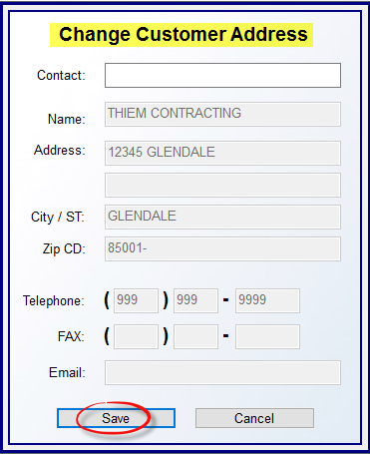

At the Contact field, if you wish to add a contact person other than the main Customer, you can type that person’s name here. The remaining fields can only be changed from the Customer Maintenance module. If you make any changes to the Contact field, you will need to click the Save button before exiting. You can also click the Cancel button to exit without making any changes.

Just below the Sold To, Ship To, Job Detail, and Project boxes explained above, you will see another display box at the very bottom left of the screen as follows:

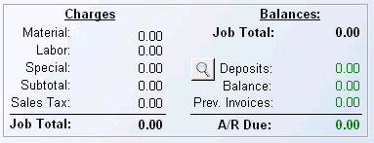

The Charges and Balances data will update automatically as the Job progresses, and also according to changes made to the Customer’s balance. The magnifying glass graphic next to the Deposits field will call up the Deposits box feature and allow you to see all payments posted to this Job that make up the balance showing in that field. It basically jumps you over to the Deposits tab option that appears at the top of the Line Items box to the right of this screen. The process for posting and managing Deposits will be explained in that section below, following the Line Items entry explanation.

Explanation of fields in Charges & Balances boxes:
As explained above, the fields in these two sections are display only, and are updated by internal procedures. They are explained below so you will understand how to utilize the information contained within them as the system updates the data.

Material- this field displays a running sales total of all the material lines on a Job as soon as a material line is entered on a Job.

Labor- the total of all Labor Lines entered on a Job will display here. If this field displays no value, it means that either labor is not required on this Job or that Labor Lines have been mistakenly left off the Job and need to be added.

Special- the total of any special charge lines entered on a Job will display here. Examples of special charges include finance charges, freight charges, contract adjustments, etc.

Subtotal- this field totals all the previous fields above.

Sales Tax- if sales tax is being accrued on the selling price of the Job, then that total sales tax figure will reflect in this field. If sales tax is being accrued on the cost of material, no tax figure will appear in this field. As explained above in the Sales Tax vs Contract section, “Contract” Jobs will not display a tax figure and “Sales Tax” Jobs will display a tax figure.

Job Total- this field displays the total of all lines entered in the Line Items screen of this Job, plus any Sales Tax that is displaying in the field at the bottom left. It is not reflective of whether material has been ordered or if inventory has been assigned, it only totals the lines currently appearing on the Job.

Deposit(s)- this field displays a running total of all deposits taken on a Job (multiple deposits can be entered for each Job). The steps for entering deposits/payments are found below following the Line Items section explanation. If the balance due on a Job is collected upon installation, it is common practice to take that final payment as a Deposit and then invoice the Job to avoid creating unnecessary receivables in the system. Also, the Deposit field will always reflect the original Deposit total even where a partial Invoice has been created, so that the Job Balance figure is always an actual figure.

Job Balance- this field displays the customer’s current balance due on the Job, less any Deposits.

Prev. Invc. (Previously Invoiced)- this field displays a running total of all invoiced lines for this Job only. This will likely not occur on residential Jobs, but can occur on commercial and builder Jobs. Certain Jobs will require multiple Invoices to be processed, which is why the amount in this field may appear as less than the Job Total amount. That will correct itself once all lines on the Job are invoiced.

Line Items Screen:
Once all the initial Job/Customer data has been entered, you will be ready to begin adding Line Items, assuming the Job wasn’t first created from the Quotation/Proposal Maintenance, Web Order Maintenance, or Property Management/Builders Templates modules. When starting from a blank screen, the Line Items screen will appear as follows:

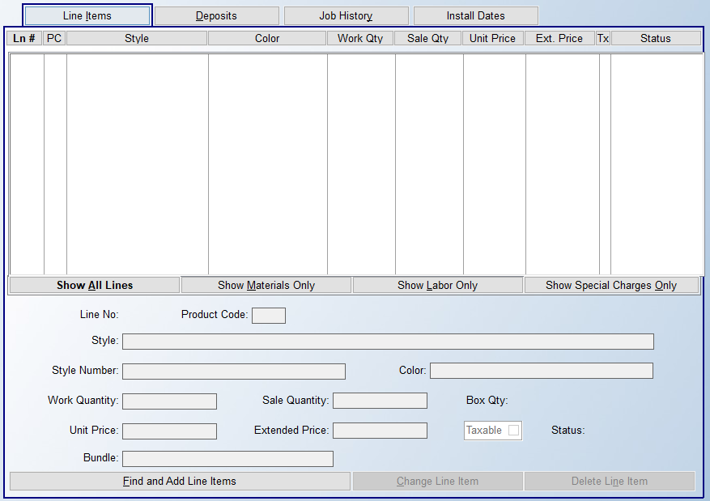

To enter a new line, at the bottom left of this screen, you will see an option as follows: Find and Add Line Items. Click on this button and the system will prompt the RollMaster Order Entry Item Selection screen as follows:

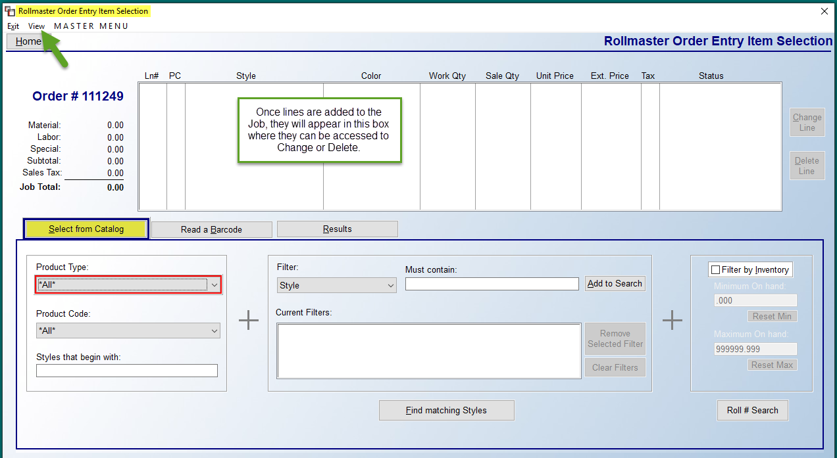

Please Note: The Read a Bar Code tab screen will only be used if your company has the RollMaster Barcoding system and equipment. If so, you can click on that tab to scan an item to read it into a Line Item. Otherwise, you will need to utilize the Select from Catalog tab screen, which is also the default screen. Please note the View menu option at the top left above the Home button. This option gives you access to the Comment Review and Bundle View options explained further down in this section.

Moving through the Select from Catalog screen from left to right, the system provides several options to search for catalog and labor items. You don’t need to use all of the options, but the more you utilize, the more refined the search Results tab screen will yield. In the Product Type box, click the down arrow to display a list of pre-set Product Types to narrow your search. Product Types are user-defined, but typically will include items such as the following: CARPET, WOOD, TILE, LABOR, etc. You can then further customize the search by selecting a code in the Product Code field using that drop-down box. Product Codes further categorize all the different types of products in your store, such as by carpet width. These codes are created in the system during the initial RollMaster set-up phase. If you click on the down arrow in this field, you will get a list of Product Codes, which will also sort based on any Product Type selection made in the previous field. To learn more about Product Codes, consult the Inventory Control manual.

The final option in the first box, Beginning Style Name, will allow you to enter the first couple of letters in the style name to further customize the search results. At this, or any prior point, you can click the Find matching Styles button to bring up a list of products to begin your selection process. However, you can also utilize the middle box to further narrow your search results. Start by selecting a Filter using the drop-down arrow in that field. Then add numbers or letters in the Must Contain field to allow the system to filter out any exceptions during the lookup process. Click the Add to Search button when finished. As you will see in the Current Filters box, the Filter you just created will appear in that box. You can add additional Filters if applicable. Once Filters have been added, when applicable, you can remove any by highlighting the Filter and then clicking the Remove Selected Filter button. You can also remove all Filters by clicking the Clear Filters button. Once one or more Filters have been added, click the Find matching Styles button to begin your search.

In the final box, at the far right, the system provides a method to select Catalog Items with existing inventory, based on a minimum and maximum available quantity. This feature does not need to be used, but has been added as an option to assist with selecting stocking items. If you click in the Filter by Inventory box, you can leave the default quantities, or type in the quantities that are applicable to your search. And finally, you can click the Roll # Search button to select a Catalog Item based on an exact Roll #. When you click this button, a Roll Number Look-Up box will appear as follows:

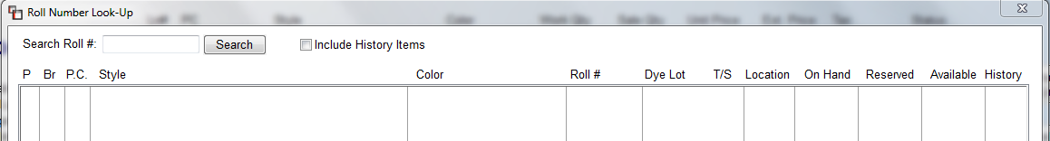
Begin typing a number in the Search Roll # field and then click the Search button to start the search.
When you are ready to begin your item search, click the Find matching Styles button to bring up the Results tab as follows:

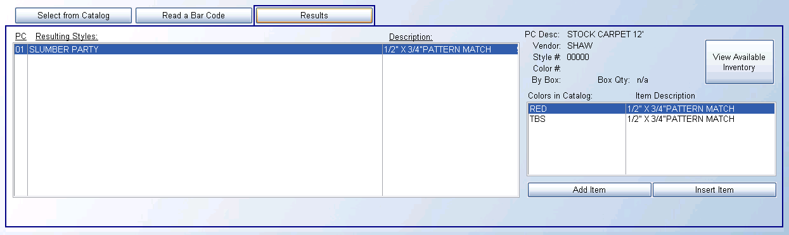

In the example above, because there were so many search criteria pre-selected, the system pulled up the only item that matched all those variables. A less narrowed search result screen will appear as follows:

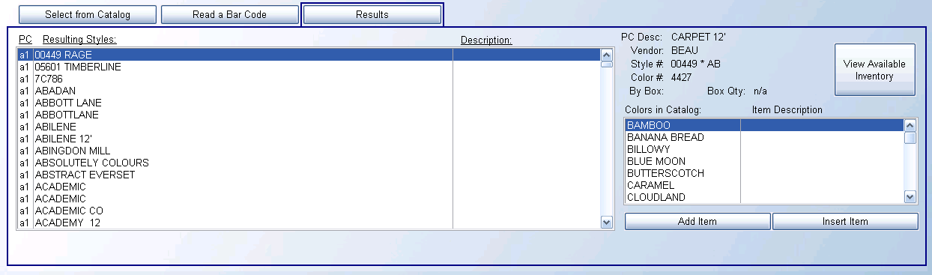

Once you have scrolled through and found the item you need, make sure the item is highlighted before proceeding. At this point, you can click the View Available Inventory button to check for any available or “on order” inventory in the system. (If you are using the Cut Sheet feature, you should refer to the section below titled “Cut Sheet Feature” for details on how that feature works during the material line entry process. This next section is written without any mention of the Cut Sheet feature.)

When you click on the View Available Inventory button, an Inventory Review screen will appear as follows:

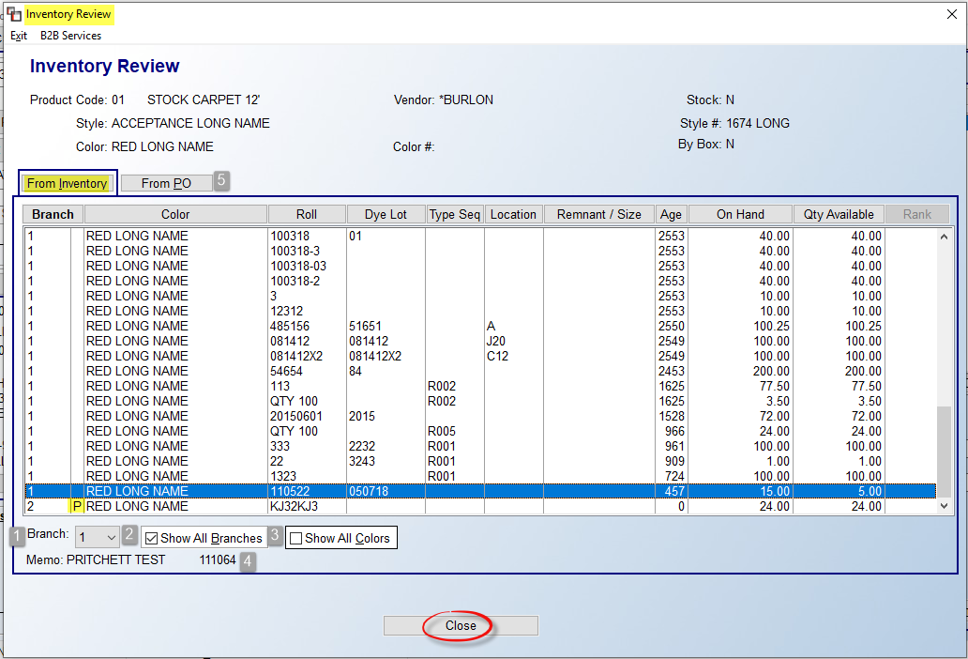

If inventory exists on this item, you will see all inventory records in the From Inventory tab screen above. You will not be able to select any inventory as this is a “view only” screen. However, you do have additional options for locating inventory available at the bottom left of the screen. At the Branch (1) field, use the down arrow to select another Branch to see what inventory may reside in that location. At the Show All Branches (2) checkbox, you can click that box to display all inventory available in all locations. At the Show All Colors (3) checkbox, you can click that box to see all colors with available inventory for the style selected. Again, this is for lookup purposes only. The Memo (4) field pulls from the Memo field in the Edit Inventory Item screen of the Inventory Maintenance module. In the Branch column, if a “P” displays next to the Branch ID, it indicates the inventory is in transit to that Branch. This is also true for the View Existing Inventory and View Assigned Inventory options and anywhere in the system these options can be accessed to view inventory.

The other option available in the Inventory Review screen is the From PO tab (5) screen. When you click on this tab, the system will prompt any open Purchase Orders Lines in the system for this material as follows:

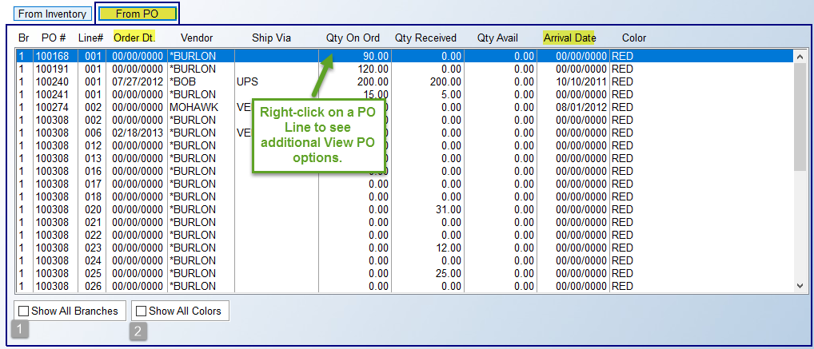

In the screen above, if the Order Date and Arrival Date columns display all zeros, it means the PO has not yet been ordered. Also, the Qty Available column will indicate if any of the material coming in is available for a Job or if more will need to be ordered. At the Show all Branches (1) checkbox, you can click to see Purchase Order detail that exists in other locations for this item. The Show All Colors (2) checkbox will allow you to view other colors On Order. If you right-click on a line, the system will prompt three additional options: View Purchase Order, View On Order Reserve (to see where incoming inventory will be assigned), and View PO Line Notes.

When you have finished reviewing the inventory and PO information, if applicable, you should be ready to add the line to the Job. To complete this task, click on the Add Item button to continue. (The Insert Item can be used to insert this line above another existing line on the Job, if applicable.) The Add or Change a Line Item box will appear as follows:

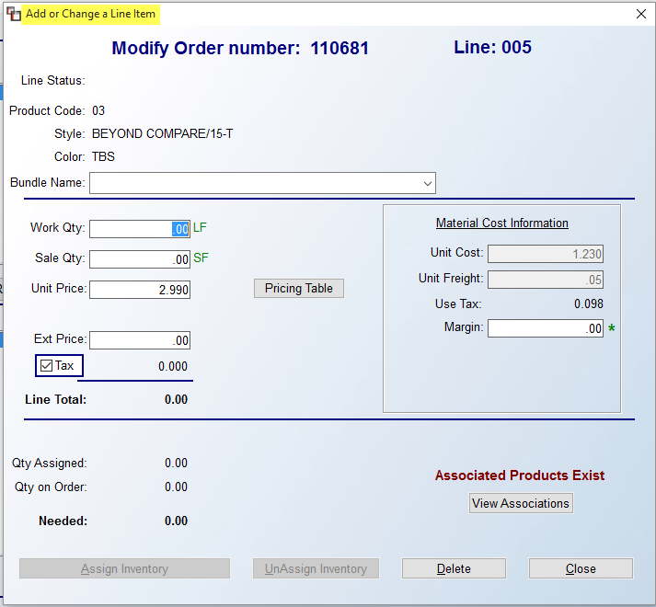

As the title of this screen indicates, you will use this same screen to both Add a new line item and Change an existing line item. Quick note: if a Job was created from a Commercial Quote, you will see a capital green “Q’ in the Material Cost Information section as follows:

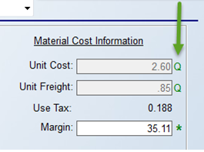

The ability to bundle together material, labor, and special charge lines together on printed sales documents has been added to the system and is activated by typing or selecting a Bundle Name in that field. Please review the Branch Control 2 section of the System Maintenance manual for complete details on how to activate and use this feature. Once activated, when printing the graphical Sales Agreement, Quotation, Work Order, or Invoice, the system will group Bundle Names together. This change will also allow for sub-totaling bundled sections on these printed reports. In order for this to work, you must select the PDFVIEW printer from the Select Printer box. The system will then prompt a bundling print option box as follows:

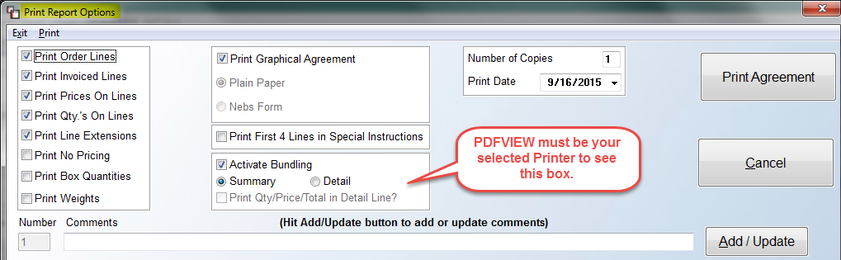
The default setting for this box will be Summary. Switch to Detail in order to print the sub-total sections. You will then also have the option to select the Print Qty/Price/Total in Detail Line? to add additional info to the printed document. In the next update, the Work Order will also print by Bundle Names.
When adding a new line item, the cursor will first be positioned in the Work Qty field. The Work Quantity should be the amount of material needed on the Job. With roll goods, such as carpet and vinyl, you will enter linear feet and the system will automatically convert linear feet to square yards (or square feet if you have that option set up in your system). In addition, before you type in an amount, you need to convert inches to decimals, if applicable. For example, if you need 50 feet, 9 inches for the Job you will enter 50.75 in the Work Qty field. The following is an “Inches to Decimals” conversion chart:

“INCHES TO DECIMALS” CONVERSION CHART
1” = .08 7” = .58
2” = .17 8” = .67
3” = .25 9” = .75
4” = .33 10” = .83
5” = .42 11” = .92
6” = .50 12” = 1.00

When entering hard surface material that is bought and sold by the square foot, you will enter the total amount of square feet needed for the Job—the system will not perform any conversion on these products, other than to force the entry of full cartons, if applicable and if the catalog item is set to force full carton quantities in Catalog Maintenance. If box quantity setup has been performed on the selected catalog item, you will note a box to the right of the Work Qty field as follows: Box Quantity. If you enter an amount in the Work Qty field, and the amount doesn’t match a full carton quantity, the system will prompt the following:
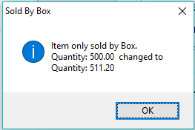

If you click the OK button, the system will prompt the minimum box quantity displaying in the box above in the Work Qty field. If instead, you would like to enter a total number of boxes and have the system convert the boxes to total Work Qty, you can click the Box Quantity button, to the right of the Work Qty field to prompt the following:

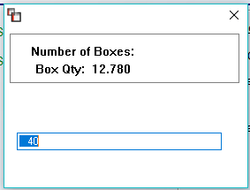

You can then type in the total number of boxes you wish to sell and the system will calculate the total square footage for the Work Qty and Sale Qty fields and prompt those amounts in the applicable fields. When you are entering material that is bought and sold by the piece, only enter the number of pieces needed for the Job.

When the cursor moves to the Sale Qty field—provided you are not using the Box Qty feature—the system will perform any needed conversion of linear foot items and display the applicable sale quantity. This will be the quantity the customer will see, if you choose to show this on the customer’s printouts. The sale quantity can be increased if necessary, and it will not affect inventory totals. The Unit Price field will default to a unit sale price based on margin pricing that should already be setup in your system. You can override this price with a new one based on User Control permissions, meaning each User may have different pricing levels available to him or her. Also, to the right of this field, you will see an option as follows: Pricing Table. This tool allows you to look at several pricing options to assist you with pricing the Job. When you click on the Pricing Table button, the system will prompt the following:

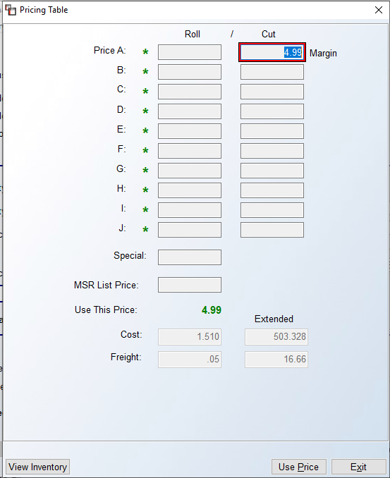

The cursor will be positioned in one of the Roll/Cut fields based on the preference setting in the System Control 1 screen with regard to default pricing level and default roll/cut. The default field will be identified by a red box, as in the screenshot above. If a User is allowed to see and enter Cost, Freight, and Margin percentage, they will be able to edit those fields in the screen above. They will also be allowed to edit the Calculated Price field. When this is done, be sure to click the Use Price button at the bottom right to select that price. Note the appearance of green asterisks to the left of the A-J fields. This denotes whether a User can see this level of programmed pricing and select from available fields. In the example above, the User can sell at all of the programmed levels because each field has a green asterisk. Also, note the Extended fields next to the Cost, Freight, and Calculated Price fields that display totals. The View Inventory button works the same from this screen as described above. Also, if there is a sale price programmed for a product, that price will display in the Special field. (Special pricing can be created in the Special Price Mtc. module accessible from the Inventory Control menu.) Whichever pricing method you use to arrive at the final price, click the Use Price button to change the original default price to the new price. You can also click the Exit button to return to the previous screen without making any changes.

Returning to the Add or Change a Line Item box, once a Unit Price is selected, the system will calculate a total for the Extended Price field. If applicable, you can click in this field and enter a new Extended Price total. The system will automatically re- calculate a new Unit Price based on the new Extended Price amount entered. The Tax field will calculate based on either Sales Tax or Contract tax. Prior to reaching this screen, the tax percentage will already be determined, along with whether tax is charged on the total sale (Sales Tax) or on the cost of material (Contract). This column determines whether tax should be assessed at all on this line. With existing system defaults established, most Users will not use this feature. For tax exempt customers, you still need to leave this field checked, even though no tax will be assessed, as this will then prompt the system to list the Job on your Sales Tax Report. A reason to uncheck this line is if you wish to make a flat adjustment amount to match a written proposal, and taxing that line is not necessary. Labor Lines are entered in the system differently than material lines and those lines default to “N” for no, except in those states that charge tax on labor. If, for local tax reasons, your store pays Sales Tax at the source, consult with the RollMaster Support department on how that should be handled.

The Associated Products Exists/View Associations button feature is explained in detail in the Catalog Maintenance section of the Inventory Control manual. Not all RollMaster Customers will utilize this feature. If used, and if the Bundle Lines feature is active, when selecting Associated Products via the View Associations screen, a Bundle Name drop-down box displays listing all the bundles currently on the Job, defaulting to the one for the line bundled. This allows for changing the Bundle Name, and all lines created will be included with the new Bundle Name.

At this point, if you are not ready to create a PO or assign inventory, you can click the Close button to add the line to the Job. You can return at a later time to start the purchasing or inventory assigning process. However, if you are ready to complete those processes, continue with the next section below:

Assign Inventory / Create PO:
To Assign Inventory or Create a PO, if you are in the Add or Change a Line Item screen, click the Assign Inventory button to proceed. Otherwise, right-click on a material line to find the Assign Material Line option and select. The system will prompt an Inventory Review box--which looks and works much like the View Available Inventory feature described above--as follows:

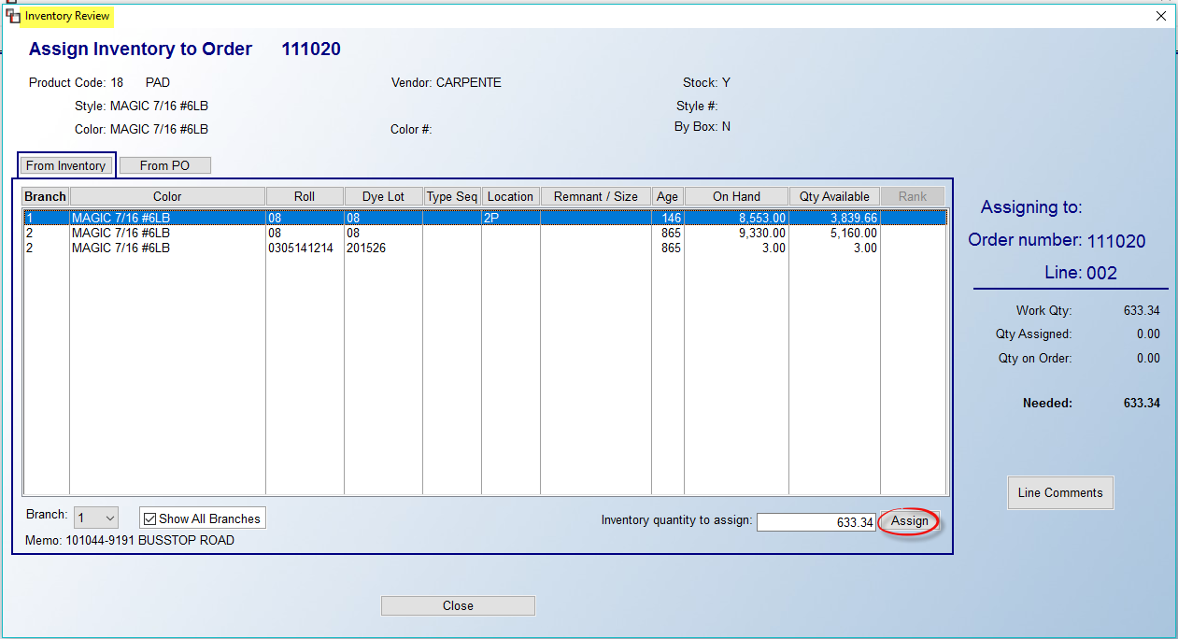

Any existing inventory in the current Branch will display in this screen and you can determine if there is enough for this line by searching the Qty Available column for adequate inventory. If you wish to search other Branches, click the Show All Branches box and, if the User has permission, inventory can be assigned from another applicable Branch. You can also switch to another single Branch via the drop-down menu in the Branch field at the bottom left. When an inventory line is highlighted, the Memo field from the PO will display beneath the Branch field. If inventory exists, you can highlight the roll item and then click the Assign button to reserve the material for this line.

If there is no existing or available inventory displaying in the From Inventory screen, you can then click on the From PO tab button to begin the Purchase Order process. In the From PO screen, the system will display any existing POs in the system for this material as follows:

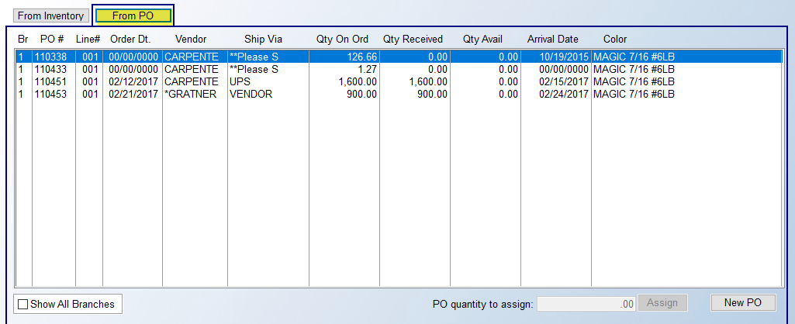

If there is an open PO with available inventory, you can click the Assign button to attach this material line to the PO line. When the material arrives, the system will then automatically assign the received material through the receiving process. To create a new PO, click the New PO button to continue. If an open PO for this Vendor exists in the system and additional lines can be added, the system will prompt a Create New P.O./Line box as follows:

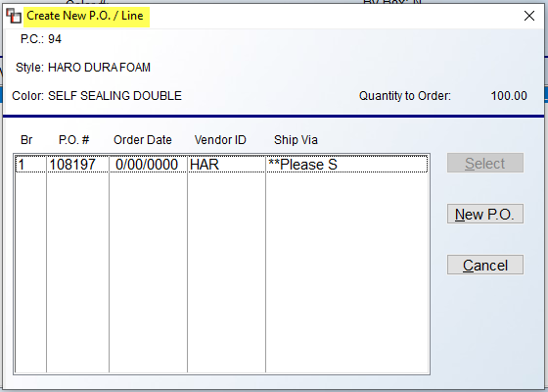

To add a line to an existing PO, highlight that line in this box and then click the Select button to continue. If no existing POs for this material exist, or you wish to create a new PO, click the New PO button. The system will prompt an Add Purchase Order Screen as follows:

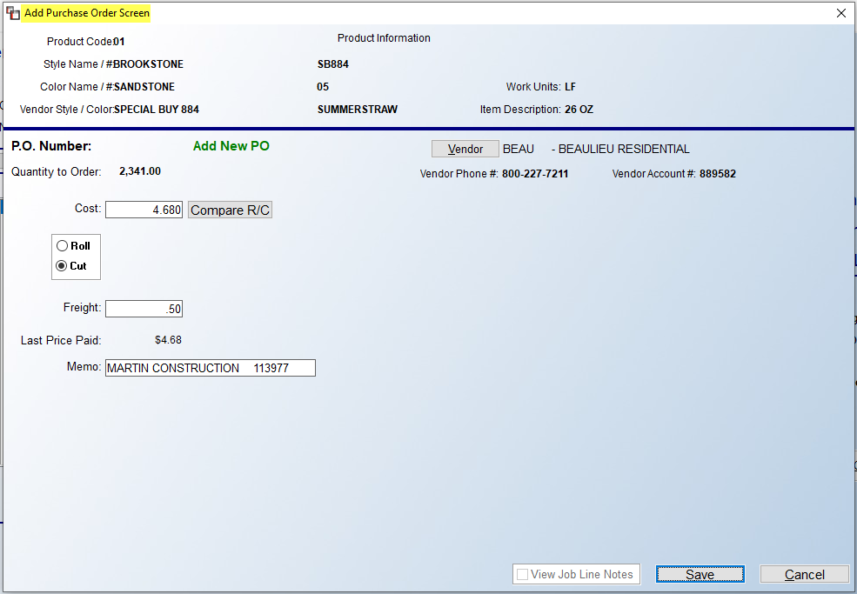

Before you proceed, it is important to note that there are two ways to handle new POs from the Line Items screen. If the person entering the Job in the system also does the ordering, he or she can actually order from this screen. If the person entering the Job does not order material, they should click on the Save button to create an “Open” PO. The central purchasing agent for the store can then print the Open P.O. Report to get a list of all the material that needs to be ordered. Please Note: There is a User Control option that determines whether a User can order material from this screen.

The first feature in this screen to consider is the Cost field. This field is pulling the default cost from the Catalog Maintenance program. You can change the cost here (where User ID allows) if you have been given a better price from a Vendor, or, if you would like to compare Roll/Cut price, click on the Compare R/C button. The system will prompt the following:
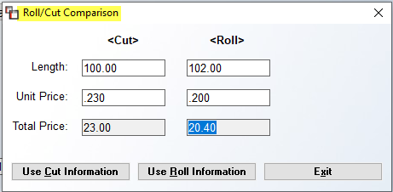

In the example above, the Vendor has 102’ roll balance at the .200 per unit price. You can access the Length field and type in roll or lot balances to determine if the balance item will be a better buy, based on the Unit Price, which can also be accessed and changed, if different. The system will then calculate a total price in the Total Price field when you make changes to the Length and Unit Price fields. Depending on what you decide, you can click the Use Cut Information to accept the data in the Cut column, click the Use Roll Information to switch to the data in the Roll column for your PO, or click the Exit button to exit this screen without any changes.

Important Note: If you make a change to the size of the material from the Roll/Cut Comparison box, after you finish with the Add Purchase Order Screen, you will need to go back to the Line Item screen, highlight the line and double-click or click the Change Line Item button at the bottom of the screen. In that screen, you will then need to click the UnAssign Inventory button so you can adjust the Work Qty column to reflect the new size. Changing the Work Qty will cause the sale quantity to increase, so you need to override the sale qty back to the original qty that was sold to the customer, because you are not selling the customer additional material. Finally, you will then click the Assign Inventory button again to re-attach the PO to the line item. Be sure to select the existing PO in the From PO tab screen and then click the Assign button at the bottom to complete the process. If you do not make these changes, the additional material will be received as available inventory in the system, even though, in most cases, all the material will be taken to the job site.

Below the Cost field, is a box containing a Roll and Cut option. If you just completed the Roll/Cut comparison, this box will reflect any changes. If you bypassed that option and you wish to switch options in this box, you can click on that option as needed and the cost information will change accordingly. The Freight field data also comes from the catalog item. It is a unit freight cost, not a total freight cost. You can override the value in this field if you know what the unit freight cost should be. The freight value can be adjusted in other areas of the system, so leaving the default at this point is not an issue, unless you wish your job cost to be more accurate prior to the invoice receipt. The Last Price field is a display only field, and is based on the last price that was paid for this product through a previous PO. If the product has not previously been ordered through the system, this field will be 0.00.

The Memo field should be used to record side mark or shipping information. Also, there is an option in Company Control 1 (see System Maintenance section of the System Administration Manual for more details) that, when enabled, will prompt the system to automatically fill in this field with key information from the Job (as in the example above). There are a couple of options available that should be reviewed during system setup. The Vendor ID field will automatically default to the Vendor listed on the Catalog Item. You can click the button to select a new Vendor—only where two or more Vendors supply the same product, as in the case of supplies and pad, etc. Based on the Vendor selected, the phone number for that Vendor will display in the Vendor Phone # field and the Vendor Account # will display, where enabled.

If a User has permission to order from this screen, they will be able to do so once they click the Save button. You will see a Line Has Been Ordered checkbox prompt under the Vendor info, and new fields will display in this screen as follows:

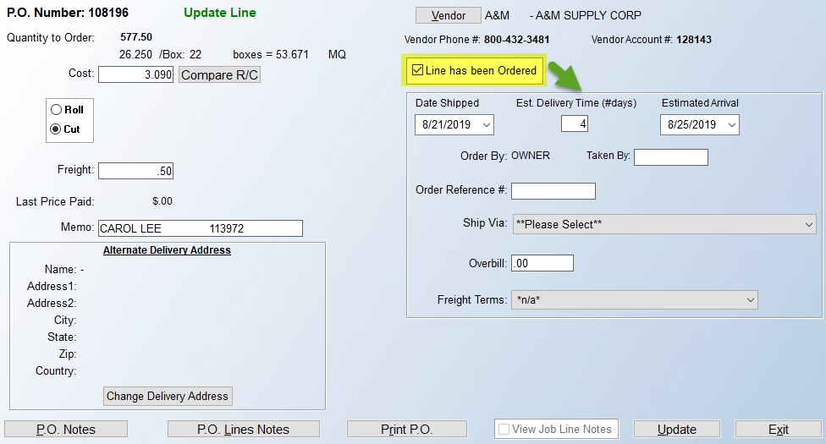

Key fields from the Purchase Order module will display here and can be accessed and changed while placing the order with a Vendor. You can click on the Date Shipped down arrow to enter a new date; override the Est. Delivery Time with a new # of days; the Estimated Arrival field will automatically calculate according to the data entered in the two prior fields, but can also be changed if applicable; the Order By will display the User ID of the current User, the Taken By field can be used to record the name of the person at the Vendor taking your order; the Order Reference # field is used to capture the Vendor’s reference number once the order is placed; the Ship Via field has a drop-down arrow so you can select from pre-determined freight carriers; and finally, if a User is allowed to see Overbill data, that info will be displayed here, and can be changed if that User has permission. Additional fields include the Alternate Delivery Address box if that needs to change, and PO Notes, PO Line Notes, and Print PO options can also be accessed. Click Update to save changes.

If the PO was not ordered, when the Save button is clicked, the system will then prompt a message box with the PO # as follows:

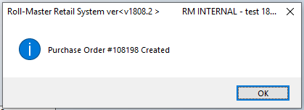

Click the OK button to continue. As soon as this has been done, new options will appear at the bottom of the screen as follows:

The P.O. Notes button, when clicked, will prompt a P.O. Notes screen, which should be used to record important notes for the purchasing department and/or receiving department concerning the order. This feature is especially useful for the salesperson to communicate with the departments that will be doing the purchasing and receiving. The P.O. Notes screen will appear as follows:

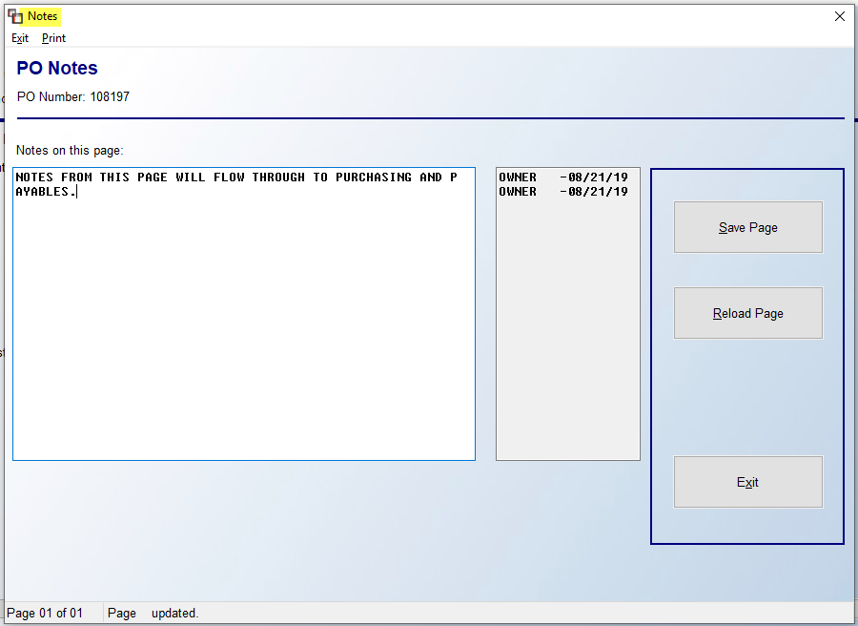

Once the Notes have been typed, click the Save Page button. You can then click the Exit button to return to the Add Purchase Order screen. If you wish to add Notes that will apply just to a single PO Line, click the P.O. Line Notes button instead of the P.O. Notes button to add Notes pertaining to just the current PO Line. This feature works exactly the same as the P.O. Notes feature just explained. Notes specific to a PO Line will stay with this PO all the way through to the bill posting process and can be added to from the purchasing, receiving and bill posting screens. Before clicking the Exit button to return to the Inventory Review screen, if any changes have been made in the Add Purchase Order screen, be sure to click the Update button before clicking the Save button.

In Job Inventory Transfer:
If the Inventory Transfer feature has been enabled in your system, you can utilize a feature from within Order Entry that allows for “In Job” Transfer requests. (FYI: there is a helpful Webinar titled “Inventory Transfer Updates” presented on 6/10/20 covering this topic. It can be found on the RollMaster Help Desk.) A User Control 7 option, located in the System Control Maintenance module, must also be turned on in order for a User to perform this task. It appears as follows: Allowed In-Job Inventory Job Transfers. Set this control to “Y” for yes to allow this process. When assigning an inventory item that is not in the current Branch, in the Assign Inventory to Order screen, the system will prompt the following Inventory Transfer screen:
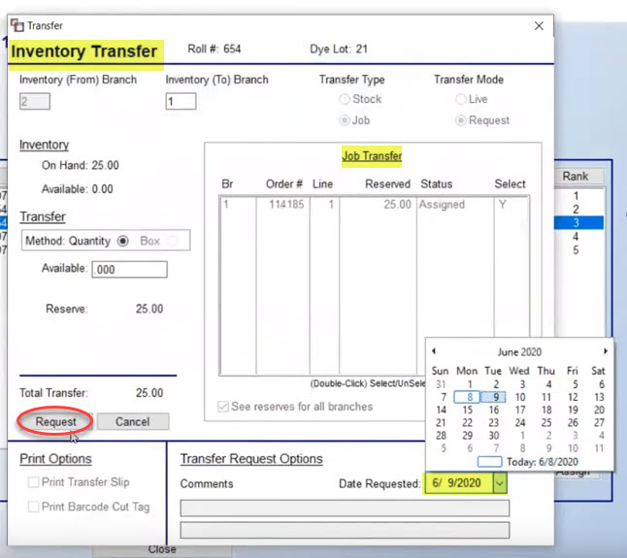
You can pre-set a default Inventory “To” Branch in the Branch Control 2 screen of the System Control Maintenance module. In the screen above, you can set the Date Requested and then click the Request button to initiate the transfer. The Job Line will reflect an “R” in the Status column denoting the Request. If you then Unassign that line, the system will prompt a message as follows: Job Transfer Requests found, Continue Unassign? You can then determine if you wish to continue with unassigning. However, if you are not ready to initiate the transfer, you can exit out of the Inventory Transfer screen and the material will be assigned and display an “N” in the status column indicating the material is not in Branch. At a later time, you can right-click on the line and select the following existing option: View Assigned Inventory. You will then right-click on the material line in this screen and see the following option: Job Transfer Request, which will prompt the screen above. Once Requested, in the View Assigned Inventory screen, you will see the newly set requested date in the Est. Arrival / Job Trans. Req Date column at the far right. For customers who utilize the Cut Sheet functionality and also transfer inventory between Branches in RollMaster, an option has been added to the Inventory Transfer box as follows: Pull Processed. This is because the Cut Sheet requires that the material either be cut or pulled if no cut is required. If you need to pull material to ship to another Branch, this switch allows for marking it as processed when receiving the transfer, eliminating the need to go back to the Cut Sheet module to process the pull before shipping on a Work Order.

Line Items Screen Status Column:
Once you begin adding lines and assigning inventory or creating POs, the Line Items screen will update as follows:

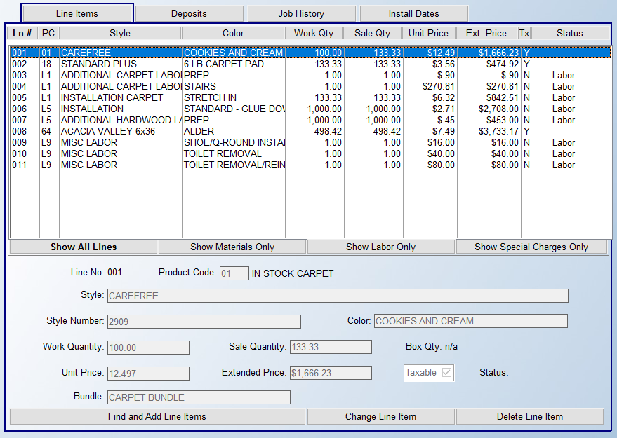

The Status column to the far right will reflect the status of a line at any given time. You cannot access this column with the cursor—it can only be updated by the system based on the current status of a line. The following is a list of status codes that will appear in this column and a corresponding explanation of each (a blank status on a material line indicates nothing has been done in the system with regard to assigning, purchasing, shipping on a work order, etc.):

Job Costed | = | Material exists in the warehouse and has been assigned to this line and it is ready for shipping to a job and then invoicing.
Part. Assigned | = | Partial material has been assigned to this line from stock inventory.
Part. Received | = | Partial material has been received in the system for this line from a purchase order.
PO Created | = | A purchase order has been created for this job line.
PO Ordered | = | Material is on order with the vendor in the P.O. Maintenance module.
Labor | = | Denotes a Labor Line.
Special Chg | = | Denotes a Special Charge Line.
Invoiced | = | The line has been invoiced in the system. Credit/Refund lines will also reflect this code but the total column amount will reflect a negative amount.
 |  | On material lines, only where material has been assigned, there are additional Status options that will appear to the left of the existing Status as follows:
I | = | The material on this line has been Invoiced.
N | = | The material resides in another branch.
P | = | The material is “in transit” from another branch.
R | = | In-Job Inventory Transfer Request Date has been set.
W | = | All material on the line has been shipped on a Work Order.
w | = | Partial material on the line has been shipped on a Work Order.
 |  | For customers utilizing the Build Order Maintenance program, there are additional line status descriptions. A blank line indicates a B.O. item has been added, but has not been ordered or assigned.
B.O. Created | = | A Build Order request has been added for the item, which will send it to production. This will also display after a B.O. Item assembly report has been printed to send to production.
B.O. Released | = | The B.O. Item has been released into production. Job Costs will also be available now.
Job Costed |  | The B.O. Item has been produced and finalized.

Line Comments:
Just as you can add Job Notes, Customer Notes, PO Notes, etc., you can also add multiple notes to each line on a Job called Line Comments. When you are in the Line Items screen, you will have a few different areas from which to access this feature. In the Inventory Review and From PO screens, you will see an option on the bottom right side of those screens as follows: Line Comments. You can click this button at any time to call up this feature. Additionally, once a line has been added to the Job, if you right-click on a highlighted line, a small box will pop up with the following options:

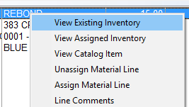

Whenever you select the Line Comments option, the system will prompt a Order Entry Line Comments screen as follows:

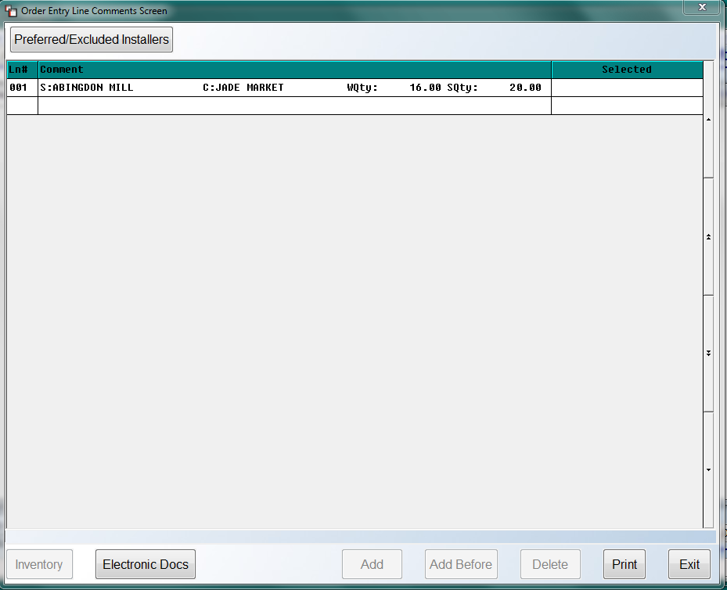
In the Quote version, you will not see the Inventory button at the bottom left of the above screen, but otherwise, the two options work the same. At the top of the screen, the system will display the Line #, Style Name, Color Name, Work Qty, and Sell Qty of the Line Item. To begin adding comments, click in the Ln # column of the applicable line and then click the Add button at the bottom of the screen. The system will prompt a Select Option menu as follows:
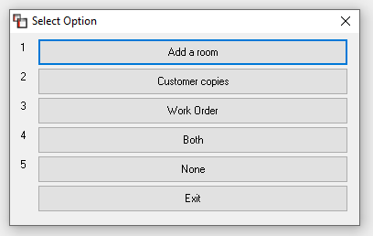
The Add a room option will allow you to enter your material cuts for the warehouse/ installer, and that data will then print on the Work Order. When this option is selected, an Add Room Comment Line box will appear as follows:

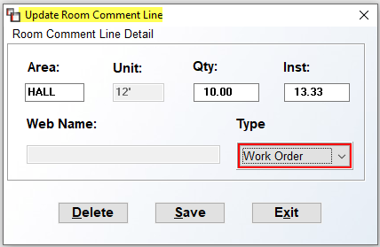

The Area field is for a brief description of the room/area for the cut, such as HALL. The Unit field will default to the width of the carpet/vinyl. Type the length of the cut in the Qty field. The Inst field will calculate based on the Unit and Qty fields. The Web Name field only applies to the RollMaster Web Portal program and will only be accessible for RollMaster customers utilizing that product integration. Click the Save button to save your Line Comment and continue.

The other types of Lines Comments are freehand fields for you to type applicable notes about the Job. The Customer copies comment lines will only appear on print outs relating to customers; the Work Order comment lines will only appear on the system Work Order; the Both comment lines will print on both the Work Order and Customer print outs; and the None comments will only be viewable via the Line Comments and Comment Review options on the Job. If you would like any of the comments to appear above the line on the Work Order only, you can type an asterisk at the beginning of the line of type. This option was added because the Work Order prints three lines for each material line and without the asterisk, the comment appears as the fourth line.
As you add various types of Line Comments in this program, the main screen will appear much like the following:
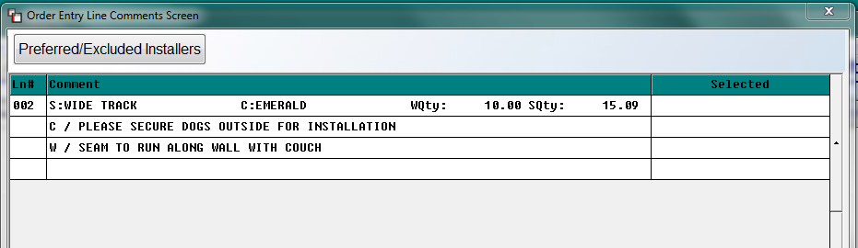
As you will note at the top left, you can access the Preferred/Excluded Installers feature from this screen by clicking that button. You can make any changes and then return to this screen to add additional line comments. Also, you can perform an Inventory Review for the current style by clicking the Inventory button at the bottom left of this screen—this option is not available in the Quote module as previously mentioned. Additionally, the Electronic Docs button will call up that program so you can make changes/additions and then return to the Line Comments screen without having to come back into the program to continue adding or editing line comments.
The remaining options along the bottom of the Line Comments screen appear as follows: Add Before, Delete, Print, and Exit. The Add Before button will only become available if you place the cursor in the Ln# column next to an existing line comment. The Add Before button will allow you to place a new line comment above the existing line in which the cursor rests when you click this button. The Delete button works the same way. If you place the cursor next to a line comment in the Ln# column, the Delete button will become available and you can click it to remove that line comment from the screen. Another way to delete a line comment is by double-clicking on an existing line to display an Update Comment Line box as follows:
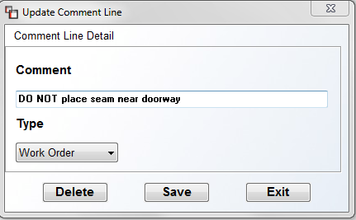
From this box, you can click the Delete button to remove the line comment, and you can also edit the Comment data by typing in that field. You also even change the Type of the Line Comment by clicking the down arrow button in the Type field to select another option. Be sure to click the Save button if you make changes. Click the Exit button to return to the prior screen. The final option in that screen, Print, will allow you to print out all the Line Comments that appear in the current screen. It will not print Line Comments on any other line on the Job.
Important Note: there is a feature in the Edit Catalog Item screen of the Catalog Maintenance module that will allow you to set a default Line Comment Type for any Catalog Item or Special Charge line. With this functionality set up, the system will automatically prompt the Update Comment Line box above right after you exit the Add or Change a Line Item screen after entering a line item the first time through.
You also have the ability to access the Line Comments screen from the Inventory Review screen while creating a PO from a job line. You will see a Line Comments button at the bottom right of the Inventory Review screen during this process. Also, from within the Add Purchase Order Screen, you have the ability to copy Line Comments over to the Purchase Order Line Notes screen. Once you click the Save button, you will see two options at the bottom right of the screen as follows:
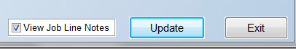
If you check the View Job Line Notes box and then click the Update button, the system will allow you to access the Line Comments screen prior to exiting. In the far right column labeled Selected, you can click next to each line you would like to copy over to P.O. Line Notes. Selected lines will display a “Y” for selected. When you have finished, click the button at the bottom of the screen titled Copy to PO Line Notes that appears as follows:
When you have successfully copied the selected Line Comments, the system will prompt a message box as follows:
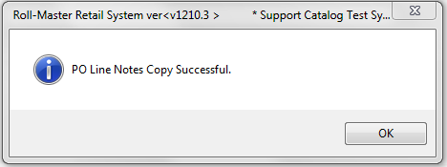
The system will automatically place an asterisk in the LN# column of the Line Items screen when comments are added. The Line Comments feature is available from the following modules: Order Entry, Quote Entry, Property Management/Builders Templates, and Job Labor Maintenance. Please Note: there is a Company Control option in the System Control Maintenance module that, when enabled, will prompt a User ID and the current date on each Line Comment added through this feature. This option will apply anywhere the Line Comment feature appears and will also work in the Notes features in Order and Quote Entry, the P.O. Notes feature, and the Vendor Notes feature—the User ID and date will not prompt on the first line of the Vendor Notes feature as that line prints on the check, but will appear on all subsequent lines. Also, there is a User Control that determines whether a User can delete existing Line Comments. RollMaster recommends that Line Comments not be deleted, as important history on a Job could be lost.

Right-Click Line Item Options:
Other than the Line Comments option as explained above, when you right-click on a material line item, you will see additional options available in the drop-down box as follows:

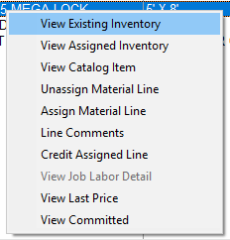

Please Note: although you will see all these options when you right-click on a Labor or Special Charge line item, the only option that will work is the Line Comments option for both and the View Job Labor Detail option for Labor Lines only. The View Existing Inventory option will call up the Inventory Review screen as explained above, and will only allow viewing of existing inventory and open POs related to this line. The View Assigned Inventory option will call up two options. If inventory has been assigned, an Assigned Inventory screen will appear as follows:

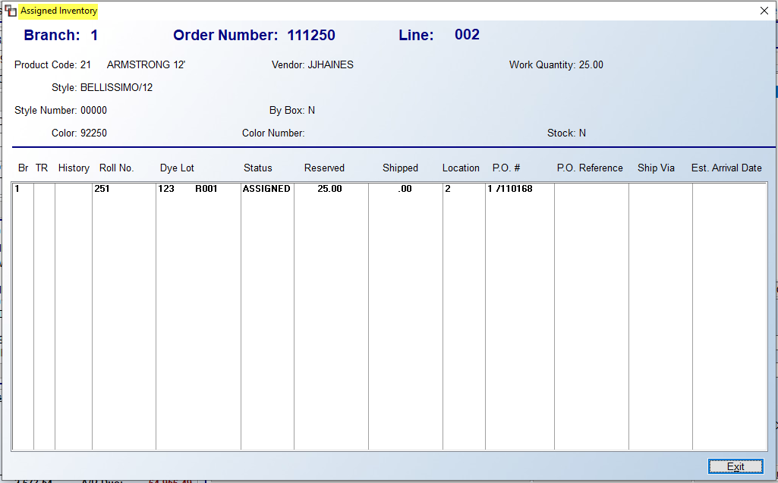

This screen will show a list of all inventory records currently assigned to a line, along with inventory detail. Click the Exit button to return to the previous screen. If the material has been ordered but not yet received, you will see the PO information on this screen as follows:

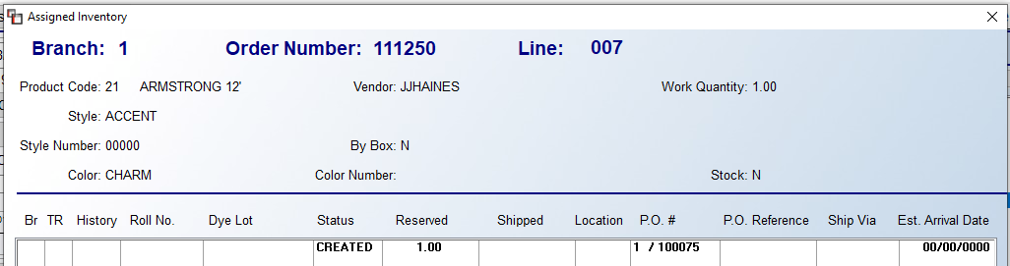

The View Catalog option will call up the Catalog Maintenance screen for the item. The Unassign Material Line option will detach any assigned material or PO from this line, allowing you to make changes to the Work Quantity or delete the line if applicable. The Assign Material Line option will bring up the Inventory Review screen, as explained above. From here you can assign inventory or initiate the PO process. The Credit Assigned Line option allows for crediting a line that has been partially or fully assigned. It writes a negative line to the Job for the quantity selected, however, the material will not be returned to stock until the line is Invoiced, so the preferred method for brining material back into the warehouse is via the Return Material to Stock option on the Work Order. The View Job Labor Detail pertains to Labor Lines only. With the cursor positioned on a Labor Line, this option will prompt the Add/Edit Payment screen for this line in the Job Labor Maint. / Installer Payments module. It is a view-only screen, but will display any payments that have been posted to an Installer for the selected Labor Line.
The next to the last option appears as follows: View Last Price. When you select this option, a View Last Unit Price screen will appear as follows:
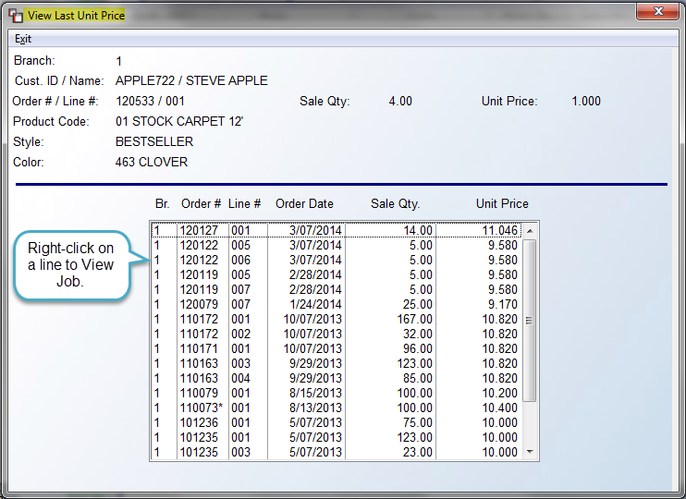
This screen will display any Unit Price history on an item from the most recent Order Date. If you right-click on a line in the screen above, the system will prompt a View Job option.
The final option, View Committed, allows for viewing “committed” inventory for a catalog item marked as a “Stocking Item” throughout the system. It was designed to work for items such as pad, which may not be assigned until the job is ready to ship, but will work on any material provided the Stocking Item checkbox is checked. In the instance of pad, you may already know how much inventory you have and how much of that is assigned, but you wouldn’t know the total amount of all the job lines waiting to be assigned. When you click on this option the system will prompt a Committed Inventory box as follows:

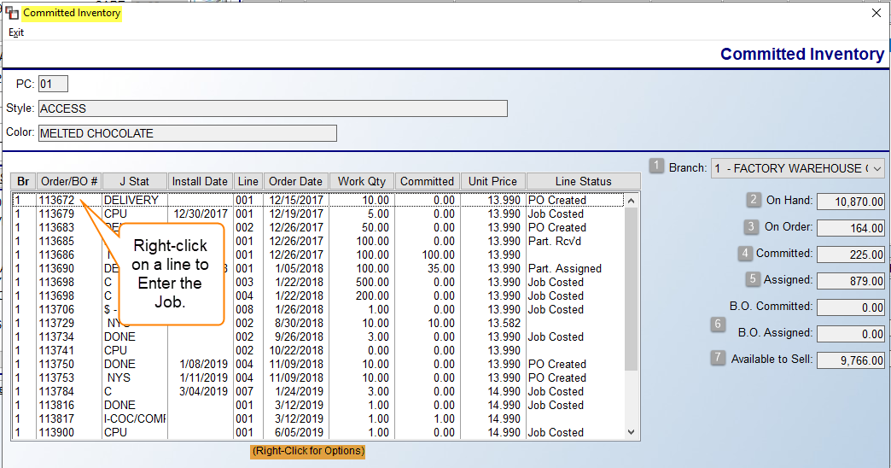

Each of the column headings are sortable when you click on them. The Branch (1) field will default to the current Branch and only display lines/quantities for that Branch; however, you can use the drop-down arrow to select another Branch, or All Branches. The On Hand (2) field displays the total of all inventory existing in the system, regardless of status. The On Order (3) field displays the total of inventory ordered on a system PO, including POs not currently assigned to an Order. The Committed (4) field displays totals for just lines that have a blank status (not assigned to any material or PO) for the selected Catalog Item. The Assigned (5) field displays totals for only lines with a Job Costed status. The B.O Committed and B.O. Assigned (6) fields display committed and assigned totals for just lines entered in the Build Order Processing module, which will only apply to those customers using that upgrade module. And finally, the Available to Sell (7) field displays the total available inventory minus what is assigned and minus what is “committed,” based on Branch selection, therefore, it is not uncommon to see a negative number sometimes if you are in an oversell situation on a product. Pad is a great example of an item repeatedly in oversell status. If you right-click on a line in the screen above, the system will prompt the following: Enter Job. This will allow you to access the Job from this screen. The Install Date column pulls from the Job, and where multiple install dates exist, it will display the first Install Date.

The View Committed option is also available in Quote Entry, Property Management / Builder Templates from the Template screen, Purchase Order Maintenance from a PO Line, and in the Results Tab screen of Catalog Selection when you right-click on a Color. And finally, the Inventory Usage Report has a checkbox to include a Committed Inventory calculation, which will only work when exporting to Excel. That checkbox appears just below the Stocking print options.

Cut Sheet Feature (If Enabled):
If you wish to create a Cut Sheet (the Cut Sheet has an interface with any Accu-cut Cutting Machine) and Floor Plan on the Work Order and assign each cut from Order Entry, you can turn this feature on from the Company Control 2 level of the System Control Maintenance module. That control will appear as follows: Activate Inventory Cut Sheet. Set this control to “Y” for yes to enable. There are several additional questions that need to be answered at the CC2 prompt. Please review that section of the manual for full details. With this feature enabled, the system will prompt you to assign cuts using existing inventory or ordered material at the time you assign material to a Material Line. It will only allow you to create cuts for the total amount in the Work Quantity column. (Please Note: with this feature enabled, the Print W/O option in the Select Option menu will appear as “Print Pick Ticket” instead and you will need to print the Installer Work Order from the Installation System menu once cuts have been made through the Inventory Cut Sheet module to create a Work Order.) As mentioned above, there have been several additional options added to the “Activate Inventory Cut Sheet” feature (explained in the System Control Maintenance section of the System Maintenance Manual) that will make this feature less restrictive, but the following will explain the full Cut Sheet functionality.

With the Cut Sheet feature fully enabled, once you add a material order line, a Floor Plan Reserves box will prompt automatically as follows:

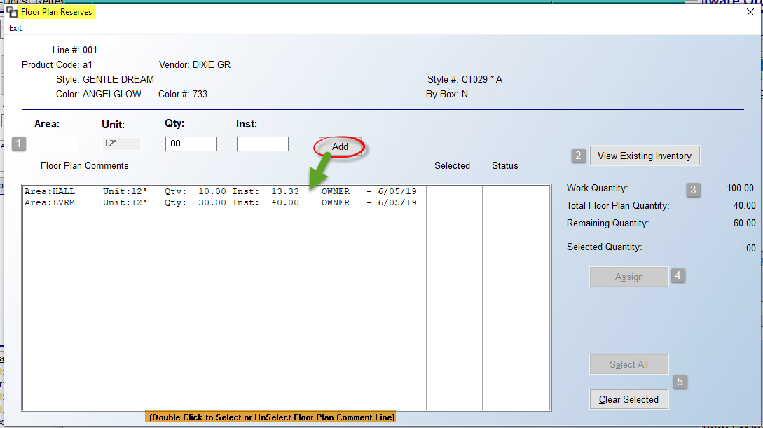

The cursor will be positioned in the Area (1) field. Type in an abbreviation for the area in which this cut will be installed such as LR for Living Room. When you hit enter, the system will place you in the Qty field. Type the length of the first cut in this field. The system will then figure the yardage (or footage) in the Inst field. Click the Add button and the system will place the data in the Floor Plan Comments box below. The View Existing Inventory (2) button will prompt a lookup screen. Continue to add Floor Plan lines until the Work Quantity and the Total Floor Plan Quantity (3) fields to the right of the Floor Plan Comments box match. If your Floor Plans are more or less than the Work Quantity entered on the Job Line, you can click the Update Work Quantity with Total Floor Plan Quantity button that appears when there is a discrepancy to change the Work Quantity field. To begin assigning material to the cut lines, you can highlight one line at a time and click the Assign (4) button, or you can click the Select All (5) button to select all lines to assign at once. If you need to order material, the system will prompt you to create a PO for the full amount needed for all floor plan lines.

In the Quotation/Proposal Maintenance module, with the floor plan Cut Sheet program enabled and if you allow Holds on Inventory in Quotes, when you put a hold on inventory, the system will prompt you to assign cuts just like in Order Entry. If you don’t put a hold on inventory, you can still create floor plan cuts by using the Comment Line feature. The same goes for the Property Management/Builders Templates module. These floor plan cuts will then carry over into Order Entry when you read in a Quote or create an Order or Quote from the Property Management/Builders Templates. One additional feature to be aware of is that if you create floor plan cut lines on a single line in Quote Entry or Property Management that exceeds the total Work Quantity on the line, when you read it into a Job, the system will warn you in the Line Items screen with a box that pops up as follows:

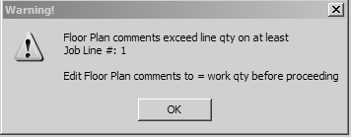

When this prompt occurs, if you correct the first line and then exit this screen and come back in, it will alert you if it encounters any other lines where this condition exists. When you receive this message, if material has been reserved from a Quote you can unassign it and the existing floor plan comment lines will be deleted and you can then re-assign and add back the correct floor plan comment lines. (We suggest you print a screen shot of the existing floor plan lines before you unassign so you will know how they need to be added back.) If no material has been assigned you will need to access the Comment Lines feature and delete any existing floor plan cut lines and then add them back by entering through the line to assign material or a purchase order as the system will not allow you to use the Comment Line Floor Plan option while in Order Entry when the Cut Sheet program is enabled.

In the Purchase Orders module, if you increase the quantity ordered on a P.O. Line that is tied to an order line, you can send the overage to the Job via the Modify Job Line feature and the system will create a new floor plan cut sheet line on the job showing the amount as “Overage.” If you try to modify the quantity for less than the Work Quantity on the Job, the system will not allow you to make the change from here and will prompt a message as follows: Job line cannot be less than Floor Plan. If you still need to make a change, you will need to go to the Job, unassign the PO, change the Work Quantity to reflect the lower amount, and then re-add the Floor Plan cut lines for the new amount, change the quantity ordered on the PO and re-assign the PO. You will also need to handle Receiving overages and shortages differently. If you are receiving an amount over the quantity ordered, you can handle this in two different ways. First, if you want to send the full amount received to the Job, just as in the Purchase Order Maintenance screen, you will need to use the Modify Job Line feature and adjust the Work Quantity on the material line to reflect the amount about to be received. Once you enter through the Use This Roll prompt, the system will prompt the following: No Floor Plan lines match assign qty; You must tie Inventory to Floor Plan. When this box pops up, it means that the amount of inventory received does not match the existing floor plan cut lines and in order to send this inventory to the Job you will need to hit OK and the system will then bring up the following:

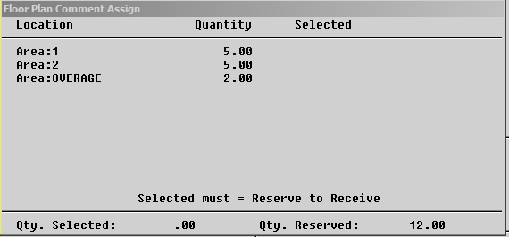

At the bottom of this screen you will note the following: Selected must = Reserve to Receive. You must hit enter on each line until the Qty. Selected equals the Qty. Reserved. An asterisk will come up on each line under the Selected column. Once these two figures match, an option to F1 to Receive will pop up and you can hit the F1 button to receive the material and assign it to the Job. The additional 2 ft. shown in this example will show as an Overage on the Job and on the Cut Sheet and also on the Pick Ticket. Another option is to receive the overage into available inventory, though this should only be done with an overage amount that makes sense to send to available inventory. Follow the prompts to send the reserved quantity to the Job and you will again get the “Tie Receipt to Comment” box and the “Floor Plan Comment Assign” box where the original cuts will be prompting. Hit enter on each cut and then you’ll get the F1 to Receive prompt. Hit the F1 key and the material will be sent to the Job and individual Pointer Records will be written. If you escape out of this box, which you should not do, without selecting the cuts and hitting the F1 key, the system will write the Pointer Record as one piece instead of as the cuts that were entered on the Job. The only way to correct this is to unassign the material from the Job and then re-enter the cuts and re-assign the material.

In the case of a shortage, in Receive Inventory the system will not let you send an amount less than the total of the floor plan cuts to the Job. If the Rec. Qty is less than the total of the floor plan cuts on the Job line, the system will prompt the following once you enter through the “Receive This Inventory” prompt: Receipt less than line qty; Print Receiving Report and reassign thru Job. The system will then prompt the following: Modify Qty. Ordered? N. When you hit enter, the system will place the cursor back at the Rec Qty field. You are not receiving any more material so hit Esc to exit. The system will not prompt you to close the PO because someone familiar to the Job will need to decide if the shortage will work or if more material needs to be ordered. You can print the Receiving Report at this point and it will display the word “Shortage” with the Job Number next to that inventory. If the shortage will work, you will need to go to the Job (review the Comment Lines first to see how the cuts need to be re-added because when you unassign the P.O., the Floor Plan cut lines will be automatically deleted), unassign the PO, and then re-enter the line to adjust the work quantity and create new floor plan cuts and assign the inventory that was just received. Once the PO is unassigned from the Job, it can be closed through P.O. Maintenance. This same scenario will need to be used if you receive in two rolls on a Job totaling the Work Qty rather than one roll. This is because the length of the two rolls may no longer work with the floor plan cuts that were originally created and someone familiar with the Job will need to determine if the two rolls will work. If the material received in will work on the Job, the process described above will need to be handled quickly as the inventory that was received in will show as available inventory until it is assigned to the original Job.

There are a few tools in the Installation Schedule menu that work in conjunction with this feature and will help facilitate scheduling and order processing procedures in the system. If you are not already doing so, we recommend that an Install Date be entered in every Job. This is so that the Installation Manager can utilize the Installation Schedule in coordination with the Cut Sheet, Pick Ticket and Installer Work Order. The next step in this process is to print the Installation Schedule for all the Jobs that are about to be installed. This print out can then be used to determine which Jobs need material cut using the Inventory Cut Sheet module, which is explained in the Installation System section of this manual.

Labor & Special Charge Line Items:
In addition to Material Line Items, if your company offers installation, you will add Labor Line Items to a Job in the Line Items screen, just as you do Material Line Items. The process for adding Labor Line Items starts out the same as adding a Material Line Item. In the Select From Catalog box, you should first select a Product Type of Labor and then search your Product Code drop-down menu for your Labor Product Codes. See example below:
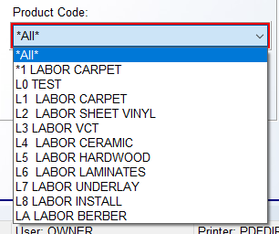

If you select Labor Carpet, then you can click the Find Matching Styles button to call up a list of all your pre-built Carpet Labor descriptions as follows:

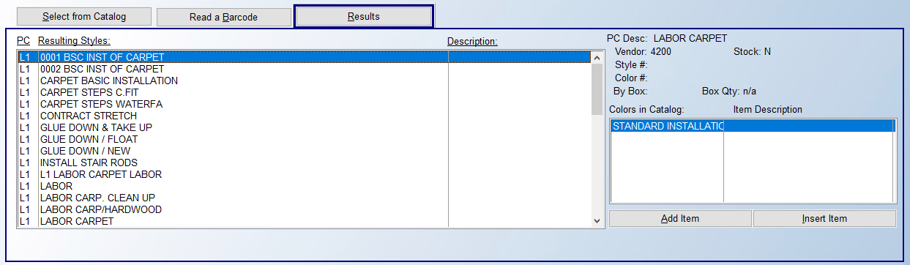

You can scroll through this list until you find your desired labor item and then click the Add Item or Insert Item buttons to add to the Line Items screen. The Insert Item will allow you to insert a Labor Line above other existing lines on a Job. An additional feature will allow you to build, or freehand, a Labor Line Item for just this Job via the fields at the very bottom of this screen. (You must be able to see costs to perform this task.) If you first click the Add Items to Order box, you can then type a Style Name and Color description in the fields at the bottom of this screen. You will also have the ability to assign an Accumulator Code to that Line. A drop-down menu will appear at the bottom right, just below Estimated Hours. Click Add Item or Insert Item to continue.

Once you click the Add Item button, an Add or Change a Line Item box will appear as follows:

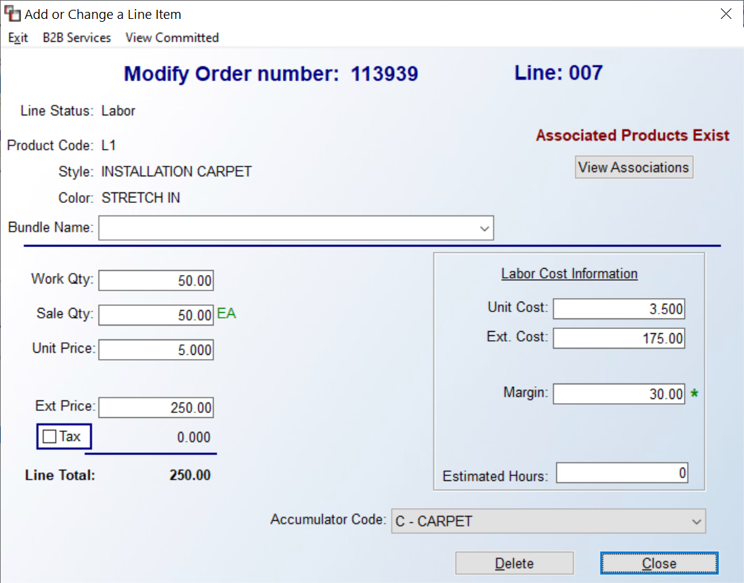

Start at the Work Qty field and type your applicable quantity for this labor line. You can make changes to the Sale Qty, Unit Price and Extended Price fields if applicable, just as you can with a material line item. If a User can see costs, as the fields on the left are being completed, the system will calculate the cost information on the right. If a User has permission, changes can be made to the Unit Cost and Extended Cost fields, if applicable. Additionally, a Margin percentage can be entered that will take the costs entered and calculate an Extended Price based on that percentage.

At the Estimated Hours field, if an hourly installer will be performing the work on this Job, type in the estimated number of hours that it will take him to complete this labor. If a subcontractor will be performing the work, there is no need to access this field. In both Quote and Order Entry, you can change the Accumulator Code on a Labor Line. This process will impact the current line only and will not make a change to the Catalog Item, essentially turning it into a manual (ad hoc) line. This means that if you wish to remove or change the Accumulator Code on the manual line, you will need to delete and start the process over. The Delete button will delete any prior data entered, and the Close button will close this screen and add the Labor Line Item to the Job.

Special Note: With prior set up, Labor lines will automatically prompt a total Work and Sale Quantity based on the yardage or footage of the prior material lines entered. This feature will not accumulate the same line twice and will only work the first time for matching Labor Catalog. (This feature will also work in Quotation Entry.) In order for this to take place, you will first need to perform some maintenance to your Material Product Codes and then to your Labor Catalog descriptions. In Product Code Maintenance, you will see a field as follows: Labor/Code. For all Carpet Product Codes, you can use a “C” for Carpet in this field. This field can only be accessed on Material Product Codes, not on Labor or Special Charge Product Codes. Once you have completed this for all Carpet Product Codes, you will then go into Catalog Maintenance and bring up your Carpet Labor Catalog descriptions where you will now see a new field as follows: Accumulator Code. This is where you will type the same code that was used on the Material Product Codes. Once this is complete, as you enter carpet material line items, the system will keep track of the yardage or footage and as soon as you enter a Labor Line where the Accumulator Code matches the prior material lines, the system will automatically prompt the total work quantity. This field can be overridden if applicable.

Special Charge Lines:
In addition to material and labor line items you can also add “Special Charge” line items to a Job. Special charge lines are used to add or subtract a cost and/or a sell amount to a Job that is not tied to material or labor, such as a finance charge, customer discount, coupon credit, referral fee, freight charge, etc. Special charge line items are added much the same as labor line items. In the Select From Catalog box, you should first select a Product Type of “Special” and then search your Product Code drop-down menu for your Special Charge Product codes. See example below:

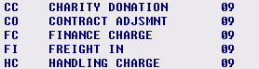

You will likely not have many catalog items under any of your special charge product codes, but you should click on the most applicable to continue. Click the Find Matching Styles button to call up a list of all your pre-built special charge descriptions as follows:

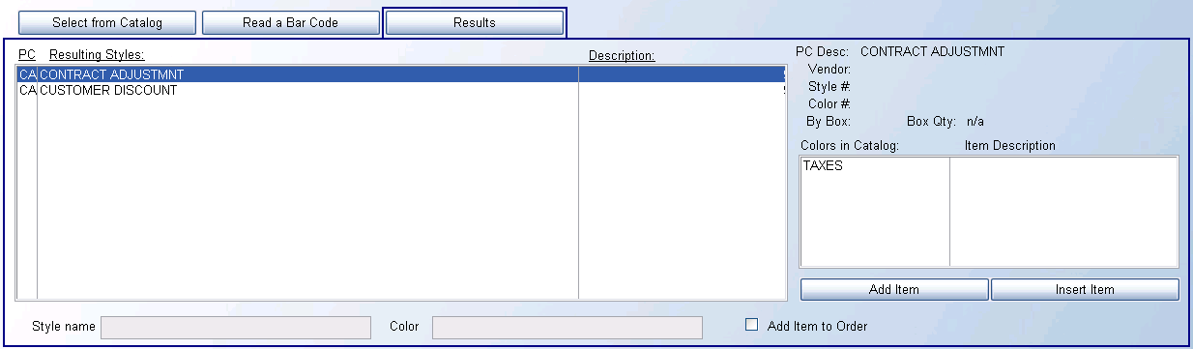

You can scroll through this list until you find your desired special charge item and then click the Add Item or Insert Item buttons to add to the Line Items screen. The Insert Item will allow you to insert a labor line above other existing lines on a Job. An additional feature will allow you to build a new special charge item for just this Job via the fields at the very bottom of this screen. If you first click the Add Items to Order box, you can then type a Style Name and Color description in the fields at the bottom of this screen, and then click Add Item or Insert Item to continue. Once you click the Add Item button, an Add or Change a Line Item box will appear as follows:

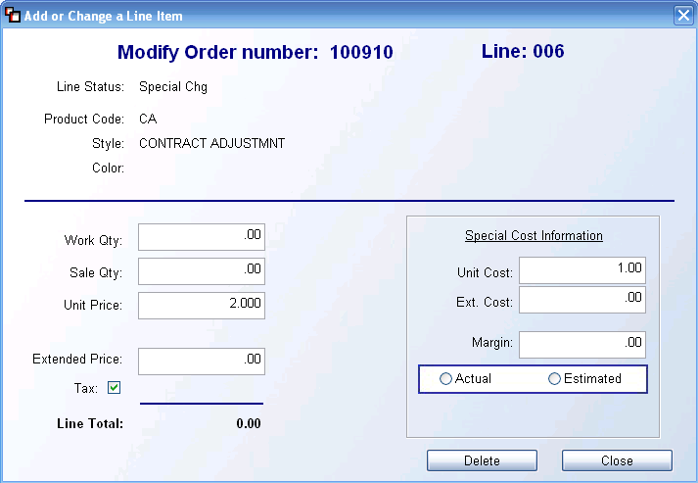

In this screen, the system will place the cursor at the Work Qty field. Special Charges are typically a flat amount, so you will primarily type a “1” in this field. Whatever figure you enter in this field will automatically default in the Sale Qy field, but you can override it if applicable. The remaining fields will calculate based on the information you entered above, but any field can be adjusted if applicable, such as the Tax option, as not all special charges will need to be taxed. To the right of this screen, you will see a Special Cost Information box. If a user is allowed to see costs, these fields can be accessed to make changes to or add cost information for this special charge, just like the option for labor line items explained above. The Actual or Estimate options are most applicable for those dealers using the Billed vs Unbilled – Costs From A/P report in the Job Cost Reports menu. When a special charge line is set to “Actual” the charge will appear on the report as a “Cost-to-Date.” When it is set to “Estimate” the charge will appear on the report as a “Cost-to-Complete.” If you will not be using this report, you can skip this option.

Line Items Screen Continued:
As you continue adding line items to a Job, the Line Items screen will begin to look something like the following:

In the middle of the screen, the following options will allow you to alter the screen to see only certain types of lines: Show All Lines, Show Materials Only, Show Labor Only, and Show Special Charges Only. This will be most helpful on large Jobs where you could conceivably have more than 15 lines on the Job and wish to make sure you have all applicable lines entered. At the very bottom of the screen, if you choose the Change Line Item and Delete Line Item options, make sure the correct line is first highlighted on the screen above before you continue. You can also double-click on a line to prompt the Add or Change a Line Item box. Changes and/or deletions can take place, provided a User has permission, prior to invoicing the line item. As mentioned above, the Change Line Item option will prompt the Change or Add a Line Item box, but you will only be allowed to make changes to quantity, cost, Bundle Name, etc., you will not be able to change the Catalog Item via that option, but there is a separate option available in the Item Selection screen when you right-click on the line that appears as follows: Change Style and Color from Results Selection Below. Please see complete details further down in this section. The Delete Line Item option, provided no material or PO is assigned to the Line, will remove the line from the Job. The system will prompt the following prior to deletion:

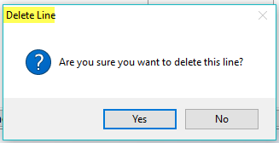

If you click the Find and Add Line Items option on an existing Line, the system will prompt the RollMaster Order Entry Item Selection screen and display all the current Line Items on the Job along with the Catalog Item selection box for you to add another Item. However, if you right-click on a Line Item from this screen, you will see another list of options as follows:

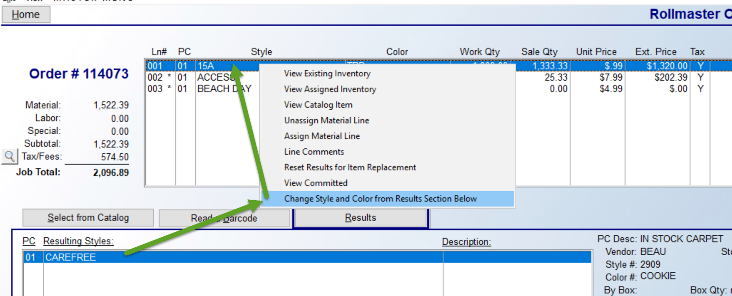

With the exception of a couple of options in this list, the rest of these options appear and have been explained in the documentation above. The Reset Results for Item Replacement option provides a shortcut for selecting more of the same material on a job, meaning it will prompt the current material item in the Results tab of the Catalog Selection box just below the screen above, saving the time of re-looking up the item. Additionally, to change the Style and/or Color of a line, you will first use the Select from Catalog tab screen to locate the new Style and/or Color, and then click the Change Style and Color from Results Section Below to read in the new item. The system will then prompt you to reset the price. A Reset Price? box will prompt as follows:

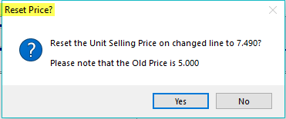

The default is Yes to Reset. Click No to keep the Old Price.

Deposits:
In addition to the Line Items tab screen, you will note a Deposits tab at the very top of the screen above. On most residential Jobs, you will post a deposit or any monies received from the Customer so the system can keep track of what is still owed on the Job. You can also add a Deposit from the Quote Entry module using these same steps. Multiple Deposits can be entered on a Job up until the point an Invoice is created. Once a Job is invoiced, all payments need to be entered in the system through the Post Customer Payments module in the Accounts Receivable Menu or via the Receive Money feature from the Home Key menu. Deposits can also be adjusted or canceled prior to invoicing. Please Note: if a Deposit exists on a Job, you cannot change the Customer ID—the Deposit must first be canceled and then re-entered after the change, if applicable.

When you click on the Deposits tab, the screen will appear as follows:

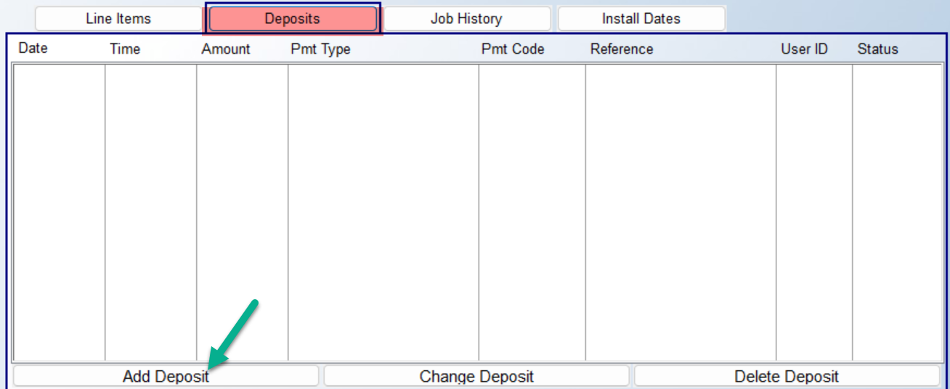

To enter a Deposit, click the Add Deposit button at the bottom left of this screen. Type the exact value of the payment in the first field. An Order Deposits box will appear as follows (if you are using Broadlume Payments, this process will differ slightly so you should review those steps with your system administrator):

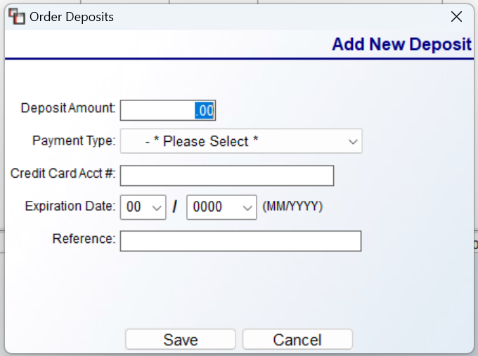

(Please Note: the system will not accept a zero Deposit Amount.) At the Deposit Amount field, type the exact dollar amount of the money received. At the Payment Type field, click on the down arrow button to prompt a menu of the forms of payment your store accepts. Click on the applicable Payment Type to continue. You can record a number at the Credit Card Acct# field, and an Expiration Date in the next fields. The Reference line is a free field that can be used to record a check number, driver’s license number, or approval code in the case of a credit card. Click the Save button to accept the Deposit or click the Cancel button to clear the data and start again.

If you click Save to keep the Deposit, the amount posted will appear both in the Deposits tab screen and in the Deposits field of the Job Totals box. At this point, you can only modify the Amount of an existing Deposit. If you need to change the Payment Type, you will need to Delete the Deposit and re-enter it with the correct information. To change or cancel an existing Deposit, from the Deposits tab screen, highlight the applicable Deposit and click the Change Deposit button. The Order Deposits box will then appear as follows:
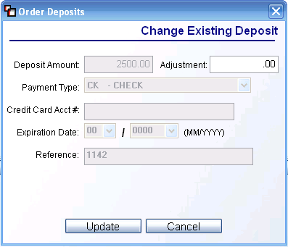

The only field accessible in this screen is the Adjustment field. This field should only be used to give a portion of the Deposit back to the Customer. In the Adjustment field, enter the amount to be refunded--do not enter a negative sign in this field. Click the Update button to continue. Prior to clicking the Update button, you can click the Cancel button to exit without making any adjustments. When you click the Update button, the system will prompt the following:

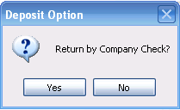

Only if you need to generate a check to the customer, should you click Yes at this prompt—see the Delete section below for how the system handles the return by company check internally. For credit card refunds, you should click No and then process the credit on the customer’s card. You can make multiple adjustments to each Deposit on a Job, provided you don’t adjust for more than is available on the Deposit, and if you need to delete a Deposit entirely, you should not use this feature. Each time a Deposit is adjusted and returned to the Customer in this way, the system creates an Accounts Payable Open Item number using the Job Number followed by a three-digit sequence number so each item number will be unique. For example, if the Job Number is 2572, the first item number would be 2572001, the second would be 2572002, and so on.

If you wish to delete a Deposit entirely, you will highlight the item in the Deposits tab screen and then click the Delete button. The system will prompt an Order Deposits box as follows:
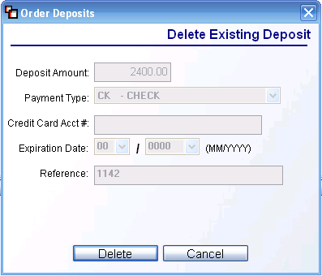

All you need to do at this point is click the Delete button to continue. If you click the Cancel button first, the system will make no changes and return you to the Deposits tab screen. When you click the Delete button, the system will prompt the “Return by Company Check” prompt. If you are returning a Deposit by credit card and not by check, you need to click No at this prompt, and the system will handle all internal procedures. If you will be returning a Deposit by company check, you need to click Yes at this prompt. The system will then prompt the following:

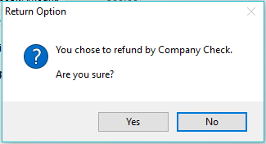

This is a second opportunity to back out of this option. Click Yes to proceed. With User Controls enabled, if a User is allowed to change the Default Posting Period, the system will then prompt the following: Enter Adjustment Date (MMDDYYYY). This field will default to the current date, but can be changed by the user if applicable. The system will then prompt a Posting Period field, and the default will be set to the current Default Posting Period. Again, only Users with permission will see this field and will be able to make a change to the Posting Period, where applicable. Users without permission to change the Posting Period will not see the two previous fields and the system will simply capture the current date and the current Default Posting Period for accounting purposes. This same scenario is true for adjusting Deposits as well.

The deleted Deposit will still show in the Deposits tab screen on the Job, but the status column will show as “Deleted” and the Deposits field in the Job Totals box will reflect the amount deleted. When you choose to return a Deposit or an adjusted Deposit amount by company check, the following procedures will automatically take place in the system: a new Vendor ID is created using the Customer ID on the Job with an “*” placed in front of the ID as such: *JONE111; an A/P Open Item for that Customer will be created using the Job Number as the Invoice number; and the system will automatically clear the credit on the Customer’s account. The final step in the Company Check Deposit refund procedure is for the A/P department to print the check. Please Note: If you are returning a Deposit by company check, the canceled Deposit will not appear on the Customer Payment Register; the value will come out of the bank account when the check is printed.

After a Job has been invoiced, any Deposits that were taken on the Job will also continue to display in the Deposit tab screen, however, the Job needs to be “Open” in order for you to view these Deposits. The Deposit(s) field in the Job Totals box will still display zero after invoicing, but if you click on the Deposit tab, each Deposit will show with the verbiage “Invoice” in the Status column. Additionally, the system will allow you to create a Credit Memo when there is a Deposit balance left on a Job. It will skip all Deposit sections so that the Customer’s account will be updated accurately. And finally, the system will not allow you to close a Job if a Deposit exists, even if you invoice a Job, leaving a balance left on the Deposit. You will need to adjust the Deposit amount if the Customer is owed a refund and then close the Job.

Job History:
The Job History tab will display a listing of any Deposits, Invoices, Credit Memos, and Post Cash Receipts payments that have been posted to a Job, and then details how those deposits/payments were applied to Invoices on the Job, as the order progresses. It includes any applicable status data, such as if a Deposit was deleted, adjusted or returned by either credit card, cash or company check—shows “A/P” in front of Adjusted. When refunds are processed, this feature will also list Credit Memo data as it occurs and if the credit has been applied to any Invoices. Additionally, if a Job is “Financed” using the Finance Payment Type Code feature, this screen will list the amount financed and the Payment Type Code used. An example of a Job History Review screen appears as follows:

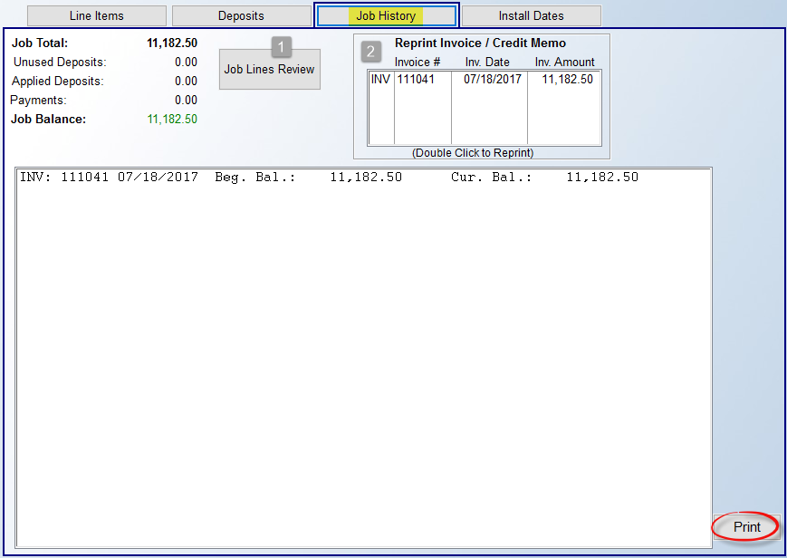

The Job Lines Review button calls up the Job Line Review program, also available from the Home Key menu, explained above. You can use all the same features when accessing the program from this button as you can from the Home Key. The Reprint Invoice / Credit Memo box will list detail of any Invoices or Credit Memos that exist on the Job. You can highlight and double-click on any listed item to reprint from this screen rather than entering the Invoice/Credit Memo module.

If you click the Print button, the system will print out the data in this screen. With regard to payment information in multiple Branch systems, if a refund is issued from a Branch that is different from the Branch it was originally posted in, the system will denote that in this screen by prompting the refunding Branch ID just before the Payment Type Code.

Install Dates:
Need to add in explanation and update Job Details box.

Job Cost, E-Docs, Refresh, Home, Quick Invoice, & Detailed Job Cost View/Print:
During the Order Entry process, once a few lines have been added, there are some additional features that will be available to you to enhance the overall order entry process. These options appear at the top left of the screen as follows:

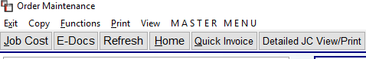

Job Cost- one of the most valuable features that is unique to the RollMaster System is the ability to view real-time job cost figures from the Job, provided the User has the ability to view these figures. With User Control permissions enabled, you can control who is able to see costs in the system, meaning that not every User may be able to see this option depending on their ability to see costs. If they can see costs, Special Charge and Labor Lines will immediately display job cost data as soon as they are entered on a Job and Material Lines will display job cost data once inventory is assigned to a line. From this module you can “view” job cost, but you cannot make any permanent changes to costs, aside from Salesperson Commissions. Job cost information is continually updated from several modules in the system as orders are processed such as P.O. Maintenance, Purchase Order Receipts Adjustment, Receive Inventory, Job Labor Maint./Installer Payments, or the A/P Review P.O. History feature.

Important Note: There are a couple of modules in the system that will provide instant job costing data once any type of line is entered on a Job. The first is the Job Cost Margin Report (in the Job Cost Reports Menu) and it should be printed daily. There is also a module in the Job Cost menu titled Work in Process—Costs From JC that will figure job cost on all lines, regardless of whether inventory has been assigned.

When you click the Job Cost button, a Job Cost Maintenance screen will appear as follows:

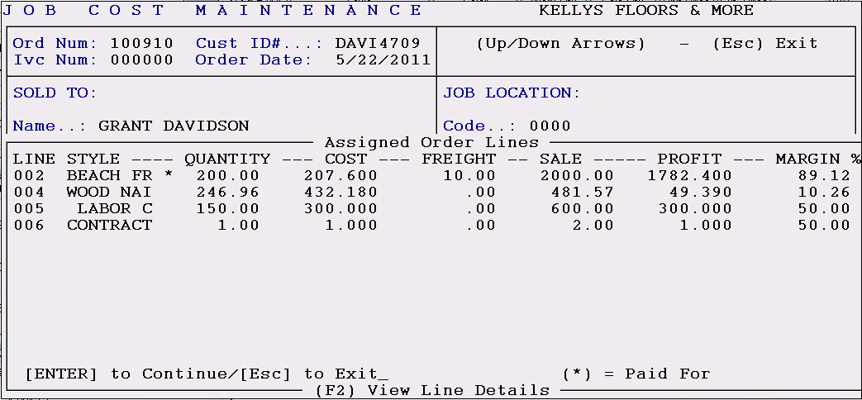

Every line from the Job, with the exception of any Material Lines that do not have inventory assigned, will be listed in this box as they appear in the Line Items screen. In the STYLE column, only eight characters of the style name will display. If an “*” appears to the right of the style name, it means that the cost has been approved in the system either via the Job Labor Maint./Installer Payments module for Labor Lines or via the A/P Open Item Maintenance module for Material Lines. The information in the QUANTITY column is pulled from the Work Qty column in the Line Items tab screen. The COST and FREIGHT column data is pulled from the current value of assigned inventory or the current cost associated with a Labor or Special Charge Line. The Sale column displays the total sale price of each line. The PROFIT column displays the total profit to be made on each line based on the current costs and sale price (Please Note: the dollar profit amount in this screen does not reflect any salesperson commission due). The MARGIN % column displays the current profit margin (Please Note: the margin percentage in this screen does not reflect any salesperson commission). If any lines have been entered with a cost but no sale value, the Profit and Margin % columns will display negative figures. In this case, the User should only be concerned with the bottom line profit and margin % on the total Job, which will be viewable in the Job Cost Totals screen. The [ENTER] TO Continue/[Esc] to Exit prompt at the bottom of the screen will allow you to proceed to the screen that displays job cost totals by hitting enter, as will the F2 key. You can also hit the Esc key while in the first screen to exit the Job Cost Maintenance screen entirely and return to the Order Entry screen. The Job Cost Totals screen will appear as follows:

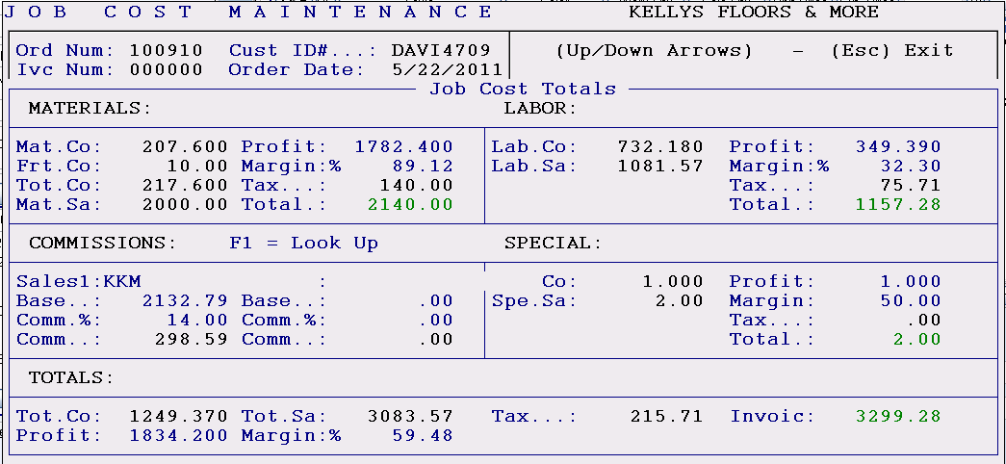

When this screen is first displayed, the Profit and Margin % fields at the bottom left will not reflect any Commission, but when you enter through the COMMISSIONS section, that data will then update those fields for display purposes only. Commission information is not finalized in the system until the Line Items are invoiced. The following is an explanation of each section of this screen.

MATERIALS- this section combines all the Material Lines on a Job where inventory has been assigned. It displays the following: the combined cost of all the material; the combined freight cost; what the material was sold for (less tax); the total profit on materials; the profit margin on just the material lines; the total tax charged for material; and finally, the total sale on materials plus tax. Please Note: If tax is charged on the cost of material (Contract Sale), an asterisk will appear in the tax field as such: Tax..*:

LABOR- this section combines all the Labor Lines on the Job. It displays the following: the combined cost of all labor; what the labor was sold for; the total profit on labor; the profit margin on labor; the total of any tax charged on labor; and finally, the total sale on labor plus any tax.

COMMISSIONS- this section displays the Salesperson Commission based on the information that was entered in the Salesperson Maintenance module. It displays the Salesperson ID, the commission base, the commission percentage, and the total commission to be paid. Please Note: The system does not include tax when calculating the commission base. If a second Salesperson is tied to this Job, that information will be displayed here as well. This is the only part of the screen that can be accessed and changed provided the Salesperson is not being paid on a Sliding Scale commission base. As soon as you hit enter in this section the system will display the following:

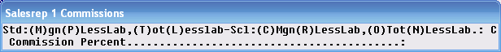

In the example above, the Salesrep 1’s commission is being figured on a Sliding Scale Base Margin percentage. If the Salesrep 1’s commission is being figured on a Sliding Scale (in this case the commission option will display as “C”, “R”, “O” or “N”) you will not be able to make any changes to the Commission Percent field or the Commission Amount unless you override the field above to one of the Standard Base options (the commission option will display as “M”, “P”, “T”, or “L”). To make any changes in this screen permanent, you will need to immediately process an Invoice upon exiting this feature. If you exit the Job completely, without invoicing, the totals will revert to what they were before you made any changes. Also, once you have enter through the COMMISSIONS section, the system will update the Profit and Margin % fields in the TOTALS section to reflect the impact the Commission will have on total job cost.

SPECIAL- this section combines any order lines on a Job that are neither material nor labor. There is never any inventory attached to these lines. Examples include finance charges, delivery charges, adjustments, discounts, etc. These lines are separated out in this section and broken down by total cost, total sale, total profit, total margin percentage, and total tax, if any. Many times these lines will have a cost tied to them but no sale price. In these instances you will get a negative profit and margin percentage, which will impact the bottom line figures in the TOTALS section.

TOTALS- this section averages all the cost, sale, tax, profit, and margin percentage totals of each section and then displays the bottom line total figures for the Job.

To exit the Job Cost Totals screen, enter all the way through the COMMISSIONS section until you get to the following prompt: Continue? (Y,N) Y. If you hit enter again after reaching this prompt, the system will return the cursor to the Job Entry screen.

E-Docs- RollMaster Edocs can be accessed from several areas throughout the RollMaster System. This includes Sales Processing, Accounts Receivable, Accounts Payable, Purchase Orders, Catalog, and Installation. An asterisk appears next to the Edocs option once a document has been added. When you access the Edocs feature, the system will display an Edoc Menu box as follows:

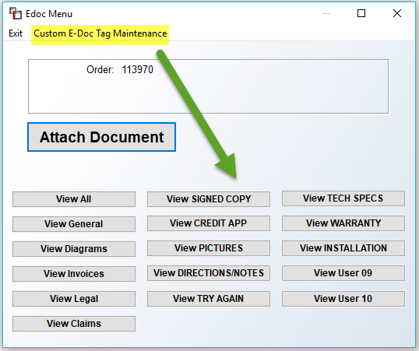
As a reminder, there are several User Controls that should be set prior to training your employees on this feature. The Custom E-Doc Tag Maintenance option at the top left allows for creating custom Document Tag files. When you click that option, the system will display a Customer E-Doc Tag Maintenance box as follows:
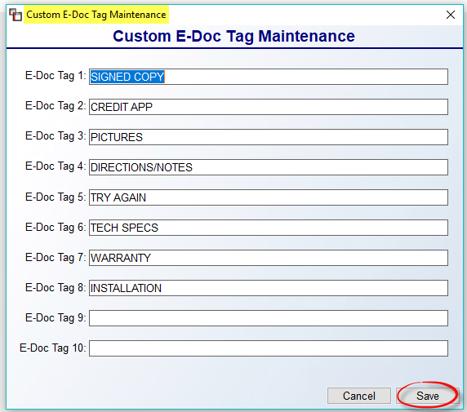
In any of the four available fields, type a new Document Tag title, such as Kelly’s Documents. Click Save to keep your changes. This new Document Tag name will appear in the Edoc Menu box throughout the system.
To attach a document or file that currently resides on your server or desktop, click the Attach Document button. The system will prompt a Windows File Lookup box and you can search your computer for the file you wish to attach. Once a document is selected, the system will prompt a Document Properties box as follows:

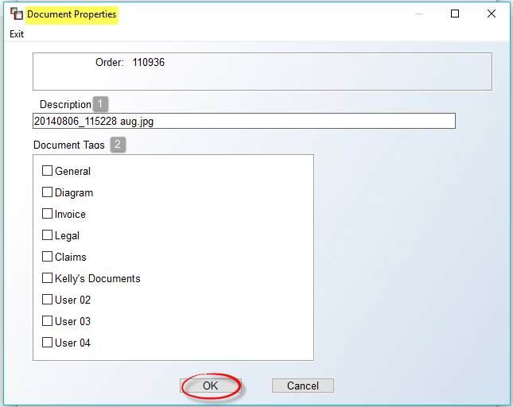

The Description (1) field will prompt the name of the file selected. You can type a more detailed Description for the document by clicking in that field and typing over the file name. In the Document Tag (2) box, click on one or more of the options in that box to determine where the document can be viewed. Once a Document Tag(s) has been selected, click the OK button to continue. The system will return you to the Edoc Menu box. In that box, an asterisk will now display next to the View button option of the Document Tag(s) selected. Once a document is attached, it can be viewed via the applicable View option from the Edoc Menu box. When you select a View option, the screen will appear as follows:
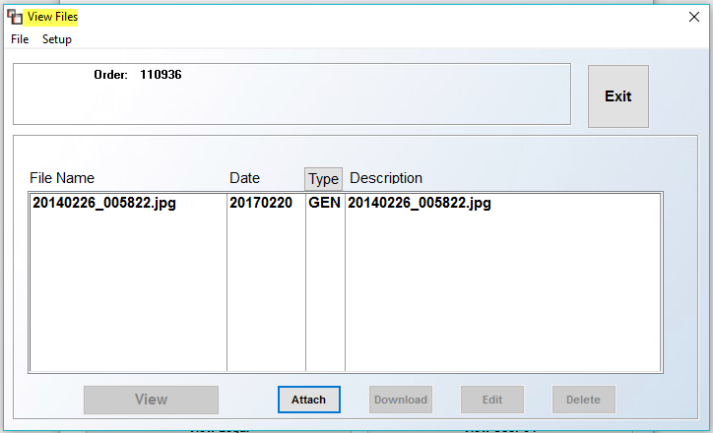

When you highlight a file, the options below will become available according to User permissions and you can manage your Edoc files accordingly. The View button will open the file for you to view on your computer. The Attach button will allow you to attach additional documents under the current Document Tag. The Download button is not currently available. The Edit button will prompt the Document Properties box where you can edit the Description and the Document Tag. The Delete button will completely remove the selected file from the Edoc system. The Setup feature at the top left of the screen above is currently disabled.

Refresh- when changes are made in the Order Entry screen after the initial entry, the Refresh button should be clicked to update the data and “refresh” the display screen.

Home- this option will bring up a menu containing a list of key modules and options that all Users should be familiar with. When you are not in the Order Entry, Quote Entry, or Property Management modules, this same menu can be called up when you hit the Home key on your computer keyboard, which is why it is referred to as “Home” in the system. When you click on the Home button or Home key, the system will prompt the following menu:

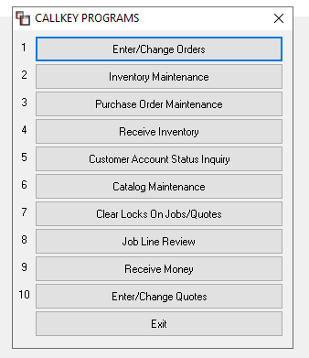

The ability to call up this menu can be extremely helpful in a situation where you need to look up a key piece of information without exiting the Job or program you are currently in, or you can use this menu to save multiple keystrokes when you are trying to get your work done. Whichever module or feature you access from this menu, when you have finished, the system will return you to the exact point you were when the Home key menu was accessed. The only restriction is you cannot call up this menu if you are currently in a program accessed from this menu, or in other words you cannot hit the Home key twice. You will need to exit the program you called up from this menu and then you can hit the Home Key or click the Home button again to call up another program.

Items 1-7 and 10 are all modules that are explained in detail under the menu sections where they appear in the system. Items 8 & 9 can only be accessed from the Home button/key and they are explained in their entirety below.

Quick Invoice- you will only see this option if all material lines are ready for Invoicing.
This feature allows you to process an Invoice in RollMaster with only two steps. You can still Partial Invoice via the regular Invoice function, if needed. Once all lines are Job Costed, on a Job, you will see a Quick Invoice button at the top left of the screen as follows:

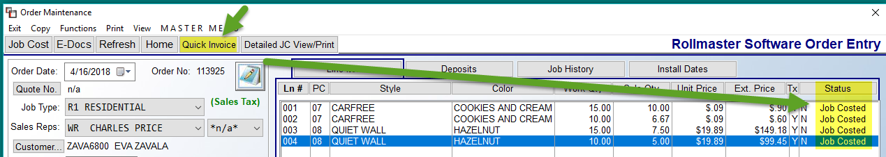

When you click on that option, if any lines are not ready for invoicing, the system will alert you to complete that process. If all lines are ready, the system will prompt the Invoice Selection Screen with all line items selected. At this point you can click the Continue button at the bottom right and the system will instantly generate and print the Invoice. If the Continue button is greyed, or unavailable, it means that one or more conditions for invoicing in the system have not been met. Things to consider would be any User Controls that would prevent invoicing of a Job, such as material needing to be shipped on a Work Order, or whether the User can Invoice, or if the Deposit doesn’t equal a percentage of the Job, etc.

Job Line Review- this option can be used to check the status of any Job in the system. When you access this option, the system prompts you to enter a Branch ID. If you have multiple Branches and a User enters a Branch ID they are not setup in, the system will not permit the User to access a Job in that Branch and will prompt a message alerting them to that fact. Once an applicable Branch ID is selected, the system will then prompt for a Job Number. If you don’t know the number, you can hit the F1 key to search by Customer ID instead. When you have selected a Job, a Job Lines Review screen will prompt, displaying all the lines on the Job as follows:

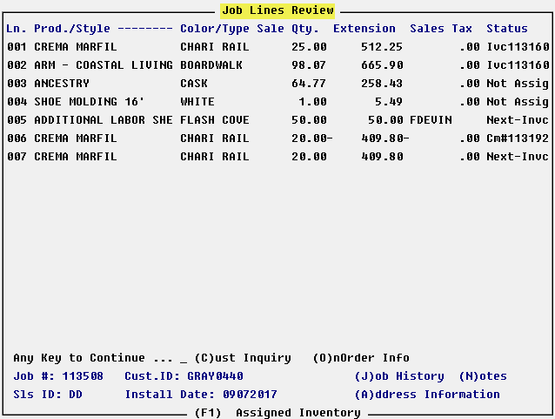

The column at the far right will display the Status of each line so you know status of the entire Job in an instant. Also, there are a few options at the bottom of the screen that will provide additional valuable information on the Job and will be explained below. If you hit any key, the system will return you to the screen you were in when you accessed the Job Line Review option. To jump to the Customer Status Inquiry module, normally accessed via Accounts Receivable, type a “C” for (C)ust Inquiry. To view Purchase Order or Roll Number information you can type an “O” for (O)nOrder Info. If inventory has been assigned to a line, the screen will display up to 10 digits of the roll number, and for multi-Branch transfers, if the inventory is in transit from one Branch to another, the system will display a “P” next to the roll number. Additional notations on the On Order Info screen will appear as follows: “W” for items that have been completely shipped on a Work Order, “w” for items that have been partially shipped on a Work Order, and “I” if the item has been invoiced. The (J)ob History option (type a “J” to call up this option), also accessible from the Order Entry module, will display a listing of all Deposits, Invoices, and Post Cash Receipts payments that have been posted to a Job to date and also how those deposits/payments were applied to any Invoices on the Job, along with any applicable status, such as if a Deposit was deleted, adjusted, or returned by either credit card, cash, or company check—will show A/P in front of Adjusted. If refunds are given, this program will also list Credit Memo data as it occurs and if applied to any Invoices. Additionally, if a Job is Financed using the Finance Payment Type Code feature, this screen will list the amount financed and the Pay Type Code. If you wish to print this information, you can use the Prt Screen button at the top of the screen.

The (N)otes option (type an “N” to call up this option) will call up the same series of Notes accessible from the Order Entry module, which has been explained in detail in that section of the documentation. The (A)ddress Information option (type an “A” to call up this option) will call up the “Sold To” and “Ship To” address information on the Job. The (F1) Assigned Inventory option will give you detail on the inventory assigned to each Job line. When you hit the F1 key, the system will prompt the following: Enter Line Number. Type in the line number you wish to view Assigned Inventory for and hit enter. The system will then display an Assigned Inventory screen as follows:

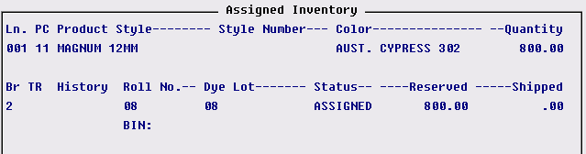

The Branch (Br) column will display the Branch in which the inventory is located; the Transfer (TR) column will display a “P” if the inventory is in transit; the History column will display an “H” if pointer records assigned to the Job have been moved to history; the Status column will display either Assigned, Work Ordered, or Invoiced; the Reserved column will show the amount reserved on the line; and the Shipped column will display any portion of the material that has been shipped on a Work Order.

Receive Money- this option will allow you to post a Deposit on any Quote or Job in the system on the fly from another Branch, as well as post a payment to any open Invoice from anywhere in the system. Please Note: The Payment Type Codes MUST be the same in all Branches for this to work. When you hit enter on the Receive Money option, the system will display the following menu:

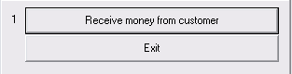

Hit enter on the Receive money from customer option and the system will then display the following:

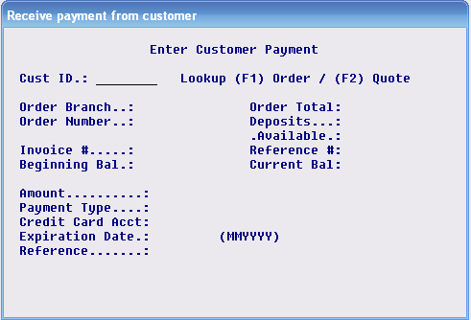

At the Cust ID field, use the (F1) key to lookup an Order or hit the (F2) key to lookup a Quote. Once the applicable Job or Quote has been selected, if you are posting a deposit, all the fields, up to the Amount field, will automatically be populated. At the Amount field type in the amount of the deposit if it is different from the total amount that is being prompted. The rest of the fields work the same as taking a deposit. (Please Note: deposits/payments can be backdated and the user can also change the posting period with user control permission from this feature. There is a User Control option-- covered in the System Administration Manual--giving each user the ability or non-ability to perform this change date/period function. Also, when a deposit or payment is made through this feature, the system will print an “R” next to the Job Number on the Customer Payment Register and Customer Payment Register History reports.) When you have completed posting the money, the system will return you to the screen you were in when you first hit the Home key. On the Job or Quote, Deposits will be reflected and can be edited if there is any problem. The Deposit will print on the Customer Payment Register of the branch you are in when you post the money for banking purposes, so for multi-branch companies, the Deposit will be reflected in that branch’s bank account. If you are posting a payment to an Invoice, you should still use the Lookup (F1) Order option to locate the Job, even though it is invoiced and closed. The system will call up the first Invoice number on that Job and then prompt an Enter Item Reference box. Type the Reference number for the payment such as a check number or credit card authorization number. The system will then place the cursor at the Amount field and prompt the remaining balance of the Invoice; hit enter to accept if the amount is correct or override with the correct payment amount. Hit enter at the Payment Type field to get a lookup and make your selection. You can then fill in the credit card information if that applies. Once you enter through this screen the payment will be posted and you will see it on the Customer’s Account, the Customer Payment Register and the Payment Distribution Report, just as if you had made the payment through the A/R Post Customer Payments module. You will also be prompted to print a receipt before you exit the program.

Detailed Job Cost View/Print- this is a direct link to the Job Cost module of the same name that can be found in the Job Cost Menu. Only Users with permission to see costs will be allowed to access this button. Any passwords protecting the Job Cost menu or this specific item will be required for any User to access this functionality. When you click this button, a Cost Review screen will appear as follows:

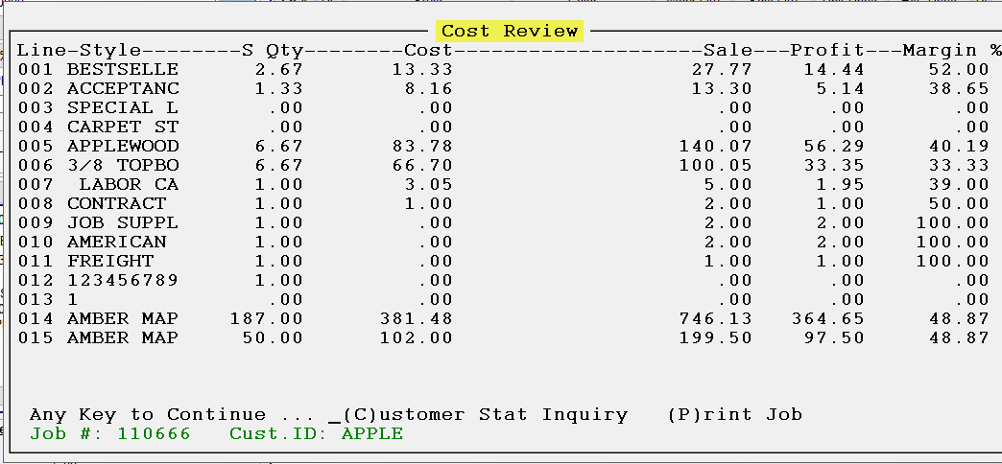

Options From Order Maintenance Screen:
When you are in a Job, the options at the top left of the screen, right above the Job Cost, E-Docs, and Home buttons, contain important reports and functions for completing the job entry process. Those options appear as follows:

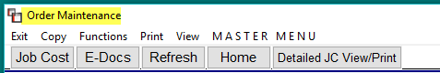

The Exit option can be clicked at any time to return you to the main Sales Processing screen. The Copy option menu appears as follows:

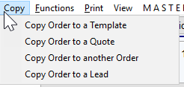

From this menu, you can copy an Order to a Template, a Quote, another Order, or, if you subscribe to the Leads Processing module, a Lead. In the Quote module, this option will allow you to copy existing Quotes to a Template, a new Quote, or a Lead. This feature will not copy over any Credit Memo Lines, nor will it copy any Inactive Catalog Line Items, wherever this feature can be accessed. When you select to copy to a Quote or new Order, a box will prompt as follows to allow for Branch selection and other pre-selections:
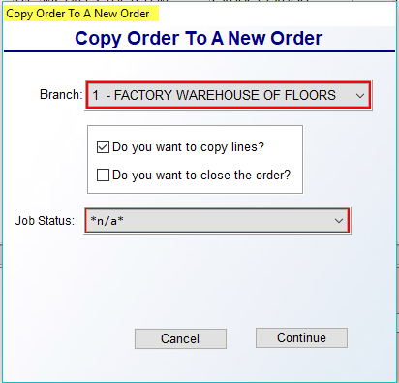
You will make applicable selections in this screen and then click Continue to copy the Order or Quote. When this process takes place, the Audit Review feature will track the following Audit Types: Copied From Quote/Job (detail displays the number of the Quote/Order copied), Quote/Job Created, and Job Type. When changing Branches, the system will first check to make sure the User exists in both Branches, second, that the Company shares Product Codes, third, to see whether the Salesperson exists in the destination Branch, and fourth, that the Product Codes of all Lines match or that the system is sharing Product Codes across all Branches. Also, if the switch is in place to log into a new Branch, that extra step will also be needed to complete the process.
Additionally, if you select to copy to a Template, the system will prompt a Create New Property Management Template box as follows:

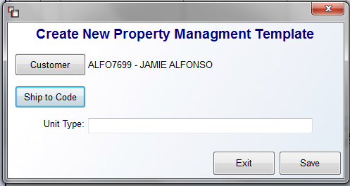
This box will allow you to change the Customer, select a Ship to Code, and add a Unit Type before copying. When copying to a Quote or Order, the system will prompt the new Quote or Order numbers and then bring up the processing screens so you can begin working in the copied Order or Quote.

Functions Menu Options
The Functions option, when clicked, will prompt a drop-down menu that contains the following options:
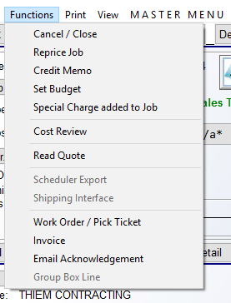

Cancel/Close- this feature will close a Job, thereby prohibiting access to any of the data fields, but it will not fall off the lookup screen and can be accessed again if necessary. The system has a module to allow you to open any closed Jobs when applicable. RollMaster recommends closing all Jobs once all the line items have been invoiced in the system. You will have the option to “Close” a Job during the final invoice print. After a Job has been closed, you can still view the information in the Job, but you cannot make any changes/additions unless it is reopened via the module mentioned above (see Open Jobs Closed in Error in the Management Functions menu). Closing a Job will take it off the Open Order Report. When a job is closed and then accessed again in the Review-only mode, the system will display the Closed Date of the job as follows:

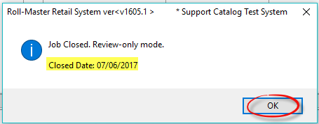

The Cancel/Close option should also be used to cancel any Jobs that have actually been cancelled by the customer prior to invoicing. Prior to canceling, you should delete any Deposits, unassign all material from the order lines, and then delete all of the order lines from the Line Items screen. This is important as some of the Job Cost reports include Closed Jobs, so if you do not delete the order lines on canceled Jobs, the report totals will be skewed. If you close a Job that contains order lines with material still assigned, the system will prompt the following: Job Costed/Assigned Lines Exist! Continue With Close (Y,N): N. This is a reminder prompt to prevent you from closing Jobs with assigned material lines. Again, if the Job is canceled, material lines should be unassigned or if a PO was created, the order line should be unassigned and the PO canceled. And once again, all lines should then be deleted from the Line Items screen to prevent those values from being included on certain Job Cost reports. Where there are no invoiced lines on a closed Job, the system will clear the Install Date field and an Audit Line will keep track of this process.

Reprice Job- this option is tied to any special pricing that is currently set up in the Special Price Mtc. (Date Range Pricing) module located in the Inventory Control menu. Based on the hierarchy of special pricing currently set up in that module, when you click on the Reprice Job option, all the existing lines on the Job will be re-priced to the current applicable special pricing. This option should only be used by customers well-versed in how the Special Price Mtc. module works. The following is a quick guide to the lowest to highest priority pricing in the RollMaster system:

Special Pricing Hierarchy:
- A-J Margin Pricing carries the lowest priority
- A-J Product Pricing is next and will override margins.
- Special Pricing Maint; Default Customer Type Pricing Level is next and will override the above.
- Special Pricing Maint; Default Customer ID Pricing Level is next and will override the above, but should not be used if Property Management below is set up
- Special Pricing Maint; Date Range Pricing by Customer Type is next and will override above.
- Special Pricing Maint; Date Range Pricing by Management Company is next and will override above.
- Special Pricing Maint; Date Range Pricing by Customer ID is next and will override all of the above. It is the highest priority pricing available in the system.

Credit Memo:
This option will only be used after one or more Invoices has been created on a Job (see Invoice section below for instructions on creating an Invoice). It is the only way to return material and refund any money to a Customer once the Job is complete and line items have been invoiced. Whether you are creating a partial credit to return a portion of the material, creating a monetary credit to satisfy a Customer, returning material without creating a credit to the Customer, or crediting an entire Job, and so on, you will do all of these things through the Credit Memo feature. (Please Note: this feature is not currently for use in Jobs that have been Progress Billed, but can be used on OTC Job Invoices.)

If a Job has been closed, when you begin the Credit Memo process, the system will prompt the following: Job Closed Review-only mode. Click the OK button to continue. If there is more than one Invoice on a job, you can look up an invoice number prior to processing the credit by clicking on the Job History button (explained above). To begin the credit process, click on the Credit Memo option from the Functions drop-down menu. The system will prompt a graphical Credit Memo Selection Screen as follows:

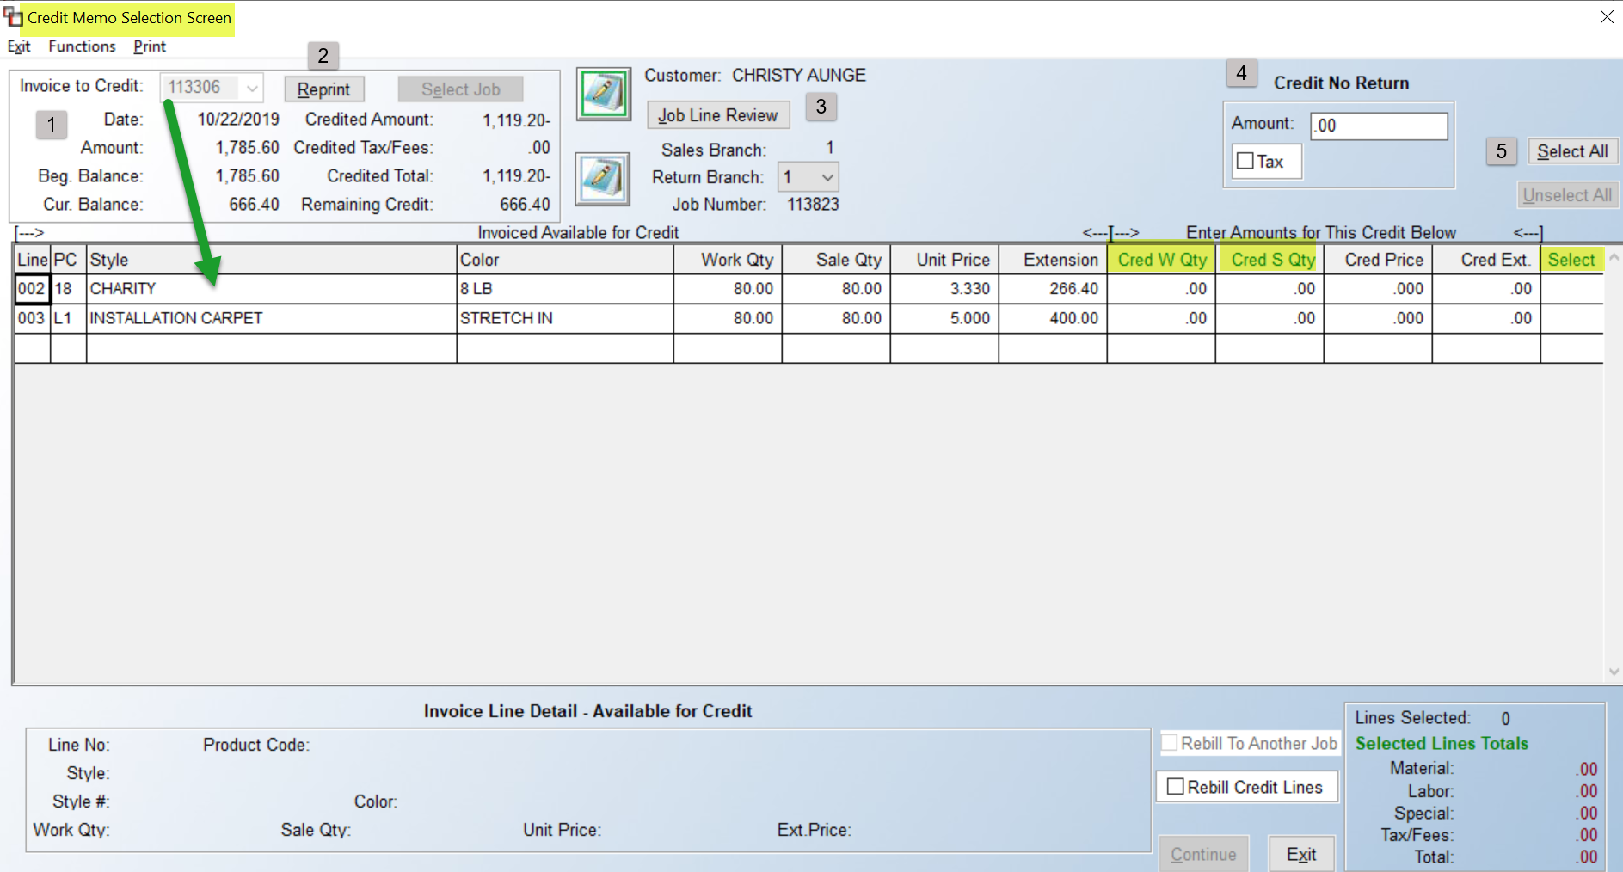

The Invoice to Credit (1) field will default to the earliest Invoice tied to the Job Number. If multiple Invoices exists, use the drop-down arrow in that field to display a complete list of Invoices on the Job and make another selection. The Date, Amount, Beginning Balance and Current Balance fields will display data applicable to the selected Invoice. If previous credits have been processed on the Invoice, the data will display in the Credited Amount, Credited Tax/Fees, Credited Total, and Remaining Credit fields. The Reprint (2) button can be used to print a copy of the selected Invoice. The Notes icon next to the Customer display field will prompt Customer Address Notes. The Notes icon below that will prompt Job Number Notes. The Job Line Review (3) button will prompt the Job Line Review screen where you can view the Invoice # tied to each Job Line, as well as prompt other key data, such as Customer Status Inquiry, On Order Info, Assigned Inventory, etc.

The Credit No Return (4) box allows you to set up a credit amount to the customer without crediting any of the lines on the Invoice. The maximum amount to credit should be net amount of the Invoice (net of previous credits). Type a value in the Amount field and check the Tax box if tax is applicable. Do not select any lines in the screen below and then click the Continue button to begin finalizing the credit.

The Select All and Unselect All (5) buttons can be used to instantly select or unselect all lines in the display screen below. When a line is selected, a “Y” will appear in the Select column. If you right-click on a line, the system will prompt the following option: Line Notes. The Line Notes option will prompt the Order Entry Line Comments Screen. Any Line Comments added from Quote or Order Entry will prompt automatically and you can add/edit/delete or use any of the available features in that screen as needed.

Partial Returns can be activated by clicking directly in the Select column of any line, or by editing the quantities in the Cred W Qty or the Cred S Qty columns. Adjustments to the Cred W Qty column will automatically adjust the Cred S Qty column, but an adjustment to the Cred S Qty will not impact the Cred W Qty column. When you click directly in the Select column of a material line, the system will prompt a Credit Memo Inventory Pointer Selection Screen as follows:

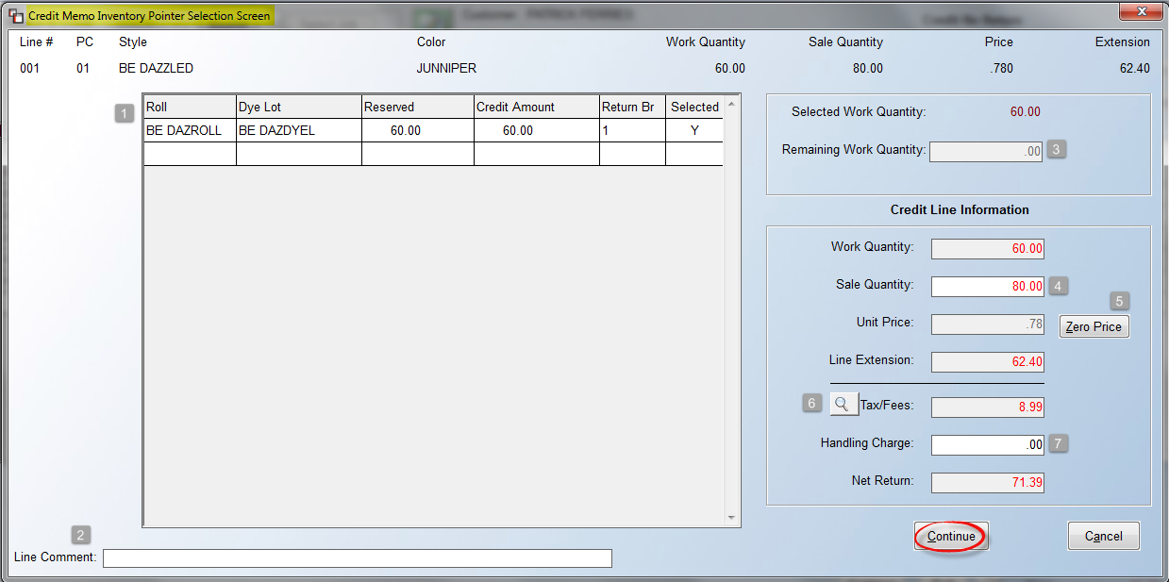

The Inventory Pointer (1) section will display all pointer records on inventory assigned/invoiced on the line. The Return Br column can be accessed to update Branch data, provided the User is allowed to change the Credit Memo return Branch. Where multiple pointer records exist, you can determine which pointer records will be impacted by the return by adjusting the Credit Amount and Selected columns. The Line Comment (2) field is used to record a comment concerning the credit/refund and will appear on the Credit Memo. The Remaining Work Quantity (3) field must be zero in order to proceed. You will receive a warning if it does not. The Sale Quantity (4) will default to the total Sale Quantity on the line, unless you made an adjustment to either the Cred W Qty or the Cred S Qty column for partial returns. This field can be changed in this screen. The Zero Price (5) button should only be used to return material to stock without creating a credit amount to return to the customer. This process will net the Credit Memo to zero and receive the material back into inventory. The magnifying glass icon (6) button will prompt a breakout of Tax/Fee data. The Handling Charge (7) field is used to charge the customer a “handling” fee or service charge for returning material where applicable. Enter the total charge in this field, not a unit price. The amount will be added as a positive line on the Credit Memo and reduce the net credit due. Click the Continue button to save the data in this screen and return to the previous screen.

On non-material lines, a Split Lines Screen will prompt as follows:

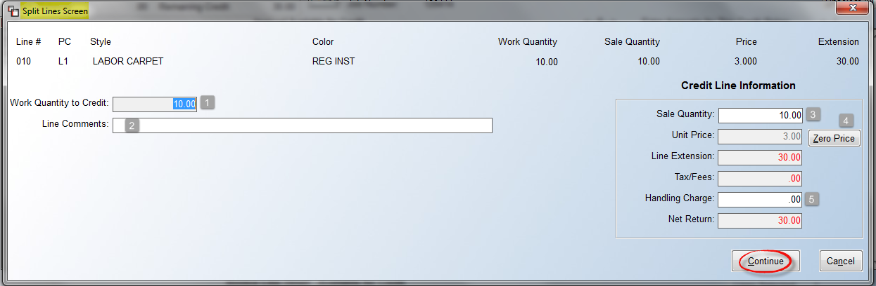

The Work Quantity to Credit (1) field will default to the total Work Quantity on the line, unless you made an adjustment to the Cred W Qty column prior to entering this screen. The Line Comments (2) field is used to record a comment concerning the credit/refund and will appear on the Credit Memo and on the Credit Report. The Sale Quantity (3) will default to the total Sale Quantity on the line, again, unless you made an adjustment to either the Cred W Qty or the Cred S Qty column for partial returns. This field can be changed in this screen. The Zero Price (4) button should only be used to create a credit amount to return to the customer. The Handling Charge (5) field is used to charge the customer a “handling” fee or service charge for the credit where applicable. Enter the total charge in this field, not a unit price. The amount will be added as a positive line on the Credit Memo and reduce the net credit due. Click the Continue button to save the data in this screen and return to the previous screen.

Once lines have been selected and any notes or comments added, you can move forward on printing the Credit Memo. At the bottom of the screen, data on what has been selected to credit will appear as follows:

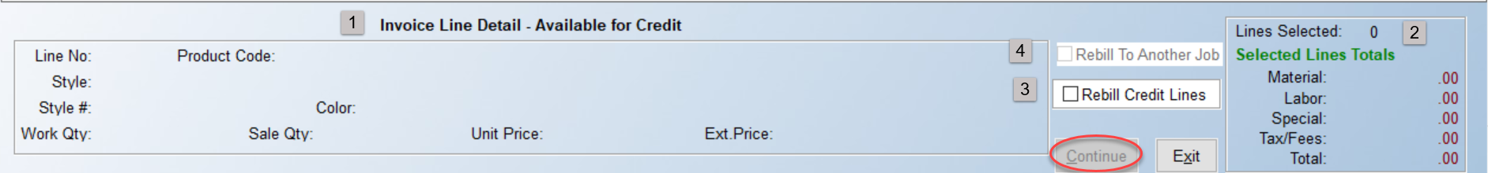

The Invoice Line Detail – Available for Credit (1) section displays details of the current line the cursor is positioned on in the screen above. The total of all lines selected will appear in the Selected Lines Total (2) section. The Rebill Credit Lines (3) option reverses an Invoice for the purpose of correcting a cost, sell, or sales tax issue. All lines are re-written and material returned, but still assigned, to allow for correcting the Invoice total, so the lines can be re-Invoiced. In cases where customers, such as Property Management companies, will only pay based on a single, perfect Invoice, this feature is a great timesaver. You can also Rebill selected Credited Lines to another Job via the Rebill To Another Job (4) option. In order to select this option, you must first select the Rebill Credit Lines option to enable and then select the new Rebill To Another Job feature. Once selected, you will continue the Credit Memo process as you normally do, but at the very end, the system will prompt a new Job containing the selected Lines using the next available Job Number.

When you are ready to print, click the Continue button. The system will prompt a Credit Memo Summary box as follows:

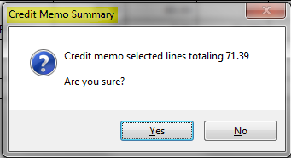

Click Yes to continue. A Print Label screen will prompt on systems with Bar-Code functionality if material is being returned. The system will then prompt the following:

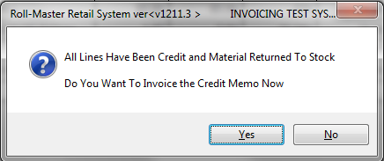

To continue the process, click Yes. The system will then prompt an Invoice Selection Screen as follows:

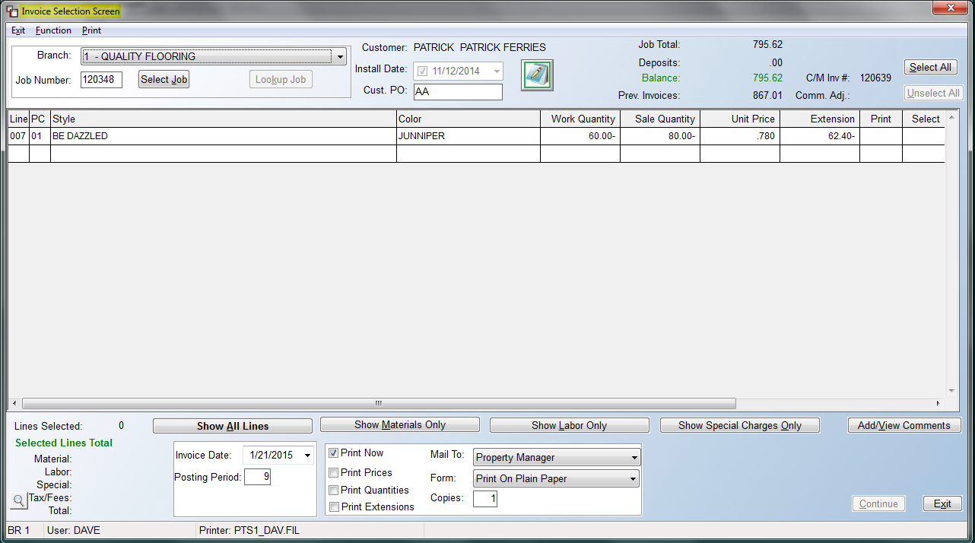

The screen above works identical to the graphical Invoicing screen. Follow the procedures for printing the Credit Memo just as you would an Invoice. Once a Credit Memo # has been generated, the system will prompt a Refund/Credit Screen as follows:

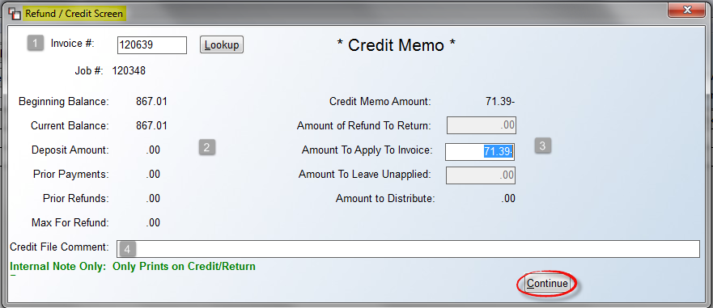

The Invoice # (1) field will prompt the original Invoice selected for credit. If you need to change Invoices, use the Lookup button—please be very sure this is what you want to do. More often than not, you will hit enter to accept the default Invoice #. The data along the left side (2) is pulling from the listed Invoice as it was created. If a Deposit or Prior Payment was made against an Invoice, that information will display in those fields. If no money has been applied to an Invoice, no money can be refunded to the customer, so in this instance, you would apply the full amount of the Credit Memo to the Invoice to clear the balance on the customer’s account. In the example above the full amount of the credit is prompting in the Amount To Apply To Invoice (3) field and you can hit enter to finalize the process. The Amount To Leave UnApplied field can be used to leave a portion of the Credit Memo unapplied for use on another Invoice, rather than process the amount as a refund. The Credit File Comment (4) field can be used to record internal notes regarding this credit. You will see this info on the Credit/Return Report.

If a customer has made a payment, you must set up the refund through the Refund/Credit Screen also, as in the example below:

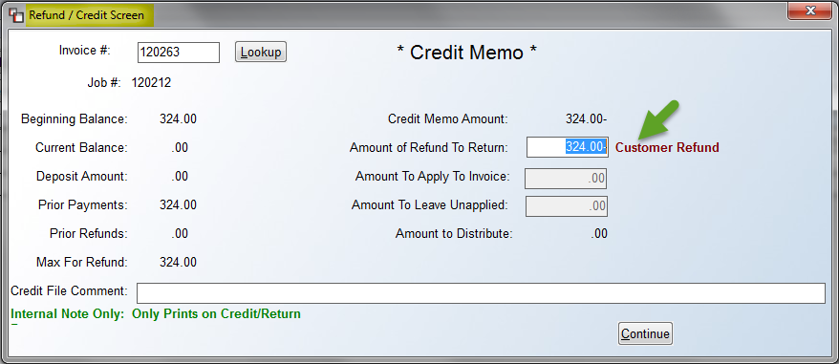

The maximum amount that can be refunded in the Amount of Refund To Return field is the amount of the deposit plus any prior payments, less any prior refunds. If there is a Current Balance on the Invoice, the difference between the Credit Memo Amount and the amount that is being refunded will appear in the Amount To Apply To Invoice field. If money needs to be refunded to the customer, as soon as you click Continue, the system will prompt the following:

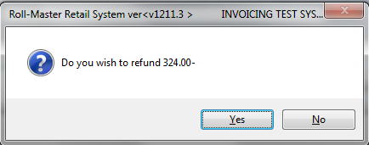
A Customer Refund box will prompt below the Refund/Credit Screen as follows:

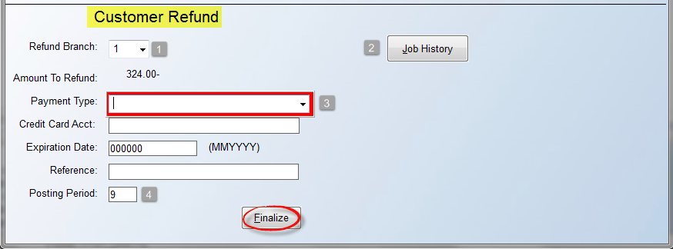

For multi-Branch operations, the Refund Branch (1) box will default to the current Branch, but you can select another Branch in which to set up the refund using the drop-down arrow. The Job History (2) button will prompt the Job Line Review screen. At the Payment Type (3) field, if a Deposit was posted on the job, the system will prompt that Payment Type that was used originally. If not, select a Payment Type using the drop-down arrow. Before clicking the Finalize button, make sure the Posting Period (4) field is correct.

When selecting a credit card or cash payment type as the Payment Type, the system will automatically update the General Ledger to reflect the money coming out of the system during this process. The transaction will also appear on the Customer Payment Register. No further processing will need to be performed. To issue a check, select the “Check” Payment Type. When Company Check is selected, a prompt will appear as follows: You chose to refund by Company Check – Are you sure? This is an additional double-check to alleviate extra work if Company Check was mistakenly selected. If you type a “Y” for yes at this prompt, the system will automatically set the customer up as a Vendor using the Customer ID on the Job and place an asterisk “*” before the ID, e.g., *COOK327, for Fred Cook. The system will also create an Open Item for that Customer, and it will appear at once on the A/P Cash Requirements Report. The item can then be selected for payment at any time. Please Note: to clear customer refund Vendors from your Vendor Listing once a check has been printed, run the Delete “*” Vendors With No Activity module accessible from the Accounts Payable menu.

Credit Memo Security/Control Features:
Security/control features have been added to the system with regard to Credit Memo Processing. These features allow you to set a number of days for which no merchandise can be returned and also allows you to flag catalog items as “Non-returnable.” There is an override control for key Users. There are two Branch Control 2 options and one User Control 6 option that need to be set up in order to use these features (explained below). During Credit Memo Processing, if the system identifies an item past the number of days to return, or an item that is flagged as “Non-Returnable,” a pop up message will prompt. If a User has permission to override, this prompt will only be a warning. Otherwise, the system will not allow the process to continue.
The following Branch Control 2 controls relate to Credit Memo processing. The first—Activate No CM if past days—if set to “Y” for yes, will allow you to enter a number of days in the next control. The Can’t CM- if past XXX days control can be set to 30 days, 120 days, etc. With these two controls set, no User will be able to process a Credit Memo for an item that is older than the number of days entered, unless you grant permission via the User Control 6 option granting override permission. The User Control 6 option to override appears in that screen as follows: Allowed To Override CM- if past xxx days. Only Users that have the authority to return/credit an item past the set number of days in should have this control set to “Y” for yes. All others should be set to “N” for no.

Set Budget- this feature was designed as a management tool to track how Job Cost changes from the time a Job is first entered in the system until the time it is completed. To use this feature, once all the order lines have been entered, click the Set Budget option from the drop-down Functions menu. The following screen will pop up:

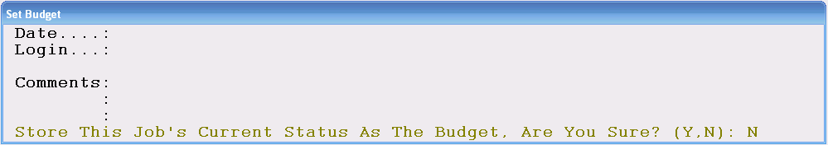

To set the budget, change the default to “Y” for yes and the system will fill in the current date along with the User’s Login ID. You can then add comments relating to the budget if applicable. At any point after the budget has been set, you can print a report to review how an order changed and how those changes impacted the bottom line profit margin. In the Job Cost Reports menu, there is a report titled Budget Vs. Actual that will compare the differences in the Job from the time the budget was set to the time the Job was invoiced. Hit the Esc key to exit this option and the system will exit the Set Budget feature

Special Charge added to Job- this option requires some setup prior to use, but it will add a percentage amount to the total Job based on existing un-invoiced lines at the time this option is enacted. There are other options for adding finance charges, overbill amounts, and overhead percentages, but this is designed to apply a Special Charge based on a percentage, such as 1% for Special Order Jobs, as an example. Please review the Company Control 4 option, P.C. for Special Charge Job Line, in the System Maintenance manual for complete details on setup.

Cost Review- if enabled in the User Control 3 menu for a User, this option will be available from the Functions menu. This feature is similar to the Cost Review option accessible from the Quotation module, but in this display, you will only see the sale and margin data for all lines totaled and averaged in each applicable section, and you will only be able to adjust the margins or total sale on the Job. When you click on this option from the Functions menu, the system will bring up the Cost Review screen as follows:

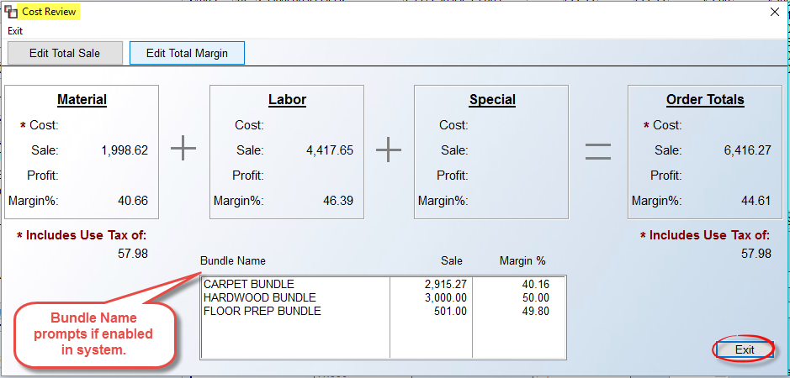

The Cost Review screen breaks out the different types of order lines—material, labor, special—and then displays the total Sale and Margin % for each type, and then combines all lines in the Order Totals box. The only options in this screen are to click either the Edit Total Sale and Edit Total Margin buttons, or click the Exit button. The Edit Total Margin button will allow you to enter the total margin for the entire Job (including Material, Labor, and Special Charges), and the system will then recalculate the Material, Labor, and Special Charge totals based on this margin. The Edit Total Sale button will allow you to enter the total sale for the entire Job, and the system will first recalculate the margin based on the total sale, and then recalculate the Material, Labor and Special Charge totals for display purposes. If any changes are made to the Total Margin or Total Sale, the system will recalculate all the lines on the Job accordingly, once you click the Exit button. If enabled, you will also see a total Sale and Margin % by Bundle Name at the bottom of the screen. If you right-click on a Bundle Name line, you will see two options as follows: Edit Total Sale and Edit Total Margin. Once a change is made, you will see it reflected immediately in the box above.

One additional option for this feature is the ability to exclude the Sale Qty of a Labor or Special Charge Line Item from the recalculation of Total Sales on the Job or Quote. A use case for this is a Warranty on Installation, where you don’t want the Sale Qty Price of what you are selling to change from what was originally entered. This does not apply to adjusting the cost or margin. The setup takes place in Product Code Maintenance on Product Codes with a Factor ID of 09 or 10. You will see a checkbox at the bottom right of that screen as follows:

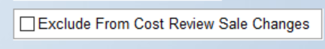

Read Quote- the easiest and quickest way to convert a new Quote to a Job is to do so through the Quotation Proposal / Maintenance module (explained below). However, you can convert an existing Quote into a Job from this feature, after first opening a new Job. You will need to make a Customer selection before accessing this option. Once selected, click on the Functions option to access the Read Quote option. When you click on this option, the system will prompt the following:

If you know the Quote number, type it in the field above. If not, you can look up the Quote by hitting the F1 key to perform a Quote Look-Up. When you hit the F1 key, the system will prompt you for the Customer ID entered in the Quote. If you do not recall the ID, you can hit enter at this prompt and a Quote Look-Up screen will appear as follows (you can type the first couple of letters of the ID before hitting enter to get closer to the desired name):

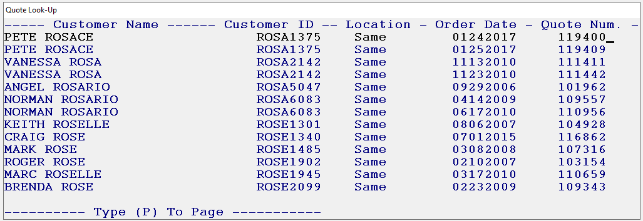

From this list, you can arrow down to select the Quote you want or type a “P” to page down the list. Please note: The Quote must be open in the system in order for this process to work, otherwise you will receive a message stating the Quote is closed and to select another. If the closed Quote is the one you would like to read into an Order, you will need to exit the current process and open the Quote via the Open Quotes Closed in Error module located in the Management Functions menu. When the desired Quote is highlighted, hit enter and the system will prompt the following:

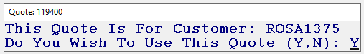

Hit enter to proceed, and the data from the Quote will instantly read into all the applicable fields in the Order Entry screen. This process will automatically close the Quote in the Quotation module

Scheduler Export- this feature will only work for those clients currently using the RollMaster Scheduling software. When you click this option, the system will automatically send the Customer’s contact information to the scheduler system, such as name, addresses, and phone numbers.

Shipping Interface- add on feature.

Work Order/Pick Ticket
In the RollMaster System, the Work Order is a printed document that serves to communicate material and labor information to the warehouse personnel and to the Installers, and it also updates valuable inventory information. This module has been designed to give the User lots of flexibility when using this function. For instance, you can print several customized Work Orders for the same Job if different installers are doing the work, or you can ship partial quantities on Work Orders for multi-phase Jobs. Important Note: The following explanation is for systems where the Inventory Cut Sheet feature is not being used.

When you click on this option, a Work Order Maintenance screen will prompt as follows:

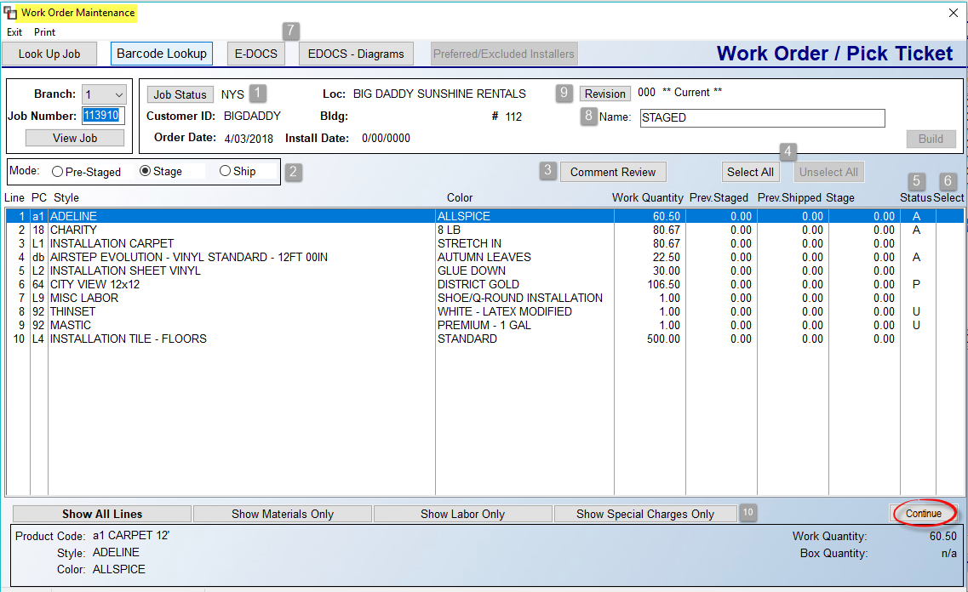

In this first section, we will cover the basics of this program, and further down in the documentation, we will get into more advanced processes, such as creating multi-stage Work Orders and Revisions. All the lines on the Job will appear in the screen above, regardless of line Status (5). To print a copy of the Work Order with all lines as they appear in the screen above, prior to selecting any lines, click Continue. The system will prompt the following: No Lines Selected. Do You Want to Print Work Order Only? Click Yes. A Pick Ticket Print Preview screen will prompt. Click the Print Now button to continue.

Screen Explanation:
The Job Status (1) field on the Job can be updated from this screen--you will be prompted to Save any changes. The Mode (2) box will default to Stage. This means you are getting the job ready, or in the pre-shipping stage. This Mode is used prior to material leaving the warehouse and allows for printing the Work Order document without shipping material. The Ship Mode will update inventory as having been cut and gone from the warehouse. The Pre-Staged mode, essentially a Pick Ticket, allows you to print material lines on the Work Order without assigning material. This is used for “job grouping” material in the warehouse, and can be used in conjunction with the Wireless Handheld Barcode scanner to instantly assign.

The Comment Review (3) button will prompt the Order Entry Comment Review Screen and works exactly the same when accessed from this screen. The Select All and Unselect All (4) buttons can be used to instantly select or unselect all lines. The Status (5) column keeps track of the current status of material lines. An “A” means Assigned, a “U” means Unassigned, a “P” means a Purchase Order is tied to that line, a “W” means the line has been shipped on a Work Order, an “M” means material is coming from multiple sources, such as inventory and Purchase Order, an “I” means the line is Invoiced, and a “C” means the material has been Cut, for those using the Cut Sheet functionality. The Select (6) column will display a “Y” for lines selected to Print on the Work Order. You also have access to the E-DOCS (7) functionality from this screen as well as in the Comment Review screen. The Name (8) field can be used to create distinct names for each Work Order, especially where you will be using Multi-Stage Work Order processing. The Revision (9) button (used more for multi-stage jobs) will prompt a list of each Work Order created, allowing you to update and print a Staged Work Order when that material and labor are ready to be shipped out of the warehouse, or for re-printing a Work Order. If you will only print a single Work Order, it is not necessary to create a unique name. You can also rename completed Work Orders that have not been cancelled or closed or where any lines have not been partially shipped.

Additional features can be accessed by right-clicking on each line. The options will vary based on the Status of a line and for the type of line. The following options are available in the Stage Mode for Assigned material lines:

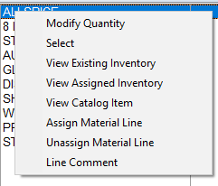

When shipped, you will see the option to Return to Stock. If a material line in Stage Mode is Unassigned, the same options will prompt, but the Modify Quantity and Select options will not be available. Labor Lines in the Stage Mode will display the following options:

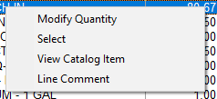

When in Ship Mode, you will see an option to Assign Installer. One additional feature to point out in the main screen is the buttons (10) along the bottom of the screen. On Jobs with multiple lines, you can click through each to narrow the view to Show Material Only, Show Labor Only, or Show Special Charges Only.

If you will be printing a single Work Order for a Job, once each material line shows an “A” Status, switch the Mode option to Ship status. The system will then prompt a Ship Selection Screen as follows:

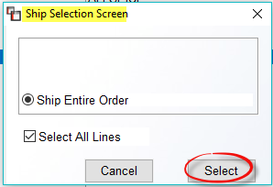

If all lines are shipping, leave the Select All Lines box checked and then click Select. The system will auto-select the lines and you can then click Continue. The system will then prompt a Work Order Print Preview Screen as follows:

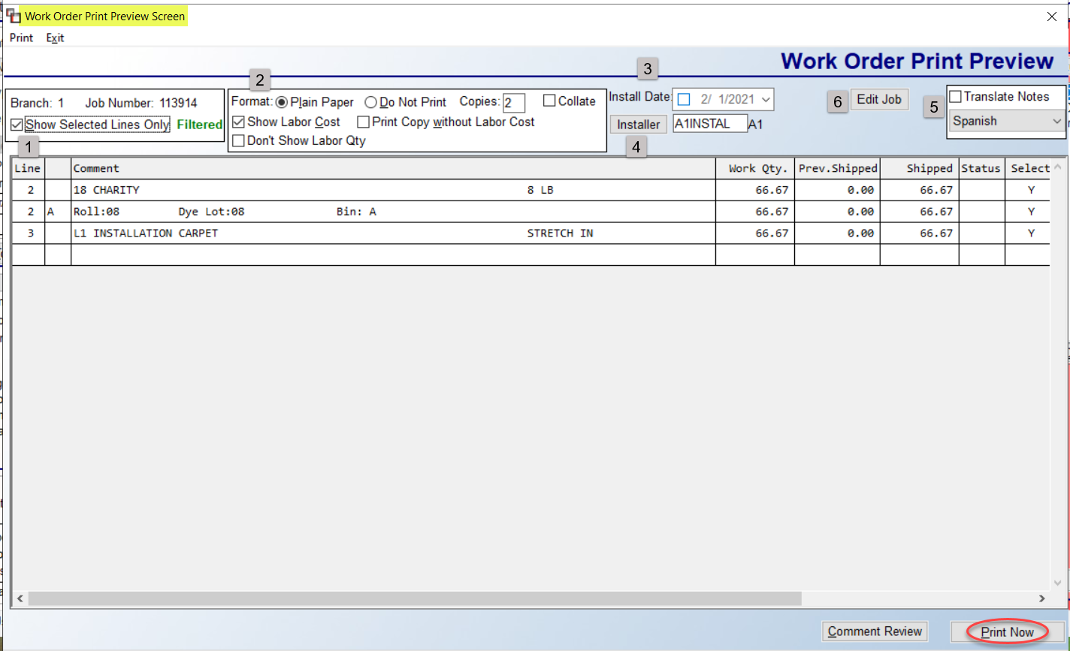

If everything is good to print, unless you want/need to update the Install Date (3) and add/change the Installer (4), you can click the Print Now button to print the Work Order. The Show Selected Lines Only (1) option will be checked by default. The Format (2) box will default to Plain Paper and you can adjust the number of Copies. If you have previously printed Staged Work Orders and simply wish to update material and labor as having left the warehouse, you can click the Do Not Print option so the system updates without generating a hard copy of the report. The Show Labor Cost option will be checked by default, but can be unchecked to not show Labor Cost. The Print Copy without Labor Cost is another option to leave off Labor Costs. And the Don’t Show Labor Qty, when checked, will encrypt the Labor Qty on the printed doc. The Translate Notes (5) feature, when checked, will copy existing Work Order Comment Lines, Customer Address Notes, and Installer Work Order Instruction Sheet data and print in both English and the language selected in the drop-down menu on the printed document. This feature also appears on all Print options of the graphical Work Order as well as the Graphical Batch Work Order Processing option. The Edit Job (6) button will prompt the current Job.

When ready, click the Print Now button to print the Work Order and ship the material. Upon printing, the system will prompt a Revision Created box showing the Revision number. Click OK to continue. The printed Graphical Work Order will look much like the following (with your company logo at top):

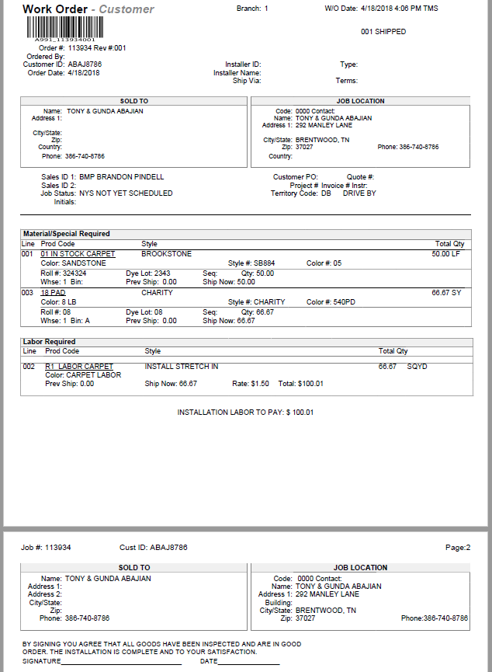

If there is an issue with the Work Order after printing, back in the main Work Order Maintenance screen, click the Revision button to prompt a list of Work Order Revisions as follows:
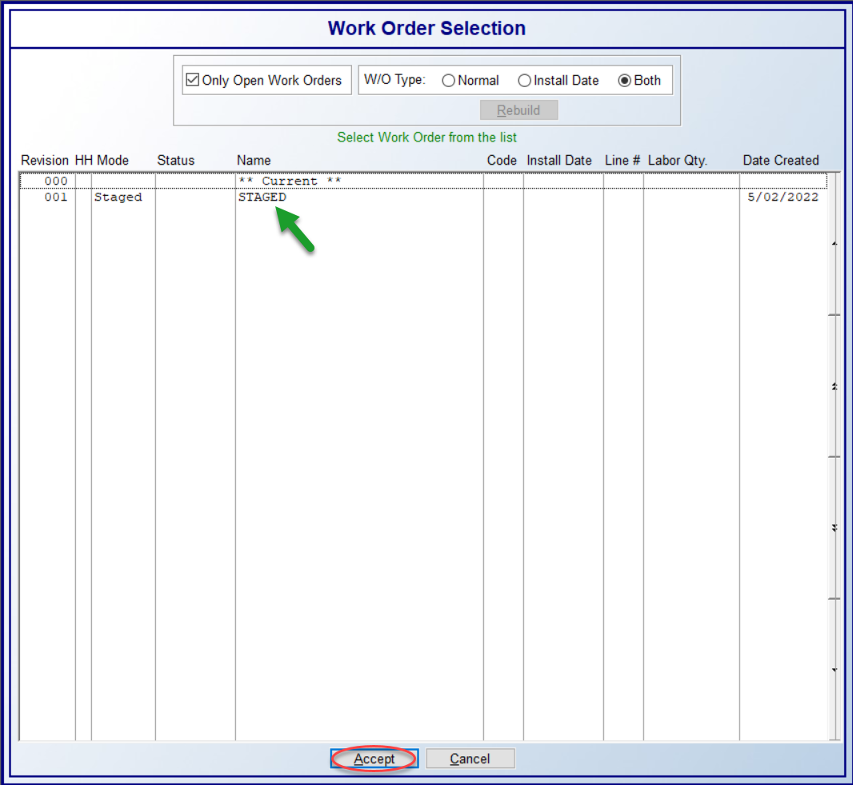
This box also pops up immediately after printing the Work Order. The Only Open Work Orders option will be checked by default. Because you can cancel a Work Order and create multiple Staged and Shipped Work Orders, the system saves all versions and you can uncheck that box to view closed Work Orders. In the W/O Type box, the default is Both. Work Orders created via the Multi-Install functionality (explained below) will be considered Install Date Work Orders. All others are considered Normal. This screen functions as a history for previously shipped, staged, cancelled staged, and cancelled shipment Work Orders for each Job. You can pull up any previous Work Order at any time.

To access a Work Order from this screen, click on the Work Order then click Accept. For Shipped Works Orders, the system will pull up the Work Order in the main screen and display a Cancel All button next to the Mode box, along with a Select All Lines checkbox as follows:

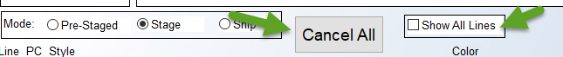

If you click the Cancel All button, the system will reset all lines so you can ship again, but the Revision will exist as a Cancelled / Closed Work Order. Please Note: this should only happen on Shipped Work Orders that need to be re-printed, but where material does not need to be returned to stock. That step will be covered in the next section. The Show All Lines checkbox allows for displaying all lines from the Job, even if they weren’t Staged or Shipped on the Work Order selected.

In both the Stage and Ship Mode, the printed documents are tied to the Terms & Disclaimer Document Maintenance module. This means you can add applicable documents to print for either mode, or print the same for both, or neither. Additionally,
when creating a Staged or Shipped Revision from a *Current W/O, you can Select and Modify quantities of both Unassigned and Purchased Inventory. You will see an “*” instead of a “Y” when selected and the document will print just like the Pre-Staged document, displaying the following: Unassigned Inventory. Additional selection displays will appear as follows: “N” for Not in Branch – Need to transfer; and if not transferred, a “P” will allow staging/shipping and display Item in Transit. The following is an example:

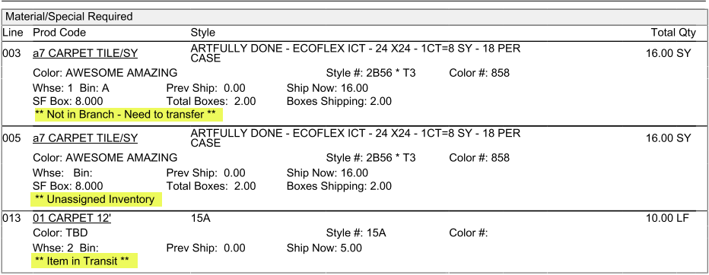

Return To Stock / Irregular Returns:
Once you have material items that have been shipped on a Work Order, you can return those items back to stock, just as you can in the text program. Very Important: Returns must be processed from the Work Order they were shipped out on. Also, Shipped materials must be returned PRIOR to being Unassigned with the Graphical Version.

Returns only applies to items that need to be returned to the warehouse and have been cut and some or all quantities are being returned for later re-selection. To initiate the process, use the Revision button to prompt the Work Order Selection screen and select the applicable Work Order. You will then right-click on the line of an item being returned to prompt the Return to Stock option. The system will prompt a Return Material Screen as follows:

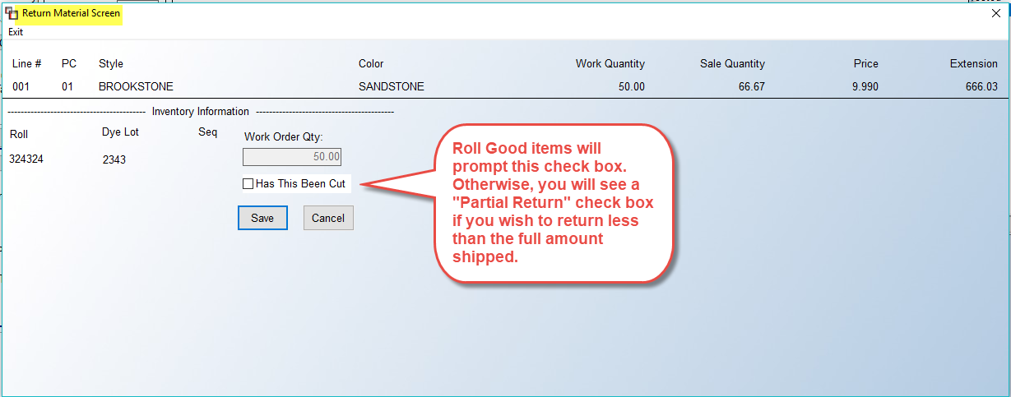

On non-Roll items, if the Partial Return box is checked, a Return Amount field will prompt as follows:
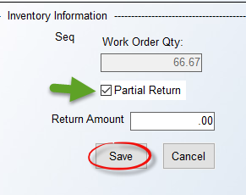
Enter the amount to put back into inventory and then click Save. You can then re-select on another Work Order, or Unassign from the Job and place back in stock.

On Roll items, the system will prompt a Has This Been Cut check box. If the entire amount in the Work Order Qty box is coming back, you can just click Save. However, when checked, you have the option to return each applicable cut, or process an Irregular Return. The system will prompt a Return Material box as follows:

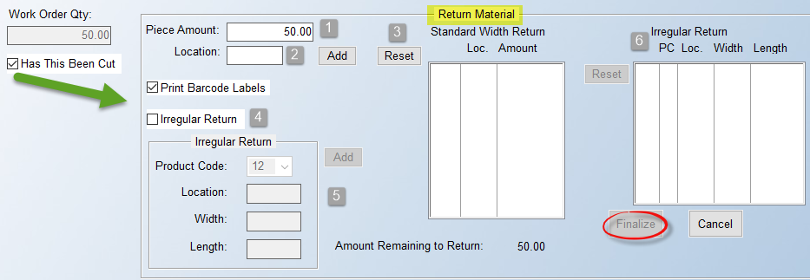

In the Piece Amount (1) field, type in the first cut amount being returned, along with the Location (2) (required field) in the warehouse, and click Add. That piece will prompt in the Standard Width Return box, and the Amount Remaining to Return will update accordingly. Type in the next cut, and so forth. If you need to re-enter the data, click the Reset (3) button to clear the existing cuts. When all cuts are entered, click the Finalize button to return to inventory. For Irregular Returns (4), click that check box. In the box (5) below, select the Product Code for the Irregular Return, and enter the Location, Width, and Length, followed by the Add button. You will then see the item(s) prompt in the Irregular Return (6) list box. Use the Reset button next to that box to clear the contents and start again if needed. When complete, click the Finalize button to move the item(s) to inventory. When you hit the Finalize button, the system will prompt a Finalize Return box with a summary of what you entered as follows:
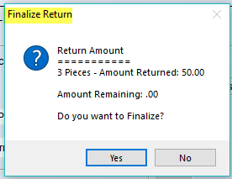

You will need to click Yes to save your changes. If you click No, the system will return you to the Return Material screen. Please Note: When a new inventory item is created from this process, the system will write a line to the Memo field on the inventory record with the Branch ID, W/O #, Job #, and Job Line #.

Multi-Stage Work Orders:
This section covers how the new graphical Work Order works in conjunction with the scheduling of Multi-Install Dates in Order Entry. All of the setup must be complete for scheduling Multi-Install Dates prior to using the Multi-Stage Work Order functionality. The process starts with the scheduling of multiple installation dates in Order Entry. Please refer to the documentation on Multi-Install Dates for details, as this section strictly covers the Graphical Work Order Multi-Stage process. As each Install Date is scheduled, the system will generate a “Stage Mode” Work Order accessible from the Revisions button/screen. It will look much like the following:

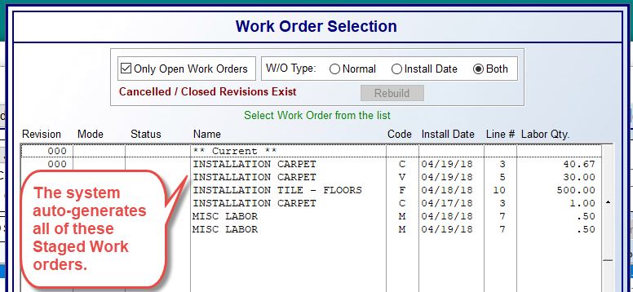

You can then select each Revision and Modify and Ship all or some lines as needed, making any needed changes based on the way the graphical Work Order functions, as explained above. You can pull up each Revision and re-name as you see fit. When you create a new Shipped Work Order Revision, the Pre-Staged Version above will auto-close, but can be called back up at any time by un-checking the Only Open Work Orders check box.

Please Note: If the Company Control 1 option in the System Control Maintenance module, W/O Print – Show Installer Pay?, is set to “Y” for yes, a check box for Show Labor Cost will display with the default setting as checked, and another check box will appear next to that one as follows: Print Copy without Labor Cost. If both options are checked, the print program will create two copies: one with Labor Cost and one without. Additionally, if the Show Labor Cost box is unchecked, the second Print Copy option will disappear. And finally, when utilizing the Re-Print option, the system will not display the Print Copy without Labor Cost check box, even if the Company Control 1 option mentioned above is set to “Y.”

Additional Features tied to other areas of the system:
With regard to shipping Private Labeled material on the graphical Work Order, if the Company Control 2 option in the System Control Maintenance module, Use Private Labeling by Customer, is set to “Y” for yes and a Private Label item appears on the Work Order, the printed document will display “-customer” instead of “-warehouse” at the Header level. See below:

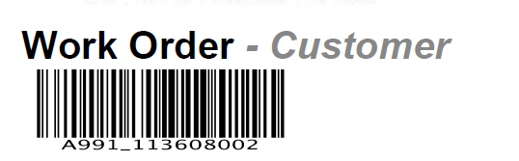

Additionally, in systems where Multi-bin functionality is enabled, an update was made to display the locations of inventory on the printed document when the inventory has not been assigned. Also, you can print Cut Tags (Barcode) from a Staged Work Order for each line. You will right-click to get to the Assigned Inventory screen, and then right-click on the Inventory to access the following option: Print Cut Tag (Barcode).

Invoice:
Invoicing in the RollMaster System is an accounting function, which means that it sends all the financial information such as revenue, receivables, cost of goods, etc., to the General Ledger. This should be the last step in the Order Entry process once the Job has been installed, or in the case of cash & carry businesses, after the customer has possession of the material. The following accounting data takes place during this process:

Crediting Revenue / Crediting Sales Tax Payable / Debiting Customer Deposits if one was taken / Debiting Accounts Receivable if there is a balance due / Debiting Cost of Goods Sold if applicable* / Crediting Inventory if applicable* / Creating Salesperson Commission information / Updating Sales Analysis

*These functions will depend on how your product codes are set up. See Product Code Maintenance for more detail.

Prior to invoicing, the Salesperson can print a Sales Agreement or Customer Receipt for the Customer to sign that can act as a contract. Also, prior to invoicing, it is important to look at the following information in the Job Totals box of the Order Entry screen. Compare the “Job Total” field with the “Deposit(s)” field. If the Job has been paid in full and those two fields do not match to the penny, you need to understand why before invoicing. It is much easier to correct before invoicing than once the Job is invoiced and closed and it becomes the A/R department’s issue. If a Customer has a balance due that will be tracked through the Accounts Receivable department, then continue with the invoicing process and the system will create a receivable for the customer.

Jobs that are estimated and quoted to the Customer outside of the system (not recommended) can usually result in small discrepancies between the total on the Job and what the Customer is expecting to pay. In this instance, an adjustment will need to be made in the Line Items screen so the system will match what the Customer is expecting to pay. To make these adjustments, check with the accounting department about setting up a Special Charge catalog item titled “Contract Adjustment” in which you can add or subtract from the job total to make it match the Deposit field to the penny. Also, the system will not allow invoicing of any material lines that do not have inventory assigned; in fact, they will not even appear in the invoicing screen. You should always double-check that all material for a Job has been received in the system before you invoice a Job, however, the system will allow you to create Partial Invoices and even Partial Line Invoices, which means that you can invoice some of the lines on a Job or even part of a line, provided partial inventory is assigned. Additional Invoices on remaining balances and other line items can be generated later, as in the case of multi-phase jobs.

You can invoice from two places in the RollMaster System—from the Functions drop-down menu within a Job, or through the Invoice/Credit Memo report module accessible from the Sales Processing Reports Menu 1 of 2. To invoice from within a Job, click on the Invoice option in the drop-down Functions menu. A Select Printer box will prompt in the event you need to change to a different printer. Make your selection to continue. The system will pull up an Invoice Selection Screen as follows:

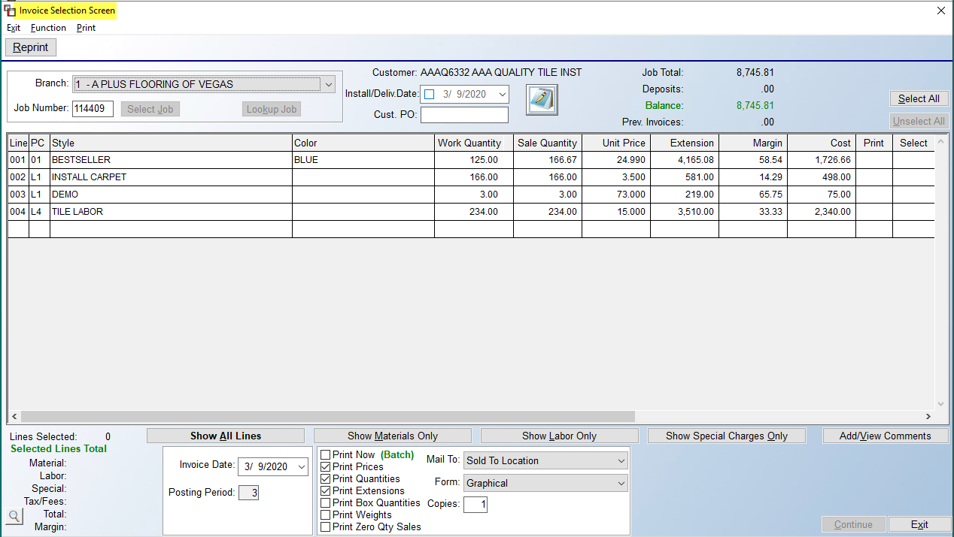
When you access this program from within a Job, that Job’s data will automatically prompt in the screen as follows (and as in the screen above):

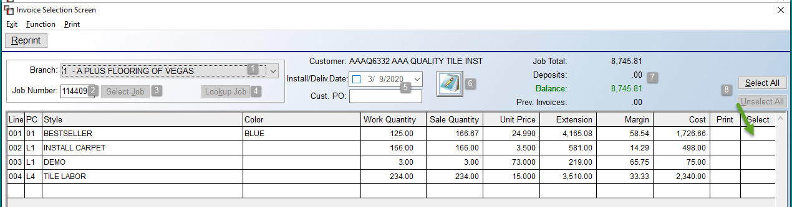

If you access the Invoice program from the Invoice/Credit Memo module, you will need to type a Job Number (2) and then click the Select Job (3) button. The Branch (1) field will default to the current Branch. For multi-Branch operations, when using the Select Job option to locate a Job to invoice, if the Branch changes, you will see a prompt notifying you of the Branch change. The system also checks that the User ID and controls set up for the Branch selected are enabled. The display at the bottom will prompt the new Branch. When the Invoice process is complete, another message will prompt asking if you wish to return to the Login Branch, or original Branch.

You can also use the drop-down arrow in the Branch (1) field to select another Branch where applicable. Additionally, you can click the Lookup Job (4) button to prompt the RollMaster Software Sales Processing screen to make your selection. The Customer, Install Date, and Cust. PO (5) fields all pull from the Job and are display only. The Notes icon (6) is for Customer Address Notes and those can be viewed and updated from this program. The Job Total, Deposits, Balance, and Prev. Invoices (7) fields pull directly from the Balances section on the Job. The Select All and Unselect All (8) buttons can be used to instantly select or unselect all lines in the display screen below. You can use these buttons, or click in the Select column of any line to change the status of that line. Please Note: The Unit Price and Margin columns, in the screen shot below, will only display values where the User can see cost. When a line is selected, a “Y” will appear in both the Print and Select columns as follows:
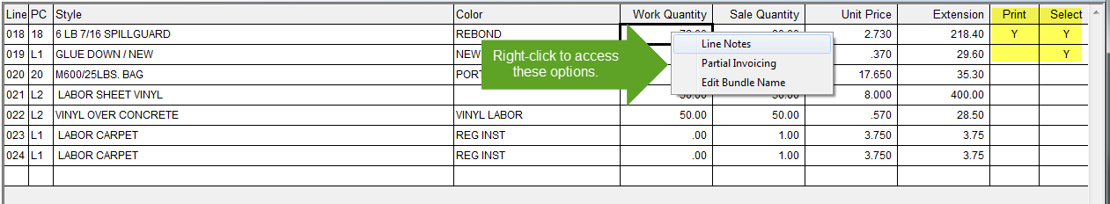
You can click in the Print column to remove the “Y” to not print that line on the Invoice. If you click in the Select column of a line, it will change the current status of the line. You can also right-click on any line to prompt the following three options: Line Notes, Partial Invoicing, and Edit Bundle Name. The Line Notes option will prompt the Order Entry Line Comments Screen. Any Line Comments added from Quote or Order Entry will prompt automatically and you can add/edit/delete or use any of the available features in that screen as needed. The Partial Invoicing option will prompt an Inventory Pointer Selection Screen as follows:

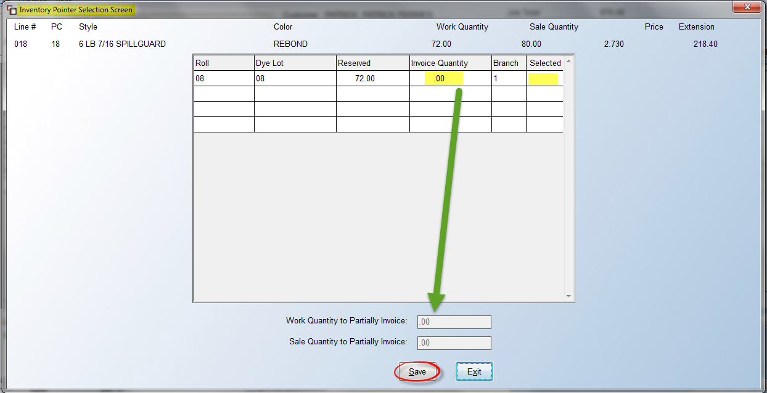
If multiple Pointer Records make up the Work Quantity, you can click in the Selected column of each record to select the entire Pointer Record, or you can click in the Invoice Quantity column of any Pointer Record and enter a quantity to partially invoice. You can make adjustments to both the Work and Sale Quantity fields, which allows for mis-matched Work/Sale Quantity relationships. However, the system will not allow splitting off more than the original line. Additionally, a full stop was added once the full Work Quantity is selected to prevent any issues with a negative Sale Quantity from occurring. Please Note: This program does allow partial invoicing of material that is partially assigned to a line. Click the Save button to keep your changes.

The Edit Bundle Name option will prompt a Customer Bundle screen as follows:

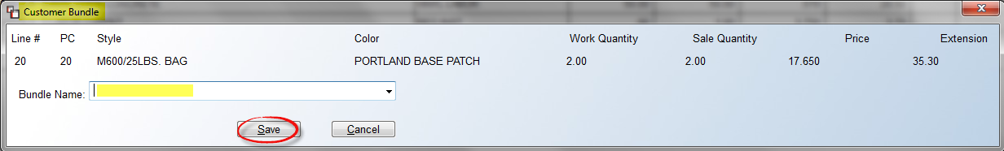

As a reminder, Bundling is activated in the Branch Control 1 screen, and then appears in the Quote or Order when bundles are set up in the Add or Change a Line Item screen. If you are using the Bundling feature, the Bundle Names can be viewed, changed, or added from this screen. Also, where Bundled Lines have been set up, if a line in the Bundle is unchecked so as not to print, if either Summary or Detail are selected for the Bundle, the value of the unchecked line will still be included in the Bundle Total. If you choose to show “Full Detail,” this change will not apply. This allows for Contract Adjustment lines to be added but not displayed.

Prior to selecting lines, you can use the buttons along the bottom of the line display screen to alter what you are viewing. Those appear as follows:

The Show All Lines button will default, but you can click the Show Materials Only, Show Labor Only, and Show Special Charges Only buttons to see only those lines on a Job. This may become more useful when invoicing several lines. The Add/View Comments button to the far right will prompt a Print Invoice Comment Lines screen as follows:

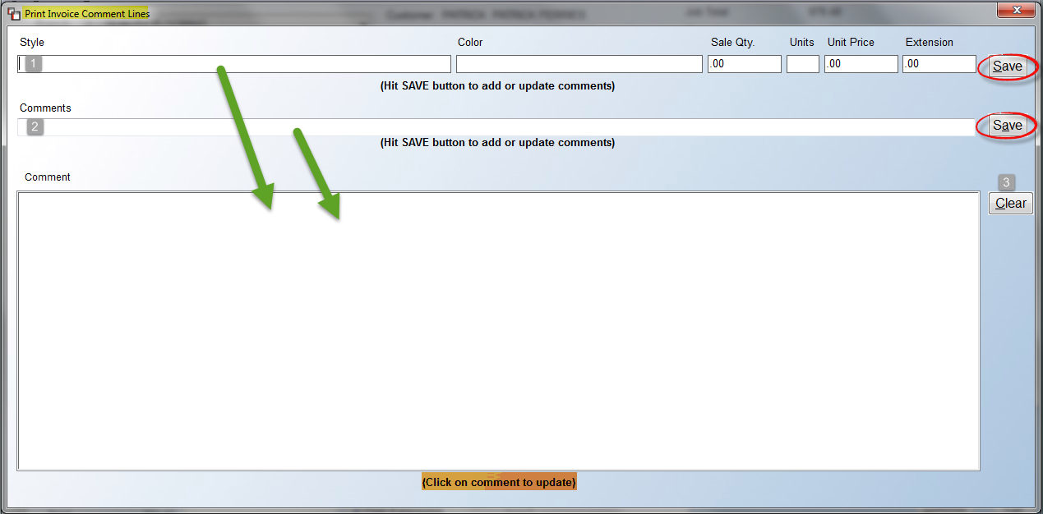

If you opt to not Print any lines, and you wish to add freehand text instead, this screen will allow you to create a Style (1) related comment and/or standard (2) Comments. Once you create a Comment Line, click the Save button to the right of that line to keep and send to the Comment section below. Once you begin creating Comment Lines, if you click the Clear (3) button, all the Comment Lines will be wiped out and you can start again. You can also edit a Comment Line by clicking on it in the Comment section. It will appear back at the top of the screen for you to make changes. You will need to click the Save button again to keep your edits.

Once lines have been selected and any Notes or Comment Lines added, you can use additional options that appear at the bottom of the screen to further customize the Invoice as follows:

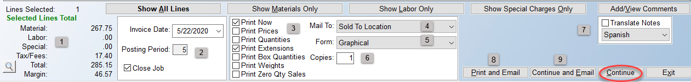

The total of any lines selected will appear in the Selected Lines Total (1) section displaying Material, Labor, and Special totals individually, and then Tax/Fees, Total and Margin for all lines selected. You can click on the magnifying glass icon to view separate Tax and Fees totals, where applicable. The Invoice Date and Posting Period (2) fields will default to current day and period. You can override the Invoice Date, if applicable. The Close Job checkbox will default to checked. If you uncheck, the system will leave the Job open after Invoicing is complete. When lines have been selected to Print on the Invoice, you can further customize the appearance of the lines by unchecking/checking one or more of the Print (3) options. As a reminder, these Print options can be set up as defaults for the entire company, and for individual Customers or Ship To Addresses, as explained at the very beginning of this document. If the Print Now box is unselected, you will see a (Batch) designation to the right of that field. This indicates the Invoice will not print until the Invoice Batch Printing process, accessible from the Function menu within this program, is run. Please see separate Batch Invoicing documentation for additional information on printing multiple Invoices at once.

The Mail To (4) field defaults to what has been set up on the Customer’s account. You can override, if applicable. The Form (5) field defaults to what is in your System setup, as does the Copies (6) field, but both can be overridden, if applicable. Additionally, if Print Preference is Active on the Customer’s Ship To Code, the selection will display in this screen in green text next to the Copies field at the bottom as follows:

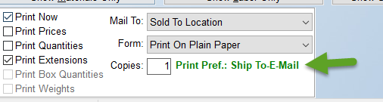

The Translate Notes (7) box for Multilingual Documents will appear if the Company Control 4 option, Allow Multilingual Translation, is enabled. If so, you can select a language from the drop-down box to translate Notes and Special Instructions, Line Comments, and Comments added from this print screen. If Emailing from RollMaster has been setup, you will see two options as follows: Print and Email (8) and Continue and Email (9). The first option will both Print and Email the Invoice. The second option will only Email the Invoice. (Complete documentation and videos can be found in your Help Desk on Emailing from RollMaster. Please contact support@rmaster.com if you need further assistance.)

Once all applicable selections have been made, to Print the Invoice, click Continue to proceed. An Invoice Summary box will display prior to finalizing with a recap of the Invoice amount, date, posting period, print status, and job status as follows:

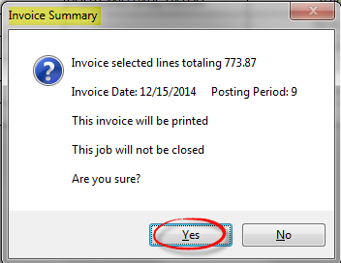

If a Job has remaining lines to invoice or a deposit balance, the summary box will let you know that the Job will not be closed. If everything looks good in the box above, click the Yes button to proceed. Otherwise, click No to make any needed changes. If you click Yes, the system will prompt the following:

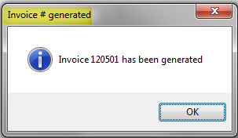

Click the OK button to continue. The system will then prompt the Select Printer box. Make your selection and the Invoice will print.

At the top left of the Invoice Selection Screen, you will see a Function menu. When you click that menu, you will see two options as follows:

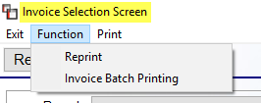

The Reprint option works the same as Reprint button, located just below the Exit option, and will prompt the same functionality. The Reprint option or button will prompt a Reprint Invoice Screen as follows:

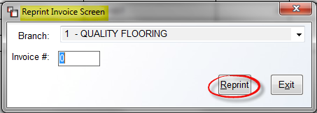

Type the Invoice #, making sure you are in the correct Branch, and click the Reprint button to proceed. A Reprint Options Screen will appear as follows:

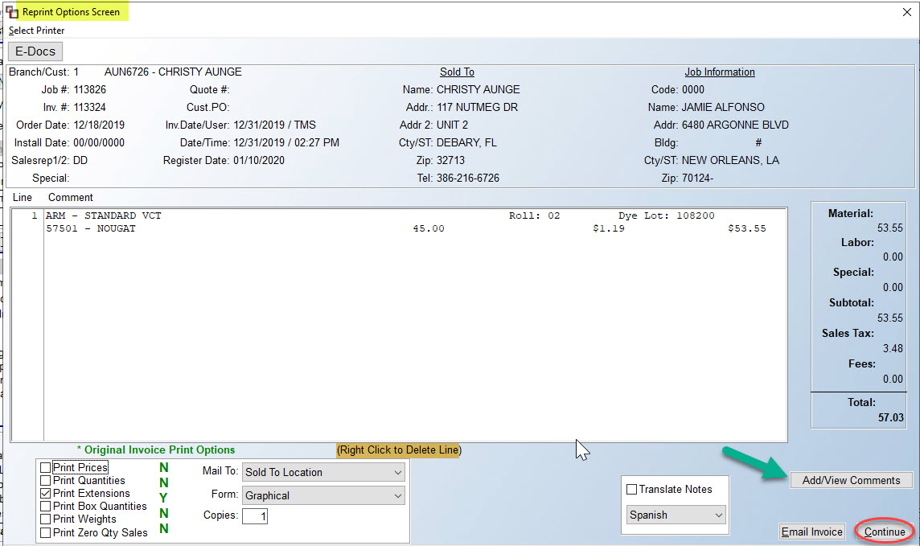

The only functionality in this screen, aside from accessing E-Docs or clicking Continue to reprint the Invoice, is to Right Click to Delete Line from the reprint, and/or click the Add/View Comments button to view or add comments to the Invoice prior to the reprint.

One additional feature in this program is the ability to add customer percentage terms by Branch to graphical Invoices. The “Pay Terms” feature prints a potential finance charge amount to be assessed for late payments and shows what the Invoice total will be for future dates if not paid. It is similar to the A/R Service Charge, but this feature doesn’t get posted to the Customer’s A/R balance, nor does it post to the system General Ledger. It also applies to all Customers and Invoices printed across the board. To complete this setup, you will need to access the Branch Control 1 level of the System Control Maintenance module to add terms data for each Branch. The Pay Terms appear as follows on the graphical Invoice:

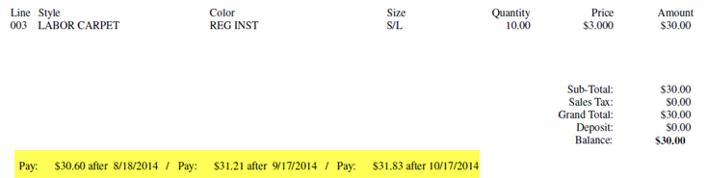

Invoice Batch Printing:
During the invoicing process, in order to set up Batch Invoicing, if the default has not been set, you need to make sure the Print Now box at the bottom of the Invoice Selection Screen is unchecked, prior to clicking the Continue button. When you uncheck that box, the system will display (Batch) to the right of the Print Now display as follows:
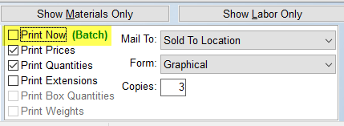
Now, when you click the Continue button, an Invoice Summary box will display prior to finalizing as follows:
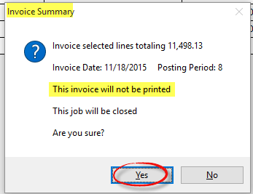

For Batch Invoices, this box will alert you of two things: This invoice will not be printed and This job will be closed. The system is placing the Invoice in a queue for printing in preparation for Invoice Batch Printing, explained below.

When you have finished creating all Batch Invoices, to start printing those Invoices, select the Invoice Batch Printing option from the Function menu at the top left of the Invoice Selection Screen. The system will prompt an Invoice Batch Printing screen as follows (click the Build button to display Batch Invoices in the screen below):

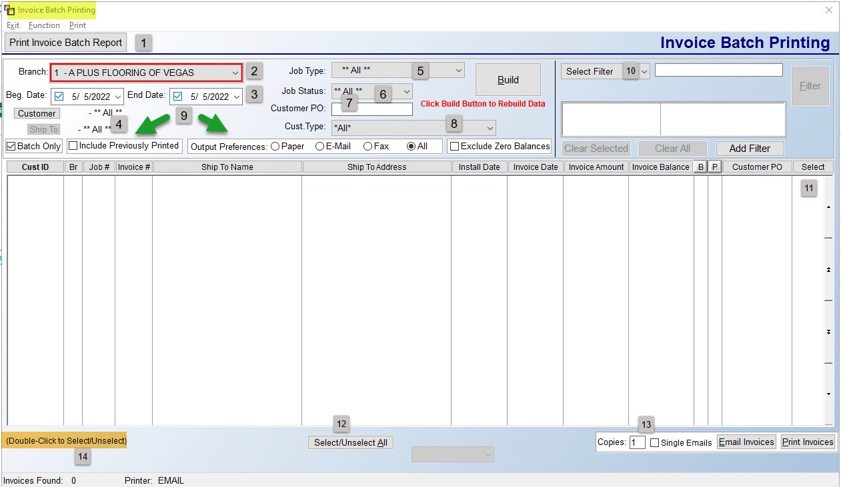

At the top left of the screen are three menu options that appear as follows: Exit, Function, and Print. The Exit option will return you to the previous screen. The Functions menu contains one option as follows: Change Print Parameters. When you click this option, the system will prompt a Print Parameters box as follows:

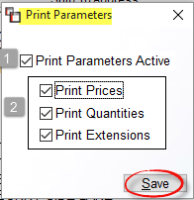

These parameters can be changed and saved for a Batch Invoice Printing run. For example, if you wish to print all Customer XYZ Invoices for the past year and you want them to look the same, regardless of any system default Print Preference settings, you can use this option. If the Print Parameters Active (1) box is checked, then the system will prompt the three Print options in the box below. In the Print (2) options box, check all that should apply to this Batch Invoice Printing. If any changes are made, click the Save button to keep these parameters selected. If Print Parameters are activated, you will see the following display at the bottom of the screen: Special Print Parameters Being Used. The Print option will give you access to the Select Printer box to make a printer change.

Moving on to the main screen, the Print Invoice Batch Report (1) button will print a list of the Invoices you see in the main display area of the Invoice Batch Printing screen. At the Branch (2) field, you can select ALL Branches or leave the current Branch. Any change to the options in this section will require you to click the Build button to update the display screen with new Invoices matching the new criteria. The Beg. Date and End Date (3) fields will default to the current date, but you can select a range of dates or a prior date to view Batch Invoices. The Customer and Ship To (4) buttons will allow you to select and see Batch Invoices for a specific Customer and/or Ship To Code. You can further customize the Batch Invoice display screen by selecting a specific Job Type (5), Job Status (6), or Customer Type (8) by using the drop-down arrow in each of those fields to make a selection. The Customer PO (8) field was primarily added so that if multiple Invoices are tied to one Customer PO, all those can be displayed together for Reprint purposes, but it can also be used to Batch Invoice for a specific Customer PO.

In the next series of fields (9), a few additional options are available. The Batch Only box will automatically be selected when you enter this screen. If you uncheck that box, and check the Include Previously Printed box and then click the Build button, the system will display any Invoice for the date range and other sort criteria selected. In the display section, you will note a “B” and a “P” column. The “B” denotes Batch, and the “P” denotes regular Print Invoice. The Output Preference can be changed as needed. The Exclude Zero Invoices option, when checked, will remove zero balance invoices from the display screen. The Select Filter (10) option works much the same as in the Quote and Order Entry modules. It is one additional method for sorting the Invoices that appear in the display screen in preparation for Batch Invoice Printing.

To select an Invoice in the display screen, you can click in the Select (11) column next to an Invoice, double-click on an Invoice line to select, or use the Select/Unselect All (12) button to instantly select or unselect all Invoices in the display screen. At the very bottom left of the screen, the system will display (14) the number of Invoices found and the current Printer selected. The next series of fields (13) gives you options for printing and emailing. At the Copies field, you can change the number of copies to print if applicable. The Single Emails option has been added to allow for sending one Invoice per Email. This is because some companies will not process multiple invoices within a PDF file and insist on a single Invoice per PDF document. This option must be checked to work and only works in conjunction with the Email Invoices button. If not emailing, click the Print Invoices button to begin Batch Invoice Printing. The system will perform internal procedures and once the Invoices have emailed/printed, the system will prompt the following:

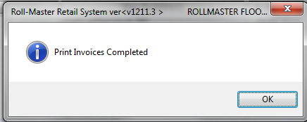

Click OK to return to the Invoice Batch Printing screen. Special Note: Many RollMaster clients utilizing this process will typically use the Invoice Batch Printing screen options as follows: check the Batch Only box as well as the Exclude Zero Balances option, set a Date Range and click the Build button. They will then sort by Address and print that Batch.

Email Acknowledgements- there are Email Address setup fields in Customer Maintenance and additional system functionality that allows you to send an Email Acknowledgement to clients and/or sales representative when orders are placed with your company. This option is identical to the one that automatically pops up when you convert a Property Management/ Builders Template or a Web Order to a Job, but was added here in the event you need to send an Email Acknowledgement prior to processing a Template or without converting a Template, as in the case of a special-order request. This feature will call up your system default Email client such as Microsoft Outlook (each customer needs to set this up prior to use) so you can use this feature from your RollMaster screen. The Customer Maintenance module offers fields for client and Sales Rep email addresses that will work with this feature and should be completed prior to use.

Print Menu Options:
When you click on the Print option at the top left of the Order Entry screen, the system will prompt a drop-down menu as follows:

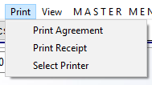

Please Note: if the Written Business Report, explained below in the Print section of the main Sales Processing screen following Batch Work Order Processing, has been enabled in your system, you will see that option display in the above drop-down Print menu. See explanation below for full details.

The Select Printer option will allow you to switch to a different printer than the one currently selected prior to printing either the Agreement or the Receipt. The first two options will allow you to print either a Sales Agreement or Customer Receipt through this menu. Both processes will be explained in this next section.

Print Agreement- this function will print a Sales Agreement, which is very similar to the Customer Receipt (explained below), but the Sales Agreement will not display any roll numbers if any material has been assigned at the time of printing, whereas the Customer Receipt will, and may be a better option for cash & carry businesses. Once all the line items have been entered for a Job, you can print a Sales Agreement to give to the customer in lieu of an Invoice, because there are no accounting functions tied to it. It can be used as a contract for the customer to sign and have a copy for their records.

To print a Sales Agreement, click on the Print Agreement option from the Print drop-down menu. If a non-graphical printer has been selected, the system will display a Print Report Options screen as follows:

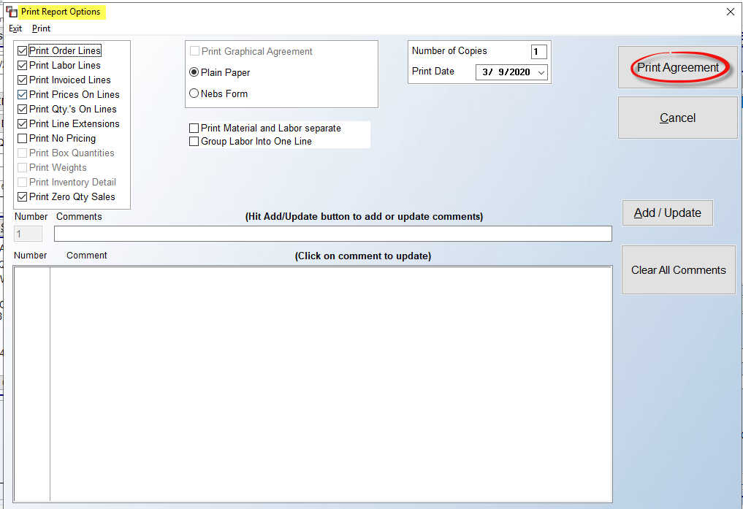

Please Note: Additional options are available when printing the Graphical Agreement. A Graphical Printer must first be selected, and then the Print Graphical Agreement option can be checked, enabling these additional print options:

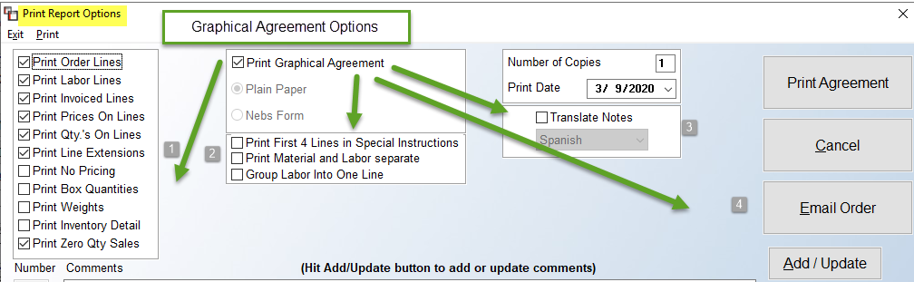

The defaults that are selected in this screen will print all line items, quantities, prices and totals as they currently exist on the Job, so if you want the Sales Agreement to reflect all of that, you can click the Print Agreement button without making any other adjustments in this screen. However, if you would prefer to customize the report in any way, the options in this screen will allow you to do that.

In the top left (1) of the Print Reports Option screen displayed above, you have several options to customize what the customer will see on the printed Sales Agreement. The first option, Print Order Lines, can be unchecked so that none of the detail of the line will print; however, you will need to type Comments to completely customize the printout. An easier option for customizing is to leave the Print Order Lines checked, and then uncheck Print Prices On Lines. This would automatically uncheck the remaining options below, and then you would need to decide whether you would like to re-check Print Labor Lines, Print Qty’s On Lines and/or Print Line Extensions to have those appear on the Agreement. Another option, Print No Pricing, when checked, will automatically uncheck the Print Prices On Lines and Print Line Extensions boxes and will also not print the Totals section on the Agreement. This option also appears in the Print Quote option of the Quote Entry module. If either the Print Box Quantities and/or Print Weights options are checked AND proper setup in Catalog Maintenance for Weight and Sold By Box/Box Qty has been completed, a third detail line will print for either/both of these fields when applicable catalog items are printed. The Print Inventory Detail will allow you to unselect Print Order Lines and simply list the details of the items on the Job and a total price. The Print Zero Qty Sales will default to checked, which means no change will take place. However, when unchecked, the docs will skip the printing of all lines with a zero S-Qty (these will be $0 lines).

Whether you are printing a text or graphical Agreement, there will be additional (2) options just below the Plain Paper and Nebs Form options. Please Note: These options are applicable for Jobs where Line Bundling has not been activated. They will all be unchecked by default. Two of these will appear for both print options as follows: Print Material and Labor Separate and Group Labor Into One Line. The first option, when checked, will print two separate documents, one with Material and one with Labor. The documents will be noted with an “M” and an “L” next to the Order #. The second option, when checked, will display a single “Installation” line with a total for all Labor. This option will work in conjunction with the one above. The third option in the graphical Agreement appears as follows: Print First 4 Lines in Special Instructions. This is referring to the Notes and Special Instructions box of the printed graphical Sales Agreement. If Comments are added in the box below, and if this option is checked, up to the first 4 lines will appear in that box.

The Translate Notes (3) box for Multilingual Documents will appear if the Company Control 4 option, Allow Multilingual Translation, is enabled. If so, you can select a language from the dropdown box to translate Notes and Special Instructions, Line Comments, and Comments added from this print screen. The Email Order (4) button can be used to send the Agreement via Email, rather than printing. Setup must first be completed in order to use this feature. Separate documentation exists for Emailing from RollMaster.

If you choose to print the Order Lines, you can still add Comments to the Sales Agreement by typing each line in the Comments box in the middle of the screen as follows:

If you need to edit an existing Comments line, click on that line in the large Comments box and it will display in the single line box above so you can make changes. Please Note: the system will only display up to 70 characters of each comment line in the large Comments box and on the printed Sales Agreement. If you would like to Clear All Comments and start again, you can click that button at any time to eliminate all comments at once. Prior to printing, if your store uses pre-printed Nebs (New England Business Systems) forms, make sure the Nebs Form option is checked, otherwise you should keep the Plain Paper selection. You can also change the Number of Copies to print more than one Agreement and you can change the Print Date, if applicable, by clicking on the date to pull up a calendar. When you are ready to print, click the Print Agreement button to continue. The system will save any changes you made in this screen, and they will also appear in the Print Receipt option, should you decide to switch to that feature.

Print Receipt- this print option works almost identical to the Print Agreement option explained above. The main difference in the two options is that the Receipt will display Roll and Dye Lot and Square Feet and Box data so the warehouse personnel is able to select the correct inventory for cash and carry orders to keep your inventory records clean. The graphical version will also print detailed payment data.

View Menu Options:
When you click on the View option at the top left of the Order Maintenance screen, the system will prompt a drop-down menu as follows:

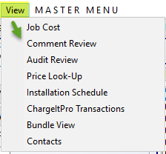

Job Cost- this is the same feature that you can access via the Job Cost button explained above and works the exact same way.

Comment Review- after using the Line Comments feature to add comments to the Job, you can use the Comment Review option to view those comment lines along with Job status information. This will become a valuable feature for you as you become proficient with the RollMaster System. When you select Comment Review from the View drop-down menu, the following screen will appear:

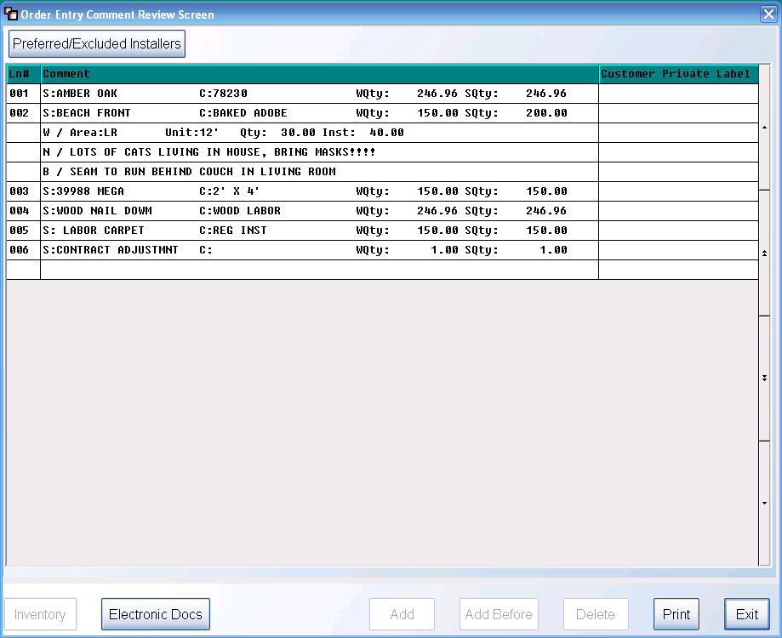

You can use this option to review all comment lines at once or you can also perform additional functionality from this screen. At the top left of the screen, you can click on the Preferred/ Excluded Installers button to review or edit a list of installers preferred or excluded for this customer. This feature was explained above in detail under “Work Order.” Additionally, if you click on any field in the LN# column, the button options along the bottom right of the screen will become available. If you click the Add button to add an additional Comment Line, the system will display a Select Option box as follows (the Add button will add a comment line to the bottom of the existing comments for a line and the Add Before button will add the line above the line you highlighted before you clicked on the Add Before button):

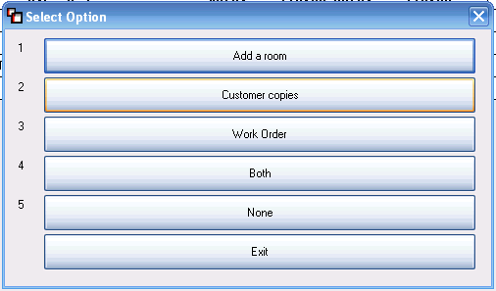

These options allow you to control who will see the Comment Line. The Add a room is for floor plan comment lines, the Customer copies is for customer comments, the Work Order is for communication to the warehouse and installers, the Both displays on customer and work order copies, and the None are strictly internal. Once you make a selection in this screen, the system will then display the following:

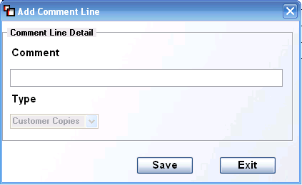

In the box above, you will type out a description in the Comment field. When you have finished typing your comment click the Save button to keep the comment line and then click the Exit button to return to the previous screen. Once a Comment Line has been saved, you can edit it by clicking on that line in the Comment column of this screen and this same box will display. If you bring up an existing Comment Line Detail box, you will also be able to change who can see a Comment Line by making a change in the Type box or editing the comment description content. If you click on an existing Add a room or Floor Plan line, the system will display the following:
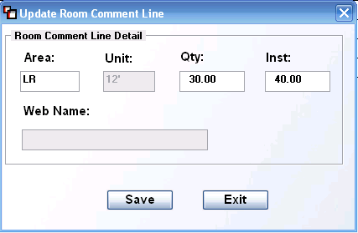

Aside from the Unit box, which is tied to the catalog item, you can edit any of these fields as needed, including the Web Name box for those customers who are using the PM Web Portal system. If this is the case, whatever appears in this box will display in the Web Portal Template for this line, provided the Web box is checked. To Delete a Comment Line entirely, click next to that line in the LN# column and then click the Delete button at the bottom right of the screen. Once you have added a series of Comment Lines under a material or labor line, you also have the ability to Copy Comments from one line to another. This feature will be used more often during the Template creation process in the Property Management/Builders Template module but can be used here as well. To use this feature, you must position the cursor in the LN# column of the actual material or labor line. For example, at line # 001 in the example above you will need to click in the field containing the “001” to call up this feature. See the following example of where to click in the screen:
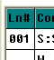

As soon as you click in the applicable field, a new button will appear at the bottom middle of the screen as follows:
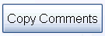

As soon as you click on the Copy Comments button, the system will display a box as follows:
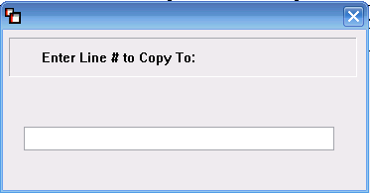

Type in the new Line # for which you want the comments to be copied to and hit enter. The system will immediately copy all existing comments to the new line. The Electronic Docs button works the same as the E-Docs feature explained in detail above.

Audit Review- this feature was added so that all changes to the Job or Quote can be viewed through this feature, such as when a Line is Added, Changed, Deleted, Assigned, etc. This feature also tracks Install Date changes, Installation Type changes, changes to the Initials box, changes to Salesrep 1 and 2 fields, and Cost changes to Labor and Special Charge Lines. Additional audit areas include changes to the Customer PO field. When a change is made, the Audit Review screen will display the following: Cust PO Changed. Another tracked change is to the Credit Status field on the Customer account. Those changes will display as follows: Credit Status Changed. Another tracked change is to the Tax checkbox on each line, which will display as follows: Line Changed. To see the actual Tax change, you will need to double-click on the Audit Line to view the Line Audit Detail. There are slight differences between what is tracked for Audit on a Job vs. a Quote, but the feature works the same as explained below. When you click on the Audit Review option, the system will prompt a Line Audit box as follows:

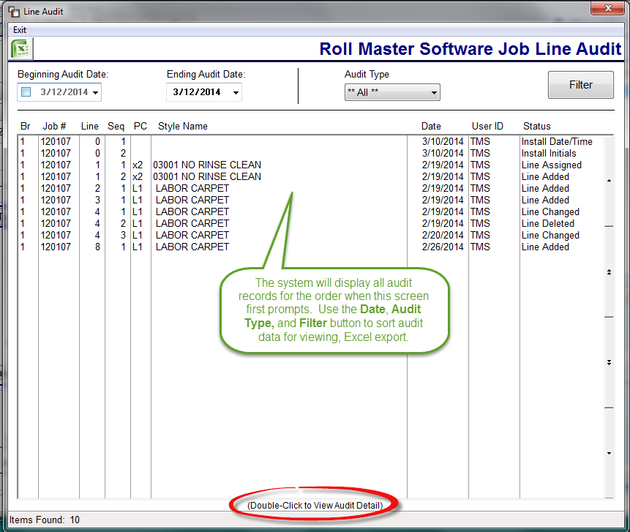
All audit lines will appear in this screen when it first prompts. The Beginning Audit Date field can be set by first clicking in that box and then changing the date fields using the drop-down menus. You can also sort the data by selecting a specific Audit Type from the drop-down menu in that field. If you make changes to the Date fields or the Audit Type, be sure to click the Filter button to re-sort the data in the screen. New types of audit data are being added with almost every update. When you click the Audit Type drop-down box, you will see a list of available Types in alphabetical order (see below). Additionally, at the top of the list, you will see two indented options as follows: Header and Line. If you select either option and then click the Filter button, the screen will display only those Audit Types that relate to the option selected. The drop-down menu appears as follows:
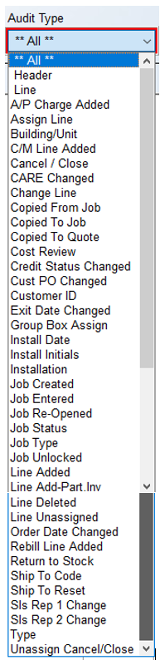
To view audit details of any line, double-click on that line to prompt the following Line Audit Detail box:
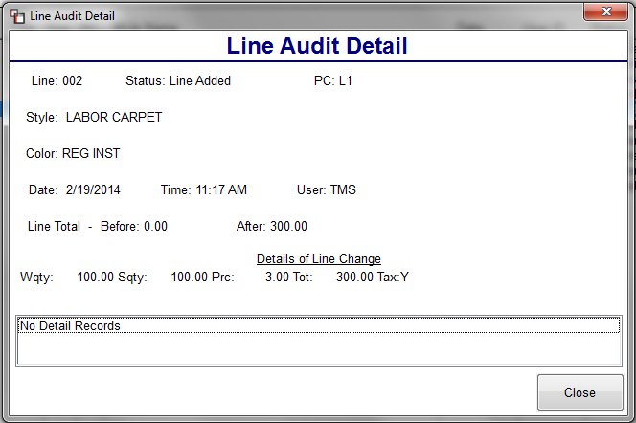
Line Audit screen data, along with Line Audit Detail, can be exported to Excel. This feature has also been added to the Quotation / Proposal Maintenance module, but will only display applicable features to the Quote, along with a recent addition of Quote Date Changed.

Price Look-Up- this option is somewhat similar to the Pricing Table feature explained above in the Line Items section, but contains a few more features that you may find helpful during the order entry process. When you click on this option, the system will first prompt the Product Selection screen for you to select a Catalog Item. Once you locate the item, the system will prompt the A-J Pricing Table as follows:

Click in one of the A-J fields above to see programmed pricing. You can scroll through the A-J pricing data just like you can in the Pricing Table from the Line Items feature, explained above. It does not display any costs, so it can be used by anyone that has access to the RollMaster System. You can also perform an inventory lookup from this screen by hitting the View Inventory button, also explained above. Hit the Exit button to return to the previous screen.

Installation Schedule- this option will be available only on Jobs that have first been sorted via the View Installation Schedule in the main Sales Processing screen. When a list of Jobs appears in the display screen, you can click the View Job button on the applicable Job and then click the Installation Schedule option from the View menu to display the Installation Schedule screen for that Job.

ChargeItPro Transactions- this option only applies to RollMaster Customers who have chosen to use ChargeItPro for credit card and payment processing. Please contact info@rmaster.com for additional information and complete documentation.

Bundle View- this option displays lines as they are currently grouped under their assigned Bundle Name and allows for managing Bundles. All the options compiled here are available elsewhere, but combined here for ease of use. When you select this option, the system will prompt a Bundle View box as follows:

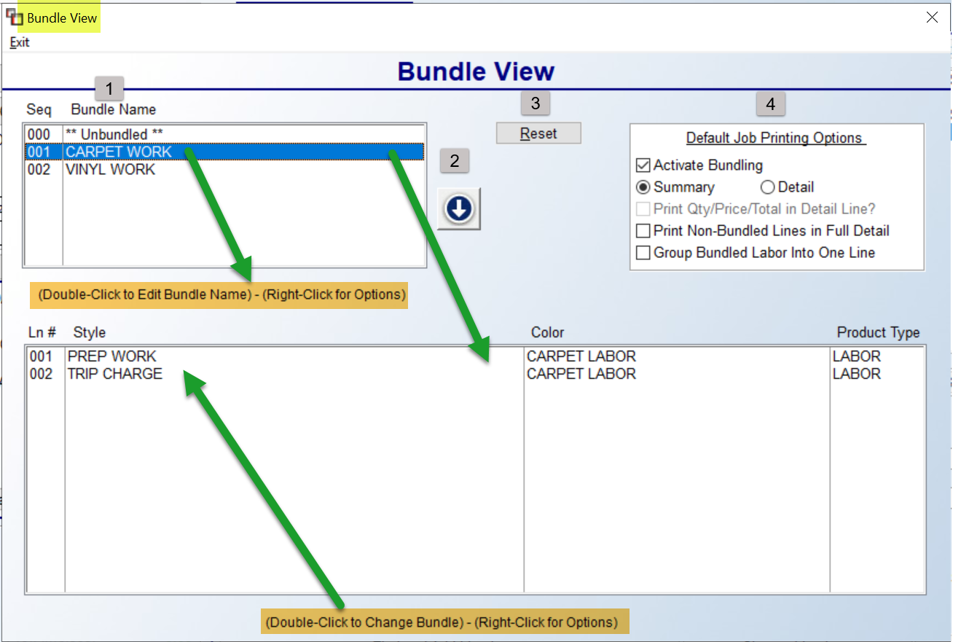

If bundled lines appear on the Job, you will see the names listed in the Bundle Name (1) box at the top left of the screen. A couple of options exist in this box, including the ability to Edit the Bundle Name. You can double-click on a name to prompt an Edit Bundle Name box as follows:
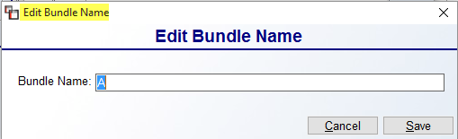
This will allow you to change the Bundle Name for all lines that exist with this Bundle Name.
If you right-click on a Bundle Name, the following options are available: New Bundle, Edit Bundle Name, Delete Bundle, and Add New Lines to Bundle. You can re-order the Bundle Names on the Job by clicking the up and down arrow (2) buttons. Any changes can be reset by clicking the Reset (3) button. The box to the top right (4) displays the current Default Job Printing Options. When printing an Agreement, Quote, or Invoice, you will also see these Bundle Print Options, provided you are printing a graphical document. You can make changes here that will impact only the current Job. When Detail is selected, the Print Qty/Price/Total in Detail Line? will become enabled. The Print Non-Bundled Lines in Full Detail option allows for printing lines that have not been bundled in full detail. The Group Bundled Labor Into One Line option allows for grouping bundled Labor Lines into one single line on the document.

All bundled lines tied to a Bundle Name will display in the box below when that Bundle Name is highlighted. If you double-click on one of those lines, the system will prompt a Change Bundle box. You can also right-click on one of those lines to display the following options: Change Bundle and Remove From Bundle.

Contacts- this option was added to allow for viewing A/R Contacts that have been set up under the Customer’s account. This will primarily be applicable for commercial and multi-family clients.

Master Menu option:
When you click on the Master Menu option, the system will prompt a drop-down menu containing a list of all the menu options available from the Master Menu when you first enter the RollMaster System as follows:

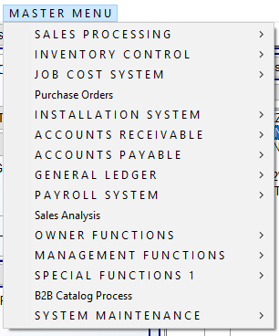

Having this option available from the Order Maintenance screen, will allow you to access any module, aside from Order Entry, to perform another function in the system, and when that task is complete, the system will return you back to the Order Maintenance screen you were in when you accessed this menu. This functionality can save considerable time during the order entry process, when another task needs to be completed outside of the order entry process.

Options From Sales Processing Screen:
The options at the top left of the Sales Processing screen will be used during various stages of job processing. Those options appear as follows:

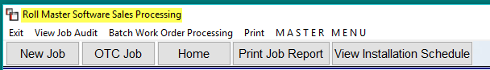

Some of these options/buttons have quick explanations, and others are quite detailed. Starting with the top row and moving left to right, we will cover each of these in that order, picking up with the second row of buttons following the MASTER MENU explanation. The Exit option will return you to the Sales Processing menu.

View Job Audit:
This feature was added so that all changes to Job lines, based on the Jobs currently displayed in the main screen, can be viewed through this feature. It works almost exactly as the Audit Review feature located within the Order Maintenance screen on each Job, (explained above) but this feature includes audit data for multiple jobs, rather than just one job. When you click on this option, the system will prompt a Line Audit box as follows:

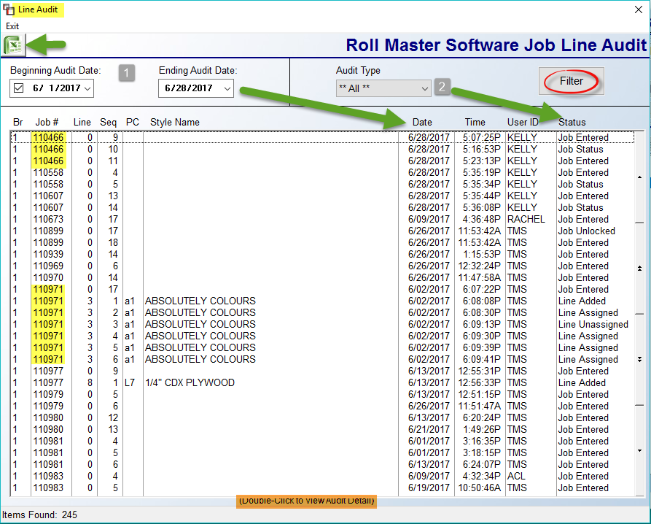
All applicable Audit Lines will appear in this screen when it first prompts. The Beginning & Ending Audit Date fields can be set by first clicking in that box and then changing the date fields using the drop-down menus. You can also sort the data by selecting a specific Audit Type from the drop-down menu in that field. When you click the drop-down menu in that field, a list of all Audit Types will appear as follows:
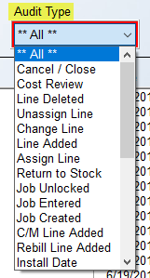
If you make changes to the Date fields or the Audit Type, be sure to click the Filter button to re-sort the data in the screen. To view audit details of any line, double-click on that line to prompt the following Line Audit Detail box:
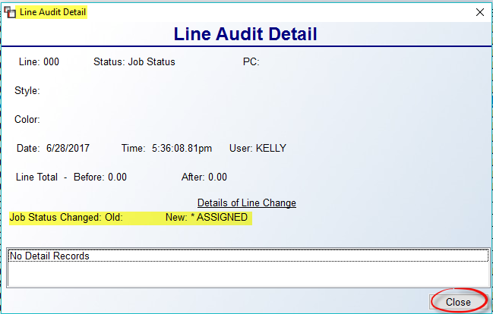
Line Audit screen data can be exported by clicking the Excel icon at the top left of the main screen.

Batch Work Order Processing:
This feature will primarily be used by Multi-Family clients where Work Orders are typically printed at a high volume on Jobs going out the next day. Batch Work Orders was designed for relatively simple Jobs where all material and labor are shipping at once, as is typically the case with large volume MF customers. These Jobs would also be “eligible” for Work Order printing, i.e., all material assigned, and in the case of RollMaster clients using the Cut Sheet features, all roll goods have been cut. If these conditions are not met, a standard Work Order print may be required.
When you click on the Batch Work Order Processing menu option, the system will prompt a Batch Work Order Processing screen as follows:

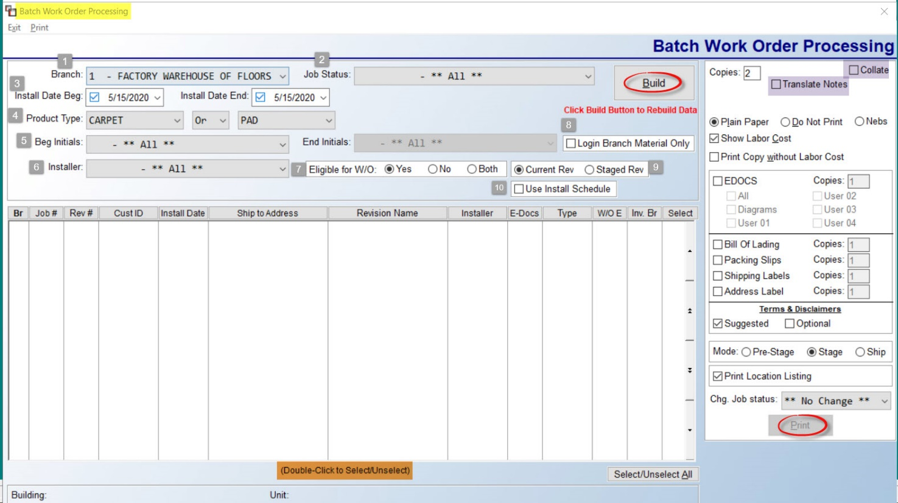

At the Branch (1) field, you can select ALL Branches, or switch to another Branch if applicable. The Job Status (2) field allows for printing by a specific Job Status. At the Install Date Beg (3) and Install Date End fields, select the day or days for which you will be printing eligible Work Orders. The Product Type (4) option can be used to display eligible Work Orders for a specific type of product. If you use this feature, the system will also prompt a second Product Type field paired with an Or/And scenario option as displayed above.

In the scenario above, to print only CARPET Or PAD, leave the settings as they are. However, to see eligible Work Orders that include CARPET And VINYL, use the drop-down menu to select And instead of Or, and change the second Product Type to VINYL. Work Orders that include both types of material may require standard Work Order processing. In this case, those should be printed prior to running Batch Work Order Processing. The Beg Initials and End Initials fields (5) are tied to the Initials Maintenance field and require that one or more Initials have been set up in that module in order to use.

At the Installer (6) field, use the drop-down arrow to select a specific Installer’s Work Orders. At the Eligible for W/O (7) field, the default is “Yes” to only display eligible Work Orders. However, you can select No or Both to also see those Work Orders. If a Job is displayed in the “No” screen, it means the Install Date matches your date criteria, but not everything on the Job is eligible for shipping on a Work Order. This will give you an opportunity to change the Install Date or correct the issue prior to Batch Processing. The Login Branch Material Only (8) box, when checked, will display Work Orders that only contain assigned material that resides in the current Branch. The Current Rev or Staged Rev option (9) box allows you to switch to only Staged Work Orders. The Use Install Schedule (10) box, when checked, gives the User the ability to print the Work Order for a Multi-day Install the way it was scheduled (including related items) on the Job since this would include multiple revisions (e.g. not just the revision titled “Current” but also other custom named revisions). See the image below for examples in the Revision Name column.
Once your view parameters are set, click the Build button to display applicable Jobs in the display screen as follows:
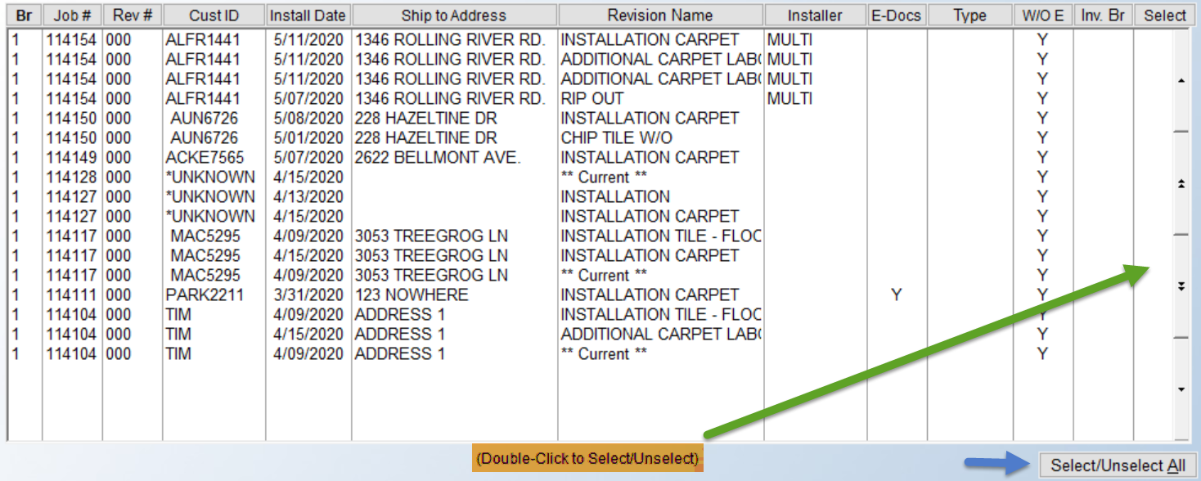

The data can be sorted by any of the column headings above; the default is Job #. The E-Docs column will indicate whether diagrams are available for printing with the Job. The Type column pulls from the freehand field in the Ship To Code screen. Many PM clients use this field to denote “Carpet,” “Vinyl,” etc. Prior to selecting jobs for Batch Processing, if you right click on a line, the system will prompt two additional options from this screen as follows: View Job & Diagrams. The View Job option will allow you to “jump” to that Job in Order Entry and will then bring you back to this screen. The Diagrams option will prompt the E-Docs feature so you can access scanned diagrams to print where applicable.

Once you have determined which jobs to include in Batch Processing, you can select which to print in a batch one of two ways. If all Jobs in the display screen are eligible, you can click the Select/ Unselect All button at the bottom right of the screen. You can also highlight and double-click on a Job to select. Prior to beginning the Batch Process, you will need to run through the Print Prompts along the right side of the screen. Those options appear as follows:

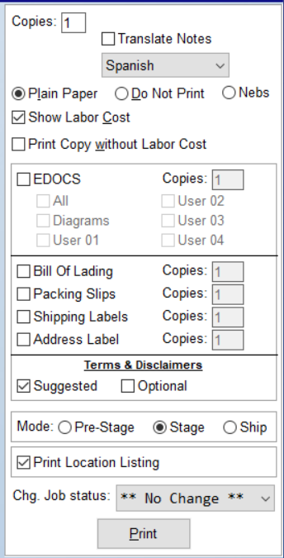

Most of these options are the same ones that appear during regular Work Order printing. Each selection will apply to all of the Work Orders within the current batch. The default settings are displayed above. If you are using SSP Printing, a Collate button appears at the top right of this box, which allows for collating together a Work Order and any additional paperwork that has been selected via Terms & Disclaimers checkbox, if that has been set up in your system. The Copies box allows for printing multiple copies of each. The Translate Notes feature, when checked, will copy existing Work Order Comment Lines, Customer Address Notes, and Installer Work Order Instruction Sheet data and print in both English and the language selected in the drop-down menu on the printed document. If you have previously printed Staged Work Orders and simply wish to update material and labor as having left the warehouse, you can click the Do Not Print option so the system updates without generating a hard copy of the report. The Show Labor Cost option will be checked by default, but can be unchecked to not show Labor Cost. The Print Copy without Labor Cost is another option to leave off Labor Costs.

If the EDOCS box is checked, you can then determine which files get included with the printout by selecting applicable checkboxes. The next section, starting with Bill Of Lading, needs to be setup prior to use, and will not be widely used by RollMaster customers. Terms & Disclaimers, again provided setup has been completed, will allow for printing Suggested, or Optional so you can pick and choose for the specific batch. The Mode section allows for changing the default Stage setting on the type of Work Orders to be batch printed. The Print Location Listing defaults to checked, but is only used for those folks using multi-bin functionality.

The Chg. Job Status drop-down box will not make changes to the Job Status field on the Job. However, you can use this option to make a Job Status selection for Jobs tied to the Work Orders you are about to Batch Process. When all selections have been made, you are to print. Once you click the Print button, the system will prompt the Print Work Order screen and begin printing each Work Order one at a time in succession. This may take a few minutes, depending on the number of Jobs. All Work Orders that print successfully will be “tagged” as printed so that you don’t duplicate Batch Processing.

Print:
When you click on this drop-down menu, you will see the following options, unless Written Business Report has not been activated in your system (see explanation below):

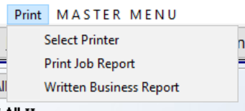

The Select Printer option will allow you to switch to a different printer from within this screen. The Print Job Report is the same as the button option that appears just below the Print menu and is explained below in the order it appears in that list of menu options. The Written Business Report was programmed to generate a transaction-al “Written Business” report, as opposed to the Job Cost Margin report that doesn’t take into account cancelled orders or increases/decreases to existing Jobs. This report writes a new file for Sale, Cost, and Margin each time a User exits a Job and a change was made to impact any of those three figures. As an example, if a Job was entered on the 30th of the previous month for 10K, but then cancelled 20-30 days later, when that cancellation happens, the 10K will hit the Written Business Report on that day.

This report must be turned on by a RollMaster Support Agent and once turned on, it can never be shut off. Also, once Invoiced, you can no longer change the Salesperson ID on the Job. There is a User Control 6 option to determine who is allowed to override the Transaction Date or Exit Date for this report. The report will not go back and capture past Jobs when activated. However, a RollMaster Support Agent can run a program to load in past Jobs based on a Date Range you provide.

From the main Order Entry screen, you'll be able to print or export a detail or summary list of Written Jobs based on customizable settings as follows:

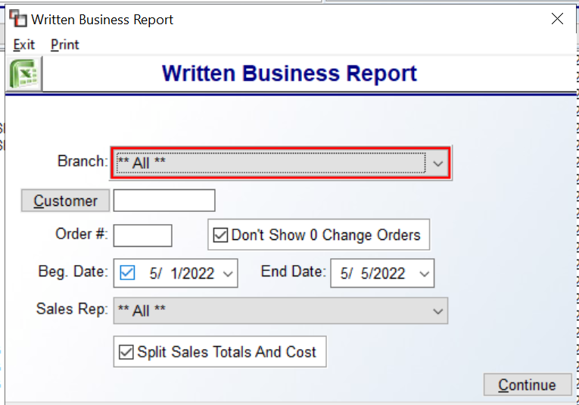

The Split Sales Totals And Cost checkbox, if unchecked, will put the full total and cost on both Salesreps. An example of this report for a specific Job appears below. The system will display a list of all changes as follows:

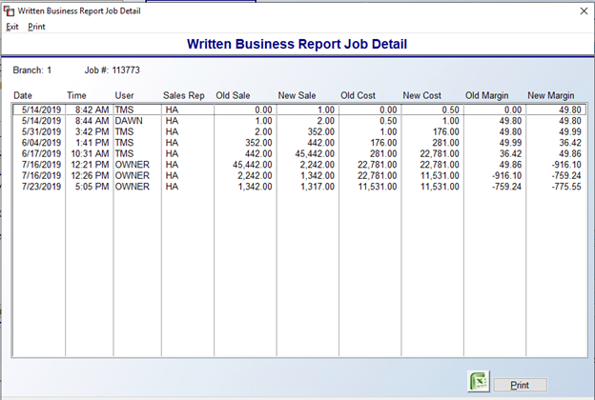
You can then export the data to Excel, or Print.

OTC Job:
When you first enter the Order Entry module, you will see an option at the top left of the screen as follows:
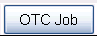

This option was developed to handle quick cash & carry transactions on material items that are in stock and will be shipping out or leaving the store without needing to be ordered or installed. You can skip entering customer information by creating a “CASH” customer and the system will instantly invoice and then prompt you to close the Job once you enter the lines, assign the material, and post the payment. There are some important aspects to this feature that you need to understand before you proceed, so please be sure to read this section carefully.

When you click on either the OTC Job button or the New OTC Job option, the system will prompt an *** OVER THE COUNTER SALE *** screen as follows:

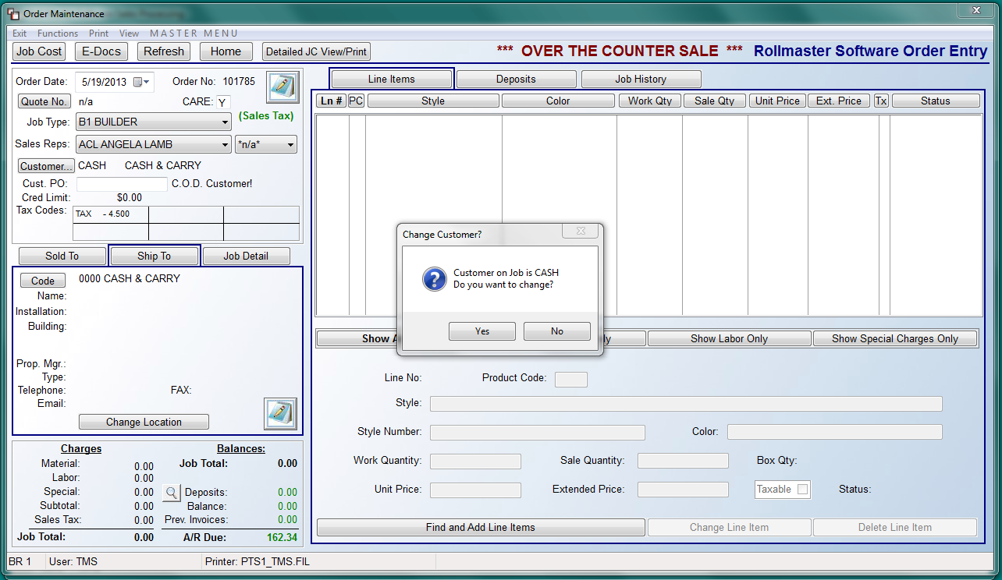

You will know you are in the OTC screen because of the red text displayed at the top of the screen as follows: *** OVER THE COUNTER SALE***. Also, if the System Control 1 Cash Sale Default control is set to “Y” for yes, and the Company Control 1 Over the Counter option is set to “CASH,” the system will prompt a Change Customer? box (as illustrated in the screen shot above). Click No to continue using the “CASH” Customer ID, or click Yes to prompt the Customer Selection box to add or search for a customer. You will not be able to exit this screen until material has been assigned to all material lines or all material lines have been deleted. Additionally, the system will not allow access to the Purchase Order feature from this module.

Upon exiting the Find and Add Line Items screen, the system will prompt the following: Are You Ready to Finalize Sale? If you click No, the system will return you to that screen. If you select Yes the process will continue by prompting the Add New Deposit box and defaulting to the total of the Job. Deposits must match the job total to continue, unless the Company Control 3 option “Allow OTC Jobs to carry Balance” is set to “Y” for yes. When the deposit requirements have been met, the system will then prompt the following:
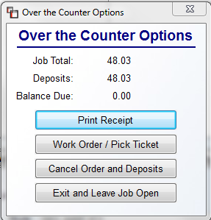
You must select one of the four options listed in the screen above before proceeding. The default option is Print Receipt. If you select the option to Cancel Order and Deposits, the system will then prompt the following:
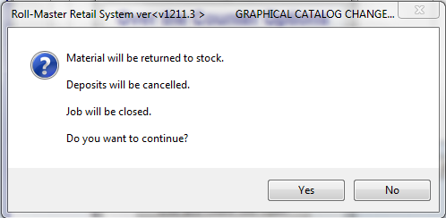
Click Yes to continue with cancelling or click No to return to the prior menu. Regarding the Print Receipt option, the program will only prompt the Posting Date and Close Job questions if the User is allowed to close Jobs. The Invoice/Credit Memo Reprint option will then automatically prompt so you can proceed with printing the Receipt/Invoice.

Print Job Report:
This report prints a list of every Job currently listed in the display screen. It lists data from all the columns, with the exception of the Beg. Install Date column. However, if you export the data to Excel, by selecting Excel as the Printer, you will see lots of additional data such as Job Type, Initials, Ship To City, Ship To Zip Code, Ship To Email, Install Date, Time, Territory Code, etc. To customize this report, use the options in this screen to sort the Jobs in the display screen, such as with the Filters option, or by Customer, etc., and then click the Build button to update the display screen before clicking on the Print Job Report button.

View Installation Schedule:
If you are using the Installation Schedule for the first time in the system, make sure proper setup has been completed. See the Installation System documentation for full details. Prior to clicking the View Installation Schedule button, you must use the Select Filter option and choose Install Date to begin as follows:
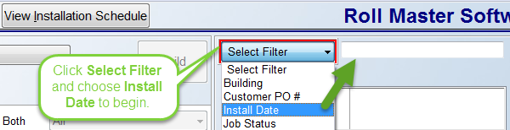
The system will then prompt a default filter description as follows: Enter Beg and End Install Dates, as in the screenshot below:
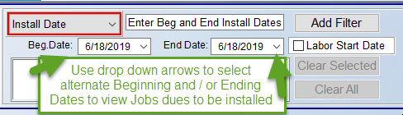
The Beg. Date and End Date fields will default to the current date. Use the drop-down arrow menus in the date fields to select a different Install Date or range of Install Dates. The Labor Start Date checkbox, when checked, allows the system to only look at the Beginning Install Date on any scheduled Jobs. This is so that multi-day or extra/fluff days added to the schedule will not factor into the lookup. Fluff days refers to days in the schedule added to tile, hardwood, etc. installs because the installer usually has to return to grout, install trim or shoe mold, etc. Please Note: Jobs with Accumulator Install Dates are filtered by the earliest Install Date record in range on a Job. Next, click the Add Filter button to prompt the new date range and display the Installation Schedule screen as follows:

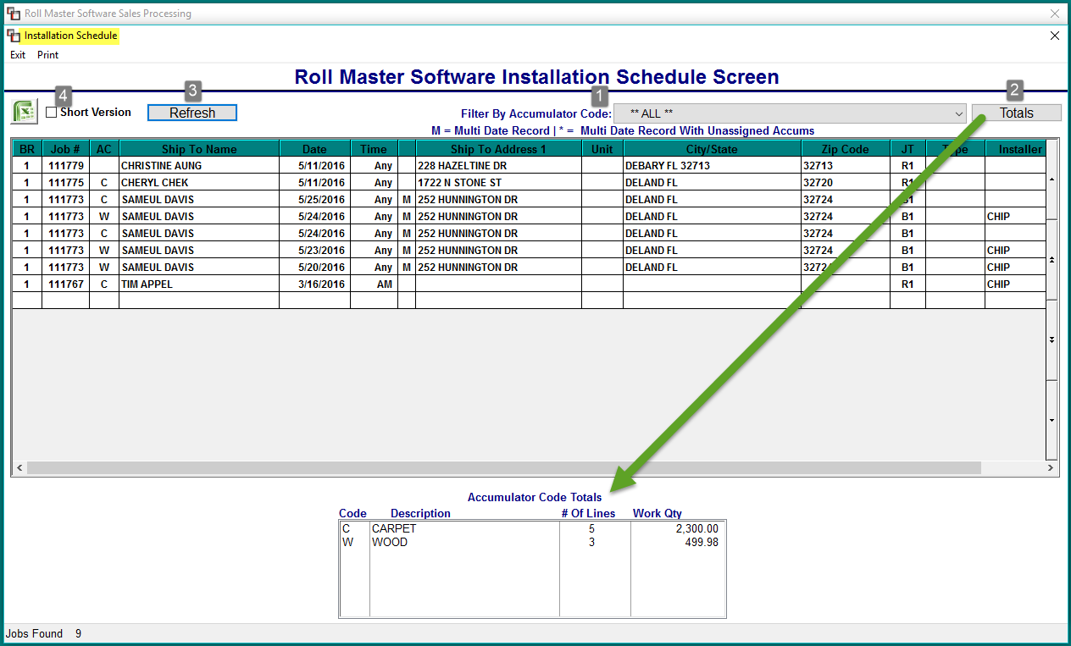
All Jobs with the Install Date(s) selected in the previous screen will appear in the screen above. You can filter the Jobs by selecting a specific Accumulator Code using the drop-down menu in the Filter By Accumulator Code (1) at the top of the screen. Based on your selection, the Jobs will sort by that Code and you will see Totals (2) for each Code in the Accumulator Code Totals box at the bottom of the screen. If you click to highlight a specific Job, clicking the Totals (2) button will return the view to the Accumulator Code Totals box. If you select a different Accumulator Code, you will need to click the Refresh (3) button to update the screen. You can also click the Refresh button to update the screen with any new installation data that has been added in the system for the selected date range since entering this module. Another option is to click in the box next to Short Version (4) to switch to that version prior to printing or exporting. Be sure to click the Refresh button after clicking the Short Version box.
You can sort the Jobs in the Installation Schedule screen by clicking on any of the Column Headers to sort by that data. The default sort is by the Date / Time columns; click on any column header to reverse the sort display. When you highlight a specific Job, the screen at the very bottom will prompt job-specific data as follows:

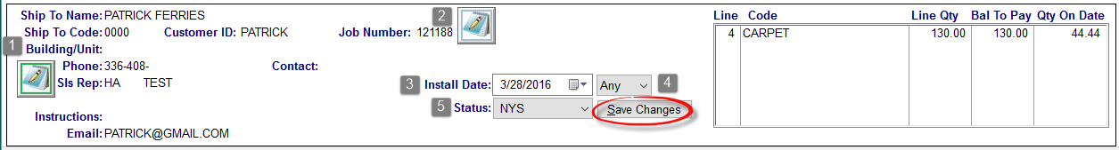

In the screen above, you can add/edit Job Location Notes/Customer Address Notes (1) using the icon at the far left, add/edit Job Number Notes (2) using the icon in the middle of the screen, and make changes to the Install Date (3), Time (4), and Status (5) fields using the drop-down menus in those fields. Be sure to click the Save Changes button to ensure your changes update these fields on the Job in the Order Entry module.
When a Job is highlighted, if you right-click on the line, the following options are available, based on User permissions:
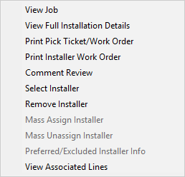
Most of these items you will already be familiar with from using them in other areas of the system. Please Note: When assigning an Installer, the system will check the Preferred/Excluded Installer list against the Customer/Ship To and pop up a warning where an Excluded Installer has been selected. One new feature is the View Full Installation Details option. When you select this option, the system will display the following:
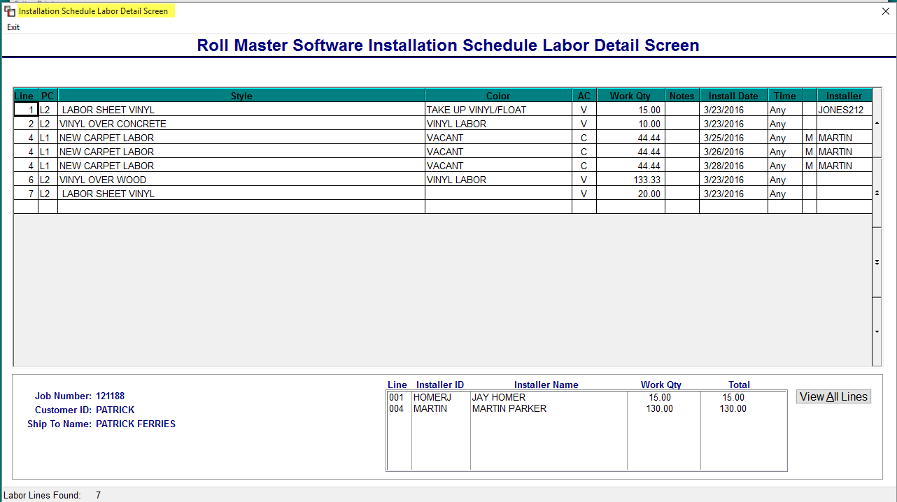

The Installer column is updated via the Select Installer option mentioned above. If an Installer ID appears in the box at the bottom of the screen, that indicates the Labor Lines have been scheduled for payment in the Job Labor Mtc./Installer Payments module. You can right-click on any of the Labor Lines in the screen above to prompt the following options, based on User permissions:

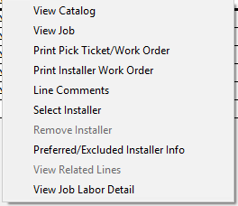

The Select Installer option is User controlled. When enabled, a User can select an Installer ID for the entire Job by using this option in the Installation Schedule screen, or assign different Installer IDs to each line by selecting this option in the screen above. Assigned Installer IDs will appear on the system Work Order and flow through to the Installer Payables System module.
When you have finished filtering and sorting data and making any applicable changes in this module, you can either print the Installation Schedule Report by clicking the Print menu option at the top left of the first screen, or export the data to Excel by clicking the Excel Icon. When you click the Excel icon, the system will prompt the following:

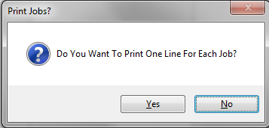

The default is No, so hit enter to continue or click the Yes button to export all lines. When you select to Print Installation Schedule Report from the Print option, the system will prompt the following:
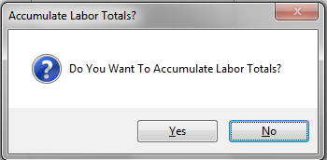

The default is No, so hit enter to continue or click the Yes button to accumulate labor totals on the report. If you select Yes, the system will then prompt the following:

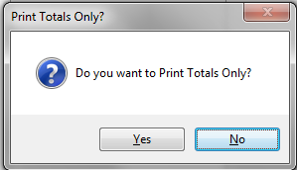

The default is No, so hit enter to continue or click the Yes button to only print accumulator totals on the report.

If you click the Short Version box prior to printing or exporting to Excel, the system will switch to the Short Version report data. Currently, the only difference between the Installation Schedule and the Installation Schedule (Short Version) is that the Short Version checkbox will automatically be selected when you access this program via the Installation Schedule (Short Version) menu option.

Quotation/Proposal Maintenance:
The Quotation/Proposal Maintenance module works almost identical to the Order Entry/ Maintenance module with a few exceptions. The biggest are that you cannot create a Purchase Order or an Invoice from the Quotation module. The purpose of the Quotation module is to provide the customer with a computerized Quote and to allow the Salesperson to store the Customer’s information in the system for future use. This program has been designed so that once a Quote is created, it can instantly be converted into an open Job in the system as soon as the Customer is ready to place the order. Therefore, no double entry of data needs to take place. When you enter this program, the screen will appear as follows:

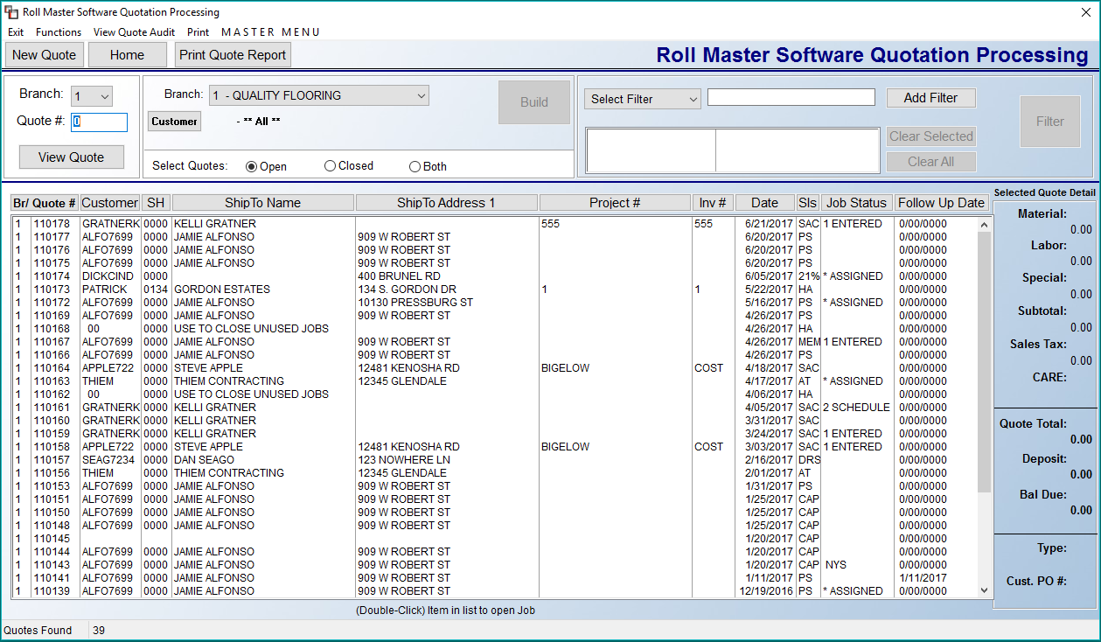

The cursor will be positioned at the Quote # field at the top left of the screen. Creating a new Quote works just the same as described above in the Order Entry/Maintenance section, but in this screen, you will click on the New Quote button to begin. All of the options for locating an existing Quote work the same in this screen as well. There are a couple of specialized Filter options for Quotes, such as Customer ID [empty], that allows for locating Quotes missing a Customer ID. This next section will focus on Quote-only features that were not applicable to the Order Entry/Maintenance program explained above. Before moving on to instructions on creating a new Quote, you should note a couple of options unique to Quote Entry that appear at the top left of the screen as follows:

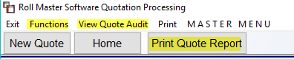

When you click on the Functions menu, an option will display as follows: Close all Quotes. This option was added to allow Users to mass close all Quotes displayed in the Results screen provided they meet the requirements to close, and the User is allowed to close Quotes. To mass delete Quotes, build a current list of applicable open Quotes and then click on Close all Quotes. The system will prompt the following:

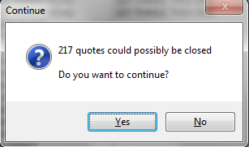

If you are sure you wish to close all selected Quotes, click the Yes button to continue. Otherwise you can click the No button to change the Quotes selected. This option can be password protected via the System Menu Passwords module using the Program Name “QECLOSE.” The View Quote Audit works the same as the View Job Audit, explained above in Order Entry. The only difference is that the Job tracks a few more items than the Quote. The Print Quote Report works the same as the Print Job Report, and can also be exported to Excel.

When you click on the New Quote button, the system will prompt a Customer Selection box, and you should follow the same procedures described above in Order Entry for either adding a new Customer or locating an existing Customer. Once the customer selection process is complete, you will continue with updating the fields on the left side of the screen, which are primarily the same fields described above in the Order Entry section. One field difference of note is the Follow Up field in the Quote Detail box, just under the Job Status field. In Order Entry, this field is the Install Date field and will revert back to that when the Quote is converted to an Order. For Quote purposes, when you check the box at this field, the system will display a drop-down Calendar box as follows:
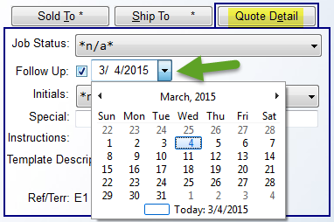
Select an applicable date to follow up with the Customer. This field can be updated any time. This field will appear on the Print Quote Report when exported to Excel.
If you are entering a residential Quote, you will add Line Items the same way you do in the Order Entry screen explained above; the only difference will be that you will not have the option to create a PO. If your Company Control setup permits, you will be able to place Inventory Holds on material from a Quote. In the Copy menu from within a Quote, you can perform the following functions: Copy to new Quote, Copy Quote to a Template, and Copy Quote to a Lead (for those with the add on Leads Processing module.) One additional feature available in the Quotation Entry screen is a Quote Cost button that appears at the top left. If you click this button, the system will generate a detailed Quote Cost Review report similar to the Detailed Job Cost View/Print report option found in the Order Entry screen.

Commercial Quote Entry:
Although the residential Quote Line Item entry process is virtually identical to the Line Item entry process explained in the Order Entry section, the process for entering line items for commercial jobs is slightly different. The Commercial Line Item feature is an available option for all User IDs set up as Commercial Salesreps, or this feature can be activated for all Quotes through the System Control Maintenance module via the Enter Cost in Quotation Entry control in the System Control 1 screen. The Commercial Line Item feature will display Material Cost Information for the item selected, along with a Margin percentage field. This feature was developed for use primarily with large commercial dealers. If the Commercial Line Item feature is selected, the Add or Change a Line Item screen will appear as follows:

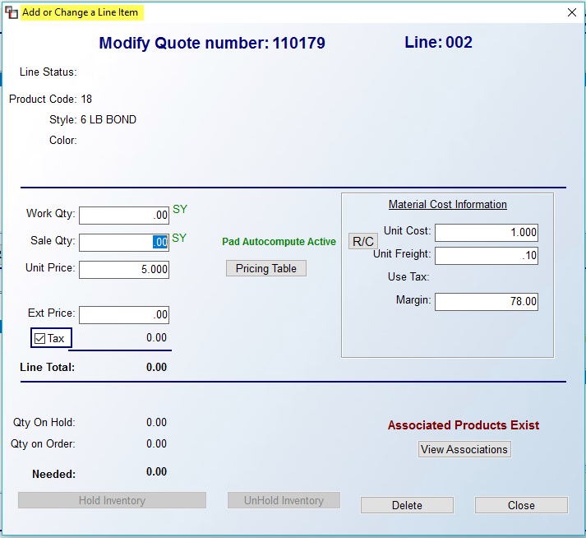

The system will automatically display the default Unit Cost and Unit Freight information currently in the system catalog. The default Margin percentage will display as well. You can change the Unit Cost and Unit Freight data if applicable, as in many cases with commercial projects, your manufacturer’s representative has likely given you special pricing for the project and you need to figure your margins and profit based on those figures. Also, the cost information entered here will automatically prompt on a system PO once the Quote has been converted to a Job. If you prefer to enter all costs on material and labor lines without determining a selling price, you can do so by entering a “.00” in the Margin field. You can then use the Cost Review feature (explained above in Order Entry, but with more options listed below) that is accessible in the Functions drop-down menu to instantly calculate material and labor selling prices based on Margins, Profit or Total Sale, which is how most commercial quotes are typically handled.

If you wish to reserve inventory to a line in a Quote, you must first turn this control on in the Company Control 1 screen of the System Control Maintenance module, located in the System Maintenance menu. The option appears as follows: Allow Inv. Holds On Quote. Type a "Y" for yes at this control, and at the second field of that prompt, type the number of days you would like all holds to be effective, e.g. "5" for five days. Also, the Clear Inventory Holds On Quotes module, explained below, can be run to automatically clear expired quote inventory holds. Once this feature is enabled, the Add or Change a Line Item screen will display Inventory option buttons at the bottom left of the screen as follows, provided a Work Qty amount was entered:

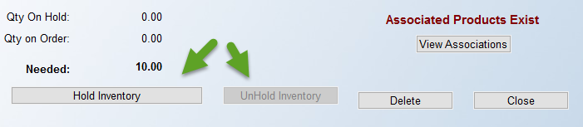

If there is available inventory for this item, you can click the Hold Inventory button. An Inventory Review screen will appear as follows:

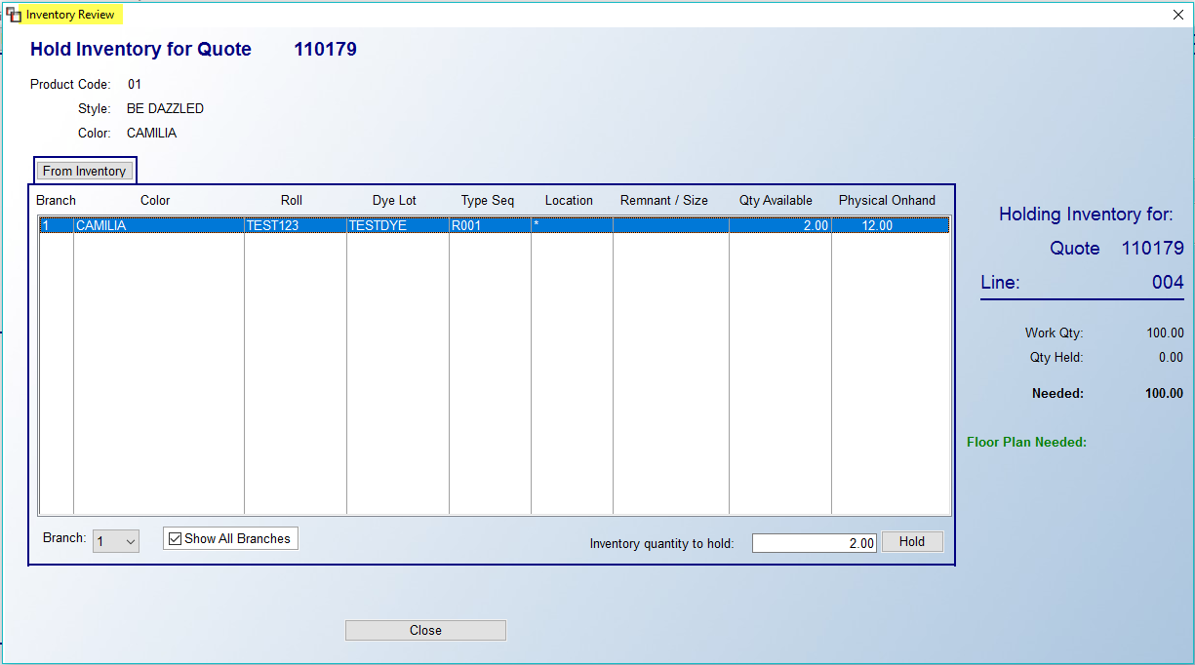

All available inventory for this style will appear in the box above. Highlight the inventory you would like to reserve and then click the Hold button at the bottom right of the screen. The system will then return you to the previous screen and the Status column for that line will display Hold. You can continue to hold/assign additional inventory or exit the screen to return to the main Quote Maintenance screen. If inventory has been placed on hold in a Quote, the system will not allow you to close the Quote. The following message will prompt:
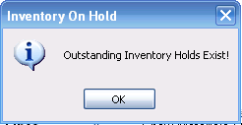

Once you hit the OK button, the prompt will disappear and the cursor will return to the Quote Date field. You will need to enter back into the Add or Change a Line Items screen and click the UnHold Inventory button and then you will be permitted to close the Quote. Also, if you put a hold on partial material, the system will display “Partial Hold” in the Status column indicating that the full inventory amount was not put on hold. You can then put a hold on more material or release the existing material. There is a module in the Sales Processing main menu, titled Clear Inventory Holds on Quotes, that can be run daily to clear all expired quote holds based on your setup in the Company Control 1 screen referenced above.

The Cost Review option in Quote Entry has a few more options available than it does in Order Entry. When you access the feature from this module, the Cost Review screen will appear as follows:

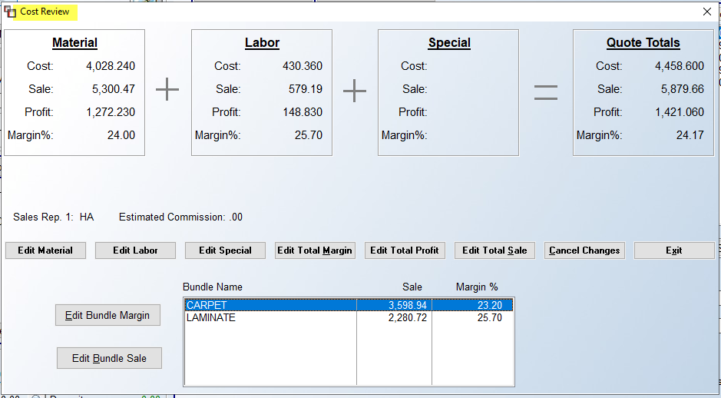

Instead of simply editing the Total Sale or Total Margin, the buttons along the bottom of the screen will also allow you to edit Material, Labor, and any Special Charges individually. You also have the ability to Edit Total Profit and Edit Total Sale. The Cancel Changes button will revert the cost back to what they were prior to entering this option. This screen will also display Sales Rep Estimated Commission(s) along the bottom, just above the Edit buttons. And finally, you can also view and edit Bundle Names at the bottom of that screen, where Bundling has been set up in the Quote. This feature also allows for editing of the Margin by Bundle grouping and Total Sale by Bundle grouping by clicking each respective button and entering a new percentage or sale total.

One additional option for this feature is the ability to exclude the Sale Qty of a Labor or Special Charge Line Item from the recalculation of Total Sales on the Job or Quote. A use case for this is a Warranty on Installation, where you don’t want the Sale Qty Price of what you are selling to change from what was originally entered. This does not apply to adjusting the cost or margin. The setup takes place in Product Code Maintenance on Product Codes with a Factor ID of 09 or 10. You will see a checkbox at the bottom right of that screen as follows:

Once all Line Items and Line Comments have been added to a Quote, you have the option to print the Quote. At the top right of the Quotation Entry screen, you will see a Print menu option. When you click on that option, the system will display a drop-down menu displaying the Print Quote and Select Printer options. The Print Quote feature is very similar to the Print Agreement feature explained above in Order Entry, the only difference being that the system will display “Proposal” at the top of the printed Quote, rather than “Sales Agreement,” and any Quotation Header Maintenance verbiage will appear at the top and bottom of the printed Quote.

Converting a Quote to an Order
When you are ready to convert a Quote into an order, you will first need to locate the open Quote in the Quotation/Proposal Maintenance program and advance to the Quote Maintenance screen for that Quote. From the Functions drop-down menu at the top left of the screen, you will find the option to Convert Quote to Job. When you click on that option, the system will perform the necessary internal processing and the Quote will instantly import over to the Order Entry Maintenance module as an open Job. All of the data from the Quote will read over to the new Open Order. When a Quote is converted to an Order, the system will add a Note to the existing Quote with the Job # as follows:

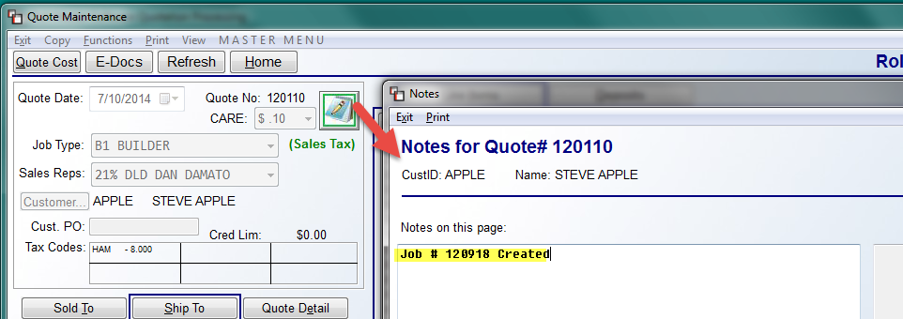

Additionally, the Quote that was copied will automatically close so you will have no more maintenance to perform in that program, but the history will remain in the Quotation Maintenance module and the closed Quote can even be opened again if applicable to be copied to another new Quote.

An additional feature in the Functions drop-down menu is the following option: Copy to New Quote. This feature can only be accessed from an Open Quote. A Closed Quote can be opened through the Open Quotes Closed in Error module, accessible from the Management Functions menu. When you click on this option from an Open Quote, the system will prompt the following:

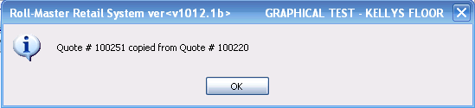

When you click the OK button, the system will return you to the main Quotation Processing screen and place the cursor at the Quote # field, which will default to the new Quote #. Click the View Quote button to access the new Quote and make any applicable changes to continue processing.

