Web Portal Client Side Processing

Main Screen Login & User Admin:
The main login screen, once setup is complete, will appear as follows:
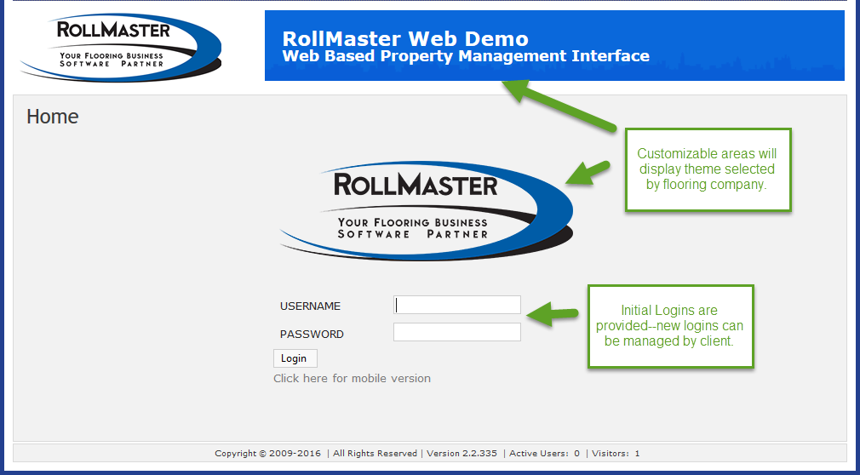
Clients have 24/7 access to this Web Portal. Each Login ID can be customized to control what each User can see, including which properties they have access to—some or all, and what they are able to see and do on the billing side. Each property is setup according to provided floorplans.
The first screen to display upon login will appear as follows:
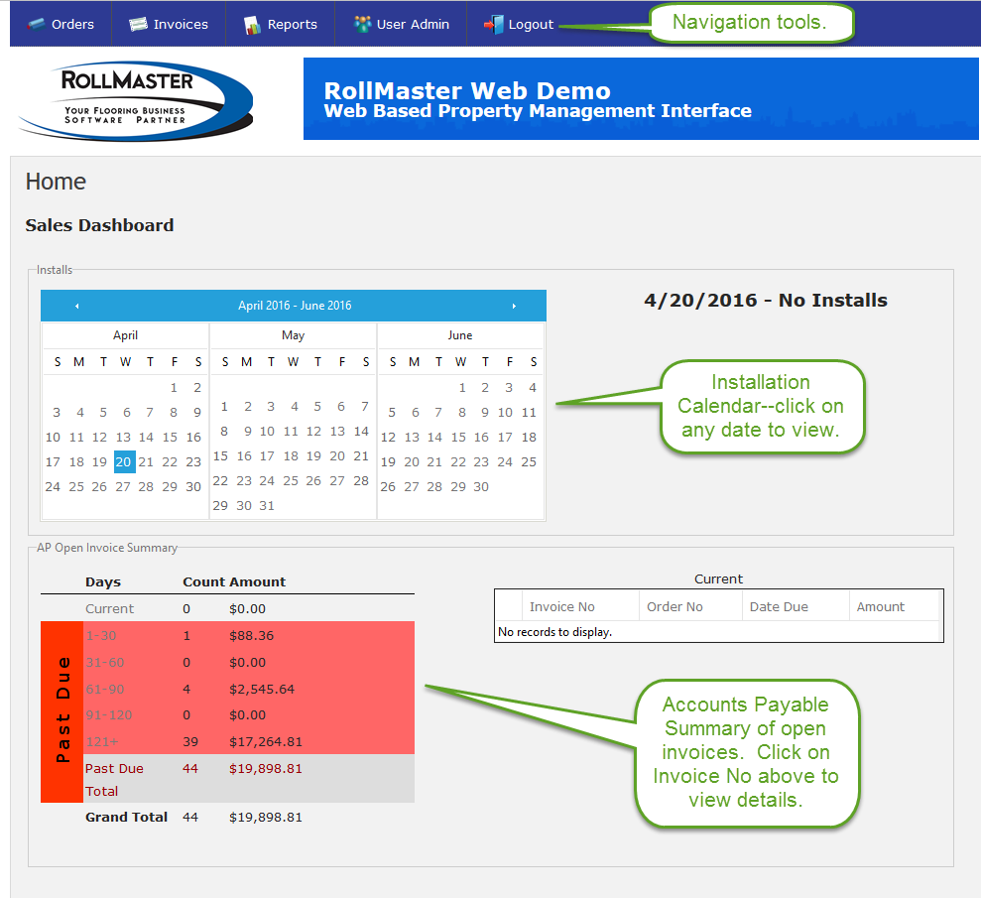
As stated above, you can control which Users see the Sales Dashboard, displayed above, as well as other pages/options within the Web Portal. To manage/add/delete Users, click on the User Admin navigation button at the top of the screen. You will first see a list of current Users as follows:
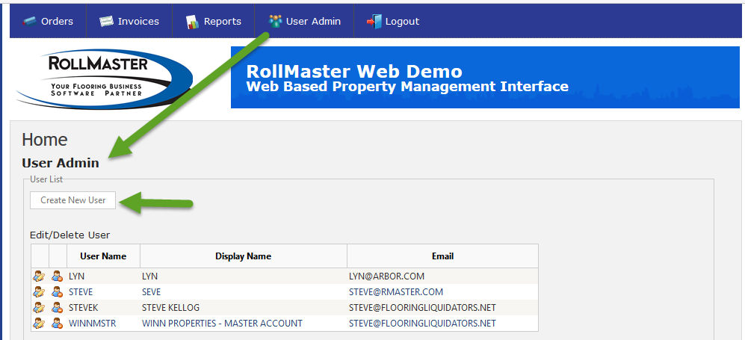
Click on an existing User to Edit/Delete, or click the Create New User button to add a new User. The portal will then prompt a New User screen as follows:
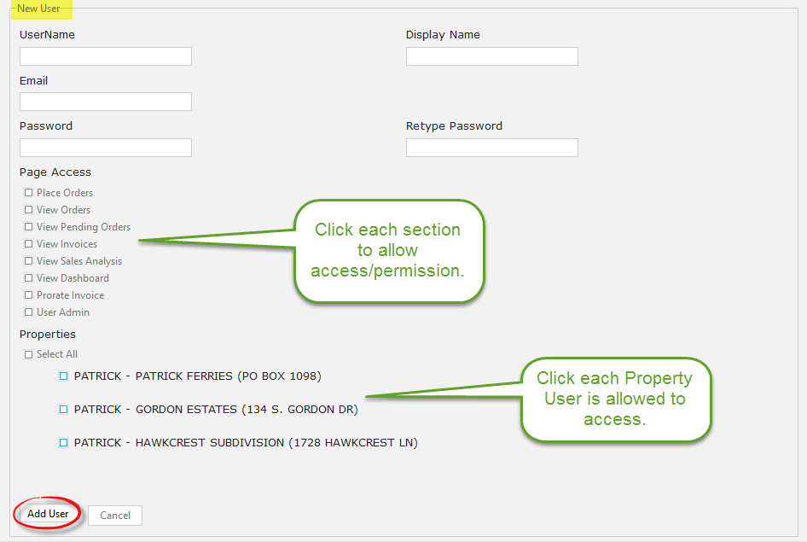
Fill in the fields at the top, click on all applicable Page Access options, select all applicable Properties for the User, and then click the Add User button to complete. This same screen will display for existing Users for you to make any changes or Delete the User.

Place Order:
To begin placing a new order, click the Orders navigation button, select Place Order from the drop down list, and the portal will display a Place Order screen as follows:
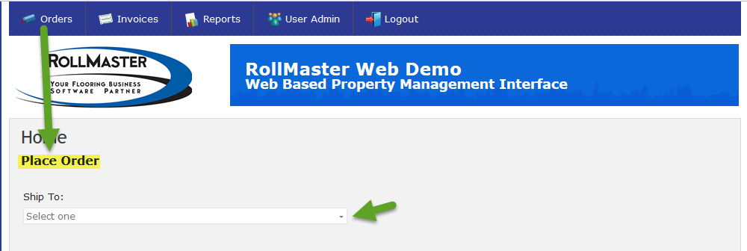

Click the down arrow button in the Ship To field to select a Property from the list. Next, click the down arrow button in the Unit Type field to select an applicable Type, as indicated below:

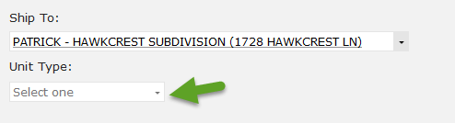

A Place Order screen will display as follows:

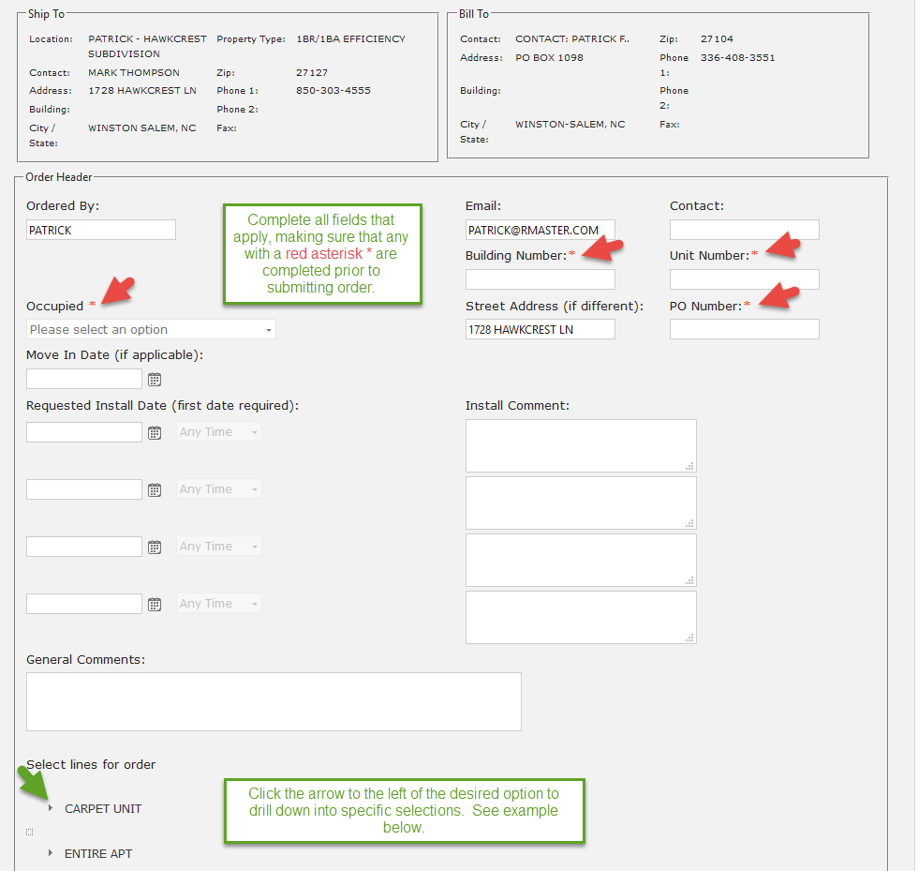
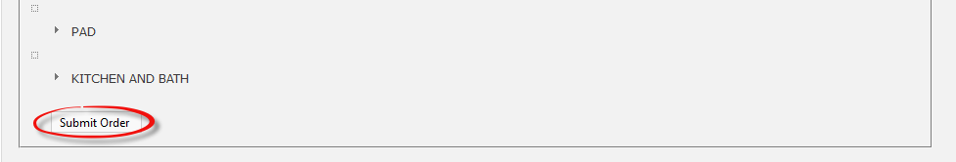

When you click on the arrow to the left of each option, the portal will open up new selections as follows:

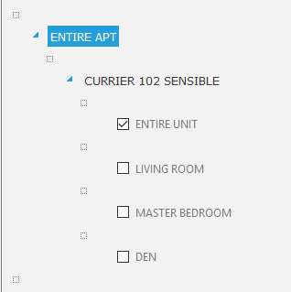

Click any selections that apply to the order, then click the Submit Order button to finalize. An email reply will be generated back to you when the order is received. Any changes from this point on must be phoned in, and any issues with the order, once received, will also be addressed with a phone call back to you.

Pending & View Orders:
An order is considered “Pending” in the Web Portal as soon as it is submitted. It only means it has been received into our system, it does not mean it has been processed. Once an order is being processed, it will move to the View Orders screen. To view Pending Orders, click on the Orders navigation button and then select Pending Orders. The portal will display a Pending Orders screen as follows:

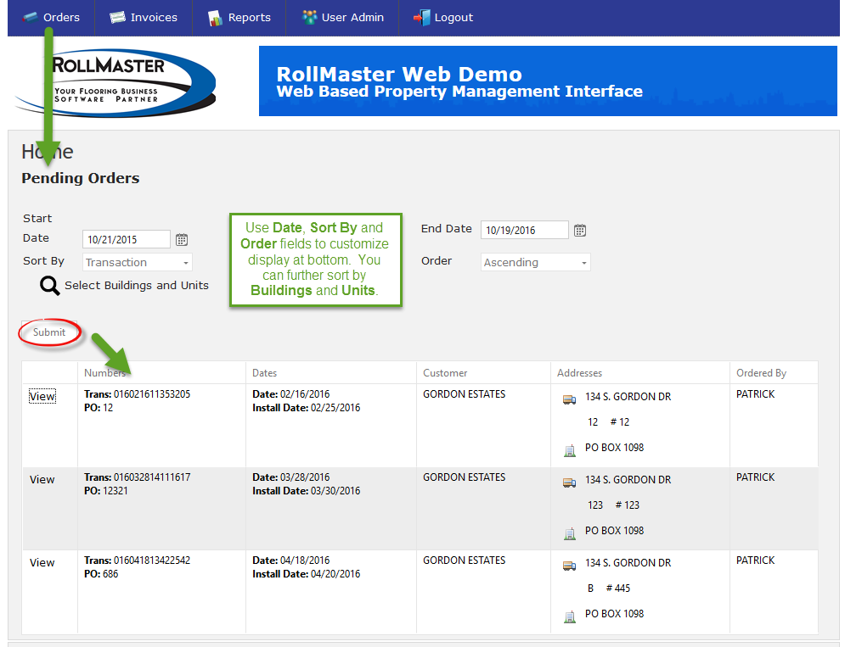

To see all Pending Orders, leave the default settings. The Start and End Date fields will automatically prompt at six months prior and six months past the current date. If you make any changes to the fields above, make sure you hit the Submit button to change the display.

Once an order has started processing, it will be moved to the View Orders screen, also accessible from the Orders navigation button. The Pending and View Orders screens look and work the same. The View option that appears along the left column of the Orders display screen will pull up detailed information on each Order as follows:

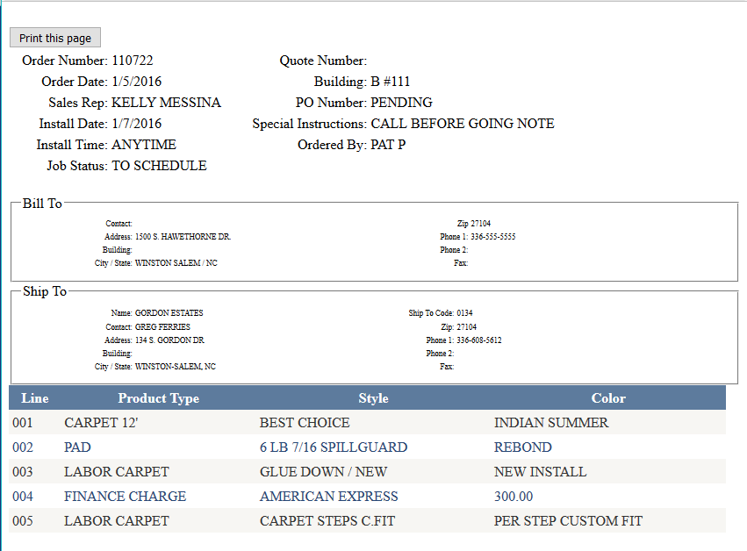

You can print a copy for your records, if needed.

View Invoices:
Once an order has been completed for the Web Portal, an Invoice will be generated and can be viewed via the View Invoices option, available from the Invoices navigation button. The screen looks similar to the View & Pending Orders screens, but with additional features. The View Invoices screen appears as follows:

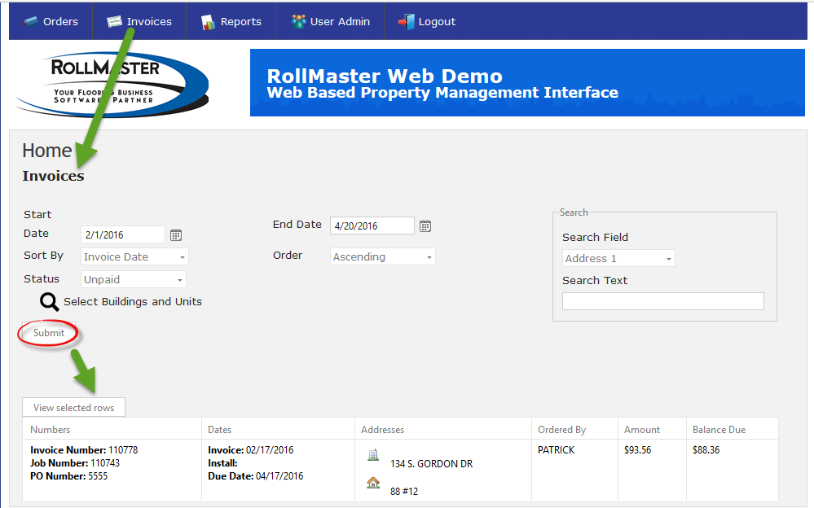

The screen above will list all Invoices that meet the parameters selected in the fields above. The Status field allows for displaying Unpaid, Paid, or All Invoices. You can also use the Select Buildings and Units option to narrow a search for a specific property and unit. Additional search options can be found in the Search box, allowing you to type an Address, Invoice #, and even an Amount, among others. Click the Submit button to display Invoices in the screen below. From the list of Invoices, you can highlight a row and then click the View selected rows button to display the full Invoice as follows:

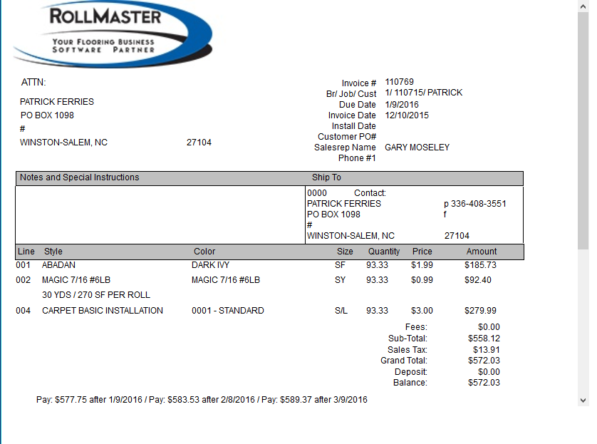

If needed, Invoices can be exported to either Excel or saved as a PDF.

Prorate Invoices:
This feature, also available from the Invoices navigation button, was designed to allow for billing of a tenant for damage to the flooring and/or apartment. This screen looks almost identical to the Invoice screen with one exception. It appears as follows:

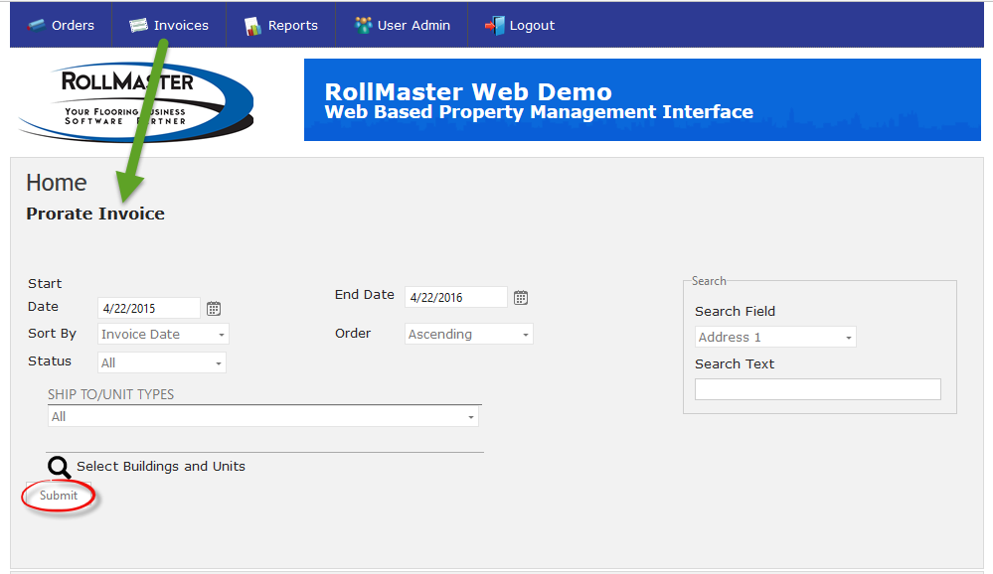

The difference here is the SHIP TO/UNIT TYPES search option. This feature allows for searching by Unit # (to determine the last time flooring was replaced in the tenants unit) or by Unit Type (to located the Invoice flooring was replaced in this type of unit). Click the Submit button to display matching Invoices. When the applicable Invoice has been located, click the Prorate option to the left of the Invoice. The Web Portal will prompt a Prorate screen as follows:

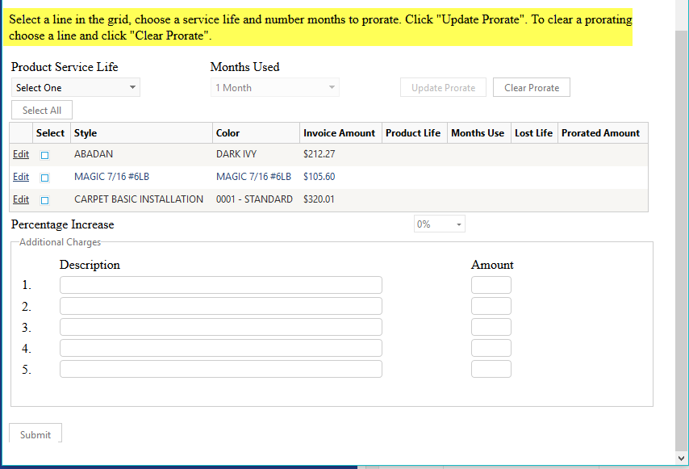
The flooring items replaced will appear in the screen above. If only the carpet is damaged, you will click in the Select column for only that item. You will then determine the Product Service Life, say 60 months, the actual Months Used, and then click Update Prorate to allow the Web Portal to calculate the amount to bill the tenant. Additional features include adding a Percentage Increase for the current replacement cost, and/or adding Additional Charges for damage such as holes in walls or pet damage and a corresponding amount. The following is an example:

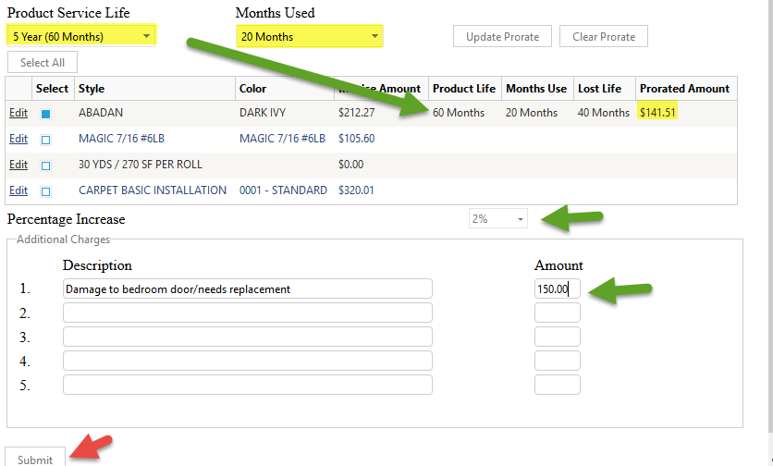

Click the Submit button to generate a Prorated Invoice as follows:

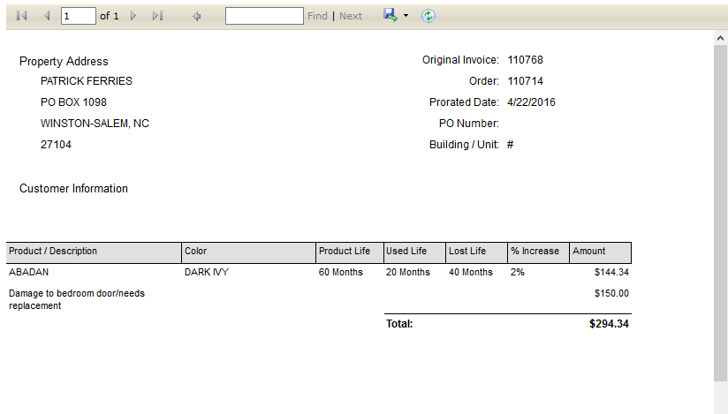

Sales Analysis:
One additional feature of the Web Portal is a feature to view Sales Analysis data of all jobs that have been completed through the Web Portal. This feature can be found under the Reports navigation button. The Sales Analysis screen appears as follows:

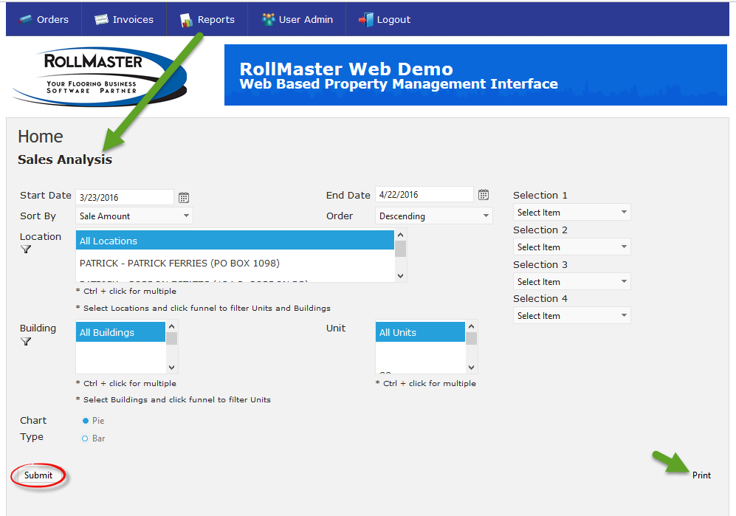

The various fields allow for analyzing data based on a variety of parameters to help with planning and other business decisions. You will need to Select an Item in from at least the Selection 1 drop down menu before clicking the Submit button, but you can use all four Selection fields to drill down into analysis, such as, Salesperson, Product Type, Style, and Color. The analysis screen will appear as follows:

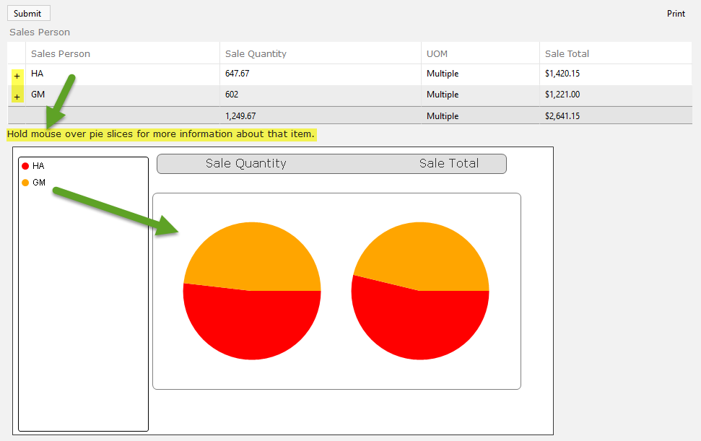

If more than one Selection was made, click on the “+” symbols in the column furthest to the left. You can also hover the mouse over different areas of the Pie or Bar display to see more info. When you click on the “+” symbol, the next level of analysis will appear as follows:

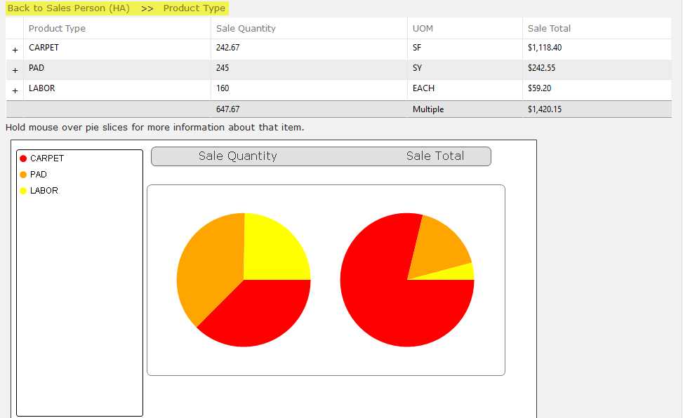

Click on the Back to… section at the top to return to the previous screen, or continue to click the “+” symbol to continue drilling down on the analysis data. The Print option will allow you to print the current data displayed on the screen.

