PM Web Portal Configurable Options

General
Currently there are 4 general customizable areas. In the top bar the Home and Contact buttons can be pointed to any location URL or MAILTO address.
The title text and subtitle text is also customizable. These items will show on all pages.
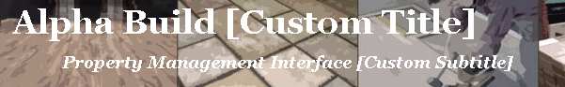

Login
There are two customizable text blocks and an image. The text blocks are above and below the login box. The login image can also be changed.
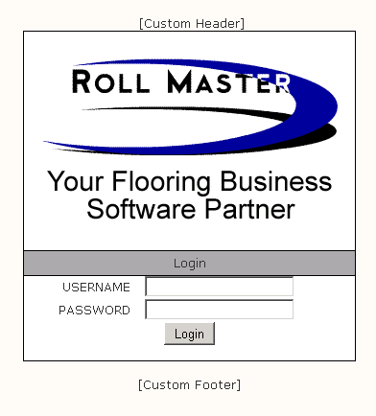

Place Order
The Labor and Material lines that do not have a Webname entered for them will be placed in a category automatically by default. The categories can be set per portal. The default is 'Labor' and 'Materials'.
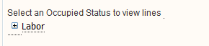
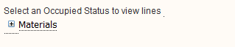

Invoice Detail
A header and footer image can be displayed on the invoices.