PM Client Side Web Portal Setup

Website Setup:
A designated link can be provided to your Property Management clients to access the Web Portal. That link is as follows: http://portal.rmaster.com/XXXXXX/
You can also create a “Login” button on your existing website that will allow clients to login from there. In Addendum A below, you will find those external login specs. This may be the easiest for your customers to simply go to your website and login “on the top right corner,” etc. You also have the ability to create a “Request Login” option for new prospective clients to inquire about getting up and running with you on their own Web Portal interface.
The Web Portal appearance can be customized to mirror your existing site, or you can select from several standard color schemes. Please see Addendum B below for possible color schemes.
In addition to the color scheme, there are four other customizable areas on the client side Web Portal. They are as follows: Navigation Buttons and Title/Subtitle areas, Login text blocks, Material & Labor default category names, and Invoice Header & Footer images. Please see Addendum C below for examples.

Marketing & Rollout:
- Marketing
  - Consistent messaging throughout the company
  - Entire Order desk should be well versed on client-side entry so they can explain it to clients. Make one person the point person.
  - Send marketing flyer and email blast
  - Salesperson –
    - They all need to be versed and able to give a 30-60 second “elevator pitch”
    - Icon should be on all of their cell phones for the 30-second pitch. They should have demo account to roll through
    - If any salesperson cannot handle that, make them a flip chart
    - Conduct sales meetings so they are versed on the pitch, objections, etc.

- Rollout
  - Pick 2 clients to start and get them all setup. Train, follow up, and give tons of attention. This is key to getting it started.
  - Once you have 2 up and going, then rollout more as salespeople generate interest.
  - Consider customer incentives to get them to order online. Think limited time promos, gift cards, contests, etc. You are trying to generate excitement and get the clients to try it. Overall it can help cement client relationships, so there are lots of reasons you want to get this going.

ADDENDUM A – External Login Specs:
Applies to Version 1.1.183 or newer
External Login Form Compatibility

Data:
Login information can be passed directly to the BMS Web Portal login page using either query strings or form data. 3 fields are required for a complete transaction.
Username | String | String value representing the login name for the user that is logging in. Value passed is case sensitive.
Password | String | String value representing the password for the user that is logging in. Value passed is case sensitive.
AutoLogin | Integer | "1" is passed when passing values to the page through an external form

Methods
Querystring:
Example Query String
http://portal.rmaster.com/XXXXX/login.aspx?username=johndoe&password=1234&autologin=1

Form data:
Example Login Form
<!DOCTYPE html PUBLIC "-//W3C//DTD XHTML 1.0 Transitional//EN" "http://www.w3.org/TR/xhtml1/DTD/xhtml1-transitional.dtd">

<html xmlns="http://www.w3.org/1999/xhtml">
<head>
<title>Login Template Form</title>
</head>
<body>
<form name="Form1" method="post" action="http://portal.rmaster.com/ XXXXX /login.aspx">
<input name="autologin" type="hidden" value="1" />
<table width="200" align="center" cellpadding="2" cellspacing="0" style="background: white;">
<tr>
<td align="center" colspan="2">Login</td>
</tr>
<tr>
<td style="padding-left: 10px;" align="left">USERNAME</td>
<td><input name="username" type="text" style="width:150px;" /></td>
</tr>
<tr>
<td style="padding-left: 10px;" align="left">PASSWORD</td>
<td><input name="password" type="password" style="width:150px;" /></td>
</tr>
<tr>
<td align="center" colspan="2"><input type="submit" name="submit" value="Login" /></td>
</tr>
</table>
</form>
</body>
</html>

ADDENDUM B – Web Portal Color Schemes:
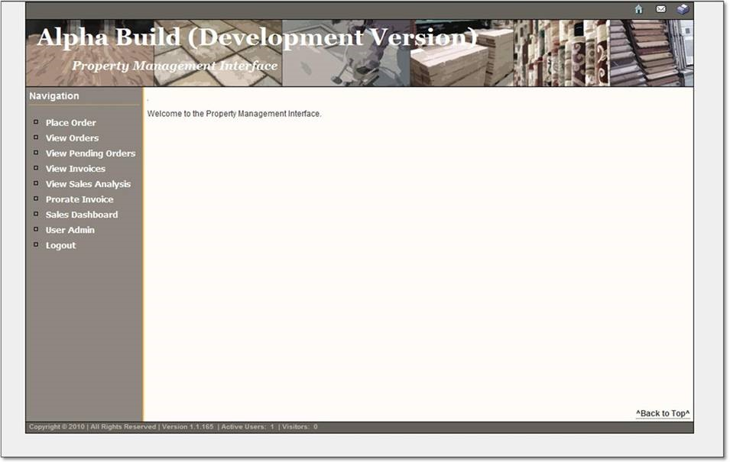

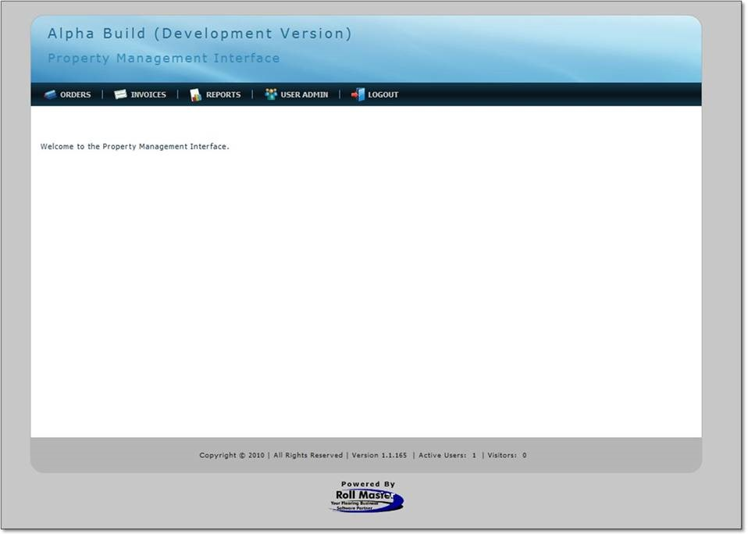
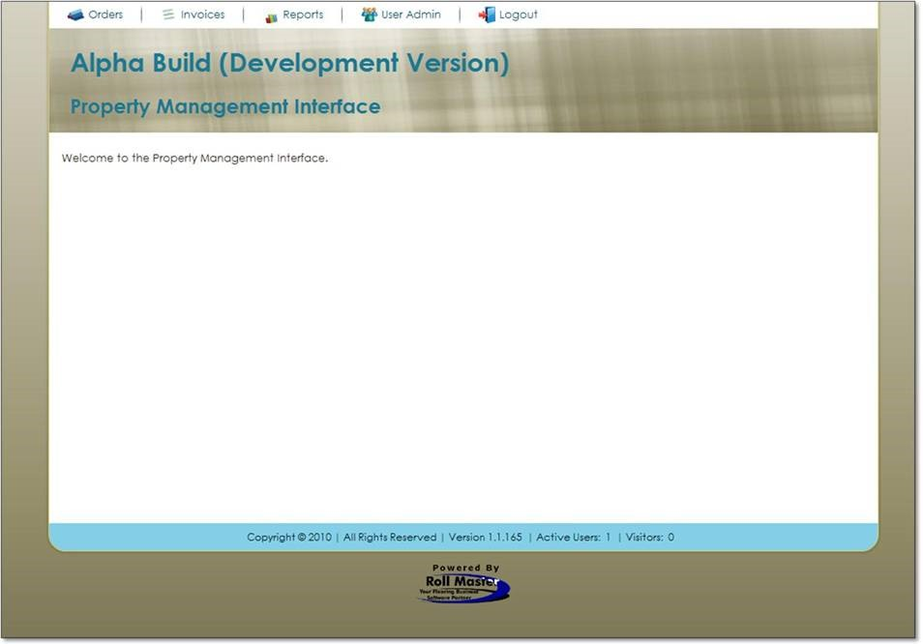
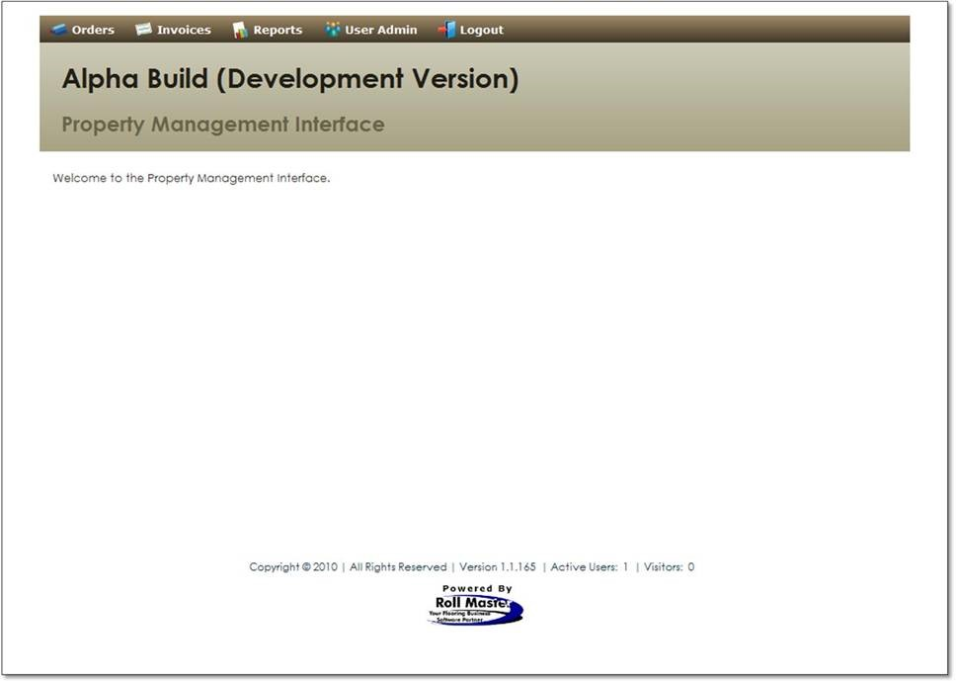

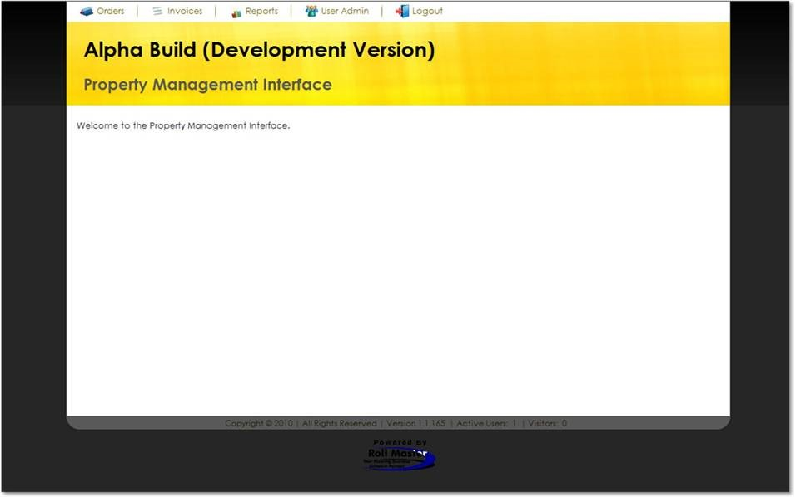

ADDENDUM C – Customizable Web Portal Areas:
Navigation Buttons & Title & Subtitle Text:
Along the top bar, the Home and Contact buttons can be pointed to any location URL or MAILTO address.
The Title text and Subtitle text are also customizable. These titles will show on all pages.
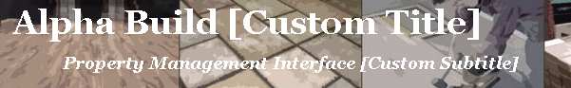

Login:
There are two customizable text blocks and an image. The text blocks are above and below the login box. The login image can also be changed.
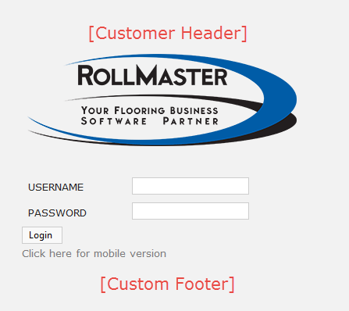

Place Order
The Labor and Material lines that do not have a Webname entered for them will be placed in a category automatically by default. The categories can be set per portal. The default is 'Labor' and 'Materials'.
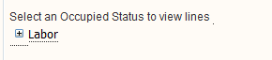
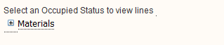

Invoice Detail
A header and footer image can be displayed on the invoices.




