The final two options available in the Report Format Maintenance module can be found under the Functions menu located at the top left of the main screen. When you click on that menu, two options will appear as follows: Verify GL Accounts and Print Report Records. Once you have finished formatting all reports, you should run the Verify GL Accounts option to make sure all General Ledger Account Numbers appear in one of the reports. If the system finds one that has not been used, it will prompt the following:

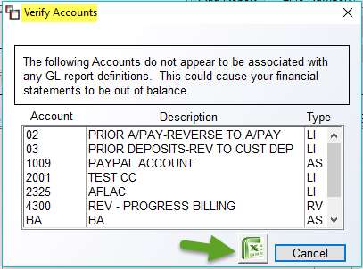

To export a list of accounts, click the Excel icon, or make a note of any accounts that need to be added to one or more of the reports and then click Cancel to return to the main screen. The Print Report Records option will prompt a General Ledger Report Format Listing box as follows:

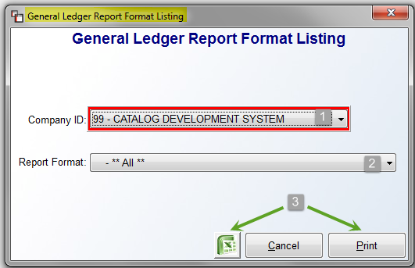

The Company ID (1) will default to the current company. If using multiple companies on BMS, switch to another company via this field, when applicable. At the Report Format (2) field, you can keep the **All** default to print the format listing for all reports, or you can use the drop down arrow to select a specific report. To export the report detail, click the Excel (3) icon. To print to paper, click the Print (3) button. To exit without printing, click the Cancel button.

