Account Maintenance/Inquiry:
Initial set-up of your system Chart of Accounts has been completed for you. You will only utilize this module to add or edit G/L accounts and also to view archived data for closed periods/years for existing accounts numbers. You will also access this module to convert to the Date Driven G/L posting method.

When you enter this module, the screen will appear as follows:

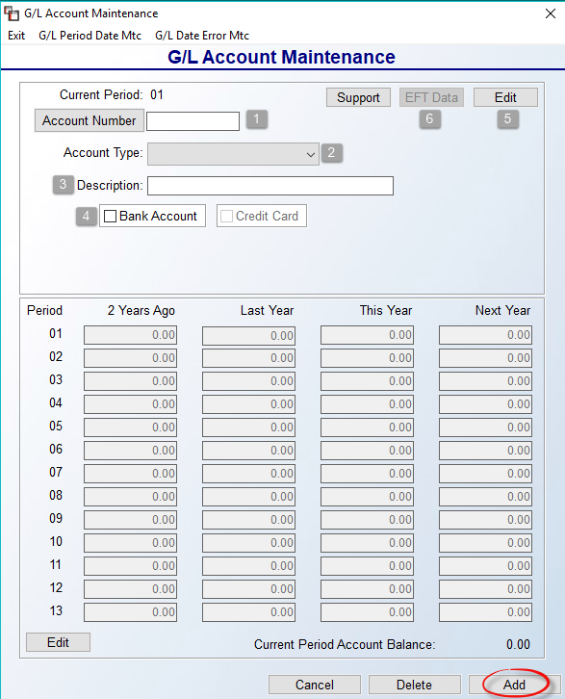

The Current Period field at the top left will display the earliest open period in the system G/L. To add an account, type the new number in the Account Number (1) field. You can use up to eight digits in this field. You can also use a period or hyphen to denote a sub-account. If you are deleting, changing, or inquiring about an account number, you can click on the Account Number button to call up a G/L Account Selection box—see additional details below. At the Account Type (2) field, use the drop down arrow menu to select the type of account you are adding. There are five possible account types as follows: AS = Asset Account (carries a Debit balance), LI = Liability Account (carries a Credit balance), EQ = Equity account (carries a Credit balance), RV = Revenue or Income Accounts (carries a Credit balance), EX = Expense and Cost of Goods accounts (carries a Debit balance). Please Note: once an account has been added to the system G/L, you cannot change this field. If you need assistance with this, please contact BMS support via email at BMSsupport@Broadlume.com.

At the Description (3) field, type the name of this account. This information will appear on the printed Chart of Accounts. Please Note: if the G/L account you are entering is a Bank Account or Credit Card account, or if it needs to be used as a Payment Type Code for posting payments, you will need to check the applicable box next to those options. The system will then display additional fields based on your selection. If you check Bank Account (4), you will see the following additional fields:

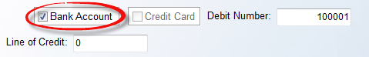

The default Debit Number will be 100001. This number will be automatically assigned and updated sequentially to each Hand Check or Electronic Payment processed in the system. The system will prevent any duplicate numbers. The Line of Credit field is used to record the maximum amount available to draw against, such as “40000.” This amount will display in the Bank Reconciliation module.

Prior to adding a Credit Card Account, you must first make sure the Account Type is set to “Liability.” The system will prompt new field descriptions just below that box as follows:

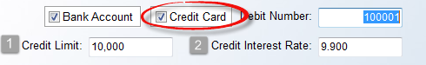

The Credit Limit (1) field should contain the maximum credit available on the credit card. The Credit Interest Rate (2) field is used to record the interest rate for the card and will display in the Bank Reconciliation module, along with the Credit Limit field.

Be sure to click the Add button at the bottom of the screen once the new Account Number has been entered properly. You can continue to add G/L Account numbers in this screen. When you have finished, click the Cancel button or the Exit button at the top left to return to the General Ledger menu.

To edit or view an existing account, click the Account Number button to call up a G/L Account Selection box as follows:

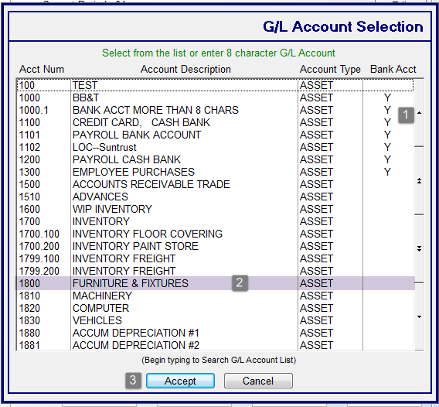

Scroll through the list of existing G/L account numbers using the up and down arrow keys along the right side (1), or begin typing the G/L number directly in this screen to sort the data to display the closest match. Once you have located the G/L Account Number, highlight (2) it and click the Accept (3) button at the bottom of the screen, or double-click on the account. The account number and any financial data will display in the G/L Account Maintenance screen. Click the Edit (5) (in first screen shot above) button to edit the Description, Bank Account or Credit Card fields. All other fields are not accessible.

The EFT Data (6) button at the top right is to be used in conjunction with A/P EFT Vendors. If this does not apply, you can disregard. However, if you plan to set up any Vendors for payment via EFT, you will need to identify any G/L Accounts used for EFT payments via this module. When you enter an Account Number that is also identified as a Bank Account, the EFT Data button will become available. When you click on that button, a General Ledger EFT Data Maintenance box will appear as follows:
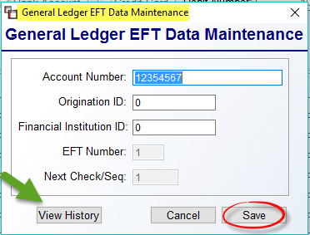

Complete the Account Number, Origination ID, and Financial Institution ID fields and then click Save to keep the data. For existing Accounts, you can view history via the box above by clicking the View History button. The history data will appear as follows:

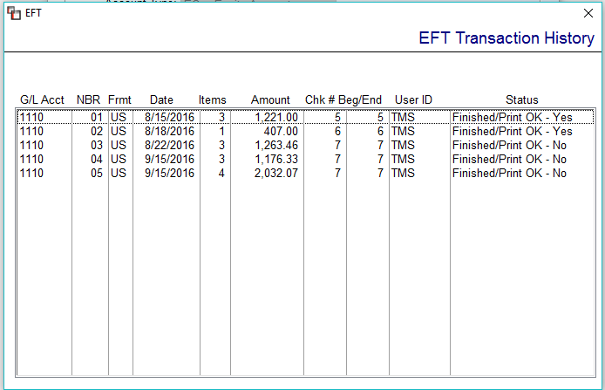

The remaining fields in the G/L Account Maintenance screen are for display only. If changes are needed to the financial data displayed in any of the “Years” columns for an account, contact BMS support for assistance. For information purposes, the first column of numbers (01-13) are accounting periods. The second column is for account balances by period for 2 Years Ago. The third column is for account balances by period for Last Year. The fourth column is for account balances by period for the current year (This Year). And the fifth column is for account balances by period for the Next Year.

To delete an existing account, click on the Account Number button and locate the applicable Account Number. Once the Account Number is displayed in the screen, click the Delete button at the bottom right. The system will then prompt the following: Are you sure you want to delete? Click “Yes” to delete the account. Please Note: the system will not allow you delete an account if there has ever been any non-zero activity recorded, even in prior closed periods/years.

