End of Year (EOY) Processes in BMS Software

This article contains general guidelines for performing End of Year processes in your BMS System. Webinars are available from prior years, but steps are the same, so they can be used as a visual guide.

 The processes listed below for BMS End of Year include:
- Preparation & Clean Up
- Reconciliations
- Tax Prep
- Last Day of the Year
- Close of Current Year

Prevent Merging of Years

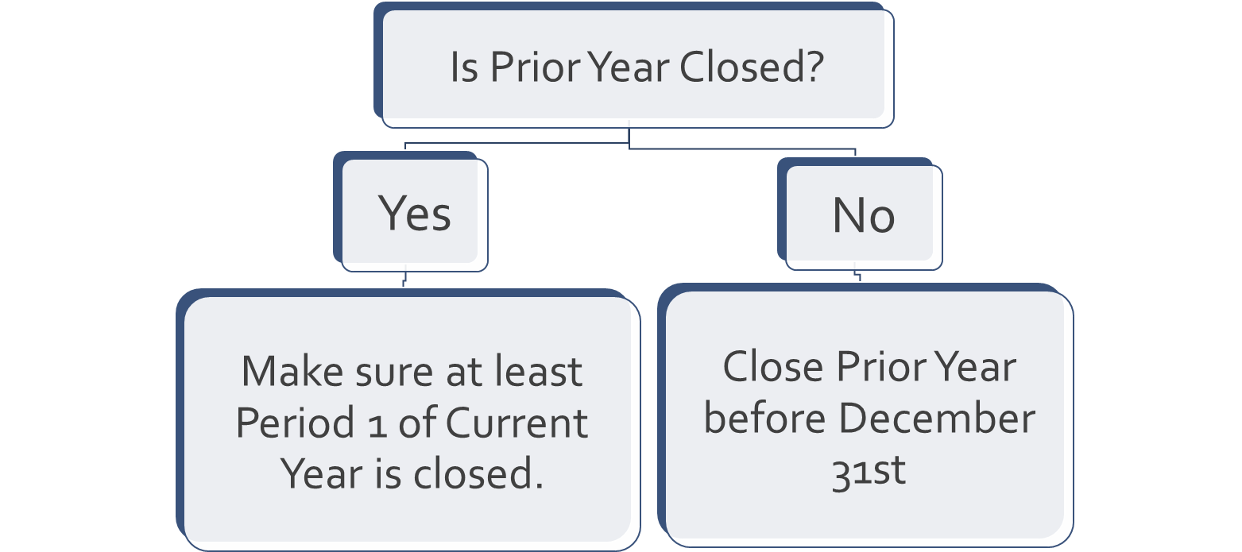

Invoicing
- Invoice all completed jobs
- Work in Process Costs from JC
- Open Order Screen Review
- Open Order Report – look for shipped lines
Purchase Orders
- Print Open PO Report to Excel
  - Sort by Amount Received
  - Sort by Estimated Arrival Date
  - Close any POs that need to be closed

Inventory
- Inventory Purge
- Perform physical inventory/cycle count
  - Make necessary adjustments
- Audit report adjustments done?

Accounts Payable
- Print AP Open Invoice Listing to Excel
  - Sort by due date – oldest to newest
  - Look for small balances
  - Delete obsolete invoices
- Print Receiving Report by Product Type (AP Not Invoiced) and research older Received PO’s

1099 Preparation
- Print AP Vendor Listing to Excel
  - Sort by Vendor Type
  - Installers = SUB
  - Other 1099 vendors (rent, interest, dividend, etc.) have Vendor Type
- Do all 1099 recipients have SS/FED ID #?

Accounts Receivable
- Print A/R Aging Standard Report
  - Look for zero balances
  - Look for small balances
  - Look for non-collectable accounts

Balance Sheet Reconciliation
- Clear Invoice Register and Post Journals
  - Trial Balance – in balance?
  - A/P, A/R, Customer Deposit Agings match G/L?
  - Installer Listing match Retainage & Installer Loans?
- Reconcile other balance sheet items
- Bank reconciliation zero to G/L
- Review other balance sheet accounts for accuracy

Last Day of the Year--December 31st
- Clear Invoice Register and Post Journals
- Regular Month End functions (see Month End Checklist)
- Change Default Posting Period to 1 (Disregard if Date Driven GL is set up)
- Save reports to PDF or Print

After Last Customer Invoice
- Print Work in Process Costs from JC to Excel and save
- Print A/R Aging As of 12/31/current year and compare to Trial Balance G/L for A/R
- (Date Driven) Change Allow Posting Period Sales Processing and A/R to Period 1 next year -- see right side of screenshot below:
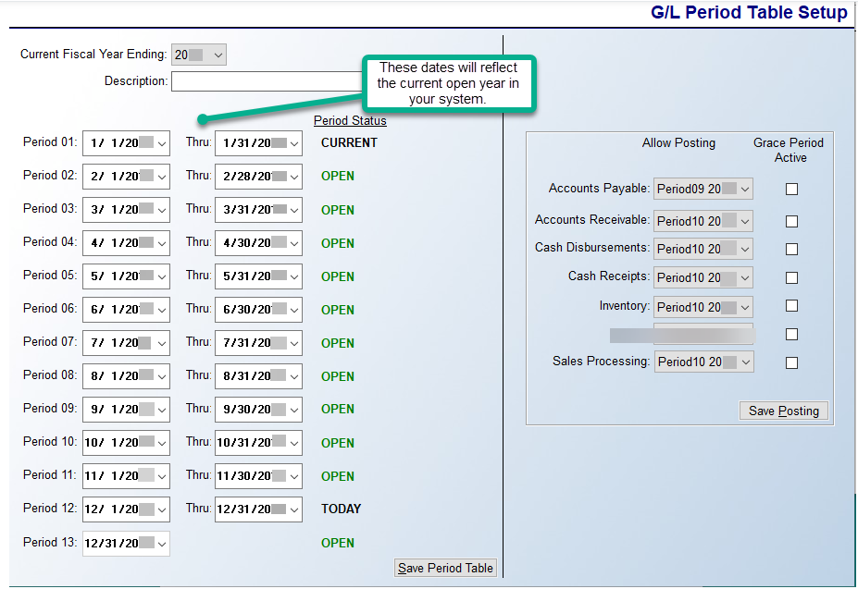

After Last A/P Invoice
- Print A/P Aging As of 12/31/CY (current year) and compare to Trial Balance G/L for A/P
- (Date Driven) Change Allow Posting Period Accounts Payable to January next year

Reconcile Inventory
- Trial Balance + Receiving Report by Product Type (A/P Not Invoiced) + Audit Report = Inventory Valuation
  - Make Journal Entries to make G/L match Inventory Valuation
- (Date Driven) Change Allow Posting Inventory to January next year
Reconcile Bank and Credit Cards
- Zero balance to G/L
- (Date Driven) Change Allow Posting to Cash Receipts and Cash Disbursements to January next year

Print 1099’s
- Print 1099’s to plain paper
- Verify company’s legal name, address, phone number and FED ID are correct
- Email support@rmaster.com to correct
- Print Vendor History by G/L Account COGS Labor and compare to 1099

Tax Prep
Once financials are given to the CPA for tax preparation:
- Hard close through period 12 in current year
- Period 13 is to remain open for CPA adjustments

After Taxes are Filed
- Enter CPA adjustments into Period 13
- Make journal entries in BMS to match CPA trial balance
- Verify BMS trial balance matches CPA trial balance
- CLOSE 20CY in BMS
- Reclassify current earnings to retained earnings
  - Journal Entry Period 1 20CY
- Adjust Distributions to Retained Earnings -- this reduces Retained Earnings
  - Journal Entry Period 1 20CY, if instructed by CPA

Questions?
Please contact BMS Support at support@rmaster.com

