

Table of Contents

Purchase Orders 1
Introduction: 1
PO Line Items—Add/Edit: 7
Right-Click Options from PO Line: 14
Order: 14
Receiving: 15
View Existing Inventory: 21
View Catalog Item: 24
View Reserved Items: 24
Generate B2B Line: 25
PO Line Notes: 25
Change Line Item: 25
Cancel/Close Line: 25
Menu Items/Buttons—Main Screen 26
Functions Menu—Main Screen 28
Ship Via Code Maintenance: 28
Purchase Order Receipt Adjustments: 29
Open PO’s Closed in Error: 31
Freight Terms Maintenance: 31
PO Ship To Address Maintenance: 33
Print Reports 34
P.O. Receipt Adjustments Audit Report: 35
Open P.O. Report: 35
Open P.O. Report (for Faxing): 37
Print Purchase Orders: 37
Receiving Reports: 38
Menu Items/Buttons--Purchase Order Screen 40
Functions Menu—Purchase Order Screen 40
Cancel / Close: 41
Generate B2B PO: 41
Cancel B2B PO: 41
Import Barcode: 41
Copy PO to New PO: 41
Copy PO to Other Branches: 42
PO Item Receipt Adjustments: 43

***CONFIDENTIALITY NOTICE*** This documentation contains confidential information belonging to broadlume and Business management software (bMS), which is protected by copyright laws and other privileges. This information is intended for the exclusive use of legally licensed BMS users. If you are not the intended recipient, you are hereby notified that any disclosure, copying, distribution, or the taking of any action in reliance on the contents of this information is strictly prohibited. If you have received this documentation in error, please email us at support@rmaster.com.

Purchase Orders

Introduction:
The Purchase Orders menu item contains programming designed to manage the purchasing and receiving of material in the BMS System. The Purchase Orders system is integrated with the Order Entry module so that special order Purchase Orders (PO’s) can be created from within a job, but ordered and managed via this menu. It is recommended that you familiarize yourself with creating a PO from the Order Entry module before you review the Purchase Orders section of this manual.

The entire Purchase Orders system, including all modules and reports, has been consolidated into one graphical program containing all of the functionality and reporting needed for PO management, including Receiving. When you click on Purchase Orders from the Master Menu, the system will first prompt you to select a printer, and will then prompt a BMS Purchase Order Processing screen as follows:

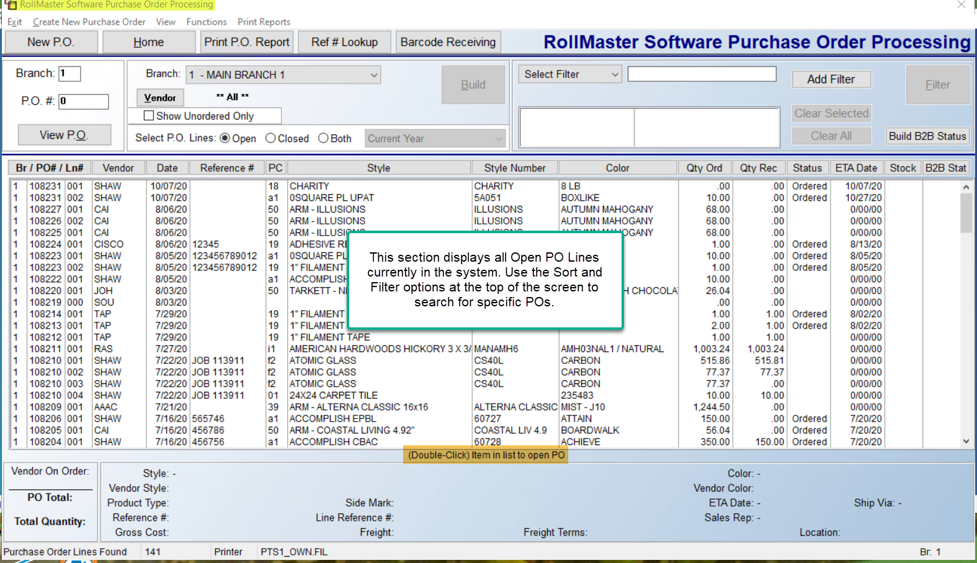

Any data you see in the screen above are all Open PO Lines, created either from Order Entry or Purchase Order Processing. Any open PO’s containing no PO Lines will display “000” in the Ln# column to the far left of the display. The screen above works much like the Quote and Order Entry screens in terms of being able to sort the lookup using filters and sort options at the top of the screen. Those options will be explained in the order they appear in the screen shot below:

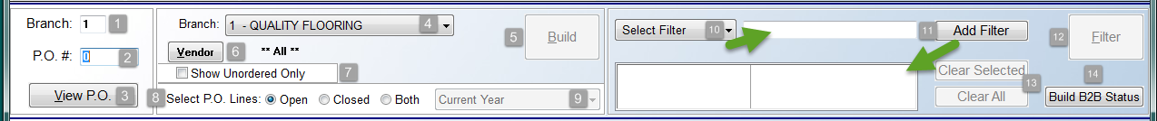

The Branch (1) field at the top left will display the current Branch. If you know the exact PO # (2), you can type in the applicable Branch and PO # in those fields and then click the View PO (3) button to call up that specific PO. If you don’t know the exact number, you should skip these fields and use the expanded Filter options in the section to the far right. The Branch (4) field that appears in the next section has a drop-down arrow menu and will allow you to switch to ALL Branches, or any other available Branch before selecting additional sort options. If you make a change to this field or any other fields in this section, be sure to click the Build (5) button to refresh the data in the screen below. The Vendor (6) button option will default to ** ALL **, but you can select a specific Vendor using that button. If you wish to see only PO Lines that have not been ordered, click the Show Unordered Only (7) box before clicking the Build button. The last option, Select PO Lines (8), will default to Open, however, you can select to view only Closed PO Lines or Both Closed and Open PO Lines by clicking either of those options. If you select either Closed or Both, you will then have the ability to narrow the PO Line search by Year (9), via the drop-down menu to the right of the Both option. The default for this option is “Current Year.” To change the search, click the down arrow to select from the following: Last Year, Last 2 Years, Last 3 Years, Last 4 Years, Last 5 Years and All. If you make a selection from the drop-down menu other than the default, be sure to click the Build button to refresh the data in the screen below.

In the box at the far right, you will see a Select Filter (10) drop-down menu. This option can be used to further narrow your PO Line search. You can select multiple Filters to narrow your search. In the example below, a “Product Code” filter was selected from the drop-down menu and “01” was manually typed in the field to the right. The Add Filter (11) button was then clicked to display the new Filter Description in the box directly below the Select Filter field. A second Filter Description consisting of “Style #” and “1674” was then entered, which is what you see in the example below:

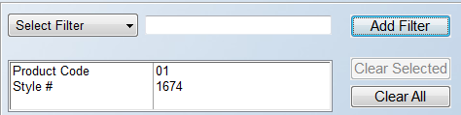

Prior to clicking the large Filter (12) button to the far right, you can highlight any programmed Filter Description and click the Clear Selected (13) button to cancel, or you can click the Clear All button at any time to remove all Filter Descriptions and start over. When you have the applicable filters entered, click the Filter button and the system will search through all the existing data and display any matching results in the screen below. One recent Filter option addition, Install Date, allows for searching and printing PO’s containing “related items” to Accumulator Code scheduled Labor Lines within a selected date range. For example, if a Carpet Labor Line is “related” to the carpet material, carpet pad, and any other supplies, this Filter will find those PO’s. This also works on the Open PO Report.

The remaining option, Build B2B Status (15), will only be used by B2B clients. When this button is clicked, the system will search for updates from B2B Suppliers and update this screen accordingly by displaying data in the B2B Stat column. You will commonly see “SN” for Shipment Notification, and other status’ relating to sending B2B PO’s.

Another way to sort data from the PO Lines display box, is to click any of the Column Header buttons along the top of the PO Lines display screen to re-sort the data by that criteria. For example, if you click the Date column button, the system will re-sort the lines by the oldest date to the newest date. If you click that button again, it will reverse the sort. You can click any of the buttons multiple times to allow you to locate a specific PO Line. There is also a scrolling tool at the far right of this list that will allow you to quickly scroll up and down through the list.

Once you locate a PO Line in the display screen, you can place the cursor on that line, or any line—with the exception of a “000” line—and right-click on the line to prompt a list of options as follows: Order or Unorder, Receiving, View Inventory, View Catalog, Vendor Maintenance, PO History Inquiry, PO Notes, PO Line Notes, & Cancel/Close Line. For B2B Vendors, one additional option will prompt as follows: Check for B2B Lines. This allows the system to check for new B2B Import files while in this screen and update the PO. Many of these options can also be accessed from other areas within the Purchase Order module, but have been placed here for convenience. PO’s without any existing PO Lines will display “000” in the PO Lines display list. On “000” lines, you can right-click on that line to bring up the following options: Vendor Maintenance, PO Notes, Cancel/Close Line, & Close PO. The Close PO option will allow you to clean up any “000” lines from this lookup screen.
Along the bottom of the main screen, when you highlight a specific PO Line, pertinent data will appear in the screen as follows:

The Vendor On Order amount will reflect your total amount On Order with the Vendor. The PO Total will reflect the total cost of the entire PO. The Total Quantity will reflect the total Work Quantity on the selected PO. The right side of the screen reflects data specific to the PO Line and the Order it is tied to, if applicable.
When you have located the PO Line you wish to edit or view, double-click on the line to open the entire Purchase Order. The system will display a Purchase Order Maintenance screen as follows:
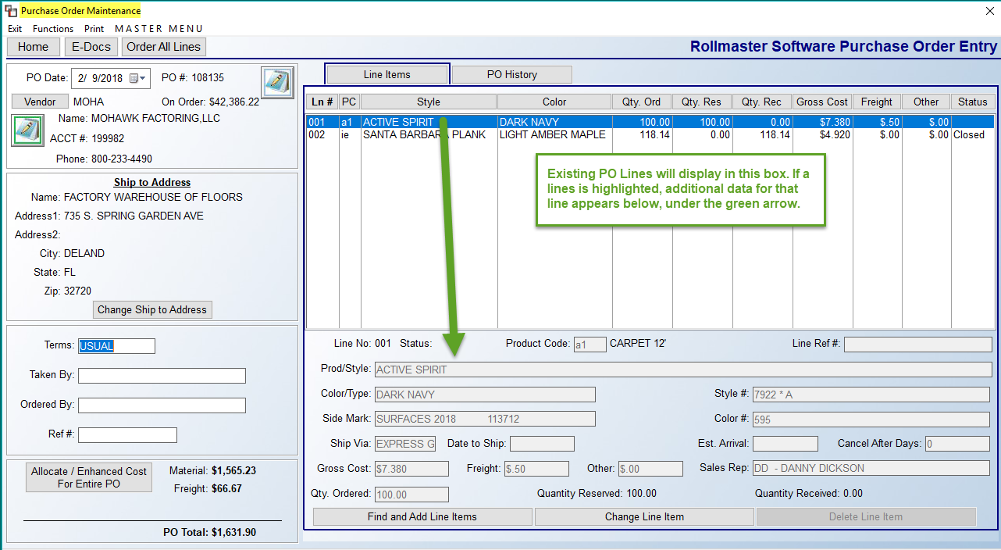
For existing Purchase Orders, any existing PO Lines will appear in the box on the right in the screen above. You can also add new lines from this screen—that process will be explained below. The fields along the left side of the screen above pertain to the entire PO and can be updated as needed. They will be explained in the order they appear in the screen shot below:
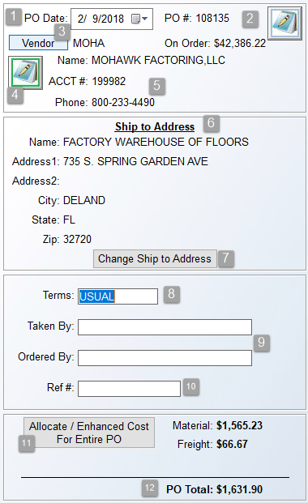

The PO Date (1) field can be changed if applicable using the drop-down calendar menu. The Notes (2) icon to the right of the PO # field is for PO Notes. You can double-click on the icon to add/edit notes for the entire PO. The Notes options work the same as the ones in the Quote and Order Entry modules. You can also add Private PO Notes (internal only) if you first enable a switch in the Company Control 4 screen (Use Private PO Notes) of the System Control Maintenance module and then type an asterisk “*” at the beginning of each line. The system allows for multiple pages of PO Notes, just like the other Notes options in the system.

Moving on, click the Vendor (3) button to change the Vendor ID on the PO or even add a new Vendor in the system. When you click the Vendor button, a Vendor Selection box will appear as follows:
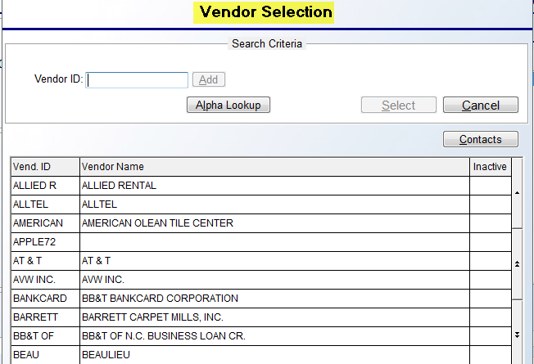

If you type a new Vendor ID, the Add button becomes enabled so you can click and jump to the Vendor Maintenance module, add the Vendor, and return to the Purchase Orders module without exiting. Returning to the prior screen, the Notes (4) icon below the Vendor button is for Vendor Notes. The Acct# and Phone (5) fields will display data for the current Vendor. The Ship to Address (6) box will default to what has been set up for the current Branch. It can be changed if the material is to be delivered to a different location via the Change Ship to Address* (7) button. The Terms (8) box will default to USUAL, but can be manually changed if applicable. The Taken By (9) field is for recording the person’s name at the vendor order desk, and the Ordered By (10) will default to the current User ID. The Ref # (10) field can be used to record the reference # from the Vendor.
The Allocate (11) option has been added to allow for allocating shared cost over multiple PO Lines. Examples of cost types are Freight, Brokerage, Storage, etc. This feature is used to allocate a confirmed freight cost across all lines by cost or quantity on a PO for PO’s with more than one line. Please Note: This feature also appears in the Review PO option in A/P Open Item Maintenance. When you click this button, an Update Cost or Expense For Entire PO box will prompt as follows:

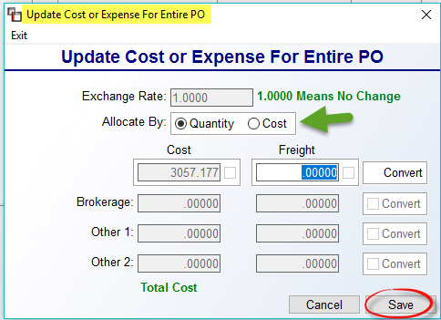

The Allocate By and top Freight column fields are the only two fields that can be accessed for the Allocation feature. The other fields are part of separate functionality dealing with Enhanced Cost, and must be turned on by a BMS Trainer. Determine whether the freight amount should be allocated by Quantity or Cost by clicking on one or the other, and then enter the total cost in the Freight field. Click the Save button and the system will distribute the amount across all PO Lines. When this feature has been used, the Freight fields will display a red “A” for Allocated to the right of the field when you exit and return to the PO screen.

And finally, the current Material and Freight costs of all PO Lines will total separately followed by a PO Total (12) at the very bottom of the screen.

*The Ship to Address can also be updated from the Add Purchase Order Screen in Order Entry if a User is allowed to “Mark PO’s as Ordered” from within an order.

PO Line Items—Add/Edit:
As explained above, the section to the right of the Purchase Order Maintenance screen lists all existing PO Lines on the selected PO. The following is another example:

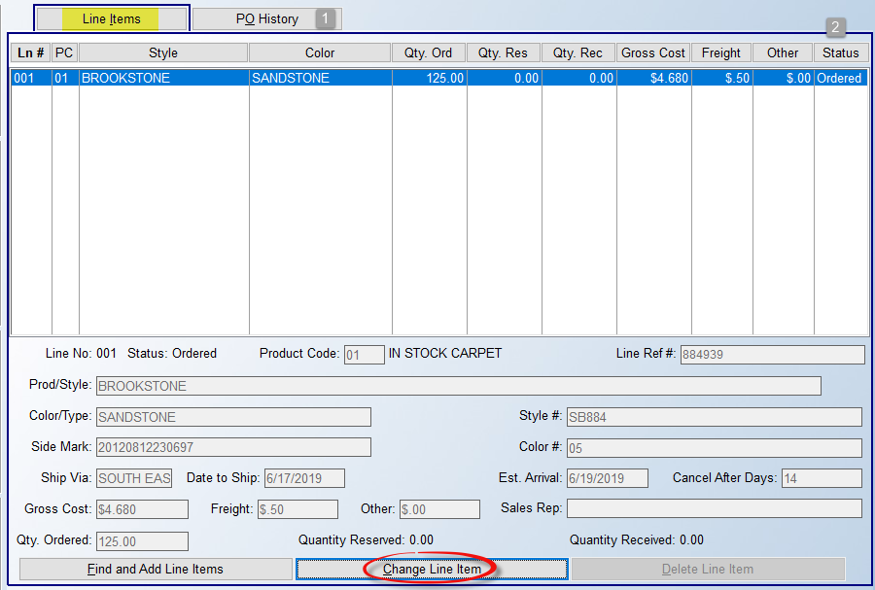

The functionality of this screen works similarly to the Quote and Order Entry Line Items screen. Please Note: the PO History (1) tab displays historical data on PO’s where material has been received. When a PO is closed in the system, the information contained within the PO Lines will display in this screen. You can view the lines only on closed PO’s. This is a view only module—you cannot print or make any changes to the information that is displayed. This screen is very handy for researching whether “02” and “08” accumulated Inventory records have been cost approved and paid via A/P Open Item Mtc.—if this is the case you will see a Vend. Invoice # in the far right column. Also, the User ID of the person who Received the material into the system will display at the bottom left of the PO History screen.

The Status (2) column will indicate if a PO Line is Unordered (Blank), Ordered, or Closed. If a line has a Status that is blank or that displays “Ordered,” you can either double-click on that line or highlight the line and click the Change Line Item button at the very bottom of the screen above to call up the following Add or Change Purchase Order Screen:

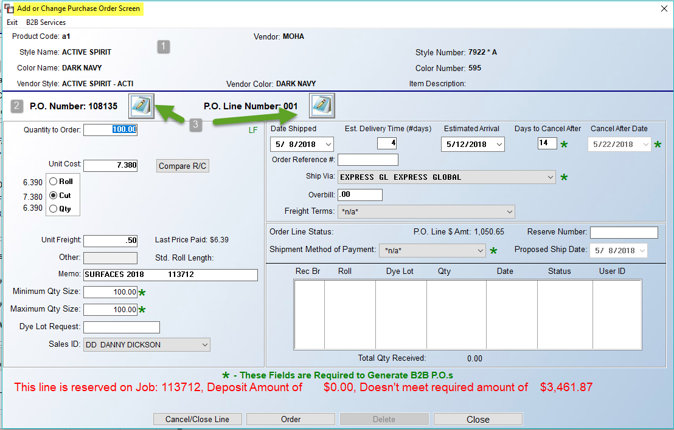

Changes can be made to this screen on any existing unordered PO Line. Each field will be briefly explained below, box-by-box. One important item to note is that there are key fields marked by a green star “” that must be completed for B2B PO’s, meaning that they may be applicable to non-B2B PO’s, but must be populated if you will be generating a B2B PO. At the very top of this screen, basic information relating to the PO will display (1). If you need to change any of this data, you will need to do that from the prior screen or via the Find and Add Line Items option screen, explained below. Just below this data, the PO Number (2) displays along with the PO Notes (3) icon, and the PO Line Number Notes (3) icon. The PO Line Number Notes relate specifically to the current PO Line. These Notes can be viewed and/or added to from the Receive Inventory module and in the A/P Open Item Maintenance module via the Review PO History process. These Notes can also be accessed and updated on PO Lines that have been ordered.
This next section will focus on the fields in the box to the far left of the screen above as follows:
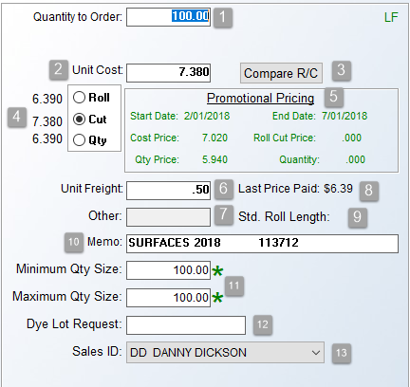
The Quantity to Order (1) field will default to what was required for the job line, unless this is a stock PO. You can override this amount if applicable, provided you update the job line where applicable, or know that any additional quantity will be received as stock inventory. For items sold by the box or by the piece, the system will display additional data as follows based on what appears in Product Code Maintenance and Catalog Maintenance for an item (this same data will prompt in the Receive Inventory screen):

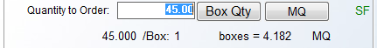

The Unit Cost (2) field will default to the catalog price. If a negotiated price applies to this order, you can override this field. Additionally, in the Roll/Cut/Qty (4) box (for roll goods only), the Cost field will default to what is selected in this box. If pricing displays in the other two radial options, you can switch to either to update the Cost field. The Compare R/C (4) button will prompt a Roll/Cut Comparison box as follows:
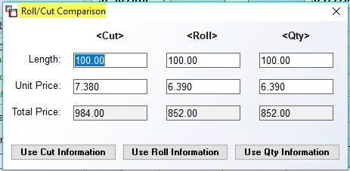

This is a tool to use for comparing Roll / Cut / Qty pricing on special order goods to determine if buying a roll balance is a better value or if any Qty pricing is applicable. The Length fields will automatically prompt the amount from the PO Line, and the Unit Price fields will default to existing Cut and Roll costs in the system catalog. The Total Price fields will reflect the pricing based on the Length and Unit Price fields. To compare a roll balance, type a new Length in the Roll column and the system will calculate a new Total Price. If the roll balance is less, click the Use Roll Information button to read that data into the PO Line. The same process works for the Qty fields. To keep the Cut pricing, click the Use Cut Information button to keep that data.

If Promotional Pricing (5) exists on an item, that data will appear in green type just below the Unit Cost field, as in the example above. Using that information, you can change the Unit Cost field to reflect that pricing. The Unit Freight (6) field will prompt from the system catalog. You can override it if you know what the unit freight cost on an order will be or you can leave the default, which will be finalized during A/P Invoice processing. The Other (7) field will display any non-material or regular freight costs, such as Brokerage, Storage, etc. The Last Price Paid (8) field will display the last unit price paid for the item. If it has not previously been ordered, this field will be blank. The Standard Roll Length (9) field will display that data if it was previously entered in the catalog. At the Memo (10) field, for PO’s created from a Job in the system, this field will default with applicable side mark information from the Job; enter to accept this info. On stock PO’s you can type “STOCK” in this field.

The Minimum Qty Size and Maximum Qty Size (11) fields are for use with B2B PO’s. It allows a client to search for roll balances above the Quantity to Order amount. If a minimum and maximum quantity size have been entered in these fields, the B2B process will allow a search for an acceptable roll balance and reserve that piece. If you will not be using this feature, simply enter through these fields. The Dye Lot Request (12) field is also for B2B clients. If you add a dye lot to this field, the Vendor will ship that dye lot or send a response if not available. The last field in this screen, Sales ID (13), will automatically prompt the Salesperson from the Job, if the PO Line is tied to a Job line. Where applicable, use the drop-down menu to select an alternate Sales ID.

Moving up and to the right of the main Add or Change Purchase Order screen, the next section appears as follows:

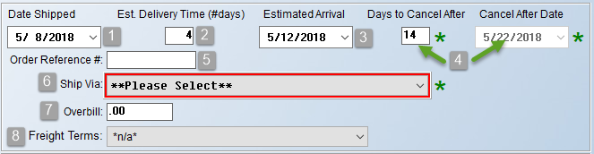

At the Date Shipped (1) field, the system will default to the current date; override that date with the actual shipping date if different from the current date. The Est. Delivery Time (#days) (2) is used to record the approximate number of days it will take for material to arrive to your warehouse, counting weekends/holidays. Based on the number of days you enter, the system will calculate the Estimated Arrival date (3) field, though you can also alter that date using the drop-down calendar. The Days to Cancel After (4) field is for B2B customers to enter a date of cancellation of the order if not shipped by the date that prompts in the Cancel After Date (4) field. At the Order Reference # (5) field, type in a reference for this PO Line or leave blank if you will have one reference for the entire PO-- you can record that info on the first page of the PO screen. This field is updated automatically during the B2B purchasing process. The Ship Via (6) field defaults to **Please Select**. This is a required field for B2B PO’s. Use the drop-down arrow to make a selection from a pre-set list of Ship Via Codes. (Please Note: Ship Via Codes can be added/edited/deleted via the Ship Via Code Maintenance option available in the Functions menu at the top of the main Purchase Order Processing screen—see explanation further down in this documentation.)

The Overbill (7) field is only visible if a User is allowed to see this data. The system will prompt the Overbill that is currently setup in the Catalog for this item. Editing this field will not change the Overbill setup in the Catalog Maintenance module for a style. Please Note: In the Company Control 2 level of the System Control Mtc. module, there is an option as follows: Material Overbill by Inventory. If set to "N" for no, then the only Overbill amount that will apply in job costing is the Overbill in Catalog Mtc., and even if you add an Overbill in the field above, it will not apply with this control set to "N." However, if this control is set to "Y" for yes, if you add an Overbill in Catalog but delete the amount on the Inventory item, no Overbill amount will display because the system is only looking at Inventory Overbill and ignoring anything in Catalog. The final field (8), Freight Terms, is a drop-down menu of pre-loaded options. These options can be set to “Inactive” or you can add new terms via the Freight Terms Maintenance feature located in the main Purchase Order Maintenance screen under the Functions menu. These terms will print on the Purchase Order and Bill of Lading, if that program is enabled. This is not a required field and can be skipped.

Just below the section above are additional fields that pertain to Order Line Status as follows:

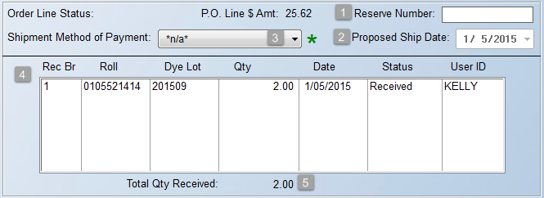

The PO Line # Amt. displays the dollar value of the PO Line, provided a User can see costs. When physically placing the order, you can add a Reserve Number (1) in that field. The Proposed Ship Date (2) field can be used to record when the vendor intends to ship material. The Shipment Method of Payment (3) field is a B2B required field, but can be used on non B2B PO’s to note how freight is to be paid. As material is received, the system will update the “Rec Br,” “Roll,” “Dye Lot,” etc., (4) columns accordingly. This section will also display any advance shipping notice (B2b doc 856) data sent by a vendor related to this PO and item. The Total Qty Received (5) field will reflect the total amount of material received to date for the PO Line.

At the bottom of the Add or Change Purchase Order screen, four options appear as follows:

The Cancel/Close Line button will cancel the line without saving any changes. The Order button should only be clicked if you are ready to place the material “On Order” in the system. The Delete button will delete a line provided it has not been ordered. The Close button will save any changes and return the cursor to the previous screen. Please note that you can also “order” the material from the main PO screen by right-clicking on a PO Line and selecting Order from the drop-down list--please see below for more details on the “right-click” options for PO Lines. Also, if you have enabled the “Deposit Required” feature on Purchase Orders, the warning info will display in red type just above these buttons if the Deposit amount on the job does not equal the required amount to place an order for special order PO’s.

Right-Click Options from PO Line:
From the Line Items box of the Purchase Order Maintenance screen, if you highlight and then right-click on an existing PO Line, several options will pop up in a menu as follows:
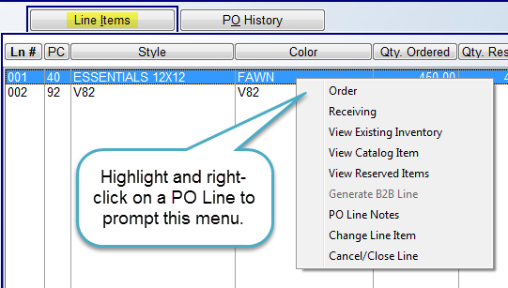

Order:
The Order option provides a quick way to place a PO Line on order if no changes need to be made other than those that relate specifically to ordering. When you select this option, the system will prompt an Order PO Lines box as follows:
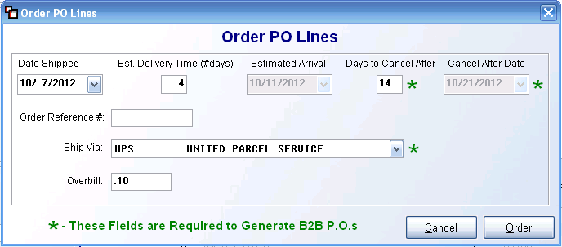
From this box, you can record the Date Shipped, Est. Delivery Time, Order Reference #, Ship Via and update Overbill cost depending on a User’s permission. As explained above, there are key fields marked by a green star “” that relate only to B2B PO’s, which means that you are only required to populate those fields if you will be generating a B2B PO. Click the Order button to place the order or click the Cancel button to exit without ordering.

Receiving:
Once a line has been ordered, the Receiving option will prompt a Receive Inventory box as follows:
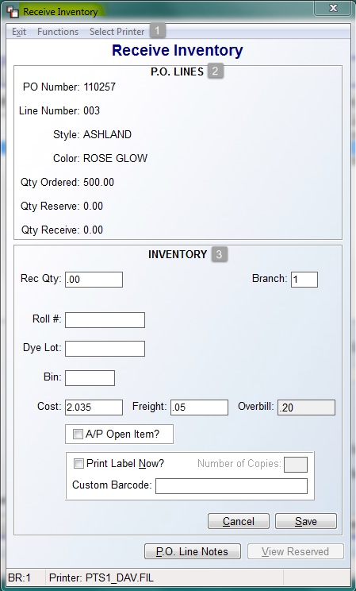
At the top left of the Receive Inventory screen, you will see a few options available prior to beginning the receiving process. The first option (1), Exit, will cancel the process and return you to the previous screen. The third option, Select Printer, will allow you to change printers, such as making a Bar Code printer selection, prior to completing the receiving process. The Functions option will display the following: Receive Entire PO. This option allows you to automatically receive all PO Lines. The system will first prompt an Enter Receiving Branch box and default to the current Branch. Enter to accept or type in another Branch. The system will then prompt a Receive Entire Purchase Order screen as follows:

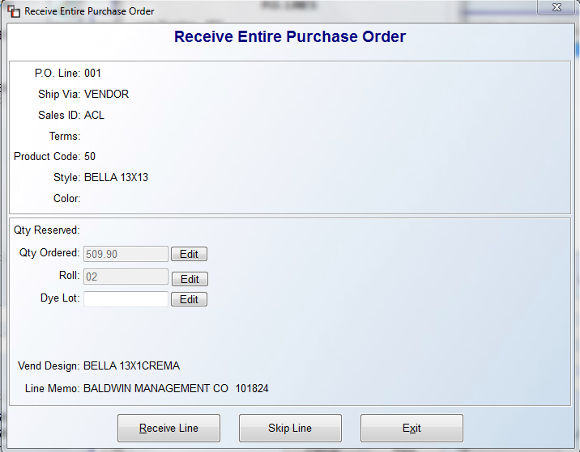
You can edit the data in the “Qty Reserved:” section, including adding a Roll and Dye Lot # if applicable, prior to clicking the Receive Line button. You can also use the Skip Line button to call up the next line, or click the Exit button to return to the previous screen.
To begin the Receiving process, start by reviewing the PO LINES (2) box. This section displays standard data for the current PO Line and is a read-only section. It also displays the Quantity Ordered for the line, Reserved on Job, and any portion already Received. In the INVENTORY (3) section, the cursor will be positioned at the Rec Qty field as follows:

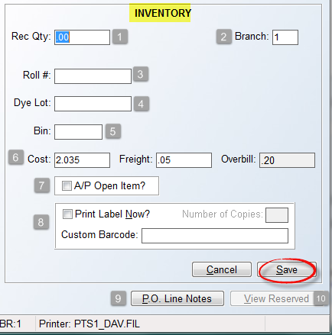

Start by typing the quantity you are physically receiving in the Rec Qty (1) field. At the Branch (2) field, the system will display the current Branch; if the inventory is being physically received into another Branch, you can type that Branch in this field and the system will instantly change Branches within this program. Please note: you should use the Transfer feature if the inventory will be moved to another Branch after receiving. In the Roll # (3) field, type in a roll number or production/run number on products requiring that information; for items with a Factor ID of 02 or 08, the system will prompt either 02 or 08 as the Roll #. For all items where you wish to accumulate and cost average inventory, you should accept the 02 and 08 prompts. The Dye Lot (4) field is used to record a dye lot number on products requiring that information. If an item has a Factor ID of 02, where it finds matching dye lots it will prompt you to merge the inventory. If an item has a Factor ID of 08, accept the 08 default to merge with existing inventory items.

At the Bin (5) field, you can enter a bin number or location number of where this material will be stored in your warehouse. You can print inventory reports by this bin/location field so it is highly recommended that this field be used. The Cost, Freight, and Overbill (6) fields will default to what was entered on the PO Line. Typically, these fields are not updated during receiving; however, if more accurate data is known at this point, changes can be made that will instantly update job costs. These fields will only display where a User can see costs. The A/P Open Item? (7) Box should only be checked if the person receiving will immediately post the A/P Invoice following receiving. Otherwise, leave it unchecked.

In the Print Label Now? (8) Box, the default for this prompt can be managed via a Company Control option in the System Control Maintenance module. That control appears as follows: Print Labels In Receive Inventory. This is a two part control option that first deals with whether you want the default for the Print Label Now prompt to be checked. If you primarily wish to print an inventory label immediately following the receipt of inventory, set this control to “Y” for yes. The second control option relates to whether you want the default label type to be Barcode (B) label, or a Normal (N) label. If your company has BMS Bar-coding equipment, you can set this default to “B;” otherwise, leave it set to “N” for normal. If printing a label, you can set the Number of Copies and enter a Custom Barcode prior to printing.

Before clicking the Save button to finalize the receiving process, you can access and update PO Line Notes (9) via that button. Additionally, you still have the ability to modify a job line via the View Reserved (10) button. When you click the View Reserved button, a Purchase Order View Reserved Inventory screen will prompt (see example below). An Install Date column was added to this screen in the last update. Aside from viewing the Reserved Inventory data, you can right click on a reserved line to call up the following two options: Modify Line and View Job. They will prompt as follows:

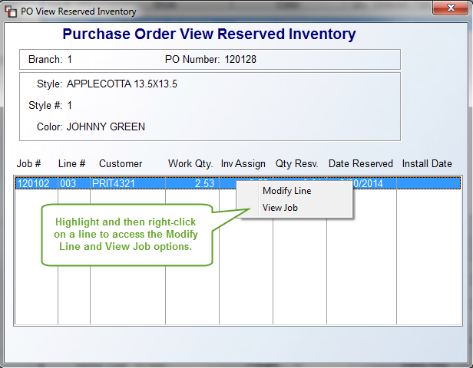

If you select the first option, the system will display a Modify Job Line screen as follows:

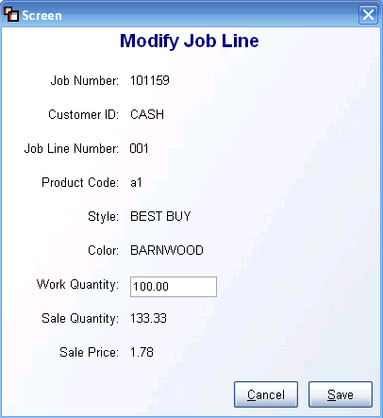

Type in the adjusted quantity in the Work Quantity field and then click Save to return to the previous screen. The View Job option will first prompt an Order Log box for the Job tied to the PO Line as follows:

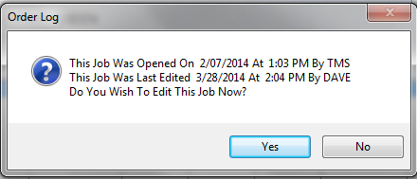

If you click the Yes button, the system will jump to that Job in the Order Entry module and place the cursor at the Order Date field. You will then be able to perform functions such as View Notes, access E-Docs, etc., and then exit and return back to the PO Line.

Once all data has been updated in the INVENTORY section, click the Save button to continue. The system will prompt an Assign Inventory screen as follows:

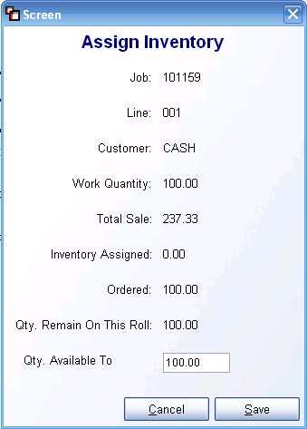

Click the Save button to receive the inventory. If the quantity received was modified, the system will prompt the following:

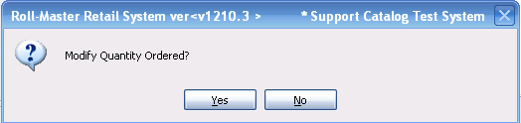

If you received an amount that is different from the quantity ordered, click the Yes button at this prompt. The system will then prompt an Enter Quantity Ordered box as follows:

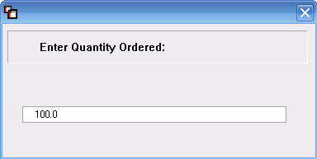

Type in the applicable amount and hit enter to continue. If the amount received is greater than the amount ordered, the system will prompt the following:
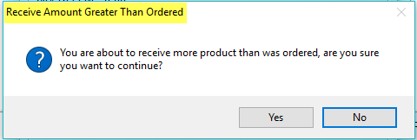

If the inventory is assigned to a Job, the system will prompt the Assign Inventory box, explained above. If it is stock, the additional portion will be added to available inventory.
If there is more than one open line remaining on a PO, the system will prompt the following:
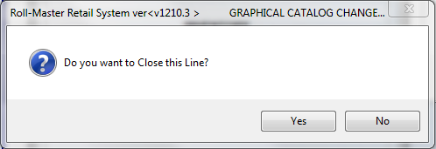

Click the Yes button to close the line. If all lines on a PO have been received, once the final open line is received, the system will prompt the following:

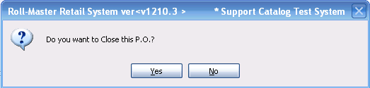

Click the Yes button to continue. The system will return you to the Purchase Order Maintenance screen.

View Existing Inventory:
The View Existing Inventory option will prompt the following Inventory Review screen:

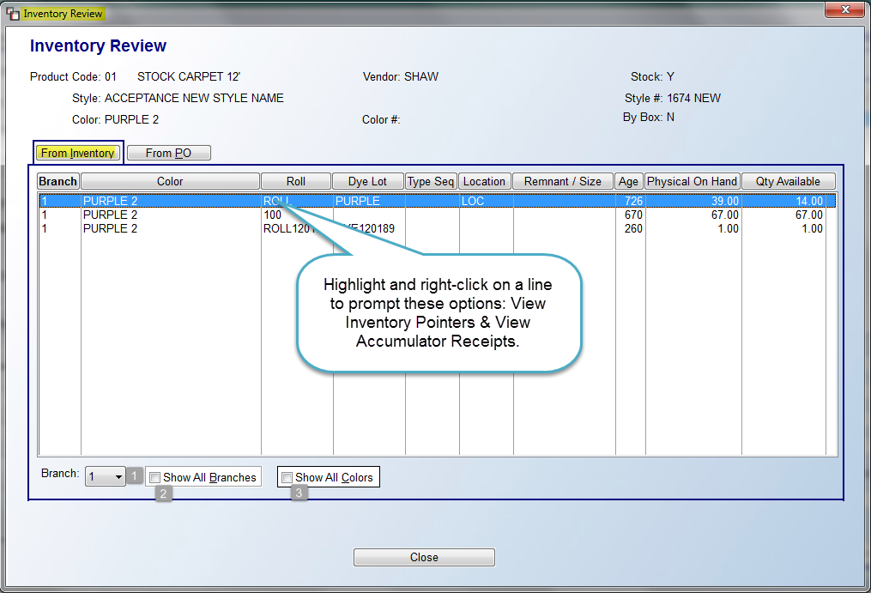

Any existing inventory received into the system will display in the screen above. The screen defaults to the current Branch, but you can expand the search by using the options at the bottom left of this screen. You can choose another Branch by clicking the down arrow button in the Branch (1) field. You can also check the Show All Branches (2) box, or you can even check the Show All Colors (3) box to see a full range of inventory. If you right-click on an inventory line item, the system will prompt the following two options: View Inventory Pointers and View Accumulator Receipts. If you select the first option, the system will prompt an Inventory Pointer View screen as follows:
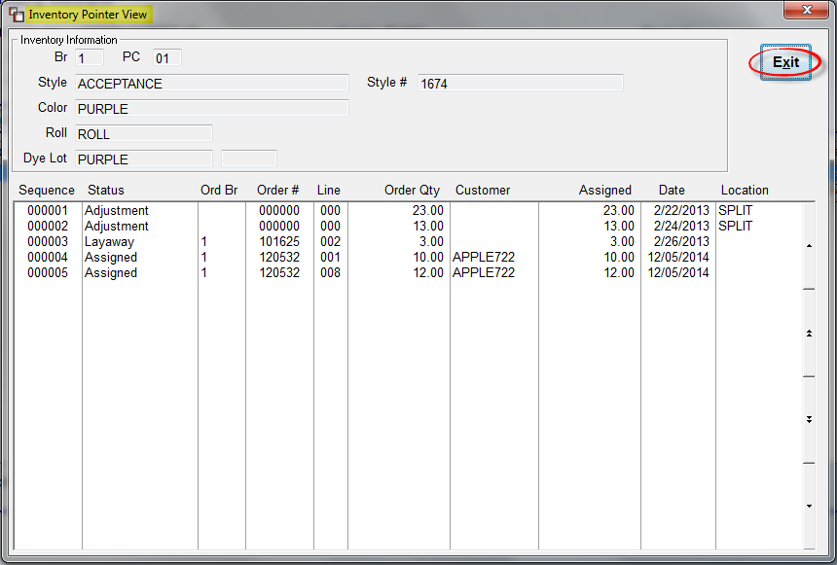
This is a view-only screen that gives you information as to what jobs the inventory is assigned to, the status, and warehouse location. Click the Exit button to return to the prior screen. The second option will only be available on “Accumulated” inventory items, such as pad and various other supply items where inventory has been accumulated into one inventory record. On items where this option is available, if you click the option, the system will display a View Accumulated Items Receipts screen as follows:
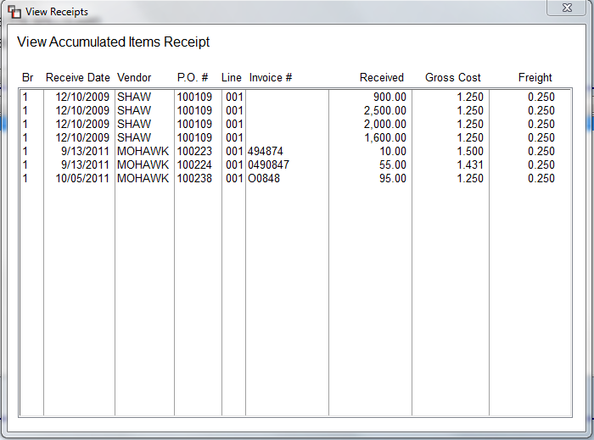
This is a display-only screen designed to display a history for all accumulated inventory.
The From PO tab screen displays Purchase Orders containing the same catalog item. When you click on the From PO tab, the system will display the following screen:

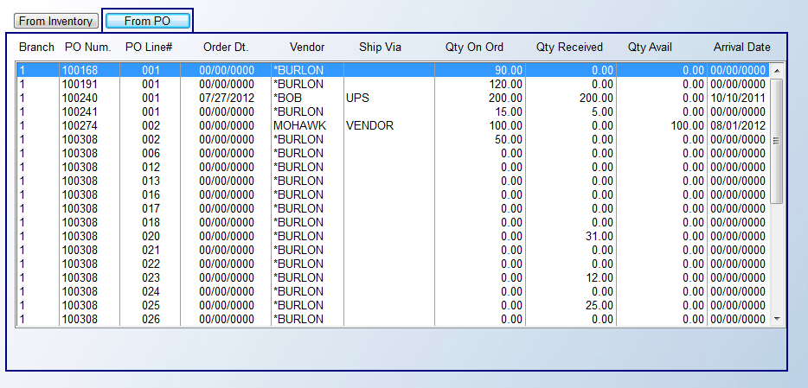

If the item you are ordering appears on another PO, that data will display in this screen along with any PO’s showing received quantities. You have additional options for exploring that data further if you right-click on a line in this screen. Those options are as follows: View Purchase Order, View On Order Reserve, and View PO Line Notes.

View Catalog Item:
The View Catalog Item option will allow you to jump to the Edit Catalog Item screen for this item. You can make changes in that screen and then return to the Purchase Order Maintenance screen when complete.

View Reserved Items:
The View Reserved Items option will prompt on PO Lines where some or all of the material is reserved against a Job Line. When you click on this option, a PO View Reserved Inventory screen will prompt as follows:
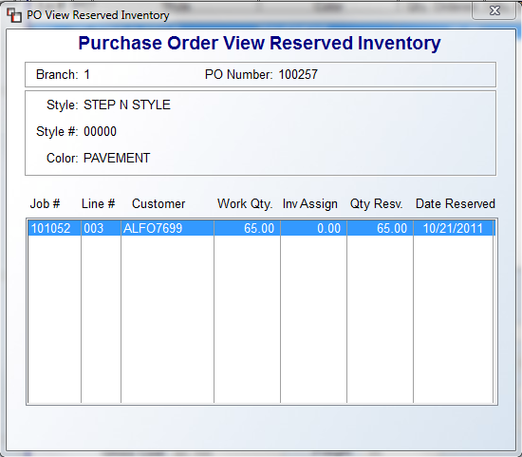
This screen will display all jobs and job lines the inventory is reserved against. You can right-click on a line to prompt the following: Modify Line. This will prompt the Modify Job Line screen explained above in the Receiving section.

Generate B2B Line:
The Generate B2B Line option will activate B2B purchasing and will only be available for B2B Clients on B2B catalog items. In order to send a PO Line to a B2B Vendor, when all fields have been completed in the PO Line screen, hit enter on this option to generate the electronic file to be sent to the vendor.

PO Line Notes:
The PO Line Notes option will prompt the PO Line Notes screen where you can view and add notes. This option will prompt a list of all PO Line Notes for the current line that have been previously added either from this module or the Order Entry module. You can also add new PO Line Notes from this option. The first two lines of PO Line Notes will print on the Open P.O. Report (for Faxing) report.

Change Line Item:
The Change Line Item option will prompt the Add Purchase Order screen, explained above.

Cancel/Close Line:
This option will clear out all of the information on a PO Line, provided it has not already been ordered. If it has been ordered, you will need to use the Unorder option from the right-click menu to change the status. If the material on the line has been assigned to an Order, you will first need to Unassign the material from the Order Line before you can Cancel/Close the PO Line. Once you use this option, the PO will be removed from the Open PO Report. You can reopen a PO via the Open PO’s Closed in Error option (explained below). If an Order is canceled or when the material on a PO has been received in the system, the PO should be Closed. If you are closing the last open Line on the PO, the system will go ahead and Close the entire PO.

Menu Items/Buttons—Main Screen
At the top left of the main Purchase Order Processing screen, a series of drop-down menu items and button options appear as follows:

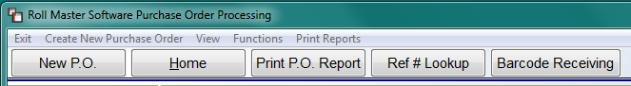

Starting with the buttons, the New P.O. button and the Create New Purchase Order menu item just above it, will perform the same task, which is to open a new Purchase Order Maintenance screen for adding a stock PO or to place an order for material not yet attached to an Order in the system. Please Note: When choosing either option to create a new PO, the system will first prompt the Vendor Selection box. If you hit Cancel or exit the Vendor Selection box without first selecting a Vendor, the system will cancel the PO creation process and prompt the following message:

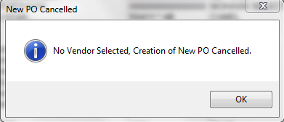

The Home button calls up the same “Hot Key” menu as the Home key on your computer keyboard. The Print P.O. Report button prints a list of all the PO Lines listed in the main section of the Purchase Order Processing screen, basically everything you see listed in the screen below the buttons. The Ref # Lookup button will call up an Enter Reference # search box as follows:
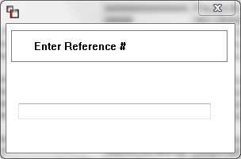

This search is tied to the Line Ref # column in the main screen below and is also the same as the Filter option of the same name. If you type in a number the system cannot match, the screen below will clear of all PO Lines, and you will need to click the “Clear Selected” button in the Filter box, and then click the Build button to return all items. As for the Barcode Receiving button, only those customers using the BMS BarCode functionality will have this option. When you click this button, the system will prompt a Scan Bar Code box to allow receiving by Barcode.

Returning to the menu items located above the button selections, the Exit menu item will take you out of the Purchase Order Maintenance module; you only need to click on the word Exit in order to accomplish this task. The View menu item currently contains only one option as follows: B2B Status Codes. When you click on this option, a B2B Status Code list will appear as follows:
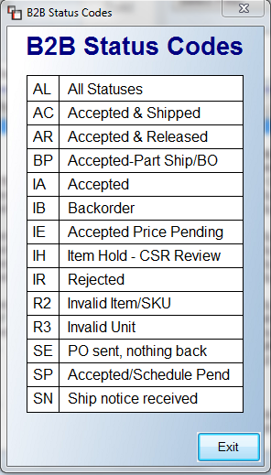

This status box is only for reference. You cannot perform any tasks in this box. Click the Exit button to close. As mentioned above, the Create New Purchase Order item works the same as the New P.O. button. The remaining two menu items, Functions & Print Reports, contain multiple options and each will be explained in detail below.

Functions Menu—Main Screen
When you click on the Functions menu item, you will currently see three options as follows:

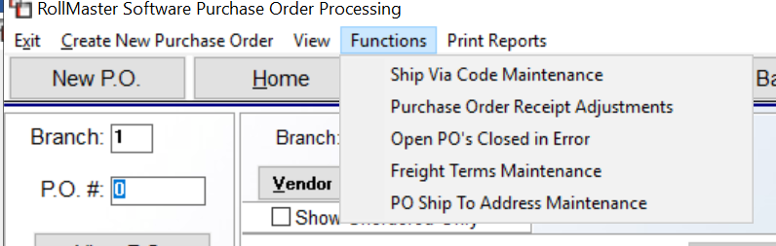

Ship Via Code Maintenance:
The Ship Via Code Maintenance option allows you to pre-build and edit Ship Via Codes for use when entering/ordering PO Lines. When you click this option, a screen will appear as follows:
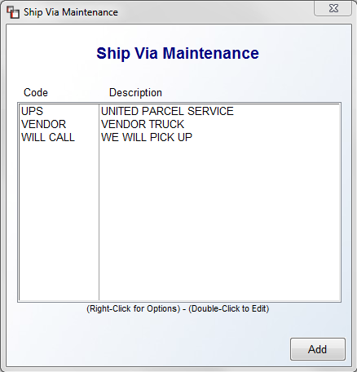
To add a new Ship Via Code, click the Add button at the bottom right of this screen. A Ship Via Maintenance box will appear as follows:
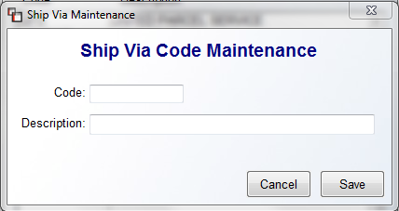

Type the name of the Code in the first field, and then type a longer Description in the field below. When you have finished, click the Save button to keep the new code. Once a code has been added and appears in the first box, you can either edit or delete a code. To edit a code, double-click or right-click on a code to access the Edit Ship Via Code option. The system will display the Ship Via Maintenance box as follows:

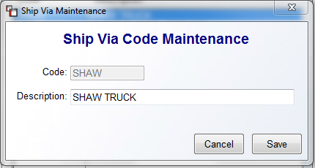

You can change the Description field, but you cannot change the Code field. Click the Save button to keep any changes. To delete a code, right-click on the code to access the Delete Ship Via Code option. The code will be deleted instantly.

Purchase Order Receipt Adjustments:
The Purchase Order Receipt Adjustments option is used to adjust receipt errors for all inventory received during the Receiving or Receive Inventory process (explained above), up until the A/P Invoice for the material is posted. When this option is selected, the system will first prompt a PO Number field. Type in the PO that needs to be adjusted. The system will then prompt a P.O. Item Receipt Adjustments screen displaying all the PO Lines on that PO as follows:

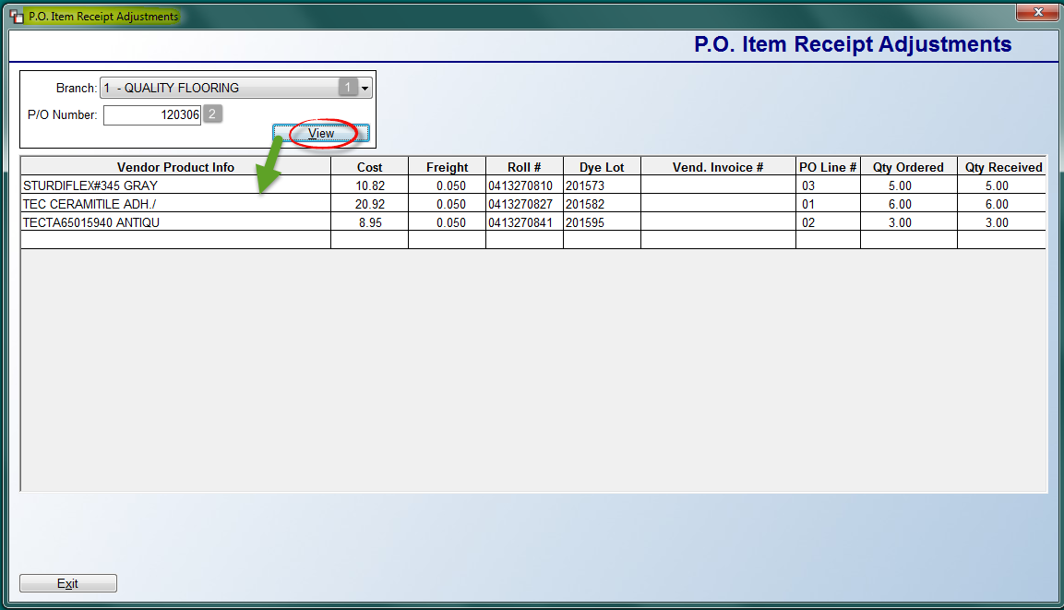

The cursor will be positioned at the Branch (1) field and default to the current Branch. Use the drop-down arrow to select another Branch. At the P/O Number (2) field, type in the PO Number you need to adjust and click the View button. All applicable PO Lines will display in the screen below. Click in the Qty Received column of the item you wish to adjust and the system will prompt a New Qty Received box at the bottom right as follows:

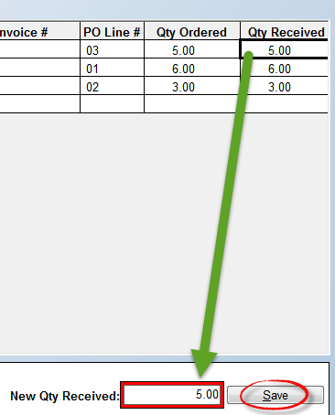
Type in the actual quantity received for this PO Line and then click the Save button to keep your changes. The system will update the PO and all applicable areas of the system.
Note: the system will not allow you to make a negative adjustment for more than the inventory on hand. You can make additional adjustments, or hit the Exit button or Esc key to exit. Once an adjustment is made, the system will automatically re-average accumulator items and adjust the Inventory Record and update the PO History receipt record. Additional Note: this option will not allow any adjustments on PO’s where an A/P Invoice has already been tied to the PO History record. The system will prompt the following message: Cannot Change, Invoice Already Paid.

Open PO’s Closed in Error:
The Open PO’s Closed in Error option is used to open a PO that has been closed for any reason. You will need to know the PO Number before you begin. Once open, you can make changes to the PO or print out a copy via the Print Purchase Orders Report option (explained below). When you enter this module, an Unclose P.O. screen will appear as follows:
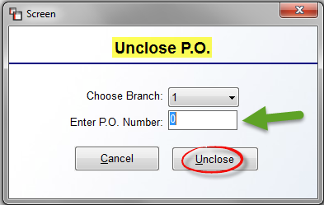

The Choose Branch field will default to the current Branch. Use the drop-down arrow to select another Branch if applicable. At the Enter P.O. Number field, type in the closed PO Number and then click the Unclose button. The system will return to the main Purchase Order Processing screen. You will need to refresh the view or type the PO Number in the P.O. # field and click the View P.O. button to access.

Freight Terms Maintenance:
There is a Freight Terms drop-down box on each PO Line screen. This option allows you to pre-set several variations of Freight Terms based on how you do business. When you select this option, a Freight Terms Maintenance box will appear as follows:

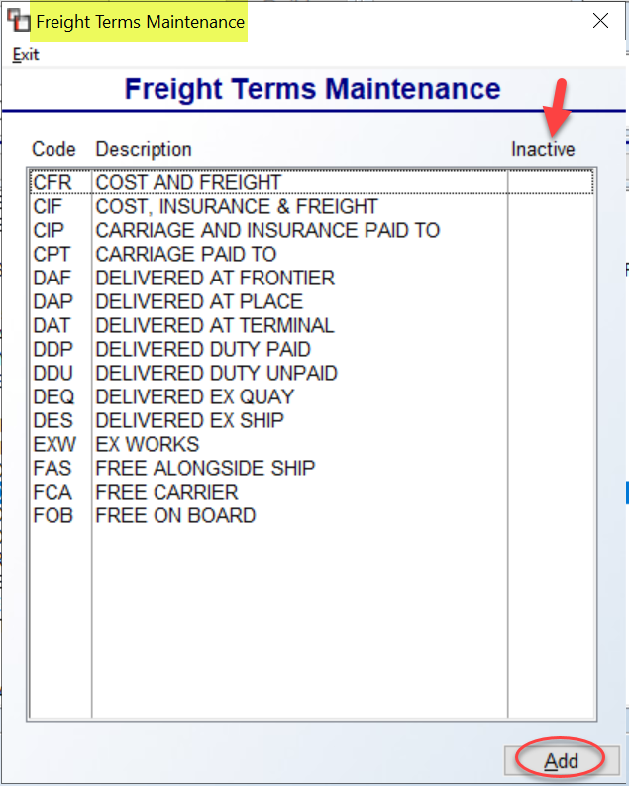

When you first enter this option, any existing Freight Terms will appear in the box above. To Edit or set as Inactive, double-click on the Freight Term. To create a new one, click the Add button to prompt an Add Freight Term box as follows:

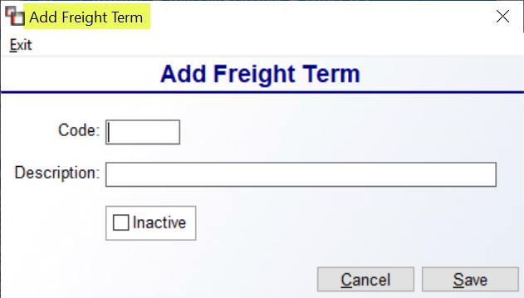
Type an up to 3-character alphanumeric Code in the first field, followed by a longer Description in the next field. Be sure to click the Save button to keep. The Inactive checkbox should only be checked to remove a Freight Term from the Lookup screen.

PO Ship To Address Maintenance:
Through this option, you can add permanent Ship To Addresses for multiple warehouse/shipping locations, and from within a PO, you can select these different Ship To Addresses without having to type the data each time via the Change Ship To Address button. When you select this option, a selection box will appear as follows:

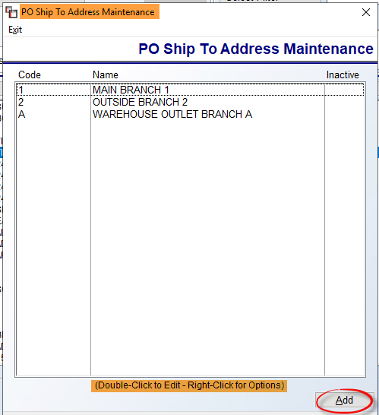

Any existing Addresses will display in the box above and you can double-click or right-click to Edit or make the address Inactive. To add a new address, click the Add button at the bottom right to prompt an Add/Update PO Ship To Address box as follows:

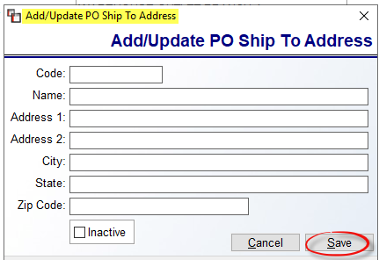

You will need to create a Code for each address—this Code will display in the Purchase Order screen when making a Ship To Address selection. Complete the address information and click Save to keep. At any point, you can enter back into any Ship To Address and set it to Inactive. In the Purchase Order Entry screen, you will see a drop-down box next to the Ship to Address field as follows:

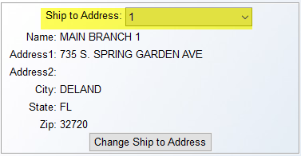

Use the drop-down box to select a different Ship to Address for the PO when applicable.

Print Reports
The Print Reports menu item is another drop-down menu and contains purchasing related reports. When you click on this menu item, a list of reports will appear as follows:

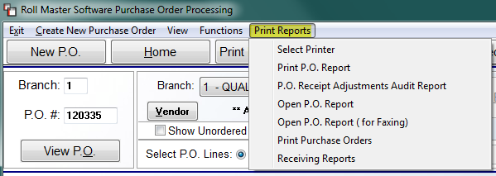

The Select Printer option allowS you to switch to a different printer prior to printing any of the listed reports. The Print P.O. Report will print a list of all PO Lines you can see in the main screen below. It works the same as the Print P.O. Report button explained above.

P.O. Receipt Adjustments Audit Report:
Any changes made in the Purchase Order Receipt Adjustments option, along with the User that made the change, will appear on this report. When you select this option, the following screen will prompt:

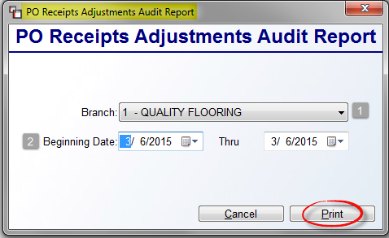

This report screen defaults to the current Branch. You can choose another Branch by clicking the down arrow button in the Branch (1) field. At the Beginning Date (2) field, the current date will default in both fields. To enter another date, or to enter a range of dates, use the drop-down calendar menus in each field. Click the Print button to print the report.

Open P.O. Report:
This report prints a list of open PO’s in the system, based on sort criteria selected. Prior to printing, you have the option of listing only PO’s that have not been ordered, or all open PO’s. This is an excellent report for keeping track of material that needs to be ordered and for following up on material that has been ordered. Ideally, when a Salesperson creates a job in the Order Entry module, he or she should create an open PO for any special order products needed for the Job, which will send information to this report. Then, the individual in charge of purchasing can print the Open PO Report on a daily basis—showing only those items that need to be ordered—to see a list of the PO’s that need to be ordered. Once or twice a week, this report can be printed showing all open PO’s and the purchasing department can follow up with Vendors to make sure all material is shipping on time.

When you enter this report option, an Open P/O Report screen will appear as follows:

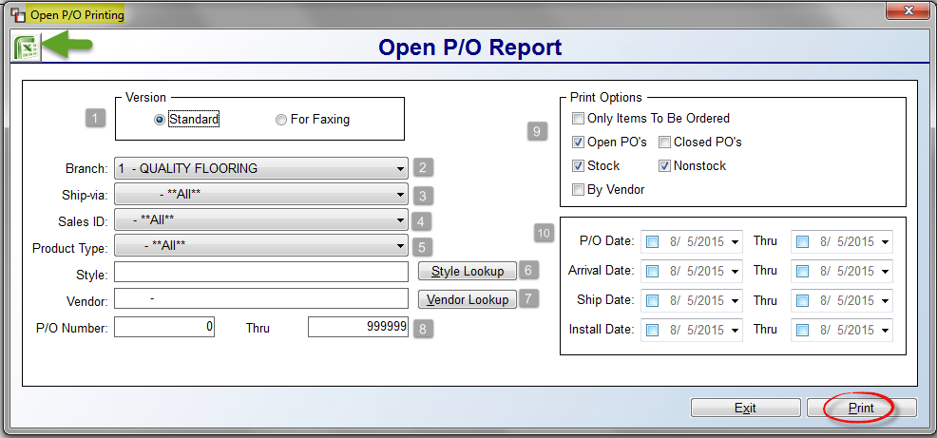
The screen above reflects all the default settings for this report. Make only those changes you need to generate the data needed. The Version (1) box will default to the Standard print program. If you click the For Faxing version, some of the defaults will change to reflect how that print option works. At the Branch (2) field, the system will default to the current Branch. However, with User permission enabled, the drop-down menu will allow you to select All Branches. The Ship-via (3), Sales ID (4), and Product Type (5) fields will all default to **All**. Use the drop-down arrows to make specific selections where applicable. The Style (6) field will allow you to select a specific style via the Style Lookup button. The Vendor (7) field will also allow you to select a specific Vendor via the Vendor Lookup button. At the P/O Number (8) fields, leave the default setting to include all applicable PO’s, or type in a specific PO or range of PO’s. The Print Options (9) box gives the purchasing department options to customize the report based on the status of PO’s. This is where you can print a report showing Only Items To Be Ordered. Or a list of all Open PO’s. Select and unselect all that apply. The final Date (10) box will not impact the report unless you check one or more of the date boxes and then enter a date or date range for the report. On the Excel export, if Install Dates are selected, three columns will appear to the right of the Special Instructions column as follows: First Install Date (within Range if selected), First Install Time (from First Install Date), and Other Install Dates (all Install Dates/Times excluding First with pipe delimiter between dates, with Range if selected). Once you have made your selections, click the Excel icon to export the data, or click the Print button to print the report.

Important Note: you can customize this report to generate the total value of materials “On Order,” either for all Vendors or separated by Vendor. The report will automatically total all “On Order” material at the bottom of the report based on any sort parameters entered prior to printing. For this to work, be sure the Only Items To Be Ordered option has not been checked and the By Vendor option is checked if you would like to see totals for each Vendor separately. Also, the report displays unit cost and line cost for each line. The freight cost has been removed from the Vendor and report total calculation.

Open P.O. Report (for Faxing):
This report has been replaced with the graphical report explained above. It will be removed from the Print Reports menu in a future update.

Print Purchase Orders:
If you need additional copies of a PO or did not print a copy of a PO after placing an order, you can access this report to print PO’s. Any PO Line Notes will automatically print on a PO. Also, if a Vendor is selected where Vendor Notes with an “*” exist for that Vendor, those Notes will print on the PO. When you select this report, the system will prompt a P/O Printing screen as follows:

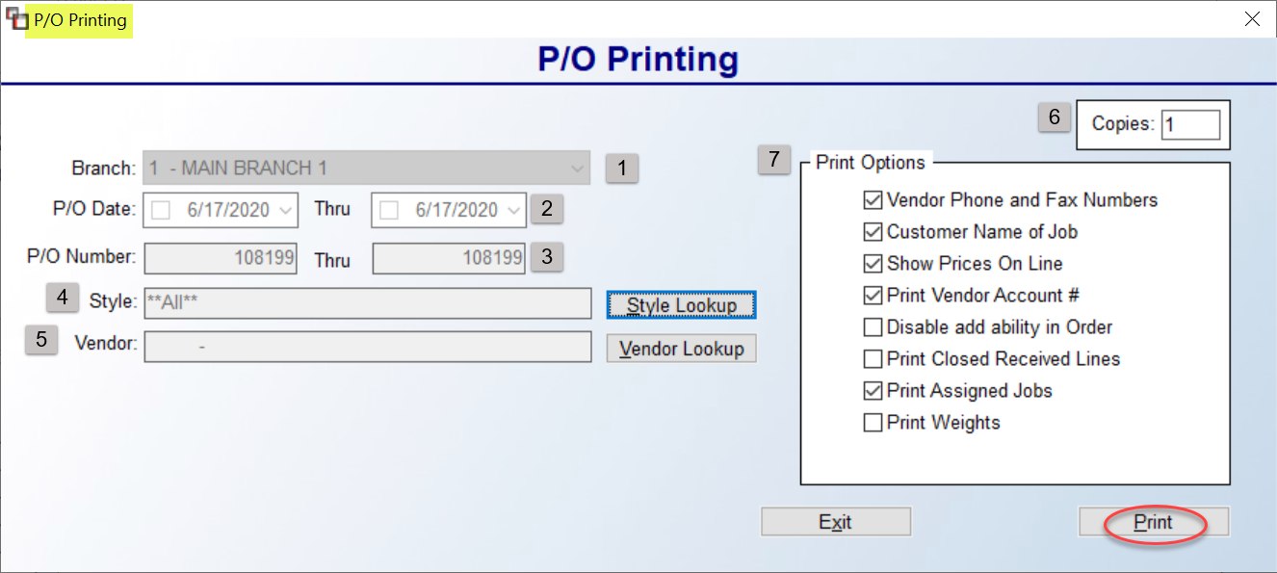

The screenshot above reflects the default settings for this report. Access any fields to customize the report. You will not be able to print a Closed PO. At the Branch (1) field, the system will default to the current Branch. However, with User permission enabled, the drop-down menu will allow you to select another Branch or All Branches. The P/O Date (2) fields can be used to select a specific date or range of dates. At the P/O Number (3) fields, leave the default setting to include all applicable PO’s, or type in a specific PO or range of PO’s. The Style (4) field will allow you to select a specific style via the Style Lookup button, where applicable. The Vendor (5) field will also allow you to select a specific Vendor via the Vendor Lookup button, where applicable. The Copies (6) box will default to “1”. Access this box if you need more than one copy of the printed PO. The Print Options (7) box provides additional options for customizing the printed PO or for customizing which PO’s print. The Print Vendor Phone and Fax Numbers option, when checked, will include this information. The Customer Name of Job includes this information on any printed PO created from an Order Line. To leave off this data, uncheck this option. The Show Prices On Line option, when checked, will display the Cost and Extension fields on the PO. The Print Vendor Account #, when checked, will display that data on the PO. The Disable add ability in Order, when checked, prevents any further additions to the PO(s) from Order Entry. The Print Closed Received Lines option, when checked, will display closed lines that have been received and closed. The Print Assigned Jobs option, when checked, will display all Jobs assigned to a PO, instead of just the first. And finally, the Print Weights option requires setup in Catalog Maintenance in order to display useable data. If the Weight field for applicable material has been completed, then when this option is checked, the total weight of material on the PO will display. The Print Open P.O. Report will also display a Report Total Weight if this setup has been completed. When all applicable options have been selected, click the Print button to continue.

Receiving Reports:
This report option contains three different variations of Receiving Reports. The main Receiving Report prints a list of inventory that was received in the system by receipt date. It is best used as a daily report to double-check that all inventory was received in the system and that it was received in correctly. If a PO Line still has a reserve quantity, no matter the reason, you will see an “*” to the right of the PO Number on the printed report. The Receiving Report By Product Type works similarly to the Receiving Report, but sorts material received by Product Type and allows you to enter a specific PO Number. The Product Type field appears at the bottom of all Product Codes for the purpose of grouping together like products for reporting purposes. For example, on all Product Codes for carpet, the Product Type is typically “Carpet.” This provides the ability to print a Receiving Report for only a specific Product Type. When this report is selected, the fields in the screenshot below will alter to include a Product Type field and a PO # field. The final report, Receiving Report By Prod Type (A/P Not Inv), works almost identically to the second report, but is designed to print only PO’s with received inventory that has not yet been tied to a Vendor Invoice via the Accounts Payable Open Item Maintenance module. This report can also be printed by Product Type.

When you select this report, a Receiving Report screen will appear as follows:
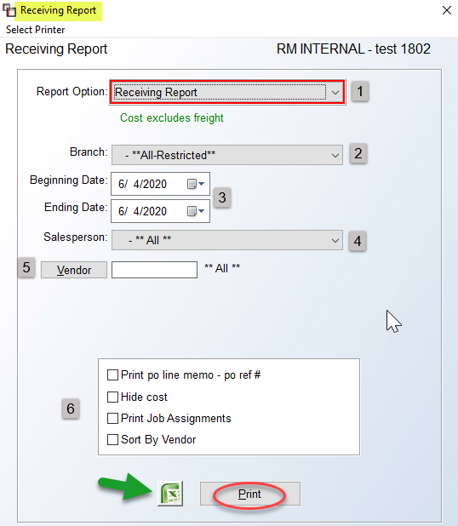
At the Report Option (1) field, use the down arrow to select one of the three Receiving Reports as follows:
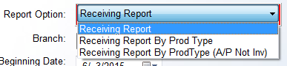
At the Branch (2) field, a User can select any Branch, provided they are set up in that Branch. The “All-Restricted” option will only include the Branches a User is able to access. Use the Beginning & Ending Date (3) fields to set a date range or change to a different date, or keep the default setting of the current date. The Salesperson (4) field defaults to **ALL**; use the drop-down arrow to select a specific Salesperson for the Branch selected, when applicable. The Vendor (5) field also defaults to All Vendors. Use the Vendor button to perform a lookup of a specific Vendor when applicable. The print (6) box options will vary slightly depending on the report selected. Only the Receiving Report will prompt the Hide Cost and Sort by Vendor options. The former will hide costs on the printed PO(s). For PO’s where received material is tied to an Order Line, click the Print po line memo – po ref # option to see PO Line memo data and PO Ref # data on the PO(s). Again, for PO’s where received material is tied to an Order Line, click the Print Job Assignments option to display the Job #, Customer Name, Line #, and Qty data. When all options are selected, click the Excel icon to export the data or click the Print button.

Please Note: if material was purchased in one Branch, but received in another, the report will list that material as received on the Receiving Branch’s report. It will also display the following on the report: Inventory Purchased in Branch: XX. The Receiving Report for the Ordering Branch will also display the material along with the following message: Inventory Received in Branch: XX.

Menu Items/Buttons--Purchase Order Screen
When you have accessed a specific PO in the Purchase Order Maintenance screen, the menu items at the top right of the screen will change over to the following:

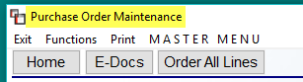

The Exit item and the Home button work the same as described at the beginning of the section above. The E-Docs button will display for those BMS clients utilizing this functionality. Contact BMS Support for additional info at info@rmaster.com. The Order All Lines button will prompt an Order PO Lines box, and the data entered in that box will populate all PO Lines and mark each as “Ordered.” The MASTER MENU item will prompt the BMS Master Menu, allowing you to “jump” to any other menu in the system to perform a task, and then return to this screen, with the exception of Purchase Orders. The Print item prompts two options: Print PO and Select Printer. The Print PO option will print the current PO and the Select Printer option will allow you to switch to another printer prior to printing the PO. The Functions menu contains several options that will be explained in detail below.

Functions Menu—Purchase Order Screen
When you click on the Functions menu item, you will see several options as follows:

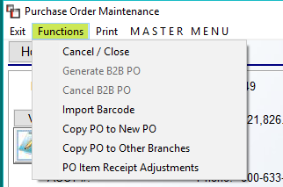

Cancel / Close:
This option will clear out all of the information on a PO, provided no lines have been ordered. If a line has been ordered, you will need to use the Unorder option from the right-click menu in the Line Items box to change the status. If the material on the line has been assigned to an Order, you will first need to Unassign the material from the Order Line before you can Cancel / Close the PO. Once you use this option, the PO will be removed from the Open PO Report. You can reopen a PO via the Open PO’s Closed in Error option (explained above). If an Order is canceled or when the material on a PO has been received in the system, the PO should be Closed.

Generate B2B PO:
The Generate B2B PO option will activate B2B purchasing and will only be available for B2B Clients on B2B catalog items. In order to send a PO to a B2B Vendor, when all fields have been completed in the PO Line screen, hit enter on this option to generate the electronic file to be sent to the Vendor.

Cancel B2B PO:
This option will only be available on B2B PO’s that have been generated via the option above. It will cancel the B2B PO.

Import Barcode:
This option will only be available on systems with the BMS Bar-coding functionality & equipment.

Copy PO to New PO:
This option is used to copy the existing PO and create a new PO using the existing data with the exception of any Notes, Shipping Dates, Memo field, Reference Numbers, Salesperson ID, etc. that will not be applicable to the new PO. When you click this option, the system will create a new PO in the system and prompt the new number as follows:

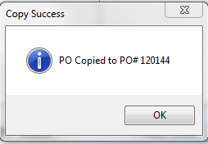
Click the OK button to continue. The system will remain in the current open PO. To access the new PO, exit the current PO and return to the main screen to locate the new PO. You can use this option on Closed PO’s.

Copy PO to Other Branches:
This option is only valid if your company is set up to share catalog between Branches. When you click on this option, the system will prompt a Copy PO to Other Branches box as follows:
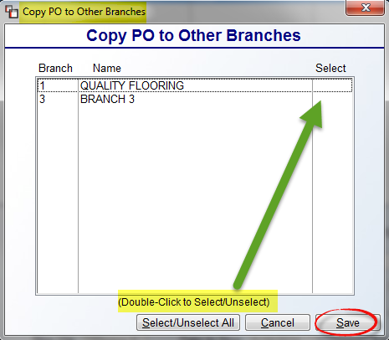
Highlight and double-click on the Branch to which you want to copy the PO. The system will place a “Y” in the Select column of that Branch. You can select more than one Branch where applicable. Use the Select/Unselect All button to mass select or unselect Branches in this screen. Click the Save button to continue with the process. The system will copy the PO with all PO Lines over to each selected Branch using the next available PO Number in that Branch. Please Note: No Notes or Reserves will be copied. You can use this option on Closed PO’s.

PO Item Receipt Adjustments:
This option works almost exactly like the Purchase Order Receipt Adjustment option explained above in the Functions Menu – Main Screen section. The difference is that when you access the program from within a PO, the system will automatically prompt that PO and any PO Lines with received material.

